BEFORE THE FLORIDA PUBLIC SERVICE COMMISSION

In re: Storm protection plan cost recovery clause. | DOCKET NO. 20200092-EI  ORDER NO. PSC-2020-0409-AS-EI  ISSUED: October 27, 2020

The following Commissioners participated in the disposition of this matter:

GARY F. CLARK, Chairman
ART GRAHAM
JULIE I. BROWN
DONALD J. POLMANN
ANDREW GILES FAY

APPEARANCES:

JASON A. HIGGINBOTHAM, CHRISTOPHER T. WRIGHT, and JOHN T. BURNETT, ESQUIRES, 700 Universe Boulevard, Juno Beach, Florida 33408-0420 and RUSSELL A. BADDERS, ESQUIRE, One Energy Place, Pensacola, FL 32520
On behalf of Florida Power & Light Company and Gulf Power Company.

J.R. KELLY, PATRICIA A. CHRISTENSEN, CHARLES REHWINKEL, and THOMAS A. (TAD) DAVID, ESQUIRES, Office of Public Counsel, c/o The Florida Legislature, 111 West Madison Street, Room 812, Tallahassee, Florida 32399-1400
On behalf of Office of Public Counsel.

STEPHANIE U. EATON, ESQUIRE, 110 Oakwood Drive, Suite 500, Winston-Salem, North Carolina 27103 and DERRICK PRICE WILLIAMSON, ESQUIRE, 1100 Bent Creek Boulevard, Suite 101, Mechanicsburg, Pennsylvania 17050
On behalf of Walmart Inc.

MALCOLM N. MEANS, ESQUIRE, Post Office Box 391, Tallahassee, Florida 32302
On behalf of Tampa Electric Company.

JON C. MOYLE, JR., ESQUIRE, 118 North Gadsden Street, Tallahassee, Florida 32312
On behalf of Florida Industrial Power Users Group.

SHAW P. STILLER and JENNIFER S CRAWFORD, ESQUIRES, Florida Public Service Commission, 2540 Shumard Oak Boulevard, Tallahassee, Florida 32399-0850
On behalf of the Florida Public Service Commission (Staff).

MARY ANNE HELTON, ESQUIRE, Deputy General Counsel, Florida Public Service Commission, 2540 Shumard Oak Boulevard, Tallahassee, Florida 32399-0850
Advisor to the Florida Public Service Commission.

KEITH C. HETRICK, ESQUIRE, General Counsel, Florida Public Service Commission, 2540 Shumard Oak Boulevard, Tallahassee, Florida 32399-0850
Florida Public Service Commission General Counsel.

FINAL ORDER APPROVING SETTLEMENT AGREEMENT

BY THE COMMISSION:

Background
The 2019 Florida Legislature enacted Section 366.96, Florida Statutes (F.S.), entitled “Storm protection plan cost recovery.” Pursuant to Section 366.96(7), F.S., we shall conduct an annual proceeding to determine a utility’s prudently incurred transmission and distribution storm protection plan costs and allow the utility to recover such costs through a charge separate and apart from its base rates, to be referred to as the storm protection plan cost recovery clause (SPPCRC). If we determine that costs were prudently incurred, those costs will not be subject to disallowance or further prudence review except for fraud, perjury, or intentional withholding of key information by the public utility.

On August 27, 2020, a Joint Motion for Expedited Approval of a Stipulation and Settlement Agreement (Motion) was filed in this docket with respect to Florida Power & Light Company’s (FPL) and Gulf Power Company’s (Gulf) requests for SPPCRC cost recovery. On October 6, 2020, we conducted a hearing to consider the Stipulation and Settlement Agreement (Agreement), a copy of which is attached hereto as Exhibit A.

The signatories to the Agreement are FPL, Gulf, the Office of Public Counsel (OPC), and Walmart, Inc. (Walmart). Tampa Electric Company (TECO), Duke Energy Florida, LLC, the Florida Industrial Power Users Group, and White Springs Agricultural Chemicals, Inc. d/b/a PCS Phosphate, the remaining parties to this docket, take no position regarding the Agreement. The proposed stipulations in the Agreement resolve all remaining issues for FPL and Gulf in Docket No. 20200092-EI.

At the October 6, 2020 public hearing, counsel for FPL and Gulf, OPC, and Walmart made presentations in favor of the Agreement. The testimony of FPL witnesses Jarro, Fuentes, and Deaton, and also the testimony of Gulf witnesses Spoor, Fuentes, and Deaton, were entered into the record. We also admitted 19 supporting evidentiary exhibits into the record without objection.
We have jurisdiction over this matter pursuant to Sections 366.03, 366.05, and 366.06, Florida Statutes.
Decision
The standard for approval of a settlement agreement is whether it is in the public interest. A determination of whether a settlement is in the public interest requires a case-specific analysis based on consideration of the proposed settlement taken as a whole.
The Agreement contains a series of stipulations regarding 2021 storm protection plan cost recovery for FPL and Gulf. These stipulations address all remaining issues for FPL and Gulf in this docket, including factors and costs to be included for recovery, projects projected to be performed, and the weighted average cost of capital. The signatories contend that approval of the Agreement is in the public interest for a number of reasons, foremost of which are promoting efficiency and transparency and avoiding the expense and delay of litigation.

Having carefully reviewed the Agreement, the parties’ arguments at hearing, and the testimony and exhibits entered into the record, we find that, taken as a whole, the Agreement provides a reasonable resolution of the issues. We find, therefore, that the Agreement, Attachment A hereto, is in the public interest, and we hereby approve it.

Based on the foregoing, it is

ORDERED by the Florida Public Service Commission that the Joint Motion for Expedited Approval of a Stipulation and Settlement Agreement filed August 27, 2020, is granted. It is further

ORDERED that the Agreement attached hereto as Attachment A, and incorporated by reference, is hereby approved. It is further

ORDERED that this docket shall remain open.

By ORDER of the Florida Public Service Commission this 27th day of October, 2020.

/s/ Adam J. Teitzman
ADAM J. TEITZMAN
Commission Clerk
Florida Public Service Commission
2540 Shumard Oak Boulevard
Tallahassee, Florida 32399
(850) 413-6770
www.floridapsc.com

Copies furnished: A copy of this document is provided to the parties of record at the time of issuance and, if applicable, interested persons.

SPS

NOTICE OF FURTHER PROCEEDINGS OR JUDICIAL REVIEW

The Florida Public Service Commission is required by Section 120.569(1), Florida Statutes, to notify parties of any administrative hearing or judicial review of Commission orders that is available under Sections 120.57 or 120.68, Florida Statutes, as well as the procedures and time limits that apply. This notice should not be construed to mean all requests for an administrative hearing or judicial review will be granted or result in the relief sought.

Any party adversely affected by the Commission's final action in this matter may request: 1) reconsideration of the decision by filing a motion for reconsideration with the Office of Commission Clerk, 2540 Shumard Oak Boulevard, Tallahassee, Florida 32399-0850, within fifteen (15) days of the issuance of this order in the form prescribed by Rule 25-22.060, Florida Administrative Code; or 2) judicial review by the Florida Supreme Court in the case of an electric, gas or telephone utility or the First District Court of Appeal in the case of a water and/or wastewater utility by filing a notice of appeal with the Office of Commission Clerk, and filing a copy of the notice of appeal and the filing fee with the appropriate court. This filing must be completed within thirty (30) days after the issuance of this order, pursuant to Rule 9.110, Florida Rules of Appellate Procedure. The notice of appeal must be in the form specified in Rule 9.900(a), Florida Rules of Appellate Procedure.

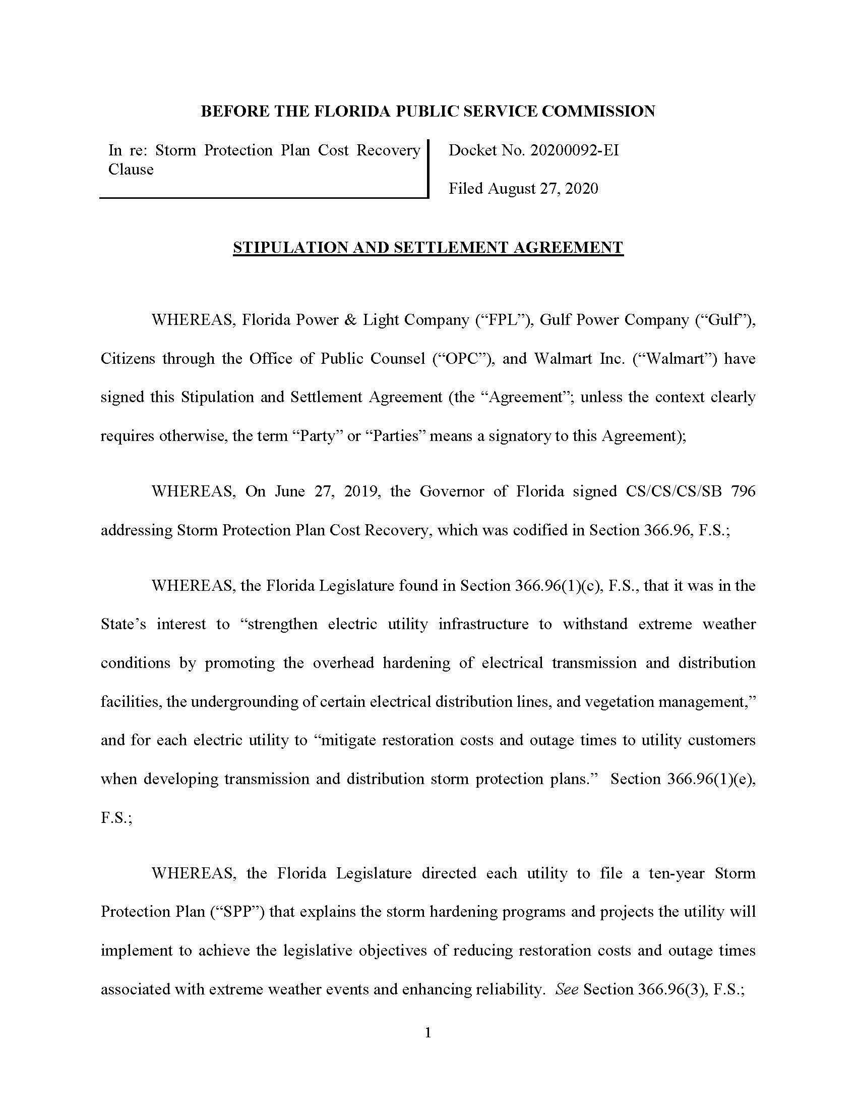

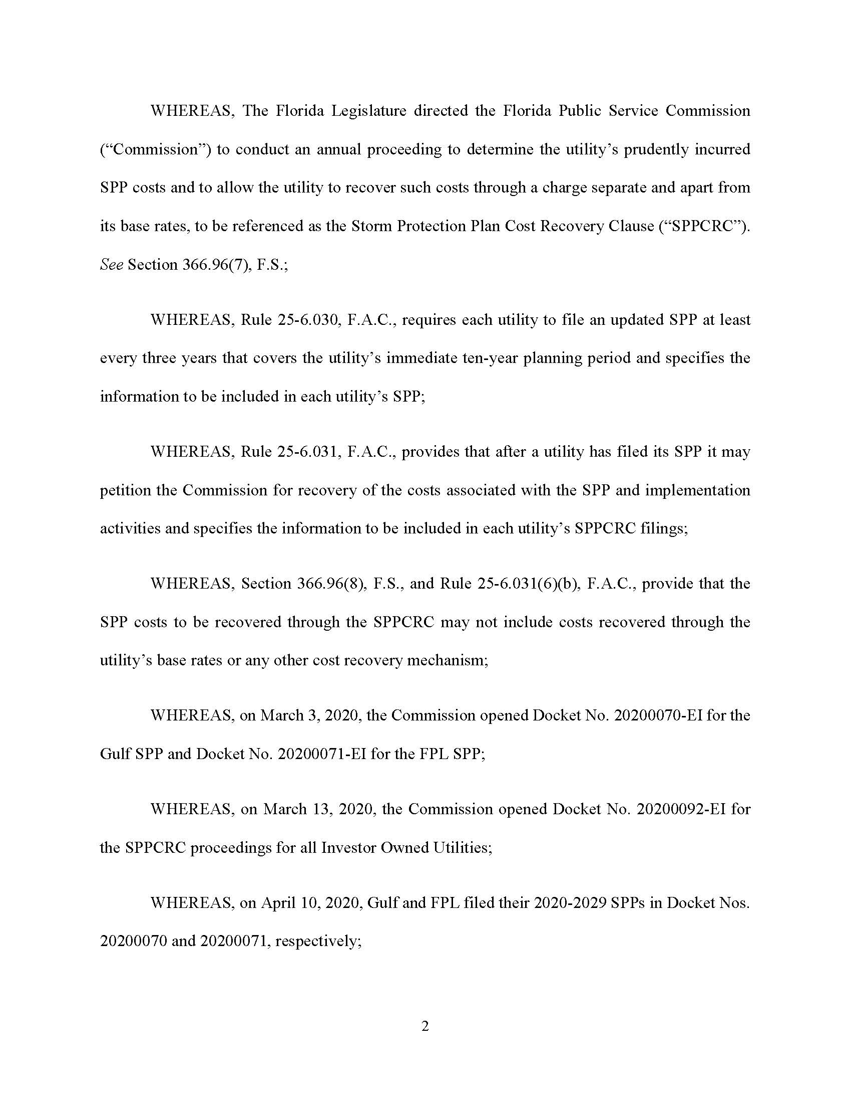

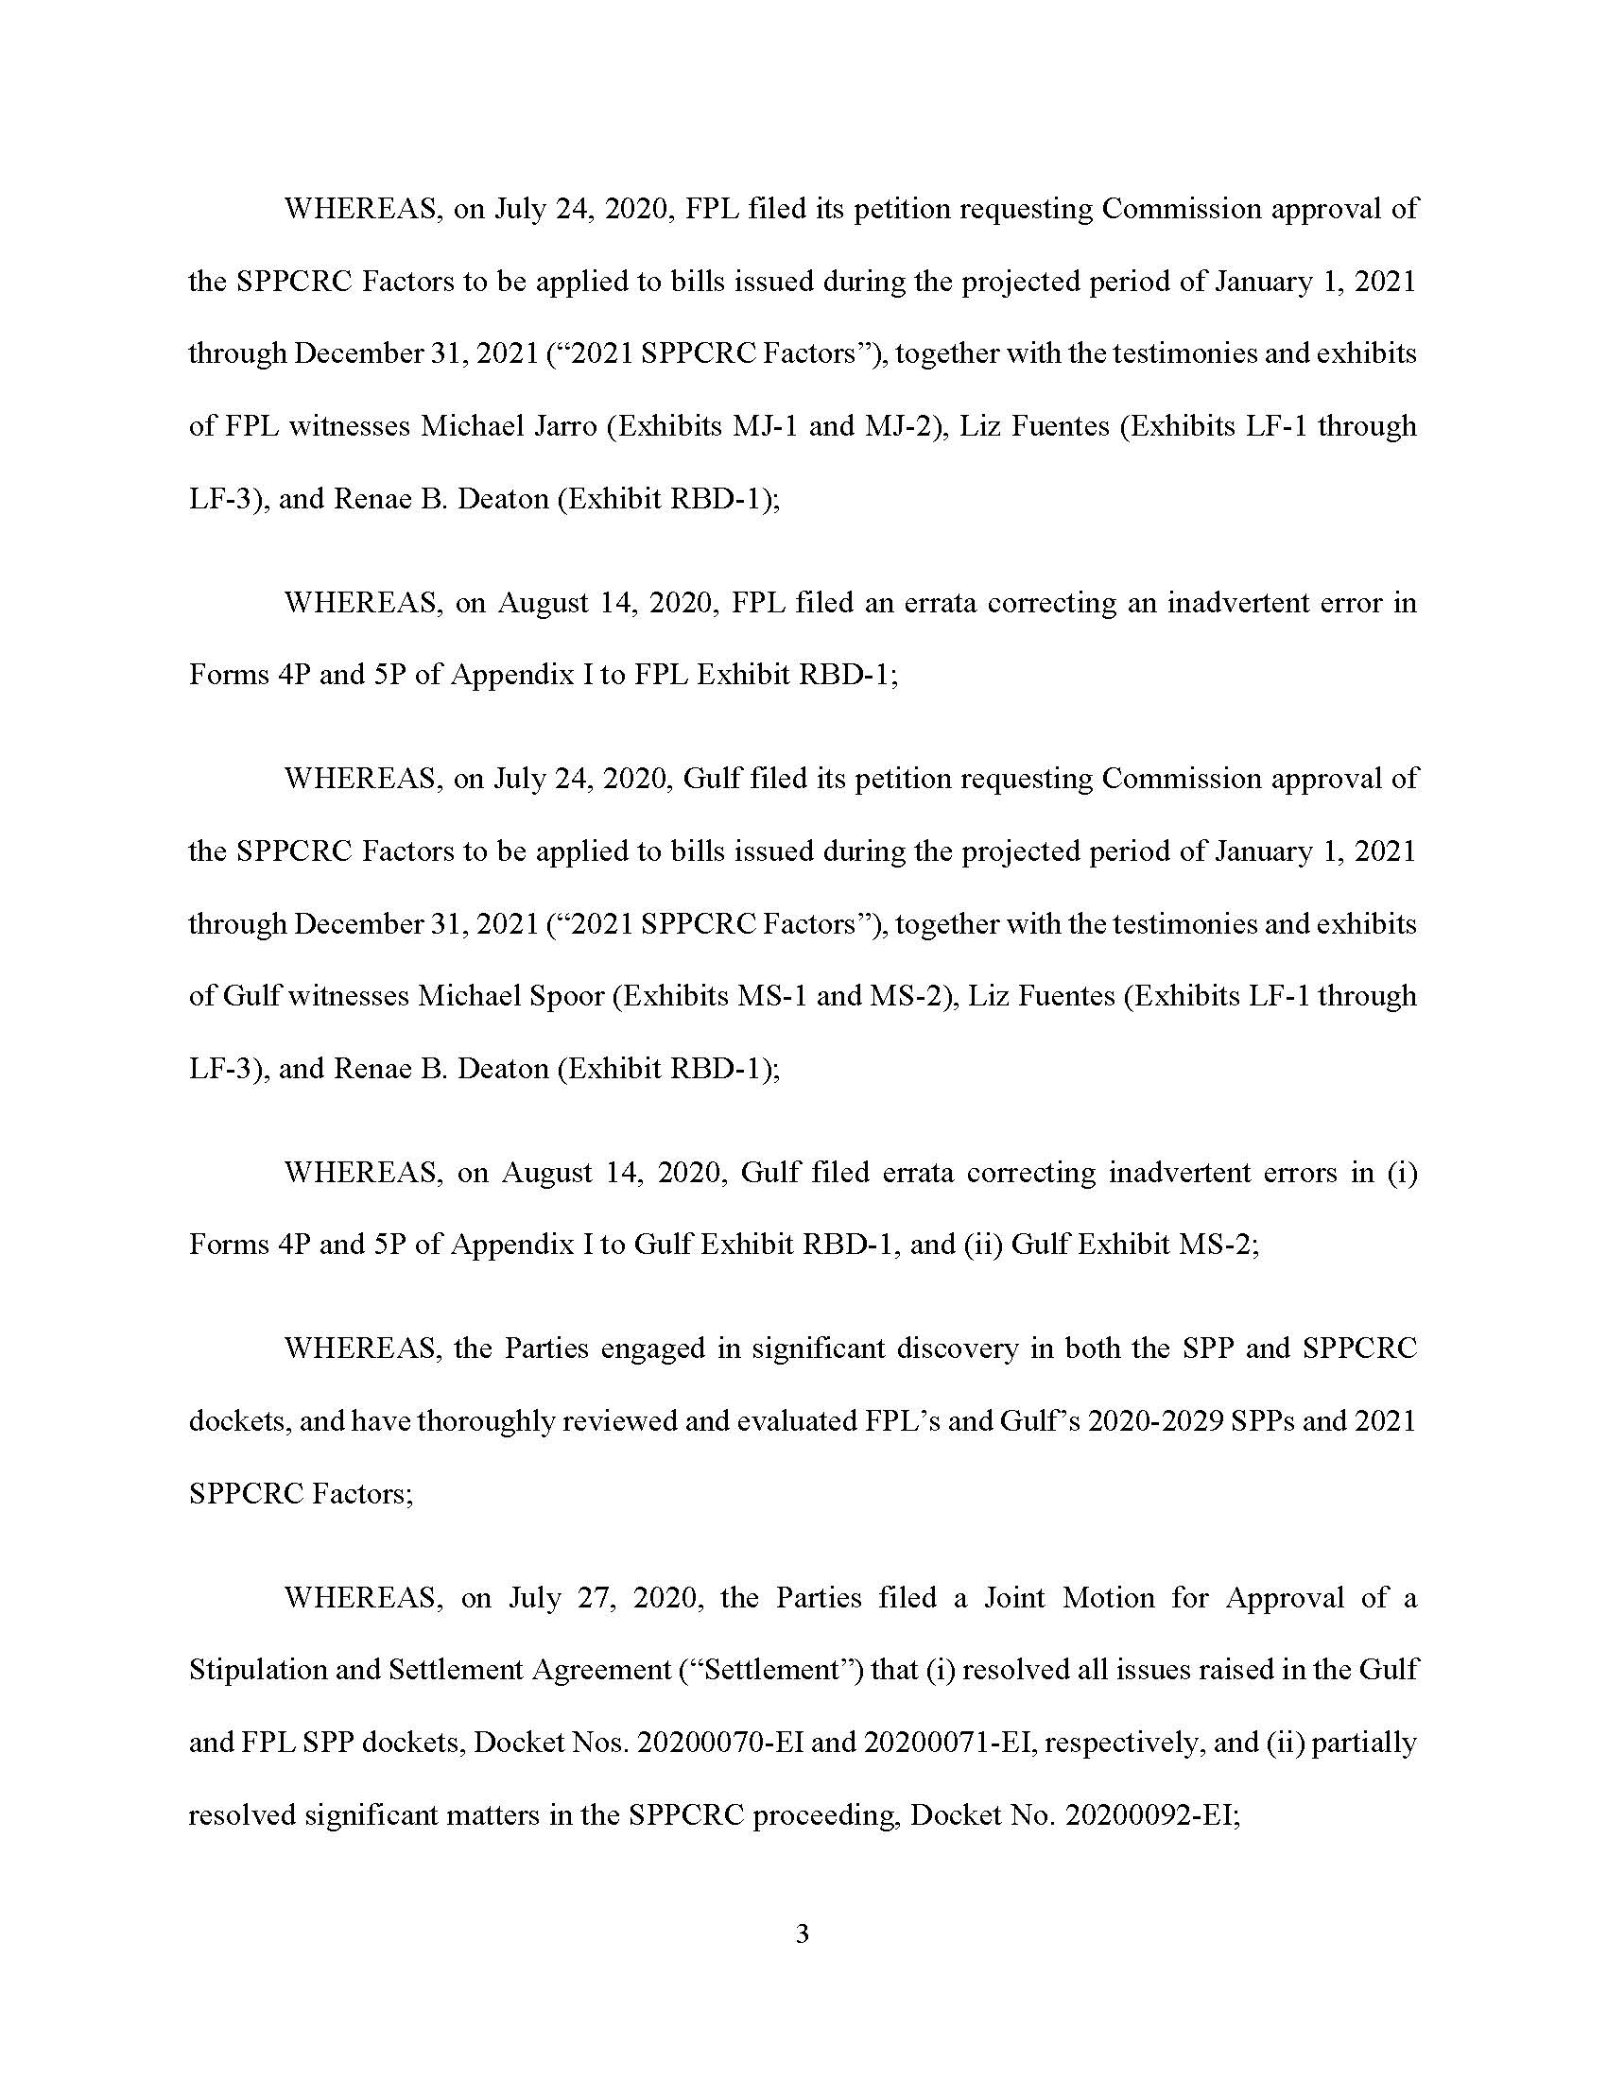

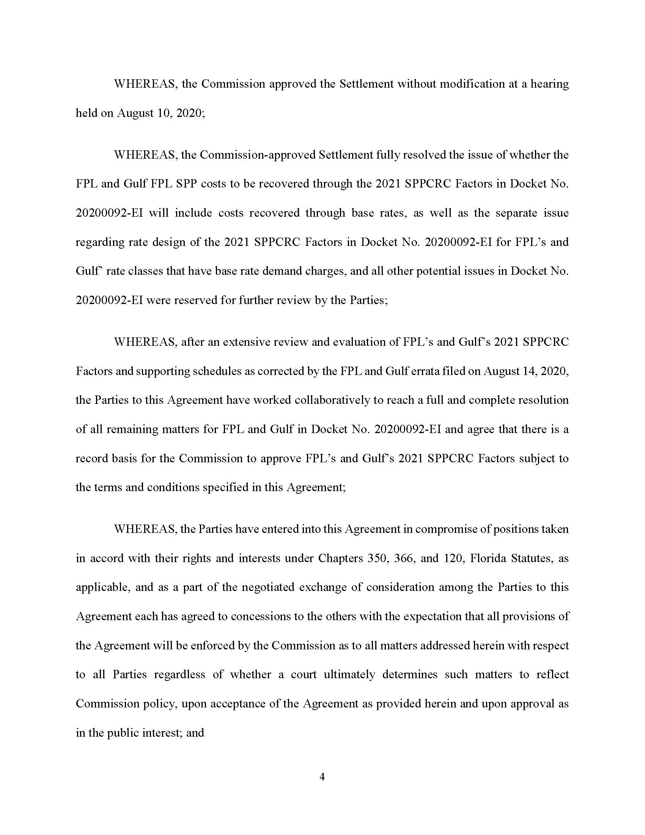

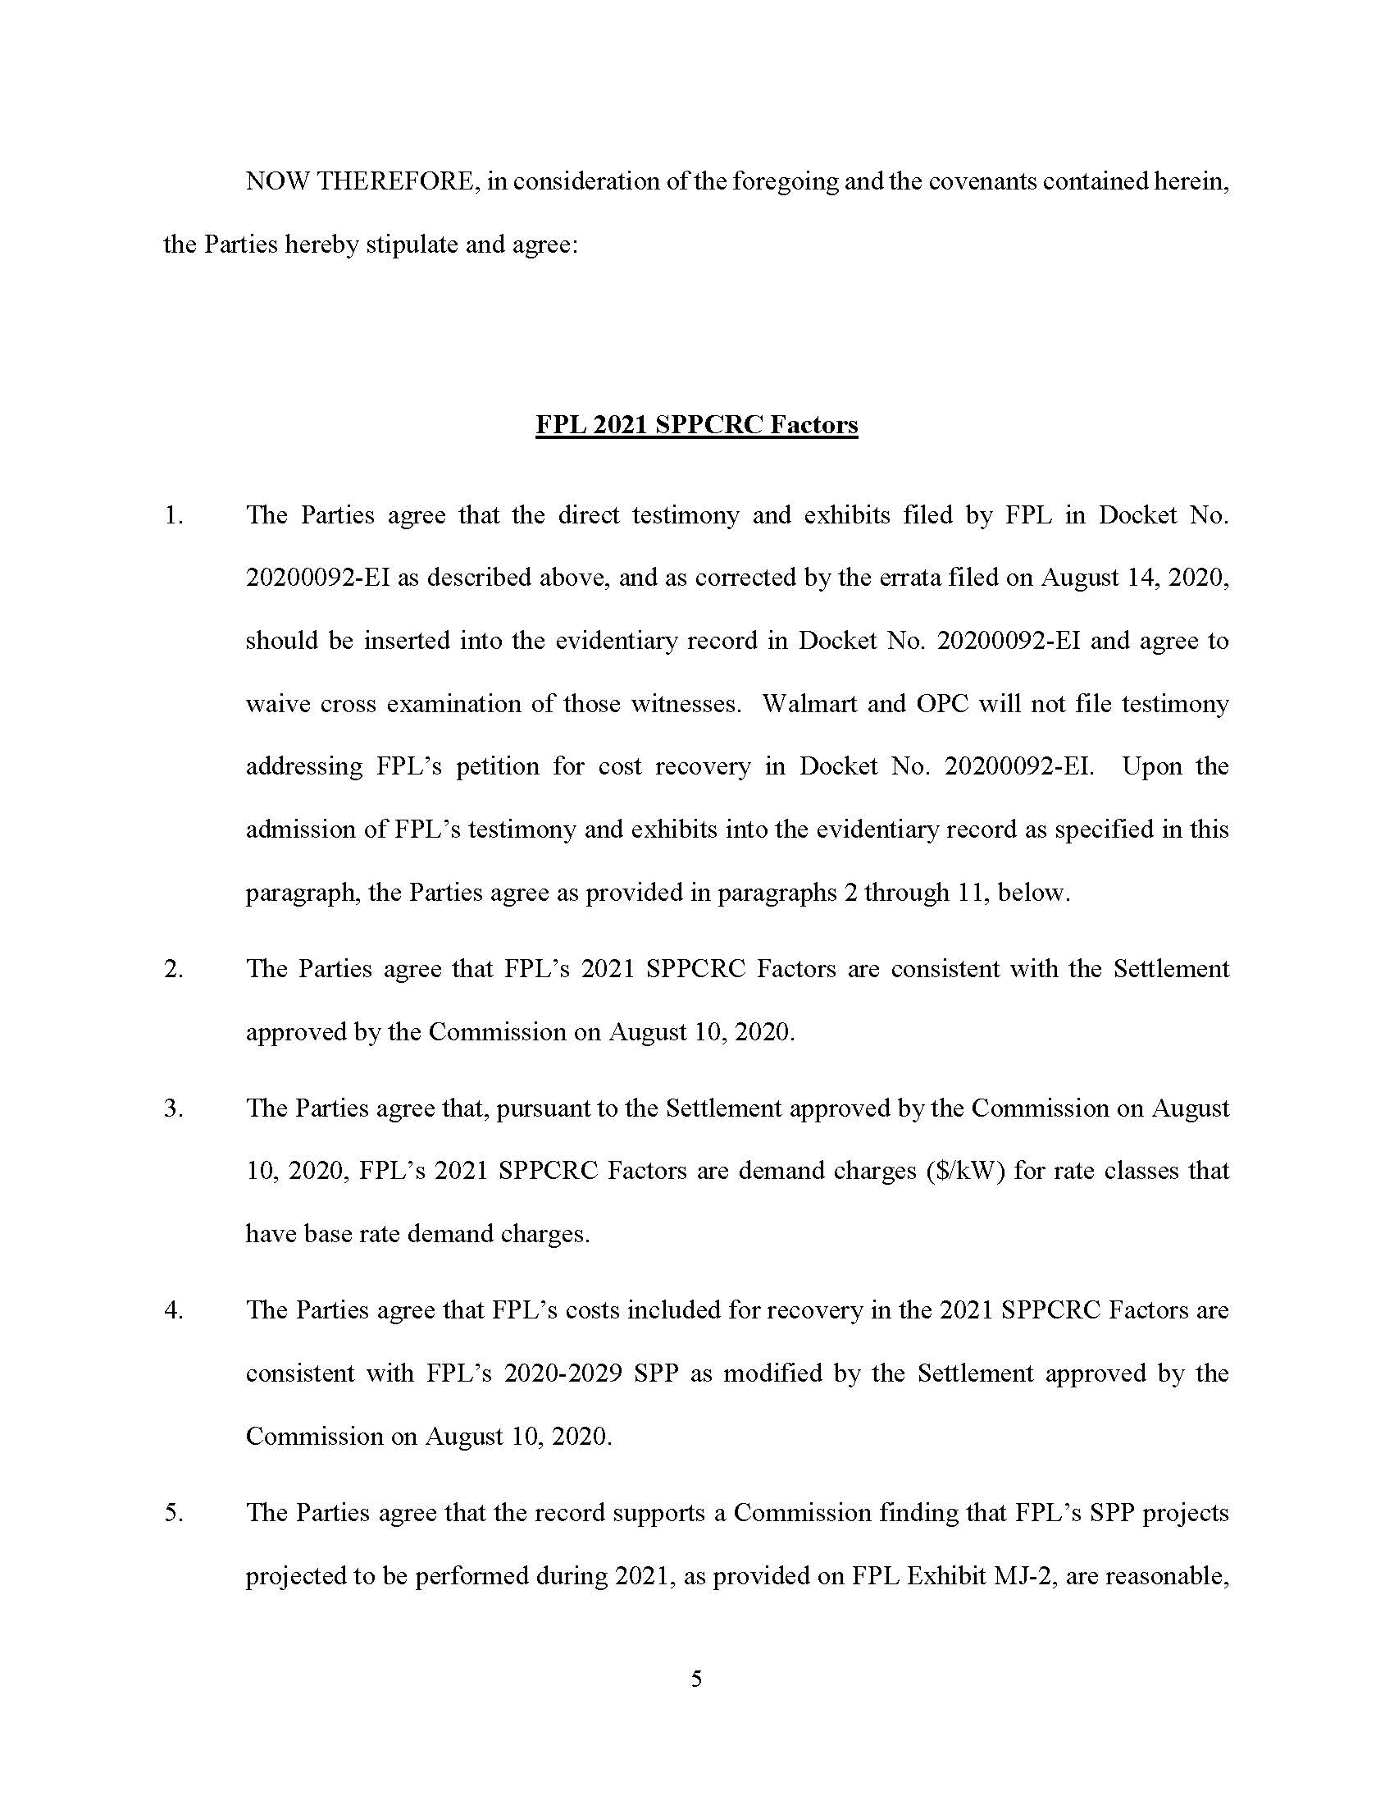

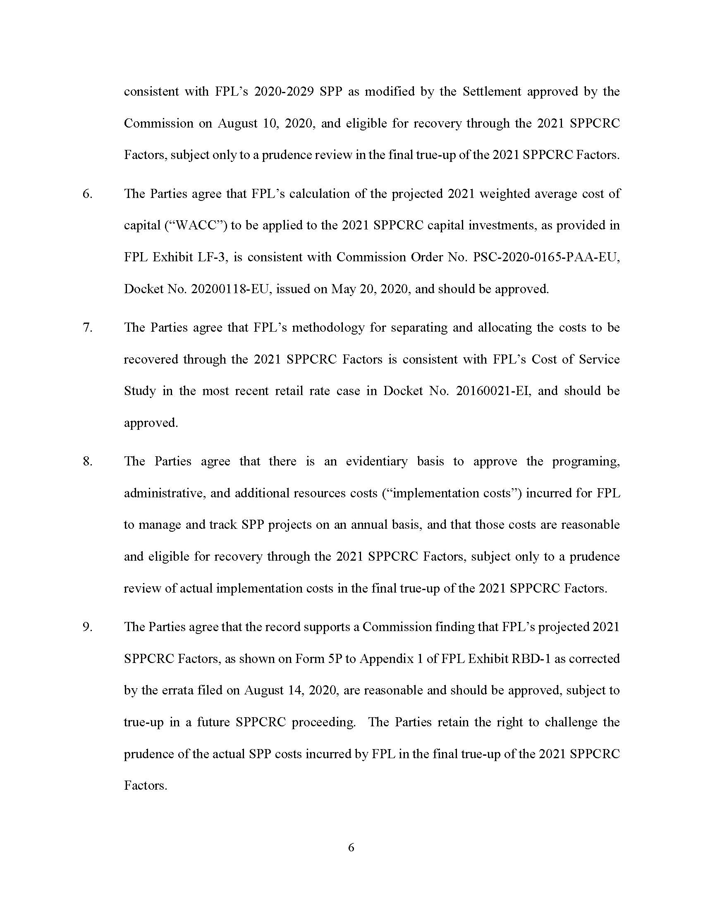

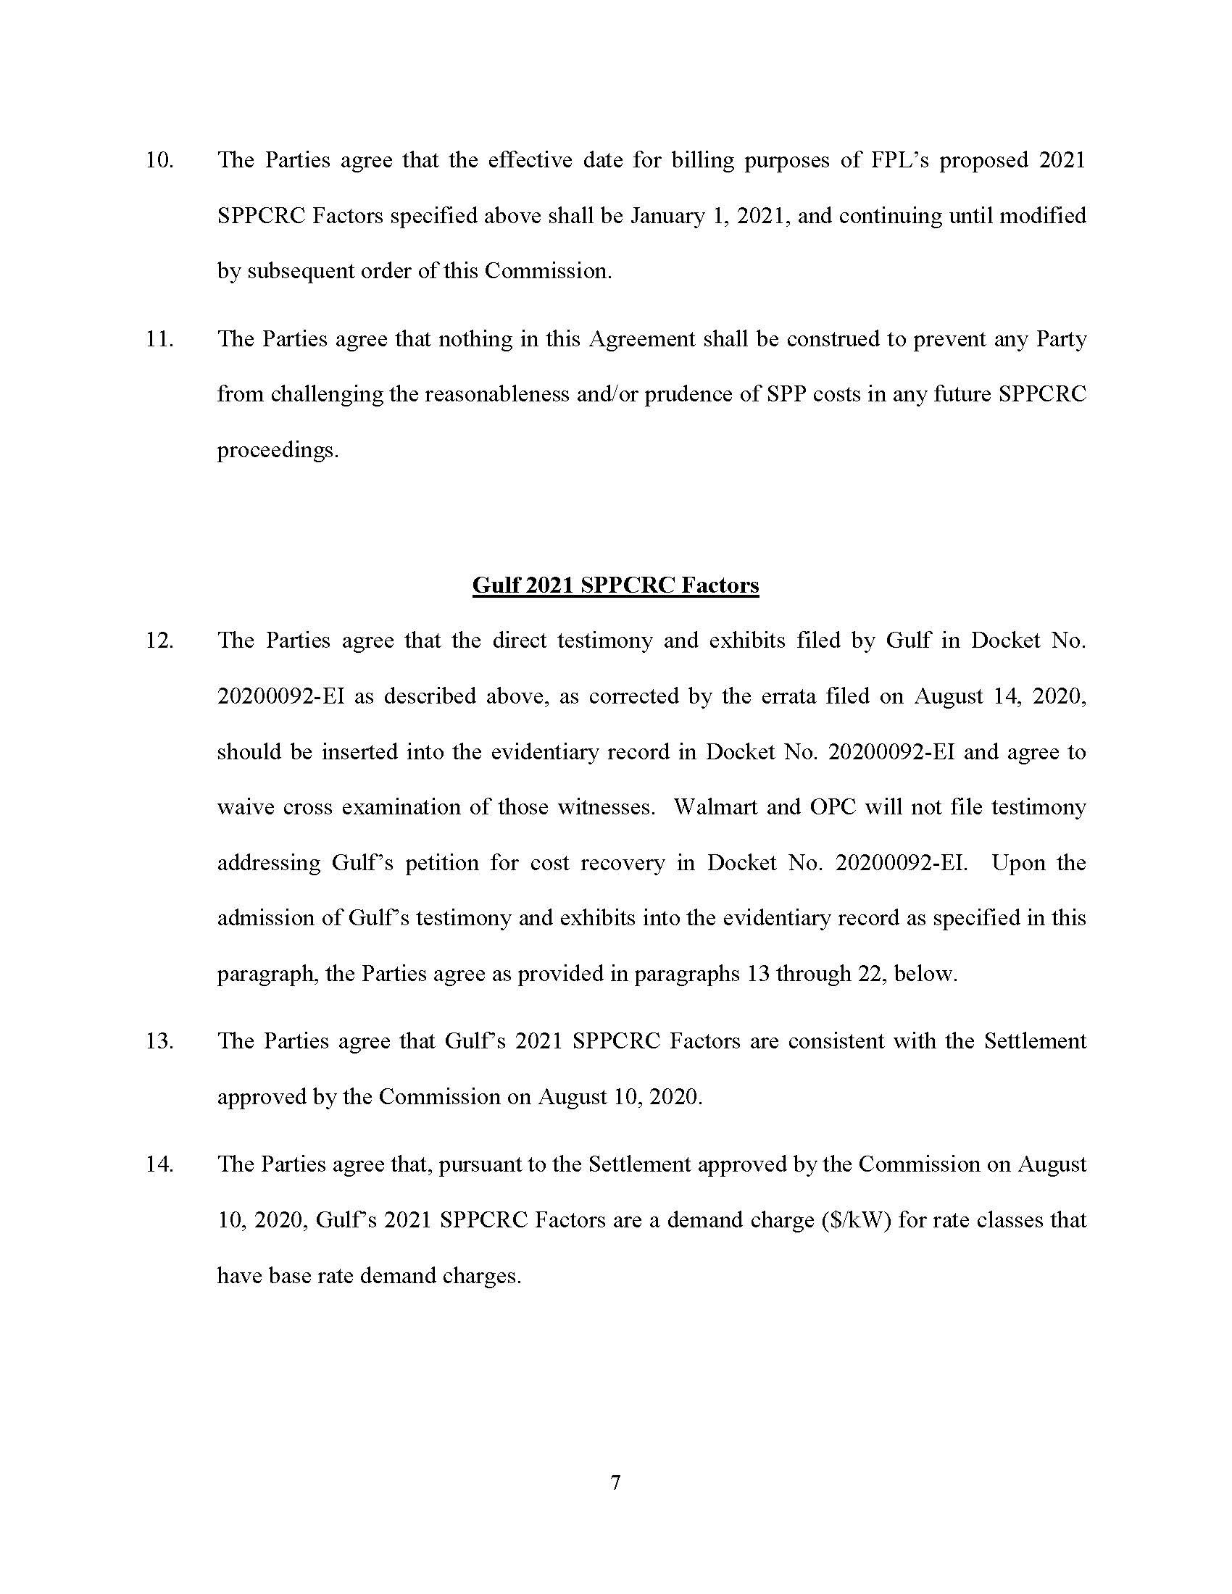

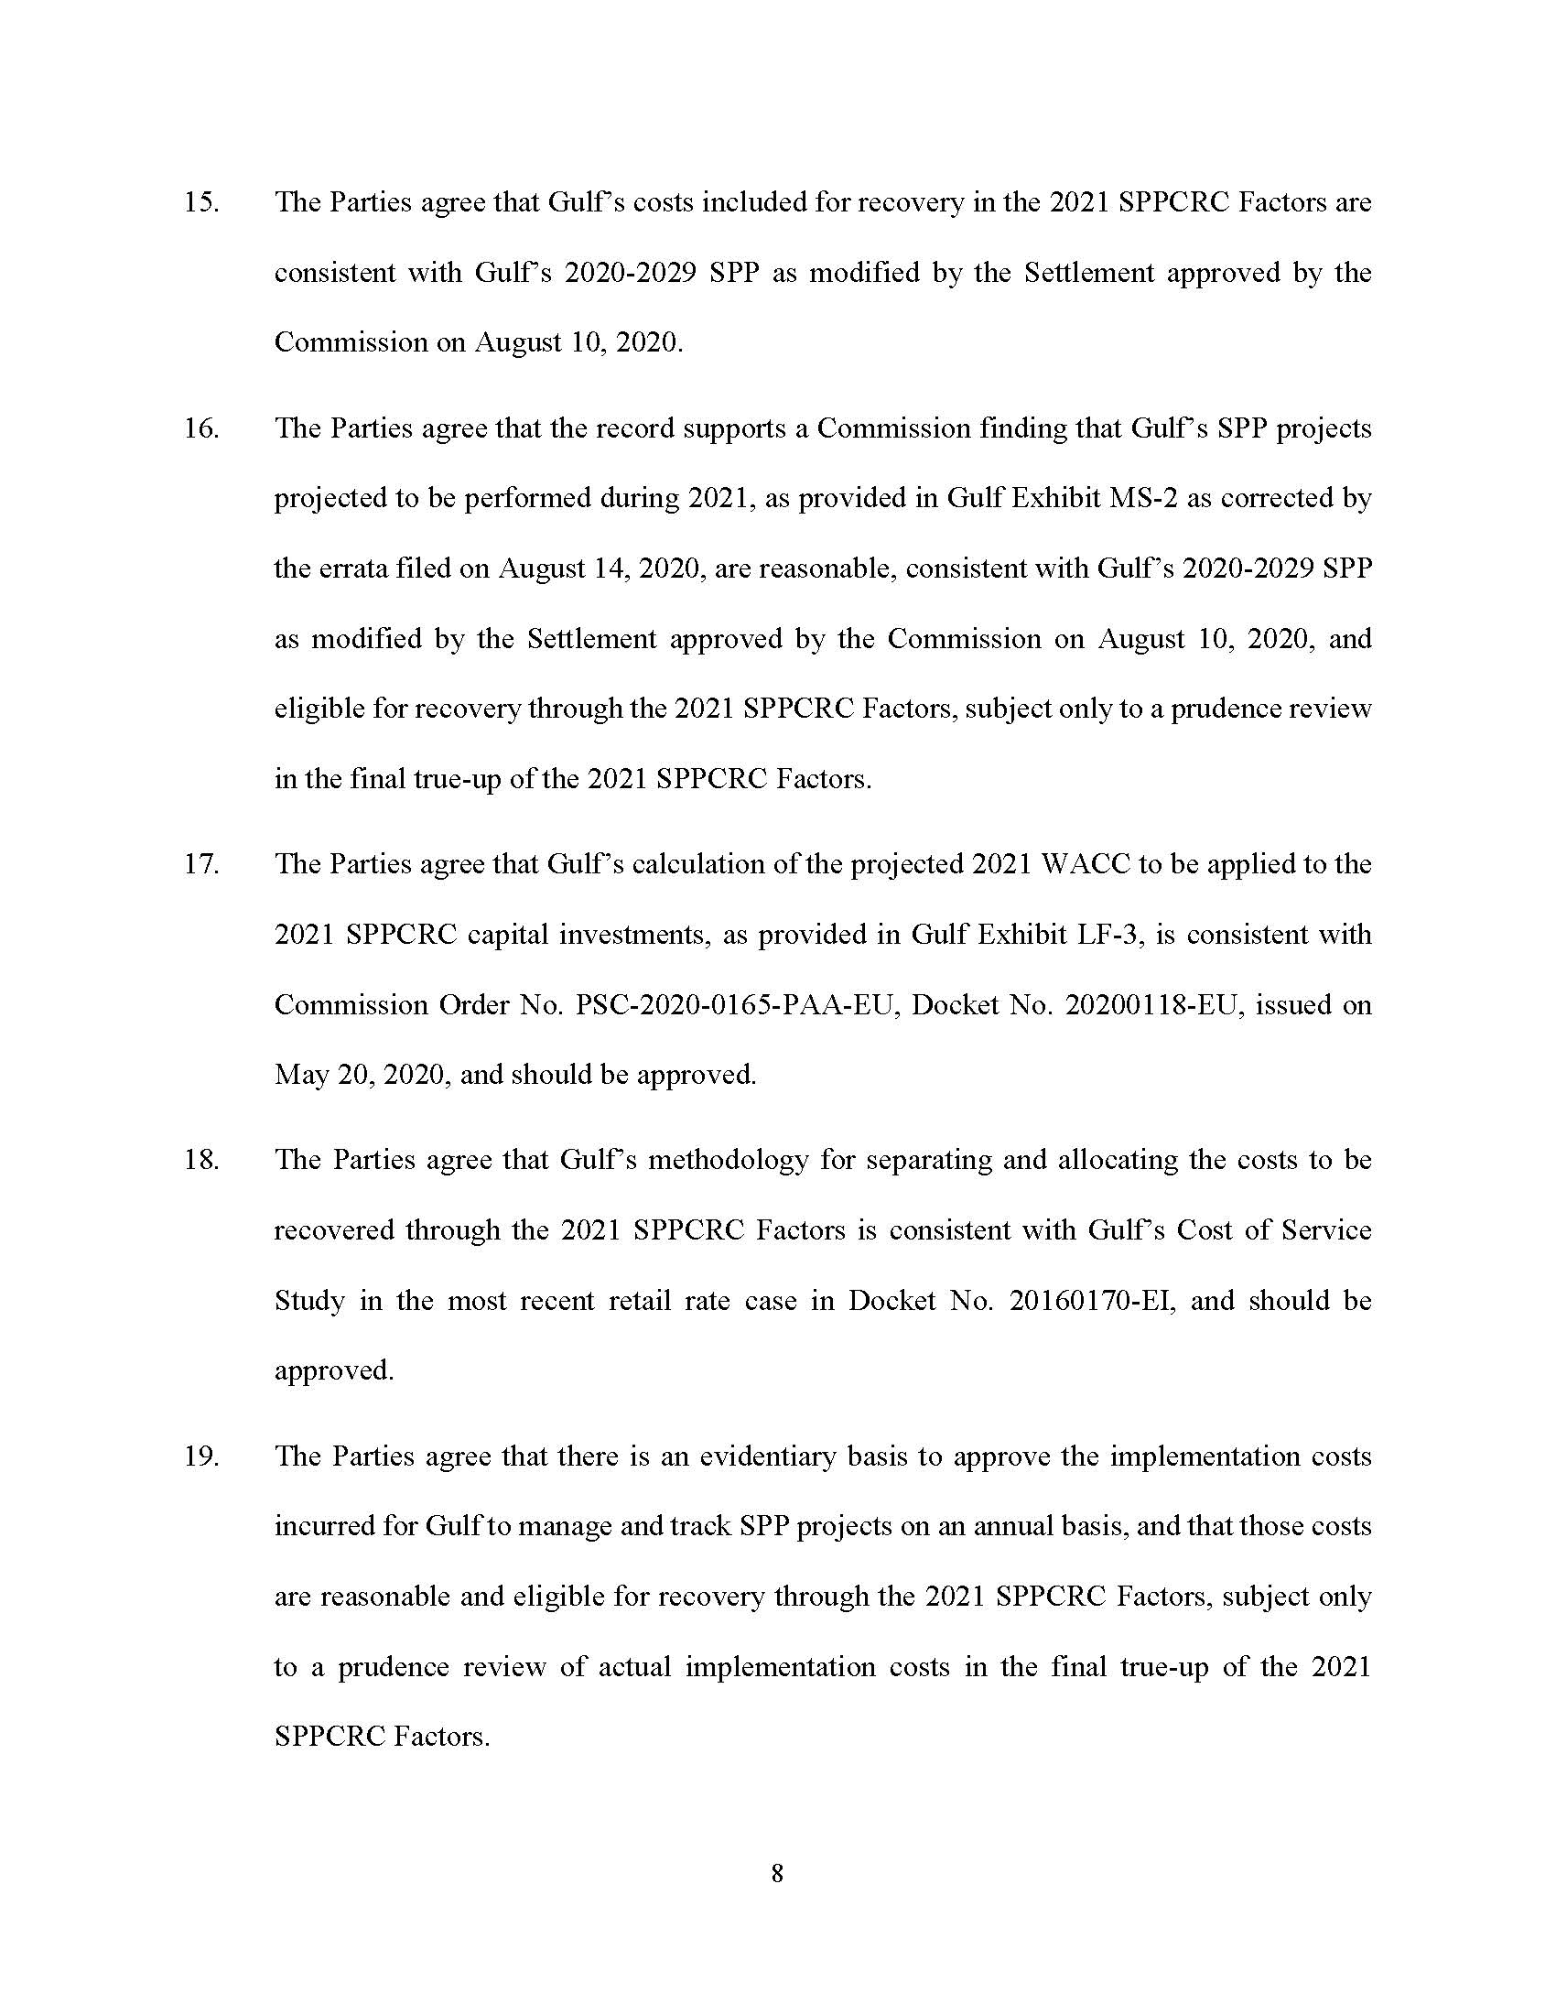

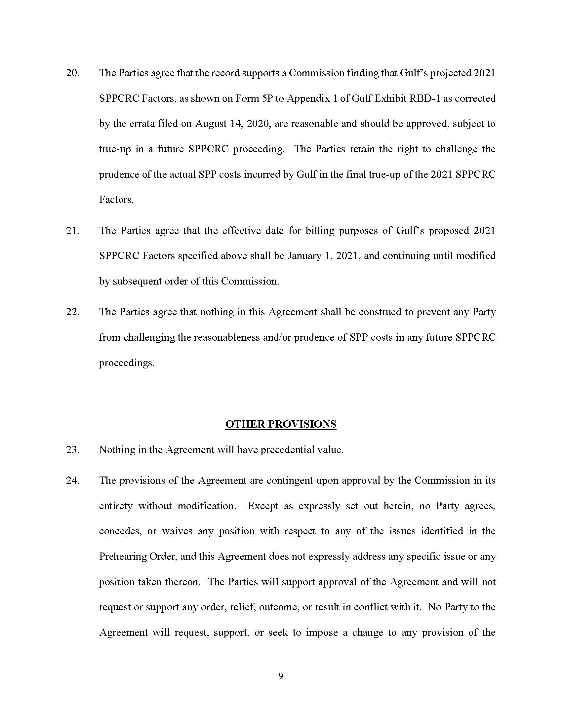

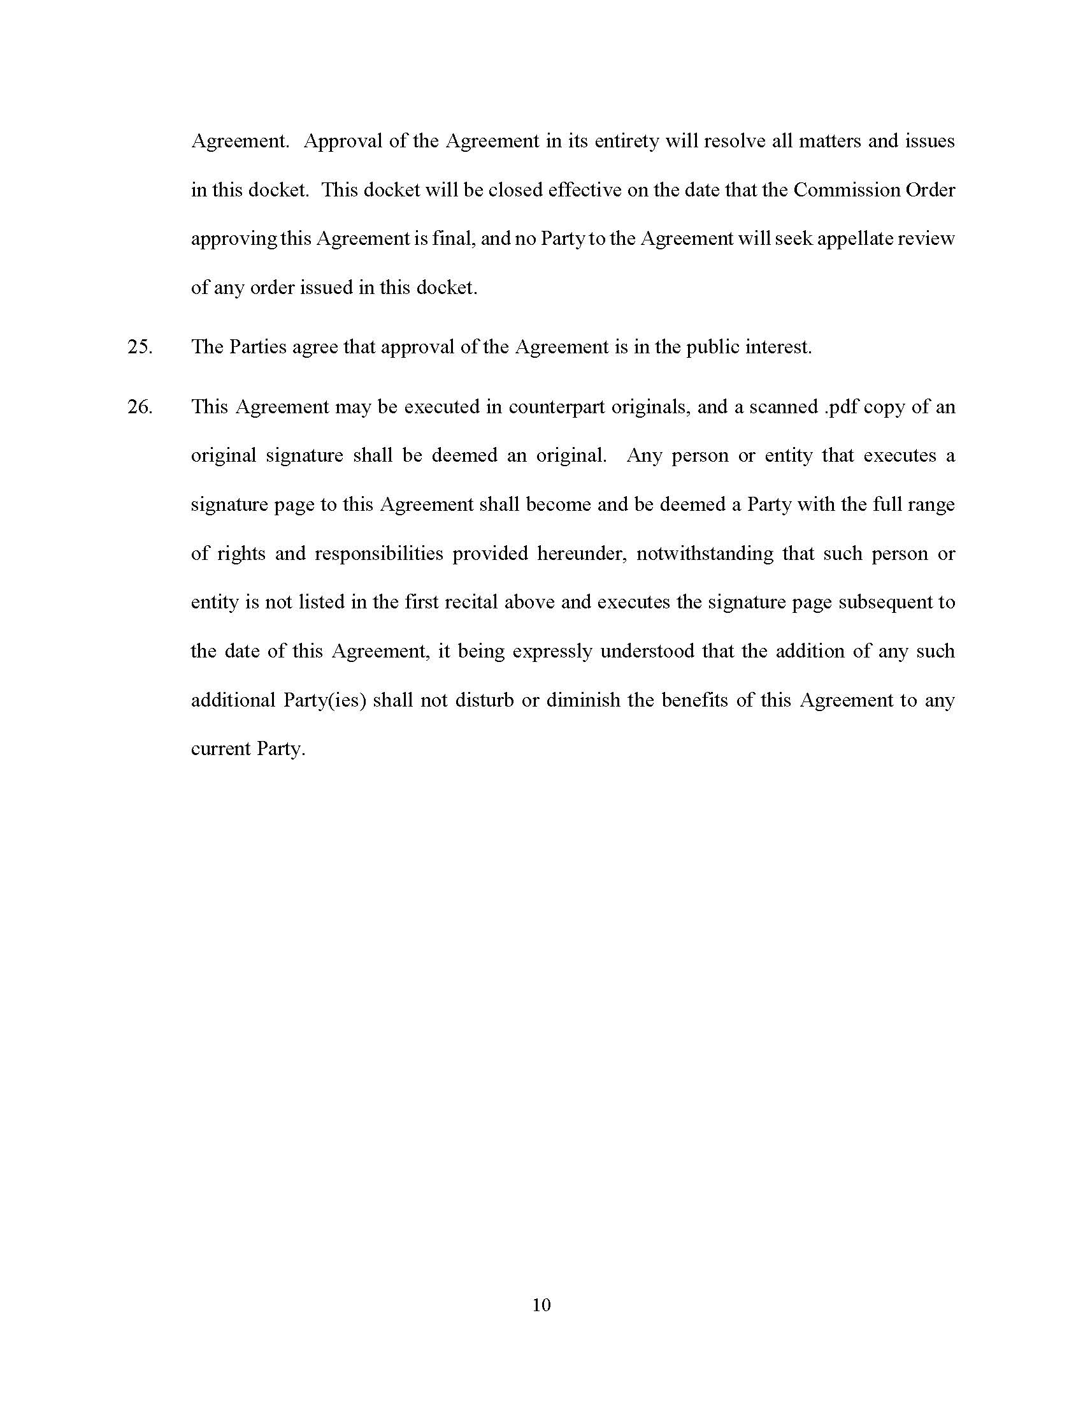

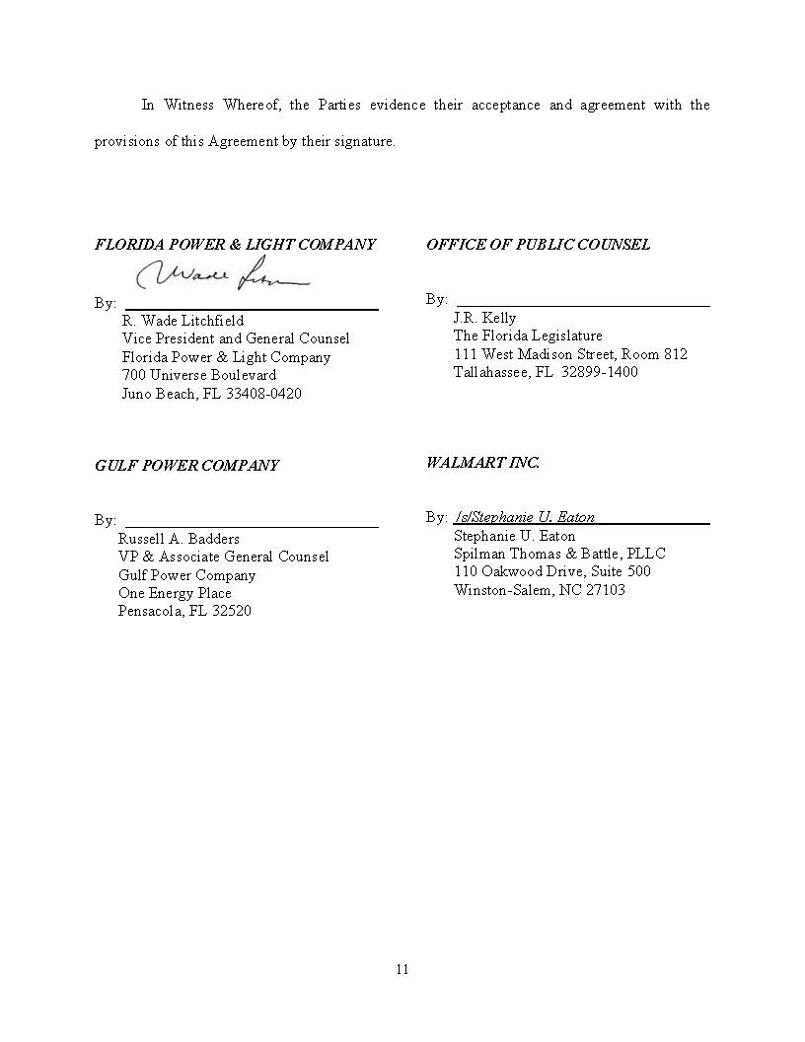

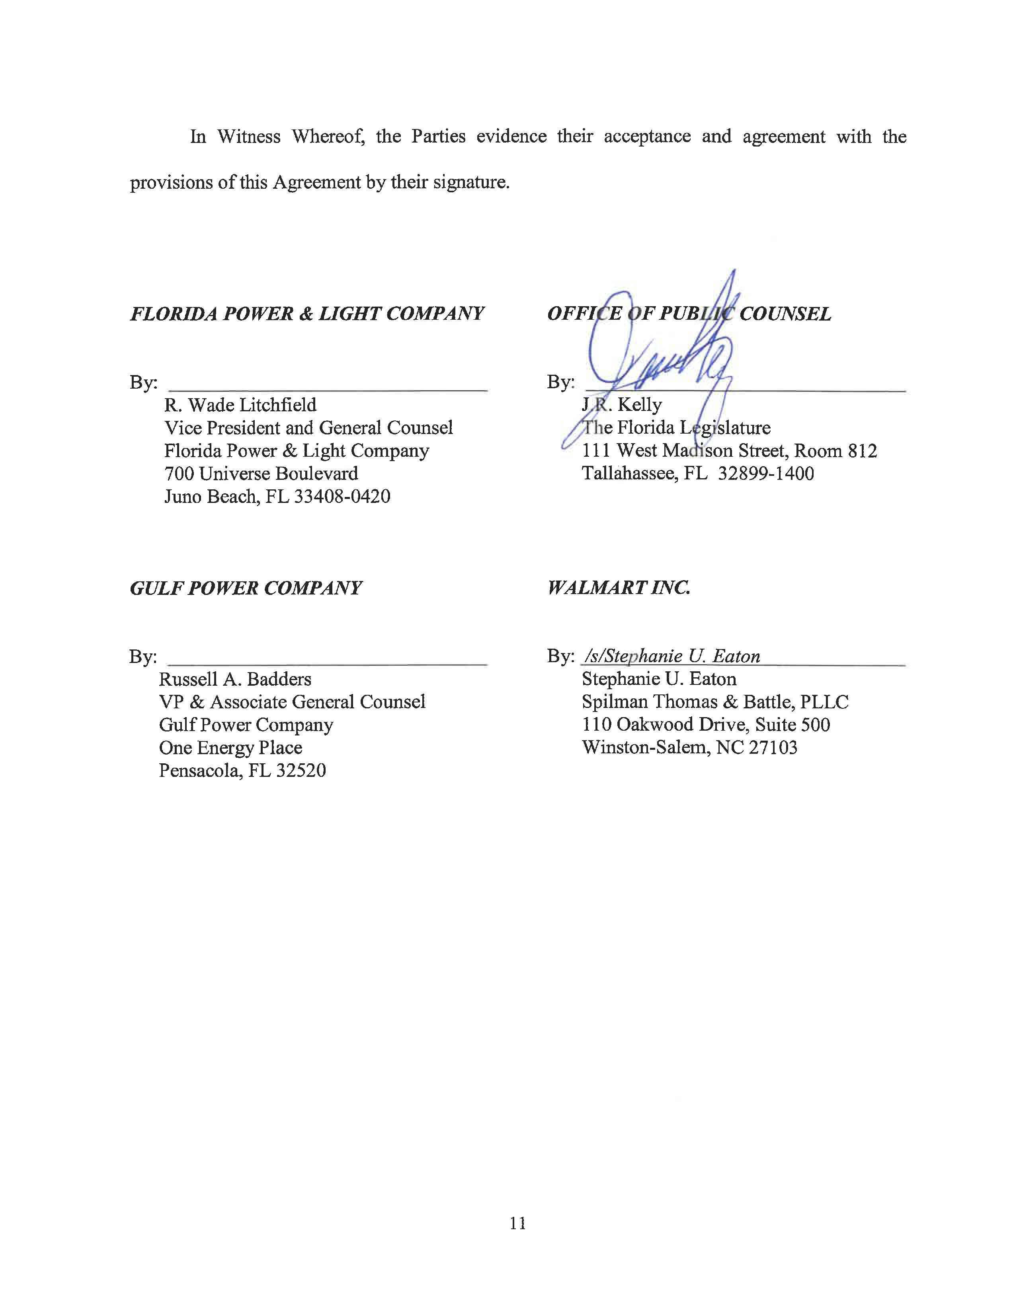

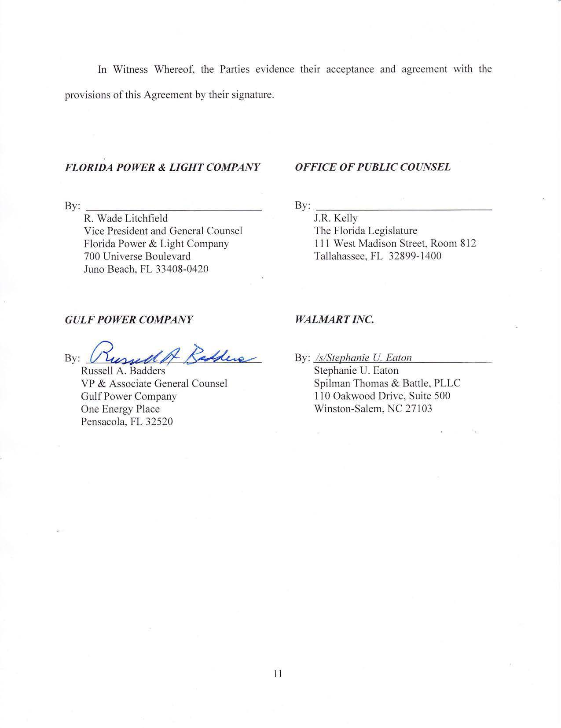

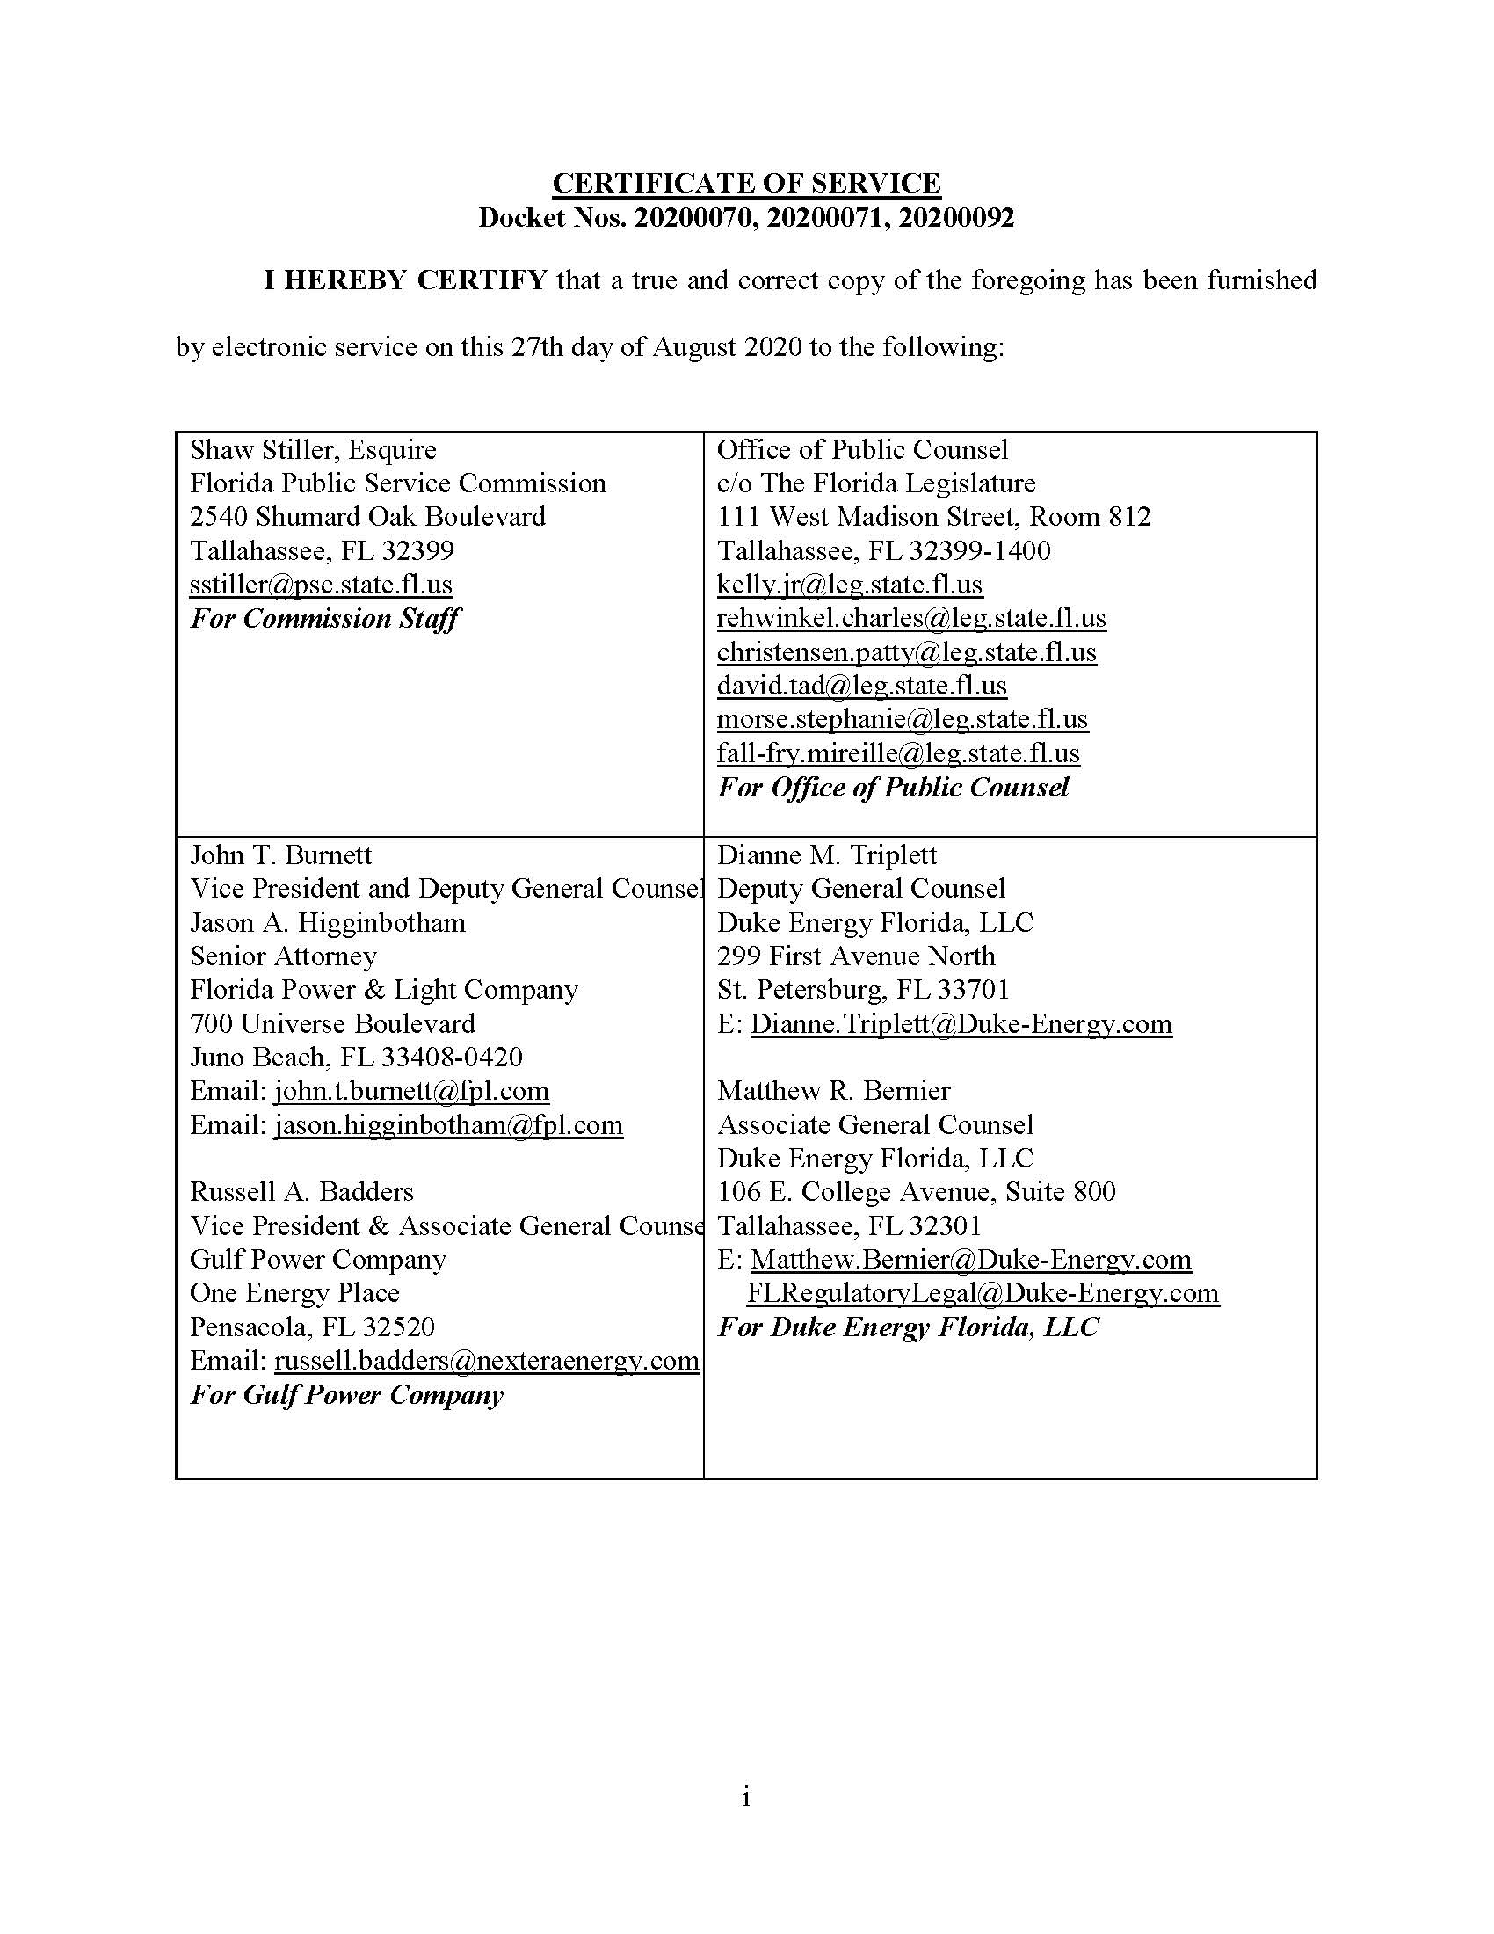

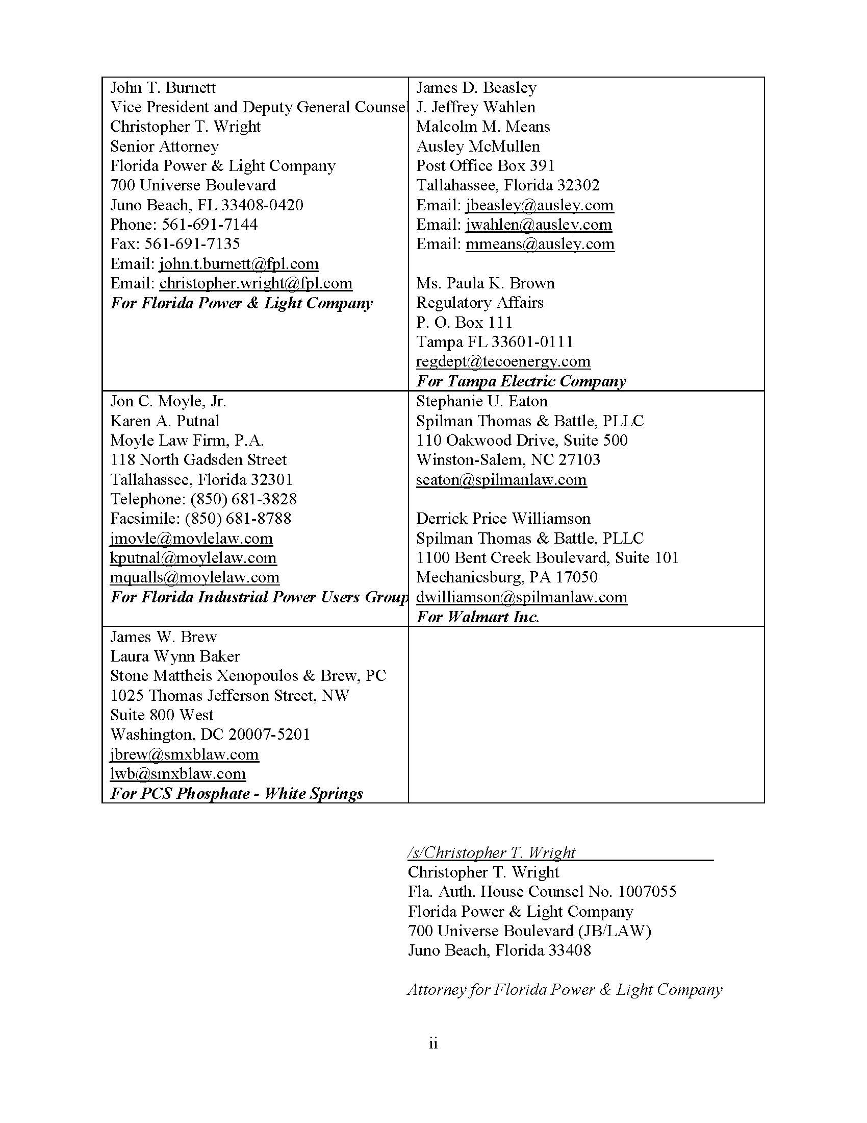

We previously approved a Settlement Agreement involving TECO in Order PSC-2020-0224-AS-EI, which established agreed terms and stipulations for TECO’s storm protection plan cost recovery. The terms of that settlement called for the TECO prefiled testimony and exhibits to be entered into the record for this docket. Accordingly, the prefiled, direct testimony and exhibits of witnesses Roche, Plusquellic, Lewis, andAshburn in support of its storm protection plan cost recovery were admitted as Exhibits 15-18 during this hearing.
Sierra Club v. Brown, 243 So. 3d 903, 910-913 (Fla. 2018); Order No. PSC-13-0023-S-EI, issued on January 14, 2013, in Docket No. 120015-EI, In re: Petition for increase in rates by Florida Power & Light Company; Order No. PSC-11-0089-S-EI, issued February 1, 2011, in Docket Nos. 080677-EI and 090130-EI, In re: Petition for increase in rates by Florida Power & Light Company and In re: 2009 depreciation and dismantlement study by Florida Power & Light Company; Order No. PSC-10-0398-S-EI, issued June 18, 2010, in Docket Nos. 090079-EI, 090144-EI, 090145-EI, and 100136-EI, In re: Petition for increase in rates by Progress Energy Florida, Inc., In re: Petition for limited proceeding to include Bartow repowering project in base rates, by Progress Energy Florida, Inc., In re: Petition for expedited approval of the deferral of pension expenses, authorization to charge storm hardening expenses to the storm damage reserve, and variance from or waiver of Rule 25-6.0143(1)(c), (d), and (f), F.A.C., by Progress Energy Florida, Inc., and In re: Petition for approval of an accounting order to record a depreciation expense credit, by Progress Energy Florida, Inc.; Order No. PSC-05-0945-S-EI, issued September 28, 2005, in Docket No. 050078-EI, In re: Petition for rate increase by Progress Energy Florida, Inc.
Order No. PSC-13-0023-S-EI, at p. 7.

