BEFORE THE FLORIDA PUBLIC SERVICE COMMISSION

In re: Storm protection plan cost recovery clause. | DOCKET NO. 20200092-EI  ORDER NO. PSC-2020-0410-AS-EI  ISSUED: October 27, 2020

The following Commissioners participated in the disposition of this matter:

GARY F. CLARK, Chairman
ART GRAHAM
JULIE I. BROWN
DONALD J. POLMANN
ANDREW GILES FAY

APPEARANCES:

MATTHEW R. BERNIER, ESQUIRE, 106 E. College Avenue, Suite 800, Tallahassee, Florida 32301
On behalf of Duke Energy Florida, LLC.

JON C. MOYLE, ESQUIRE, 118 North Gadsden Street, Tallahassee, Florida 32312
On behalf of Florida Industrial Power Users Group.

JAMES W. BREW, ESQUIRE, Stone Mattheis Xenopoulos & Brew, PC, 1025 Thomas Jefferson Street, NW, Eighth Floor, West Tower, Washington, District of Columbia 20007
On behalf of White Springs Agricultural Chemicals, Inc. d/b/a PCS Phosphate – White Springs.

J.R. KELLY and CHARLES REHWINKEL, ESQUIRES, Office of Public Counsel, c/o The Florida Legislature, 111 West Madison Street, Room 812, Tallahassee, Florida 32399-1400
On behalf of Office of Public Counsel.

STEPHANIE U. EATON, ESQUIRE, 110 Oakwood Drive, Suite 500, Winston-Salem, North Carolina 27103
On behalf of Walmart Inc.

SHAW P. STILLER and JENNIFER S. CRAWFORD, ESQUIRES, Florida Public Service Commission, 2540 Shumard Oak Boulevard, Tallahassee, Florida 32399-0850
On behalf of the Florida Public Service Commission (Staff).

MARY ANNE HELTON, ESQUIRE, Deputy General Counsel, Florida Public Service Commission, 2540 Shumard Oak Boulevard, Tallahassee, Florida 32399-0850
Advisor to the Florida Public Service Commission.

KEITH C. HETRICK, ESQUIRE, General Counsel, Florida Public Service Commission, 2540 Shumard Oak Boulevard, Tallahassee, Florida 32399-0850
Florida Public Service Commission General Counsel.

FINAL ORDER APPROVING SETTLEMENT AGREEMENTS

BY THE COMMISSION:

Background
The 2019 Florida Legislature enacted Section 366.96, Florida Statutes (F.S.), entitled “Storm protection plan cost recovery.” Pursuant to Section 366.96(7), F.S., we shall conduct an annual proceeding to determine a utility’s prudently incurred transmission and distribution storm protection plan costs and allow the utility to recover such costs through a charge separate and apart from its base rates, to be referred to as the storm protection plan cost recovery clause (SPPCRC). If we determine that costs were prudently incurred, those costs will not be subject to disallowance or further prudence review except for fraud, perjury, or intentional withholding of key information by the public utility.

On September 1, 2020, we conducted a hearing to consider two Motions for Approval of Settlement Agreement. Both Motions were filed by Duke Energy Florida, LLC (Duke or Company) in Docket No. 20200069-EI (Storm Protection Plan docket or SPP) and Docket No. 20200092-EI (Storm Protection Plan Cost Recovery Clause or SPPCRC). The first Motion was filed July 17, 2020, and requested approval of the “2020 SPP/SPPCRC Agreement” (July Agreement), attached hereto as Exhibit A. The second Motion was filed August 10, 2020, and requested approval of the “SPPCRC Stipulation and Settlement Agreement” (August Agreement), attached hereto as Exhibit B.

The signatories to both Agreements are Duke, the Office of Public Counsel (OPC), and White Springs Agricultural Chemicals, Inc. d/b/a PCS Phosphate (PCS). The Florida Industrial Power Users Group (FIPUG) is a party to both dockets but did not sign and takes no position regarding either Agreement. Walmart, Inc. (Walmart) is a party to both dockets, takes no position regarding the July Agreement, and objects to the August Agreement.

The July Agreement contains a series of stipulations regarding the reasonable costs Duke should be permitted to recover through the SPPCRC in 2021. We approved the July Agreement at the September 1, 2020 hearing, without objection from any party.

At the September 1, 2020 public hearing, counsel for Duke, OPC, and PCS made presentations in favor of the August Agreement. Duke also introduced into evidence the testimony of witnesses Oliver and Foster. Counsel for Walmart presented argument in opposition to the August Agreement. Walmart also introduced into evidence the testimony of its witness Chriss and conducted cross examination of Duke witness Foster. Eight evidentiary exhibits were admitted without objection. At the conclusion of the hearing, we established September 11, 2020, as the deadline for any party wishing to file a brief to do so. Duke, PCS, and Walmart timely filed post-hearing briefs.
We have jurisdiction over this matter pursuant to Sections 366.03, 366.05, and 366.06, Florida Statutes.
Decision
The standard for approval of a settlement agreement is whether it is in the public interest. A determination of whether a settlement is in the public interest requires a case-specific analysis based on consideration of the proposed settlement taken as a whole.
Duke’s July Agreement
As noted above, we approved the uncontested July Agreement, Attachment A hereto, at the September 1, 2020 hearing in this docket. The July Agreement contains a series of stipulations regarding the reasonable costs Duke should be permitted to recover through the SPPCRC in 2021. The signatories contend that approval of the July Agreement is in the public interest for a number of reasons, foremost of which are promoting efficiency and transparency, and avoiding the expense and delay of litigating the contentious issues of whether costs are incremental and whether there is double recovery. After hearing opening statements by all parties, we found the July Agreement to be in the public interest, and therefore approved it.

Duke’s August Agreement

The August Agreement also contains a series of stipulations. Specifically, the signatories agree that the prefiled testimony provides us with a record basis to approve the reasonableness of Duke’s 2021 SPPCRC costs and revenue requirements. The signatories further agree that the SPPCRC rate factors should be approved, but that such rates should not have precedential value in future SPPCRC proceedings. Finally, the signatories agree that Duke should be permitted to seek recovery of its initial 2020-2029 SPP development costs through the SPPCRC, where Duke will bear the burden of proving reasonableness and prudence.

Walmart objects to the August Agreement because it allows Duke to recover SPP costs from demand-metered customers through a $/kWh energy charge. Walmart argues that we should require Duke to charge demand-metered customers on a demand, or $/kW, charge.

The August Agreement resolves all remaining issues raised regarding Duke’s 2021 SPPCRC cost and revenue requirements in this docket and allows for future consideration of reasonableness and prudence. Having carefully reviewed the August Settlement Agreement, the testimony and exhibits entered into the record, and the parties’ post-hearing briefs, we find that, taken as a whole, it provides a reasonable resolution of these issues. We find, therefore, that the August Agreement, Attachment B hereto, is in the public interest, and we hereby approve it.

Based on the foregoing, it is

ORDERED by the Florida Public Service Commission that the Motion to Approve 2020 SPP/SPPCRC Agreement filed by Duke Energy Florida, LLC, on July 17, 2020, is granted. It is further

ORDERED that the 2020 SPP/SPPCRC Agreement filed on July 17, 2020, referred to herein as the July Agreement and attached hereto as Attachment A, and incorporated by reference, is hereby approved. It is further

ORDERED by the Florida Public Service Commission that the Joint Motion for Approval of Settlement Agreement filed by Duke Energy Florida, LLC, on August 10, 2020, is granted. It is further

ORDERED that the SPPCRC Stipulation and Settlement Agreement filed on August 10, 2020, referred to herein as the August Agreement and attached hereto as Attachment B, and incorporated by reference, is hereby approved. It is further

ORDERED that this docket shall remain open.

By ORDER of the Florida Public Service Commission this 27th day of October, 2020.

/s/ Adam J. Teitzman
ADAM J. TEITZMAN
Commission Clerk
Florida Public Service Commission
2540 Shumard Oak Boulevard
Tallahassee, Florida 32399
(850) 413-6770
www.floridapsc.com

Copies furnished: A copy of this document is provided to the parties of record at the time of issuance and, if applicable, interested persons.

SPS

NOTICE OF FURTHER PROCEEDINGS OR JUDICIAL REVIEW

The Florida Public Service Commission is required by Section 120.569(1), Florida Statutes, to notify parties of any administrative hearing or judicial review of Commission orders that is available under Sections 120.57 or 120.68, Florida Statutes, as well as the procedures and time limits that apply. This notice should not be construed to mean all requests for an administrative hearing or judicial review will be granted or result in the relief sought.

Any party adversely affected by the Commission's final action in this matter may request: 1) reconsideration of the decision by filing a motion for reconsideration with the Office of Commission Clerk, 2540 Shumard Oak Boulevard, Tallahassee, Florida 32399-0850, within fifteen (15) days of the issuance of this order in the form prescribed by Rule 25-22.060, Florida Administrative Code; or 2) judicial review by the Florida Supreme Court in the case of an electric, gas or telephone utility or the First District Court of Appeal in the case of a water and/or wastewater utility by filing a notice of appeal with the Office of Commission Clerk, and filing a copy of the notice of appeal and the filing fee with the appropriate court. This filing must be completed within thirty (30) days after the issuance of this order, pursuant to Rule 9.110, Florida Rules of Appellate Procedure. The notice of appeal must be in the form specified in Rule 9.900(a), Florida Rules of Appellate Procedure.

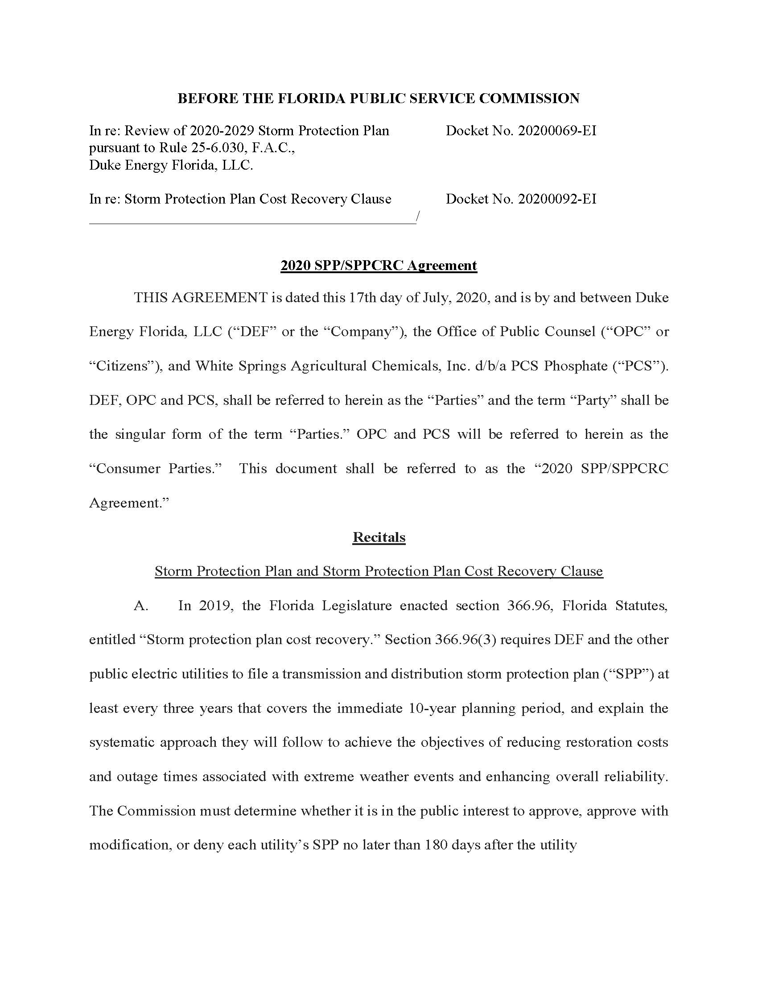

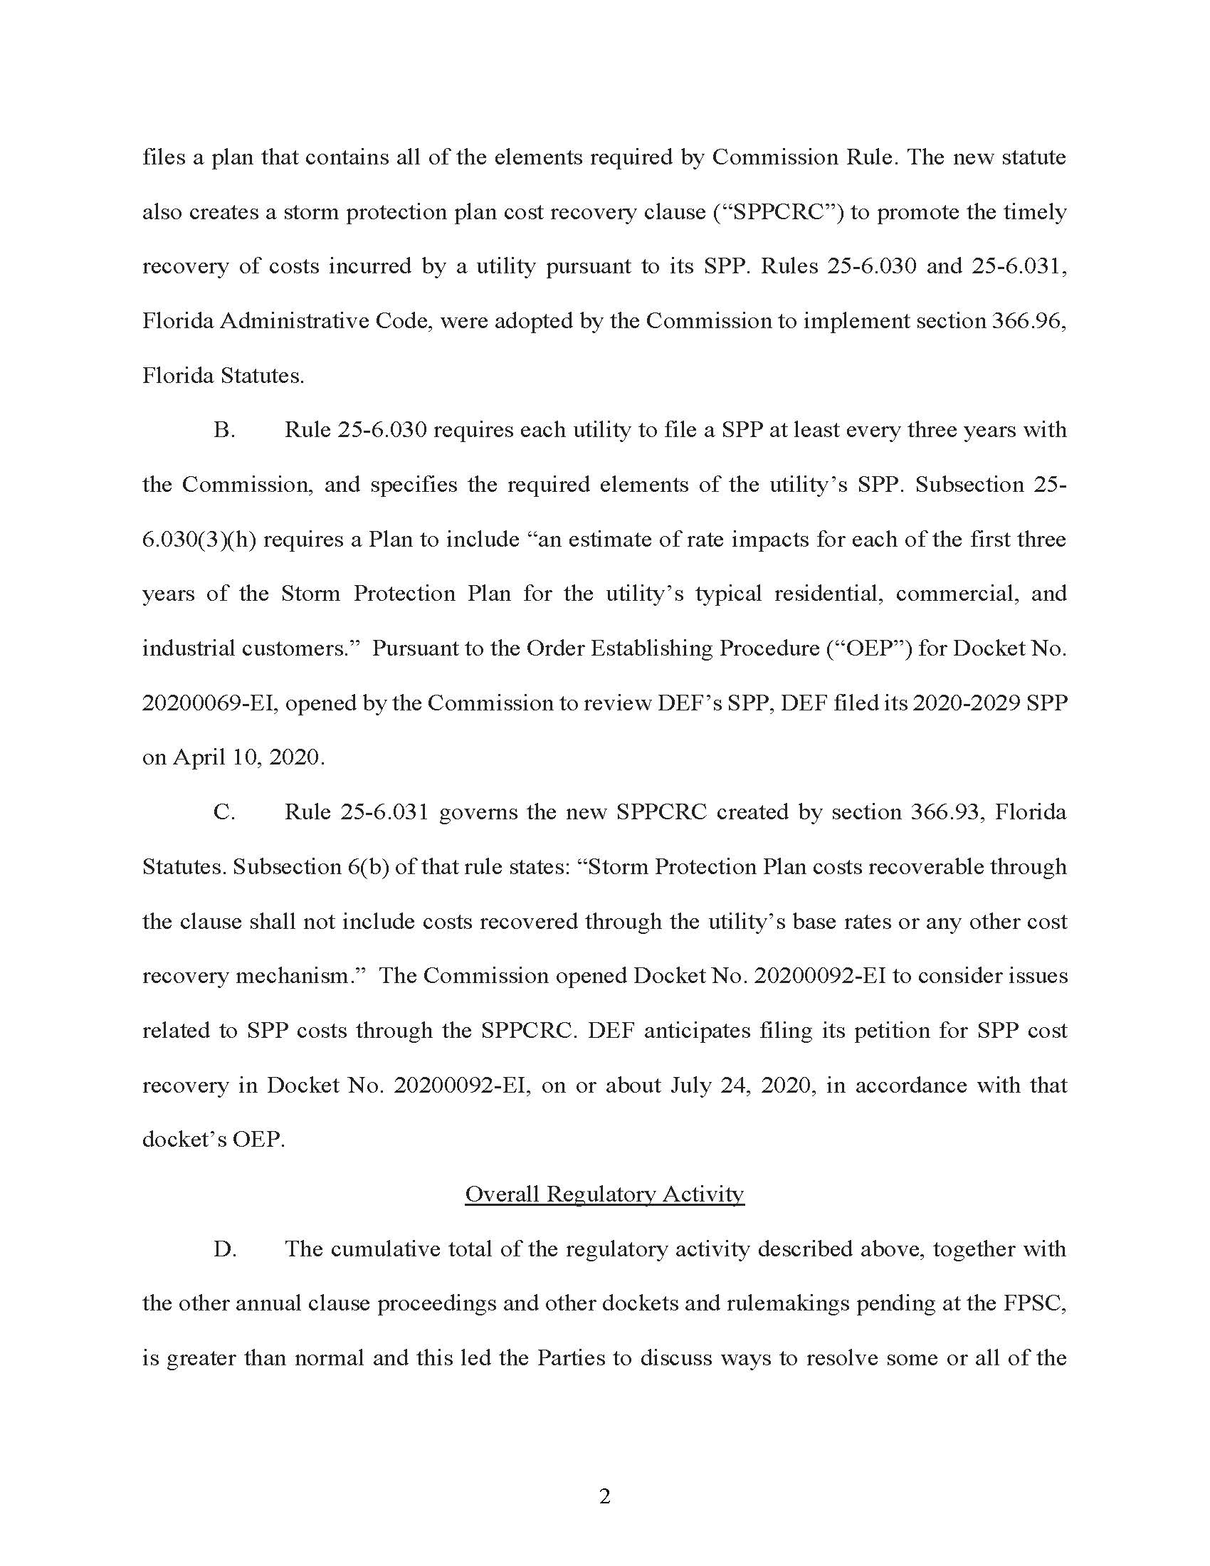

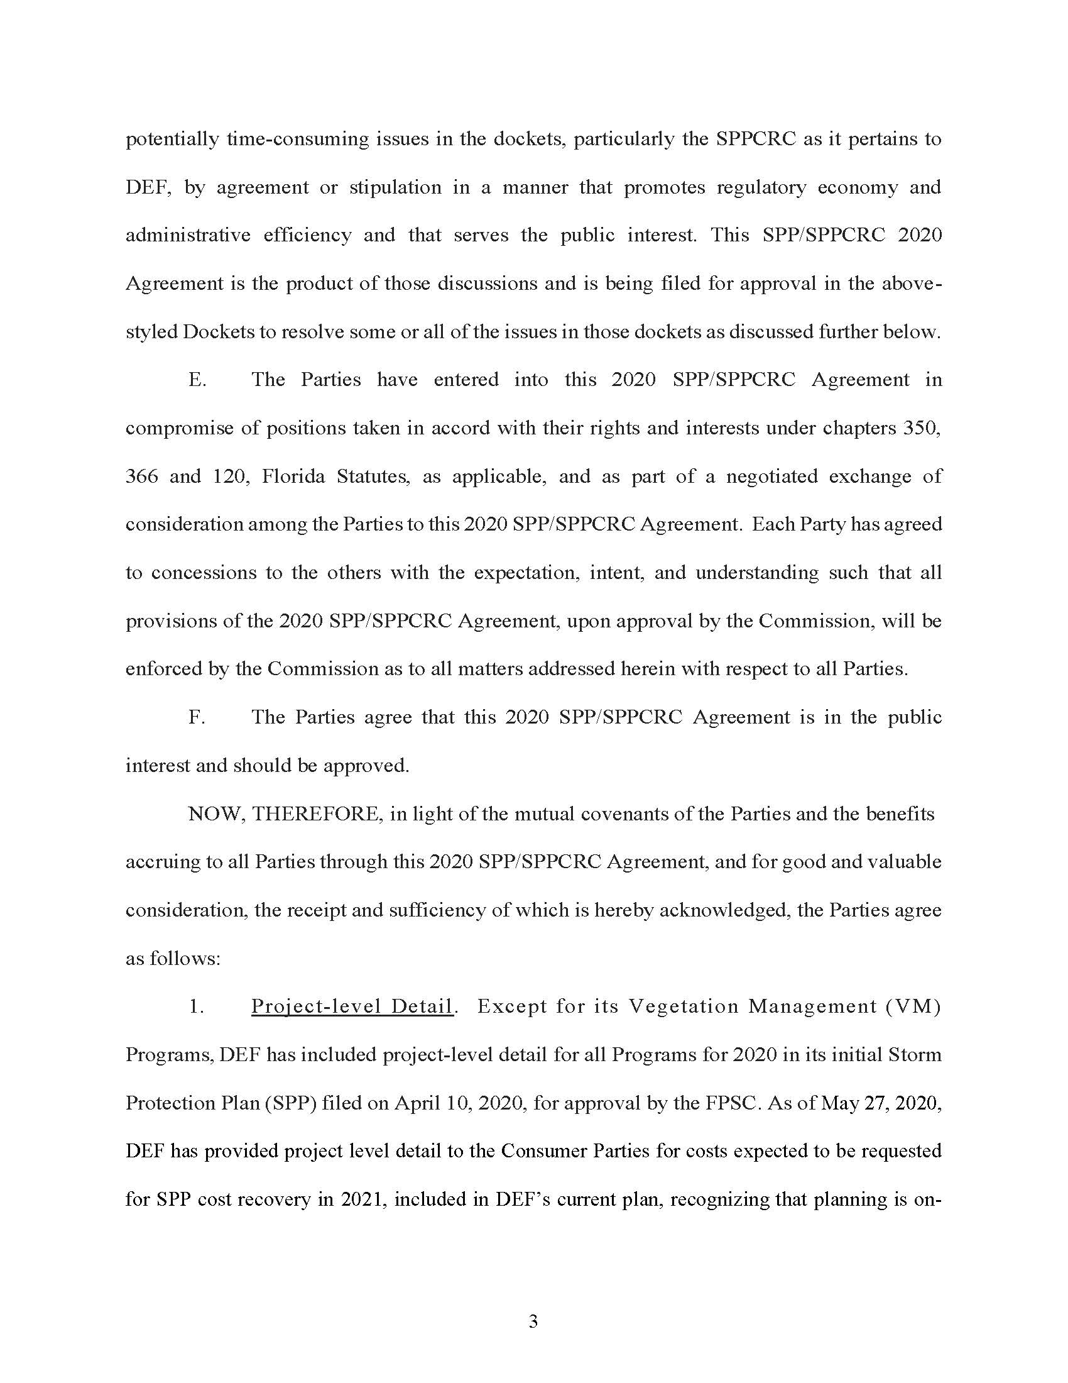

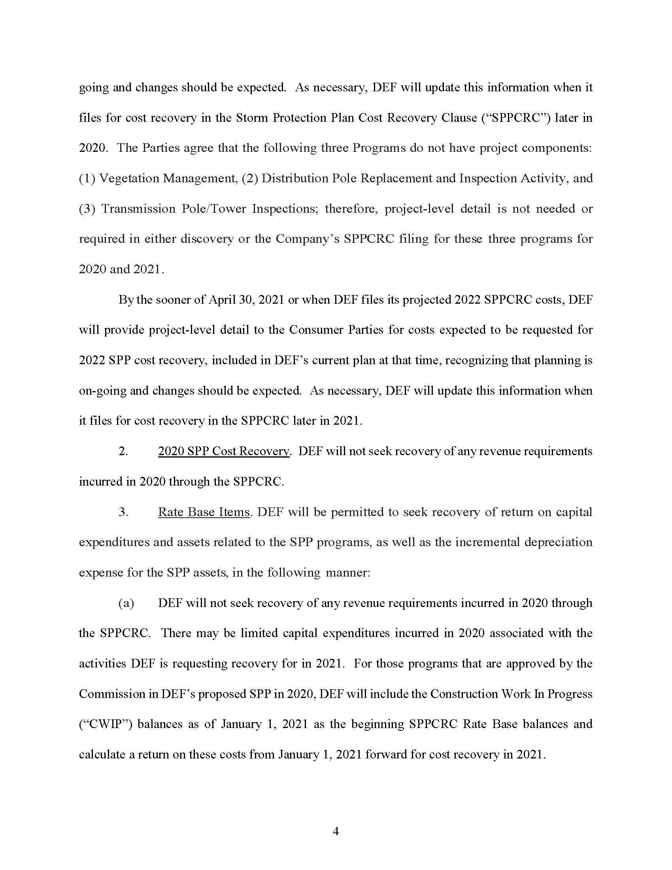

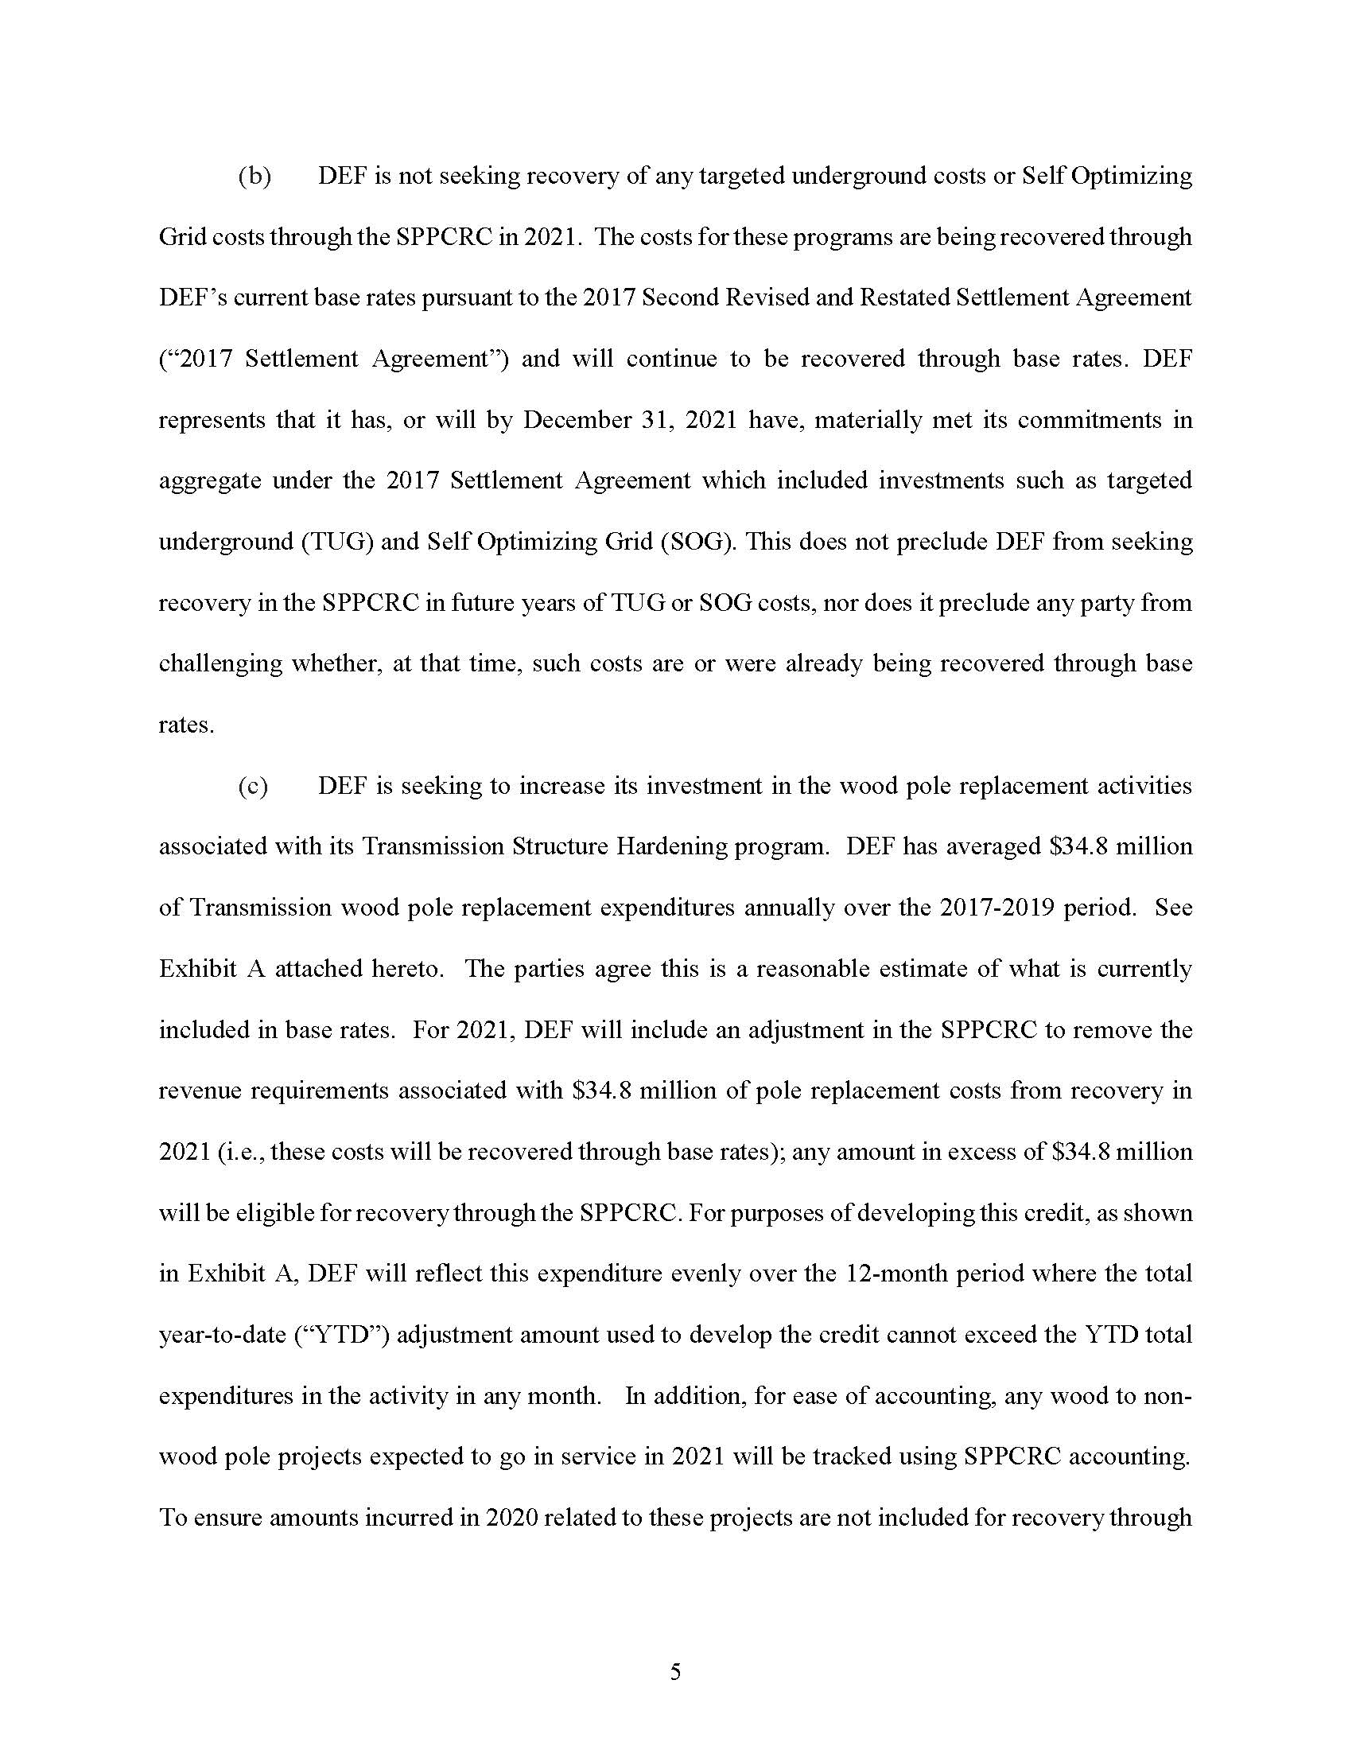

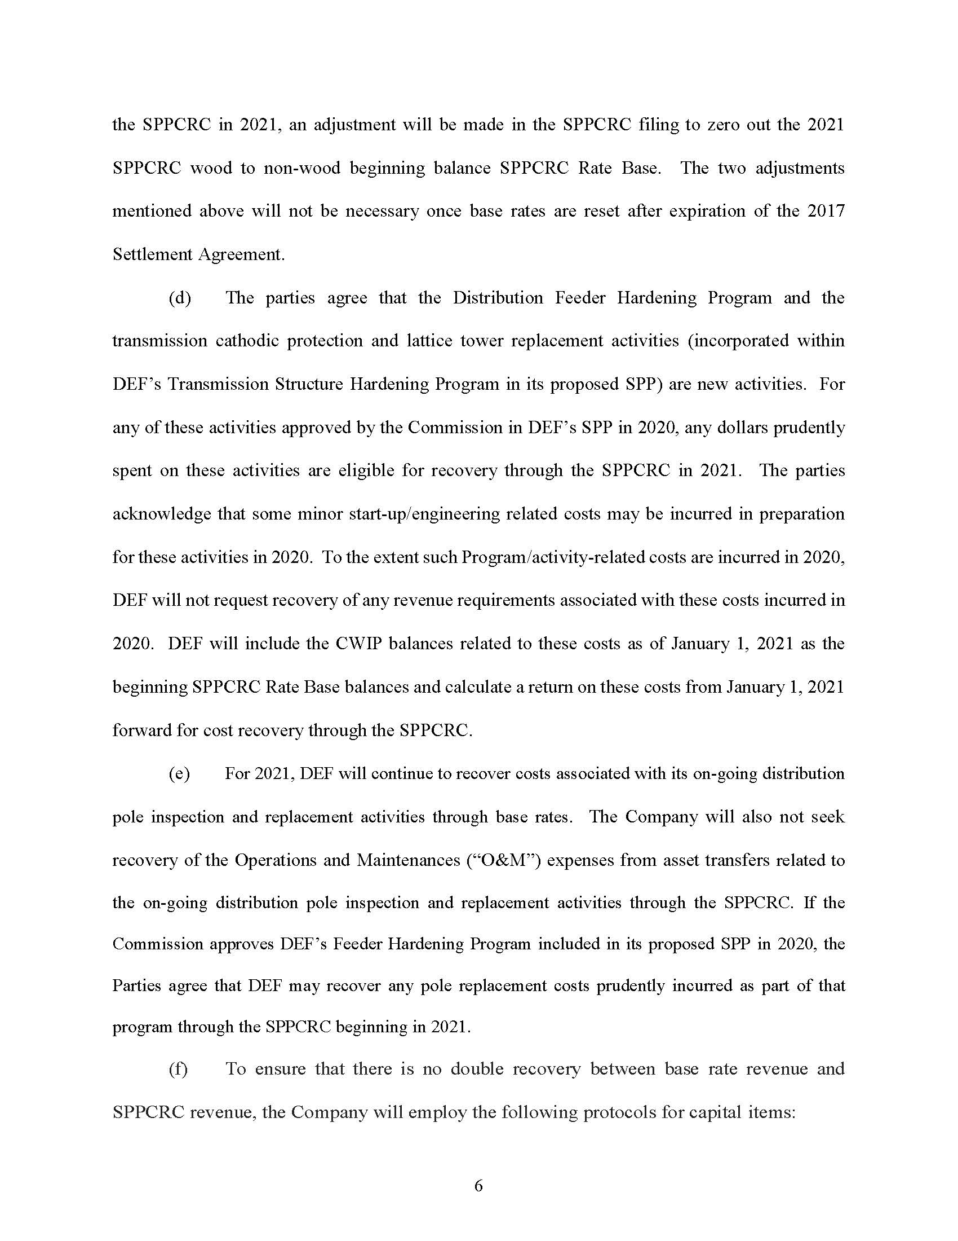

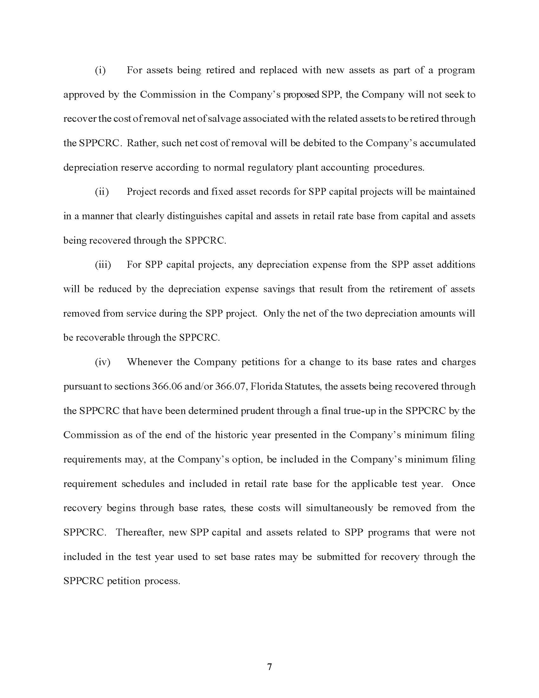

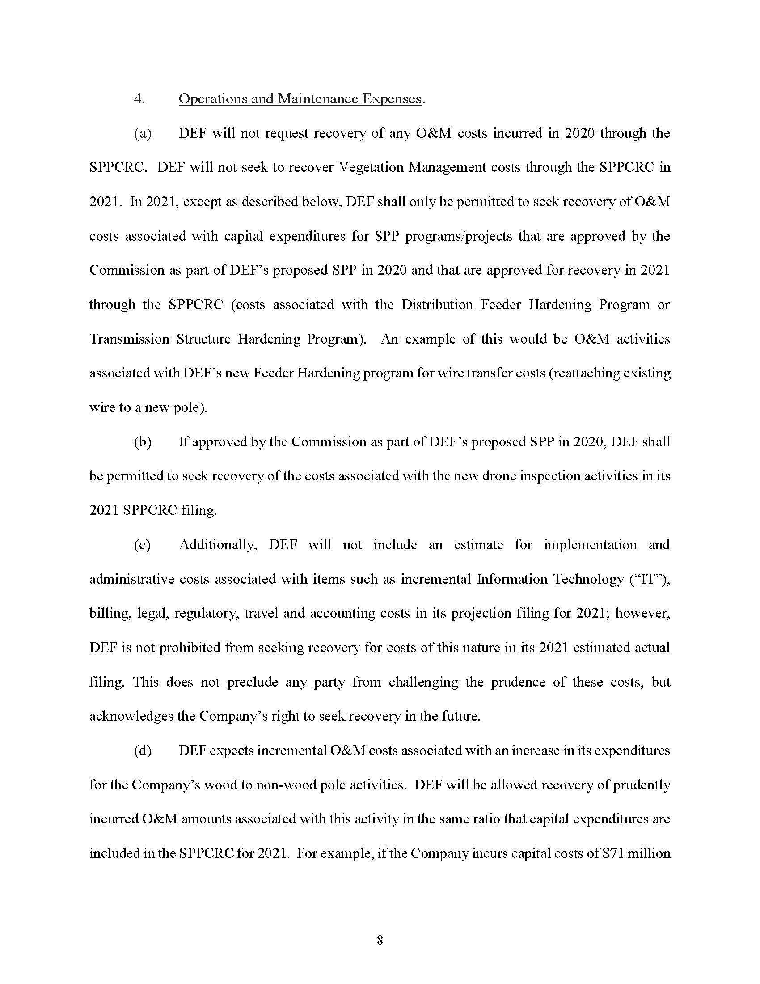

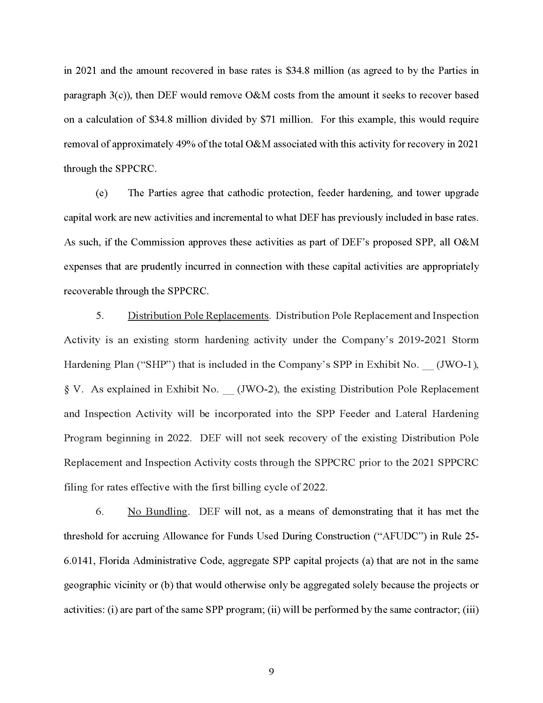

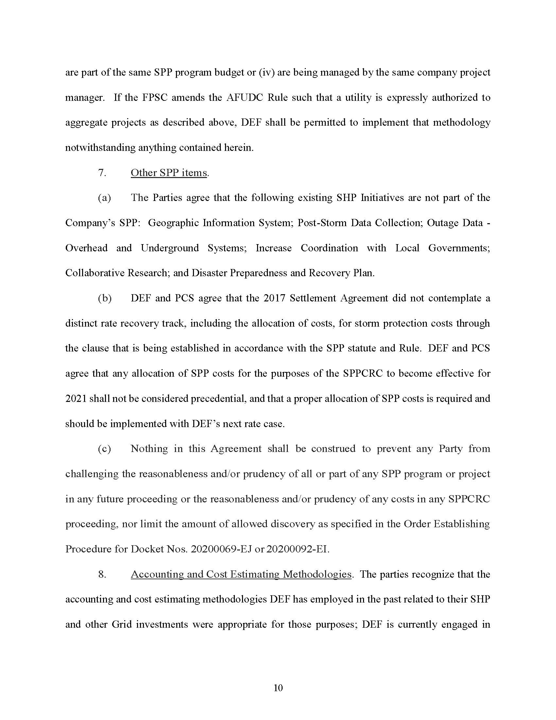

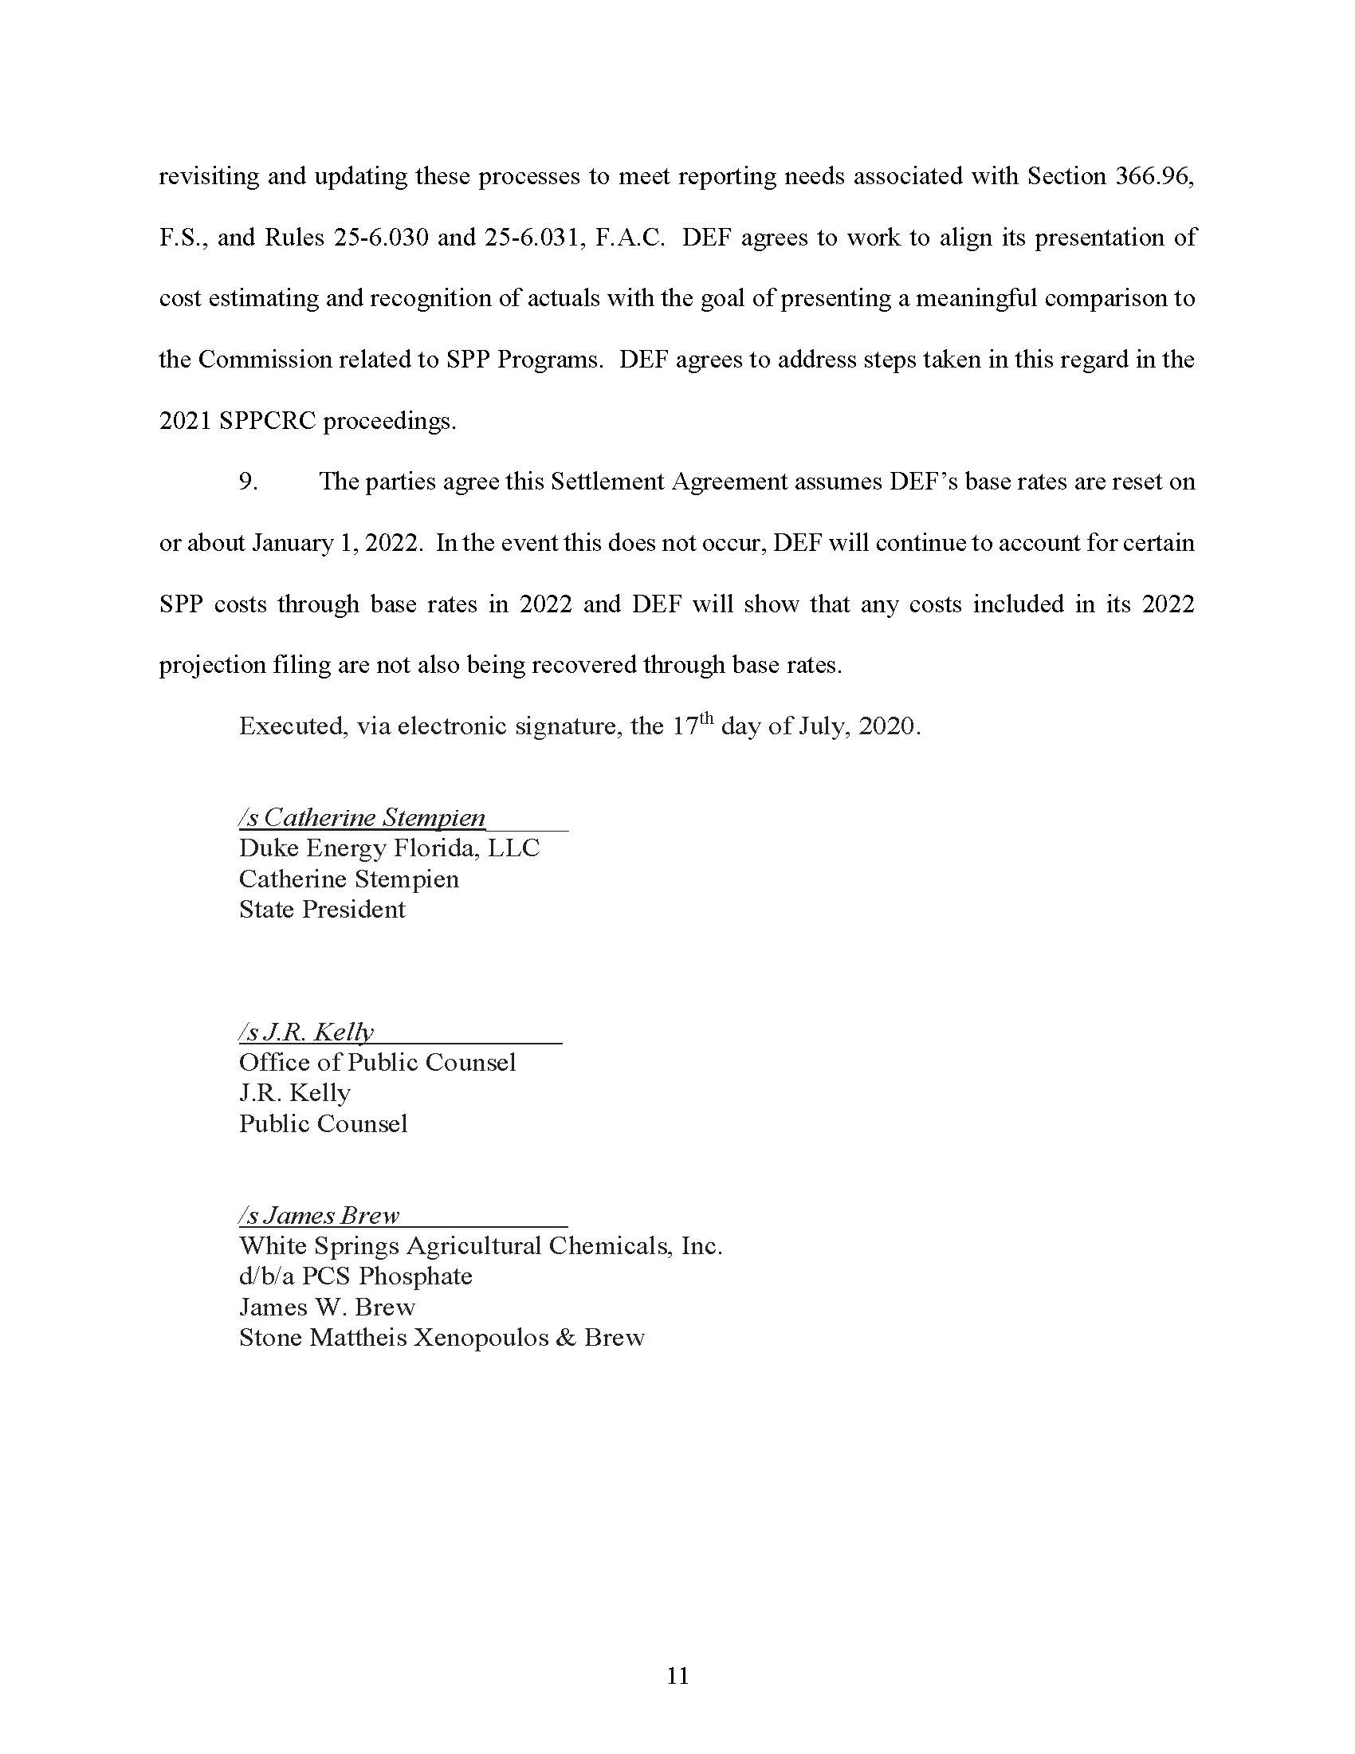

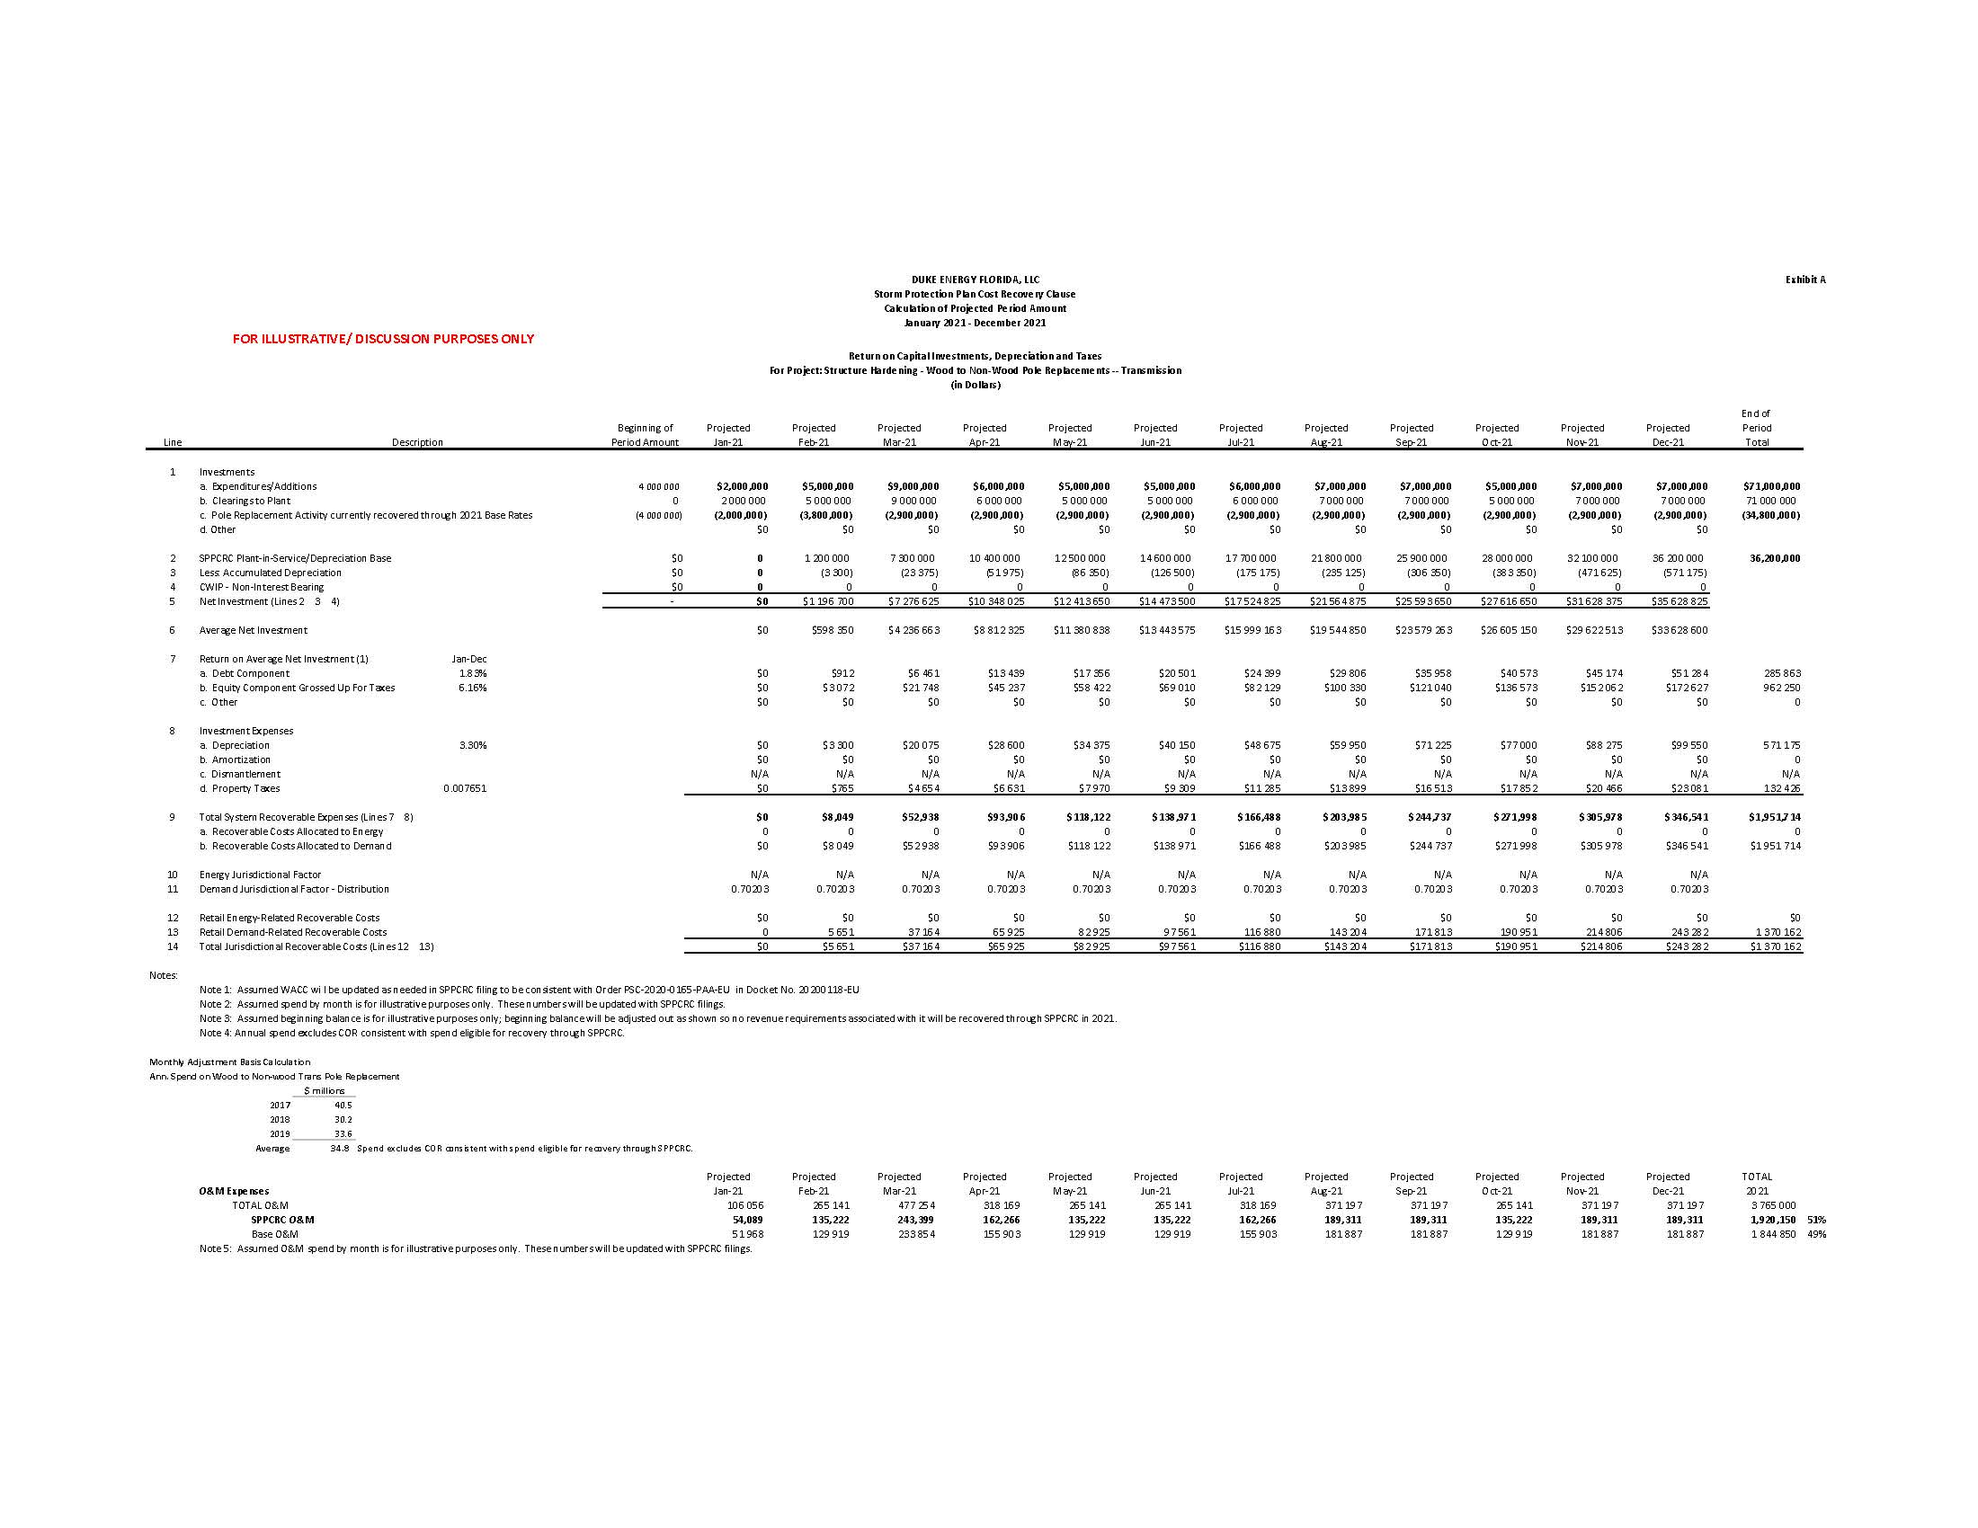

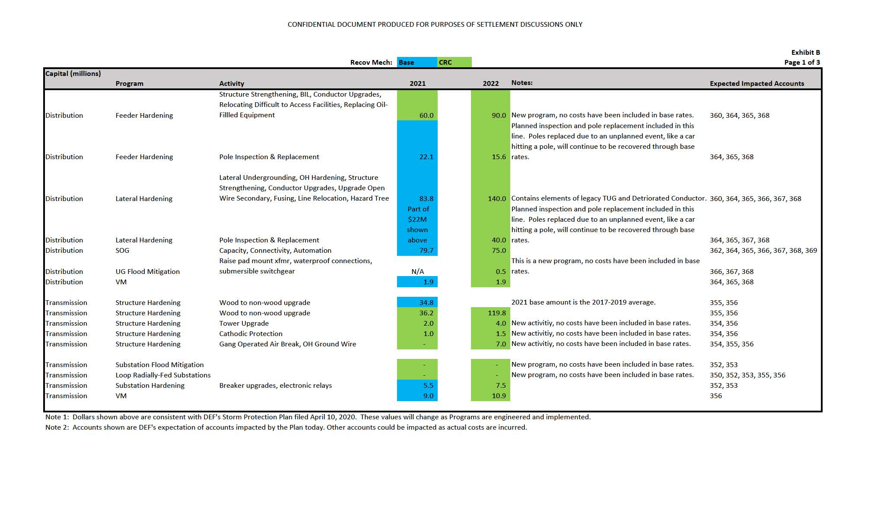

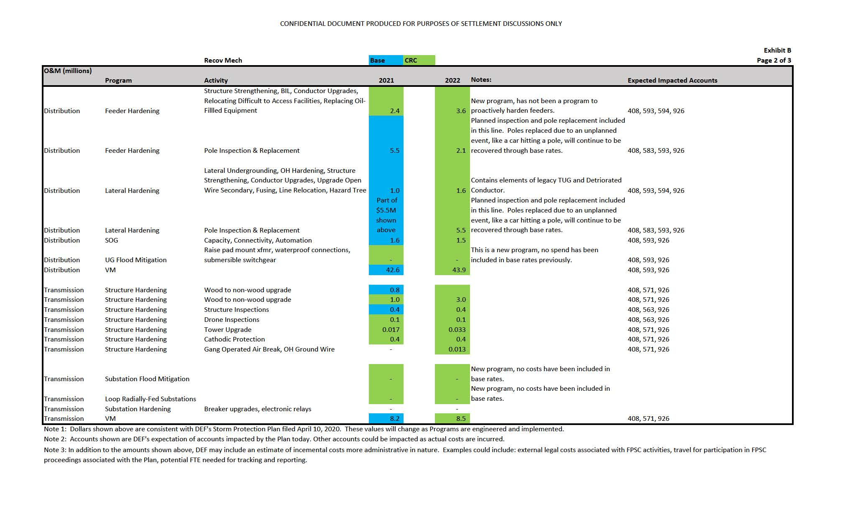

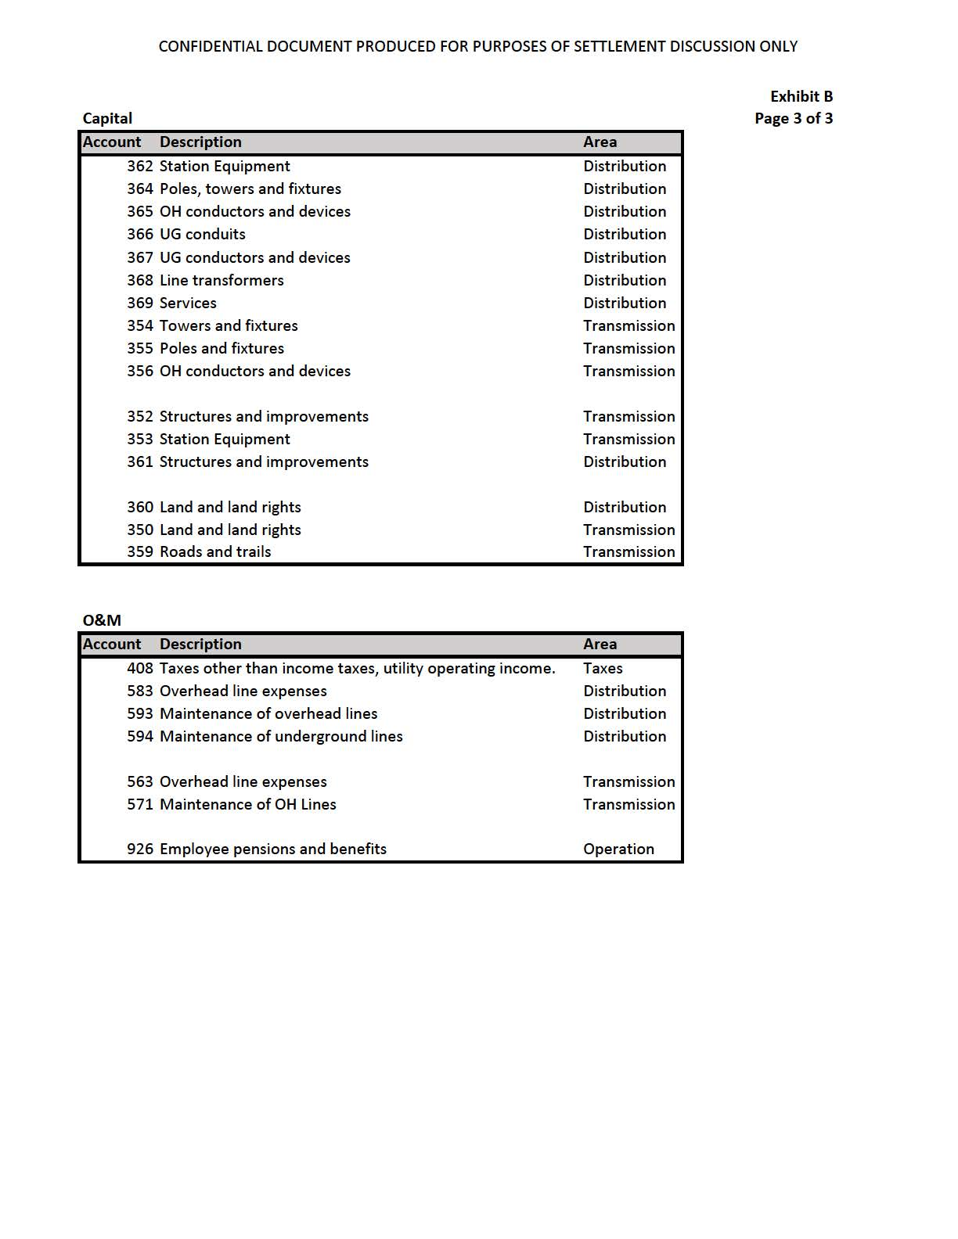

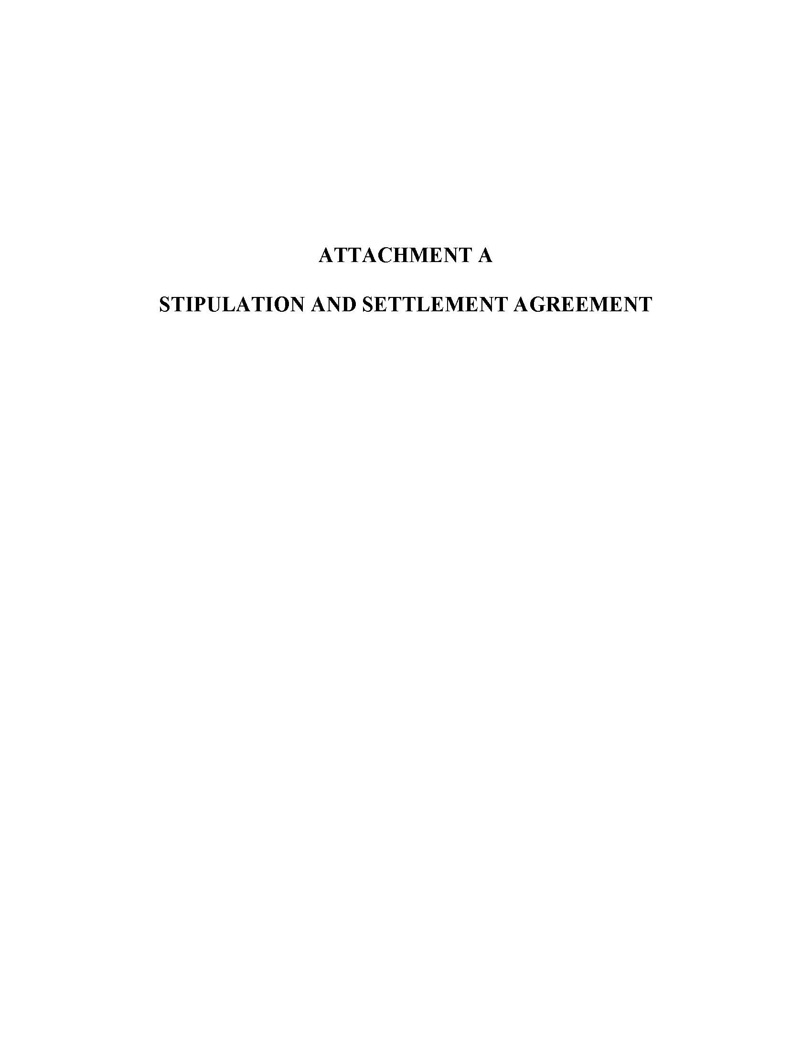

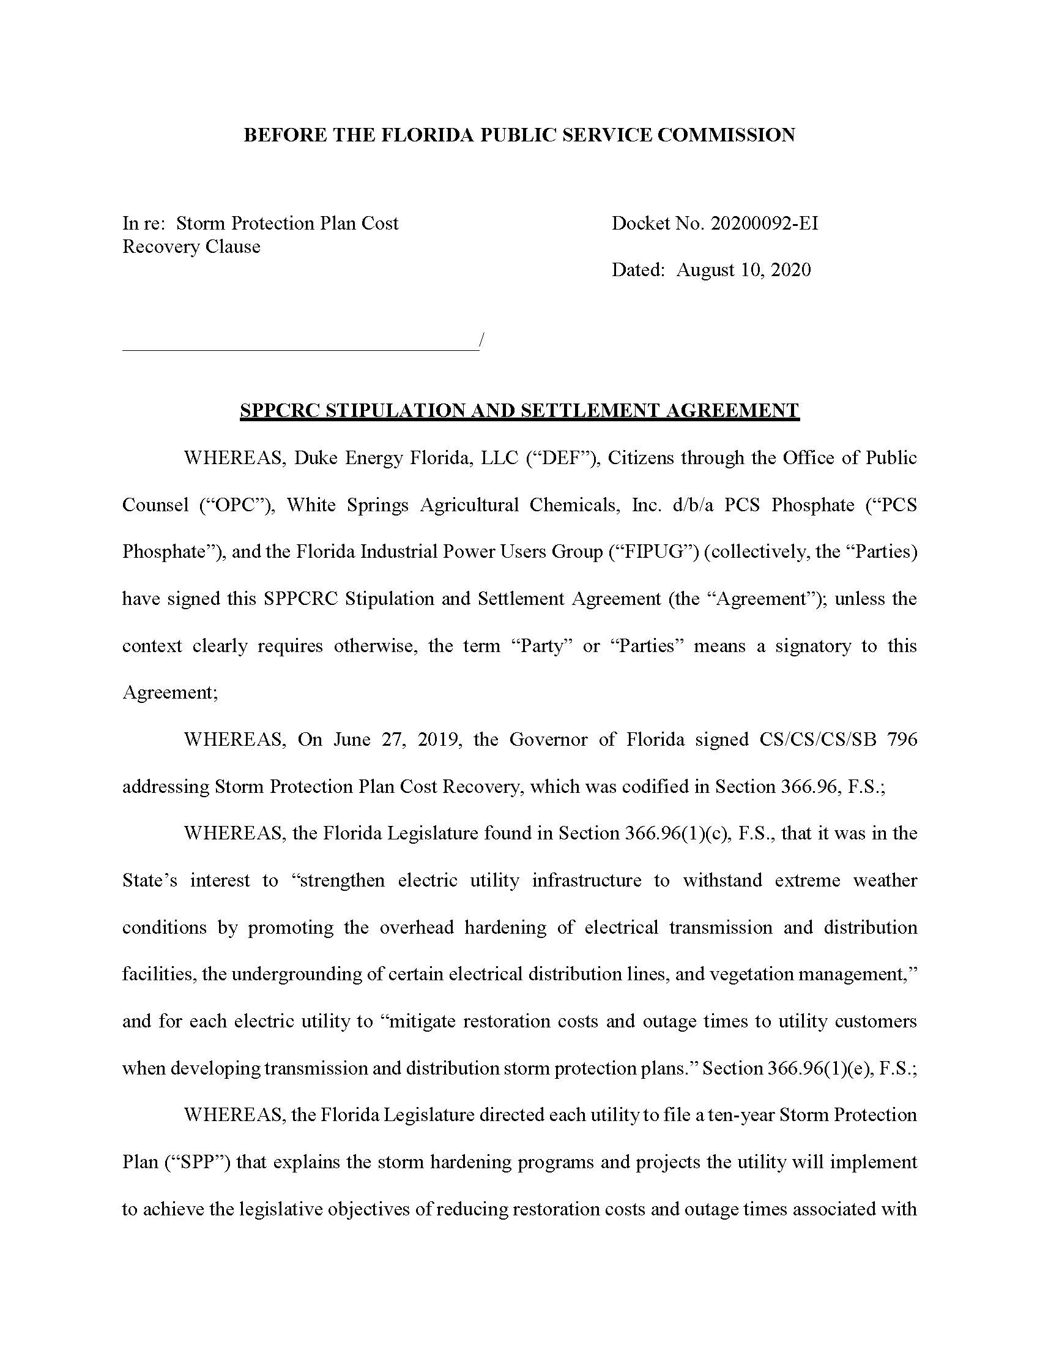

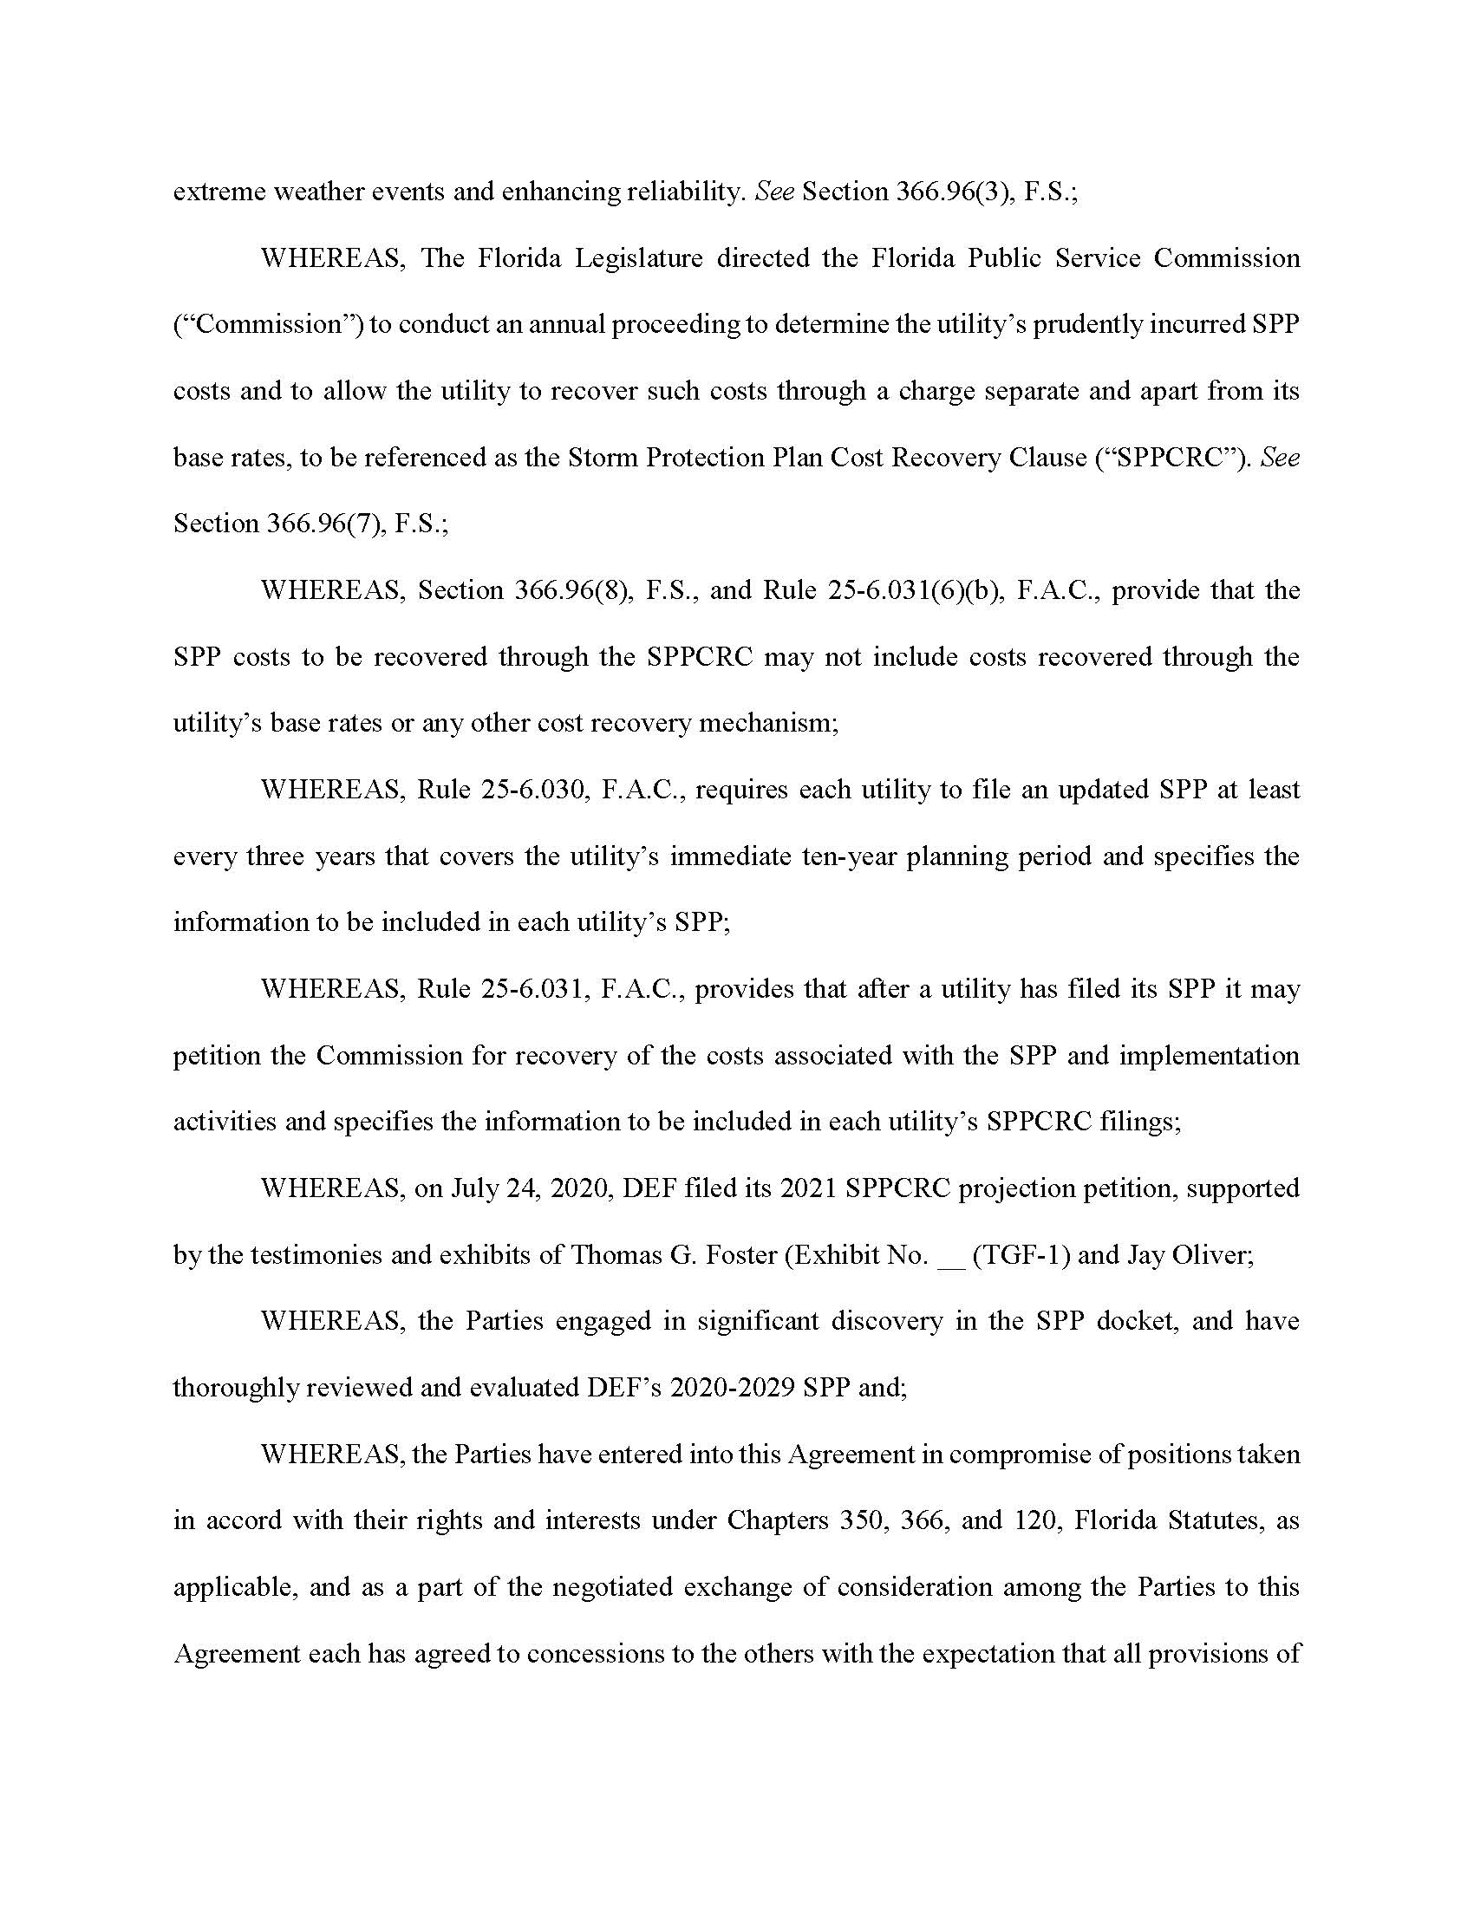

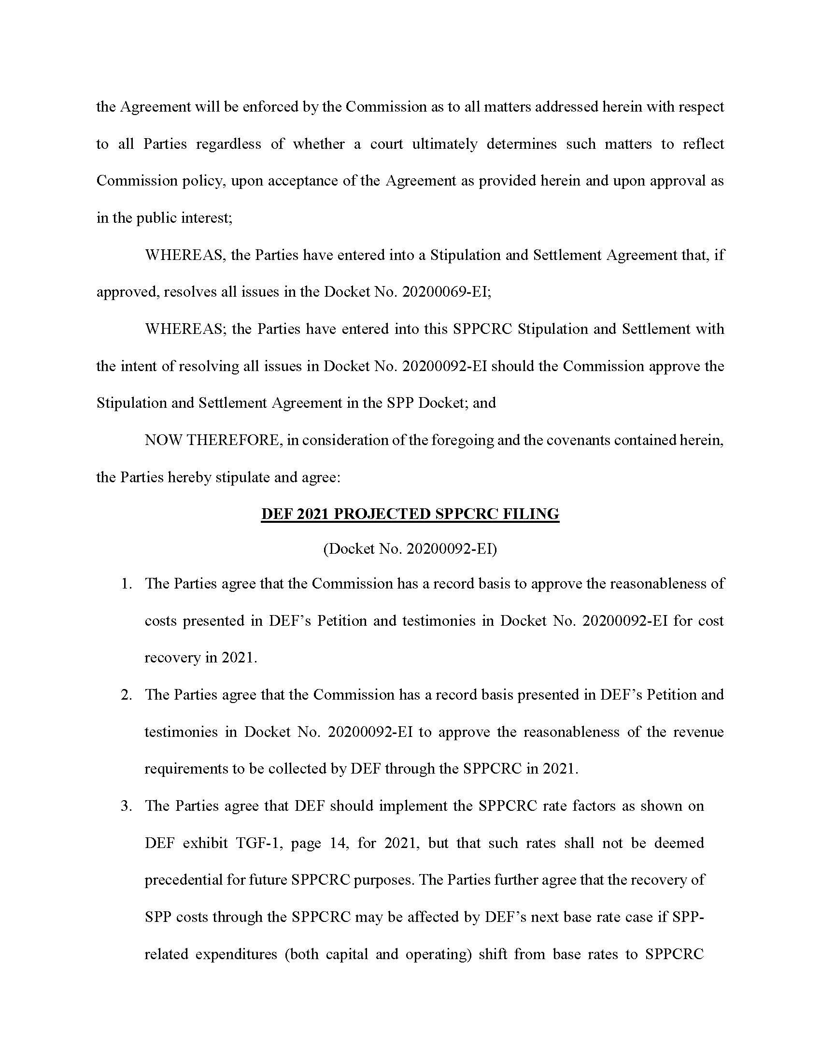

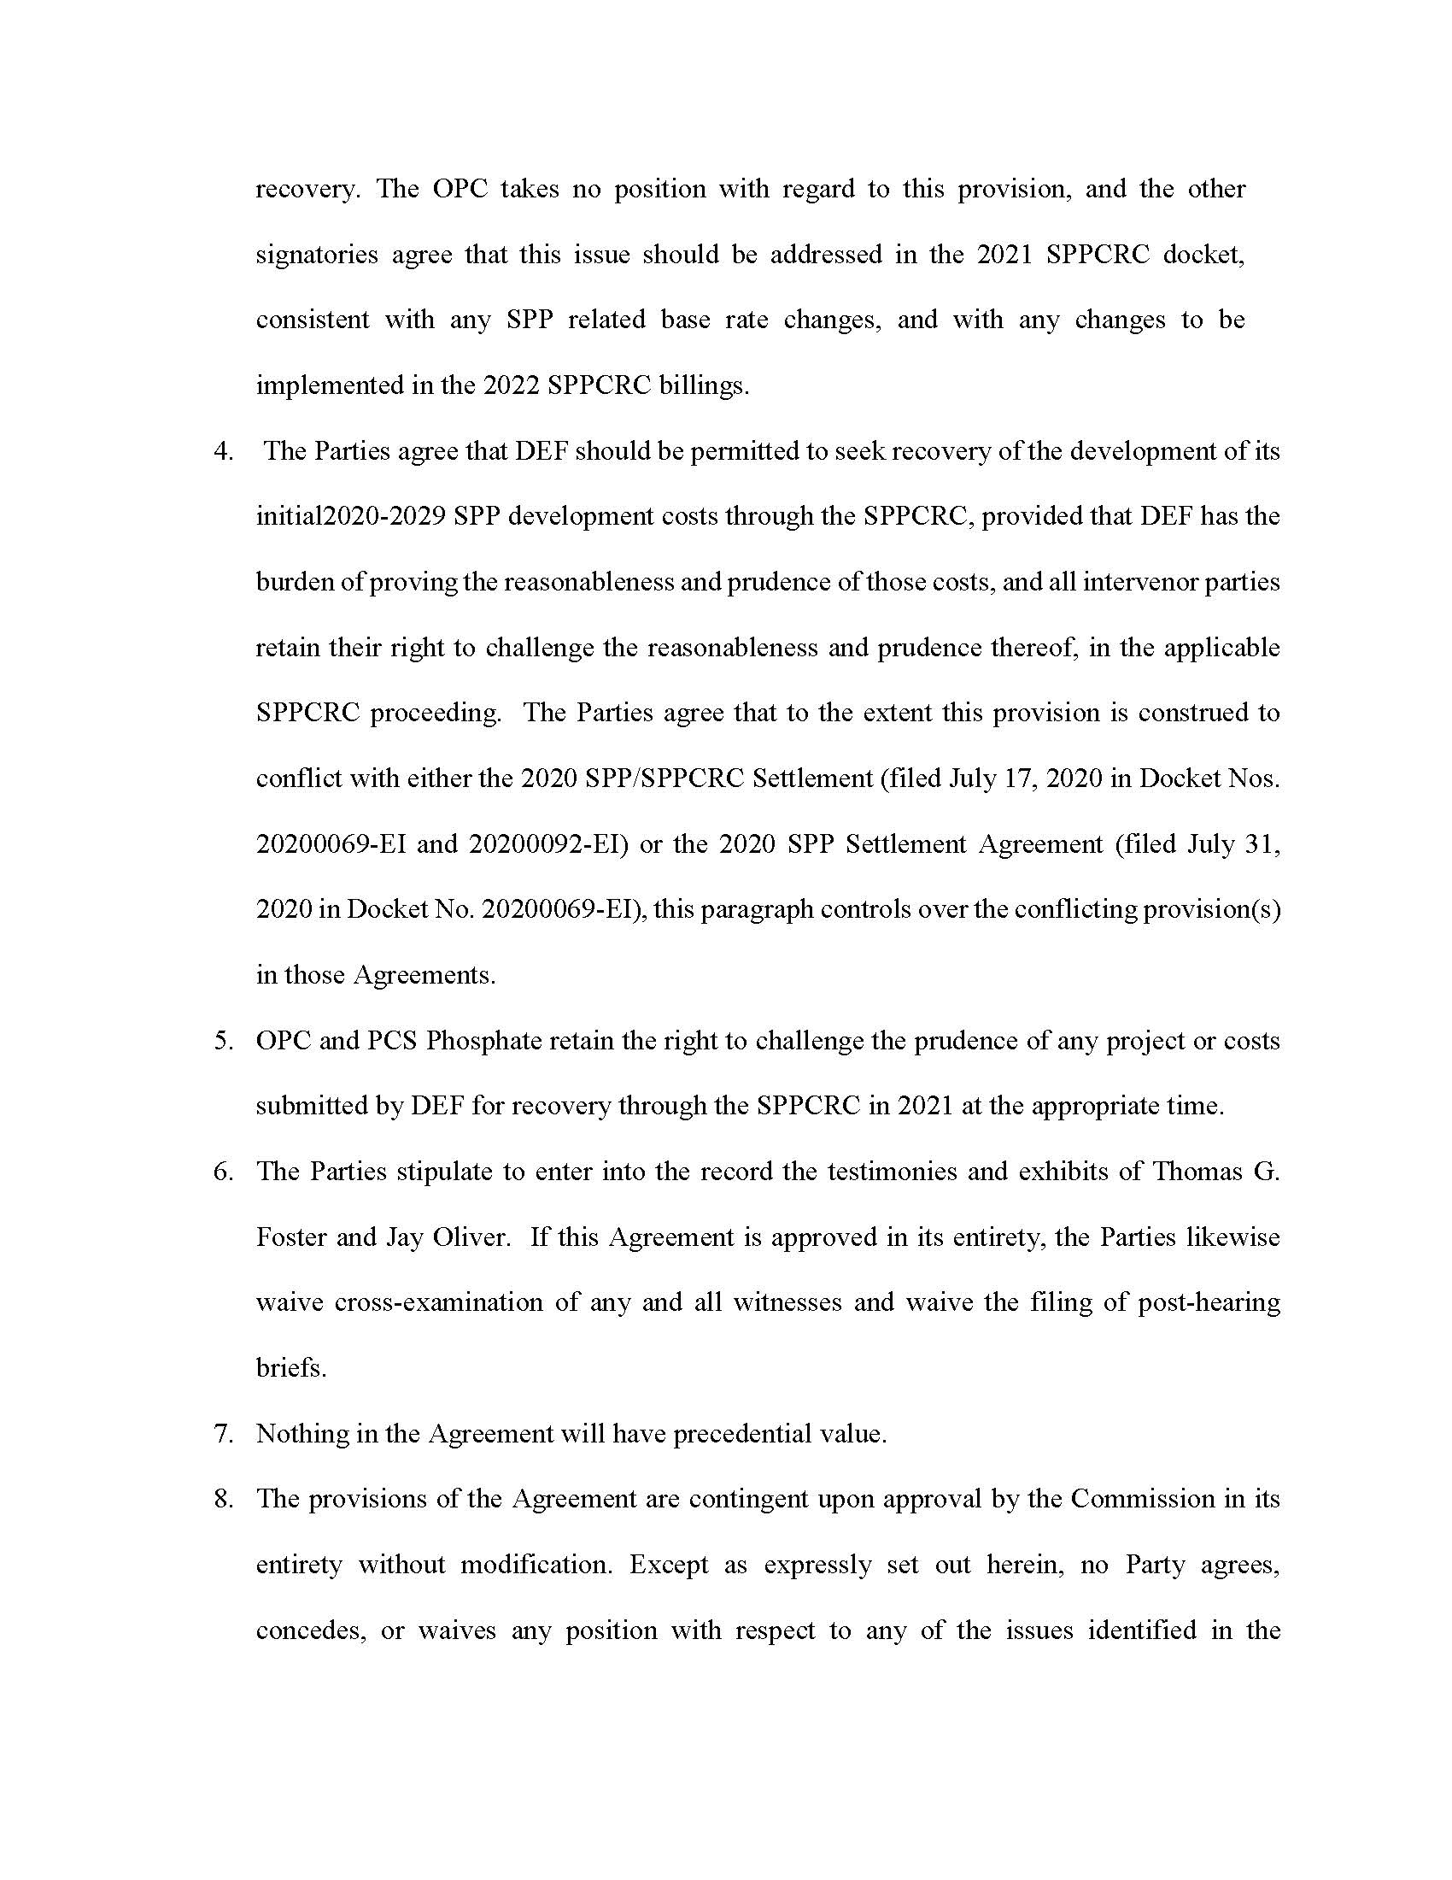

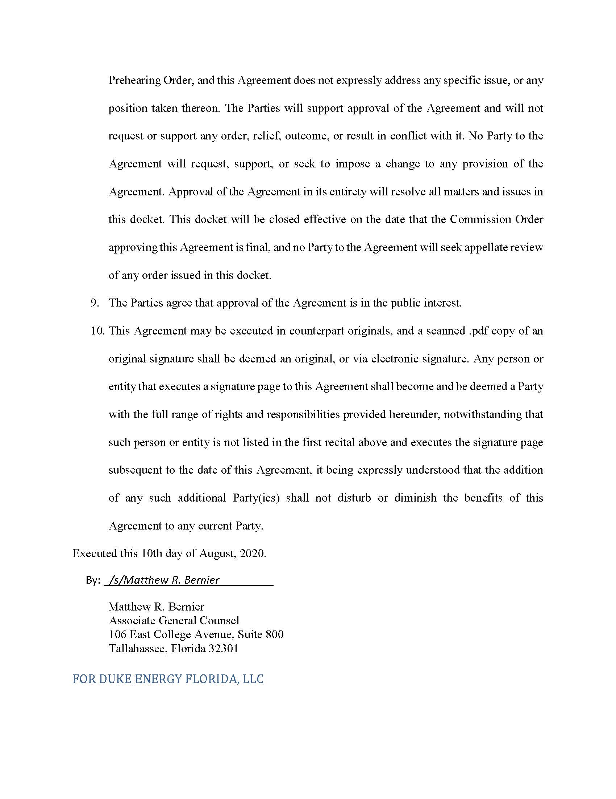

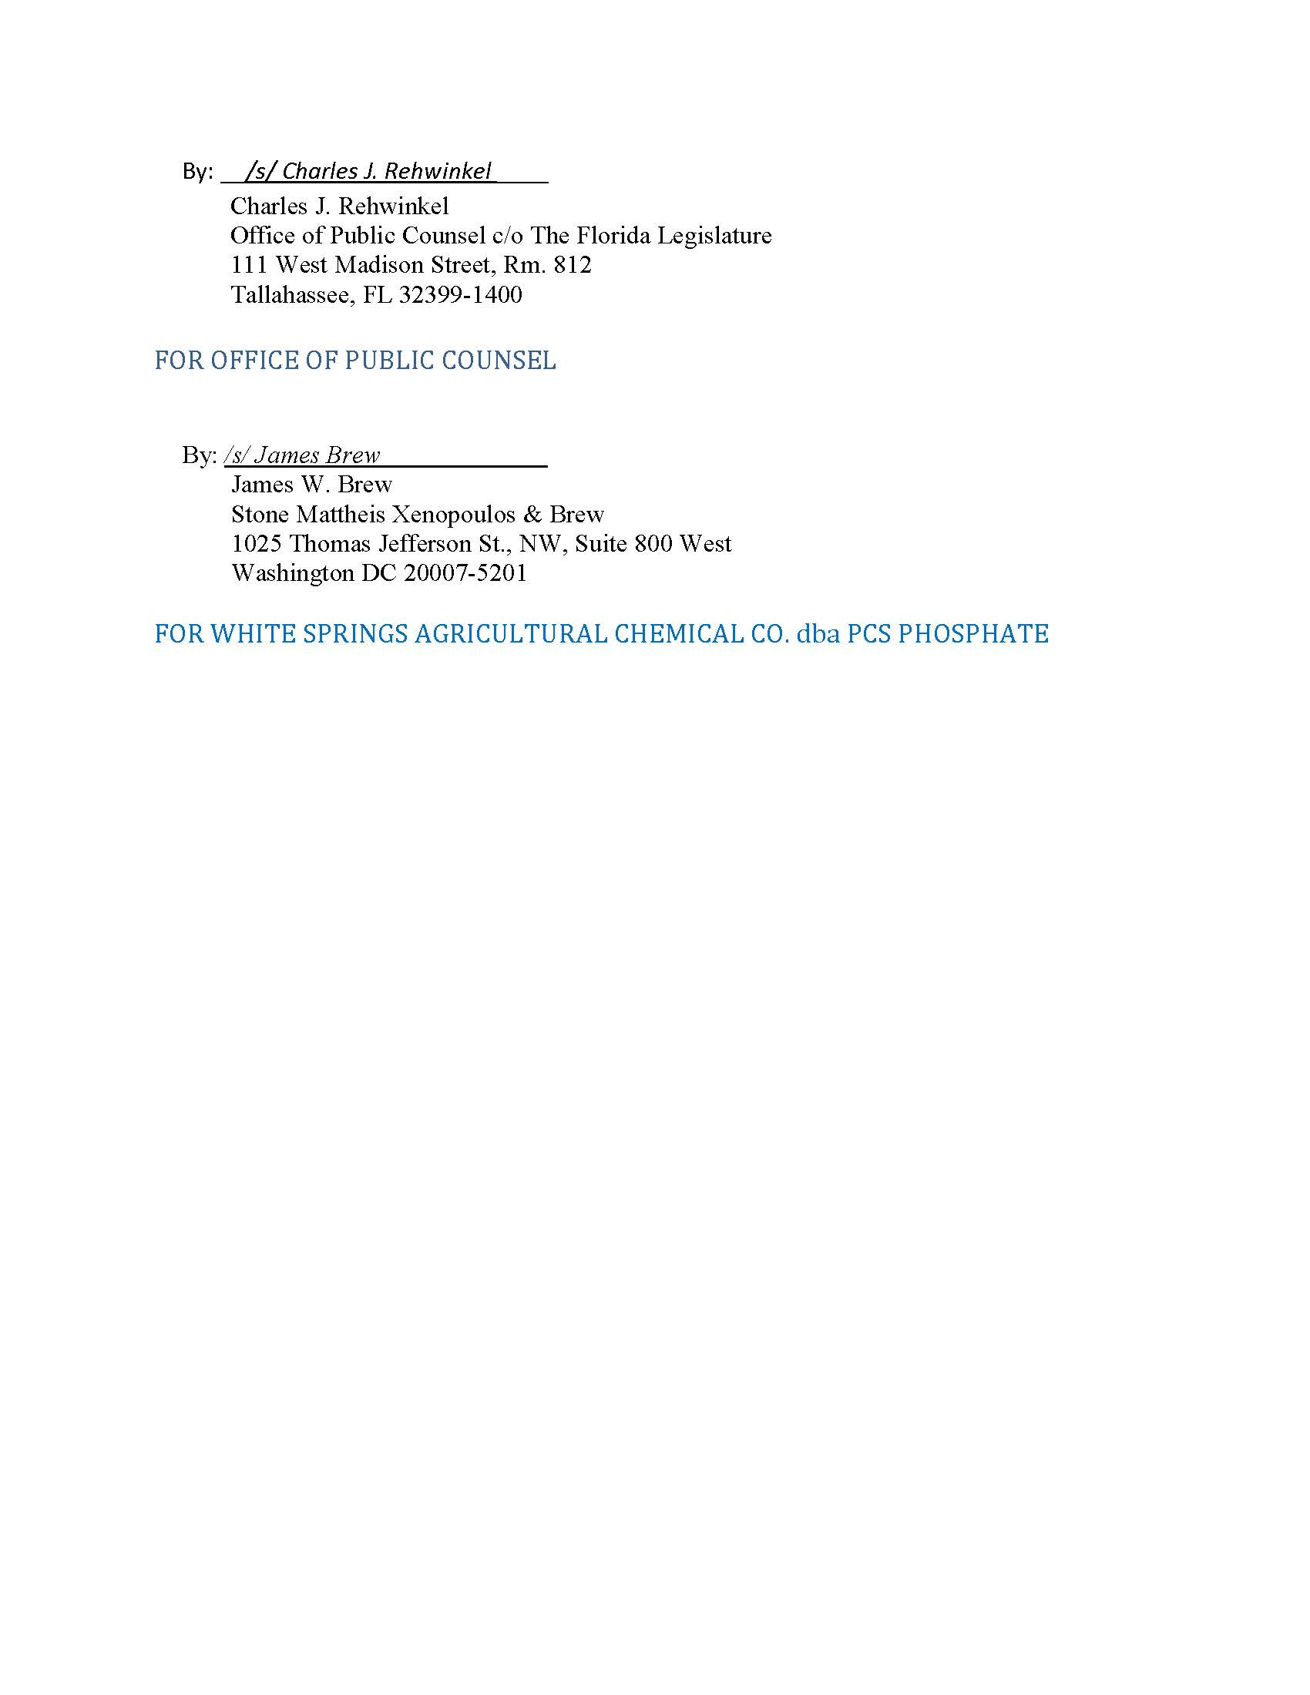

On August 10, 2020, after these Settlement Agreements were executed and filed, we approved a Settlement regarding Duke in Docket No. 20200069-EI. Based on that approval, that docket was closed August 28, 2020. The closing of that docket was a ministerial act and does not affect the substance of the two Agreements, which were both considered at the September 1, 2020 public hearing as part of Docket No. 20200092-EI.
Sierra Club v. Brown, 243 So. 3d 903, 910-913 (Fla. 2018); Order No. PSC-13-0023-S-EI, issued on January 14, 2013, in Docket No. 120015-EI, In re: Petition for increase in rates by Florida Power & Light Company; Order No. PSC-11-0089-S-EI, issued February 1, 2011, in Docket Nos. 080677-EI and 090130-EI, In re: Petition for increase in rates by Florida Power & Light Company and In re: 2009 depreciation and dismantlement study by Florida Power & Light Company; Order No. PSC-10-0398-S-EI, issued June 18, 2010, in Docket Nos. 090079-EI, 090144-EI, 090145-EI, and 100136-EI, In re: Petition for increase in rates by Progress Energy Florida, Inc., In re: Petition for limited proceeding to include Bartow repowering project in base rates, by Progress Energy Florida, Inc., In re: Petition for expedited approval of the deferral of pension expenses, authorization to charge storm hardening expenses to the storm damage reserve, and variance from or waiver of Rule 25-6.0143(1)(c), (d), and (f), F.A.C., by Progress Energy Florida, Inc., and In re: Petition for approval of an accounting order to record a depreciation expense credit, by Progress Energy Florida, Inc.; Order No. PSC-05-0945-S-EI, issued September 28, 2005, in Docket No. 050078-EI, In re: Petition for rate increase by Progress Energy Florida, Inc.
Order No. PSC-13-0023-S-EI, at p. 7.

