State of Florida |  | Public Service Commission  Capital Circle Office Center ● 2540 Shumard Oak Boulevard  Tallahassee, Florida 32399-0850  -M-E-M-O-R-A-N-D-U-M-
DATE: | November 17, 2020
TO: | Office of Commission Clerk (Teitzman)
FROM: | Division of Economics (Hampson, Smith II, Coston)  Office of the General Counsel (Trierweiler)
RE: | Docket No. 20200209-EI – Petition for approval of proposed disposition of voluntary solar partnership rider and program, by Florida Power & Light Company.
AGENDA: | 12/01/20 – Regular Agenda – Tariff Filling – Interested Persons May Participate
COMMISSIONERS ASSIGNED: |  |  | All Commissioners
PREHEARING OFFICER: |  |  | Administrative
CRITICAL DATES: |  |  | 60-Day Suspension Date Waived by FPL until 12/1/2020
SPECIAL INSTRUCTIONS: |  |  | None

Case Background
On September 4, 2020, Florida Power & Light Company (FPL or utility) filed a petition for approval of proposed disposition of its Voluntary Solar Partnership Rider and Program (SolarNow or program). SolarNow was first approved in 2014 (2014 Order) as a three-year pilot with a termination date of December 31, 2017. The program offers FPL customers an opportunity, for $9 per month, to participate in a voluntary program designed to fully-fund the construction and operation of solar photovoltaic generation facilities and support programs to educate customers on solar energy. These solar facilities are located in communities throughout FPL’s service territory. Customers may enroll or cancel their enrollment at any time.

In 2017, the Commission approved a one-year extension to allow FPL to gather additional data regarding the durability of customer interest over a more substantial period. In 2018, the Commission approved an additional one-year extension to allow FPL to complete and evaluate research regarding how the SolarNow pilot program and a planned new shared solar program, SolarTogether, would impact each other. In December 2019, the Commission approved an additional one-year extension to allow FPL to further assess the potential overlap of the SolarNow pilot program and the pending SolarTogether petition. On March 20, 2020, the Commission approved the optional SolarTogether program and tariff. The SolarTogether program allows FPL customers to subscribe to a portion of new solar capacity built through the program and to receive a credit on their bill based on a portion of the system savings produced by that solar capacity.

In this instant petition, FPL proposed to extend SolarNow until December 31, 2025, while ceasing construction of additional SolarNow assets in 2021, which is discussed in Issue 1 of the recommendation. Additionally, FPL has proposed to accelerate depreciation of all SolarNow assets over a five-year period from 2021 to 2025, to coincide with the program’s expiration, which is discussed in Issue 2 of the recommendation. FPL’s proposal to accelerate the depreciation of the SolarNow assets is designed to align with the proposed termination of the program in December 2025. Under the proposed tariff language, the program would remain open to current and new participants. FPL’s proposed SolarNow tariff revision, as shown in Attachment A to this recommendation, extends the termination date for service under the program from December 31, 2020 to December 31, 2025, and removes language to provide greater clarity on the SolarNow expiration.

On September 9, 2020, FPL waived the 60-day file and suspend provision of Section 366.06(3), Florida Statutes (F.S.), until the December 1, 2020 Agenda Conference. During the evaluation of the petition, staff issued one data request to FPL for which responses were filed on October 16, 2020. FPL filed a revised tariff to clarify language in response to staff’s first data request, No. 12. In response to an informal meeting with staff, FPL filed clarifying responses to staff’s questions on November 9, 2020. The Commission has jurisdiction over this matter pursuant to Sections 366.05, 366.06, and 366.075, F.S.

Discussion of Issues

Issue 1:
Should the Commission approve FPL's proposed extension and revisions to the SolarNow tariff?

Recommendation:
Yes. The Commission should approve FPL’s proposed extension and revisions to the SolarNow tariff, Tariff Sheet No. 8.930. FPL’s proposed revisions to the tariff would extend service under the SolarNow pilot program through December 31, 2025, and would provide clarity regarding the program’s expiration. This tariff should remain open to existing and new participants through its expiration. The revised tariff, as shown in Attachment A, should be effective January 1, 2021 through December 31, 2025. Once construction of new assets has ended, FPL should file for administrative approval by staff a revised SolarNow tariff to reflect the removal of the reference to construction of solar facilities. (Hampson)

Staff Analysis:

Description of the Current SolarNow Program
SolarNow is designed to be fully-funded by participating customers who voluntarily contribute to the program. Participants contribute to the revenue requirement associated with constructing and operating solar structures and the funding of educational outreach events hosted by the utility. The revenue requirement includes a return, depreciation, operations and maintenance expenses, and other costs such as property taxes and insurance. As required by the 2014 Order, marketing and administrative expenses are capped at 20 percent of participant contributions. FPL has met this requirement each year since SolarNow’s inception.
Since 2016, FPL has demonstrated that the revenues received under SolarNow exceed the revenue requirement of the solar facilities. FPL projects that the customer contributions for 2020 will total $5,658,000 by year end, while the 2020 revenue requirement for the program will total $5,386,000 by year end. The electricity generated by the solar facilities displaces fuel that otherwise would have been used for generation, resulting in avoided fuel costs. FPL calculated the 2020 fuel savings to be $67,000, resulting in an estimated positive net impact to all customers of $340,000.
As of August 2020, SolarNow had 51,049 total participants. Participation over the lifetime of the program has exceeded FPL’s expectations, with enrollment peaking at 58,000 participants, over 4 times the “high participation” case presented in the original 2014 filing. When evaluating the potential market overlap between SolarTogether and SolarNow, FPL found that the introduction of SolarTogether had minimal impact on the SolarNow’s participation. On Page 7 of the petition, FPL stated that although 420 residential customers left the program in favor of SolarTogether, 1,799 residential customers maintain dual enrollment, or approximately 3.4 percent of SolarNow participants.
In its petition, FPL discussed several reasons why it proposed ending the program, despite exceeding the utility’s expectations. In 2014, opportunities for customers to participate in solar programs were narrow and customer awareness of solar generation was likewise limited. However, in the six years since the program’s inception, cost-effective, large-scale solar has become far more prevalent. The lessons learned from SolarNow have allowed FPL to initiate its SolarTogether initiative. As such, customers now have the opportunity to participate in a program which shares the economic benefits of solar with both participants and non-participants.

FPL Proposal Regarding Construction of New Assets
As directed by the 2014 Order, FPL is required to size construction of SolarNow’s solar projects based on the level of participation, so that participant contributions will approximate the project’s revenue requirement net of estimated avoided fuel and emissions costs. FPL stated that it would not install any additional solar structures after approximately March 21, 2021, but would continue to enhance existing sites. In response to additional questions from staff, FPL stated that the final asset to be constructed is still under negotiation; as a result, there is still uncertainty regarding the asset’s completion date. FPL also stated that if the project does not come to fruition, the utility intends to replace it with a comparable project. In addition, once construction of new assets has ended, the contributions from participants would be used to pay for the depreciation of existing assets at an accelerated rate, as discussed in Issue 2. In response to staff’s first data request No. 6, FPL stated that if at the end of SolarNow there is a revenue requirement shortfall, the utility and its shareholders would absorb these costs, as directed by the 2014 Order.

Program Participation
In its petition, FPL stated that the tariff would remain open to new participants after FPL ceases construction of new assets, as other program benefits would still be available to participants. Specifically, the utility asserts that the solar assets would continue to provide renewable generation, promote awareness and community engagement, and education. FPL plans to continue to partner with various host sites to offer benefits, as well as expand educational outreach about solar generation.
FPL stated that after construction of new assets ends, communication to participants would no longer reference the construction of new solar facilities and would instead focus on the program’s education and community activities. The utility agreed to provide any future communication and marketing materials to participants for staff review to ensure that the materials accurately reflect that any voluntary contributions would contribute towards the maintenance and enhancement of the solar facilities and educational activities, and not further construction. Furthermore, as discussed in the 2014 Order, the utility stated that through the NextEra Energy Foundation, it would continue contributing $200,000 in annual charitable contributions during the remaining life of SolarNow.
Staff believes that once construction of new assets has ended, the SolarNow tariff should reflect that the program would be designed to maintain and enhance the solar assets and provide educational activities and that no further construction would occur. In response to staff’s request, FPL submitted on November 9, 2020, a draft revised SolarNow tariff that removes the reference regarding the construction of facilities. Staff believes the revised tariff, as provided on November 9, 2020, is appropriate and once construction of new assets has ended, FPL should file for administrative approval by staff a revised SolarNow tariff to reflect the removal of the reference to construction of solar facilities.

Conclusion
After review of FPL’s petition, responses to staff’s data request, and discussions with the utility, staff recommends that the Commission should approve FPL’s proposed extension and revisions to the SolarNow tariff, Tariff Sheet No. 8.930. FPL’s proposed revisions to the tariff would extend service under the SolarNow pilot program through December 31, 2025, and would provide clarity regarding the program’s expiration. This tariff should remain open to new participants through its expiration. The revised tariff, as shown in Attachment A, should be effective January 1, 2021 through December 31, 2025. Once construction of new assets has ended, FPL should file for administrative approval by staff a revised SolarNow tariff to reflect the removal of the reference to construction of solar facilities.

Issue 2:
Should the Commission approve FPL’s request to accelerate the depreciation of its SolarNow assets?

Recommendation:
Yes. The Commission should approve FPL’s request to use accelerated depreciation related to its SolarNow assets, on the condition that the utility remove all revenues, expenses, plant in service, and accumulated depreciation associated with the SolarNow Program from its Minimum Filings Requirements in any rate proceeding the utility may file which impacts 2021 through 2025 customer rates. (Smith II)

Staff Analysis:
In its petition, FPL requested accelerated depreciation for its assets related to the SolarNow program. FPL explained that the reason for accelerating the depreciation of these assets is to coordinate the end of the SolarNow program with the recovery of the net book value of the assets related to the program. The utility proposes to depreciate the remaining net book value of all assets in the SolarNow program over the remaining five years of the program (2021-2025). The utility explained that this would achieve FPL’s objective of having the customer contributions fund the SolarNow program’s costs. The projected net book value of the SolarNow assets as of December 31, 2020 is $24,293,852.
The goal of depreciation is to spread the recovery of an asset’s costs over the useful life of the asset. The current depreciation rates applicable to most of FPL’s SolarNow assets are based on an anticipated 30-year life. Use of accelerated depreciation is appropriate in instances where an asset has become obsolete or not cost-effective to maintain. However, obsolescence is not the reason for accelerating the depreciation in this case insofar as these assets would not be retired early but are expected to be in service, on average, an additional 17 years after program termination.
Staff considered two reasons why it may be appropriate for these assets to be depreciated on an accelerated basis as proposed by FPL. First, accelerated depreciation would reduce the likelihood of non-participant rate impacts during this program extension if FPL’s participant attrition rates are reasonably accurate. The total participant contributions associated with the program over its 11 year period (2014-2025), based on the $9 monthly charge and FPL’s anticipated customer attrition rates of 2-3 percent per month, are sufficient to allow the recovery of all program costs incurred over the period from the program participants, including full recovery of the SolarNow assets. Achieving full recovery of the SolarNow assets prior to the program’s conclusion protects the general body of ratepayers by removing any future depreciation expense and return on rate base that could potentially be transferred to them. Second, the primary purposes of the assets placed in service for the SolarNow pilot program are expected to be realized by the end of the program in 2025. Those purposes include offering FPL’s customers an opportunity to contribute to new solar photovoltaic generation facilities and to promote customer education and solar awareness objectives as the solar market developed. FPL’s recently approved SolarTogether program provides customers with an opportunity to contribute to solar development.
FPL provided a calculation of the depreciation expense at current rates and the proposed accelerated rates. Those calculations reflect an annual increase in depreciation expense of $3,960,140 for the final five years of the program. The utility also provided a calculation showing that the increased revenue requirement, due to the accelerated depreciation, would exceed the customer contributions and system savings for the remaining years of the program. However, according to FPL, the program produced a surplus of revenue from previous years. This surplus would largely offset the revenue shortfall through the end of the program, if the utility’s participant attrition rates are accurate.
Staff believes FPL’s forecast of the SolarNow expenses through 2025 have a relatively high degree of certainty, while the forecast of program revenues based on customer contributions is much less certain. In its petition, the utility projects a participant attrition rate of 2-3 percent per month over the final five years of the program. This attrition rate could be partially offset by new participants joining the program. However, if the utility’s planned cessation of new solar construction for purposes of this program or any other factors cause that attrition rate to be higher than anticipated, the utility’s projected revenue surplus at the conclusion of the program may not materialize and may in fact result in a revenue shortfall. Staff believes it is important to ensure that any potential revenue shortfall is not borne by FPL’s general body of ratepayers.

As discussed in Issue 1, the 2014 Order requires that at the conclusion of the program, any revenue requirement exceeding revenue was to be recorded below-the-line, and absorbed by the utility’s shareholders. To date, the program has had a surplus of revenues; therefore, the general body of ratepayers has not borne any of the costs associated with this program. However, staff believes certain regulatory actions are necessary to protect the general ratepayers from any potential revenue shortfalls which may be realized through 2025 resulting from the proposed accelerated depreciation rates combined with potentially higher than estimated attrition rates. According to FPL’s projections, a program revenue shortfall begins to occur in 2021, and is projected to grow each year thereafter until the end of the SolarNow program. These shortfalls, without additional measures recommended below, would possibly be included in the utility’s next rate proceeding, and ultimately affect the base rates of the general body of ratepayers.
Staff believes the Commission can ensure compliance with the 2014 Order by requiring FPL to move the SolarNow program below the line in its next rate case. To this end, staff recommends that the utility be required to make adjustments to its MFRs when it files its next general rate case impacting 2021 through 2025 customer rates. These MFR adjustments should remove all revenues, expenses, plant in service, and accumulated depreciation related to the SolarNow program. By adjusting the MFRs in this manner, any revenue shortfall is borne by FPL’s shareholders rather than FPL’s general body of ratepayers, as originally intended by the utility, and mandated by the 2014 Order. At the same time, if any surplus remains after final disposition of the program, it may be donated by the shareholders to STEAM-related charities, as referenced on page 10 of the Petition.
Staff believes that the accelerated depreciation of SolarNow assets as proposed by FPL, with the MFR adjustments staff proposes, is appropriate given that the purpose of the assets in this voluntary program is achieved within the period of the program. Staff’s suggested regulatory treatment will also protect the general body of ratepayers from financial harm, both during the period of the program and after the program’s conclusion. Therefore, staff recommends approval of FPL’s request for accelerated depreciation, with the condition the utility removes all revenues, expenses, plant in service, and accumulated depreciation associated with the SolarNow program from its MFRs in any rate proceeding the utility may file which impacts 2021 through 2025 customer rates.

Issue 3:
Should this docket be closed?

Recommendation:
If Issues 1 and 2 are approved and a protest is filed within 21 days of the issuance of the order, the tariff should remain in effect, with any revenues held subject to refund, pending resolution of the protest. If no timely protest is filed, this docket should be closed upon the issuance of a consummating order. (Trierweiler)

Staff Analysis:
If Issues 1 and 2 are approved and a protest is filed within 21 days of the issuance of the order, the tariff should remain in effect, with any revenues held subject to refund, pending resolution of the protest. If no timely protest is filed, this docket should be closed upon the issuance of a consummating order.

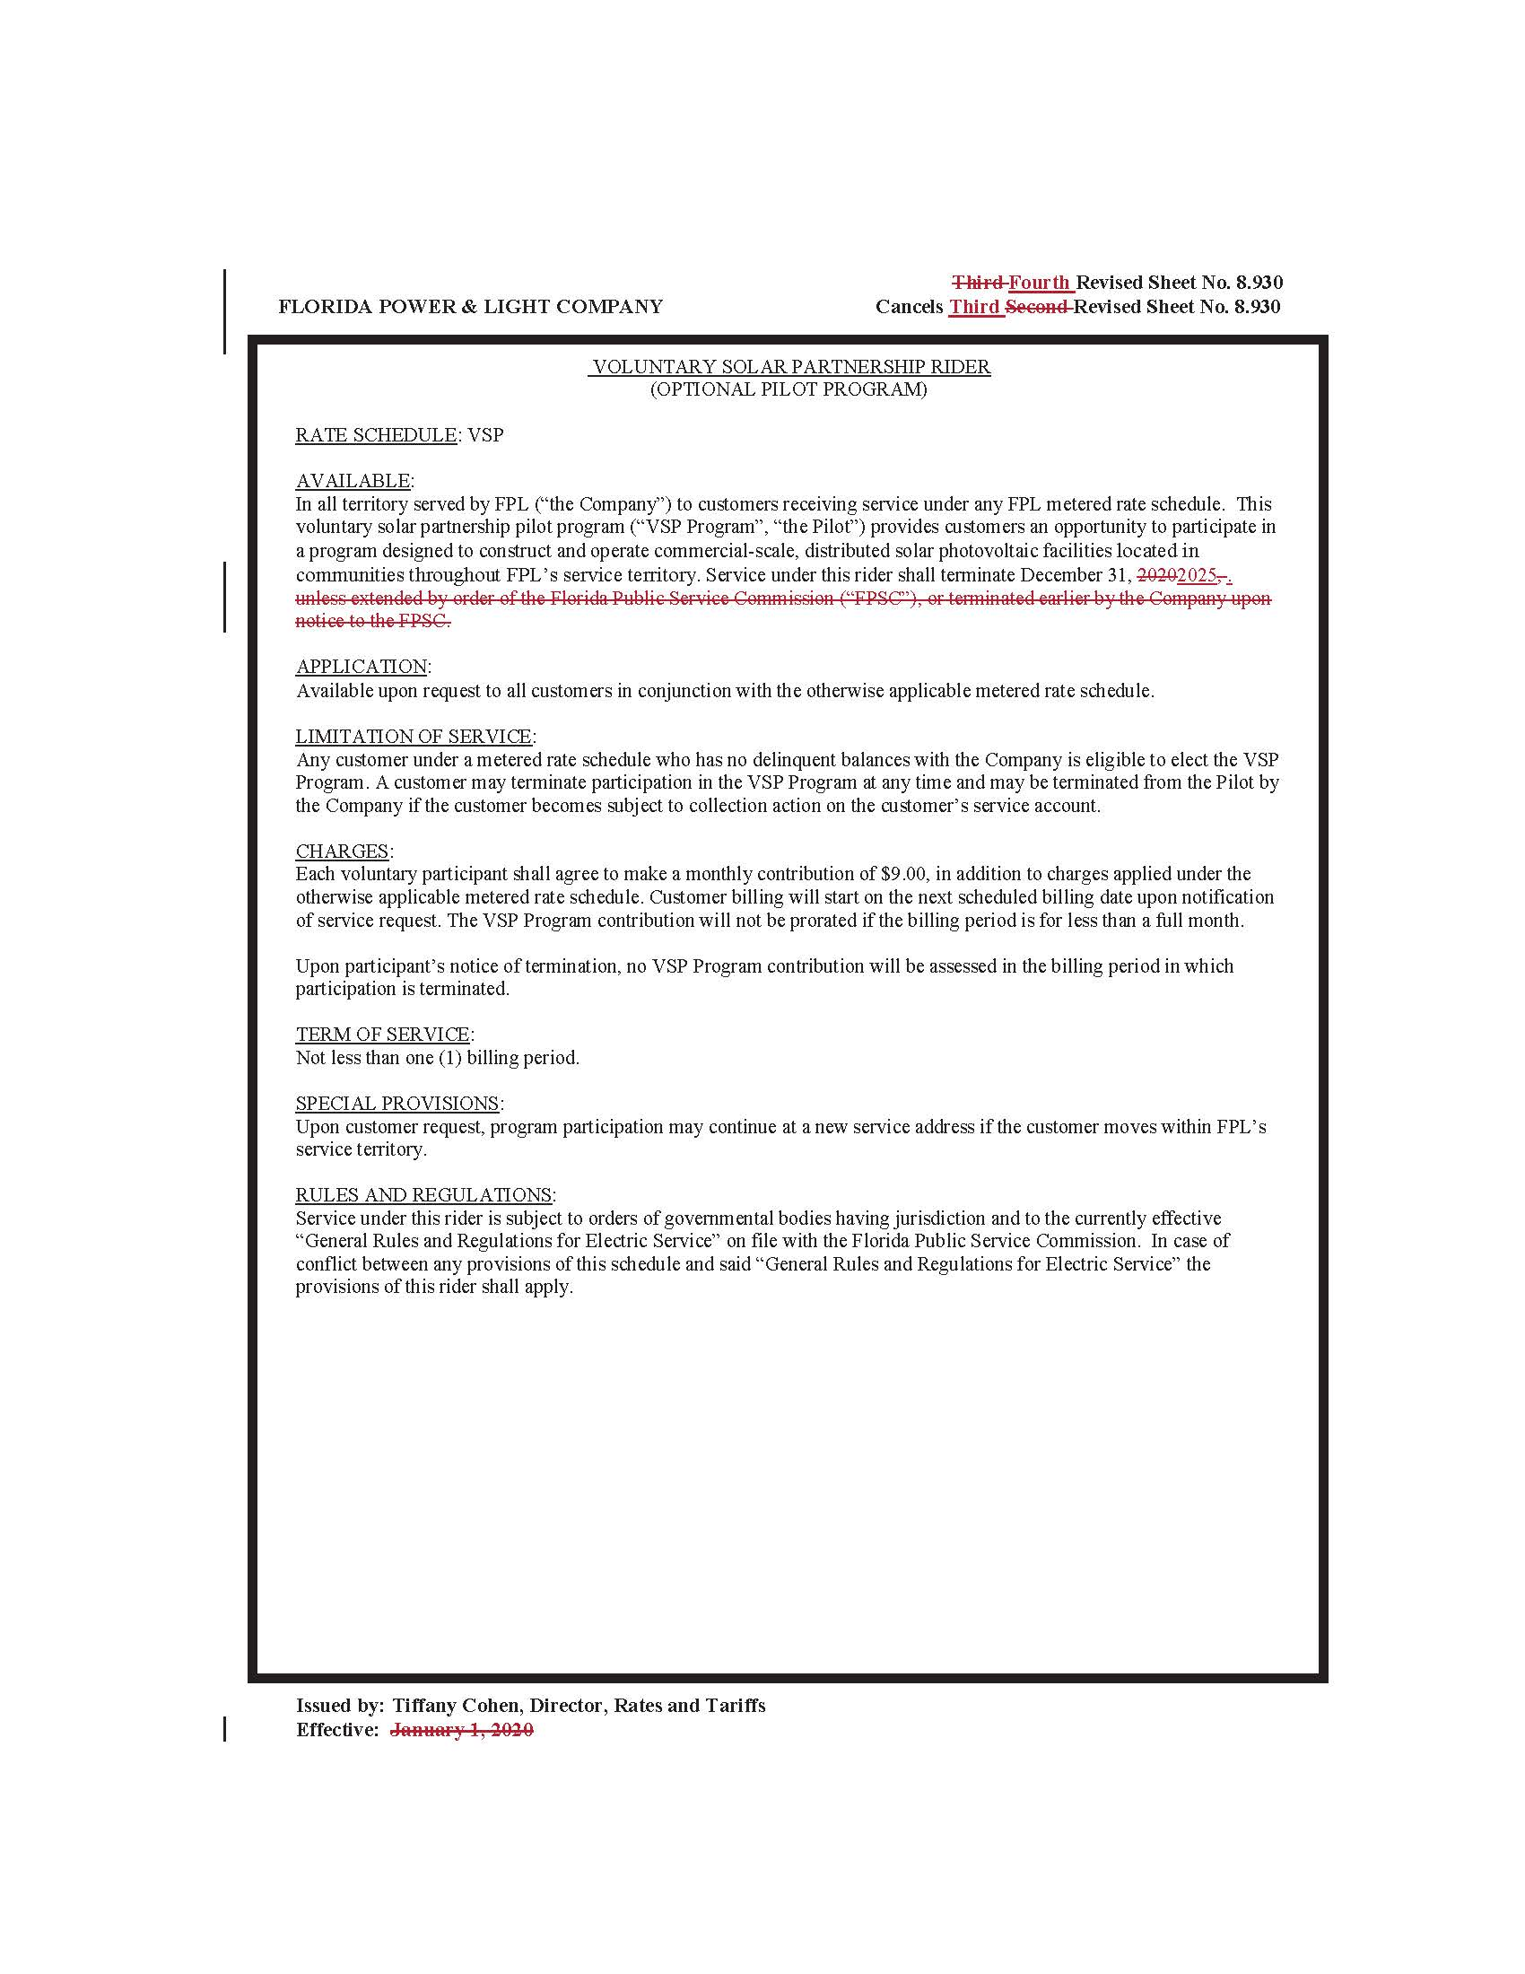

Order No. PSC-14-0468-TRF-EI, issued August 29, 2014, in Docket No. 20140070-EI, In re: Petition for approval of voluntary solar partnership pilot program and tariff, by Florida Power & Light Company.
Order No. PSC-2017-0499-TRF-EI, issued December 29, 2017, in Docket No. 20170212-EI, In re: Petition for one-year extension of voluntary solar partnership rider and program, by Florida Power & Light Company.
Order No. PSC-2018-0581-TRF-EI, issued December 17, 2018, in Docket No. 20180160-EI, In re: Petition for 12-month extension of voluntary solar partnership rider and program, by Florida Power & Light Company.
Order No. PSC-2019-0544-TRF-EI, issued December 20, 2019, in Docket No. 20190190-EI, In re: Petition for approval of twelve-month extension of voluntary solar partnership rider and program, by Florida Power & Light Company.
Order No. PSC-2020-0084-S-EI, issued March 20, 2020, in Docket No. 20190061-EI, In re: Petition for approval of FPL SolarTogether program and tariff, by Florida Power & Light Company.
Document No. 11292-2020, FPL’s response to Staff’s First Data Request, No. 12.
Amounts reflect actuals through June 2020 and forecasted data for July 2020 – December 2020. See Document No. 11292-2020, FPL’s response to Staff’s First Data Request, No. 3, Attachment No. 1.
FPL provided a list of all SolarNow projects that are either planned or currently under construction. See Document No. 11292-2020, FPL’s response to Staff’s First Data Request, No. 11.
Order No. PSC-14-0468-TRF-EI states “FPL explained that should SolarNow be terminated after the three-year trial period, and in the event that participant contributions and avoided/fuel emission benefits do not cover the remaining revenue requirements, FPL and its shareholders will absorb the difference below-the-line.”
Document No. 06079-2020, Petition by Florida Power & Light Company for Approval of Proposed Disposition of Voluntary Solar Partnership Rider and Program, p.9.
See Id.
See Id.
Document No. 11292-2020, FPL’s response to Staff’s First Data Request, No. 4.
Document No. 11292-2020, FPL’s response to Staff’s First Data Request, No. 5.
Increase in depreciation expense for 2021 equals $4,843,915 - $883,775 and for 2022-2025 equals $4,834,459 - $874,319.
Document No. 11292-2020, FPL’s response to Staff’s First Data Request, No. 4.
Order No. PSC-14-0468-TRF-EI, issued in Docket No. 140070-EI, on August 29, 2014, In re: Petition for approval of voluntary solar partnership pilot program and tariff, by Florida Power & Light Company.
Document No. 11838-2020, Letter dated 11/9/20, with attached additional information regarding the SolarNow program.
Order No. PSC-2020-0312-PAA-EI, issued in Docket No. 20200182-EI, on September 15, 2020, In re: Joint petition for declaratory statement regarding application of MFR requirements in Rule 25-6.043(1), F.A.C. or, in the alternative, petition for variance, by Florida Power & Light Company and Gulf Power Company.

