State of Florida |  | Public Service Commission  Capital Circle Office Center ● 2540 Shumard Oak Boulevard  Tallahassee, Florida 32399-0850  -M-E-M-O-R-A-N-D-U-M-
DATE: | November 20, 2020
TO: | Office of Commission Clerk (Teitzman)
FROM: | Office of the General Counsel (Harper)  Division of Accounting and Finance (Cicchetti)  Division of Economics (Guffey, Coston)
RE: | Docket No. 20200237-PU – Amendment of Rules 25-6.0141, F.A.C., Allowance for Funds Used During Construction, and 25-30.116, F.A.C., Allowance for Funds Used During Construction, and adoption of Rule 25-7.0141, F.A.C., Allowance for Funds Used During Construction.
AGENDA: | 12/01/20 – Regular Agenda – Rule Proposal – Interested Persons May Participate
COMMISSIONERS ASSIGNED: |  |  | All Commissioners
PREHEARING OFFICER: |  |  | Polmann
RULE STATUS: |  |  | Proposal May Be Deferred
SPECIAL INSTRUCTIONS: |  |  | None

Case Background
Rule 25-6.0141, Florida Administrative Code (F.A.C.), Allowance for Funds Used During Construction, and Rule 25-30.116, F.A.C., Allowance for Funds Used During Construction, describe the requirements and methodology for accruing Allowance for Funds Used During Construction (AFUDC) for investor-owned electric utilities and water and wastewater utilities, respectively. Rule 25-7.0141, F.A.C., Allowance for Funds Used During Construction, addresses AFUDC for natural gas utilities, but unlike the Commission’s other AFUDC rules, it simply states that “[a] utility may not accrue [AFUDC] without prior Commission approval.”

AFUDC is the carrying cost of funding an eligible utility investment during construction. Allowing utilities to accrue AFUDC lets utilities recover the costs they incur to finance investments before the investments are placed in service and earn a return through base rates. Generally Accepted Accounting Principles (GAAP) governs the recognition and recording of AFUDC.

The focus of this rulemaking is to adopt a more comprehensive AFUDC rule for natural gas utilities and to update and clarify and create consistency among all of the Commission’s AFUDC rules.

Notices of Development of Rulemaking for all three rules were published in the June 10, 2020 edition of the Florida Administrative Register, Volume 46, No. 113. A rule development workshop was held on June 29, 2020. Representatives from Florida Power & Light Company (FPL), Tampa Electric Company (TECO), Duke Energy Florida, LLC (DEF), Gulf Power Company (Gulf), Florida Public Utilities Company (FPUC), Florida City Gas (FCG), Peoples Gas System (PGS), and the Office of Public Counsel (OPC) participated at the workshop and submitted post-workshop comments.

This recommendation addresses whether the Commission should propose the amendment of Rules 25-6.0141, 25-7.0141, and 25-30.116, F.A.C. The Commission has jurisdiction pursuant to Sections 350.127(2), 366.05(1), and 367.121(1), Florida Statutes (F.S.).

Discussion of Issues

Issue 1:
Should the Commission propose the amendment of Rule 25-6.0141, F.A.C., Allowance for Funds Used During Construction, Rule 25-7.0141, F.A.C., Allowance for Funds Used During Construction, and Rule 25-30.116, F.A.C., Allowance for Funds Used During Construction?

Recommendation:
Yes. The Commission should propose the amendment of Rules 25-6.0141, 25-7.0141, and 25-30.116, F.A.C., as set forth in Attachment A. The Commission should also certify Rules 25-6.0141, 25-7.0141, and 25-30.116, F.A.C., as minor violation rules. (Cicchetti, Harper, Guffey)

Staff Analysis:
Staff recommends that the Commission amend Rules 25-6.0141, 25-7.0141, and 25-30.116, F.A.C., as set forth in Attachment A. Although any additions to Rule 25-7.0141, F.A.C, would technically be amendments to the rule, staff’s recommended amendments would in effect create a new rule for natural gas utilities as current Rule 25-7.0141, F.A.C., simply states that “[a] utility may not accrue [AFUDC] without prior Commission approval.” Staff’s recommended language for Rule 25-7.0141, F.A.C., generally mirrors the Commission’s current AFUDC rules for investor-owned electric utilities.

Overall, staff is recommending similar updates and clarifications to all three industry rules for consistency. For all three rules, staff is recommending that a definition section be included in each rule. Staff believes the definition of “project” should be amended to be consistent with the concept of the definition of project in the Commission’s storm hardening plan rule and additional rule language should be added to clarify that a utility may bundle projects under certain circumstances. Staff’s more substantive recommended amendments to the rules are discussed in more detail below.

Definition of Project
For all three rules, staff is recommending that a definition section be included in each rule to define “AFUDC” as the carrying cost of funding an eligible utility project investment during its construction. Staff also recommends that the definition of “project” in the rules should be amended to be consistent with the concept of the definition of project in Rule 25-6.030, F.A.C., Storm Protection Plan. As such, staff recommends the definition of “project” under the rules specify that it is temporary with a defined beginning and end and with the goal of placing a specific utility investment into service or public use for the provision of utility service. This definition is necessary because utilities may take part in projects that require construction on a single site or that require multiple sites. Staff believes that the recommended rule language encompasses the concept that a “project” under the rules can include multiple locations or designs within Florida.

Bundling of Projects
The rules currently do not have a provision that addresses bundling of projects. Staff is recommending the addition of the following language in all of the AFUDC rules:

A utility may bundle related projects that achieve a specific outcome if it demonstrates that the total cost of the bundled projects excluding AFUDC is less than the total cost of the unbundled projects.

The large investor-owned electric utilities (IOUs) agree with staff’s recommended rule language. In support of this rule language, they suggest the AFUDC rule be amended to define a project in a manner that better recognizes how IOUs make investment and procurement decisions. By recognizing that investments can span more than one location and include more than one design, and thus can be bundled if it is demonstrated that doing so results in a lower total cost than the total costs of the unbundled projects, the IOUs suggest the AFUDC rule will encourage a range of cost effective investments for the benefit of customers.

OPC objects to the proposed wording of the bundling provision. In its comments, OPC argues that the concept of bundling could permit a combination of individual projects such that the commencement date of one of the bundled projects and the in-service date of another bundled project are combined to total a period longer than a year, thereby circumventing the duration restriction. OPC also suggests the bundling concept could permit double recovery of the return on investment on certain projects by allowing the accrual of AFUDC on projects that may otherwise be presumed to be included in Construction Work in Progress (CWIP) in rate base and therefore are recovered through base rates.

Staff appreciates all stakeholder arguments on this point. If the purpose of the bundling of projects was simply to qualify for AFUDC, staff agrees with OPC that it could be problematic. However, the staff’s recommended rule language requires a demonstration of cost effectiveness. The AFUDC rule should not be drafted in such a way that it creates a regulatory hurdle to IOU planning and construction of cost-effective projects. Therefore, staff recommends the above rule language.

Threshold for Project Eligibility
Rule 25-6.0141(1), F.A.C., the AFUDC rule pertaining to investor-owned electric utilities, sets forth which projects are eligible and ineligible for AFUDC. The rule currently has a 0.5 percent threshold for eligibility. The rule provides that projects that involve gross additions to plant in excess of 0.5 percent of the sum of the total balance in Account 101, Electric Plant in Service, and Account 106, Completed Construction not Classified, at the time the project commences and are expected to be completed in excess of one year after commencement of construction, or were originally expected to be completed in one year or less and are suspended for six months or more, or are not ready for service after one year, are eligible for AFUDC. Also, the rule further provides that a project is ineligible for AFUDC where gross additions to plant are less than 0.5 percent of the sum of the total balance in Account 101, Electric Plant in Service, and Account 106, Completed Construction not Classified, at the time the project commences.

Staff recommends that the threshold in Rule 25-6.0141, F.A.C., be amended from 0.5 percent to 0.40 percent of the sum of Accounts 101 and 106. Staff believes that the purpose of the rule, which is to allow AFUDC for certain projects, is not being met because the 0.5 percent threshold is too high. Staff acknowledges the IOUs’ argument that due to growing rate base since 1996 when the rule was last amended, projects that are significant in size are currently excluded from eligibility to accrue AFUDC. Staff believes that reducing the threshold will result in a reasonable increase to the number of projects eligible to accrue AFUDC.

OPC argues in its post-workshop comments that the AFUDC threshold should not be amended. OPC asserts that lowering the cost threshold for projects eligible for AFUDC, rather than being covered under CWIP, will result in a compounded accumulation of the utility’s average weighted cost of capital (WACC) during the construction period, which is then added to the capital amount of the plant-in-service when the project is completed and placed in service. OPC opines that by lowering the cost threshold, projects that are currently assumed to be included in CWIP in rate base as a result of the CWIP balance implied in the last rate case will now receive AFUDC treatment. In other words, if the cost threshold is lowered, more projects will be eligible for AFUDC in between rate cases.

Further, OPC argues broadening the eligibility of projects for AFUDC would be contrary to the original purpose of the rule, which was to provide threshold language designed to limit projects to those that have material costs and that would take more than one year to complete in order to encourage utility investment in large projects without seeking rate relief. OPC also argues that based on the level of CWIP authorized by the Commission in the utilities’ last base rate cases, the reduction in the threshold for AFUDC eligible projects could result in double recovery from customers.

While more projects will be eligible for AFUDC in between rate cases under staff’s recommended rule amendments, Sections 366.041(1) and 366.06(1), F.S., the Commission’s general ratemaking authority, require the Commission to set just, fair, reasonable, and compensatory rates. Staff believes the recommended amendments comport with these statutory objectives. Furthermore, OPC’s comments addressed an earlier draft of the rule with a threshold amount of the lower of $50 million or .25 percent of the sum of the total balance in Accounts 101,106, 108 and 111. Staff’s recommended rule, however, has a threshold amount of 0.40 percent of Accounts 101 and 106, which reduces the dollar amount of projects eligible for AFUDC compared to the draft upon which OPC commented.

Finally, staff acknowledges that the recommended rule as it is currently written could allow for some cases of double recovery (i.e., a project accrues AFUDC even though a certain amount of CWIP was allowed in a company’s last rate case). However, staff’s recommended rule allows for less projects qualifying for AFUDC than the draft commented on by OPC, and expected upcoming rate cases should prevent potential double recovery.

No stakeholders requested a change in the threshold for eligible projects in Rule 25-30.116, the water and wastewater AFUDC rule, and there was no stakeholder opposition to a $25,000 threshold in Rule 25-7.0141, F.A.C., the natural gas AFUDC rule. Moreover, staff believes that each threshold amount is appropriate for each of the rules. Staff, therefore, recommends that the Commission keep the current threshold for project eligibility in Rule 25-30.116, F.A.C., and establish the threshold as $25,000 in Rule 25-7.0141, F.A.C.

Minor Violation Rules Certification
Rules 25-6.0141, 25-7.0141, and 25-30.116, F.A.C., are on the Commission’s list of minor violation rules. Pursuant to Section 120.695, F.S., as of July 1, 2017, the agency head shall certify whether any part of each rule filed for adoption is designated as a minor violation rule. A minor violation rule is a rule that would not result in economic or physical harm to a person or an adverse effect on the public health, safety, or welfare or create a significant threat of such harm when violated. Staff recommends that the Commission continue to certify Rules 25-6.0141, 25.7.0141, 25-30.116, F.A.C., as minor violation rules.

Statement of Estimated Regulatory Costs
Pursuant to Section 120.54(3)(b)1., F.S., agencies are encouraged to prepare a statement of estimated regulatory costs (SERC) before the adoption, amendment, or repeal of any rule. A SERC was prepared for this rulemaking and is appended as Attachment B. As required by Section 120.541(2)(a)1., F.S., the SERC analysis includes whether the rule amendments are likely to have an adverse impact on economic growth, private sector job creation or employment, or private sector investment in excess of $1 million in the aggregate within five years after implementation. Staff notes that none of the impact/cost criteria will be exceeded as a result of the recommended revisions.

The SERC concludes that the amendments to Rules 25-6.0141, 25-7.0141, and 25-30.116, F.A.C., will likely not directly or indirectly increase regulatory costs in excess of $200,000 within 1 year after implementation. Further, the SERC concludes that the amendment of the rules will not likely increase regulatory costs, including any transactional costs, or have an adverse impact on business competitiveness, productivity, or innovation in excess of $1 million in the aggregate within five years of implementation. Thus, the amendment of the rules do not require legislative ratification, pursuant to Section 120.541(3), F.S.

In addition, the SERC states that the amendments to Rules 25-6.0141, 25-7.0141, 25-30.116, F.A.C., would have no impact on small businesses, would have no implementation or enforcement cost on the Commission or any other state and local government entity, and would have no impact on small cities or small counties. The SERC states that no additional transactional costs are likely to be incurred by individuals and entities required to comply with the requirements.

Conclusion
The Commission should propose the amendment of Rules 25-6.0141, 25-7.0141, and 25-30.116, F.A.C., as set forth in Attachment A. The Commission should certify Rules 25-6.0141, 25-7.0141, 25-30.116, F.A.C., as minor violation rules.

Issue 2:
Should this docket be closed?

Recommendation:
Yes. If no requests for hearing or comments are filed, the rules should be filed with the Department of State, and the docket should be closed. (Harper)

Staff Analysis:
If no requests for hearing or comments are filed, the rules may be filed with the Department of State and the docket closed. When these rules become effective, staff will bring a recommendation in a separate docket for the Commission’s consideration on any other existing Commission rules that need to be amended or repealed.

25-6.0141 Allowance for Funds Used During Construction.
(1) Definition of terms of this rule.
(a) Allowance for funds used during construction (AFDUC) is the carrying cost of funding an eligible utility project investment during its construction.
(b) A project means a temporary endeavor with a defined beginning and end series of tasks that need to be completed in order to reach a specific outcome (e.g., a specific utility investment placed into service or devoted to public use for the provision of electric service), designed to produce an in-service plant investment result.
(2)(1) Construction work in progress (CWIP) or nuclear fuel in process (NFIP) not under a lease agreement that is not included in rate base may accrue allowance for funds used during construction (AFUDC), under the following conditions:
(a) Eligible projects. The following projects may be included in CWIP or NFIP and accrue AFUDC:
1. Projects that involve gross additions to plant in excess of 0.40 0.5 percent of the sum of the total balance in Account 101, Electric Plant in Service, and Account 106, Completed Construction not Classified, at the time the project commences and
a. Are expected to be completed in excess of one year after commencement of construction, or
b. Were originally expected to be completed in one year or less and are suspended for six months or more, or are not ready for service after one year.
2. A utility may bundle related projects that achieve a specific outcome if it demonstrates that the total cost of the bundled projects excluding AFUDC is less than the total cost of the unbundled projects.
(b) Ineligible projects. The following projects may be included in CWIP or NFIP, but may not accrue AFUDC:
1. Projects, or portions thereof, that do not exceed the level of CWIP or NFIP included in rate base in the utility’s last rate case.
2. Projects where gross additions to plant are less than 0.40 0.5 percent of the sum of the total balance in Account 101, Electric Plant in Service, and Account 106, Completed Construction not Classified, at the time the project commences.
3. Projects expected to be completed in less than one year after commencement of construction.
4. Property that has been classified as Property Held for Future Use.
(c) Unless otherwise authorized by the Commission, the following projects may not be included in CWIP or NFIP, nor accrue AFUDC:
1. Projects that are reimbursable by another party.
2. Projects that have been cancelled.
3. Purchases of assets which are ready for service when acquired.
4. Portions of projects providing service during the construction period.
(d) Other conditions. Accrual of AFUDC is subject to the following conditions:
1. Accrual of AFUDC is not to be reversed when a project originally expected to be completed in excess of one year is completed in one year or less;
2. AFUDC may not be accrued retroactively if a project expected to be completed in one year or less is subsequently suspended for six months, or is not ready for service after one year;
3. When a project is completed and ready for service, it must shall be immediately transferred to the appropriate plant account(s) or Account 106, Completed Construction Not Classified, and may no longer accrue AFUDC;
4. Where a work order covers the construction of more than one property unit, the AFUDC accrual must cease on the costs related to each unit when that unit reaches an in-service status;
5. When the construction activities for an ongoing project are expected to be suspended for a period exceeding six months, the utility must notify the Commission of the suspension and the reason(s) for the suspension, and must submit a proposed accounting treatment for the suspended project; and
6. When the construction activities for a suspended project are resumed, the previously accumulated costs of the project may not accrue AFUDC if such costs have been included in rate base for ratemaking purposes. However, the accrual of AFUDC may be resumed when the previously accumulated costs are no longer included in rate base for ratemaking purposes.
(e) Subaccounts. Account 107, Construction Work in Progress, and Account 120.1, Nuclear Fuel in Process of Refinement, Conversion, Enrichment and Fabrication, must be subdivided so as to segregate the cost of construction projects that are eligible for AFUDC from the cost of construction projects that are ineligible for AFUDC.
(f) Prior to the commencement of construction on a project, a utility may file a petition to seek approval to include an individual project in rate base that would otherwise qualify for AFUDC treatment per paragraph (2)(1)(a).
(g) On a prospective basis, the Commission, upon its own motion, may determine that the potential impact on rates may require the exclusion of an amount of CWIP from a utility’s rate base that does not qualify for AFUDC treatment per paragraph (2)(1)(a) and to allow the utility to accrue AFUDC on that excluded amount.
(3)(2) The applicable AFUDC rate will be determined as follows:
(a) The most recent 13-month average embedded cost of capital, except as noted below, must be derived using all sources of capital and adjusted using adjustments consistent with those used by the Commission in the utility’s last rate case.
(b) The cost rates for the components in the capital structure will be the midpoint of the last allowed return on common equity, the most recent 13-month average cost of short term debt and customer deposits, and a zero cost rate for deferred taxes and all investment tax credits. The cost of long term debt and preferred stock will be based on end of period cost. The annual percentage rate must be calculated to two decimal places.
(4)(3) Discounted monthly AFUDC rate. A discounted monthly AFUDC rate, calculated to six decimal places, must be employed to ensure insure that the annual AFUDC charged does not exceed authorized levels.
(a) The formula used to discount the annual AFUDC rate to reflect monthly compounding is as follows:
M = [((1 + A/100)^{1/12 – 1})-1]x 100Where:
M | = | discounted monthly AFUDC rate
A | = | annual AFUDC rate
(b) The monthly AFUDC rate, carried out to six decimal places, must be applied to the average monthly balance of eligible CWIP and NFIP that is not included in rate base.
(5)(4) The following schedules must be filed with each petition for a change in AFUDC rate:
(a) Schedule A. A schedule showing the capital structure, cost rates and weighted average cost of capital that are the basis for the AFUDC rate in subsection (3)(2).
(b) Schedule B. A schedule showing capital structure adjustments including the unadjusted capital structure, reconciling adjustments and adjusted capital structure that are the basis for the AFUDC rate in subsection (3)(2).
(c) Schedule C. A schedule showing the calculation of the monthly AFUDC rate using the methodology set out in this rule.
(6)(5) No utility may charge or change its AFUDC rate without prior Commission approval. The new AFUDC rate will be effective the month following the end of the 12-month period used to establish that rate and may not be retroactively applied to a previous fiscal year unless authorized by the Commission.
(7)(6) Each utility charging AFUDC must include in its December Earnings Surveillance Reports to the Commission Schedules A and B identified in subsection (4) of this rule, as well as disclosure of the AFUDC rate it is currently charging.
(8)(7) The Commission may, on its own motion, initiate a proceeding to revise a utility’s AFUDC rate.
(9)(8) Each utility must include in its Forecasted Surveillance Report a schedule of individual projects that commence during that forecasted period and are estimated to have a gross cost in excess of 0.40 0.5 percent of the sum of the total balance in Account 101, Electric Plant in Service, and Account 106, Completed Construction not Classified. The schedule must include the following minimum information:
(a) Description of the project.
(b) Estimated total cost of the project.
(c) Estimated construction commencement date.
(d) Estimated in-service date.
Rulemaking Authority 350.127(2), 366.05(1) FS. Law Implemented 350.115, 366.04(2)(a), (f) 366.06(1), (2), 366.08 FS. History–New 8-11-86, Formerly 25-6.141, Amended 11-13-86, 12-7-87, 1-7-97, 12-30-19,_____________.

25-7.0141 Allowance for Funds Used During Construction.
(1) Definition of terms for this rule.
(a) Allowance for funds used during construction (AFUDC) is the carrying cost of funding an eligible utility project investment during its construction.
(b) A project means a temporary endeavor with a defined beginning and end series of tasks that need to be completed in order to reach a specific outcome (e.g., a specific utility investment placed into service or devoted to public use for the provision of natural gas service), designed to produce an in-service plant investment result.
A utility shall not accrue allowance for funds used during construction without prior Commission approval.
(2) Construction work in progress (CWIP) that is not included in rate base may accrue AFUDC under the following conditions:
(a) Eligible projects. The following projects may be included in CWIP and accrue AFUDC:
1. Projects that involve gross additions to plant in excess of $25,000 and
a. Are expected to be completed in excess of one year after commencement of construction, or
b. Were originally expected to be completed in one year or less and are suspended for six months or more, or are not ready for service after one year.
2. A utility may bundle related projects that achieve a specific outcome if it demonstrates that the total cost of the bundled projects excluding AFUDC is less than the total cost of the unbundled projects.
(b) Ineligible projects. The following projects may be included in CWIP, but may not accrue AFUDC:
1. Projects, or portions thereof, that do not exceed the level of CWIP included in rate base in the company's last rate case.
2. Projects where gross additions to plant are less than $25,000.
3. Projects expected to be completed in less than one year after commencement of construction.
4. Property that has been classified as Property Held for Future Use.
(c) Unless otherwise authorized by the Commission, the following projects may not be included in CWIP nor accrue AFUDC:
1. Projects that are reimbursable by another party.
2. Projects that have been cancelled.
3. Purchases of assets which are ready for service when acquired.
4. Portions of projects providing service during the construction period.
(d) Other conditions. Accrual of AFUDC is subject to the following conditions:
1. Accrual of AFUDC is not to be reversed when a project originally expected to be completed in excess of one year is completed in one year or less;
2. AFUDC may not be accrued retroactively if a project expected to be completed in one year or less is subsequently suspended for six months, or is not ready for service after one year;
3. When a project is completed and ready for service, it must be immediately transferred to the appropriate plant account(s) or Account 106, Completed Construction Not Classified, and may no longer accrue AFUDC;
4. Where a work order covers the construction of more than one property unit, the AFUDC accrual must cease on the costs related to each unit when that unit reaches an in service status;
5. When the construction activities for an ongoing project are expected to be suspended for a period exceeding six (6) months, the utility must notify the Commission of the suspension and the reason(s) for the suspension, and must submit a proposed accounting treatment for the suspended project; and
6. When the construction activities for a suspended project are resumed, the previously accumulated costs of the project may not accrue AFUDC if such costs have been included in rate base for ratemaking purposes. However, the accrual of AFUDC may be resumed when the previously accumulated costs are no longer included in rate base for ratemaking purposes.
(e) Subaccounts. Account 107, Construction Work in Progress, must be subdivided so as to segregate the cost of construction projects that are eligible for AFUDC from the cost of construction projects that are ineligible for AFUDC.
(f) Prior to the commencement of construction on a project, a utility may file a petition to seek approval to include an individual project in rate base that would otherwise qualify for AFUDC treatment per paragraph (2)(a).
(g) On a prospective basis, the Commission, upon its own motion, may determine that the potential impact on rates may require the exclusion of an amount of CWIP from a utility’s rate base that does not qualify for AFUDC treatment per paragraph (2)(a) and to allow the utility to accrue AFUDC on that excluded amount.
(3) The applicable AFUDC rate will be determined as follows:
(a) The most recent 13-month average embedded cost of capital, except as noted below, must be derived using all sources of capital and adjusted using adjustments consistent with those used by the Commission in the Company's last rate case.
(b) The cost rates for the components in the capital structure will be the midpoint of the last allowed return on common equity, the most recent 13-month average cost of short-term debt and customer deposits and a zero cost rate for deferred taxes and all investment tax credits. The cost of long-term debt and preferred stock will be based on end of period cost. The annual percentage rate will be calculated to two decimal places.
(4) Discounted monthly AFUDC rate. A discounted monthly AFUDC rate, calculated to six decimal places, must be employed to ensure that the annual AFUDC charged does not exceed authorized levels.
(a) The formula used to discount the annual AFUDC rate to reflect monthly compounding is as follows:
M = [((1 + A/100)^{1/12} )-1]x 100
Where:
M = discounted monthly AFUDC rate
A = Annual AFUDC rate
(b) The monthly AFUDC rate, carried out to six decimal places, must be applied to the average monthly balance of eligible CWIP that is not included in rate base.
(5) The following schedules must be filed with each petition for a change in AFUDC rate:
(a) Schedule A. A schedule showing the capital structure, cost rates and weighted average cost of capital that are the basis for the AFUDC rate in subsection (3).
(b) Schedule B. A schedule showing capital structure adjustments including the unadjusted capital structure, reconciling adjustments and adjusted capital structure that are the basis for the AFUDC rate in subsection (3).
(c) Schedule C. A schedule showing the calculation of the monthly AFUDC rate using the methodology set out in this rule.
(6) No utility may charge or change its AFUDC rate without prior Commission approval. The new AFUDC rate will be effective the month following the end of the 12-month period used to establish that rate and may not be retroactively applied to a previous fiscal year unless authorized by the Commission.
(7) Each utility charging AFUDC must include in its December Rate of Return surveillance report to the Commission Schedules A and B identified in subsection (5) of this rule, as well as disclosure of the AFUDC rate it is currently charging.
(8) The Commission may, on its own motion, initiate a proceeding to revise a utility's AFUDC rate.
Rulemaking Authority 350.127(2), 366.05(1) FS. Law Implemented 350.115, 366.05(1), 366.06(1) FS. History–New 8-11-86, Formerly 25-7.141, Amended 11-13-86, 12-7-87, 11-23-95,________________.

25-30.116 Allowance for Funds Used During Construction.
(1) Definition of terms for this rule.
(a) Allowance for funds used during construction (AFUDC) is the carrying cost of funding an eligible utility project investment during its construction.
(b) A project means a temporary endeavor with a defined beginning and end series of tasks that need to be completed in order to reach a specific outcome (e.g., a specific utility investment placed into service or devoted to public use for the provision of utility service), designed to produce an in-service plant investment result.
(2)(1) Construction work in progress (CWIP) that is not included in rate base may accrue allowance for funds used during construction (AFUDC), under the following conditions:
(a) Eligible projects. The following projects may be included in CWIP and accrue AFUDC:
1. Projects that involve gross additions to plant in excess of $5,000 and
a.2. Are expected to be completed in excess of sixty days after commencement of construction, or
b.3. Were originally expected to be completed in sixty days or less but are not ready for service after sixty days.
2. A utility may bundle related projects that achieve a specific outcome if it demonstrates that the total cost of the bundled projects excluding AFUDC is less than the total cost of the unbundled projects.
(b) Ineligible projects. The following projects may be included in CWIP, but may not accrue AFUDC:
1. Projects, or portions thereof, that do not exceed the level of CWIP included in rate base in the company’s last rate case.
2. Projects where gross additions to plant are less than $5,000.
3. Projects expected to be completed in less than sixty days after commencement of construction.
4. Property that has been classified as Property Held for Future Use.
(c) Unless otherwise authorized by the Commission, the following projects may not be included in CWIP nor accrue AFUDC:
1. Projects that are reimbursable by another party.
2. Projects that have been cancelled.
3. Purchases of assets which are ready for service when acquired.
4. Portions of projects providing service during the construction period.
(d) Other conditions. Accrual of AFUDC is subject to the following conditions:
1. Accrual of AFUDC is not to be reversed when a project originally expected to be completed in excess of sixty days is completed in sixty days or less;
2. AFUDC may not be accrued retroactively if a project expected to be completed in sixty days or less is subsequently suspended for six months, or is not ready for service after sixty days;
3. When a project is completed and ready for service, it must shall be immediately transferred to the appropriate plant account(s) or Account 106, Completed Construction Not Classified, and may no longer accrue AFUDC;
4. Where a work order covers the construction of more than one property unit, the AFUDC accrual must shall cease on the costs related to each unit when that unit reaches an in-service status;
5. When the construction activities for an ongoing project are expected to be suspended for a period exceeding six (6) months, the utility must shall notify the Commission of the suspension and the reason(s) for the suspension, and must shall submit a proposed accounting treatment for the suspended project; and
6. When the construction activities for a suspended project are resumed, the previously accumulated costs of the project may not accrue AFUDC if such costs have been included in rate base for ratemaking purposes. However, the accrual of AFUDC may be resumed when the previously accumulated costs are no longer included in rate base for ratemaking purposes.
(e) Subaccounts. Account 105, Construction Work in Progress, must shall be subdivided so as to segregate the cost of construction projects that are eligible for AFUDC from the cost of construction projects that are ineligible for AFUDC.
(f) Prior to the commencement of construction on a project, a utility may file a petition to seek approval to include an individual project in rate base that would otherwise qualify for AFUDC treatment per paragraph (2)(a).
(g) On a prospective basis, the Commission, upon its own motion, may determine that the potential impact on rates may require the exclusion of an amount of CWIP from a utility’s rate base that does not qualify for AFUDC treatment per paragraph (2)(a) and to allow the utility to accrue AFUDC on that excluded amount.
(3)(2) The applicable AFUDC rate will shall be determined as follows:
a) The most recent 12-month average embedded cost of capital, except as noted below, must shall be derived using all sources of capital and adjusted using adjustments consistent with those used by the Commission in the Company’s last rate case.
(b) The cost rates for the components in the capital structure will shall be the midpoint of the last allowed return on common equity, the most recent 12-month average cost of short term debt and customer deposits and a zero cost rate for deferred taxes and all investment tax credits. The cost of long term debt and preferred stock will shall be based on end of period cost. The annual percentage rate must shall be calculated to two decimal places.
(c) A company that has not had its equity return set in a rate case must shall calculate its return on common equity by applying the most recent water and wastewater equity leverage formula.
(d) The treatment by the Commission of all investment tax credits at a zero cost rate shall be contingent upon a ruling from the Internal Revenue Service that such treatment will not, for companies elected to be treated under Section 46(f)(2) of the Internal Revenue Code, result in the forfeiture of the tax credits. Pending receipt of such a ruling, each utility shall continue to use the weighted overall cost of capital calculated in a manner consistent with the final IRS Regulation Section 1.46-6 published May 22, 1986, as the cost of the utility’s 4% and 10% investment tax credits.
(e) Any such ruling request must be submitted to the Commission by December 15, 1987. The AFUDC cost rate for the investment tax credit for any company which fails to submit its own letter ruling request to the IRS shall be governed by the first letter ruling issued by the IRS in response to a request submitted pursuant to paragraph (2)(d) of this rule.
(4)(3) Discounted monthly AFUDC rate. A discounted monthly AFUDC rate, calculated to six decimal places, must shall be employed to ensure insure that the annual AFUDC charged does not exceed authorized levels.
(a) The formula used to discount the annual AFUDC rate to reflect monthly compounding is as follows:
M = [((1 + A/100)^{1/12} )-1]x 100 [(1 + A/100)^{1/12} – 1] x 100
Where:
M = discounted monthly AFUDC rate
A = annual AFUDC rate
(b) The monthly AFUDC rate, carried out to six decimal places, must shall be applied to the average monthly balance of eligible CWIP that is not included in rate base.
(5)(4) The following schedules must shall be filed with each petition for a change in AFUDC rate:
(a) Schedule A. A schedule showing the capital structure, cost rates and weighted average cost of capital that are the basis for the AFUDC rate in subsection (3)(2).
(b) Schedule B. A schedule showing capital structure adjustments including the unadjusted capital structure, reconciling adjustments and adjusted capital structure that are the basis for the AFUDC rate in subsection (3)(2).
(c) Schedule C. A schedule showing the calculation of the monthly AFUDC rate using the methodology set out in this rule.
(6)(5) No utility may charge or change its AFUDC rate without prior Commission approval. The new AFUDC rate will shall be effective the month following the end of the 12-month period used to establish that rate and may not be retroactively applied to a previous fiscal year unless authorized by the Commission.
(7)(6) Each utility charging AFUDC must shall include with its Annual Report to the Commission Schedules A and B identified in subsection (5)(4) of this rule, as well as disclosure of the AFUDC rate it is currently charging.
(8)(7) The Commission may, on its own motion, initiate a proceeding to revise a utility’s AFUDC rate.
(8) Paragraphs (a) and (b) of subsection (1) shall not be effective for any utility until it implements final rates in a general rate case initiated after the effective date of this rule. The foregoing notwithstanding, those provisions will become effective for all utilities no later than January 1, 1989.
Rulemaking Authority 350.127(2), 367.121(1)(f) FS. Law Implemented 350.115, 367.081(2), 367.121(1)(b) FS. History–New 8-11-86, Formerly 25-30.121, Amended 11-13-86, 12-7-87,________.

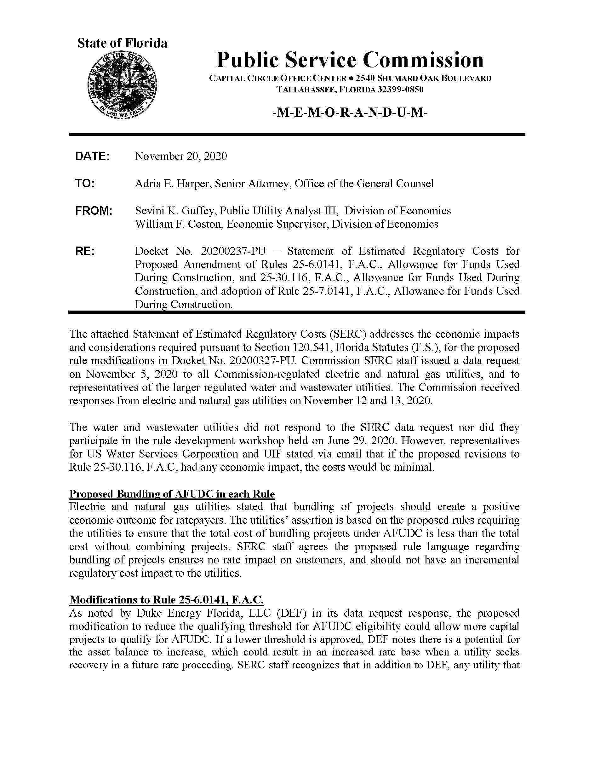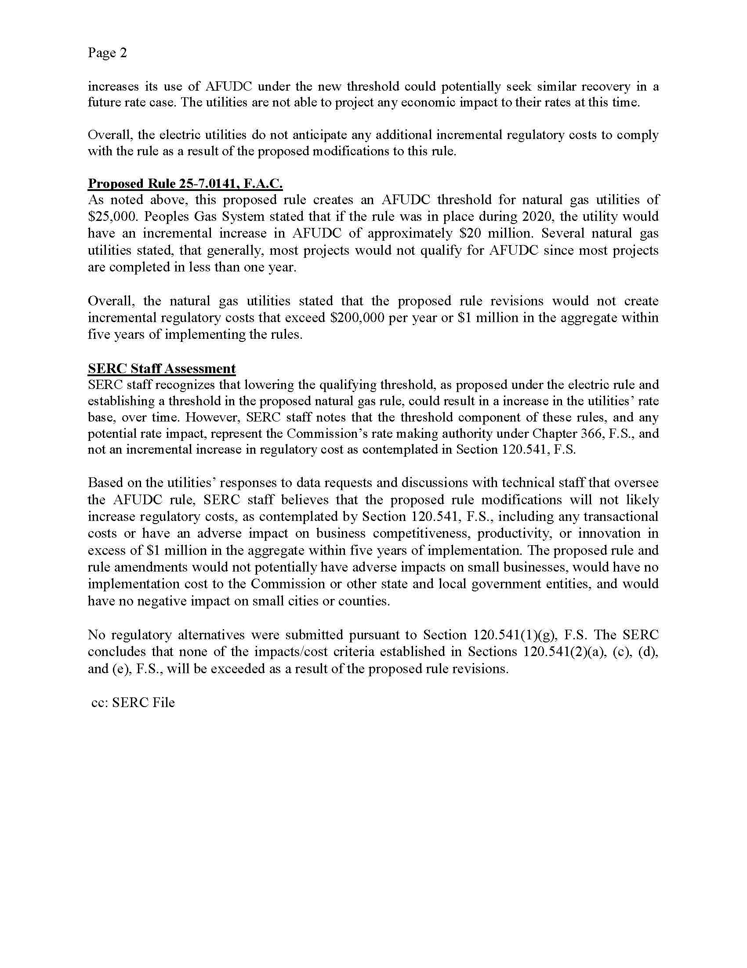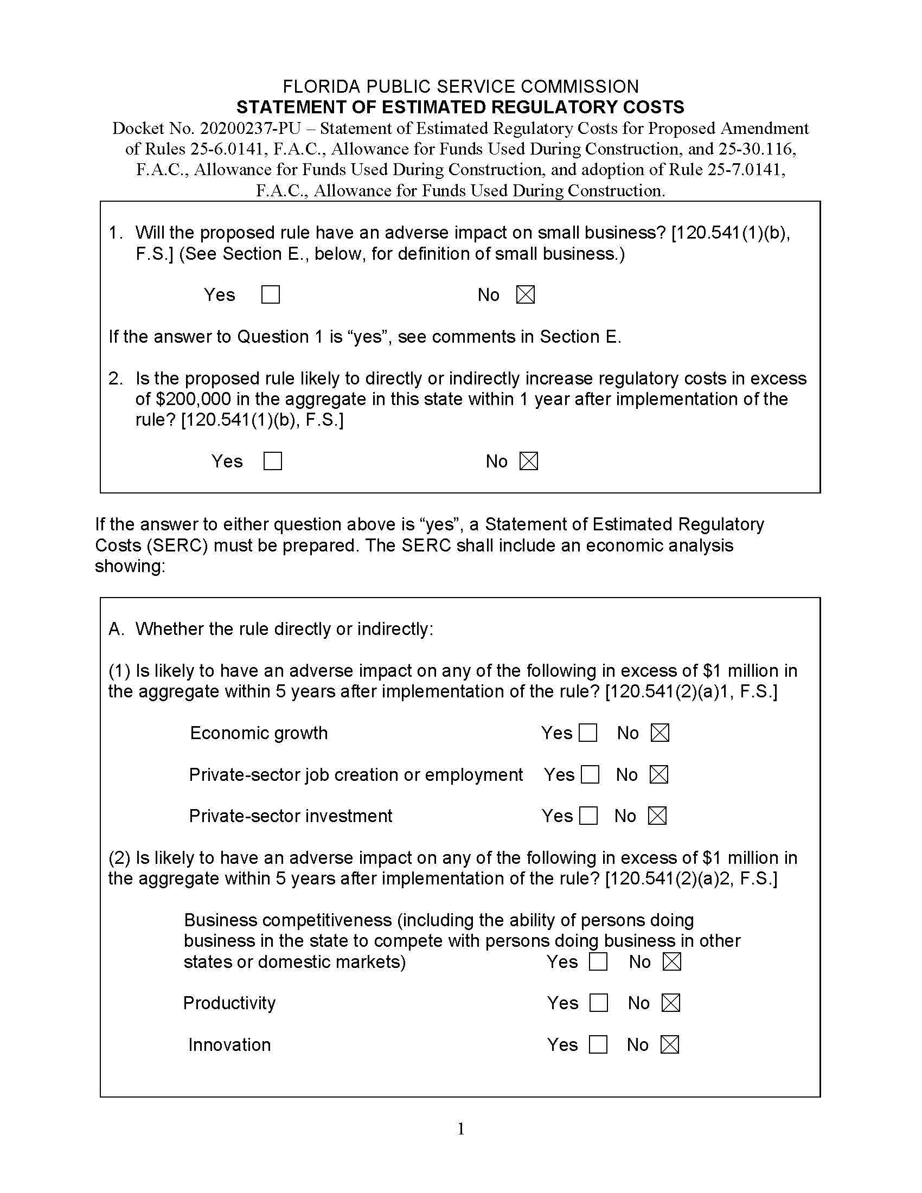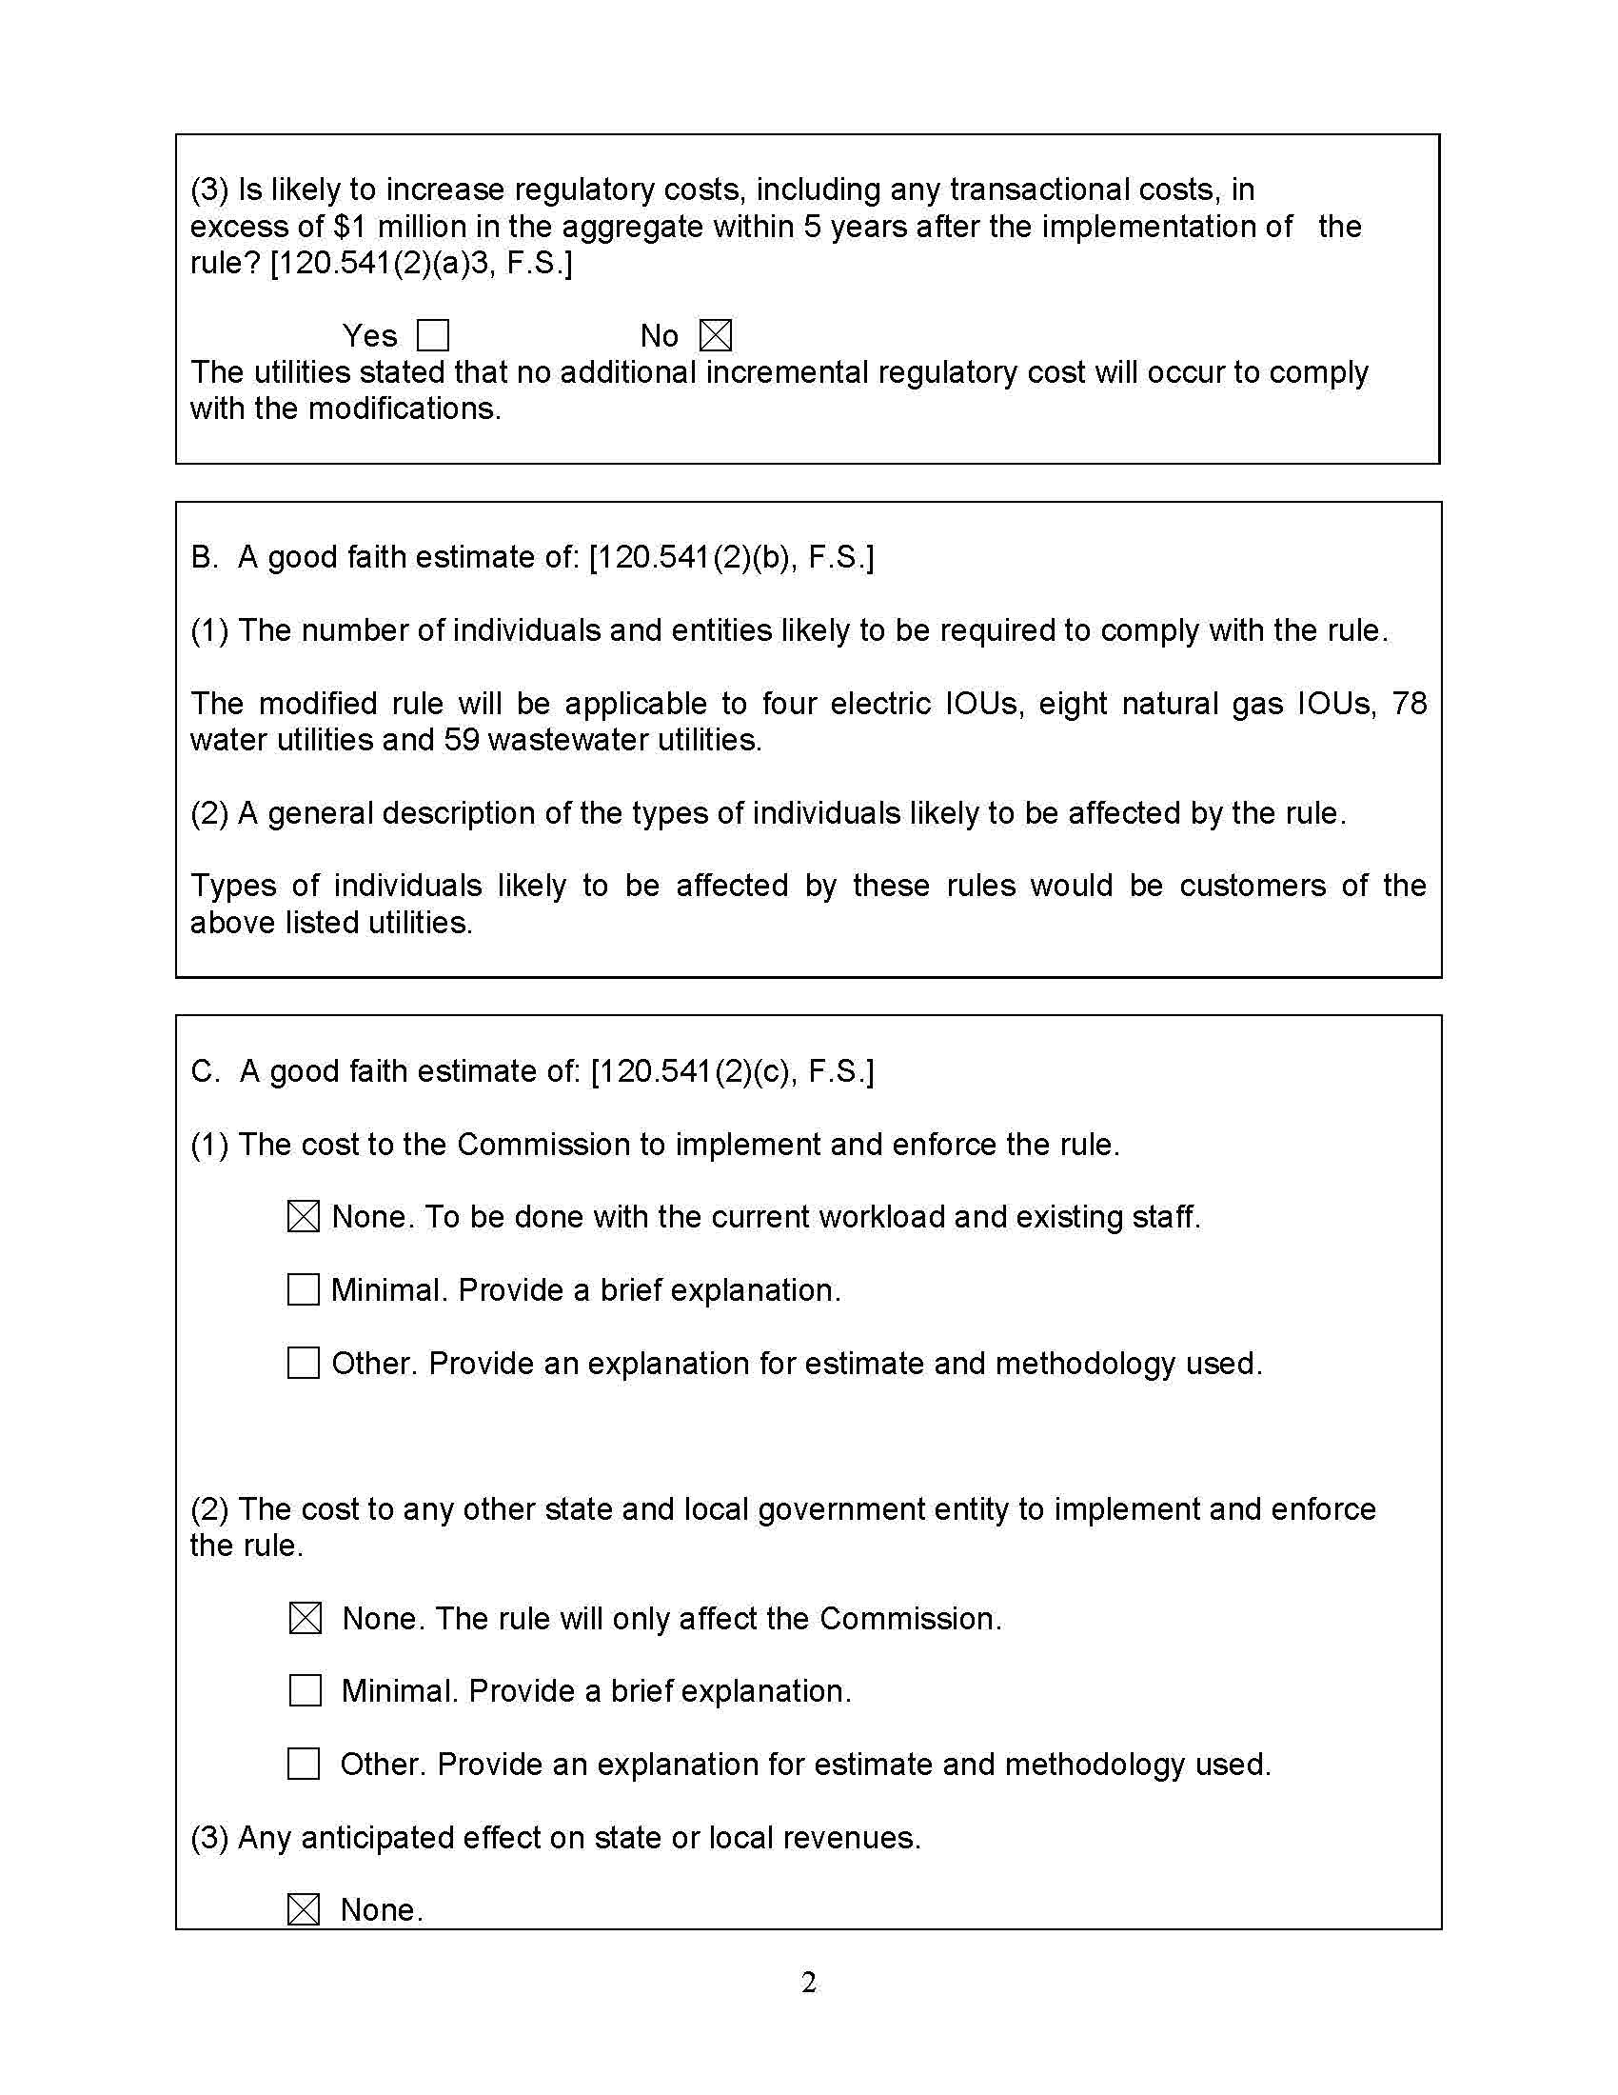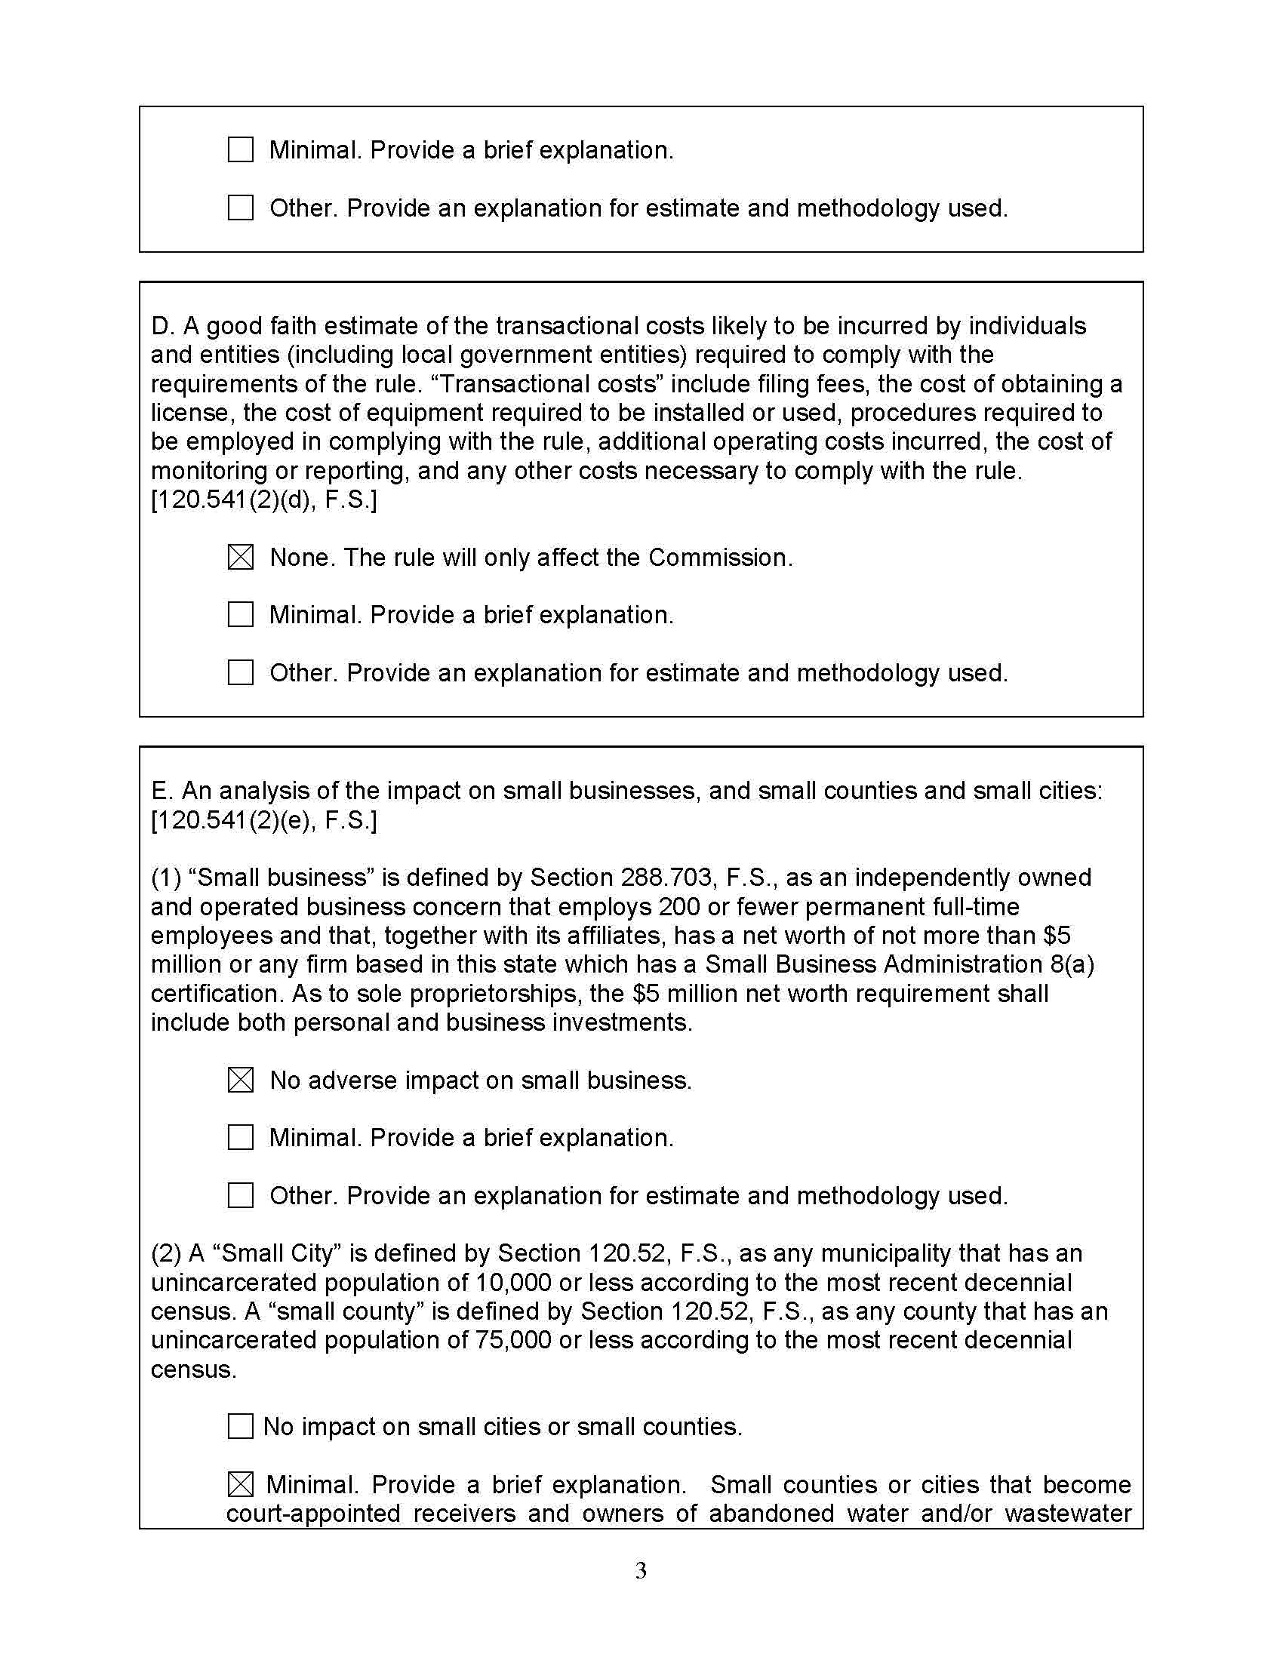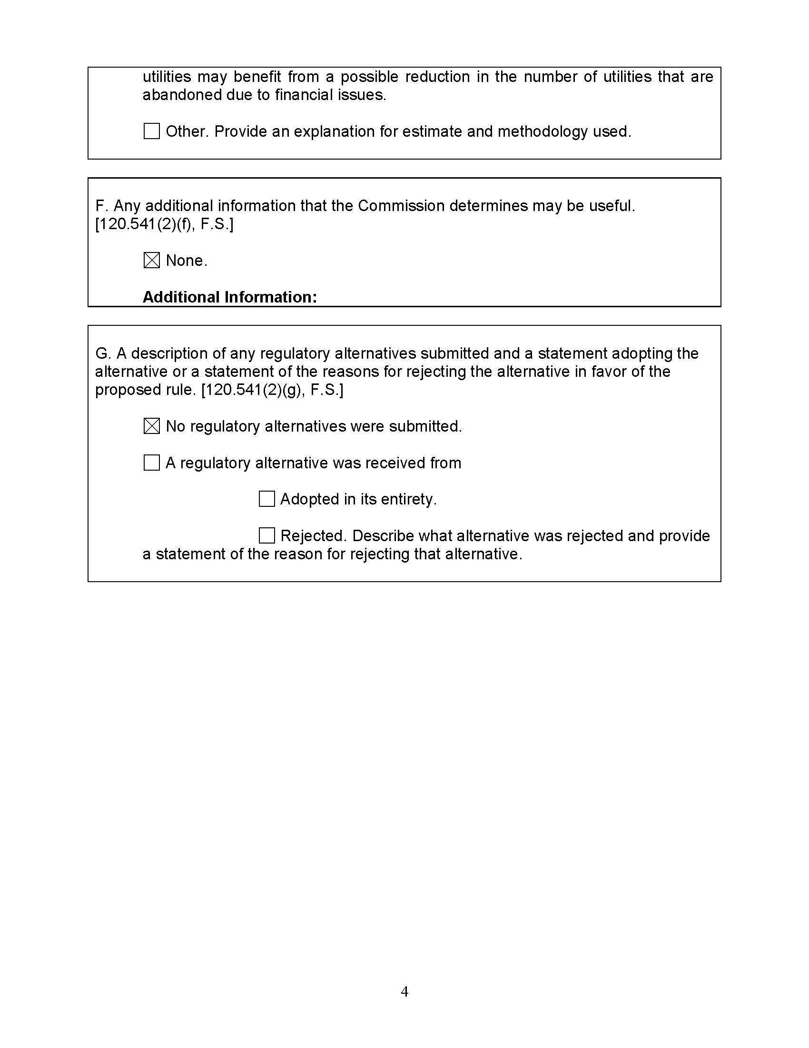

Moreover, the Commission is authorized to allow AFUDC by Sections 350.115, 366.04(2)(a), (f) 366.06(1), (2), 366.08 F.S.
Rule 25-6.030, F.A.C., requires each investor-owned electric utility to file a petition with the Commission for approval of a storm protection plan. The rule describes the information that must be included in the storm protection plan. Paragraph (2)(b) of the rule defines a project as a specific activity designed to enhance a specified portion of existing electric transmission or distribution facilities for the purpose of reducing restoration costs and outage times, and improving overall service reliability.
See Draft Rules 25-6.0141(2)(a)2., 25-7.0141(2)(a)2., 25-30.116(2)(a)2., F.A.C.
See Subparagraphs (2)(a)1. and (2)(b)2., and subsection (9) of Draft Rule 25-6.0141, F.A.C.

