BEFORE THE FLORIDA PUBLIC SERVICE COMMISSION

In re: Petition for a limited proceeding to approve fourth SoBRA, by Tampa Electric Company. | DOCKET NO. 20200064-EI  ORDER NO. PSC-2020-0448-TRF-EI  ISSUED: November 20, 2020

The following Commissioners participated in the disposition of this matter:

GARY F. CLARK, Chairman
ART GRAHAM
JULIE I. BROWN
DONALD J. POLMANN
ANDREW GILES FAY

ORDER GRANTING TAMPA ELECTRIC COMPANY’S PETITION FOR
APPROVAL OF FOURTH SOLAR BASE RATE ADJUSTMENT
AND APPROVING TARIFF

BY THE COMMISSION:

Background
By Order No. PSC-2017-0456-S-EI, issued on November 27, 2017, we approved Tampa Electric Company’s (TECO or Company) Amended and Restated Stipulation and Settlement Agreement (2017 Settlement). The 2017 Settlement allows for the inclusion into base rates of up to 600 megawatts (MW) of solar projects which meet certain criteria through a Solar Base Rate Adjustment (SoBRA) mechanism.
On June 5, 2018, we approved TECO’s First SoBRA tranche which consisted of two solar projects, Payne Creek and Balm, with a total installed capacity of 144.7 MW. On December 7, 2018, we approved TECO’s Second SoBRA tranche which consisted of five solar projects, Lithia, Grange Hall, Bonnie Mine, Peace Creek, and Lake Hancock, with a total installed capacity of 261.3 MW. On November 12, 2019, we approved TECO’s Third SoBRA tranche which consisted of two solar projects, Wimauma and Little Manatee River, with a total installed capacity of 149.3 MW. A Fourth tranche of 50 MW is available contingent upon meeting certain criteria tied to the projects in the First and Second SoBRA tranches, which is addressed below.
By Order No. PSC-2020-0224-AS-EI, issued June 30, 2020, we approved TECO’s 2020 Settlement Agreement (2020 Settlement). The 2020 Settlement addressed, among other issues, how to calculate the average installed costs for the First and Second SoBRA tranches. On September 4, 2020, we approved TECO’s true-up of the First and Second SoBRAs in Order No. PSC-2020-0303-PAA-EI (True-Up Order), which include a reduction in revenue requirements to be implemented along with the TECO’s Fourth SoBRA revenue requirement calculation.
On February 27, 2020, as required by the 2017 Settlement, TECO notified this Commission that it intended to seek approval of a Fourth SoBRA tranche. On July 31, 2020, TECO filed a petition for approval of the Fourth SoBRA tranche, the last allowed by the 2017 Settlement, which consists of one solar project, Durrance, with a total installed capacity of 45.7 MW. We have jurisdiction pursuant to Sections 366.06 and 366.076, Florida Statutes (F.S.).

Decision
Paragraph 6 of the 2017 Settlement outlines the conditions under which TECO may seek cost recovery of certain solar facilities for all SoBRA tranches, with additional requirements for the availability of the Fourth SoBRA tranche.
Cost Recovery Eligibility
The Fourth SoBRA tranche consists of a single solar project, Durrance, located in Polk County, with a projected in-service date on or before January 1, 2021. While the Durrance project will be installed at a total capacity of 60.1 MW, TECO is only seeking recovery of 45.7 MW through the SoBRA mechanism. We previously approved a portion of a solar project for recovery through the 2017 Settlement in a stipulation approving the Second SoBRA Tranche for the Lake Hancock Solar project. The recovery for the remaining 14.4 MW may be addressed in a future docket.
Subparagraph 6(c) of the 2017 Settlement outlines the conditions under which TECO may seek cost recovery of a Fourth SoBRA tranche with up to an additional 50 MW of solar capacity. These conditions include that the projects from the First and Second SoBRAs are in-service and operating as designed by December 31, 2019, and the average installed cost is no more than $1,475 per kilowatt of alternating current capacity (kW_{ac}). Pursuant to paragraph 3 of the 2020 Settlement, the weighted average installed cost is determined by the average of the First and Second SoBRA installed costs taken together. The First and Second SoBRA projects’ actual in-service dates were no later than April 25, 2019, and the weighted average installed cost was $1,448/kW_{ac}. The in-service date and installed cost for each project in the First and Second SoBRAs are listed in Table 1.
Table 1
In-Service Dates and Installed Costs for First and Second SoBRA Projects
Project Name | In-Service Date | Installed Cost ($/kW_{ac})
First SoBRA
Payne Creek Solar | September 1, 2018 | 1,342
Balm Solar | September 27, 2018 | 1,478
Second SoBRA
Lithia Solar | January 1, 2019 | 1,481
Grange Hall Solar | January 2, 2019 | 1,430
Peace Creek Solar | March 1, 2019 | 1,479
Bonnie Mine Solar | January 23, 2019 | 1,496
Lake Hancock Solar | April 25, 2019 | 1,459
Source: Order No. PSC-2020-0303-PAA-EI, issued September 4, 2020 in Docket No 20200144-EI,
In re: Petition for limited proceeding to true-up first and second SoBRA, by Tampa Electric Company
TECO is eligible for cost recovery of the Fourth SoBRA project, Durrance, under the conditions outlined in paragraph 6 of the 2017 Settlement and paragraph 3 of the 2020 Settlement, on the requested 45.7 MW portion of its solar capacity.

Cost-Effectiveness
Subparagraph 6(g) of the 2017 Settlement states that the cost-effectiveness for SoBRA project(s) shall be evaluated based only on whether the projects in the SoBRA will lower the Company’s overall projected system cumulative present value revenue requirement (CPVRR) as compared to the system without the SoBRA project(s). This compares the cost of the added generation, transmission, operations and maintenance (O&M) and other expenses of the proposed solar project(s) to the avoided traditional generation, transmission, fuel, and O&M expenses that would otherwise have been incurred if the facilities had not been constructed.
Overall, TECO estimates that the 45.7 MW portion of the Durrance project included in the Fourth SoBRA produces projected system CPVRR savings of $31.0 million without accounting for costs associated with carbon emissions. Using TECO’s base case estimate for avoided carbon costs would increase system savings by $7.2 million to a total of $38.3 million, while its high scenario would increase system savings by $24.2 million to a total of $55.2 million. Even if the total 60.1 MW capacity of Durrance project is considered, the project still produces savings of $39.9 million without consideration of carbon costs.
As part of its analysis, TECO used a non-standard value of deferral for avoided generation. As discussed in the stipulations approving each of the prior SoBRA tranches, the parties agreed to use a pro-rata share of the avoided generation benefits of the full 600 MW of all SoBRAs combined. As TECO witness Aponte admits in his testimony, the Fourth SoBRA project does not avoid any generation, but credits the unit for $34.5 million in savings based on its share of the 600 MW SoBRA capacity. This value was calculated based on the Company’s current avoided unit, a reciprocating engine. However, at the time of approval of the 2017 Settlement, and in its three prior SoBRA dockets, TECO used a combustion turbine as the avoided unit, which has a lower capacity cost. If this change in unit type did not occur, the value of deferral would be reduced by $10.3 million to $24.3 million in savings. Even with this reduction, the Fourth SoBRA is projected to be cost-effective and reduce system costs by $20.8 million without consideration of carbon costs. The results of each of the carbon scenarios and the avoided unit comparisons are summarized in Table 2.
Table 2
Cost-Effectiveness Analysis Results
CO₂ Emissions | Avoided Unit and Capacity Comparisons
 | Reciprocating Engine (45.7 MW) | Reciprocating Engine (60.1 MW) | Combustion Turbine (45.7 MW)
CPVRR ($ Millions)
Low | 31.0 | 39.9 | 20.8
Base | 38.3 | 50.9 | 28.0
High | 55.2 | 77.2 | 45.0
Source: Exhibit JAA-1 from Document No. 04171-2020.
The 45.7 MW portion of the Durrance project included in TECO’s Fourth SoBRA will lower the Company’s projected system costs as compared to the system without the solar project; therefore, the Fourth SoBRA is considered to be cost-effective under subparagraph 6(g) of the 2017 Settlement.
Installed Costs
Subparagraph 6(d) of the 2017 Settlement specifies a $1,500 per kWac installed cost cap for each SoBRA project. The estimated direct installed cost of the Durrance project is $66.7 million, or approximately $1,460 per kWac. In addition, TECO is claiming Allowance for Funds Used During Construction (AFUDC) of approximately $1.9 million. The total all-in-cost is $68.6 million or $1,500 per kWac which is equal to the $1,500 per kWac installed cost cap specified in subparagraph 6(d) of the 2017 Settlement. The projected installed costs for the Durrance project are listed in Table 3 by subcategory.
Table 3
Projected Installed Cost for Fourth SoBRA
Projected Cost | Cost ($ Million) | Cost ($ per kWac)
Major Equipment and Balance of System | 55.3 | 1,210
Development | 1.6 | 35
Transmission Interconnect | 3.0 | 66
Land | 5.8 | 127
Owner’s Cost | 1.0 | 22
AFUDC | 1.9 | 41
Total | 68.6 | 1,500
Source: Exhibit MDW-1 from Document No. 04171-2020
The estimated installed cost of the Durrance project in the Fourth SoBRA is $1,500 per kWac, which is equal to the installed cost cap specified in subparagraph 6(d) of the 2017 Settlement.

Annual Revenue Requirement
In 2017, TECO received authorization for a framework to recover costs associated with the construction and operation of a then-conceptual series of solar generating facilities. The framework included conditions by which the Company can petition this Commission to implement project-specific estimated annual revenue requirements, beginning on specified dates, subject to certain agreed-upon conditions. In particular, the effective date of the Fourth SoBRA’s rate adjustment can be no earlier that January 1, 2021, and that incremental annual revenue requirement may not exceed $10.2 million.
The Company is requesting that we approve an estimated annual revenue requirement based on the projected installed cost of the single project comprising the Fourth SoBRA, Durrance. The projected annual revenue requirement for the Fourth SoBRA project also includes a relatively minor revenue requirement revision stemming from the Company’s “trued-up” First and Second SoBRA projects. This amount, $77,000, identified in the True-Up Order, was ordered to be carried forward and applied to the Company’s Fourth SoBRA/instant request.
The cumulative Fourth SoBRA annual revenue requirement is initially formulated using an estimated capital cost (Issue 3). Other delineated components of the revenue requirement include operation and maintenance expenses, depreciation expense, financing costs, insurance costs, and taxes. The proposed estimated total annual revenue requirement associated with TECO’s Fourth SoBRA is $7,611,000. This amount consists of an estimated capital cost of $6,802,000, an annual fixed operation and maintenance expense of $244,000, and land-associated costs in the amount of $564,000. However, after the incorporation of the revenue requirement revision identified in the True-Up Order, the annual revenue requirement associated with TECO’s Fourth SoBRA project is $7,534,000.

Table 4 displays the total estimated annual Fourth SoBRA revenue requirement by cost category, as well as the estimated-to-actual annual revenue requirement revision from the First and Second SoBRA projects.
Table 4
Fourth SoBRA Estimated Annual Revenue Requirement
Plant Durrance | Revenue Requirement ($000)
Capital | $6,802
Fixed Operation & Maintenance | 244
Land | 564
Fourth SoBRA Revenue Requirement Subtotal | 7,611
True-Up | ($77)
Grand Total* | $7,534
Source: Prepared Direct Testimony and Exhibit of TECO witness Jose A. Aponte, Exhibit (JAA-1),
Document No. 3.
*May not compute exactly due to rounding.
The estimated annual revenue requirement associated with TECO’s Fourth SoBRA project is $7,534,000.

Base Rate Increase

TECO Witness Ashburn in his testimony filed on July 31, 2020, provides the proposed tariffs and base rates to reflect the annual revenue requirement increase of $7,534,000. Witness Ashburn states that the base rate increase was allocated to the rate classes as required by the 2017 Settlement. For a residential customer using 1,000 kilowatt-hours, the base rate increase will be $0.44. Commercial customers will see base rate increases between 0.5 and 1 percent, depending on usage. Based on the calculations provided by Witness Ashburn, we find that the base rate increase was calculated in accordance with the 2017 Settlement.

Based on the foregoing, it is

ORDERED by the Florida Public Service Commission that Tampa Electric Company’s Petition for Approval of the Fourth Solar Base Rate Adjustment is granted. It is further

ORDERED that Tampa Electric Company’s proposed tariff, as shown in Attachment A, is approved effective with the first billing cycle of January 2021. It is further

ORDERED that if a protest is filed within 21 days of issuance of the Order, the tariff shall remain in effect with any charges held subject to refund pending resolution of the protest. It is further

ORDERED that if no timely protest is filed, this docket shall be closed upon the issuance of a Consummating Order.

By ORDER of the Florida Public Service Commission this 20th day of November, 2020.

/s/ Adam J. Teitzman
ADAM J. TEITZMAN
Commission Clerk
Florida Public Service Commission
2540 Shumard Oak Boulevard
Tallahassee, Florida 32399
(850) 413-6770
www.floridapsc.com

Copies furnished: A copy of this document is provided to the parties of record at the time of issuance and, if applicable, interested persons.
SPS

NOTICE OF FURTHER PROCEEDINGS

The Florida Public Service Commission is required by Section 120.569(1), Florida Statutes, to notify parties of any administrative hearing or judicial review of Commission orders that is available under Sections 120.57 or 120.68, Florida Statutes, as well as the procedures and time limits that apply. This notice should not be construed to mean all requests for an administrative hearing or judicial review will be granted or result in the relief sought.

Mediation may be available on a case-by-case basis. If mediation is conducted, it does not affect a substantially interested person's right to a hearing.

The Commission's decision on this tariff is interim in nature and will become final, unless a person whose substantial interests are affected by the proposed action files a petition for a formal proceeding, in the form provided by Rule 28-106.201, Florida Administrative Code. This petition must be received by the Office of Commission Clerk, 2540 Shumard Oak Boulevard, Tallahassee, Florida 32399-0850, by the close of business on December 11, 2020.

In the absence of such a petition, this Order shall become final and effective upon the issuance of a Consummating Order.

Any objection or protest filed in this docket before the issuance date of this order is considered abandoned unless it satisfies the foregoing conditions and is renewed within the specified protest period.

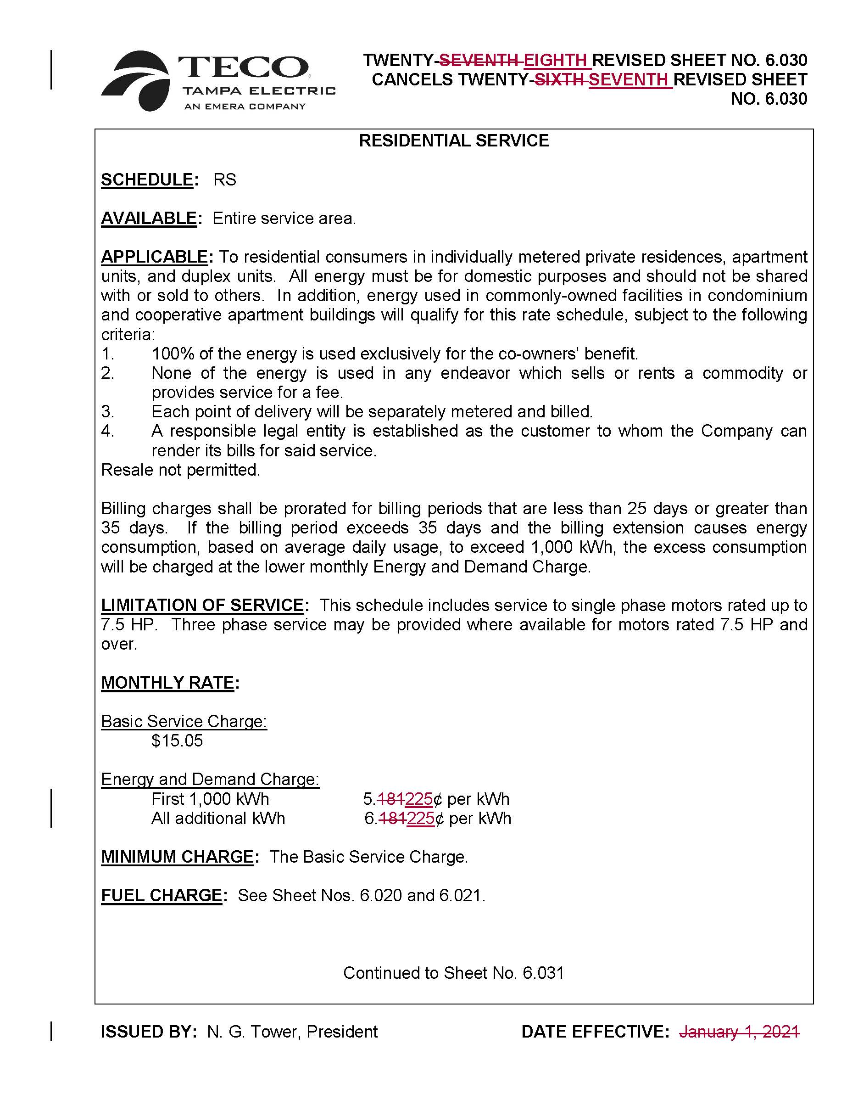

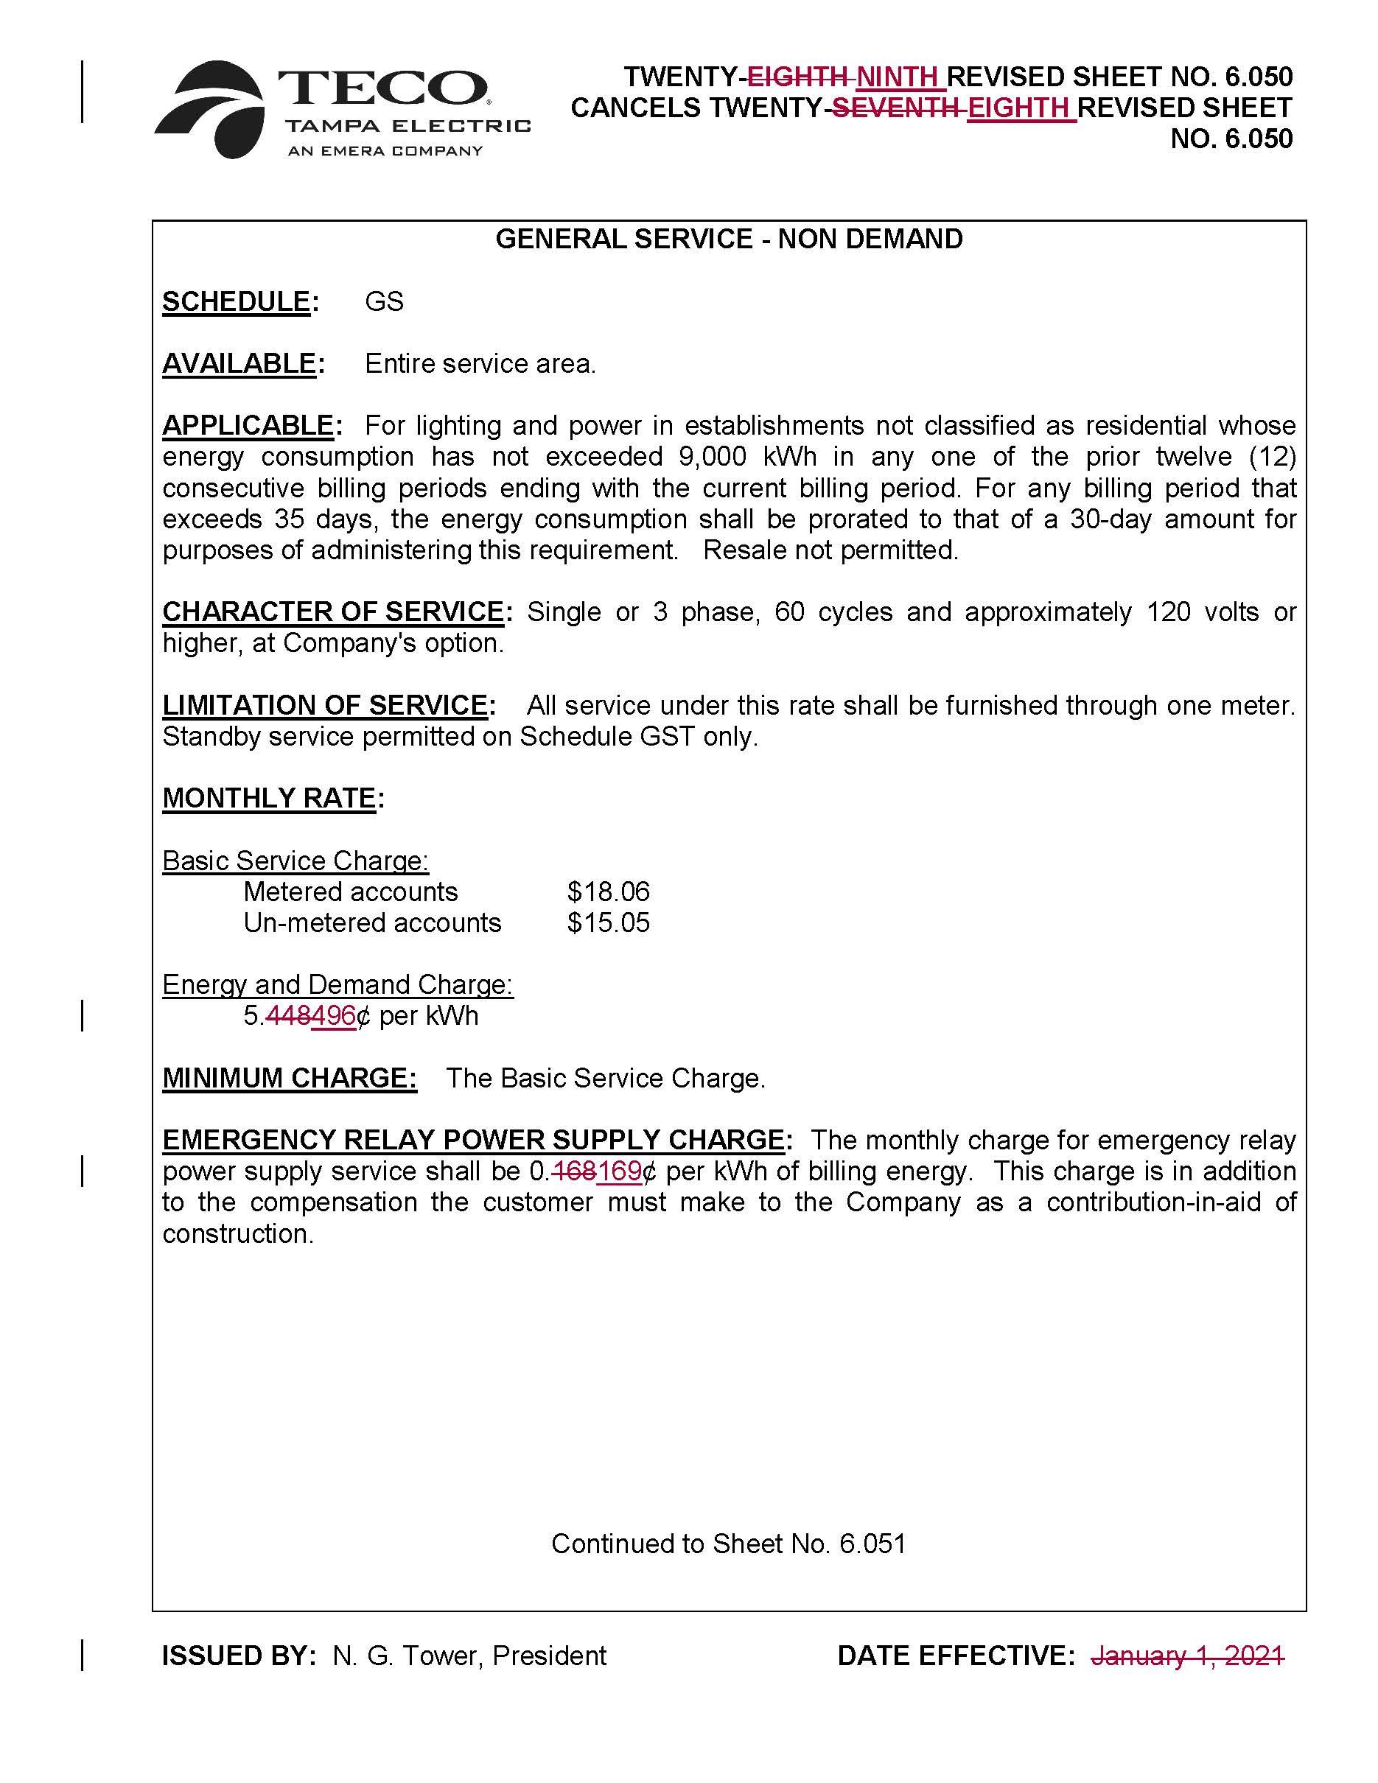
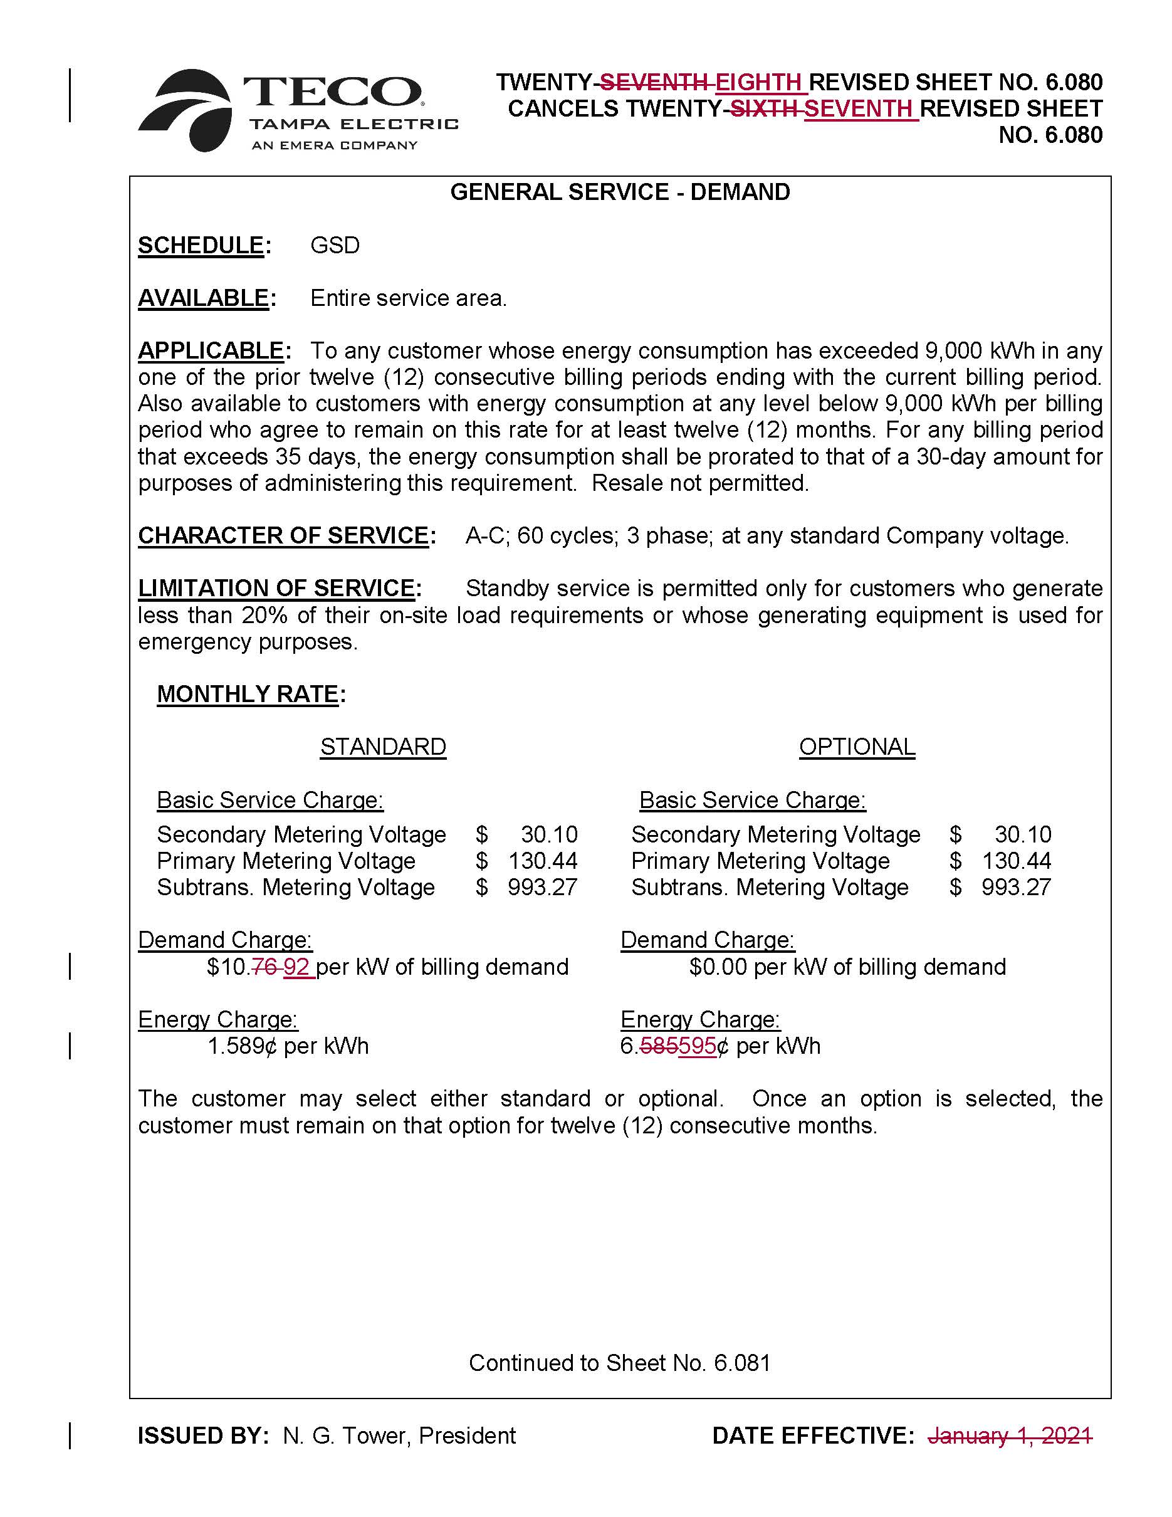
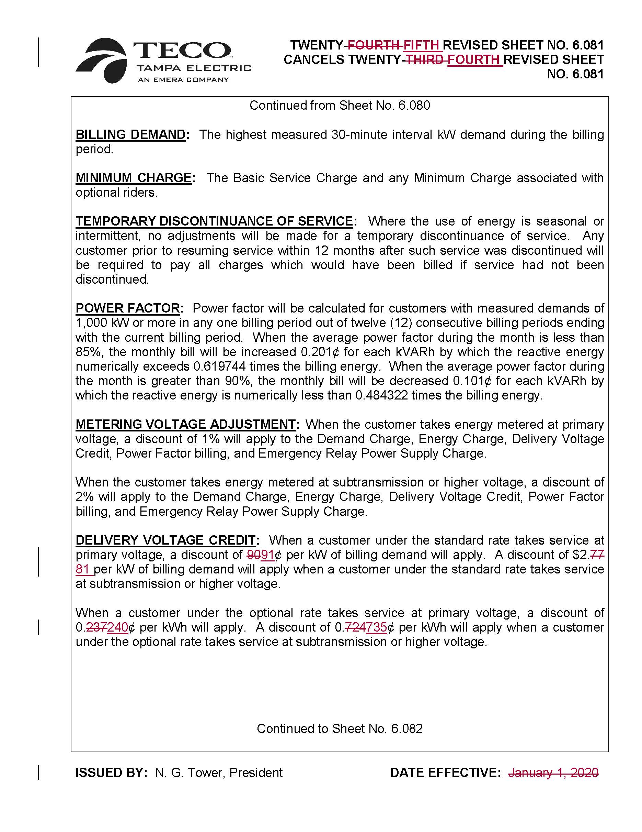
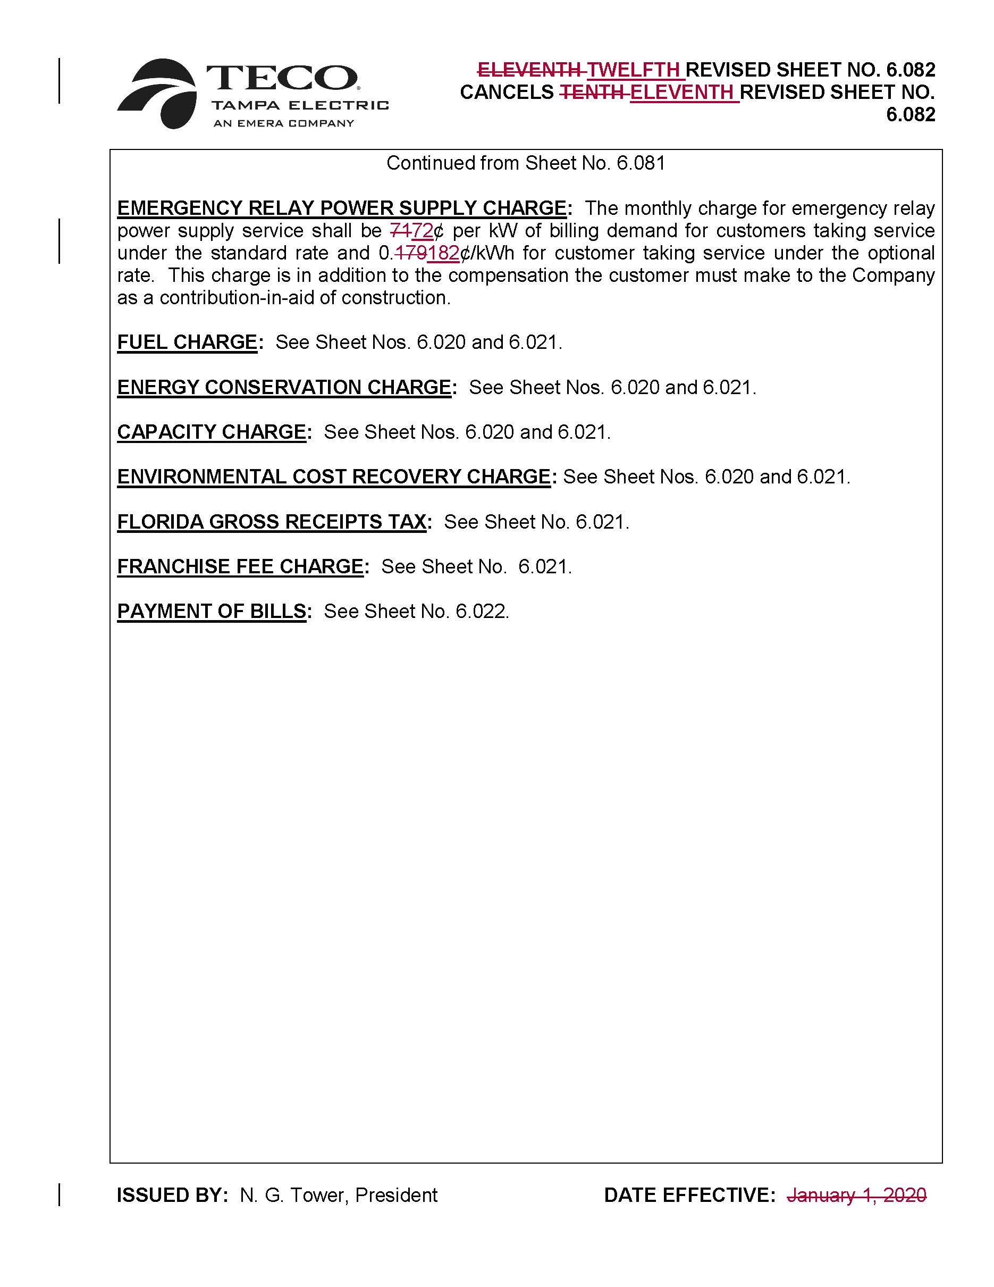
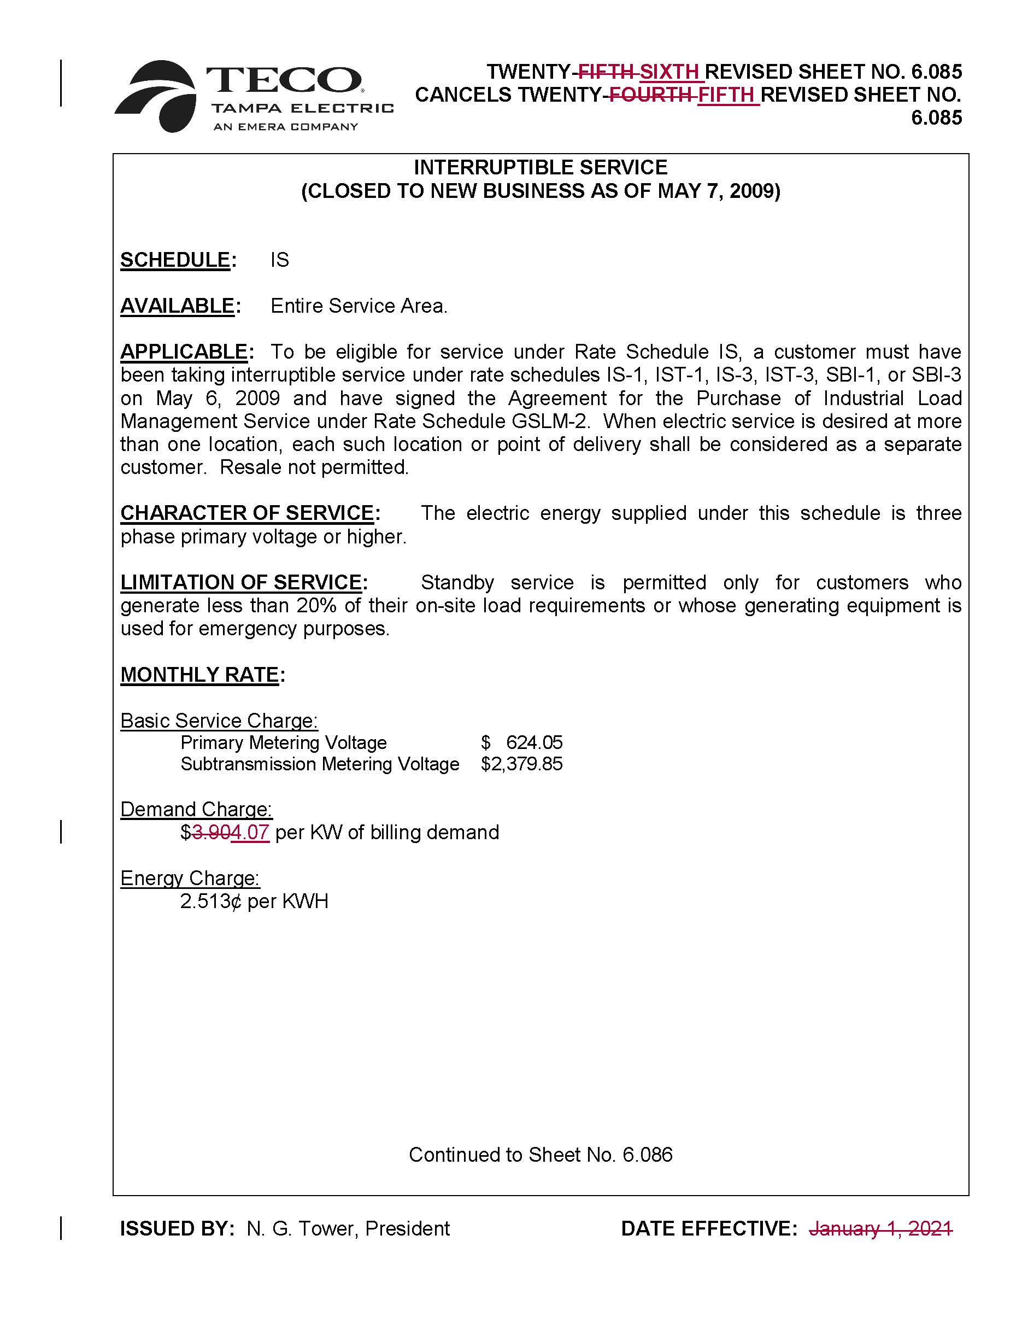
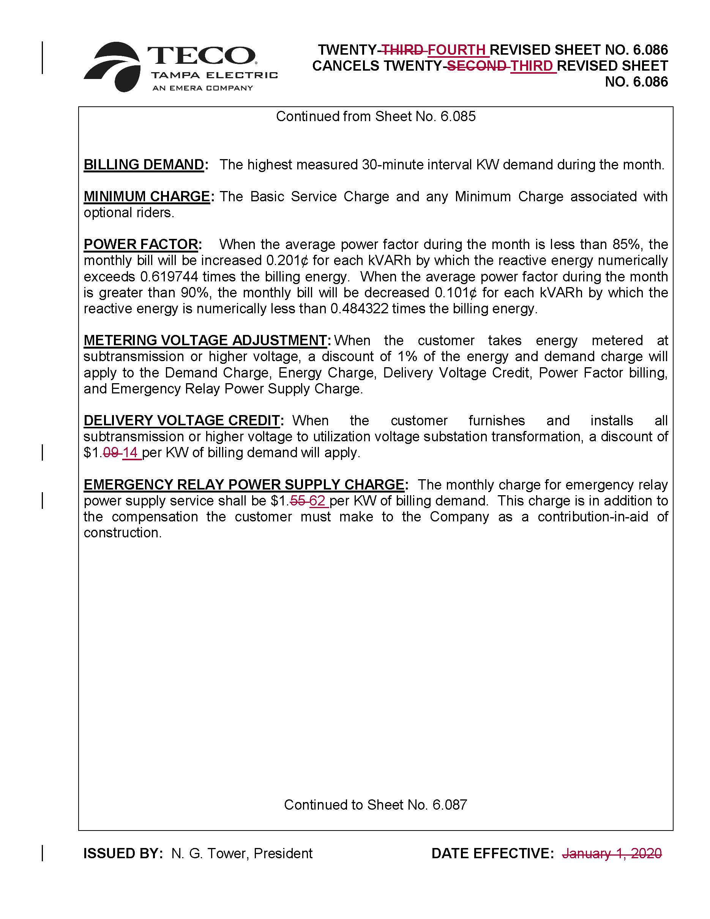
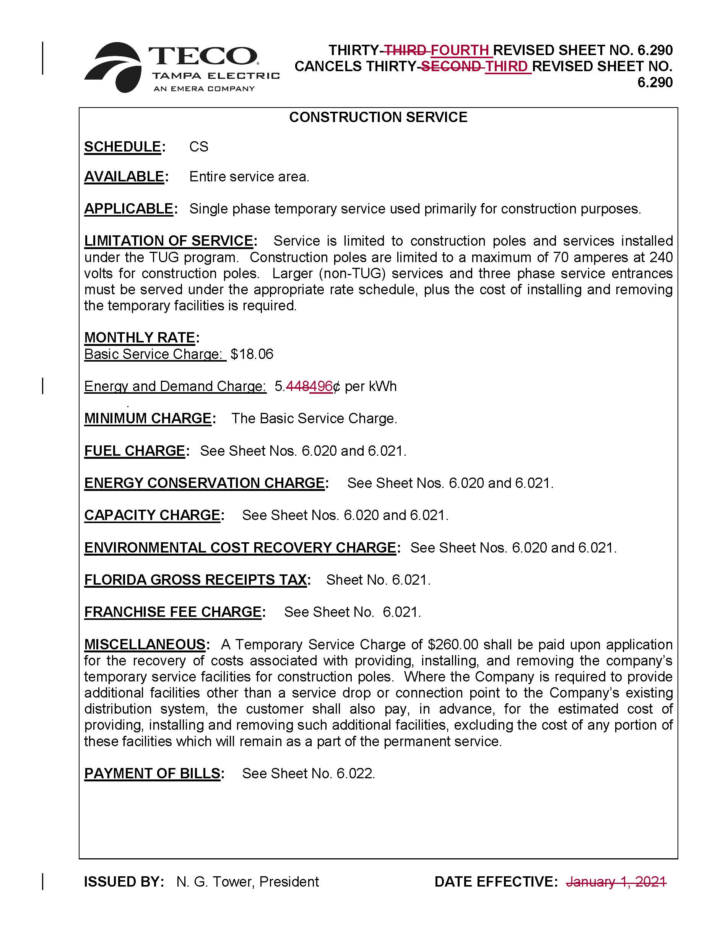

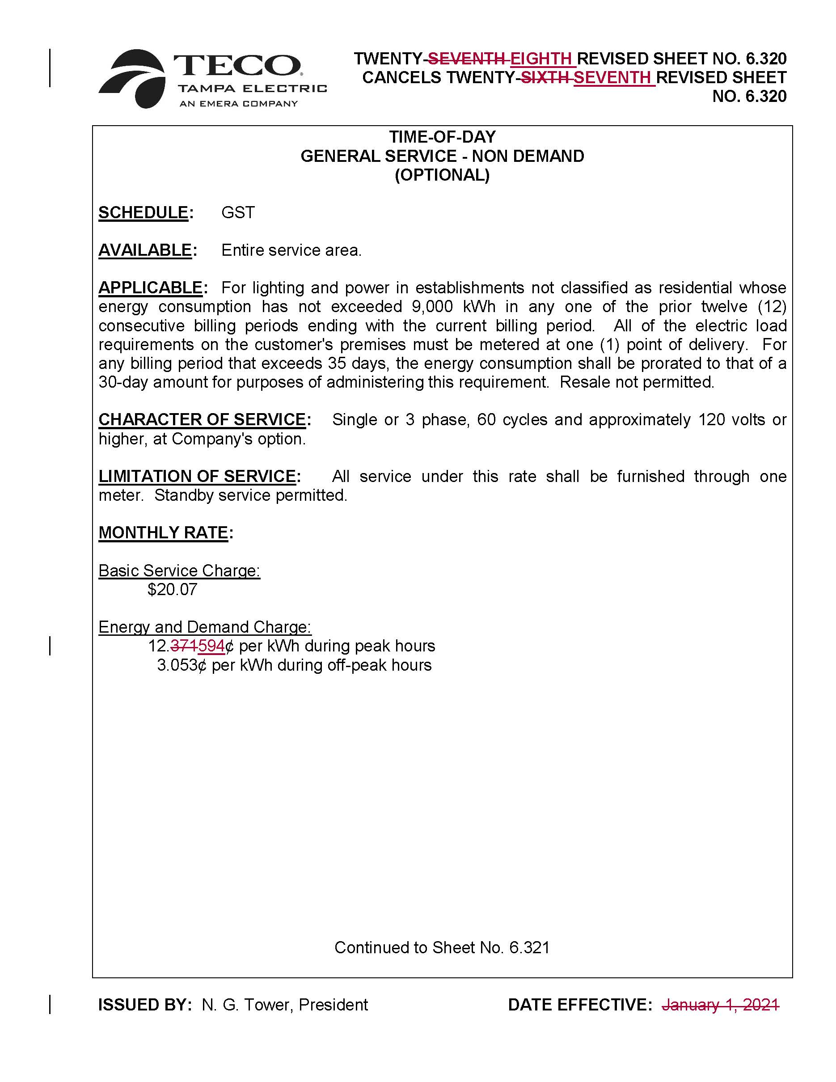
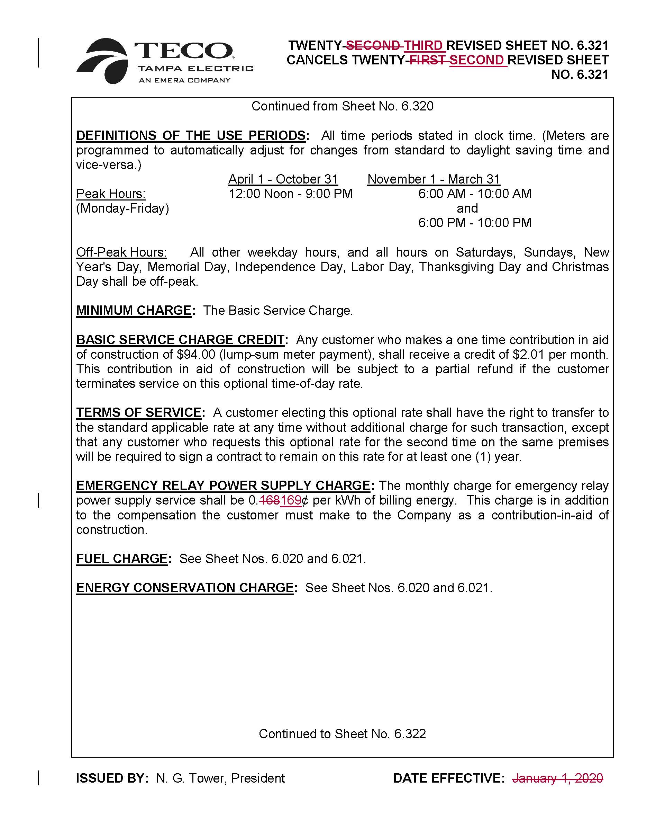
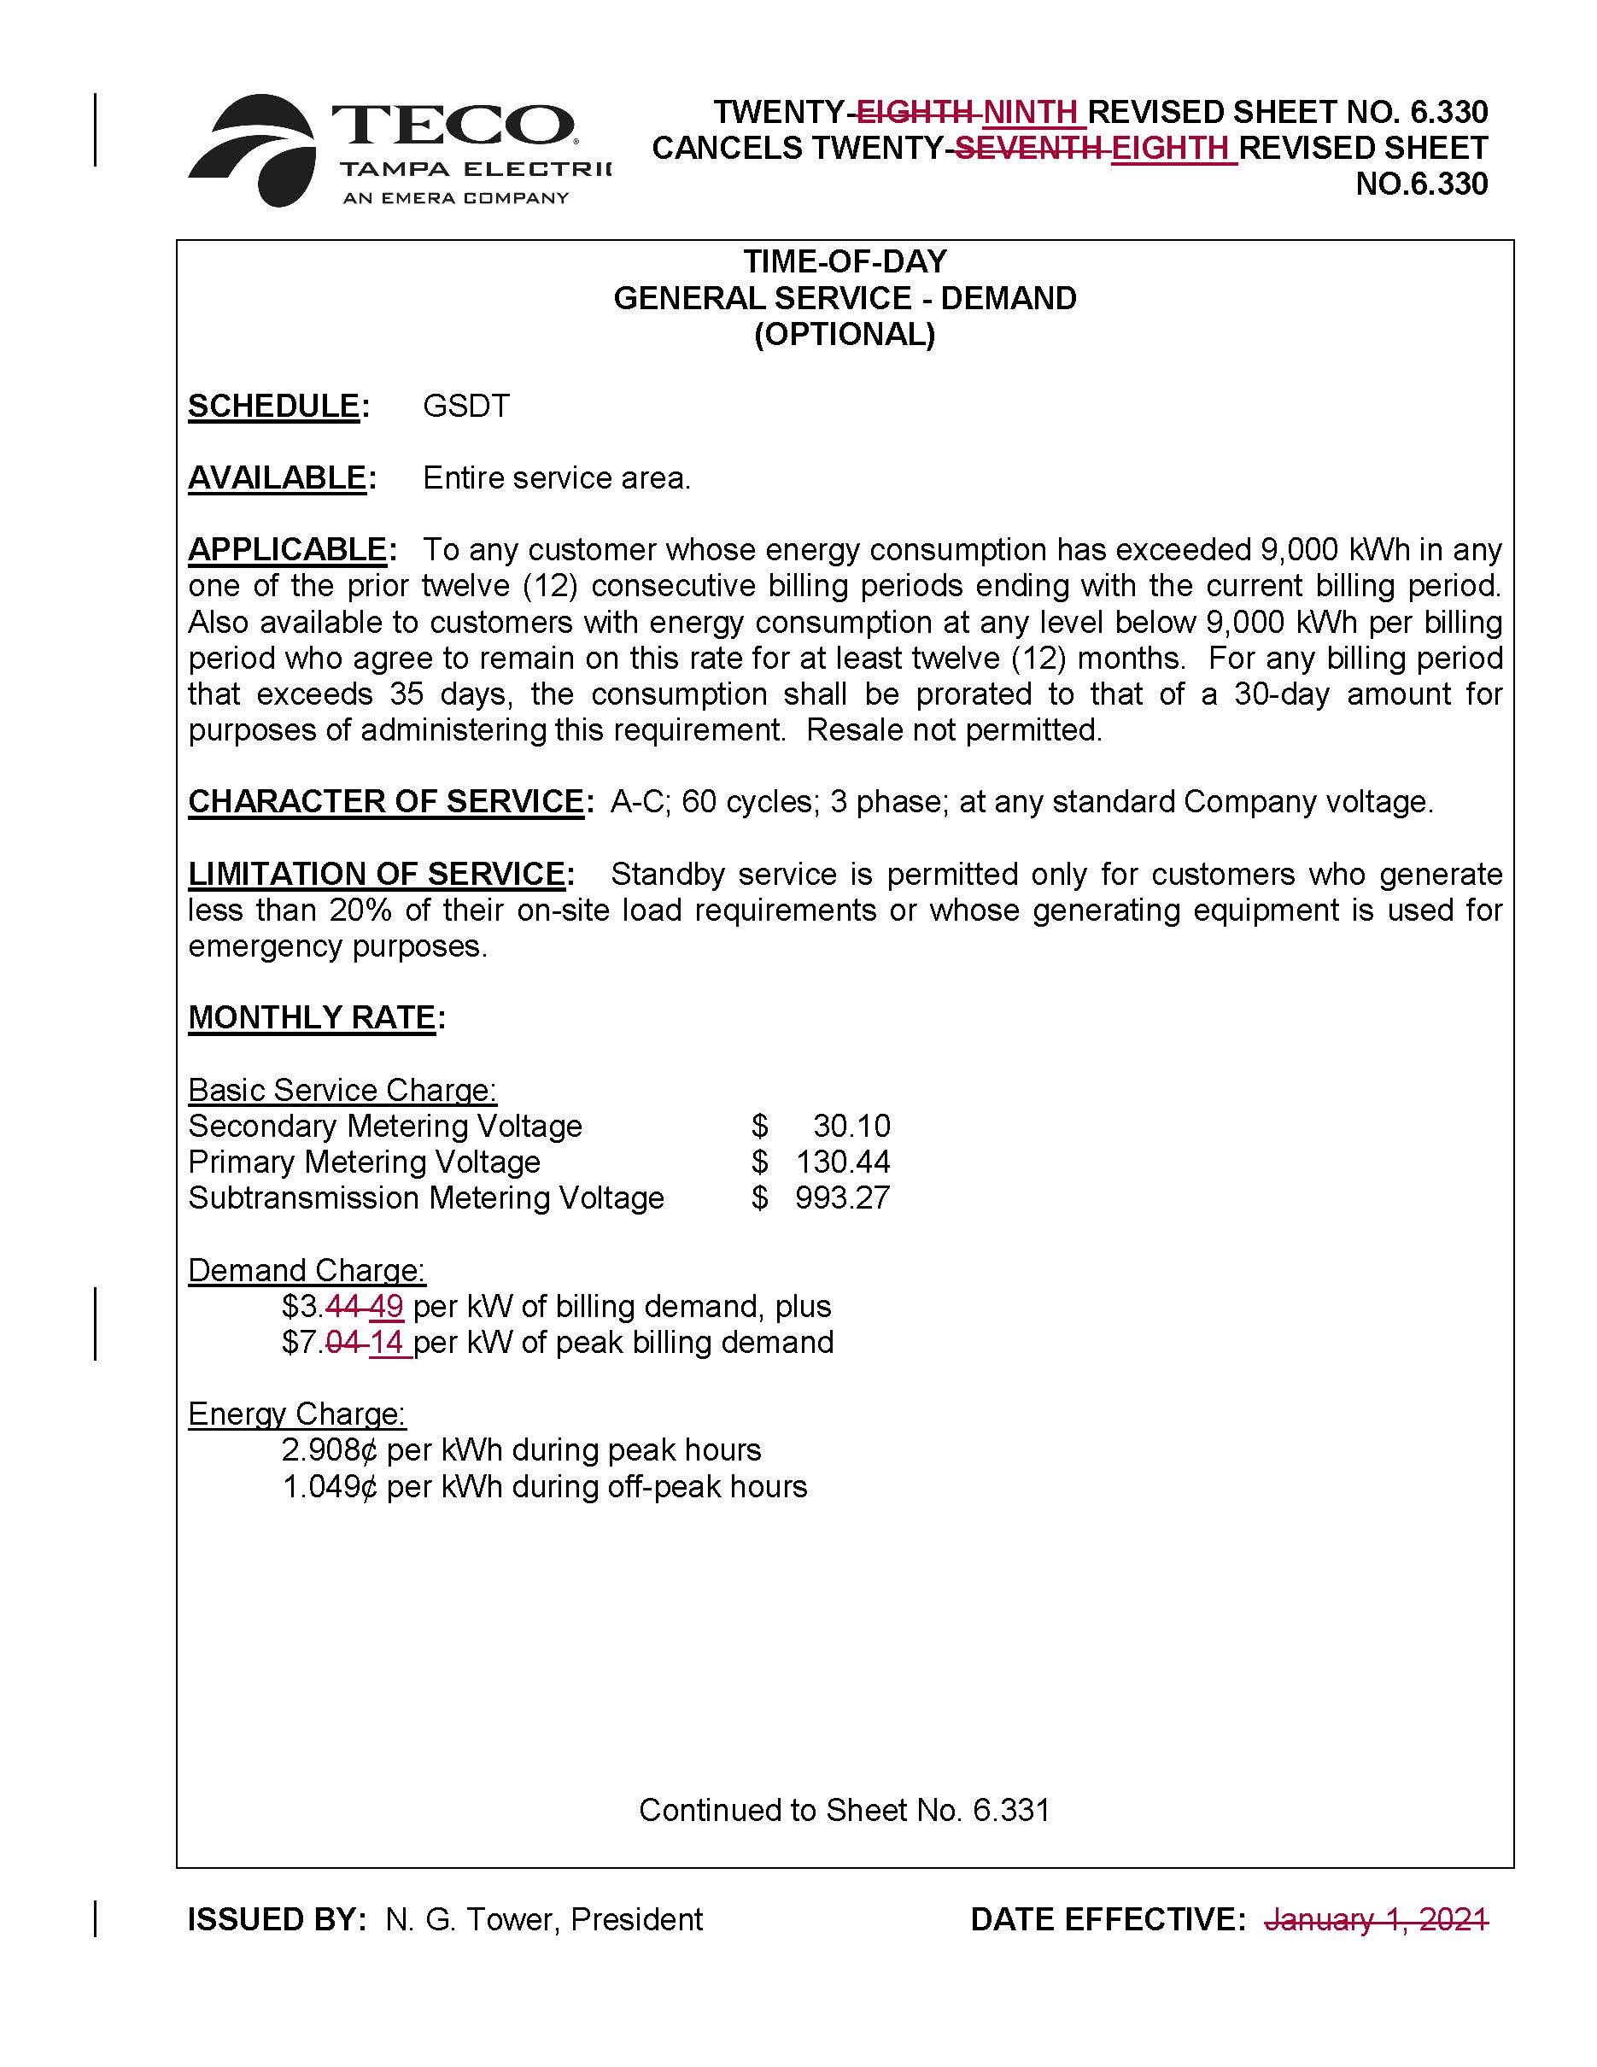
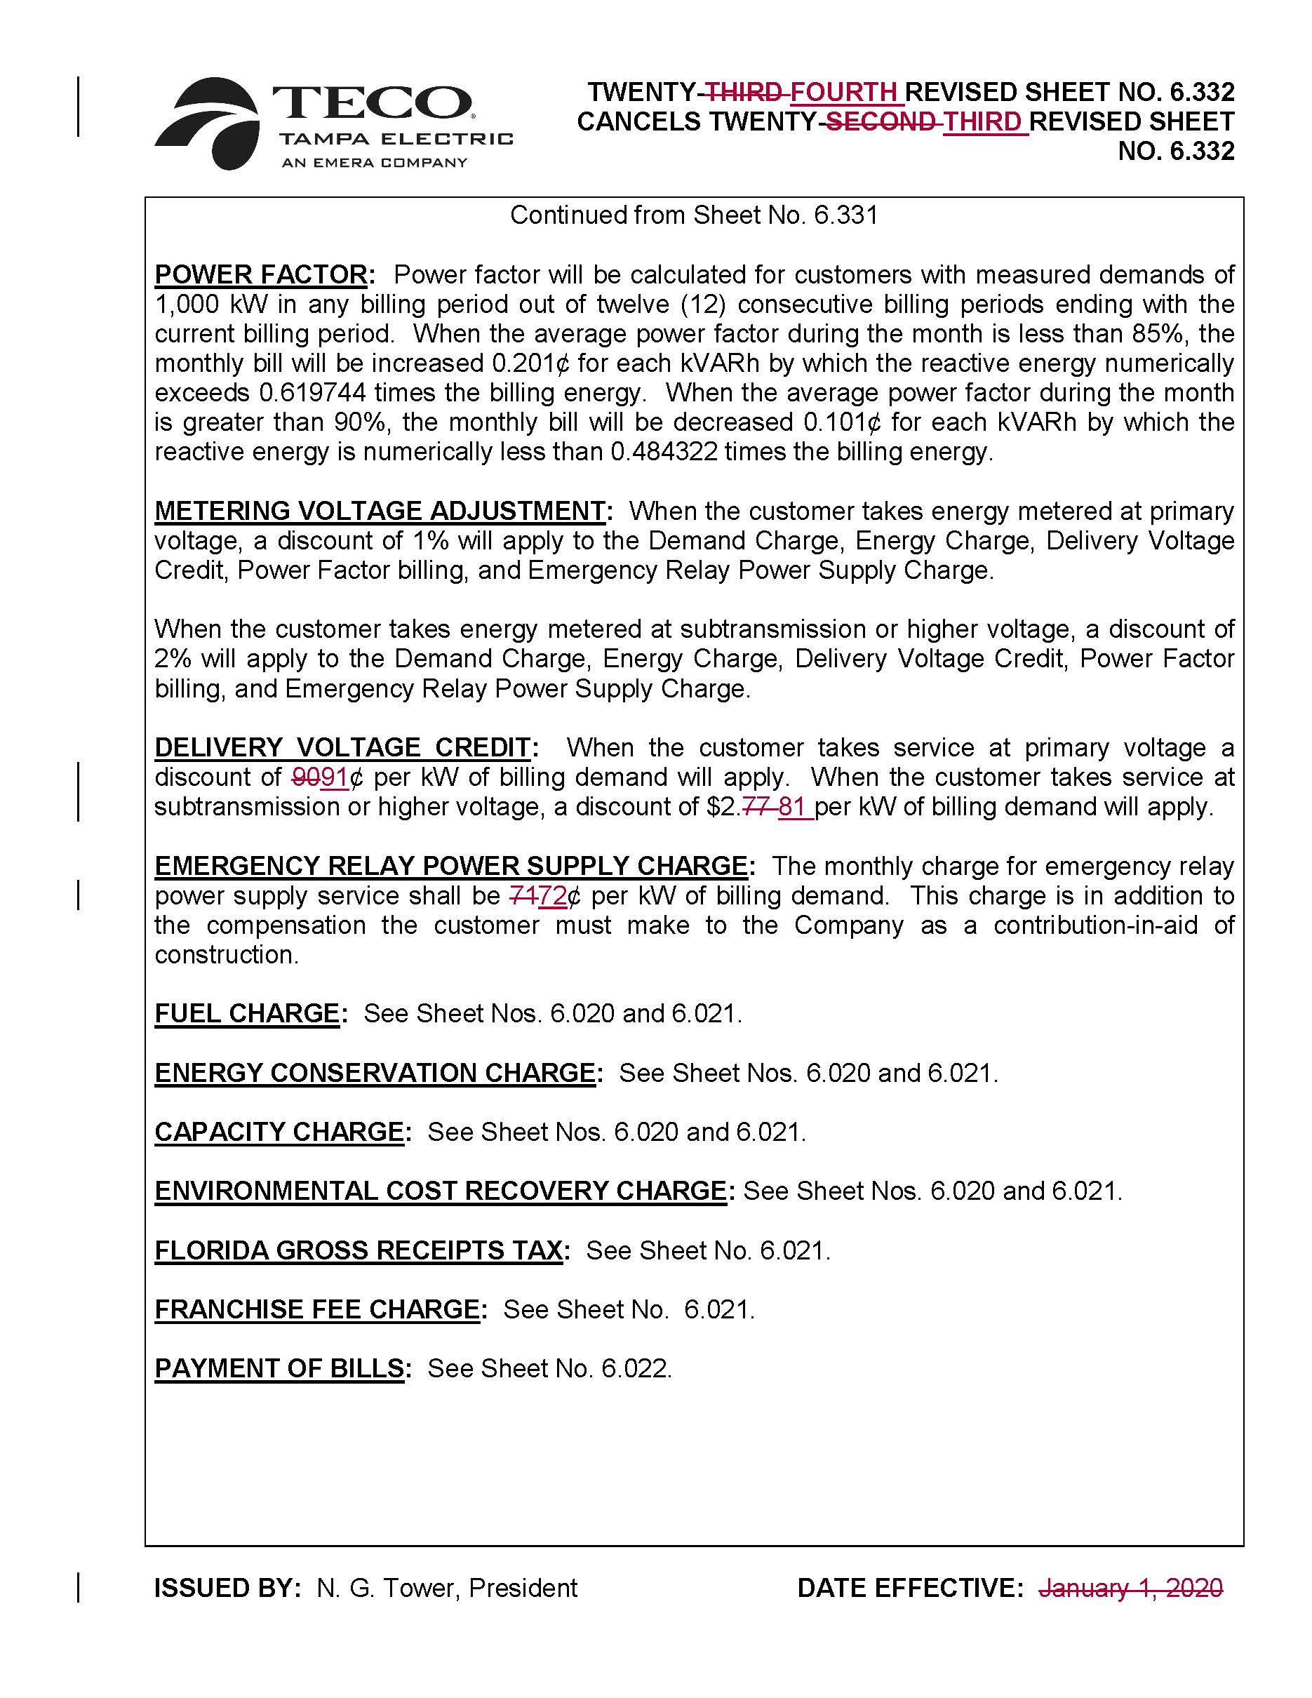
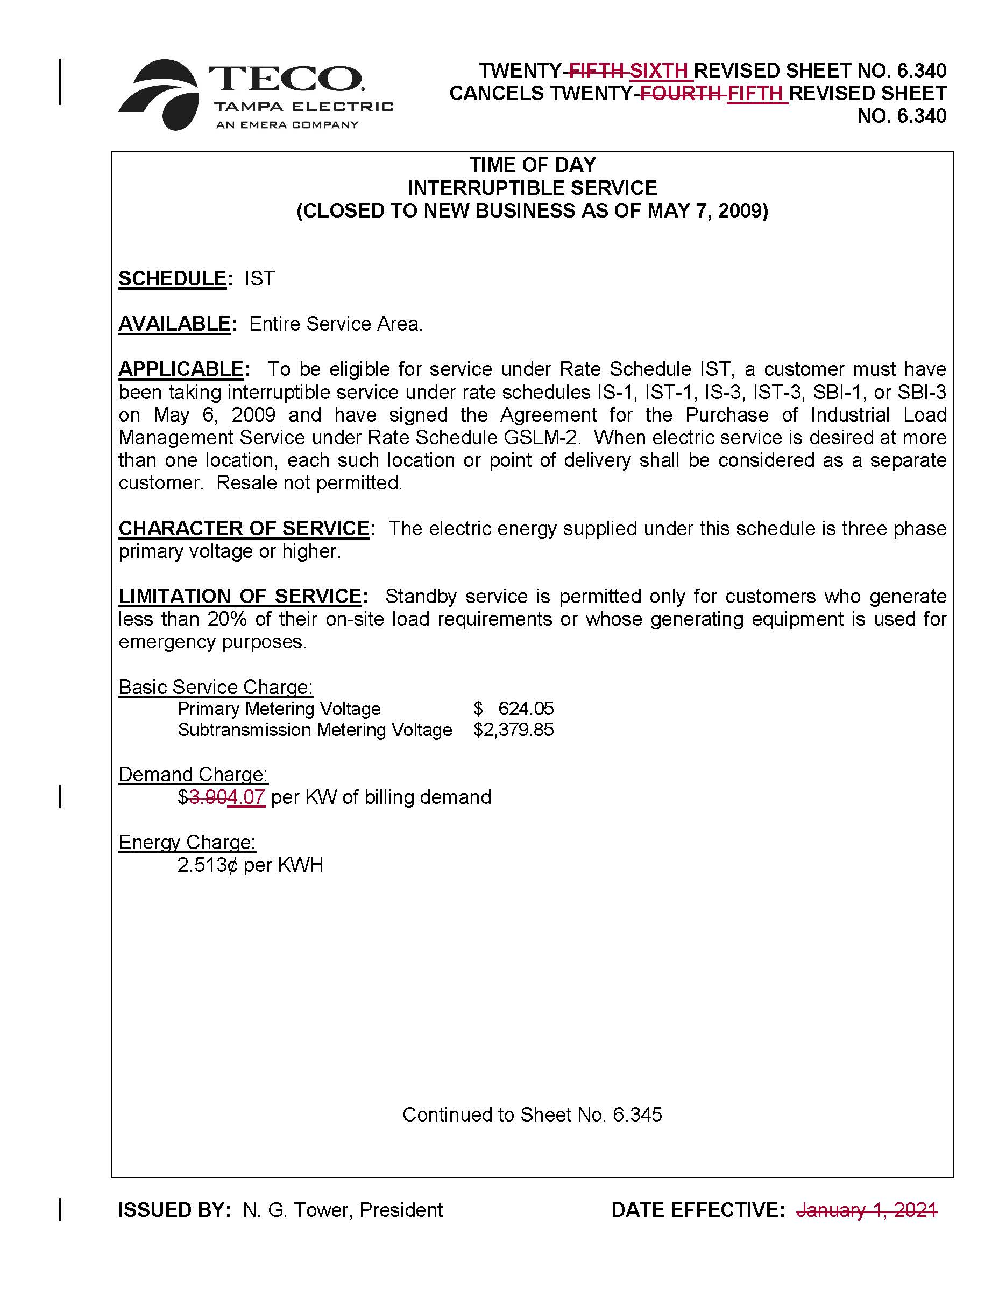
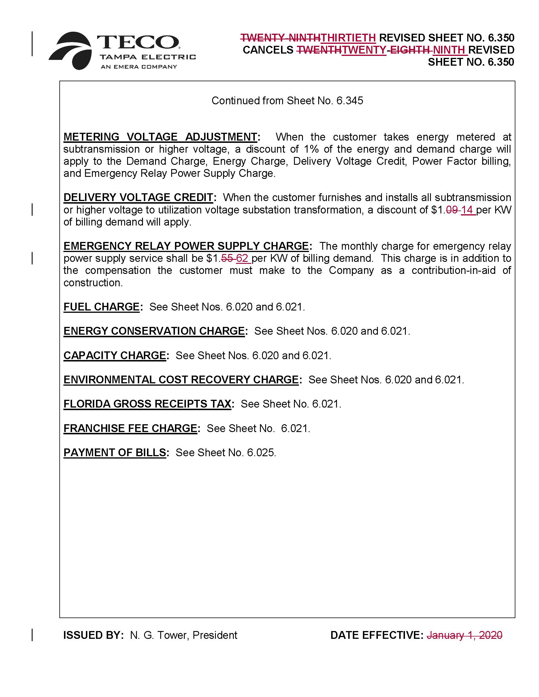
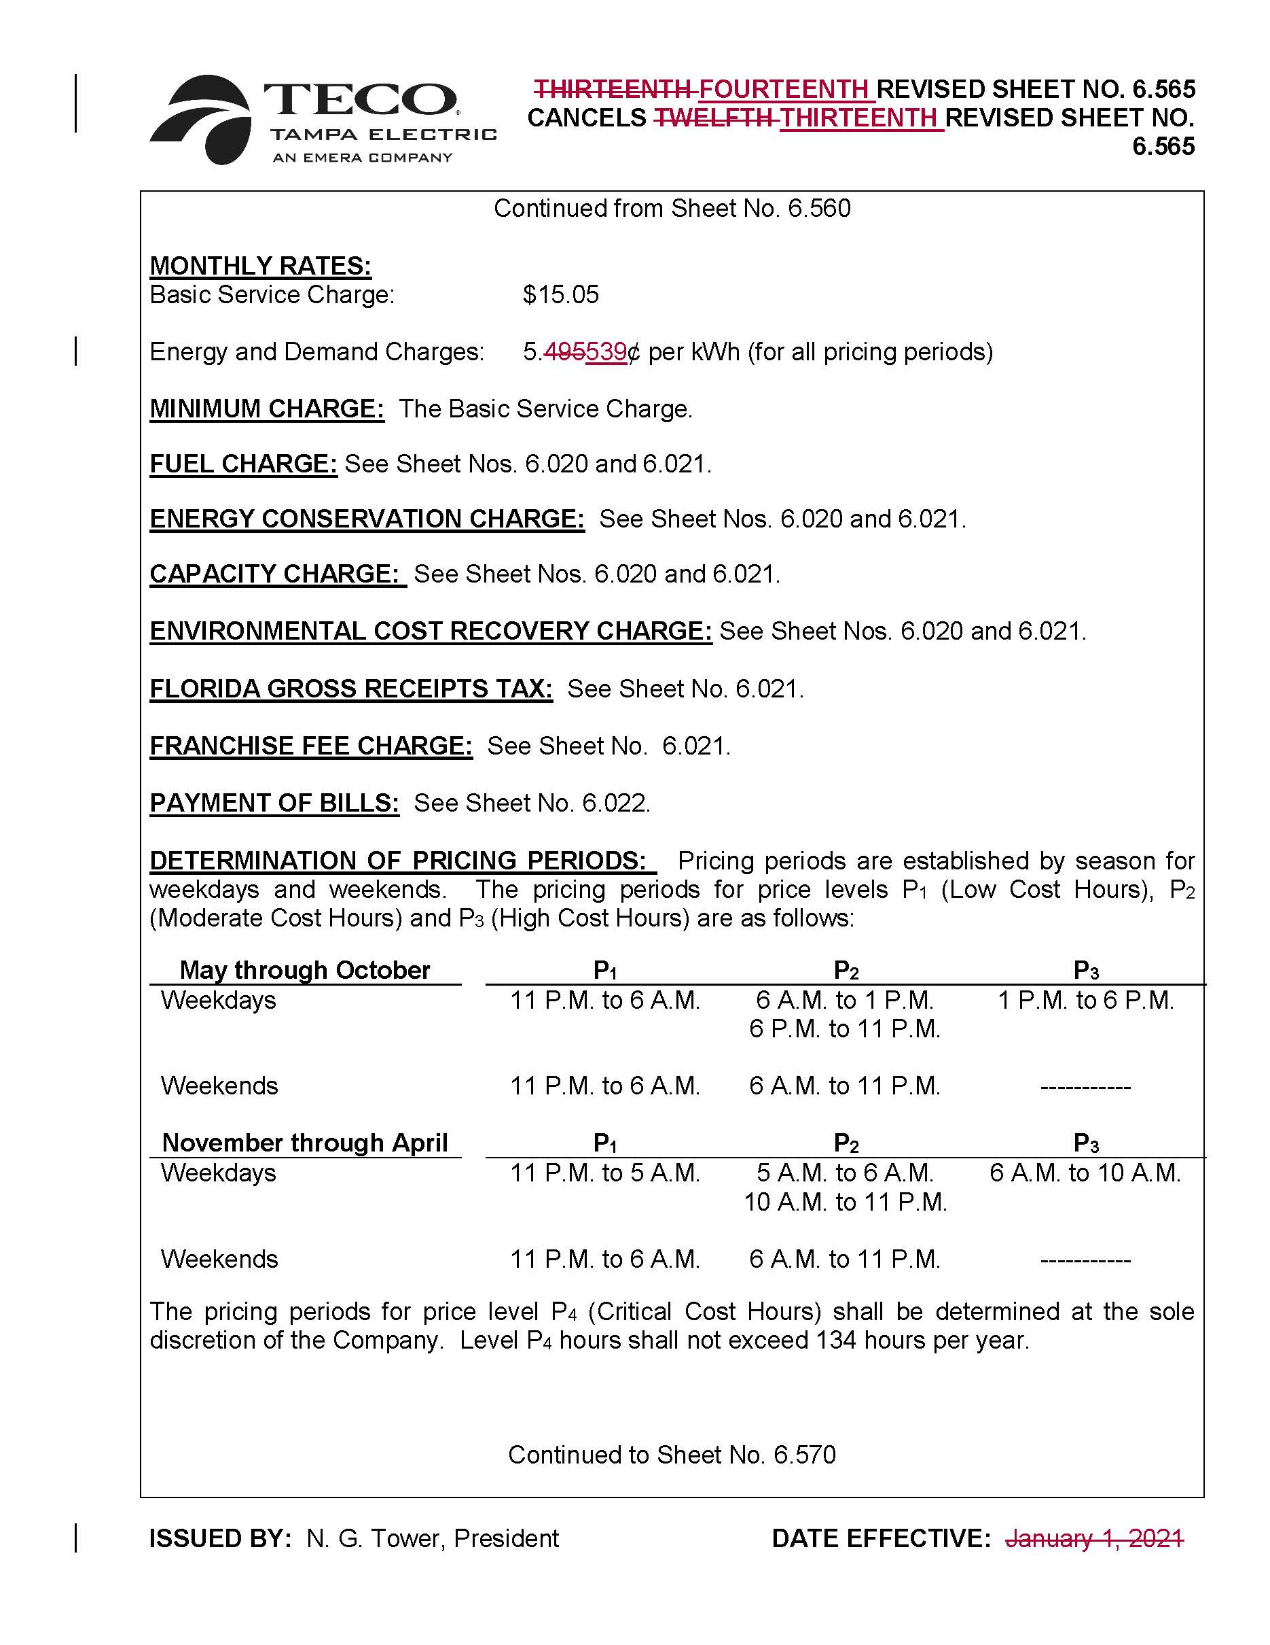
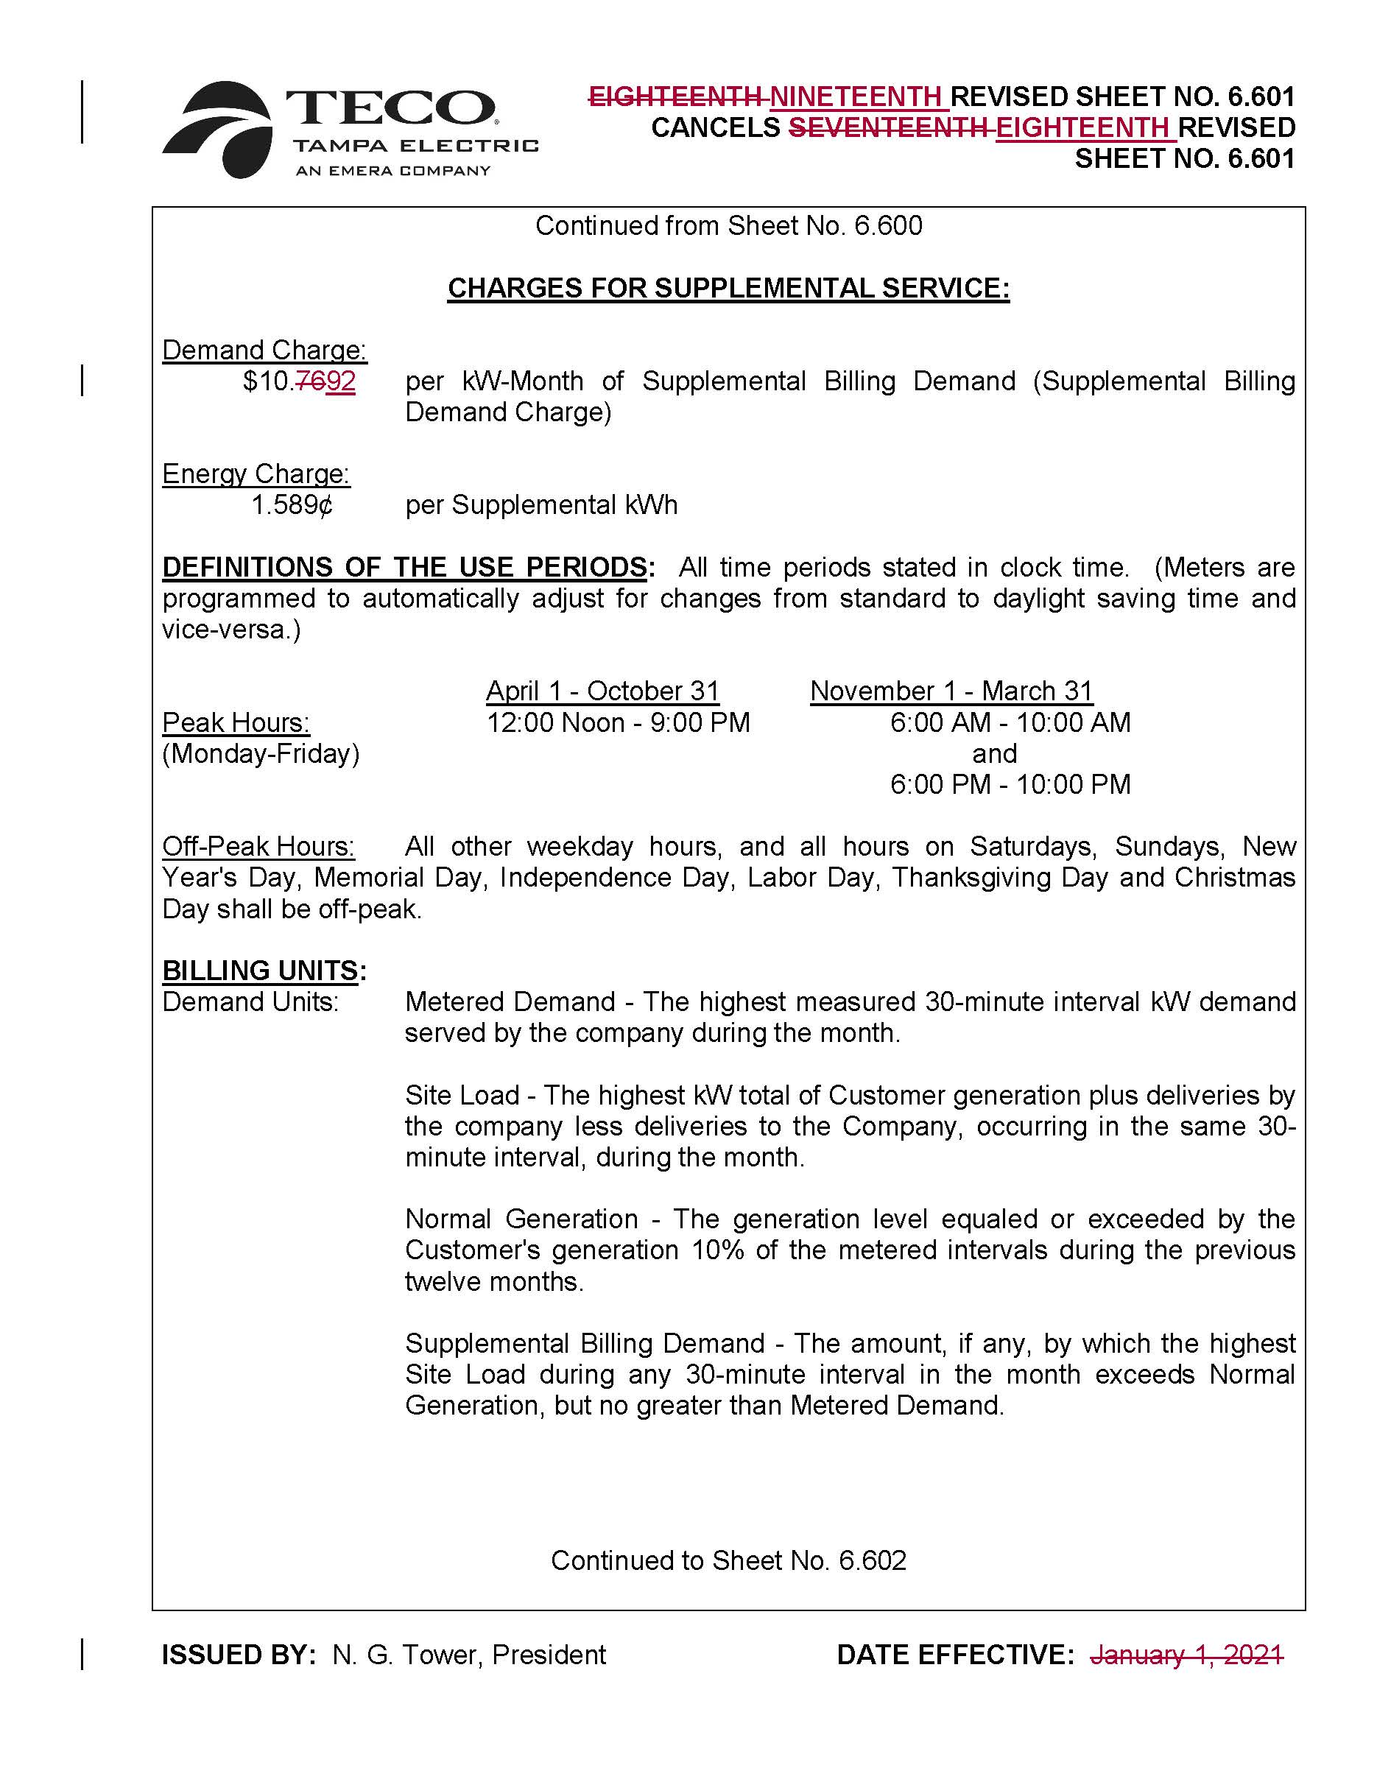
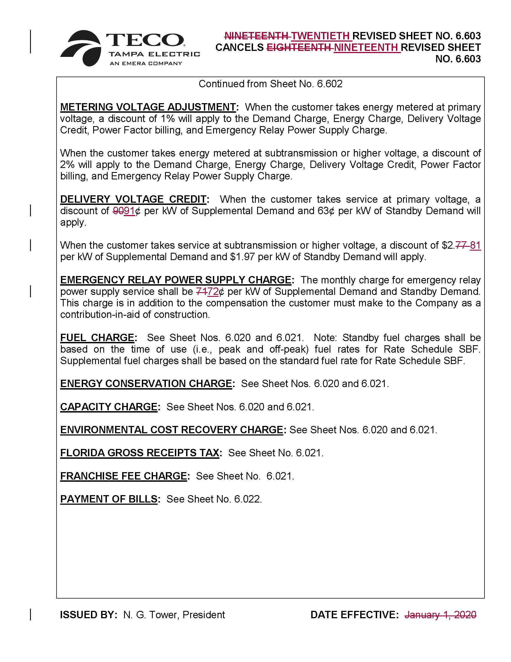
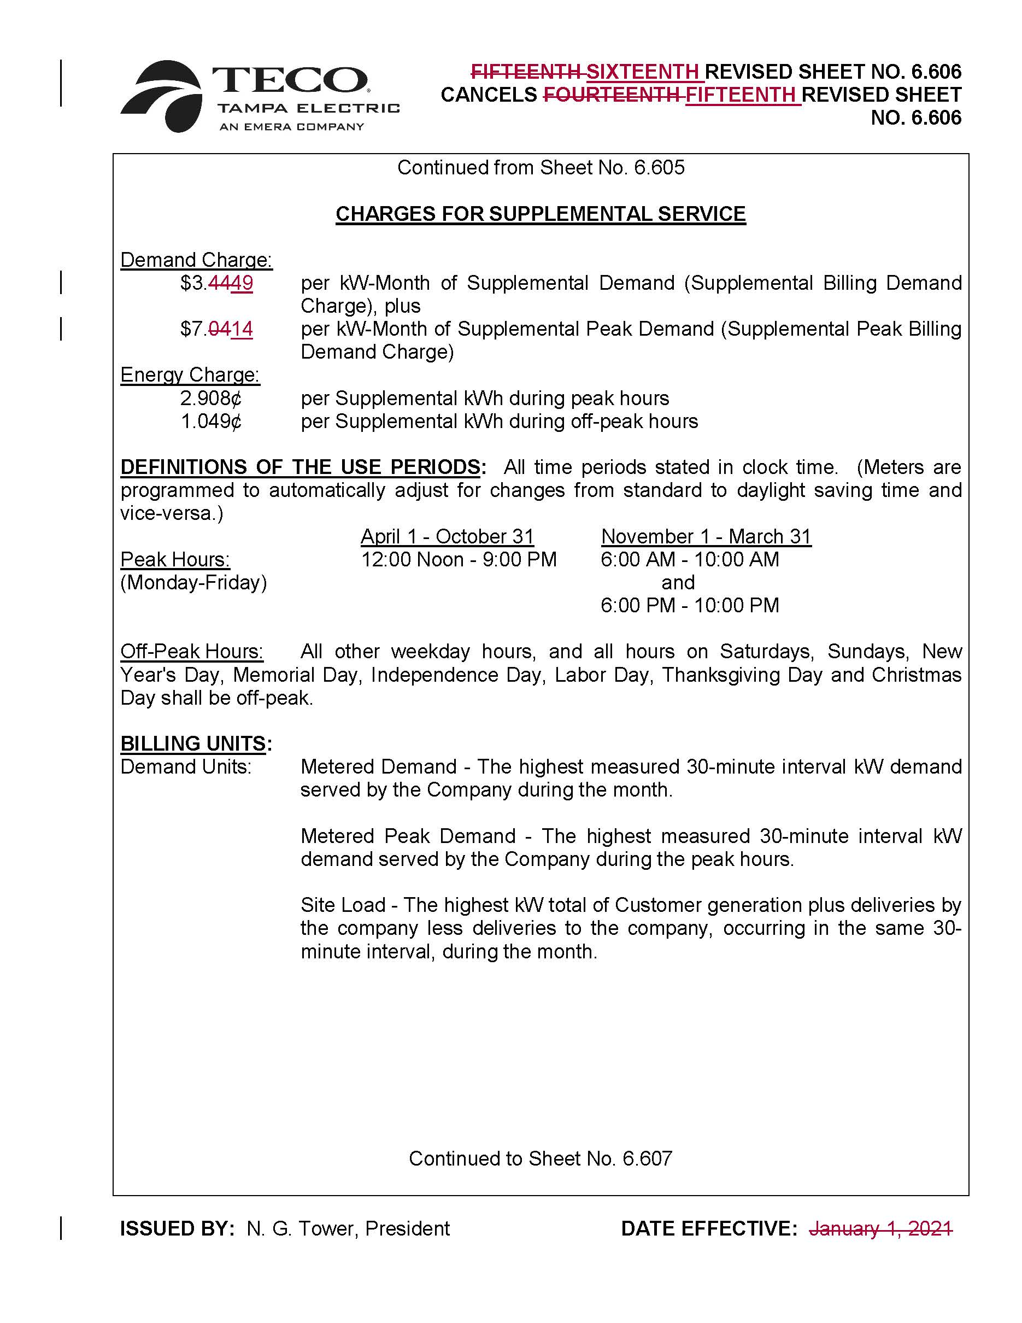

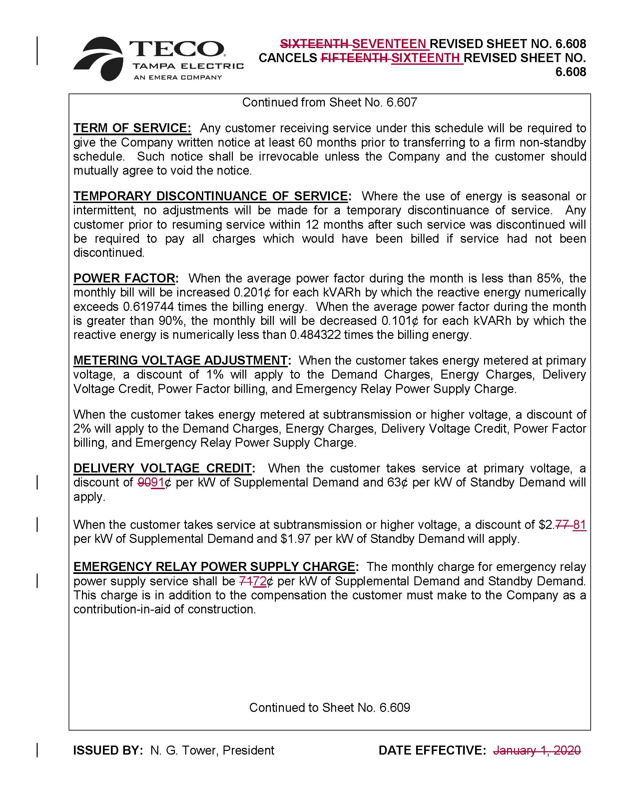
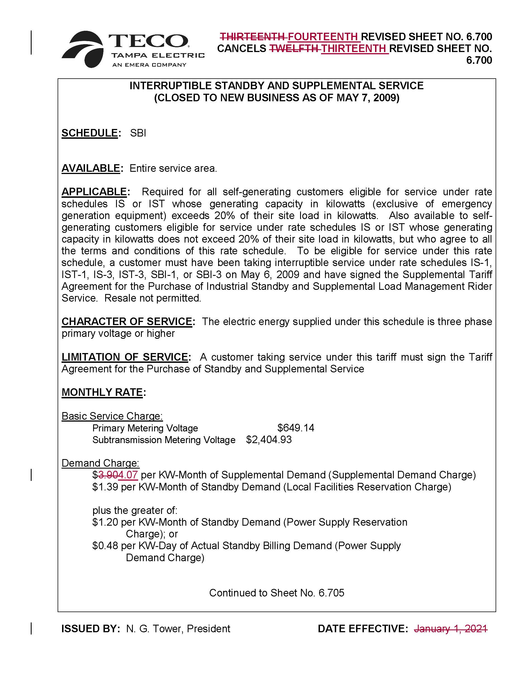
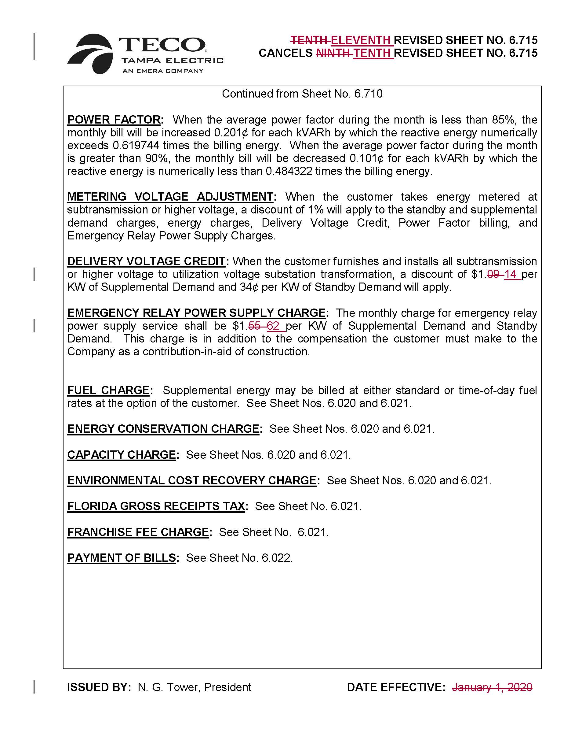
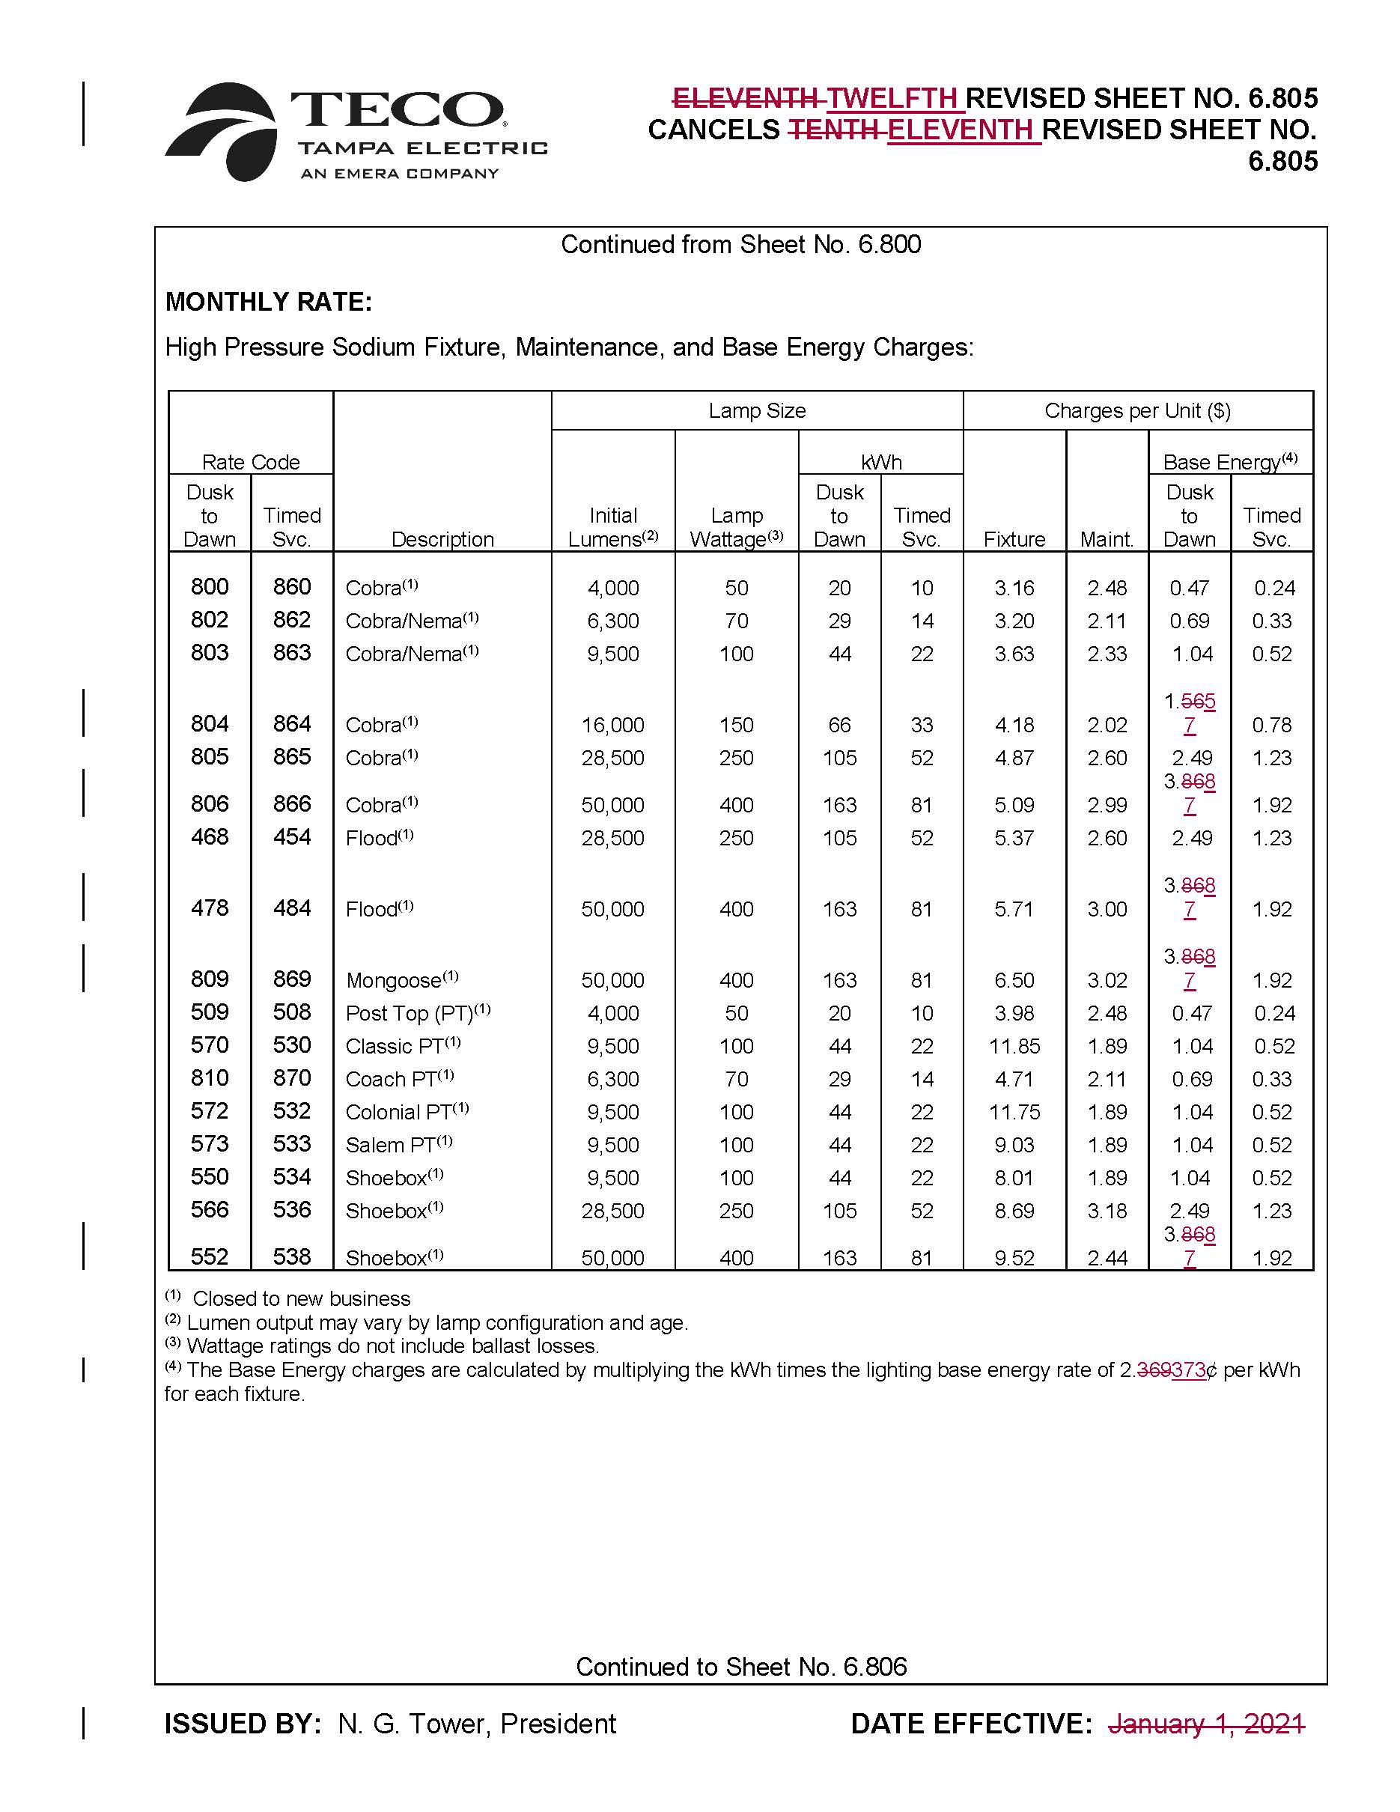
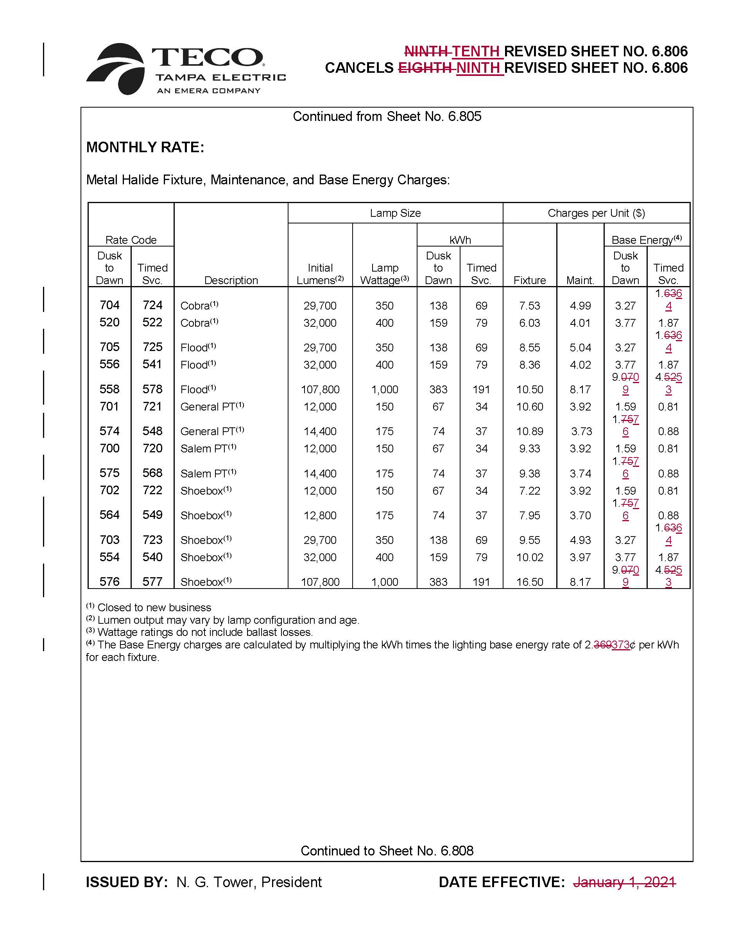
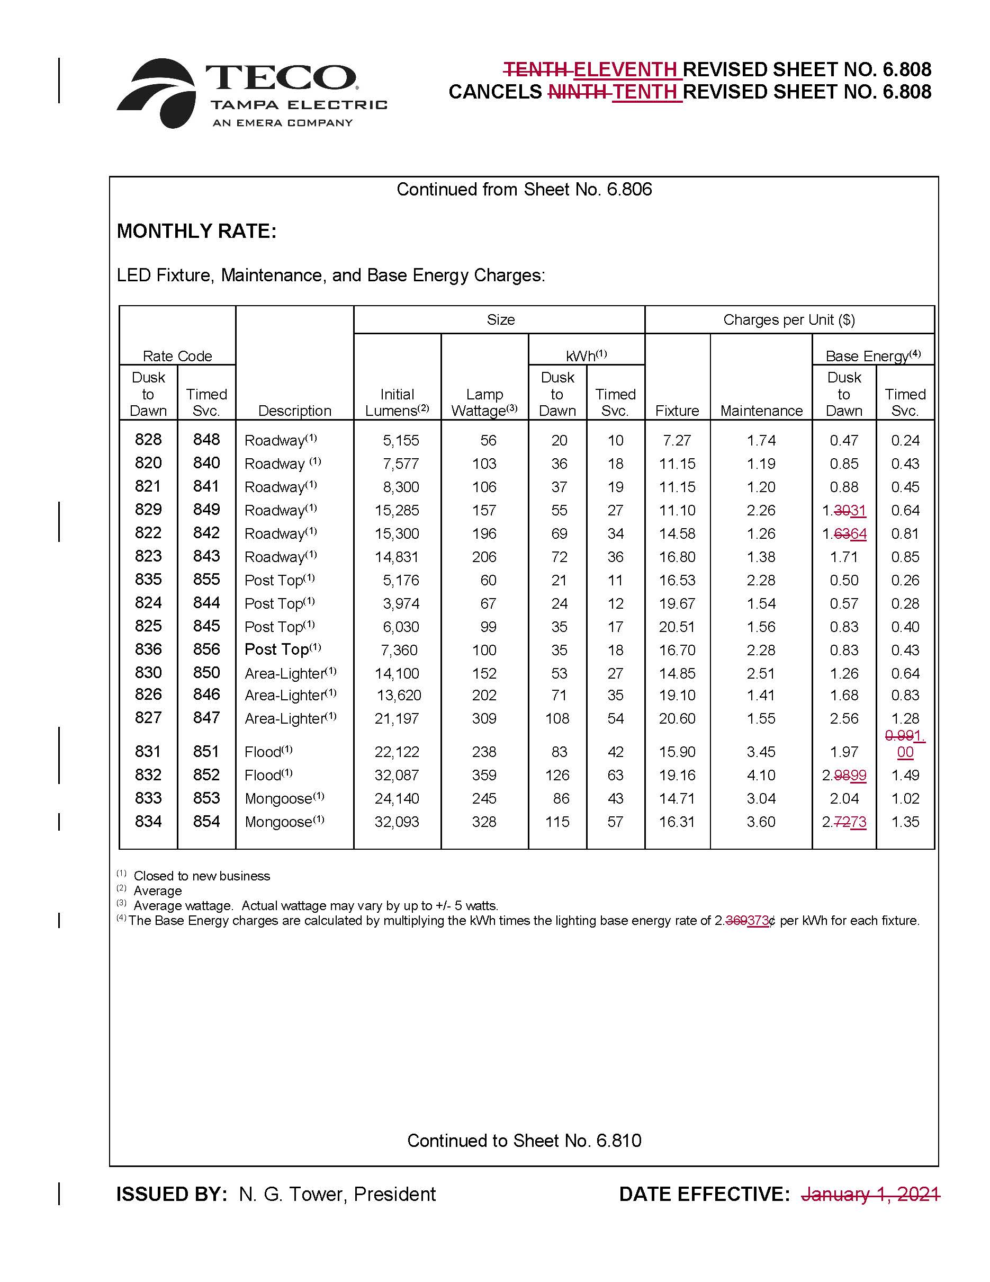

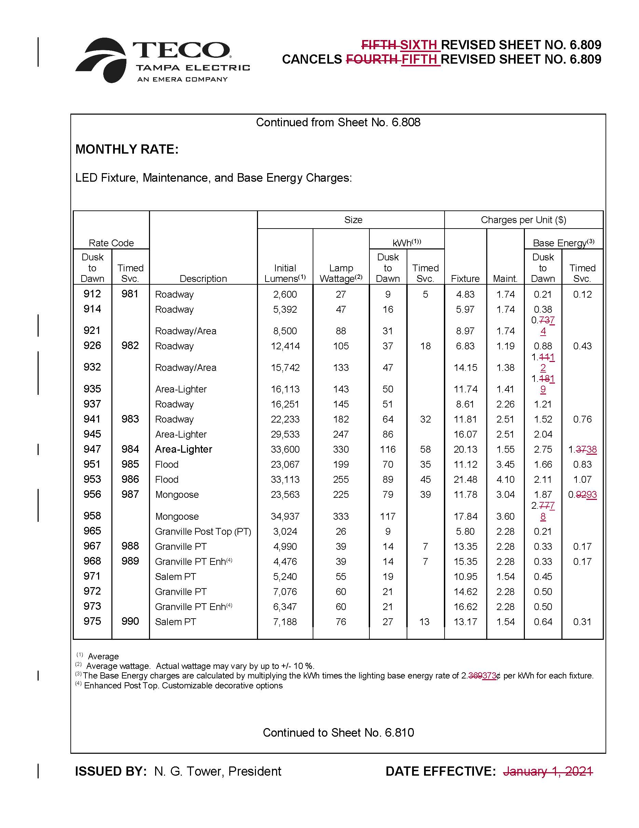
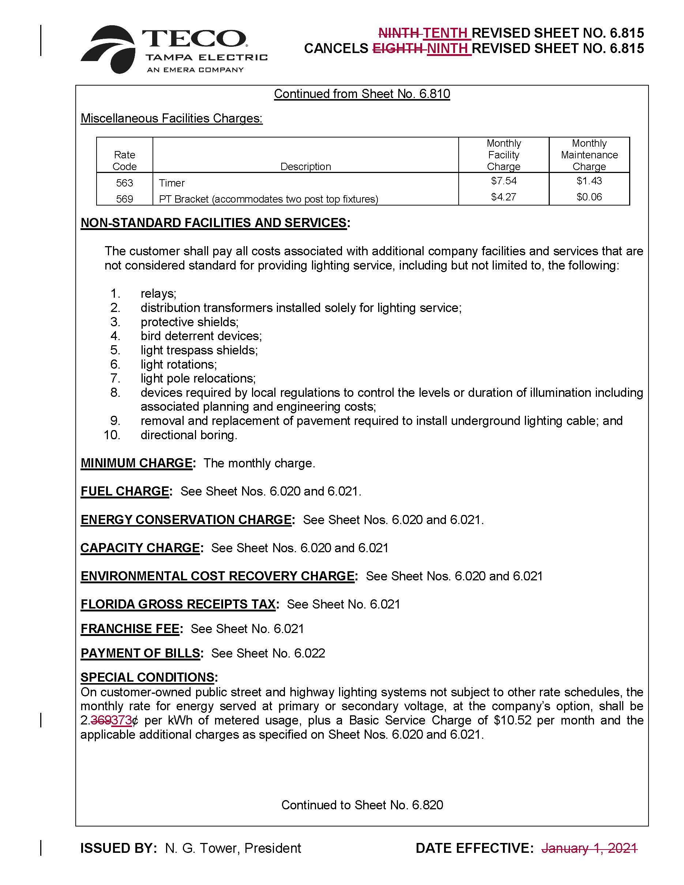
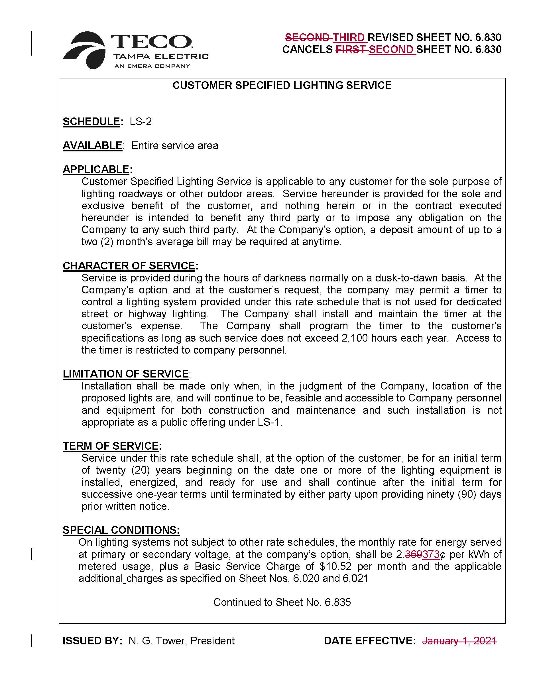
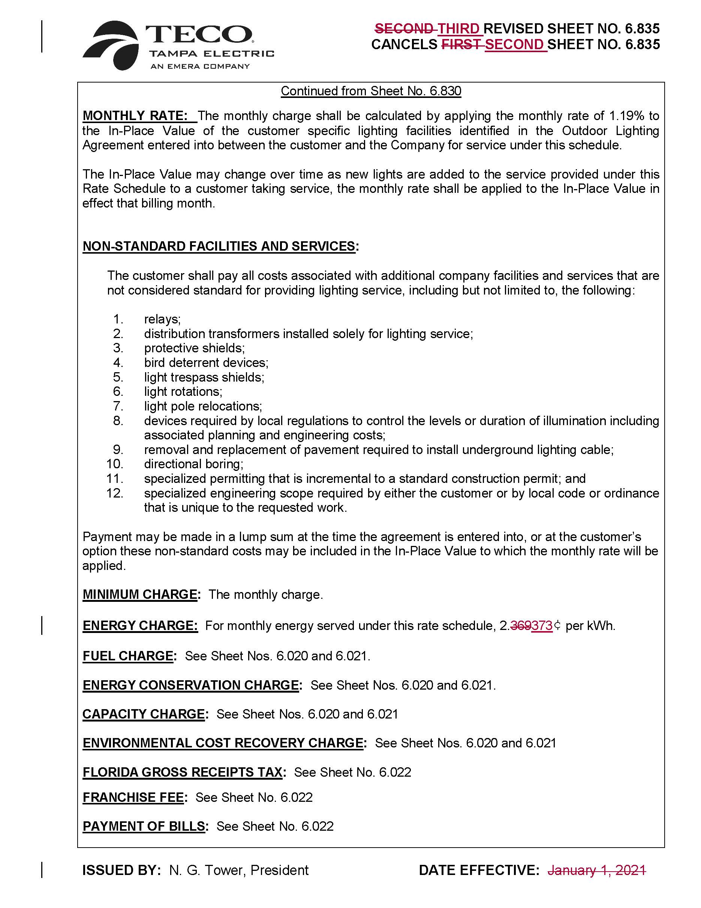

Order No. PSC-2017-0456-S-EI, issued November 27, 2017, in Docket No. 20170210-EI, In re: Petition for limited proceeding to approve 2017 amended and restated stipulation and settlement agreement, by Tampa Electric Company, and Docket No. 20160160-EI, In re: Petition for approval of energy transaction optimization mechanism, by Tampa Electric Company.
Order No. PSC-2018-0288-FOF-EI, issued June 5, 2018, in Docket No. 20170260-EI, In re: Petition for limited proceeding to approve first solar base rate adjustment (SoBRA), effective September 1, 2018, by Tampa Electric Company.
Order No. PSC-2018-0571-FOF-EI, issued December 7, 2018, in Docket No. 20180133-EI, In re: Petition for limited proceeding to approve second solar base rate adjustment (SoBRA), effective January 1, 2019, by Tampa Electric Company.
Order No. PSC-2019-0477-FOF-EI, issued November 12, 2019 in Docket No. 201900136-EI, In re: Petition for limited proceeding to approve Third solar base rate adjustment (SoBRA), effective January 1, 2020, by Tampa Electric Company.
Order No. PSC-2020-0224-AS-EI, issued June 30, 2020, in Docket Nos. 20200064-EI, In re: Petition for a limited proceeding to approve fourth SoBRA, by Tampa Electric Company; 20200065-EI, In re: Petition for a limited proceeding to eliminate accumulated amortization reserve surplus for intangible software assets, by Tampa Electric Company; 20200067-EI, In re: Review of 2020-2029 Storm Protection Plan pursuant to Rule 25-6.030, F.A.C., Tampa Electric Company, 20200092-EI, In re: Storm protection plan cost recovery clause; and 20200145-EI, In re: Petition to approve the 2020 settlement agreement by Tampa Electric Company.
Order No. PSC-2020-0303-PAA-EI, issued September 4, 2020 in Docket No 20200144-EI, In re: Petition for limited proceeding to true-up first and second SoBRA, by Tampa Electric Company.
Order No. PSC-2018-0571-FOF-EI, issued December 7, 2018, in Docket No. 20180133-EI, In re: Petition for limited proceeding to approve second solar base rate adjustment (SoBRA), effective January 1, 2019, by Tampa Electric Company.
Order No. PSC-2018-0288-FOF-EI, issued June 5, 2018, in Docket No. 20170260-EI, In re: Petition for limited proceeding to approve first solar base rate adjustment (SoBRA), effective September 1, 2018, by Tampa Electric Company. Order. No. PSC-2018-0571-FOF-EI, issued December 7, 2018, in Docket No. 20180133-EI, In re: Petition for limited proceeding to approve second solar base rate adjustment (SoBRA), effective January 1, 2019, by Tampa Electric Company. Order No. PSC-2019-0477-FOF-EI, issued November 12, 2019, in Docket No. 201900136-EI, In re: Petition for limited proceeding to approve Third solar base rate adjustment (SoBRA), effective January 1, 2020, by Tampa Electric Company.
Order No. PSC-2017-0456-S-EI, issued November 27, 2017, in Docket No. 20170210-EI, In re: Petition for limited proceeding to approve 2017 amended and restated stipulation and settlement agreement, by Tampa Electric Company, and Docket No. 20160160-EI, In re: Petition for approval of energy transaction optimization mechanism, by Tampa Electric Company.
2017 Settlement, ¶6(b).
Order No. PSC-2020-0303-PAA-EI, issued September 4, 2020, in Docket No. 20200144-EI, In re: Petition for limited proceeding to true-up first and second SoBRA, by Tampa Electric Company.
Id.

