BEFORE THE FLORIDA PUBLIC SERVICE COMMISSION

In re: Petition for approval of 2019 true-up, projected 2020 true-up, and 2021 revenue requirements and surcharges associated with cast iron/bare steel pipe replacement rider, by Peoples Gas System. | DOCKET NO. 20200206-GU  ORDER NO. PSC-2020-0507-TRF-GU  ISSUED: December 18, 2020

The following Commissioners participated in the disposition of this matter:

GARY F. CLARK, Chairman
ART GRAHAM
JULIE I. BROWN
DONALD J. POLMANN
ANDREW GILES FAY

TARIFF ORDER

BY THE COMMISSION:

Background
On September 1, 2020, Peoples Gas System (PGS) filed a petition for approval of its final 2019 true-up, projected 2020 true-up, and 2021 revenue requirement and surcharges associated with the cast iron/bare steel replacement rider (CI/BSR Rider or rider). The rider was originally approved in Order No. PSC-12-0476-TRF-GU (2012 order) to recover the cost of accelerating the replacement of cast iron and bare steel pipes through a surcharge on customers’ bills. PGS’s current surcharges were approved in Order No. PSC-2019-0549-TRF-GU. In the 2012 order, we found that “replacement of these types of pipelines is in the public interest to improve the safety of Florida's natural gas infrastructure, and reduce the possibility of loss of life and destruction of property should an incident occur."
In Order No. PSC-17-0066-AS-GU, we approved a comprehensive settlement agreement between PGS and the Office of Public Counsel (OPC). The settlement agreement, in part, added problematic plastic pipe (PPP) installed in the company's distribution system to eligible replacements under the rider. PPP was manufactured before 1983 and has significant safety concerns. In certain areas, the PPP is interspersed with, or connected to, the cast iron/bare steel pipe that is being replaced under the rider. As provided for in the settlement agreement, PPP replacements are included in the calculation of the 2021 rider surcharges.
On June 8, 2020, PGS filed a petition for a base rate increase in Docket No. 20200051-GU. As part of the rate case, PGS requested to start billing the interruptible service rate classes (SIS, IS, and ISLV) the CI/BSR Rider surcharges effective January 1, 2021. Currently, interruptible service customers are not paying a CI/BSR surcharge. After discussion with Commission staff, PGS decided to remove the request with regards to the interruptible service rate classes from Docket No. 20200051-GU, and request consideration in the instant docket.
In Order No. PSC-2020-0485-FOF-GU, we approved a Settlement Agreement between PGS, OPC, and the Florida Industrial Power Users Group. Included in the Settlement Agreement is a provision to move $23.6 million of the 2021 CI/BSR revenue requirement related to PGS’s CI/BSR investments made through December 31, 2020 ($200.7 million) from recovery through the CI/BSR surcharges to recovery through base rates effective January 1, 2021. The instant petition reflects this provision of the Settlement Agreement and excludes the $23.6 million from the calculation of the 2021 CI/BSR surcharges.
In its petition, PGS waived the 60-day file-and-suspend provision of Section 366.06(3), Florida Statutes (F.S.). We have jurisdiction over this matter pursuant to Sections 366.03, 366.04, 366.05, and 366.06, F.S.

Decision

I. PGS’s Request to Apply the CI/BSR surcharge to the Interruptible Service Rate Classes
The CI/BSR Rider charges have been in effect since January 2013. In PGS’s original petition, the utility excluded its interruptible service customers from the CI/BSR Rider surcharge. Interruptible service customers include the following rate classes: Small Interruptible Service (SIS), Interruptible Service (IS), and Interruptible Service – Large Volume (ISLV). In response to Commission staff’s first data request, PGS stated that at the time of the original petition, a majority of interruptible service customers were directly connected to an interstate pipeline and did not use a large portion of PGS’s distribution system.
After further consideration, the utility believes that all customers benefit from the replacement of aging infrastructure, which allows the utility to maintain a safe, reliable system. Therefore, the utility believes that it is “fair and reasonable for customers in these rate classes to contribute a proportional cost of the program.” The proposed 2021 factors for these rate classes are included in Tariff Sheet No. 7.806 (Attachment B).
In Exhibit D of its petition, PGS provided CI/BSR factor calculations for all rate classes with and without the interruptible rate classes. The non-interruptible rate classes benefit from PGS’s proposal by receiving a minor reduction in their CI/BSR factor. We note that since the allocation of the CI/BSR costs to the rate classes is based on the percent of total plant allocated to the rate classes in PGS’s last rate case, the interruptible service classes only receive a small percent allocation of the total CI/BSR costs. Based on the average therm usage for interruptible customers provided by PGS in its 2020 rate case filing, we calculated the monthly bill impact of the proposed CI/BSR surcharges for an SIS customer to be $117, for an IS customer to be $182, and for an ISLV customer to be $50.
We have reviewed PGS’s filings and supporting documentation and find that interruptible service customers benefit from the replacement of the utility’s aging infrastructure under this rider. Therefore, we hereby approve PGS’s request to apply the CI/BSR surcharge to the interruptible service rate classes effective January 1, 2021. This ensures that all customers are contributing towards the CI/BSR replacement costs.

II. PGS’s Proposed CI/BSR Rider Surcharges for the Period January through December 2021
The CI/BSR Rider charges have been in effect since January 2013. Rider PPP charges have been in effect since 2017. In 2020, PGS’s cast iron and bare steel replacement activity focused in the areas of Miami, Tampa, St. Petersburg, Orlando, Jacksonville, Eustis, Daytona, and Ocala. In 2021, PGS states it will focus on replacement projects in Miami, Tampa, St. Petersburg, Orlando, Jacksonville, Avon Park, Daytona, and Ocala. The projected completion date for the CI/BSR replacement program is 2022 for mains and services. The replacement of PPP is expected to continue until 2028.
Attachment A to this order contains tables which display the replacement progress and forecasts for CI/BSR (Table 2) and for PPP (Table 3). Additionally, PGS provided Table 1 which consolidates the actual and projected CI/BSR and PPP miles replaced investment for each year of the program and the corresponding revenue requirements.

True-ups by Year

PGS's calculation for the 2021 revenue requirement and surcharges includes a final true-up for 2019, an actual/estimated true-up for 2020, and projected costs for 2021. Pursuant to the 2012 order, the capital expenditures for 2017 through 2019 exclude the first $1 million of facility replacements each year because that amount is included in rate base. PGS has included depreciation expense savings as discussed in the 2012 order; however, the utility has not identified any operations and maintenance savings.

Final True-up for 2019

Exhibit A of the petition shows that the revenues collected for 2019 were $10,398,531 compared to a revenue requirement of $13,781,390, resulting in an under-recovery of $3,382,859. The final 2018 over-recovery of $15,885, 2019 under-recovery of $3,382,859, and interest of $15,576 associated with any over- and under-recoveries results in a final 2019 under-recovery of $3,382,549.

Actual/Estimated 2020 True-up

In Exhibit B of the petition, PGS provided actual revenues for January through July and forecast revenues for August through December of 2020, totaling $18,660,466, compared to an actual/estimated revenue requirement of $19,287,435, resulting in an under-recovery of $626,969. The final 2019 under-recovery of $3,382,549, 2020 under-recovery of $626,969, and interest of $14,824 associated with any over- and under- recoveries results in a total 2020 under-recovery of $4,024,341.

Projected 2021 Costs

Exhibit C of the petition shows PGS projects investment or capital expenditures of $35,475,247 for the replacement of cast iron/bare steel infrastructure and PPP in 2021. As shown in Table 1 of Attachment A of this order, this consists of the CI/BSR infrastructure investment of $16,171,113 and the PPP investment of $19,304,134. The return on investment (which includes federal income taxes, regulatory assessment fees, and bad debt), depreciation expense (less savings), and property tax expense associated with that investment is $1,427,069. After adding the total 2020 under-recovery of $4,024,341, the total 2021 revenue requirement is $5,451,411. Table 1 displays the 2021 revenue requirement calculation.

Table 0
2021 Revenue Requirement
2021 Projected Expenditures | $35,475,247
Return on Investment | $1,295,164
Depreciation Expense (less savings) | 170,926
Property Tax Expense | (39,021)
2021 Revenue Requirement | $1,427,069
Plus 2020 Under-recovery | 4,024,341
Total 2021 Requirement | $5,451,411
Source: Page 1 of 3 in Exhibit C in petition (Docket No. 20200206-GU).

Proposed Surcharges

As established in the 2012 order, the total 2021 revenue requirement is allocated to rate classes using the same methodology that was used for the allocation of mains and services in the cost of service study used in PGS's most recent rate case. After calculating the percentage of total plant costs attributed to each rate class, the respective percentages were multiplied by the 2021 revenue requirement resulting in the revenue requirement by rate class. Dividing each rate class's revenue requirement by projected therm sales provides the rider surcharge for each rate class. In the instant petition, PGS has requested to alter the allocation methodology to include interruptible service customers in the CI/BSR surcharge.
The proposed 2021 rider surcharge for residential customers would be $.02188 per therm (compared to the current surcharge of $.09203). The 2021 monthly bill impact will be $.44 for a residential customer who uses 20 therms. The reduction in the surcharges is the result of a Settlement Agreement filed in the rate case docket, as discussed in Background, which moves $23.6 million of the 2021 revenue requirement to recovery through base rates effective January 1, 2021. The proposed Tariff Sheet No. 7.806 is Attachment B to this order.

Conclusion

We have reviewed PGS’s filings and supporting documentation and find that the calculations are consistent with the methodology approved in the 2012 order and are reasonable and accurate. Therefore, we hereby approve PGS’s proposed 2021 CI/BSR Rider surcharges to be effective for the period January through December 2021.
Based on the foregoing, it is

ORDERED by the Florida Public Service Commission that Peoples Gas System’s request to apply the CI/BSR surcharge to the interruptible service rate classes effective January 1, 2021 is hereby approved. It is further

ORDERED that PGS’s proposed CI/BSR Rider surcharges for the period January through December 2021 are hereby approved. It is further

ORDERED that if a protest is filed within 21 days of issuance of the Order, the tariff shall remain in effect with any charges held subject to refund pending resolution of the protest. It is further

ORDERED that if no timely protest is filed, this docket shall be closed upon the issuance of a Consummating Order.

By ORDER of the Florida Public Service Commission this 18th day of December, 2020.

/s/ Adam J. Teitzman
ADAM J. TEITZMAN
Commission Clerk
Florida Public Service Commission
2540 Shumard Oak Boulevard
Tallahassee, Florida 32399
(850) 413-6770
www.floridapsc.com

Copies furnished: A copy of this document is provided to the parties of record at the time of issuance and, if applicable, interested persons.

SJO

NOTICE OF FURTHER PROCEEDINGS

The Florida Public Service Commission is required by Section 120.569(1), Florida Statutes, to notify parties of any administrative hearing or judicial review of Commission orders that is available under Sections 120.57 or 120.68, Florida Statutes, as well as the procedures and time limits that apply. This notice should not be construed to mean all requests for an administrative hearing or judicial review will be granted or result in the relief sought.

Mediation may be available on a case-by-case basis. If mediation is conducted, it does not affect a substantially interested person's right to a hearing.

The Commission's decision on this tariff is interim in nature and will become final, unless a person whose substantial interests are affected by the proposed action files a petition for a formal proceeding, in the form provided by Rule 28-106.201, Florida Administrative Code. This petition must be received by the Office of Commission Clerk, 2540 Shumard Oak Boulevard, Tallahassee, Florida 32399-0850, by the close of business on January 8, 2021.

In the absence of such a petition, this Order shall become final and effective upon the issuance of a Consummating Order.

Any objection or protest filed in this docket before the issuance date of this order is considered abandoned unless it satisfies the foregoing conditions and is renewed within the specified protest period.

Table 1
PGS’s’ CI/BSR Replacement Program Progress
 | CI/BS Miles Replaced | PPP Miles Replaced | CI/BS Investment $ | PPP Investment $ | CI/BS Revenue Requirement $ | PPP Revenue Requirement $
2017 | 51 |  | 17,588,366 | 2,915,802 | 6,868,302 | 74,021
2018 | 62 | 56 | 27,035,678 | 15,890,424 | 8,510,823 | 848,201
2019 | 52 | 42 | 35,821,371 | 17,425,589 | 11,075,229 | 2,706,161
2020 | 51 | 50 | 33,672,240 | 12,523,353 | 14,872,709 | 4,414,726
2021 | 30 | 50 | 16,171,113 | 19,304,134 | 1,206,157 | 220,912
2022 | 5 | 50 | 3,306,701 | 18,282,717 | 2,643,484 | 2,506,862
2023 |  | 50 | 0 | 18,739,785 | 2,864,957 | 4,636,325
2024 |  | 50 |  | 19,208,280 | 2,830,125 | 6,783,015
2025 |  | 50 |  | 19,688,487 | 2,788,208 | 8,954,706
2026 |  | 45 |  | 18,327,034 | 2,746,064 | 11,070,133
2027 |  | 45 |  | 18,616,695 | 2,703,903 | 13,083,051
2028 |  | 28 |  | 13,452,047 | 2,661,753 | 14,831,134
Source: Response to staff’s first data request.

Table 2
PGS’s CI/BSR Replacement Progress
Year | Main Replacements |  |  |  |  | Service Replacements
 | Replaced Cast Iron (miles) | Replaced Bare Steel (miles) | Remaining Cast Iron at Year End (miles) | Remaining Bare Steel at Year End (miles) | Total Miles Remaining of CI/BS Mains | Replaced Number of Bare Steel Services | Total Number of Remaining Bare Steel Services
2012 |  |  | 100 | 354 | 454 |  | 14,978
2013 | 13 | 38 | 87 | 316 | 403 | 907 | 14,071
2014 | 2 | 18 | 85 | 298 | 383 | 7,964 | 6,107
2015 | 26 | 60 | 59 | 238 | 297 | 1,019 | 5,088
2016 | 15 | 35 | 44 | 203 | 247 | 1,050 | 6,963
2017 | 15 | 36 | 29 | 178 | 207 | 1,135 | 4,279
2018 | 10 | 52 | 18 | 126 | 144 | 1,970 | 2,309
2019 | 8 | 44 | 10 | 76 | 86 | 649 | 1,660
2020 | 4 | 47 | 6 | 29 | 35 | 1,000 | 660
2021 | 5 | 25 | 1 | 4 | 5 | 660 | 0
2022 | 1 | 4 | 0 | 0 | 0 | 0 | 0
Source: Response to staff’s first data request.

Table 3
PGS’s PPP Replacement Program Progress
 | PPP (miles) | Total Remaining PPP Mains (miles) | Replaced Number of PPP Services | Total Number of Remaining PPP Services
2016 | 0 | 551 | 0 | -
2017 | ** | 509 | 1,396 | 26,841
2018 | 56 | 461 | 3,941 | 24,741
2019 | 42 | 418 | 2,349 | 20,420
2020 | 50 | 368 | Not yet Determined | -
2021 | 50 | 318 | Not yet Determined | -
2022 | 50 | 268 | Not yet Determined | -
2023 | 50 | 218 | Not yet Determined | -
2024 | 50 | 168 | Not yet Determined | -
2025 | 50 | 118 | Not yet Determined | -
2026 | 45 | 73 | Not yet Determined | -
2027 | 45 | 28 | Not yet Determined | -
2028 | 28 | 0 | Not yet Determined | -
Source: Response to staff’s first data request.

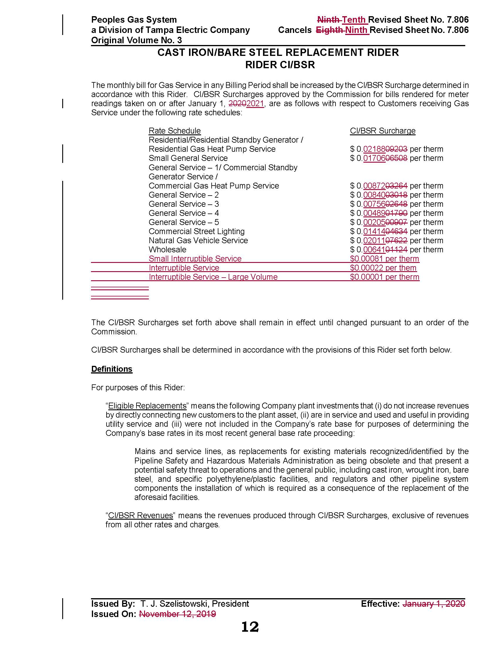

Order No. PSC-12-0476-TRF-GU, issued September 18, 2012, in Docket No. 20110320-GU, In re: Petition for approval of Cast Iron/Bare Steel Pipe Replacement Rider (Rider CI/BSR), by Peoples Gas System.
Order No. PSC-2019-0549-TRF-GU, issued December 30, 2019, in Docket No. 20190171-GU, In re: Petition for approval of 2018 true-up, projected 2019 true-up; and 2020 revenue requirements and surcharges associated with cast iron/bare steel pipe replacement rider.
Order No. PSC-17-0066-AS-GU, issued February 28, 2017, in Docket No. 20160159-GU, In re: Petition for approval of settlement agreement pertaining to Peoples Gas System's 2016 depreciation study, environmental reserve account, problematic plastic pipe replacement, and authorized ROE.
Order No. PSC-2020-0485-FOF-GU, issued December 10, 2020, in Docket No. 20200051-GU, In re: Petition for rate increase by Peoples Gas System.
PGS’s response to Staff’s First Data Request, Question 5.
The SIS rate class is allocated 2.47 percent, the IS class 1.97 percent, and the ISLV rate class 0.04 percent of the total CI/BSR costs.
Under current rates, without fuel, the average monthly bill is $10,450 for an SIS, $27,851 for an IS customer, and $48,000 for an ISLV customer.
Order No. PSC-12-0476-TRF-GU required PGS to identify and report any O&M and depreciation expense savings in its annual petitions for recovery of the CI/BSR Rider surcharge.
As a result of the proposed transfer of the current CI/BSR assets into base rates in Docket No. 20200051-GU, the CI/CBR Rider will receive an offsetting property tax credit in 2021.

