State of Florida |  | Public Service Commission  Capital Circle Office Center ● 2540 Shumard Oak Boulevard  Tallahassee, Florida 32399-0850  -M-E-M-O-R-A-N-D-U-M-
DATE: | February 18, 2021
TO: | Office of Commission Clerk (Teitzman)
FROM: | Division of Accounting and Finance (M. Andrews, D. Buys, Hightower, Mouring)  Division of Economics (Coston, Forrest)  Office of the General Counsel (Trierweiler, Osborn)
RE: | Docket No. 20200241-EI – Petition for limited proceeding for recovery of incremental storm restoration costs related to Hurricane Sally, by Gulf Power Company.
AGENDA: | 03/02/21 – Regular Agenda – Interested Persons May Participate
COMMISSIONERS ASSIGNED: |  |  | All Commissioners
PREHEARING OFFICER: |  |  | Graham
CRITICAL DATES: |  |  | 03/02/21 (Requested Implementation Date)
SPECIAL INSTRUCTIONS: |  |  | This Item should be taken up immediately before staff's recommendation in Docket No. 20200242-EI

Case Background
On November 10, 2020, Gulf Power Company (Gulf or Company) filed a petition for a limited proceeding seeking authority to implement an interim storm restoration recovery charge to recover incremental storm restoration costs related to Hurricane Sally. Gulf estimates a total of $206 million for incremental restoration costs related to Hurricane Sally. In its petition, Gulf asserts that prior to Hurricane Sally, Gulf’s Storm Reserve was fully depleted and in a deficit position, primarily due to incremental costs incurred from Hurricane Michael. Gulf filed its petition pursuant to the provisions of the Stipulation and Settlement Agreement (SSA) approved by the Commission in Order No. PSC-2017-0178-S-EI. Pursuant to Paragraph 7(a) of the SSA, Gulf can recover storm costs, not exceeding $4.00/1,000 kilowatt hour (kWh) on monthly residential customer bills, on an interim basis, beginning 60 days following the filing of a petition for recovery. In addition, pursuant to Paragraph 7(b), Gulf may petition the Commission to allow for a charge greater than $4.00/1,000 kWh, or a period longer than 12 months, if costs exceed $100 million in a calendar year. In its petition, Gulf has requested an interim storm restoration charge applicable to all rate classes, effective March 1, 2021. For residential customers, the proposed charge would be $3.00 on a 1,000 kWh bill. On December 16, 2020, Gulf agreed to waive the 60-day time frame set forth in the SSA and requested that the Commission approve the storm restoration recovery charge to become effective March 2, 2021.

The Office of Public Counsel’s intervention in this docket was acknowledged in Order No. PSC-2020-0484-PCO-EI, issued December 9, 2020.
The Commission has jurisdiction over this matter pursuant to Sections 366.04, 366.05, 366.06, and 366.076, Florida Statutes.

Discussion of Issues

Issue 1:
Should the Commission authorize Gulf to implement an interim storm restoration recovery charge?

Recommendation:
Yes. The Commission should authorize Gulf to implement an interim storm restoration recovery charge, subject to refund. Once the total actual storm costs are known, Gulf should be required to file documentation of the storm costs for Commission review and true up of any excess or shortfall. (M. Andrews)

Staff Analysis:
As stated in the Case Background, Gulf filed its petition for a limited proceeding seeking authority to implement an interim storm restoration recovery charge applicable to all rate classes to recover an estimated total of $206 million for incremental restoration costs related to Hurricane Sally. In addition, the $206 million also includes $900,000 of interest on the unamortized storm reserve balance. Also, Gulf’s Storm Reserve is fully depleted, primarily due to the incremental costs incurred from Hurricane Michael. Gulf has requested an interim storm restoration recovery charge of 0.3 cents per kWh, which equates to $3.00 on a 1,000 kWh residential electric bill, effective March 2, 2020. As discussed in Issue 2, the interim storm charge would vary by rate class. Gulf estimates that the interim charge collected from all rate classes will yield approximately $24 million per year. Gulf residential customer bills currently reflect a monthly Hurricane Michael storm recovery charge of $8.00 on a 1,000 kWh to be in effect till September 2023. The combination of the Hurricane Michael recovery charge and the Hurricane Sally interim recovery charge sum to $11.00 on a 1,000 kWh residential electric bill. Once Gulf has fully recovered the Hurricane Michael storm costs, Gulf proposes to seek Commission authority to increase the Hurricane Sally storm restoration recovery charge to $10.00 on a 1,000 kWh residential electric bill and for this level to remain in place until the Hurricane Sally costs are fully recovered and the Storm Reserve is replenished to approximately $41 million.
In its petition, Gulf asserts that it incurred total retail recoverable costs of approximately $206 million as a result of Hurricane Sally. Gulf represents that this amount was calculated in accordance with the Incremental Cost and Capitalization Approach (ICCA) methodology prescribed in Rule 25-6.0143, Florida Administrative Code (F.A.C.).
The approval of an interim storm restoration recovery charge is preliminary in nature and is subject to refund pending a further review once the total actual storm restoration costs are known. After the actual costs are reviewed for reasonableness and prudence, and are compared to the actual amount recovered through the interim storm restoration recovery charge, a determination will be made whether any over/under recovery has occurred. The disposition of any over/under recovery, and associated interest, would be considered by the Commission at a later date.
Based on a review of the information provided by Gulf in its petition, staff recommends that the Commission authorize Gulf to implement an interim storm restoration recovery charge, subject to refund. Once the total actual storm costs are known, Gulf should be required to file documentation of the storm costs for Commission review and true up of any excess or shortfall.

Issue 2:
Should the Commission approve Gulf's proposed interim storm restoration recovery charge tariff as shown in Attachment A to the recommendation?

Recommendation:
Yes. The Commission should approve Gulf's proposed interim storm restoration recovery charge tariff as shown in Attachment A to the recommendation. The proposed tariff should become effective March 2, 2021. (Forrest)

Staff Analysis:
In its petition, Gulf proposed to begin applying the interim storm restoration recovery charge to customer bills on March 2, 2021, and to include the charge in the non-fuel energy surcharge on customer bills. In support of its rate calculations, Gulf provided Exhibit 3 to the petition, which illustrates the computation of the proposed interim storm restoration recovery charge for each rate class. Gulf represented that it followed the methodology for allocation of storm costs among rate classes consistent with the cost of service study filed in its 2016 rate case in Docket No. 20160186-EI. Staff reviewed Gulf’s calculations and believes the allocation methodology to be appropriate and reasonable.
Application of the allocation methodology for the residential customer rate class results in a proposed interim storm recovery charge of 0.3 cents per kWh, which equates to $3.00 on a 1,000 kWh residential electric bill. The proposed interim charges for all rate classes are presented in Original Sheet No. 6.25.1, which is included in Attachment A to this recommendation.
Based on its review of the information provided by Gulf, staff recommends the Commission approve Gulf's proposed interim storm restoration recovery charge tariff as shown in Attachment A to the recommendation. The proposed tariff should become effective March 2, 2021.

Issue 3:
What is the appropriate security to guarantee the amount collected subject to refund through the interim storm restoration recovery charge?

Recommendation:
The appropriate security to guarantee the funds collected subject to refund is a corporate undertaking. (Hightower, D. Buys)

Staff Analysis:
Staff recommends that all funds collected subject to refund be secured by a corporate undertaking. The criteria for a corporate undertaking include sufficient liquidity, ownership equity, profitability, and interest coverage to guarantee any potential refund. Staff reviewed Gulf’s financial statements to determine if the Utility can support a corporate undertaking to guarantee the funds collected for recovery of incremental storm restoration costs related to Hurricane Sally. Gulf’s 2019, 2018 and 2017 financial statements were used to determine the financial condition of the Company. Gulf’s financial performance demonstrates adequate levels of liquidity, ownership equity, profitability, and interest coverage to guarantee the potential refund.

Staff believes Gulf has adequate resources to support a corporate undertaking in the amount requested. Based on this analysis, staff recommends that a corporate undertaking is acceptable. This brief financial analysis is only appropriate for deciding if the Company can support a corporate undertaking in the amount proposed and should not be considered a finding regarding staff's position on other issues in this proceeding.

Issue 4:
Should this docket be closed?

Recommendation:
No. This docket should remain open pending final reconciliation of actual recoverable Hurricane Sally storm costs with the amount collected pursuant to the interim storm restoration recovery charge, and the calculation of a refund or additional charge if warranted. (Trierweiler)

Staff Analysis:
No, this docket should remain open pending final reconciliation of actual recoverable Hurricane Sally storm costs with the amount collected pursuant to the interim storm restoration recovery charge, and the calculation of a refund or additional charge if warranted.

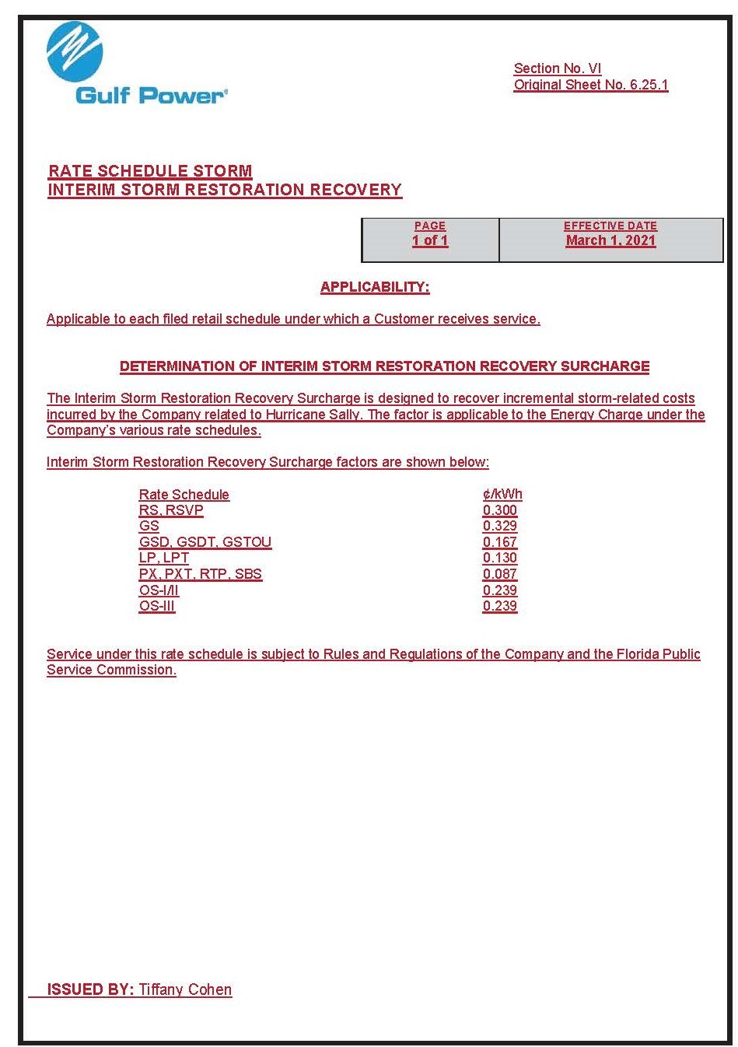

Order No. PSC-2017-0178-S-EI, issued May 16, 2017, in Docket No. 160186-EI, In re: Petition for rate increase by Gulf Power Company; and Docket No. 160170-EI, In re: Petition for approval of 2016 depreciation and dismantlement studies, approval of proposed depreciation rates and annual dismantlement accruals and Plant Smith Units 1 and 2 regulatory asset amortization, by Gulf Power Company.
Order No. PSC-2020-0349-S-EI, issued October 8, 2020, in Docket No. 20190038-EI, In re: Petition for limited proceeding for recovery of incremental storm restoration costs related to Hurricane Michael, by Gulf Power Company.

