BEFORE THE FLORIDA PUBLIC SERVICE COMMISSION

In re: Petition for approval of regulatory assets related to the retirements of the coal generation assets at Plant Crist Units 4, 5, 6, and 7, by Gulf Power Company.  In re: Environmental Cost Recovery Clause. | DOCKET NO. 20200242-EI  ORDER NO. PSC-2021-0115-PAA-EI  ISSUED: March 22, 2021  DOCKET NO. 20210007-EI

The following Commissioners participated in the disposition of this matter:

GARY F. CLARK, Chairman
ART GRAHAM
ANDREW GILES FAY
MIKE LA ROSA

NOTICE OF PROPOSED AGENCY ACTION
ORDER GRANTING PETITION FOR WAIVER OF RULE
25-6.0436(7)(a), FLORIDA ADMINISTRATIVE CODE AND
Granting Petition for approval of regulatory
assets related to the retirements of the coal
generation assets at Plant Crist Units 4, 5, 6, and 7,
by Gulf Power Company

BY THE COMMISSION:

NOTICE is hereby given by the Florida Public Service Commission that the action discussed herein is preliminary in nature and will become final unless a person whose interests are substantially affected files a petition for a formal proceeding, pursuant to Rule 25-22.029, Florida Administrative Code (F.A.C.).

Background
On November 10, 2020, Gulf Power Company (Gulf or Company) filed a petition seeking approval to create two regulatory assets and defer recovery of amounts related to the retirement of Plant Crist Units 4, 5, 6, and 7 (Units), and for a Mid-Course Correction to its 2021 Environmental Cost Recovery Clause (ECRC) factors reflecting the impact of the early retirement of the coal generation assets and capability at Plant Crist Units 4-7. The decision to retire Units 4-7 was based on damage sustained to these Units as a result of Hurricane Sally on September 16, 2020. As of retirement of the Units on October 15, 2020, the Net Book Value (NBV) of the Units was approximately $462 million. The reduction to the ECRC factors requested by Gulf would reduce rates by $3.71 per 1,000 kilowatt-hour (kwh). In conjunction with its request for a reduction to its ECRC factors, Gulf has filed a petition to implement an interim storm restoration recovery charge to recover incremental storm restoration costs related to damage caused by Hurricane Sally.
On January 19, 2021, Gulf submitted a Petition for Waiver of Rule 25-6.0436(7)(a), Florida Administrative Code (F.A.C.), which was filed in this docket. This Petition seeks waiver of the deadline for a utility to file for our approval of amended capital schedules to address unrecovered assets related to the early retirement of major assets.
The Office of Public Counsel is listed as an interested person in this docket.
We have jurisdiction over this matter pursuant to Sections 366.04 and 366.06, Florida Statutes (F.S.).

Decision
In its Petition filed November 10, 2020, Gulf requested authority to establish two regulatory assets (one in rate base and one in the ECRC) related to the unrecovered investments associated with the early retirement of the coal generation assets and capability at Plant Crist Units 4-7, and to defer the recovery of such regulatory assets until base rates are reset in a general base rate proceeding. Gulf also requested our approval for a corresponding Mid-Course Correction to its 2021 ECRC factors.

Petition for Waiver

Because Gulf requested our approval for this authority after the proposed early retirement date of the major installations, the Company is seeking a waiver of the first clause of Rule 25-6.0436(7)(a), F.A.C., underscored below:

Prior to the date of retirement of major installations, the Commission shall approve capital recovery schedules to correct associated calculated deficiencies where a utility demonstrates that (1) replacement of an installation or group of installations is prudent and (2) the associated investment will not be recovered by the time of retirement through the normal depreciation process.

Gulf has not requested a waiver of any other portion of Rule 25-6.0436(7)(a), F.A.C., or any other Commission rule.

The Company’s original request for a waiver was contained in paragraph six of its Petition. However, the request was unclear and failed to comply with the requirements of Section 120.542, F.S. Accordingly, Commission staff requested that if Gulf wished to waive a portion of the Commission’s rules, it should file a petition consistent with the requirements of Section 120.545, F.S., and Rule 28-104.002, F.A.C. Gulf subsequently submitted a stand-alone Petition for Waiver, which was filed in this docket on January 19, 2021. Pursuant to Section 120.542(6), F.S., notice of Gulf’s Waiver Petition was published in the January 22, 2021 edition of the Florida Administrative Register, Vol. 47, No. 14. No comments were submitted on the Waiver Petition.

Legal Standard for Rule Variances and Waivers

Section 120.542(1), F.S., states that the purpose of a rule variance or waiver is to provide relief to persons subject to regulation in cases where strict application of rule requirements can lead to unreasonable, unfair, and unintended results in particular circumstances. Section 120.542(2), F.S., sets forth a two-prong test for granting variances or waivers to rules. If the petitioner satisfies both prongs of the test, the agency must grant the variance or waiver.
First, the petitioner must show that “application of [the] rule would create a substantial hardship or would violate principles of fairness.” A “substantial hardship” is a “demonstrated economic, technological, legal, or other type of hardship.” Principles of fairness are violated when “the literal application of a rule affects a particular person in a manner significantly different from the way it affects other similarly situated persons who are subject to the rule.” Second, the petitioner must demonstrate that it will achieve the purpose of the underlying statutes by other means.
Each petitioner for rule variance or waiver has the burden of proving its entitlement to a variance or waiver under its particular circumstances. Thus, our determination as to whether a petitioner should be granted a variance or waiver is based on whether the legal test has been met under the specific circumstances of each petitioner.

Substantial Hardship

The 2020 Gulf and Florida Power & Light Company Ten-Year Site Plan set forth the Company’s anticipated timeframes for the conversion of Plant Crist Units 6 and 7 from coal-fired generation to natural-gas fired generation as well as for the corresponding retirement of coal generation assets and capability at Plant Crist Units 4-7. The Site Plan slated the conversion of Plant Crist Units 6 and 7 to natural gas for fourth quarter 2020 or first quarter 2021. The coal assets associated with Plant Crist Units 4-7 were scheduled to be retired December 31, 2021.

On September 26, 2020, Hurricane Sally damaged Plant Crist. This damage was significant, and caused the Company to assess the benefits of converting Plant Crist Units 6 and 7 to natural gas instead of making the repairs necessary to return these Units to coal-burning generation. This comparison demonstrated greater cost benefits by completing an early conversion of Plant Crist Units 6 and 7 to natural gas instead of repairing and temporarily returning them to coal operations. This conclusion lead Gulf to file the instant Petition for authority to address the unrecovered investments associated with the coal operation assets and capability of Plant Crist Units 4-7.

Prior to Hurricane Sally, Gulf had planned to file a request for our approval of regulatory assets or capital recovery schedules associated with the retirement of coal operations at Plant Crist Units 4-7 in 2021 by separate petition or with its planned base rate case filing. However, the timing of the proposed retirement was accelerated unforeseeably by the damage caused by Hurricane Sally. Gulf asserts that the Petition, though admittedly filed after the proposed date of retirement of Plant Crist Units 4-7, was submitted as soon as practicable after completion of post-Hurricane Sally assessments and analyses. The Company argues that because the timing and extent of damage from Hurricane Sally were unforeseen, application of Rule 25-6.0436(7)(a), F.A.C., to categorically prohibit it from reacting to this significant change by accelerating planned conversions imposes a substantial hardship. Gulf notes that the conversion of Plant Crist Units 6 and 7 was anticipated within the next calendar year, and that the creation of the regulatory assets and Mid-Course Correction will result in an estimated savings to ratepayers of $3.6 million. Gulf projects the Mid-Course Correction will enable a decrease of $3.71/1,000 kWh on a monthly residential bill. The alternative, continues Gulf, was to repair Plant Crist Units 6 and 7, operate on coal for the short-term, and then complete the conversion to natural gas operations later in 2021, all while foregoing these projected savings. Such an alternative would pose a substantial hardship in terms of financial costs and operational inefficiencies.

Purpose of the Underlying Statute

Rule 25-6.0436(7)(a), F.A.C., implements three statutes. The first is Section 350.115, F.S., which provides the Commission authority to “prescribe by rule uniform systems and classifications of accounts for each type of regulated company and approve or establish adequate, fair, and reasonable depreciation rates and charges.” The second statute implemented is Section 366.04,(2)(f), F.S., which grants the Commission authority to “prescribe and require the filing of periodic reports and other data as may be reasonably available and as necessary to exercise its jurisdiction hereunder.” The third statute implemented by the Rule is Section 366.06(1), F.S., which requires, inter alia, that the Commission “keep a current record of the net investment of each public utility company” and establish adequate, fair, and reasonable depreciation rates and charges.
Gulf notes that nothing in its waiver request alters its substantive reporting requirements or affects our jurisdiction. Gulf asserts that we can fully address all issues related to establishing adequate, fair, and reasonable depreciation rates and charges, and the appropriate treatment of unrecovered investments during a general base rate proceeding.
Gulf has demonstrated that applying the Rule in this docket would impose a substantial hardship on the Company. Gulf has also demonstrated that the purposes of the statutes underlying the portion of the Rule being waived will be served by other means. We have previously waived a separate time requirement in Rule 25-6.0436, F.A.C., on a request from another utility that had experienced damage from a hurricane. For these reasons, we approve Gulf’s Petition for Waiver of a portion of Rule 25-6.0436(7)(a), F.A.C.
Request for Approval to Create Regulatory Assets and Defer Recovery
Gulf’s petition seeks our approval to create two regulatory assets, representing an unrecovered $67.6 million in base rate capital investment and $394.5 million in ECRC capital investments ($462.2 million in total), due to the early retirement of coal generation assets and capability at Plant Crist Units 4, 5, 6 and 7. Gulf seeks to defer base rate and ECRC recovery of the regulatory assets, and determination of the associated amortization periods, until Gulf's base rates are next reset in a general base rate proceeding. Gulf’s decision to retire the Units early was based on significant damage caused to the Units by Hurricane Sally. As noted above, Gulf had originally planned to convert Crist Units 6 and 7 from coal to natural gas generation in the fourth quarter 2020 to first quarter 2021 timeframe, maintain Crist Units 6 and 7 as available capacity during 2021, and retire the coal generation assets and capability of Crist Units 4-7 on or about December 31, 2021, upon the completion of other investments to provide power to Gulf customers. As of retirement of Crist Units 4-7 on October 15, 2020, the Net Book Value of the Units was approximately $462 million. The following table contains the start of service year and previously scheduled retirement year for each of the Units.
Unit # | Start of Service Year | Previous Retirement Year
4 | 1959 | 2024
5 | 1961 | 2026
6 | 1970 | 2035
7 | 1973 | 2038

In the last proceeding in which we reviewed the depreciation rates of Crist Units 4-7, the estimated retirement dates ranged from 2024 through 2038. In February 2019, Gulf’s management approved a plan to switch the primary fuel type from coal to natural gas, with the coal generation assets remaining available until December 2021 to serve as a back-up fuel option. In its filings in the 2020 Fuel Docket, Gulf had already ceased using coal at Crist Units 4 and 5, and planned to use coal at Crist Units 6 and 7 until October 2020.
On September 16, 2020, Hurricane Sally caused significant damage to the Plant Crist site. Due to the hurricane damage sustained at Crist Units 4-7, Gulf decided to retire the coal generation assets and capability at an even earlier date, October 15, 2020, instead of repairing the coal generation assets of Crist Units 4-7. This left approximately 240,000 tons of coal unburned and located either at Plant Crist or at the Alabama State Docks. In its petition, Gulf supported its decision by providing a cumulative present value of revenue requirements (CPVRR) analysis evaluating the cost effectiveness of repairing the coal generation assets of the Crist Units and retiring them in December 2021, versus the October 2020 retirement of the coal generating assets. The CPVRR analysis provided three scenarios on the disposition of the remaining 240,000 tons of unburned coal, which would either be burned over a six month period or sold. The retirement option was more cost effective in each scenario, producing an estimated savings of between $3.6 million and $4.9 million. In response to Commission staff’s data request, Gulf provided an analysis of a fourth scenario, in which the unburned coal would be burned over a shorter three-month period. The estimated savings in this scenario was reduced to $1.7 million. The primary driver of savings is the differential between coal and natural gas fuel prices and the additional operational costs of the coal generation assets.
Based on this preliminary analysis, shifting the early retirement date from December 2021 to October 2020 appears to generate customer savings. However, we have not reviewed either the conversion to natural gas, which allows the early retirement of the coal generation assets, or the early retirement date of December 2021, against which the cost-effectiveness analysis was conducted. Gulf has also provided no information supporting either the conversion to natural gas or the December 2021 early retirement date used in the CPVRR analysis.
Based on these factors, we are not making a final prudence determination of whether the October 2020 early retirement of the coal generating assets and capability is reasonable at this time. The next opportunity to review the full record to determine the prudency of the retirement of the coal generation assets and capability at Plant Crist Units 4-7 would be Gulf’s next general base rate proceeding.
Because these Units are being retired early, certain entries must be made to Gulf’s books and records. Rule 25-6.0436(6), F.A.C., requires a utility to compile an annual depreciation status report showing changes to categories of depreciation that will require a revision. In addition, Rule 25-6.0436(7)(a), F.A.C., provides that:
Prior to the date of retirement of major installations, the Commission shall approve capital recovery schedules to correct associated calculated deficiencies where a utility demonstrates that (1) replacement of an installation or group of installations is prudent and (2) the associated investment will not be recovered by the time of retirement through the normal depreciation process.
Gulf’s current depreciation rates are based on retirement dates of 2024, 2026, 2035, and 2038 for these Units. Therefore, the investment in these Units will not be recovered through the normal depreciation process due to the early retirement of these Units.
The retirement and deferral of recovery for these Units affects Gulf’s ECRC factors. In Attachment AE-1 of its petition, Gulf provides capital recovery schedules for these Units for both base and clause recovery. The NBV for the portion of Units 4-7 recovered through the ECRC is $394,547,432 and the accumulated depreciation is $204,005,124. With the retirement and deferral of recovery of these Units, the resulting ECRC factors would reduce Gulf’s revenue requirement by $30,051,492.
The concept of deferral accounting allows companies to defer costs due to events beyond their control and seek recovery through rates at a later time. If the subject costs are significant, the alternative would be for a company to seek a rate proceeding each time it experiences an exogenous event. We find it appropriate to create the requested regulatory assets for the amounts associated with the early retirement of the coal generation assets and capability at Plant Crist and defer recovery until the amounts can be addressed in a future proceeding. Further, our approval to record the regulatory assets for accounting purposes does not limit our ability to review the amounts and recovery period for reasonableness in a future proceeding in which the regulatory assets are included. On January 11, 2021, FPL filed a request for approval of a base rate proceeding. Gulf formally merged into FPL in January 2021, with operational consolidation to be essentially complete by January 2022.

Request for Mid-Course Correction to 2021 Environmental Cost Recovery Clause Factors
Gulf stated in its petition that the early retirement of the Plant Crist Units 4-7 will reduce the projected amount identified for collection through the ECRC. As such, the Company has requested that the 2021 ECRC factors be reduced to reflect the retirement of the Plant Crist assets. As discussed immediately above, Gulf stated that approval of the requested Mid-Course Correction to the ECRC factors would reduce the Company’s annual revenue requirement by $30,051,492.
The current residential ECRC factor is 1.992 cents per kilowatt-hour (¢/kWh). The residential factor with the proposed ECRC revenue reduction would be 1.621 ¢/kWh. This proposal would reduce a 1,000 kWh residential bill by $3.71. Gulf stated the allocation method used to calculate this reduction is consistent with the cost of service methodology approved in the Company's last rate case.
We approve tariff sheet No. 6.36 to revise the currently-approved 2021 ECRC factors and tariff for the period March through December 2021 to reflect the early retirement of the coal generation assets and capability at Plant Crist Units 4-7. The proposed tariff, as shown in Attachment A to this Order, shall go into effect March 2, 2021.

Based on the foregoing, it is

ORDERED by the Florida Public Service Commission that the Petition for Waiver of Rule 25-6.0436(7)(a), Florida Administrative Code, filed by Gulf Power Company, is granted. It is further
ORDERED that the Petition for Approval of Regulatory Assets Related to the Retirements of the Coal Generation Assets at Plant Crist Units 4, 5, 6, and 7 filed by Gulf is granted, with review of the amounts and recovery period and a determination of reasonableness reserved for a future proceeding in which the regulatory assets are included. It is further

ORDERED that Gulf’s petition to revise the currently-approved 2021 ECRC factors and tariff for the period March through December 2021, to reflect the early retirement of the coal generation assets and capability at Plant Crist Units 4-7, is approved. The proposed tariff, shown in Attachment A to this order, shall go into effect March 2, 2021. It is further

ORDERED that the provisions of this Order, issued as proposed agency action, shall become final and effective upon the issuance of a Consummating Order unless an appropriate petition, in the form provided by Rule 28-106.201, Florida Administrative Code, is received by the Commission Clerk, 2540 Shumard Oak Boulevard, Tallahassee, Florida 32399-0850, by the close of business on the date set forth in the “Notice of Further Proceedings” attached hereto. It is further

ORDERED that if no timely protest is filed, Docket No. 20200242-EI shall be closed upon the issuance of a Consummating Order. It is further

ORDERED that Docket No. 20210007-EI shall remain open.

By ORDER of the Florida Public Service Commission this 22nd day of March, 2021.

/s/ Adam J. Teitzman
ADAM J. TEITZMAN
Commission Clerk
Florida Public Service Commission
2540 Shumard Oak Boulevard
Tallahassee, Florida 32399
(850) 413-6770
www.floridapsc.com

Copies furnished: A copy of this document is provided to the parties of record at the time of issuance and, if applicable, interested persons.
SPS

NOTICE OF FURTHER PROCEEDINGS

The Florida Public Service Commission is required by Section 120.569(1), Florida Statutes, to notify parties of any administrative hearing or judicial review of Commission orders that is available under Sections 120.57 or 120.68, Florida Statutes, as well as the procedures and time limits that apply. This notice should not be construed to mean all requests for an administrative hearing or judicial review will be granted or result in the relief sought.

Mediation may be available on a case-by-case basis. If mediation is conducted, it does not affect a substantially interested person's right to a hearing.

The Commission's decision on this tariff is interim in nature and will become final, unless a person whose substantial interests are affected by the proposed action files a petition for a formal proceeding, in the form provided by Rule 28-106.201, Florida Administrative Code. This petition must be received by the Office of Commission Clerk, 2540 Shumard Oak Boulevard, Tallahassee, Florida 32399-0850, by the close of business on April 12, 2021.

In the absence of such a petition, this Order shall become final and effective upon the issuance of a Consummating Order.

Any objection or protest filed in this docket before the issuance date of this order is considered abandoned unless it satisfies the foregoing conditions and is renewed within the specified protest period.

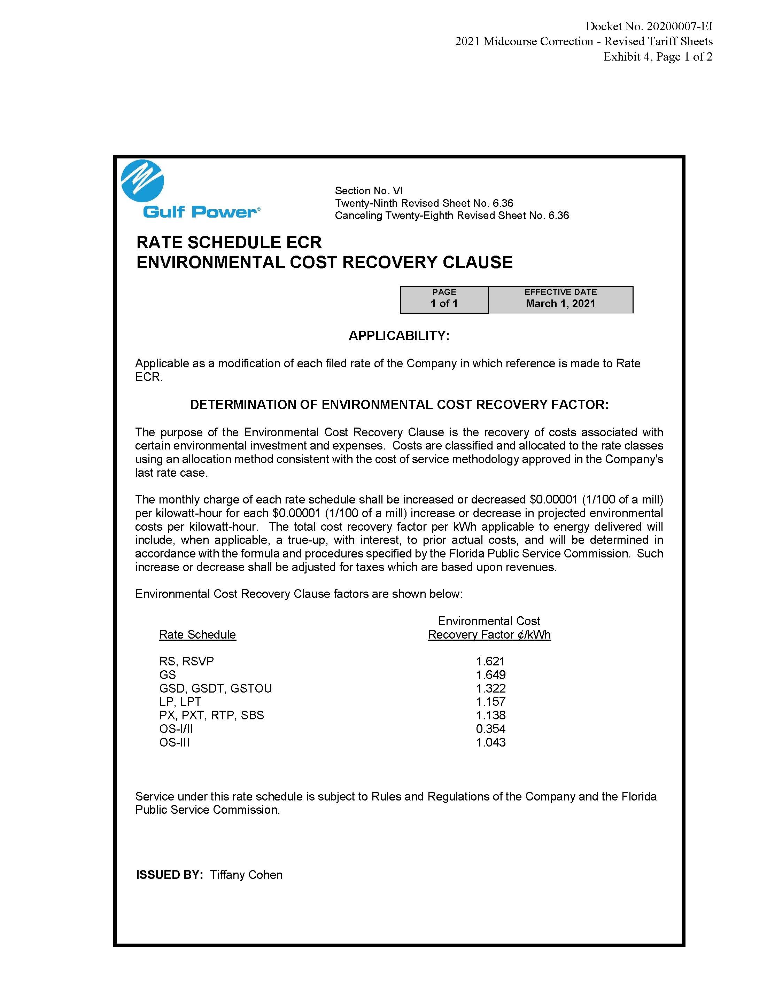

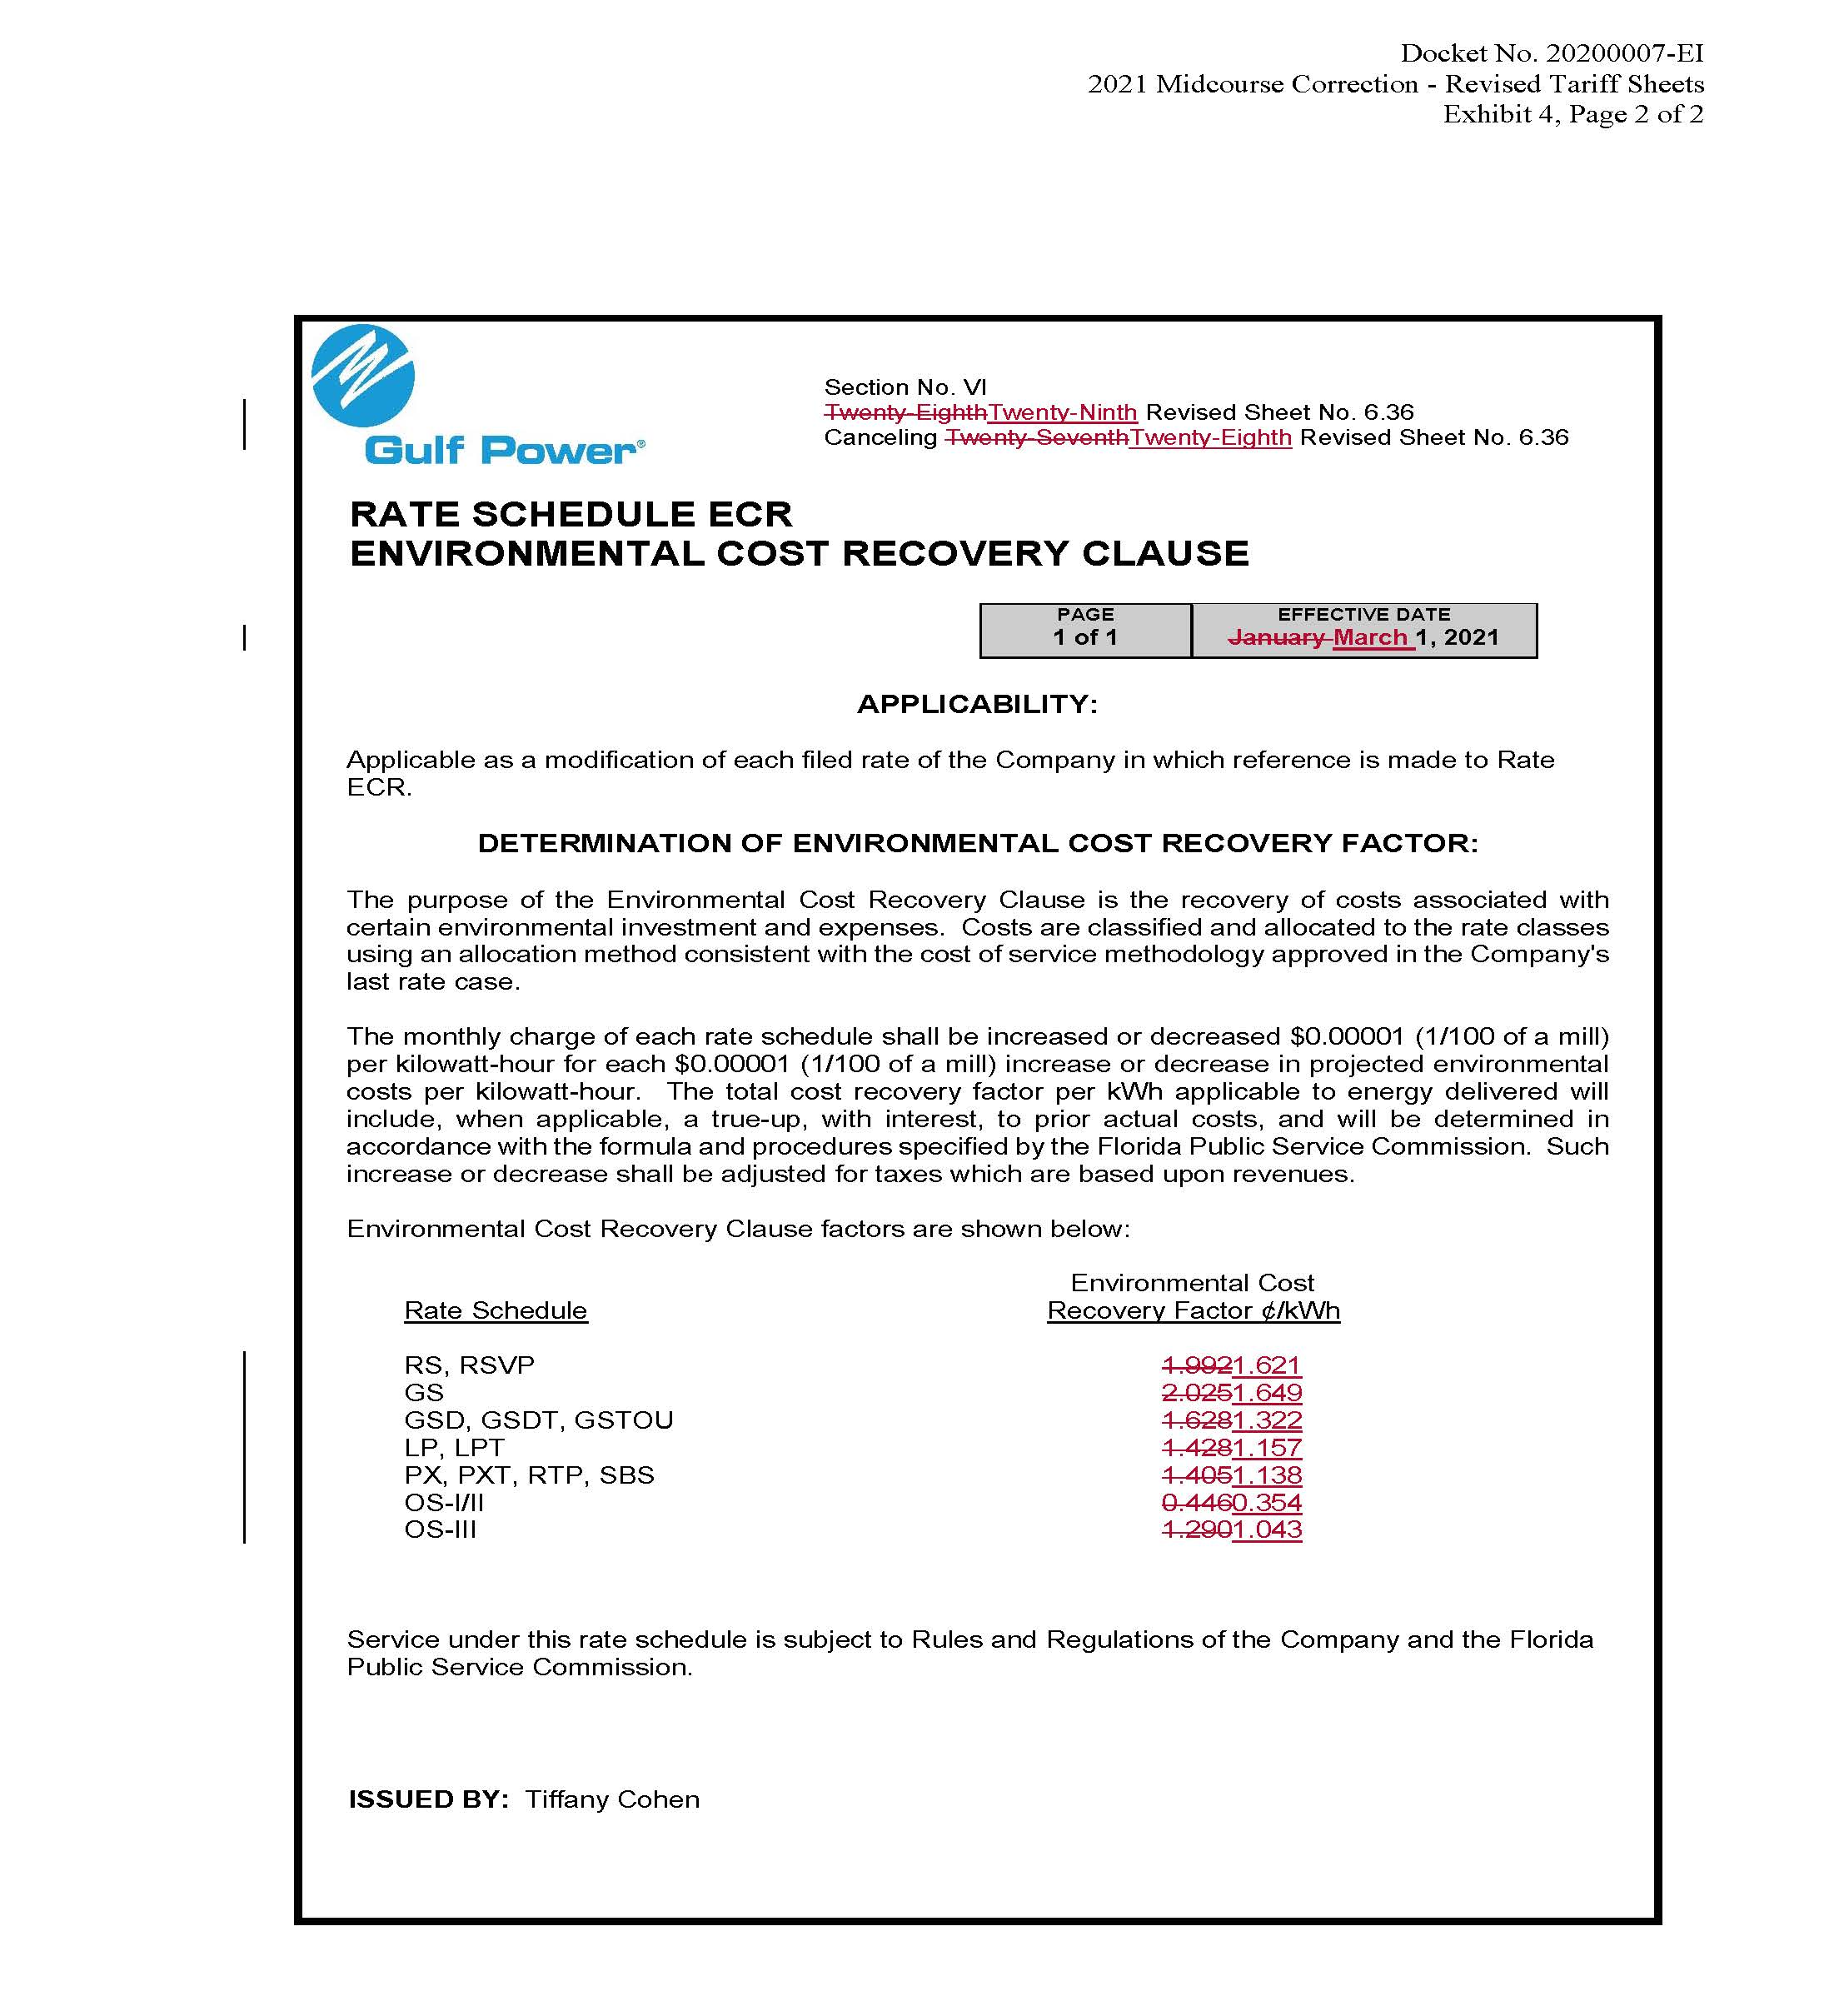

See Docket No. 20200241-EI
The proposed early retirement date of the relevant major installations is October 15, 2020.
A waiver is a decision by an agency not to apply all or part of a rule to a person who is subject to the rule. Section 120.52(22), F.S. A variance is an agency decision to grant a modification to all or part of the literal requirements of an agency rule to a person who is subject to the rule. Section 120.52(21), F.S.
Plant Crist Units 4 & 5 has previously been converted from coal to natural gas.
Order No. PSC-2019-0322-PAA-EI, issued August 7, 2019, in Docket No. 20190130-EI, In re: Petition for waiver of depreciation study filing requirement in Rule 25-6.0436(4)(a), F.A.C., by Florida Public Utilities Company.
See Order No. PSC-2017-0178-S-EI, issued May 16, 2017, in Docket No. 20160170-EI, In re: Petition for approval of 2016 depreciation and dismantlement studies, approval of proposed depreciation rates and annual dismantlement accruals and Plant Smith Units 1 and 2 regulatory asset amortization, by Gulf Power Company.
See Document No. 11785-2020 in Docket 20200001-EI.
See Docket No. 20210015-EI

