State of Florida |  | Public Service Commission  Capital Circle Office Center ● 2540 Shumard Oak Boulevard  Tallahassee, Florida 32399-0850  -M-E-M-O-R-A-N-D-U-M-
DATE: | April 22, 2021
TO: | Office of Commission Clerk (Teitzman)
FROM: | Division of Economics (Ward, Coston)  Office of the General Counsel (Lherisson)
RE: | Docket No. 20210042-GU – Petition for approval of firm service agreement with Peoples Gas System, by SeaCoast Gas Transmission, L.L.C.
AGENDA: | 05/04/21 – Regular Agenda – Proposed Agency Action – Interested Persons May Participate
COMMISSIONERS ASSIGNED: |  |  | All Commissioners
PREHEARING OFFICER: |  |  | La Rosa
CRITICAL DATES: |  |  | None
SPECIAL INSTRUCTIONS: |  |  | None

Case Background
On February 19, 2021, SeaCoast Gas Transmission, L.L.C. (SeaCoast), filed a petition seeking Commission approval of a Firm Service Agreement (Agreement) with Peoples Gas System (Peoples), collectively the parties. Peoples is a local distribution company which owns and operates natural gas distribution facilities to serve retail customers and is subject to the Commission's regulatory jurisdiction under Chapter 366, Florida Statutes (F.S.). SeaCoast operates as an intrastate natural gas transmission company as defined in Section 368.103, F.S., and only transports natural gas.
By Order No. PSC-08-0747-TRF-GP, SeaCoast received approval of an intrastate gas pipeline tariff that allows it to construct and operate intrastate pipeline facilities and to actively pursue agreements with natural gas customers. SeaCoast provides transportation service only; it does not engage in the sale of natural gas. Pursuant to Order No. PSC-08-0747-TRF-GP, SeaCoast is allowed to enter into certain gas transmission agreements without prior Commission approval. However, SeaCoast is requesting Commission approval of this proposed agreement as it does not fit any of the criteria enumerated in the tariff for which Commission approval would not be required. The parties are subsidiaries of TECO Energy, Inc., and agreements between affiliated companies must be approved by the Commission pursuant to Section 368.105, F.S., and Order No. PSC-08-0747-TRF-GP.
The proposed Agreement is contained in Attachment A to this recommendation. During the evaluation of the instant petition, staff issued a data request to the parties for which responses were received on April 1, 2021. In addition, staff held an informal conference call on April 15, 2021, with the parties to discuss specifics of the request. The Commission has jurisdiction over this matter pursuant to Sections 366.04, 366.05(1), 366.06, and 368.105, F.S.

Discussion of Issues

Issue 1:
Should the Commission approve the February 19, 2021 proposed Agreement between SeaCoast and Peoples?

Recommendation:
Yes, the Commission should approve the February 19, 2021 proposed Agreement between SeaCoast and Peoples. (Ward)

Staff Analysis:
In order to serve growth and safeguard system reliability for existing and new customers in the Lakeland and Polk County area, Peoples has entered into the proposed Agreement with SeaCoast to expand gas flow into this region of its service territory. To provide intrastate transportation of gas to Peoples, SeaCoast will tap into an existing four-inch pipeline lateral of Florida Gas Transmission Company, LLC’s (FGT) system serving Hillsborough County and extend a new 2.5 mile six-inch pipeline into Peoples’ new high pressure main pipeline at the Polk-Hillsborough County line. As part of this project, an existing out-of-service gate station that previously provided gas to an end-use industrial customer will serve as the access point of the expansion. During staff’s April 15, 2021 call with Peoples, the utility explained that the recommission process would involve testing and repairing the gate station to bring it in line with current safety and operational standards. The cost to recommission the gate station is included in the proposed Agreement. The map showing the proposed extension and its connections to existing facilities is contained in Attachment B of the recommendation.
The parties stated that they have completed the preliminary design for the infrastructure extensions. Pending Commission approval of the Agreement, the permitting process will be initiated and is expected to take four to five months. Construction is anticipated to begin in the third quarter of 2021. SeaCoast estimated that the proposed transmission pipeline will be completed by the first quarter of 2022. Peoples stated that it projects approximately 5,480 existing customers, including 4,750 residential and 730 commercial/industrial customers, would benefit from the expansion project through increased resiliency and reliability. In addition, Peoples stated that the proposed project would support additional customer growth in the Lakeland region.
The proposed Agreement specifies an initial term of 20 years and thereafter shall be extended for additional 10-year increments, unless either party gives no less than 30 days of written notification of termination. The negotiated reservation charge (confidential) included in the proposed Agreement is designed to allow SeaCoast to recover its operational and maintenance costs, depreciation, taxes, and return on investment associated with the new transmission pipeline. SeaCoast stated that the rate set forth in the Agreement is a cost-based rate similar to rates set forth in firm service agreements with its other customers. SeaCoast asserts that the agreement is just, reasonable and not unreasonably preferential or unduly discriminatory, and therefore, consistent with Section 368.105(3)(b), F.S. While specific circumstances vary by projects due to pipe sizing, construction conditions, permitting, etc., staff believes that the information provided by SeaCoast for the proposed pipeline appears reasonable and comparable to similar agreements.

Consideration of Potential Alternatives to the SeaCoast Extension
Peoples stated that it evaluated other options to meet demand and improve delivery of gas to customers in the Lakeland and Polk County area, but those alternatives were more expensive and had shortcomings. One option considered by Peoples was a transmission line that traversed the Lakeland area with approximately 9 miles of eight-inch steel pipeline serving as the project’s main line, along with approximately 2.5 miles of six-inch steel pipeline for the distribution system. The origin point of this alternative was Peoples’ North Lakeland Gate Station, which serves Peoples’ Lakeland and Tampa divisions. Peoples explained that this alternative line could create competing capacity demands on its North Lakeland Gate Station, which could limit the efficiency and effectiveness of that option. Contracting with SeaCoast, as proposed in the Agreement, would provide Peoples with an alternative access to FGT’s system. This option would result in improved system resiliency through an additional gas delivery access point.
In response to staff’s data request, SeaCoast and Peoples provided a cost estimate for the proposed six-inch SeaCoast transmission pipeline and stated that this alternative is the most cost- effective. Peoples also stated that FGT provided a proposal to expand its pipeline in order to meet the requirements of this project, but the FGT proposal was not cost-effective in comparison to the proposal from SeaCoast and could not be completed within the utility’s time requirements.

Peoples’ Cost Recovery of Payments to SeaCoast
Peoples' payments to SeaCoast would be included in the calculation of the monthly Purchased Gas Adjustment (PGA) factor. Consistent with the methodology approved by the Commission in Docket No. 20000810-GU, a portion of the costs would be paid by transportation customers taking service under Peoples' Natural Choice Transportation Service program via the swing charge mechanism. Swing service charge revenues collected from transportation customers would then be credited back to the PGA. Sales customers purchase their gas from Peoples and are subject to Peoples' PGA charges. Peoples stated that if this project is approved it would include the charges in the 2022 PGA cap that would be filed for Commission review and approval in September 2021. Peoples estimates the impact on the PGA cap to be $0.0073 per therm.

Conclusion
In 2015 and 2019, the Commission approved similar transportation agreements between Peoples and SeaCoast. Based on the petition and the parties' responses to staff’s data request, the parties have supported the importance of the need for pipeline extensions to service customers in the Lakeland and Polk County area. Staff believes that the proposed Agreement is cost-effective, reasonable, meets the requirements of Section 368.105, F.S., and benefits Peoples’ customers. Staff therefore recommends approval of the proposed Agreement between the parties dated February 19, 2021.

Issue 2:
Should this docket be closed?

Recommendation:
Yes. If no protest is filed by a person whose substantial interests are affected within 21 days of the issuance of the Order, this docket should be closed upon the issuance of a Consummating Order. (Lherisson)

Staff Analysis:
Yes. If no protest is filed by a person whose substantial interests are affected within 21 days of the issuance of the Order, this docket should be closed upon the issuance of a Consummating Order.

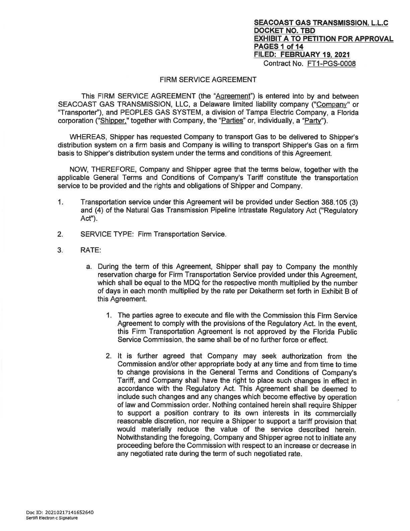

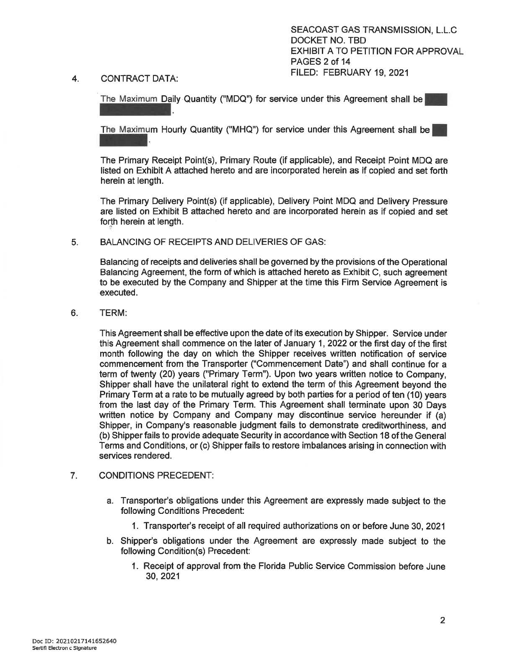

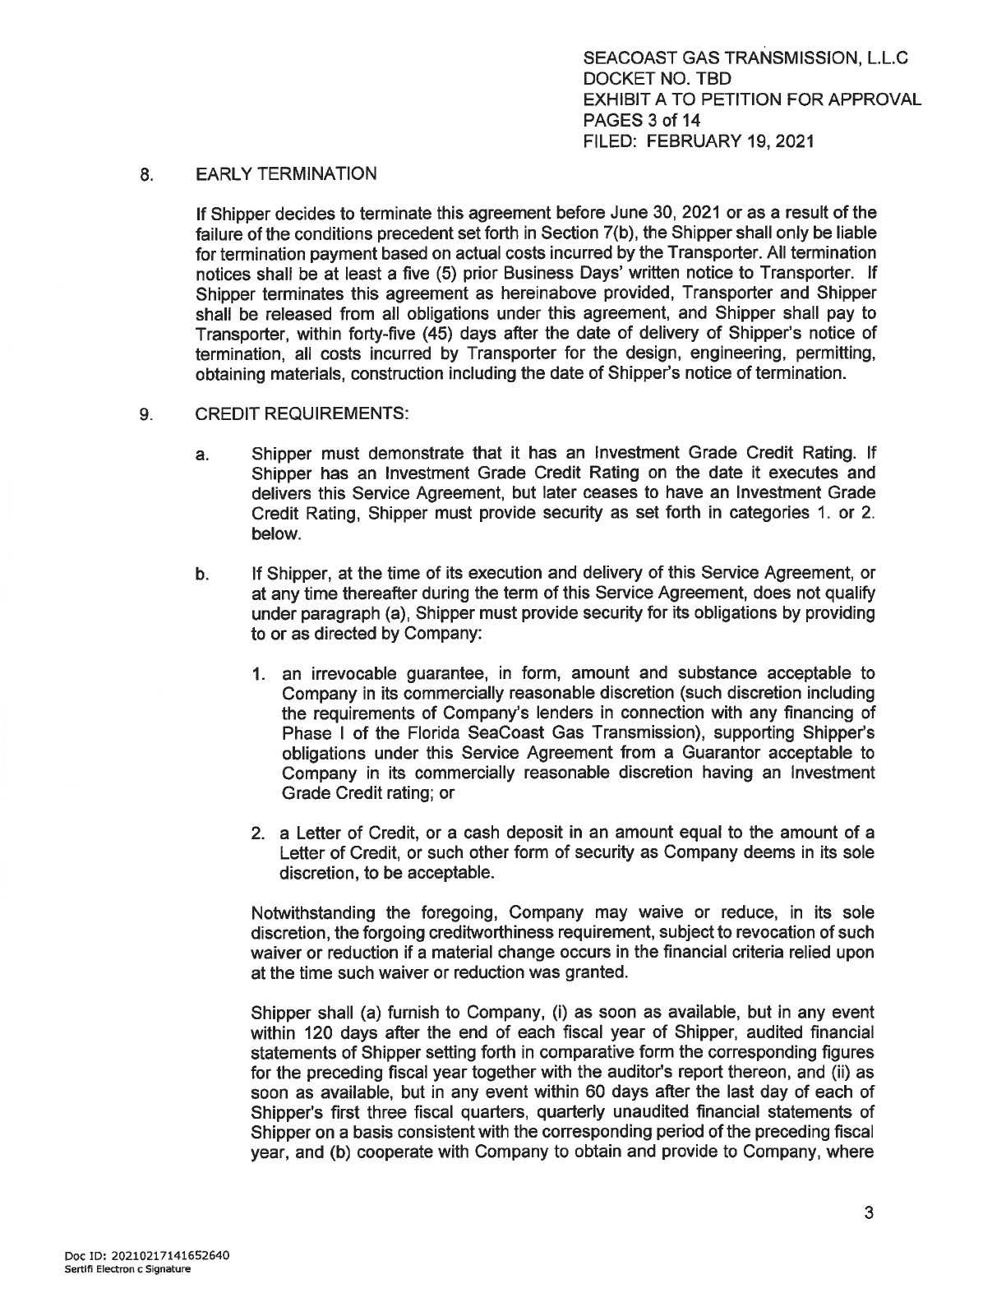
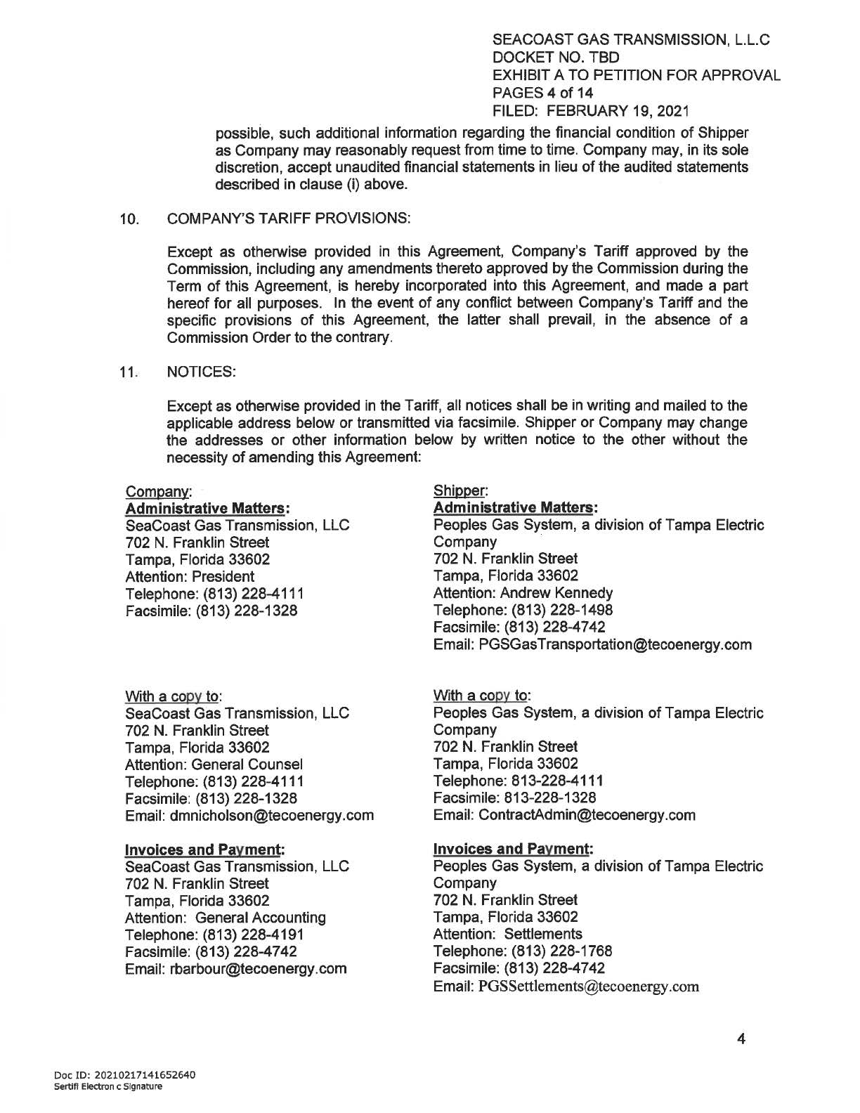

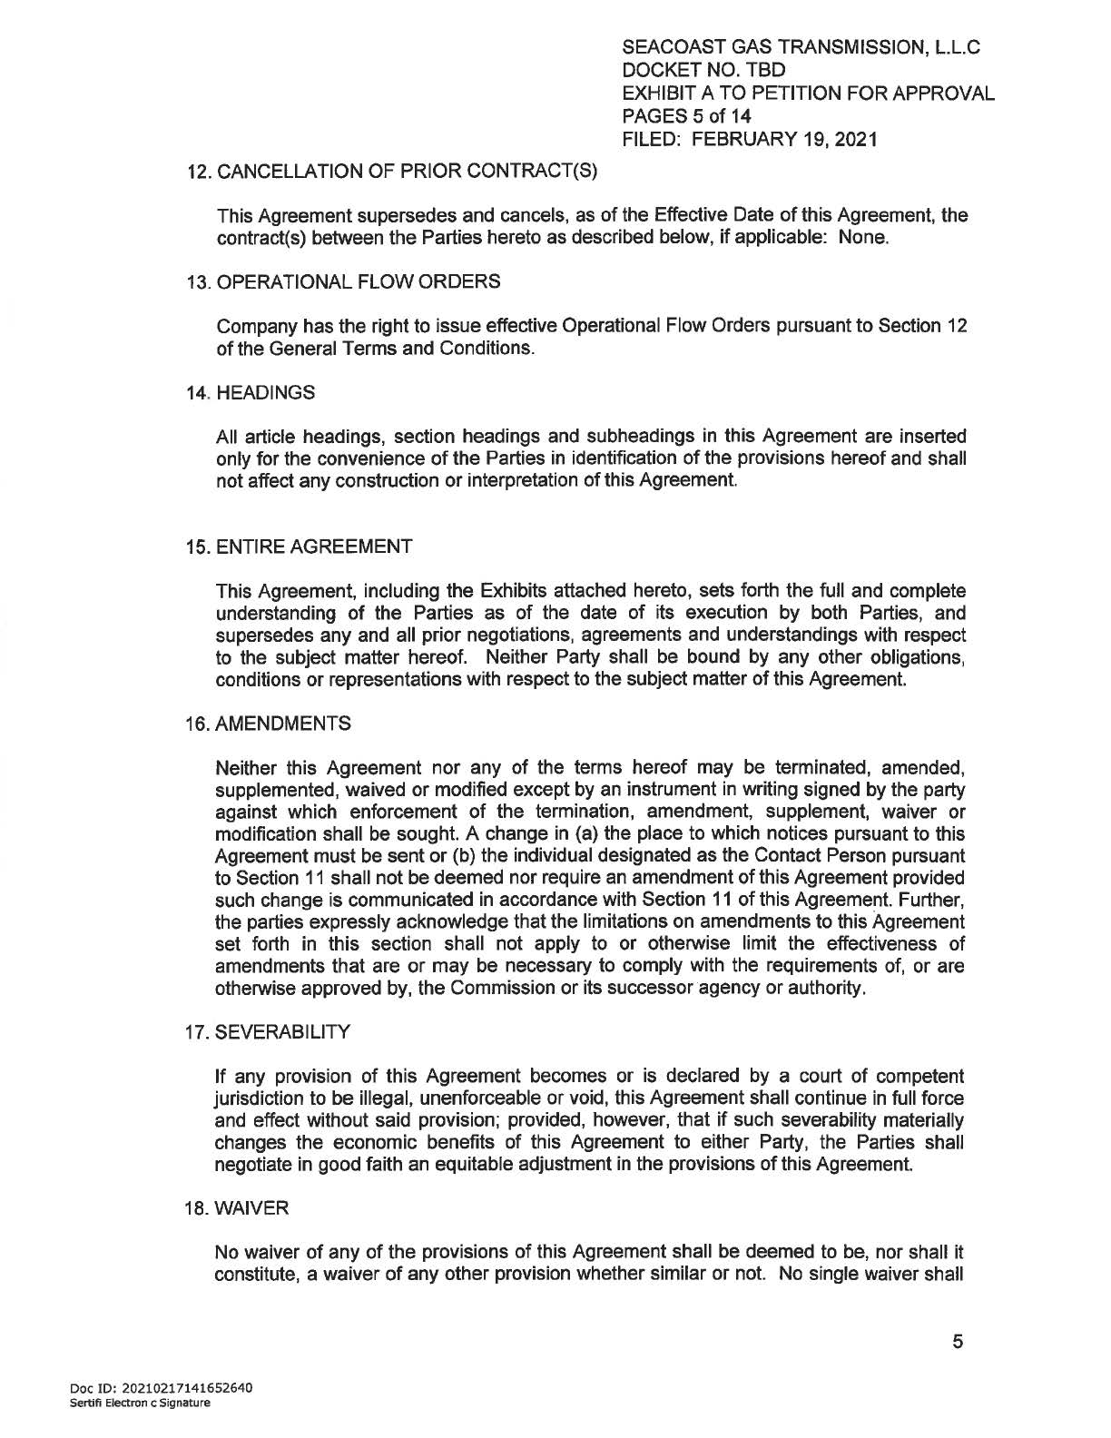

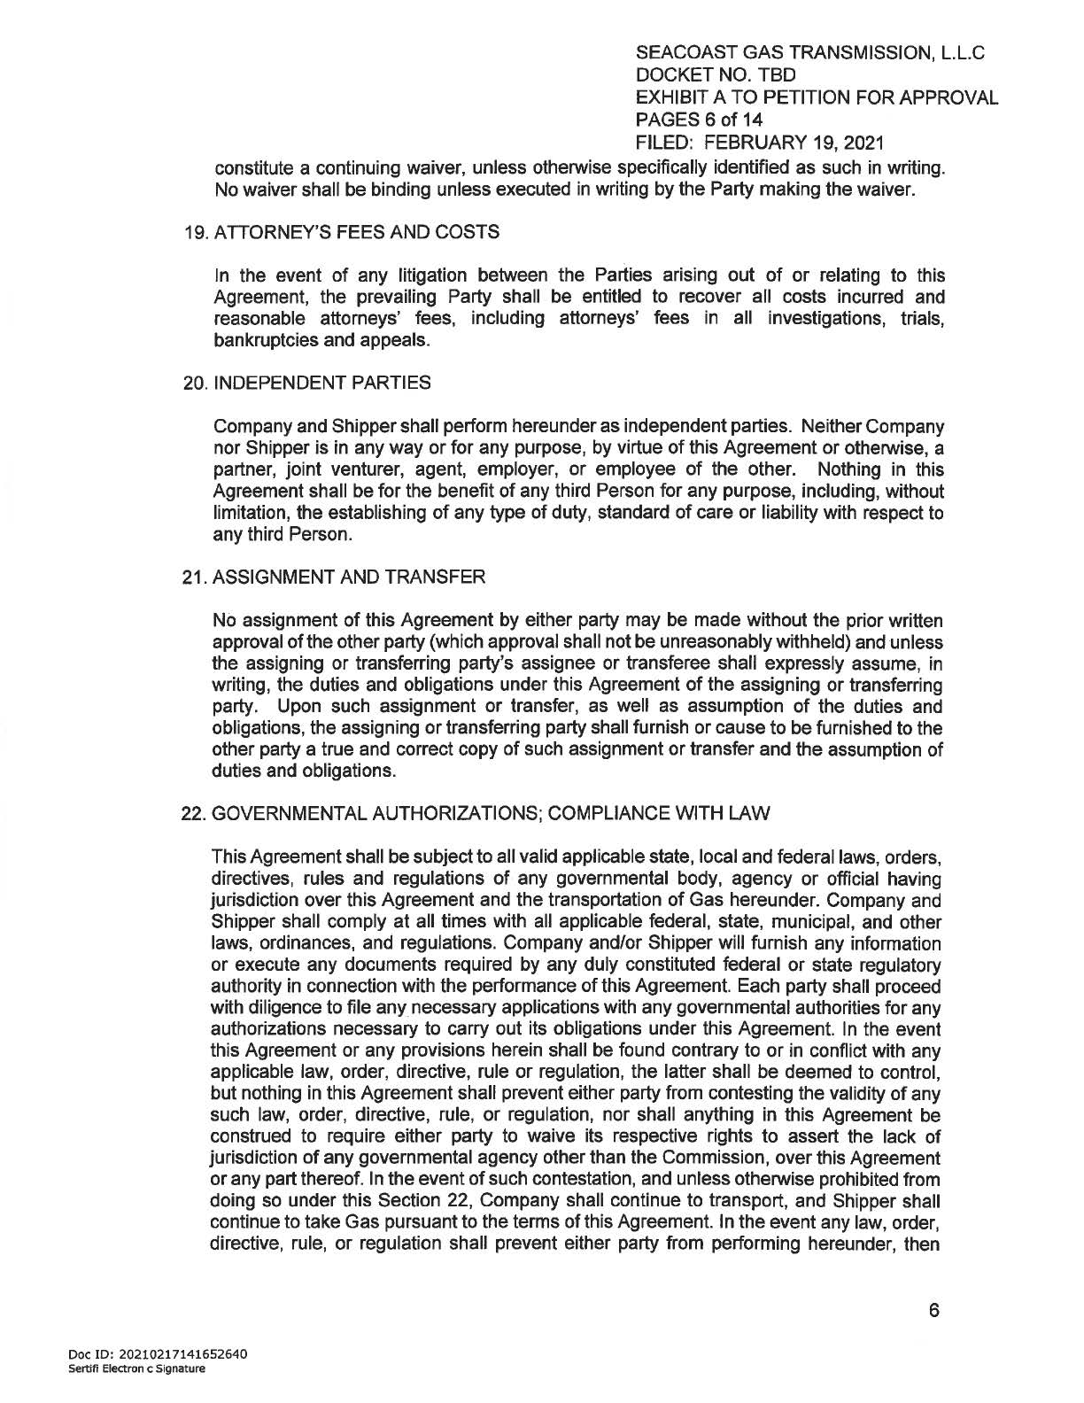

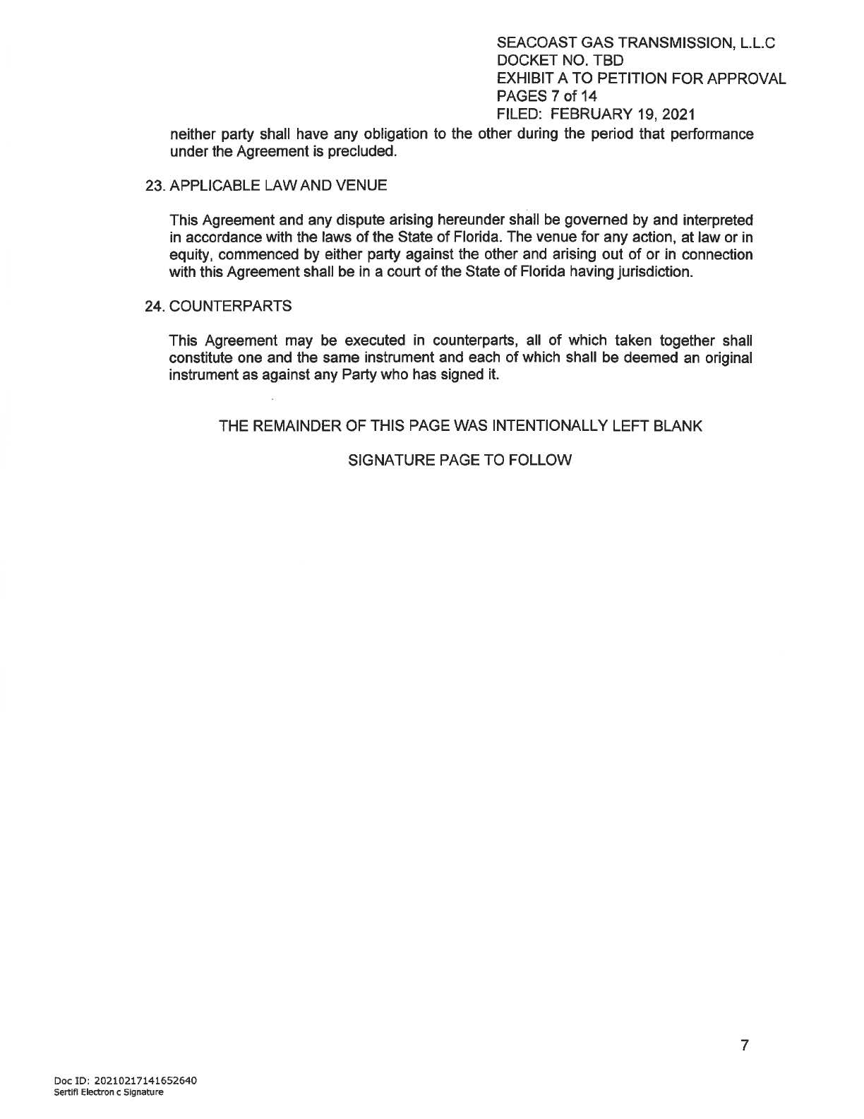

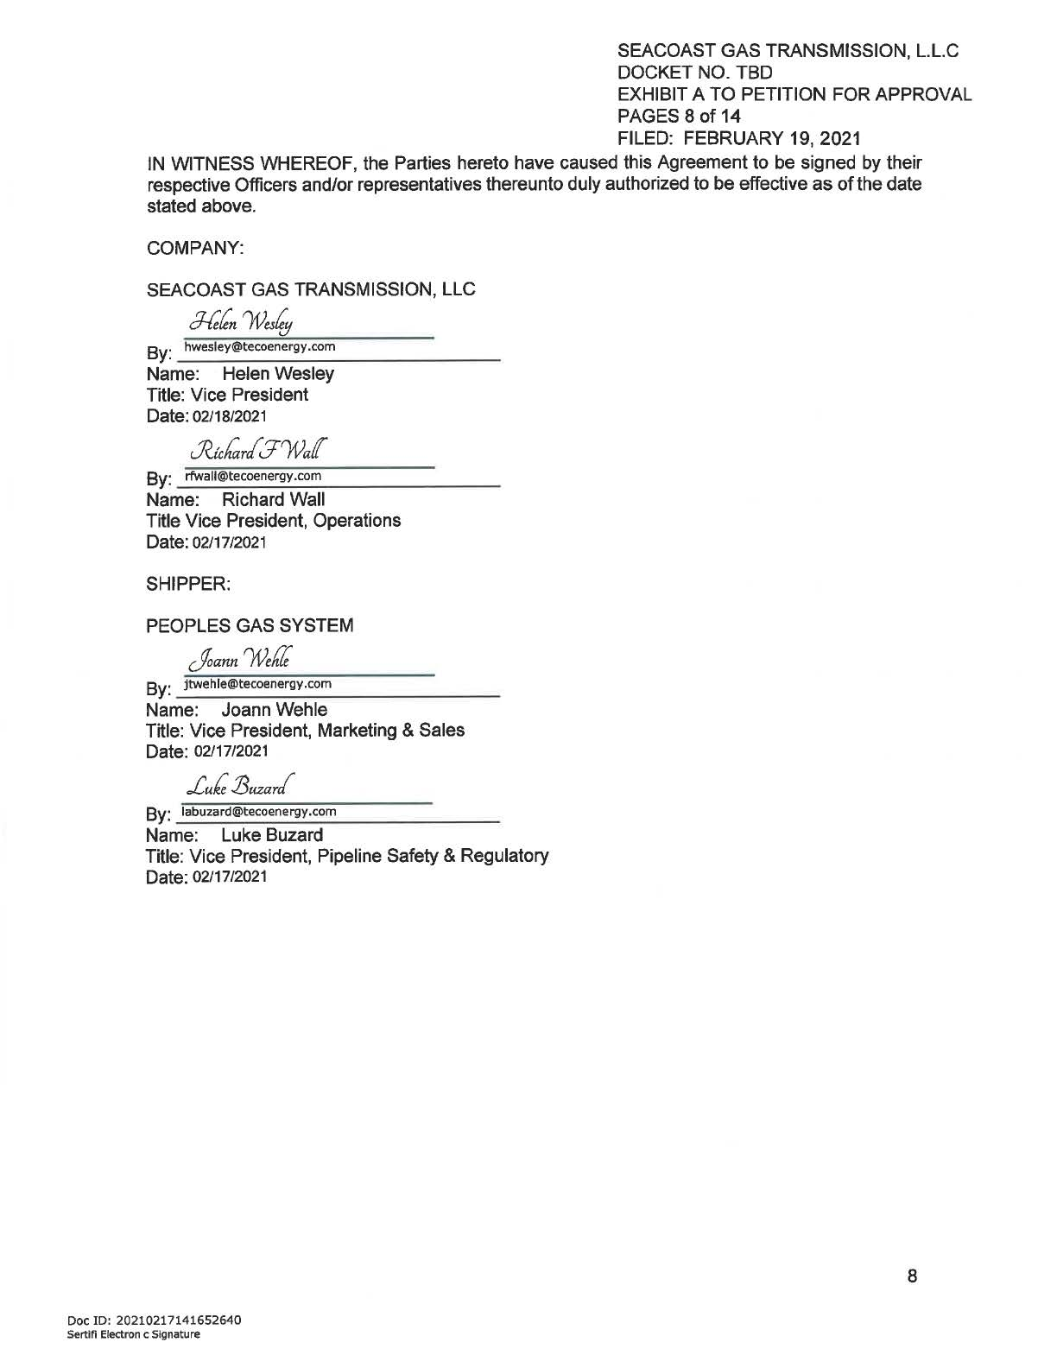

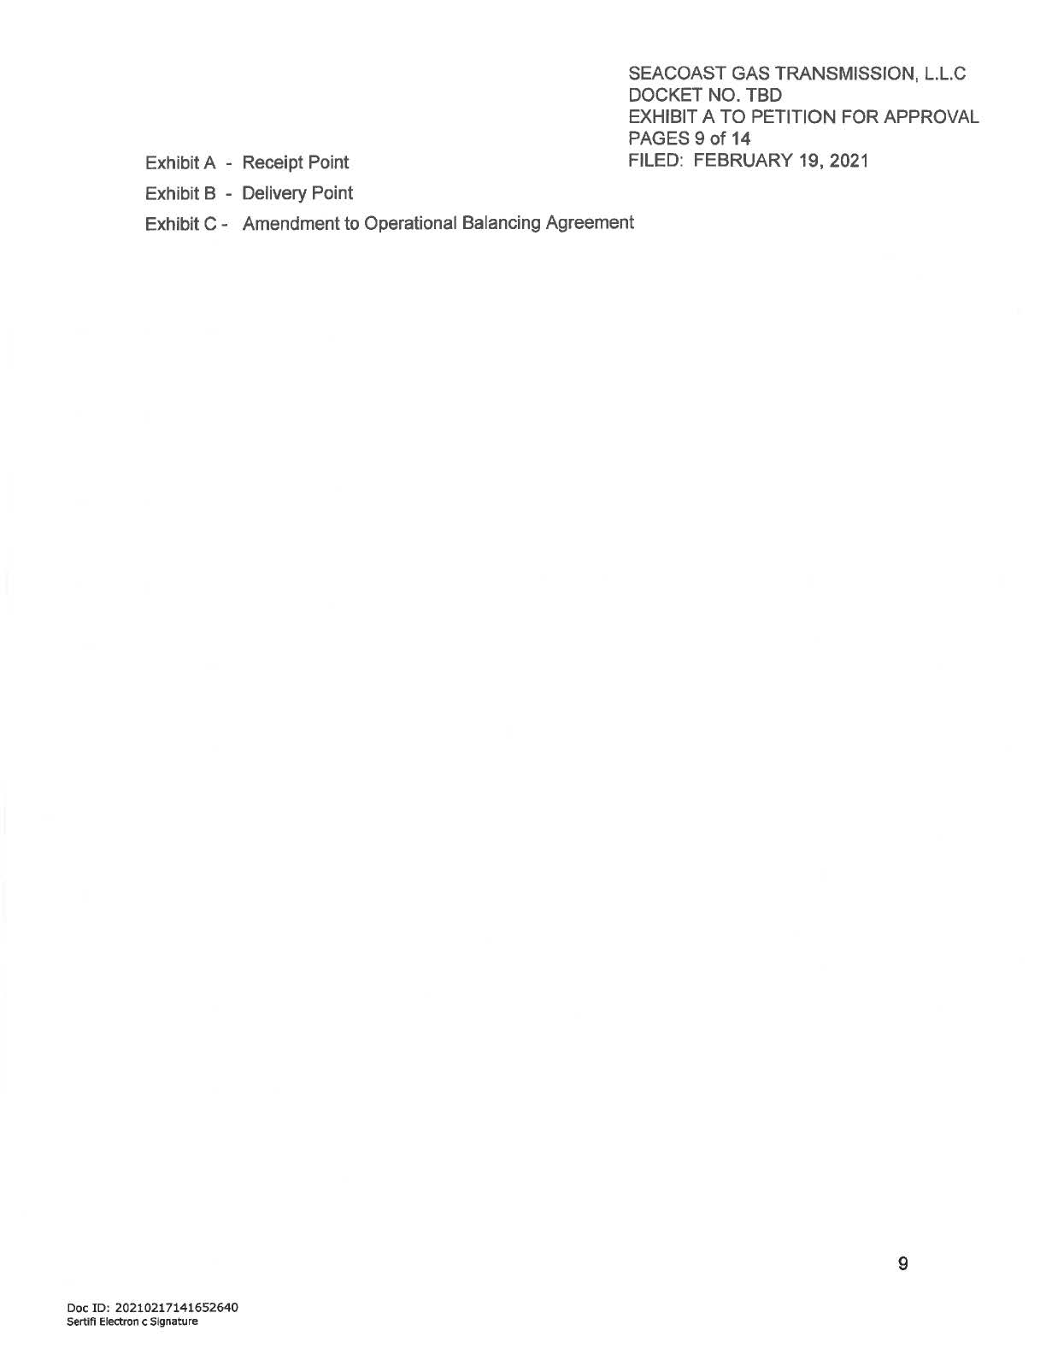

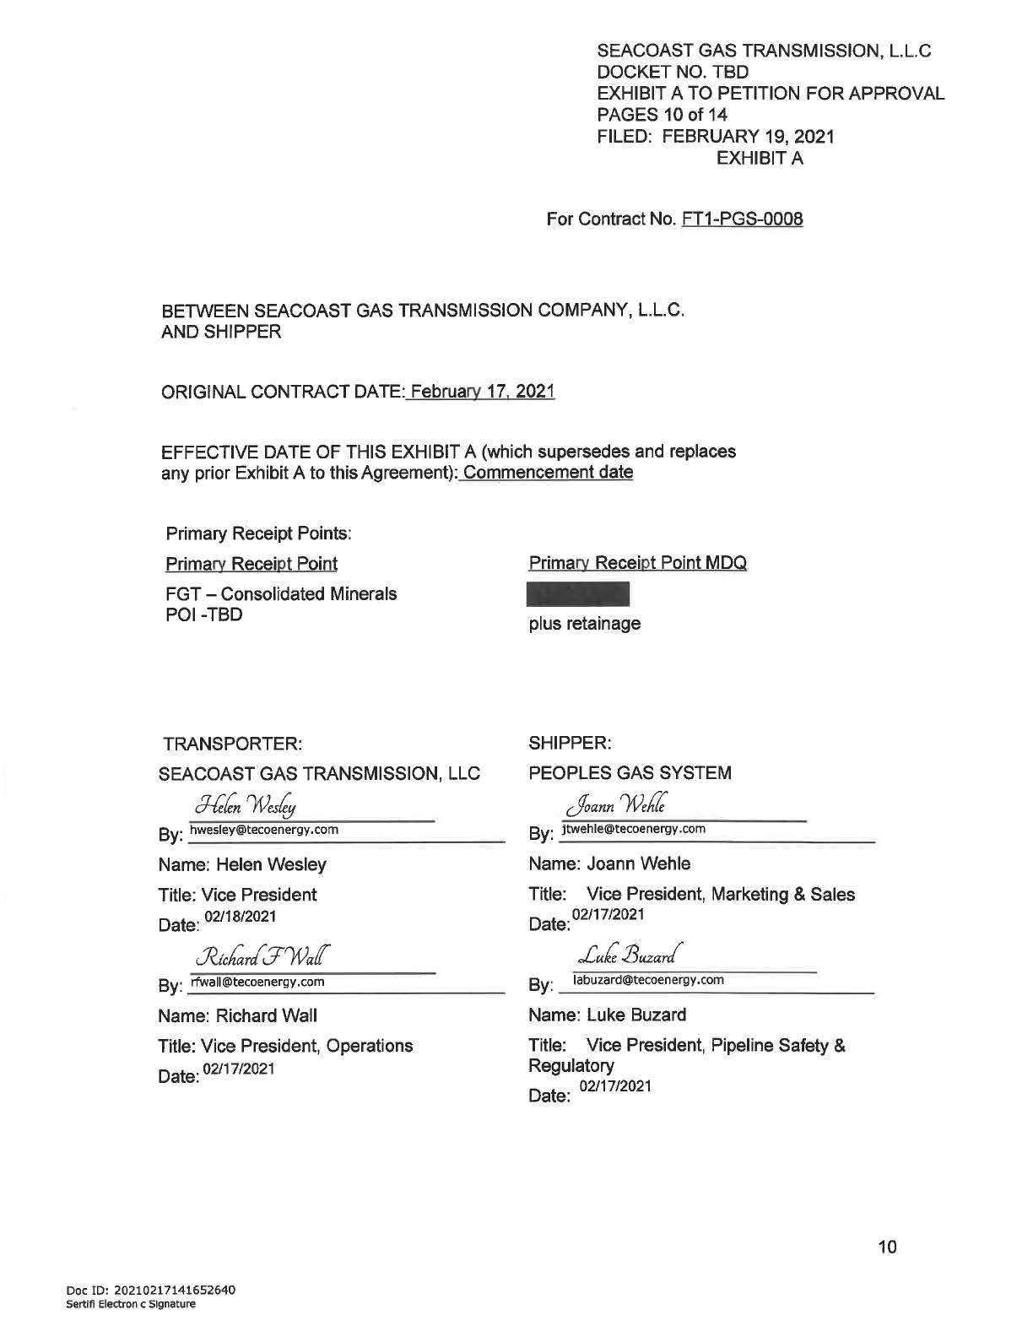

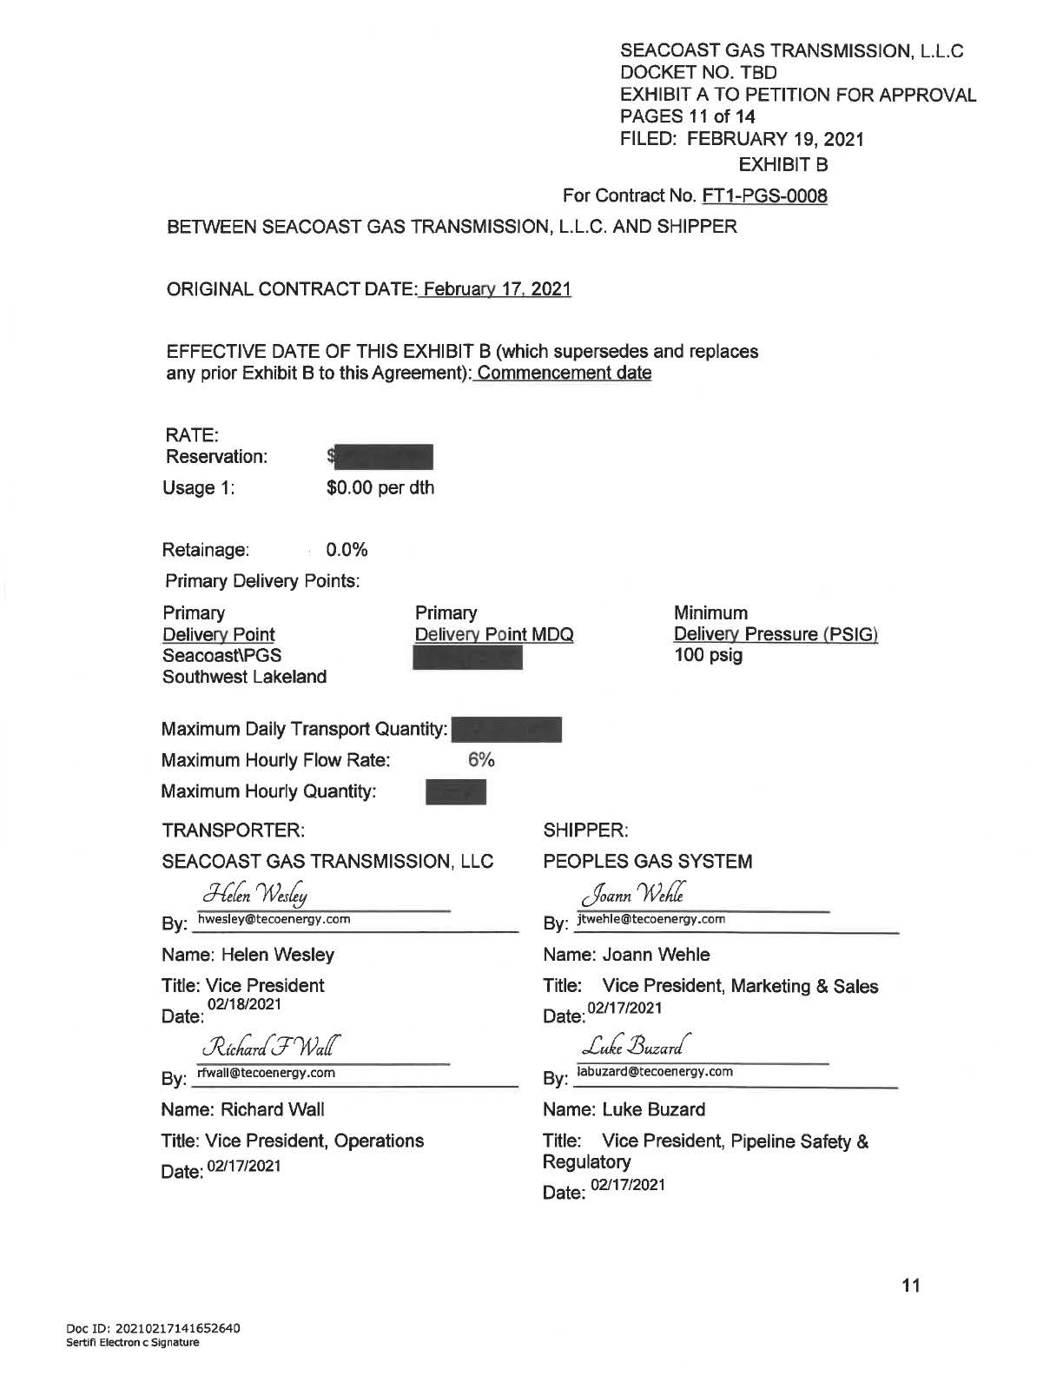

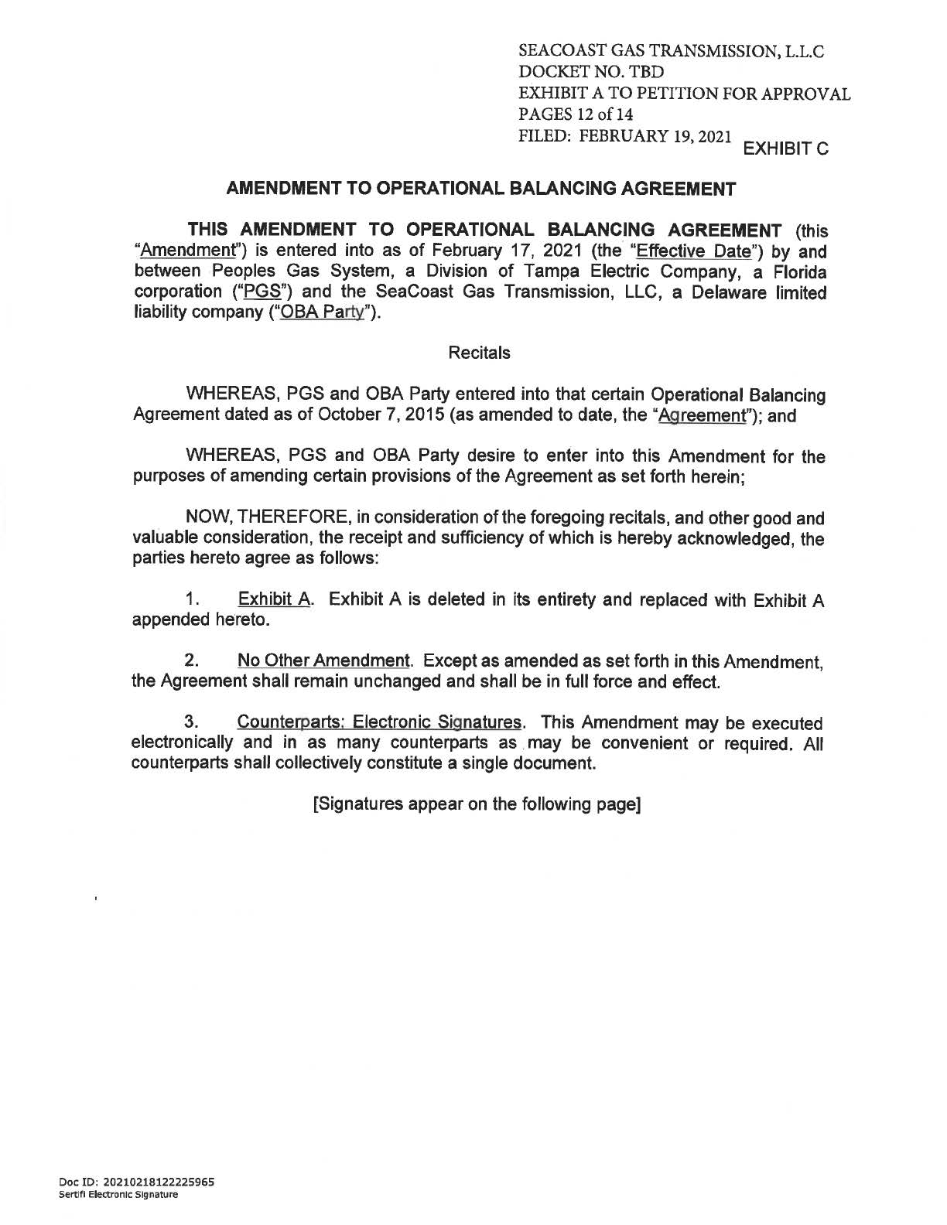

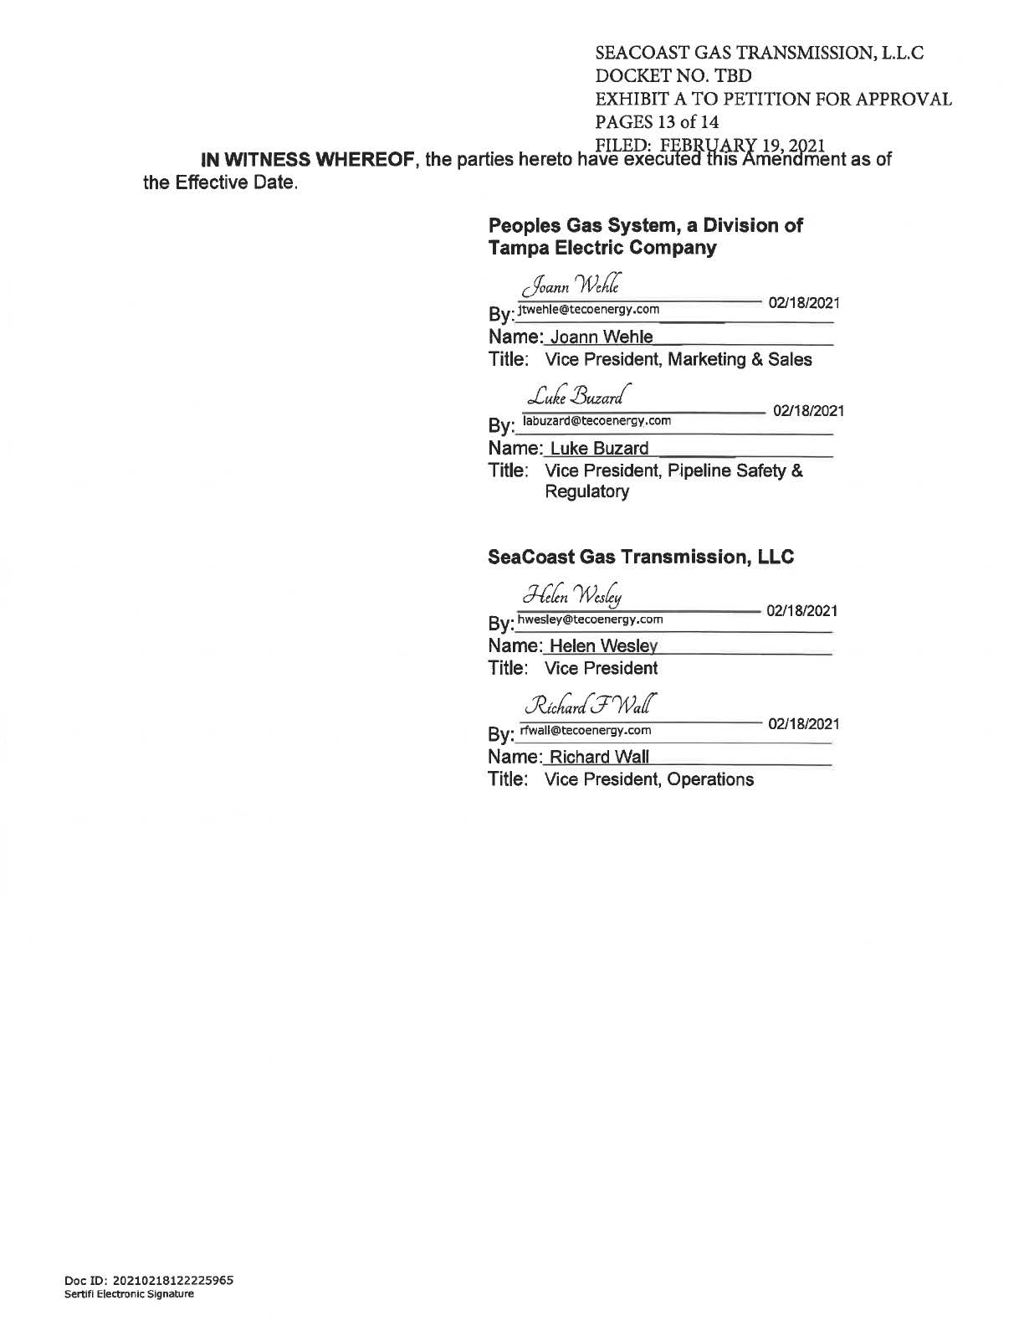

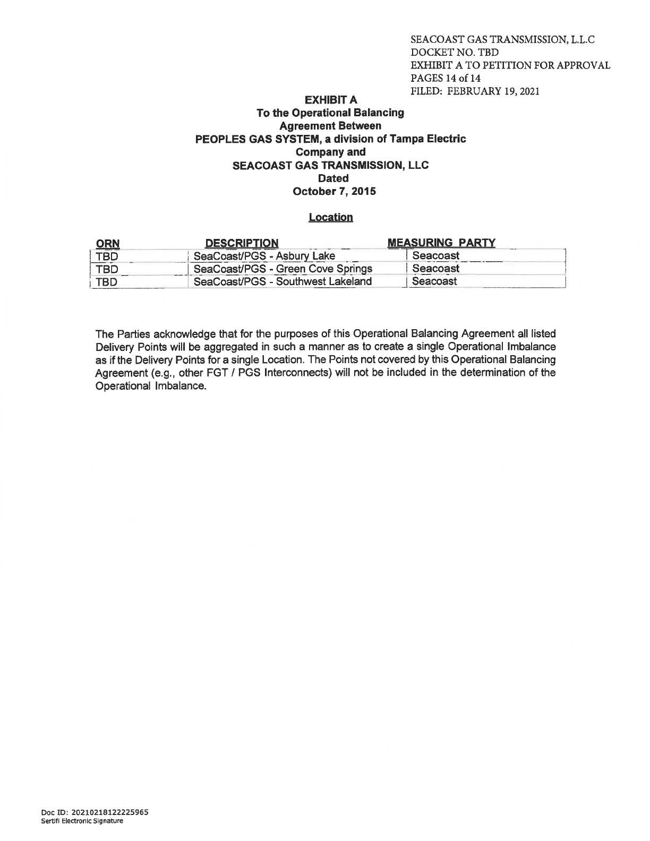

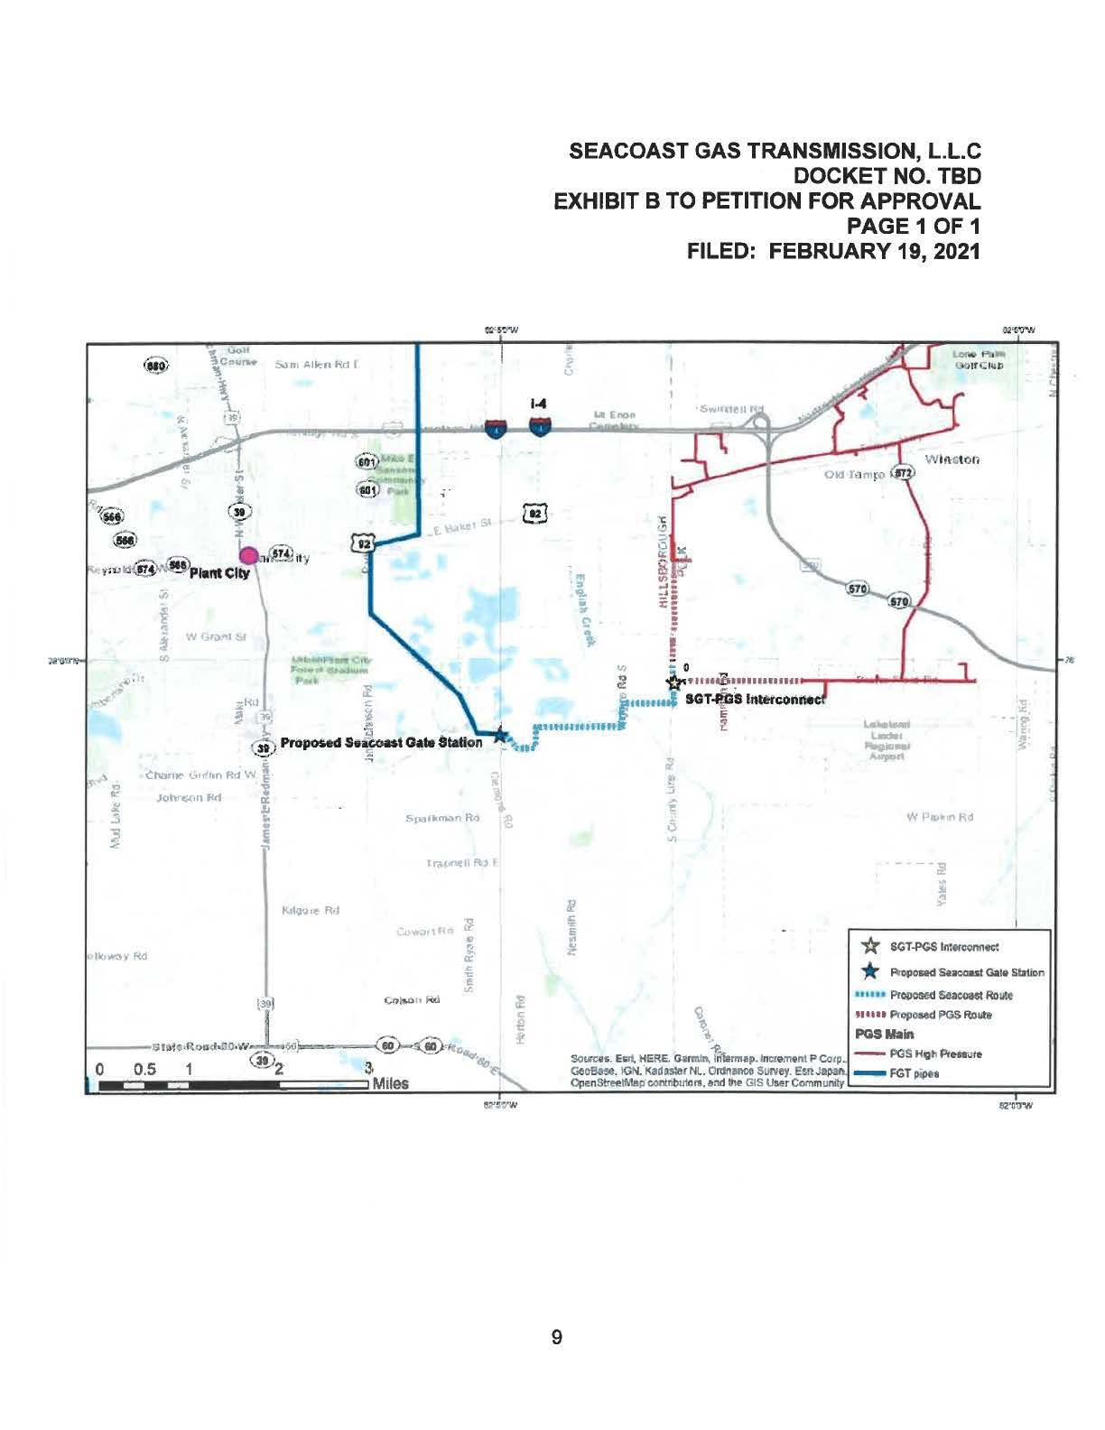

Order No. PSC-08-0747-TRF-GP, issued November 12, 2008, in Docket No. 20080561-GP, In re: Petition for approval of natural gas transmission pipeline tariff by SeaCoast Gas Transmission, LLC.
Peoples Gas System’s response to Staff’s first data request, question 5. Document No. 03189-2021.
Peoples Gas System’s response to Staff’s first data request, question 1. Document No. 03189-2021.
Peoples Gas System’s response to Staff’s first data request, question 4. Document No. 03189-2021.
The swing charge mechanism is designed to recover the estimated costs incurred by the Company to provide swing service (i.e., manage the level of gas and interstate pipeline capacity nominated for delivery to Peoples' system) to transportation customers. The revenue derived from the charge is credited to the Purchased Gas Adjustment clause.
Order No. PSC-15-0574-PAA-GU, issued December 18, 2015, in Docket No. 20150221-GU, In re: Petition for approval of firm service agreement with Peoples Gas System for an extension in Clay County, by SeaCoast Gas Transmission, LLC.
Order No. PSC-2019-0545-PAA-GU, issued December 20, 2019, in Docket No. 20190145-GU, In re: Joint petition for approval of restructures Nassau County agreements to reflect Callahan expansion, by Peoples Gas System, Florida Public Utilities Company, SeaCoast Gas Transmission, and Peninsula Pipeline Company, Inc.

