State of Florida |  | Public Service Commission  Capital Circle Office Center ● 2540 Shumard Oak Boulevard  Tallahassee, Florida 32399-0850  -M-E-M-O-R-A-N-D-U-M-
DATE: | June 25, 2021
TO: | Office of Commission Clerk (Teitzman)
FROM: | Division of Engineering (Phillips, Ellis)  Office of the General Counsel (Murphy)
RE: | Docket No. 20210067-EQ – Petition for approval of revised standard offer contract and a revised accompanying rate schedule QS-2, by Florida Power & Light Company.
AGENDA: | 07/08/21 – Regular Agenda – Proposed Agency Action – Interested Persons May Participate
COMMISSIONERS ASSIGNED: |  |  | All Commissioners
PREHEARING OFFICER: |  |  | Administrative
CRITICAL DATES: |  |  | None
SPECIAL INSTRUCTIONS: |  |  | Staff recommends the Commission consider with Docket No. 20210066-EQ

Case Background
Section 366.91(3), Florida Statutes (F.S.), requires each investor-owned utility (IOU) to continuously offer to purchase capacity and energy from renewable generating facilities and small qualifying facilities. Florida Public Service Commission (Commission) Rules 25-17.200 through 25-17.310, Florida Administrative Code (F.A.C.), implement the statute and require each IOU to file with the Commission, by April 1 of each year, a revised standard offer contract based on the next avoidable fossil fueled generating unit of each technology type identified in the utility’s current Ten-Year Site Plan (TYSP). On April l, 2021, Florida Power & Light Company (FPL) filed a petition for approval of its revised standard offer contract, based on its 2021 TYSP. The Commission has jurisdiction over this standard offer contract pursuant to Sections 366.04 through 366.055, and 366.91, F.S.

Discussion of Issues

Issue 1:
Should the Commission approve the revised standard offer contract and associated rate schedule QS-2 filed by Florida Power & Light Company?

Recommendation:
Yes. The provisions of FPL’s revised standard offer contract and associated rate schedule QS-2 conform to all requirements of Rules 25-17.200 through 25-17.310, F.A.C. The revised standard offer contract provides flexibility in the arrangements for payments so that a developer of renewable generation may select the payment stream best suited to its financial needs. (Phillips)

Staff Analysis:
Section 366.91(3), F.S., and Rule 25-17.250, F.A.C., require that FPL, as an IOU, continuously make available a standard offer contract for the purchase of firm capacity and energy from renewable generating facilities (RF) and small qualifying facilities (QF) with design capacities of 100 kilowatts (kW) or less. Pursuant to Rules 25-17.250(1) and (3), F.A.C., the standard offer contract must provide a term of at least 10 years, and the payment terms must be based on the utility’s next avoidable fossil-fueled generating unit identified in its most recent TYSP, or if no avoided unit is identified, its next avoidable planned purchase.
Similar to last year’s standard offer contract, FPL submitted a joint TYSP with Gulf Power Company (Gulf) for 2021, with the companies planning to merge into a single remaining entity by 2022. While the joint 2021 TYSP does not feature an avoidable fossil-fueled generating unit or planned purchases that could be deferred during the planning period, FPL has identified a 1,991 megawatt (MW) natural gas-fired combined cycle unit (CC) as the next planned generating unit. The projected in-service date of the unit is June 1, 2031. The Commission has previously approved using a unit outside of the TYSP planning period as the avoided unit for standard offer contract purposes.
Under FPL’s standard offer contract, the RF/QF operator commits to certain minimum performance requirements based on the identified avoided unit, such as being operational and delivering an agreed upon amount of capacity by the in-service date of the avoided unit, and thereby becomes eligible for capacity payments in addition to payments received for energy. The standard offer contract may also serve as a starting point for negotiation of contract terms by providing payment information to an RF/QF operator, in a situation where one or both parties desire particular contract terms other than those established in the standard offer
In order to promote renewable generation, the Commission requires the IOU to offer multiple options for capacity payments, including the options to receive early or levelized payments. If the RF/QF operator elects to receive capacity payments under the normal or levelized contract options, it will receive as-available energy payments only until the in-service date of the avoided unit (in this case June 1, 2031), and thereafter, begin receiving capacity payments in addition to the energy payments. If either the early or early levelized option is selected, then the operator will begin receiving capacity payments earlier than the in-service date of the avoided unit. However, payments made under the early capacity payment options tend to be lower in the later years of the contract term because the net present value (NPV) of the total payments must remain equal for all contract payment options.
Table 1 contains FPL’s estimates of the annual payments for each payment option available under the revised standard offer contract to an operator with a 50 MW facility operating at a capacity factor of 94 percent, which is the minimum capacity factor required under the contract to qualify for full capacity payments. Normal and levelized capacity payments begin with the projected in-service date of the avoided unit (June 1, 2031) and continue for 10 years, while early and early levelized capacity payments begin five years prior to the in-service date, or 2027 for this example.

Table 1 - Estimated Annual Payments to a 50 MW Renewable Facility
(94% Capacity Factor)
Year | Energy Payment | Capacity Payment (By Type)
 |  | Normal | Levelized | Early | Early Levelized
 | $(000) | $(000) | $(000) | $(000) | $(000)
2022 | 7,667 | - | - | ‐ | ‐
2023 | 6,793 | - | - | ‐ | ‐
2024 | 7,418 | - | - | ‐ | ‐
2025 | 8,347 | - | - | ‐ | ‐
2026 | 8,650 | - | - | ‐ | ‐
2027 | 8,862 | - | - | 1,210 | 1,357
2028 | 9,109 | - | - | 2,100 | 2,326
2029 | 9,419 | - | - | 2,144 | 2,326
2030 | 9,908 | - | - | 2,189 | 2,326
2031 | 9,607 | 2,063 | 2,242 | 2,235 | 2,326
2032 | 9,695 | 3,581 | 3,844 | 2,282 | 2,326
2033 | 10,171 | 3,656 | 3,844 | 2,330 | 2,326
2034 | 10,675 | 3,733 | 3,844 | 2,379 | 2,326
2035 | 11,053 | 3,812 | 3,844 | 2,429 | 2,326
2036 | 11,589 | 3,892 | 3,844 | 2,480 | 2,326
2037 | 11,935 | 3,974 | 3,844 | 2,532 | 2,326
2038 | 12,188 | 4,057 | 3,844 | 2,583 | 2,326
2039 | 12,315 | 4,143 | 3,844 | 2,640 | 2,326
2040 | 12,601 | 4,230 | 3,844 | 2,695 | 2,326
2041* | 5,289 | 1,778 | 1,602 | 1,133 | 969
Total | 193,291 | 38,919 | 38,439 | 33,364 | 32,564
Total (NPV) | 93,259 | 13,319 | 13,319 | 13,319 | 13,319
Source: FPL’s Response to Staff’s First Data Request and staff calculation
*Payments end in May 2041, resulting in a partial year of energy capacity and payments.
FPL’s standard offer contract, in type-and-strike format, is included as Attachment A to this recommendation. The changes made to FPL’s tariff sheets are consistent with the updated avoided unit. Revisions include updates to calendar dates and payment information which reflect the current economic and financial assumptions for the avoided unit. At this time FPL and Gulf operate as separate utilities; however they have requested to consolidate rates in the ongoing rate case.

Conclusion
Staff recommends that FPL’s revised standard offer contract and associated rate schedule QS-2 be approved as filed. The provisions of FPL’s revised standard offer contract conform to all requirements of Rules 25-17.200 through 25-17.310, F.A.C. The revised standard offer contract provides flexibility in the arrangements for payments so that a developer of renewable generation may select the payment stream best suited to its financial needs.

Issue 2:
Should this docket be closed?

Recommendation:
Yes. This docket should be closed upon issuance of a consummating order, unless a person whose substantial interests are affected by the Commission’s decision files a protest within 21 days of the issuance of the Commission’s Proposed Agency Action Order. Potential signatories should be aware that, if a timely protest is filed, FPL’s standard offer contract may subsequently be revised. (Murphy)

Staff Analysis:
This docket should be closed upon the issuance of a consummating order, unless a person whose substantial interests are affected by the Commission’s decision files a protest within 21 days of the issuance of the Commission’s Proposed Agency Action Order. Potential signatories should be aware that, if a timely protest is filed, FPL’s standard offer contract may subsequently be revised.

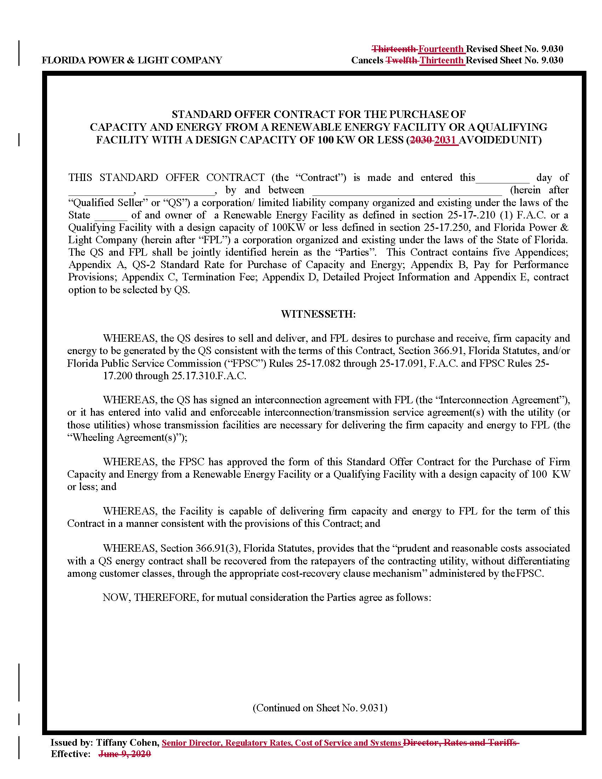

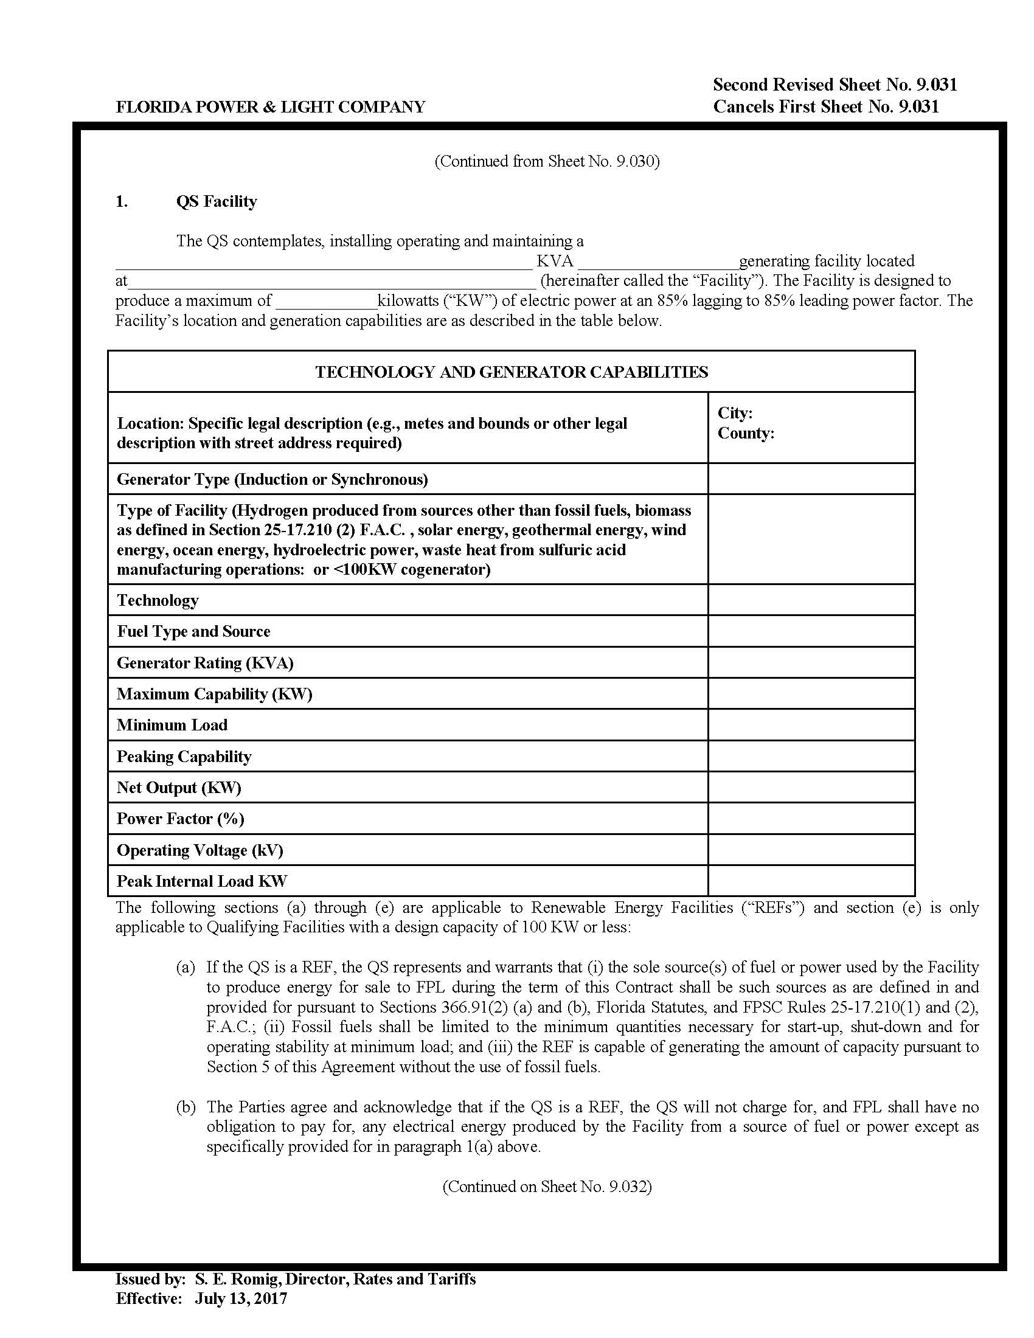

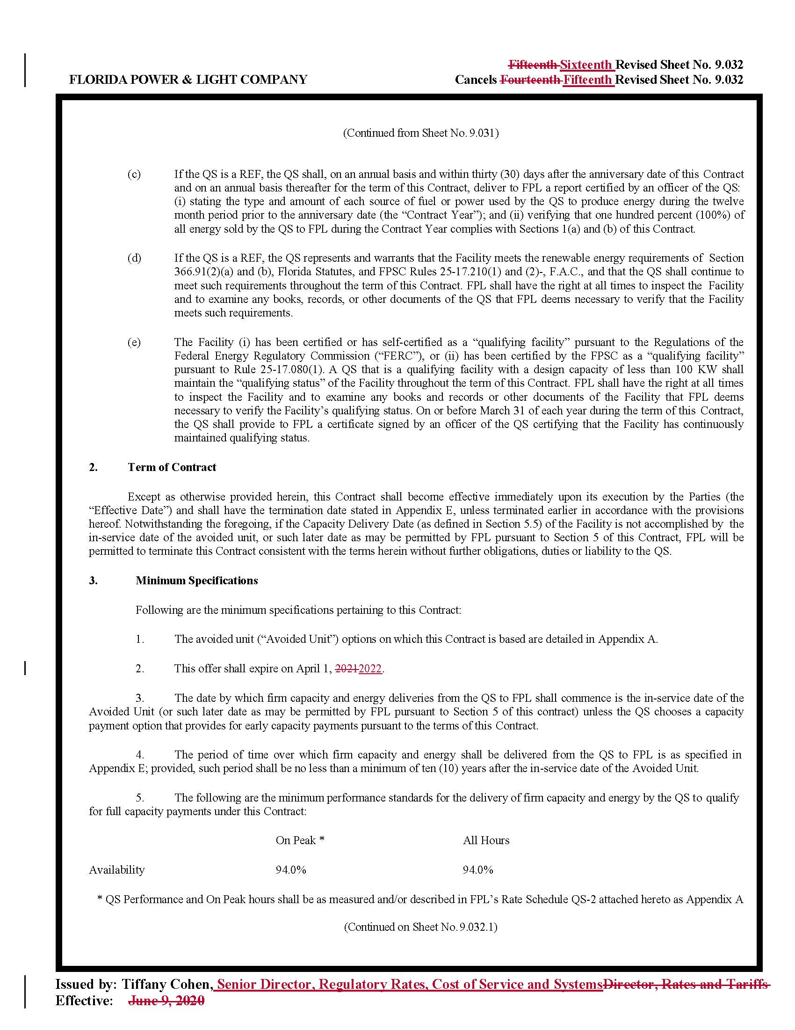

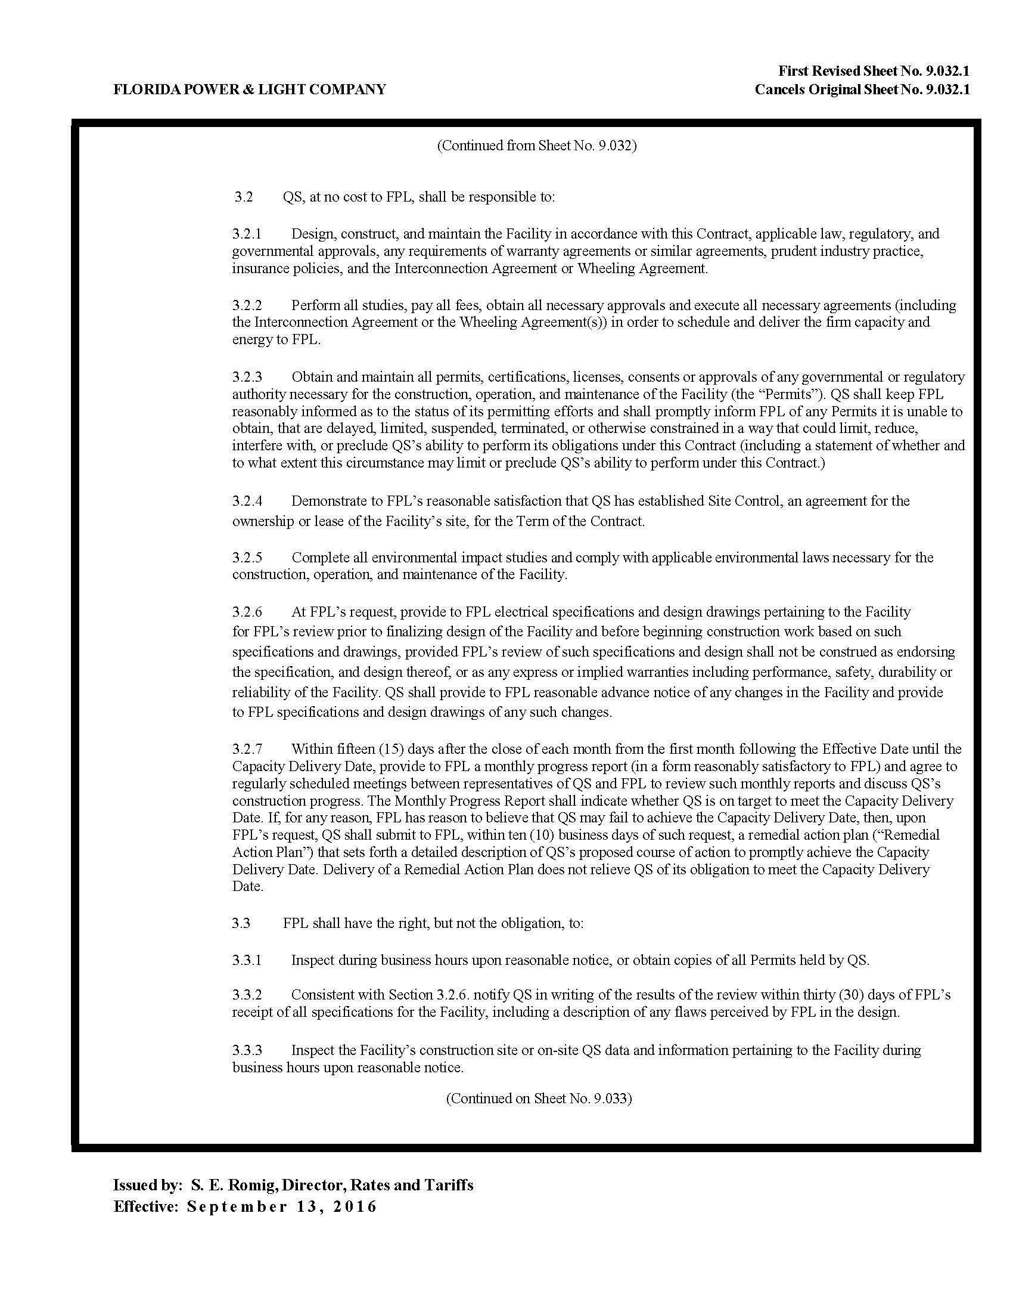

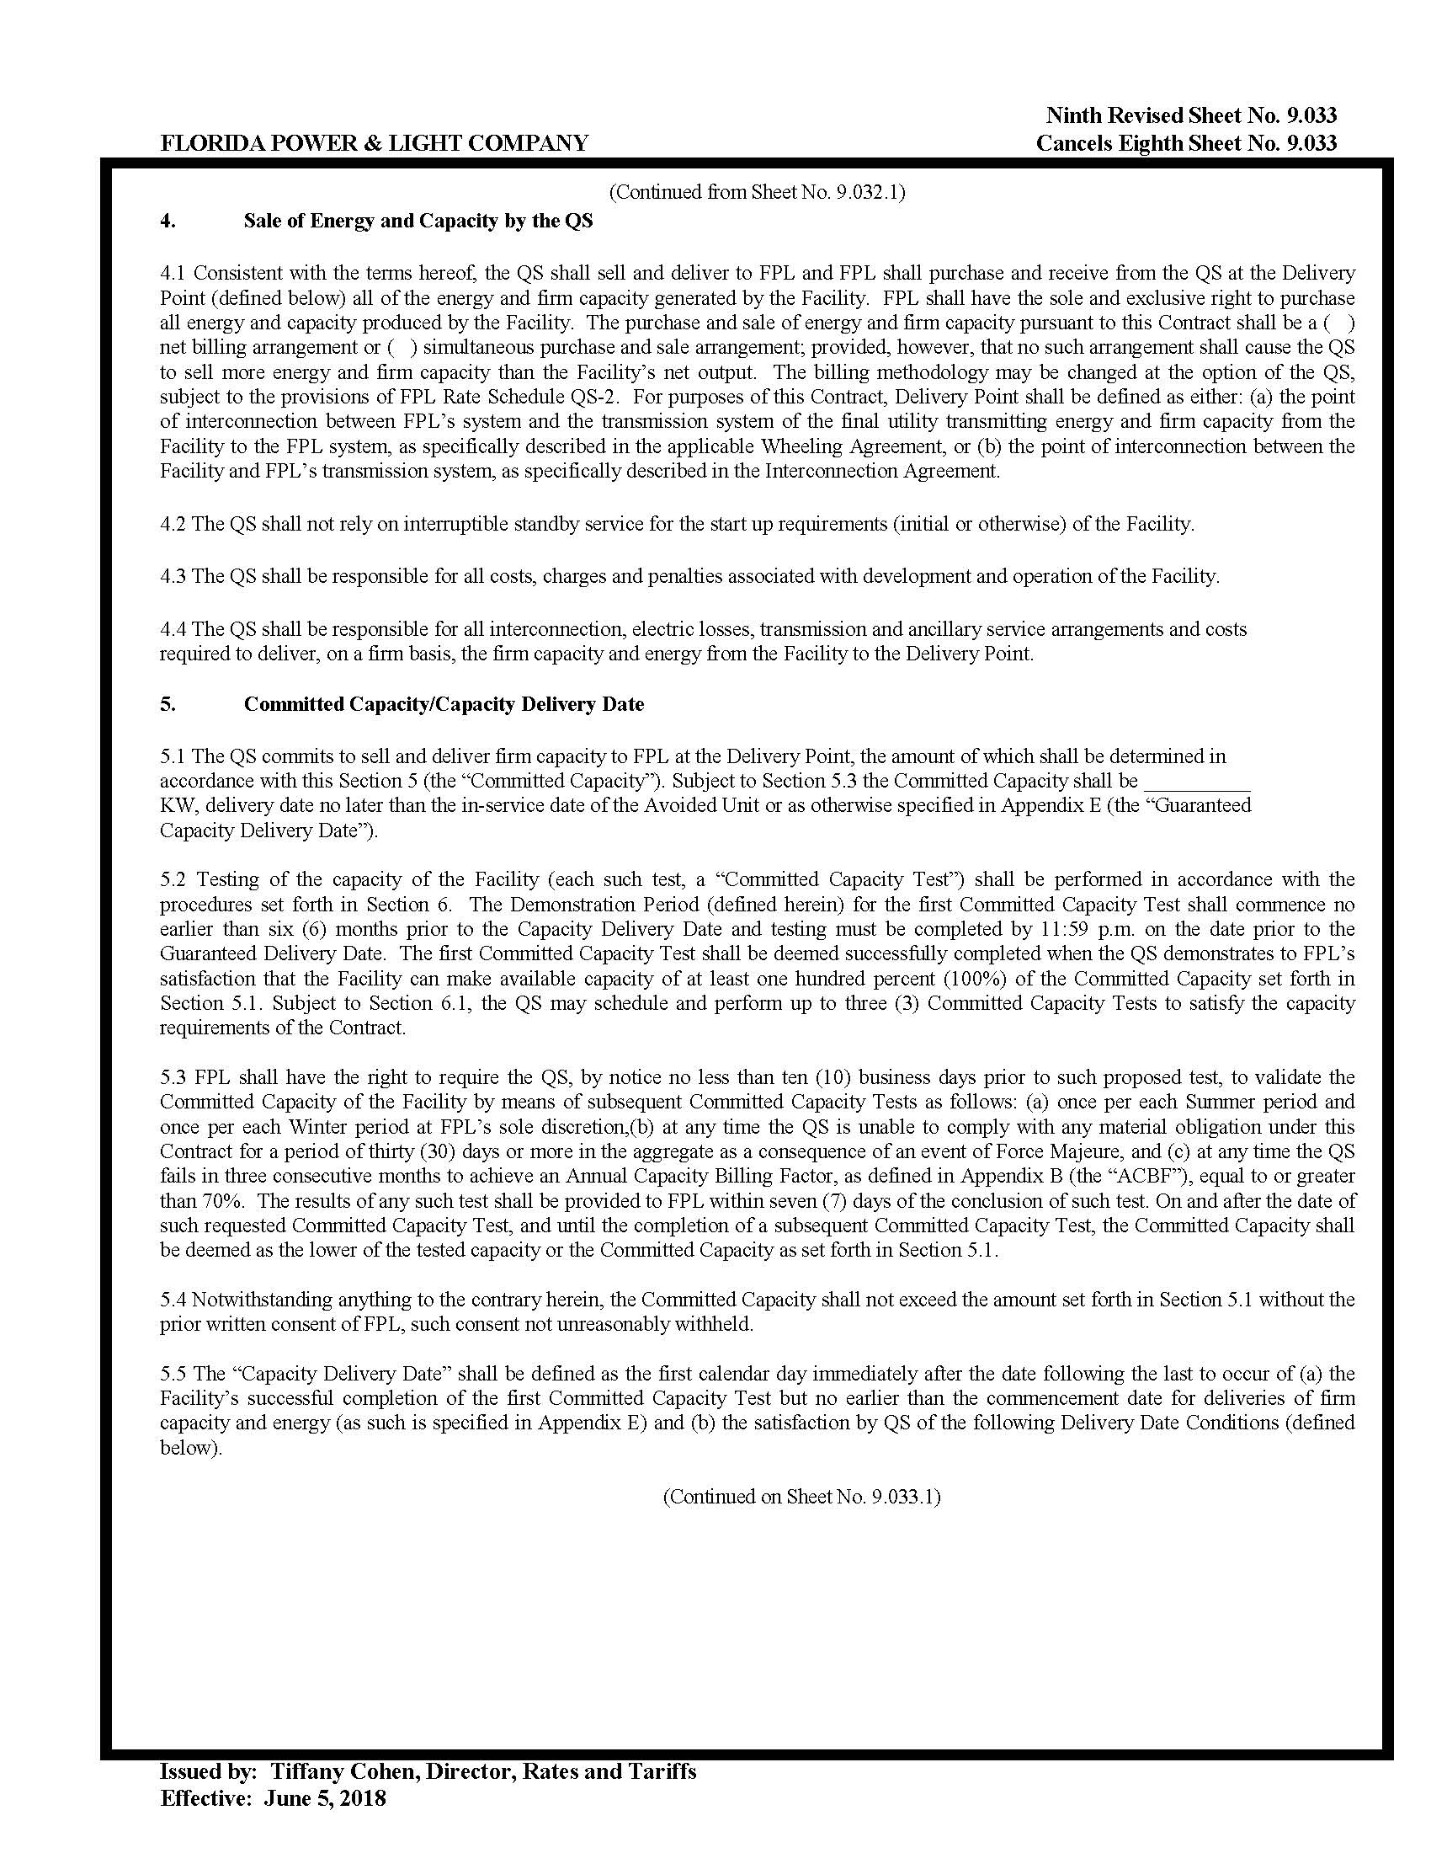

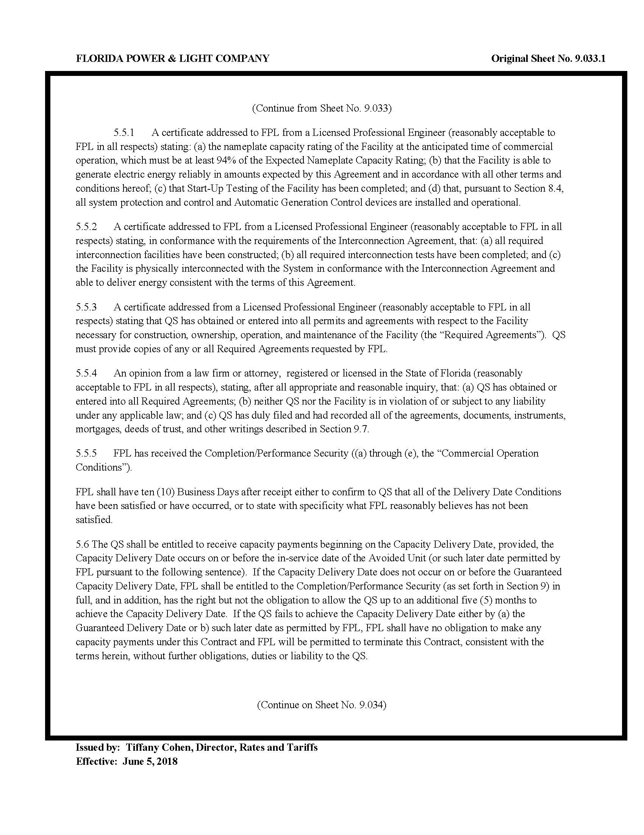

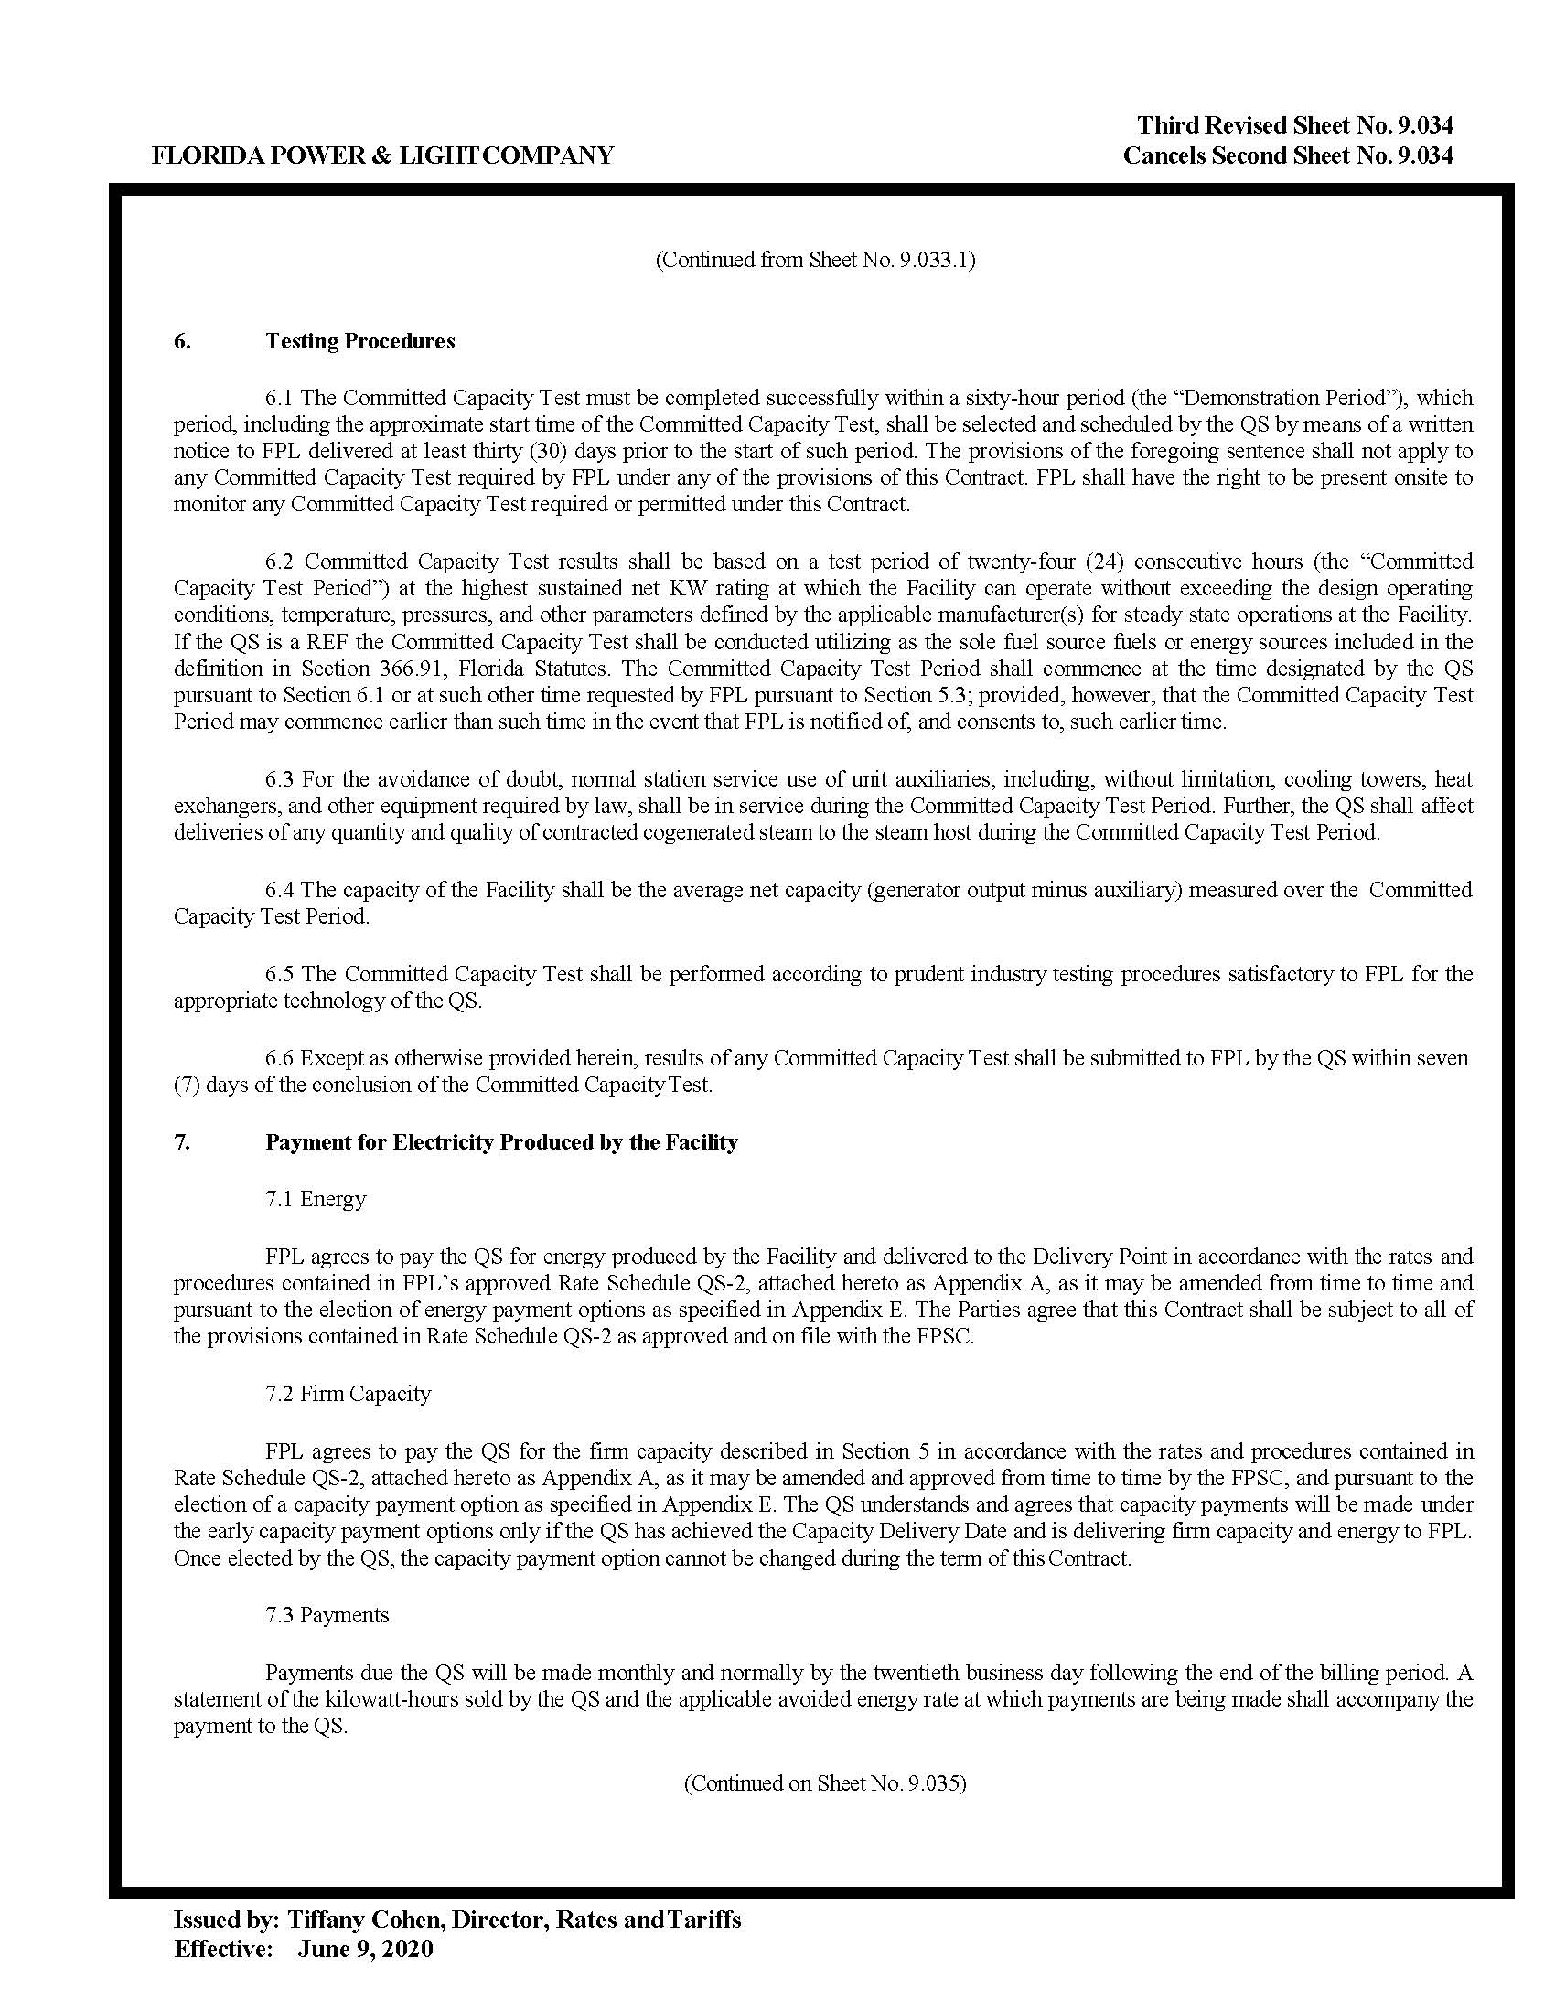

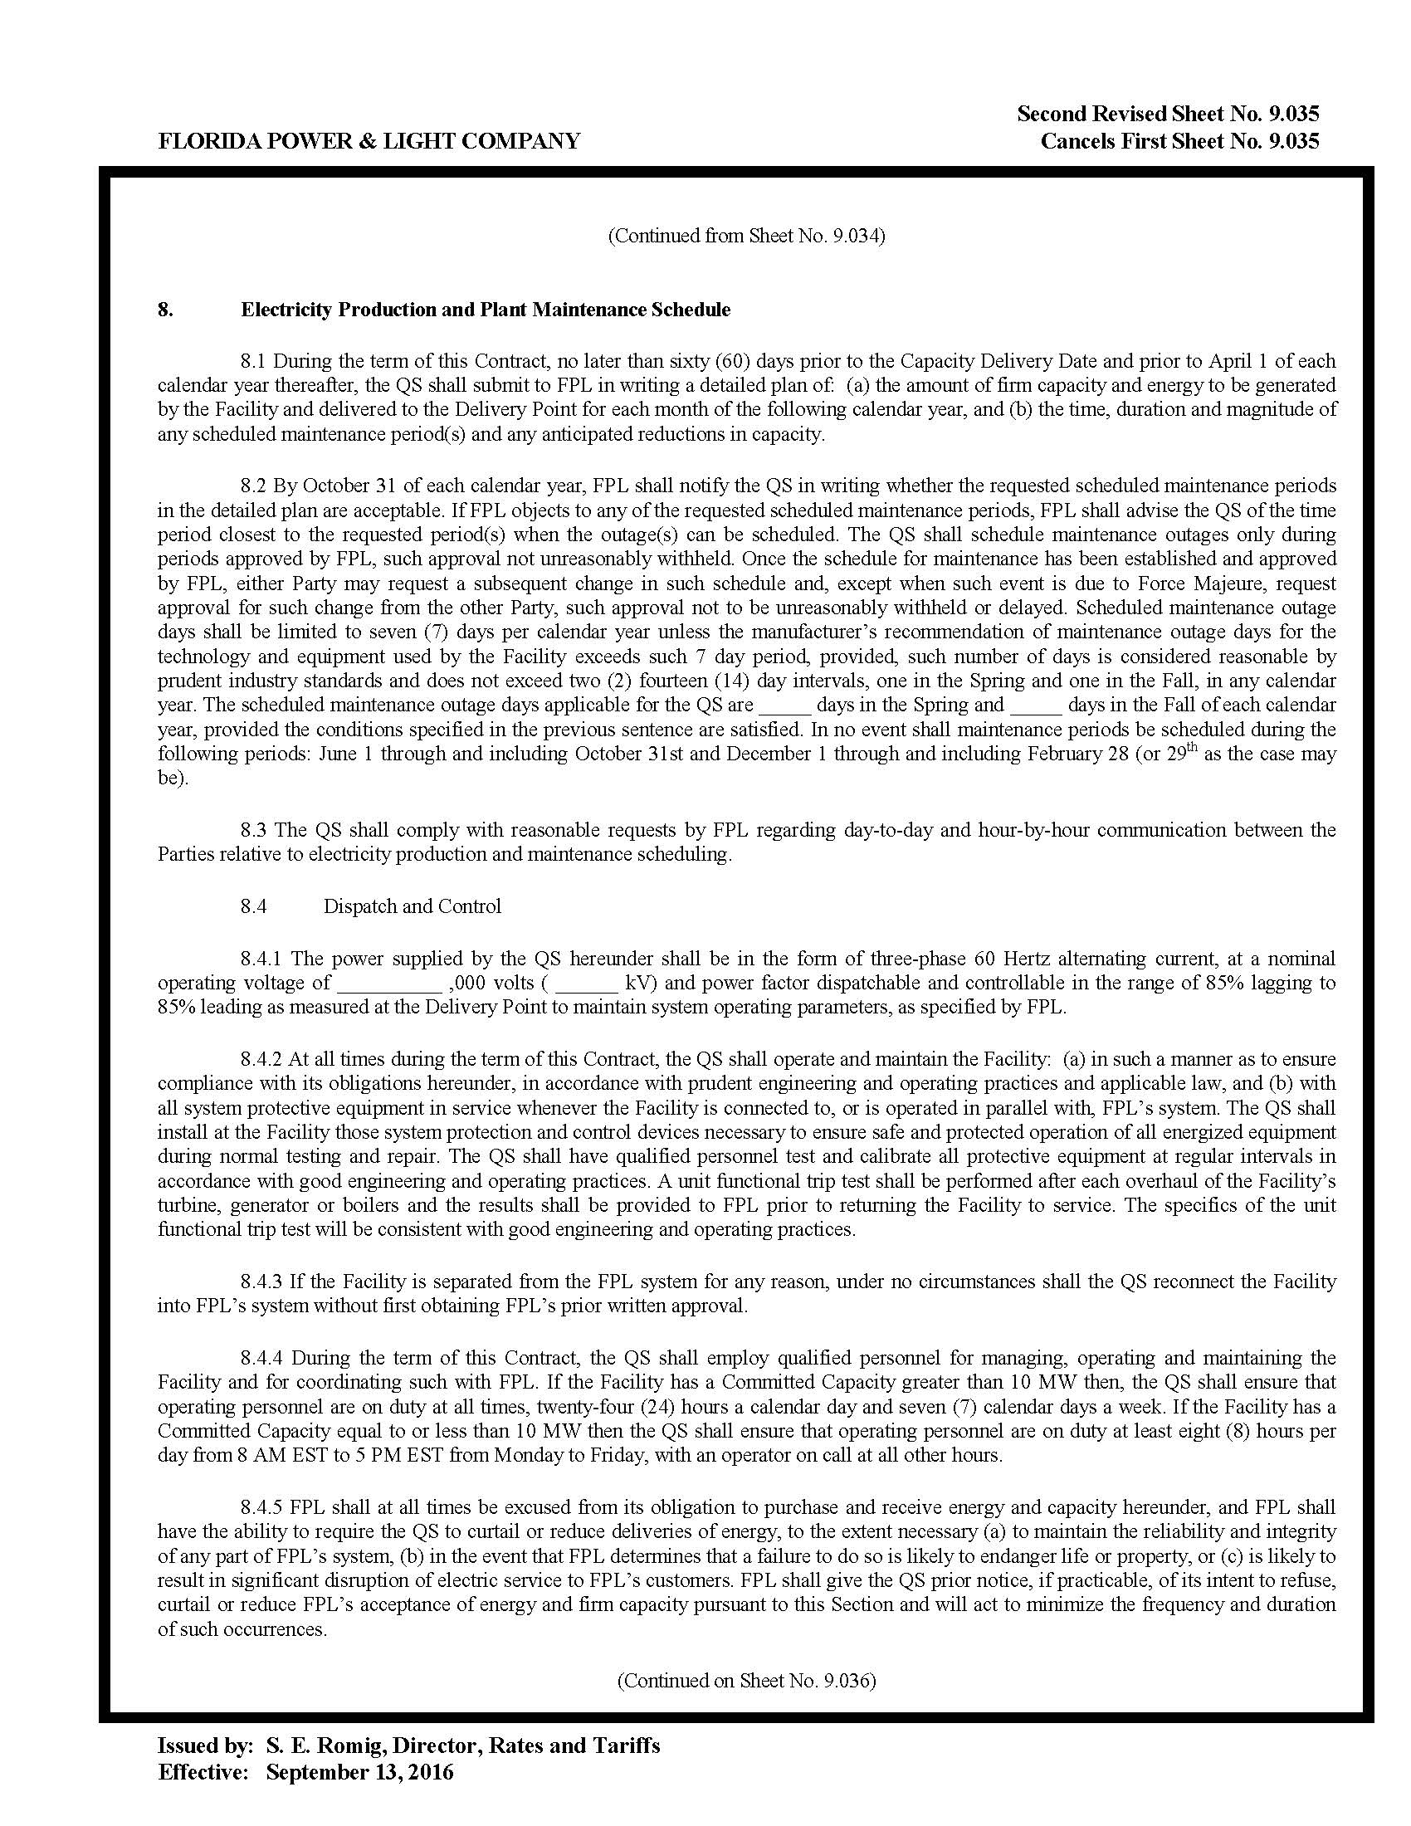

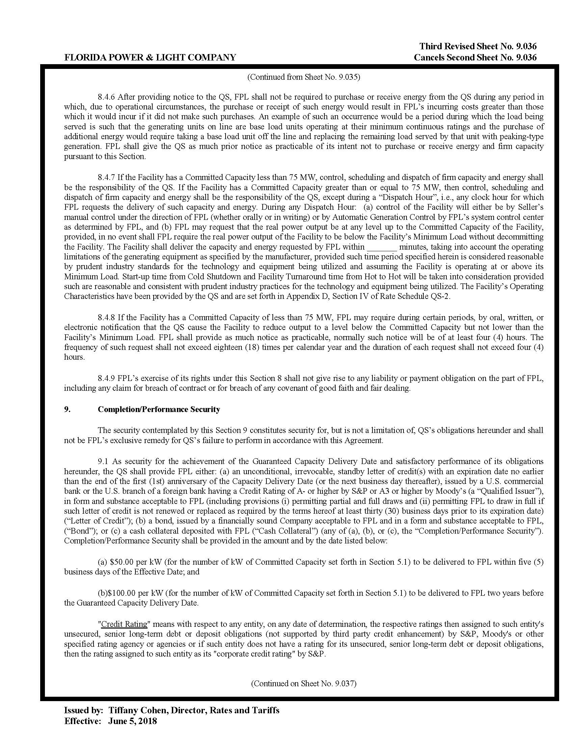

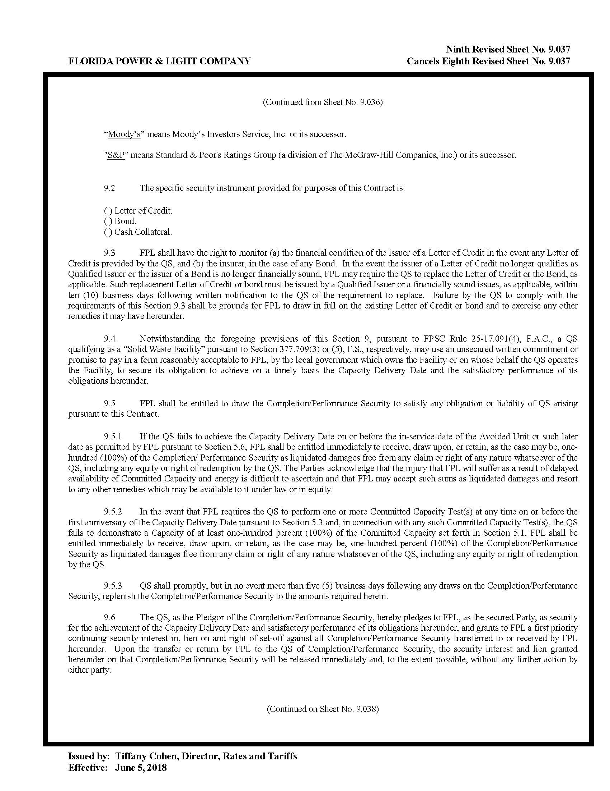

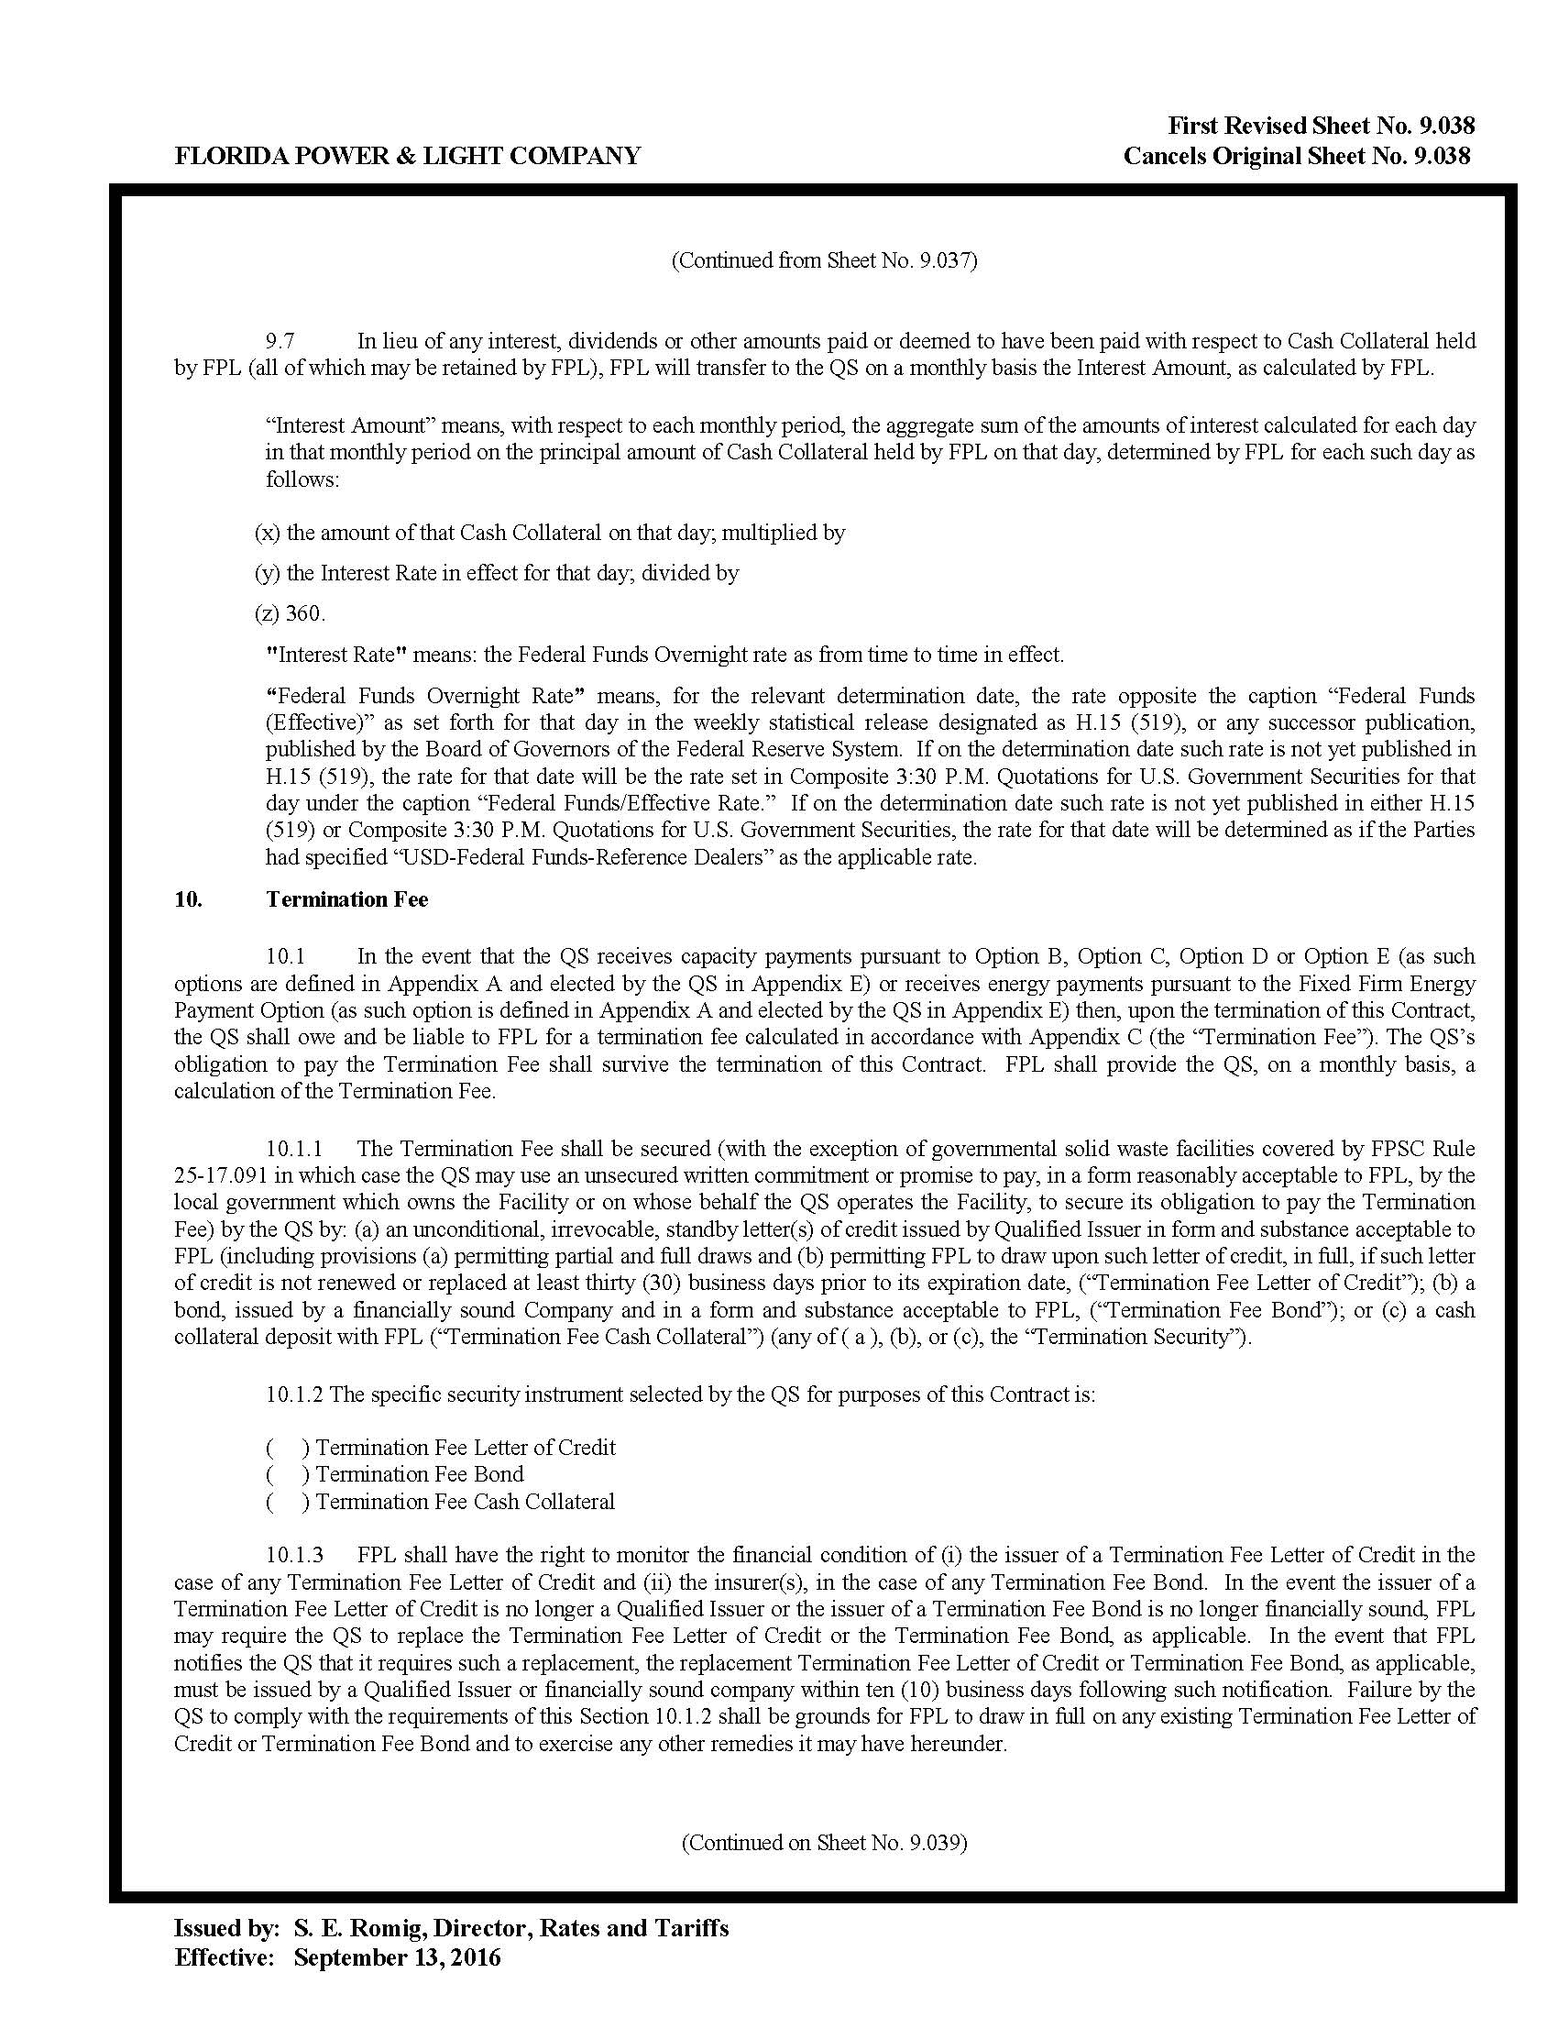

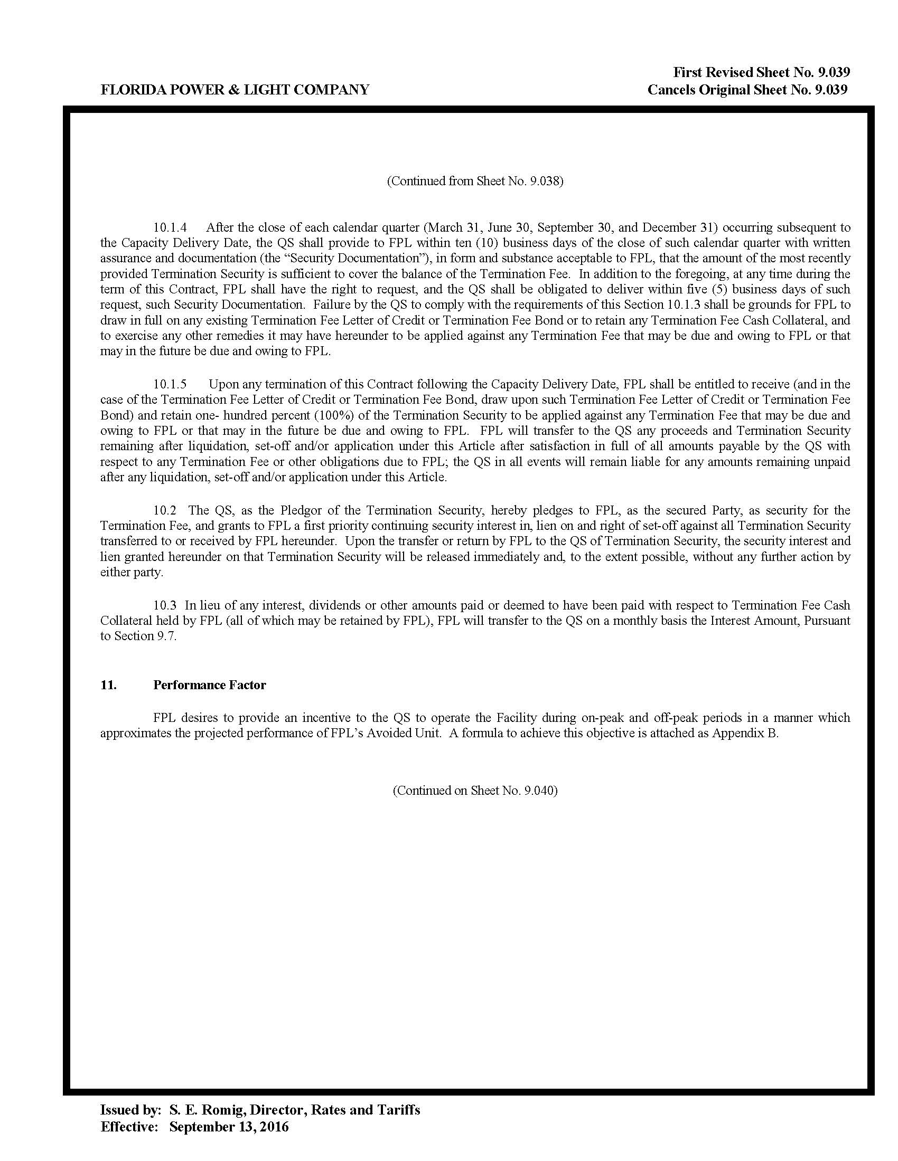

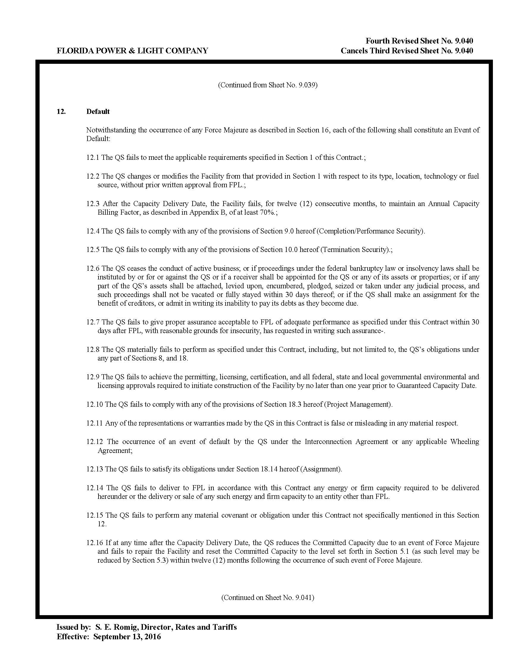

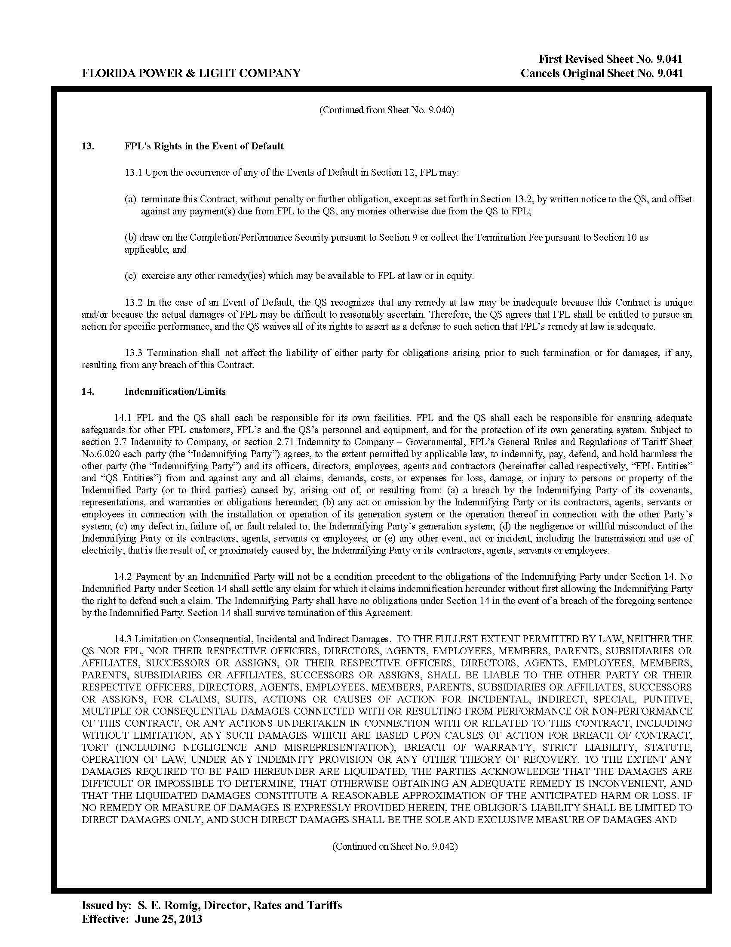

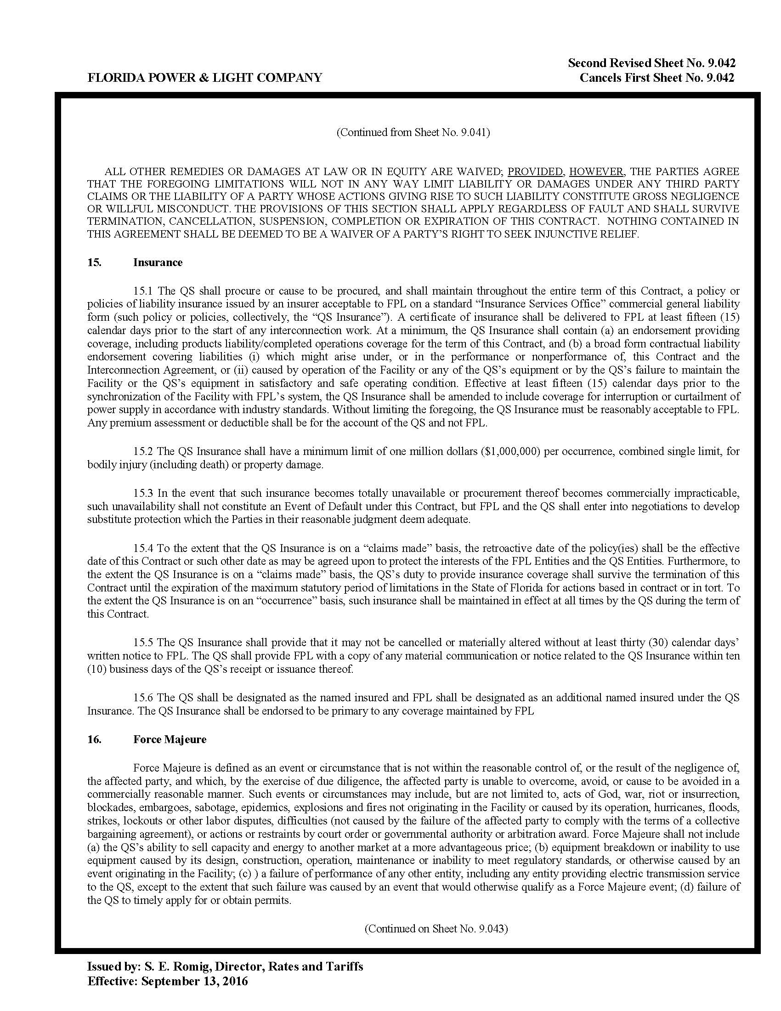

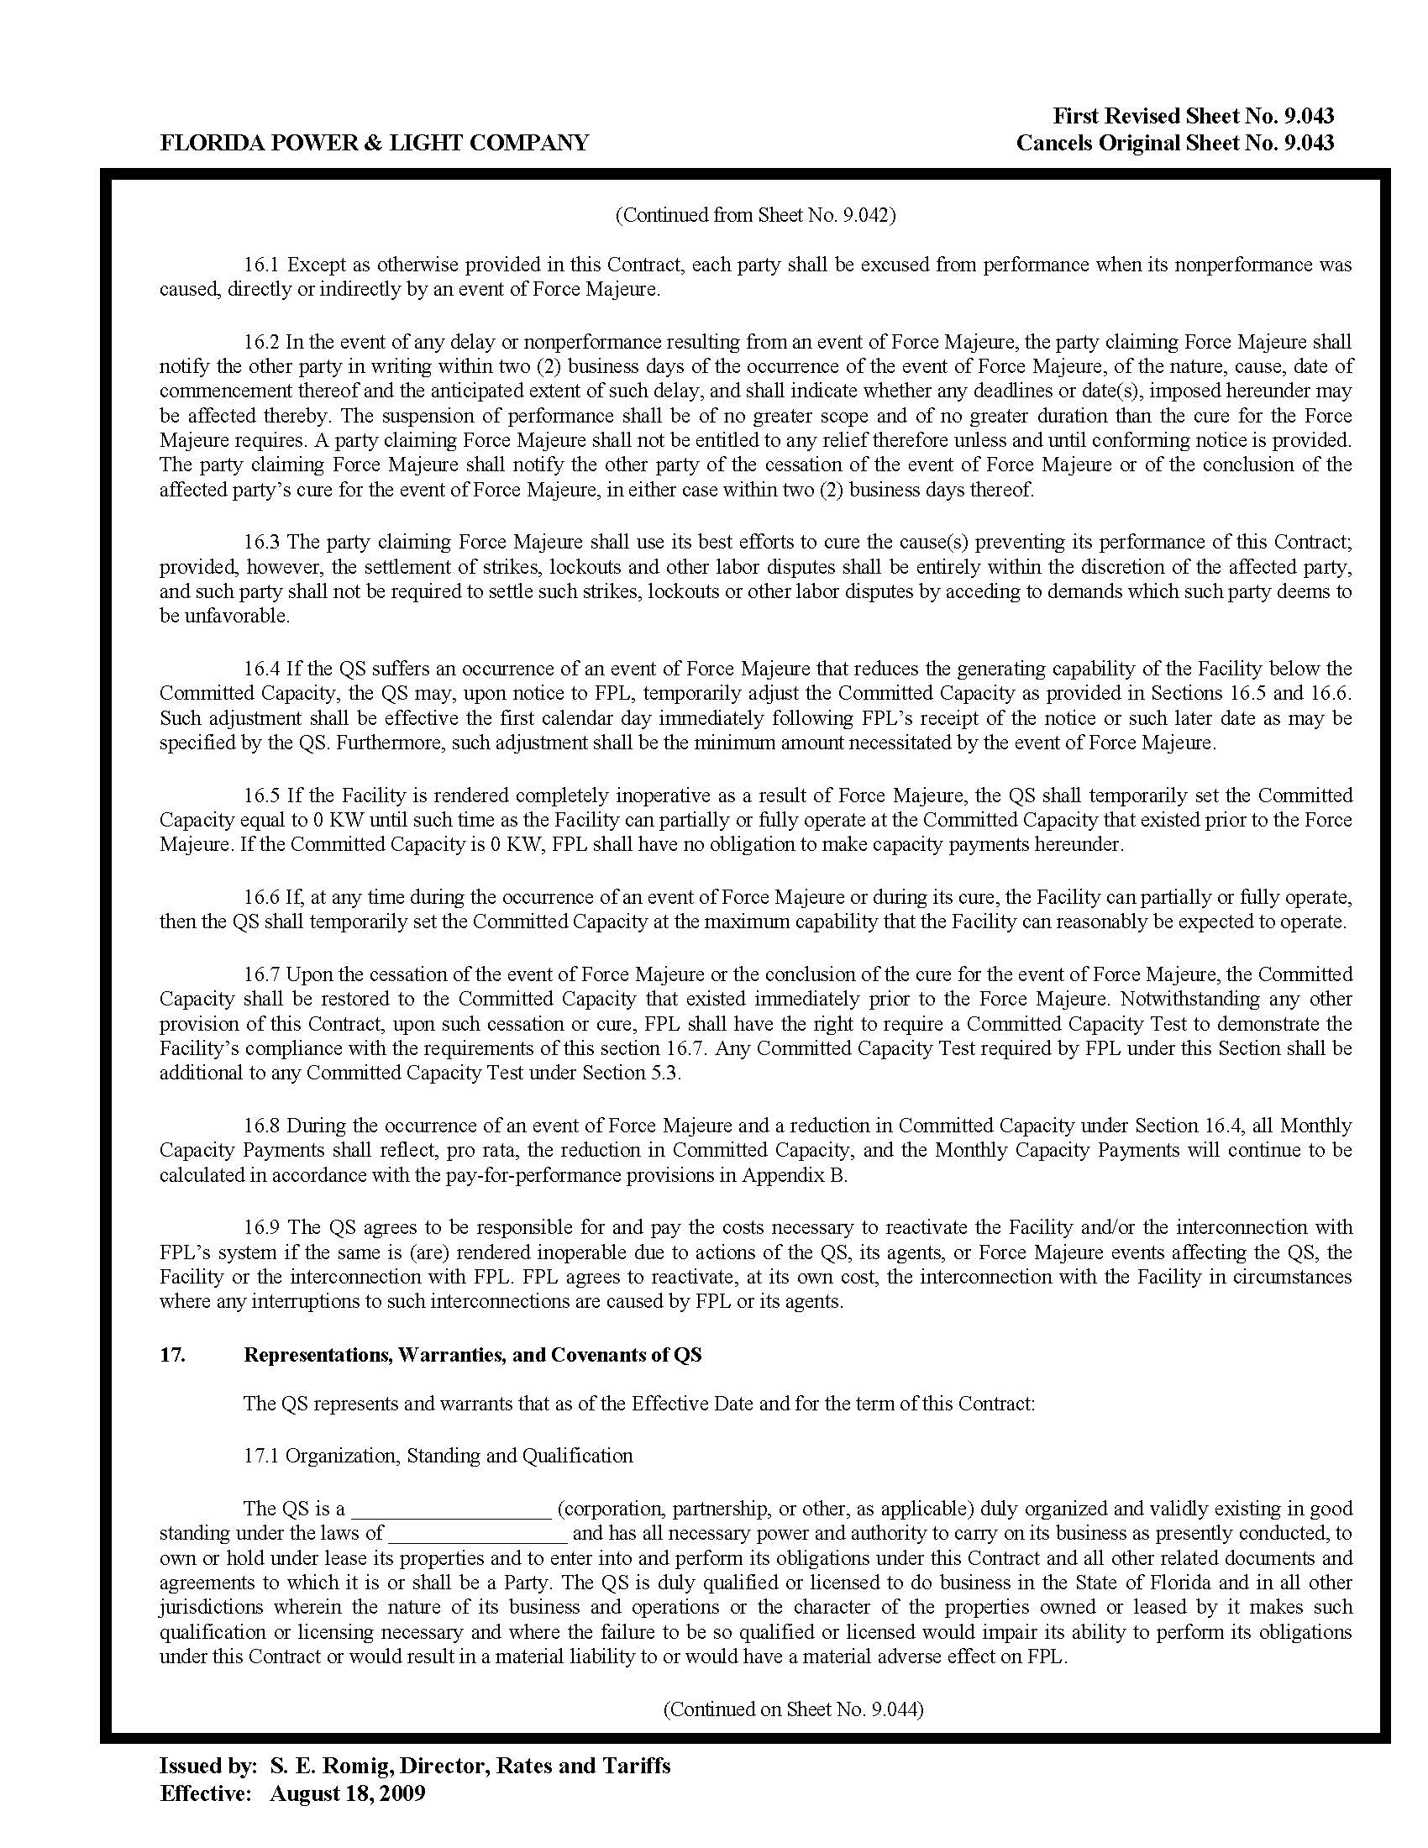

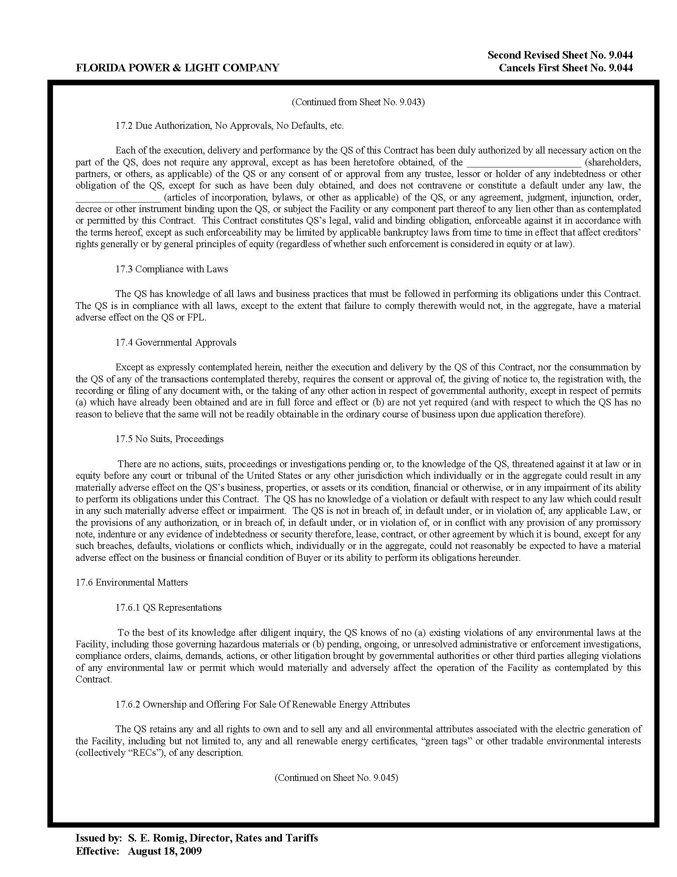

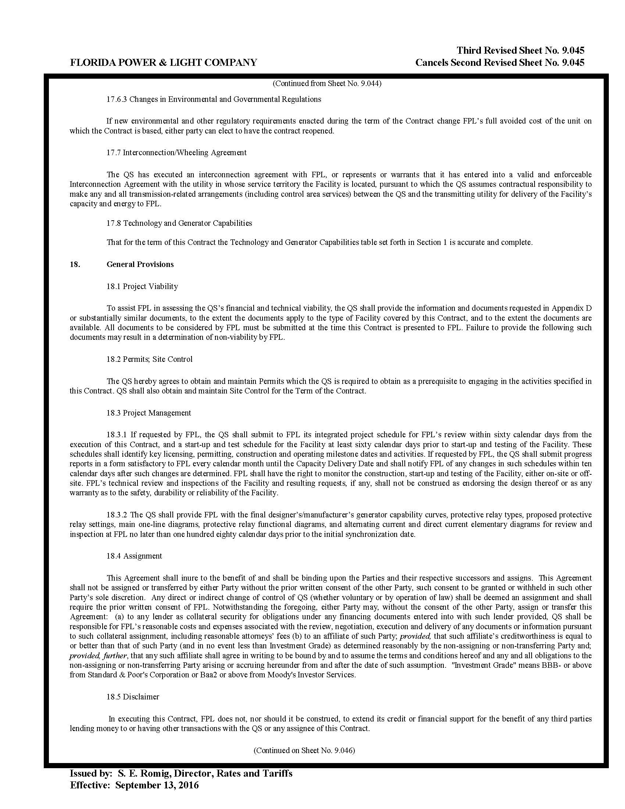

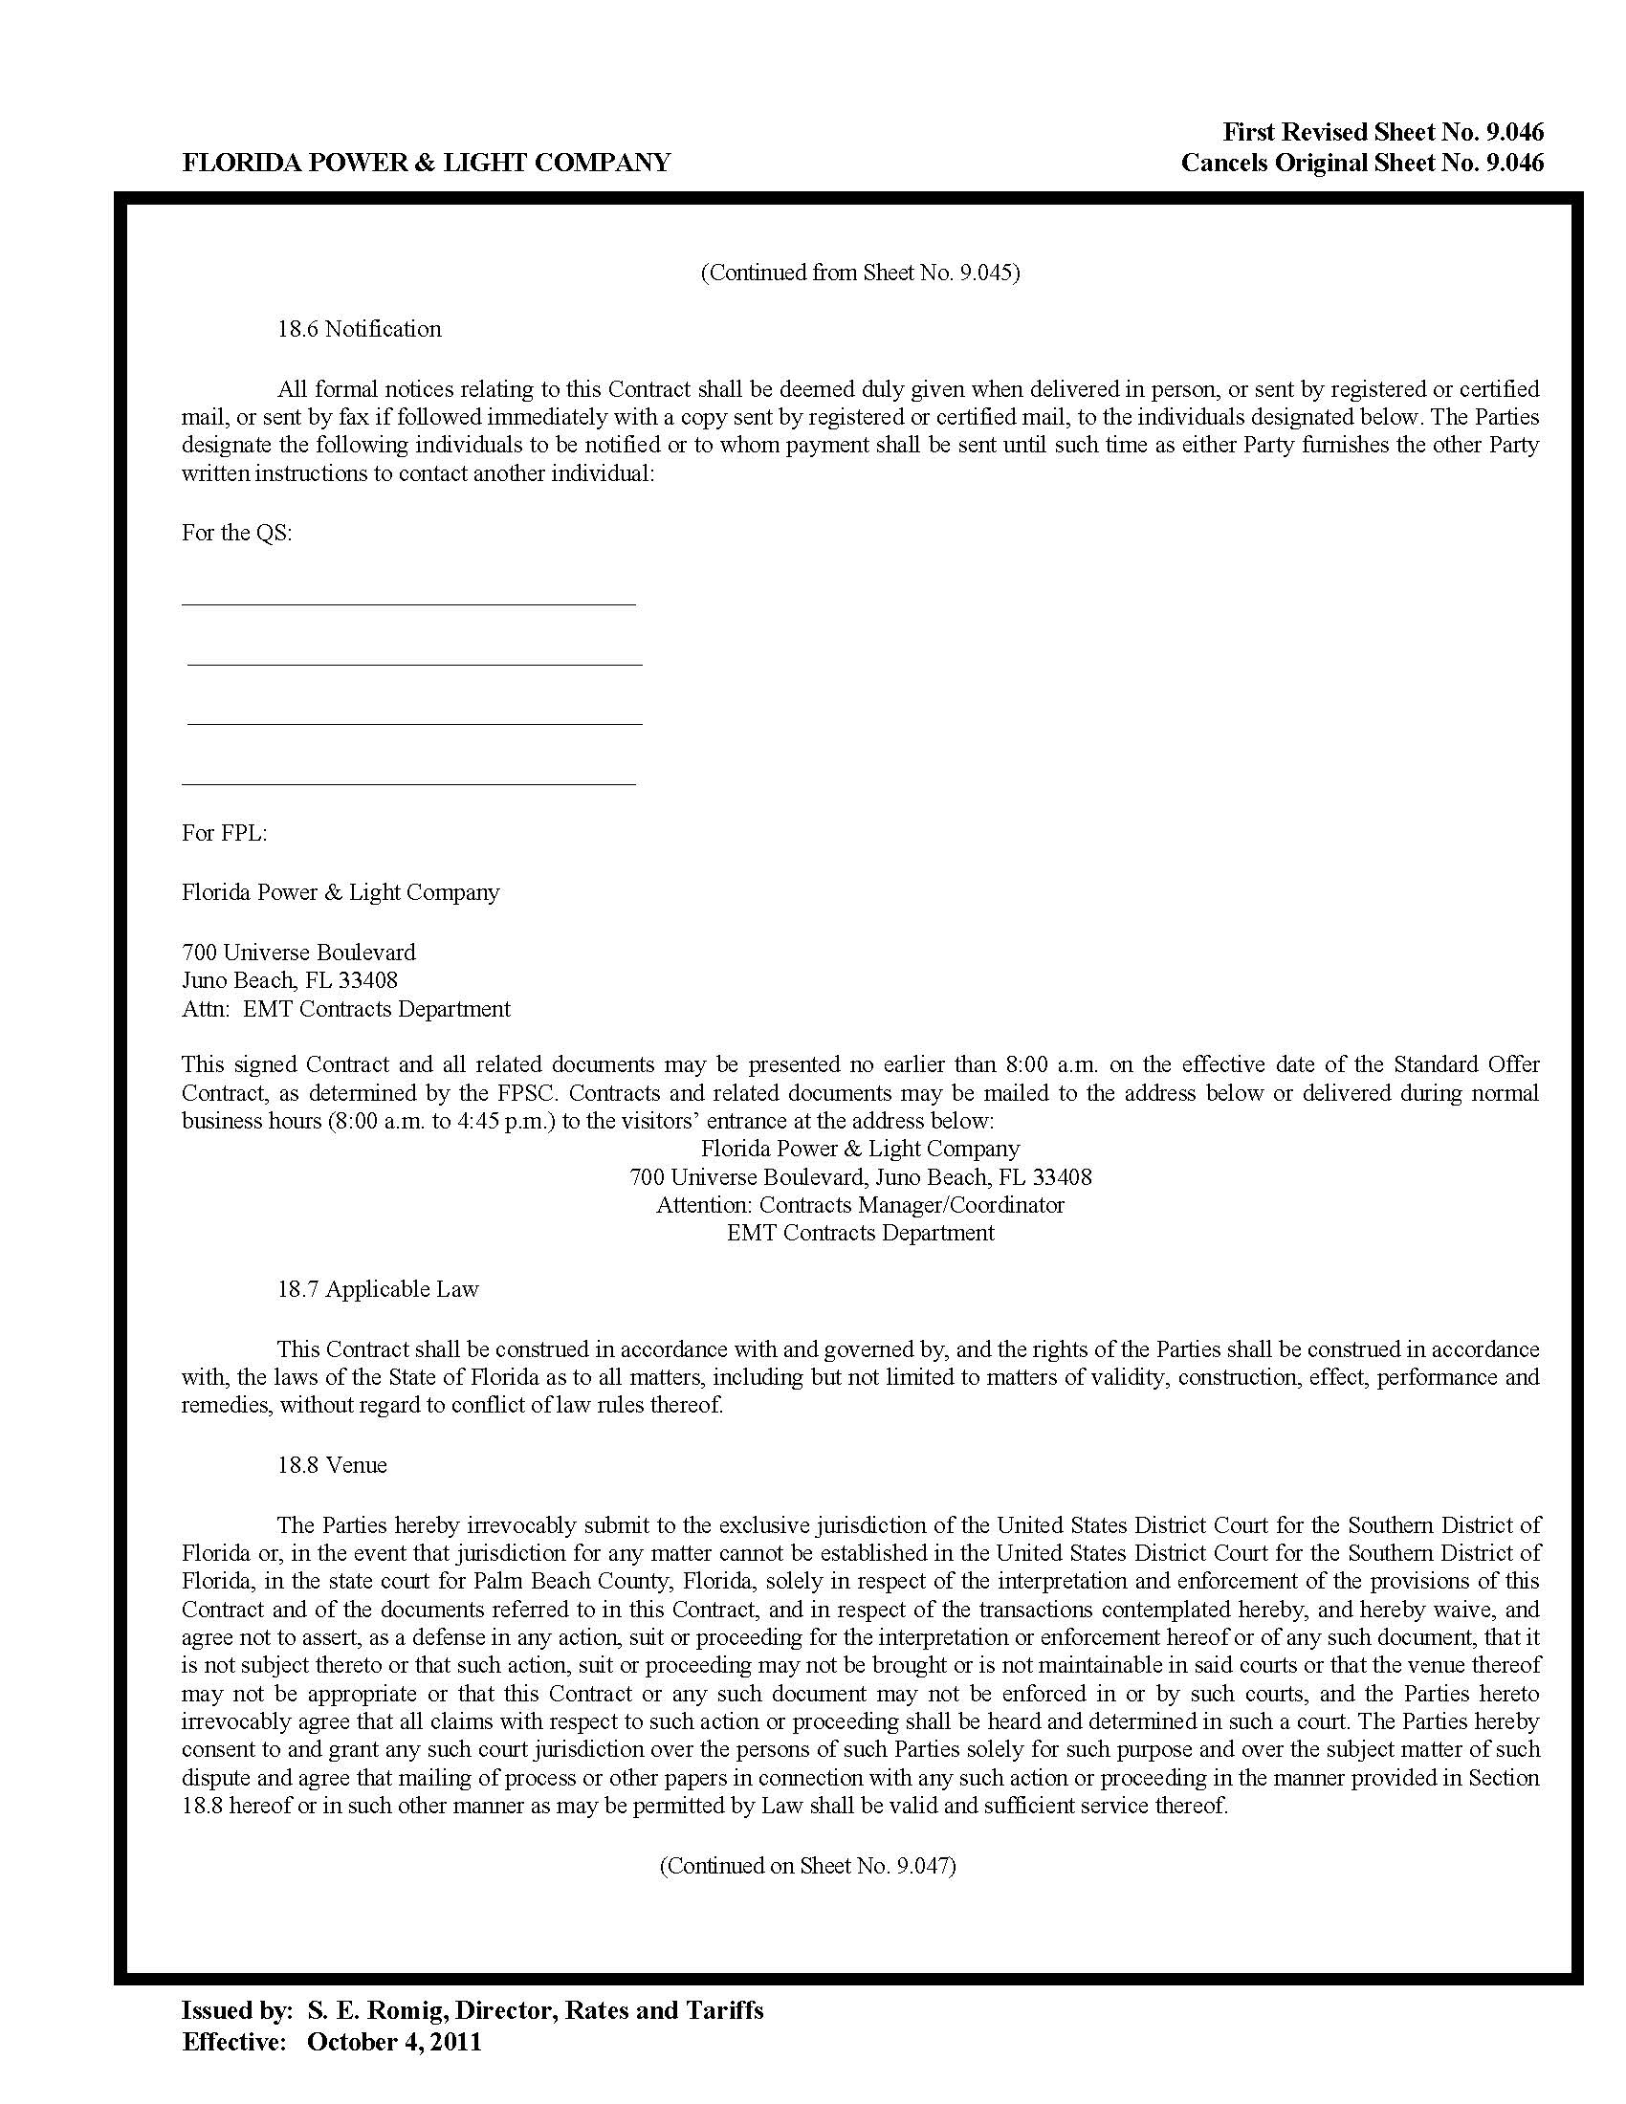

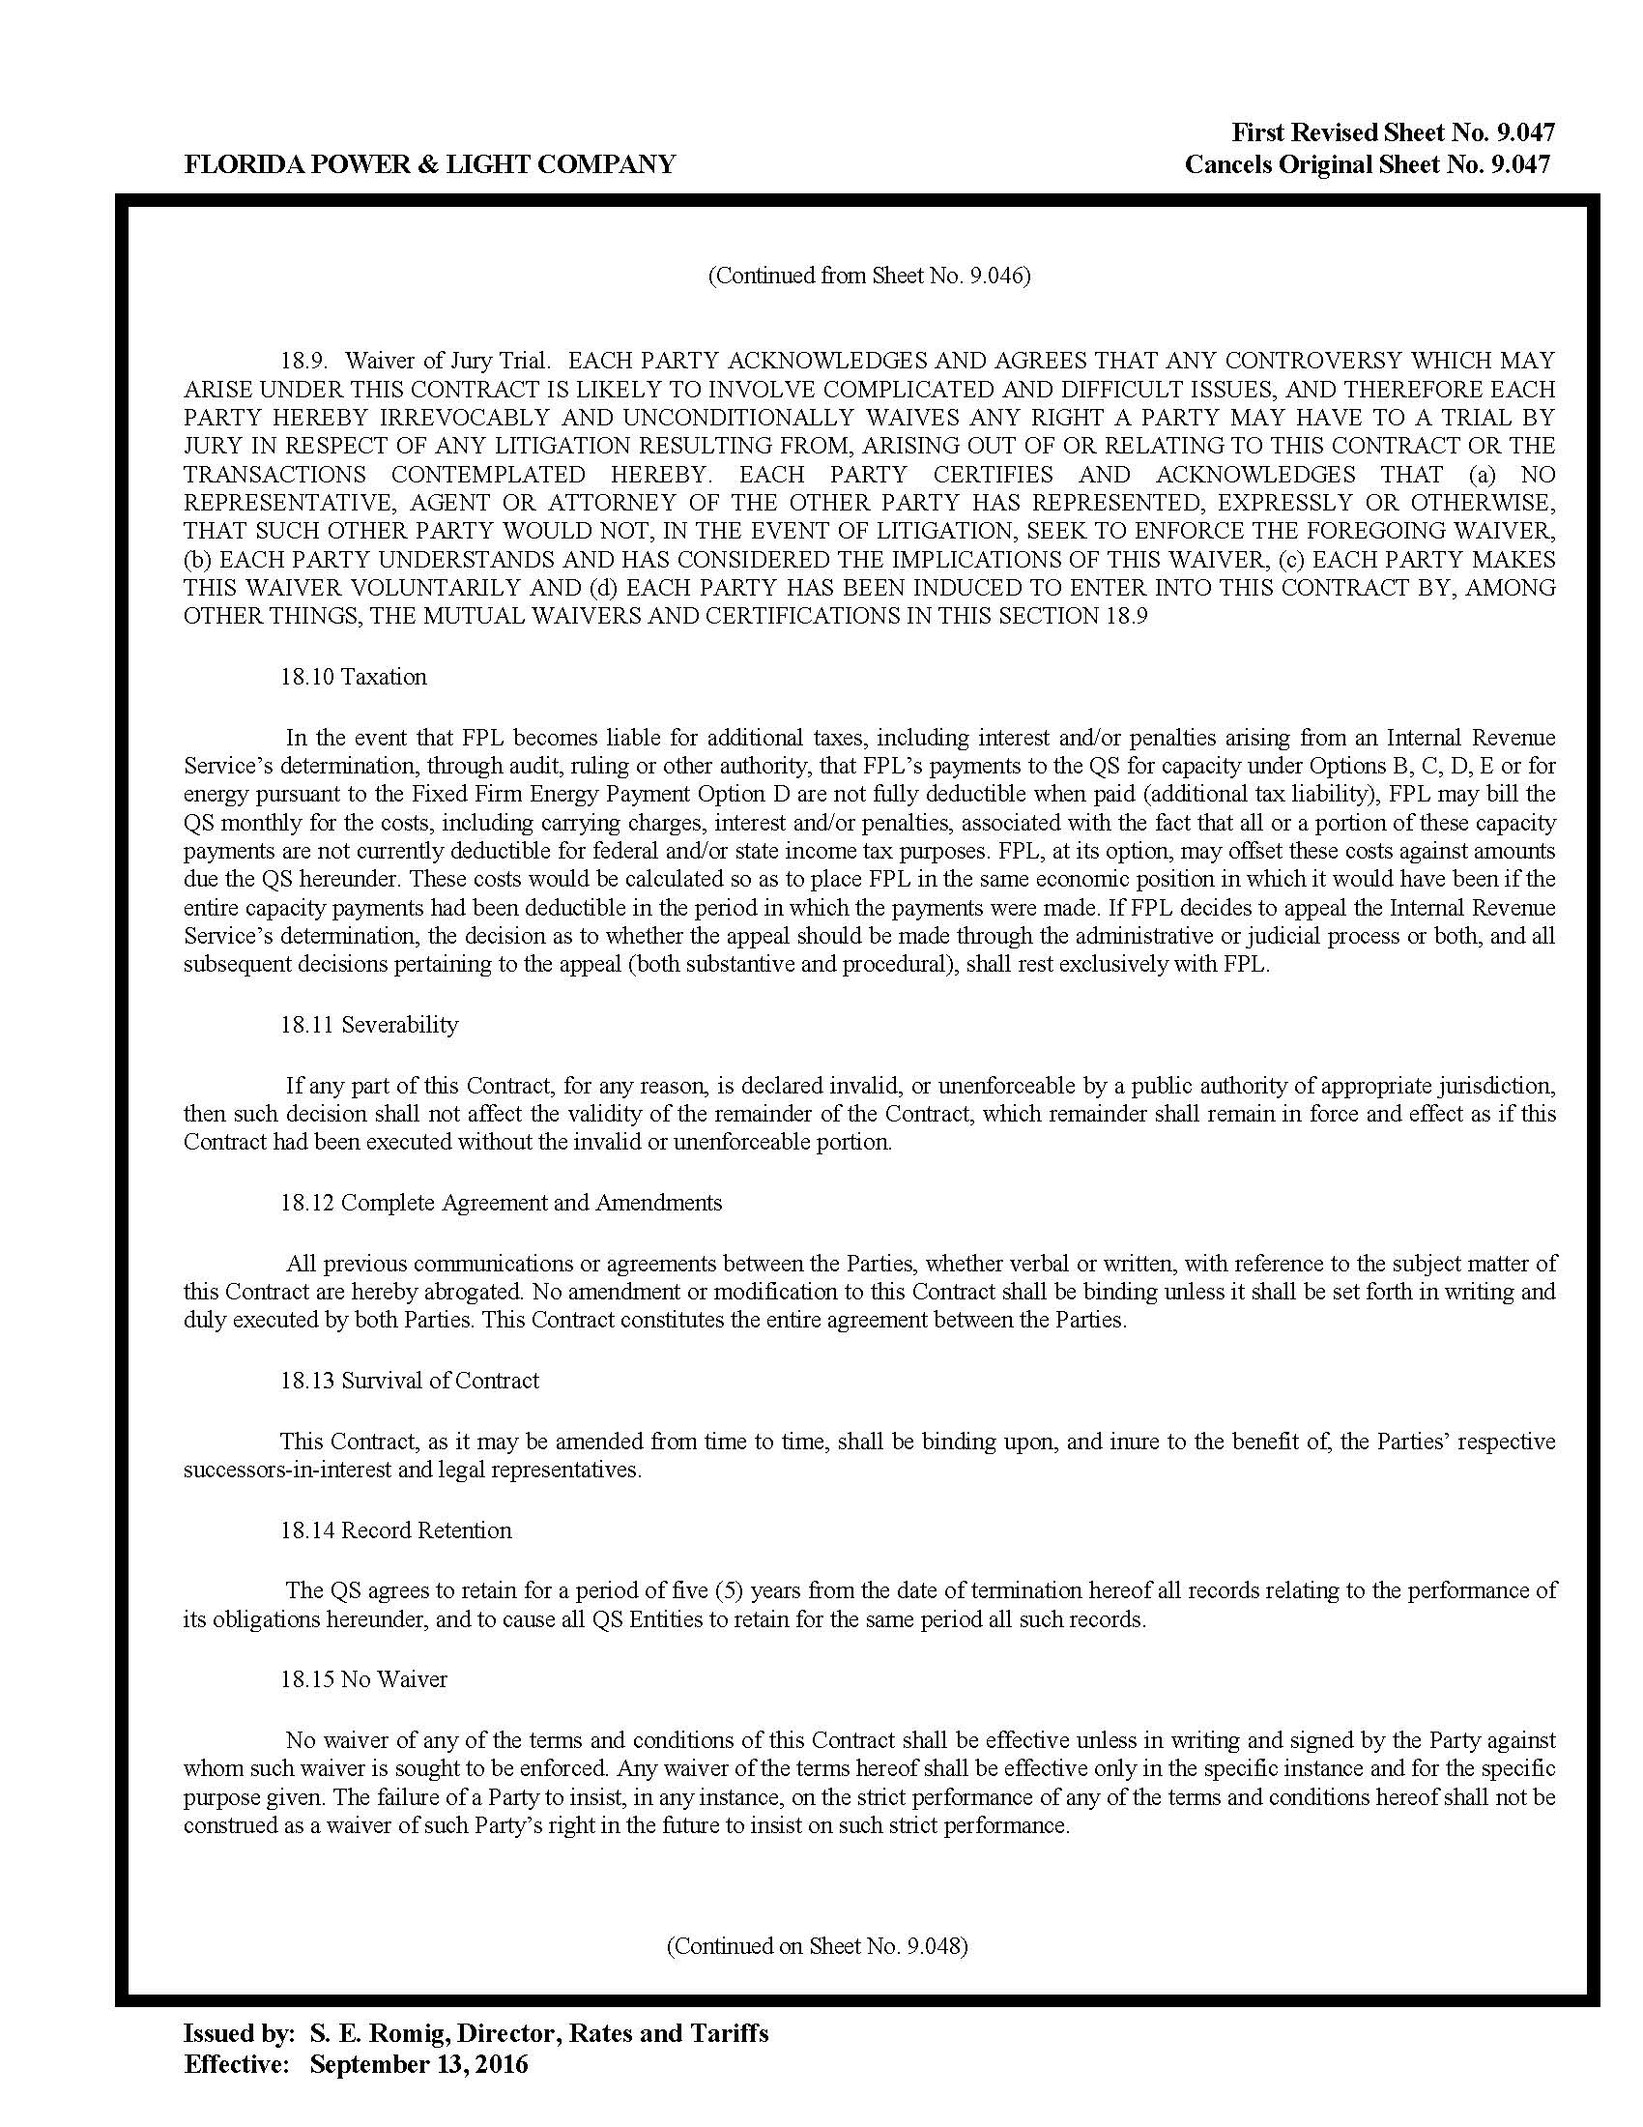

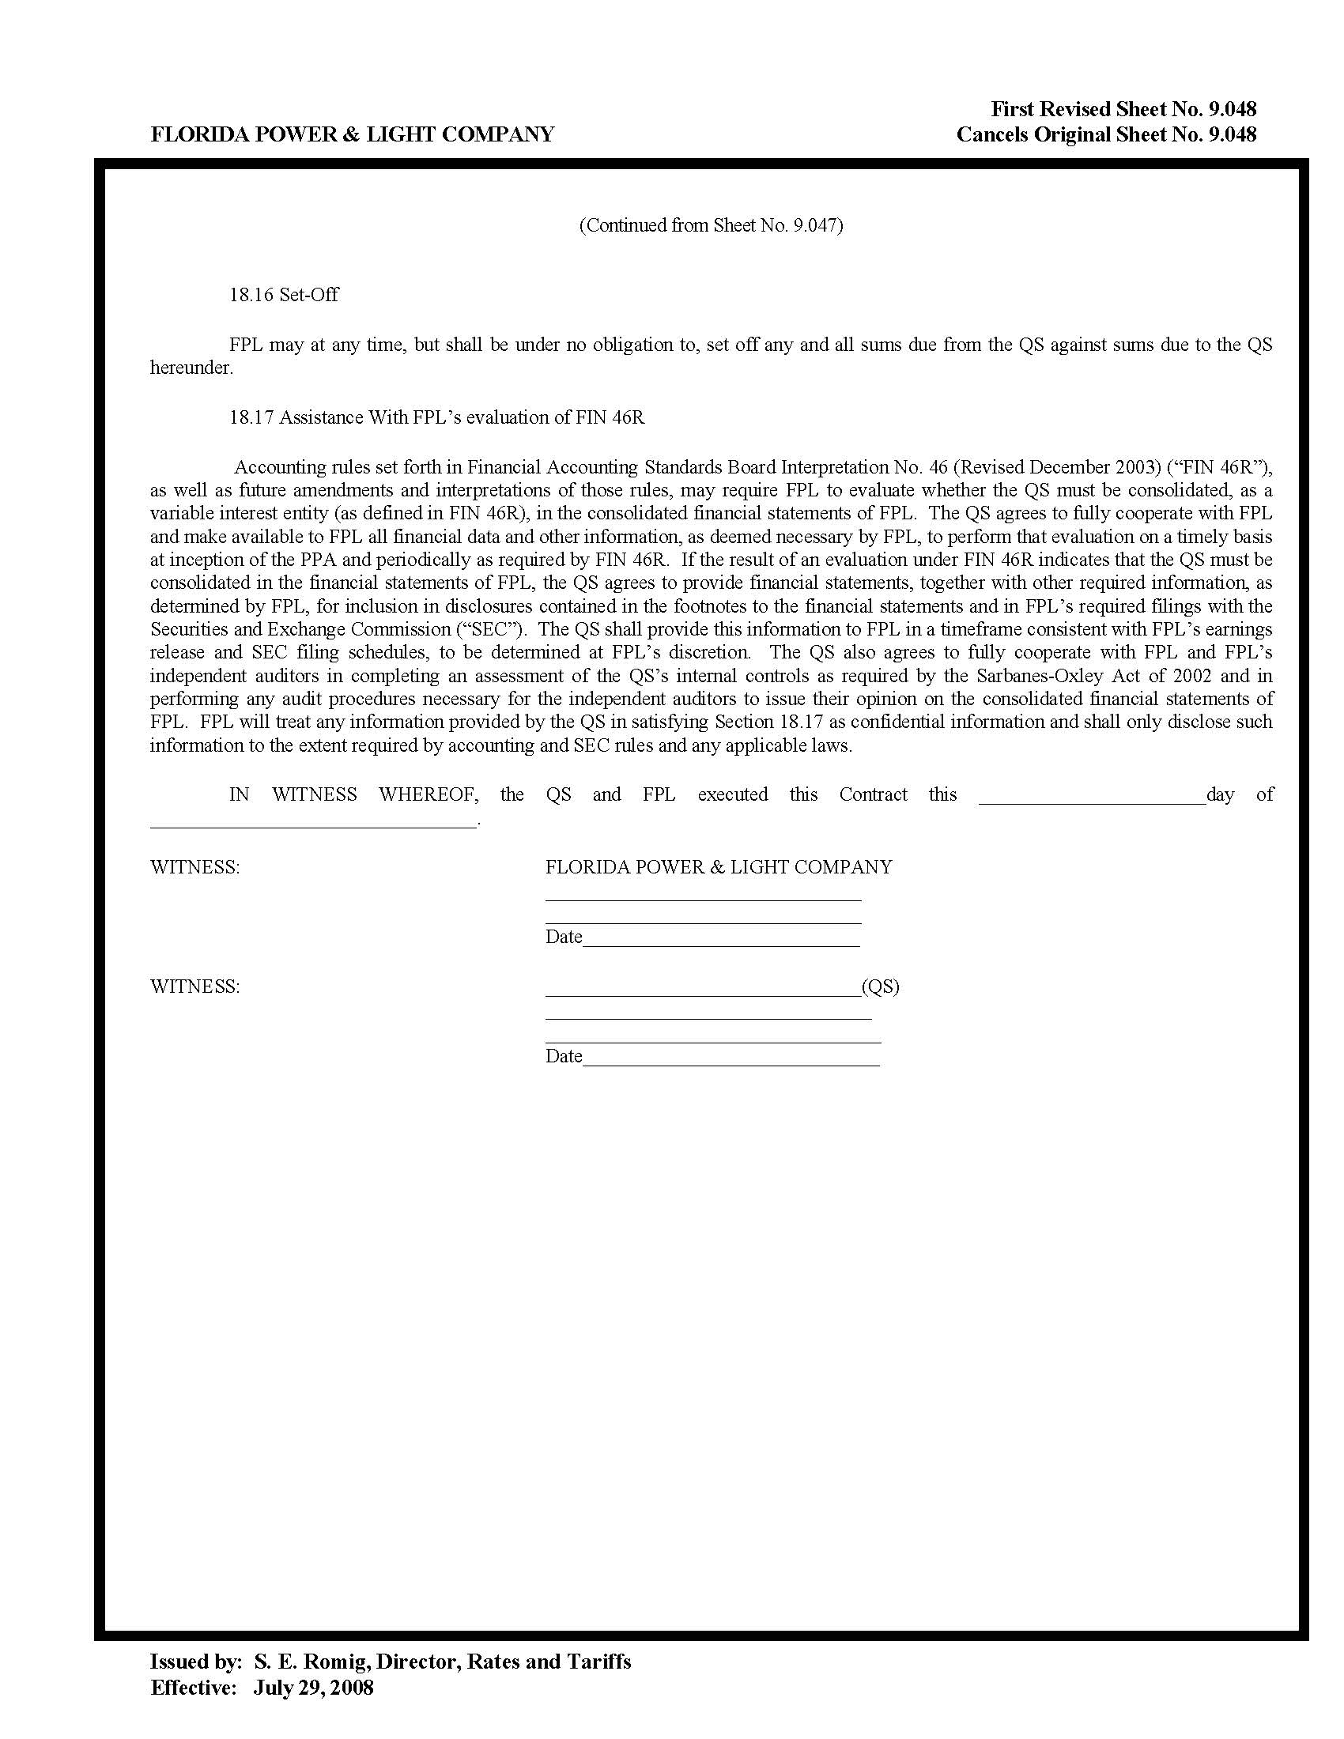

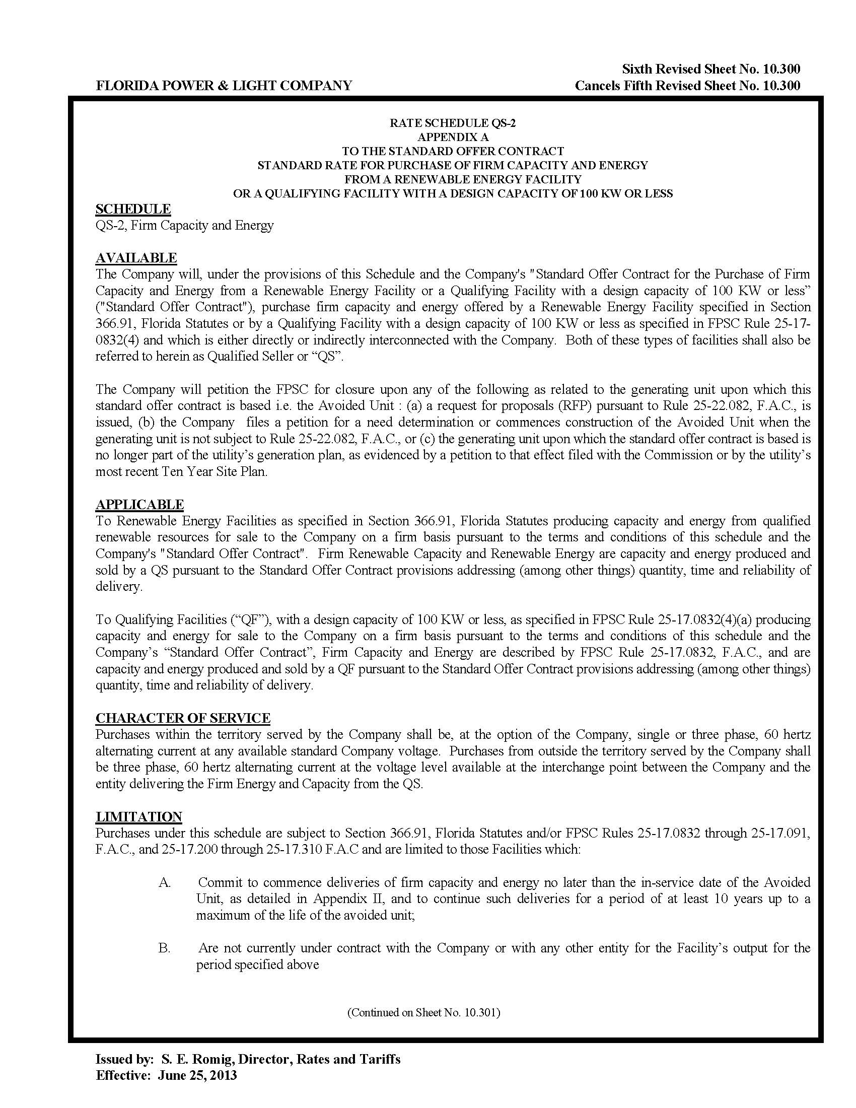

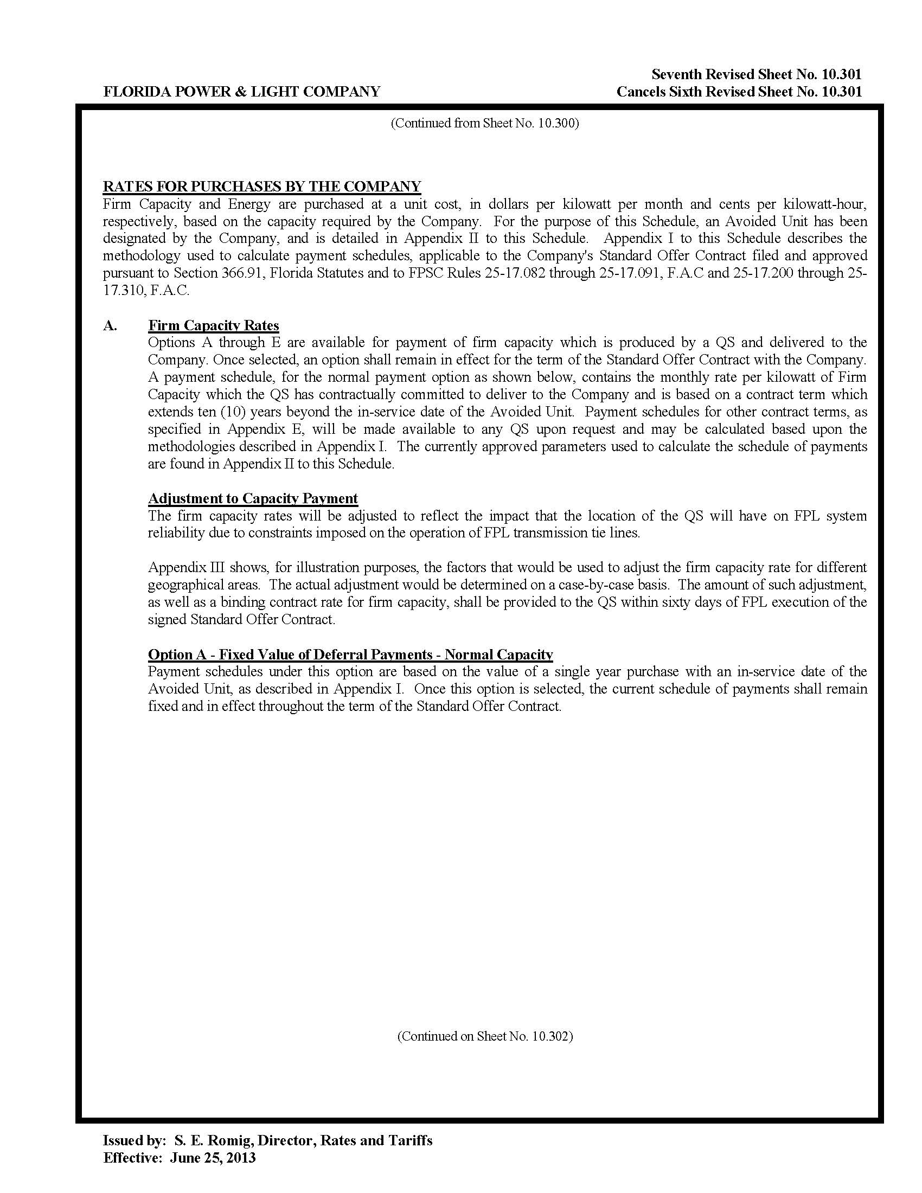

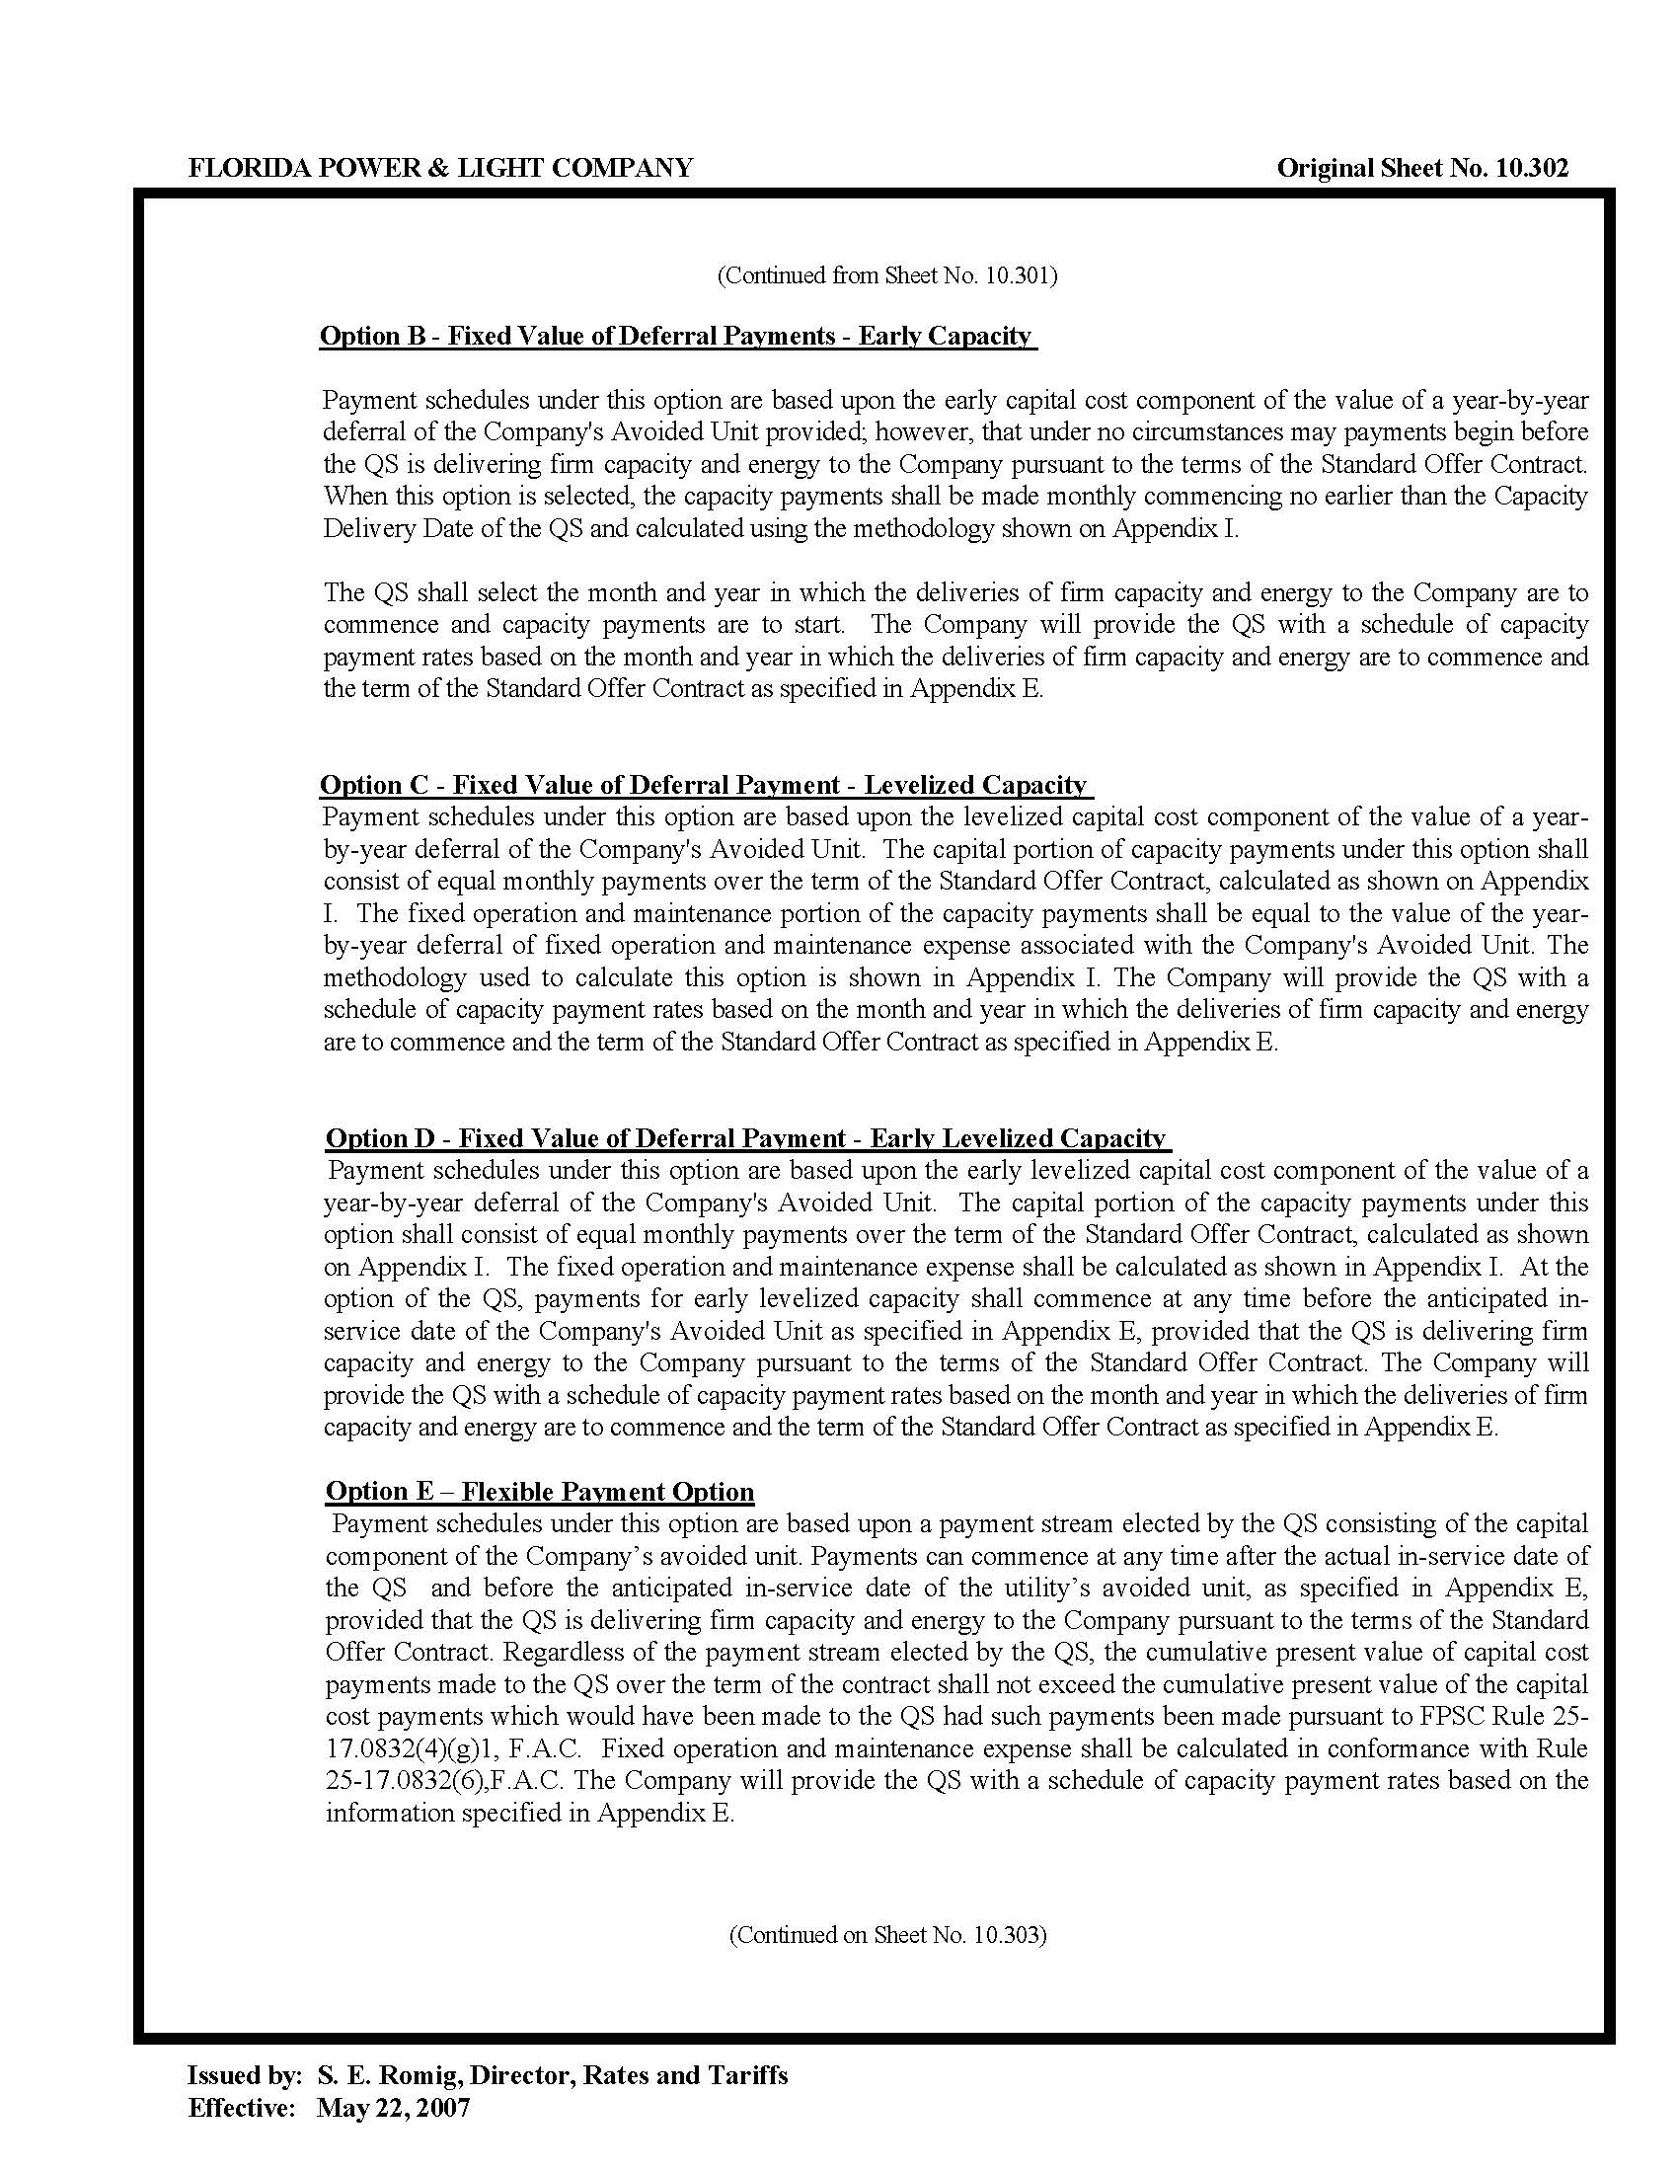

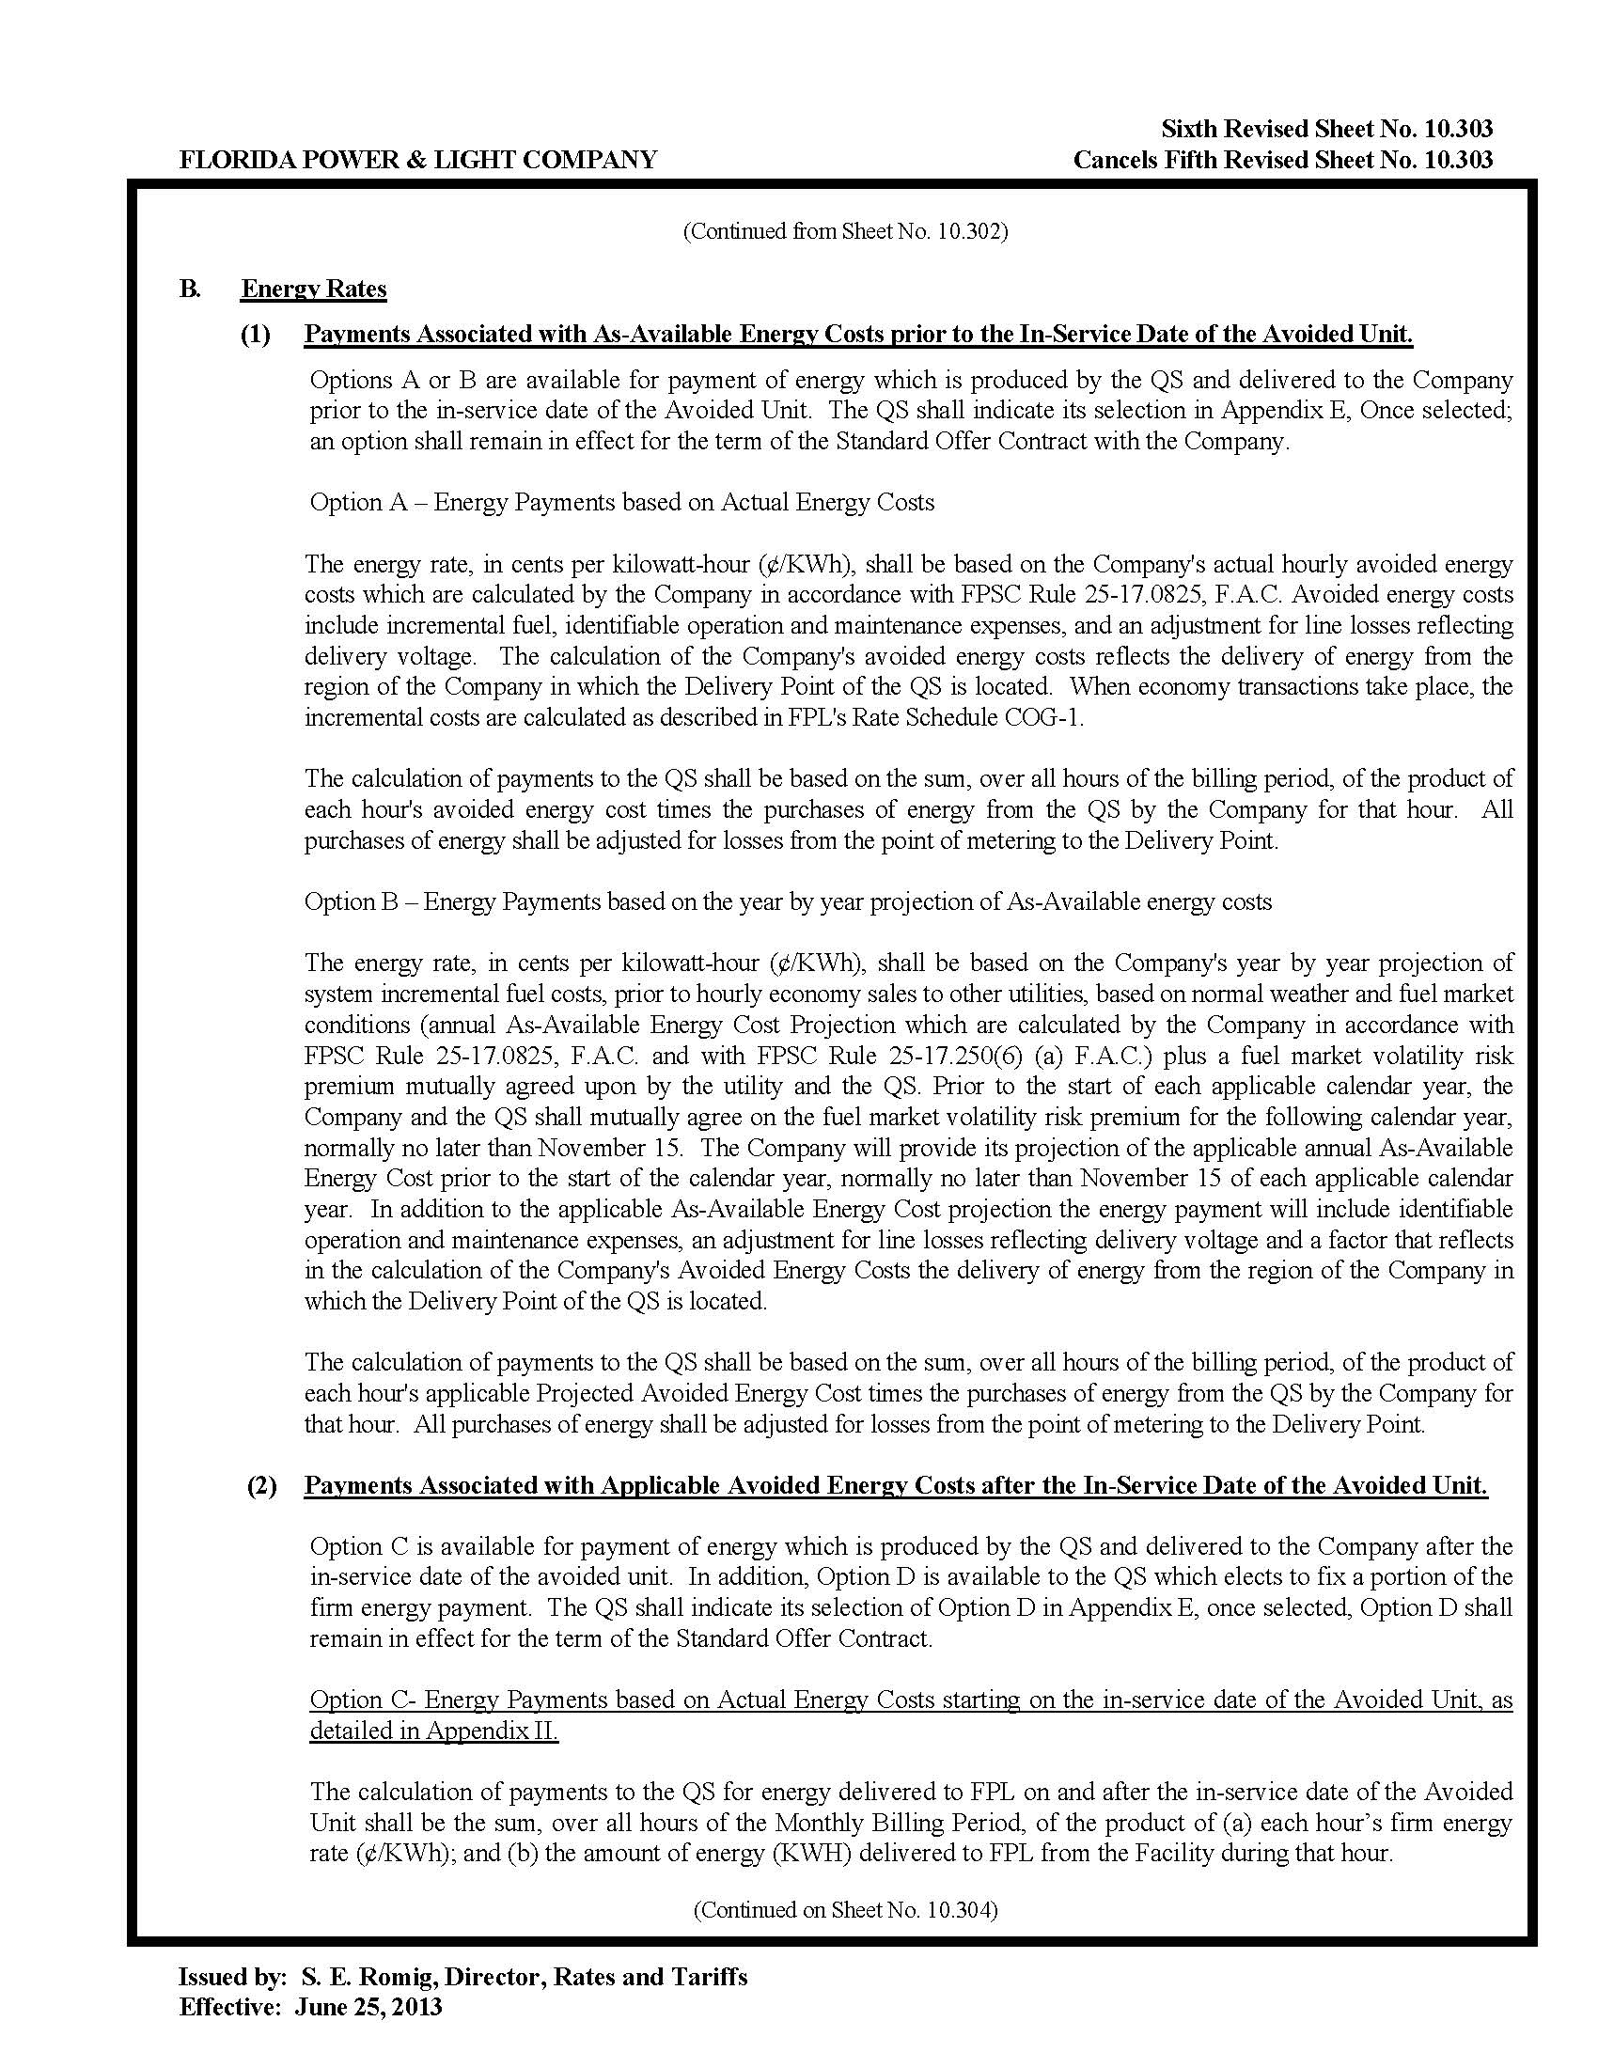

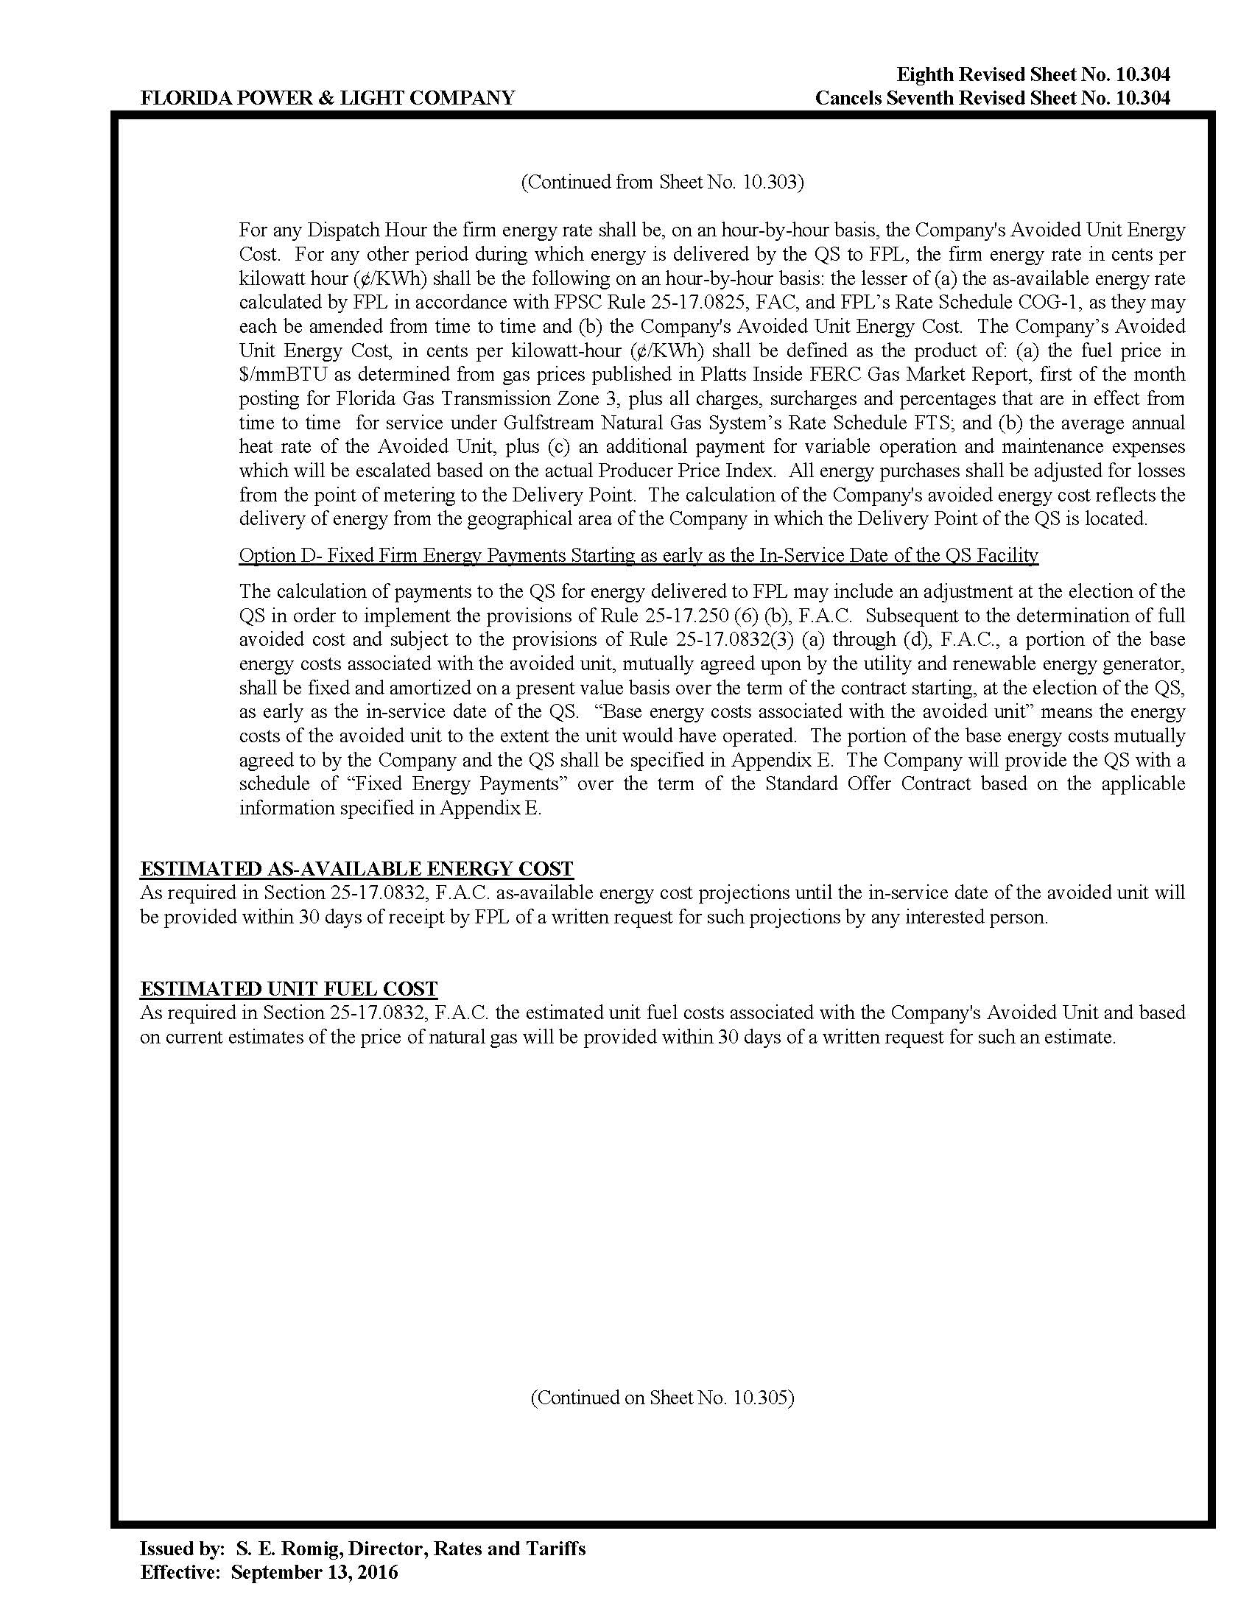

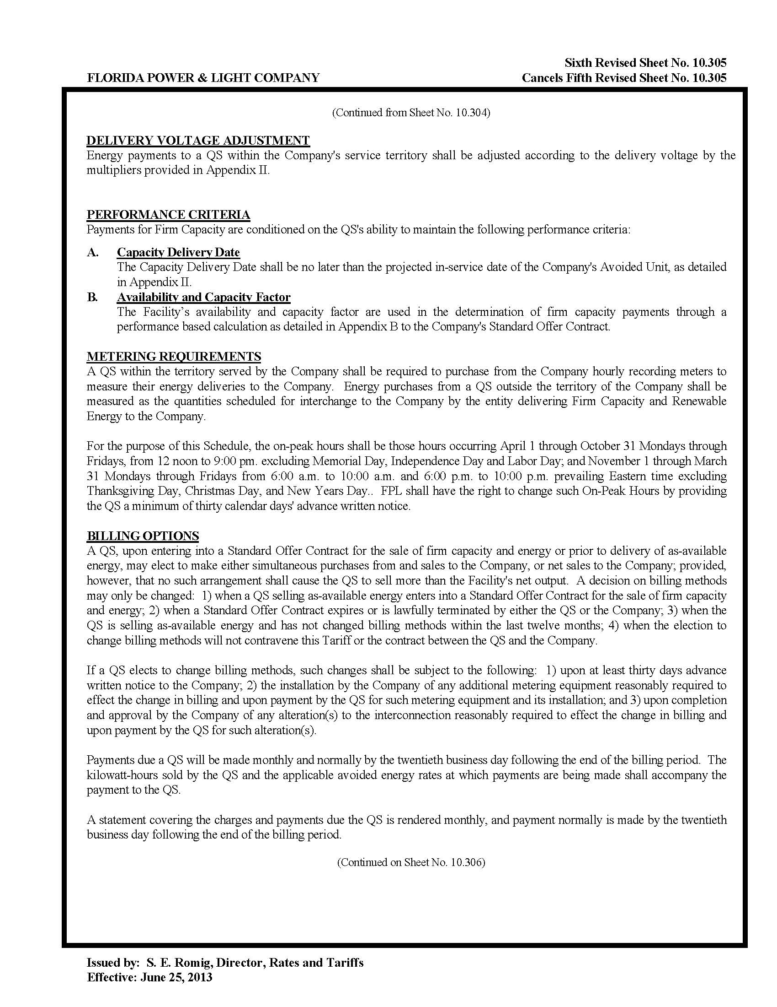

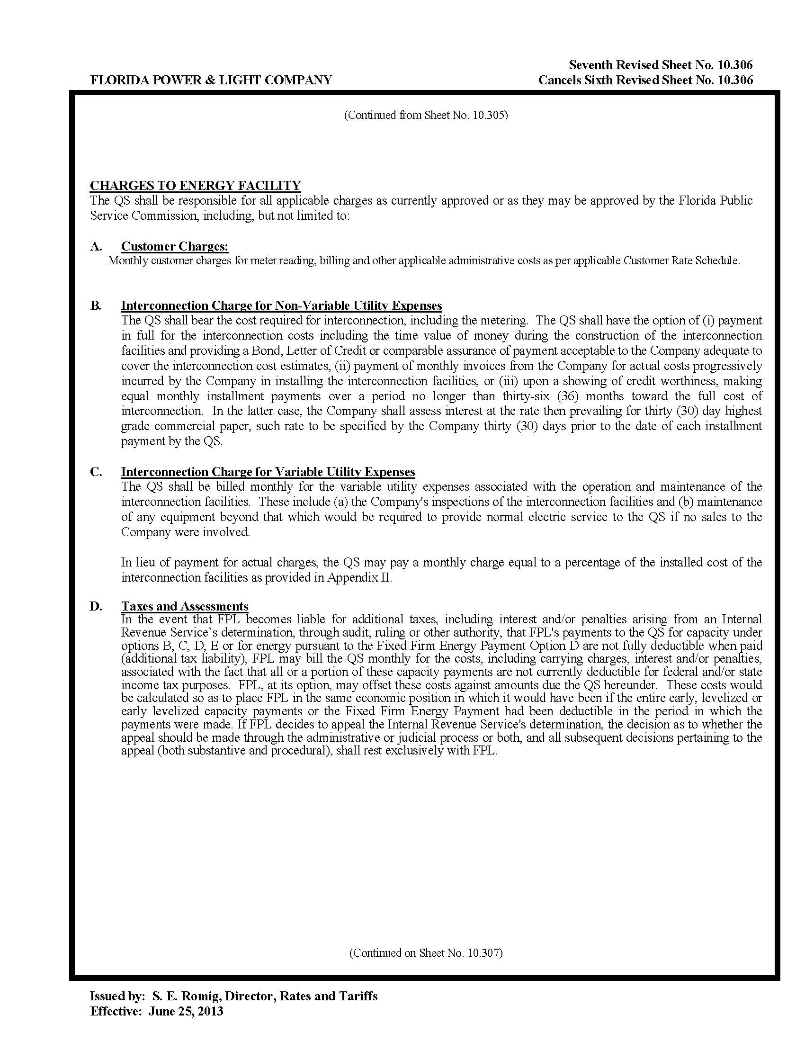

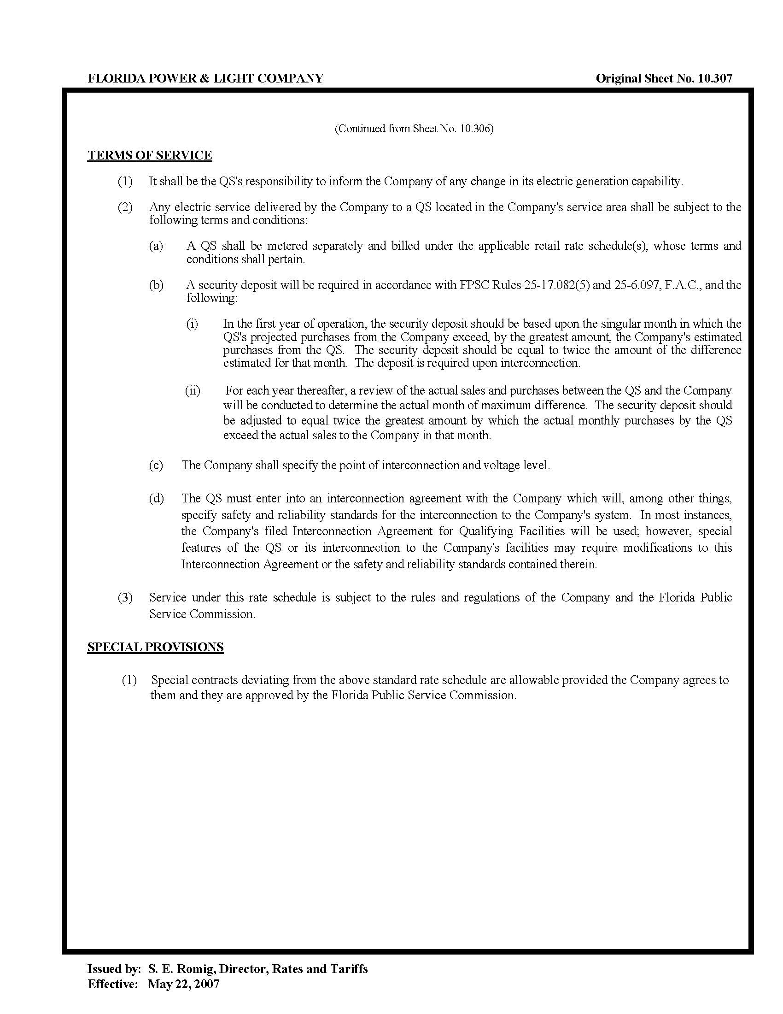

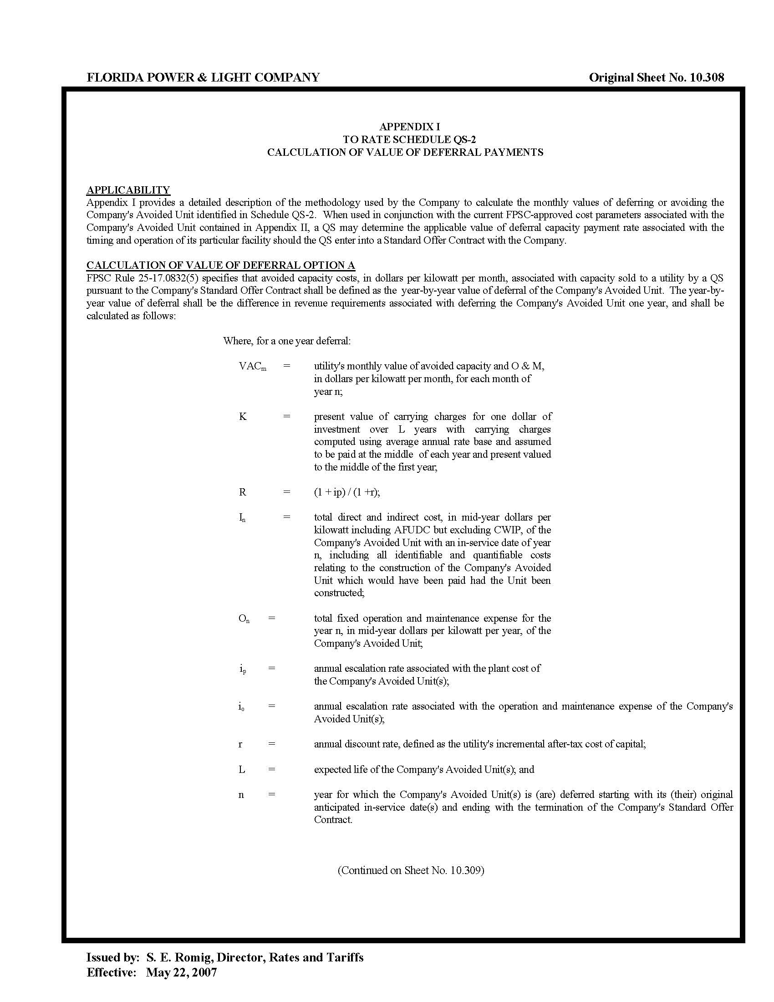

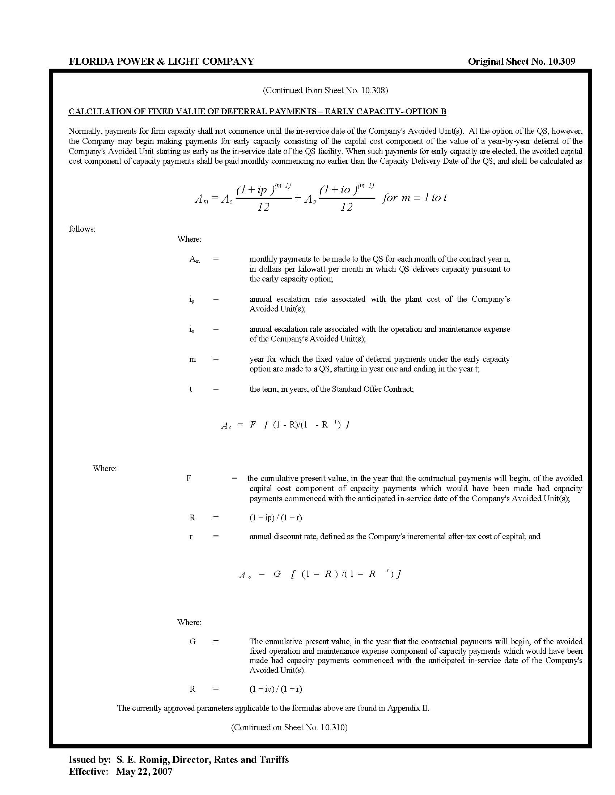

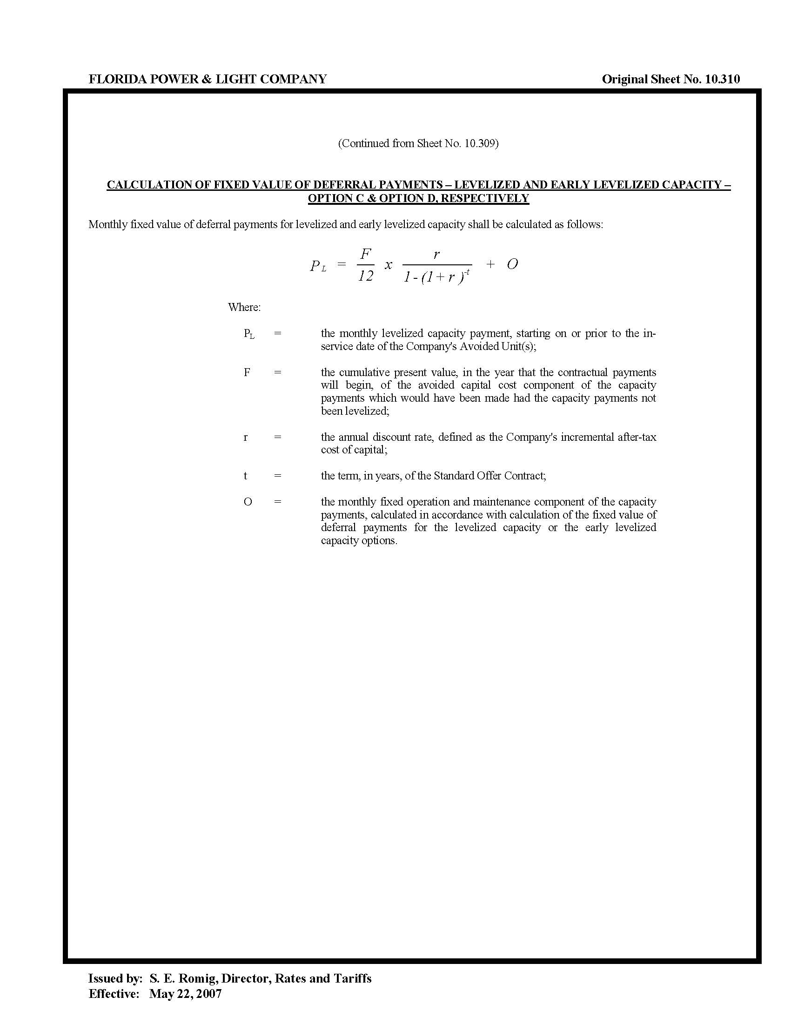

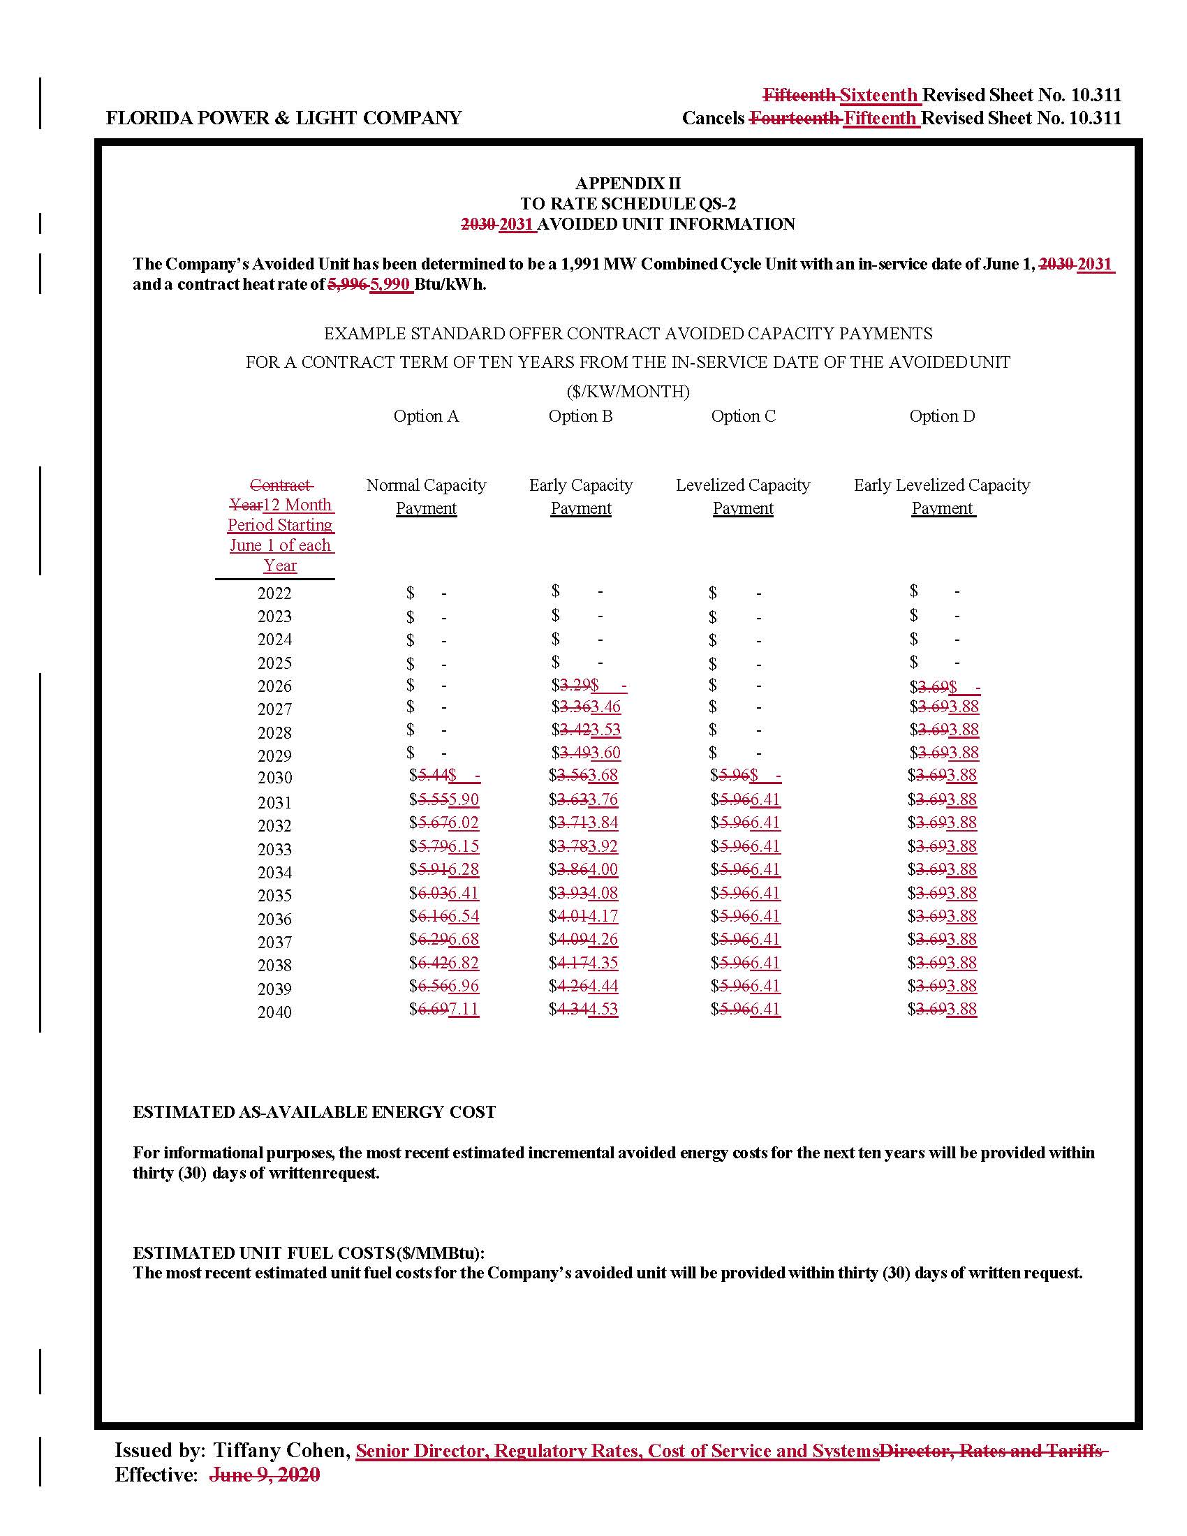

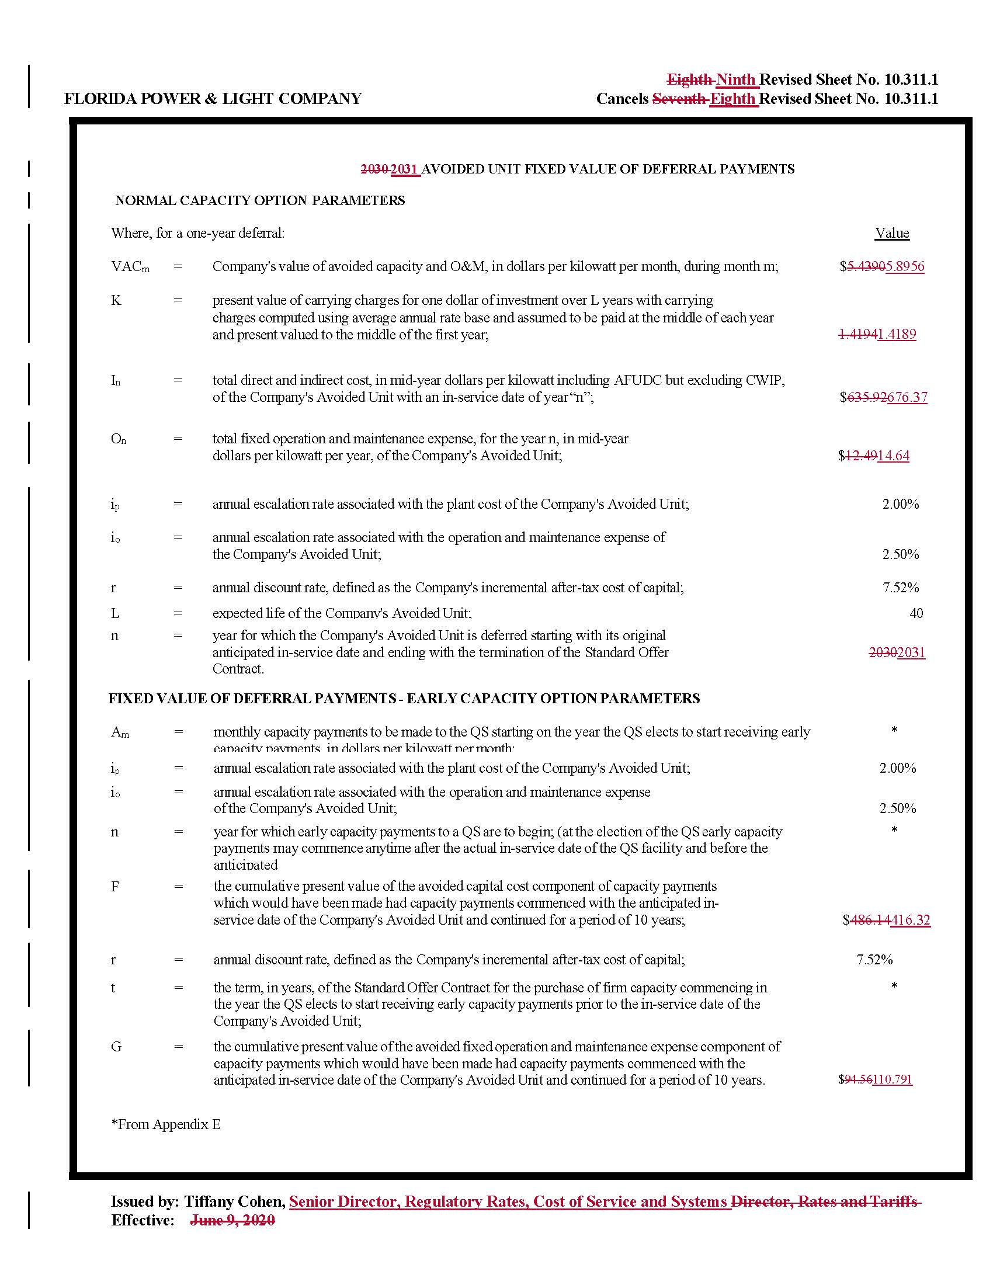

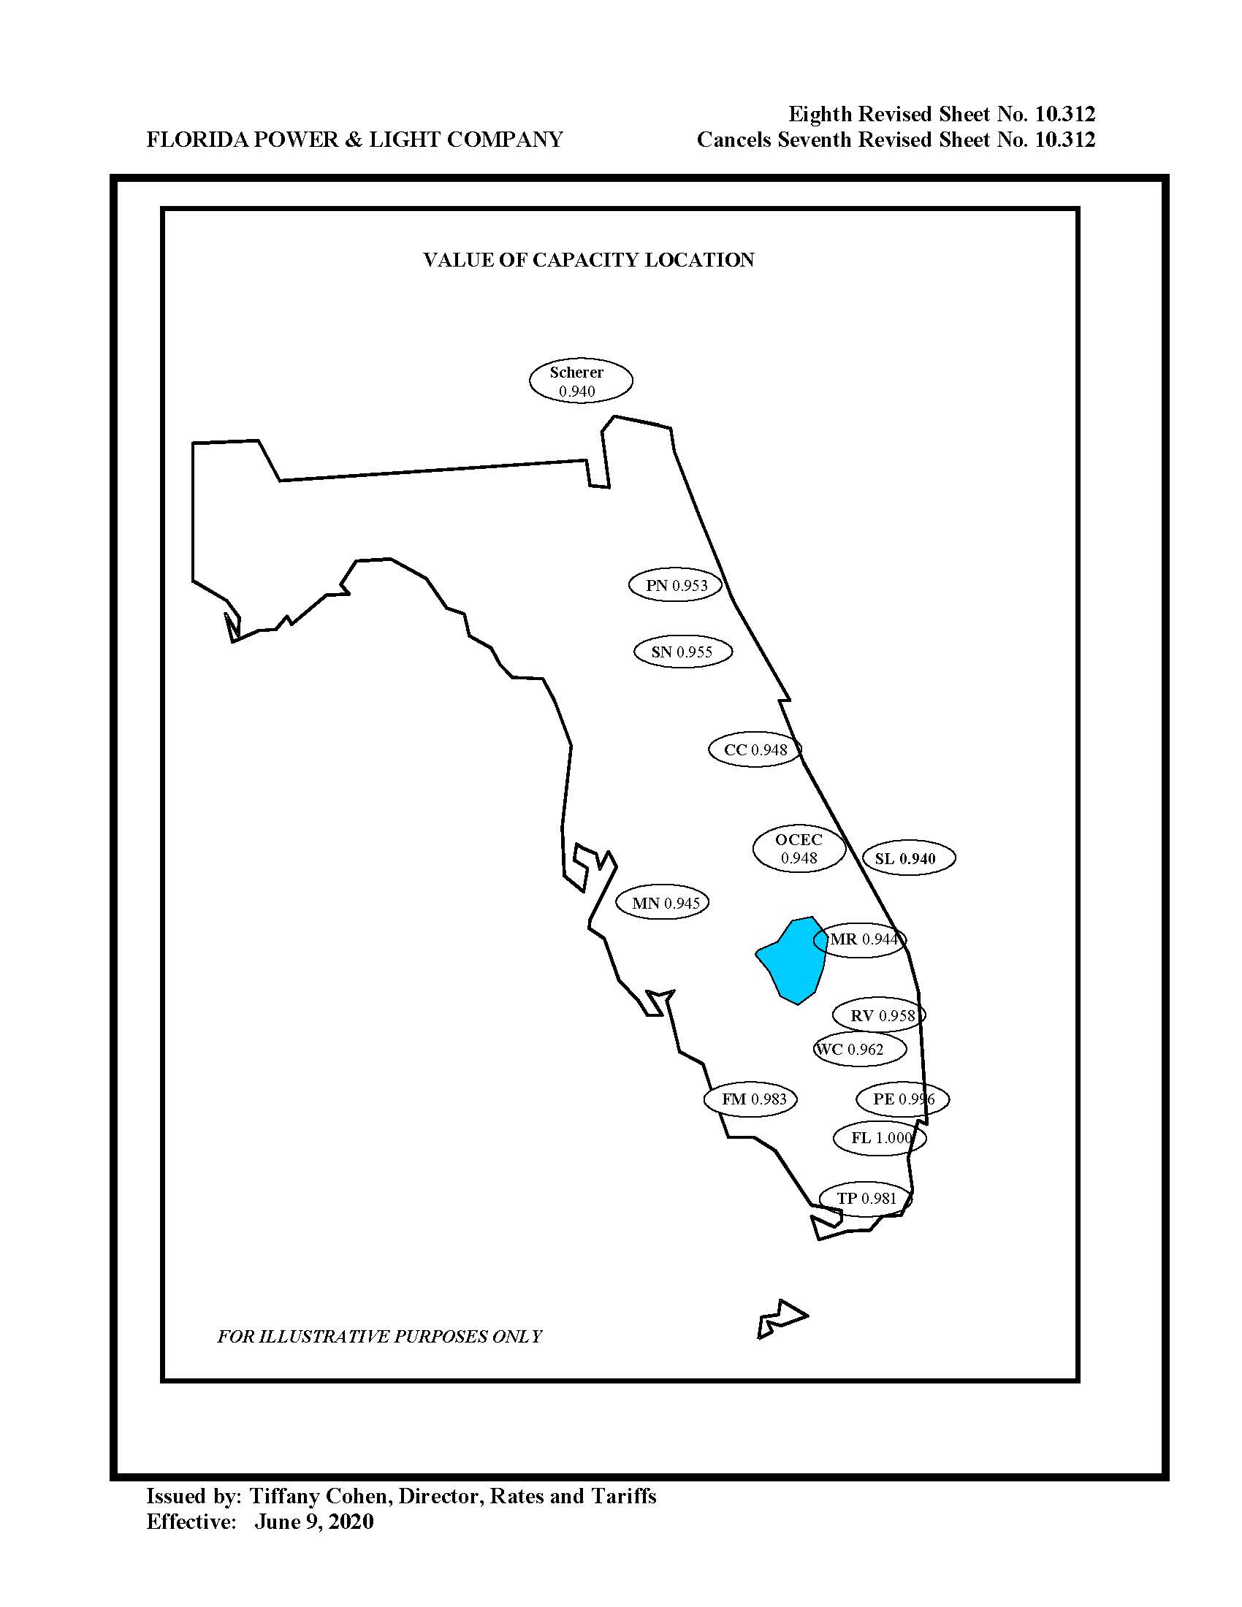

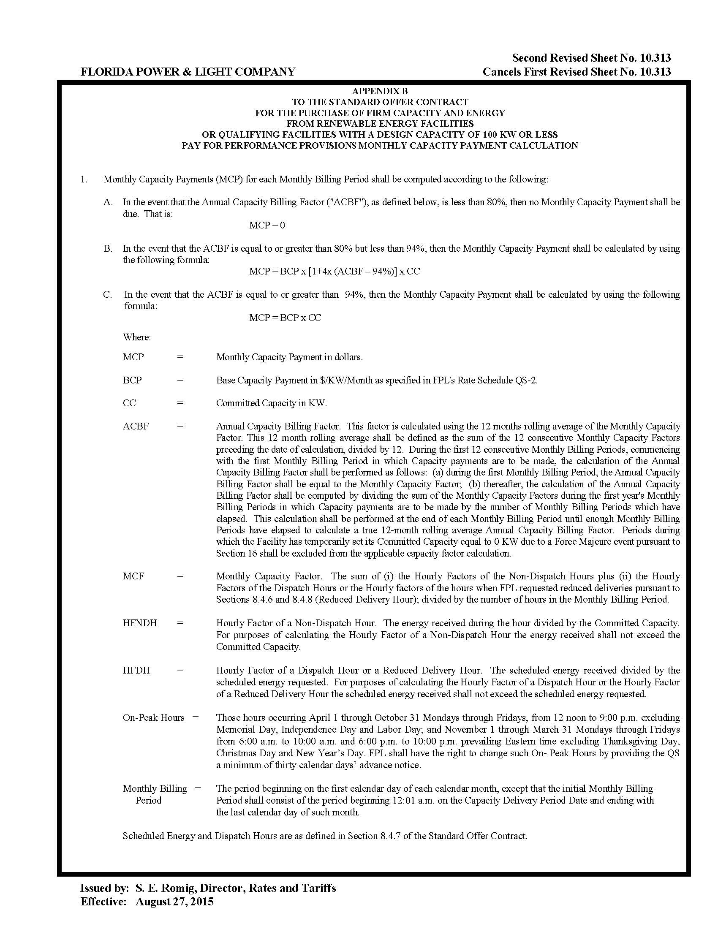

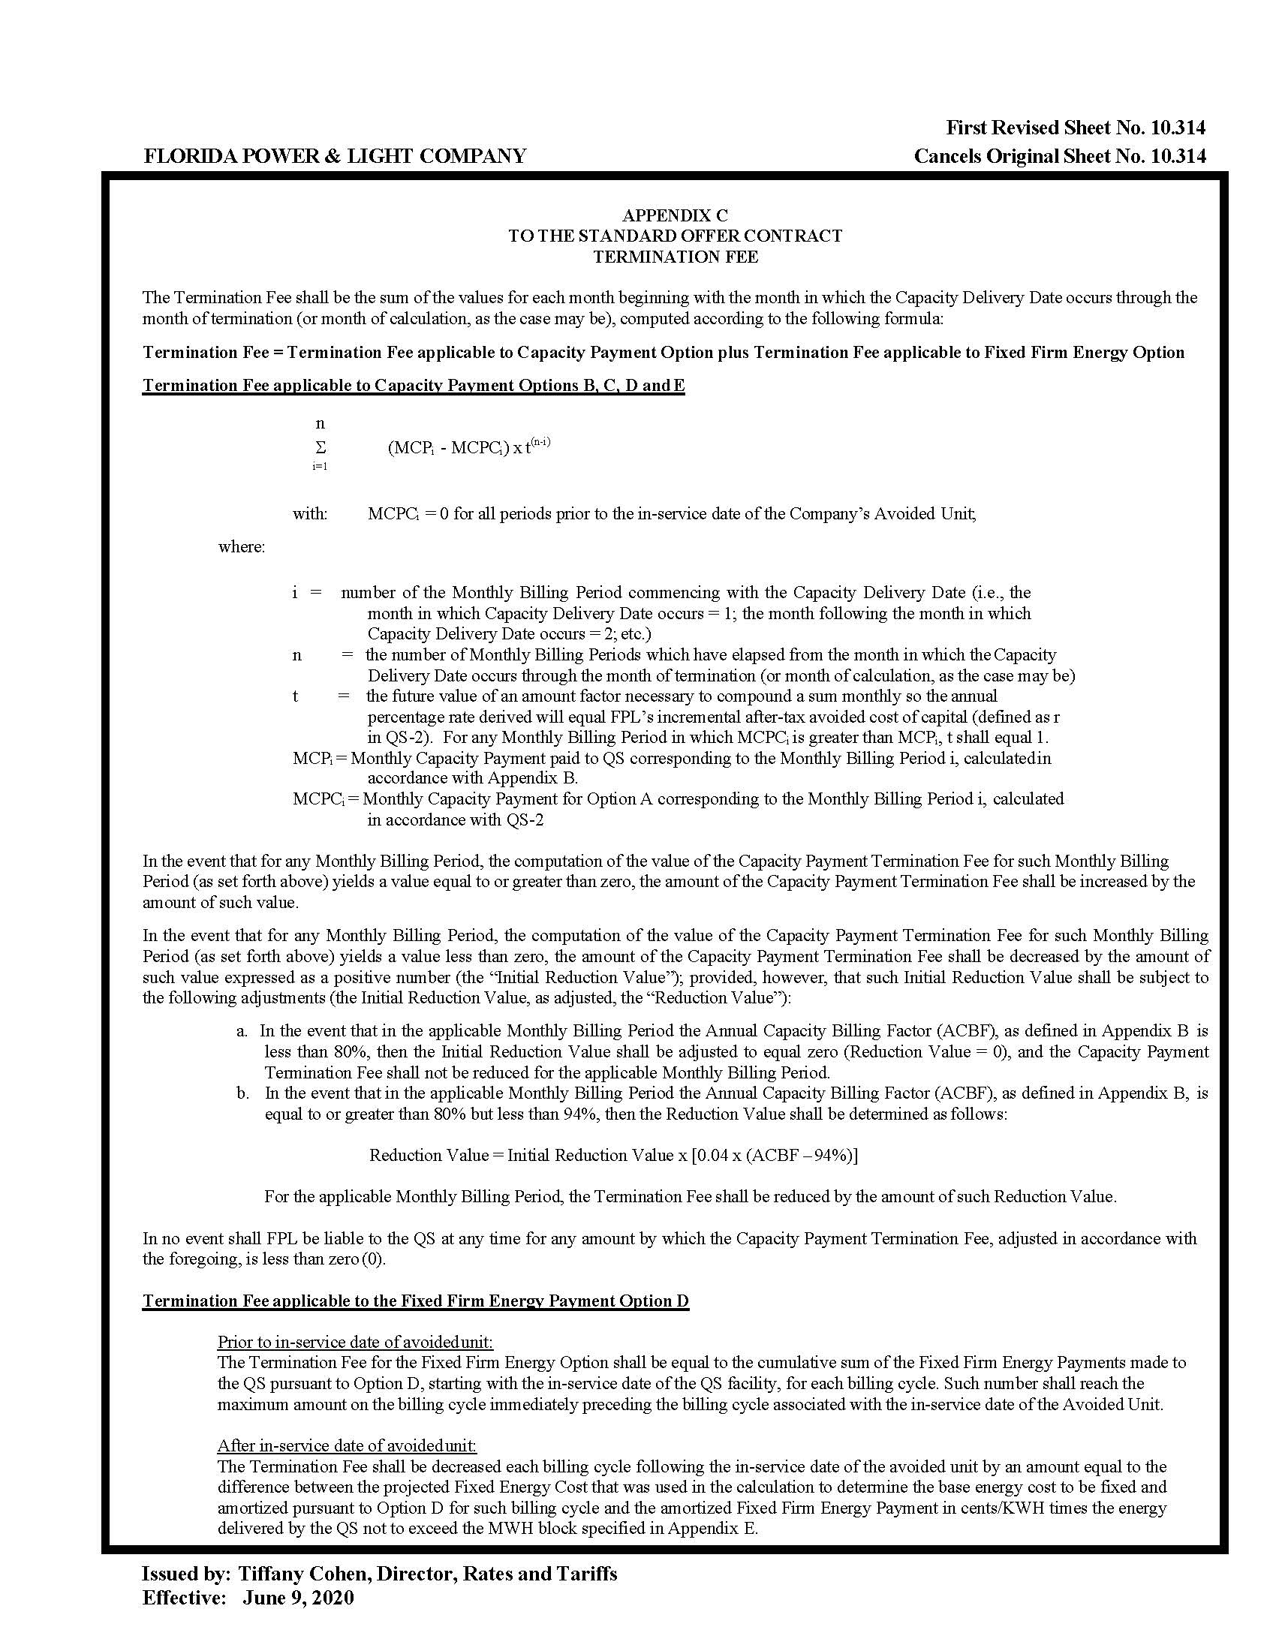

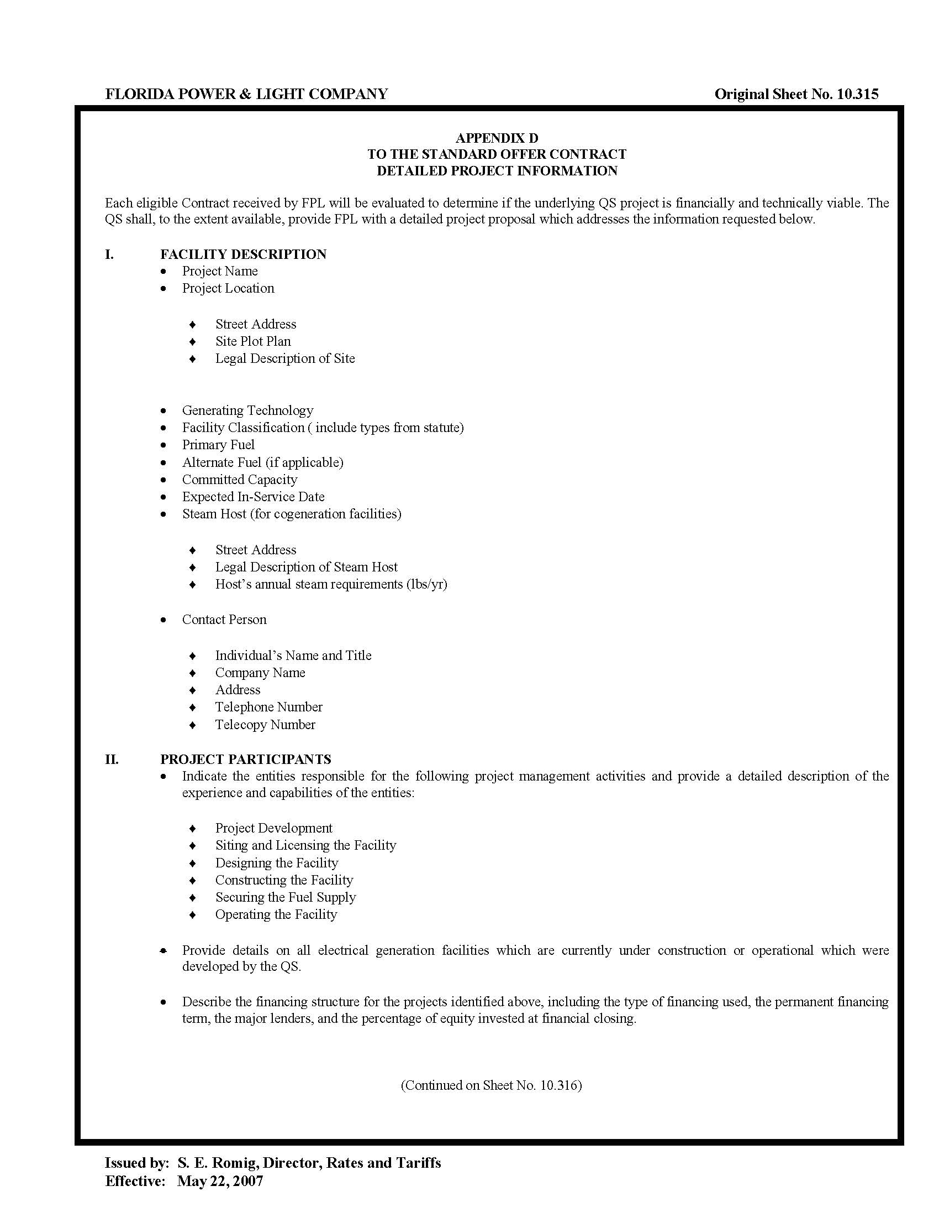

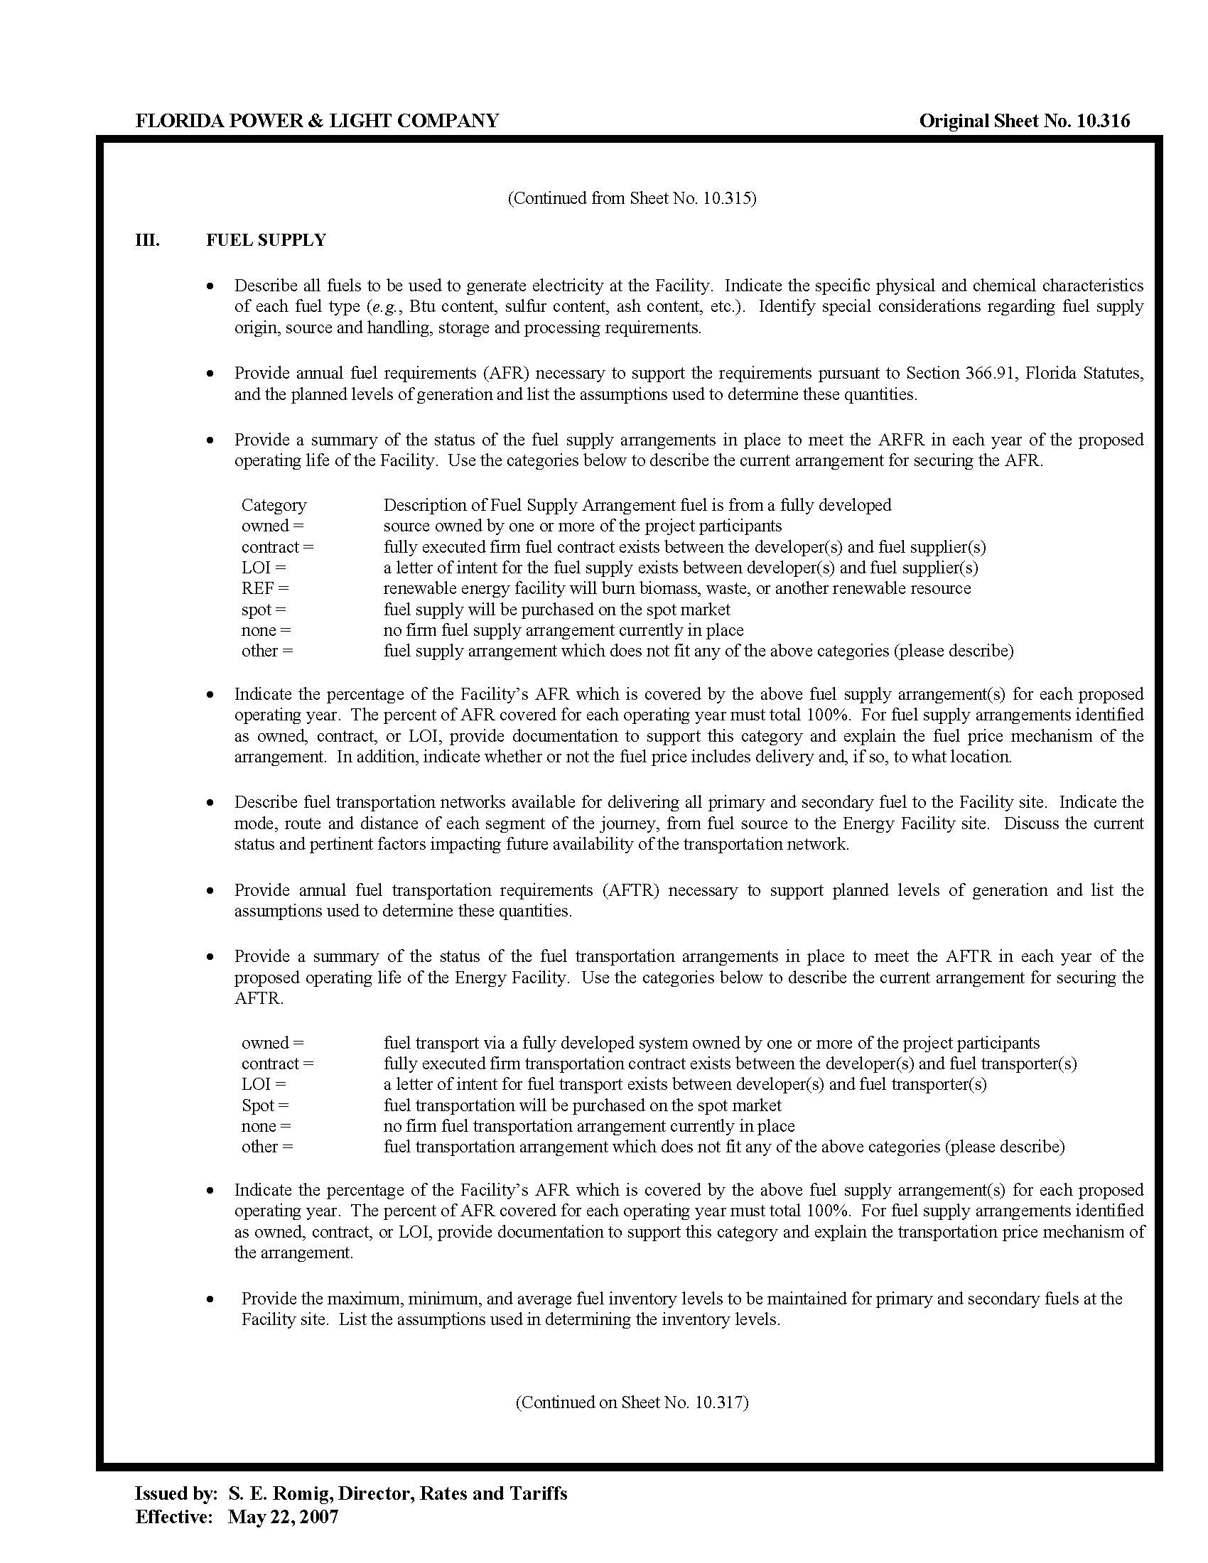

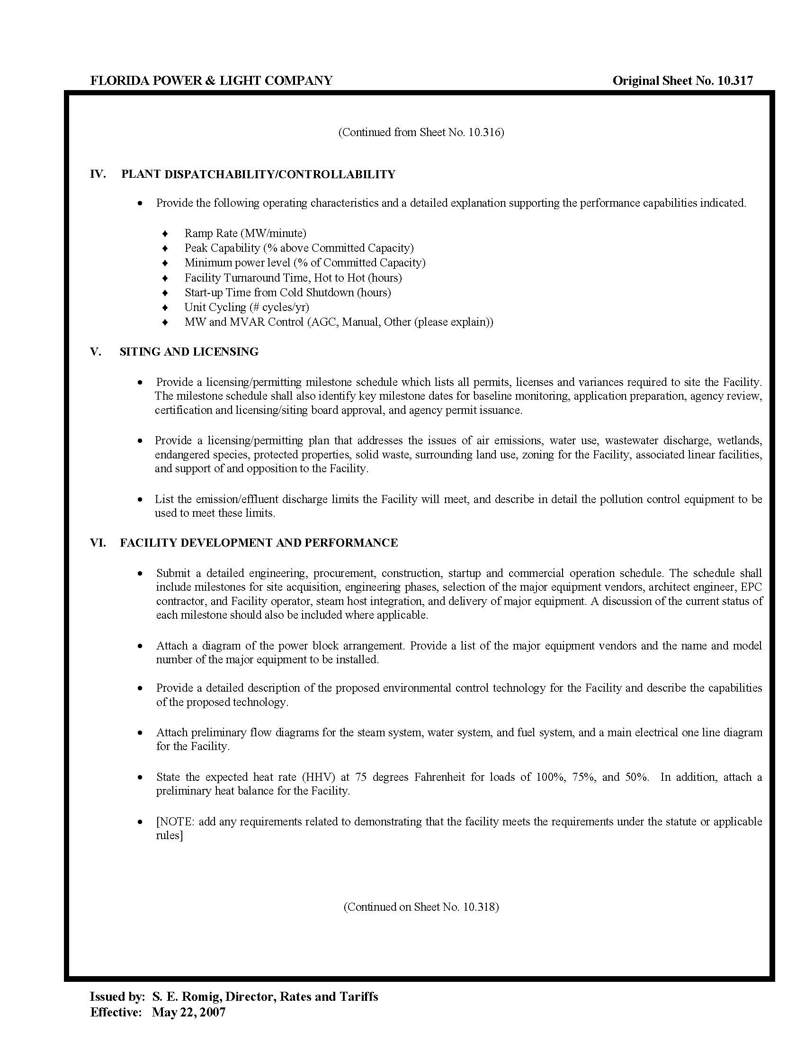

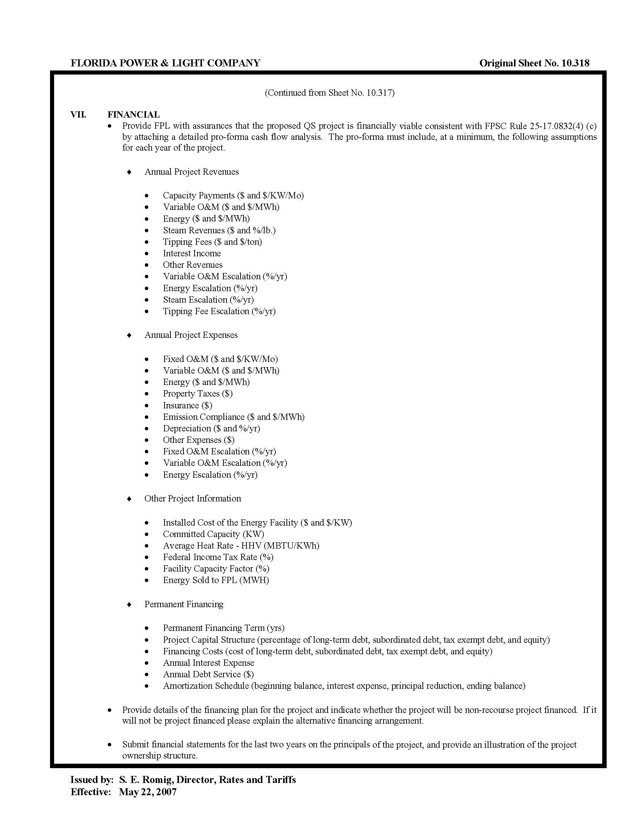

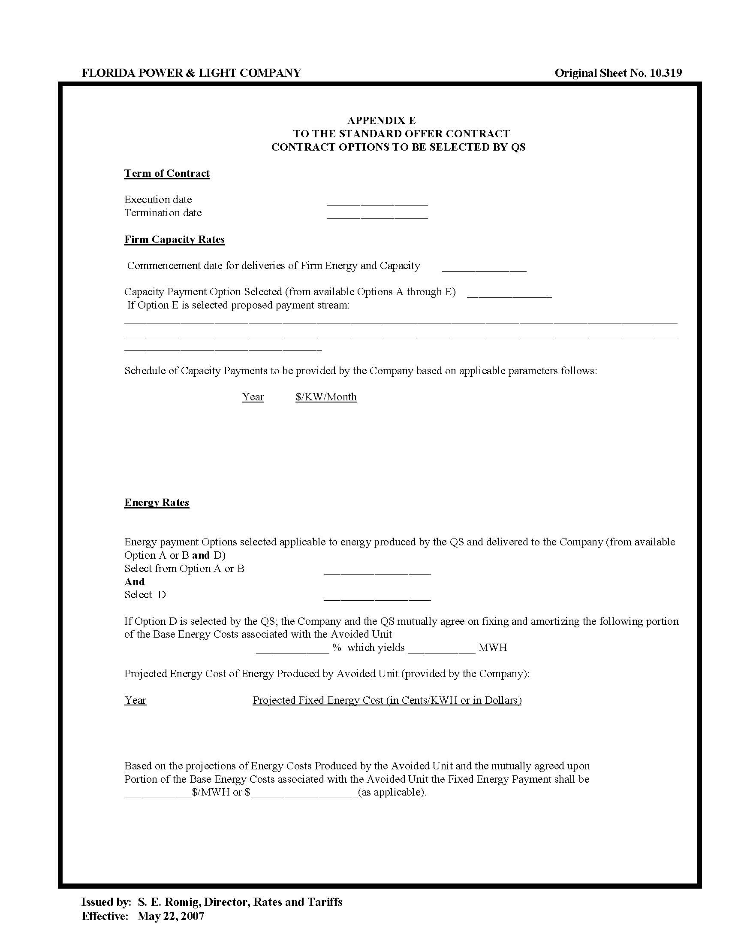

See Order No. PSC-2018-0316-PAA-EQ, issued June 20, 2018, in Docket No. 20180083-EQ, In re: Petition for approval of renewable energy tariff and standard offer contract, by Florida Power & Light Company; Order No. PSC-2020-0212-PAA-EQ, issued June 26, 2020, in Docket No. 20200114-EQ, In re: Florida Power & Light Company’s Petition for Approval of a Renewable Energy Tariff and Standard Offer Contract; and Order No. PSC-2020-0213-PAA-EQ, issued June 26, 2020, in Docket No. 20200115-EQ, In re: Petition for approval of new standard offer for purchase of firm capacity and energy from renewable energy facilities or small qualifying facilities and rate schedule QS-2, by Gulf Power Company.
Document No. 03880-2021, filed May 1, 2021, in Docket No. 20210067-EQ.
Document No. 02759-2021, filed March 12, 2021, in Docket No. 20210015-EQ.

