BEFORE THE FLORIDA PUBLIC SERVICE COMMISSION

In re: Petition for approval of transportation service agreement between Peninsula Pipeline Company, Inc. and Florida Division of Chesapeake Utilities Corporation. | DOCKET NO. 20210106-GU  ORDER NO. PSC-2021-0372-PAA-GU  ISSUED: September 27, 2021

The following Commissioners participated in the disposition of this matter:

GARY F. CLARK, Chairman
ART GRAHAM
ANDREW GILES FAY
MIKE LA ROSA
GABRIELLA PASSIDOMO

NOTICE OF PROPOSED AGENCY ACTION
ORDER APPROVING TRANSPORTATION SERVICE AGREEMENT

BY THE COMMISSION:

NOTICE is hereby given by the Florida Public Service Commission that the action discussed herein is preliminary in nature and will become final unless a person whose interests are substantially affected files a petition for a formal proceeding, pursuant to Rule 25-22.029, Florida Administrative Code (F.A.C.).

Background
On May 26, 2021, Peninsula Pipeline Company, Inc. (Peninsula) filed a petition seeking approval of a firm transportation service agreement (Agreement) between Peninsula and the Florida Division of Chesapeake Utilities Corporation, d/b/a Central Florida Gas (CFG), collectively the Joint Petitioners. Peninsula operates as a natural gas transmission company as defined by Section 368.103(4), Florida Statutes (F.S.). CFG provides natural gas service to residential, commercial, and industrial customers in areas including Polk County and currently receives deliveries of natural gas over interstate transmission pipelines owned by Gulfstream Natural Gas System and Florida Gas Transmission Company (FGT). CFG is a local distribution company subject to our regulatory jurisdiction pursuant to Chapter 366, F.S.
By Order No. PSC-07-1012-TRF-GP, Peninsula received approval of an intrastate gas pipeline tariff that allows it to construct and operate intrastate pipeline facilities and to actively pursue agreements with natural gas customers. Peninsula provides transportation service and does not engage in the sale of natural gas. Pursuant to Order No. PSC-07-1012-TRF-GP, Peninsula is allowed to enter into certain gas transmission agreements without our prior approval. However, Peninsula requested our approval of this proposed Agreement as it does not fit any of the criteria enumerated in the tariff for which our approval would not be required. Furthermore, the Joint Petitioners are subsidiaries of Chesapeake Utility Corporation and agreements between affiliated companies must be approved by us pursuant to Section 368.105, F.S., and Order No. PSC-07-1012-TRF-GP.
In accordance with the proposed Agreement, Peninsula will construct, own, and operate a natural gas pipeline, a new gate station, and a new delivery receipt station in Polk County. During the evaluation of the petition, we issued two data requests to the Joint Petitioners, for which responses were received on July 23, 2021 and on August 9, 2021. In addition, Commission staff held an informal follow-up meeting with the Joint Petitioners on August 16, 2021. The proposed Agreement is included with this order as Attachment A. The project map, identifying the proposed construction projects, is included as Attachment B to this order. The dashed line represents the pipeline Peninsula will construct, pursuant to the proposed Agreement. We have jurisdiction over this matter pursuant to Sections 366.05(1), 366.06, and 368.105, F.S.

Decision

Proposed Transportation Service Agreement

The Joint Petitioners have entered into the proposed Agreement to provide CFG with the additional capacity needed to serve new incremental load in the Winter Haven distribution system. The overall scope of Peninsula’s project contemplates the construction of a steel pipeline, a new gate station with FGT, and a new delivery receipt station.

Specifically, Peninsula would construct a gate station connecting the new pipeline to the FGT Avon Park Lateral, south of Winter Haven. Peninsula would also install 7,400 feet of 4-inch steel pipeline beginning from the new gate station and continuing northward to the new delivery receipt station. Peninsula would construct the delivery receipt station in the area of Pollard Road and Logistics Parkway. The Joint Petitioners state that the proposed project would allow CFG to capture new load growth in the area, including a large can manufacturing facility expected to begin operation in the third quarter of 2021. Peninsula stated that it anticipates the construction of the pipeline, gate station with FGT, and the delivery receipt station to be completed in the first quarter of 2022.

The proposed Agreement specifies an initial term of 20 years, with an extension on a year-by-year basis, unless either party gives written notification of termination not less than 90 days prior to expiration. In response to staff’s data request, CFG explained it did not issue a formal Request for Proposals. The Joint Petitioners state that FGT has declined to bid for similar projects in previous discussions, citing that constructing and owning laterals like those proposed is not the focus of their expansion activities.

We note that the pipeline along Bomber Road, shown as the solid line on Attachment B, will be constructed and owned by CFG and is therefore not part of the proposed Agreement. In response to Commission staff’s data request, the Joint Petitioners explained that the 4-inch medium-density polyethylene pipeline is an extension of CFG’s existing distribution main, making CFG the logical choice to construct and own that pipeline.

Negotiated Monthly Reservation Payments to Peninsula

The Joint Petitioners assert that the negotiated monthly reservation charge contained in the proposed Agreement is consistent with market rates, because the rates are substantially the same as rates set forth in similar agreements as required by Section 368.105(3)(b), F.S. We have reviewed the proposed Agreement’s monthly reservation charge as well as the cost estimates for each portion of the project and the breakdown between labor and materials. In discussions with Commission staff, the Joint Petitioners explained that the negotiated monthly reservation charge was determined based on the expected costs associated with the project, including design costs, capital and depreciation costs, operations and maintenance costs, safety and regulatory compliance costs, taxes, and Peninsula’s return on equity.
CFG has proposed to recover its payments to Peninsula through its swing service rider mechanism, consistent with other gas transmission pipeline costs incurred by CFG. The swing service rider allows CFG to recover intrastate capacity costs from its transportation customers and is a cents per therm charge that is included in the monthly gas bill of transportation customers. We find that while CFG will incur costs associated with this service expansion, any new load will help spread the costs over a larger customer base. The benefit of Peninsula, as opposed to CFG, constructing the new pipeline is primarily that Peninsula’s construction and ownership of the pipeline will protect CFG’s ratepayers from undertaking the costs and risks associated with the project.

Anticipated System Benefits

The Joint Petitioners assert that the proposed project is anticipated to provide multiple reliability and operational benefits for CFG. First, the project would introduce additional natural gas supply from FGT to CFG’s distribution system approximately mid-way between existing FGT gate stations in Bartow and Winter Haven. We agree this would provide additional reliability for CFG’s distribution system, should either current FGT gate station in the Bartow and Winter Haven area become constrained.

Second, the Joint Petitioners explained that completion of Peninsula’s proposed project would allow CFG to decrease the pipeline pressure along Spirit Lake Road, eliminating the need for several existing farm taps. CFG has identified eight farm taps for retirement, which would otherwise need to be rebuilt within the next year. By decreasing the pressure along Spirit Lake Road, CFG is able to avoid the cost associated with rebuilding the older equipment. In response to staff’s data request, the Joint Petitioners stated that customers served by these farm taps should not anticipate any changes to service reliability. We agree that retiring the aging farm taps would avoid the additional costs associated with rebuilding the equipment and would not impact reliability for customers currently served by them.

Finally, CFG has identified four larger regulator stations that could also be retired as a result of decreasing the pipeline pressure. Two regulator stations to be removed from service are located near high traffic roads and their removal should result in increased public safety. The Joint Petitioners state that the remaining two regulator stations are located in a CFG operations yard and are fed by a higher-pressure pipeline that crosses under Lake Shipp. We agree that retiring the regulator stations would result in reduced maintenance expenses and increased safety in the area. CFG stated that it anticipates the retirement of the farm taps and four regulator stations to be completed by the end of the second quarter of 2022, dependent upon Peninsula’s completion of its project.

Conclusion

Based on the petition and the Joint Petitioners’ responses to our data request, we hereby approve the proposed Transportation Service Agreement between Peninsula and CFG dated May 7, 2021. The proposed Agreement is reasonable and meets the requirements of Section 368.105, F.S. Furthermore, the proposed Agreement benefits CFG customers by enhancing reliability, serving new incremental load, and by avoiding the risks associated with ownership of the facilities.

Based on the foregoing, it is

ORDERED by the Florida Public Service Commission that the proposed Transportation Service Agreement between Peninsula Pipeline Company, Inc. and the Florida Division of Chesapeake Utilities Corporation, d/b/a Central Florida Gas, dated May 7, 2021, is hereby approved. It is further

ORDERED that the provisions of this Order, issued as proposed agency action, shall become final and effective upon the issuance of a Consummating Order unless an appropriate petition, in the form provided by Rule 28-106.201, F.A.C., is received by the Commission Clerk, 2540 Shumard Oak Boulevard, Tallahassee, Florida 32399-0850, by the close of business on the date set forth in the “Notice of Further Proceedings” attached hereto. It is further

ORDERED that in the event this Order becomes final, this docket shall be closed.

By ORDER of the Florida Public Service Commission this 27th day of September, 2021.

/s/ Adam J. Teitzman
ADAM J. TEITZMAN
Commission Clerk
Florida Public Service Commission
2540 Shumard Oak Boulevard
Tallahassee, Florida 32399
(850) 413-6770
www.floridapsc.com

Copies furnished: A copy of this document is provided to the parties of record at the time of issuance and, if applicable, interested persons.

SFO

NOTICE OF FURTHER PROCEEDINGS OR JUDICIAL REVIEW

The Florida Public Service Commission is required by Section 120.569(1), Florida Statutes, to notify parties of any administrative hearing that is available under Section 120.57, Florida Statutes, as well as the procedures and time limits that apply. This notice should not be construed to mean all requests for an administrative hearing will be granted or result in the relief sought.

Mediation may be available on a case-by-case basis. If mediation is conducted, it does not affect a substantially interested person's right to a hearing.

The action proposed herein is preliminary in nature. Any person whose substantial interests are affected by the action proposed by this order may file a petition for a formal proceeding, in the form provided by Rule 28-106.201, Florida Administrative Code. This petition must be received by the Office of Commission Clerk, 2540 Shumard Oak Boulevard, Tallahassee, Florida 32399-0850, by the close of business on October 18, 2021.

In the absence of such a petition, this order shall become final and effective upon the issuance of a Consummating Order.

Any objection or protest filed in this/these docket(s) before the issuance date of this order is considered abandoned unless it satisfies the foregoing conditions and is renewed within the specified protest period.

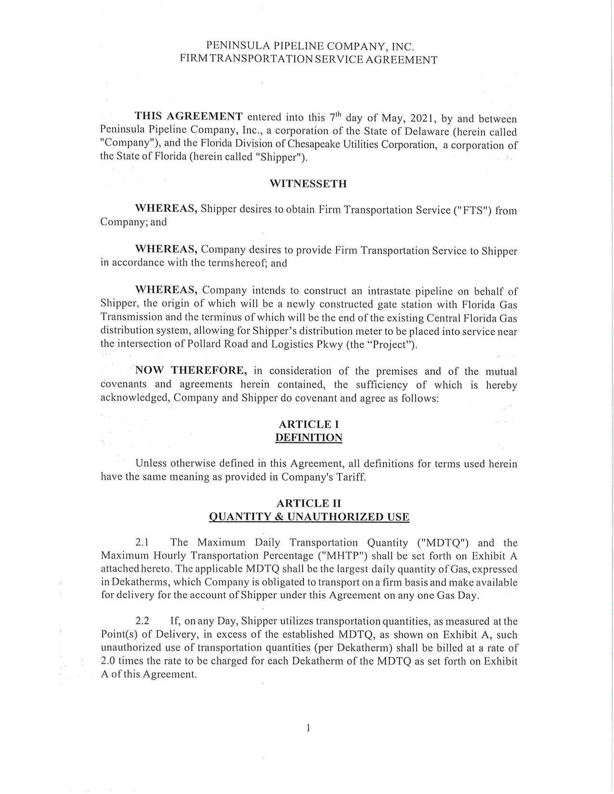

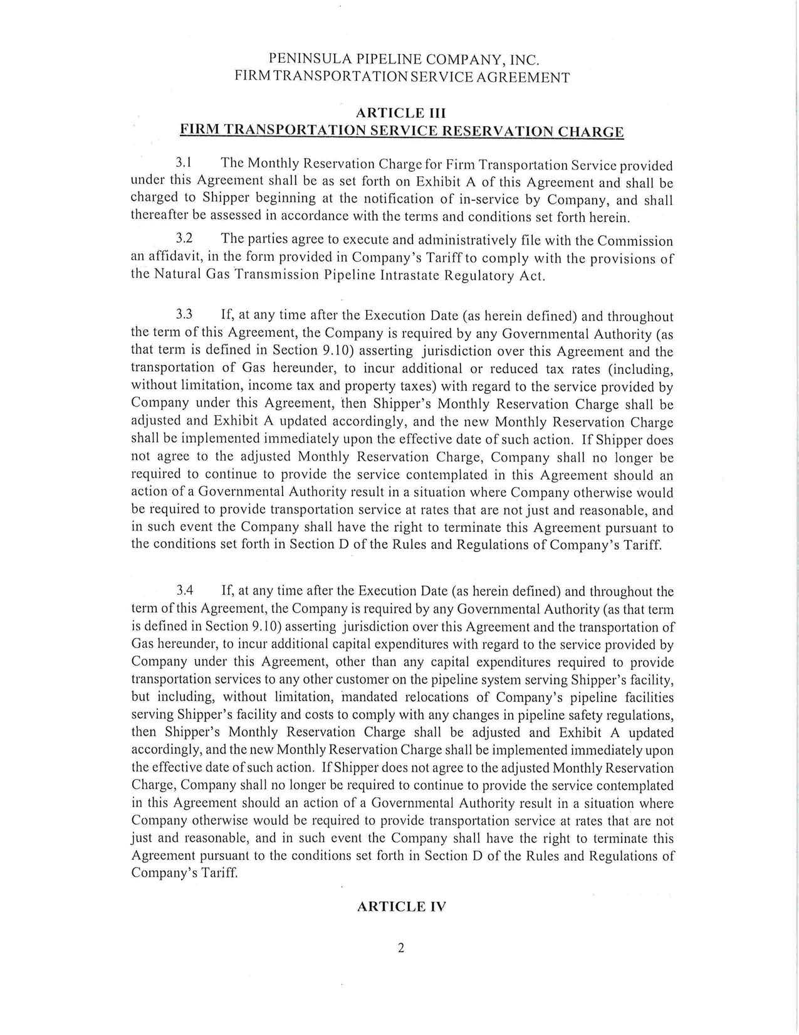

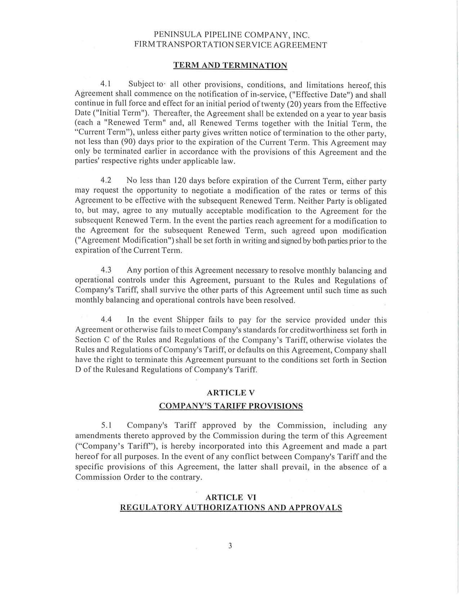

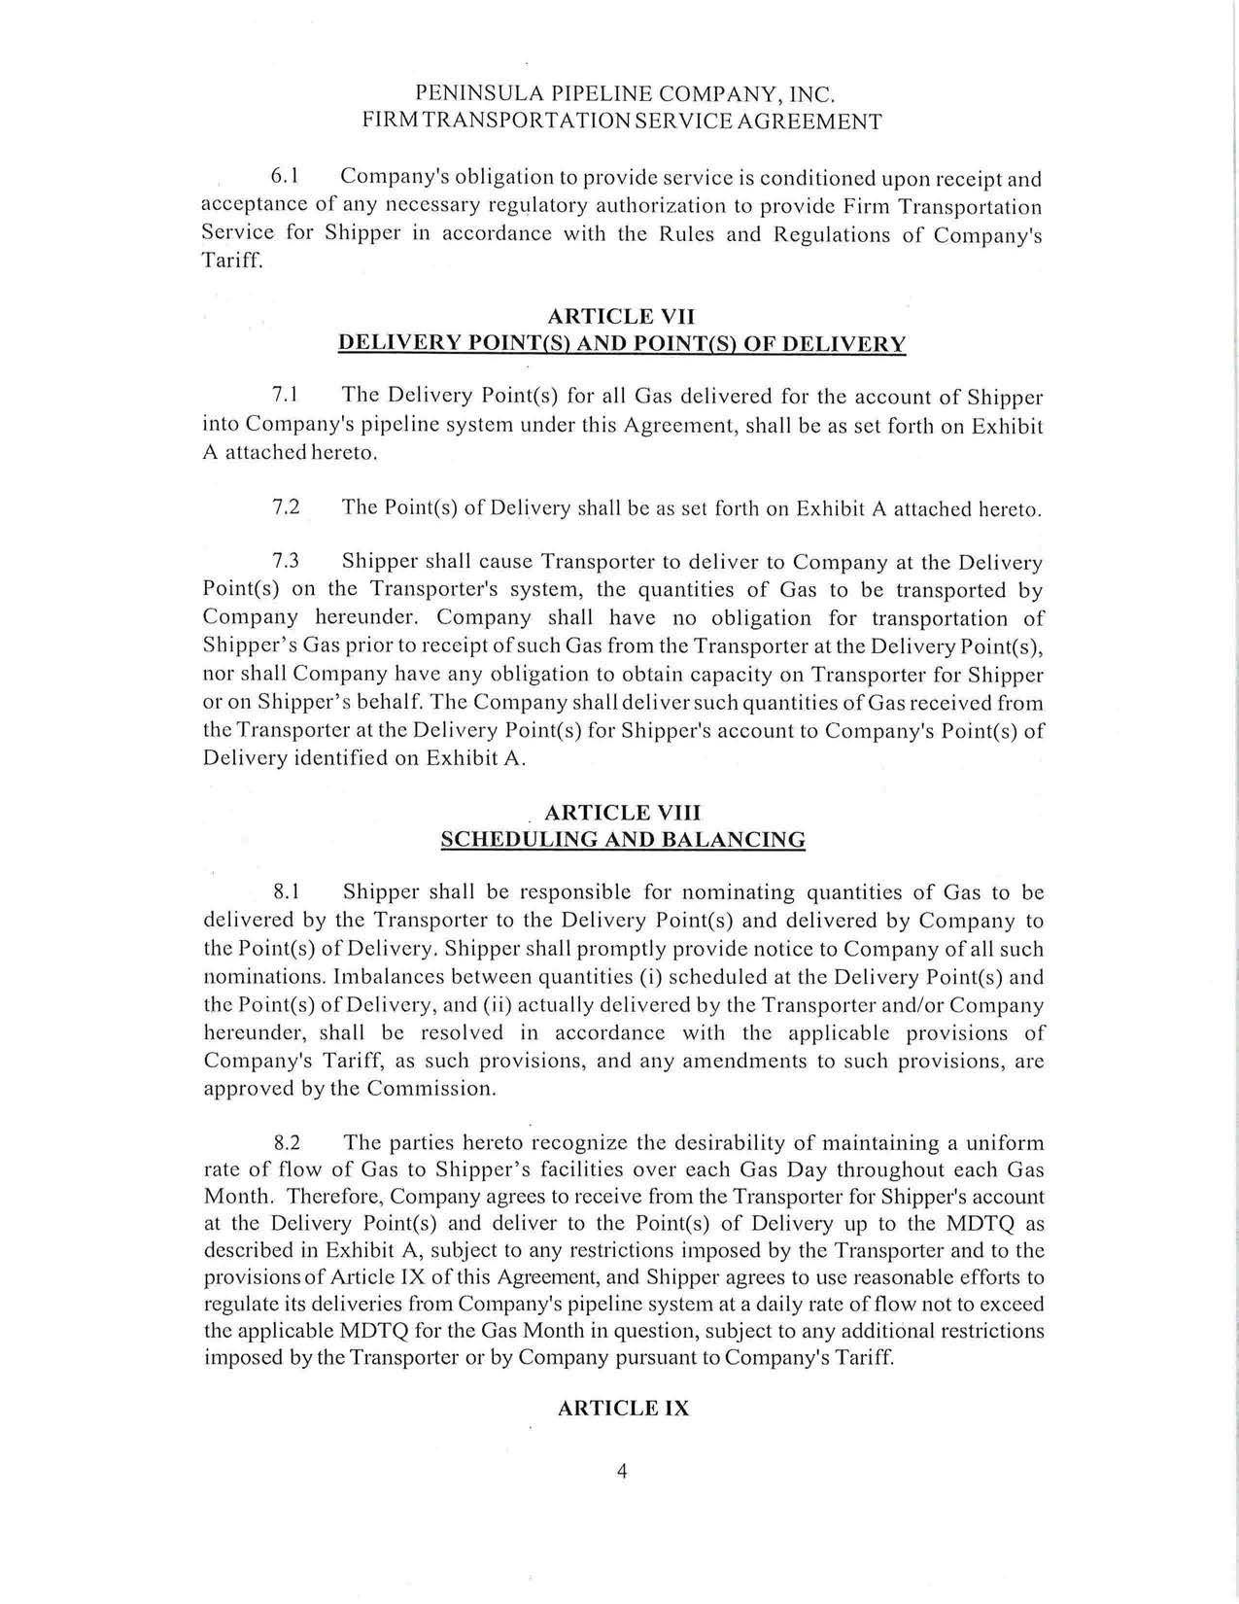

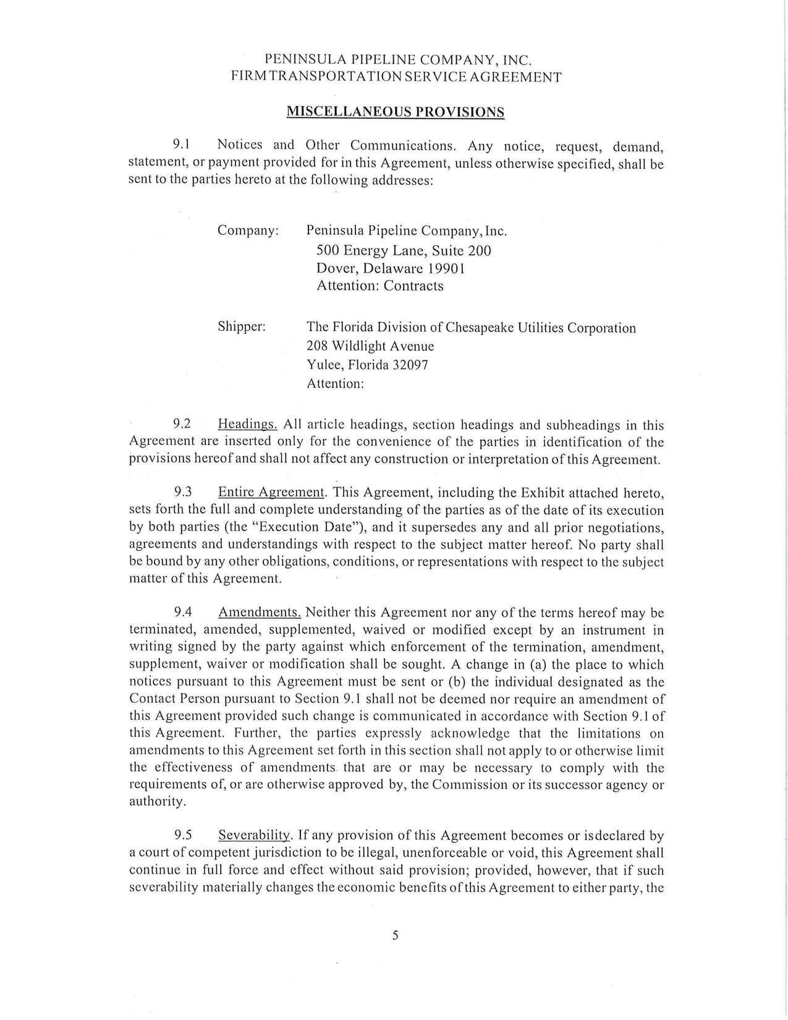

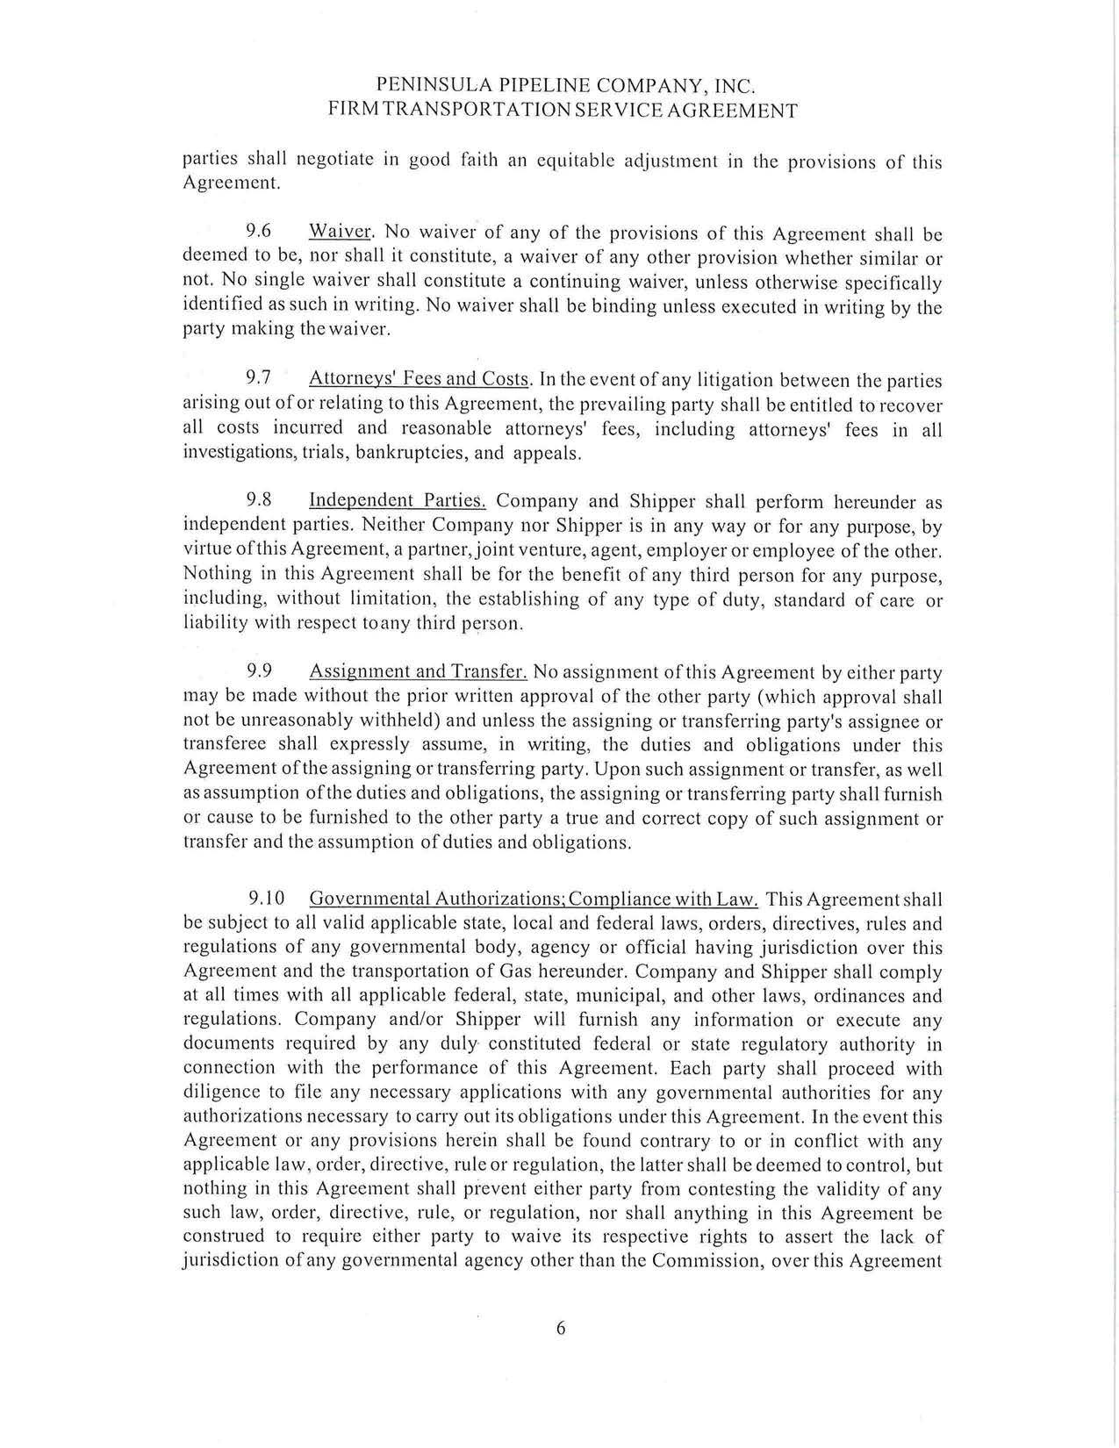

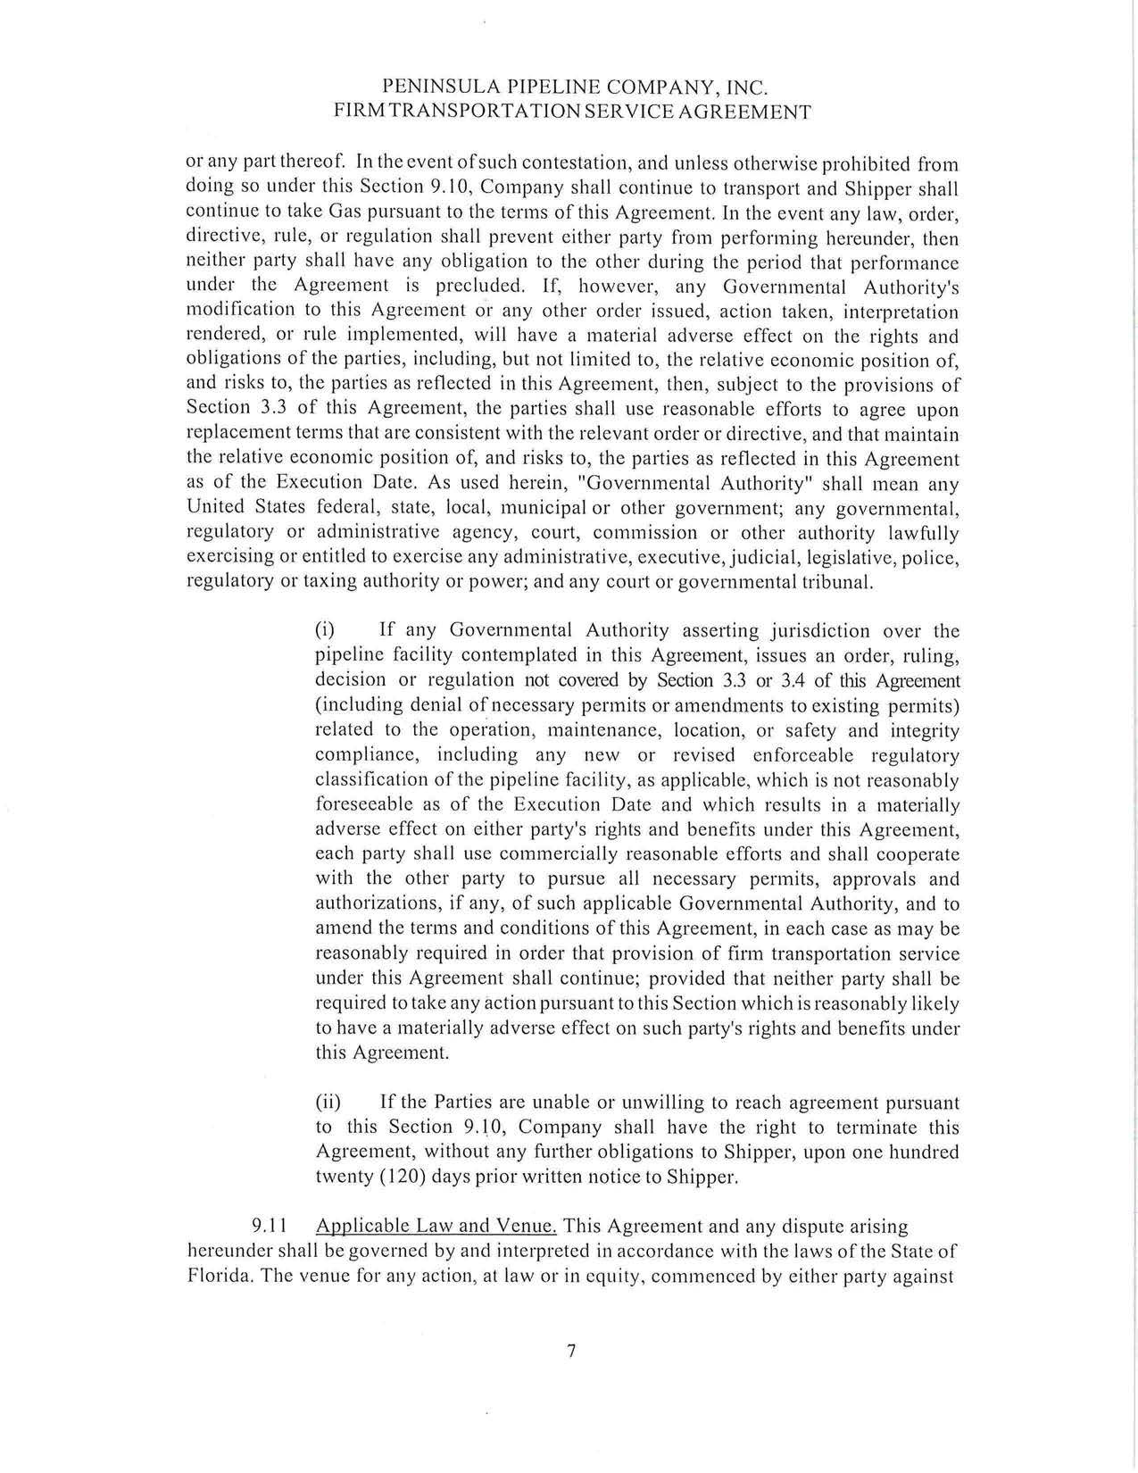

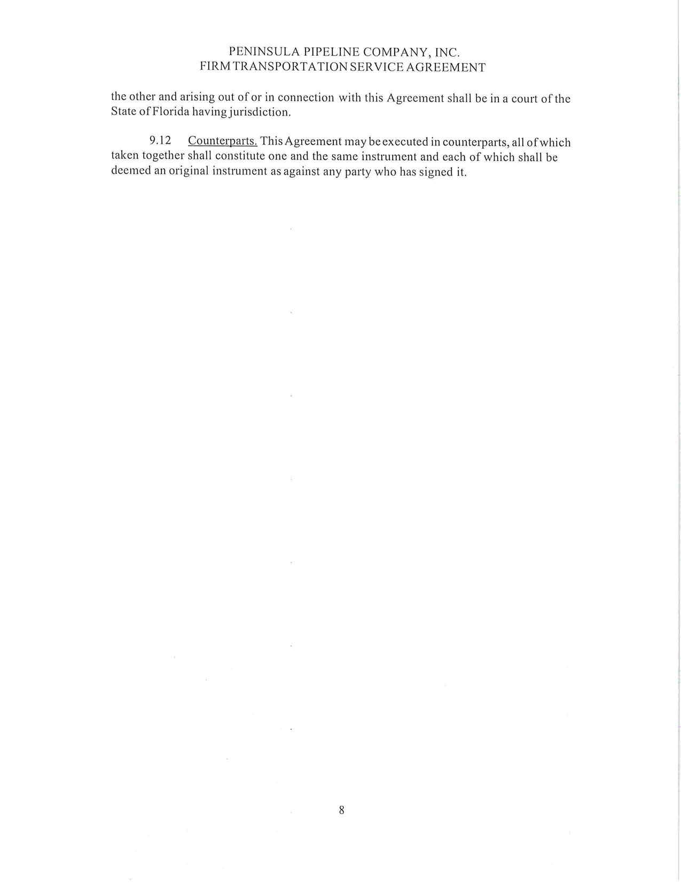

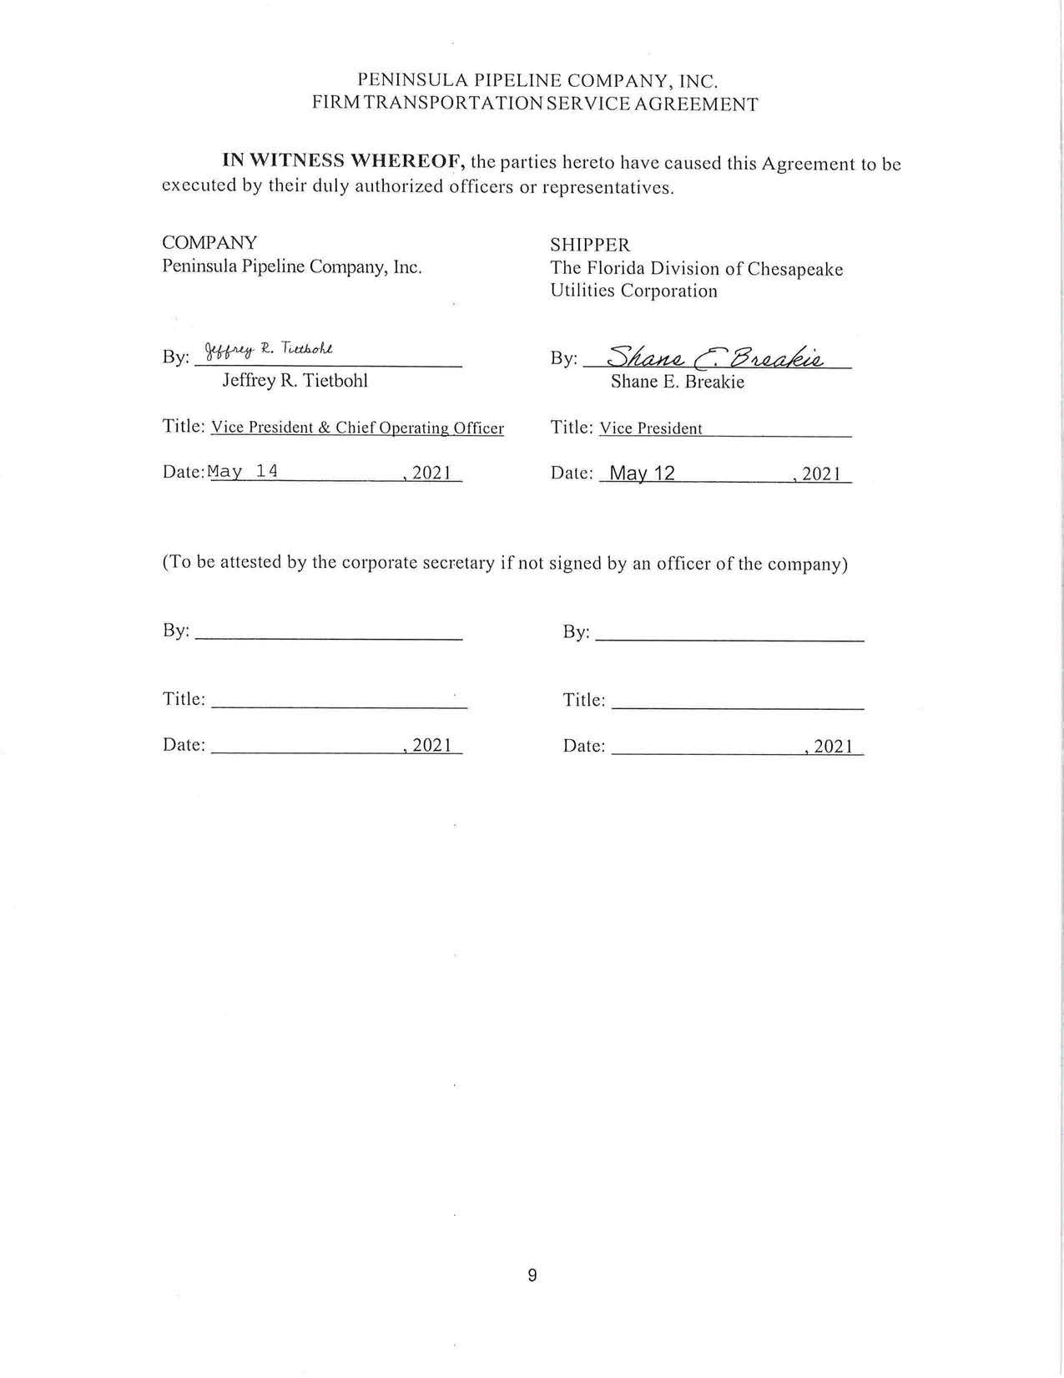

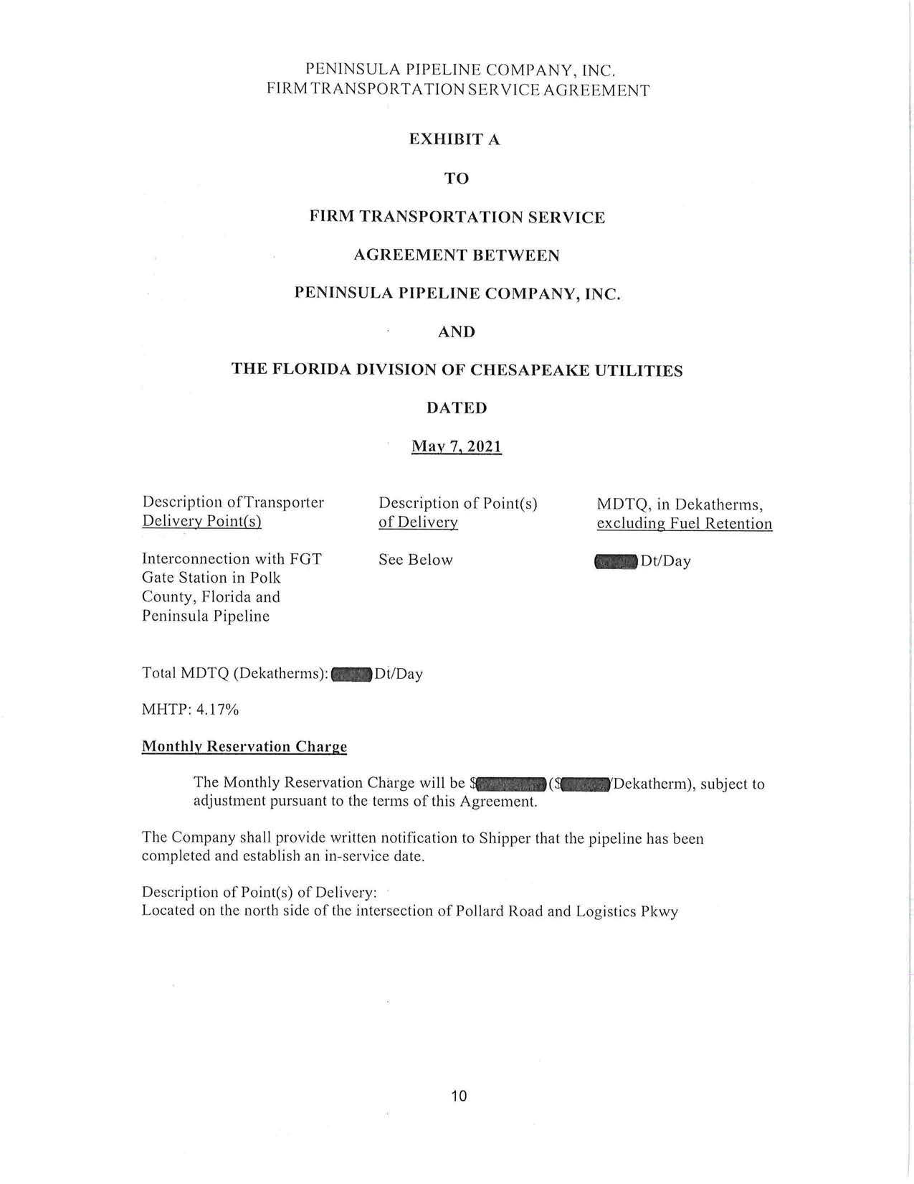

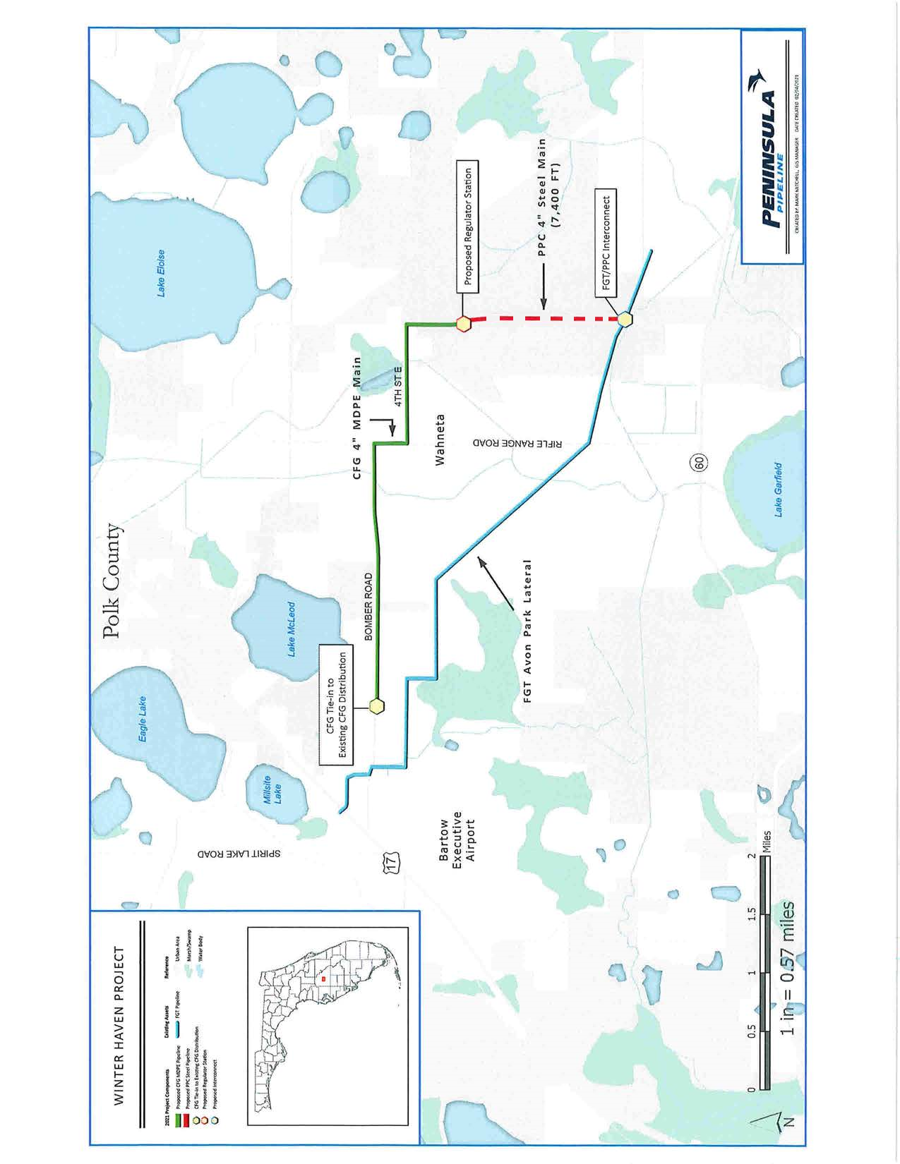

Order No. PSC-06-0023-DS-GP, issued January 9, 2006, in Docket No. 20050584-GP, In re: Petition for declaratory statement by Peninsula Pipeline Company, Inc. concerning recognition as a natural gas transmission company under Section 368.101, F.S., et seq.
Order No. PSC-07-1012-TRF-GP, issued December 21, 2007, in Docket No. 20070570-GP, In re: Petition for approval of natural gas transmission pipeline tariff by Peninsula Pipeline company, Inc.
Peninsula Pipeline Company, Inc., Intrastate Pipeline Tariff, Original Vol. 1, Original Sheet No. 11, Section 3.
Peninsula Pipeline Company, Inc., Intrastate Pipeline Tariff, Original Vol. 1, Original Sheet No. 12, Section 4.
A gate station is a facility that depressurizes, odorizes, and measures the natural gas received from transmission pipelines.
Joint Responses to our First Data Request, No. 3 (DN 08276-2021).
Joint Responses to our First Data Request, No. 6 (DN 08276-2021).
Joint Responses to our First Data Request, No. 5 (DN 08276-2021).
Joint Responses to our First Data Request, No. 1 (DN 08276-2021).
Order No. PSC-2018-0557-TRF-GU, issued November 20, 2018, in Docket No. 20180158-GU, In re: Joint petition for approval of swing service rider, by Florida Public Utilities Company, Florida Public Utilities Company-Indiantown Division, Florida Public Utilities Company-Fort Meade, and Florida Division of Chesapeake Utilities Corporation.
CFG does not purchase gas for its customers.
A farm tap is a smaller regulator station used to serve a single family home or small development directly from the natural gas main.
Joint Responses to our First Data Request, No. 4 (DN 08276-2021).
Joint Responses to our First Data Request, No. 3 (DN 08276-2021).

