State of Florida |  | Public Service Commission  Capital Circle Office Center ● 2540 Shumard Oak Boulevard  Tallahassee, Florida 32399-0850  -M-E-M-O-R-A-N-D-U-M-
DATE: | October 21, 2021
TO: | Office of Commission Clerk (Teitzman)
FROM: | Division of Economics (Guffey, Coston)  Office of the General Counsel (Sandy, Crawford)
RE: | Docket No. 20210147-GU – Joint petition for approval of swing service rider rates for January through December 2022, by Florida Public Utilities Company, Florida Public Utilities Company-Indiantown Division, Florida Public Utilities Company-Fort Meade, and Florida Division of Chesapeake Utilities Corporation.
AGENDA: | 11/02/21 – Regular Agenda – Tariff Filing – Interested Persons May Participate
COMMISSIONERS ASSIGNED: |  |  | All Commissioners
PREHEARING OFFICER: |  |  | Administrative
CRITICAL DATES: |  |  | 8-Month Effective Date: 4/30/22
SPECIAL INSTRUCTIONS: |  |  | None

Case Background
On August 31, 2021, Florida Public Utilities Company, Florida Public Utilities Company-Indiantown Division, Florida Public Utilities Company-Fort Meade, and Florida Division of Chesapeake Utilities Corporation d/b/a Central Florida Gas (jointly, Companies) filed a petition for approval of revised Swing Service Rider Rates and associated tariffs for the period January through December 2022. FPUC is a local natural gas distribution company (LDC) subject to the regulatory jurisdiction of the Commission pursuant to Chapter 366, Florida Statutes (F.S.). FPUC is a wholly-owned subsidiary of Chesapeake Utilities Corporation, which is headquartered in Dover, Delaware. Chesapeake is also an LDC subject to the Commission’s jurisdiction under Chapter 366, F.S., and is an operating division of Chesapeake Utilities Corporation.
The Commission first approved the Companies’ swing service rider tariff in Order No. PSC-16-0422-TRF-GU (swing service order) and the initial swing service rider rates were in effect for the period March through December 2017. As required in the swing service order, the Companies submitted the instant petition with revised 2022 swing service rider rates for Commission approval by September 1, 2021. The January through December 2021 swing service rider rates were approved in Order No. PSC-2020-0452-TRF-GU. The swing service rider is a cents per therm charge that is included in the monthly gas bill of transportation customers. This is staff’s recommendation on the 2022 swing service rider rates.
At the October 10, 2021 Agenda Conference, the Commission suspended the 60-day file and suspend provision of Section 366.06(3), F.S. During its evaluation of the petition, staff issued two data requests to the Companies for which responses were received on September 23, 2021 and on October 11, 2021. The updated swing service rider rates and associated revised tariff sheets are shown in Attachment A to the recommendation. The Commission has jurisdiction over this matter pursuant to Sections 366.04, 366.05, and 366.06, F.S.

Discussion of Issues

Issue 1:
Should the Commission approve the Companies' proposed swing service rider rates and tariffs for the period January through December 2022?

Recommendation:
No. The Commission should deny the proposed swing service rider rates and tariffs for the period January through December 2022, as filed. However, the Companies should be given the option to file revised rates and tariffs within 10 days of the Commission’s vote, for administrative approval by staff, that reflect the removal of $8,093 in legal fees from the calculation, for the period January through December 2022. (Guffey, Coston)

Staff Analysis:
The Companies incur intrastate capacity costs when they transport natural gas on intrastate pipelines (i.e., pipelines operating within Florida only). The Companies have two types of natural gas customers: sales and transportation. The swing service rider allows the Companies to recover the intrastate pipeline capacity costs directly from all transportation customers as intrastate pipeline projects benefit all customers.

Types of Natural Gas Customers
Sales customers are primarily residential and small commercial customers that purchase natural gas from an LDC and receive allocations of intrastate capacity costs through the Purchased Gas Adjustment (PGA) charge. Of the joint petitioners in the instant docket, only Florida Public Utilities Company and Florida Public Utilities Company – Fort Meade have sales customers.
Transportation customers receive natural gas from third party marketers, also known as shippers and, therefore, do not pay the PGA charge to the LDC. The Companies’ transportation customers can be categorized as Transitional Transportation Service (TTS) or non-TTS. TTS program shippers purchase gas in aggregated customer pools for residential and small commercial customers, who do not contract directly with a shipper for their gas supply. Of the joint petitioners in the instant docket, only Florida Public Utilities Company – Indiantown Division (Indiantown) and Chesapeake have TTS customers.
TTS customers receive allocations of intrastate capacity costs through the swing service rider. Prior to the approval of the swing service rider, TTS customers received allocations of intrastate capacity costs through the Operational Balancing Account (OBA) mechanism. The OBA mechanism allowed Indiantown and Chesapeake to assign intrastate capacity costs to TTS shippers, who then passed the costs on to the TTS customers for whom they purchase gas. With the approval of the swing service rider, TTS customers are now charged directly for their allocated portion of the intrastate capacity costs (rather than Indiantown and Chesapeake charging the shippers who then passed the costs on to the TTS customers).
Non-TTS customers are primarily large commercial or industrial customers who contract directly with a shipper for their natural gas supply. Prior to the approval of the swing service rider, non-TTS customers were not paying a share of the intrastate capacity costs.

Updated 2022 Swing Service Rider Rates
The updated 2022 swing service rider rates were calculated based on the same methodology approved in the 2016 swing service order. As stated in paragraph 9 of the Companies’ instant petition, the total intrastate capacity costs for the period July 2020 through June 2021 are $25,538,406. The total intrastate capacity costs reflect payments by the Companies to intrastate pipelines for the transportation of natural gas, pursuant to Commission approved transportation agreements. In addition, the intrastate capacity costs include payments to outside contractors the Companies hired to provide expertise on the purchase of commodity and capacity, and legal consulting fees.
Of these costs, $6,443,673 will be billed directly to certain large special contract customers. The remaining costs of $19,094,732 are allocated between sales and transportation customers and will be recovered during the period January 1, 2022 through December 31, 2022.
The Companies used actual therm usage data for the period July 2020 through June 2021 to allocate the intrastate capacity costs. Based on the usage data, the appropriate split for allocating the cost is 69.3 percent or $13,233,244 to transportation customers and 30.7 percent or $5,861,488 to sales customers. The transportation customers’ share of $13,233,244 is allocated to the various transportation rate schedules in proportion with each rate schedule’s share of the Companies’ total throughput. The sales customers’ share of the cost of $5,861,488 is embedded in the PGA.
To calculate the swing service rider rates, the transportation customers’ share of the cost is allocated to each rate schedule and is divided by the rate schedule’s number of therms. The swing service rider charge is billed directly to the customers. The swing service revenues the Companies are projected to receive in 2022 is a total of $13,233,244.

Credit to the PGA
The total intrastate capacity costs are embedded in the PGA with the projected 2022 swing service rider revenues incorporated as a credit in the calculation of the 2022 PGA. The amount credited to the 2022 PGA is $13,233,244 plus $6,443,673 received from special contract customers, for a total of $19,676,917.

COVID-19 Regulatory Asset Settlement Agreement
The Companies, in their 2022 Swing Service Rider calculation, included additional costs in accordance with the COVID-19 Regulatory Asset Settlement Agreement (Agreement) approved in Order No. PSC-2021-0266-S-PU. This Agreement allows FPUC’s natural gas utilities and electric division to recover, over the next two years, a total of $2,085,759 of incremental expenses for costs incurred due to COVID-19. Of this amount, $731,659 ($365,830 annually) is attributable to natural gas customers, while the remainder ($1,354,120) is attributable to FPUC’s electric division. Using the same allocation methodology in the calculation of the swing service rider, 69.3 percent, or $507,040 ($253,519 annually), will be allocated to the transportation customers and 30.7 percent, or $224,619 ($112,309 annually) will be allocated to sales customers and recovered through the PGA over the next two years. The proposed swing service rider rates include both the intrastate capacity costs and the Covid-19 costs approved in the Agreement.

Legal Fees
The calculation of the proposed swing service rider rates includes $17,054 in legal fees to Gunster Yoakley & Stewart, P.A., one of the law firms that the Companies engage to provide advice and file petitions. The Companies are currently allowed legal fees in the amount of $8,227. In response to staff data requests regarding the increase of the legal fees from the currently approved $8,227 to $17,054, the Companies responded that the increase was attributable to assistance the law firm provided to the consolidation of the natural gas tariffs the Commission approved in Order No. PSC-2021-0148-TRF-GU (consolidation docket). Specifically, $16,187 of legal costs related to the consolidation docket was included in the instant petition. The remaining $867 in legal fees are related to the swing service rider and are appropriate for inclusion in the calculation of the swing service rider rates as those costs were not included to establish current base rates.
Prior to the consolidation docket, the Companies had in place four utility-specific Commission-approved tariffs that presented a variety of administrative and operational challenges for the utilities and their customers. The Commission approved the consolidation of these tariffs into a new Original Volume 1 Tariff that applies to all four utilities. The approved revisions eliminated inconsistencies across the tariffs, without changing customer rates, and allowed the Companies to operate under a consolidated tariff. Tariff sections that were consolidated included miscellaneous and general information, system maps and communities served, rules and regulations, formatting of the tariffs showing rates and charges, revision to the Area Extension Program tariff, provisions related to the Maximum Allowable Construction Cost (MACC), and standard forms.
In addition, as part of their consolidation of tariffs, the Companies established consistent transportation service programs across the four utilities to be able to provide a more uniform transportation service. Allowing transportation customers and pool managers to operate under the same tariff provisions across the Companies results in a less cumbersome and more efficient administrative process.
The Companies included all the legal fees incurred for the consolidation docket for recovery in the instant docket. While swing service is related to providing transportation services and the legal expenses incurred for the consolidation docket are not normal recurring legal expenses, the consolidation docket did not solely focus on transportation service. The Companies didn’t state in the consolidation docket that they would seek recovery of legal fees associated with consolidation in this docket. Further, the Companies did not provide support for their requested legal fees or a breakdown with respect to work done on the transportation-related tariff changes in the consolation docket and other tariff changes not related to transportation service. Therefore, staff does not believe inclusion of the total $16,187 amount is appropriate.
However, staff agrees that some portion of the legal fees associated with the tariff consolidation were directed to promoting a more efficient and consistent transportation service across the Companies. Absent an exact breakdown of the legal cost incurred, staff believes it would be reasonable to allow recovery of half the legal fees, $8,093 ($16,187 ÷ 2), through the swing service rider. Staff notes that this would be more in line with the $8,227 of legal fees currently approved in the Companies’ swing service rider rates.
In response to staff’s request for additional information and discussions with the Companies, the Companies provided the calculation of the swing service rider rates with the $16,187 removed and with half the amount removed. The calculations have been placed in the docket file. The impact on the swing service rider rates, under either calculation, is minor.

Conclusion
The Commission should deny the proposed swing service rider rates and tariffs for the period January through December 2022, as filed. However, the Companies should be given the option to file revised rates and tariffs within 10 days of the Commission’s vote, for administrative approval by staff, that reflect the removal of $8,093 in legal fees from the calculation, for the period January through December 2022.

Issue 2:
Should this docket be closed?

Recommendation:
If the Commission approves staff’s recommendation in Issue 1, the Companies timely file revised rates and tariffs meeting the conditions of the order, and a protest is filed within 21 days of the issuance of the order, the revised tariffs should remain in effect, with any revenues held subject to refund, pending resolution of the protest. If the Companies timely file revised rates and tariffs and no timely protest is filed, this docket should be closed upon the issuance of a consummating order.
If the Commission approves staff’s recommendation in Issue 1, the Companies do not timely file revised rates and tariffs meeting the conditions of the order, and a protest is filed within 21 days of the issuance of the order, the rates and charges originally requested in the Companies’ August 31, 2021, filing could be placed into effect, with any revenues held subject to refund, pending resolution of the protest. If the Companies do not timely file revised rates and tariffs and no timely protest is filed, the docket should be closed upon the issuance of a consummating order. (Sandy, Crawford)

Staff Analysis:
If the Commission approves staff’s recommendation in Issue 1, the Companies timely file revised rates and tariffs meeting the conditions of the order, and a protest is filed within 21 days of the issuance of the order, the revised tariffs should remain in effect, with any revenues held subject to refund, pending resolution of the protest. If the Companies timely file revised rates and tariffs and no timely protest is filed, this docket should be closed upon the issuance of a consummating order.
If the Commission approves staff’s recommendation in Issue 1, the Companies do not timely file revised rates and tariffs meeting the conditions of the order, and a protest is filed within 21 days of the issuance of the order, the rates and charges originally requested in the Companies’ August 31, 2021, filing could be placed into effect, with any revenues held subject to refund, pending resolution of the protest. If the Companies do not timely file revised rates and tariffs and no timely protest is filed, the docket should be closed upon the issuance of a consummating order.

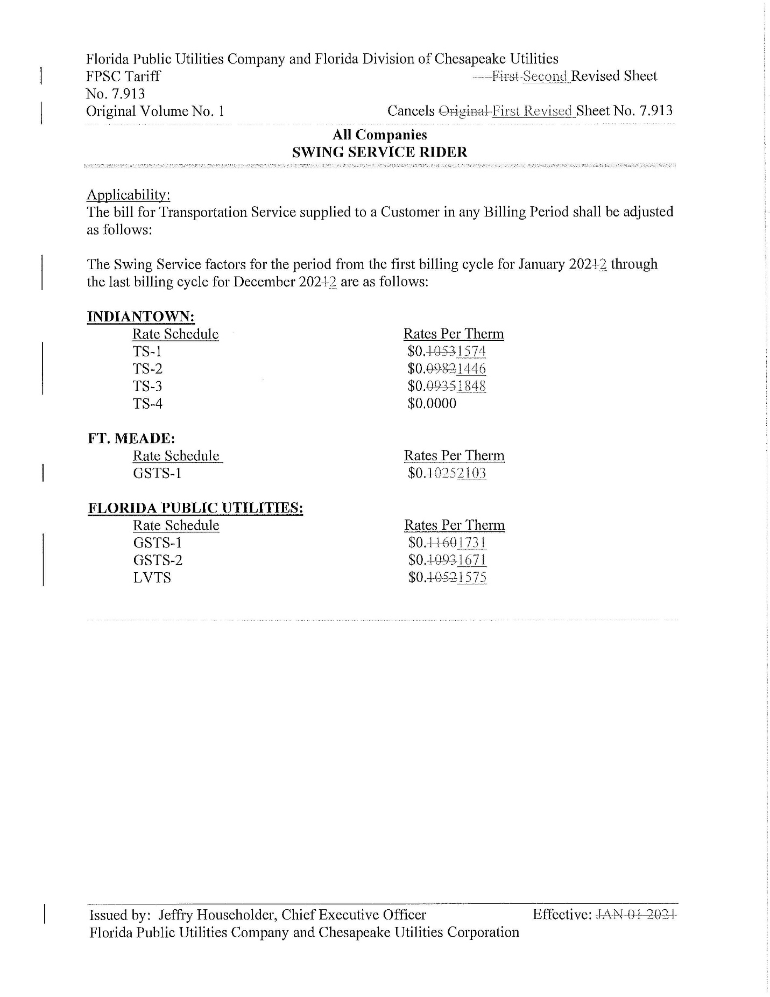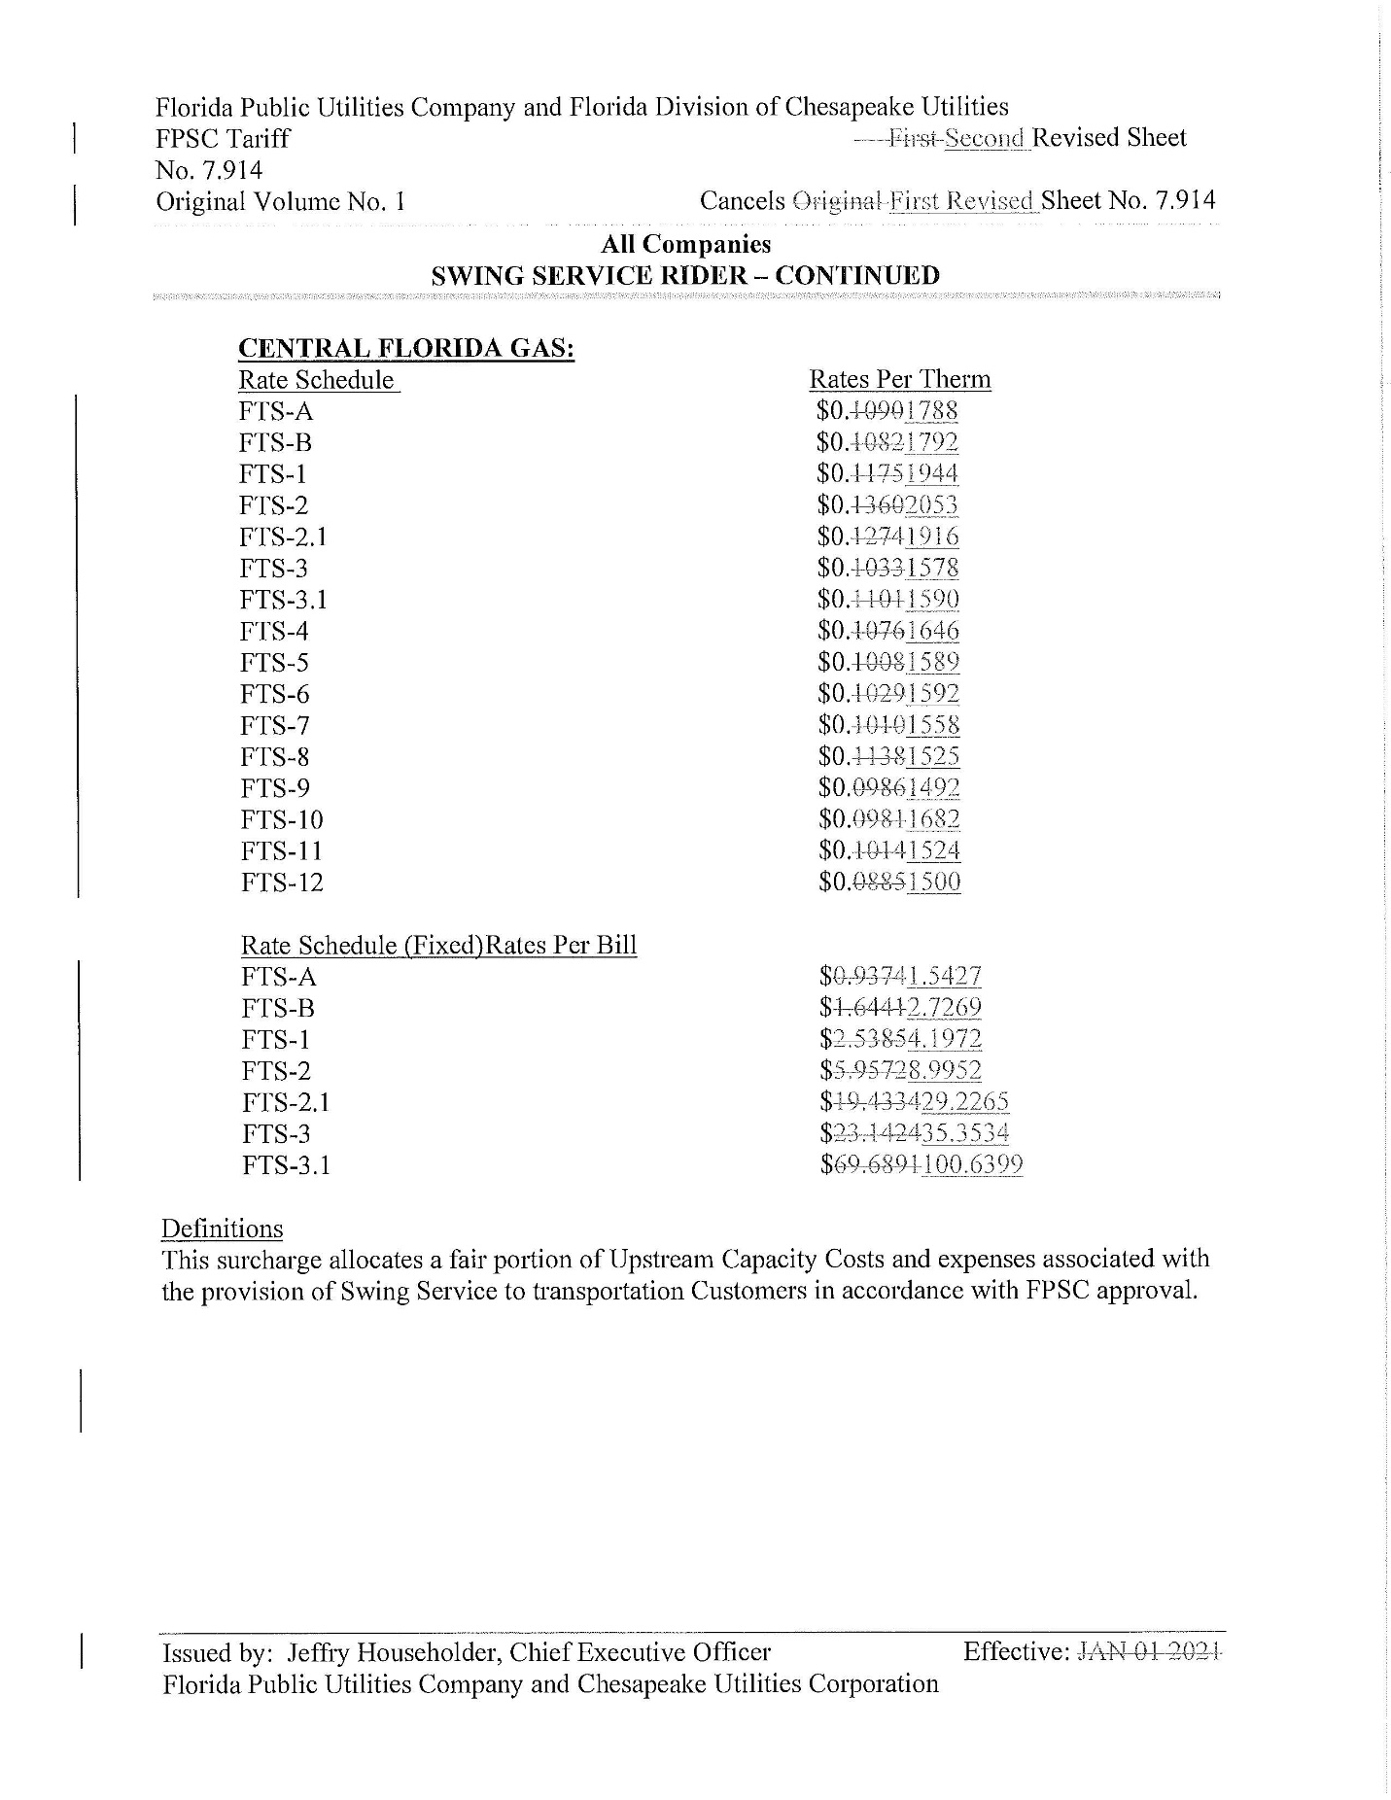

Order No. PSC-16-0422-TRF-GU, issued October 3, 2016, in Docket No. 160085-GU, In re: Joint petition for approval of swing service rider, by Florida Public Utilities Company, Florida Public Utilities Company-Indiantown Division, Florida Public Utilities Company-Fort Meade, and Florida Division of Chesapeake Utilities Corporation.
Order No. PSC-2020-0452-TRF-GU, issued November 23, 2020, Docket No. 20200203-GU, In re: Joint petition for approval of swing service rider rates for January through December 2021, by Florida Public Utilities Company, Florida Public Utilities Company-Indiantown Division, Florida Public Utilities Company-Fort Meade, and Florida Division of Chesapeake Utilities Corporation.
The PGA charge is set by the Commission in the annual PGA cost recovery clause proceeding.
The Commission does not regulate the shippers or their charges for the gas commodity.
See direct testimony of Derrick M. Craig on behalf of FPUC, filed on August 6, 2021, Document No. 08901-2021, in Docket No. 20210003-GU, Exhibit No. DMC-2, Schedule E-1, line 8 on Page 1 of 6 and direct testimony of Derrick M. Craig, page 6 lines 3-5, filed on August 31, 2021, Document No. 09957-2021, in Docket No. 20210147-GU.
Amendatory Order No. PSC-2021-0266A-S-PU, issued August 26, 2021, in Docket No. 20200194-PU, In re: Petition for approval of regulatory assets to record costs incurred due to COVID-19, by Florida Public Utilities Company, Florida Public Utilities Company – Indiantown Division, Florida Public Utilities Company - Fort Meade, Florida Division of Chesapeake Utilities Corporation.
Exhibit A in Document No. 07608-2021, filed July 8, 2021, in Docket No. 20200194-PU.
Order No. PSC-2021-0148-TRF-GU, issued April 22, 2021, in Docket No. 20200214-GU, In re: Joint petition of Florida Public Utilities Company, Florida Public Utilities Company-Indiantown Division, Florida Public Utilities Company-Fort Meade, and the Florida Division of Chesapeake Utilities Corporation for approval of consolidation of tariffs, for modifications to retail choice transportation service programs, and to change the MACC for Florida Public Utilities Company.
Document No. 12219-2021.

