State of Florida |  | Public Service Commission  Capital Circle Office Center ● 2540 Shumard Oak Boulevard  Tallahassee, Florida 32399-0850  -M-E-M-O-R-A-N-D-U-M-
DATE: | October 21, 2021
TO: | Office of Commission Clerk (Teitzman)
FROM: | Division of Economics (Ward, Coston)  Office of the General Counsel (Osborn)
RE: | Docket No. 20210148-GU – Petition for approval of 2020 true-up, projected 2021 true-up, and 2022 revenue requirements and surcharges associated with cast iron/bare steel replacement rider, by Peoples Gas System.
AGENDA: | 11/02/21 – Regular Agenda – Tariff Filing – Interested Persons May Participate
COMMISSIONERS ASSIGNED: |  |  | All Commissioners
PREHEARING OFFICER: |  |  | Administrative
CRITICAL DATES: |  |  | 5/1/22 (8-Month Effective Date); 60-Day Suspension waived by the utility
SPECIAL INSTRUCTIONS: |  |  | None

Case Background
On September 1, 2021, Peoples Gas System (Peoples or utility) filed a petition for approval of its final 2020 true-up, projected 2021 true-up, and 2022 revenue requirement and surcharges associated with the cast iron/bare steel replacement rider (CI/BSR Rider or rider). The rider was originally approved in Order No. PSC-12-0476-TRF-GU (2012 order) to recover the cost of accelerating the replacement of cast iron and bare steel pipes through a surcharge on customers’ bills. In the 2012 order, the Commission found that “replacement of these types of pipelines is in the public interest to improve the safety of Florida's natural gas infrastructure, and reduce the possibility of loss of life and destruction of property should an incident occur." Peoples’ current surcharges were approved in Order No. PSC-2020-0507-TRF-GU (2020 order). In the 2020 order, the Commission also approved applying the rider surcharges to the Interruptible Service rate classes who had previously been excluded.
In Order No. PSC-17-0066-AS-GU the Commission approved a comprehensive settlement agreement between PGS and the Office of Public Counsel (OPC). The settlement agreement, in part, added problematic plastic pipe (PPP) installed in the company's distribution system to eligible replacements under the rider. PPP was manufactured before 1983 and has significant safety concerns. In certain areas, the PPP is interspersed with, or connected to, the cast iron/bare steel pipe that is being replaced under the rider. As provided for in the settlement agreement, PPP replacements are included in the calculation of the 2022 rider surcharges.
In its petition, Peoples waived the 60-day file-and-suspend provision of Section 366.06(3), Florida Statutes (F.S.). The Commission has jurisdiction over this matter pursuant to Sections 366.03, 366.04, 366.05, and 366.06, F.S.

Discussion of Issues

Issue 1:
Should the Commission approve Peoples’ proposed CI/BSR Rider surcharges for the period January through December 2022?

Recommendation:
Yes, the Commission should approve Peoples’ proposed CI/BSR Rider surcharges for the period January through December 2022. (Ward)

Staff Analysis:
The CI/BSR Rider charges have been in effect since January 2013. Rider PPP charges have been in effect since 2017. In 2021, Peoples’ cast iron and bare steel replacement activity focused in the areas of Miami, Tampa, St. Petersburg, Orlando, Eustis, Jacksonville, Daytona, Avon Park, and Ocala. In 2022, Peoples states it will focus on replacement projects in Miami, Tampa, St. Petersburg, Orlando, Eustis, Jacksonville, Daytona, Avon Park, and Ocala. The projected completion date for the CI/BSR replacement program is 2022 for mains and services. The replacement of PPP is expected to continue until 2028.
In Peoples’ 2020 rate case, the Commission approved a settlement agreement between Peoples and the parties to the docket. As part of this agreement, $23.6 million of the 2021 CI/BSR revenue requirement related to Peoples’ Rider CI/BSR investments made through December 31, 2020 ($200.7 million) was moved from recovery through the CI/BSR Rider to recovery through base rates, effective January 1, 2021. The agreement also required Peoples to record the difference between the actual December 31, 2020 Rider CI/BSR net book value and the $200.7 million as an adjustment to the January 1, 2021 Rider CI/BSR net book value. This adjustment is a reduction of $2.2 million ($198.5 million - $200.7 million) and is reflected in the 2021 calculations.
Attachment A to this recommendation contains tables which display the replacement progress and forecasts for CI/BSR Rider (Table 2) and for PPP (Table 3). Additionally, Peoples provided Table 1 which consolidates actual and projected CI/BSR and PPP miles replaced investment and revenue requirements for each year of the replacement program.

True-ups by Year
Peoples' calculation for the 2022 revenue requirement and surcharges includes a final true-up for 2020, an actual/estimated true-up for 2021, and projected costs for 2022. Pursuant to the 2012 order, the capital expenditures for 2017 through 2019 exclude the first $1 million of facility replacements each year because that amount is included in rate base. Peoples has included depreciation expense savings as discussed in the 2012 order; however, the utility has not identified any operations and maintenance savings.

Final True-up for 2020
Exhibit A of the petition shows that the revenues collected for 2020 were $17,991,960 compared to a revenue requirement of $19,175,814, resulting in an under-recovery of $1,183,854. The final 2019 under-recovery of $3,382,549, 2020 under-recovery of $1,183,854, and interest associated with any over- and under-recoveries, results in a final 2020 under-recovery of $4,581,212.

Actual/Estimated 2021 True-up
In Exhibit B of the petition, Peoples provided actual revenues for January through July and forecast revenues for August through December of 2021, totaling $5,501,540, compared to an actual/estimated revenue requirement of $1,263,467, resulting in an over-recovery of $4,238,073. The final 2020 under-recovery of $4,581,212, 2021 over-recovery of $4,238,073, and interest associated with any over- and under-recoveries, results in a total 2021 under-recovery of $344,870.

Projected 2022 Costs
Exhibit C of the petition shows Peoples projects investment or capital expenditures of $27,291,015 for the replacement of cast iron/bare steel infrastructure and PPP in 2022. As shown in Table 1 of Attachment A of the recommendation, this consists of the CI/BSR infrastructure investment of $6,866,249 and the PPP investment of $20,424,766. The return on investment (which includes federal income taxes, regulatory assessment fees, and bad debt), depreciation expense (less savings), and property tax expense associated with that investment are $5,051,475. After adding the total 2021 under-recovery of $344,870, the total 2022 revenue requirement is $5,396,345. Table 1-1 displays the 2022 revenue requirement calculation.
Table 1-1
2022 Revenue Requirement
2022 Projected Expenditures | $27,291,015
Return on Investment | $3,848,242
Depreciation Expense (less savings) | $653,667
Property Tax Expense | $549,565
2022 Revenue Requirement | $5,051,475
Plus 2021 Under-recovery | $344,870
Total 2022 Revenue Requirement | $5,396,345
Source: Page 1 of 3 in Exhibit C in petition (Docket No. 20210148-GU)

Proposed Surcharges
As established in the 2012 order, the total 2022 revenue requirement is allocated to rate classes using the same methodology that was used for the allocation of mains and services in the cost of service study used in Peoples' most recent rate case. After calculating the percentage of total plant costs attributed to each rate class, the respective percentages were multiplied by the 2022 revenue requirement resulting in the revenue requirement by rate class. Dividing each rate class's revenue requirement by projected therm sales provides the rider surcharge for each rate class.
If the Commission approves this recommendation, the proposed 2022 rider surcharge for residential customers is $.02014 per therm (compared to the current surcharge of $.02188). The 2022 monthly bill impact will be $.40 for a residential customer who uses 20 therms. The proposed tariff page provided in the petition is Attachment B to this recommendation.

Conclusion
Staff reviewed Peoples’ filings and supporting documentation and believes that the calculations are consistent with the methodology approved in the 2012 order and are reasonable and accurate. Therefore, staff recommends approval of Peoples’ proposed 2022 Rider CI/BSR surcharges to be effective for the period January through December 2022.

Issue 2:
Should this docket be closed?

Recommendation:
Yes. If Issue 1 is approved and a protest is filed within 21 days of the issuance of the order, the tariff should remain in effect, with any revenues held subject to refund, pending resolution of the protest. If no timely protest is filed, this docket should be closed upon the issuance of a consummating order. (Osborn)

Staff Analysis:
Yes. If Issue 1 is approved and a protest is filed within 21 days of the issuance of the order, the tariff should remain in effect, with any revenues held subject to refund, pending resolution of the protest. If no timely protest is filed, this docket should be closed upon the issuance of a consummating order.

Table 1
Peoples’ CI/BSR Replacement Program Progress
 | CI/BS Miles Replaced | PPP Miles Replaced | CI/BS Investment | PPP Investment | CI/BS Revenue Requirement | PPP Revenue Requirement
2017 | 51 |  | $17,588,366 | $2,915,802 | $6,868,302 | $74,021
2018 | 62 | 56 | $27,035,678 | $15,890,424 | $8,510,823 | $848,201
2019 | 52 | 42 | $35,821,371 | $17,425,589 | $11,075,229 | $2,706,161
2020 | 55 | 43 | $32,317,184 | $11,115,571 | $14,817,804 | $4,358,010
2021 (projected) | 34 | 50 | $22,276,649 | $15,615,604 | $1,424,567 | $(161,100)
2022 | 7 | 50 | $6,866,249 | $20,424,766 | $3,141,854 | $1,909,621
2023 |  | 50 |  | $18,167,124 | $3,596,461 | $3,969,687
2024 |  | 50 |  | $18,621,303 | $3,561,044 | $5,921,914
2025 |  | 50 |  | $19,086,835 | $3,512,324 | $7,897,652
2026 |  | 45 |  | $17,766,986 | $3,463,181 | $9,820,999
2027 |  | 45 |  | $18,047,796 | $3,414,026 | $11,661,302
2028 |  | 24 |  | $14,276,750 | $3,364,870 | $13,330,589
Source: Response to staff’s first data request.

Table 2
Peoples’ CI/BSR Replacement Progress
Year | Main Replacements |  |  |  |  | Service Replacements
 | Replaced Cast Iron (miles) | Replaced Bare Steel (miles) | Remaining Cast Iron at Year End (miles) | Remaining Bare Steel at Year End (miles) | Total Miles Remaining of CI/BS Mains | Replaced Number of Bare Steel Services | Total Number of Remaining Bare Steel Services
2012 |  |  | 100 | 354 | 454 |  | 14,978
2013 | 13 | 38 | 87 | 316 | 403 | 907 | 14,071
2014 | 2 | 18 | 85 | 298 | 383 | 7,964 | 6,107
2015 | 26 | 60 | 59 | 238 | 297 | 1,019 | 5,088
2016 | 15 | 35 | 44 | 203 | 247 | 1,050 | 6,963
2017 | 15 | 36 | 29 | 178 | 207 | 1,135 | 4,279
2018 | 10 | 52 | 18 | 126 | 144 | 1,970 | 2,309
2019 | 8 | 44 | 10 | 83 | 93 | 649 | 1,660
2020 | 4 | 51 | 6 | 35 | 41 | 423 | 1237
2021 | 4 | 30 | 2 | 5 | 7 | 800 | 437
2022 | 2 | 5 | 0 | 0 | 0 | 437 | 0
Source: Response to staff’s first data request.

Table 3
Peoples PPP Replacement Program Progress
 | PPP (miles) | Total Remaining PPP Mains (miles) | Replaced Number of PPP Services | Total Number of Remaining PPP Services
2016 | 0 | 551 | 0 | -
2017 | ** | 509 | 1,396 | 26,841
2018 | 56 | 461 | 3,941 | 24,741
2019 | 42 | 418 | 2,349 | 20,420
2020 | 43 | 370 | 2,046 | 18,374
2021 | 51 | 319 | Not Yet Determined** | -
2022 | 55 | 264 | Not Yet Determined** | -
2023 | 50 | 214 | Not Yet Determined** | -
2024 | 50 | 164 | Not Yet Determined** | -
2025 | 50 | 114 | Not Yet Determined** | -
2026 | 45 | 69 | Not Yet Determined** | -
2027 | 45 | 24 | Not Yet Determined** | -
2028 | 24 | 0 | Not Yet Determined** | -
Source: Response to staff’s first data request.

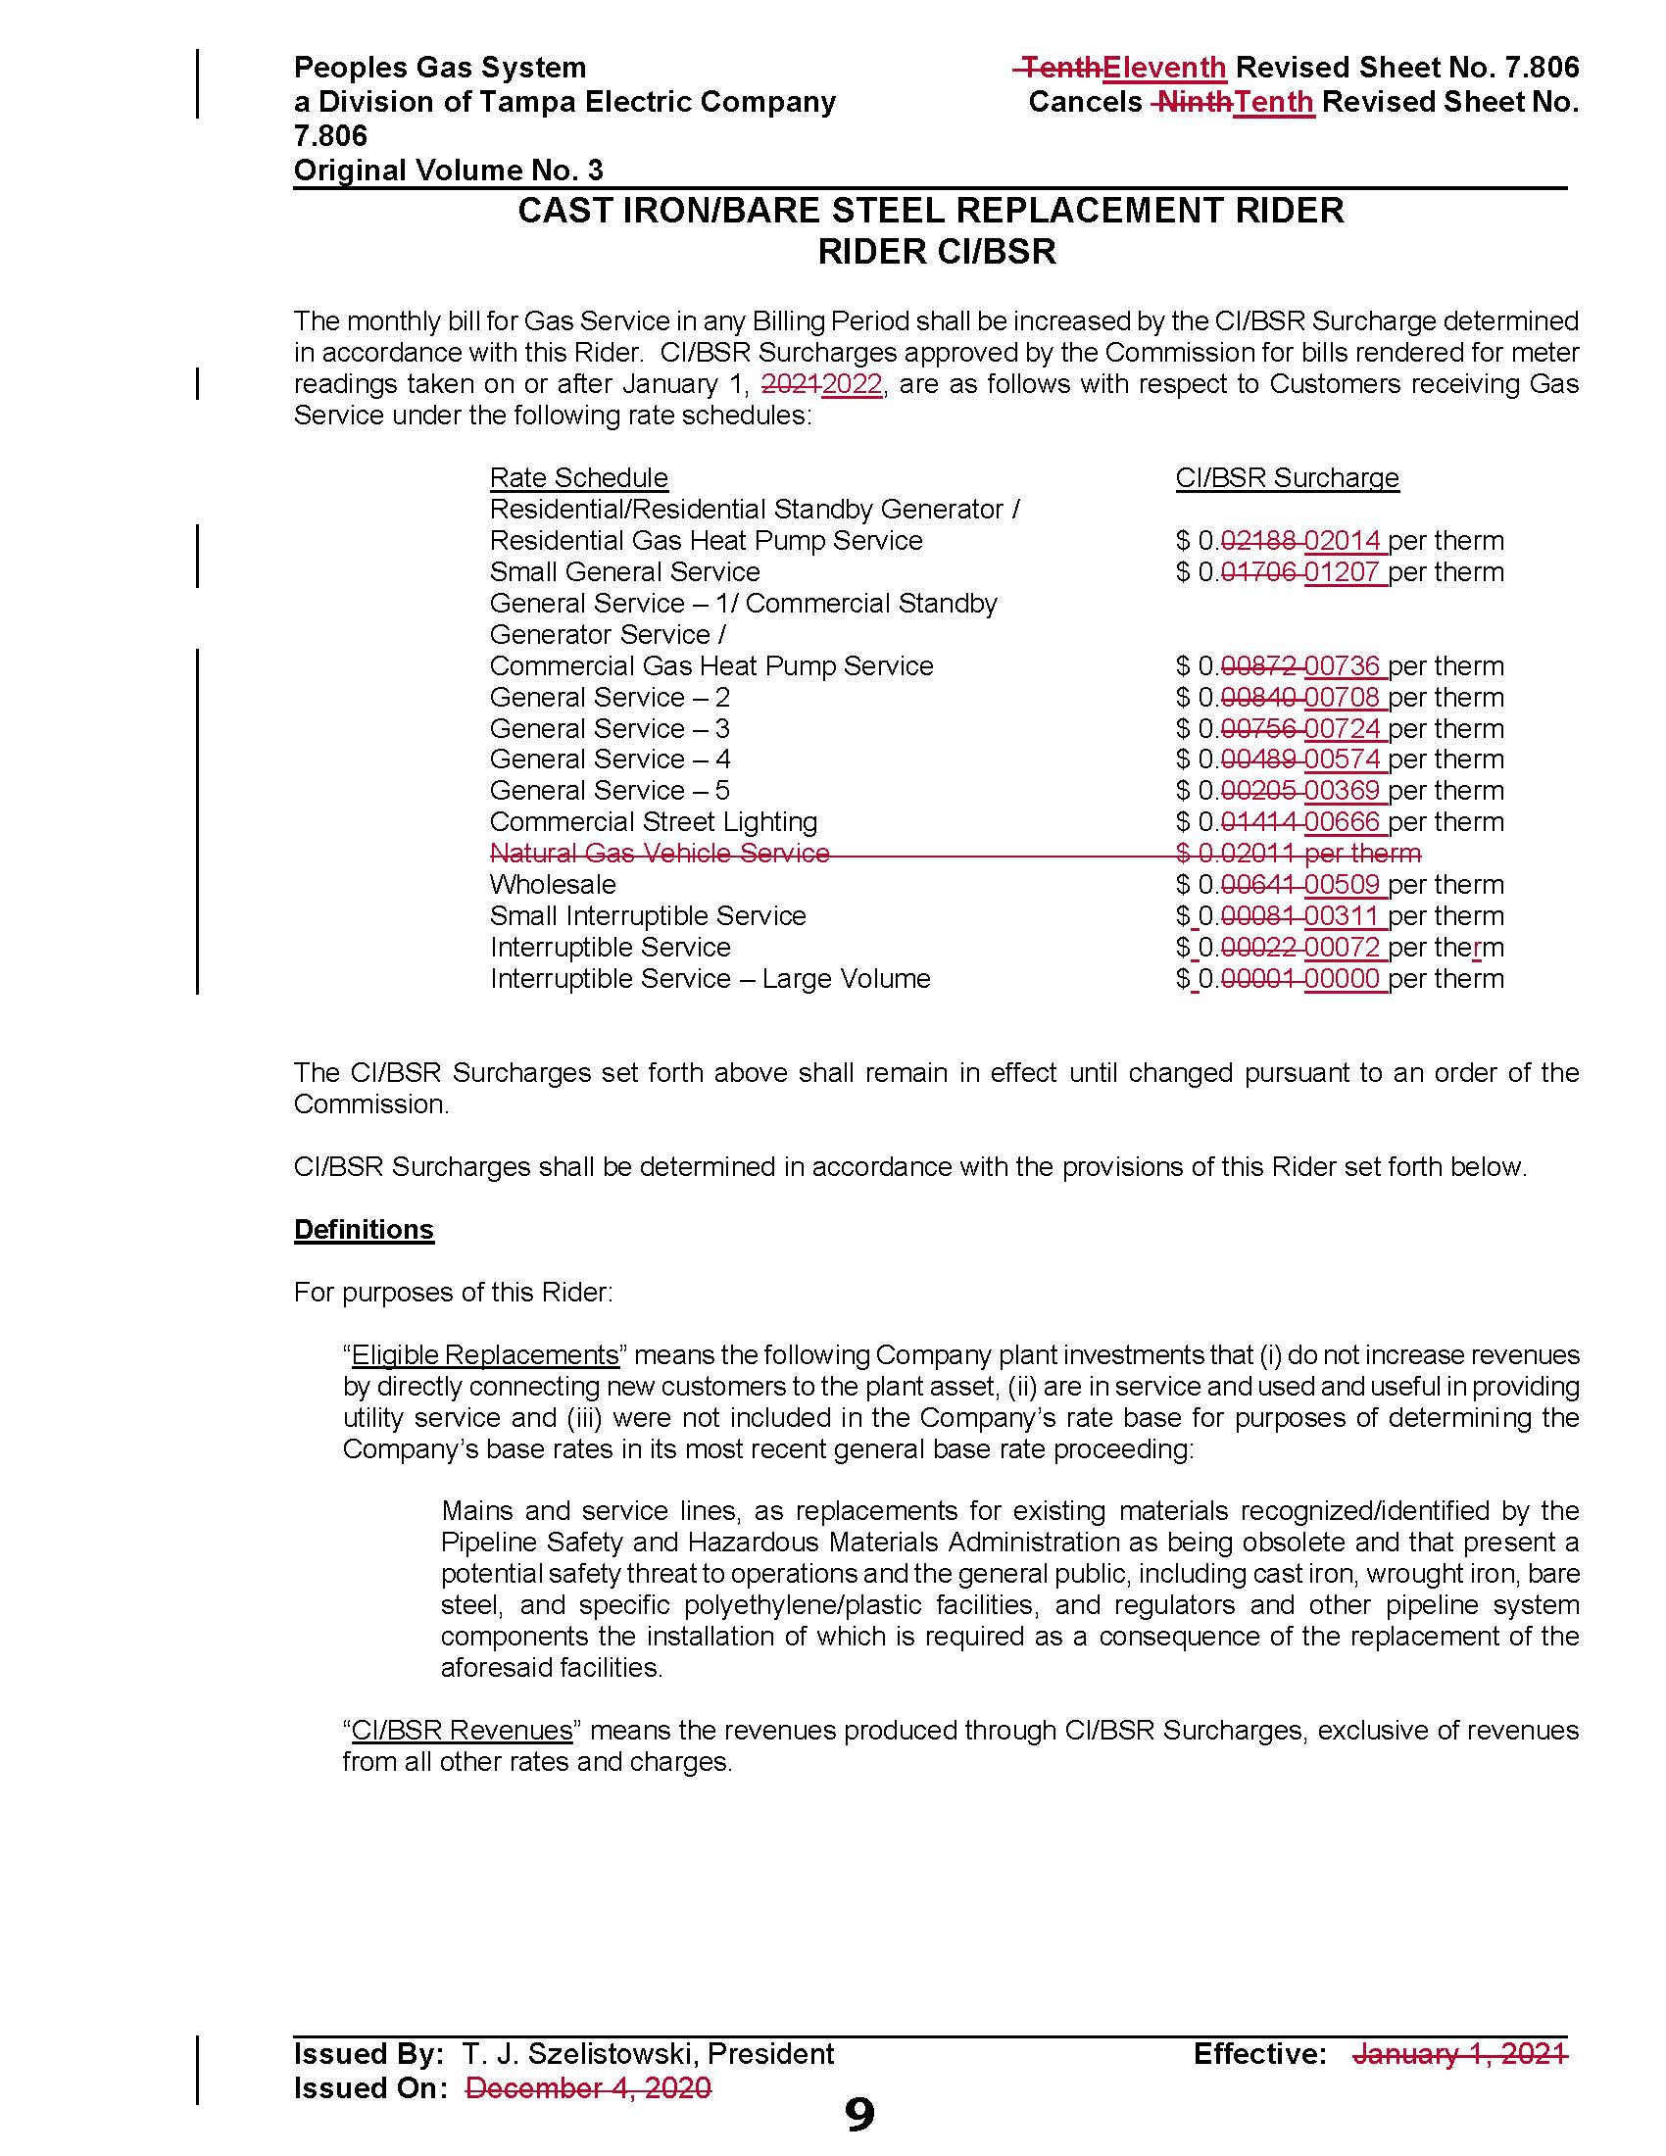

Order No. PSC-12-0476-TRF-GU, issued September 18, 2012, in Docket No. 20110320-GU, In re: Petition for approval of Cast Iron/Bare Steel Pipe Replacement Rider (Rider CI/BSR), by Peoples Gas System.
Order No. PSC-2020-0507-TRF-GU, issued December 18, 2020, in Docket No. 20200206-GU, In re: Petition for approval of 2019 true-up, projected 2020 true-up; and 2021 revenue requirements and surcharges associated with cast iron/bare steel pipe replacement rider, by Peoples Gas System.
Order No. PSC-17-0066-AS-GU, issued February 28, 2017, in Docket No. 20160159-GU, In re: Petition for approval of settlement agreement pertaining to Peoples Gas System’s 2016 depreciation study, environmental reserve account, problematic plastic pipe replacement, and authorized ROE.
Order No. PSC-2020-0485-FOF-GU, issued December 10, 2020, in Docket No. 20200051-GU, In re: Petition for rate increase by Peoples Gas System.

