BEFORE THE FLORIDA PUBLIC SERVICE COMMISSION

In re: Application for amendment of Certificate Nos. 677-W and 577-S to delete territory in Lake and Sumter Counties, by Gibson Place Utility Company, LLC. | DOCKET NO. 20210125-WS  ORDER NO. PSC-2022-0049-FOF-WS  ISSUED: January 31, 2022

The following Commissioners participated in the disposition of this matter:

ANDREW GILES FAY, Chairman
ART GRAHAM
GARY F. CLARK
MIKE LA ROSA
GABRIELLA PASSIDOMO

ORDER GRANTING GIBSON PLACE UTILITY COMPANY, LLC’S REQUEST TO DELETE TERRITORY FROM CERTIFICATE NOS. 677-W AND 577-S

BY THE COMMISSION:

Background
Gibson Place Utility Company, LLC (GPU or Utility) is a water and wastewater Utility in Lake and Sumter Counties. The Utility is in the Southwest Florida Management District (SWFWMD) and is not in a water use caution area. The Utility was granted its original certificates on November 24, 2020, and the Commission also approved the Utility’s request for partial waiver of Rule 25-30.033, Florida Administrative Code (F.A.C.), for rates to be set at a later date.
On July 27, 2021, pursuant to Section 367.045, Florida Statutes (F.S.), the Utility applied for an amendment to delete part of its service territory from Certificate Nos. 677-W and 577-S. The proposed territory to be deleted consists of two separate areas within the Utility’s certificated service territory that are currently undeveloped. Of the two areas, one will consist of high density commercial customers, while the other will have some commercial customers along with mostly multi-family residential units. The Utility is requesting these two areas be deleted because they will be developed after the remaining territory, which will consist of single family age-restricted housing units. Based on the Utility’s November 10, 2021 Status Report, GPU anticipates it will begin to serve customers within the remaining territory the first quarter of 2023 and plans to file the financial information to establish rates and charges as part of Docket No. 20200185-WS. The Commission has jurisdiction pursuant to Section 367.045, F.S.

Decision
On July 27, 2021, GPU applied for an amendment to delete portions of its certificated service territory. GPU has not completed the construction of its water and wastewater plants, nor its water distribution or wastewater collection systems in either the area to be deleted or the remaining original service territory. GPU is requesting to delete this territory because it will be developed at a different pace than the rest of the certificated service area.
The Utility’s application is compliant with the filing requirements set forth in Rule 25-30.036, F.A.C. Revised tariff sheets were not provided with the Utility’s application, as the Utility has been granted a temporary waiver of this Rule requirement pursuant to Order No. PSC-2020-0473-PAA-WS. In addition, the Utility provided proof of compliance with the noticing provisions set forth in Rule 25-30.030, F.A.C. No objections to the application have been received and the time for filing such has expired.
We hereby find it is in the public interest to approve the application filed by GPU to amend its water and wastewater certificates to delete the territory as shown in Attachment A. The resultant Order should serve as GPU’s amended certificate and should be retained by the Utility.

Based on the foregoing, it is

ORDERED by the Florida Public Service Commission that the application filed by Gibson Place Utility Company, LLC to delete part of its service territory from Certificate Nos. 677-W and 577-S shall be granted. It is further

ORDERED that this Order shall serve as Gibson Place Utility Company, LLC’s amended certificate and should be retained by the Utility. It is further

ORDERED that this docket shall be closed.

By ORDER of the Florida Public Service Commission this 31st day of January, 2022.

/s/ Adam J. Teitzman
ADAM J. TEITZMAN
Commission Clerk
Florida Public Service Commission
2540 Shumard Oak Boulevard
Tallahassee, Florida 32399
(850) 413-6770
www.floridapsc.com

Copies furnished: A copy of this document is provided to the parties of record at the time of issuance and, if applicable, interested persons.

RPS

NOTICE OF FURTHER PROCEEDINGS OR JUDICIAL REVIEW

The Florida Public Service Commission is required by Section 120.569(1), Florida Statutes, to notify parties of any administrative hearing or judicial review of Commission orders that is available under Sections 120.57 or 120.68, Florida Statutes, as well as the procedures and time limits that apply. This notice should not be construed to mean all requests for an administrative hearing or judicial review will be granted or result in the relief sought.

Any party adversely affected by the Commission's final action in this matter may request: 1) reconsideration of the decision by filing a motion for reconsideration with the Office of Commission Clerk, 2540 Shumard Oak Boulevard, Tallahassee, Florida 32399-0850, within fifteen (15) days of the issuance of this order in the form prescribed by Rule 25-22.060, Florida Administrative Code; or 2) judicial review by the Florida Supreme Court in the case of an electric, gas or telephone utility or the First District Court of Appeal in the case of a water and/or wastewater utility by filing a notice of appeal with the Office of Commission Clerk, and filing a copy of the notice of appeal and the filing fee with the appropriate court. This filing must be completed within thirty (30) days after the issuance of this order, pursuant to Rule 9.110, Florida Rules of Appellate Procedure. The notice of appeal must be in the form specified in Rule 9.900(a), Florida Rules of Appellate Procedure.

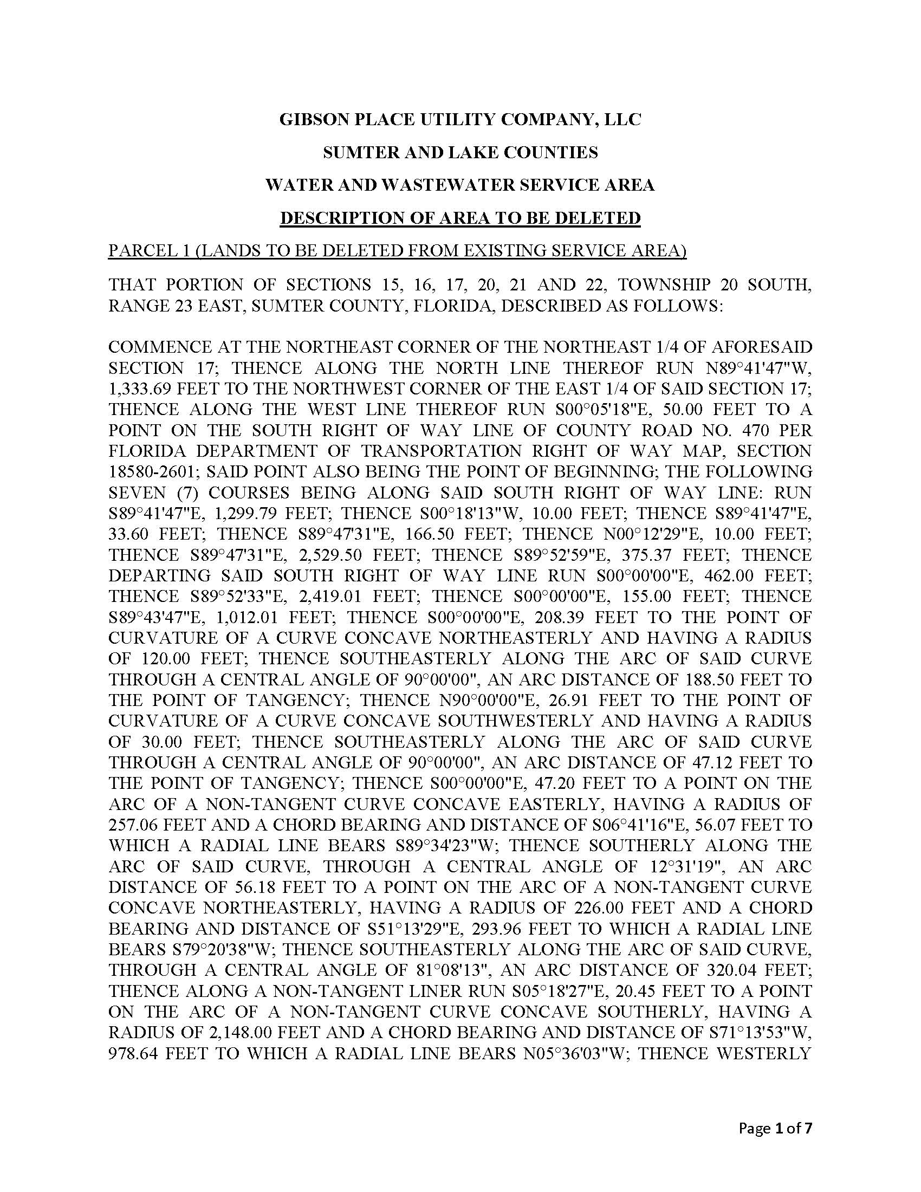
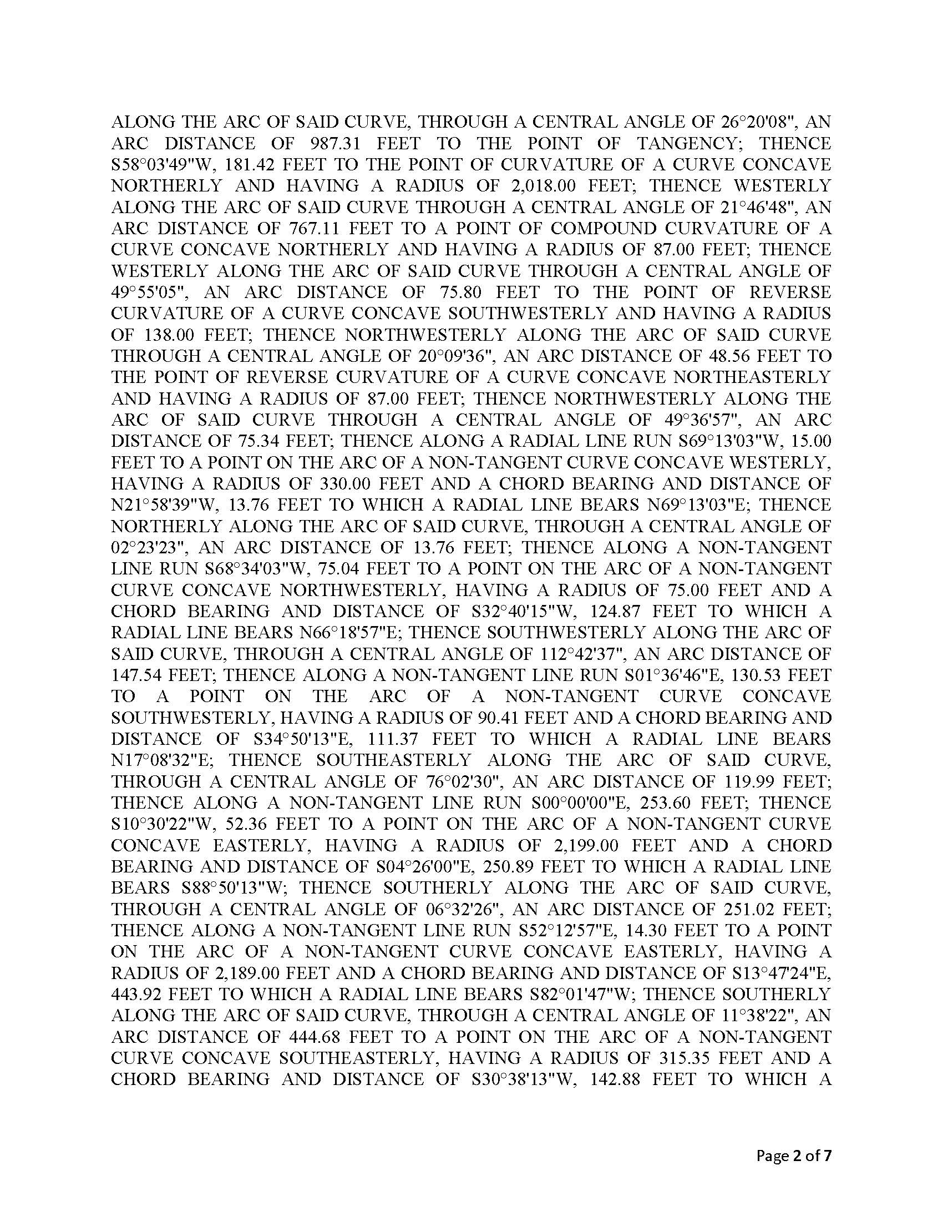
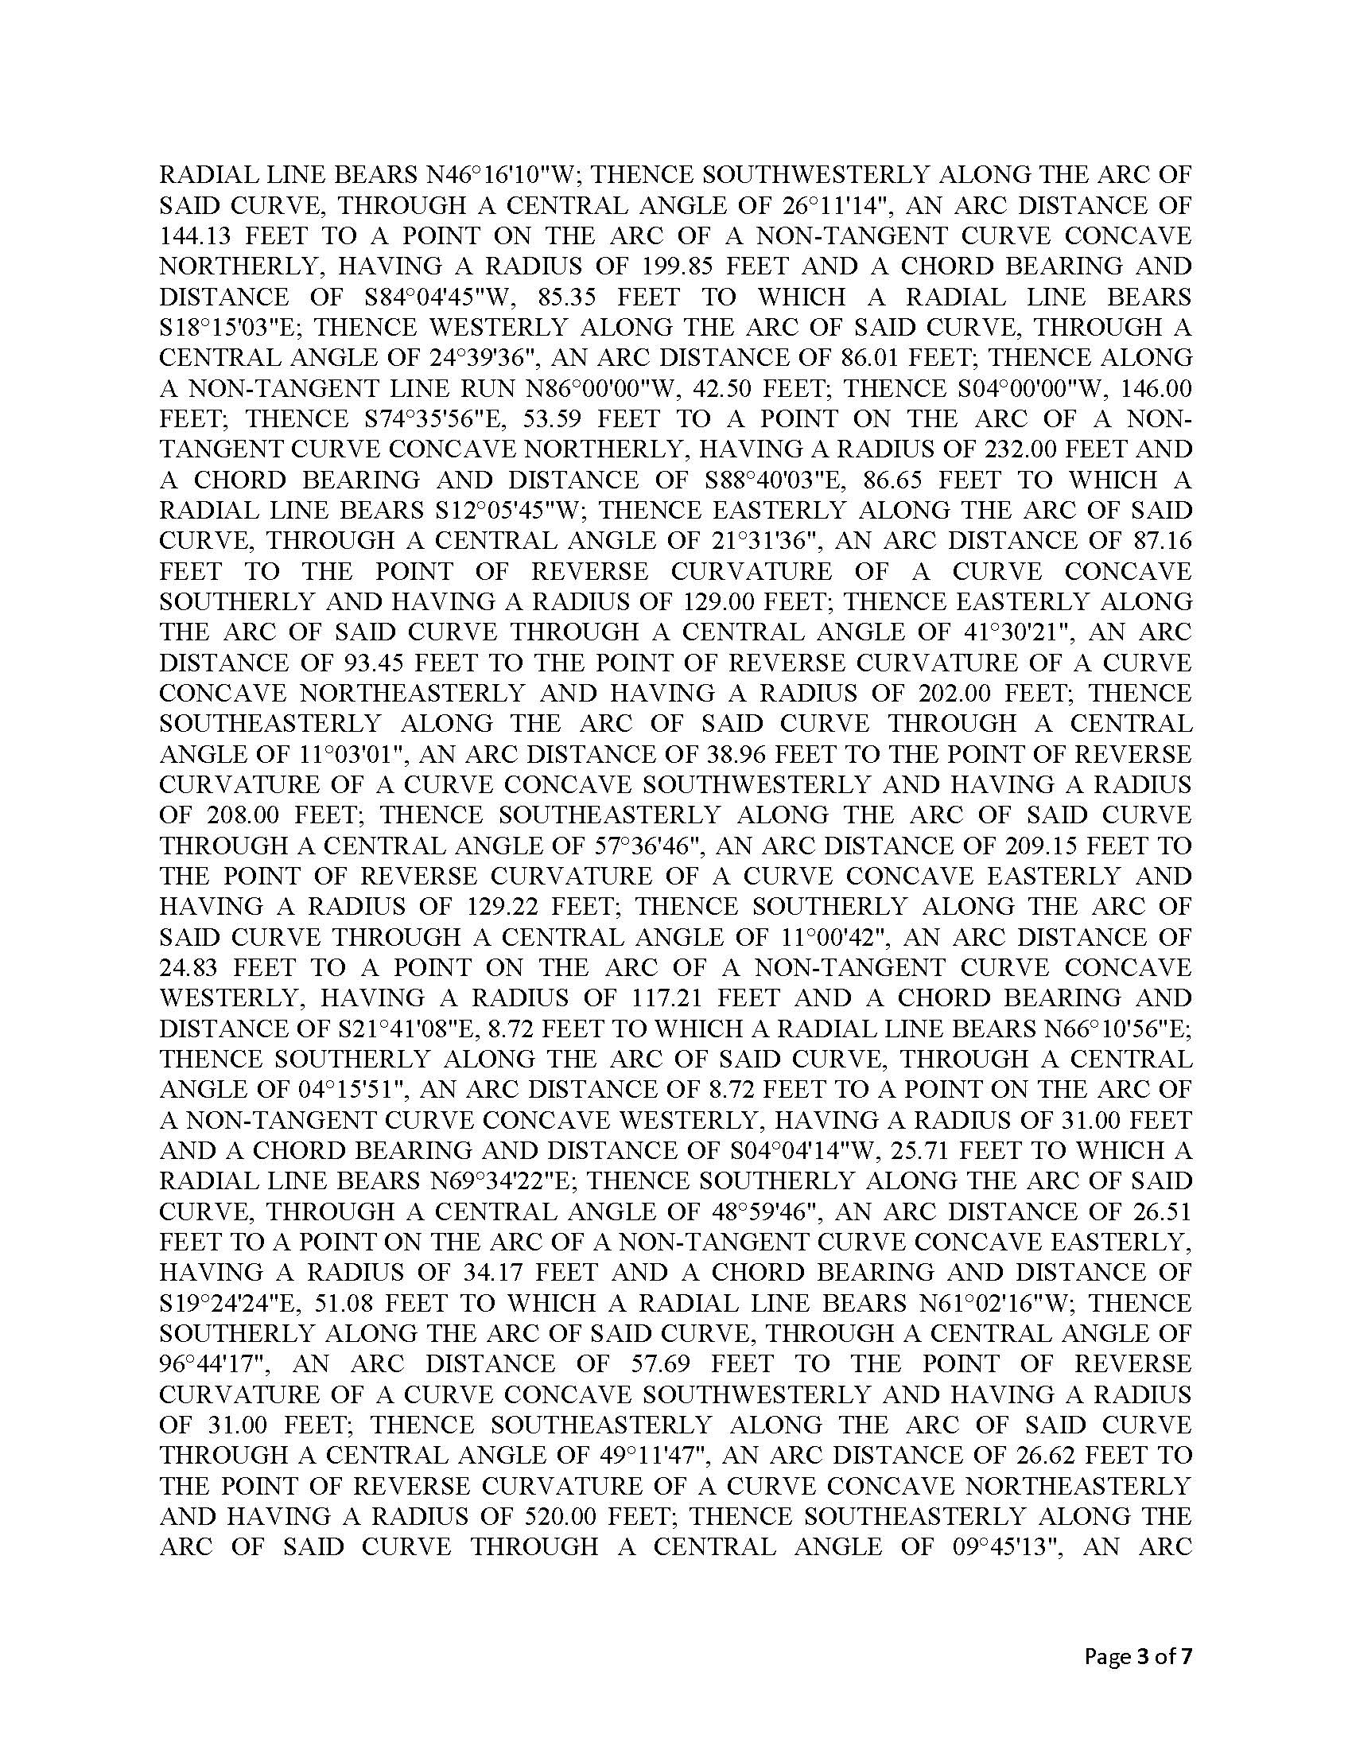
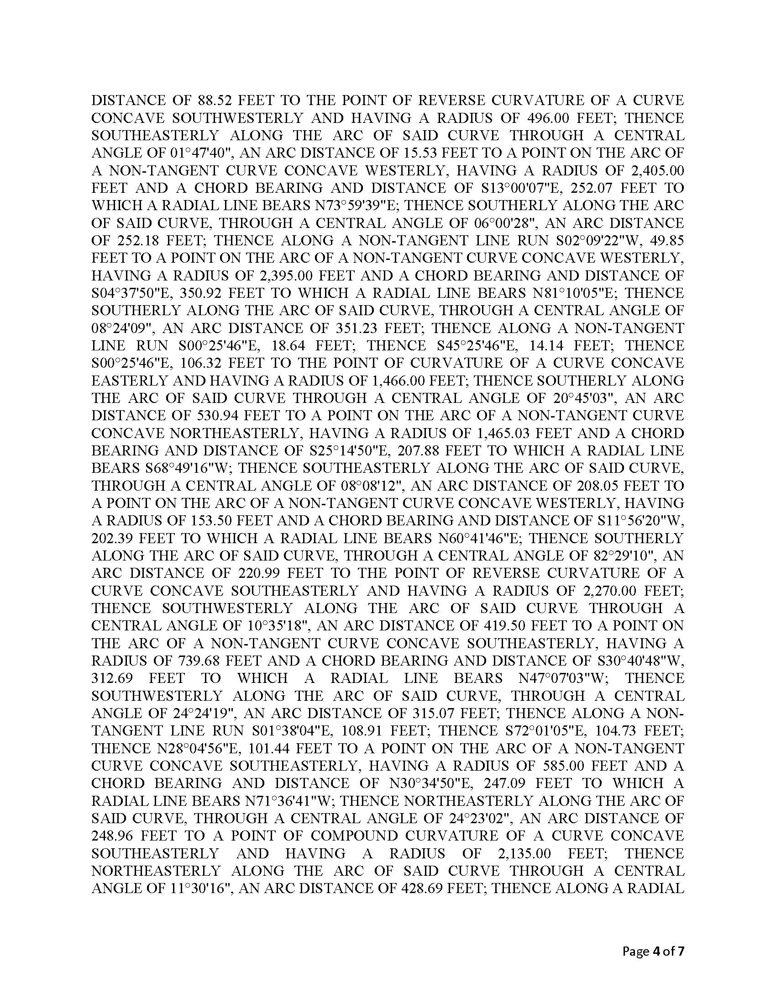
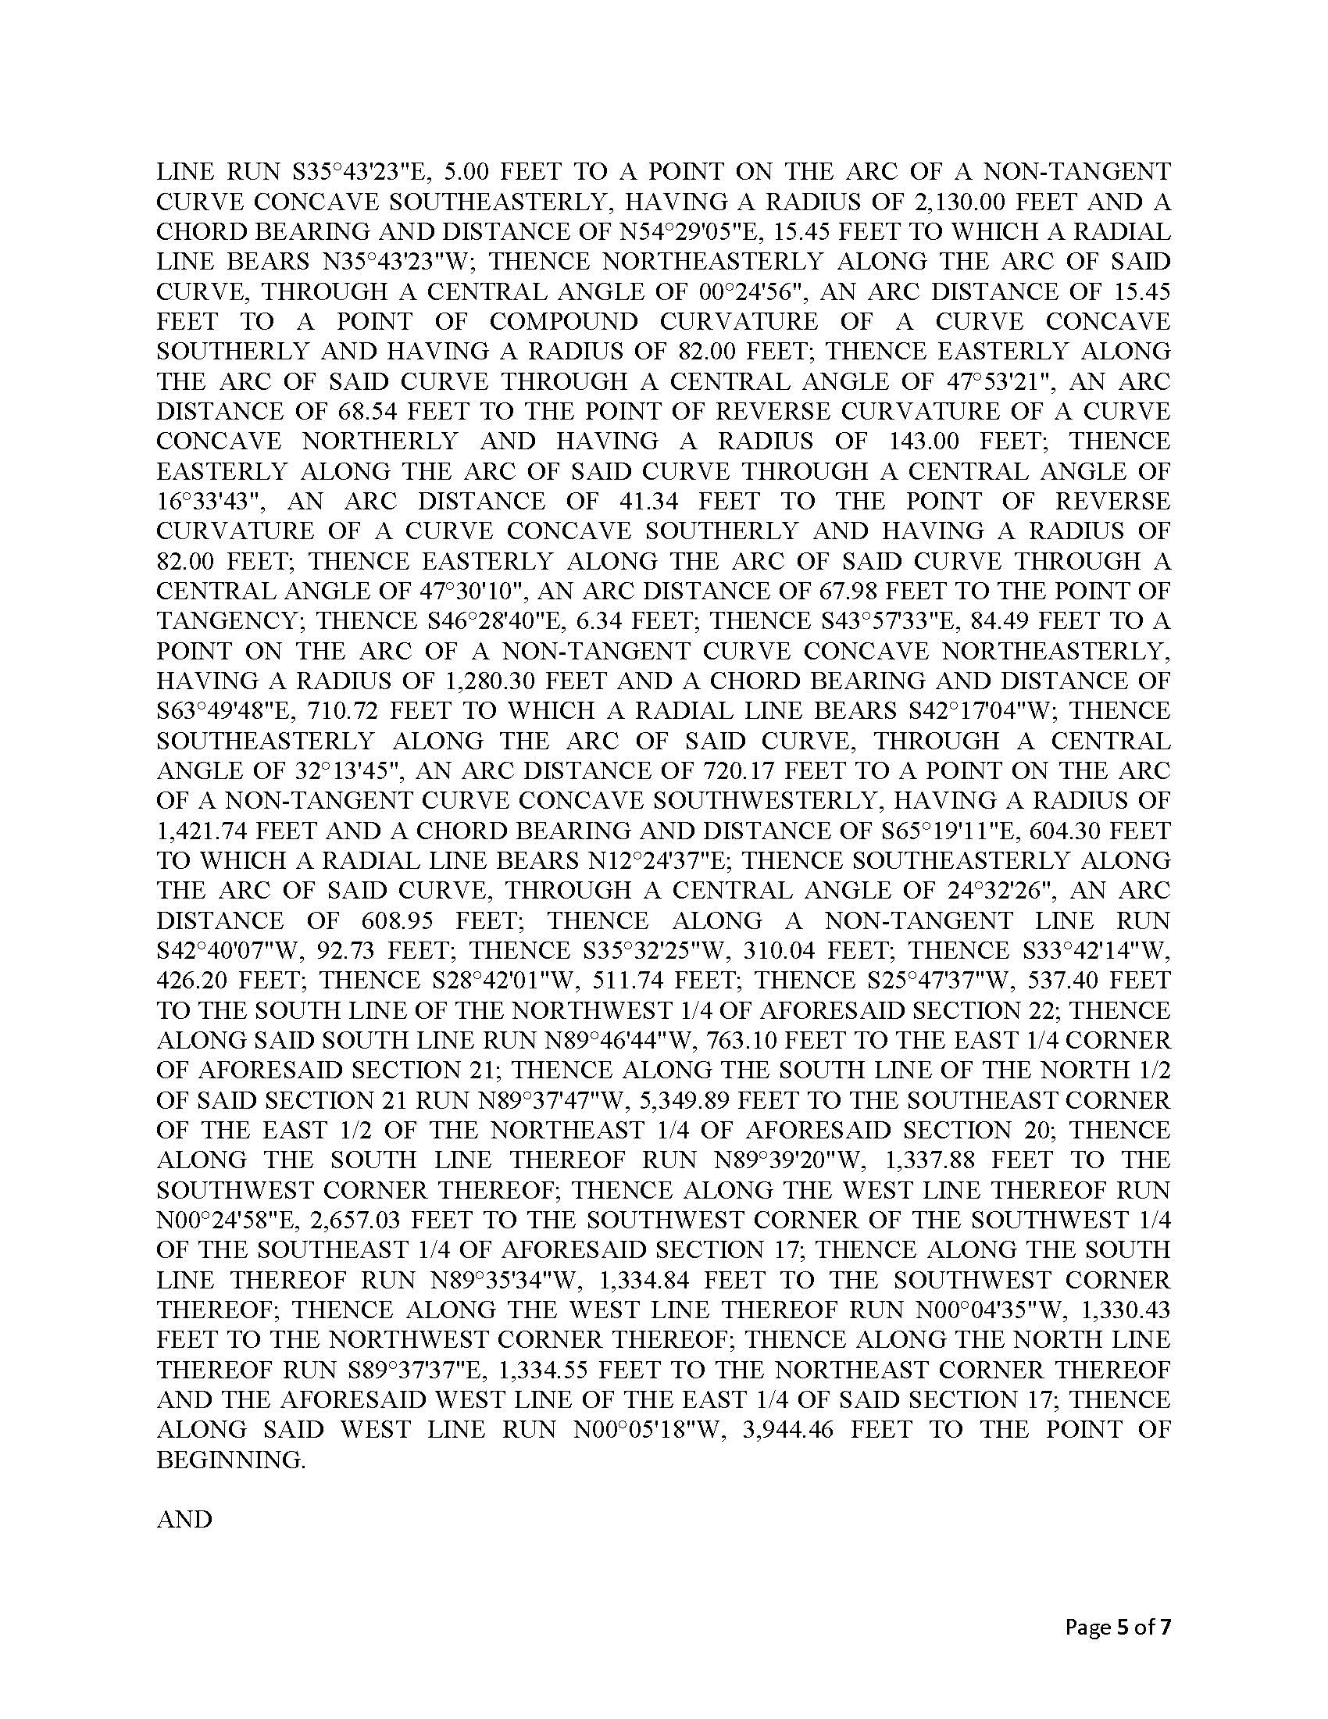
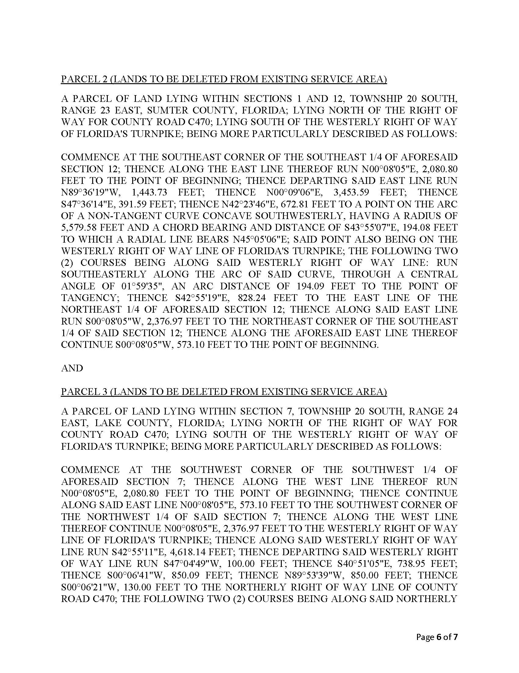
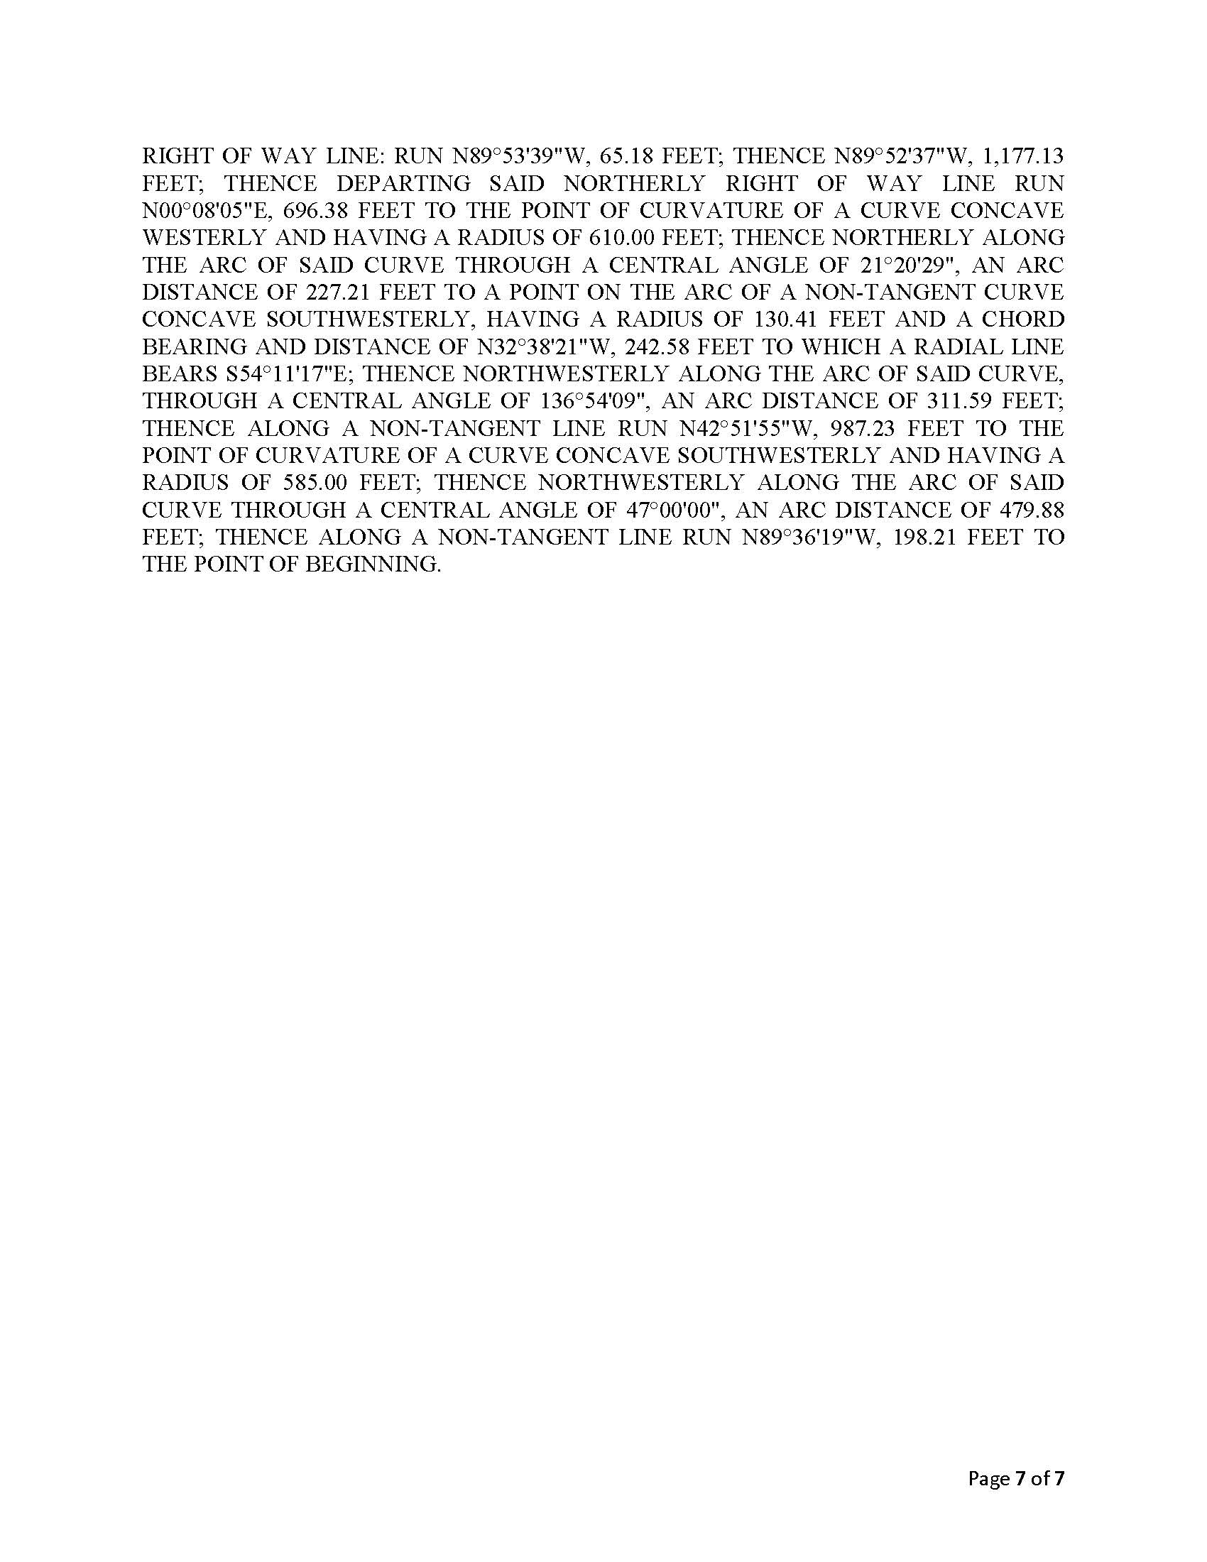
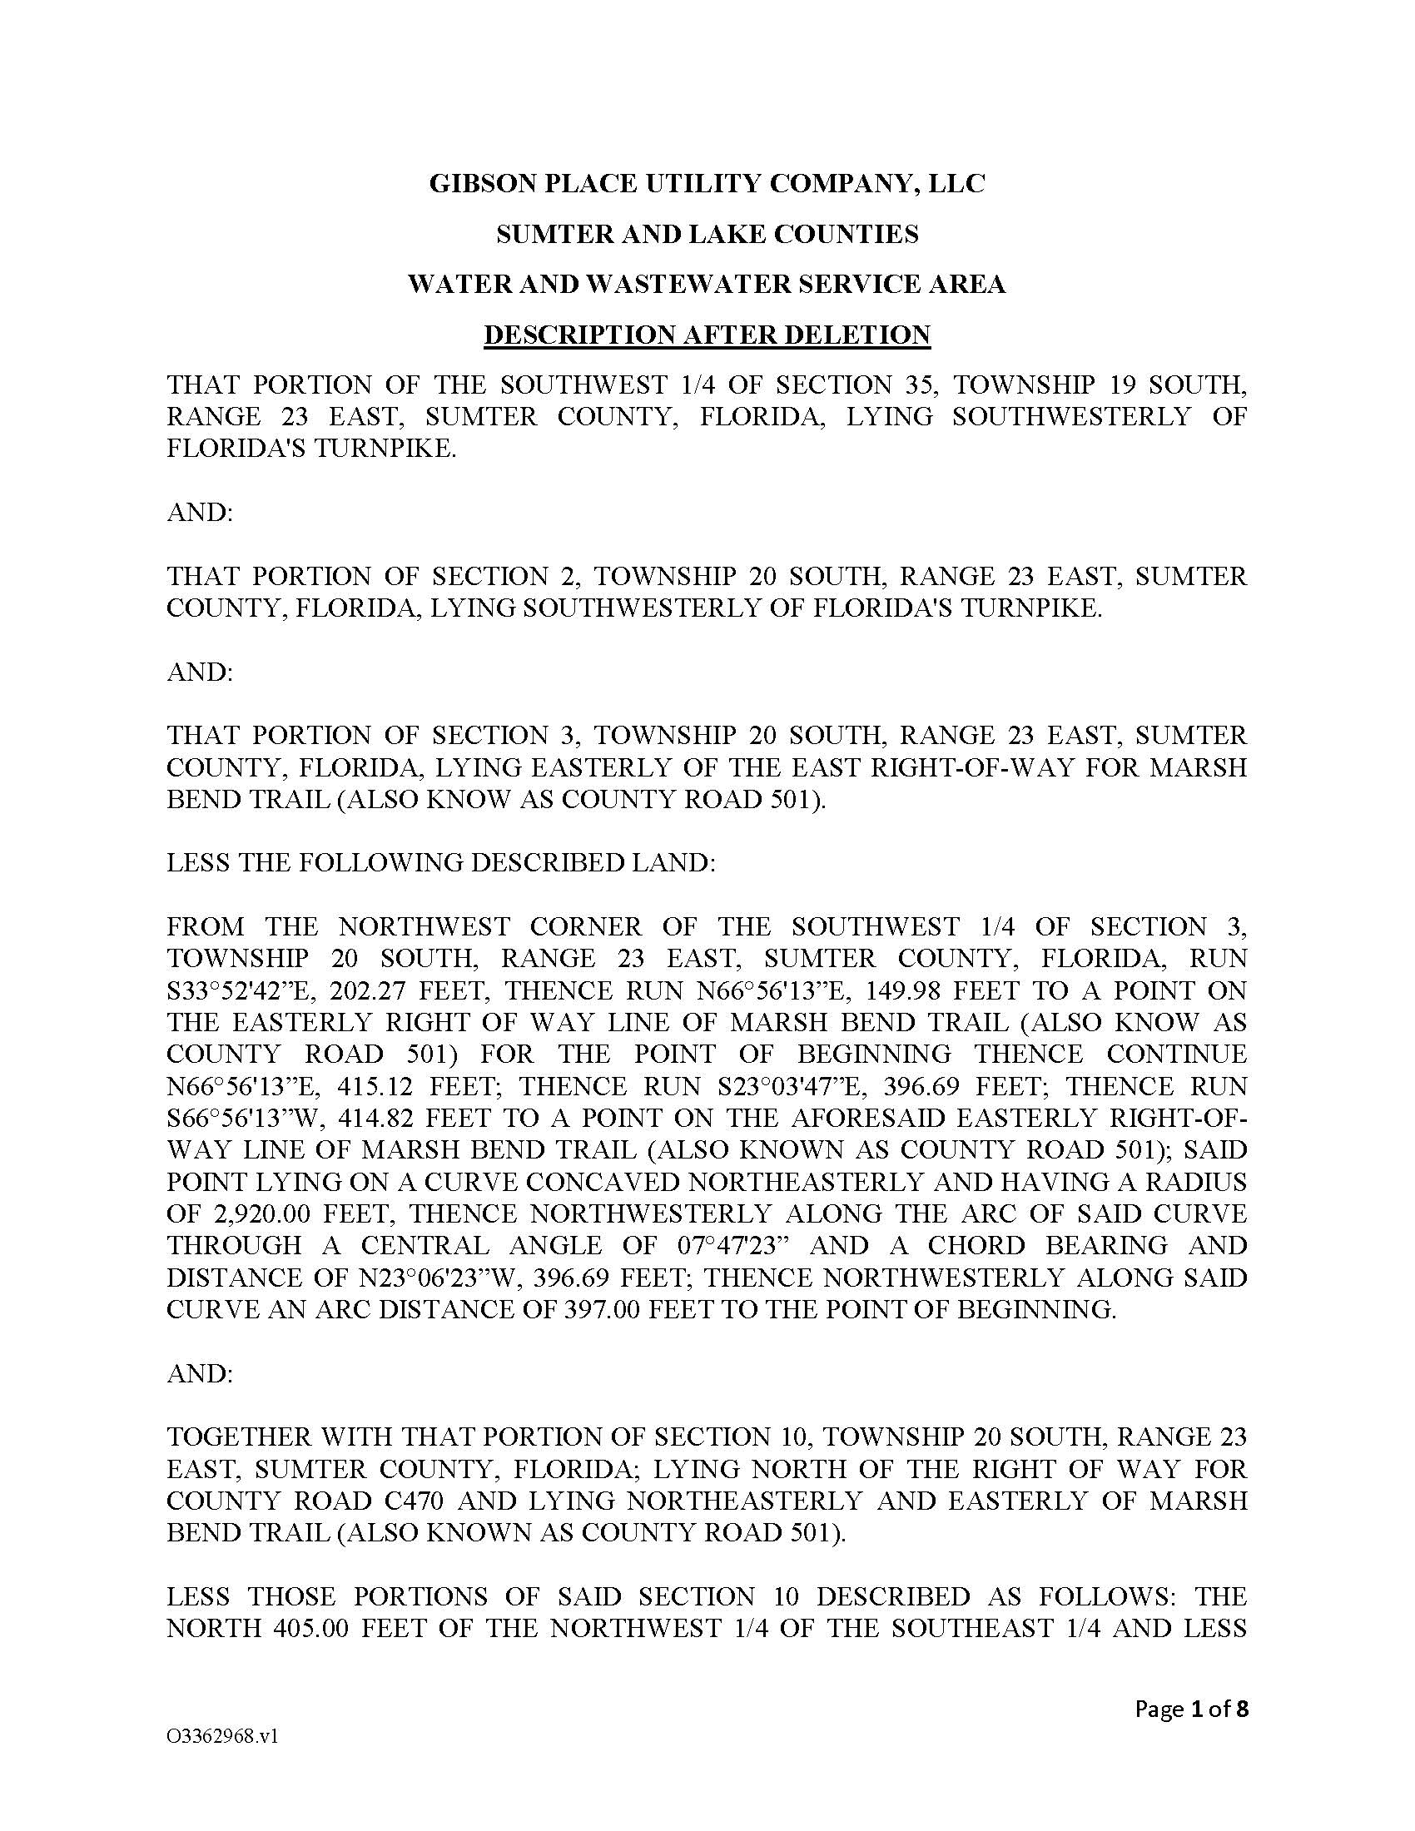
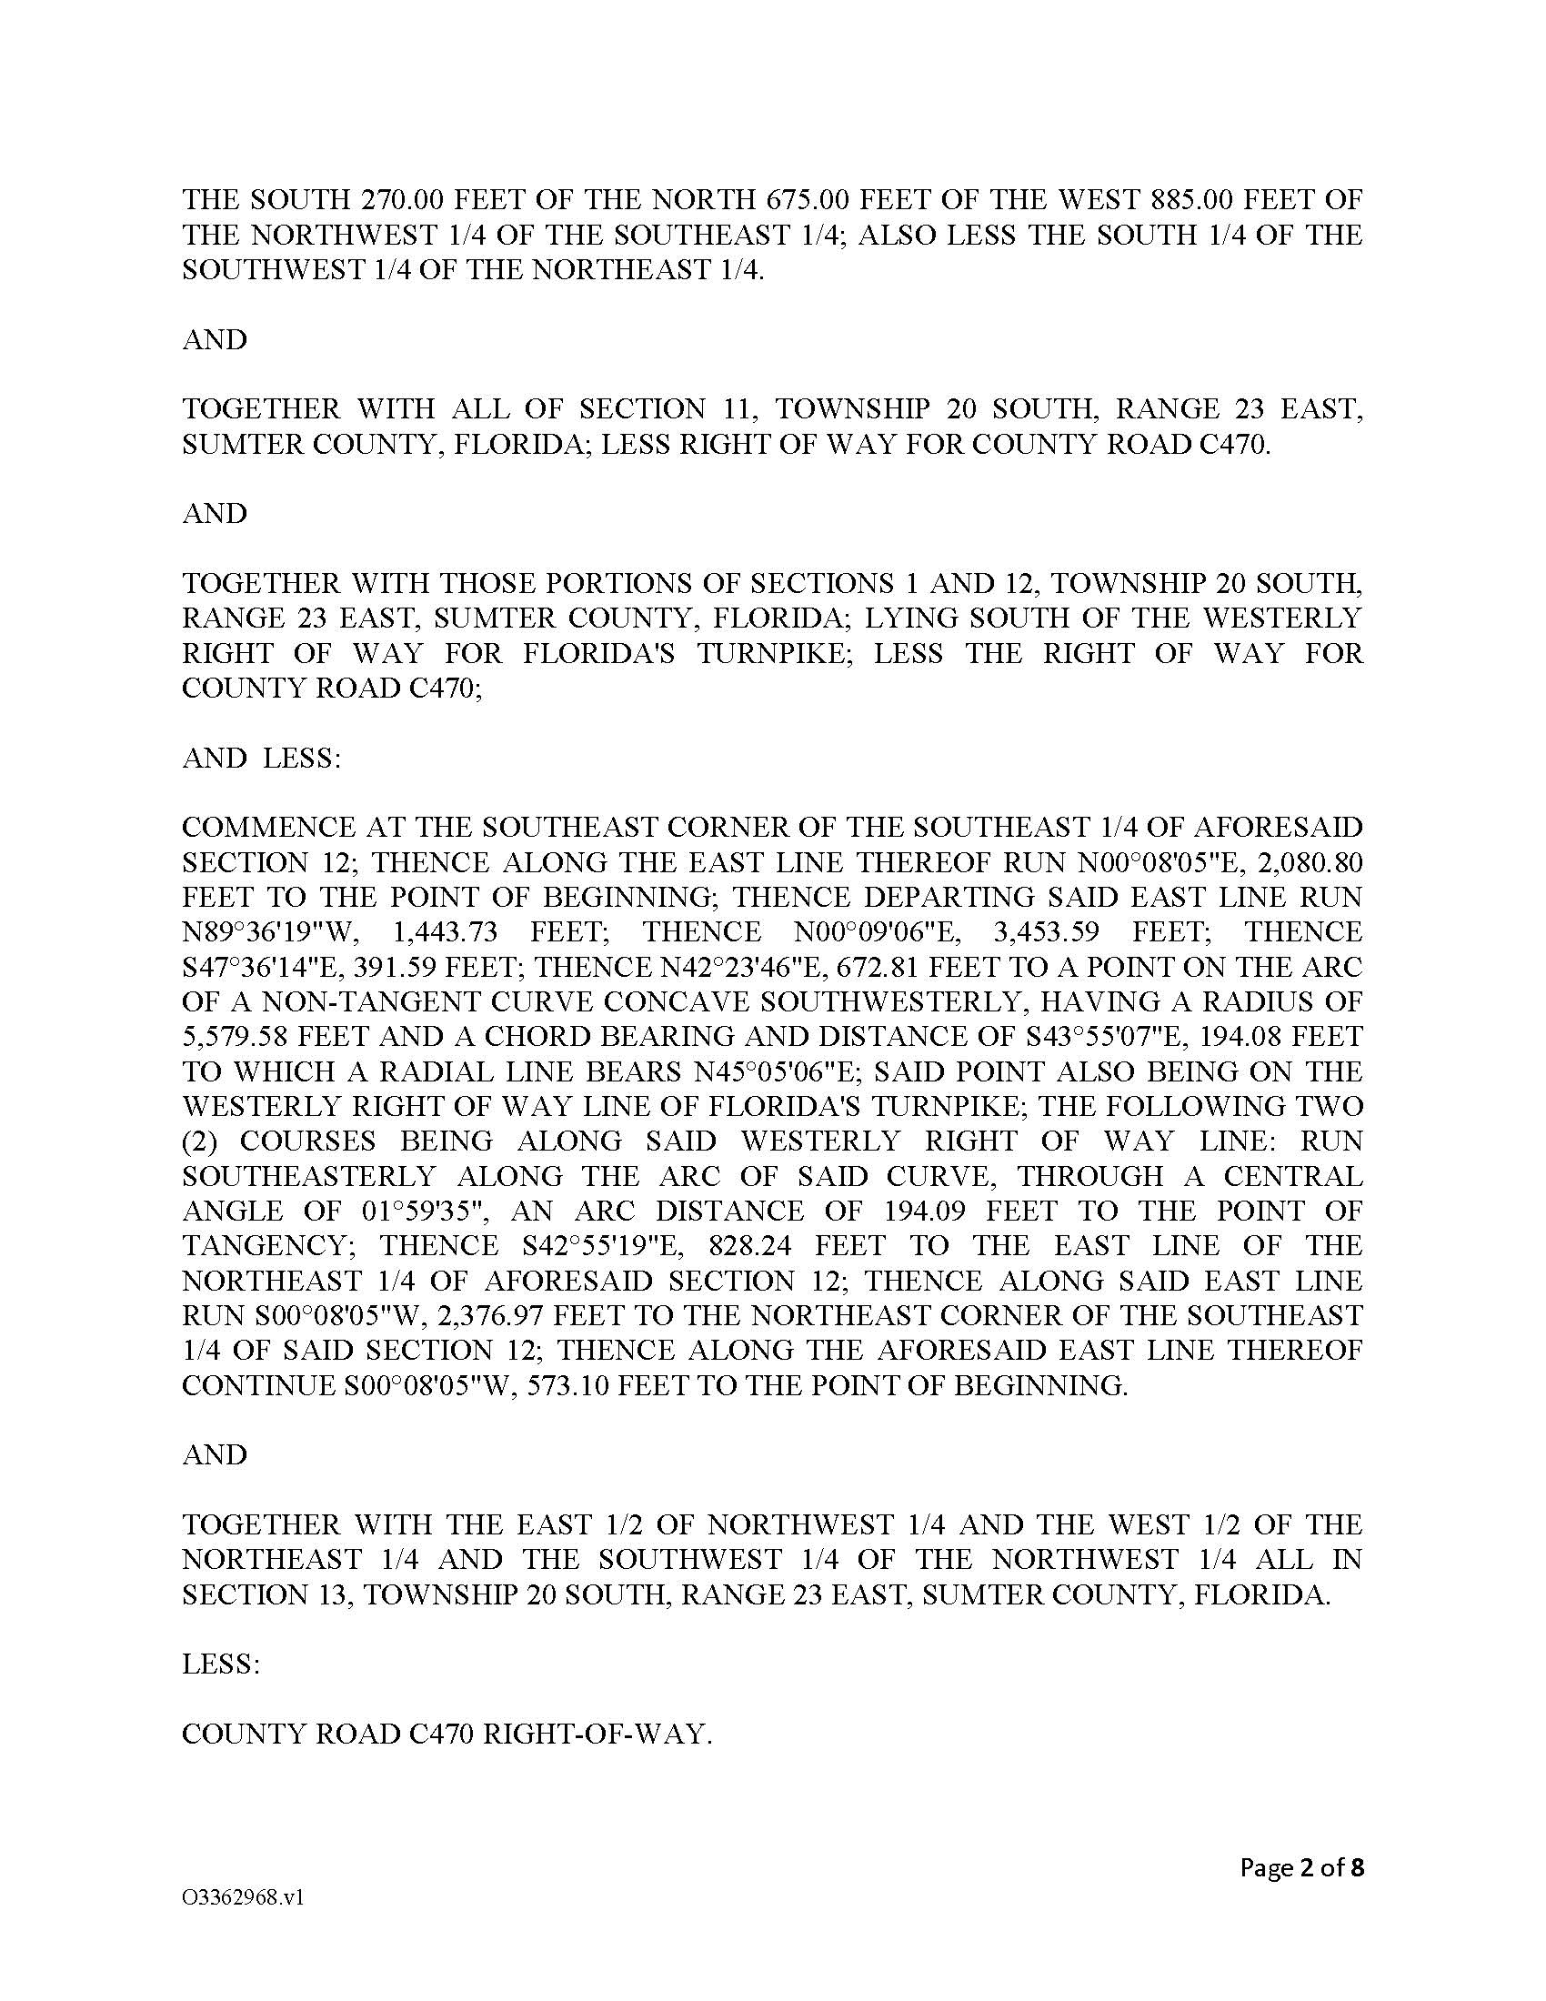
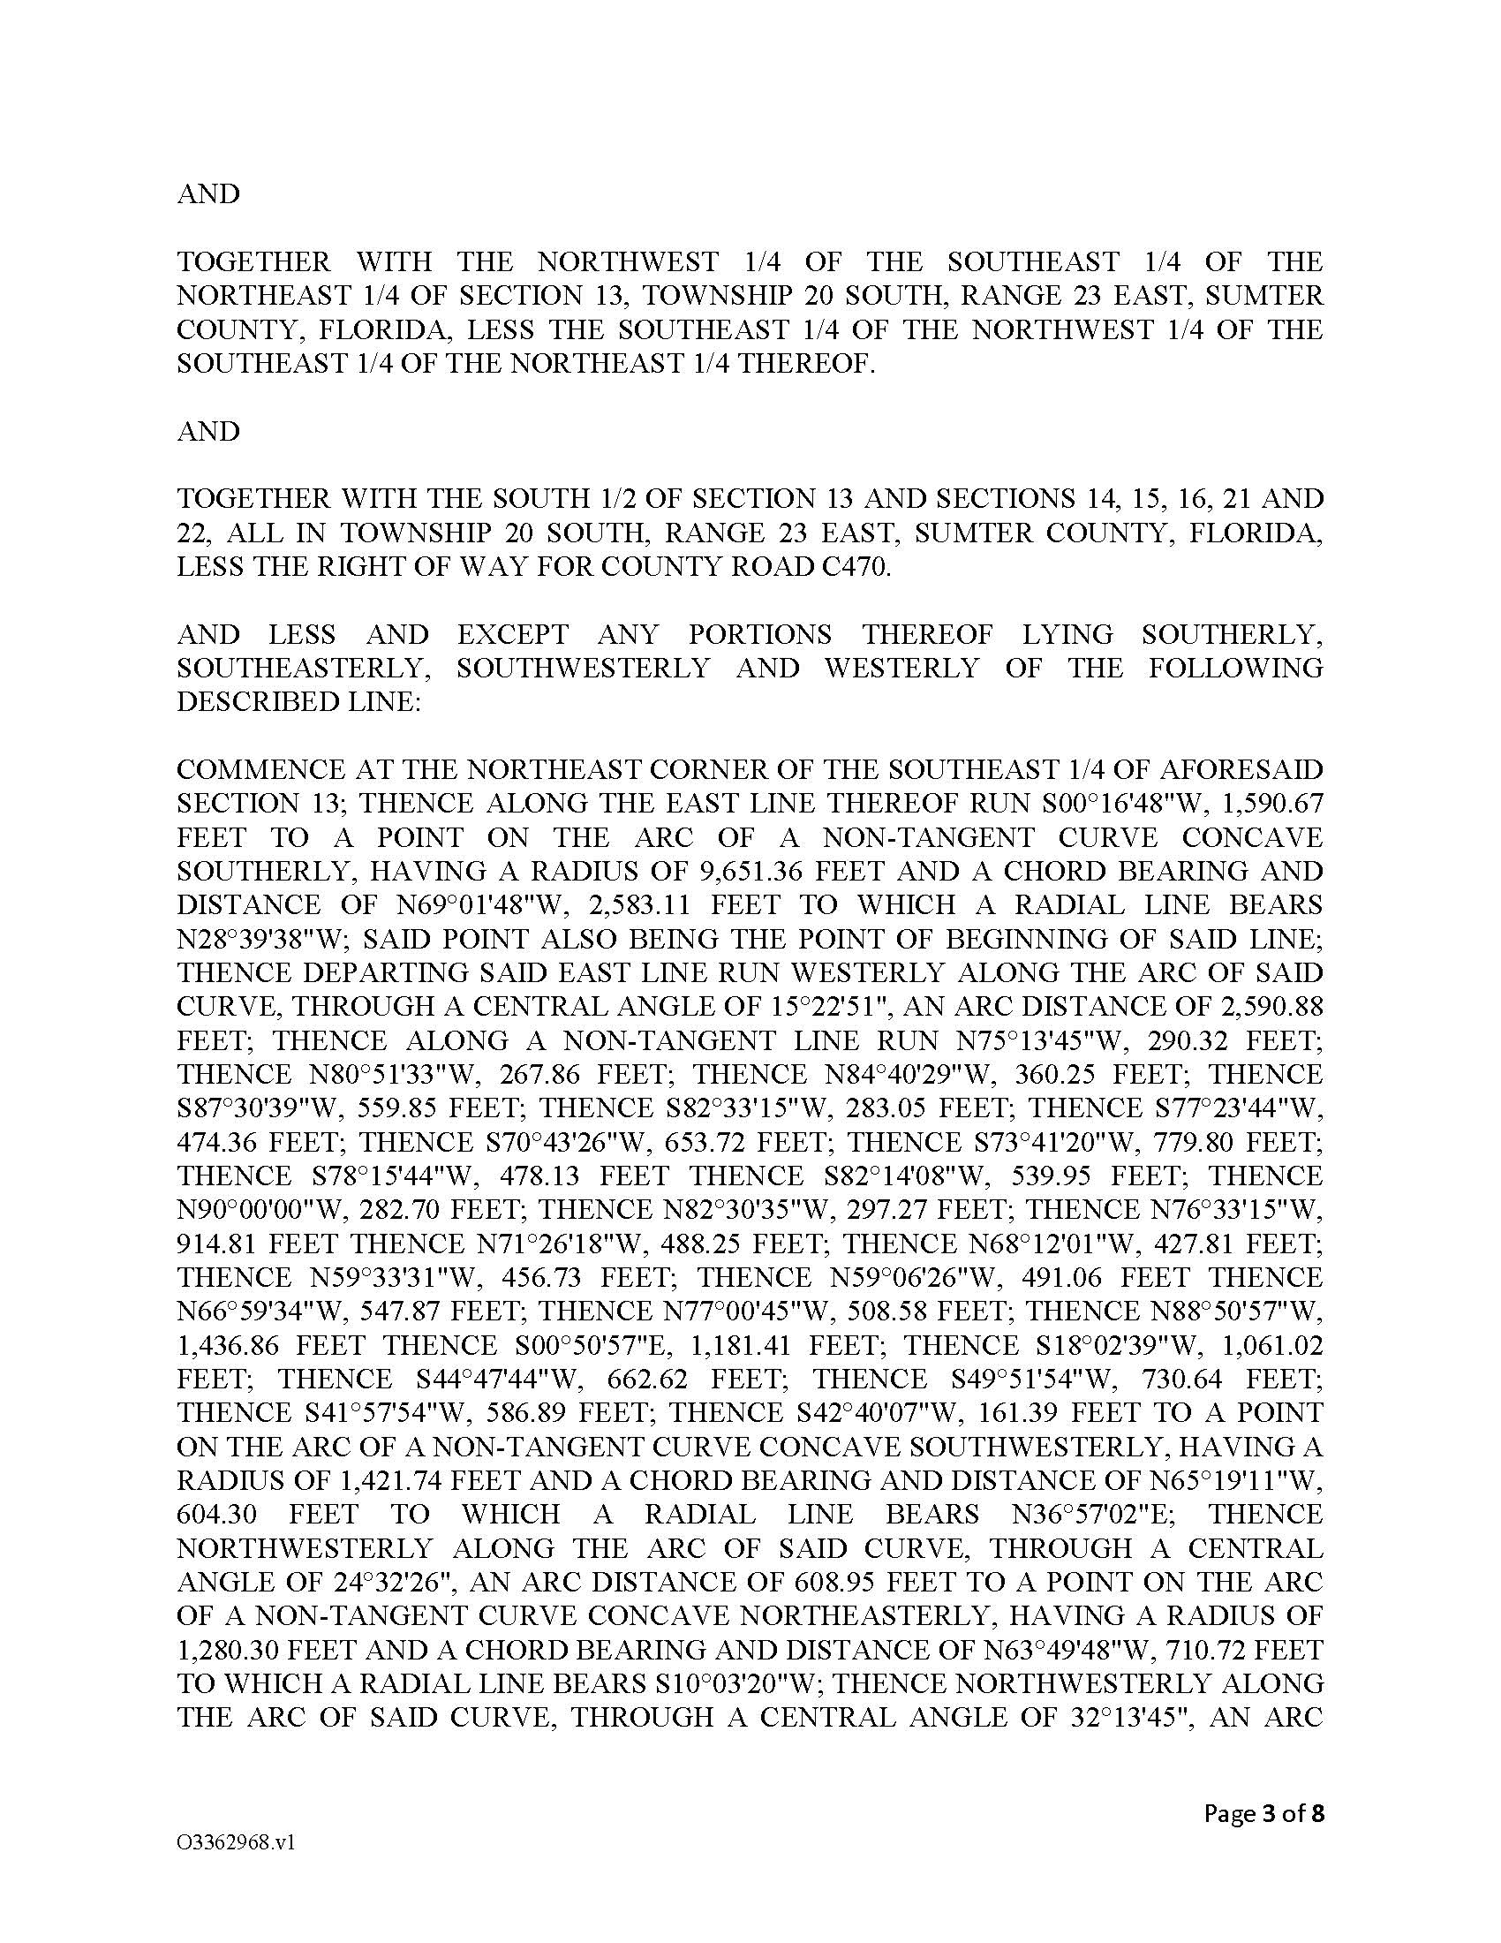
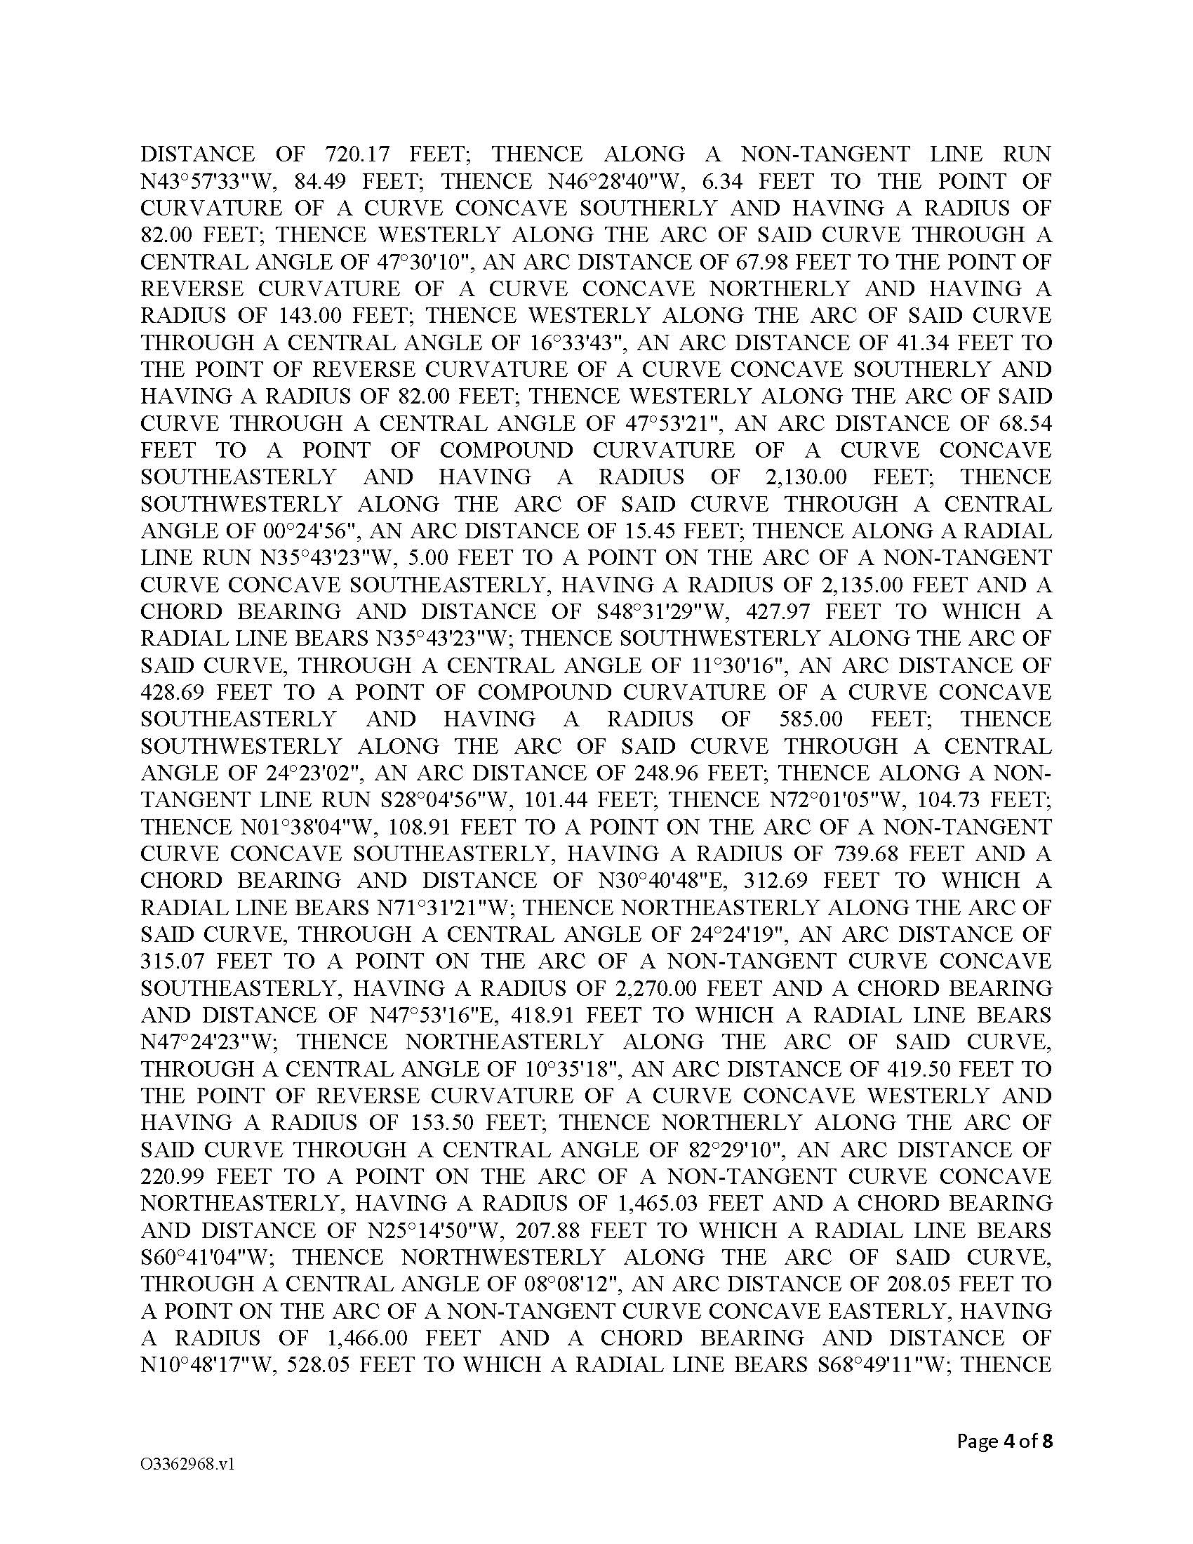
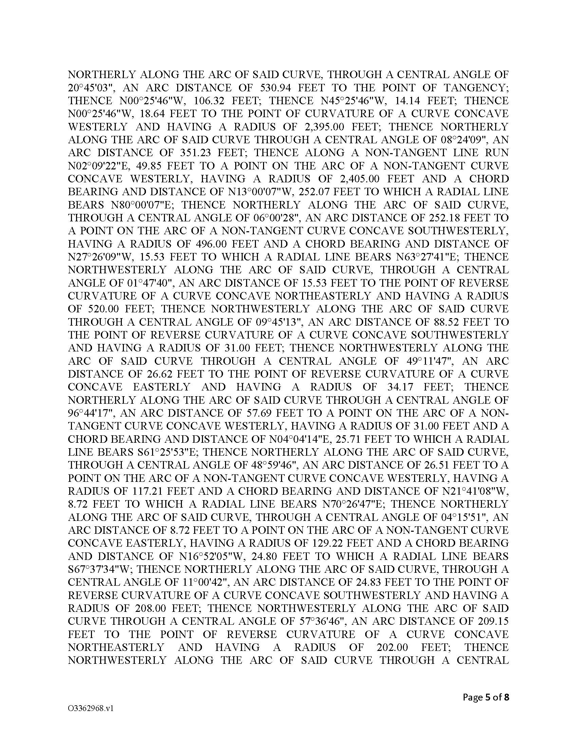
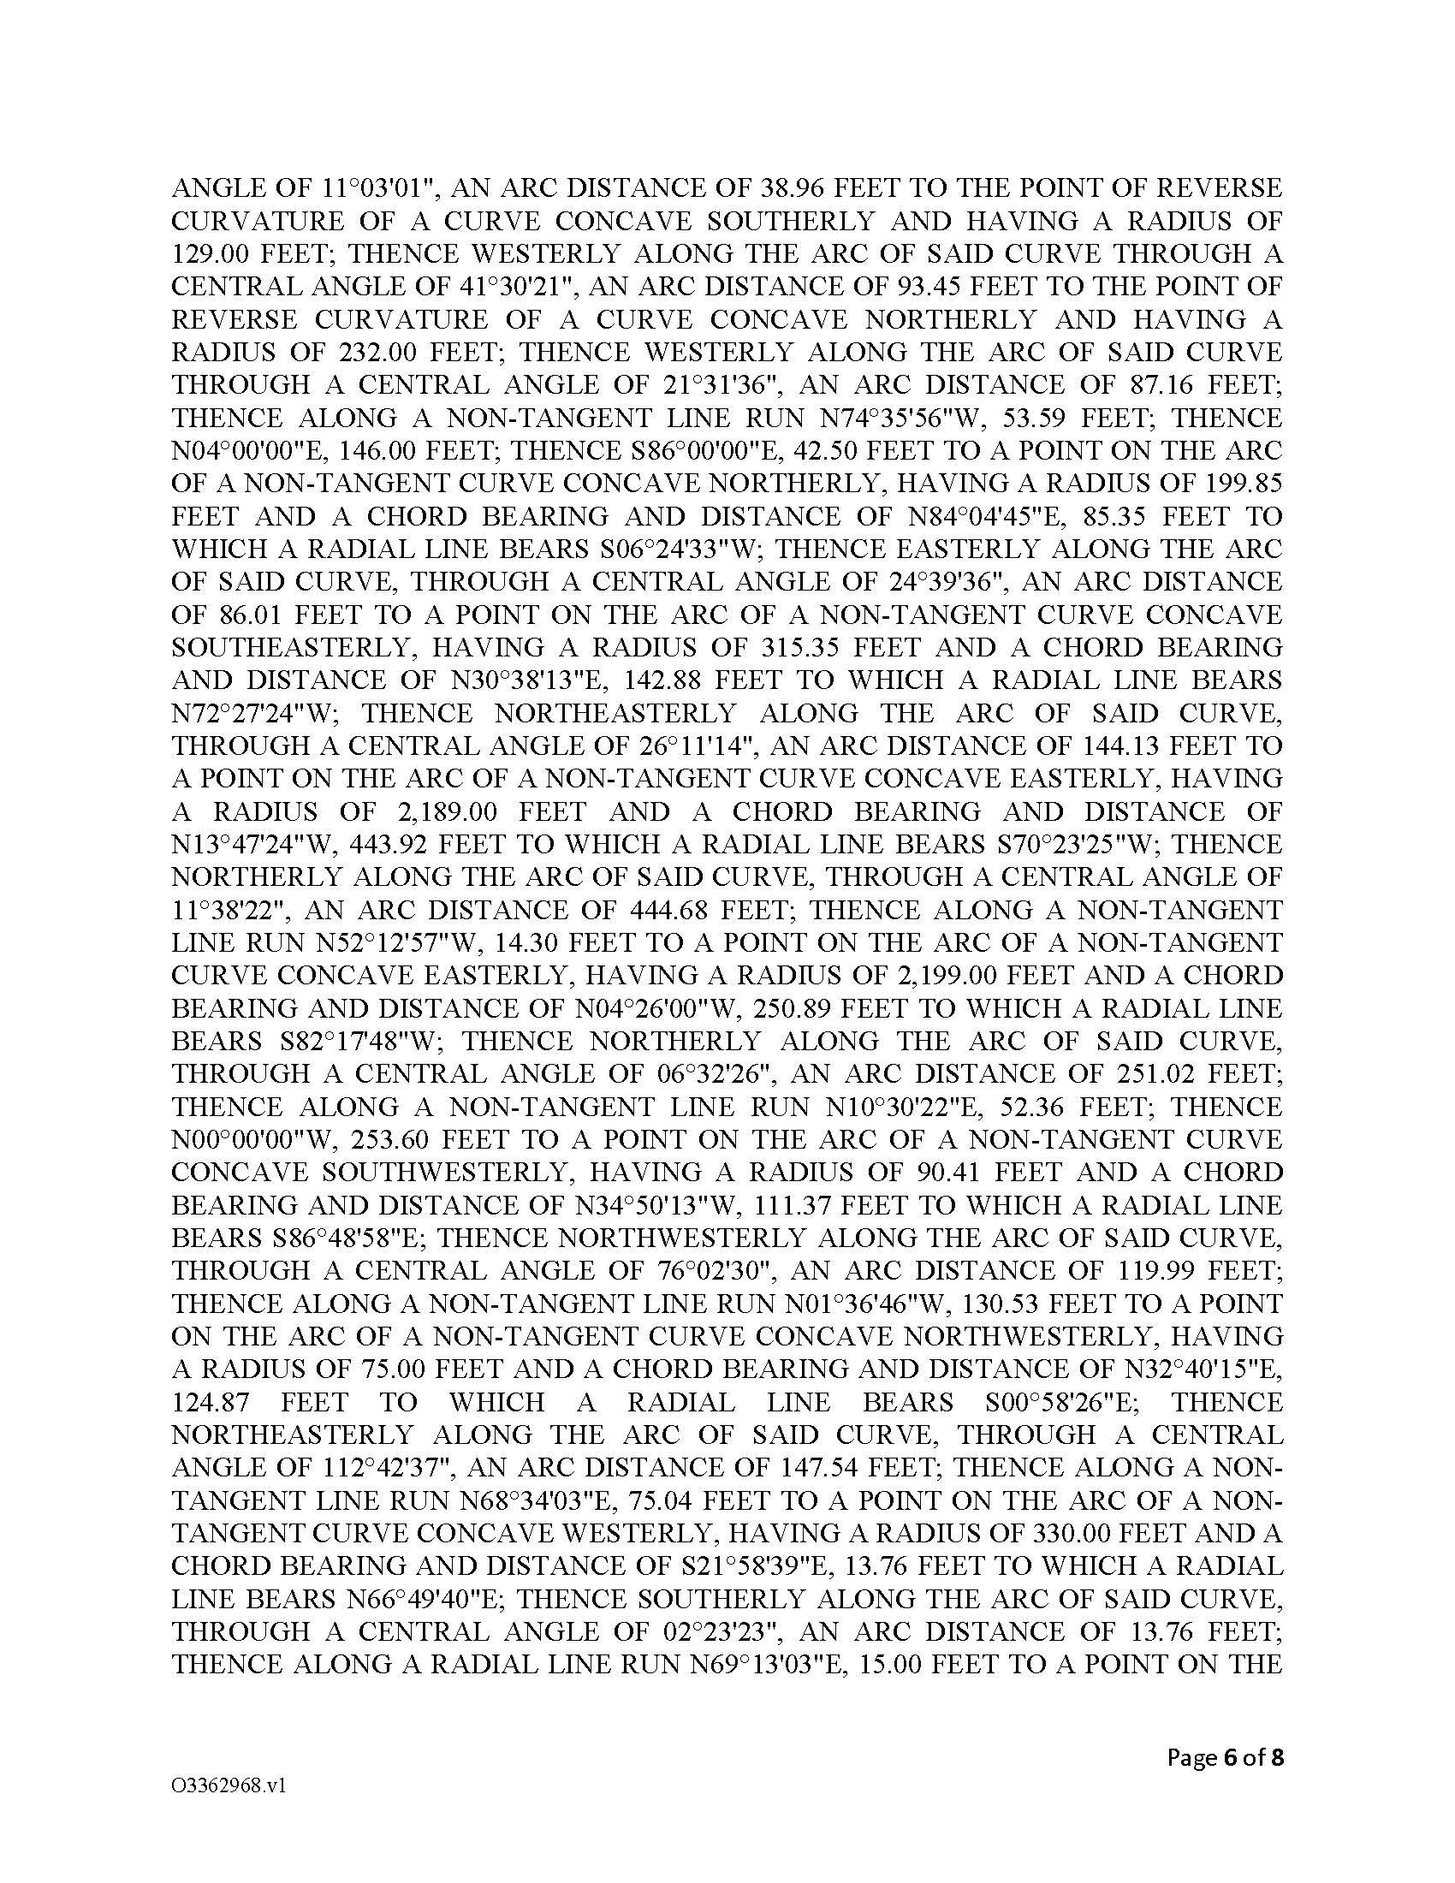
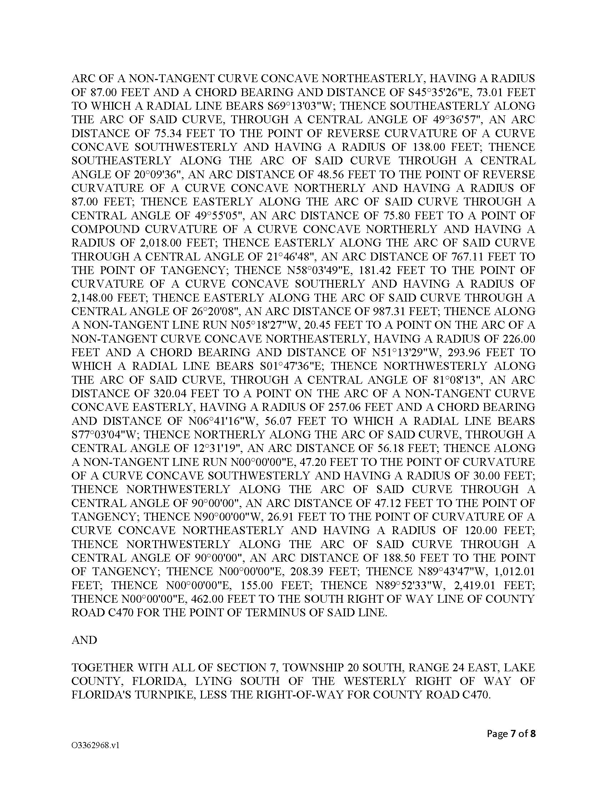
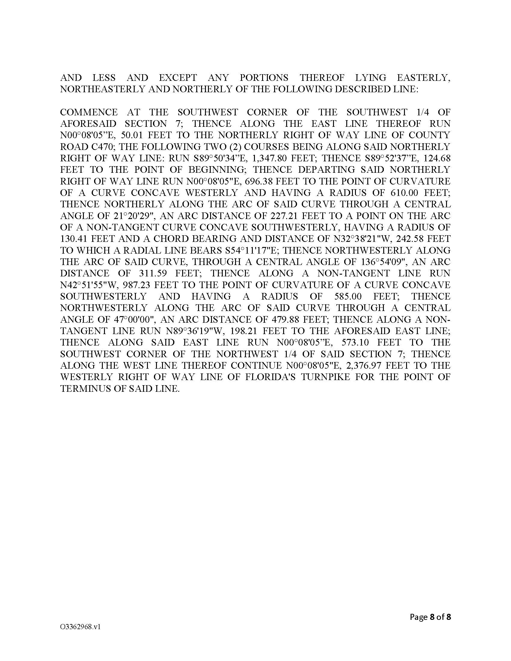
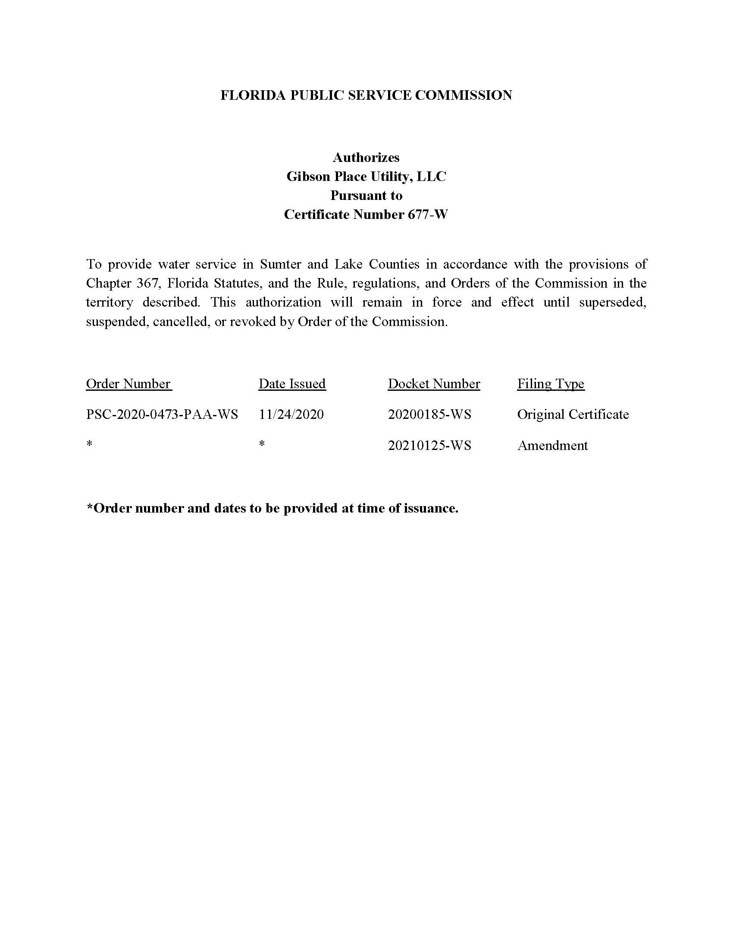
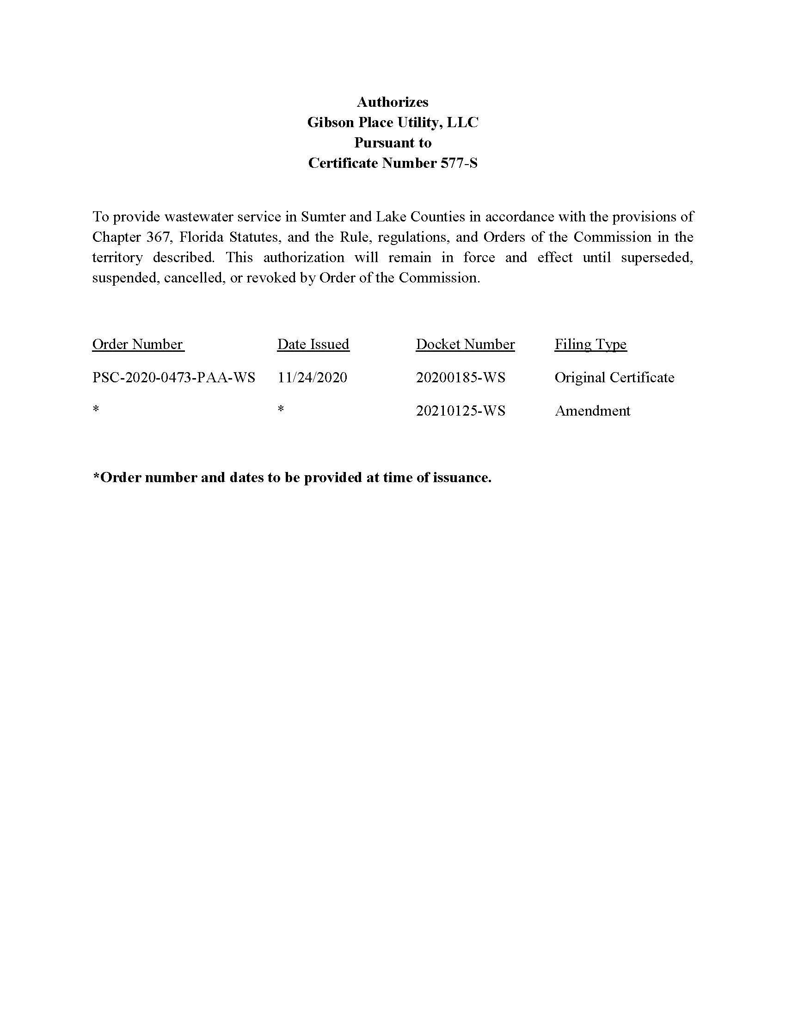

Order No. PSC-2020-0473-PAA-WS, issued November 24, 2020, in Docket No. 20200185-WS, In re: Application for certificates to provide water and wastewater service in Lake and Sumter Counties, by Gibson Place Utility Company, LLC.
Pursuant to Order No. PSC-2020-0473-PAA-WS, GPU is required to send a status report to the Commission every six months detailing the status of its permitting with the Florida Department of Environmental Protection and SWFWMD as well as the anticipated commencement date of its operations.
Document No. 12619-2021, filed November 10, 2021, in Docket No. 20200185-WS

