BEFORE THE FLORIDA PUBLIC SERVICE COMMISSION

In re: Joint petition for approval of amendment to territorial agreement in Sumter County, by Sumter Electric Cooperative, Inc. and City of Bushnell. | DOCKET NO. 20210170-EU  ORDER NO. PSC-2022-0065-PAA-EU  ISSUED: February 18, 2022

The following Commissioners participated in the disposition of this matter:

ANDREW GILES FAY, Chairman
ART GRAHAM
GARY F. CLARK
MIKE LA ROSA
GABRIELLA PASSIDOMO

NOTICE OF PROPOSED AGENCY ACTION
ORDER APPROVING AMENDMENT TO TERRITORIAL AGREEMENT

BY THE COMMISSION:

NOTICE is hereby given by the Florida Public Service Commission that the action discussed herein is preliminary in nature and will become final unless a person whose interests are substantially affected files a petition for a formal proceeding, pursuant to Rule 25-22.029, Florida Administrative Code (F.A.C.).

Background

On October 29, 2021, Sumter Electric Cooperative, Inc. (SECO) and the City of Bushnell (City or Bushnell) filed a joint petition for approval of an amendment (First Amendment) to their currently effective territorial agreement (2020 Territorial Agreement) in Sumter County. In Order No. PSC-2020-0258-PAA-EU, we approved the joint petitioners’ currently effective agreement. The proposed First Amendment is to accommodate three customer-driven requests. The proposed First Amendment and associated maps are included in Attachment A to this Order.

During the review process, Commission staff issued a data request to the joint petitioners, to which the response was received on December 22, 2021. We have jurisdiction over this matter pursuant to Section 366.04, Florida Statutes (F.S.).

Decision

Pursuant to Section 366.04(2)(d), F.S., and Rule 25-6.0440(2), Florida Administrative Code (F.A.C.), we have jurisdiction to approve territorial agreements between and among rural electric cooperatives, municipal electric utilities, and other electric utilities. Unless we determine that the First Amendment to the 2020 Territorial Agreement will cause a detriment to the public interest, the First Amendment should be approved.

The Proposed First Amendment to the Territorial Agreement

Through this proposed First Amendment, the joint petitioners seek to modify the existing territorial boundary in Sumter County to address service needs of three customers. The proposed amendment will result in lower capital expenditure to serve each of the three customers. The first request is from a new customer seeking to construct and operate a large industrial facility in the City’s service area. However, the City is unable to serve the large industrial customer without significant capital investment and construction of new facilities. After review of the customer’s needs, the parties agreed that SECO is able to serve the customer with less new investment and facilities.

The second customer request is for security lighting service within the City’s service territory where electric service is not currently available and the City is unable to provide the required service without significant costs and facility extensions. SECO is able to provide the security lighting service with less new investment and less costly extension of existing facilities. The City has agreed to allow SECO to provide the security lighting service to the customer.

The third customer request is from an existing recreational vehicle (RV) park owner, served by the City, who is planning to expand the RV park to an area within SECO’s service territory. Although the RV park is expanding within SECO’s service territory, the specific area currently does not have electric service. SECO would require extensive capital investment and construction of new facilities to provide electricity to the proposed RV expansion area. The RV park customer desires that the City provide electric service for the expanded area and the City is able to provide the needed electric service with less expenses and facility enhancements than SECO.

In order to provide electricity to the three customers discussed above in an efficient manner, the parties have agreed to exchange certain territorial area parcels and modify the boundary of the currently effective territorial agreement. Paragraph 7 of the First Amendment states that the proposed boundary modifications will meet the customers’ needs and will eliminate uneconomic duplication of facilities, and will not cause a decrease in reliability of electric service to existing or future customers of either party.

The proposed First Amendment also asserts that the territorial areas subject to this amendment currently do not have electric service, and therefore there are no customers to be notified or customer accounts to be transferred between the two parties. Pursuant to Paragraph 4 of the petition, the proposed First Amendment to the 2020 Territorial Agreement will become effective upon the issuance of an Order by us approving the First Amendment in its entirety.

Conclusion

After review of the joint petition, we find that the First Amendment to the Territorial Agreement will not cause a detriment to the public interest, will eliminate any potential uneconomic duplication of facilities, and will not cause a decrease in reliability of electric service to the present or future customers of SECO or Bushnell. Therefore, we hereby approve the proposed First Amendment to the 2020 Territorial Agreement between SECO and Bushnell in Sumter County.

Based on the foregoing, it is

ORDERED by the Florida Public Service Commission that the First Amendment to the territorial agreement in Sumter County, by Sumter Electric Cooperative, Inc. and City of Bushnell, attached as Attachment A hereto, is hereby approved. It is further

ORDERED that the provisions of this Order, issued as proposed agency action, shall become final and effective upon the issuance of a Consummating Order unless an appropriate petition, in the form provided by Rule 28-106.201, Florida Administrative Code, is received by the Commission Clerk, 2540 Shumard Oak Boulevard, Tallahassee, Florida 32399-0850, by the close of business on the date set forth in the “Notice of Further Proceedings” attached hereto. It is further

ORDERED that in the event this Order becomes final, this docket shall be closed.

By ORDER of the Florida Public Service Commission this 18th day of February, 2022.

/s/ Adam J. Teitzman
ADAM J. TEITZMAN
Commission Clerk
Florida Public Service Commission
2540 Shumard Oak Boulevard
Tallahassee, Florida 32399
(850) 413-6770
www.floridapsc.com

Copies furnished: A copy of this document is provided to the parties of record at the time of issuance and, if applicable, interested persons.

BYL

NOTICE OF FURTHER PROCEEDINGS OR JUDICIAL REVIEW

The Florida Public Service Commission is required by Section 120.569(1), Florida Statutes, to notify parties of any administrative hearing that is available under Section 120.57, Florida Statutes, as well as the procedures and time limits that apply. This notice should not be construed to mean all requests for an administrative hearing will be granted or result in the relief sought.

Mediation may be available on a case-by-case basis. If mediation is conducted, it does not affect a substantially interested person's right to a hearing.

The action proposed herein is preliminary in nature. Any person whose substantial interests are affected by the action proposed by this order may file a petition for a formal proceeding, in the form provided by Rule 28-106.201, Florida Administrative Code. This petition must be received by the Office of Commission Clerk, 2540 Shumard Oak Boulevard, Tallahassee, Florida 32399-0850, by the close of business on March 11, 2022.

In the absence of such a petition, this order shall become final and effective upon the issuance of a Consummating Order.

Any objection or protest filed in this/these docket(s) before the issuance date of this order is considered abandoned unless it satisfies the foregoing conditions and is renewed within the specified protest period.
p

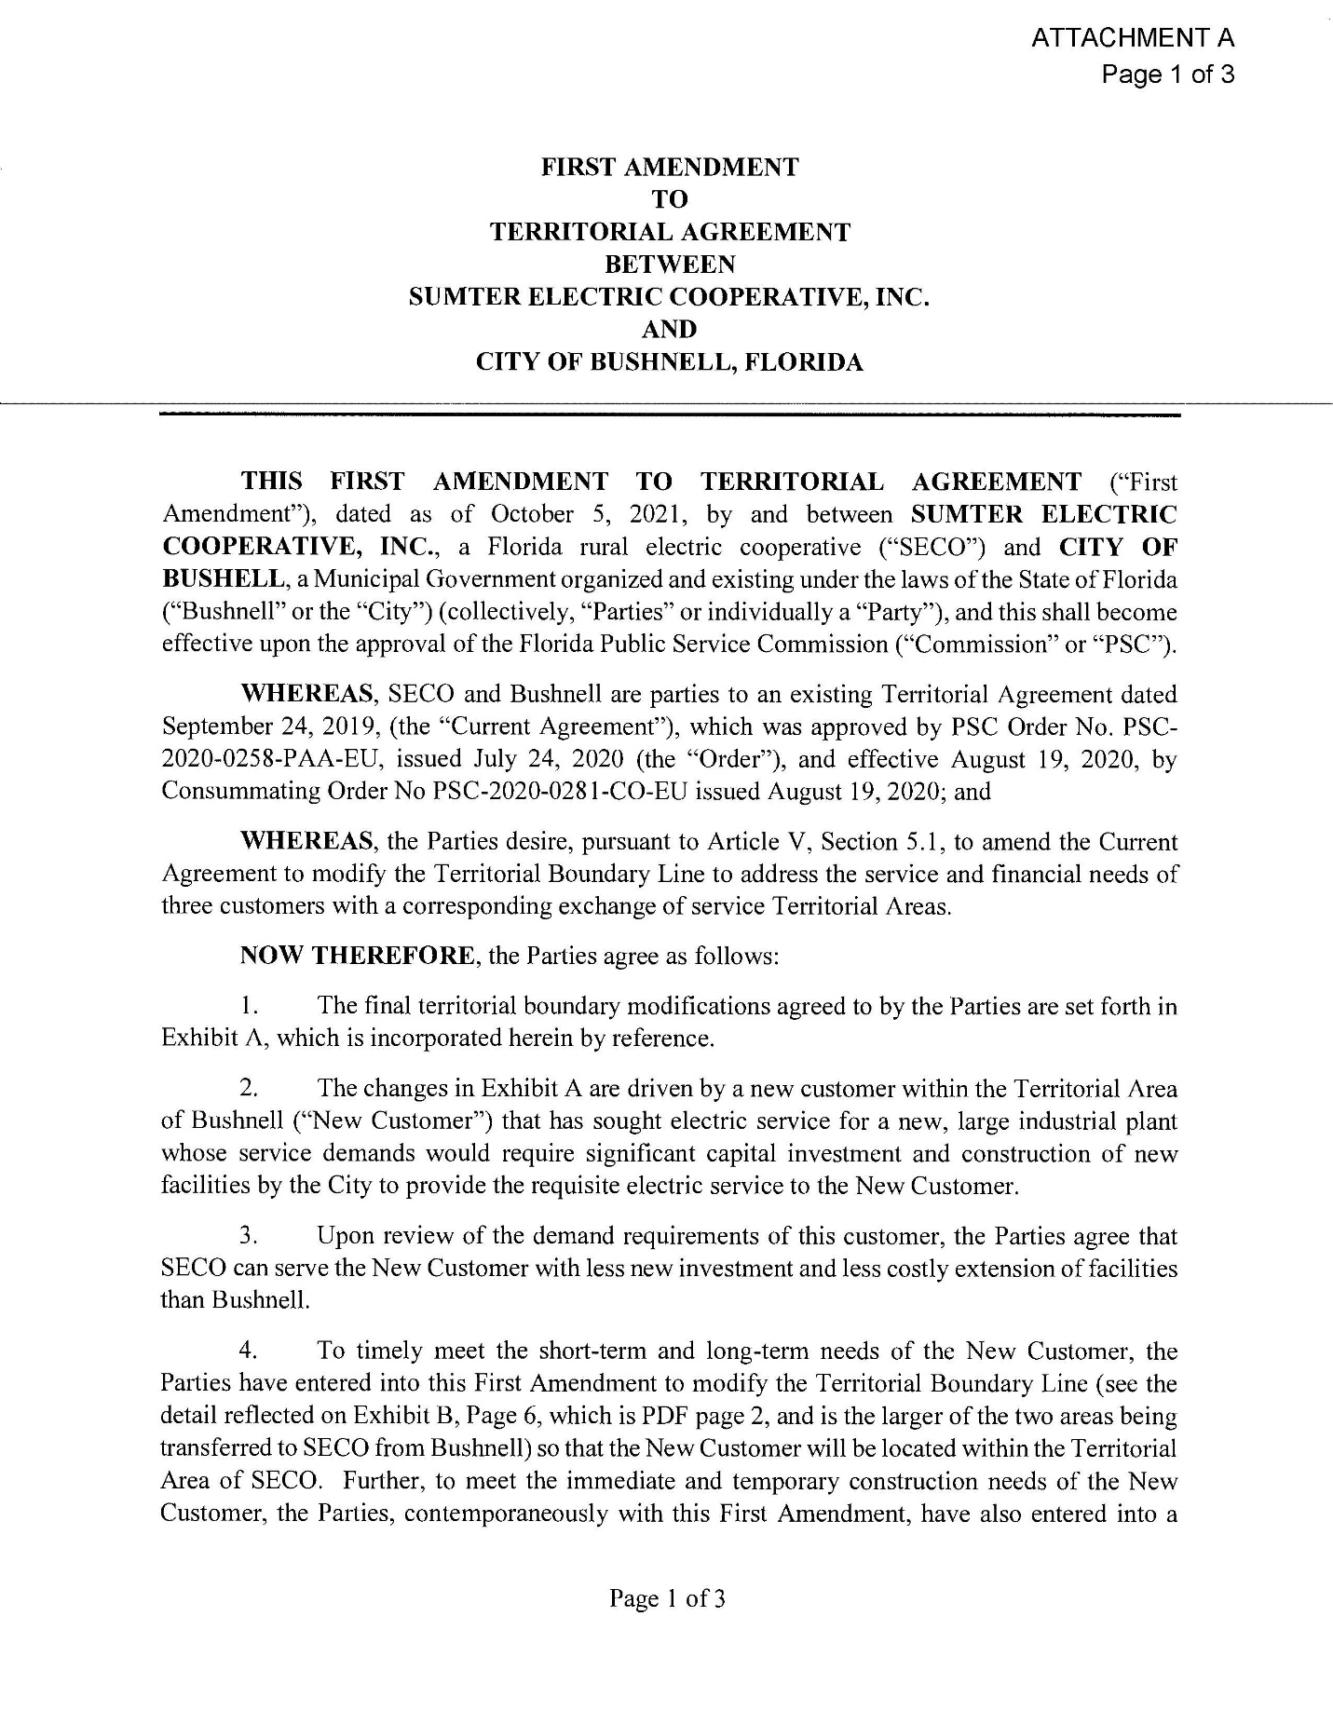
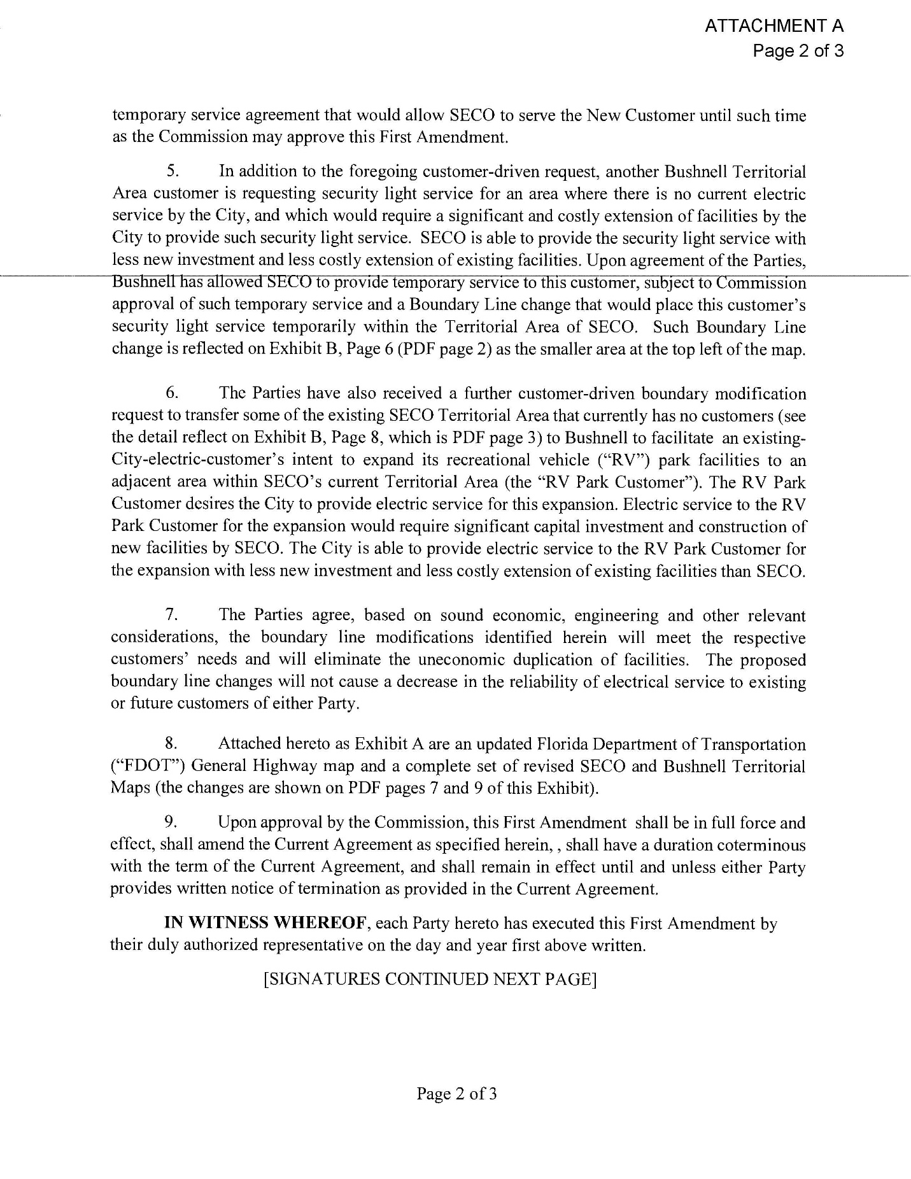
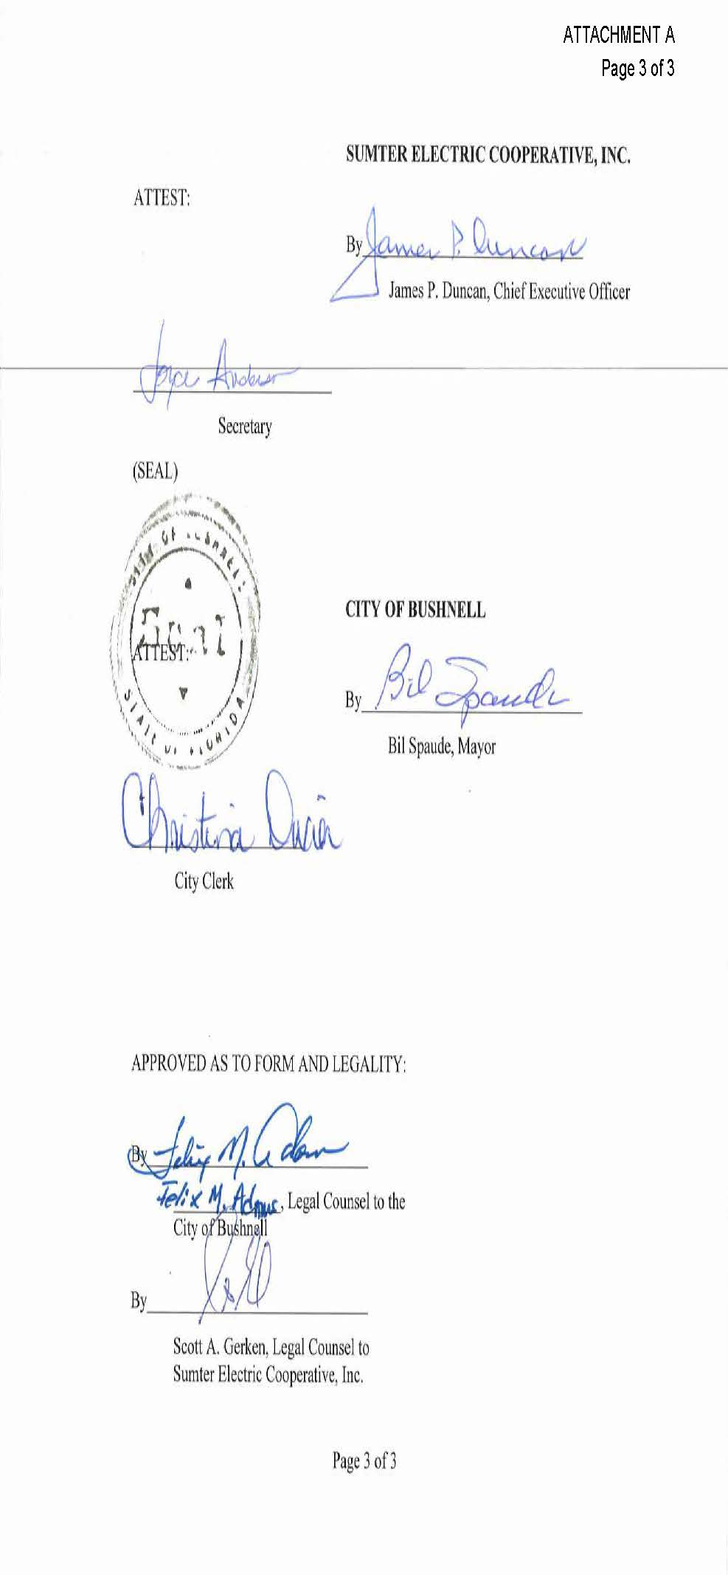
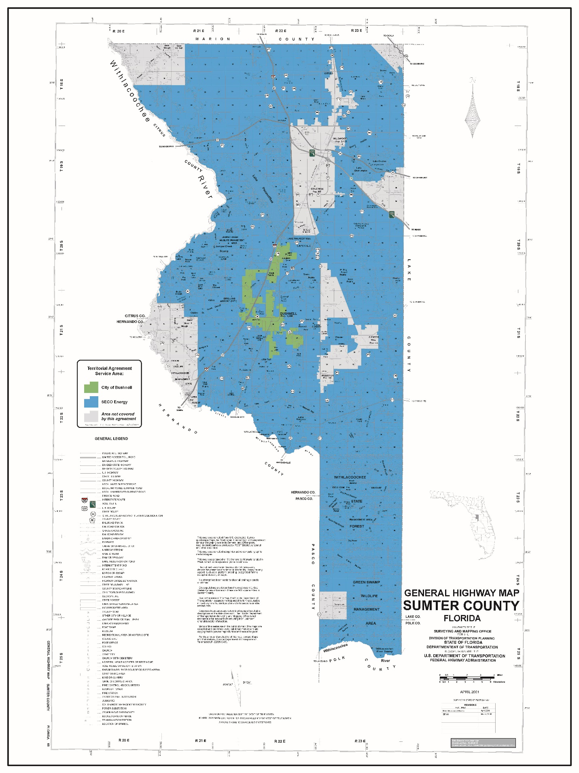
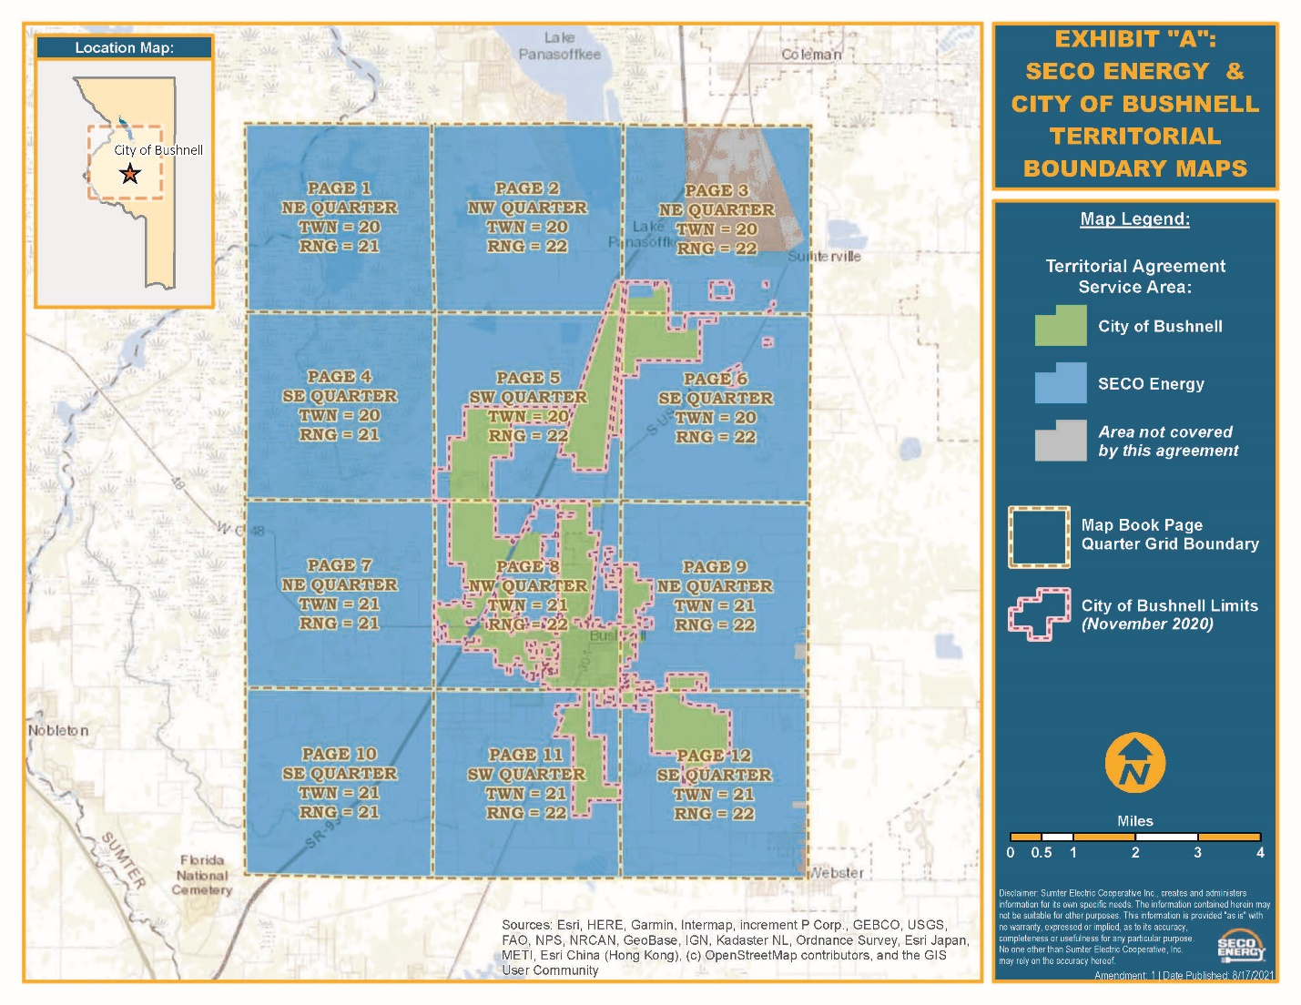
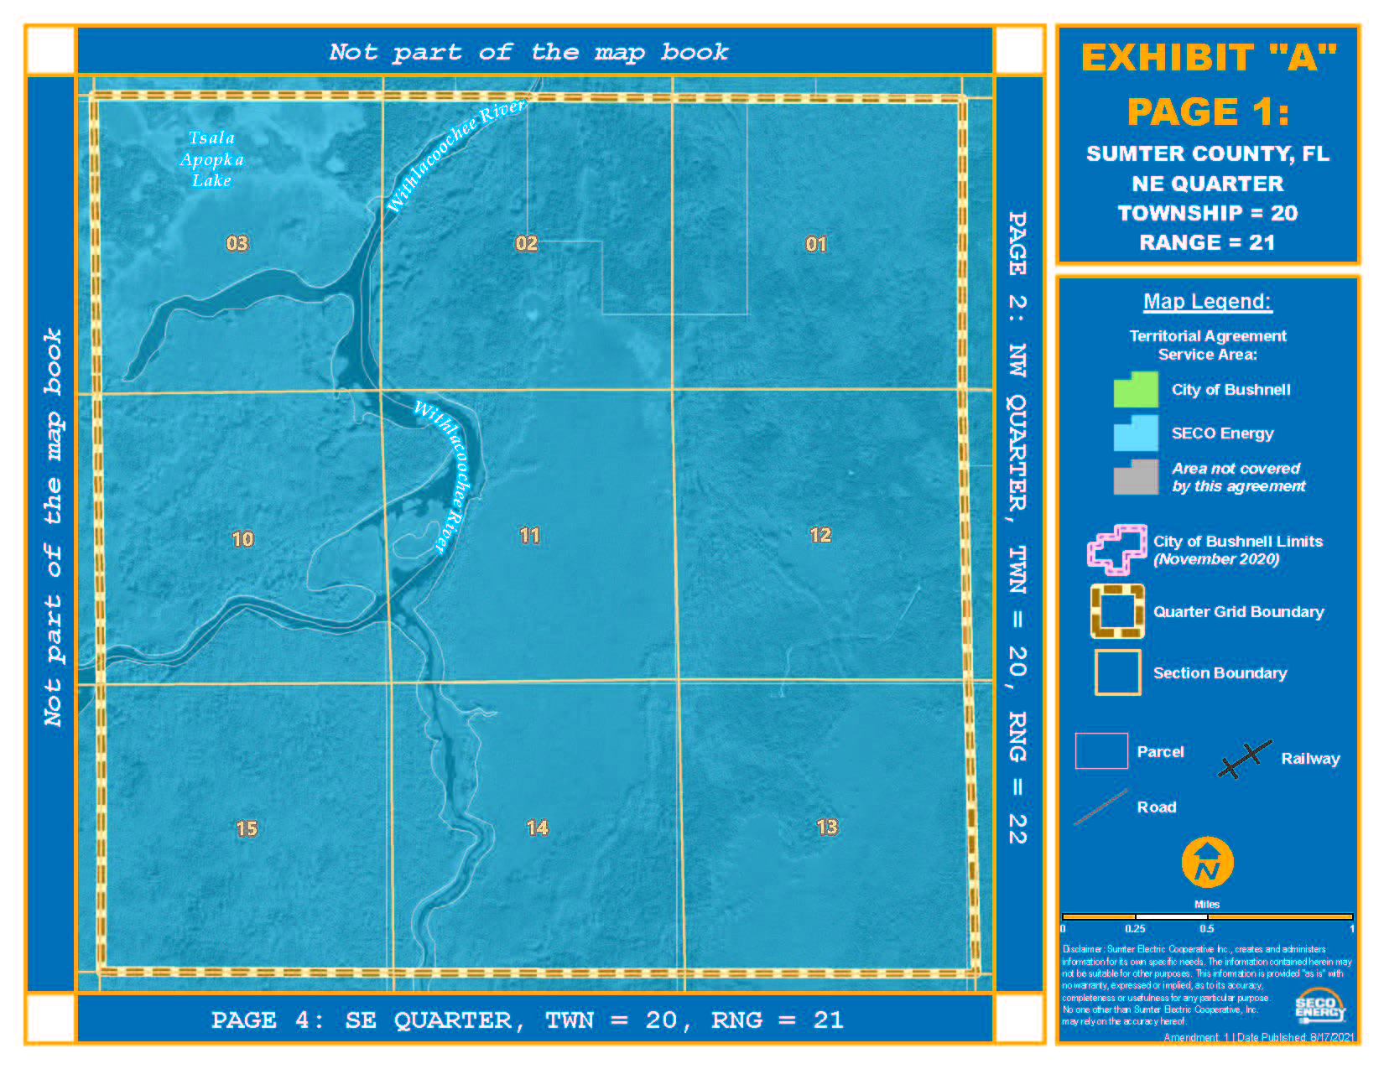
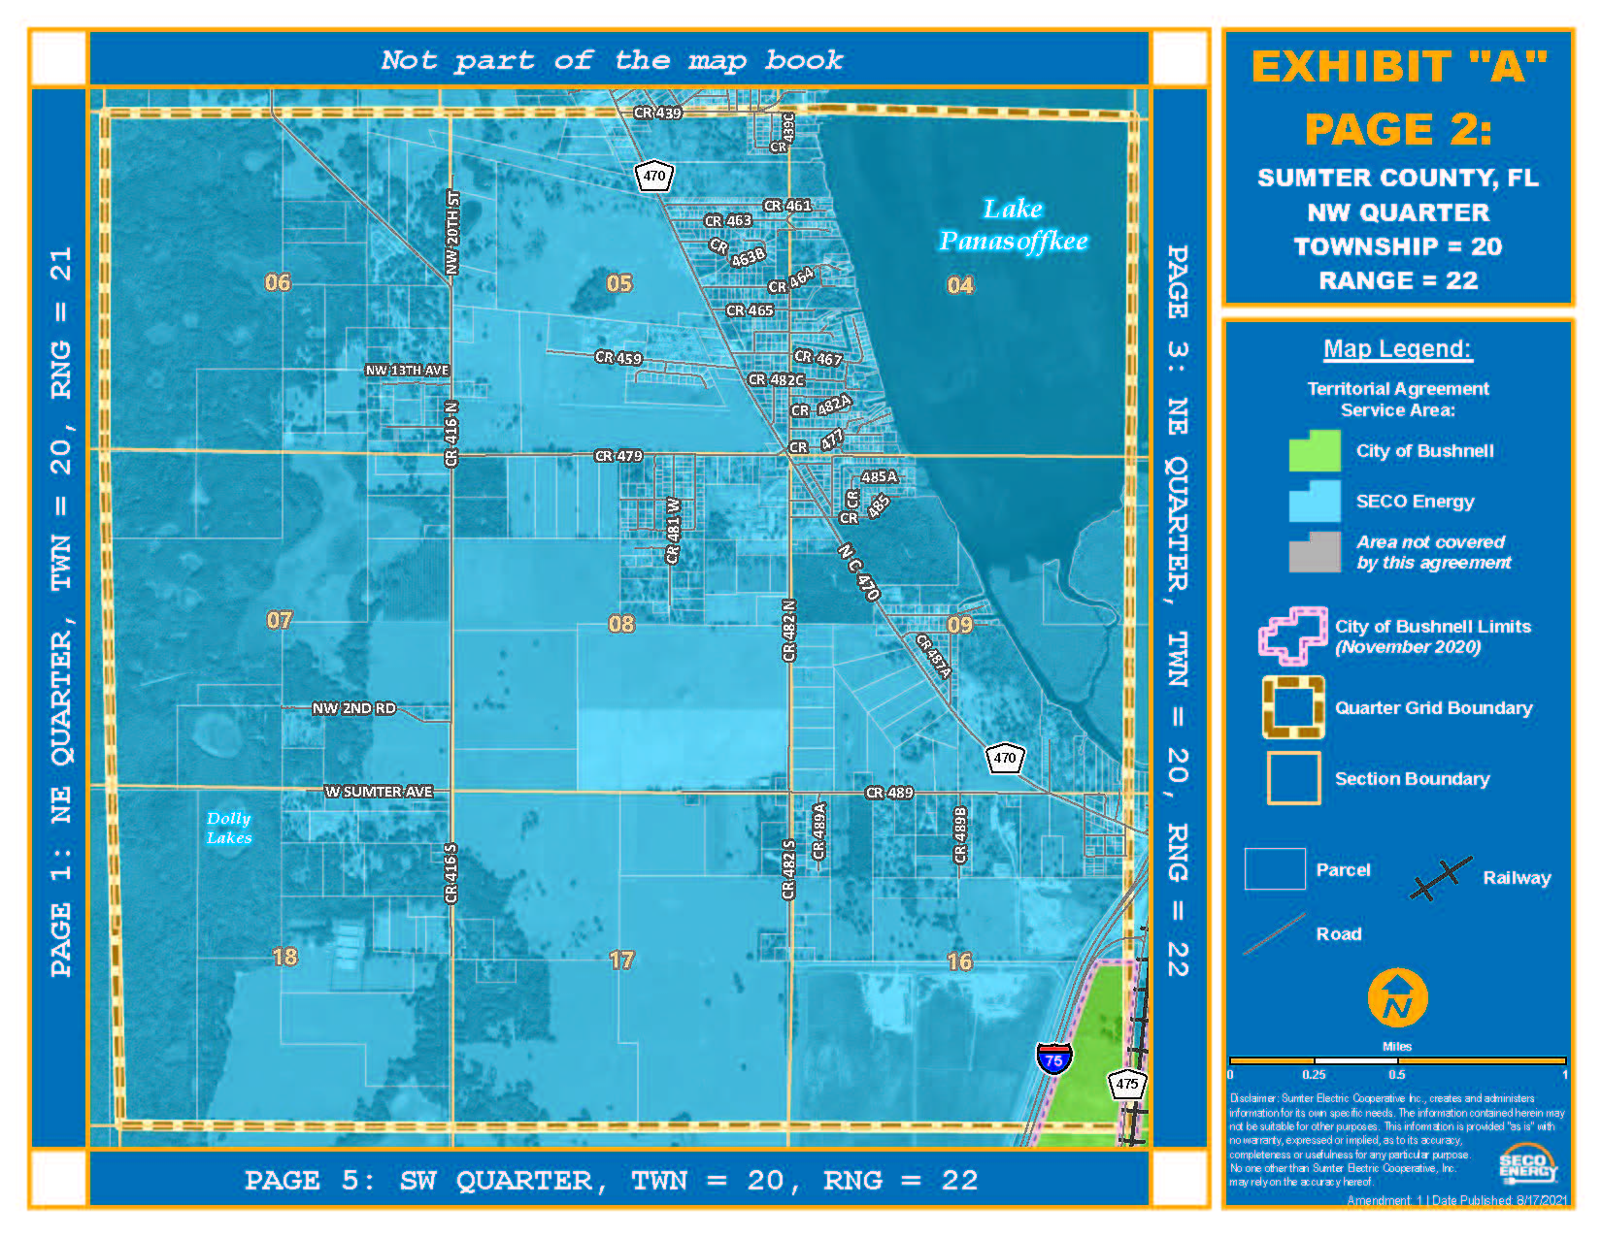
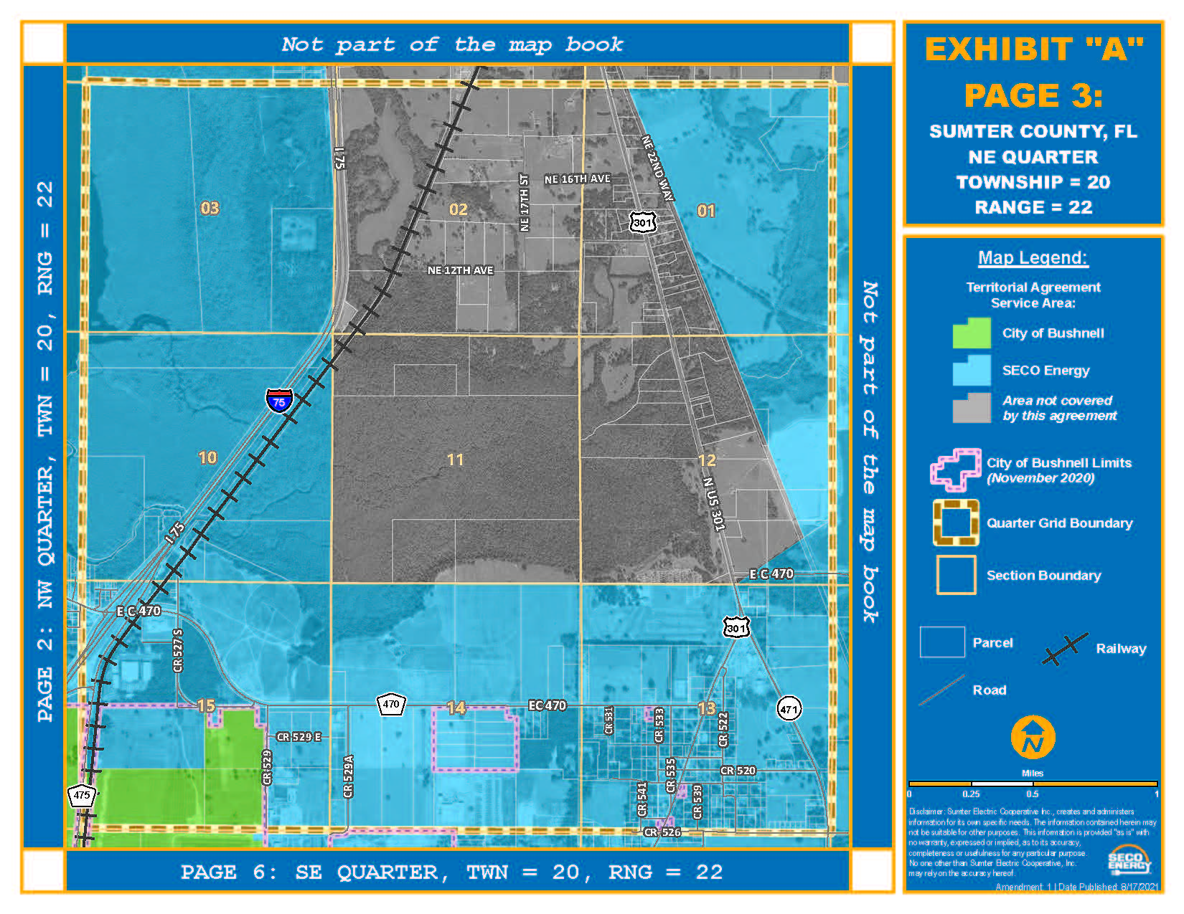
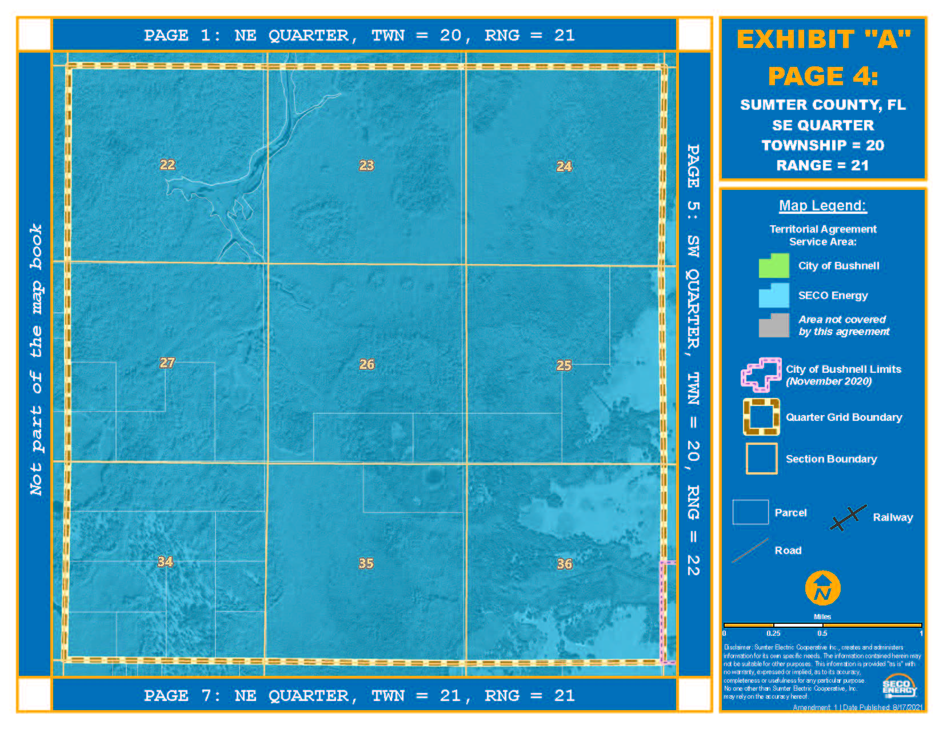
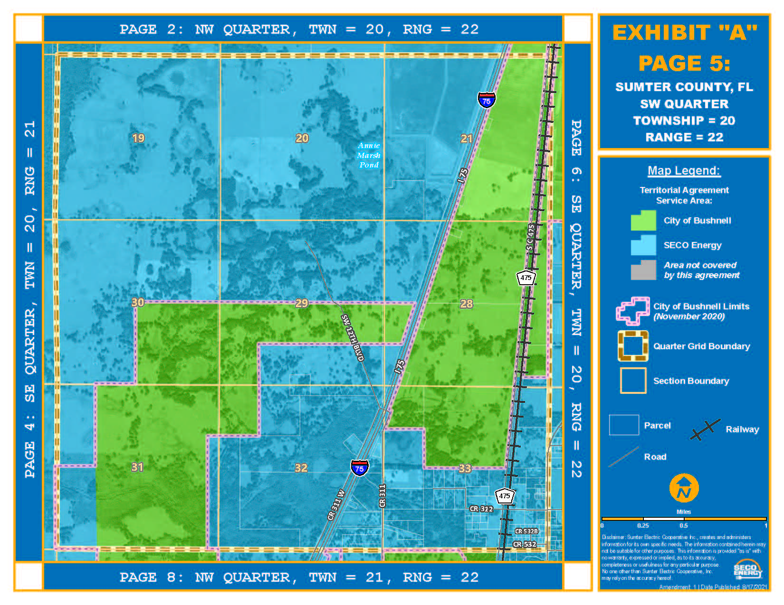
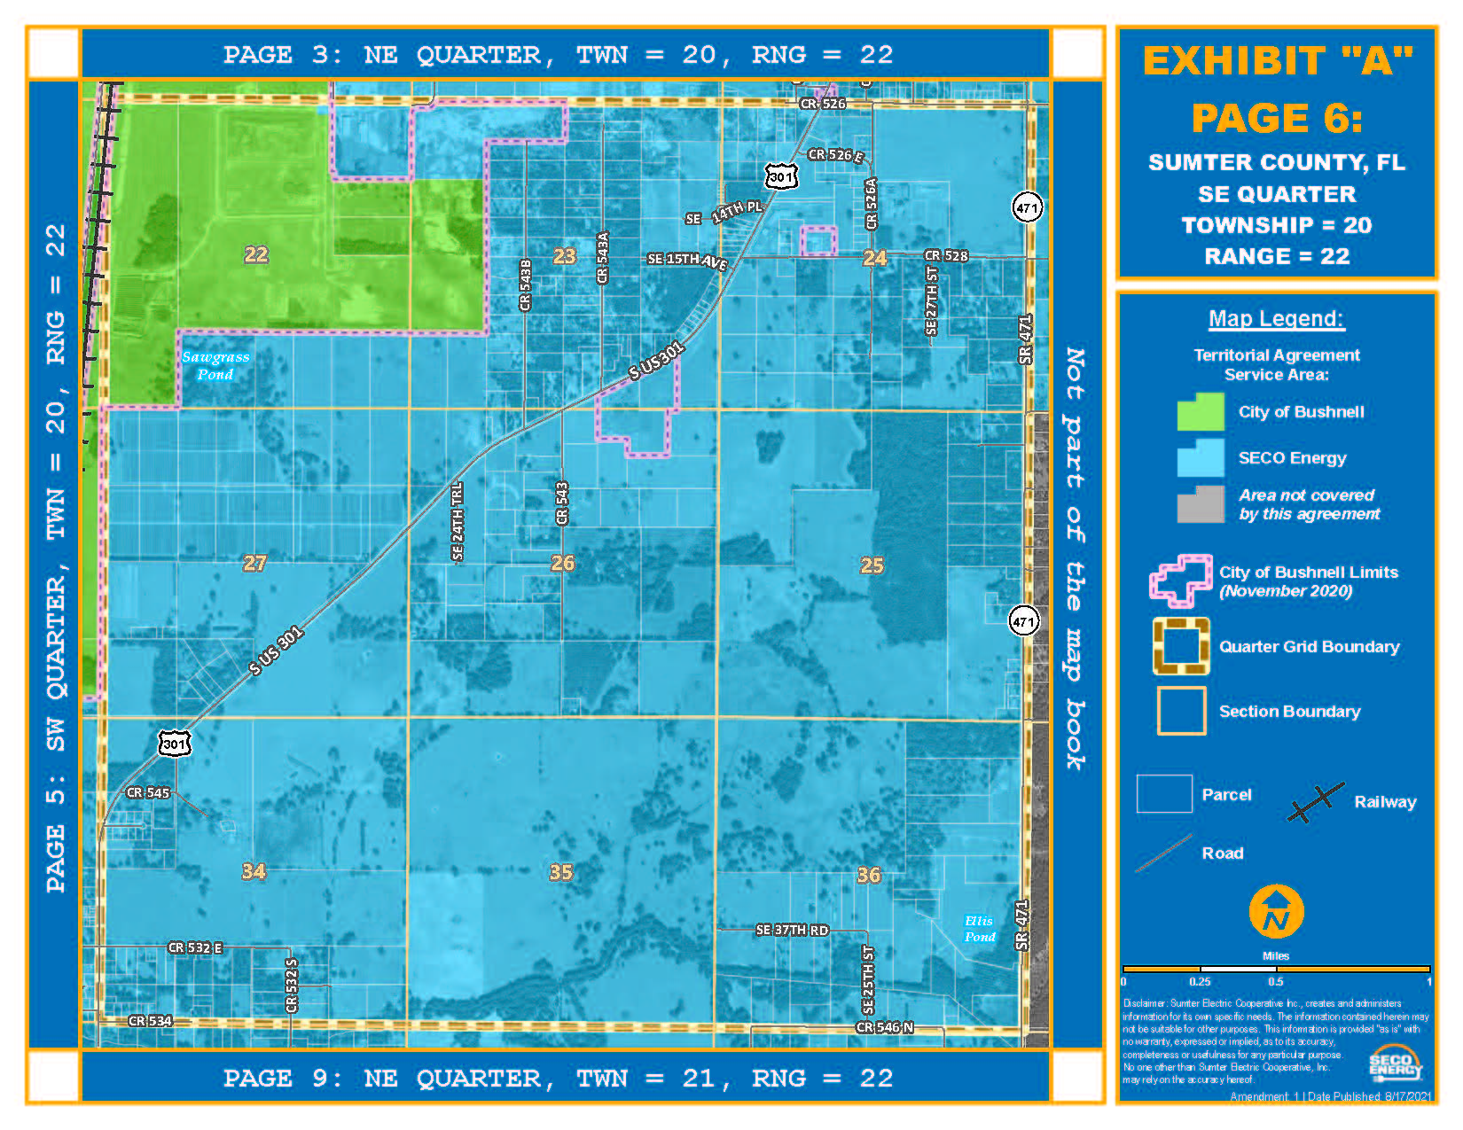
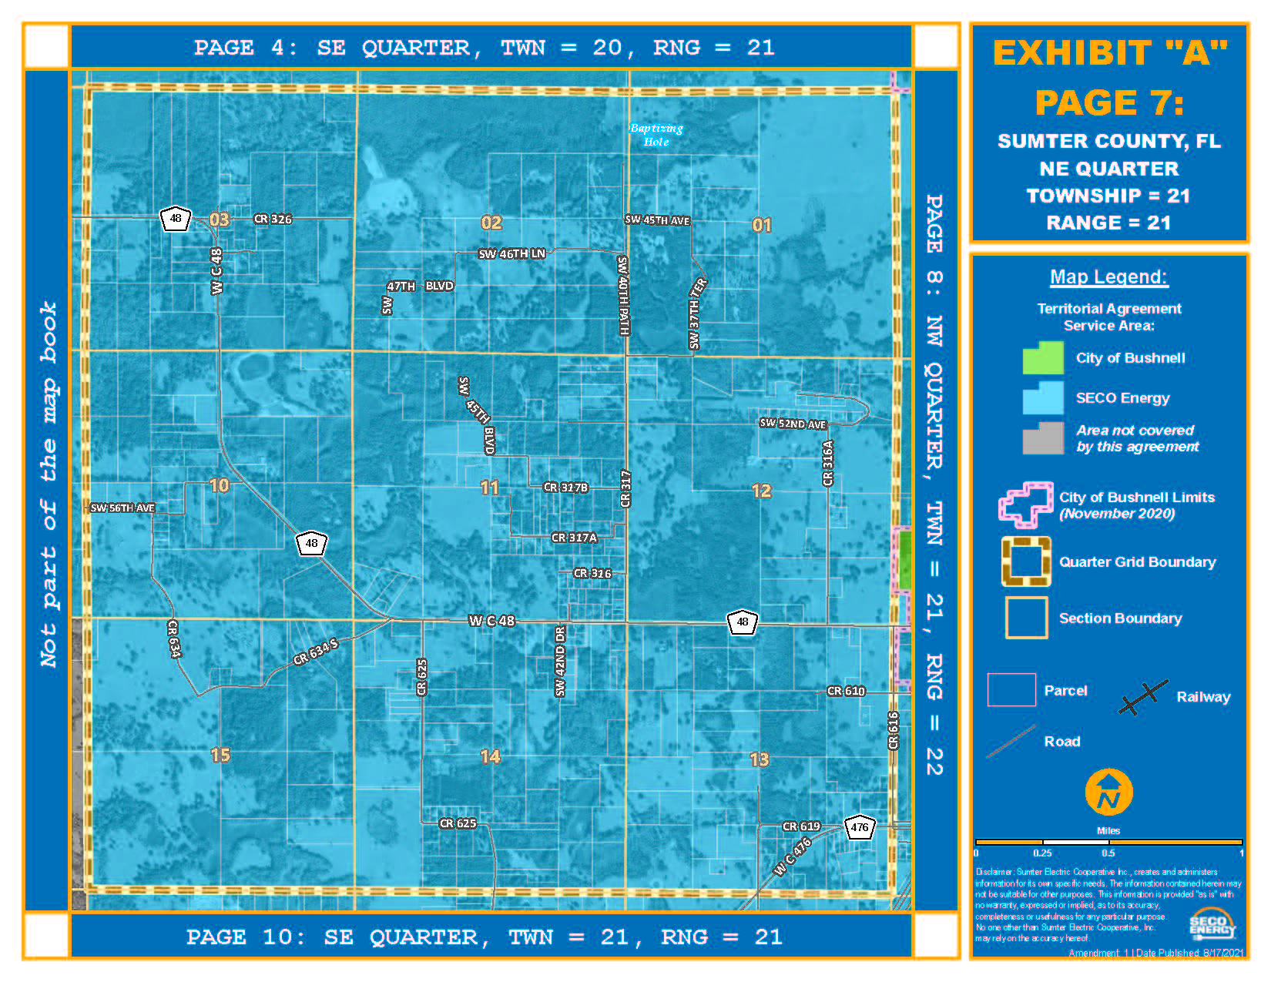
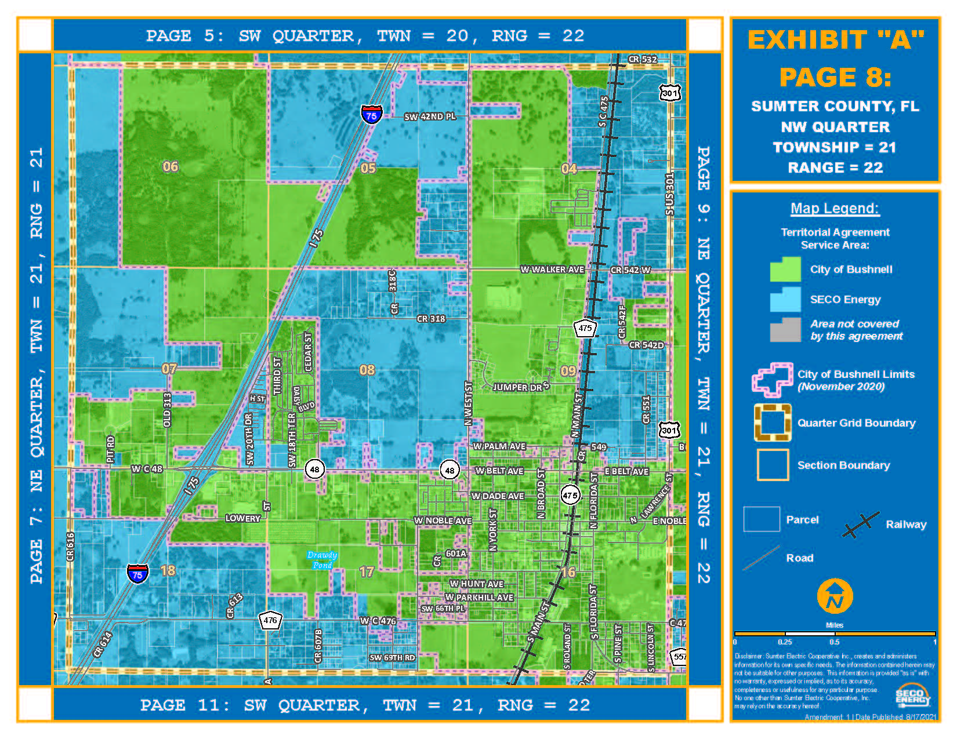
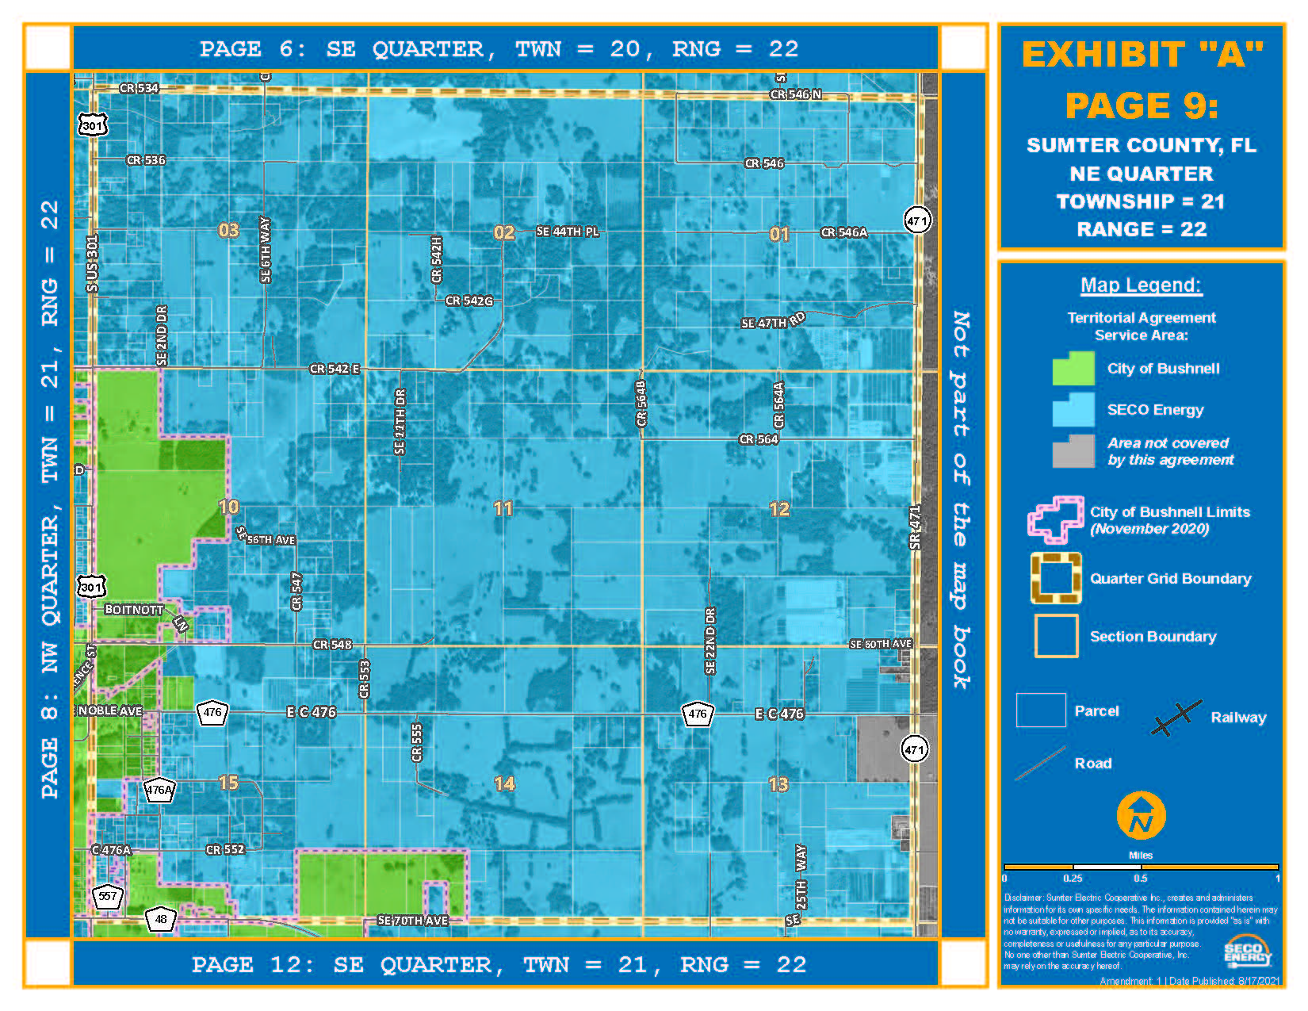
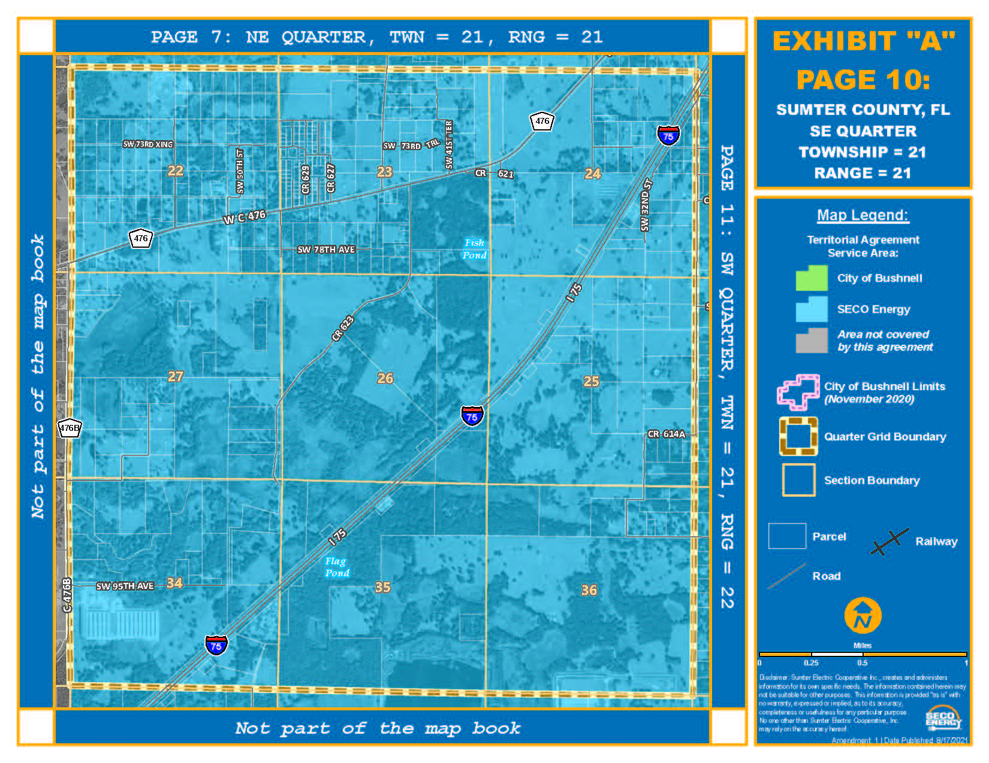
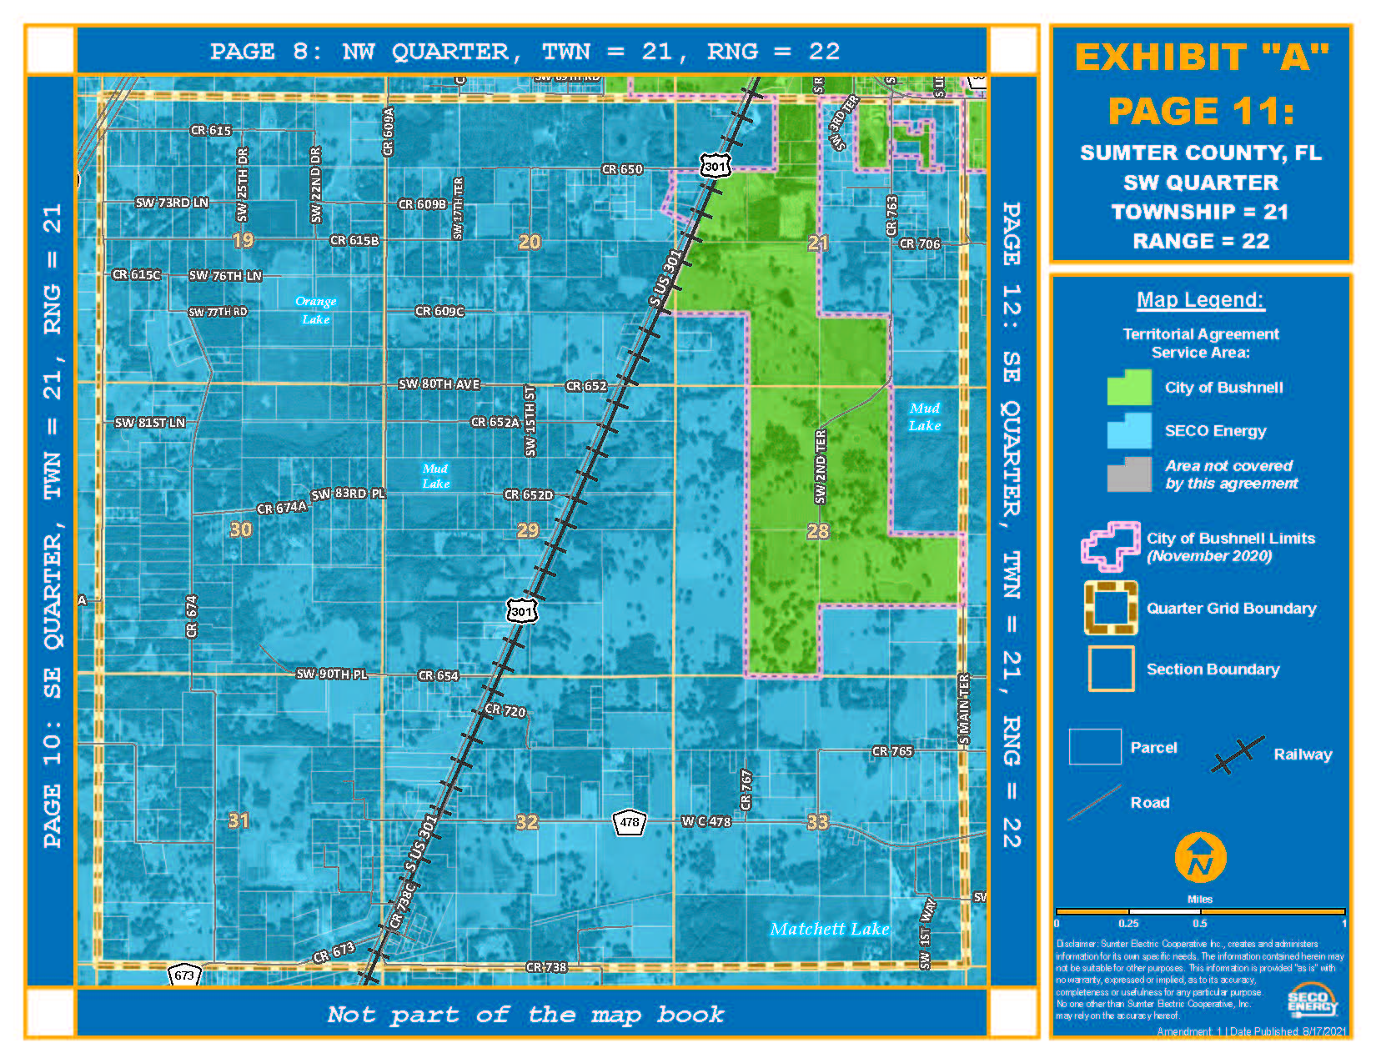
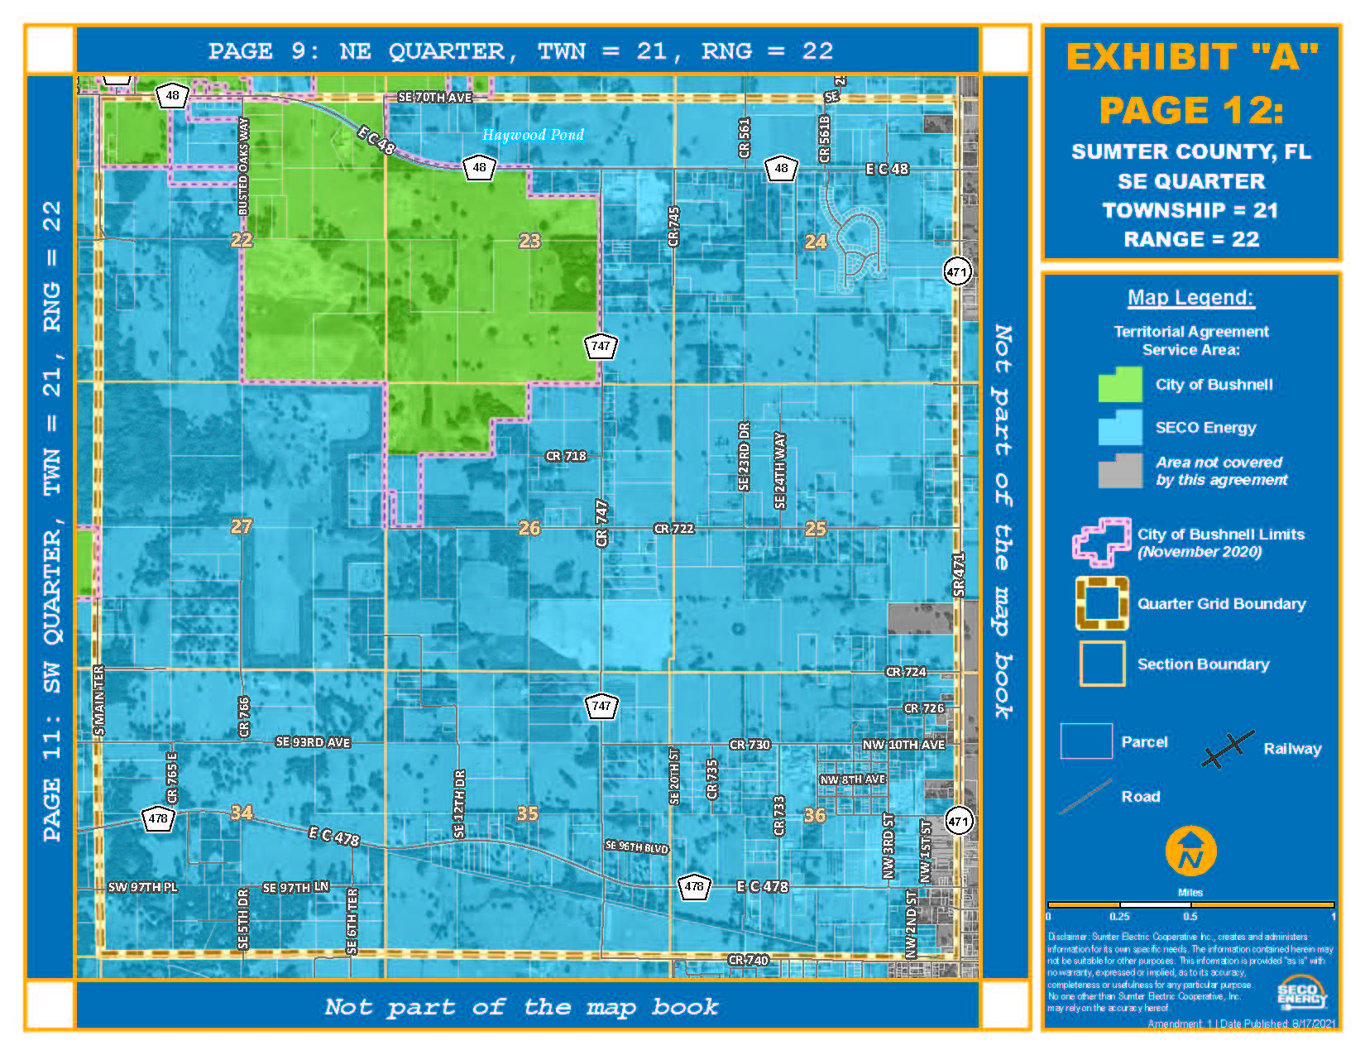
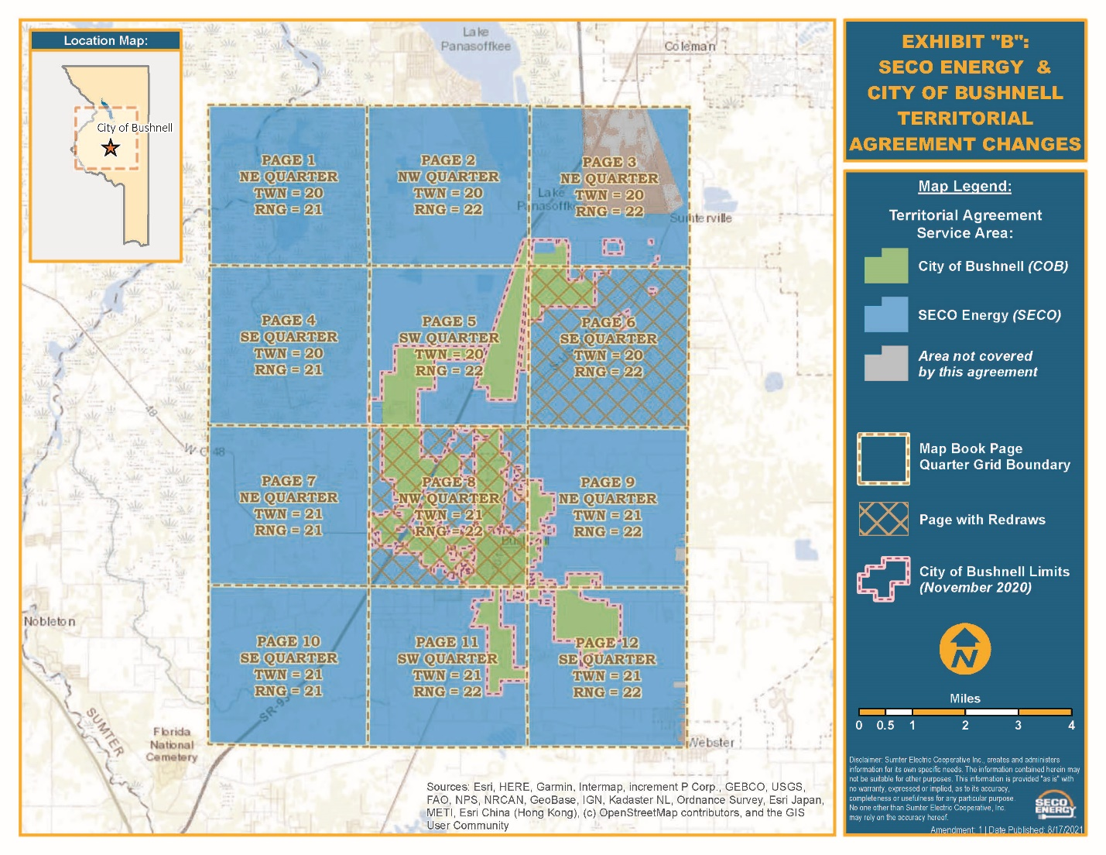
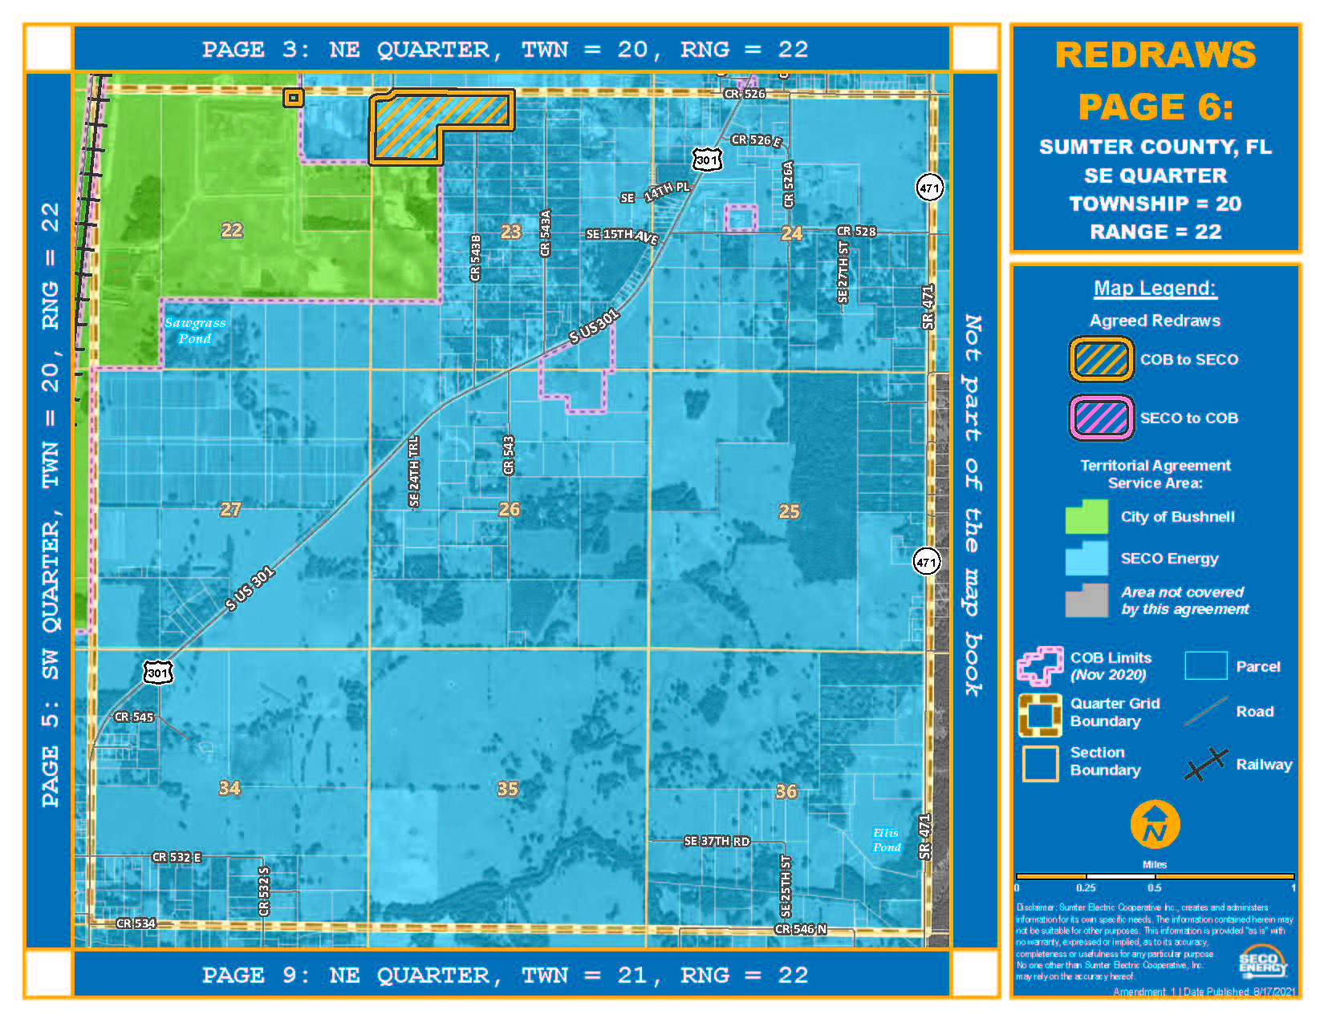
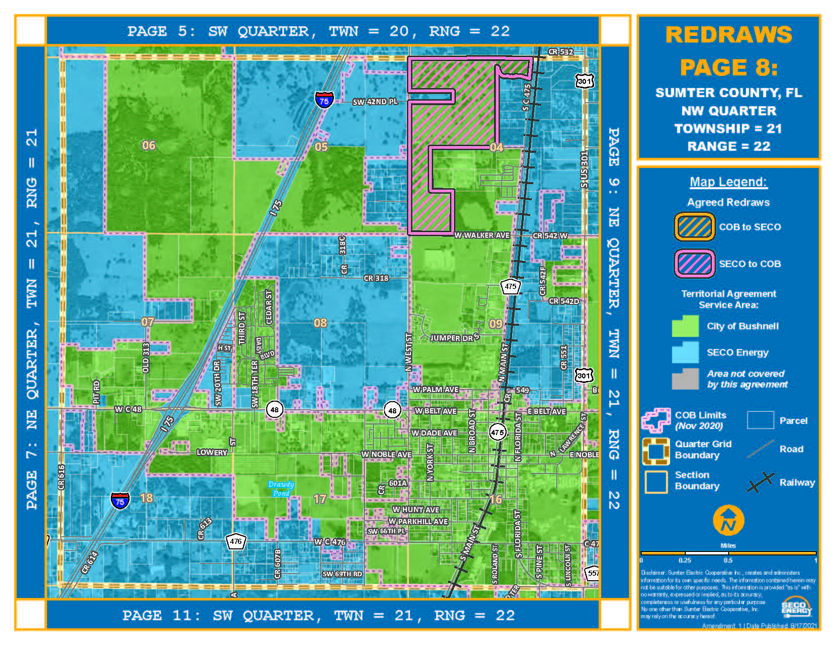

Order No. PSC-2020-0258-PAA-EU, issued July 24, 2020, in Docket No. 20200138-EU, In re: Joint petition for approval of territorial agreement in Sumter County, by Sumter Electric Cooperative, Inc. and City of Bushnell.
Utilities Commission of the City of New Smyrna Beach v. Florida Public Service Commission, 469 So. 2d 731 (Fla. 1985).

