BEFORE THE FLORIDA PUBLIC SERVICE COMMISSION

In re: Joint petition for approval of amendment to territorial agreement, by Tampa Electric Company and Withlacoochee River Electric Cooperative, Inc. | DOCKET NO. 20210197-EU  ORDER NO. PSC-2022-0117-PAA-EU  ISSUED: March 17, 2022

The following Commissioners participated in the disposition of this matter:

ANDREW GILES FAY, Chairman
ART GRAHAM
GARY F. CLARK
MIKE LA ROSA
GABRIELLA PASSIDOMO

NOTICE OF PROPOSED AGENCY ACTION
ORDER APPROVING AMENDMENT TO TERRITORIAL AGREEMENT

BY THE COMMISSION:

NOTICE is hereby given by the Florida Public Service Commission that the action discussed herein is preliminary in nature and will become final unless a person whose interests are substantially affected files a petition for a formal proceeding, pursuant to Rule 25-22.029, Florida Administrative Code (F.A.C.).

Background
On December 28, 2021, Tampa Electric Company (TECO) and Withlacoochee River Electric Cooperative, Inc. (WREC) (collectively, joint petitioners) filed a joint petition for approval of an amendment to their current territorial agreement in Pasco County (the proposed amendment). TECO serves retail customers in Hillsborough County and in portions of Polk, Pinellas, and Pasco Counties. WREC serves retail customers in portions of Hernando, Citrus, Sumter, Pasco, and Polk Counties.

The original electric service boundary between TECO and WREC was approved by us in 1974 in Order No. 6281. The boundary was amended in 1990 in Order No. 23905 and further amended in 2006 in Order No. PSC-06-0128-PAA-EU (2006 Order). The boundary was amended for a third time in 2017 in Order No. PSC-17-0241-PAA-EU (2017 Order). The instant petition seeks to amend the territorial boundaries to accommodate proposed modifications to the service area within the Two Rivers Ranch subdivision (Two Rivers Ranch or subdivision) located adjacent to the Hillsboro-Pasco County line, as shown in Attachment B, attached hereto. All other aspects of the current agreement, shown as Attachment A, attached hereto, would remain in place.

Our staff issued a data request on January 25, 2022, to which the responses were received on February 9, 2022.

We have jurisdiction over this matter pursuant to Section 366.04, Florida Statutes, (F.S.).

Decision
A new residential subdivision, known as Two Rivers Ranch, is currently under development adjacent to the Hillsborough-Pasco County line. A section of the existing service boundary runs through the planned subdivision. The joint petitioners state that the current service boundary runs through proposed home lots, across planned streets, and without regard to future utility easement areas in the subdivision.

In 2021, TECO and WREC had discussions for the provision of electric service to the new Two Rivers Ranch subdivision. These discussions led to a mutual agreement between TECO and WREC regarding the most efficient, reliable provision of electricity to the new subdivision. Under this agreement, the revised boundary lines would follow along parcel lines within the subdivision and only cross one road. The joint petitioners assert that this proposal would allow both utilities to have sufficient access to the areas to be served and it would facilitate the orderly provision of electricity by the two utilities. The joint petitioners state that the revised agreement would ensure that each parcel tract and homeowners’ association within the larger development would be served by a single utility. Furthermore, the joint petitioners assert that the proposed territorial amendment would not cause a decrease in the reliability of electric service to the existing and future ratepayers of either utility and would prevent the uneconomic duplication of facilities.

Under the proposed amendment, TECO could gain 475 new residential customers from the transfer of proposed lots in WREC’s current territory, while WREC could gain 561 new residential customers from the transfer of proposed lots in TECO’s current territory. In response to our staff’s data request, the joint petitioners stated that all of the aforementioned customers would be within the Two Rivers Ranch subdivision. The joint petitioners state that the boundaries are designed to reallocate lots, as evenly as possible, between the utilities, while avoiding uneconomic duplication and providing safe and reliable service. As this subdivision has not been developed, there are no current customers to be transferred as a result of the proposed territorial amendment. Similarly, there are no affected customers to be notified. Pursuant to Rule 25-6.0440(1)(f), F.A.C., the joint petitioners provided a map depicting the proposed boundary line of the subdivision. The map is shown in Attachment B to this Order.

After review of the petition, the proposed territorial amendment, and the joint petitioners' responses to our staff’s data request, we find that the proposed territorial amendment is in the public interest and will enable TECO and WREC to better serve the future customers in the Two Rivers Ranch subdivision in Pasco County. It appears that the proposed territorial amendment eliminates any potential uneconomic duplication of facilities and will not cause a decrease in the reliability of electric service. Therefore, we approve the proposed amendment to the territorial agreement between TECO and WREC in Pasco County.

Based on the foregoing, it is

ORDERED by the Florida Public Service Commission that the joint petition by Tampa Electric Company and Withlacoochee River Electric Cooperative, Inc. to amend their territorial agreement related to the boundaries of Two Rivers Ranch in Pasco County is approved. It is further

ORDERED that the provisions of this Order, issued as proposed agency action, shall become final and effective if no protest is filed by a person whose substantial interests are affected within 21 days of the issuance of the Order. It is further

ORDERED that this docket shall be closed upon the issuance of a Consummating Order.

By ORDER of the Florida Public Service Commission this 17th day of March, 2022.

ADAM J. TEITZMAN
Commission Clerk
Florida Public Service Commission
2540 Shumard Oak Boulevard
Tallahassee, Florida 32399
(850) 413-6770
www.floridapsc.com

Copies furnished: A copy of this document is provided to the parties of record at the time of issuance and, if applicable, interested persons.

RPS

NOTICE OF FURTHER PROCEEDINGS OR JUDICIAL REVIEW

The Florida Public Service Commission is required by Section 120.569(1), Florida Statutes, to notify parties of any administrative hearing that is available under Section 120.57, Florida Statutes, as well as the procedures and time limits that apply. This notice should not be construed to mean all requests for an administrative hearing will be granted or result in the relief sought.

Mediation may be available on a case-by-case basis. If mediation is conducted, it does not affect a substantially interested person's right to a hearing.

The action proposed herein is preliminary in nature. Any person whose substantial interests are affected by the action proposed by this order may file a petition for a formal proceeding, in the form provided by Rule 28-106.201, Florida Administrative Code. This petition must be received by the Office of Commission Clerk, 2540 Shumard Oak Boulevard, Tallahassee, Florida 32399-0850, by the close of business on April 7, 2022.

In the absence of such a petition, this order shall become final and effective upon the issuance of a Consummating Order.

Any objection or protest filed in this/these docket(s) before the issuance date of this order is considered abandoned unless it satisfies the foregoing conditions and is renewed within the specified protest period.

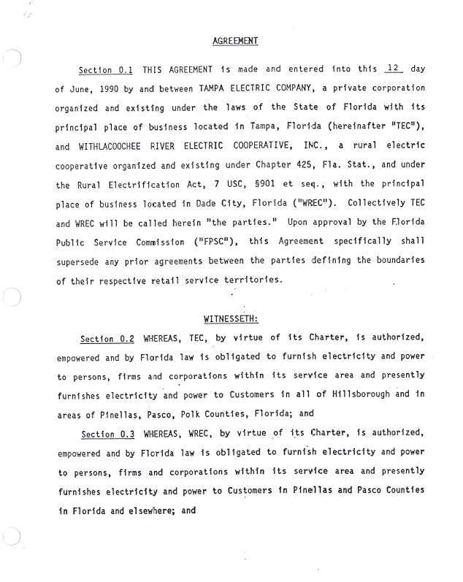
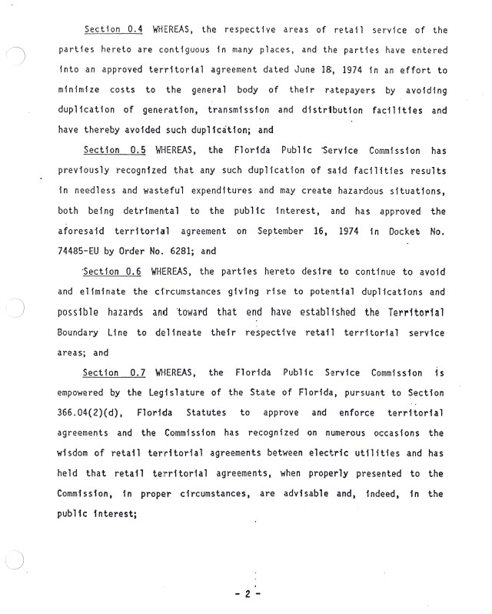
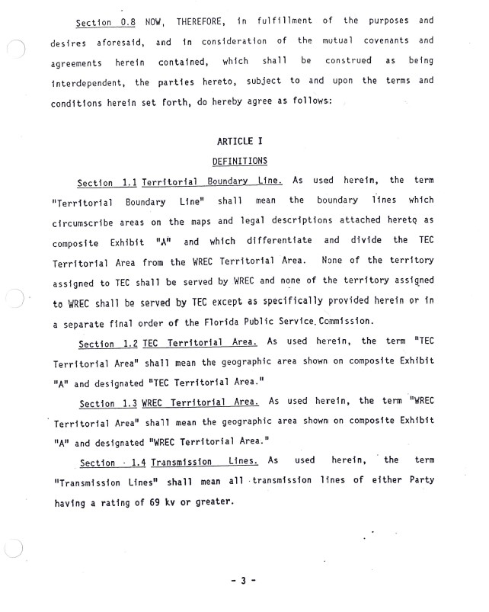
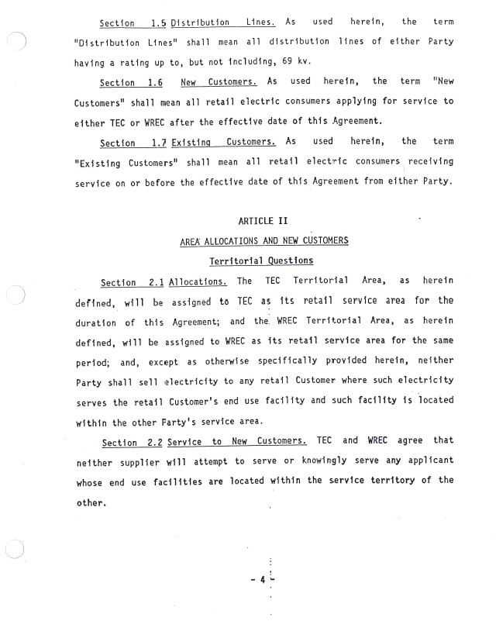
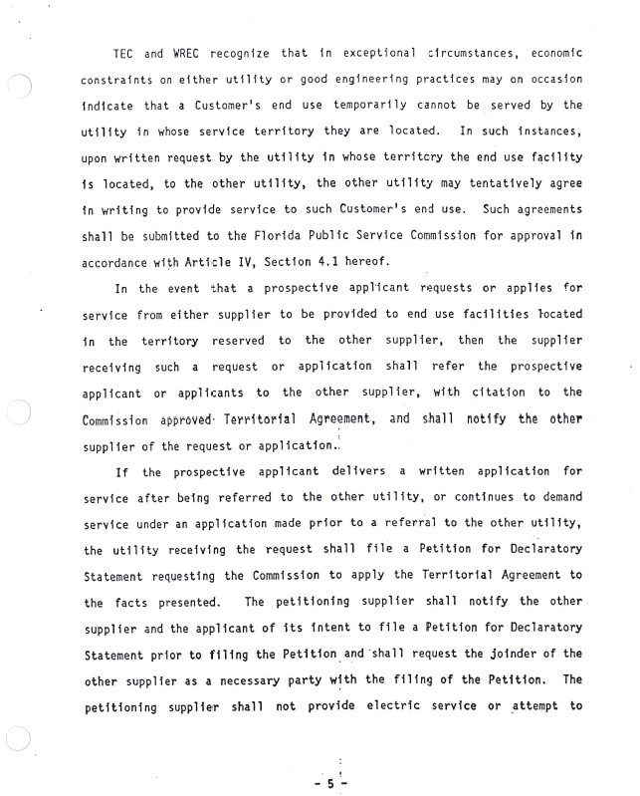
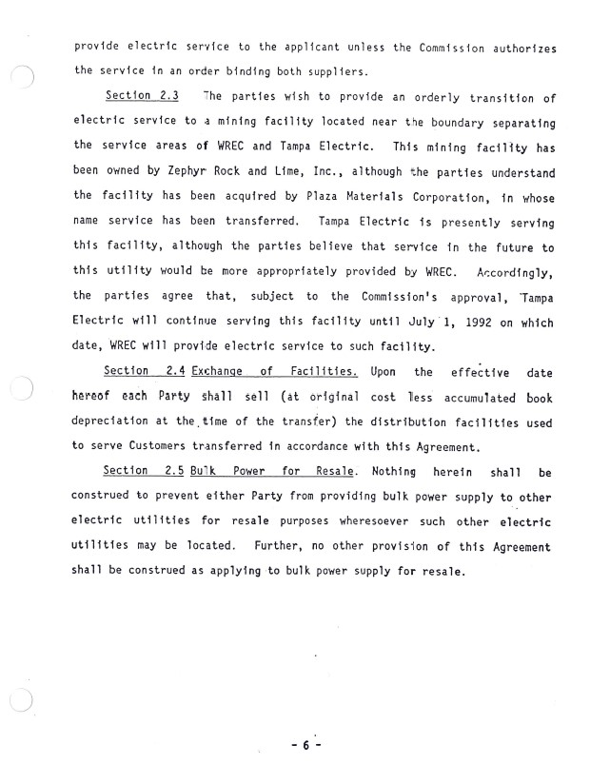
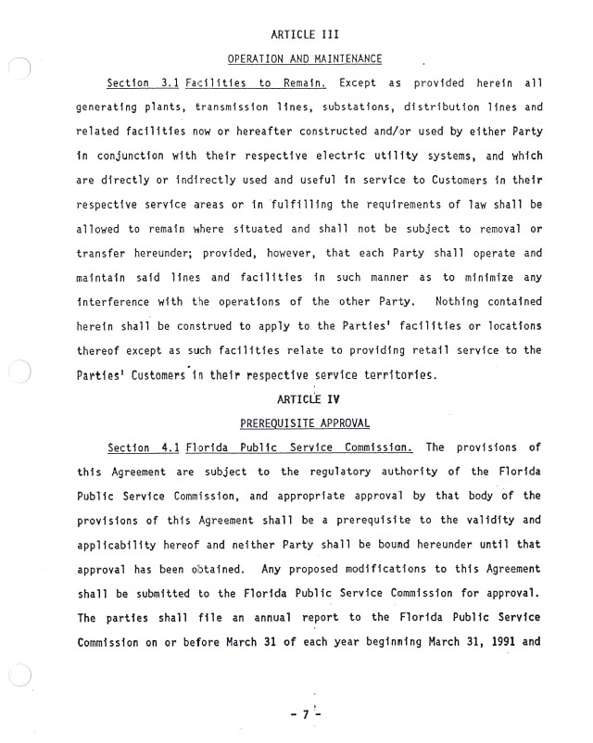
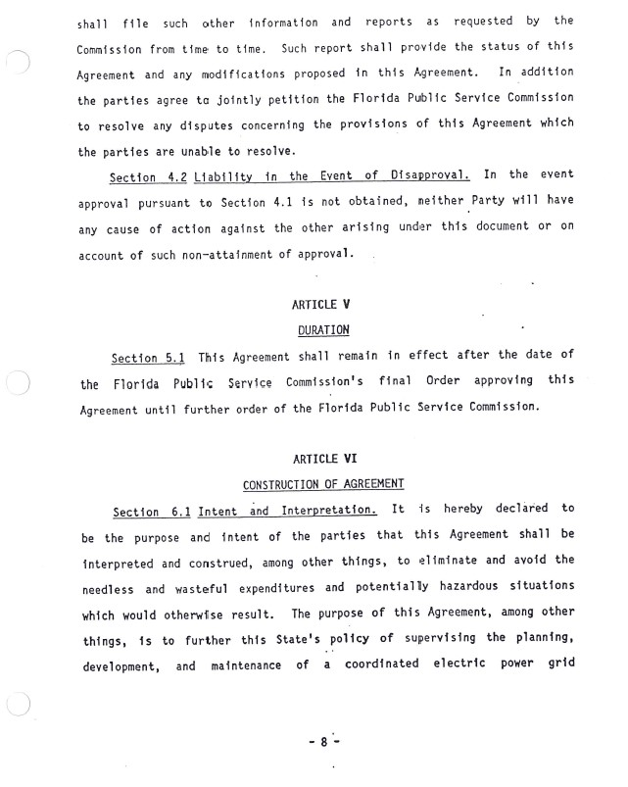
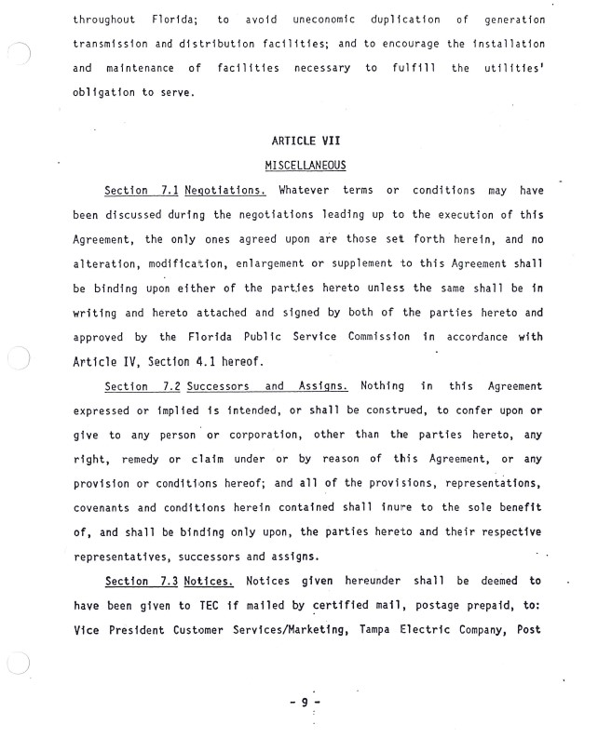
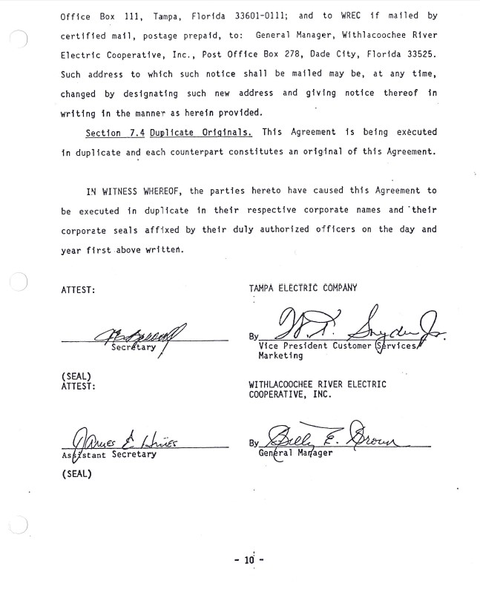
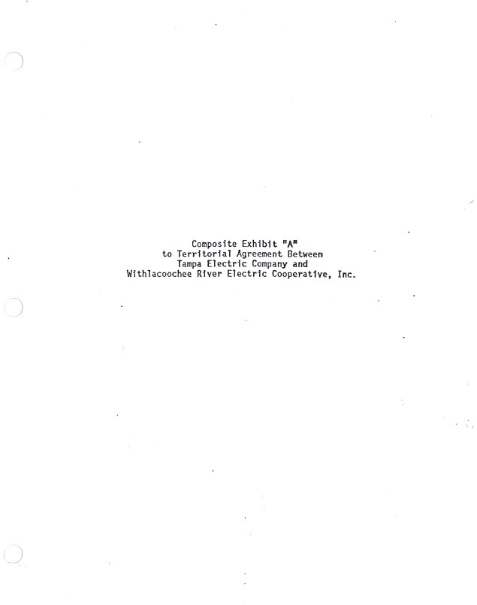
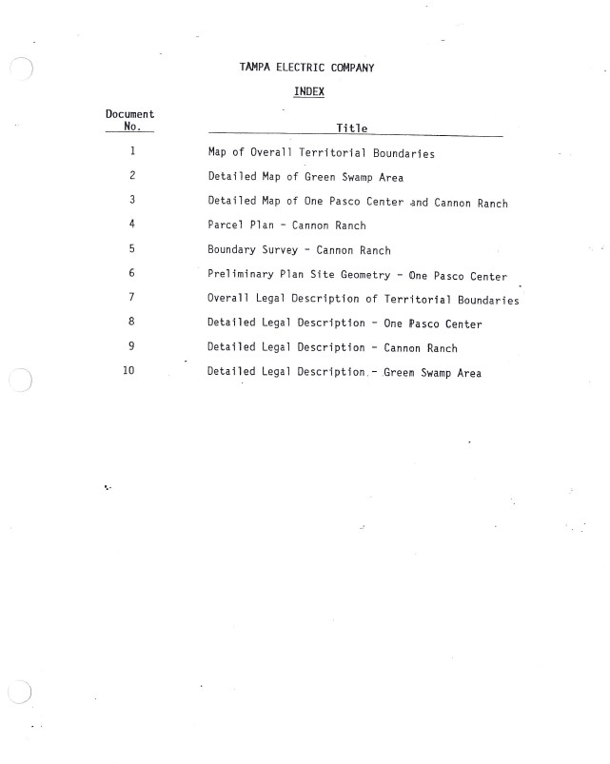
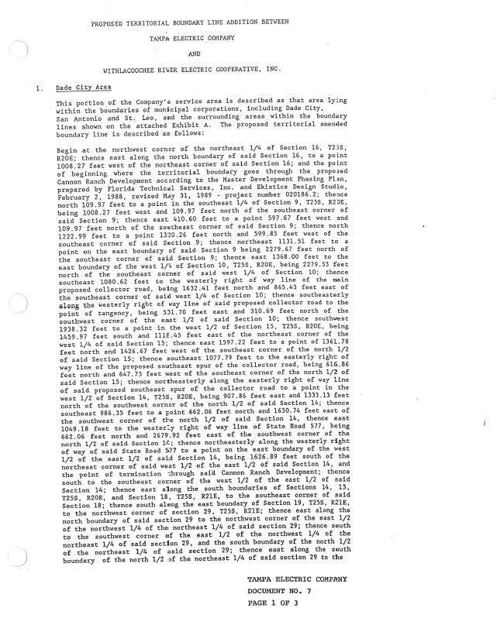
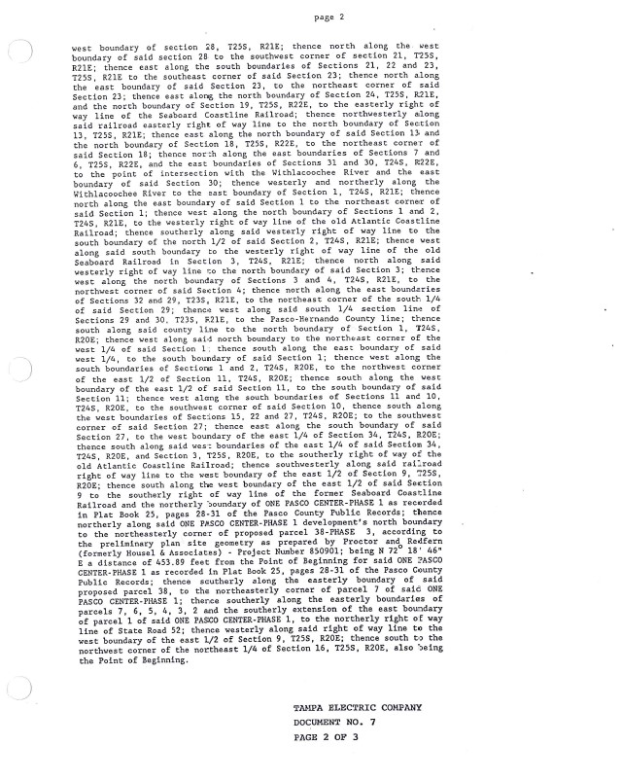
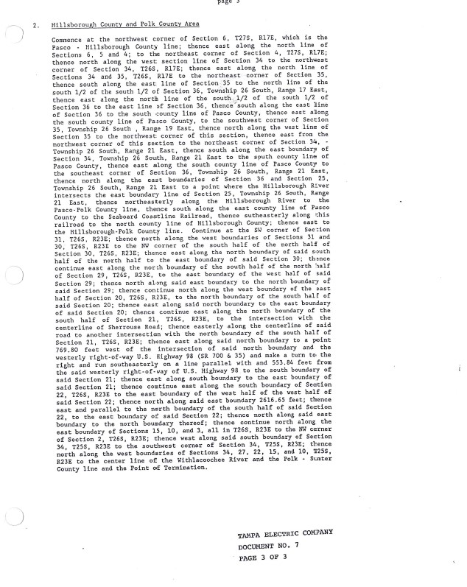
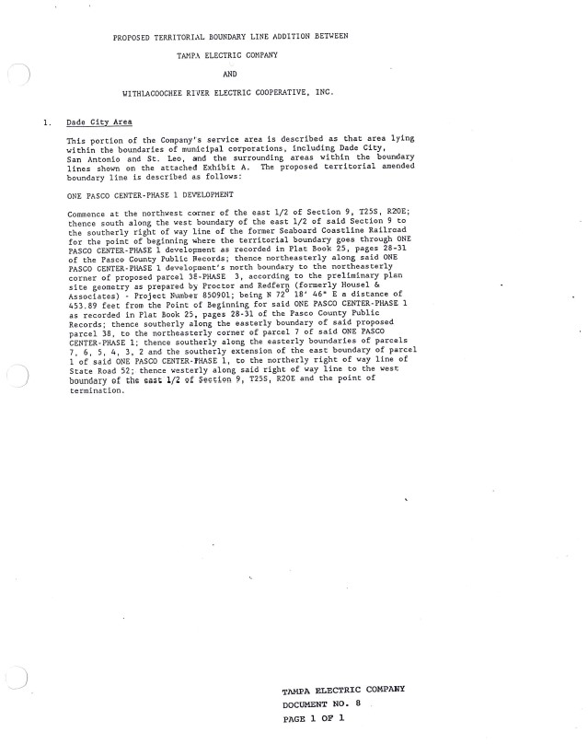
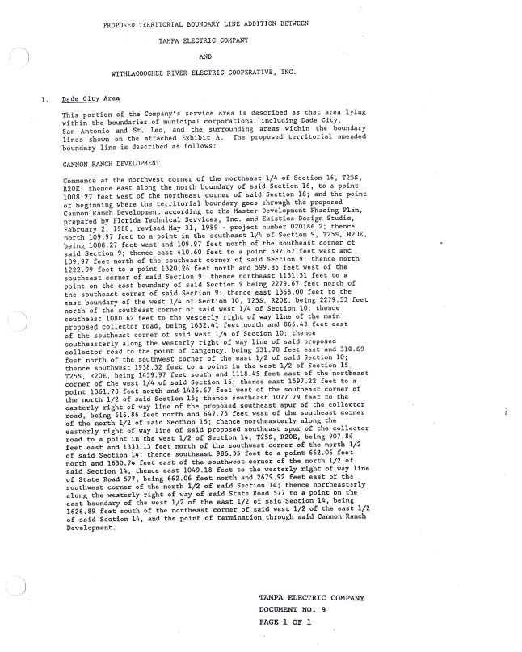
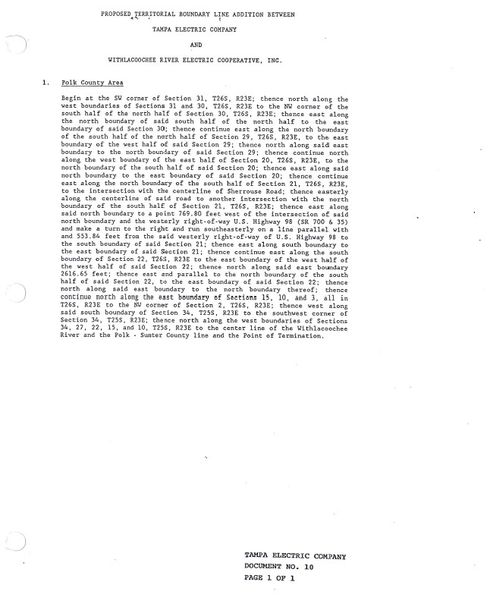
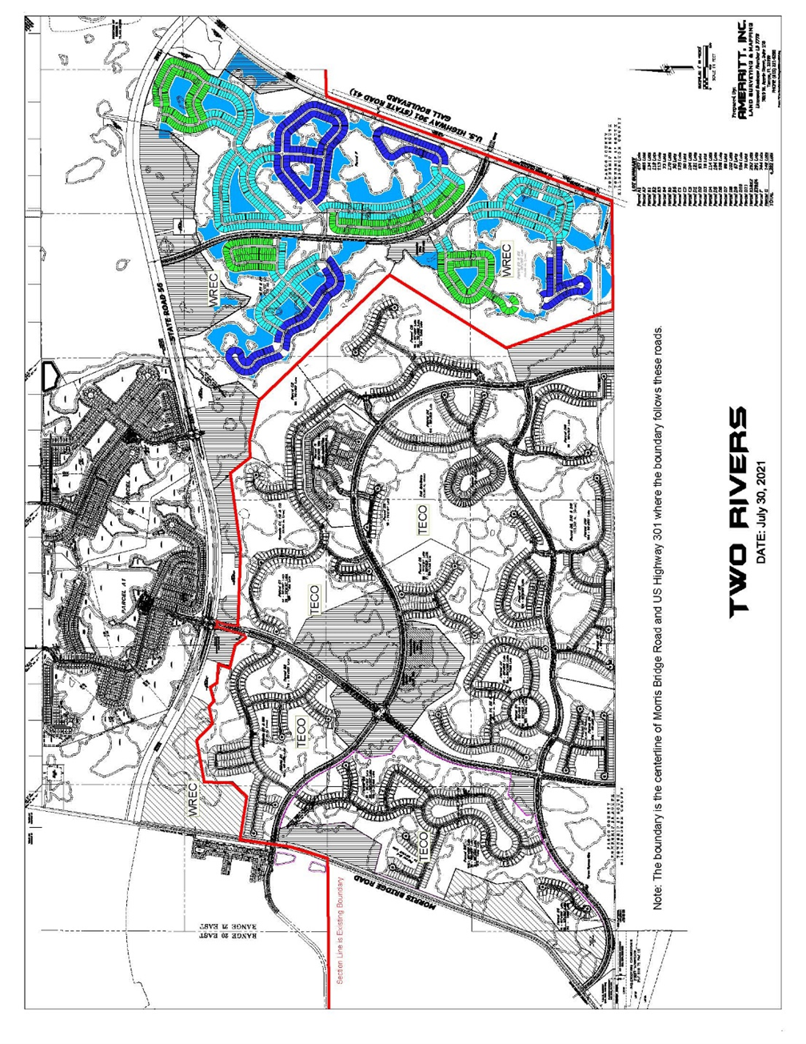

Order No. 6281, issued September 16, 1974, in Docket No. 1974485-EU, In re: Application of Tampa Electric Company for approval of territorial agreement with Withlacoochee River Electric Cooperative, Inc., relative to respective retail electric systems and service areas.
Order No. 23905, issued December 20, 1990, in Docket No 19900752-EU, In re: Joint Petition for Approval of 1990 Amendment to Territorial Agreement by Tampa Electric Company and Withlacoochee River Electric Cooperative, Inc.
Order No. PSC-06-0128-PAA-EU, issued February 16, 2006, in Docket No. 20041408-EU, In re: Joint petition of Tampa Electric Company and Withlacoochee River Electric Cooperative, Inc. for expedited interim approval of customer transfers pending consideration of joint application for permanent relocation of territorial boundaries.
Order No. PSC-17-0241-PAA-EU, issued June 21, 2017, in Docket No. 20170068-EU, In re: Joint petition for approval of amendment to territorial agreement, by Tampa Electric Company and Withlacoochee River Electric Cooperative, Inc.

