BEFORE THE FLORIDA PUBLIC SERVICE COMMISSION

In re: Petition to modify tariff to close existing lighting tariff to new business and introduce new LED lighting tariff by Florida Public Utilities Company. | DOCKET NO. 20220011-EI  ORDER NO. PSC-2022-0132-TRF-EI  ISSUED: April 8, 2022

The following Commissioners participated in the disposition of this matter:

ANDREW GILES FAY, Chairman
ART GRAHAM
GARY F. CLARK
MIKE LA ROSA
GABRIELLA PASSIDOMO

ORDER APPROVING LED LIGHTING TARIFF

BY THE COMMISSION:
BACKGROUND

On January 3, 2022, Florida Public Utilities Company (FPUC or utility) filed a petition requesting Commission approval to modify its Lighting Service tariff (Rate Schedule LS). Currently, Rate Schedule LS offers customers various High Pressure Sodium (HPS) and Metal Halide (MH) outdoor lighting options. In its petition, FPUC proposed to close the existing HPS and MH fixture options to new customers and offer new Light Emitting Diode (LED) fixture options.
Our staff issued a data request on January 26, 2022, with responses filed by the utility on February 9, 2022. In its response, FPUC submitted revised tariff sheets Nos. 56, 57, and 58 to reflect corrections made to the cost support for the LED fixtures. The revised tariffs are included as Attachment A to this order. On January 12, 2022, FPUC filed a letter in this docket waiving the 60-day file and suspend provision of Section 366.06(3), Florida Statutes (F.S.). We have jurisdiction over this matter pursuant to Sections 366.04, 366.05, and 366.06 F.S.
DECISION

FPUC, under Rate Schedule LS, currently provides outdoor lighting service offering HPS and MH fixtures. The utility requested approval to modify its Rate Schedule LS to close the existing HPS and MH fixture options to new customers and to offer new customers fifteen LED fixture options. Current customers served under Rate Schedule LS would remain on the HPS and MH fixture rates and would not see a change in their lighting bill. If a customer served under Rate Schedule LS needs to replace a light fixture, it would be replaced with an LED fixture and billed under the new LED fixture rates. All new lighting customers would be served under the proposed new LED lighting rates.

Closure of HPS and MH Fixtures
To support its petition, FPUC explained that as technology advances in the lighting market, the demand for HPS and MH fixtures has decreased, while the demand for LED lighting has increased. LED is a type of solid-state light that uses a semiconductor to convert electric current to visible light. LED lighting is a more energy efficient lighting source compared to its predecessors HPS and MH lights. Along with demand decreasing for HPS and MH lights, manufacturers have begun to phase out traditional product lines for HPS and MH lighting sources and replace them with the more energy efficient LED production.
New LED Fixtures
FPUC has proposed to add fifteen new LED fixture rate options: five cobra heads, four decorative, four flood lights, and two shoe box with varying lamp lumens and watt sizes. The charges for the new LED lighting fixtures are comprised of three components: the fixture, maintenance, and energy charges. The fixture charge includes the estimated total cost to install an LED fixture and any carrying costs and taxes. The maintenance charge is the cost associated with maintaining the LED fixture for its expected service life. The energy charge is calculated by multiplying the estimated energy usage of the fixture by the lighting non-fuel energy charge. The new LED fixtures and associated charges can be seen on tariff sheet No. 57.
In conjunction with its petition, the utility submitted supporting cost information for the proposed LED fixture, maintenance, and energy charges. In its response to our staff’s data request, the utility made two corrections to its originally-submitted calculations. With previous lighting options, there was a need to factor power loss into the calculation. However, with LED technology, there is no longer a need to factor in a power loss adjustment. Thus, the utility removed the eighteen percent power loss calculation that was originally submitted with the petition.
Along with that change, the utility stated that an adjustment was needed in its original overhead calculation. FPUC determined the correct percentage for the overhead calculation should be decreased from 35 percent to 34 percent. These two cost calculation adjustments resulted in a decrease to the proposed LED fixture rates submitted with the original petition. The revised tariff sheets, which include these corrections, were submitted with the utility’s data request responses and are attached as Attachment A to this order. We have reviewed these changes and find them to be appropriate and reasonable.
FPUC has provided us with documentation that supports closing the HPS and MH lighting rates to new customers and to offer LED lighting rates in its place. This should not only decrease energy used by FPUC subscribers, but should also lower operating and maintenance costs for the utility. We have approved similar petitions to close existing HPS and MH fixture options to new customers and offer LED fixture options. All pertinent information in the docket and the cost support submitted to us have been reviewed and analyzed.
Based on our review of the information and cost support materials submitted to us, we approve FPUC’s proposed modifications to the Rate Schedule LS lighting tariff as shown on Attachment A to this order. The proposed new LED fixture options are cost based and expand the fixture options available to customers. Closing the current HPS and MH options for new installations allows FPUC to recognize energy efficiencies and technological improvements in the lighting industry.
Based on the foregoing, it is
ORDERED by the Florida Public Service Commission that Florida Public Utilities Company’s Petition to Modify Tariff to Close Existing Lighting Tariff to New Business and Introduce New LED Lighting Tariff is hereby granted as stated in the body of this order. It is further
ORDERED that if a protest is filed within 21 days of the issuance of the order approving the proposed tariffs, the current tariffs shall remain in effect pending resolution of the protest. If no timely protest is filed, revised tariff sheets Nos. 56, 57, and 58, Rate Schedule LS Lighting Service, shall become effective, and the docket closed, upon the issuance of a Consummating Order.
By ORDER of the Florida Public Service Commission this 8th day of April, 2022.
/s/ Adam J. Teitzman
ADAM J. TEITZMAN
Commission Clerk
Florida Public Service Commission
2540 Shumard Oak Boulevard
Tallahassee, Florida 32399
(850) 413-6770
www.floridapsc.com

Copies furnished: A copy of this document is provided to the parties of record at the time of issuance and, if applicable, interested persons.

SBr
NOTICE OF FURTHER PROCEEDINGS

The Florida Public Service Commission is required by Section 120.569(1), Florida Statutes, to notify parties of any administrative hearing or judicial review of Commission orders that is available under Sections 120.57 or 120.68, Florida Statutes, as well as the procedures and time limits that apply. This notice should not be construed to mean all requests for an administrative hearing or judicial review will be granted or result in the relief sought.

Mediation may be available on a case-by-case basis. If mediation is conducted, it does not affect a substantially interested person's right to a hearing.

The Commission's decision on this tariff is interim in nature and will become final, unless a person whose substantial interests are affected by the proposed action files a petition for a formal proceeding, in the form provided by Rule 28-106.201, Florida Administrative Code. This petition must be received by the Office of Commission Clerk, 2540 Shumard Oak Boulevard, Tallahassee, Florida 32399-0850, by the close of business on April 29, 2022.

In the absence of such a petition, this Order shall become final and effective upon the issuance of a Consummating Order.

Any objection or protest filed in this docket before the issuance date of this order is considered abandoned unless it satisfies the foregoing conditions and is renewed within the specified protest period.

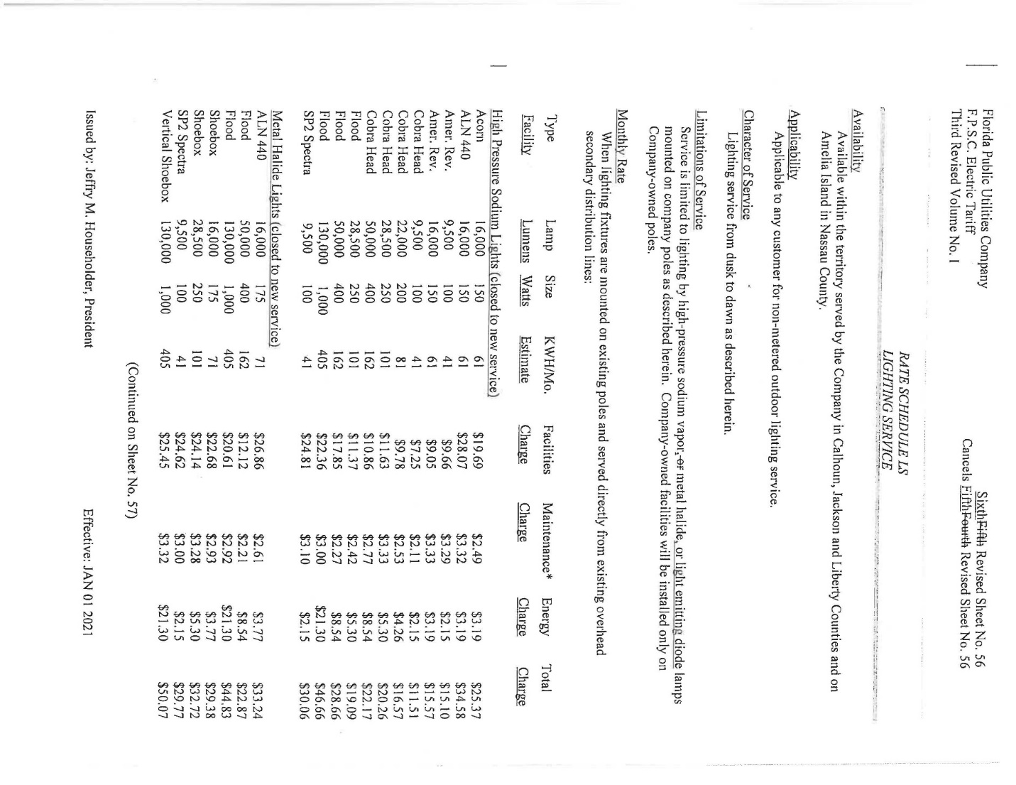

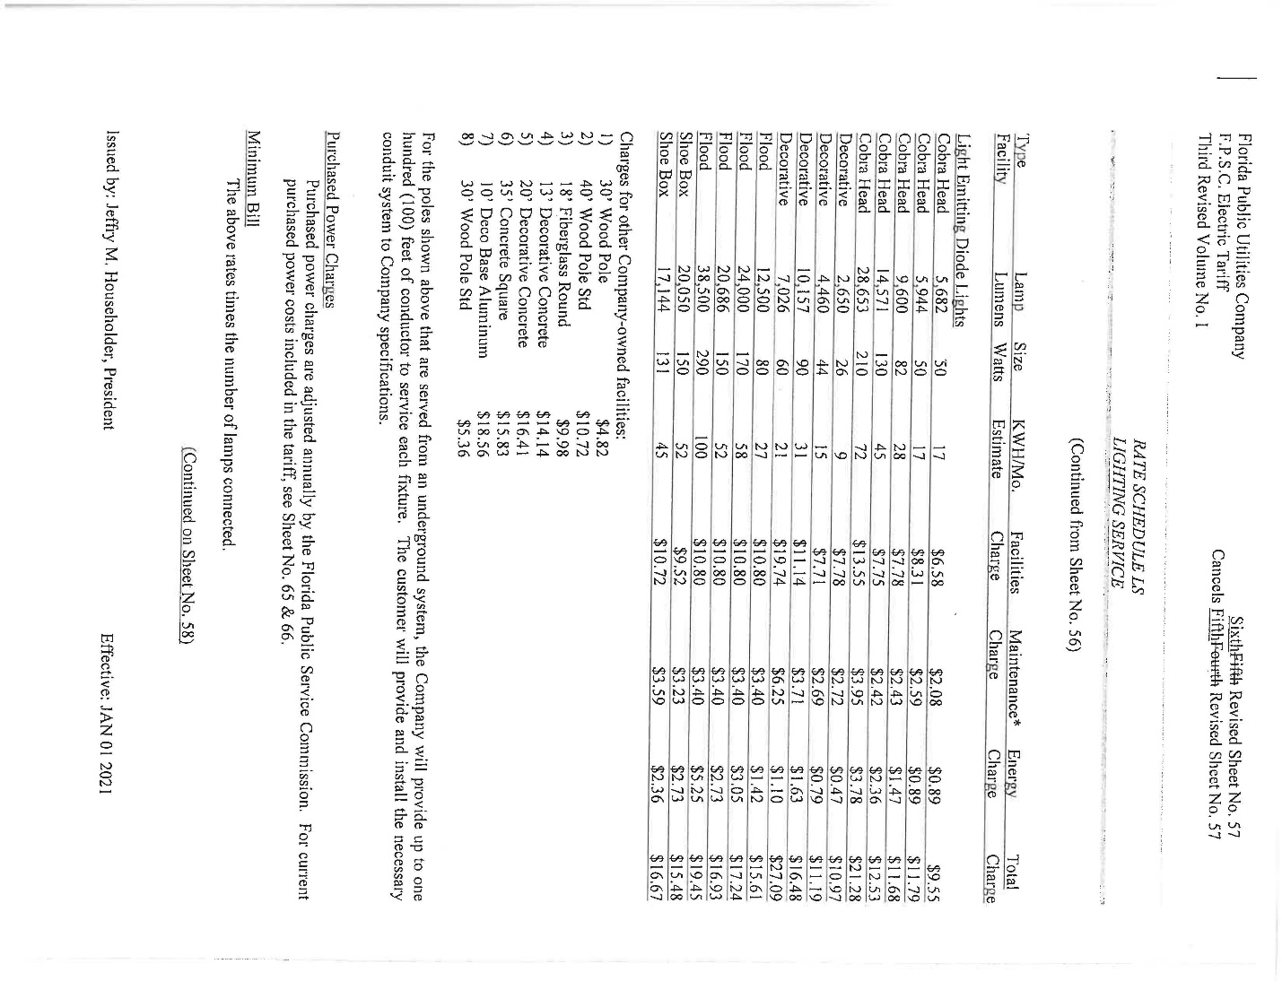

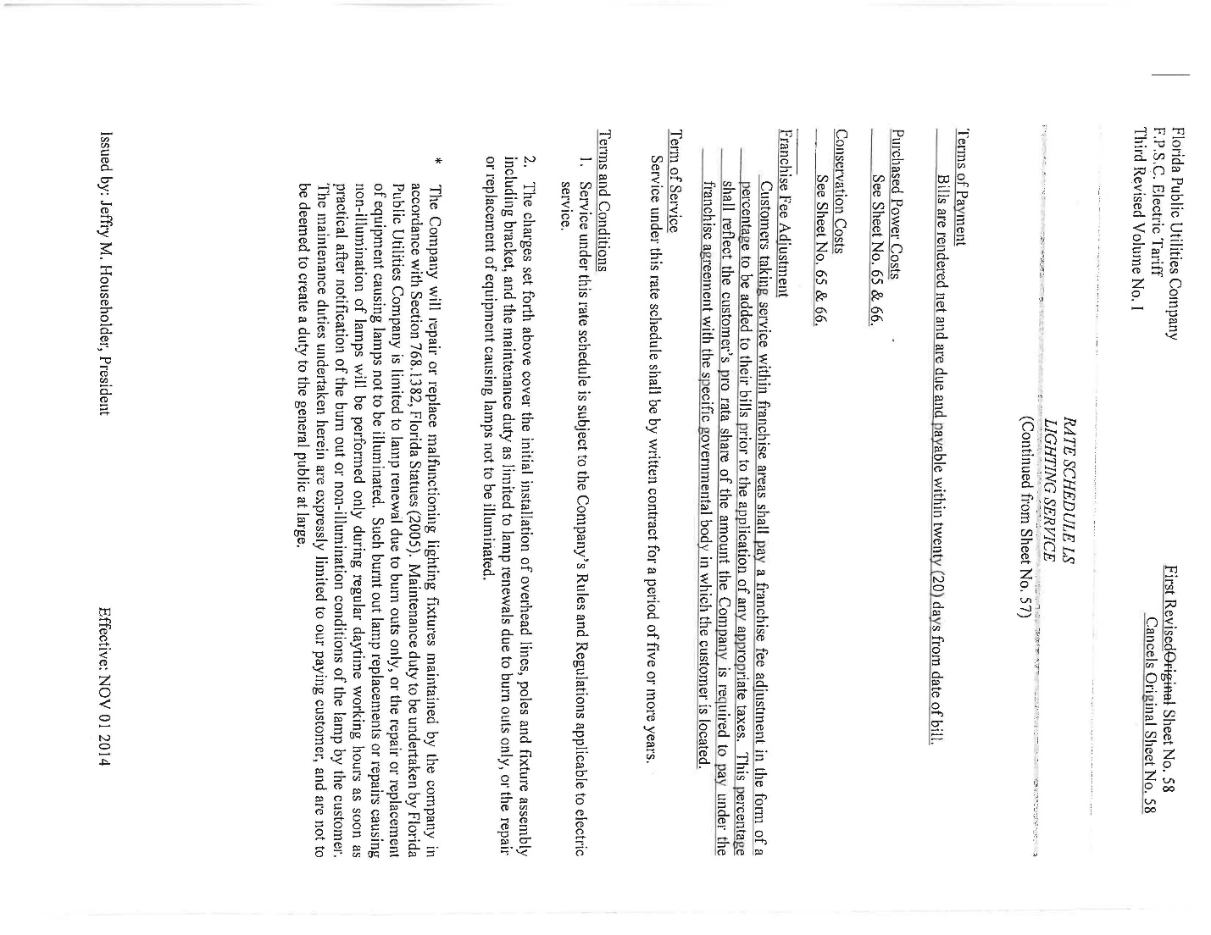

Order No. PSC-2019-0100-TRF-EI, issued March 13, 2019, in Docket No. 20190023-EI, In re: Petition for approval of modifications to rate schedule LS-1, lighting service, by Duke Energy Florida, LLC., and Order No. PSC-15-0094-TRF-EI, issued February 5, 2015, in Docket No. 20140232-EI, In re: Petition for approval of revised lighting tariff by Tampa Electric Company.

