State of Florida |  | Public Service Commission  Capital Circle Office Center ● 2540 Shumard Oak Boulevard  Tallahassee, Florida 32399-0850  -M-E-M-O-R-A-N-D-U-M-
DATE: | June 24, 2022
TO: | Office of Commission Clerk (Teitzman)
FROM: | Division of Economics (Barrett, Coston)  Office of the General Counsel (Sandy)
RE: | Docket No. 20220003-GU – Purchased gas adjustment (PGA) true-up
AGENDA: | 07/07/22 – Regular Agenda – Interested Persons May Participate
COMMISSIONERS ASSIGNED: |  |  | All Commissioners
PREHEARING OFFICER: |  |  | La Rosa
CRITICAL DATES: |  |  | 07/7/22
SPECIAL INSTRUCTIONS: |  |  | None

Case Background
On May 26, 2022, Peoples Gas System (Peoples or Company) filed a Petition for a Mid-Course Correction of its purchased gas adjustment factor cap (PGA cap) (Petition). In its Petition, Peoples asserts that, without a mid-course adjustment to its PGA cap, it expects an under-recovery of costs greater than 10 percent of 2022 projected revenues. Peoples requested that, in order to reduce rate impact, its Petition should be heard at the July 7, 2022 Agenda Conference and that the requested factor adjustment be effective with the first billing cycle in August through the last billing cycle for December 2022. The currently-effective PGA cap was established in Order No. PSC-2021-0437-FOF-GU (2021 PGA Order). At Page 3 in the 2021 PGA Order, the Commission approved a levelized PGA cap for Peoples for the period January 2022 through December 2022 of $1.19163 per therm. The Company seeks a mid-cycle adjustment because recent market price projections for natural gas significantly exceed the price projections that were used to set the current PGA cap. Absent a correction, this projected increase in the price of natural gas is expected to result in a relatively large under-recovery of PGA costs by the end of 2022.
Peoples’ Petition conforms to requirements previously established by the Commission for seeking a mid-course correction to forecasted gas expenses. The Commission has previously approved mid-course corrections to the PGA cap for several utilities when the amount of projected under recovery was substantial.
Issue 1 in this recommendation addresses the PGA cost differences and the proposed related adjustment to the PGA cap. The proposed effective date of the revised PGA cap, as reflected in the proposed tariff sheet revision, is addressed in Issue 2. The revised tariff sheet is included as Attachment A to this recommendation.
The Commission is vested with jurisdiction over the subject matter of this proceeding by the provisions of Chapter 366, Florida Statutes (F.S.), including Sections 366.04, 366.05, and 366.06, F.S.

Discussion of Issues

Issue 1:
Should the Commission approve the Petition for Mid-Course Correction filed by Peoples Gas System?

Recommendation:
Yes. The Commission should approve the Petition for Mid-Course Correction filed by Peoples Gas System. Adjusting the PGA cap as proposed by the Company would allow it the opportunity to timely recover the recent market-driven escalation in the Company’s forecasted costs for natural gas that are expected to be much higher than originally forecasted. (Barrett)

Staff Analysis:

Summary of Petition
By Order No. PSC-2021-0437-FOF-GU (2021 PGA Order), the Commission approved Peoples’ levelized PGA cap factor of $1.19163 per therm, effective with the first billing cycle for January 2022. Since implementing the current PGA cap, Peoples has monitored its natural gas cost recovery revenue and expenses on an ongoing basis, and based upon the actual 2021 results and updated estimates for 2022, the Company now projects that an under-recovery greater than 10 percent is likely to occur absent a modification to the PGA cap.
In its revised projection for the remainder of 2022, the Company estimates that the expense for purchasing natural gas will significantly exceed the revenues that are projected to be recovered via the currently-approved levelized PGA cap. Specifically, the revised 2022 expense for purchasing natural gas is estimated to be $194,212,488, while the projected revenues for the same period would be $177,743,492. When this difference between expenses and revenues is coupled with the true-up balances, interest charges, and other adjustments, the end-of-year (2022) true-up balance is projected to be an under-recovery of $23,491,901. The Company asserts that unless a mid-course correction is made for the remainder of 2022, the true-up balance of $12,048,954 under-recovery that existed at the beginning of 2022 is estimated to increase to $23,491,901 by the end of December 2022.
Peoples asserts that the primary cause of the projected 2022 under-recovery is a significant increase in projected 2022 natural gas prices, yielding higher costs than the projected costs that were used to establish the currently-approved PGA cap. According to Peoples, since the issuance of the 2021 PGA Order, a convergence of inter-related factors has “resulted in an extraordinary environment affecting natural gas pricing.” These factors include strong liquified natural gas (LNG) exports, geopolitical uncertainty caused by Russia’s military invasion of Ukraine, lower-than-projected storage inventory levels, demand for natural gas exceeding current natural gas production levels, and atypical weather patterns. (Petition at 3) Peoples believes resetting the PGA cap for August through December of 2022 would provide its customers with the appropriate price signal, while at the same time allow it to recover the reprojected costs for purchased natural gas.
Peoples is proposing to reset its PGA cap from $1.19163 per therm to $1.70492 per therm, effective with the first billing cycle of August 2022 through the last billing cycle of December 2022. If approved, applying this revised PGA cap will allow the Company to address the under-recovered true-up balance, although it may not eliminate the full amount of the re-projected expenses if natural gas prices continue to increase. However, Commission approval of this mid-cycle action would allow the Company to reduce the impact of the true-up balance in 2022, and thereby mitigate having to do so during the year 2023, for customers who are subject to the PGA. If approved, the Company states that the average RS-2 residential customer with monthly consumption of 14 therms would incur an additional gas cost of $7.19 per month if natural gas costs require the PGA to increase to the proposed new PGA cap between August and December.
A revised tariff sheet in “clean” and “legislative” formats is attached to the Company’s Petition. Because the Company is requesting an effective date beginning with the first billing cycle in August 2022, Peoples requested consideration of this Petition on or before the July 7, 2022 Commission Agenda Conference in order to allow it to provide notice to customers. The Company’s proposed effective date and revisions to its tariff are addressed in Issue 2.

Analysis
In projecting its costs for natural gas, the Company evaluates New York Mercantile Exchange (NYMEX) natural gas futures settlement prices. For 2022, this evaluation was done in July 2021, resulting in a average price of $3.40 per MMBTU. In the 2021 PGA proceeding, Peoples’ witness Bramley testified that a significant weather event earlier in February 2021 caused daily cash prices for natural gas to set records across much of the United States. In testimony dated August 6, 2021, she stated:
However, starting in May [of 2021] and continuing into July, the current and forward price for natural gas has continued to increase. Unlike the temporary natural gas price movements Peoples experienced in February [of 2021], with Winter Storm Uri, the increases seen since May are expected to be a fundamental market shift that continues for the current year and into 2022. The drivers of this change are low natural gas storage levels, high demand for liquefied natural gas exports, extreme weather, and low production growth. (TR 47)
Updated NYMEX natural gas futures settlement prices for 2022 were evaluated and averaged over May 4-10, 2022 (excluding weekends), indicating an annual average of $7.00 per MMBTU, which is more than double the average that was forecasted at the time the original 2022 forecast was prepared ($3.40 per MMBTU). Staff notes that the factors driving this increase, per the Company’s Petition in this case, are nearly identical to those factors cited by the Company in the development of the current PGA cap. In its Petition, the Company also noted that current events in Ukraine have influenced natural gas market prices. Staff agrees that it is reasonable to conclude that these are causative factors impacting recent increases in natural gas prices and price futures.
The underrecovery of costs in 2022 is not based on year-to-date actual outcomes of PGA expenses, revenues, and other adjustments, but rather projected PGA expenses exceeding projected revenues for the last 7 months of 2022. During this forward-looking 7-month period, expenses are expected to significantly exceed revenues due primarily to the aforementioned increases in the projected price of natural gas.
Absent the instant pleading, staff believes November’s cost recovery hearing would be the forum for Peoples to seek recovery of its actual and estimated costs. However, as the Petition demonstrates, Peoples is expecting to incur higher market prices than originally projected for natural gas, resulting in an estimated 2022 year-end under-recovery balance of $23,491,901.
Based on the data provided in Peoples’ revised forecast, staff calculated the mid-course correction percentage by comparing the projected 2022 year-end under-recovery balance ($23,491,901) to the projected 2022 revenues ($177,743,492). The resulting mid-course correction percentage, 13.22 percent, exceeds the 10 percent trigger for mid-course correction procedures as identified in Order No. PSC-93-0708-FOF-GU.
Staff believes addressing the imbalance in costs at an earlier occasion is preferred over waiting until November’s hearing to do so. Although the Commission sets a levelized PGA cap, utilities have the flexibility to charge a lower factor on monthly bills. A mid-cycle change to reset the PGA cap is an opportunity for the Commission to be responsive to the market-driven escalation in forecasted costs. While it is possible that market prices between now and November’s hearing could change in a manner that would reduce the projected under-recovery balance, the opposite is possible as well. Absent any action, the higher or lower true-up balance would be addressed at the November evidentiary hearing in this docket, when the Commission sets the Company’s 2023 PGA cap. However, staff believes a PGA cap change implemented for the August through December 2022 billing cycles is more timely. Staff believes this action will greatly reduce the true-up balance through the remaining months of 2022, and the results of that action would, in turn, moderate or eliminate the portion of the 2023 PGA cap that is calculated from the end-of-year (2022) true-up balance.
In addition, it is important to note that, while the instant Petition addresses a proposed revision to the PGA cap for Peoples, the determination of prudence of PGA costs incurred is reserved as an issue to be resolved at the time of the hearing or in a subsequent Commission Agenda Conference. Any costs found to be imprudently incurred and recovered would be a matter to be addressed by the Commission at that time.

Bill Impact for typical residential customer
The revised PGA cap the Company is recommending is $1.70492 per therm, an increase of approximately $0.51 cents per therm. If approved, the Company stated that an average residential customer taking service under the RS-2 tariff with monthly consumption of 14 therms would incur an additional gas cost of $7.19 per month, for the August through December 2022 billing cycles. Staff typically assumes average residential usage of 20 therms per month for comparative purposes. A sample bill for a residential customer on the RS-2 rate schedule using 20 therms of natural gas is shown below in Table 1-1. Based on the proposed PGA cap adjustment, a residential customer taking service under the RS-2 tariff with monthly consumption of 20 therms would incur an additional gas cost of $10.27 per month, for the August through December 2022 billing cycles.
Table 1-1
Sample Bill for Residential Customer on the
RS-2 Rate Schedule Using 20 Therms
Invoice Component | Currently-Approved Charges  for July, 2022  ($) | Proposed New Charges for  Aug-Dec, 2022  ($) | Current to Proposed Difference  ($) | Current to Proposed Difference  (%)
Customer Charge | $18.10 | $18.10 | - | -
Distribution Charge (factor = 0.42721) | 8.54 | 8.54 | - | -
Purchased Gas Adjustment | 23.83 | 34.10 | $10.27 | 43.10%
Gross Receipts Tax | 1.03 | 1.03 | - | -
Total Bill | $51.50 | $61.77 | $10.27 | 19.94%
Source: Peoples provided this information to staff, noting that Franchise Fees and Municipal Public Service Taxes are not included for this sample bill, because both values are dependent upon the customer’s location.

Conclusion
Staff recommends the Commission approve the Petition for Mid-Course Correction filed by Peoples Gas System. Adjusting the PGA cap as proposed by the Company would allow Peoples the opportunity to timely recover the recent market-driven escalation in the Company’s forecasted costs for natural gas that are expected to be much higher than originally forecasted.

Issue 2:
If approved by the Commission, what is the appropriate effective date for Peoples’ revised levelized PGA cap?

Recommendation:
The appropriate revised levelized PGA cap shown on Attachment A (tariff sheet No. 7.101-1) should become effective with the first billing cycle of August 2022. (Coston)

Staff Analysis:
In its Petition, Peoples has requested that the proposed revisions to the PGA cap and associated tariffs become effective beginning with the first billing cycle of August 2022, which starts August 2, 2022. Under this request, the effective date of the increase would be 26 days post-Commission vote. Attachment A to this recommendation contains the proposed tariff sheet.
The Commission has considered the effective date of rates and charges of the revised PGA cap and for the levelized purchased gas adjustment cost recovery factors on a case-by-case basis. While petitions for purchased gas adjustment cost recovery mid-course corrections are infrequent, the Commission has approved an effective date less than 30 days from the Commission’s vote.
In Order No. PSC-05-1029-PCO-GU, the Commission approved a mid-course correction to Florida Public Utilities Company’s PGA cap on the effective date of the Commission’s vote. In 2001, the Commission approved requests by six natural gas utilities for mid-course corrections to their caps. In each of these cases, the Commission allowed the new cap to take effect the day of the Commission’s vote. In the 2001 cases, the Commission stated that the requests were driven by drastic increases in the price of natural gas.
For comparison purposes, over the last 20 years, in the electric Fuel Cost Recovery Clause docket, the Commission has approved fuel cost recovery factor rate decreases effective sooner than the next full billing cycle after the date of the Commission’s vote, with the range between the vote and effective date being from 25 to 2 days. The rationale for that action being that it was in the customers’ best interests to implement the lower rate as soon as possible. With regard to fuel cost recovery factor/rate increases, the Commission has approved an effective date of the revised factors ranging from 14 to 29 days after the vote. In two of these cases, the Commission noted that the utility had given its customers 30 days’ written notice before the date of the vote that a fuel cost recovery factor increase had been requested and provided the proposed effective date of the higher fuel factors. Staff believes the same rationale is applicable to a gas mid-course correction.
As previously noted, there are 26 days between the Commission’s vote on July 7, 2022, and the beginning of Peoples’ billing cycle on August 2, 2022. Staff notes that an effective date in August 2022 will provide the greatest number of months within 2022 over which to spread recovery, resulting in a lower potential monthly bill impact for Peoples’ customers.
On May 26, 2022, the Company added information about this Petition to its website, and bill and email notifications are planned for issuance with the July 1, 2022 billing cycle. Staff reviewed drafts of customer notifications prior to the issuance of bills for the July 2022 billing cycle. If approved, billing and email notifications will be issued with the August 2, 2022 billing cycle announcing the Commission’s decision on the matter. Per the Company, its webpage would also be updated to reflect the Commission decision.

Conclusion
Based on the above, staff recommends that the appropriate revised levelized PGA cap shown on Attachment A should become effective with the first billing cycle of August 2022.

Issue 3:
Should this docket be closed?

Recommendation:
No. Docket No. 20220003-GU is an on-going proceeding and should remain open. (Sandy)

Staff Analysis:
Docket No. 20220003-GU is an on-going proceeding and should remain open.

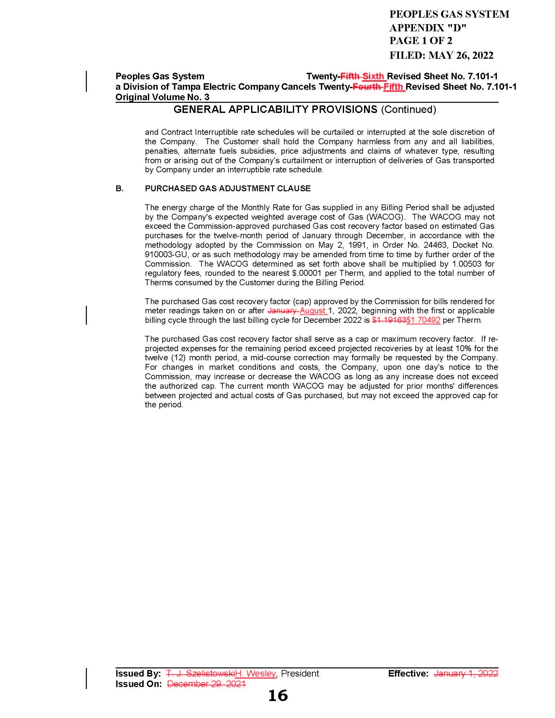

Document No. 03200-2022.
Order No. PSC-2021-0437-FOF-GU, Final Order Approving Purchased Gas Adjustment True-up Amounts and Establishing Purchased Gas Cost Recovery Factors To Be Applied During the Period of January 2022 through December 2022, issued November 22, 2021, in Docket No. 20210003-GU, In re: Purchased Gas Adjustment (PGA) true-up.
An annual docket is established to review the actual and estimated purchased gas costs. Ordinarily, the appropriate levelized purchased gas cost recovery (cap) factors for Peoples and the other investor-owner natural gas utilities are set/reset for a full 12-month period on an annual basis. The next hearing for the Purchased Gas Adjustment docket is scheduled to begin on November 1, 2022.
See Order No. PSC-05-1029-PCO-GU (2005 Mid-course Order, issued October 21, 2005, in Docket No. 20050003-GU, In re: Purchased Gas Adjustment (PGA) true up. (The Commission has adopted a method for recovery of purchased gas costs by regulated natural gas utilities by means of a levelized Purchased Gas Adjustment (PGA) factor to serve as a cap, or maximum recovery factor, for each calendar year commencing January 1 through December 31. The Commission has also adopted a method by which a utility may, at its option, request a mid-course correction if revised projected expenses for the remainder of the period significantly exceed projected revenues as calculated under the Commission-approved cap. The Commission has previously approved mid-course corrections to the PGA cap for several utilities when the amount of projected under recovery was substantial.)
See Order No. PSC-00-1910-PCO-GU, Chesapeake Utilities Corporation Mid-Course Correction, issued February 19, 2001, in Docket No. 010003-GU, In re: Purchased Gas Adjustment (PGA) True-up; Order No. PSC-00-1422-PCO-GU, City Gas Company of Florida Mid-Course Correction, issued February 19, 2001, in Docket No. 010003-GU, In re: Purchased Gas Adjustment (PGA) True-up; Order No. PSC-00-2137-PCO-GU, Florida Public Utilities Mid-Course Correction, issued February 19, 2001, in Docket No. 010003-GU, In re: Purchased Gas Adjustment (PGA) True-up; Order No. PSC-00-1524-PCO-GU, Peoples Gas System Mid Course Correction, issued February 19, 2001, in Docket No. 010003-GU, In re: Purchased Gas Adjustment (PGA) True-up; Order No. PSC-00-1909- PCO-GU, Indiantown Gas Company Mid Course Correction, issued February 19, 2001, in Docket No. 010003-GU, In re: Purchased Gas Adjustment (PGA) True-up; Order No. PSC-00-2138-PCO-GU, St. Joe Natural Gas Company Mid-Course Correction, issued February 19, 2001, in Docket No. 010003-GU, In re: Purchased Gas Adjustment (PGA) True-up.
Document No. 00411-2022, Peoples’ monthly PGA filing for December 2021 (Schedule A-2, Line 12).
The results of that analysis indicated the five-day average NYMEX Futures Natural Gas price of $3.40 per MMBTU. For forecasting purposes, Peoples adjusts that value to account for unexpected and unforeseen changes due to market forces over the forecasted period. The adjusted annual average price was $4.08 per MMBTU.
Document No. 12644-2021, Transcript –Volume 1, Page 1 to 63, of 11/2/21 hearing in Docket No. 20210003-GU.
The Company provided information that the adjusted value used for forecasting purposes was $7.47 per MMBTU. The adjustment of $0.47 per MMBTU is to account for unexpected and unforeseen changes due to market forces over the forecasted period. The Company also provided information on an analysis performed roughly a month later, indicating that current NYMEX future prices that the Company evaluated (as of June 6, 2022) for the 3rd and 4th quarter of 2022 exceed $9.00 per MMBTU.
As a general matter, supply disruptions in any market for natural gas will influence demand and commodity prices in other markets. Constrained supply would put upward pressure on market prices.
See Petition, Appendix A, Page 9.
Peoples Gas System Response to Data Request.
Order No. PSC-2005-1029-PCO-GU, Final Order Approving Mid-Course Correction, issued October 21, 2005, in Docket No. 20050003-GU, In re: Purchased Gas Adjustment (PGA) true-up.
See Order No. PSC-00-1910-PCO-GU, Chesapeake Utilities Corporation Mid-Course Correction, issued February 19, 2001, in Docket No. 010003-GU, In re: Purchased Gas Adjustment (PGA) True-up; Order No. PSC 00-1422- PCO-GU, City Gas Company of Florida Mid-Course Correction, issued February 19, 2001, in Docket No. 010003-GU, In Re: Purchased Gas Adjustment (PGA) True-up; Order No. PSC-00-2137-PCO-GU, Florida Public Utilities Mid-Course Correction, issued February 19, 2001, in Docket No. 010003-GU, In Re: Purchased Gas Adjustment (PGA) True-up; Order No. PSC-00-1524-PCO-GU, Peoples Gas System Mid Course Correction, issued February 19, 2001, in Docket No. 010003-GU, In Re: Purchased Gas Adjustment (PGA) True-up; Order No. PSC-00-1909- PCO-GU, Indiantown Gas Company Mid Course Correction, issued February 19, 2001, in Docket No. 010003-GU, In Re: Purchased Gas Adjustment (PGA) True-up; Order No. PSC-00-2138-PCO-GU, St. Joe Natural Gas Company Mid-Course Correction, issued February 19, 2001, in Docket No. 010003-GU, In Re: Purchased Gas Adjustment (PGA) True-up.
The website link for Peoples’ Frequently Asked Questions page, which contains information about the Petition, is: https://www.peoplesgas.com/rates/faq/

