BEFORE THE FLORIDA PUBLIC SERVICE COMMISSION

In re: Petition for approval of a new small commercial lighting tariff, by Tampa Electric Company. | DOCKET NO. 20220037-EI  ORDER NO. PSC-2022-0244-TRF-EI  ISSUED: June 27, 2022

The following Commissioners participated in the disposition of this matter:

ANDREW GILES FAY, Chairman
ART GRAHAM
GARY F. CLARK
MIKE LA ROSA
GABRIELLA PASSIDOMO

ORDER APPROVING NEW SMALL COMMERCIAL LIGHTING TARIFF

BY THE COMMISSION:

Background
On February 18, 2022, Tampa Electric Company (TECO or utility) filed a petition for approval of a new Small Commercial Bright Choices Outdoor Lighting Agreement tariff (Small Commercial lighting agreement or proposed Agreement). The proposed Small Commercial lighting agreement would allow customers requesting the installation of less than $20,000 of lighting equipment on commercial property to take lighting service on a month-to-month term. The proposed Agreement may be terminated by either party with 30 days’ notice. TECO further proposed several modifications and clarifications to its current lighting tariffs.
TECO provides outdoor lighting service to customers under its Lighting Service (LS-1) tariff. The LS-1 tariff provides the lighting rates for all fixture and pole options. LS-1 customers are also required to sign a lighting agreement, which specifies the terms and conditions of lighting service. Prior to 2022, all customers taking service under TECO’s LS-1 tariff were required to sign the standard, Commission-approved Bright Choices Outdoor Lighting Agreement, which specifies a primary contract term of 10 years.
As a provision of TECO’s 2021 rate case settlement agreement, we approved a Small Residential lighting agreement effective January 1, 2022. The Small Residential lighting agreement allows residential customers installing less than $10,000 of lighting equipment to take service under the LS-1 tariff on a month-to-month term instead of a primary term of 10 years. Customers installing more than $10,000 of lighting equipment on residential property are still required to sign the standard Bright Choices Outdoor Lighting Agreement.
This petition contains TECO’s proposal for a counterpart Small Commercial lighting agreement. The proposed Agreement contains similar language to the Small Residential Lighting Agreement and would allow customers seeking installation of lighting equipment costing less than $20,000 on commercial property to take service on a month-to-month term.
In Order No. PSC-2022-0140-PCO-EI, we suspended the proposed tariffs to allow our staff sufficient opportunity to review the petition and gather all pertinent information in order to present us with an informed recommendation on the tariff proposals. During the evaluation of the petition, Commission staff issued two data requests to TECO and received responses on March 28, 2022, and April 26, 2022. In response to the second data request, TECO filed revised tariff sheet Nos. 6.835 and 7.275 to clarify definitions and address questions that had been raised in the data requests. All revised tariff sheets, along with the original tariff sheets related to the proposed Agreement, are appended to this order as Attachment A.
We have jurisdiction over this matter pursuant to Sections 366.03, 366.04, 366.05, and 366.06, Florida Statutes (F.S.).

DECISION
The Agreement proposed by TECO is its petition is designed to provide commercial customers with more flexible terms than the 10-year term specified in the Bright Choices Outdoor Lighting Agreement. Under the proposed Agreement, customers requesting the installation of lighting equipment costing $20,000 or less on commercial property would agree to lighting service on month-to-month terms and would be charged for lighting facilities pursuant to TECO’s LS-1 tariffs. The terms of the proposed Agreement are consistent with the Commission-approved Small Residential lighting agreement.
TECO explained that the $20,000 installation cost maximum for the proposed Agreement is based on a common unit and quantity of fixtures and poles for a typical small commercial application. The utility also provided two examples for a typical small commercial lighting equipment installation costing approximately $20,000. For both overhead and underground service examples described, TECO stated that a typical installation would include between four and 12 fixture and pole units.
In the event a customer terminates the proposed Agreement in the short-term, TECO explained that there would be no impact to the general body of ratepayers. However, TECO stated that “there is an impact to lighting customers in the next rate proceeding as the cost of the facilities not producing revenues is included in the cost of service for all lighting customers if not removed.” TECO further explained that the facilities would remain in place as a new customer taking over the property typically requests that the existing lights be turned on and the utility does not plan to utilize the proposed Agreement in situations where service would be temporary or seasonal. If a new property owner requests removal of the lighting equipment, the equipment would either be salvaged or returned to stock for reuse.
Commission staff inquired regarding the amount of commercial lighting installations performed by TECO in the past year that were below the proposed $20,000 maximum installation cost. In response, the utility stated that it had performed a total of 140 installations for commercial customers in the year 2021, assuming that one lighting installation correlates to one lighting agreement. Of those 140 commercial lighting installations, 133, or 95 percent, had material costs less than $20,000. Furthermore, TECO explained that the average material cost of those 133 commercial lighting installations was $2,190.
The proposed Agreement may be terminated by either party, after providing the other with 30 days’ notice. In response to Commission staff’s second data request, the utility stated that there would be no removal costs or other fees for customers terminating the proposed Agreement, except in the event of light trespass. If removal of any equipment is the only practicable resolution for a light trespass objection, the customer would be responsible for the removal costs for the equipment that must be removed.
TECO explained that the proposed Agreement would also be available to commercial tenants. This is consistent with TECO’s Commission-approved standard Bright Choices Outdoor Lighting Agreement and Small Residential lighting agreement.

Other Lighting Tariff Revisions

In addition to the proposed Agreement, TECO has proposed several modifications and clarifications to its current lighting tariffs. The main modifications are described below. None of the modifications affect the lighting rates and charges customers pay.
In its LS-1 tariffs (tariff sheet Nos. 6.800-6.821), TECO proposes to reopen a style of pole that was previously closed to new customers and modify the non-standard facilities and service section. The Round style light pole (Rate Code 523) was previously closed in 2017 at the request of the utility. TECO explained that the Round style light pole was closed to new business because, at the time, there were few Round style light poles in service. TECO now proposes to reopen this pole style at the request of the City of Tampa. The City of Tampa has selected the Round style light pole as a signature pole for expanded use.
Tariff sheet No. 6.815 lists certain non-standard lighting facilities and services that are not typically provided by TECO as a part of a lighting installation. As a result, the requesting customer is responsible for the costs associated with those facilities and services. TECO explained that the proposal to modify the list to make clarifying edits and include additional non-standard services was in response to frequent questions from customers.
In its Customer Specified Lighting Service (LS-2) tariffs (tariff sheet Nos. 6.830 and 6.835), TECO proposed to add a definition of in-place value for any customers transferring from LS-1 to LS-2 service. The LS-2 tariff is available to customers, at the option of the utility, requesting special fixtures or poles that are not available under the LS-1 tariff and to bill customers for the fixture and maintenance costs, TECO applies a monthly charge calculated by multiplying 0.93 percent of the in-place value of the facilities.
In its Small Residential lighting agreement (tariff sheet Nos. 7.215-7.245), TECO proposed the following tariff clarifications. First, TECO added a provision to indicate that during construction or removal of lighting equipment, the requesting customer is responsible for the costs of custom sidewalk restoration. Second, TECO clarified that the customer is responsible for any removal costs if the lighting installation becomes objectionable to other parties (other than the customer) and removal of the lighting is the only practicable resolution.
The proposed clarifications to the Small Residential lighting agreement have also been incorporated in the proposed Small Commercial lighting agreement. We have reviewed the modifications described above and believe they are reasonable.
Based on our review of the information submitted to us, we approve TECO’s petition for a new proposed Agreement and other associated lighting tariff revisions. The proposed Agreement with a month-to-month term will benefit LS-1 customers seeking installation of lighting equipment costing less than $20,000 on commercial property. The proposed tariff sheets are contained in Attachment A to this Order. The proposed tariffs shall be effective upon the issuance of a consummating order.

Based on the foregoing, it is

ORDERED by the Florida Public Service Commission that Tampa Electric Company’s Petition for New Small Commercial Lighting Tariff is hereby approved as stated in the body of this order. It is further

ORDERED that if a protest is filed within 21 days of issuance of the order approving the proposed tariffs, the current tariffs shall remain in effect pending resolution of the protest. If no timely protest is filed, revised tariff sheets Nos. 6.800, 6.810, 6.815, 6.830, 6.835, 7.010, 7.215, 7.220, and 7.240, original tariff sheets Nos. 7.250, 7.255, 7.260, 7.265, 7.270, 7.275, and 7.280, which are appended to this order as Attachment A, shall become effective, and the docket closed, upon the issuance of a Consummating Order.

By ORDER of the Florida Public Service Commission this 27th day of June, 2022.

/s/ Adam J. Teitzman
ADAM J. TEITZMAN
Commission Clerk
Florida Public Service Commission
2540 Shumard Oak Boulevard
Tallahassee, Florida 32399
(850) 413-6770
www.floridapsc.com

Copies furnished: A copy of this document is provided to the parties of record at the time of issuance and, if applicable, interested persons.

SPS

NOTICE OF FURTHER PROCEEDINGS

The Florida Public Service Commission is required by Section 120.569(1), Florida Statutes, to notify parties of any administrative hearing or judicial review of Commission orders that is available under Sections 120.57 or 120.68, Florida Statutes, as well as the procedures and time limits that apply. This notice should not be construed to mean all requests for an administrative hearing or judicial review will be granted or result in the relief sought.

Mediation may be available on a case-by-case basis. If mediation is conducted, it does not affect a substantially interested person's right to a hearing.

The Commission's decision on this tariff is interim in nature and will become final, unless a person whose substantial interests are affected by the proposed action files a petition for a formal proceeding, in the form provided by Rule 28-106.201, Florida Administrative Code. This petition must be received by the Office of Commission Clerk, 2540 Shumard Oak Boulevard, Tallahassee, Florida 32399-0850, by the close of business on July 18, 2022.

In the absence of such a petition, this Order shall become final and effective upon the issuance of a Consummating Order.

Any objection or protest filed in this docket before the issuance date of this order is considered abandoned unless it satisfies the foregoing conditions and is renewed within the specified protest period.

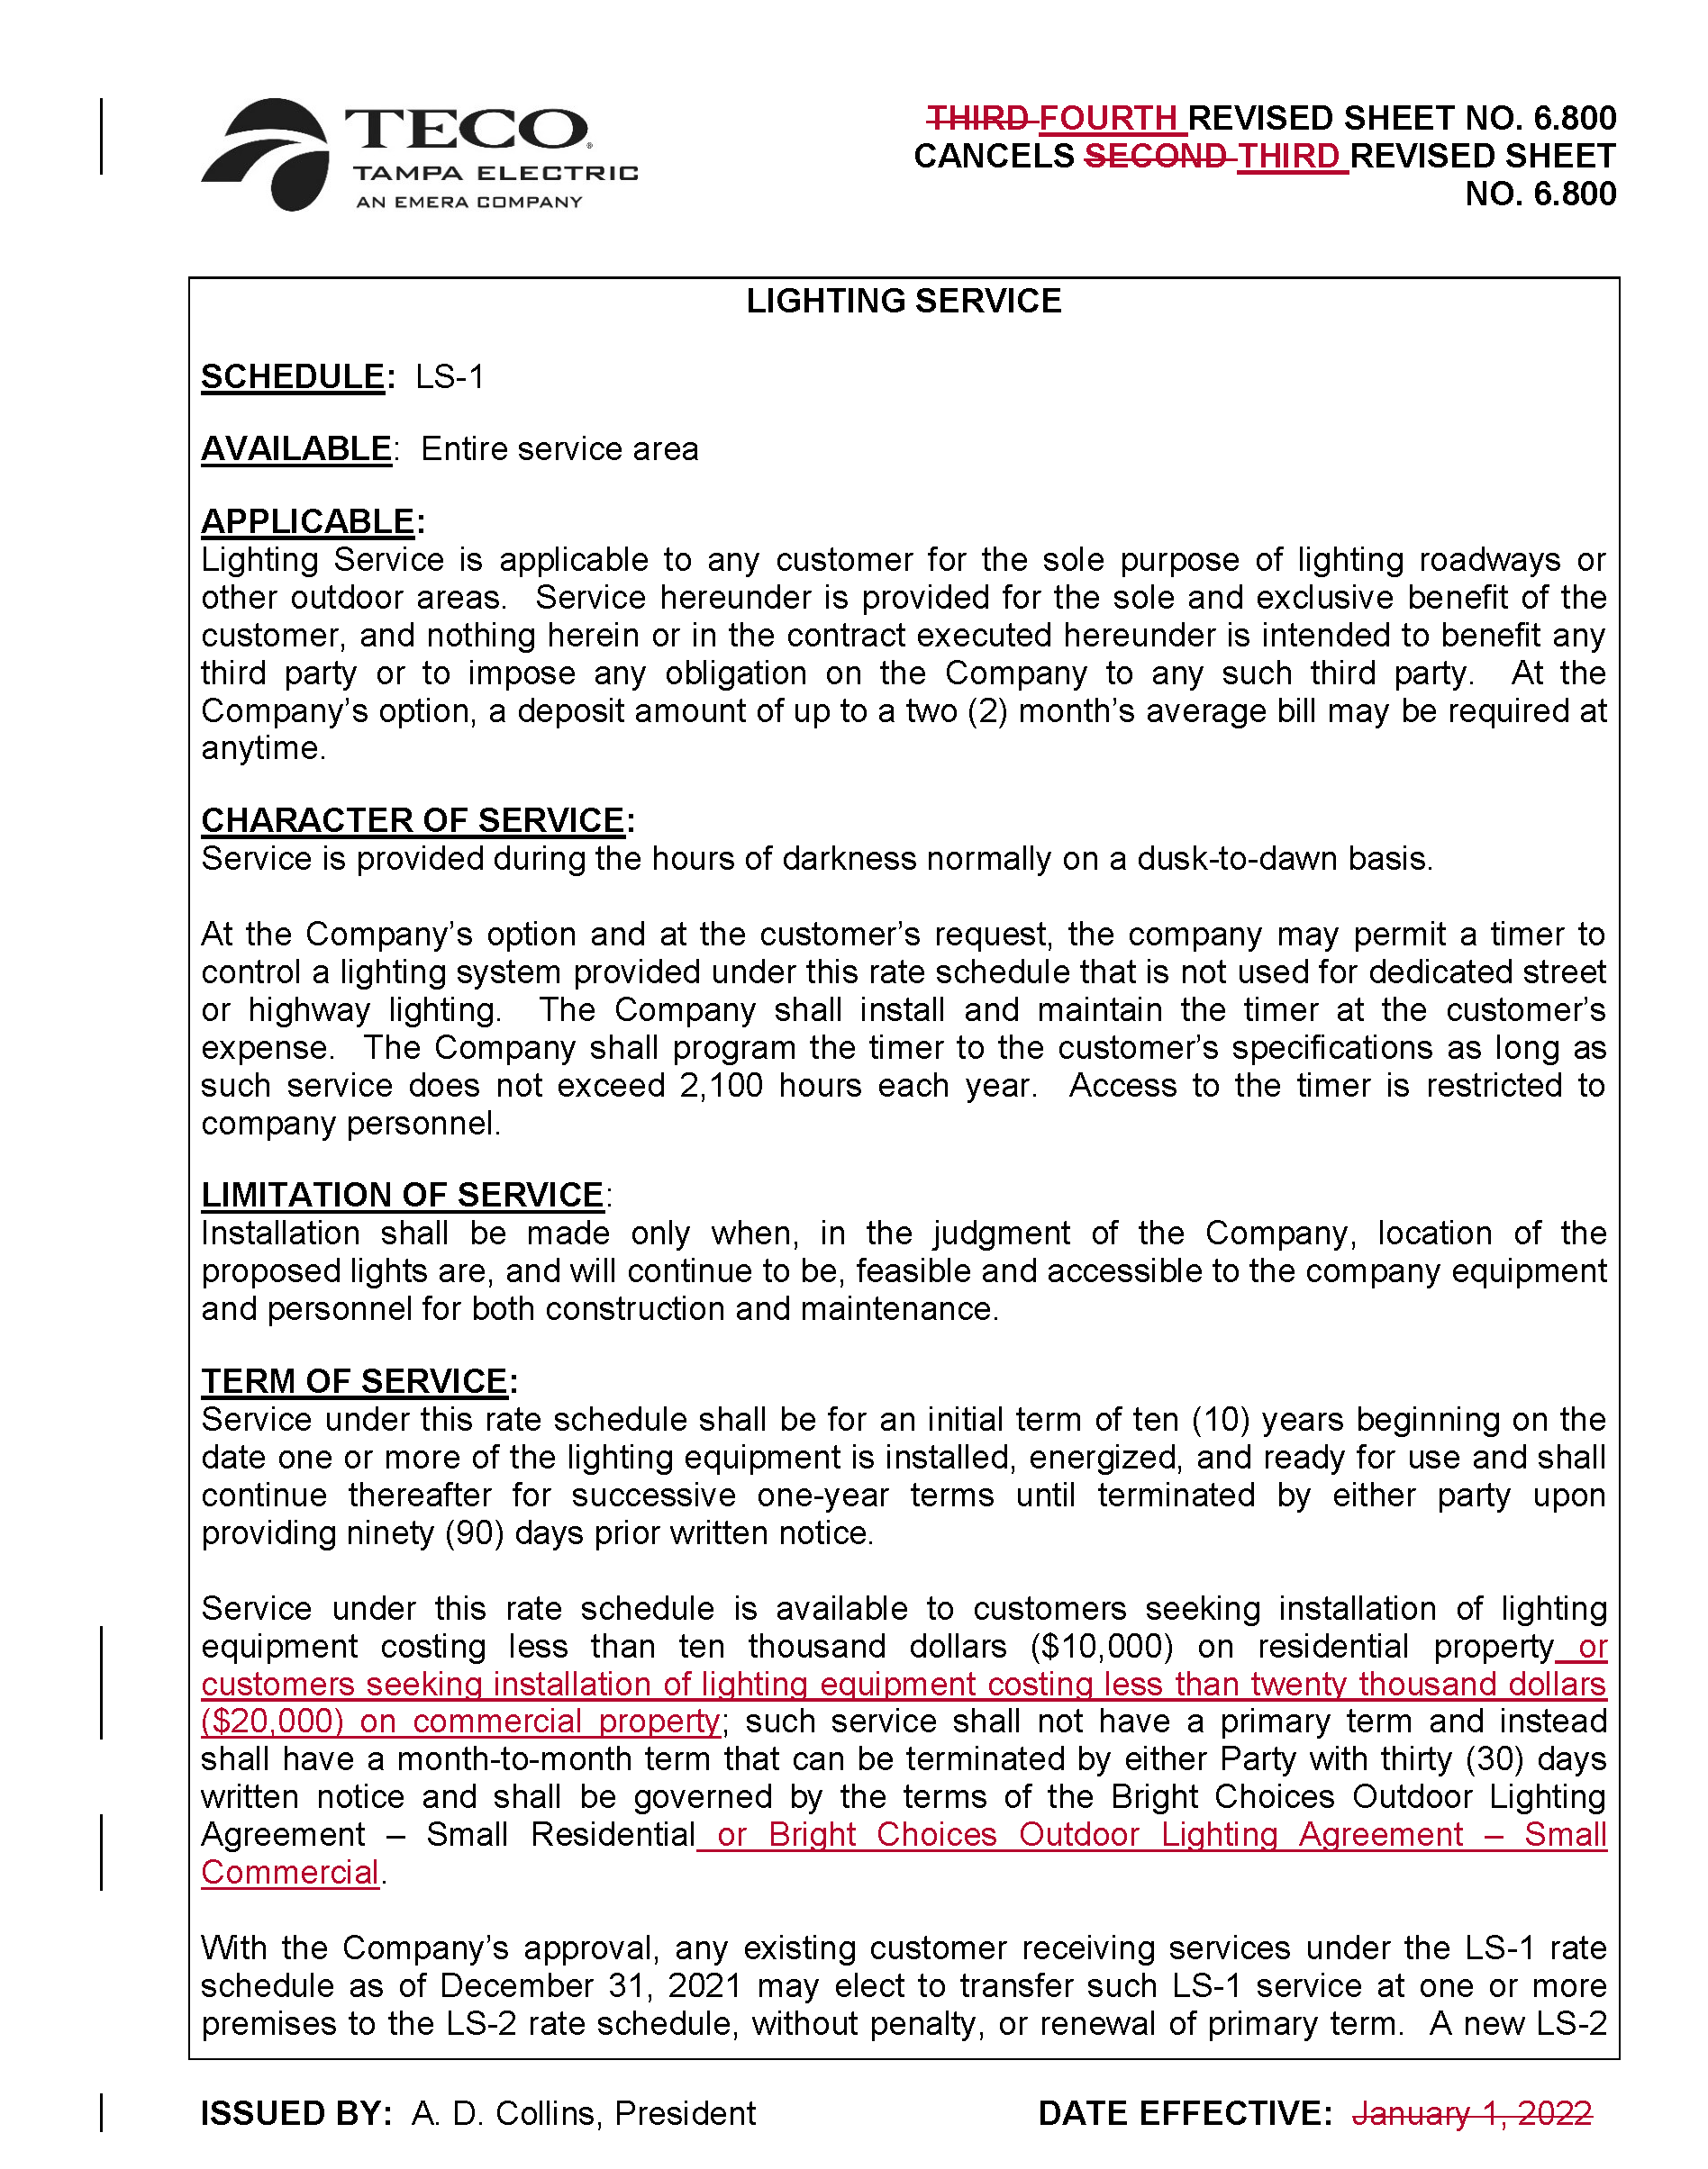
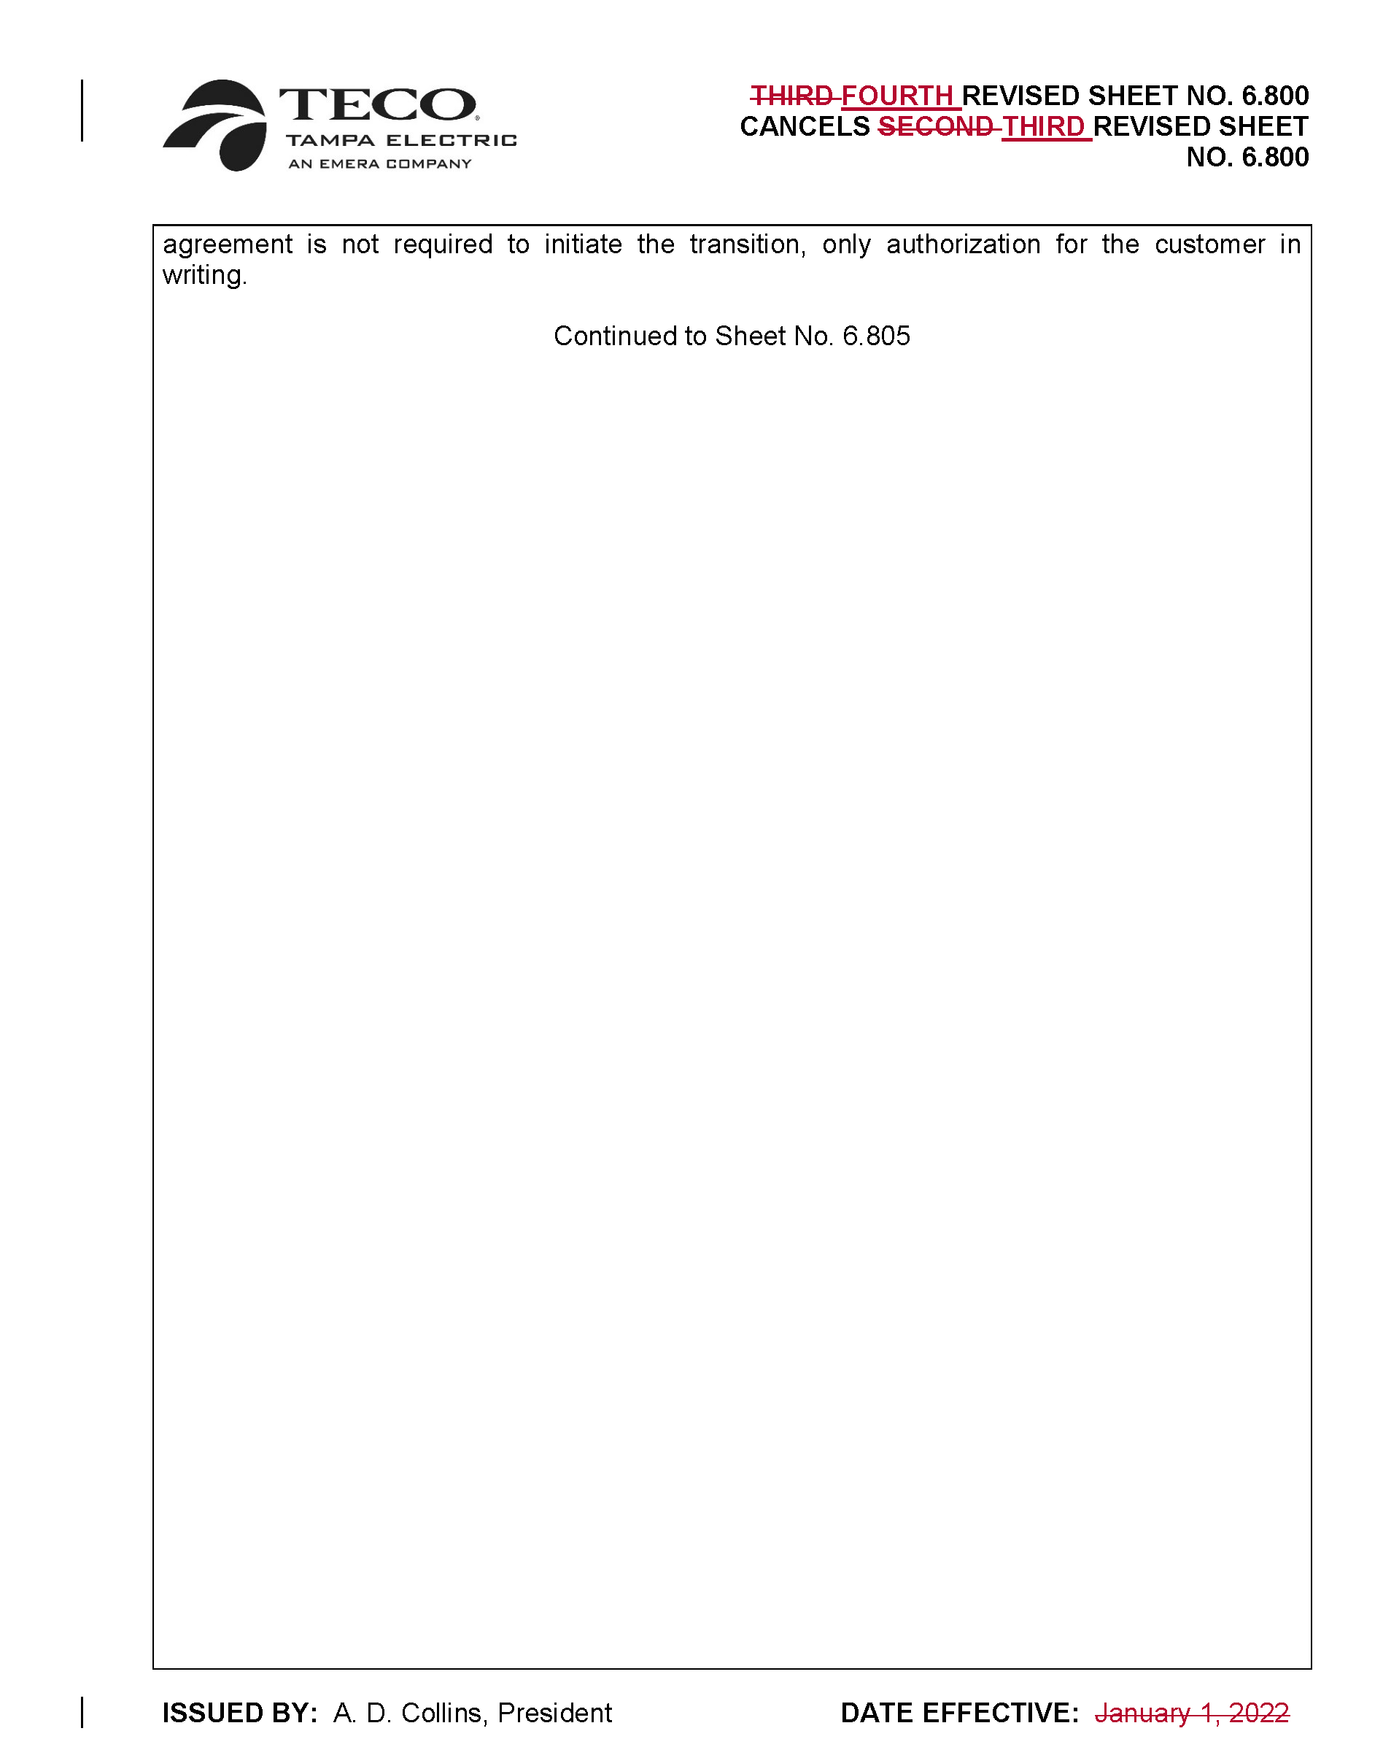
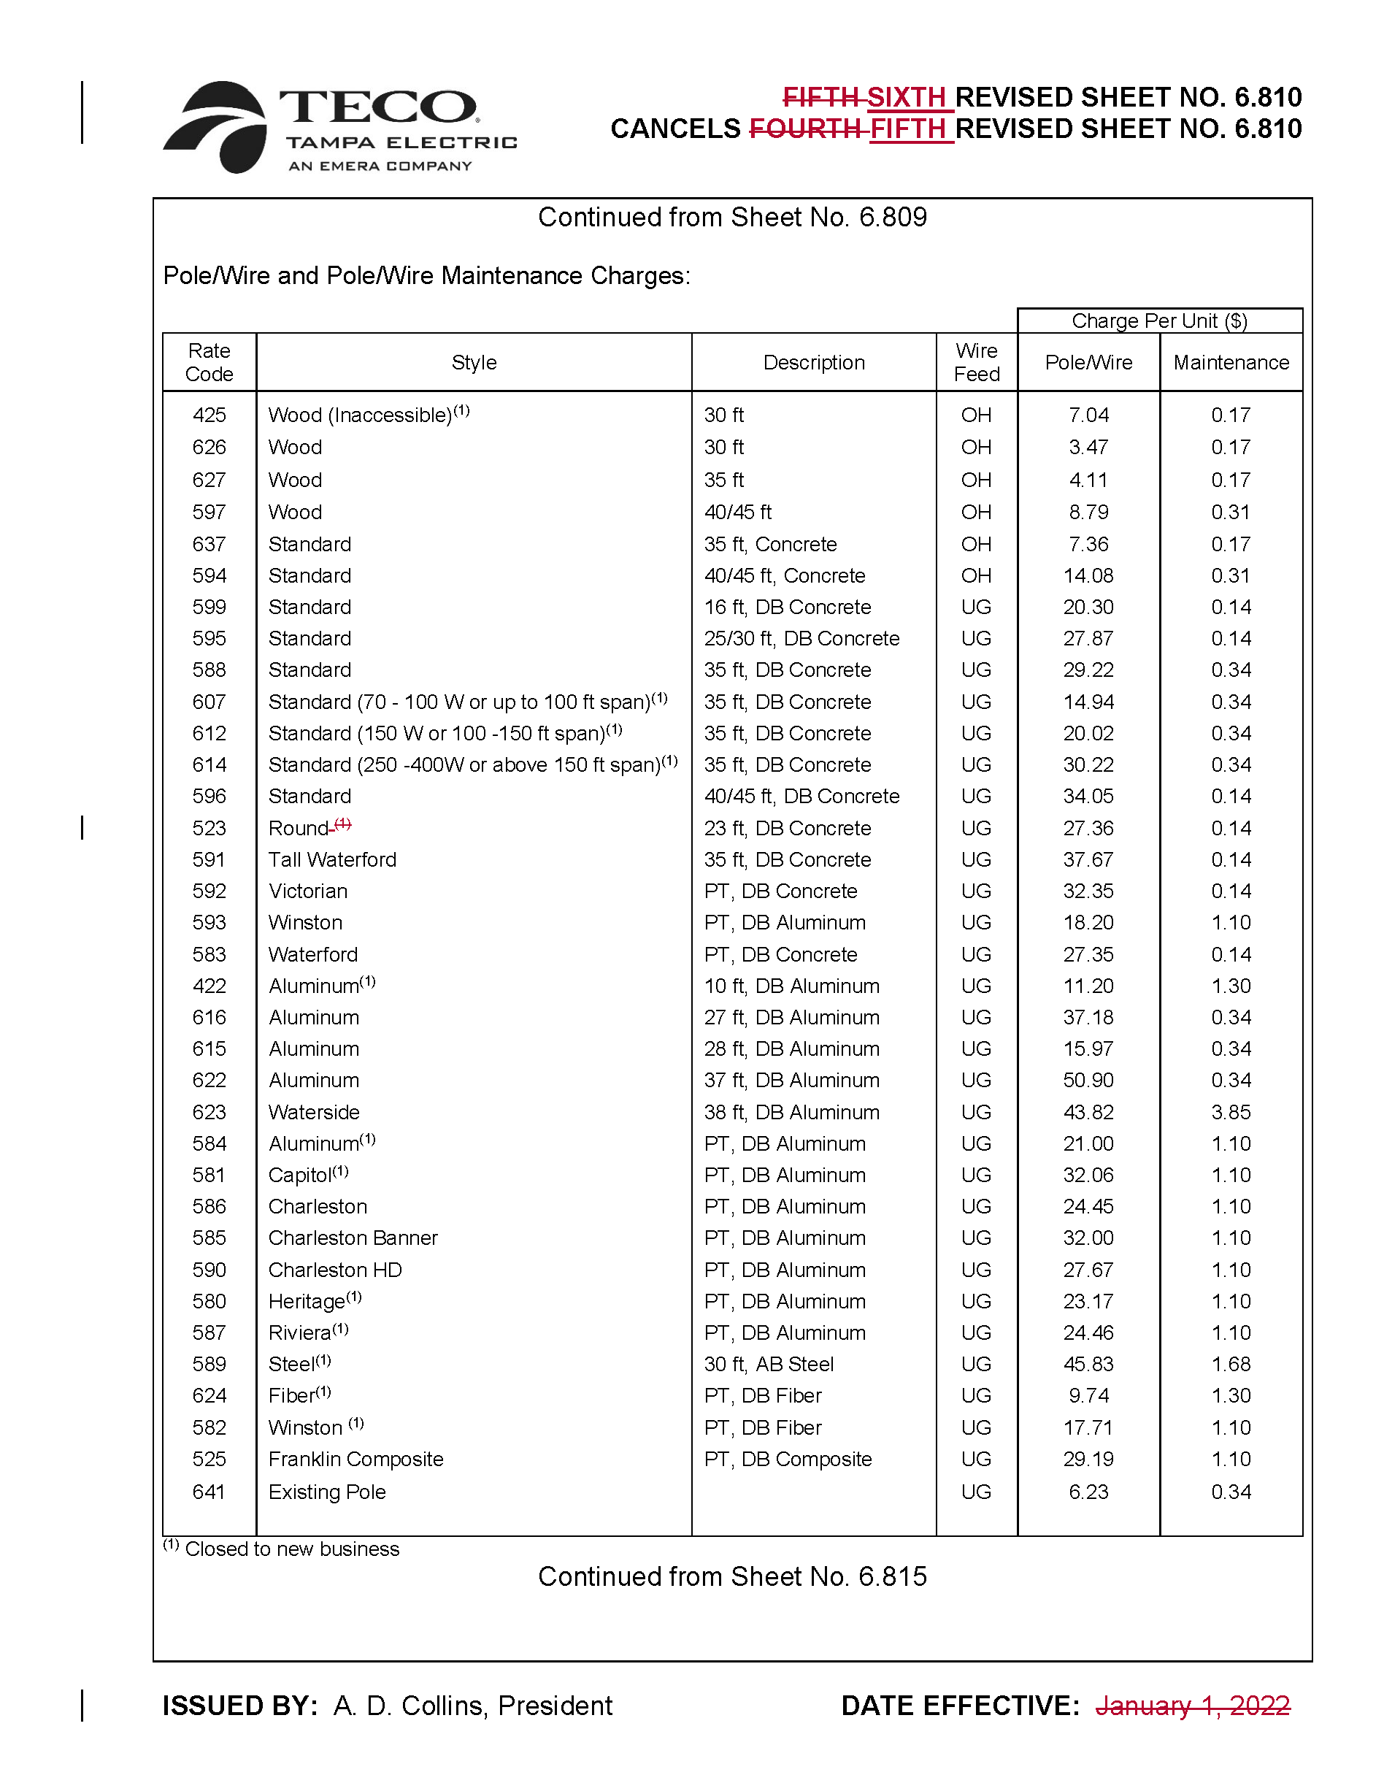
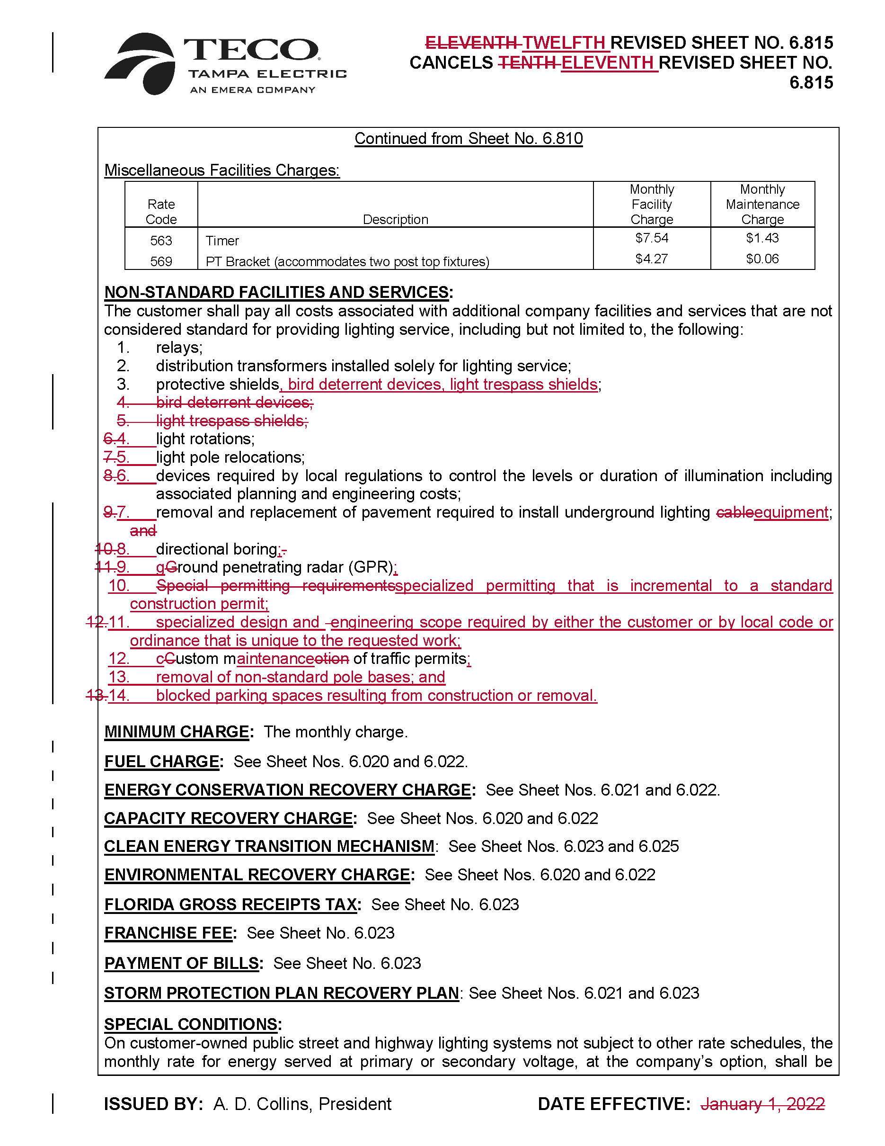
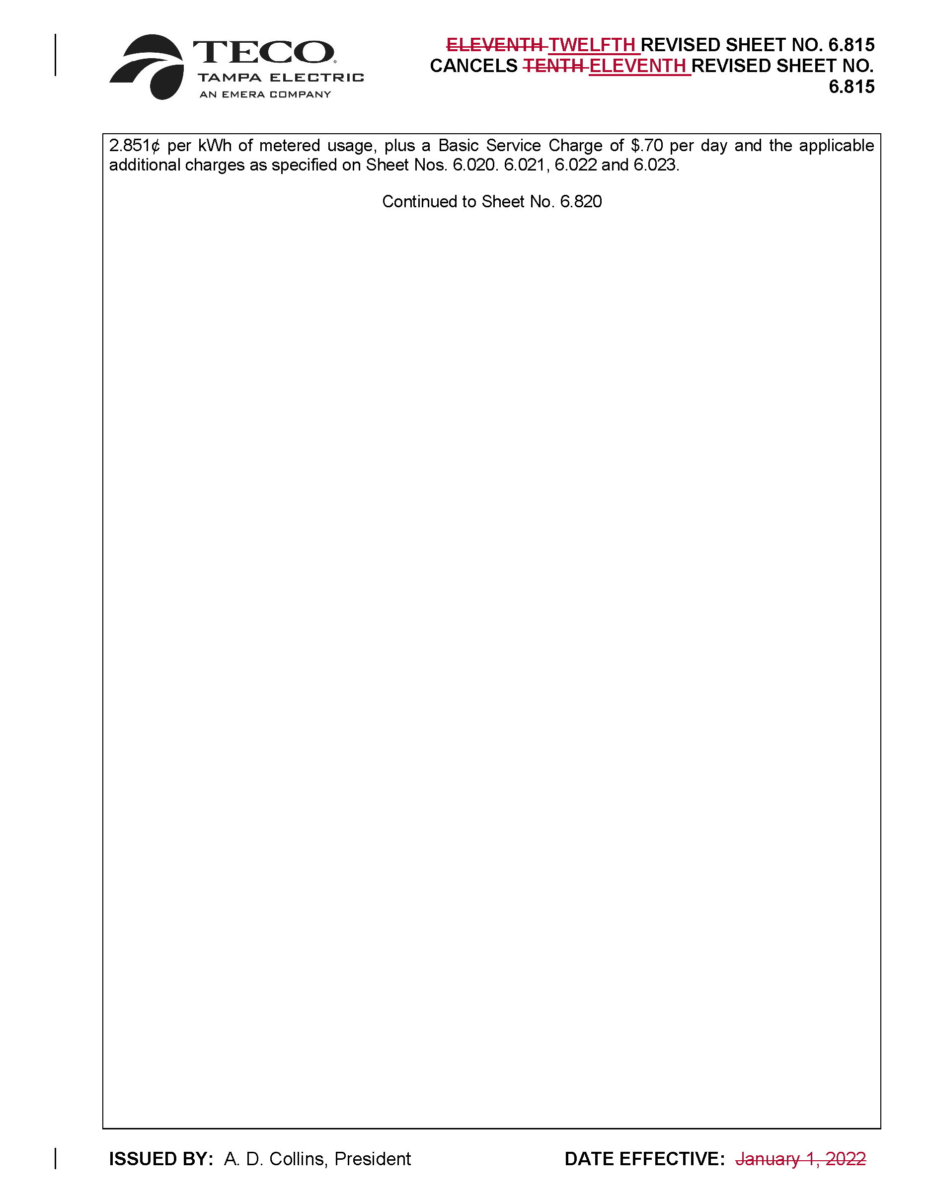
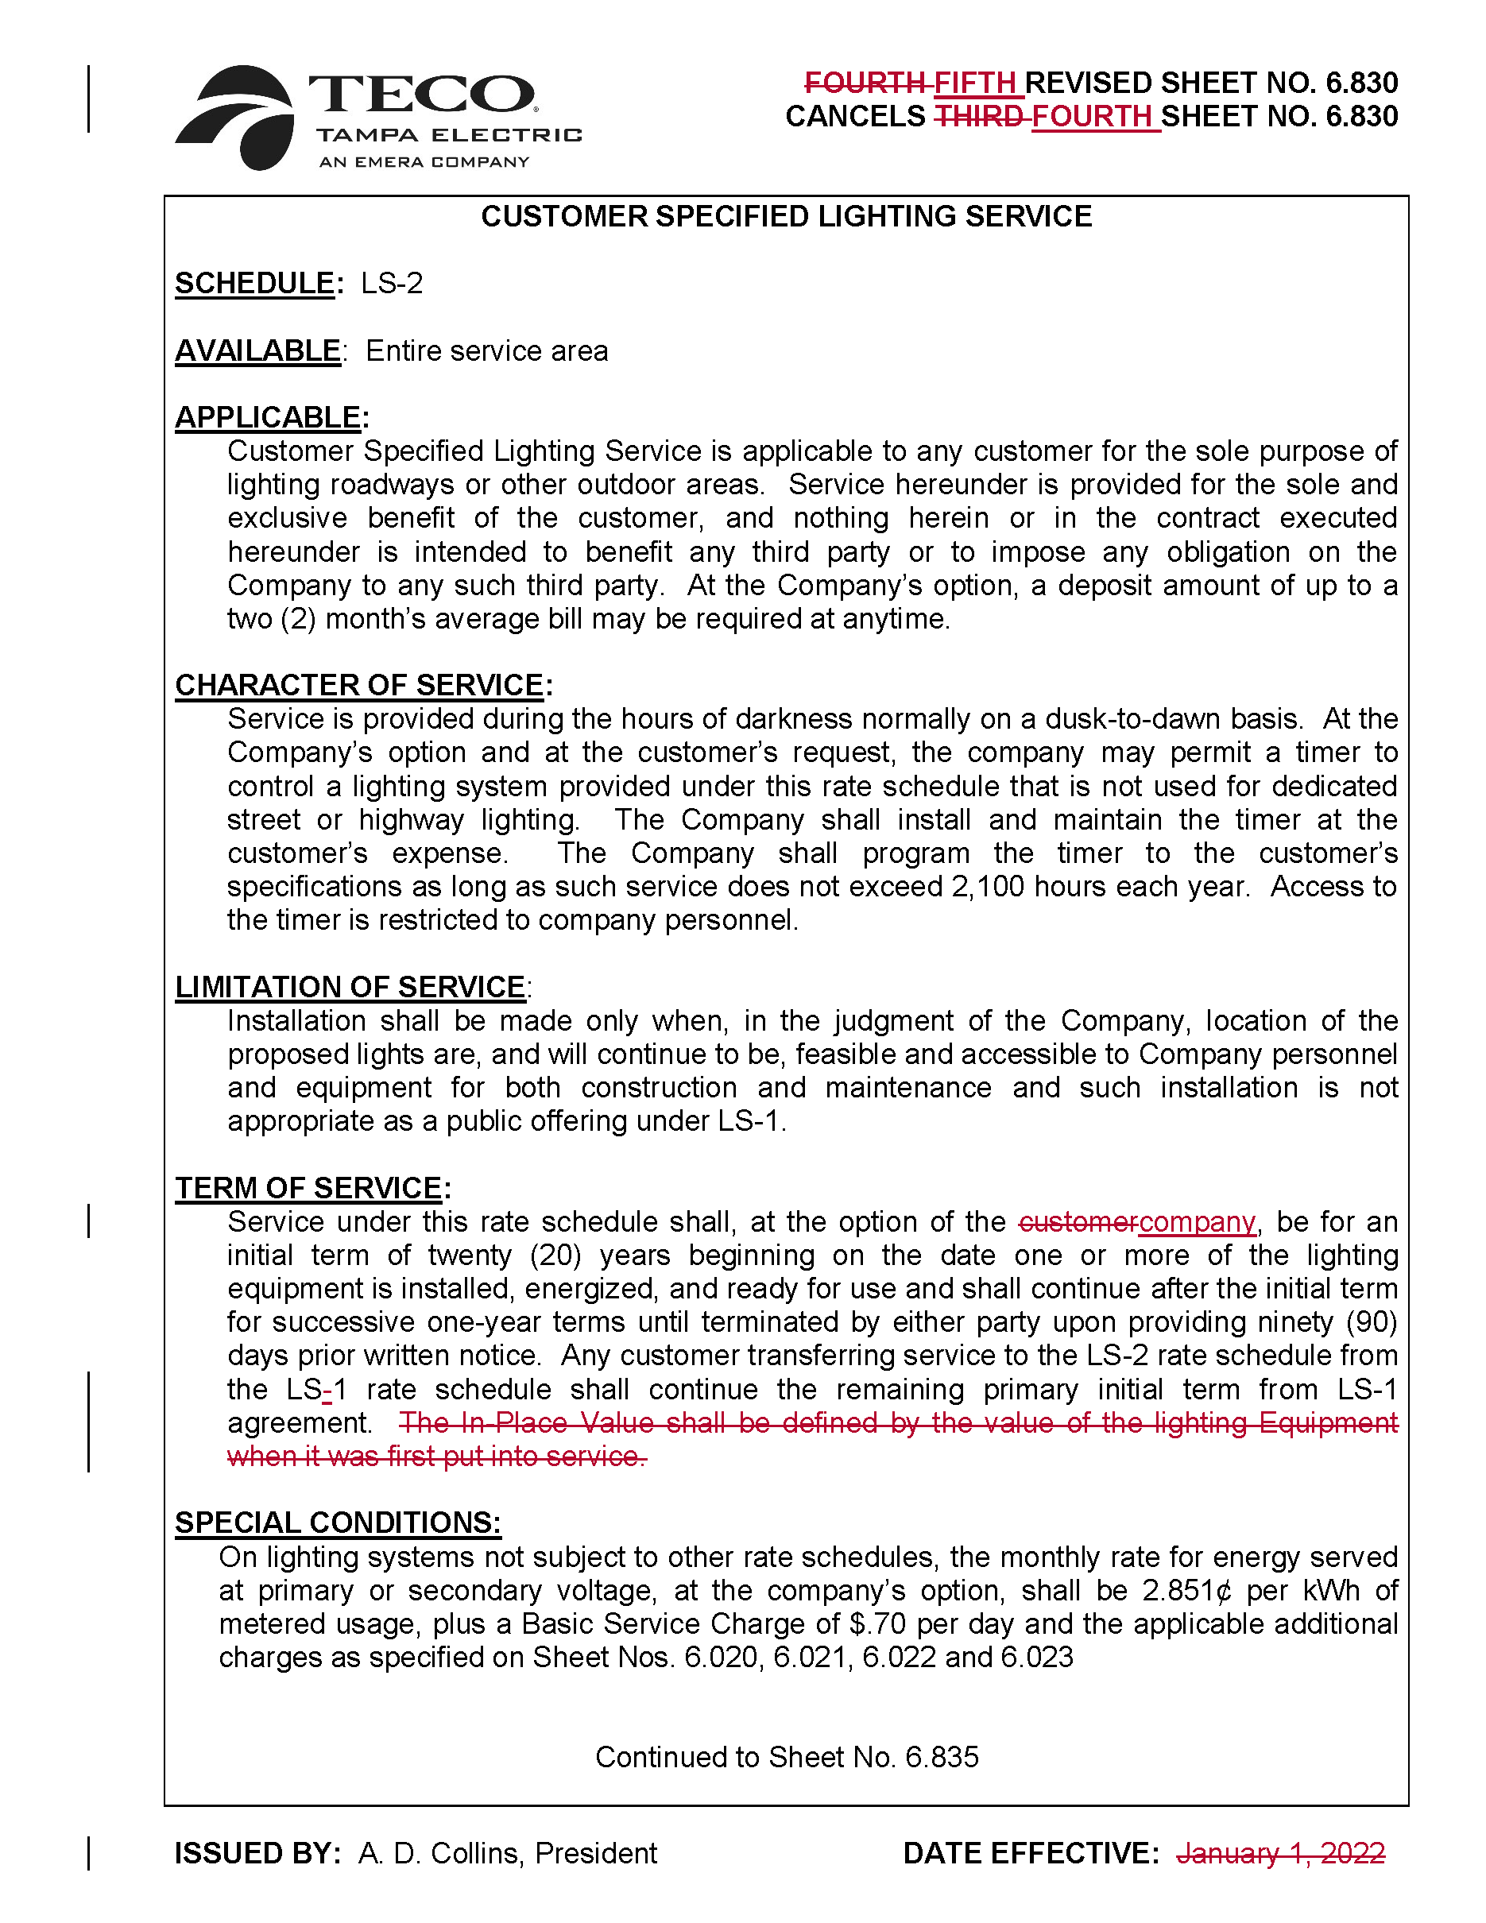
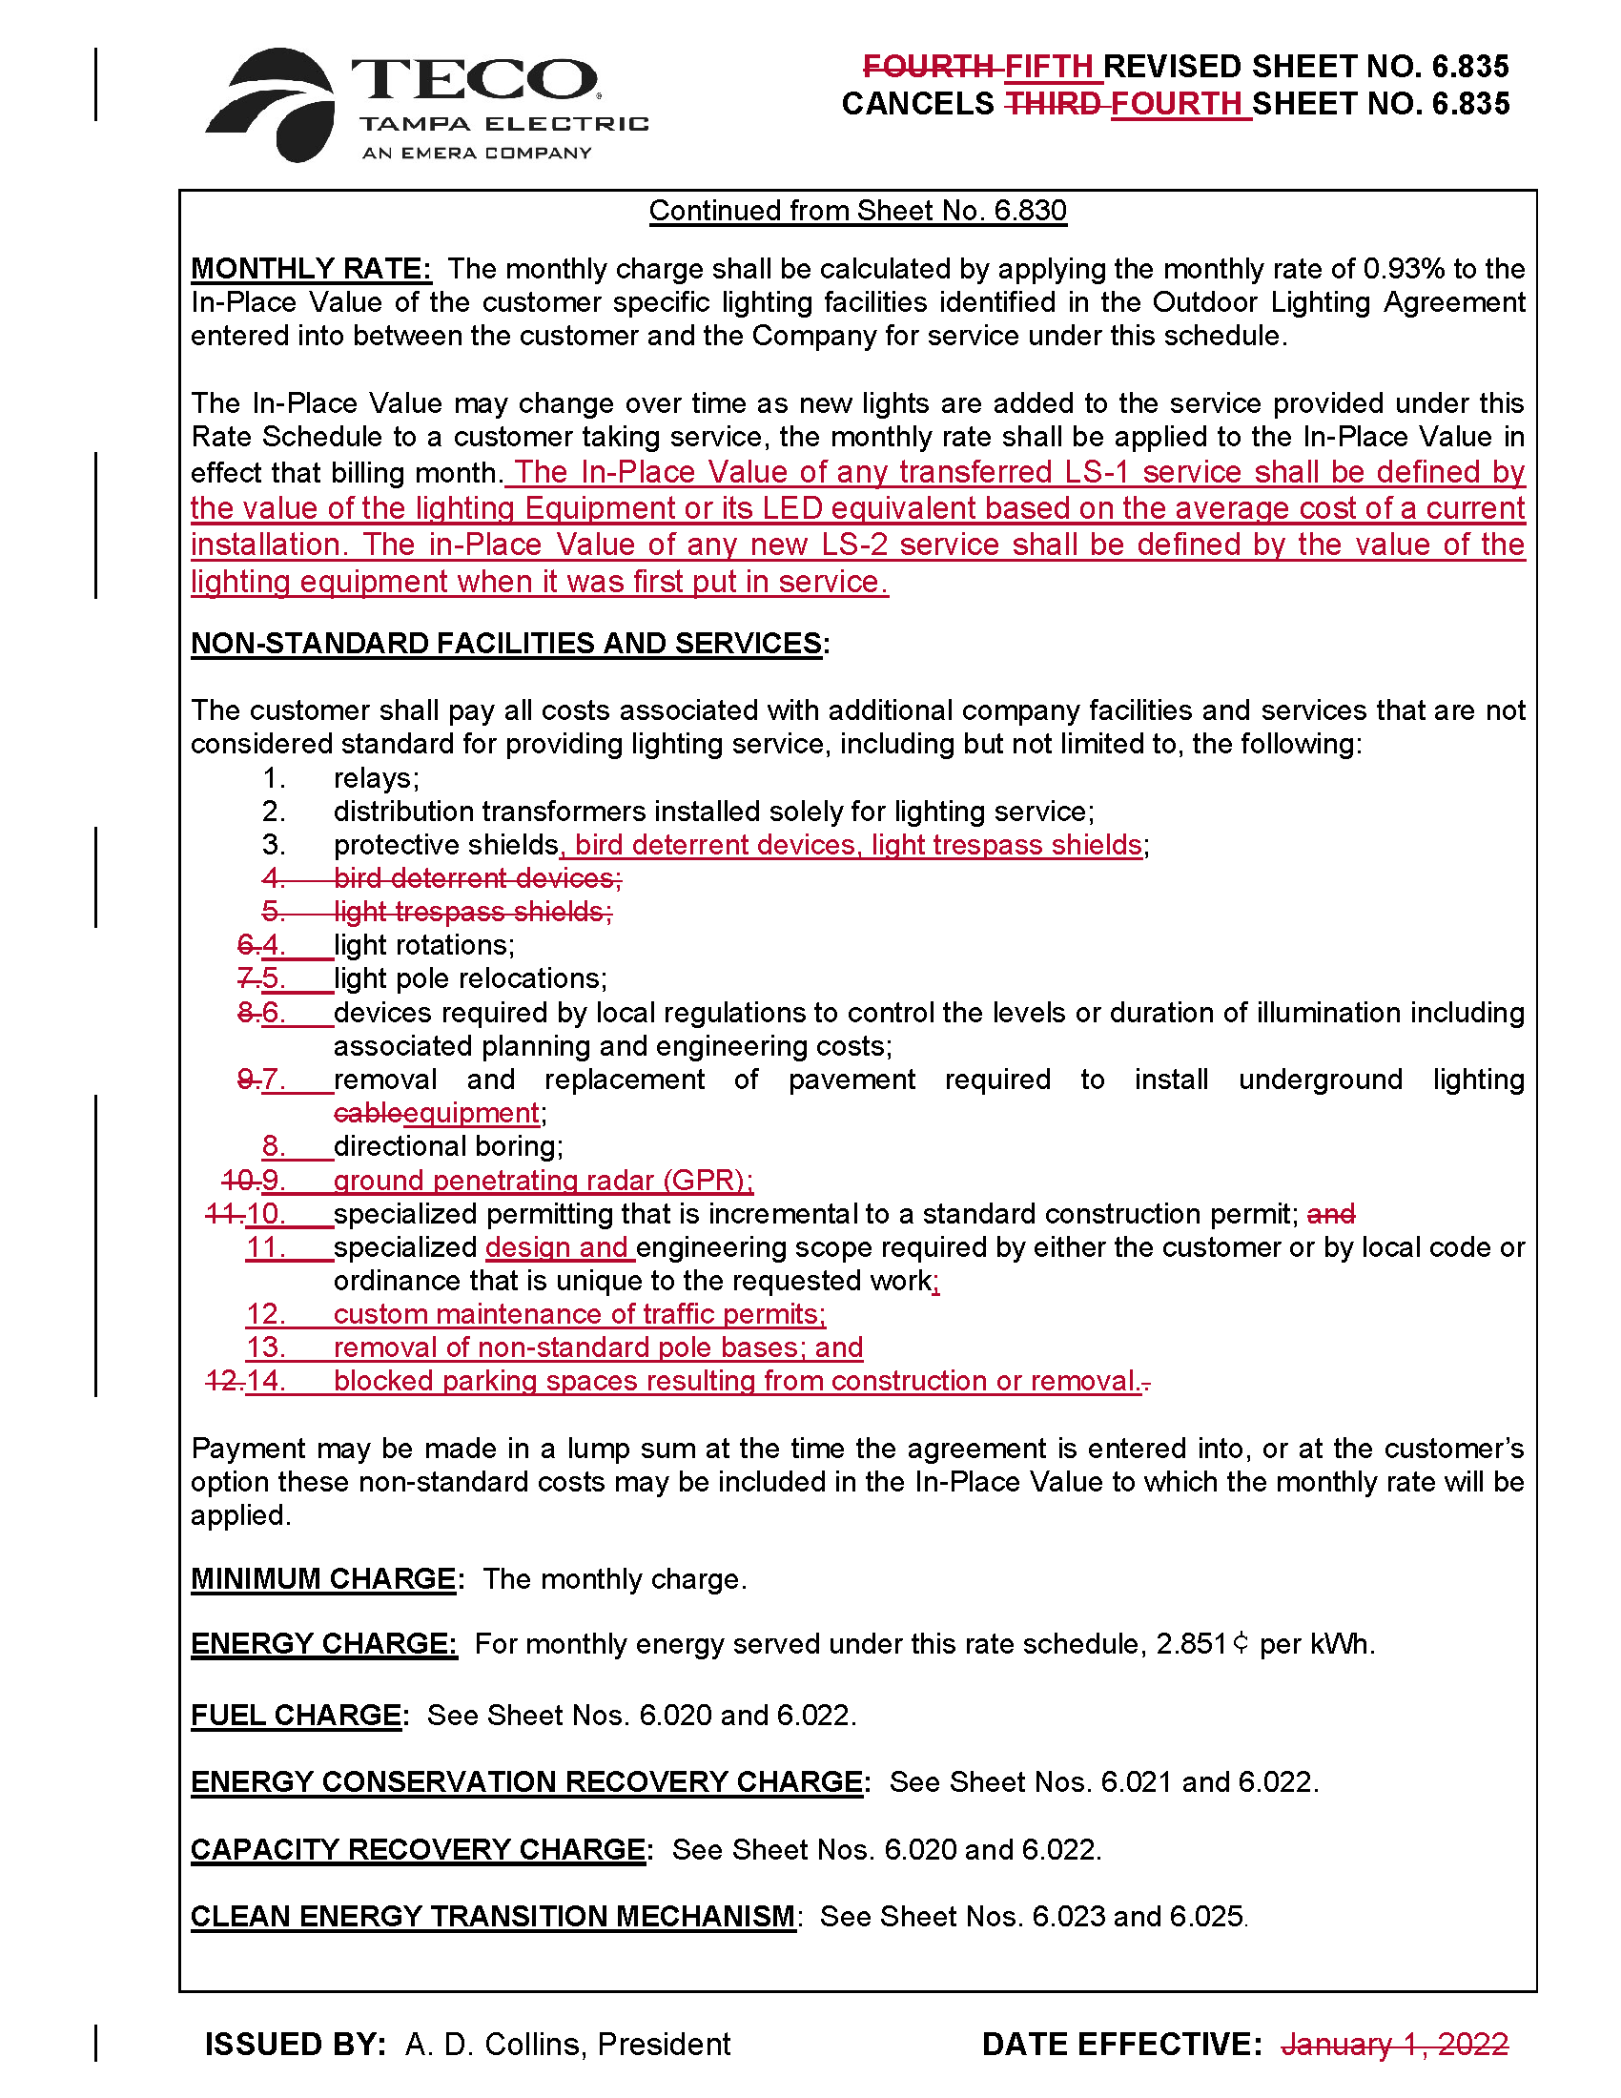
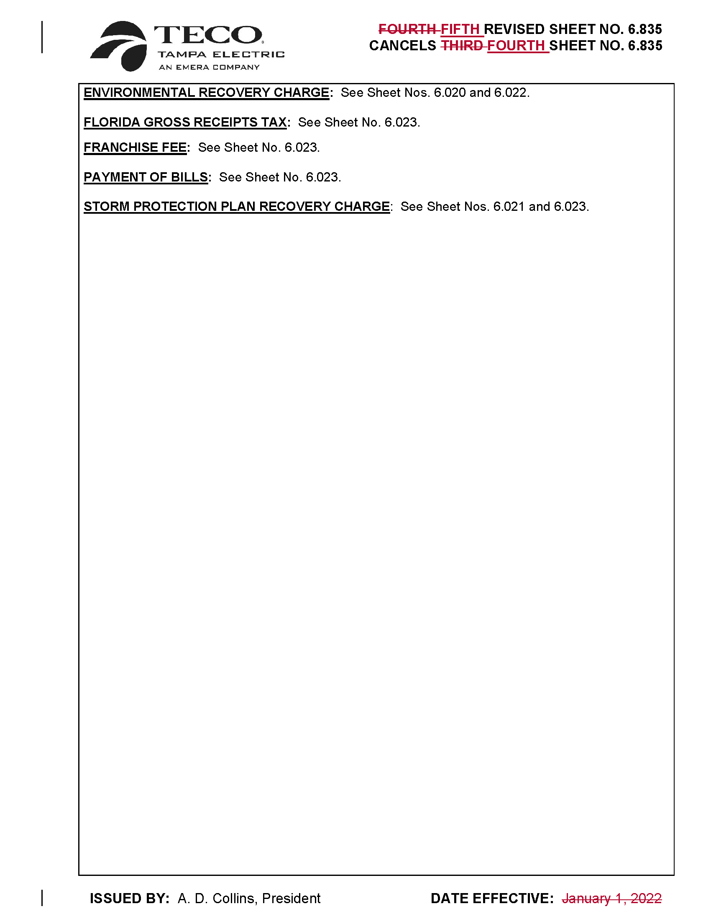
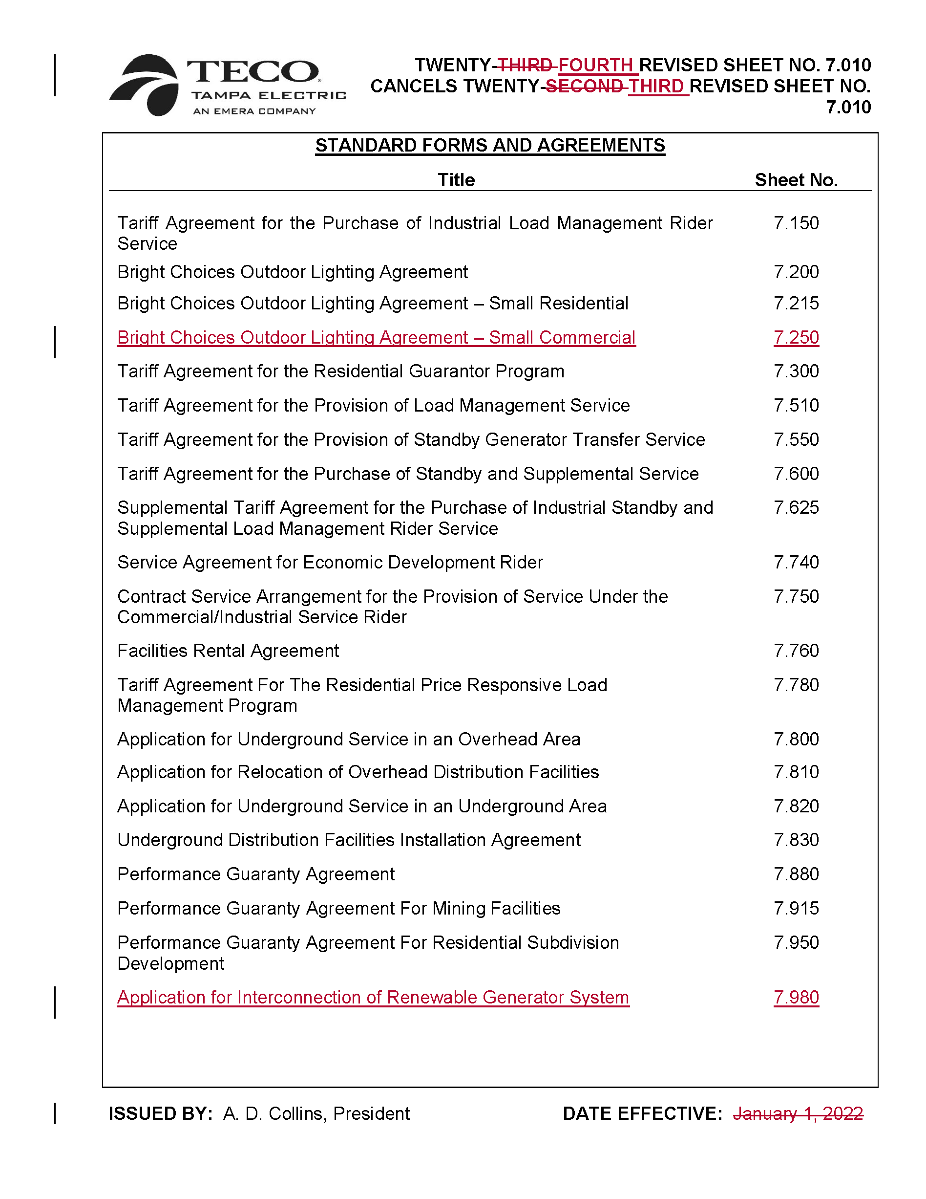
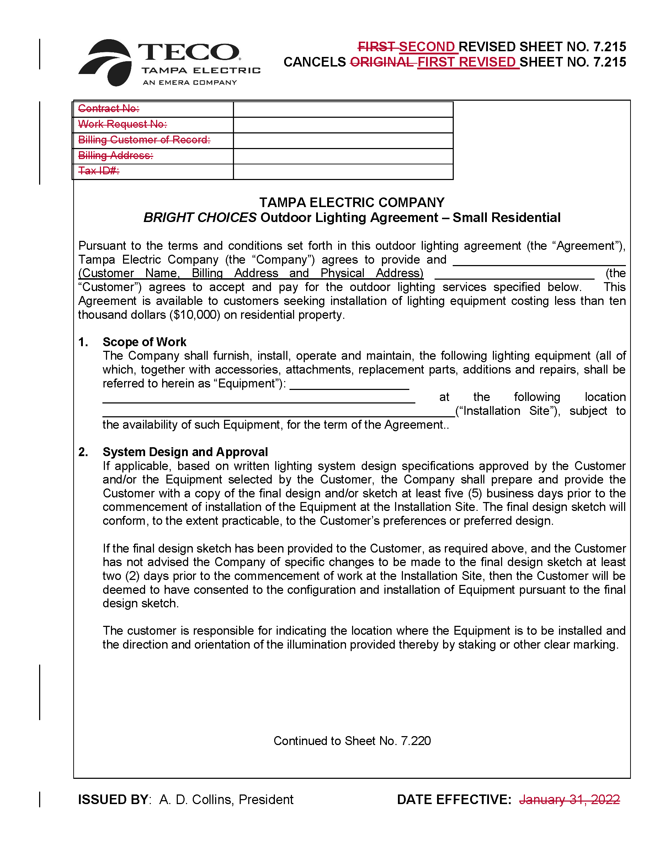
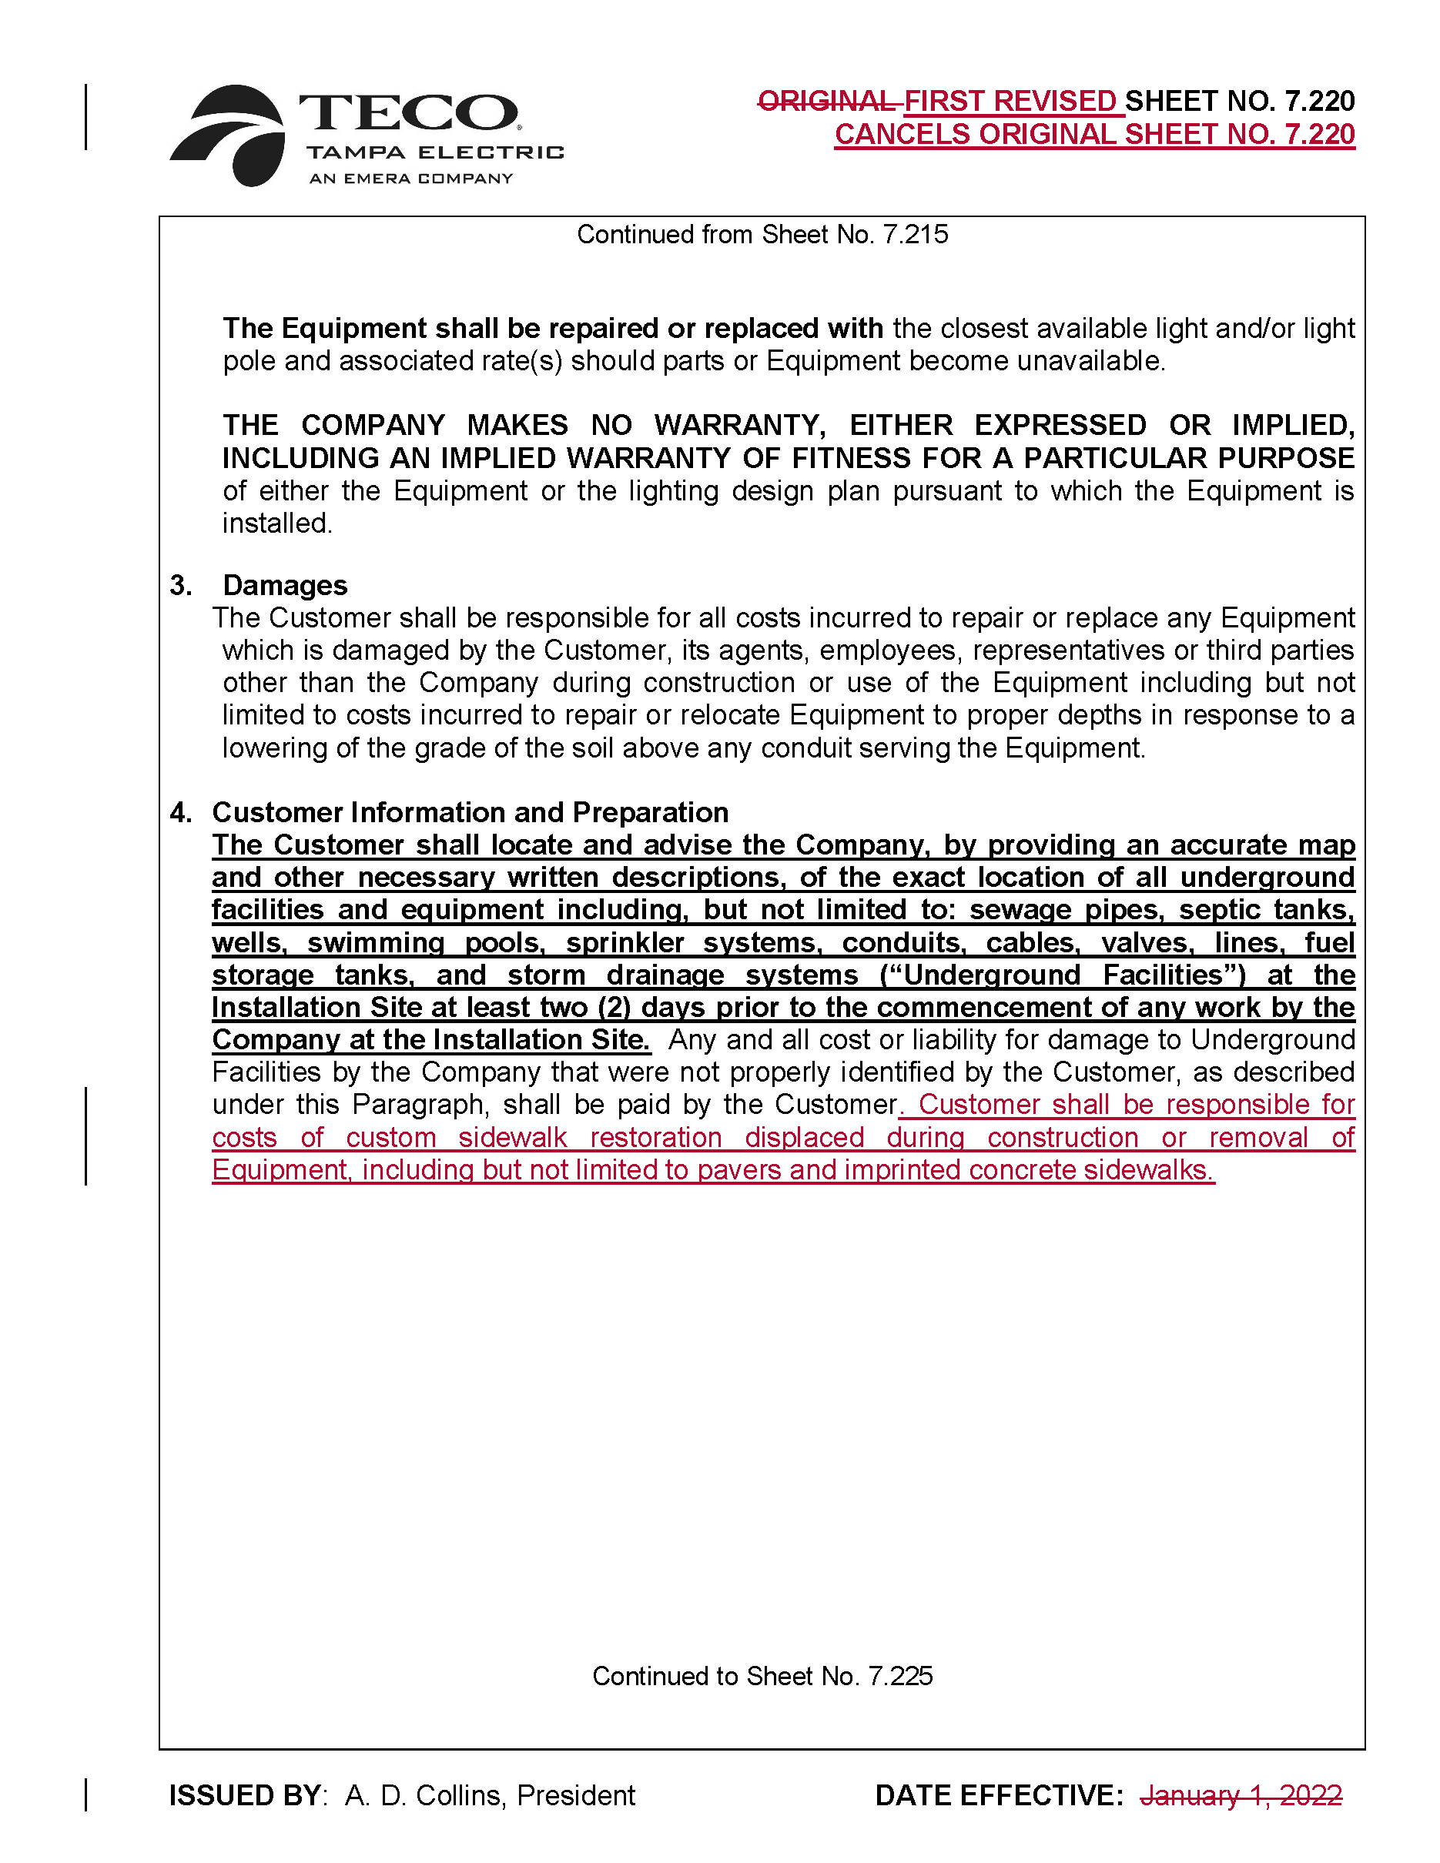
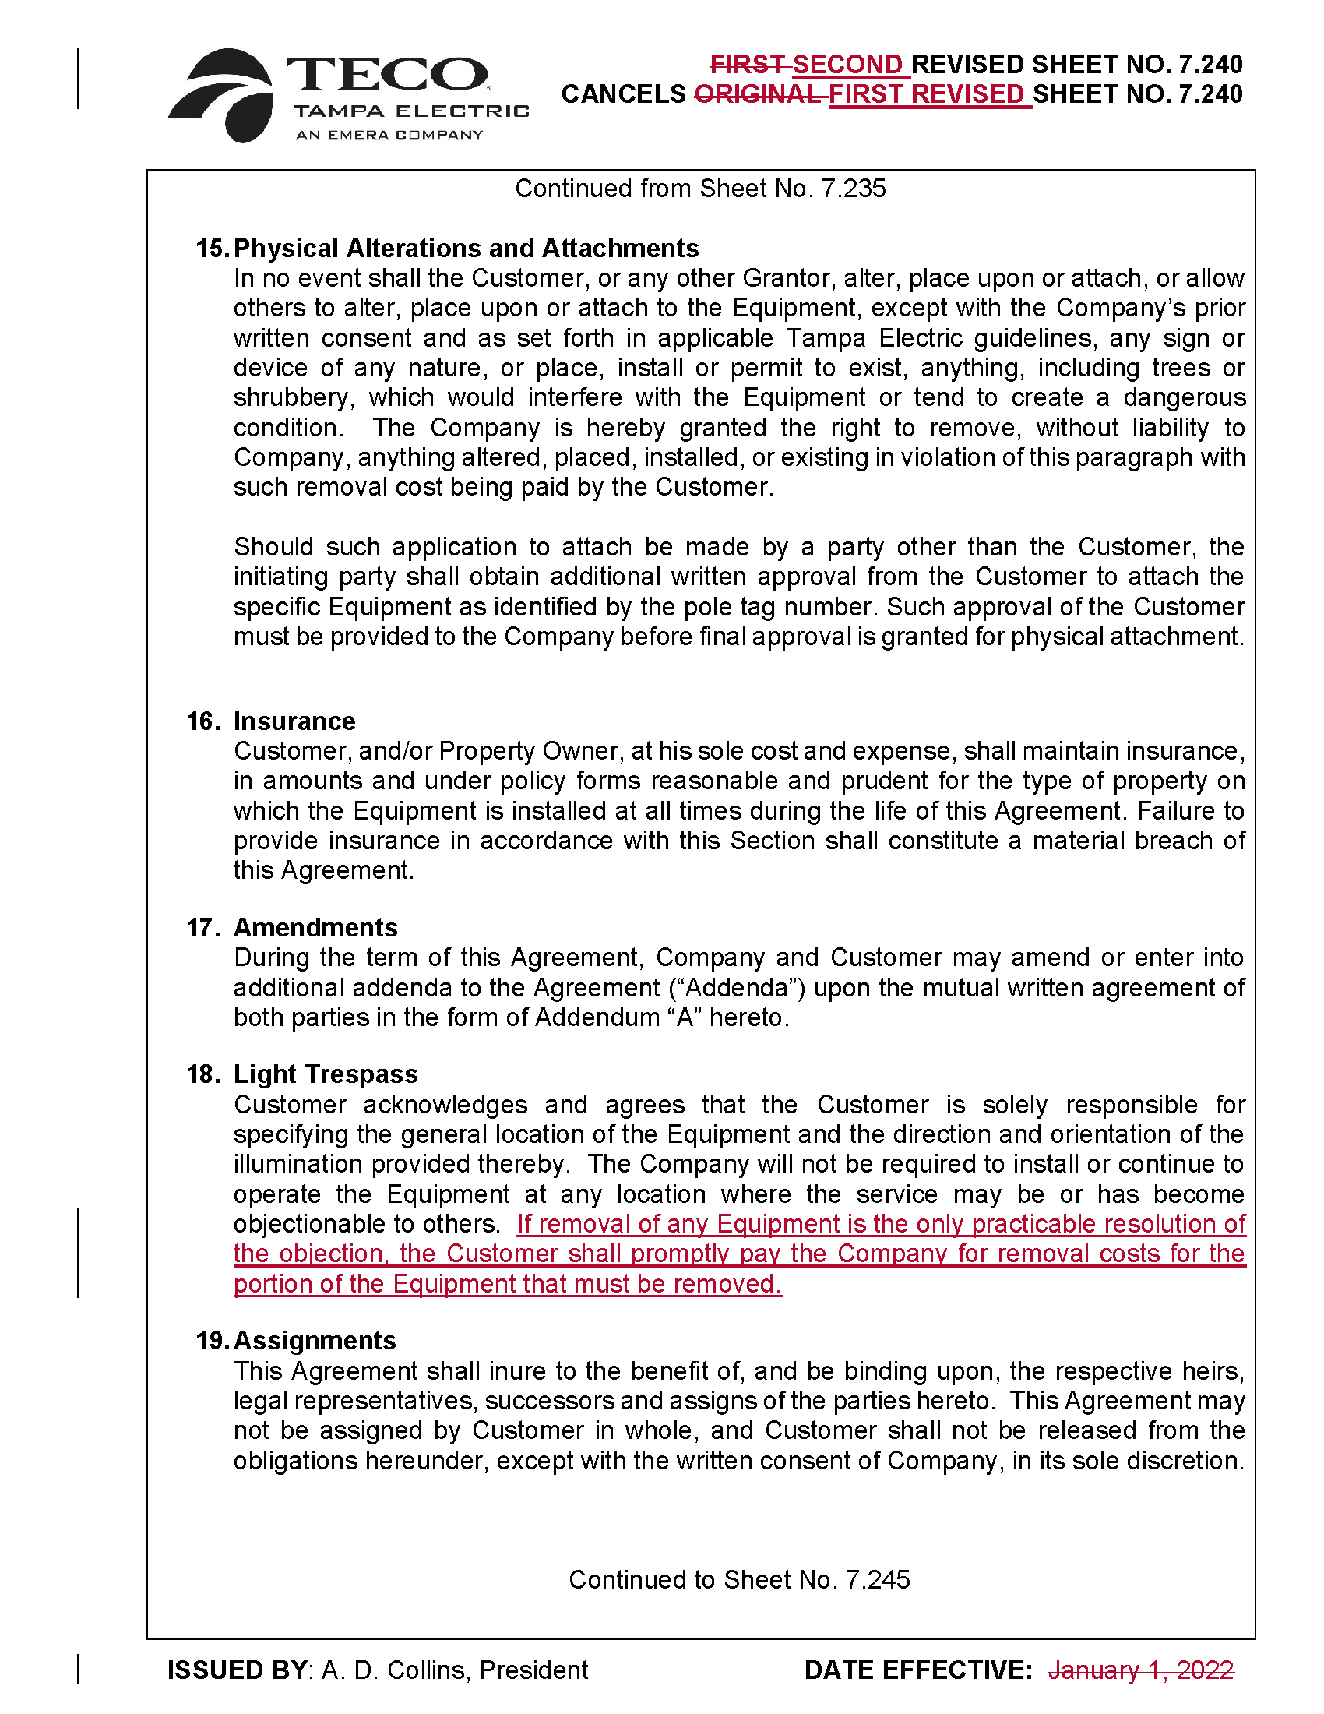
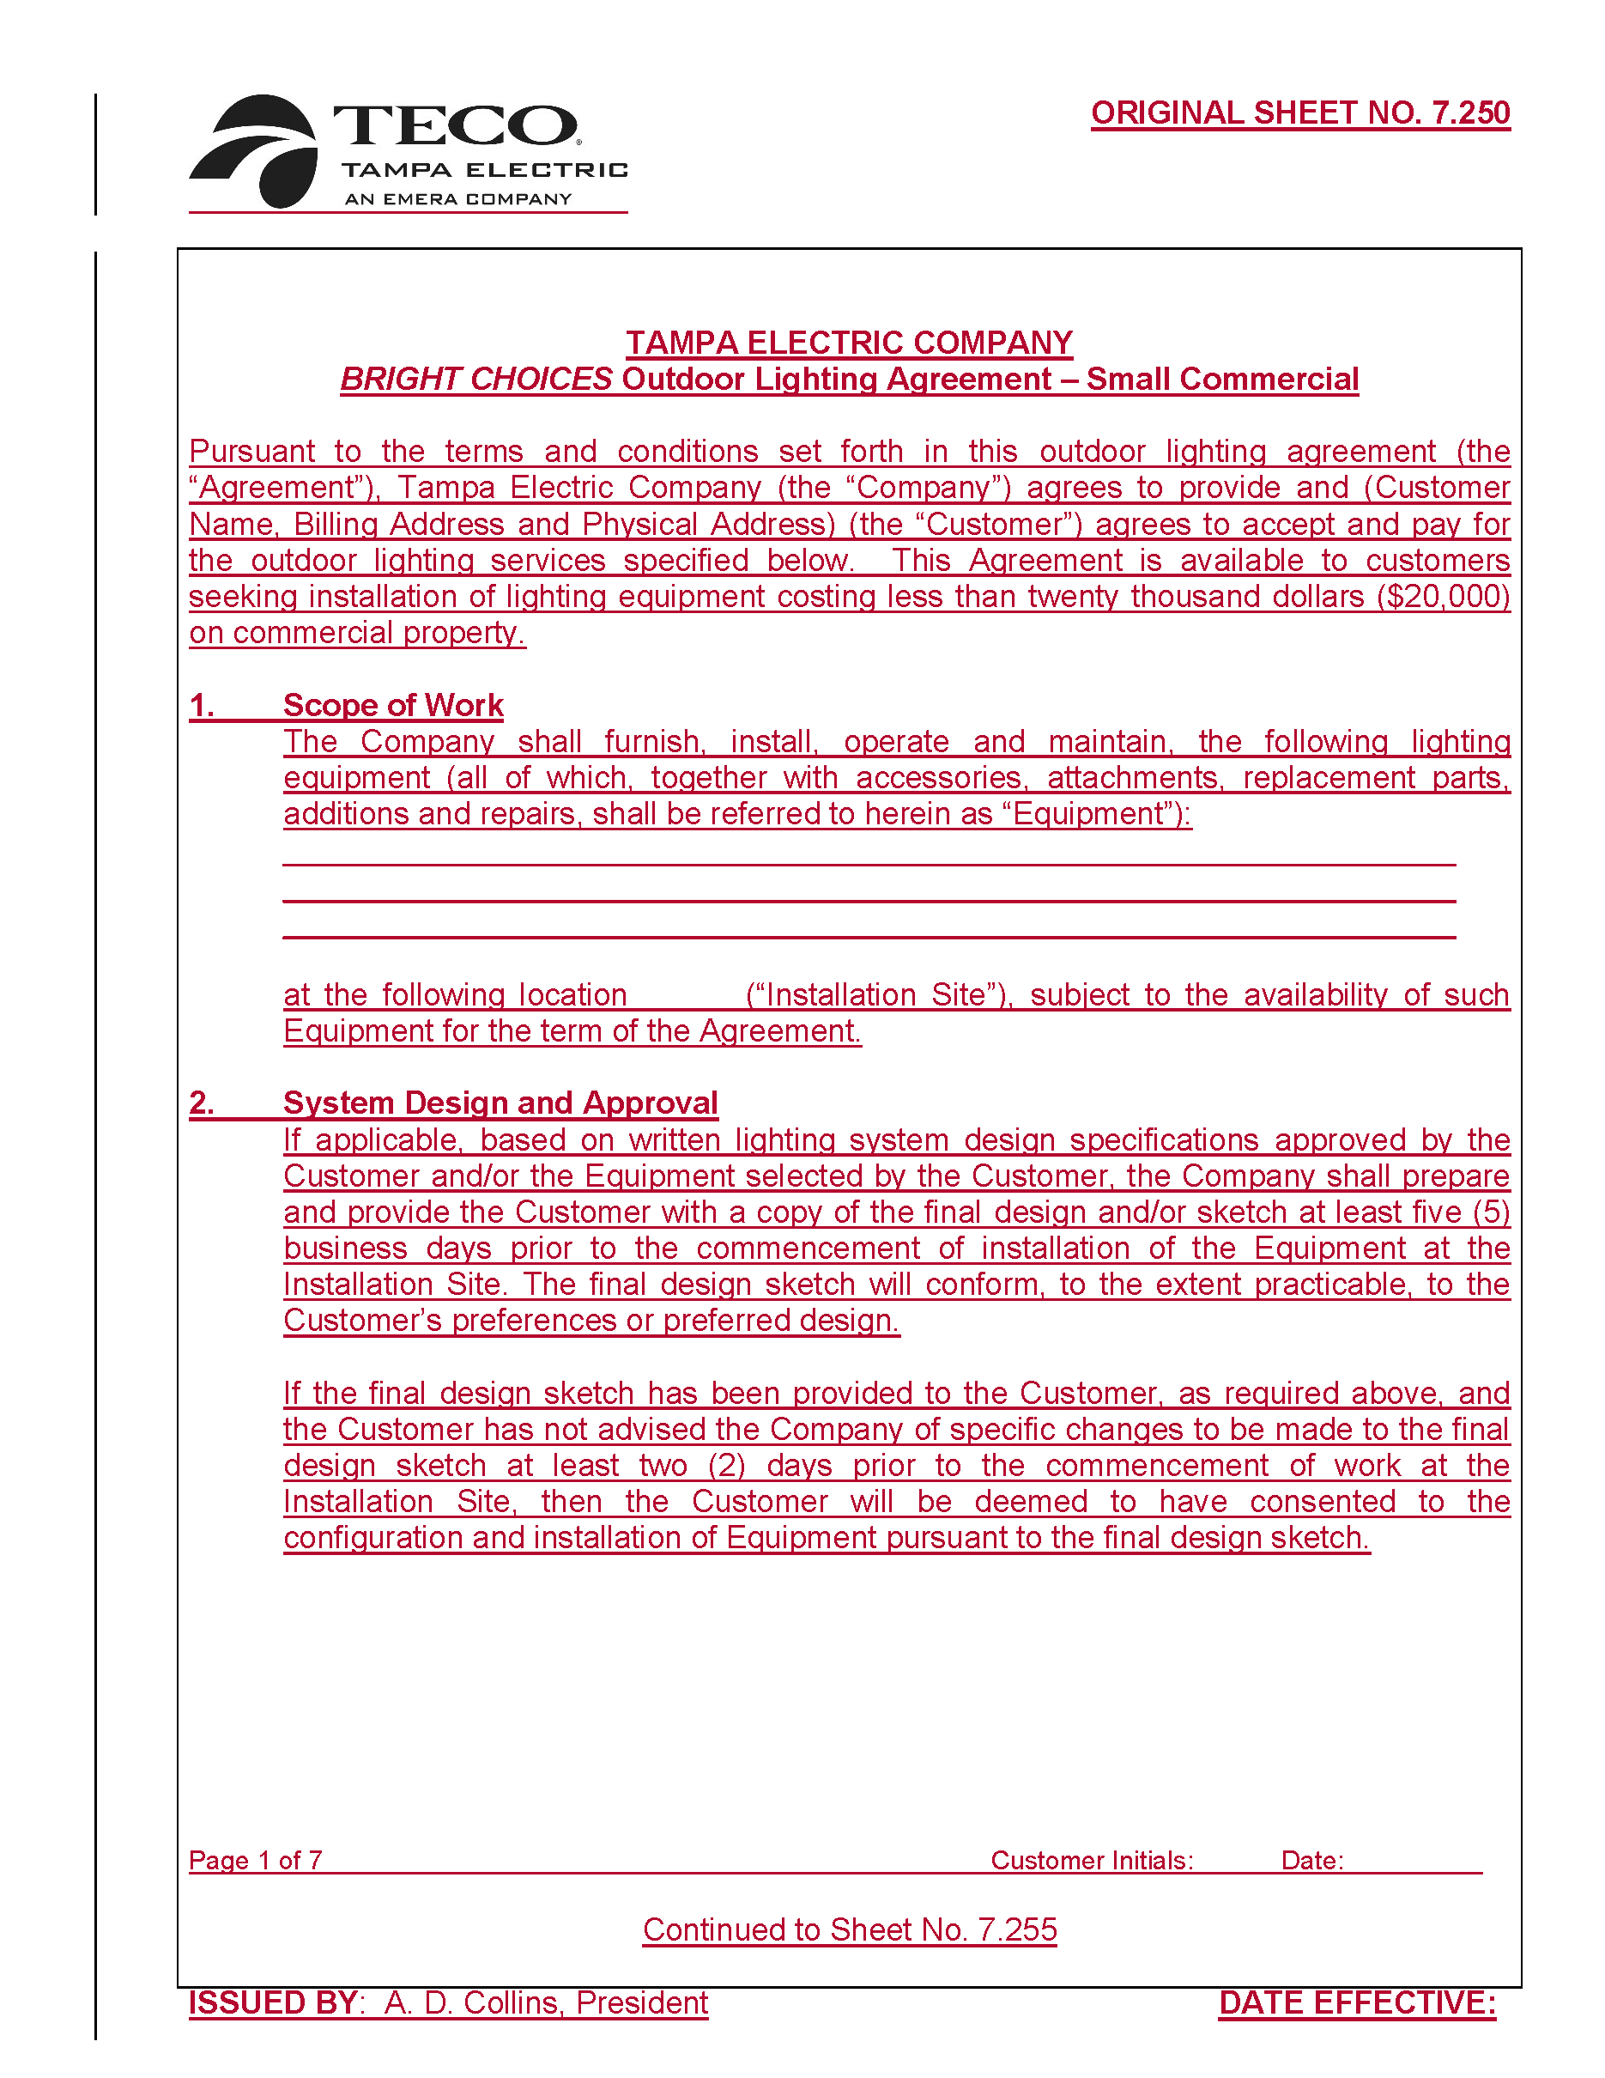
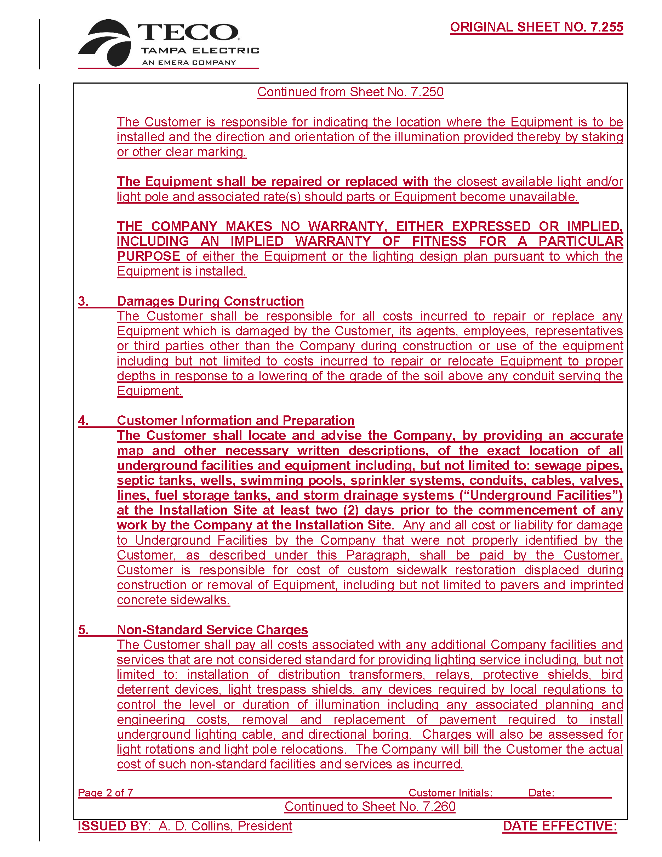
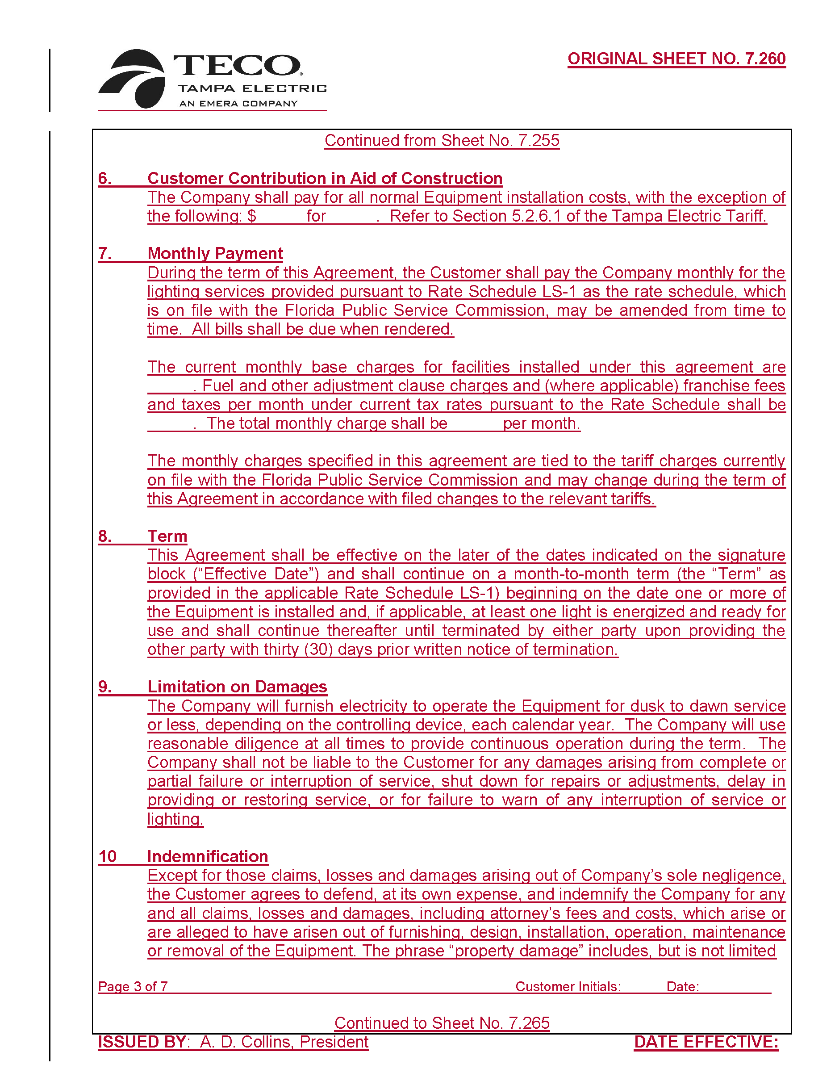
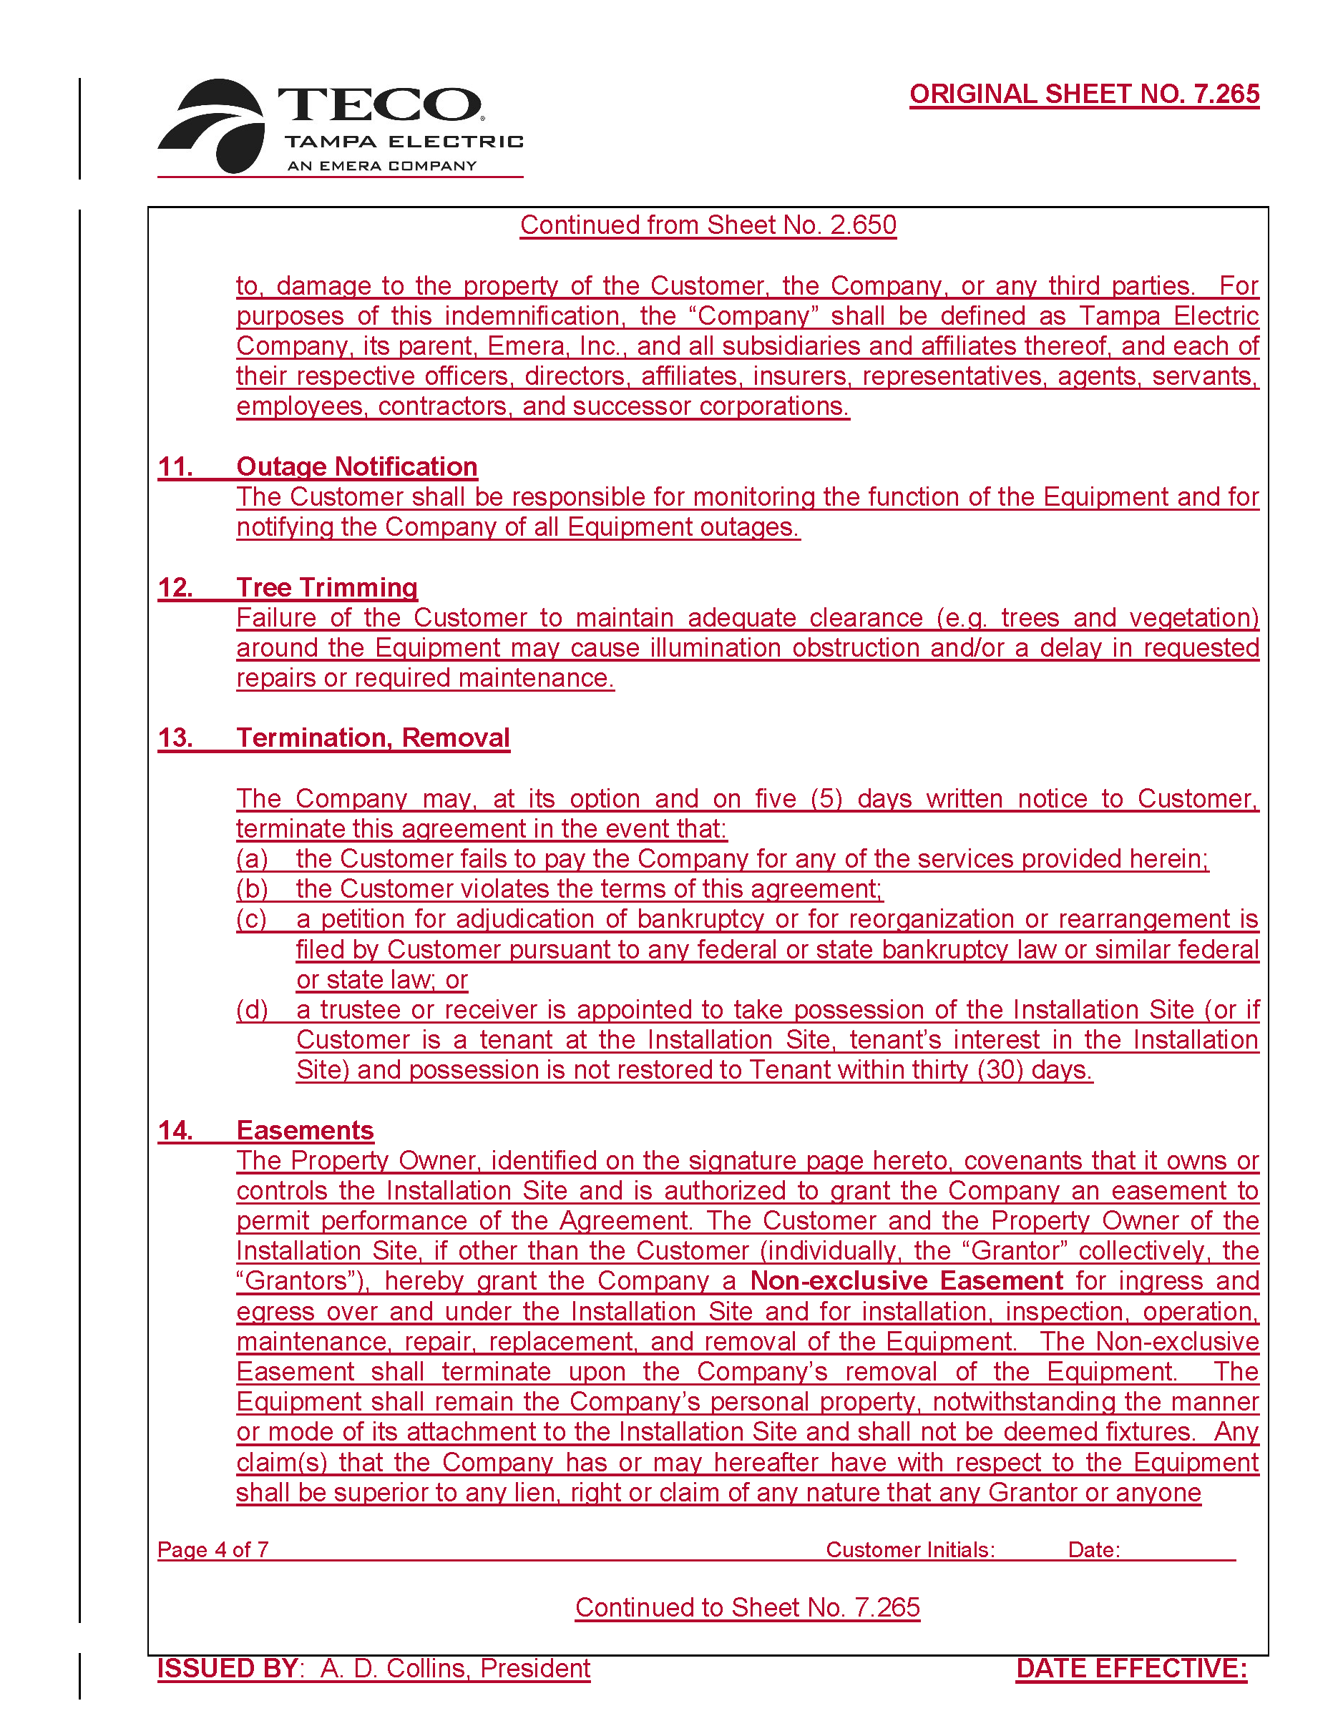
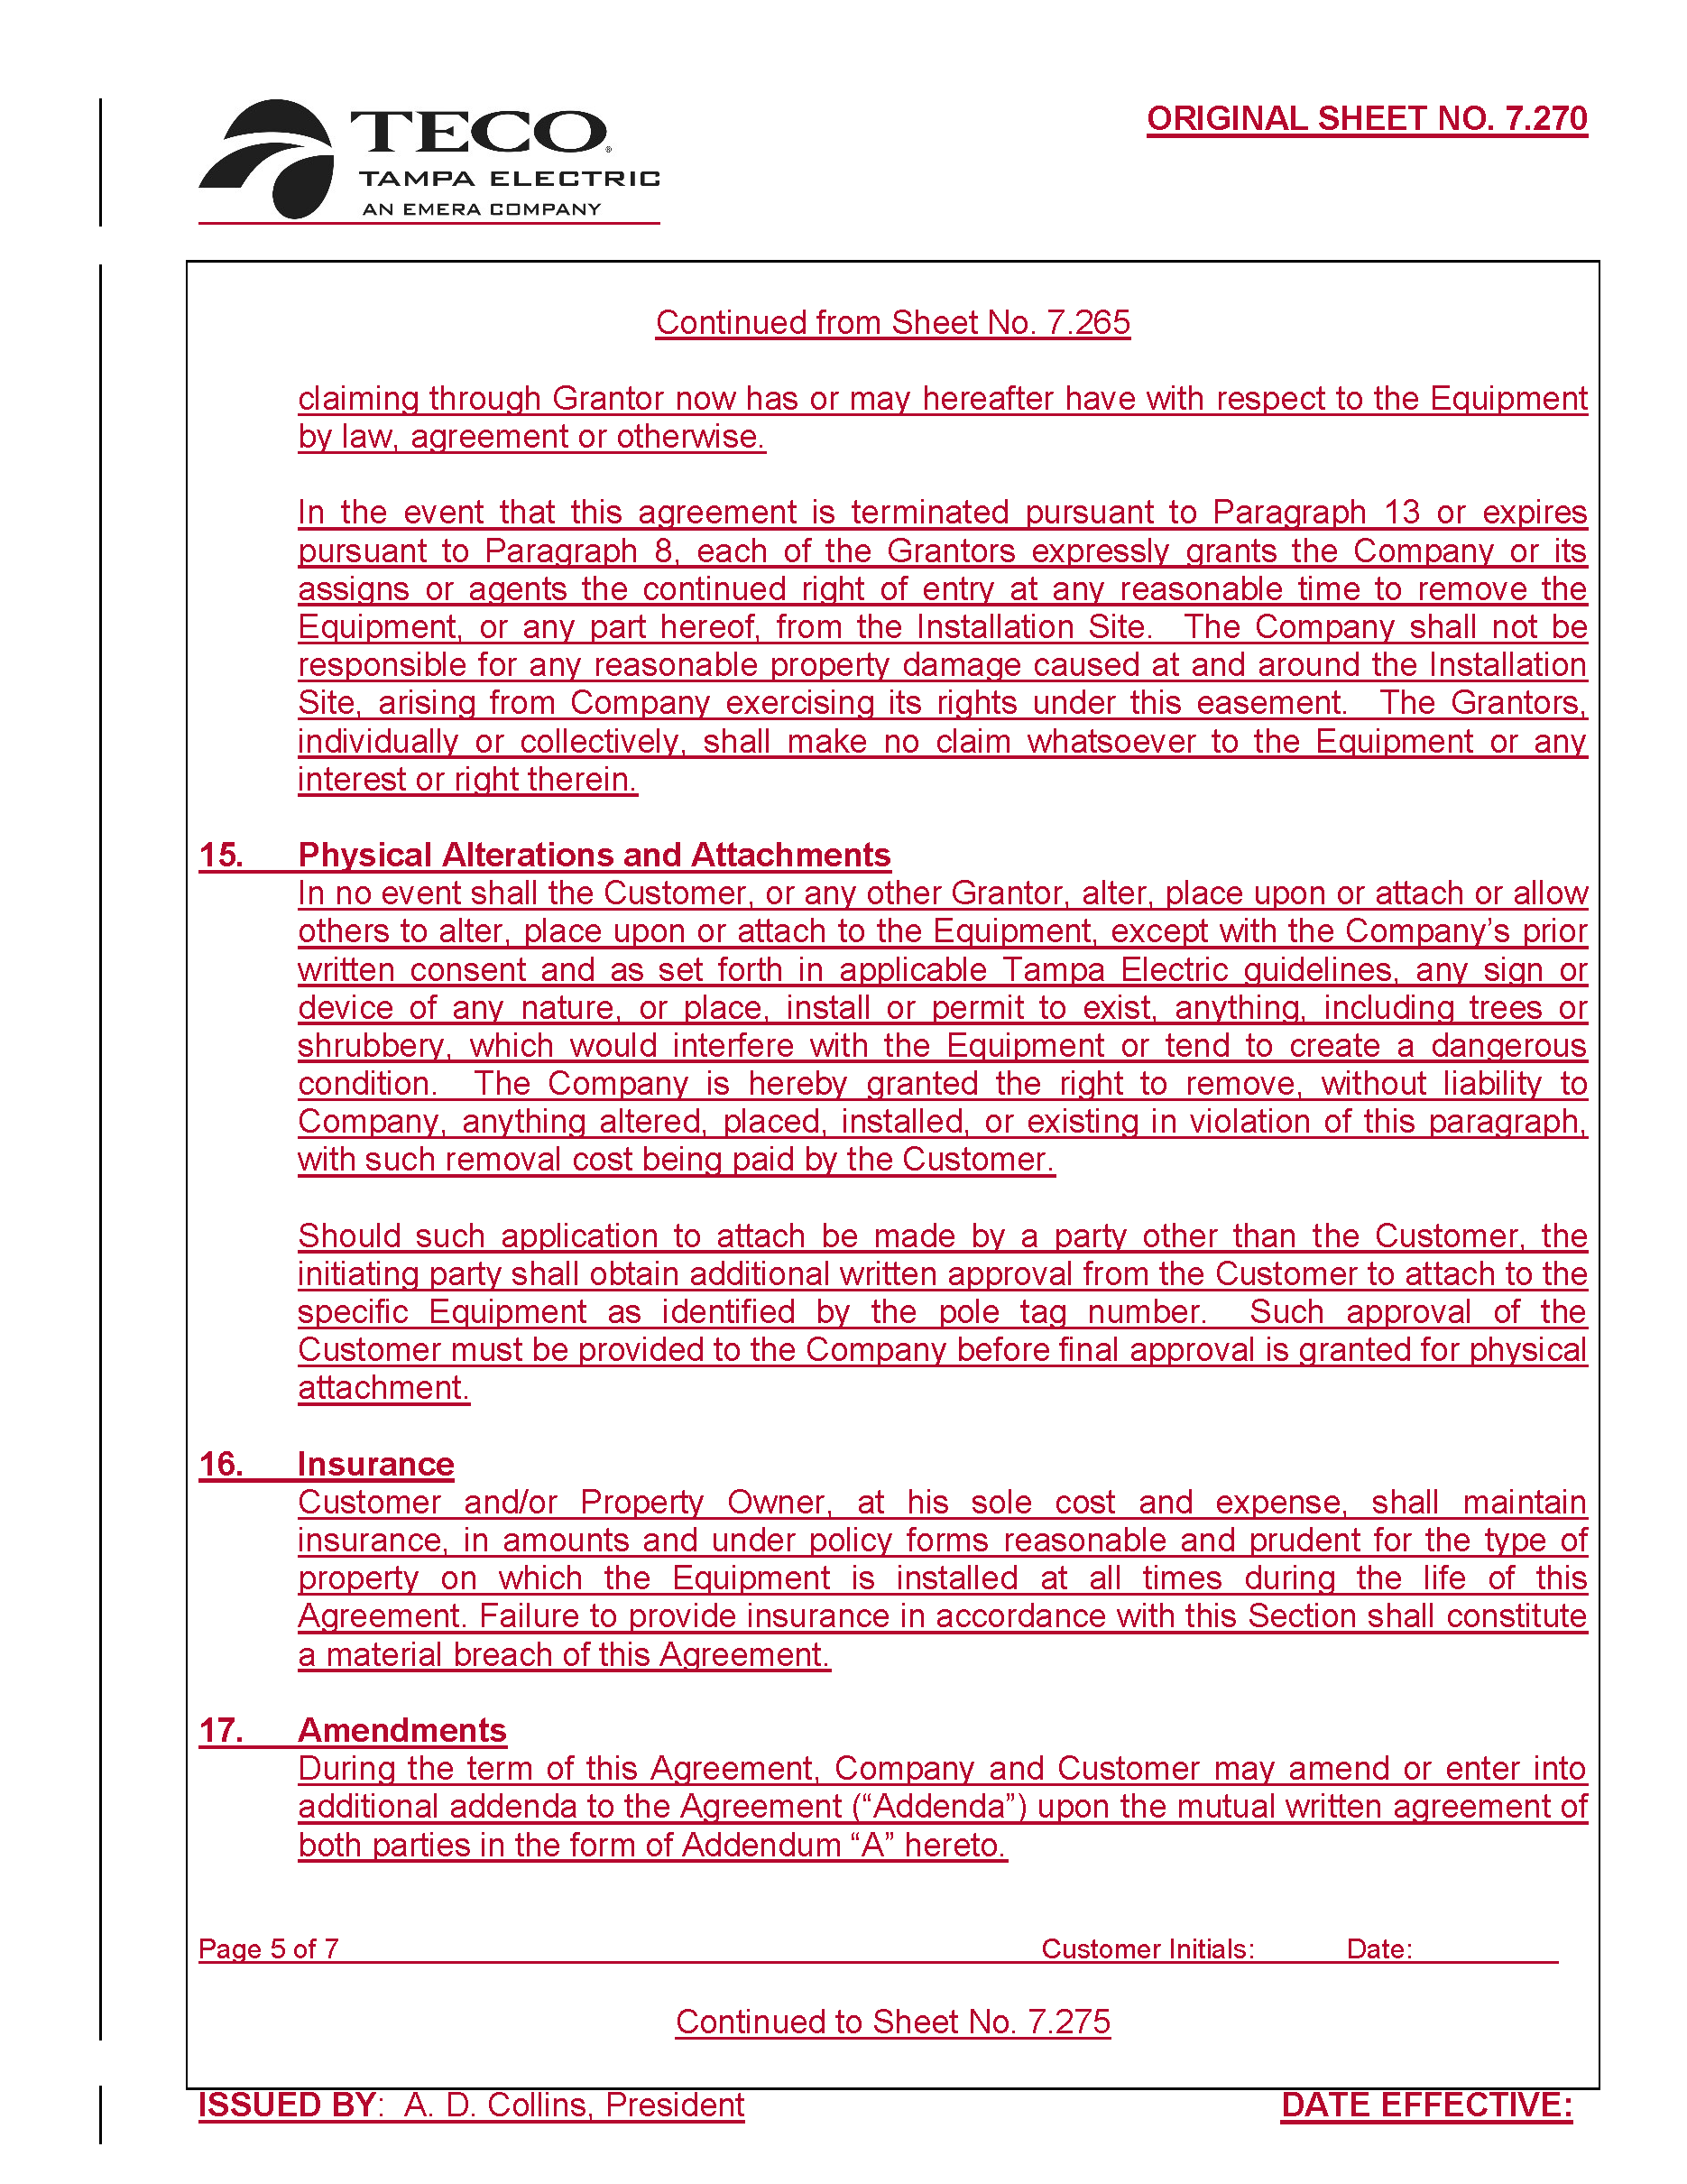
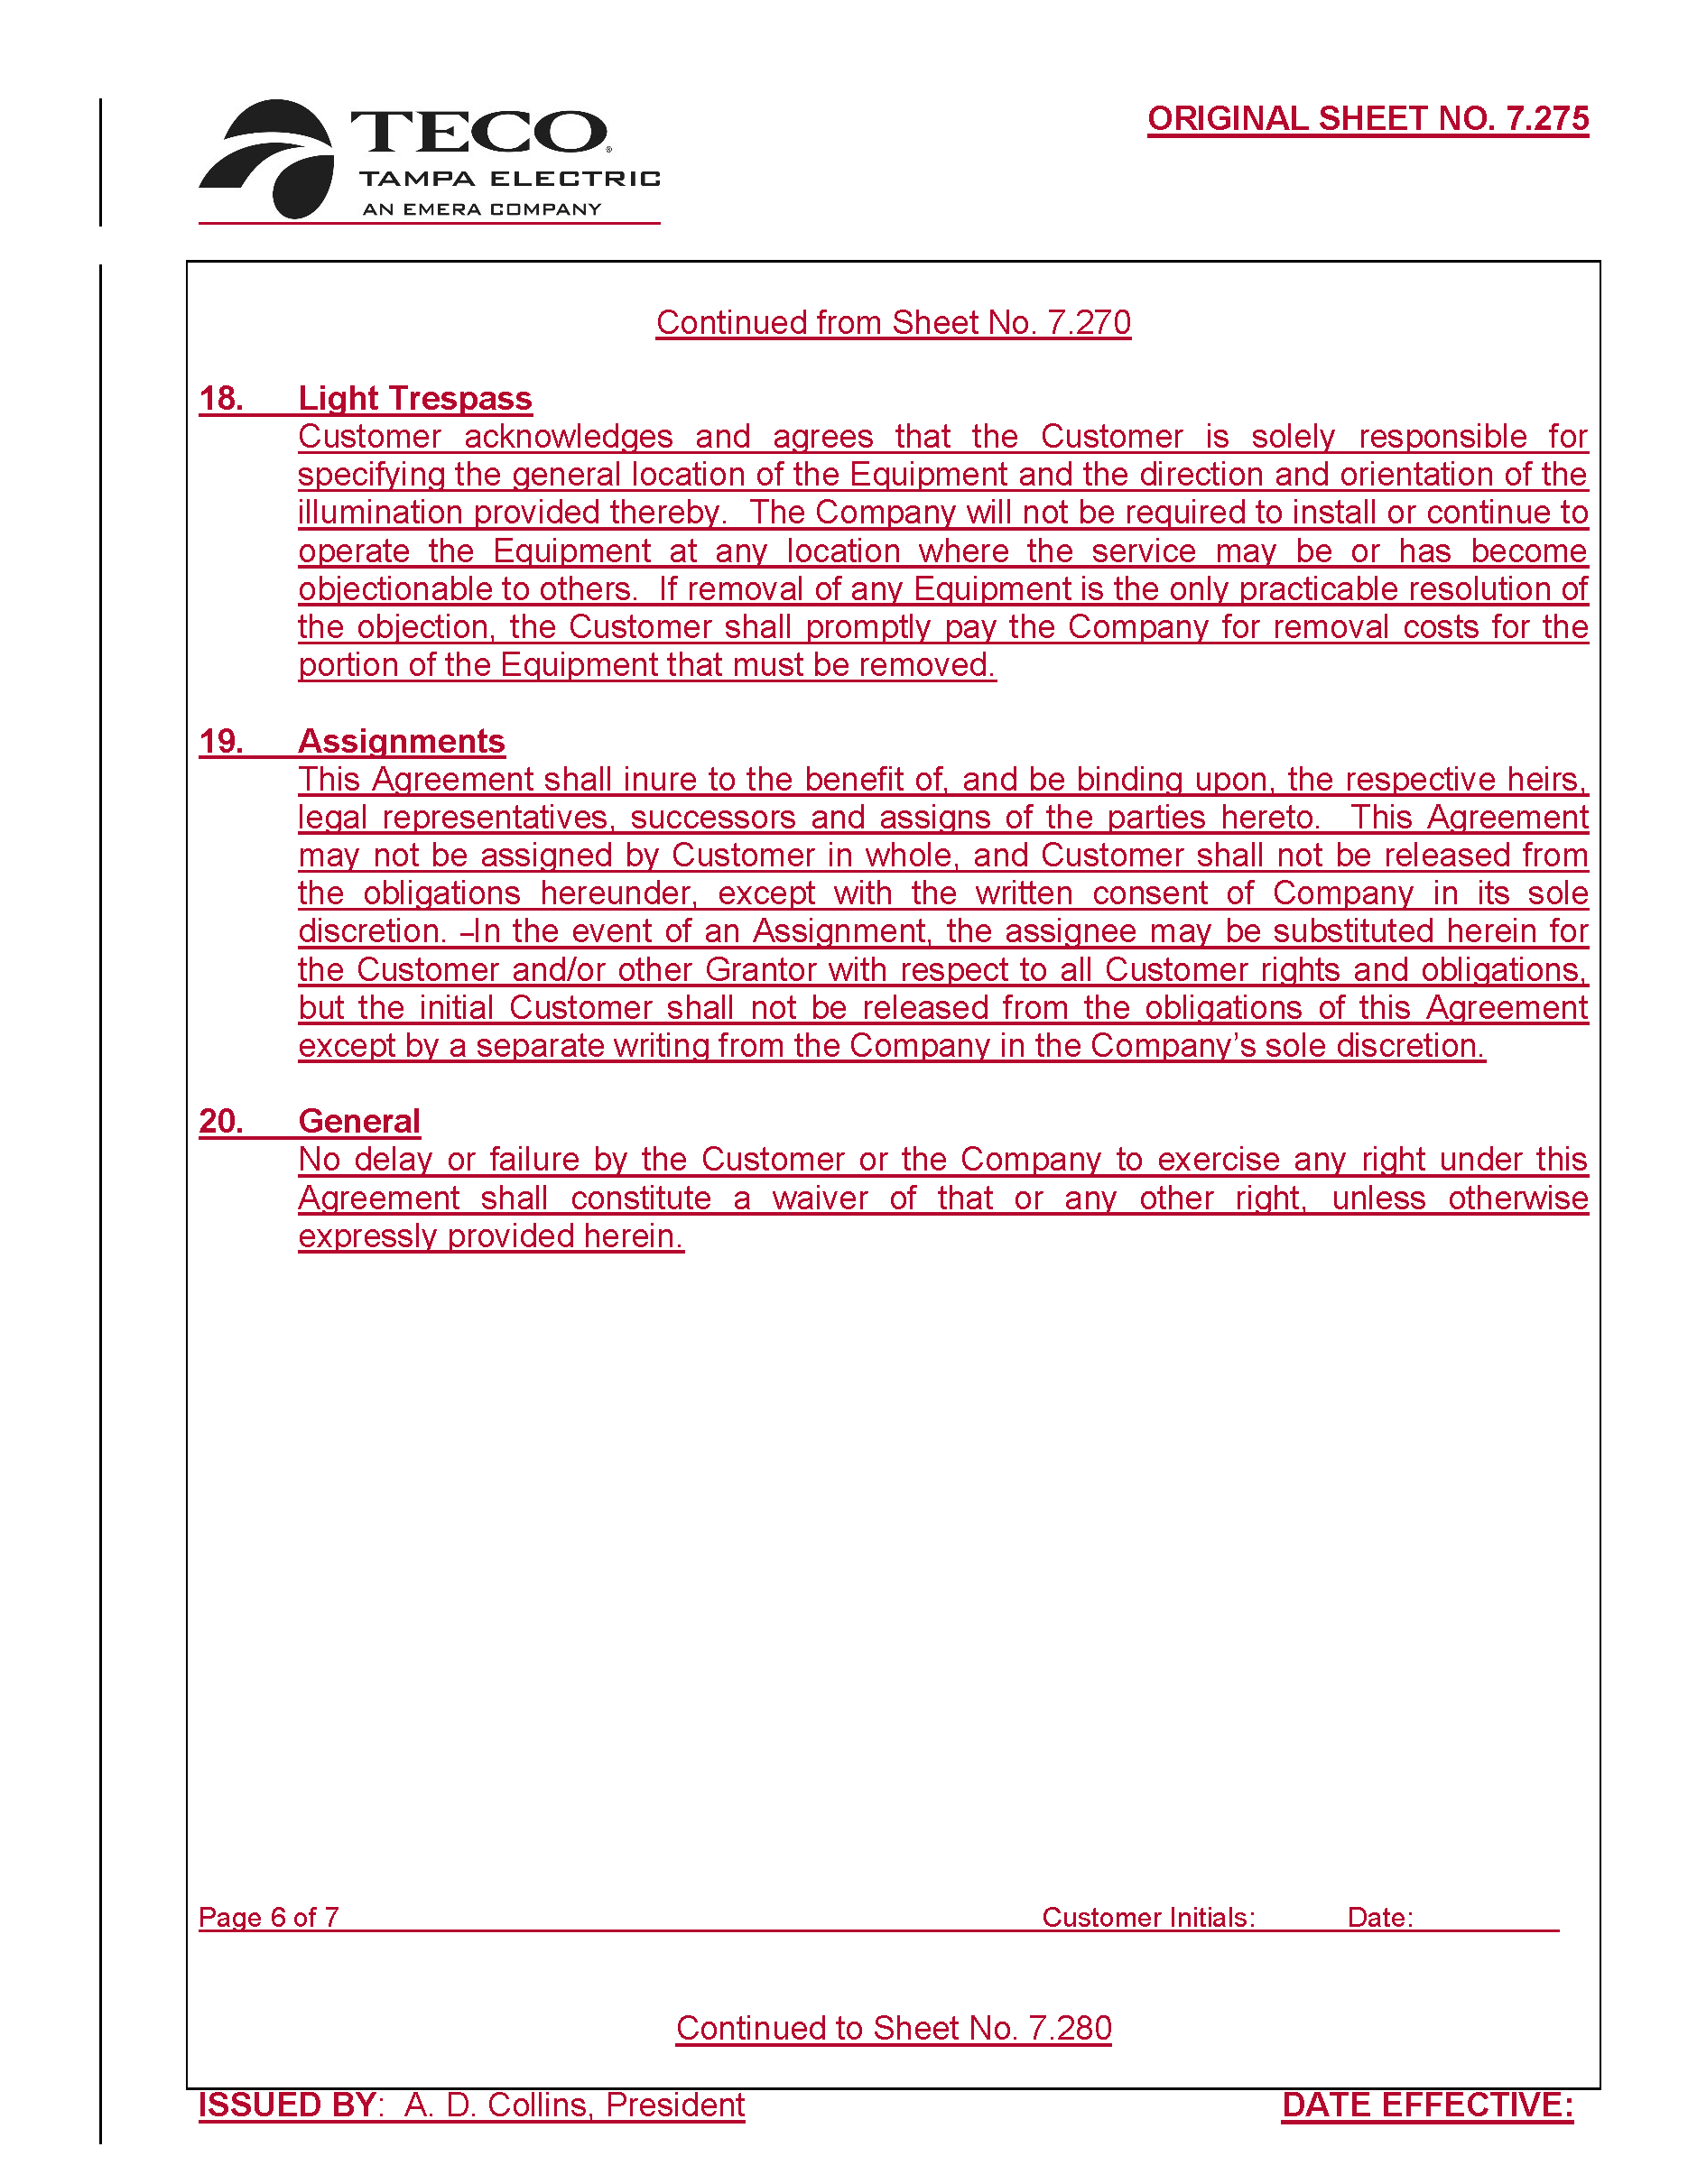
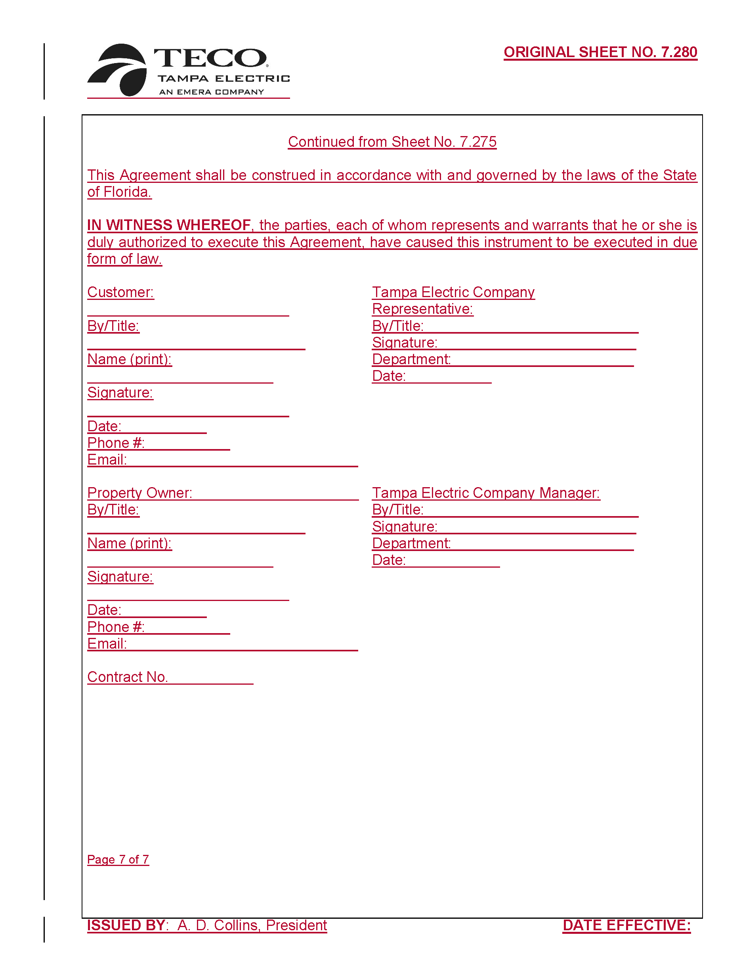

Order No. PSC-2021-0423-S-EI, issued November 10, 2021, in Docket No. 20210034-EI, In re: Petition for rate increase by Tampa Electric Company.
Order No. PSC-2022-0140-PCO-EI, issued April 12, 2022, in Docket No. 20220037-EI, In re: Petition for approval of a new small commercial lighting tariff, by Tampa Electric Company.
TECO’s responses to staff’s first data requests (DN 02105-2022), TECO’s responses to staff’s second data requests (DN 02624-2022).
TECO’s responses to staff’s second data request, request No. 11.
TECO’s responses to staff’s first data request, request No. 1.
TECO’s responses to staff’s second data request, request No. 1.
TECO’s responses to staff’s first data request No. 2 and second data request No. 8.
TECO’s responses to staff’s second data request, request No. 2.
TECO defines light trespass as “an unintentional and annoying intrusion of light onto a neighboring property.” Order No. PSC-03-0417-TRF-EI, issued March 26, 2003, in Docket No. 20030122-EI, In re: Petition for approval of revised lighting tariffs, by Tampa Electric Company.
TECO’s responses to staff’s second data request, request No. 4.
TECO’s responses to staff’s second data request, request No. 5.
Order No. PSC-2018-0106-TRF-EI, issued February 26, 2018, in Docket No. 20170198, In re: Petition to close to new business all existing lighting rates and approve new LED lighting rates and tariffs, by Tampa Electric Company.
TECO’s responses to staff’s first data request, request No. 8.

