State of Florida  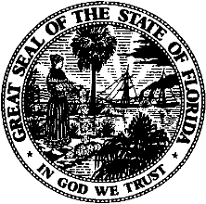 | Public Service Commission  Capital Circle Office Center ● 2540 Shumard Oak Boulevard  Tallahassee, Florida 32399-0850  -M-E-M-O-R-A-N-D-U-M-
DATE: | July 21, 2022
TO: | Office of Commission Clerk (Teitzman)
FROM: | Office of Industry Development and Market Analysis (Day, Deas, Fogleman)  Office of the General Counsel (Imig, Jones, Trierwieler)
RE: | Applications for Certificate of Authority to Provide Telecommunications Service
AGENDA: | 8/2/2022 - Consent Agenda - Proposed Agency Action - Interested Persons May Participate
SPECIAL INSTRUCTIONS: |  | None

Please place the following Applications for Certificate of Authority to Provide Telecommunications Service on the consent agenda for approval.

DOCKET NO. | COMPANY NAME | CERT. NO.
20220104-TX | Ubiquity Florida, LLC | 8973
20220109-TX | Accelecom GA LLC | 8974
20220116-TL | Gold Data USA Inc. | 8975

The Commission is vested with jurisdiction in this matter pursuant to Section 364.335, Florida Statutes. Pursuant to Section 364.336, Florida Statutes, certificate holders must pay a minimum annual Regulatory Assessment Fee if the certificate is active during any portion of the calendar year. A Regulatory Assessment Fee Return Notice will be mailed each December to the entities listed above for payment by January 30.

