BEFORE THE FLORIDA PUBLIC SERVICE COMMISSION

In re: Petition for approval of transportation service agreement to reflect expansion of St. Cloud by Florida Public Utilities Company and Peninsula Pipeline Company, Inc. | DOCKET NO. 20220123-GU  ORDER NO. PSC-2022-0351-PAA-GU  ISSUED: October 11, 2022

The following Commissioners participated in the disposition of this matter:

ART GRAHAM, Chairman
GARY F. CLARK
MIKE LA ROSA
GABRIELLA PASSIDOMO

NOTICE OF PROPOSED AGENCY ACTION
ORDER APPROVING FIRM TRANSPORTATION AGREEMENT

BY THE COMMISSION:

NOTICE is hereby given by the Florida Public Service Commission that the action discussed herein is preliminary in nature and will become final unless a person whose interests are substantially affected files a petition for a formal proceeding, pursuant to Rule 25-22.029, Florida Administrative Code.

Background

On July 6, 2022, Peninsula Pipeline Company, Inc. (Peninsula) filed a petition seeking approval of a firm transportation service agreement (Agreement) between Peninsula and Florida Public Utilities Company (FPUC), collectively the parties. The purpose of the Agreement is to expand and reinforce the St. Cloud gas distribution system in Osceola County. On July 7, 2022, Peninsula filed an amended petition correcting the title of the petition. Peninsula operates as an intrastate natural gas transmission company as defined by Section 368.103(4), Florida Statutes (F.S.). FPUC is a local distribution company (LDC) subject to our regulatory jurisdiction pursuant to Chapter 366, F.S.
By Order No. PSC-07-1012-TRF-GP, Peninsula received our approval of an intrastate gas pipeline tariff that allows it to construct and operate intrastate pipeline facilities and to actively pursue agreements with natural gas customers. Peninsula provides gas transportation service only; it does not engage in the sale of natural gas. Pursuant to Order No. PSC-07-1012-TRF-GP, Peninsula is allowed to enter into certain gas transmission agreements without our prior approval. However, Peninsula is requesting our approval of this proposed Agreement as it does not fit any of the criteria enumerated in the tariff for which our approval would not be required. The parties are subsidiaries of Chesapeake Utility Corporation (Chesapeake), a Delaware corporation authorized to conduct business in Florida, and agreements between affiliated companies must be approved by us pursuant to Section 368.105, F.S., and Order No. PSC-07-1012-TRF-GP.

Pursuant to the proposed Agreement and project map (Attachments A and B to this order), Peninsula will construct, own, and operate a new natural gas pipeline, a new district regulator, and an additional interconnect with Florida Gas Transmission Company’s (FGT) system. Additionally, pursuant to the proposed Agreement, FPUC will construct a pipeline which will interconnect to Peninsula. The proposed project will enable FPUC to serve the Twin Lakes community and potential future gas customers in Osceola County. During the evaluation of the amended petition, our staff issued a data request to the parties for which responses were received on August 5, 2022. We have jurisdiction over this matter pursuant to Sections 366.05(1), 366.06, and 368.105, F.S.

Decision

Proposed Transportation Service Agreement
FPUC provides natural gas service to residential, commercial, and industrial customers in Osceola County, and receives deliveries of natural gas to serve these customers over interstate transmission pipelines owned by Florida Gas Transmission (FGT).
The parties have entered into the proposed firm transportation Agreement to enable FPUC to reinforce its St. Cloud distribution system and meet increased natural gas demand in Osceola County. The proposed Agreement has the added benefit of providing FPUC with an additional source of gas (via the Peninsula intrastate pipeline) and enhancing an existing interconnection with the FGT pipeline.
The proposed Agreement specifies an initial term of 20 years and thereafter shall be extended on a year-to-year basis, unless either party gives no less than 90 days of written notification of termination. If either party desires to negotiate modifications to the rates or terms of this Agreement, they may do so no less than 120 days prior to expiration of the current active term. The proposed St. Cloud expansion project is discussed below and the project map is contained on Attachment B to this order.

Proposed St. Cloud Expansion Project
Attachment B shows the proposed St. Cloud gas distribution expansion project. As shown by the blue line, starting at an existing city gate interconnection with FGT on Missouri Avenue in Osceola County, Peninsula will construct 23,232 feet (4.4 miles) of 4-inch steel pipeline traveling south along Missouri Avenue, west along Fertic Road, then south along Canoe Creek Road up to the Nolte Road intersection.
From the Canoe Creek Road and Nolte Road intersection, Peninsula will continue the steel pipeline east along Nolte Road and conclude at the district regulator station at the intersection of Nolte Road and Hickory Tree Road, also shown by the blue line.
Finally, indicated by a red line, from the Nolte Road and Hickory Tree Road intersection, FPUC will construct 1,320 feet of 6-inch medium-density polyethylene plastic pipeline along Hickory Tree Road providing a connection to an existing gas main. The parties assert that the selected route of the St. Cloud expansion project provides the largest benefit to the area, to FPUC, and its customers.

Anticipated System benefits
The parties assert that the proposed project will enable FPUC to serve the Twin Lakes community, a large residential development projected to have 1,400 dwelling units when fully built out. Other commercial customers, along Peninsula’s portion of the project, are expected to be served as well. The petition also states that FPUC will be positioned to serve other developments to be built in and around St. Cloud in Osceola County. The parties assert that construction of the pipeline is necessary because the existing infrastructure is not adequate to serve the Twin Lakes community when it is expected to be fully built out by 2029. Additionally, FPUC is currently negotiating with the developer of Center Lake Ranch, which at built out is expected to have a total of 2,054 dwelling units (in two development phases) and some commercial development. The parties assert that the proposed project will reinforce FPUC’s St. Cloud distribution system with an additional source of interstate gas with the potential to provide natural gas service to future customers in Osceola County.
In response to our staff’s data request, the parties stated that FPUC did not obtain formal Request for Proposals (RFP) responses from other entities. FPUC explained that in previous discussions and requests with FGT for other projects, FGT has declined to bid on projects related to construction, owning, and operating laterals such as the proposed expansion project in this petition, which are not a focus of FGT’s expansion activities.

Negotiated Monthly Reservation Payments to Peninsula
The parties assert that the negotiated monthly reservation charge contained in the proposed agreement is consistent with market rates, because the rates are substantially the same as rates set forth in similar agreements as required by Section 368.105(3)(b), F.S. The parties assert that Peninsula will recover the pipeline and district regulator construction costs through the monthly reservation charge to FPUC as shown in Exhibit A to the proposed Agreement. The monthly reservation charge is designed to recover costs such as, but not limited to, engineering, permitting, materials, and installation costs associated with pipeline and related facilities, ongoing maintenance including Pipeline and Hazardous Materials Safety Administration (PHMSA) compliance, safety requirements, property taxes, gas control, and Peninsula’s return on investment.
FPUC is proposing to recover its payments to Peninsula through Purchased Gas Adjustment (PGA) and swing service rider mechanisms. The PGA allows FPUC to periodically adjust the price of natural gas supplied to its customers to reflect the actual cost of gas purchased and delivered on behalf of the customers. The swing service rider allows FPUC to recover intrastate capacity costs from their transportation customers and is a cents per therm charge that is included in the monthly customer gas bill of transportation customers. While FPUC will incur costs associated with this service expansion, new load added to the system will help spread the costs over a larger customer base.
Based upon our review of the petition and the parties’ responses to our staff’s data request, we find that the proposed Agreement is reasonable and meets the requirements of Section 368.105, F.S. Furthermore, the proposed Agreement benefits FPUC’s current and potential future customers by having an additional source of gas for the growing areas in Osceola County. Therefore, we approve the proposed Agreement between Peninsula and FPUC dated June 20, 2022.
Based on the foregoing, it is
ORDERED by the Florida Public Service Commission that the firm transportation Agreement dated June 20, 2022 between Florida Public Utilities Company and Peninsula Pipeline Company, Inc. is hereby approved. It is further,
ORDERED that if no protest is filed by a person whose substantial interests are affected within 21 days of the issuance of this order, this docket should be closed upon the issuance of a consummating order.
By ORDER of the Florida Public Service Commission this 11th day of October, 2022.

/s/ Adam J. Teitzman
ADAM J. TEITZMAN
Commission Clerk
Florida Public Service Commission
2540 Shumard Oak Boulevard
Tallahassee, Florida 32399
(850) 413-6770
www.floridapsc.com

Copies furnished: A copy of this document is provided to the parties of record at the time of issuance and, if applicable, interested persons.

SBr

NOTICE OF FURTHER PROCEEDINGS OR JUDICIAL REVIEW

The Florida Public Service Commission is required by Section 120.569(1), Florida Statutes, to notify parties of any administrative hearing that is available under Section 120.57, Florida Statutes, as well as the procedures and time limits that apply. This notice should not be construed to mean all requests for an administrative hearing will be granted or result in the relief sought.

Mediation may be available on a case-by-case basis. If mediation is conducted, it does not affect a substantially interested person's right to a hearing.

The action proposed herein is preliminary in nature. Any person whose substantial interests are affected by the action proposed by this order may file a petition for a formal proceeding, in the form provided by Rule 28-106.201, Florida Administrative Code. This petition must be received by the Office of Commission Clerk, 2540 Shumard Oak Boulevard, Tallahassee, Florida 32399-0850, by the close of business on November 1, 2022.

In the absence of such a petition, this order shall become final and effective upon the issuance of a Consummating Order.

Any objection or protest filed in this/these docket(s) before the issuance date of this order is considered abandoned unless it satisfies the foregoing conditions and is renewed within the specified protest period.

ATTACHMENT A
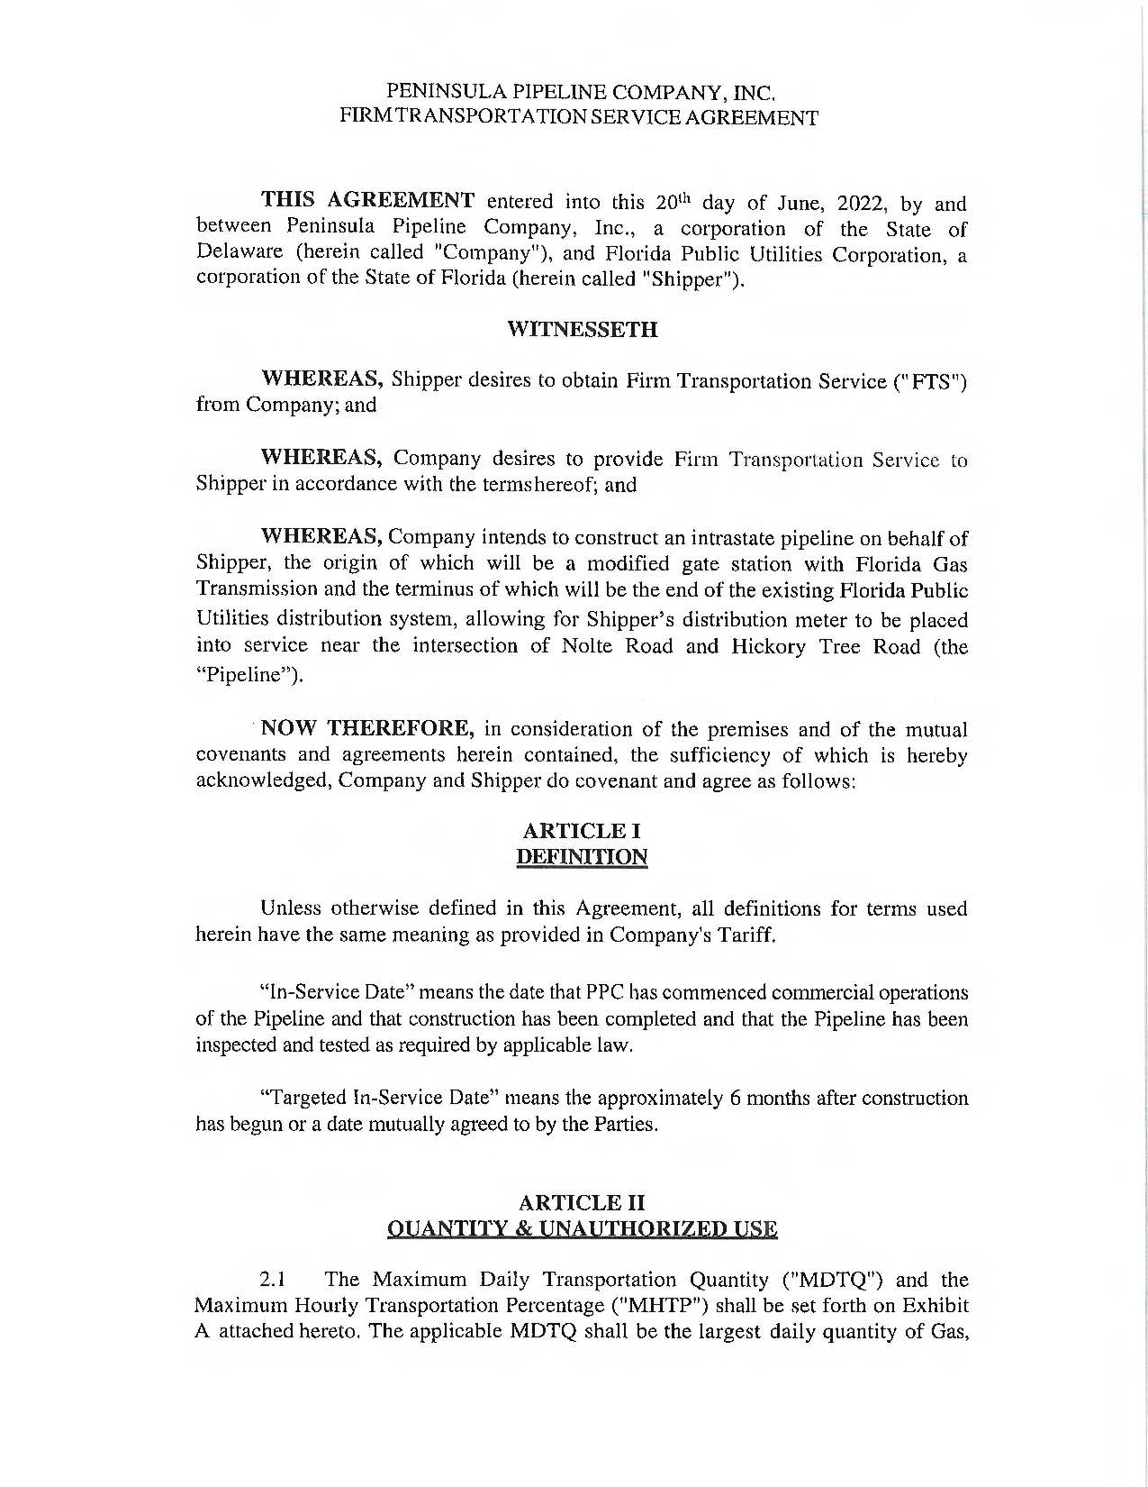
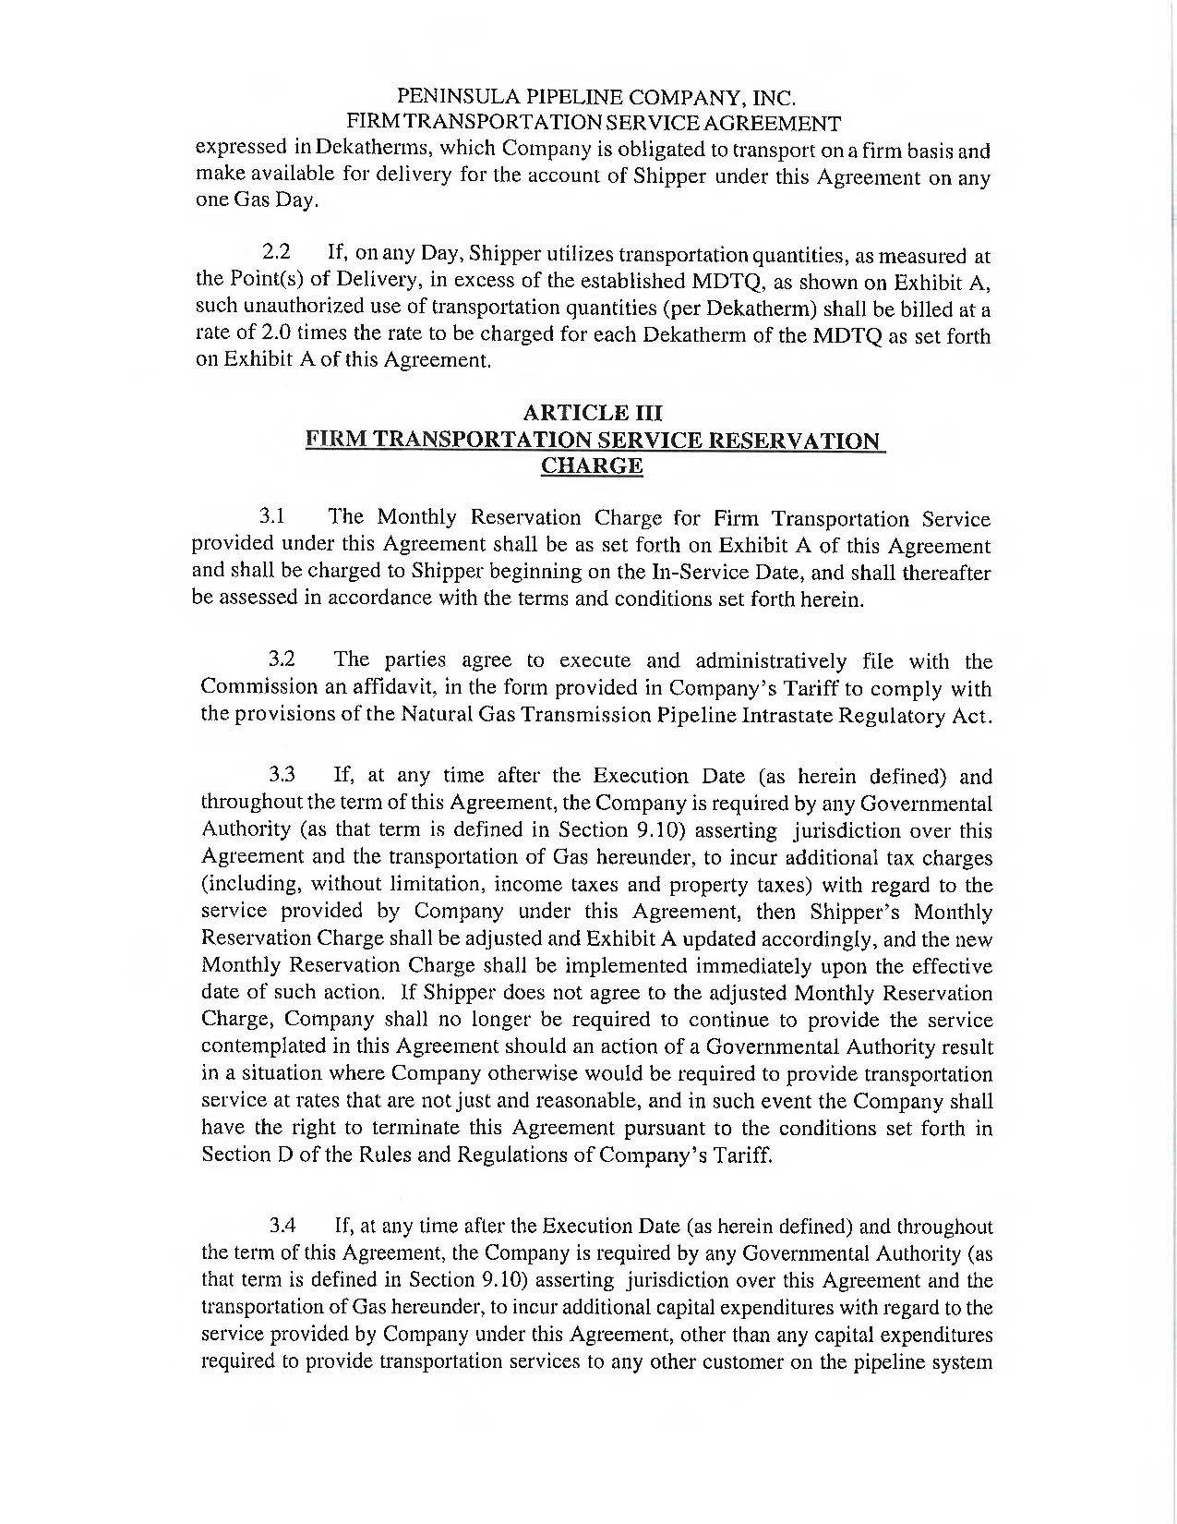

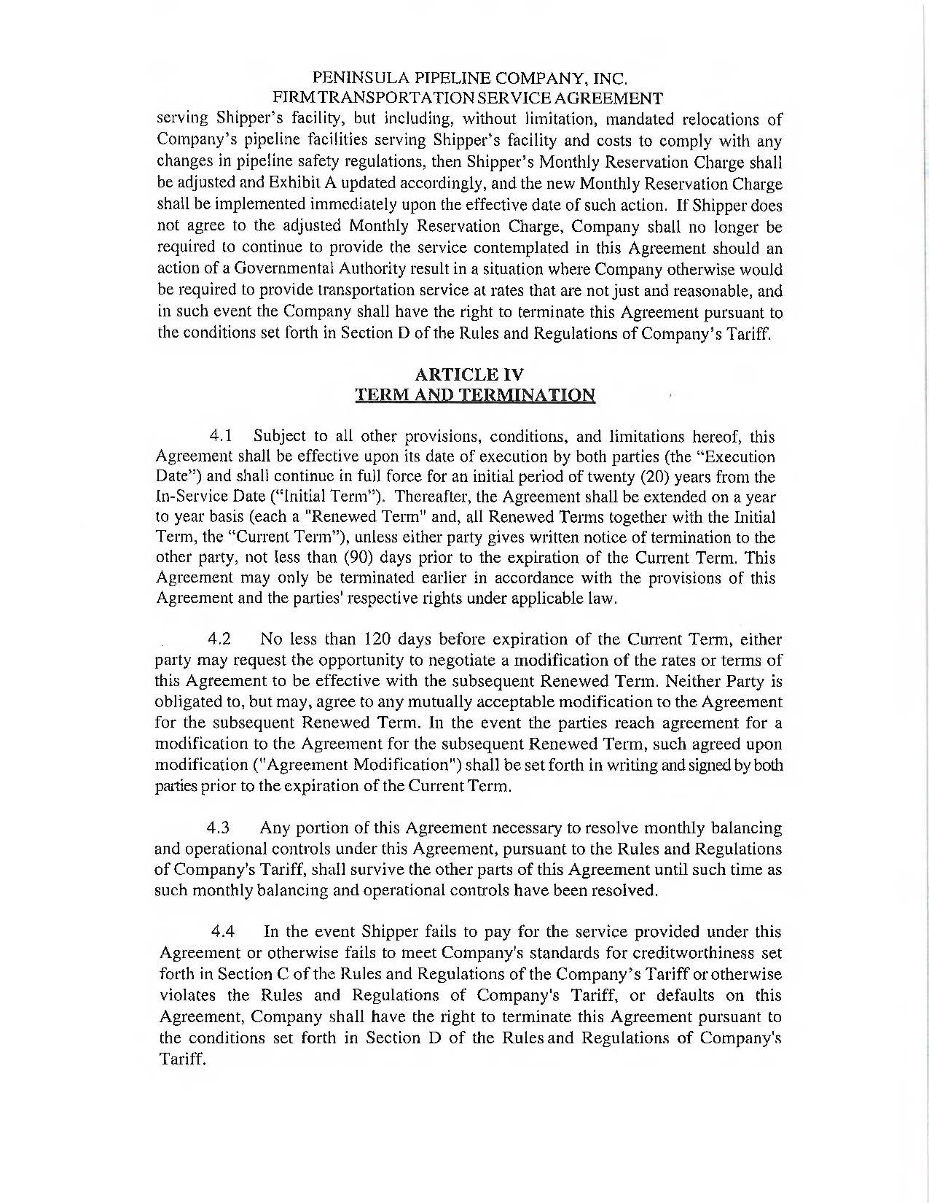

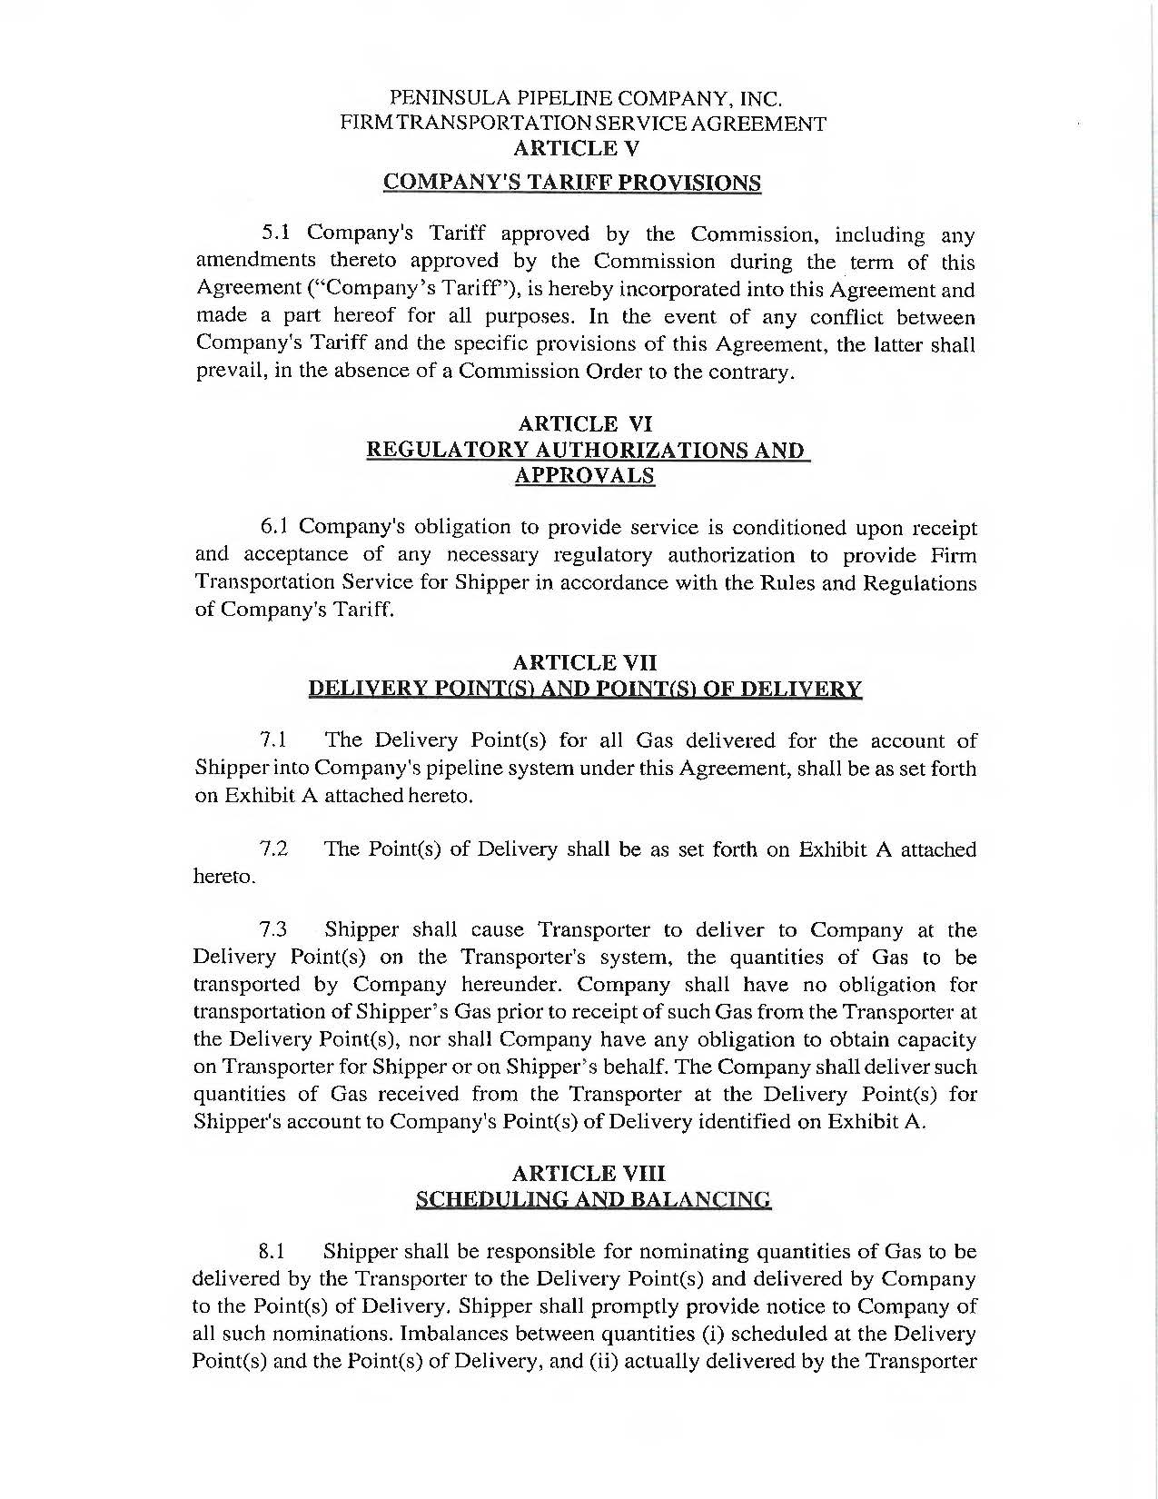

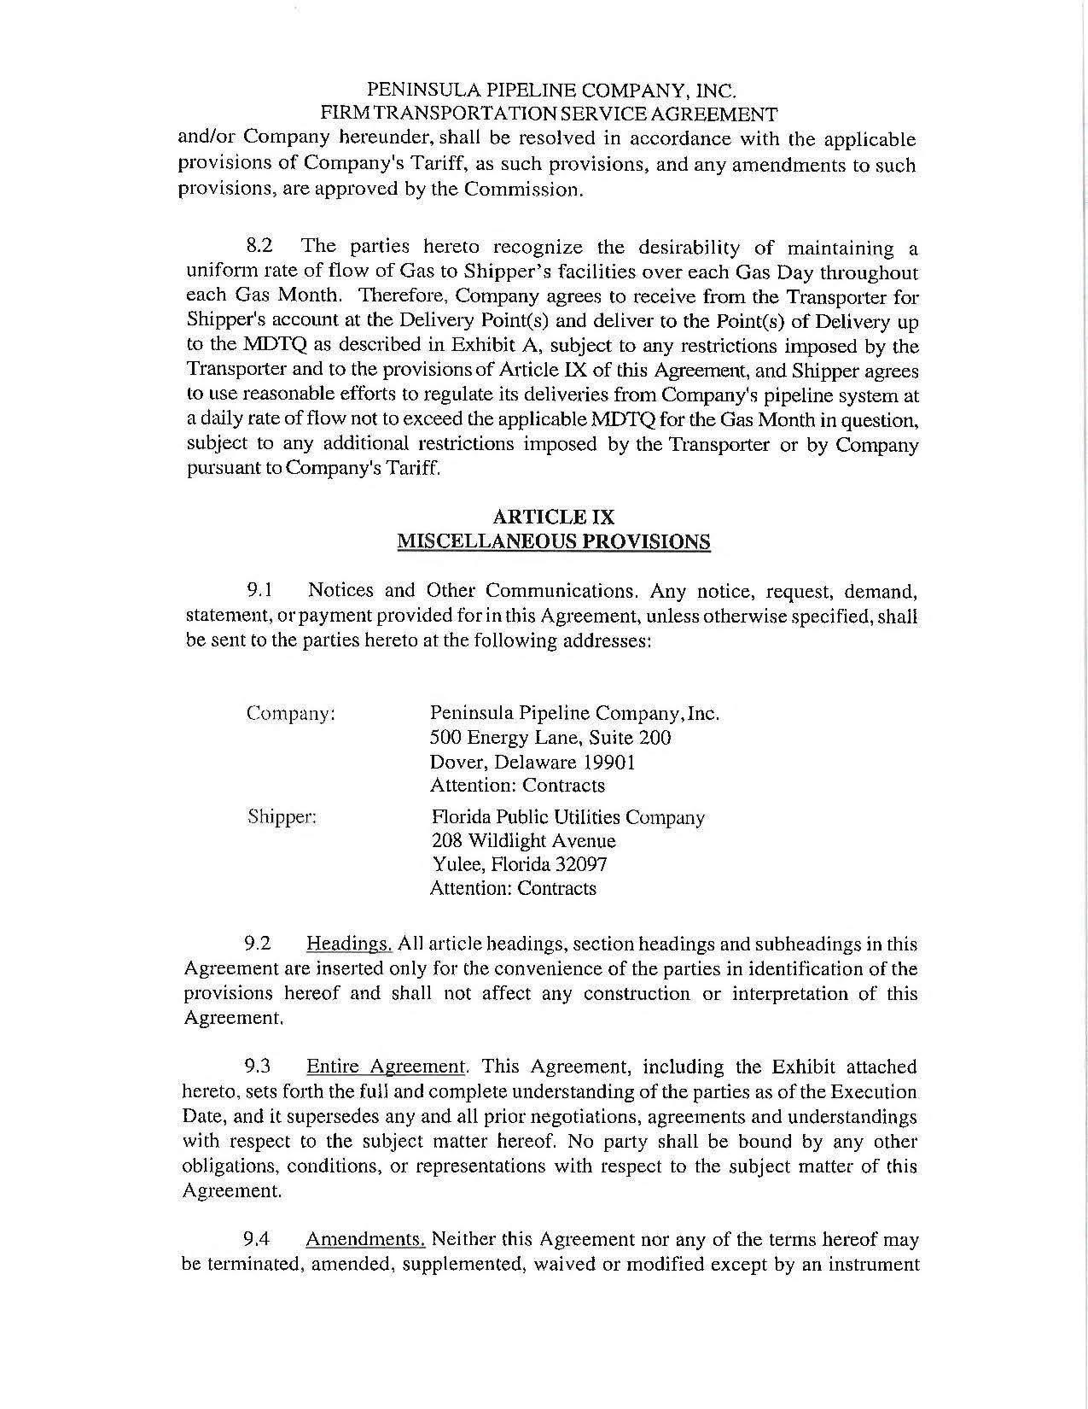

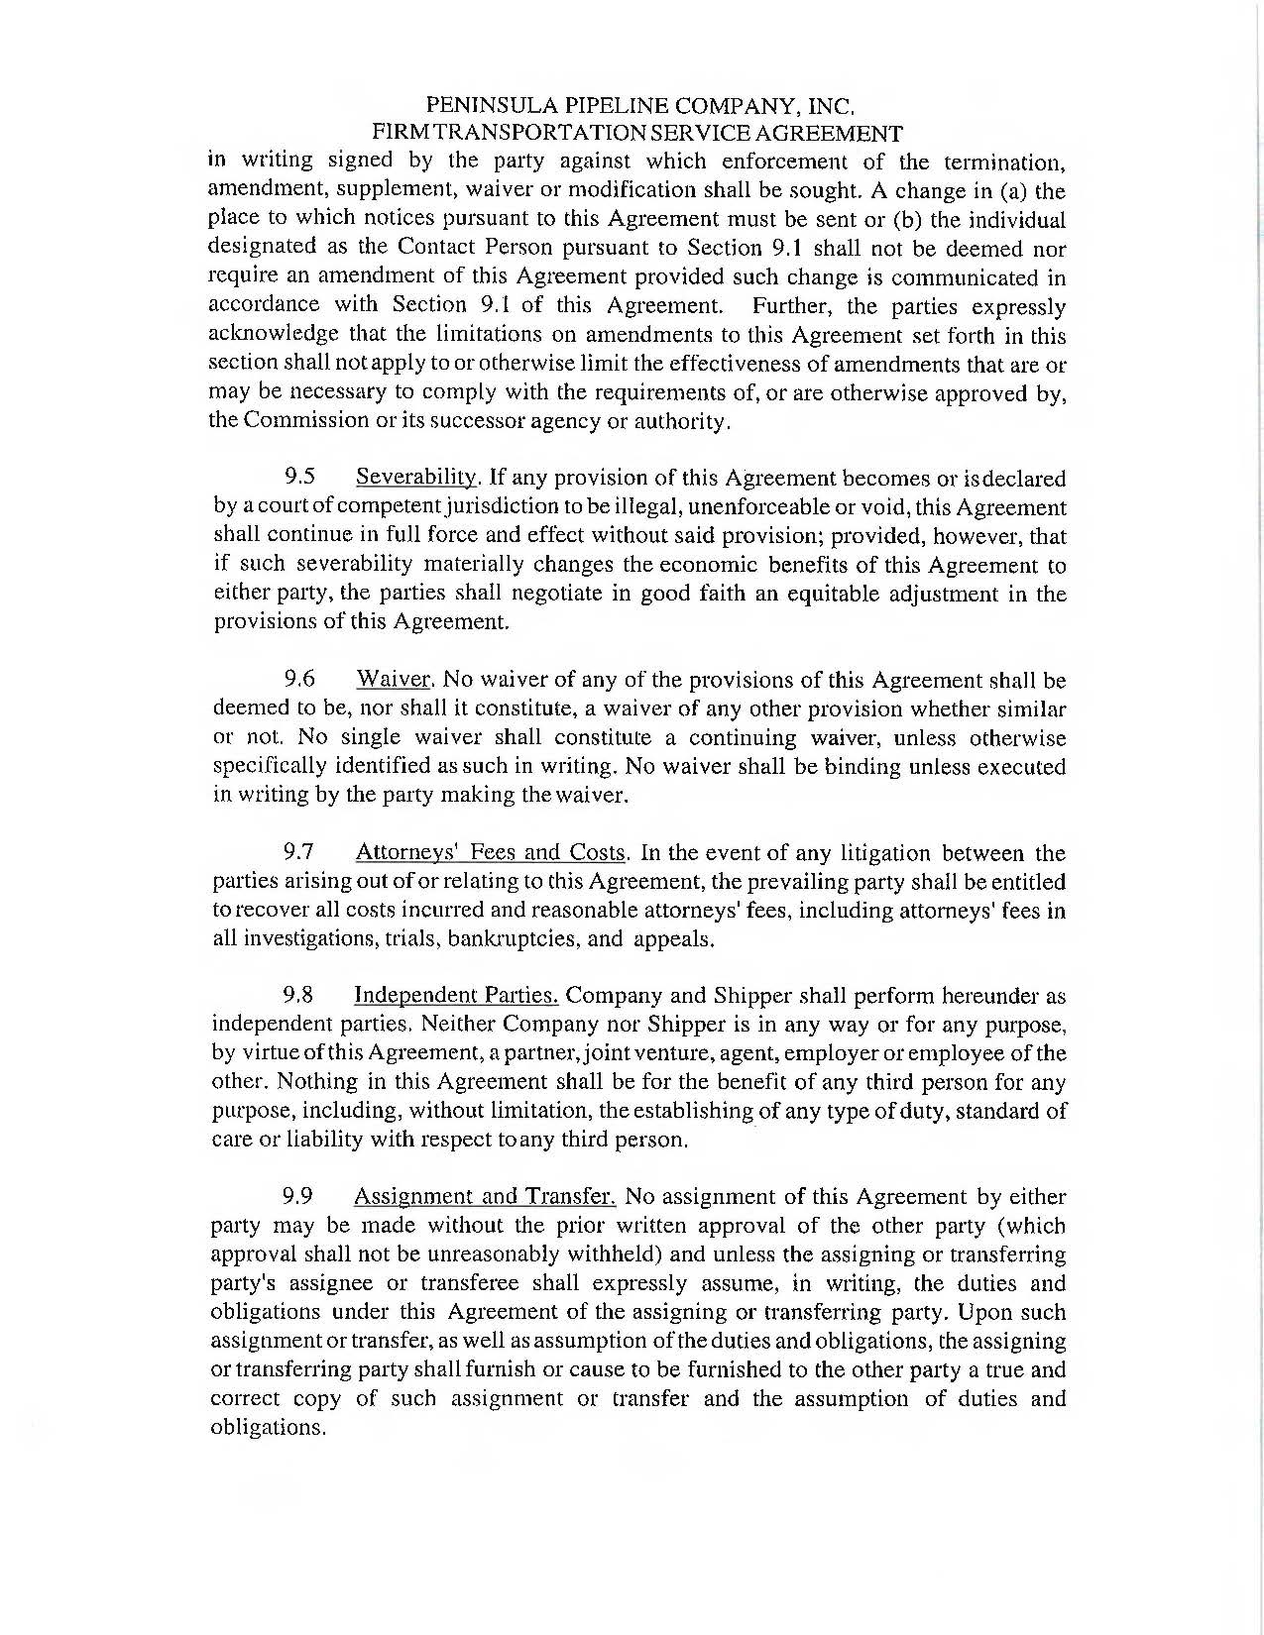

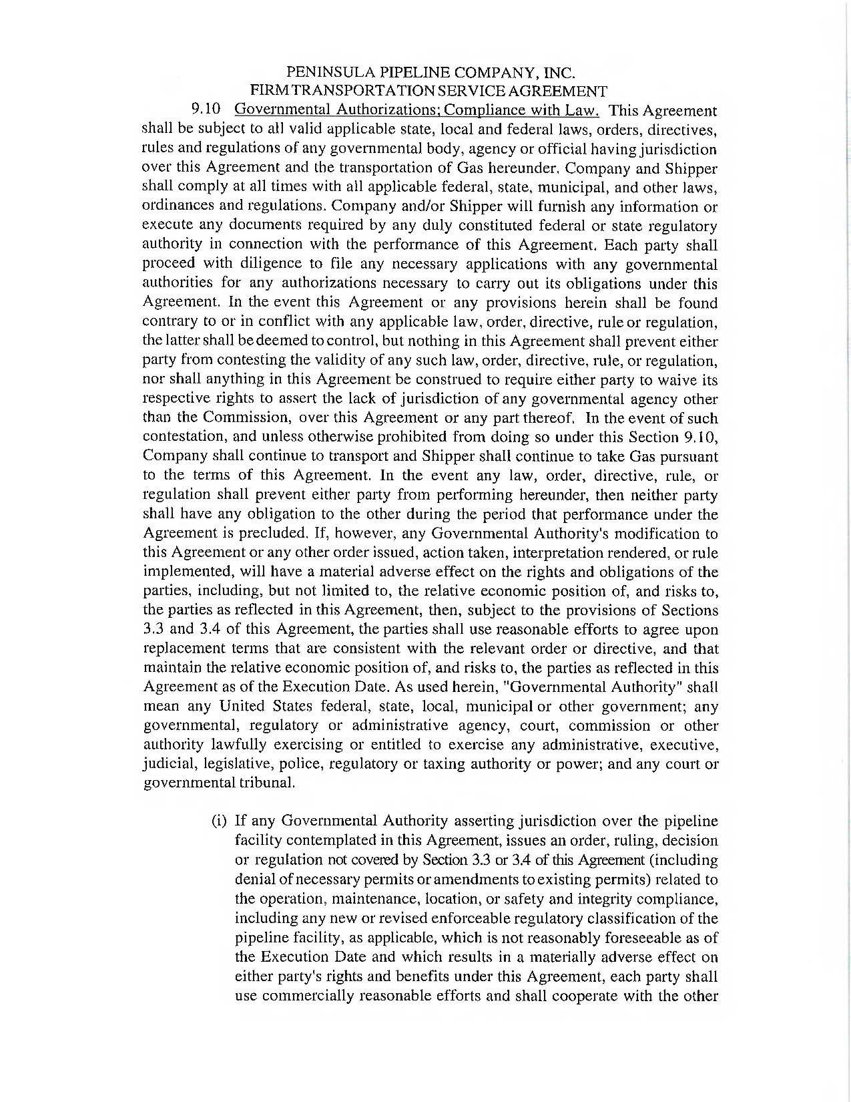

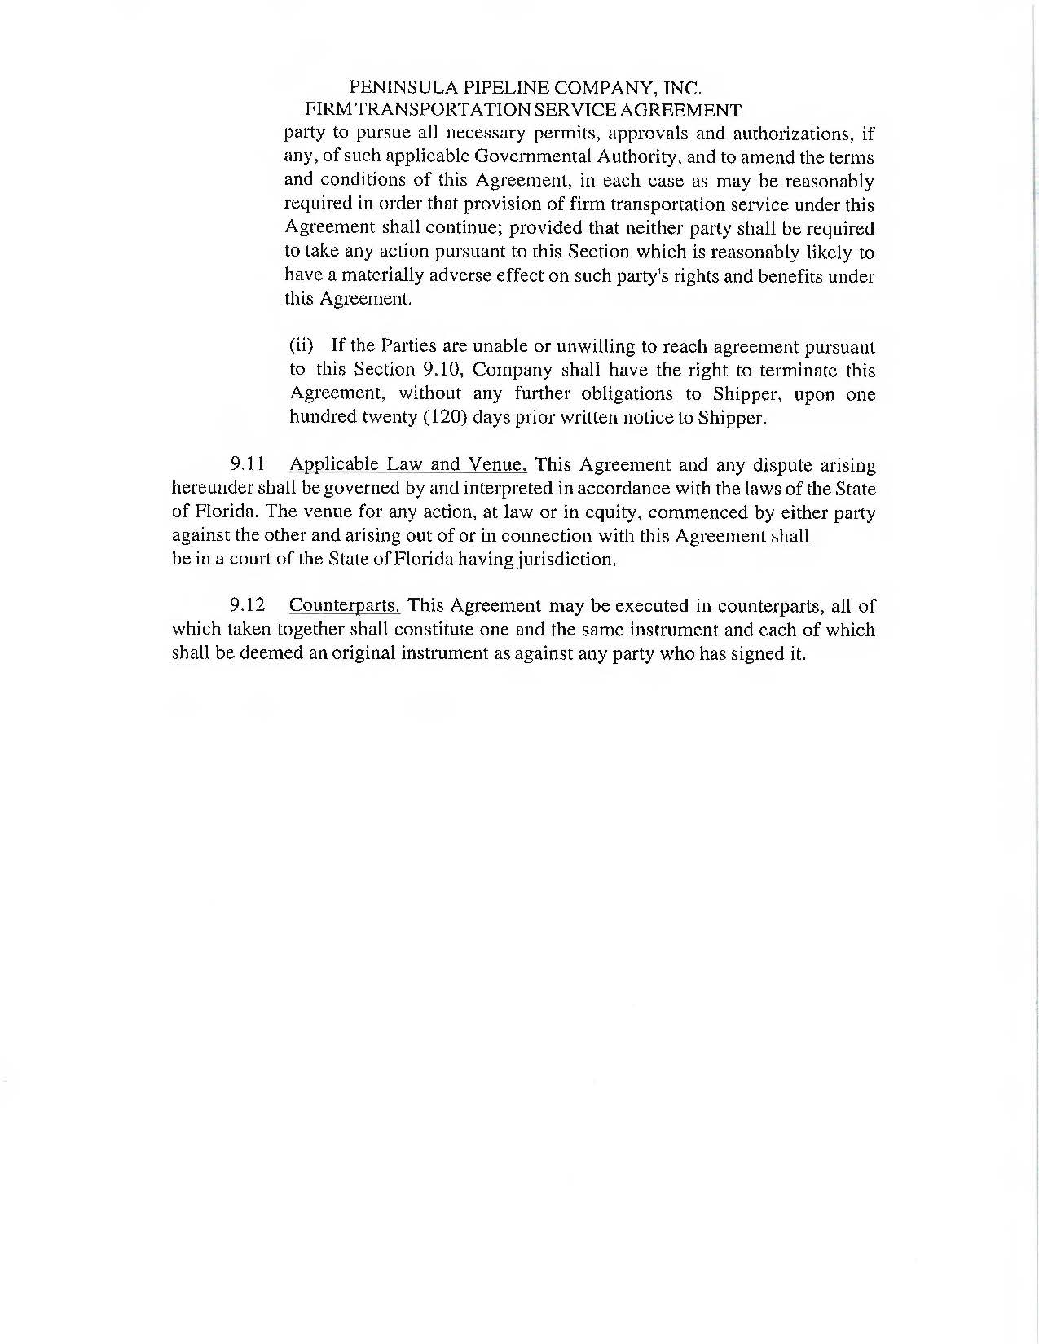

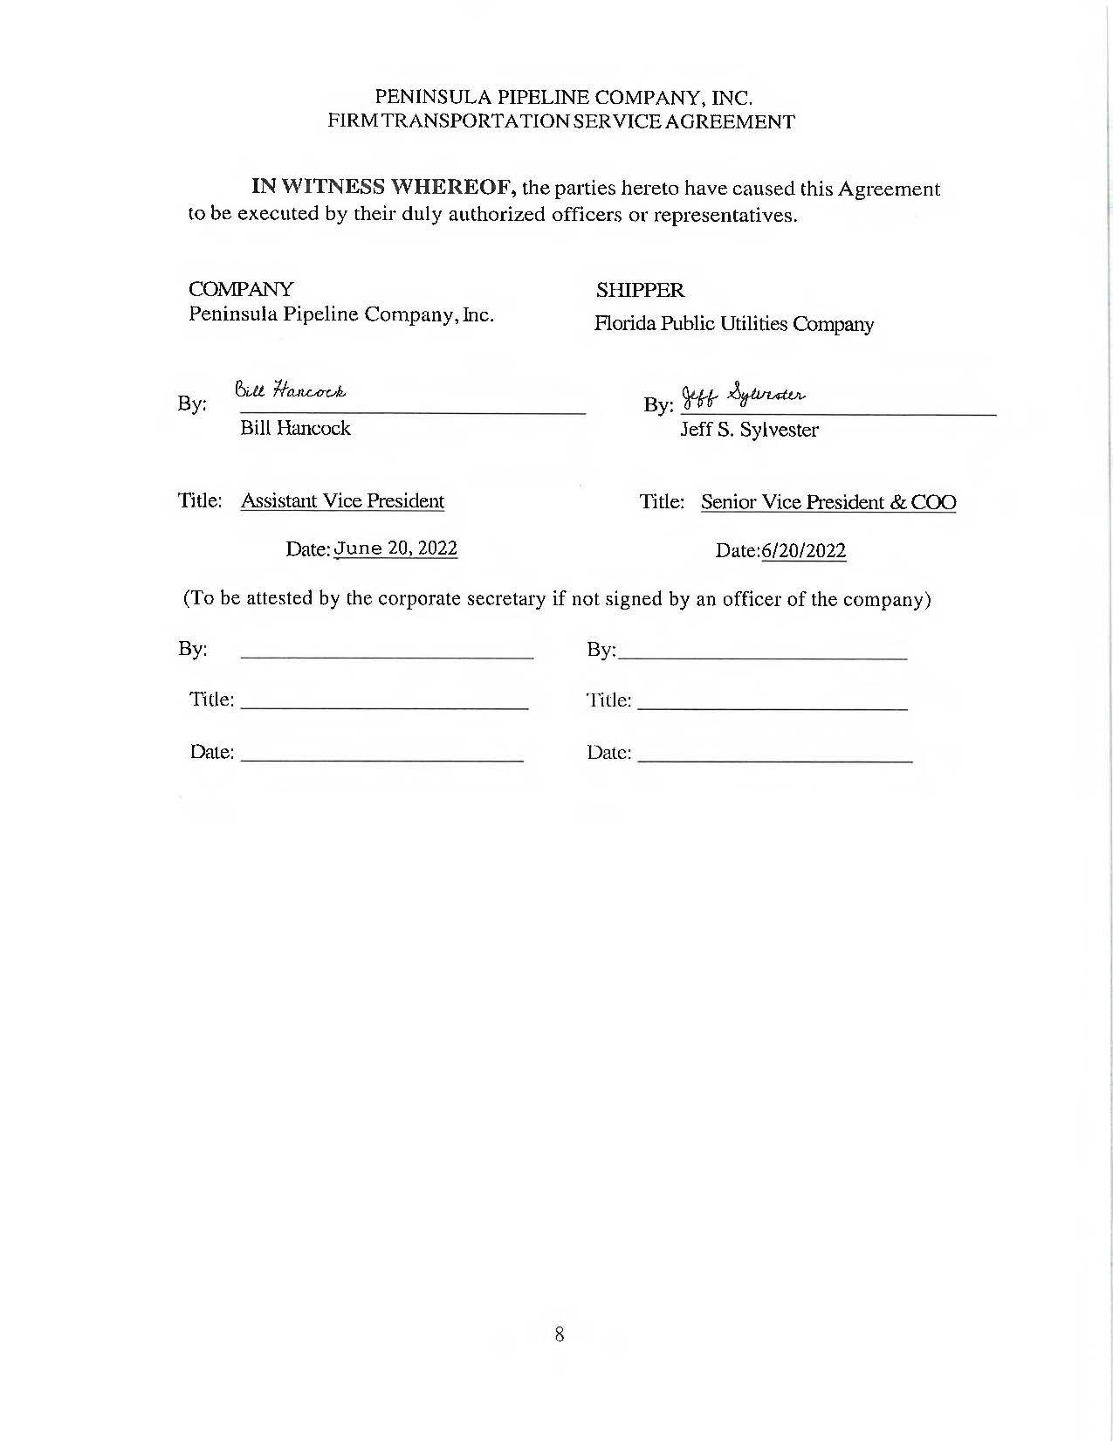
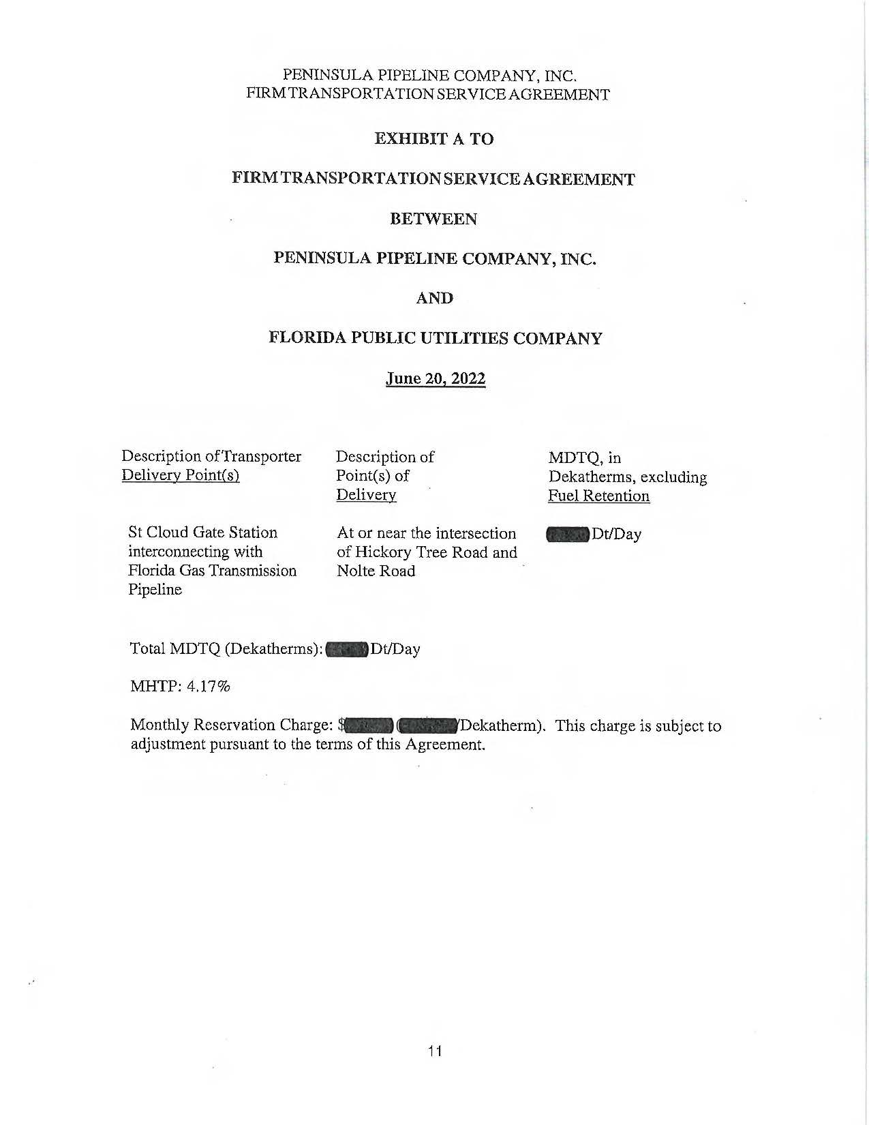

ATTACHMENT B

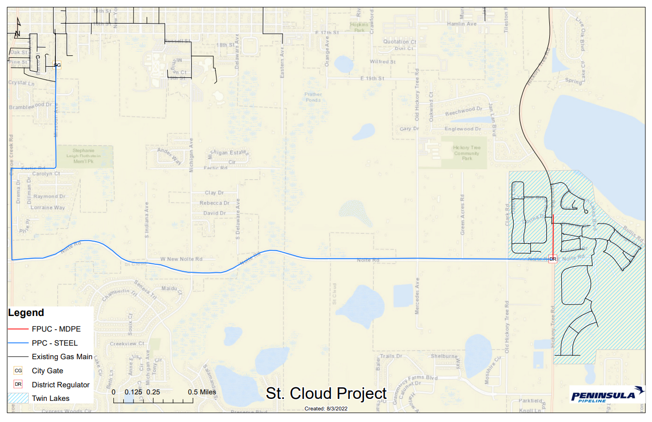

Order No. PSC-06-0023-DS-GP, issued January 9, 2006, in Docket No. 050584-GP, In re: Petition for declaratory statement by Peninsula Pipeline Company, Inc. concerning recognition as a natural gas transmission company under Section 368.101, F.S., et seq.
Order No. PSC-07-1012-TRF-GP, issued December 21, 2007, in Docket No. 070570-GP, In re: Petition for approval of natural gas transmission pipeline tariff by Peninsula Pipeline Company, Inc.
Peninsula Pipeline Company, Inc., Intrastate Pipeline Tariff, Original Vol. 1, Original Sheet No. 11, Section 3.
Peninsula Pipeline Company, Inc., Intrastate Pipeline Tariff, Original Vol. 1, Original Sheet No. 12, Section 4.
Response No. 3 in Staff’s First Data Request, Document No. 05281-2022.
Response No. 11 in Staff’s First Data Request, Document No. 05281-2022

