BEFORE THE FLORIDA PUBLIC SERVICE COMMISSION

In re: Application for transfer of water and wastewater facilities of River Grove Utilities, Inc., water Certificate No. 674-W, and wastewater Certificate No. 575-S to Cobblestone II RVG LLC; and amendment of water Certificate No. 674-W, and wastewater certificate 575-S, in Brevard County.  In re: Application for quick-take amendment of Certificate Nos. 674-W and 575-S, to delete territory in Brevard County by Cobblestone II RVG LLC, a Delaware limited liability company d/b/a River Grove Utility. | DOCKET NO. 20220085-WS  DOCKET NO. 20220090-WS  ORDER NO. PSC-2022-0361-PAA-WS  ISSUED: October 24, 2022

The following Commissioners participated in the disposition of this matter:

ART GRAHAM, Chairman
GARY F. CLARK
MIKE LA ROSA
GABRIELLA PASSIDOMO

NOTICE OF PROPOSED AGENCY ACTION
ORDER ESTABLISHING NET BOOK VALUE, DECLINING TO MAKE AN ACQUISITION ADJUSTMENT, AND REVISING MISCELLANEOUS SERVICE CHARGES
AND
ORDER GRANTING TRANSFER OF CERTIFICATE NOS. 674-W AND 575-S, AMENDING CERTIFICATES TO DELETE PART OF THE SERVICE TERRITORY, AND CONTINUING EXISTING RATES, LATE PAYMENT CHARGE, SERVICE AVAILABILITY CHARGES, NON-SUFFICIENT FUNDS CHARGES, AND INITIAL CUSTOMER DEPOSITS

BY THE COMMISSION:

NOTICE is hereby given by the Florida Public Service Commission that the action discussed herein determining net book value, declining to make an acquisition adjustment, and revising miscellaneous service charges is preliminary in nature and will become final unless a person whose interests are substantially affected files a petition for a formal proceeding, pursuant to Rule 25-22.029, Florida Administrative Code (F.A.C.).

Background
River Grove Utilities, Inc. (RGU or Seller) is a Class C water and wastewater utility providing service to approximately 179 residential customers in Brevard County. RGU is located in the St. Johns River Management District. According to RGU’s 2021 Annual Report, the Utility had gross revenues of $166,257 and a net operating loss of $2,365. We granted an original certificate to RGU in 2019.
On April 22, 2022, Cobblestone II RVG LLC, (Cobblestone or Buyer) filed an application for the transfer of Certificate Nos. 674-W and 575-S from RGU to Cobblestone (Docket No. 20220085-WS). On May 5, 2022, Cobblestone filed a separate application for a quick-take amendment of Certificate Nos. 674-W and 575-S, to delete part of the service territory (Docket No. 20220085-WS). The property being deleted contains two single-family residences with additional undeveloped acreage. These residences are not receiving water or wastewater services from the Utility. This property is owned by the seller of RGU, who does not object to this deletion of the service territory.
This order addresses the transfer of Certificate Nos. 674-W and 575-S, the appropriate net book value of the system for transfer purposes, the need for an acquisition adjustment (Docket No. 20220085-WS), and the request for a service territory deletion (Docket No. 20220090-WS). We have jurisdiction pursuant to Sections 367.045, 367.071, and 367.081, Florida Statutes (F.S).

Decision

- Transfer of Certificate Nos. 674-W and 575-S
On April 22, 2022, the Buyer filed an application for the transfer of Certificate Nos. 674-W and 575-S from RGU to Cobblestone. The application is in compliance with Section 367.071, F.S., and our rules concerning applications for transfer of certificates. The sale to the Buyer occurred on April 21, 2022, contingent upon our approval, pursuant to Section 367.071(1), F.S.
- Noticing, Territory, and Land Ownership

Cobblestone provided notice of the application pursuant to Section 367.071, F.S., and Rule 25-30.030, F.A.C. No objections to the transfer were filed, and the time for doing so has expired. The application contains a description of the service territory, which is appended to this order as Attachment A. The Buyer provided a copy of the warranty deed executed on April 15, 2022, as evidence that the Utility has rights to long-term use of the land upon which the treatment facilities are located pursuant Rule 25-30.30.037(2)(s), F.A.C.
- Purchase Agreement and Financing

Pursuant to Rule 25-30.037(2)(g), (h), and (i), F.A.C., the application contains a statement regarding financing and a copy of the Purchase Agreement, which includes the purchase price, terms of payment, and a list of the assets purchased. There are no customer deposits, guaranteed revenue contracts, developer agreements, customer advances, leases, or debt of River Grove that must be disposed of with regard to the transfer. According to the Purchase Agreement, the total purchase price for the mobile home community, as well as the water and wastewater assets is $19,000,000. In response to our staff’s data request, the Buyer stated the specific purchase price of the water and wastewater assets should be set equal to the depreciated original cost as established by us. As discussed in Section II of this Order, we have calculated a net book value of $159,093 for water and $2,250 for wastewater. Therefore, we find that a purchase price of $161,343 ($159,093 + $2,250) for the water and wastewater assets shall be recognized.

- Facility Description and Compliance

In March 2019, RGU interconnected its water distribution system with Brevard County’s Barefoot Bay and now purchases bulk water service from Barefoot Bay. RGU’s wastewater treatment plant (WWTP) has the permitted capacity of 0.030 million gallons per day and consists of flow equalization, influent screening, aeration, secondary clarification, chlorination, and aerobic digestion of biosolids. Based on the Utility’s application and our examination, the systems appear to be in satisfactory condition and compliant with the Florida Department of Environmental Protection standards.
- Financial and Technical Ability

Pursuant to Rule 25-30.037(2)(l), and (m), F.A.C., the Buyer provided statements describing its financial and technical ability to provide water and wastewater service. As referenced in the transfer application, the Buyer will fulfill the commitments, obligations, and representation of the Seller with regards to utility matters. We reviewed the financial statements of the parent company, Cobblestone MHC Fund II LP, and find the Buyer has documented adequate resources to support the Utility’s operations.
In its application, the Buyer indicated that it has no experience in the water or wastewater industry; however, it will rely on one of its related parties which operates a wastewater system serving one of its other mobile home communities in Florida. Additionally, the Seller contracted its WWTP operations to US Water Services Corporation and the Buyer indicated that it intends to keep this contract in place. We therefore find that the Buyer has demonstrated the technical and financial ability to provide service to the existing service territory.

- Rates, Charges, and Customer Deposits

The Utility's rates, charges, and initial customer deposits were last approved in its 2019 application for original certificates to provide water and wastewater. Rule 25-9.044(1), F.A.C., provides that, in the case of a change of ownership or control of a Utility, the rates, classifications, and regulations of the former owner must continue unless authorized to change by us. In regard to the Utility’s miscellaneous service charges, the late payment charge of $7.50 is appropriate. However, the remaining miscellaneous service charges do not conform to Rule 25-30.460, F.A.C., and are addressed in Section III of this Order. Therefore, we find that the Utility’s existing rates, late payment charge, service availability charges, non-sufficient funds charges, and initial customer deposits as shown in Schedule No. 2, attached hereto, shall remain in effect, until authorized to change by us in a subsequent proceeding. The tariff pages reflecting the transfer shall be effective on or after the stamped approval date on the tariff sheet pursuant to Rule 25-30.475(1), F.A.C.

- Regulatory Assessment Fees (RAFs) and Annual Reports

We have verified that the Seller is current on the filing of annual reports and RAFs through December 31, 2021. The Buyer shall be responsible for filing the Utility’s annual reports and paying RAFs after April 21, 2022, and all future years.
- Conclusion

Based on the foregoing, we find that the transfer of Certificate Nos. 674-W and 575-S is in the public interest and shall be approved effective October 4, 2022, the date of our vote. This Order shall serve as the Buyer’s certificate and shall be retained by the Buyer. With the exception of the miscellaneous service charges, addressed in Section III of this Order, the existing rates and charges shown on Schedule No. 2 shall remain in effect until a change is authorized by us in a subsequent proceeding. The tariffs reflecting the transfer shall be effective for services rendered or connections made on or after the stamped approval date on the tariffs pursuant to Rule 25-30.475, F.A.C. The Utility is current with respect to annual reports and RAFs through December 31, 2021. The Buyer shall be responsible for filing the Utility’s annual reports and paying RAFs after April 21, 2022, and all future years.

- Net Book Value (NBV) and Acquisition Adjustment

Rate base has never been established for the Utility. The purpose of establishing NBV for transfers is to determine whether an acquisition adjustment should be approved. The NBV does not include normal ratemaking adjustments for used and useful plant or working capital. The Utility’s NBV has been updated to reflect balances as of April 1, 2022. The approved NBV is shown on Schedule No. 1, attached hereto.
- Utility Plant in Service (UPIS)

The Utility’s general ledger reflects UPIS balances of $661,426 for water and $8,100 for wastewater as of April 1, 2022. We do not have any adjustments to the Utility’s UPIS balances. Therefore, we find UPIS balances of $661,426 for water and $8,100 for wastewater as of April 1, 2022.
- Land

The Utility’s general ledger reflects land balances of $2,250 for water and $2,250 for wastewater as of April 1, 2022. We do not have any adjustments to the Utility’s land balances. Therefore, we find land balances of $2,250 for water and $2,250 for wastewater as of April 1, 2022.
- Accumulated Depreciation

The Utility’s general ledger reflects accumulated depreciation balances of $73,163 for water and $8,100 for wastewater as of April 1, 2022. We do not have any adjustments to the Utility’s accumulated depreciation balances. Therefore, we find accumulated depreciation balances of $73,163 for water and $8,100 for wastewater as of April 1, 2022.
- Contributions-in-Aid-of-Construction (CIAC) and Accumulated Amortization of CIAC

The Utility’s general ledger reflects CIAC balances of $476,202 for water and $0 for wastewater as of April 1, 2022. The Utility’s general ledger also reflects accumulated amortization of CIAC balances of $44,782 for water and $0 for wastewater as of April 1, 2022. We do not have any adjustments to the Utility’s CIAC or Accumulated Amortization of CIAC balances. Therefore, we find CIAC balances of $476,202 for water and $0 for wastewater, and accumulated amortization of CIAC balances of $44,782 for water and $0 for wastewater, as of April 1, 2022.
- Net Book Value

The Utility’s general ledger reflects NBV of $159,093 for water and $2,250 for wastewater as of April 1, 2022. We do not find that any adjustments are necessary. As such, we find NBV of $159,093 for water and $2,250 for wastewater. NBV and the National Association of Regulatory Utility Commissioners, Uniform System of Accounts (NARUC USOA) balances for UPIS and accumulated depreciation are shown on Schedule No. 1, as of April 1, 2022.

- Acquisition Adjustment
An acquisition adjustment results when the purchase price differs from the NBV of the assets at the time of the acquisition. The Utility and its assets were purchased for $161,343. As stated above, we find the appropriate NBV total to be $161,343. Pursuant to Rule 25-30.0371, F.A.C., a positive acquisition adjustment may be appropriate when the purchase price is greater than the NBV, and a negative acquisition adjustment may be appropriate when the purchase price is less than NBV. As the purchase price is equal to the NBV, we find that no acquisition adjustment is warranted.
- Conclusion

We find that the NBV of the water and wastewater systems for transfer purposes is $159,093 and $2,250, respectively, as of April 1, 2022. No acquisition adjustment shall be included in rate base. Within 90 days of the date of the final order, the buyer shall be required to notify us in writing that it has adjusted its books in accordance with our decision. The adjustments shall be reflected in the Utility’s 2022 Annual Report when filed.

- Revised Miscellaneous Service Charges
Effective June 24, 2021, Rule 25-30.460, F.A.C., was amended to remove initial connection and normal reconnection charges. The definitions for initial connection charges and normal reconnection charges were subsumed in the definition of the premises visit charge. It was envisioned that the utility tariffs would be reviewed by our staff on a prospective basis to ensure conformance with the amended rule. The Utility’s miscellaneous service charges consist of initial connection and normal reconnection charges. Therefore, we find that the initial connection and normal reconnection charges be removed and the definition for the premises visit charge be updated to comply with amended Rule 25-30.460, F.A.C. The Utility’s proposed and our approved miscellaneous service charges are shown below in Tables 1 and 2.

Table 1
Utility Proposed Miscellaneous Service Charges
 | Normal Hours
Initial Connection Charge | $30.00
Normal Reconnection Charge | $30.00
Violation Reconnection Charge | $30.00
Premises Visit Charge  (in lieu of disconnection) | $30.00
Table 2
Approved Miscellaneous Service Charges
 | Normal Hours
Violation Reconnection Charge | $30.00
Premises Visit Charge | $30.00

- Conclusion

Based on the above, the miscellaneous service charges shall be revised to conform to the recent amendment to Rule 25-30.460, F.A.C. The tariff shall be revised to reflect the removal of initial connection and normal reconnection charges. The approved charges shall be effective on or after the stamped approval date on the tariff sheet pursuant to Rule 25-30.475(1), F.A.C. Cobblestone shall be required to charge the approved miscellaneous service charges until authorized to change them by us in a subsequent proceeding.

- Amendment for Deletion of Portion of Certificate Nos. 674-W and 575-S

- Deletion of Territory

On May 5, 2022, Cobblestone applied for an amendment to delete a portion of its certificated service territory. In its application, Cobblestone provided a legal description of the territory proposed to be deleted in the format prescribed in Rule 25-30.029, F.A.C., along with a complete legal description of the remaining territory. Cobblestone also provided a detailed system map with the territory proposed to be deleted and retained plotted thereon.

In addition to their application, Cobblestone filed a notice with our Clerk on June 14, 2022. As set forth in the application and notice, the area to be deleted is undeveloped acreage with two single-family homes that are not served by the Utility. The property is owned by the Seller of RGU, who does not object to this deletion. No objections to the application have been received and the time for filing such has expired. The Utility’s application is compliant with the filing requirements set forth in Rule 25-30.036(4), F.A.C.

- Conclusion

Based on the above, we find that it is in the public interest to approve the application filed by Cobblestone to amend its water and wastewater certificates to delete territory with the resulting territory as shown in Attachment A, attached hereto, effective October 4, 2022, the date of our vote. This Order shall serve as Cobblestone’s amended certificates and shall be retained by the Utility.

Based on the foregoing, it is

ORDERED by the Florida Public Service Commission that the transfer of Certificate Nos. 674-W and 575-S from River Grove Utilities, Inc., to Cobblestone II RVG LLC, is in the public interest and shall be approved effective October 4, 2022. This Order shall serve as the Buyer’s certificate and shall be retained by the Buyer. The existing rates and charges shown on Schedule No. 2 of this shall remain in effect until a change is authorized by us in a subsequent proceeding. The tariffs reflecting the transfer shall be effective for services rendered or connections made on or after the stamped approval date on the tariffs pursuant to Rule 25-30.475, F.A.C. The Buyer shall be responsible for filing the Utility’s annual reports and paying RAFs after April 21, 2022, and all future years. It is further

ORDERED that the Net Book Value of the water and wastewater systems for transfer purposes is $159,093 and $2,250, respectively, as of April 1, 2022. No acquisition adjustment shall be included in rate base. Within 90 days of the date of the final order, the buyer shall be required to notify us in writing that it has adjusted its books in accordance with the our decision. The adjustments shall be reflected in the Utility’s 2022 Annual Report when filed. It is further

ORDERED that the miscellaneous service charges shall be revised to conform to the recent amendment to Rule 25-30.460, F.A.C. The tariff shall be revised to reflect the removal of initial connection and normal reconnection charges. The approved charges shall be effective on or after the stamped approval date on the tariff sheet pursuant to Rule 25-30.475(1), F.A.C. Cobblestone II RVG LLC, shall be required to charge the approved miscellaneous service charges until authorized to change them by us in a subsequent proceeding. It is further

ORDERED that it is in the public interest to approve the application filed by Cobblestone II RVG LLC, to amend its water and wastewater certificates to delete territory with the resulting territory as shown in Attachment A. This Order shall serve as Cobblestone II RVG LLC’s amended certificates and shall be retained by the Utility. It is further

ORDERED that the provisions of this Order, issued as proposed agency action, shall become final and effective upon the issuance of a Consummating Order unless an appropriate petition, in the form provided by Rule 28-106.201, Florida Administrative Code, is received by the Commission Clerk, 2540 Shumard Oak Boulevard, Tallahassee, Florida 32399-0850, by the close of business on the date set forth in the “Notice of Further Proceedings” attached hereto. It is further

ORDERED that this docket shall remain open for Commission staff’s verification that within 90 days of the date of the final order, the buyer has notified Commission staff in writing that it has adjusted its books in accordance with the Commission's Order approving the transfer. Once these actions are complete, this docket shall be closed administratively.

By ORDER of the Florida Public Service Commission this 24th day of October, 2022.

/s/ Adam J. Teitzman
ADAM J. TEITZMAN
Commission Clerk
Florida Public Service Commission
2540 Shumard Oak Boulevard
Tallahassee, Florida 32399
(850) 413-6770
www.floridapsc.com

Copies furnished: A copy of this document is provided to the parties of record at the time of issuance and, if applicable, interested persons.

RPS

NOTICE OF FURTHER PROCEEDINGS OR JUDICIAL REVIEW

The Florida Public Service Commission is required by Section 120.569(1), Florida Statutes, to notify parties of any administrative hearing or judicial review of Commission orders that is available under Sections 120.57 or 120.68, Florida Statutes, as well as the procedures and time limits that apply. This notice should not be construed to mean all requests for an administrative hearing or judicial review will be granted or result in the relief sought.

As identified in the body of this order, our action determining net book value, declining to make an acquisition adjustment, and revising miscellaneous service charges is preliminary in nature. Any person whose substantial interests are affected by the action proposed by this order may file a petition for a formal proceeding, in the form provided by Rule 28-106.201, Florida Administrative Code. This petition must be received by the Office of Commission Clerk, at 2540 Shumard Oak Boulevard, Tallahassee, Florida 32399-0850, by the close of business on November 14, 2022. If such a petition is filed, mediation may be available on a case-by-case basis. If mediation is conducted, it does not affect a substantially interested person's right to a hearing. In the absence of such a petition, this order shall become effective and final upon the issuance of a Consummating Order.

Any objection or protest filed in this docket before the issuance date of this order is considered abandoned unless it satisfies the foregoing conditions and is renewed within the specified protest period.

Any party adversely affected by the Commission's final action in this matter may request: (1) reconsideration of the decision by filing a motion for reconsideration with the Office of Commission Clerk, within fifteen (15) days of the issuance of this order in the form prescribed by Rule 25-22.060, Florida Administrative Code; or (2) judicial review by the Florida Supreme Court in the case of an electric, gas or telephone utility or the First District Court of Appeal in the case of a water or wastewater utility by filing a notice of appeal with the Office of Commission Clerk and filing a copy of the notice of appeal and the filing fee with the appropriate court. This filing must be completed within thirty (30) days after the issuance of this order, pursuant to Rule 9.110, Florida Rules of Appellate Procedure. The notice of appeal must be in the form specified in Rule 9.900(a), Florida Rules of Appellate Procedure.

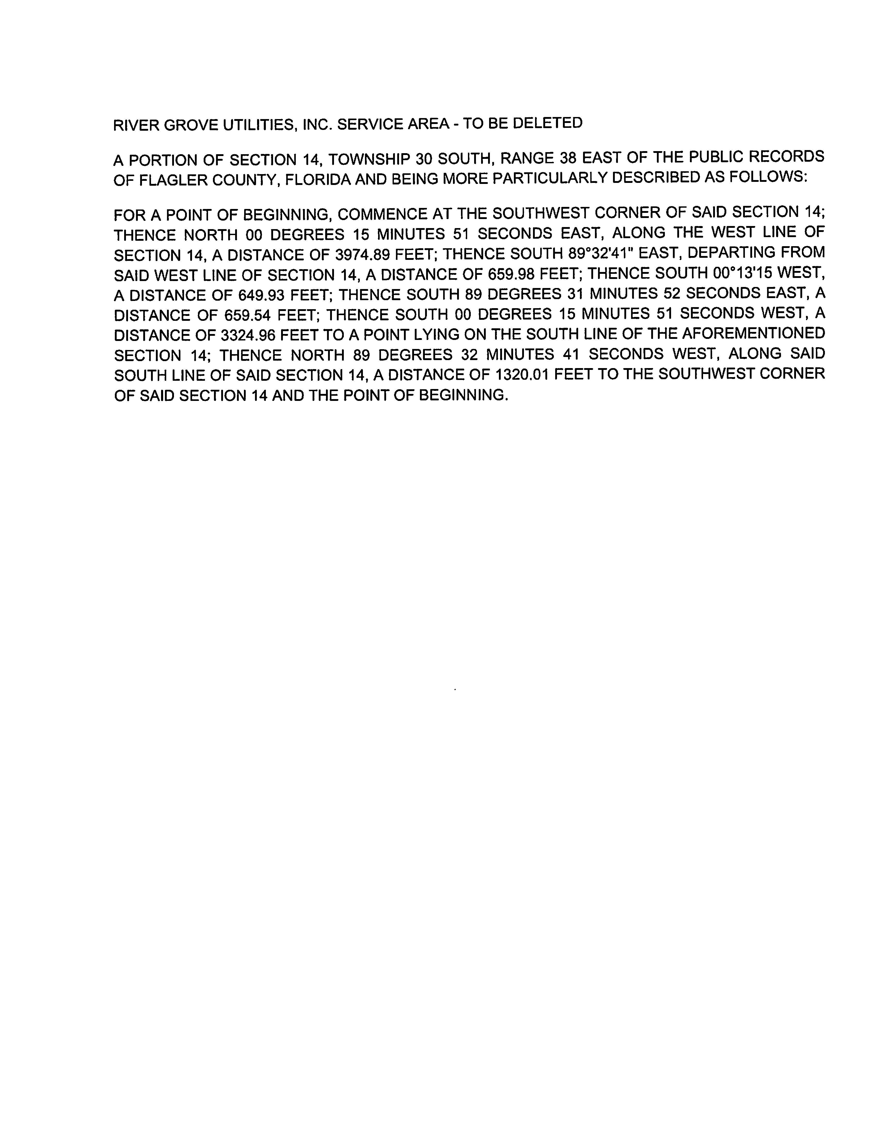
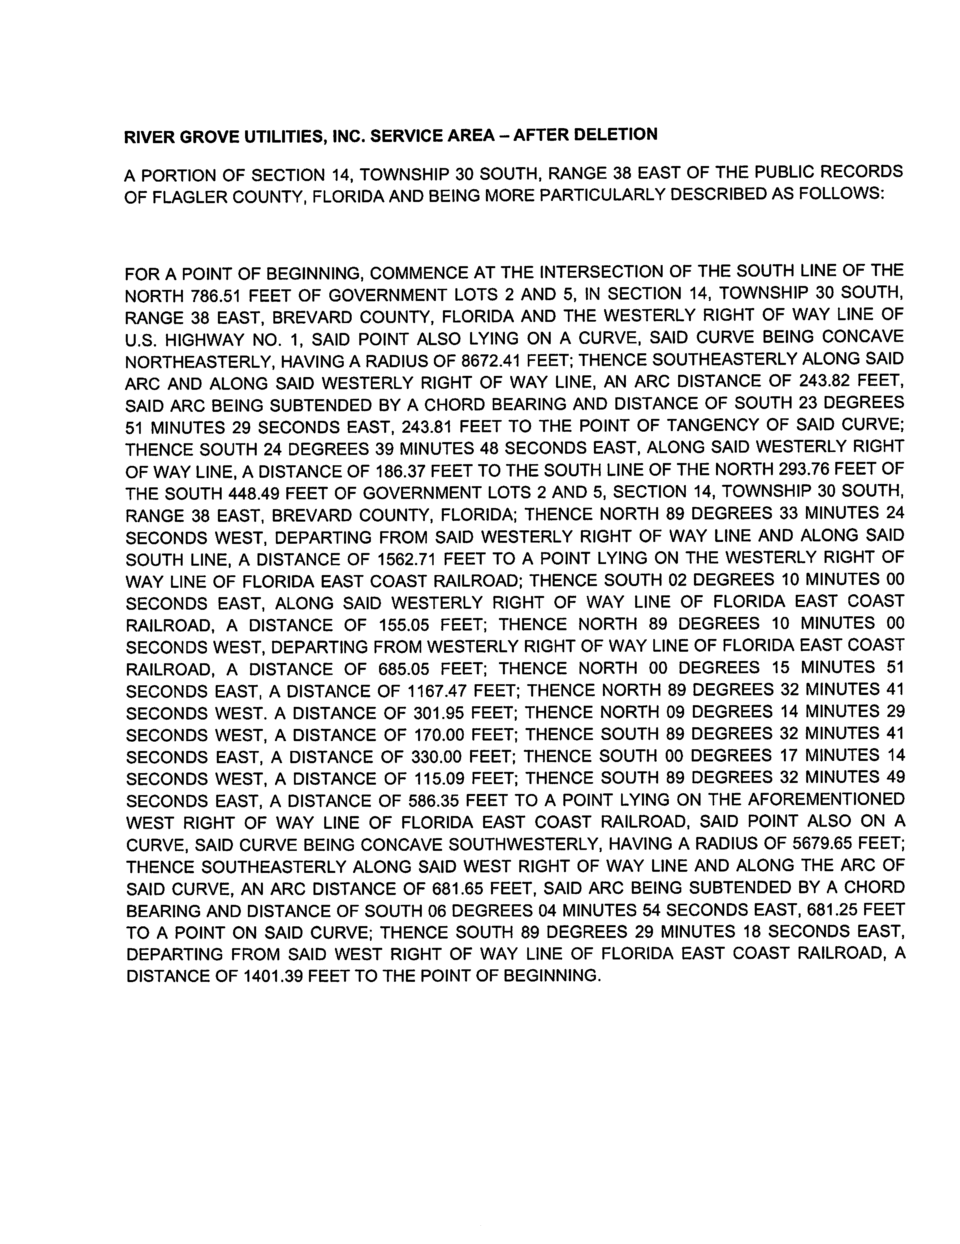

FLORIDA PUBLIC COMMISSION
Authorizes
Cobblestone II RVG LLC
Pursuant to
Certificate Number 674-W
To provide water services in Brevard County in accordance with the provisions of Chapter 367, Florida Statutes, and the Rules, Regulations, and Order of this Commission in the territory described by the Orders of the Commission. The authorization shall remain in the force and effect until superseded, suspended, concealed or revoked by Order of the Commission.

Order Number Date Issued Docket Number Filing Type
PSC-2020-0059-PAA-WS 02/24/2020 20190147-WS Original Certificate
PSC-2022-0361-PAA-WS 10/24/2022 20220085-WS Transfer
PSC-2022-0361-PAA-WS 10/24/2022 20220090-WS Territory Amendment

FLORIDA PUBLIC COMMISSION
Authorizes
Cobblestone II RVG LLC
Pursuant to
Certificate Number 575-S
To provide wastewater services in Brevard County in accordance with the provisions of Chapter 367, Florida Statutes, and the Rules, Regulations, and Order of this Commission in the territory described by the Orders of the Commission. The authorization shall remain in the force and effect until superseded, suspended, concealed or revoked by Order of the Commission.

Order Number Date Issued Docket Number Filing Type
PSC-2020-0059-PAA-WS 02/24/2020 20190147-WS Original Certificate
PSC-2022-0361-PAA-WS 10/24/2022 20220085-WS Transfer
PSC-2022-0361-PAA-WS 10/24/2022 20220090-WS Territory Amendment

Cobblestone II RVG LLC
Water System

Schedule of Net Book Value as of April 1, 2022

Description | Balance  Per Utility | Adjustments | Comm. Approved
Utility Plant in Service | $661,426 | $0 | $661,426
Land & Land Rights | 2,250 | 0 | 2,250
Accumulated Depreciation | (73,163) | 0 | (73,163)
CIAC | (476,202) | 0 | (476,202)
Amortization of CIAC | 44,782 | 0 | 44,782
Total | $159,093 | $0 | $159,093

Wastewater System

Schedule of Net Book Value as of April 1, 2022

Description | Balance  Per Utility | Adjustments | Comm. Approved
Utility Plant in Service | $8,100 | $0 | $8,100
Land & Land Rights | 2,250 | 0 | 2,250
Accumulated Depreciation | (8,100) | 0 | (8,100)
CIAC | 0 | 0 | 0
Amortization of CIAC | 0 | 0 | 0
Total | $2,250 | $0 | $2,250

Cobblestone II RVG LLC

Water System
Schedule of Approved Account Balances as of April 1, 2022

Account  No. | Description | UPIS | Accumulated Depreciation
303 | Land and Land Rights | $2,250
310 | Power Generation Equipment | 4,000 | 4,000
320 | Water Treatment Equipment | 8,100 | 8,100
331 | Transmission and Distribution Mains | 287,909 | 22,730
333 | Services | 303,598 | 26,023
334 | Meter and Meter Install. | 51,308 | 9,054
340 | Office Furniture & Equip. | 6,511 | 3,256
 |  | $663,676 | $73,163

Wastewater System
Schedule of Approved Account Balances as of April 1, 2022

Account  No. | Description | UPIS | Accumulated Depreciation
353 | Land and Land Rights | $2,250
380 | Treatment and Disposal Equipment | 8,100 | 8,100
 |  | $10,350 | $8,100

Cobblestone II RVG, LLC.
Monthly Water Rates

Residential and General Service
All Meter Sizes |  |  |  | $34.92
Charge Per 1,000 gallons |  |  |  | $7.15
Initial Customer Deposits
Meter Sizes | Residential |  |  |  | General Service
5/8” x 3/4” | $175.00 |  | 2x Average Estimated Bill
All Other Meter Sizes | 2x Average Estimated Bill |  | 2x Average Estimated Bill

Service Availability Charges
Meter Installation Charge
5/8" x 3/4" $353.00
All Other Meter Sizes Actual Cost

Cobblestone II RVG, LLC.
Monthly Wastewater Rates

Residential and General Service
All Meter Sizes |  |  |  | $24.66
Charge Per 1,000 gallons |  |  |  | $3.36
Initial Customer Deposits
Meter Sizes | Residential |  |  |  | General Service
5/8” x 3/4” | $99.00 |  | 2x Average Estimated Bill
All Other Meter Sizes | 2x Average Estimated Bill |  | 2x Average Estimated Bill

Order No. PSC-2020-0059-PAA-WS, issued February 24, 2020, in Docket No. 20190147-WS, In re: Application for certificates to provide water and wastewater service in Brevard County by River Grove Utilities, Inc.
Attachment A represents the proposed service territory to be served, including the deleted territory discussed in Section IV of this Order.
Order No. PSC-2020-0059-PAA-WS, issued February 24, 2020, in Docket No. 20190147-WS, In re: Application for certificates to provide water and wastewater service in Brevard County by River Grove Utilities, Inc.
Order No. PSC-2021-0201-FOF-WS, issued June 4, 2020, in Docket No. 20200240-WS, In re: Proposed amendment of Rule 25-30.460, F.A.C., Application for Miscellaneous Service Charges.
Document No. 03882-2022, filed in Docket No. 20220085-WS and Document No. 03881-2022, filed in Docket No. 20220090-WS.

