State of Florida |  | Public Service Commission  Capital Circle Office Center ● 2540 Shumard Oak Boulevard  Tallahassee, Florida 32399-0850  -M-E-M-O-R-A-N-D-U-M-
DATE: | December 28, 2022
TO: | Office of Commission Clerk (Teitzman)
FROM: | Office of the General Counsel (Rubottom) JHR, SMC  Division of Economics (Guffey) JGH  Division of Engineering (Kissel, Graves) TB, RG
RE: | Docket No. 20220182-GU – Proposed amendment of Rule 25-12.005, F.A.C., Codes and Standards Adopted.
AGENDA: | 01/10/23 – Regular Agenda – Rule Proposal – Interested Persons May Participate
COMMISSIONERS ASSIGNED: |  |  | All Commissioners
PREHEARING OFFICER: |  |  | Passidomo
RULE STATUS: |  |  | Proposal May Be Deferred
SPECIAL INSTRUCTIONS: |  |  | None

Case Background
Rule 25-12.005, Florida Administrative Code (F.A.C.), implements the minimum federal safety standards and reporting requirements for pipeline facilities and transportation of natural gas as prescribed by the Pipeline and Hazardous Materials Safety Administration (PHMSA) regulations. The adoption of the federal codes is required by the Commission’s certification agreement with the PHMSA pursuant to 49 United States Code (U.S.C.) § 60105. The federal regulations are found in 49 Code of Federal Regulations (C.F.R.) Parts 191, 192, and 199.
Staff initiated rulemaking to amend Rule 25-12.005, F.A.C., for the purpose of incorporating by reference into the rule the updated, October 1, 2021, version of the federal standards (49 C.F.R. Parts 191, 192, and 199) that apply to natural gas pipeline operators under the Commission’s jurisdiction.
A Notice of Rule Development for this rule appeared in the August 19, 2022, edition of the Florida Administrative Register, Vol. 48, No. 162. No requests for a rule development workshop were made, and no workshop was held. This recommendation addresses whether the Commission should propose the amendment of Rule 25-12.005, F.A.C. The Commission has jurisdiction pursuant to Sections 120.54, 368.03, and 368.05, Florida Statutes (F.S.).

Discussion of Issues

Issue 1:
Should the Commission propose the amendment of Rule 25-12.005, F.A.C., Codes and Standards Adopted?

Recommendation:
Yes. The Commission should propose the amendment of Rule 25-12.005, F.A.C., as set forth in Attachment A. The Commission should also certify that Rule 25-12.005, F.A.C., is not a rule the violation of which would be a minor violation pursuant to Section 120.695, F.S. (Rubottom, Kissel)

Staff Analysis:
Rule 25-12.005, F.A.C., implements federal reporting requirements and safety standards, including safety and incident reporting requirements, gas transportation safety standards, and drug and alcohol testing protocols for employees of natural gas pipeline operators and emergency response persons under the direct authority or control of a gas utility or gas pipeline operator. The rule incorporates by reference federal regulations found in 49 C.F.R. Parts 191, 192, and 199 that apply to natural gas pipeline operators within the Commission’s jurisdiction. Staff recommends that Rule 25-12.005, F.A.C., be amended as set forth in Attachment A to incorporate by reference the updated version of the federal regulations as published in the October 1, 2021, version of the C.F.R.
The updated C.F.R. provisions further clarify and define the standards pertaining to pipeline safety regulations. This includes new requirements for onshore steel transmission lines such as the reconfirmation of maximum allowable operating pressures, the establishment of medium consequence areas, and new requirements for inline inspection tool launcher and receiver safety. The standards for plastic pipe have also been revised to include the use of new material, more stringent standards for plastic fittings and joints, stronger mechanical fitting requirements, and joining tool maintenance and calibration. Other revisions to the C.F.R. include provisions required by the PIPES Act of 2020 and an update to the list of documents that are incorporated into the C.F.R. by reference.
Minor Violation Rules Certification
Pursuant to Section 120.695, F.S., for each rule filed for adoption, the agency head shall certify whether any part of the rule is designated as a rule the violation of which would be a minor violation. Rule 25-12.005, F.A.C., is not on the Commission’s minor violation rule list because violation of the rule would result in physical harm to a person; adverse effects on the public health, safety, or welfare; or would create a significant threat of such harm. Thus, if the Commission proposes the amendment, staff recommends that the Commission certify that Rule 25-12.005, F.A.C., is not a rule the violation of which would be a minor violation pursuant to Section 120.695, F.S.
Statement of Estimated Regulatory Costs
Pursuant to Section 120.54, F.S., agencies are encouraged to prepare a statement of estimated regulatory costs (SERC) before the adoption, amendment, or repeal of any rule. Agencies are required to prepare a SERC for any rule that will have an adverse impact on small business or that is likely to directly or indirectly increase regulatory costs in excess of $200,000 in the aggregate within one year after implementation. The SERC analysis includes whether the rule will, within five years of implementation, have an adverse impact in excess of $1 million in the aggregate on economic factors such as economic growth, private sector job creation or employment, private sector investments, or business competitiveness, productivity, or innovation. If expected adverse impacts or regulatory costs exceed any of the above criteria, a proposed rule may not take effect until it is ratified by the Legislature.
A SERC was prepared and is appended hereto as Attachment B. The SERC concludes that the rule will not have an adverse impact on small business and that the rule is not likely to directly or indirectly increase regulatory costs in excess of $200,000 in the aggregate within one year after implementation. Further, the SERC concludes that the rule will not likely have an adverse impact on economic growth, private sector job creation or employment, private sector investment, or business competitiveness, productivity, or innovation in excess of $1 million in the aggregate within five years of implementation. None of the adverse impact or regulatory cost criteria set forth in Section 120.541(2)(a), F.S., will be exceeded as a result of the recommended amendments to the rule. Thus, the rule does not require legislative ratification pursuant to Section 120.541(3), F.S. In addition, the SERC states that the rule will have no impact on small cities or counties and will not increase the cost to the Commission to implement and enforce the rule. No regulatory alternatives have been submitted pursuant to Section 120.541(1)(a), F.S.
Conclusion
Based on the foregoing, staff recommends the Commission propose the amendment of Rule 25-12.005, F.A.C., as set forth in Attachment A. In addition, staff recommends that the Commission certify that Rule 25-12.005, F.A.C., is not a rule the violation of which would be a minor violation pursuant to Section 120.695, F.S.

Issue 2:
Should this docket be closed?

Recommendation:
Yes. If no requests for hearing or JAPC comments are filed, and no proposal for a lower cost regulatory alternative is submitted, the rule may be filed with the Department of State for adoption, and the docket should be closed. (Rubottom)

Staff Analysis:
If no requests for hearing or JAPC comments are filed, and no proposal for a lower cost regulatory alternative is submitted pursuant to Section 120.541(1)(a), F.S., the rule may be filed with the Department of State for adoption, and the docket should be closed.

25-12.005 Codes and Standards Adopted.
The reporting requirements for operators of natural gas pipeline facilities and transportation of gas prescribed by the Pipeline and Hazardous Materials Safety Administration in 49 C.F.R. Part 191 (October 1, 2021 2018), are is adopted and incorporated by reference as part of these rules and may be accessed at [new hyperlink] http://www.flrules.org/Gateway/reference.asp?No=Ref-10790. The mMinimum fFederal sSafety sStandards for natural gas pipeline facilities and the transportation of natural gas prescribed by the Pipeline and Hazardous Materials Safety Administration in 49 C.F.R. Part 192 (October 1, 2021) Sections 192.121, 192.123, 192.143, 192.145, 192.149, 192.191, 192.204, 192.281, 192.283, 192.285, 192.3, 192.313, 192.321, 192.329, 192.367, 192.375, 192.376, 192.455, 192.513, 192.59, 192.720, 192.756, of 49 C.F.R. 192, as amended by 83 Federal Register 58716, November 20, 2018, are adopted and incorporated by reference as part of these rules and may be accessed at [new hyperlink] http://www.flrules.org/Gateway/reference.asp?No=Ref-10792. The remaining sections of 49 C.F.R. 192, as of October 1, 2018, are adopted and incorporated by reference as part of these rules and may be accessed at http://www.flrules.org/Gateway/reference.asp?No=Ref-10794. 49 C.F.R. 199 (October 1, 2018), “Drug and Alcohol Testing,” is adopted and incorporated by reference to control drug use, by setting standards and requirements to apply to the testing and use of all emergency response personnel under the direct authority or control of a gas utility or pipeline operator, as well as all employees directly or indirectly employed by gas pipeline operators for the purpose of operation and maintenance and all employees directly or indirectly employed by intrastate gas distribution utilities for onsite construction of natural gas transporting pipeline facilities. The drug and alcohol testing requirements prescribed by the Pipeline and Hazardous Materials Safety Administration in 49 C.F.R. Part 199 (October 1, 2021 2018) are adopted and incorporated by reference as part of these rules and may be accessed at [new hyperlink] http://www.flrules.org/Gateway/reference.asp?No=Ref-10791. Part 199 also is adopted to prescribe standards for use of employees who do not meet the requirements of the regulations.
Rulemaking Authority 368.03, 368.05(2), 350.127(2) FS. Law Implemented 368.03, 368.05 FS. History–New 11-14-70, Amended 9-24-71, 9-21-74, 10-7-75, 11-30-82, 10-2-84, Formerly 25-12.05, Amended 8-8-89, 1-7-92, 5-13-99, 4-26-01, 12-15-09, 10-11-12, 3-2-17, 7-10-19, .

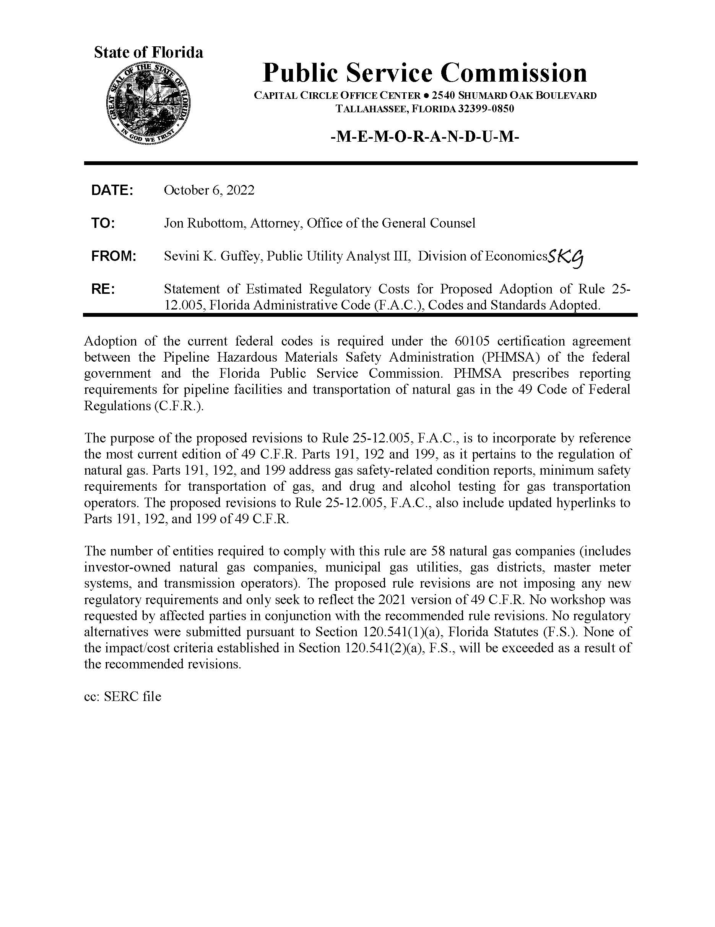

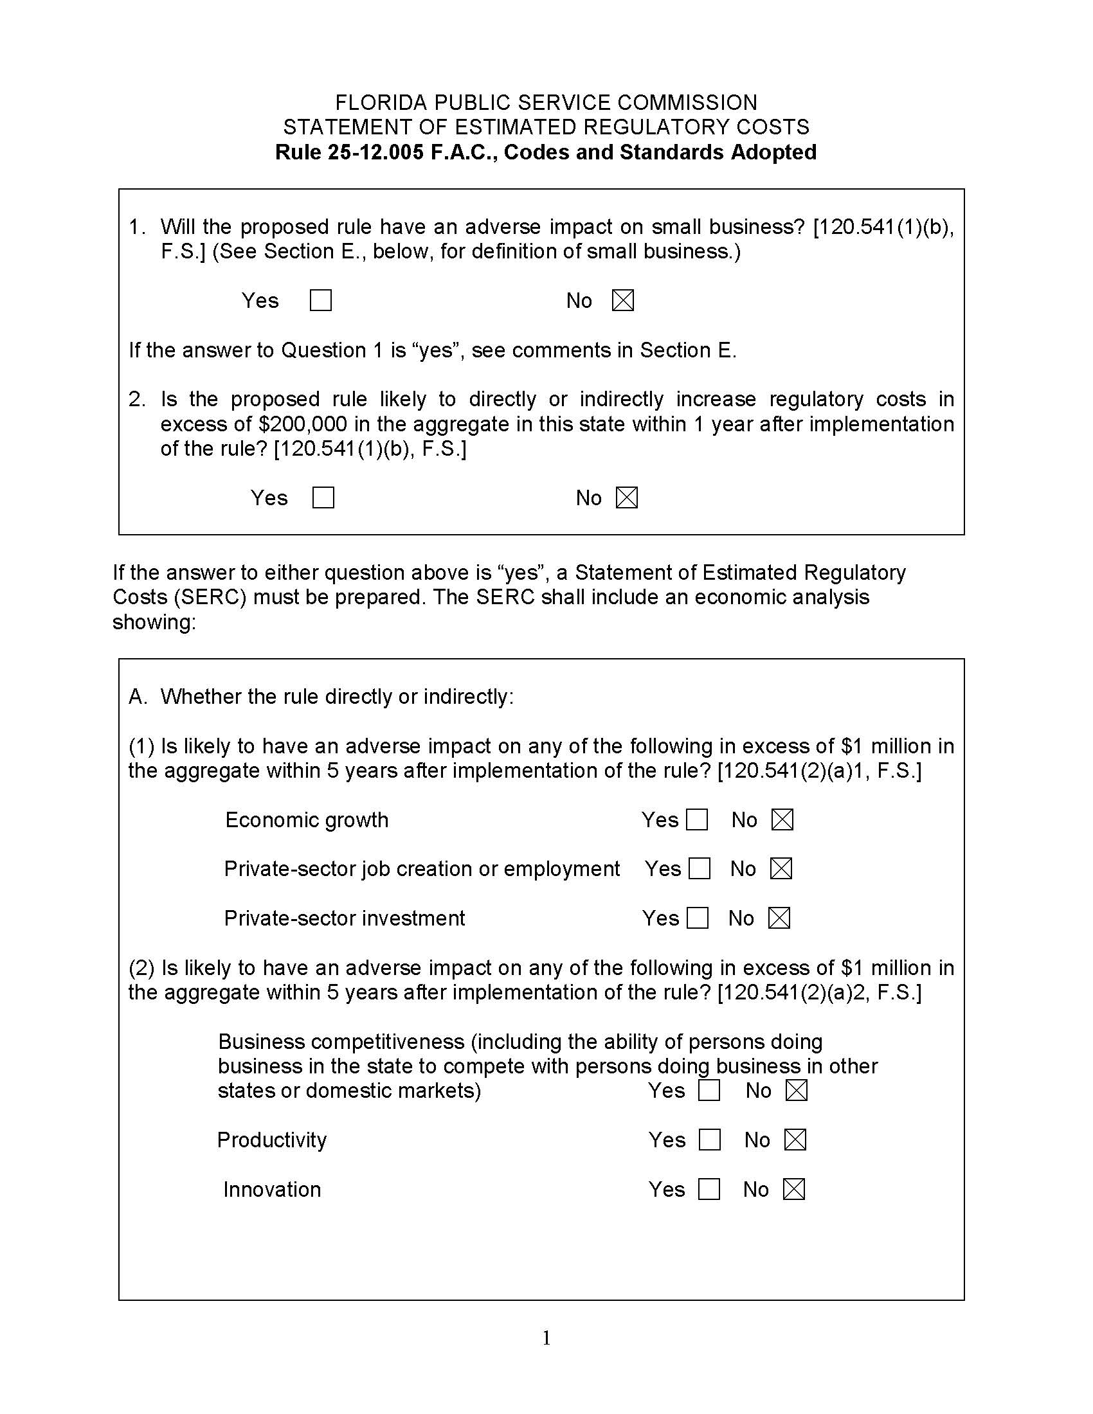

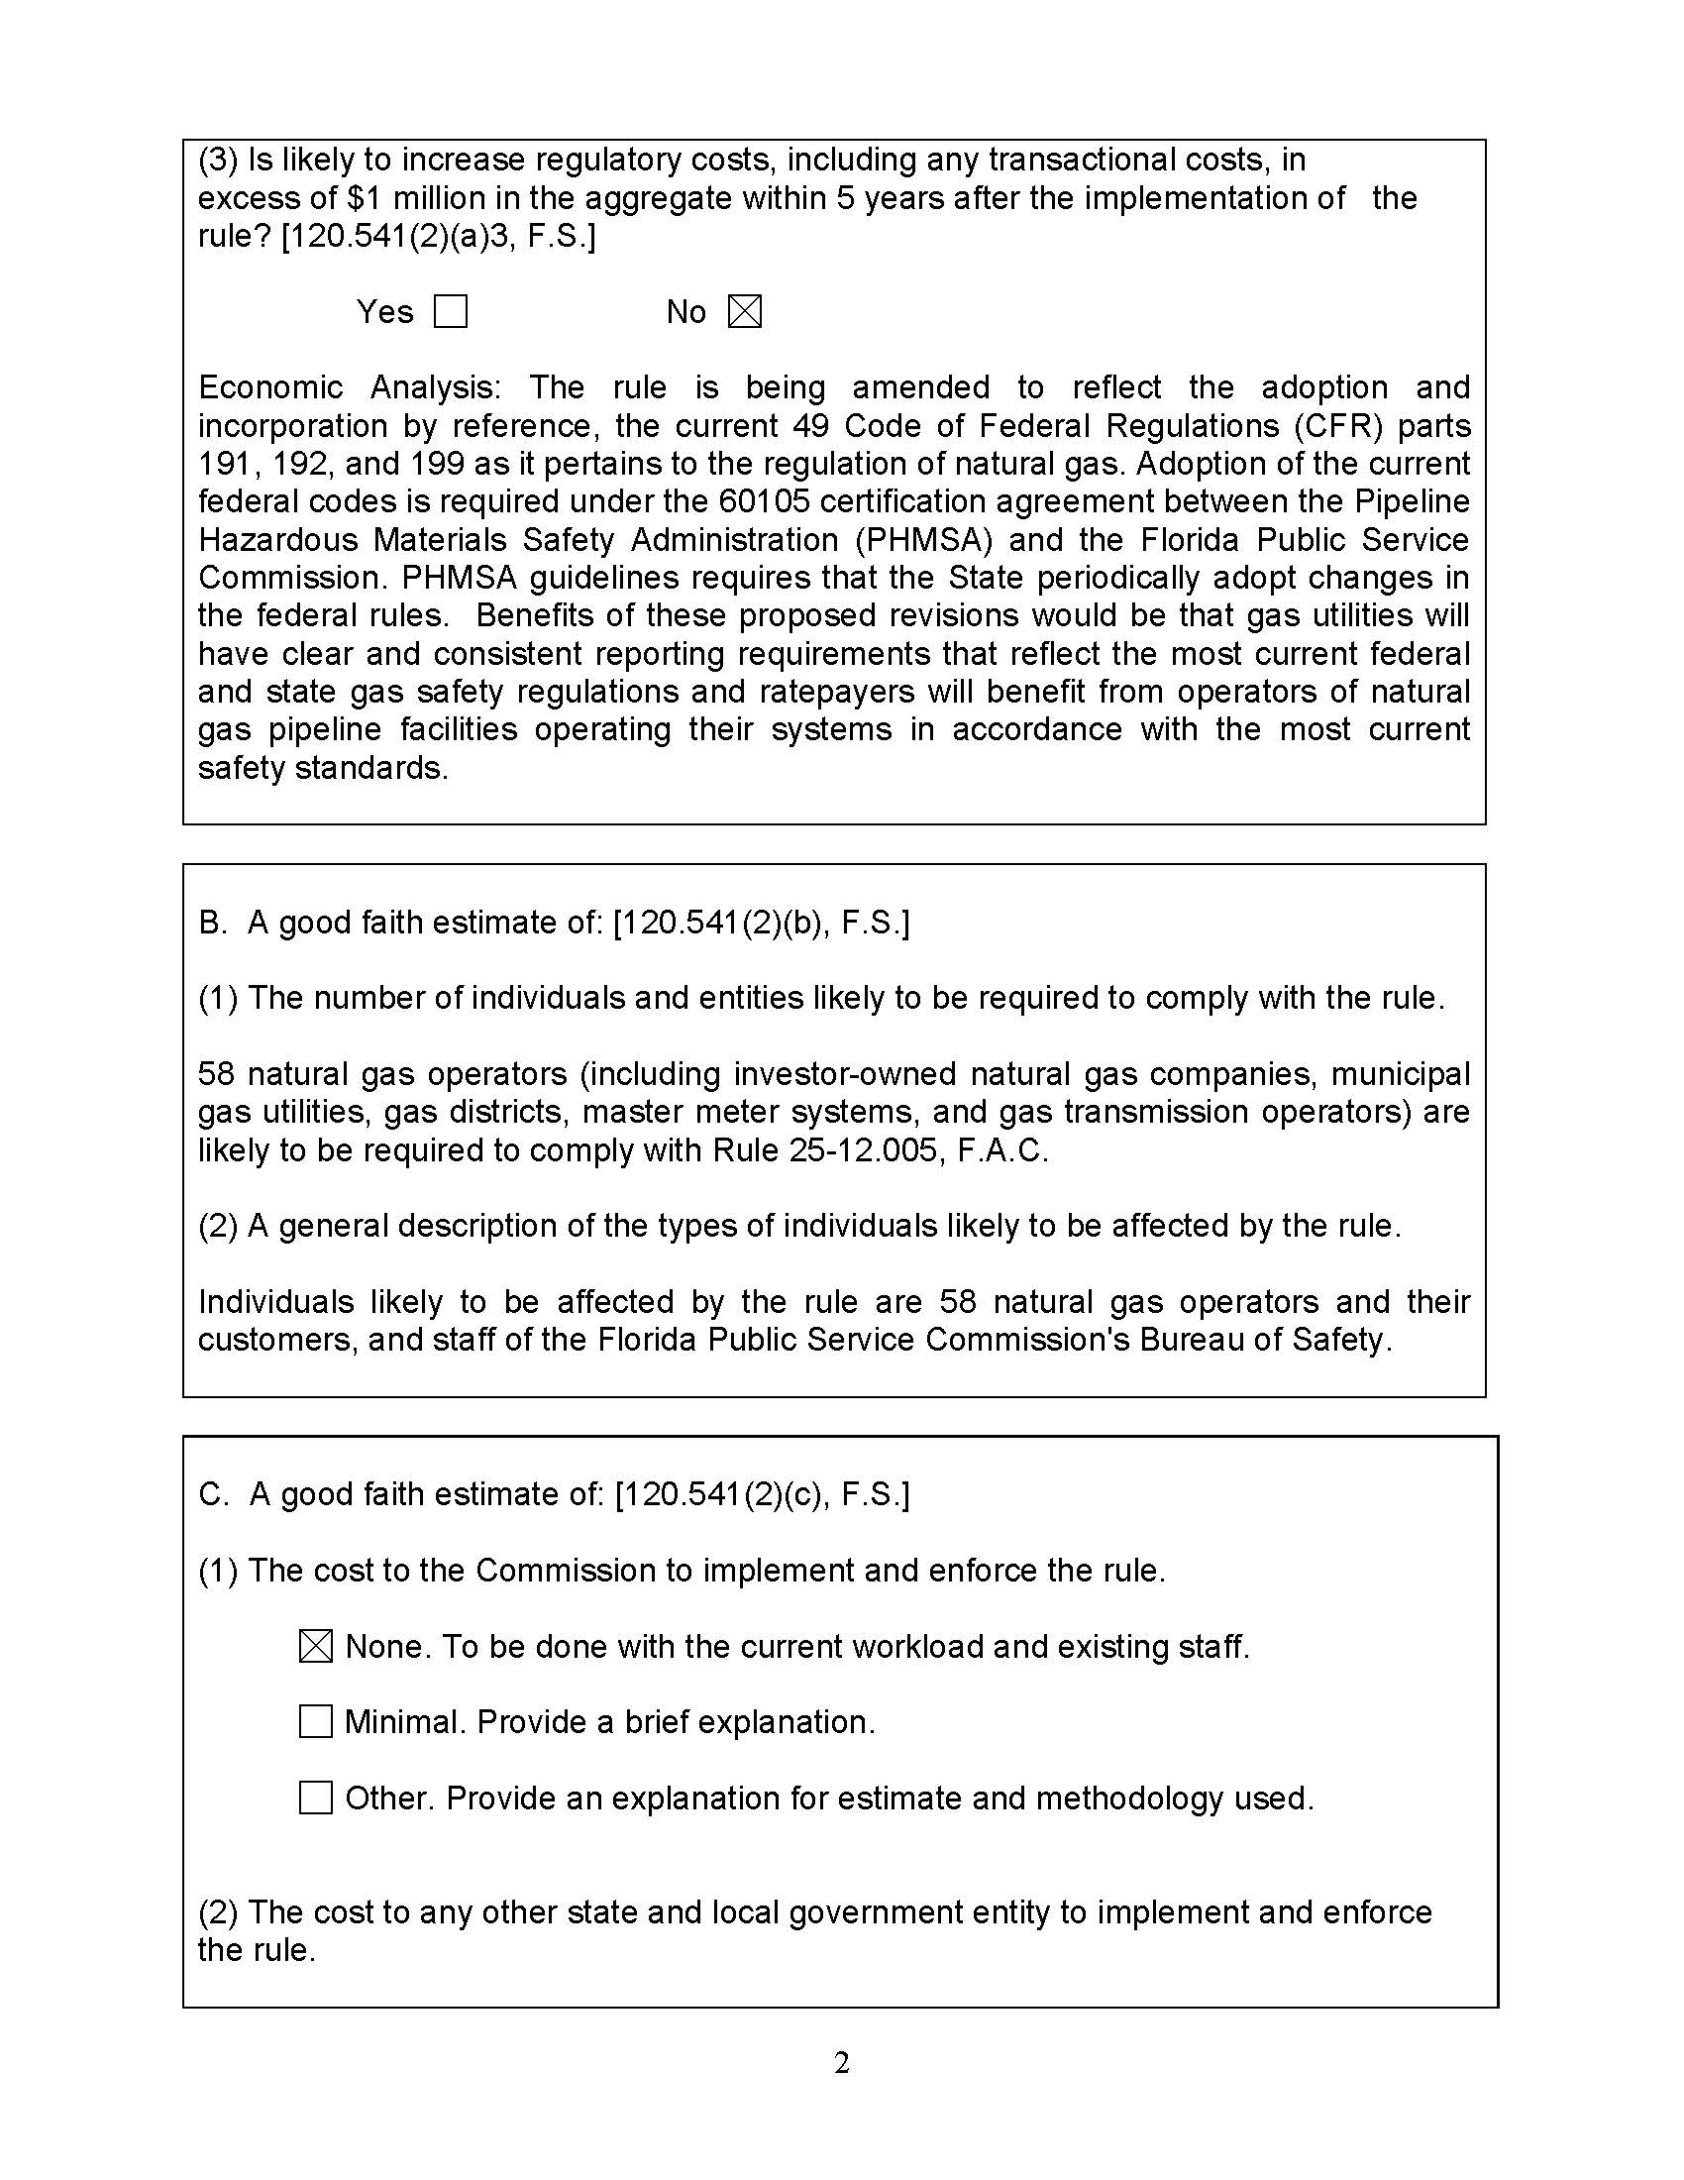

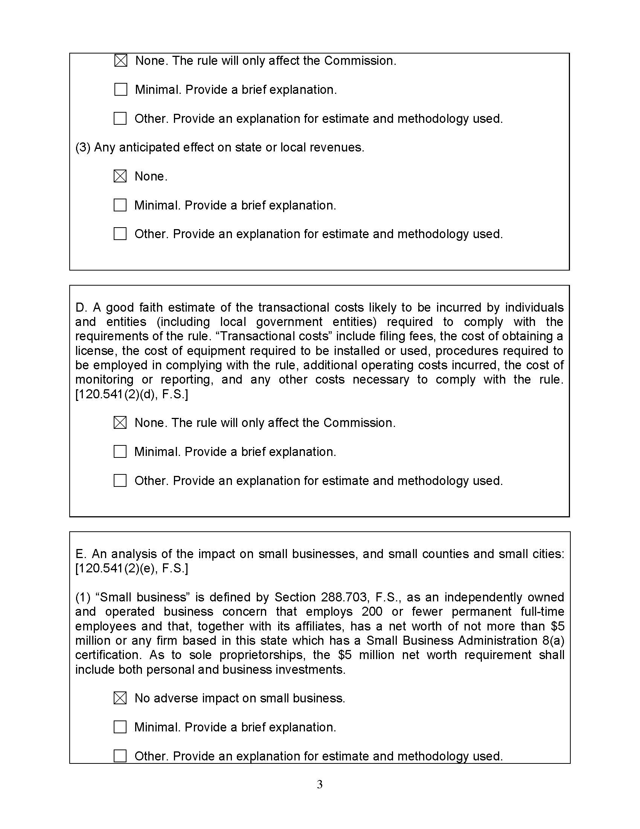

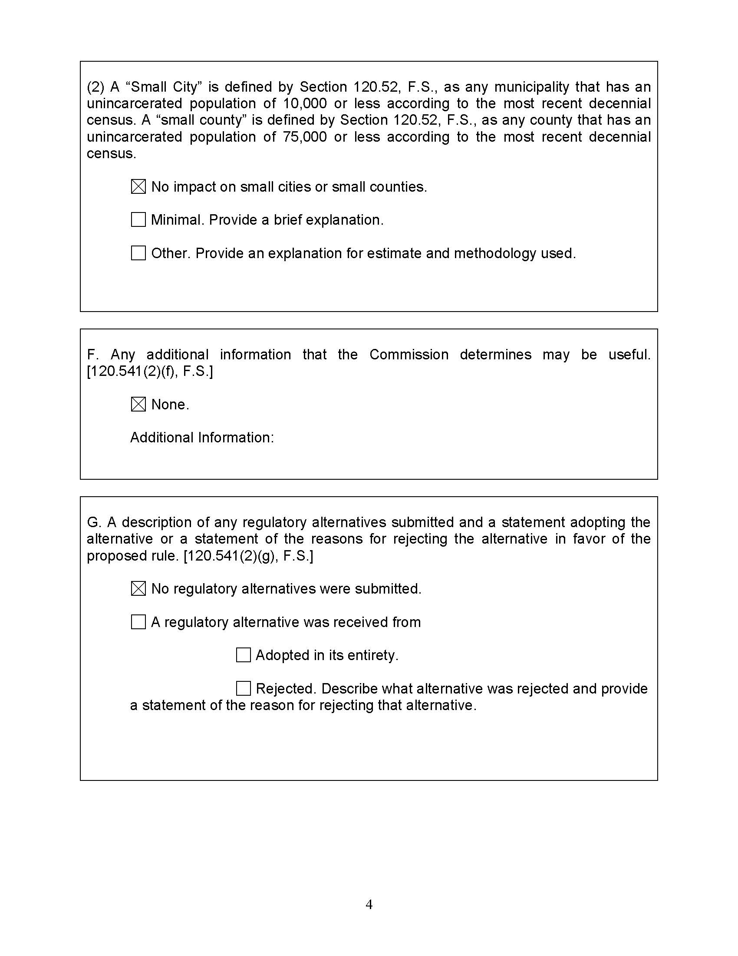

Under 49 U.S.C. § 60105, PHMSA has no regulatory jurisdiction over safety standards and practices of intrastate pipeline facilities and transportation to the extent that a State authority annually certifies that it implements and enforces applicable federal standards through a compliant pipeline safety program.
PIPES Act of 2020, Pub. L. No. 116-260, 134 Stat. 2210 (2020).
Section 120.695(2)(c)3., F.S.
Section 120.541(1)(b), F.S.
Id.
Section 120.541(2)(a), F.S.
Section 120.541(3), F.S.

