State of Florida |  | Public Service Commission  Capital Circle Office Center ● 2540 Shumard Oak Boulevard  Tallahassee, Florida 32399-0850  -M-E-M-O-R-A-N-D-U-M-
DATE: | February 23, 2023
TO: | Office of Commission Clerk (Teitzman)
FROM: | Division of Accounting and Finance (Gatlin, D. Buys, Hinson, Norris)  Division of Economics (Draper, Hampson)  Office of the General Counsel (Thompson, Sandy)
RE: | Docket No. 20230019-EI – Petition for recovery of costs associated with named tropical systems during the 2018-2022 hurricane seasons and replenishment of storm reserve, by Tampa Electric Company.
AGENDA: | 03/07/23 – Regular Agenda – Interested Persons May Participate
COMMISSIONERS ASSIGNED: |  |  | All Commissioners
PREHEARING OFFICER: |  |  | Graham
CRITICAL DATES: |  |  | 03/24/2023 (60-day Interim Deadline)
SPECIAL INSTRUCTIONS:

Case Background
On January 23, 2023, Tampa Electric Company (TECO or Company) filed a petition for a limited proceeding seeking authority to implement an interim storm restoration recovery charge to recover $131 million for the incremental restoration costs related to Tropical Storms Alberto, Nestor, and Eta, and Hurricanes Dorian, Elsa, Ian, and Nicole, as well as the replenishment of its storm reserve. (collectively, “the storms”) Included in the $131 million is interest charged for Hurricanes Ian and Nicole. Pursuant to the 2021 Stipulation and Settlement Agreement (2021 Settlement) approved by the Commission in Order No. PSC-2021-0423-S-EI, the recovery of storm costs from customers will begin, on an interim basis, 60 days after the filing of a cost recovery petition and tariff with the Commission. TECO requested a 12-month recovery period, applied to all bills starting with the first billing cycle of April 2023.
The Commission has jurisdiction over this matter pursuant to Sections 366.04, 366.05, 366.06, and 366.076, Florida Statutes.

Discussion of Issues

Issue 1:
Should the Commission authorize TECO to implement an interim storm restoration recovery charge?

Recommendation:
Yes. The Commission should authorize TECO to implement an interim storm restoration recovery charge, subject to refund. Once the total actual storm costs are known, TECO should be required to file documentation of the total storm costs for Commission review and true-up of any excess or shortfall. (Hinson)

Staff Analysis:
As stated in the Case Background, TECO filed a petition to seek recovery of $131 million in incremental storm restoration costs for the Storms as well as the replenishment of its storm reserve. In its petition, TECO requested to replenish the storm reserve to $55.8 million.
The petition was filed pursuant to the provisions of the 2021 Settlement. Pursuant to paragraph 8(a) of the 2021 Settlement, TECO is authorized to seek recovery of costs associated with any tropical storms named by the National Hurricane Center. Recovery of storm costs will begin, on an interim basis, 60 days following the filing of a petition for recovery.
In its petition, TECO asserted that it incurred approximate recoverable costs in the amounts of $7,499,858 for Hurricane Dorian; $1,874,575 for Hurricane Elsa; $119,216,291 for Hurricane Ian; $1,152,980 for Hurricane Nicole; $1,944 for Tropical Storm Alberto; $8,282 for Tropical Storm Nestor; and $729,515 for Tropical Storm Eta. The remaining $397,518 is for GPS software used to track vendor crews identified by TECO as ARCOS, implemented pursuant to the 2019 Settlement Agreement under the provision of Future Process Improvements. The Company further asserted that all amounts were calculated in accordance with the Incremental Cost and Capitalization Approach methodology prescribed in Rule 25-6.0143, Florida Administrative Code.
The approval of an interim storm restoration recovery charge is preliminary in nature and is subject to refund pending further review once the total actual storm restoration costs are known. After the actual costs are reviewed for prudence and reasonableness, and are compared to the actual amount recovered through the interim storm restoration recovery charge, a determination will be made whether any over/under recovery has occurred. The disposition of any over or under recovery, and associated interest, will be considered by the Commission at a later date.
Based on a review of the information provided by TECO in its petition, staff recommends that the Commission authorize the Company to implement an interim storm restoration recovery charge subject to refund. Once the total actual storm costs are known, TECO should be required to file documentation of the storm costs for Commission review and true-up of any excess or shortfall.

Issue 2:
What is the appropriate security to guarantee the amount collected subject to refund through the interim storm restoration recovery charge?

Recommendation:
The appropriate security to guarantee the funds collected subject to refund is a corporate undertaking. (D. Buys)

Staff Analysis:
Staff recommends that all funds collected subject to refund be secured by a corporate undertaking. The criteria for a corporate undertaking include sufficient liquidity, ownership equity, profitability, and interest coverage to guarantee any potential refund. TECO requested a 12-month collection period from April 2023 through March 2024 for Interim Storm Cost Recovery Charges of $130,881,964 related to the Storms, including the ARCOS cost. Staff reviewed TECO’s three most recent annual reports filed with the Commission (2021, 2020, and 2019) to determine if the Company can support a corporate undertaking to guarantee the funds collected for recovery of incremental storm restoration costs related to all the weather events. TECO’s financial information demonstrates the Company has a deficient level of liquidity; that is, current assets are less than current liabilities. However, the Company has sufficient levels of ownership equity, profitability, and interest coverage to support a potential refund of $131 million. TECO’s average net income for the three years 2021, 2020, and 2019 is almost three times the requested corporate undertaking amount ($352 million vs. $131 million). Moreover, it is improbable TECO will be required to refund the entire requested amount.
Staff believes TECO has adequate resources to support a corporate undertaking in the amount requested. Based on this analysis, staff recommends that a corporate undertaking of $131 million is acceptable. This brief financial analysis is only appropriate for deciding if the Company can support a corporate undertaking in the amount proposed and should not be considered a finding regarding staff's position on other issues in this proceeding.

Issue 3:
Should the Commission approve TECO's proposed interim storm restoration recovery charge tariff as shown in Attachment A to the recommendation?

Recommendation:
Yes. The Commission should approve TECO’s proposed interim storm restoration recovery charge tariff, as shown in Attachment A to this recommendation, effective with the first billing cycle of April 2023 through March 2024. The Commission should also approve TECO’s other tariff revisions, as provided in its petition, which refer to the proposed storm surcharge. The interim storm restoration recovery charge should be subject to a final true-up. (Hampson)

Staff Analysis:
TECO is seeking approval of interim storm cost recovery surcharges associated with the Storms. The proposed interim storm cost recovery surcharges are shown in proposed Tariff Sheet No. 6.024 (Attachment A to this recommendation). The surcharges would be applicable to all rate classes. The Company has also proposed changes to several other tariffs to include references to the proposed interim storm cost recovery surcharge, as well as a definition for the storm surcharge in its technical terms and abbreviations section. These tariff modifications are included in Exhibit 6 (clean version) and Exhibit 7 (legislative version) to TECO’s petition.
TECO explained that it has allocated the storm cost recovery amount to the rate classes consistent with the rate design approved in the 2021 Settlement. Staff reviewed the storm cost recovery allocation and calculation of rates and it appears that TECO has calculated rates in accordance with the 2021 Settlement, using projected billing determinants for the recovery period.
The interim storm restoration recovery charge calculations are shown in Exhibit 5 to TECO’s petition. For residential customers, the surcharge would be 1.022 cents per kilowatt-hour (kWh), which would equate to $10.22 on a 1,000 kWh residential bill. If approved by the Commission, the storm cost recovery surcharge would be included in the non-fuel energy charge on customer bills.

CONCLUSION
Staff recommends that the Commission approve TECO’s proposed interim storm restoration recovery charge tariff, as shown in Attachment A to this recommendation, effective with the first billing cycle of April 2023 through March 2024. The Commission should also approve TECO’s other tariff revisions which refer to the proposed storm surcharge. Furthermore, the interim storm restoration recovery charge should be subject to a final true-up.

Issue 4:
Should this docket be closed?

Recommendation:
No. This docket should remain open pending final reconciliation of actual recoverable storm costs with the amount collected pursuant to the interim storm restoration recovery charge and the calculation of a refund or additional charge if warranted. (Thompson, Sandy)

Staff Analysis:
No, this docket should remain open pending final reconciliation of actual recoverable storm costs with the amount collected pursuant to the interim storm restoration recovery charge and the calculation of a refund or additional charge if warranted.

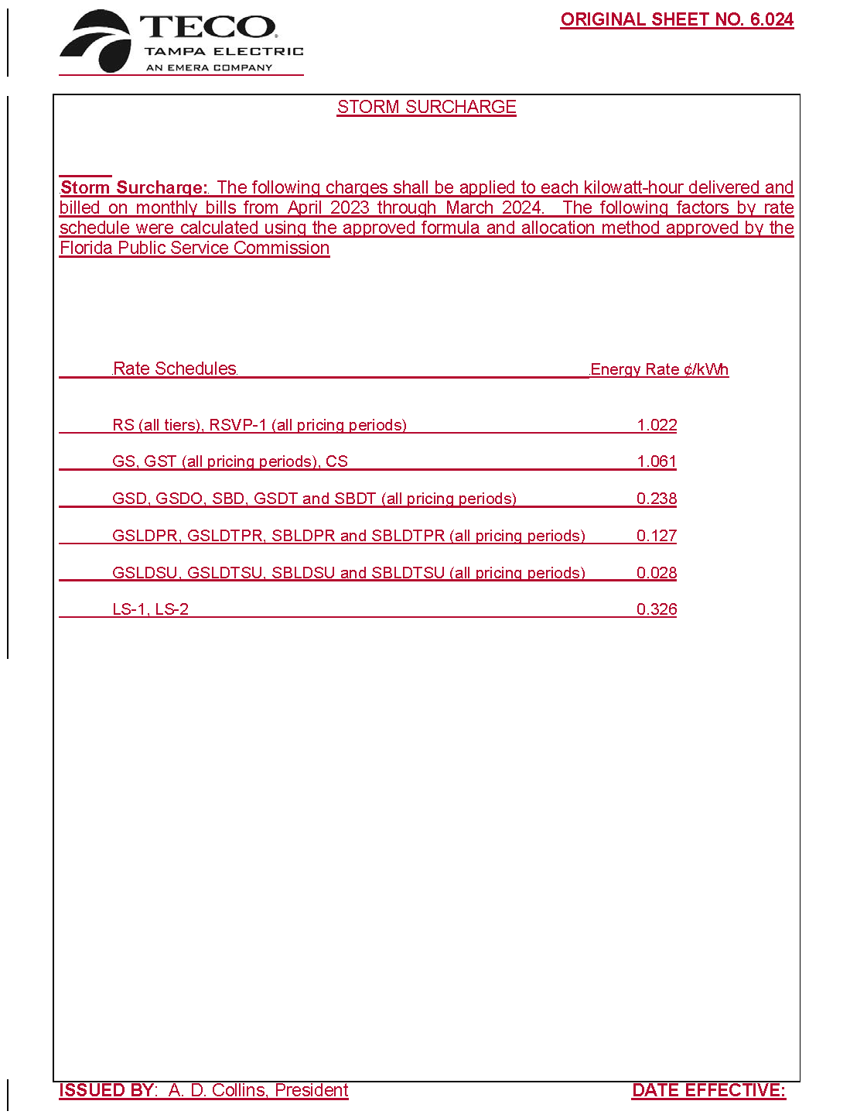

Order No. PSC-2021-0423-S-EI, issued November 10, 2021, in Docket No. 20210034-EI, In re: Petition for rate increase by Tampa Electric Company.
Order No. PSC-2019-0234-AS-EI, issued June 14, 2019, in Docket No. 20170271-EI, In re: Petition for recovery of costs associated with named tropical systems during the 2015, 2016, and 2017 hurricane seasons and replenishment of storm reserve subject to final true-up, Tampa Electric Company.
Order No. PSC-2021-0423-S-EI, issued November 10, 2021, in Docket No. 20210034-EI, In re: Petition for rate increase by Tampa Electric Company.

