State of Florida |  | Public Service Commission  Capital Circle Office Center ● 2540 Shumard Oak Boulevard  Tallahassee, Florida 32399-0850  -M-E-M-O-R-A-N-D-U-M-
DATE: | March 23, 2023
TO: | Office of Commission Clerk (Teitzman)
FROM: | Division of Engineering (Davis, Ellis)  Office of the General Counsel (M. Thompson, J. Crawford)
RE: | Docket No. 20220186-EI – Petition for approval of purchased power agreement between Tampa Electric Company and Pasco County.
AGENDA: | 04/04/23 – Regular Agenda – Proposed Agency Action - Interested Persons May Participate
COMMISSIONERS ASSIGNED: |  |  | All Commissioners
PREHEARING OFFICER: |  |  | La Rosa
CRITICAL DATES: |  |  | None
SPECIAL INSTRUCTIONS: |  |  | None

Case Background
On November 4, 2022, Tampa Electric Company (TECO or Company), filed a petition requesting approval of a negotiated purchased power agreement (PPA) for the purchase of firm capacity and energy with Pasco County, Florida (Pasco). A copy of the PPA is attached (Attachment A). The PPA is based on Pasco’s Waste-to-Energy Facility (WTE Facility) located in Spring Hill, Florida, which is an existing 31 megawatt (MW) Qualifying Facility (QF). The WTE Facility is located in the territory of Duke Energy Florida, LLC (DEF), and would require access to DEF’s transmission capacity to deliver the electricity to TECO. Pasco is proposing to initially sell 21 MW, with the option to sell 25 MW, of firm capacity and energy to TECO for a 10-year period from January 1, 2025, through December 31, 2034.
The Florida Public Service Commission (Commission) has jurisdiction over this matter pursuant to Sections 366.051, 366.81, and 366.91, Florida Statutes (F.S.).

Discussion of Issues

Issue 1:
Should the Commission approve cost recovery of the negotiated purchased power agreement between Pasco and TECO?

Recommendation:
Yes, the fixed energy priced agreement should be approved. However, in order to minimize risks to ratepayers, all transmission costs above the negotiated cost cap contained in the agreement and future costs associated with renewable energy credits should not be approved for cost recovery at this time. (Davis)

Staff Analysis:
Pasco proposes to sell 21 MW from its WTE facility (with an option to increase up to 25 MW when planned facility upgrades are completed) of firm capacity and energy at a 92 percent monthly availability to TECO for a term from January 1, 2025, through December 31, 2034. The date of planned facility upgrades are not known at this time. The facility will use municipal solid waste as its primary fuel, a source of renewable energy pursuant to Section 366.91(2)(e), F.S. The price structure in the contract has no capacity payment, but an “all-in” confidential dollars per megawatt-hour (MWh) energy rate payment. The initial rate is fixed for the first 5 years and steps up to a higher energy price in years 6-10.
The contract has two notable features relating to transmission and renewable energy credits (RECs). Regarding transmission, as the Pasco WTE Facility is interconnected and located within DEF’s service territory, it will require use of a portion of DEF’s transmission capacity to deliver energy to a delivery point with TECO. Traditionally, a QF such as Pasco would request this service and pay DEF for the transmission service pursuant to Rule 25-17.0889, Florida Administrative Code (F.A.C.). However, Section 5 of the PPA makes TECO responsible for requesting and securing the required transmission service from DEF and for paying all costs including potential transmission studies, system upgrades if needed, and transmission capacity fees based on DEF’s Open Access Transmission Tariff (OATT). TECO’s monthly payments to Pasco would be reduced by the amount of the transmission expenses incurred below the negotiated cost cap. In essence, such treatment would assign the cost of transmission service to Pasco, consistent with Rule 25-17.0889, F.A.C. However, any transmission expenses above the cost cap, including transmission studies and system upgrades, would be paid by TECO and potentially recovered through the Fuel and Purchased Power Cost Recovery Clause (Fuel Clause).
The other notable feature relates to RECs. RECs are tradeable renewable energy credits, which can be certified to represent the production of energy from a renewable power source typically in increments of 1 MWh. An entity can purchase a REC in order to retire it to either meet a regulatory requirement (such as a state or federal renewable portfolio standard) or to otherwise claim the environmental aspects of the energy produced. TECO will receive the RECs associated with the energy purchased through the contract at no cost, with some caveats. These caveats include two main components: (1) if federal or state legislation establish a value for RECs, TECO would be required to pay the larger of these two values to Pasco; and (2) if Pasco is able to find a third party buyer, TECO would be required to sell them to the third party and provide the proceeds to Pasco or purchase the RECs themselves, in a de facto right of first refusal arrangement. In the latter scenario, REC payments would also be applied to the transmission cost cap, potentially reducing amounts paid by TECO.
Rule 25-17.0832(3), F.A.C., states that in reviewing negotiated firm capacity and energy contracts for the purpose of cost recovery, the Commission shall consider factors relating to the contract that would impact the utility's customers, including: need for power by purchasing utility and/or Florida utilities statewide, the cost-effectiveness of the contract, security provisions for early payments, and performance guarantees associated with the facility. These factors are evaluated below.

Need for Power
Based on TECO’s 2022 Ten-Year Site Plan (TYSP), the next planned capacity addition that could be avoided is a natural gas-fired reciprocating engine, rated at 18.7 MW with an in-service date of January 1, 2028. Therefore, the PPA’s firm capacity of 21 MW could defer the construction of the future generation unit for the duration of the PPA. As TECO is projected to rely upon natural gas for up to 85 percent of its energy during the contract period, according to its 2022 TYSP, the PPA would improve the Company’s fuel diversity by increasing the contribution of renewable resources. Therefore, staff believes the proposed negotiated contract will enhance TECO's system reliability and increase TECO’s fuel diversity.

Cost-Effectiveness
Rule 25-17.0832(3)(b), F.A.C., states in part that the Commission should consider whether the cumulative present worth of payments to a QF are no greater than the cumulative present worth of the purchasing utility's avoided cost of capacity and energy. In its petition, TECO stated that the estimated benefits of the PPA ranged from $4.3 million to $11.4 million on a net present value (NPV) basis. The reason for the savings are primarily reduced fuel, with other avoided costs including deferred generation capital, fixed O&M, and deferred natural gas transport. The break-even point for the cost-effectiveness of the PPA occurs in the first year of the contract for both the low and high savings range. The range is dependent upon when or if the facility upgrades from 21 MW to 25 MW, and the analysis includes the impact of system benefits from the avoided capacity and fuel, versus the costs of the PPA energy payments and DEF transmission costs. In response to Staff’s First Data Request, TECO stated that the cost-effectiveness was based on the Company’s 2021 TYSP, not the 2022 TYSP which was filed April 1, 2022, well before the filing of TECO’s petition. As a result, staff requested a revised analysis using the Company’s 2022 TYSP and the most recent available fuel forecasts. In response to Staff’s Data Request, TECO provided that the cost-effectiveness now ranged from $1.2 million to $9.0 million on a NPV basis. The reason for the savings for this range is the same as the previous range. The break-even point occurs in the first year for the 21 MW scenario and the third year for the 25 MW scenario. Table 1-1 summarizes the cost-effectiveness scenarios reviewed by staff for the PPA.

Table 1-1
PPA Savings Scenarios
Scenario | Savings ($million)
 | High (21 MW) | Low (25 MW)
Petition: 2021 TYSP and Fuel Forecast | $11.4 | $4.3
Revised: 2022 TYSP and 01/23 Fuel Forecast | $9.0 | $1.2
Source: TECO’s Response to Staff’s First Data Request.

Economic Risks
Because the PPA includes fixed energy rate payments, the rates are not allowed to float with changes to TECO’s system fuel costs. This allocates all the risk of fuel price fluctuations from the Pasco WTE Facility to TECO’s ratepayers. For example, if fuel costs do not escalate as quickly as projected in the cost-effectiveness analyses, it may result in a loss to customers. Conversely, if fuel costs escalate faster, customers would see an increased benefit. Regardless, TECO would remain obligated to pay the contracted rate and may seek to recover the costs from the ratepayers through the Fuel Clause, subject to Commission review.
In a previous docket, the Commission has expressed concerns regarding fixed price contracts. In Docket No. 20110090-EQ, the Commission noted in its approval of a Progress Energy Florida, Inc. (PEF) PPA that also featured fixed energy rates for the duration of the contract, that:
While the company does not make a return on purchased power, it is responsible for protecting the ratepayers during negotiations with renewable power providers and should include terms and conditions that minimize risk to the company’s general body of ratepayers. By using fixed prices for all components of the contract, risks associated with fuel price fluctuations are shifted to the ratepayers, and away from the renewable generator. PEF should strive in its future negotiations to be diligent in protecting its ratepayers from undue or excessive risk. Notwithstanding the benefits of a negotiated purchase power agreement, in negotiating future contracts and to protect the ratepayers, utilities and companies should strive to adhere to Rule 25-17.250, F.A.C., in that only a portion of the base energy costs associated with the avoided unit shall be fixed, and prospectively, utilities should strive not to established a “100 percent fixed” or a majority fixed base energy cost.
An example of this risk posed to ratepayers is highlighted in the revised analysis requested by staff, with TECO noting a decrease in its fuel projections as part of its midcourse correction. Changes in forecasts, including fuel savings and other factors such as transmission rates and deferred capacity, reduced the NPV benefit as shown in Table 1-1.
The proposed PPA also exposes ratepayers to a new form of risk associated with transmission costs. The typical purchased power agreement assumes all transmission costs are carried by the QF. For example, in TECO’s Standard Offer Contract, the QF is solely responsible for all cost to provide transmission to the point of interconnection with TECO. As discussed above, the PPA assigns the cost of securing transmission service to TECO. The costs are then passed along to Pasco up to the negotiated cost cap. Based on the analysis provided by TECO, transmission costs above the cost cap are projected to be incurred by TECO no earlier than in year 4 of the 10-year contract, with transmission costs higher if Pasco is able to deliver at a higher output (up to 25 MW pursuant to the PPA). TECO describes the transmission cost risk as having decreased between filing its petition and the revised analysis requested by staff, as DEF’s transmission cost forecast was lower than used in the petition’s analysis. However, the transmission cost above the negotiated cost cap remains a risk to ratepayers.
While the contract is projected to be cost-effective based on the assumed transmission cost risks in TECO’s analysis, if the PPA is approved this cost could be passed on to the ratepayers since the costs are incurred by TECO as part of the PPA. In response to Staff’s Second Data Request, Questions Nos. 7 through 9, TECO stated that it would not seek recovery for costs for transmission studies, upgrades and associated administrative costs with arranging transmission services. This still leaves ratepayers potentially liable for any transmission costs associated with DEF’s OATT above the cost cap. To be consistent with Rule 25-17.0889, F.A.C. and to prevent adding any transmission risks to ratepayers, staff recommends that all costs associated with transmission services above the cost cap should not be eligible for cost recovery at this time.

Renewable Energy Credits
Based on the proposed PPA, TECO will receive RECs when purchasing power through the contract at no cost to TECO, except under certain circumstances. If a monetary value is established by a state or federal government entity, the higher of the established governmental monetary values will be used as a basis of payment to Pasco. If no governmental monetary value is established, then Pasco has the option to market the RECs to a third party buyer. However, if Pasco is successful in finding a third party buyer, TECO has a de facto right of first refusal. Under this scenario, TECO would either pay the market price or sell the RECs to a third party buyer, and turn the proceeds over to Pasco. At this time, there is no federal or state legislation requiring the purchase of RECs. Staff recommends that the Commission’s approval of the PPA not be considered as approval of any future REC purchases pursuant to the PPA, but that TECO be required to demonstrate the need for their purchase if it seeks cost recovery in the future.

Security and Performance Guarantees
Security in this contract include provisions to ensure repayment of firm capacity and energy payments in the event that the qualifying facility fails to deliver firm capacity and energy pursuant to the terms and conditions of the contract. Rule 25-17.0832(3)(c), F.A.C., requires the Commission to consider if such security is adequate for the contract. The QF is an existing facility which eliminates the risk of early “all-in” energy (which includes capacity) payments due to construction delays. However, the contract begins in year 2025 and the avoided unit is scheduled for 2028 implementation. If the QF defaults during this time period, the contract includes a termination payment table for determining compensation to TECO.
Performance guarantees, as included in this contract, detail how a QF is to operate and require financial penalties or other remedies should it fail to do so within the contract's terms and conditions. Rule 25-17.0832(3)(d), F.A.C., requires the Commission to consider whether the utility's ratepayers will be protected by the contract's terms. Staff has reviewed the performance guarantees contained in the negotiated contract and believes they are adequate. These protections include a lower energy rate payment if Pasco WTE facility does not provide a monthly energy availability of at least 92 percent at TECO-DEF service territory boundary. Also, if the Pasco WTE Facility has an availability less than 70 percent for any 6-months in a calendar year during the contract, this failure will be considered a default which means TECO can recover costs of obtaining replacement power from Pasco.

Conclusion
Based on TECO’s most recent planning assumptions, the fixed-price purchased power agreement is projected to provide TECO’s customers NPV benefits that range from $1.2 to $9.0 million over a ten year period. However, in order to minimize risks to ratepayers, all transmission costs above the negotiated cost cap contained in the agreement and future costs associated with renewable energy credits should not be approved for cost recovery at this time.

Issue 2:
Should this docket be closed?

Recommendation:
Yes. This docket should be closed upon issuance of a Consummating Order unless a person whose substantial interests are affected by the Commission's decision files a protest within 21 days of the issuance of the proposed agency action. (Thompson)

Staff Analysis:
This docket should be closed upon issuance of a Consummating Order unless a person whose substantial interests are affected by the Commission's decision files a protest within 21 days of the issuance of the proposed agency action.

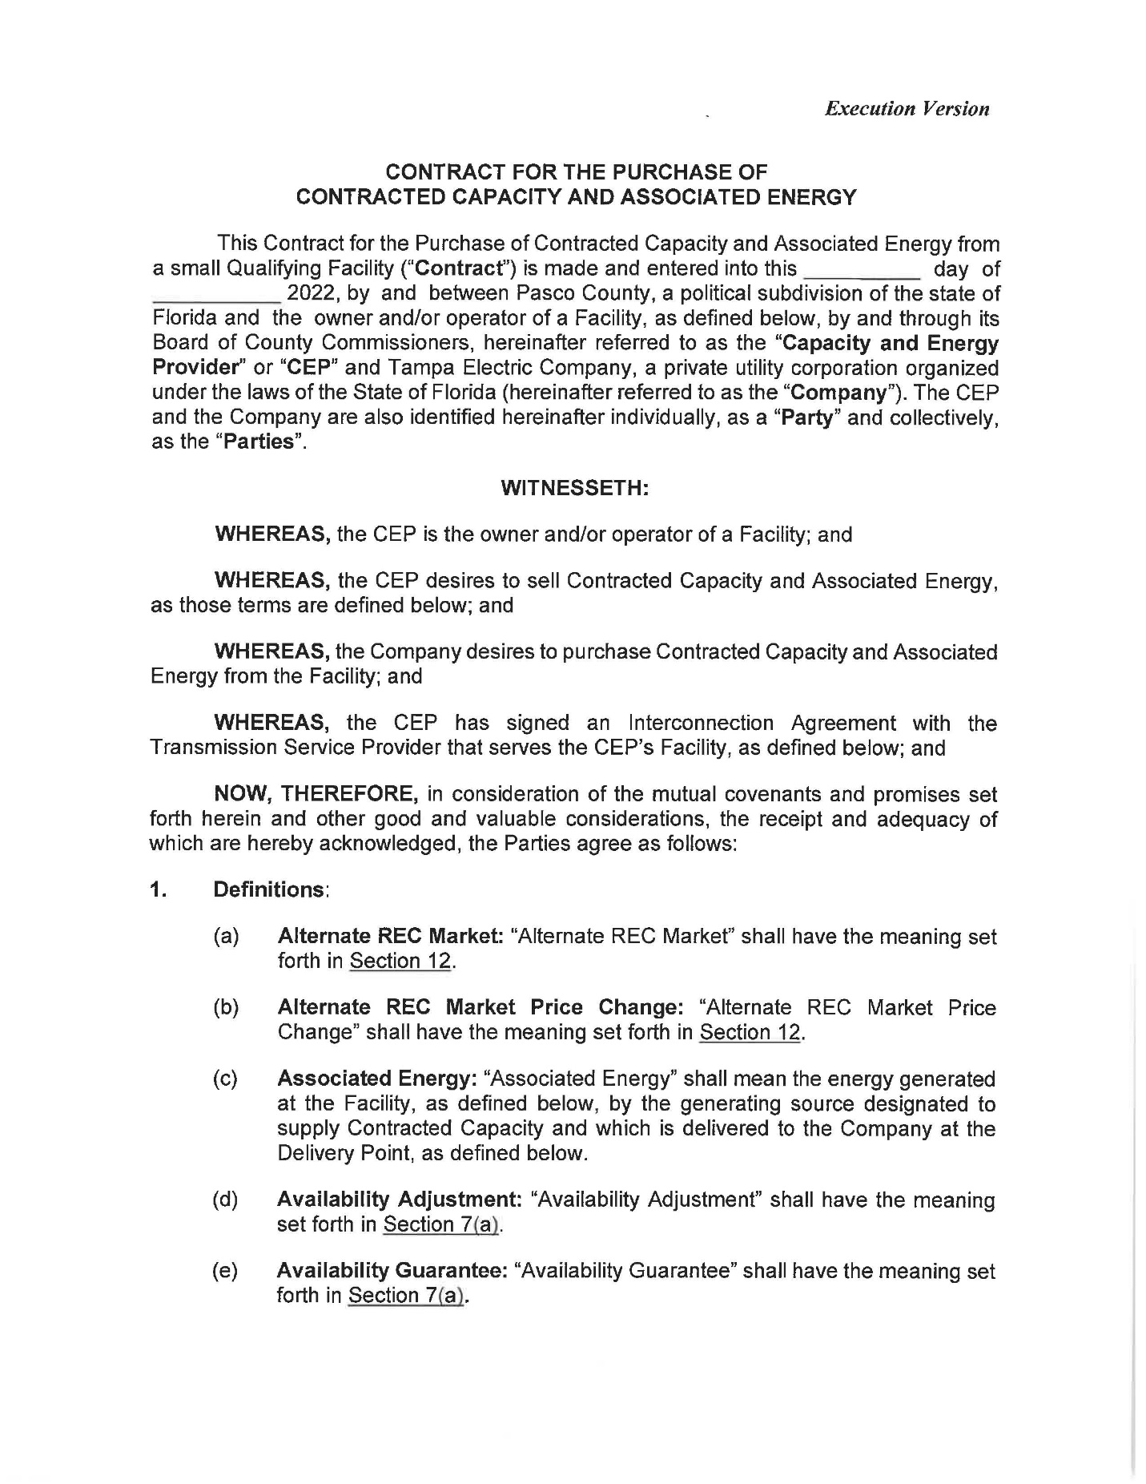

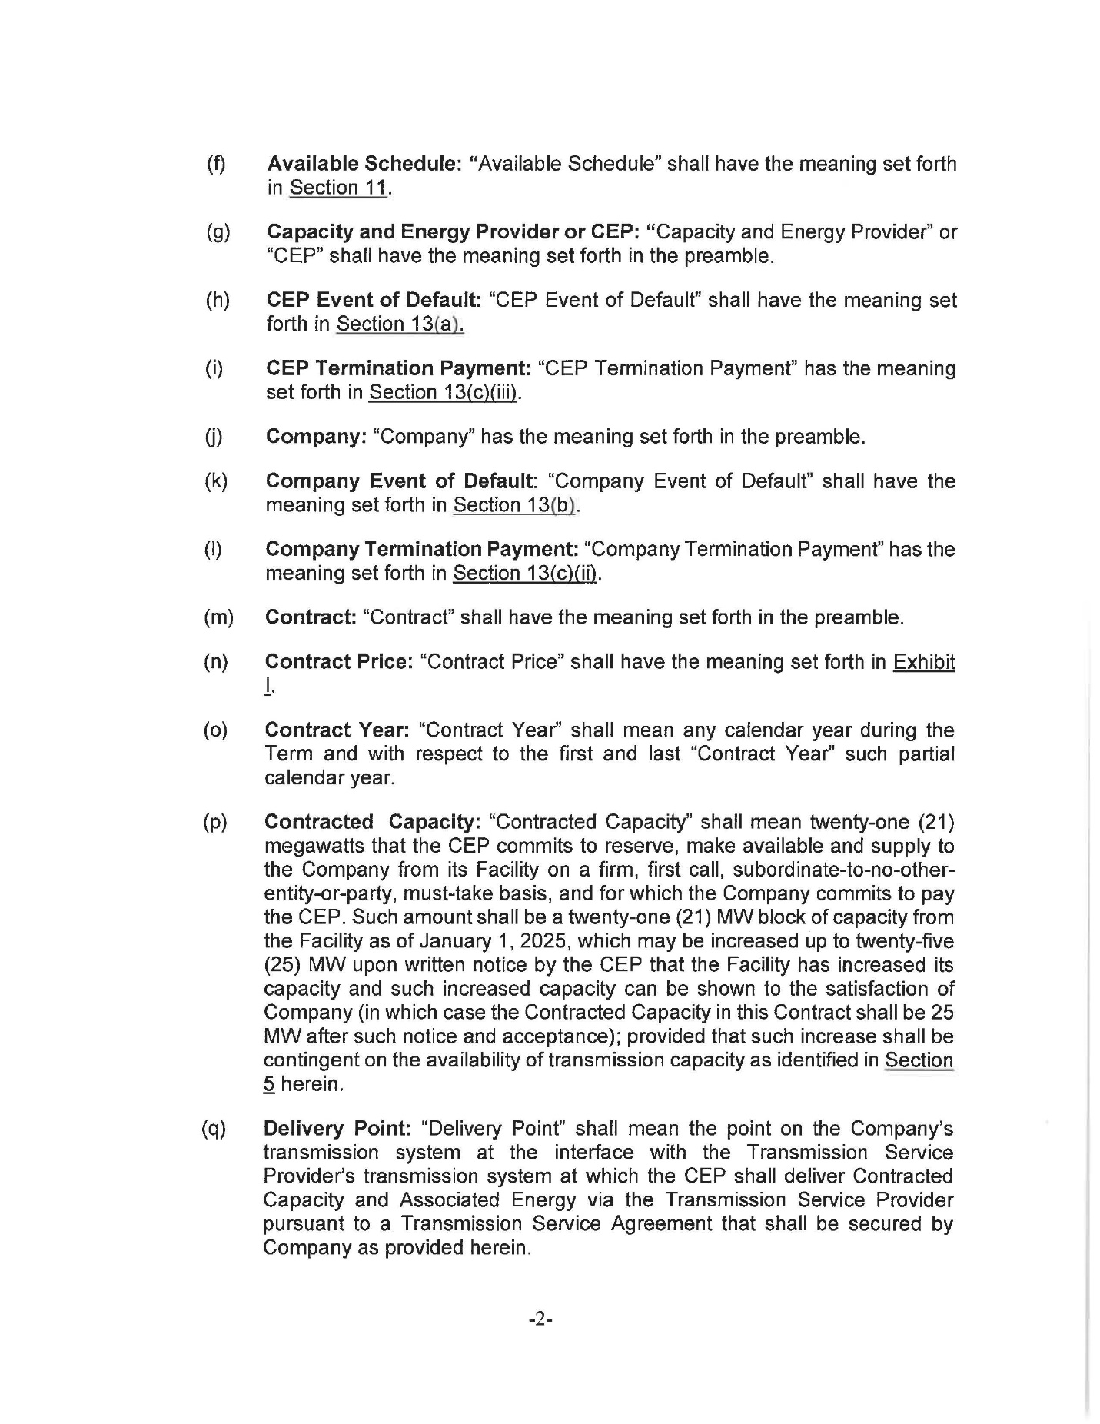

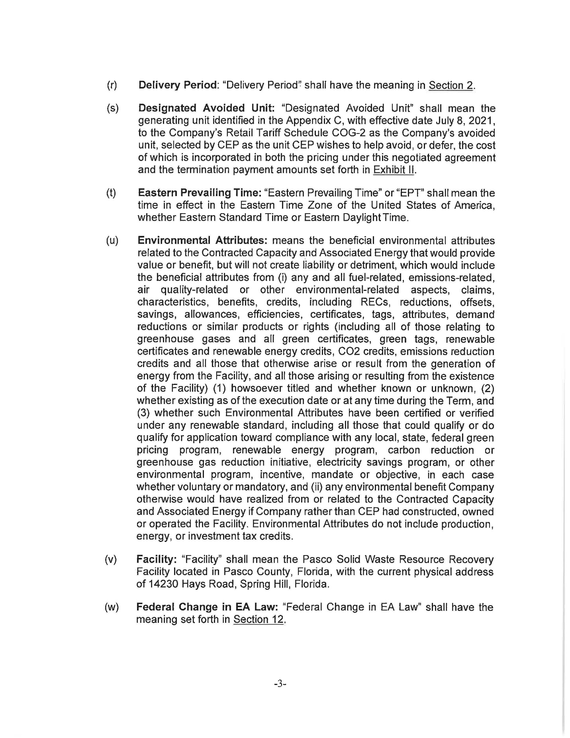

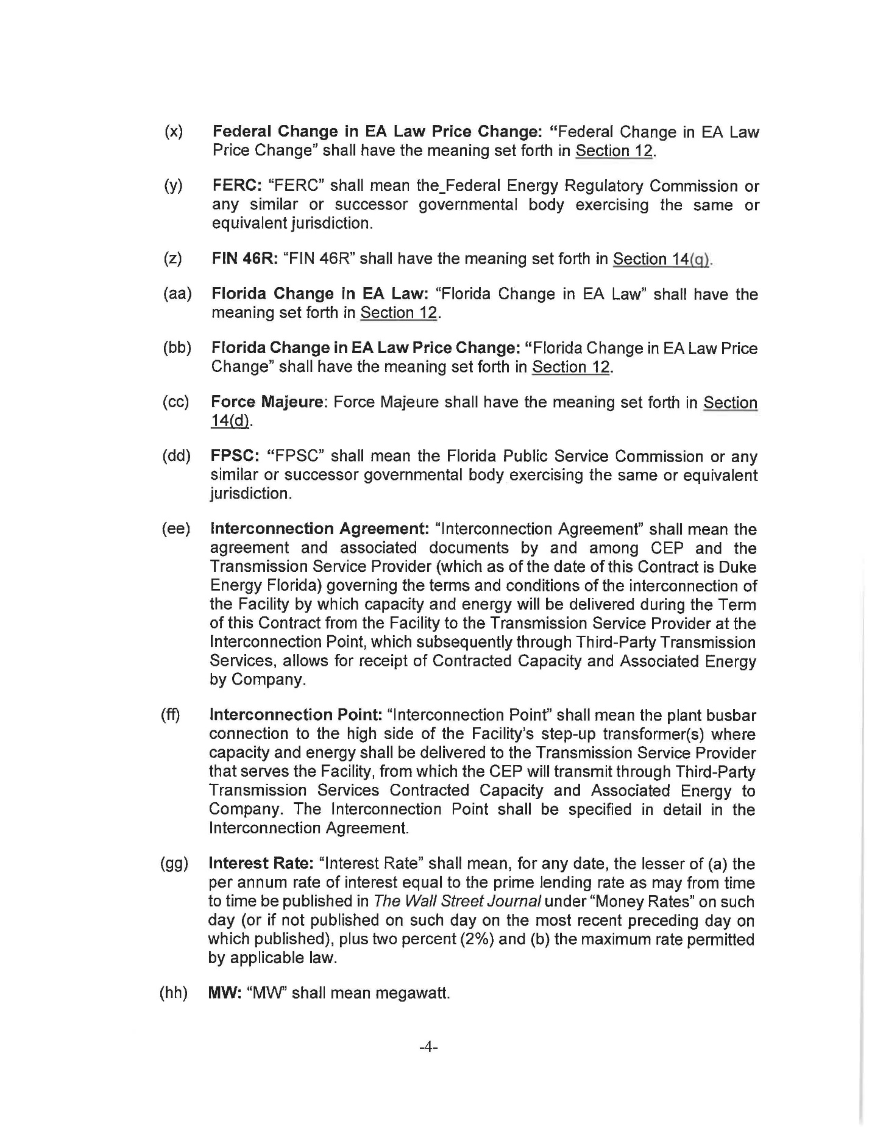

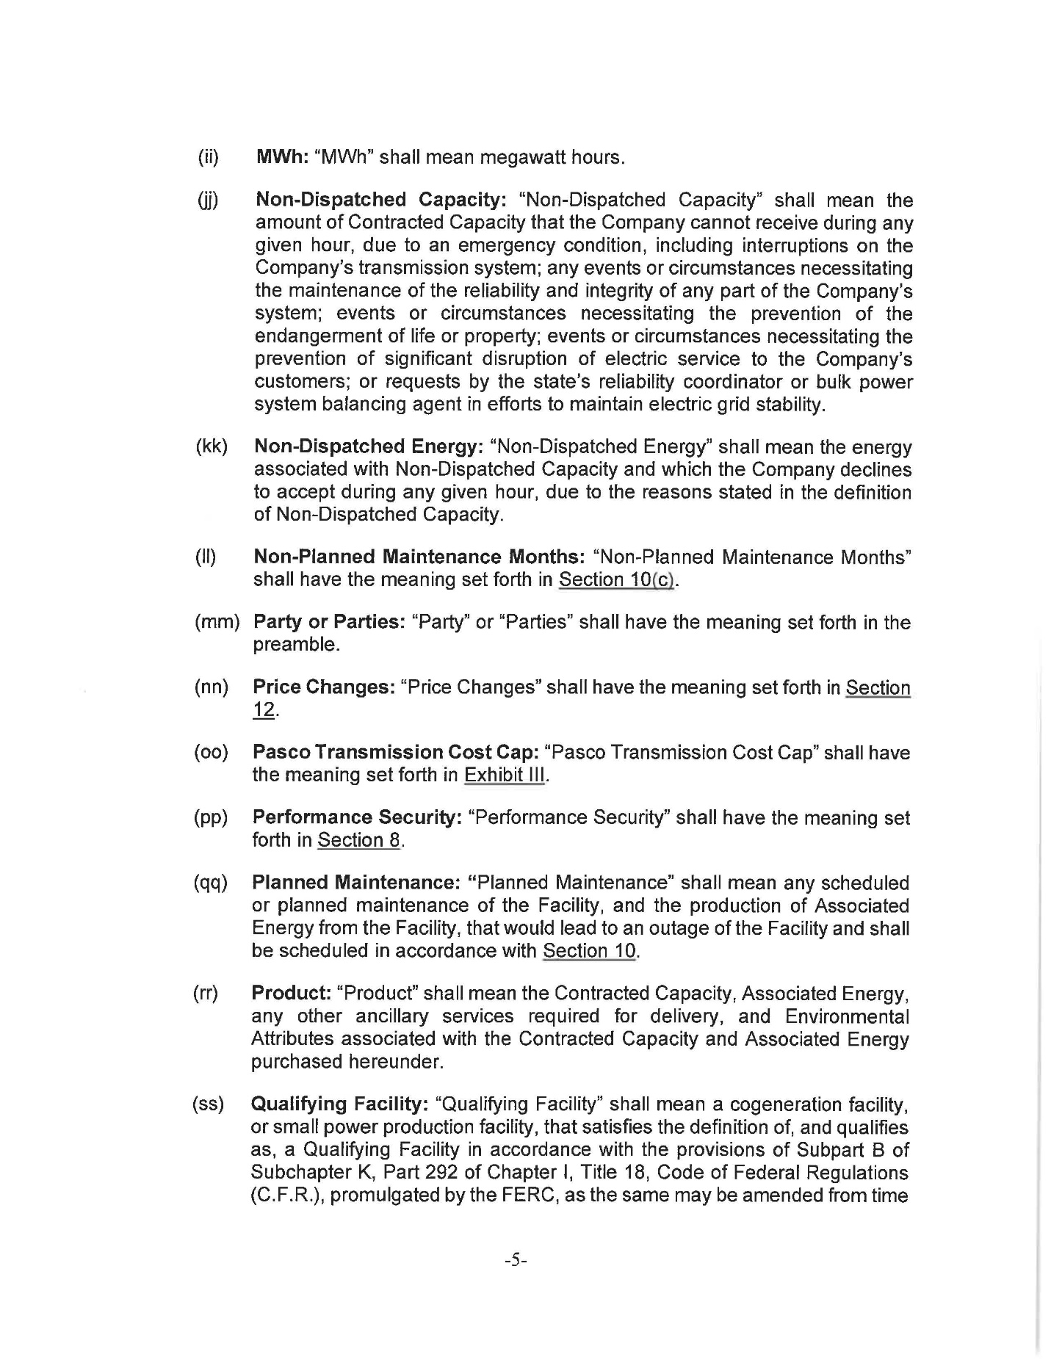

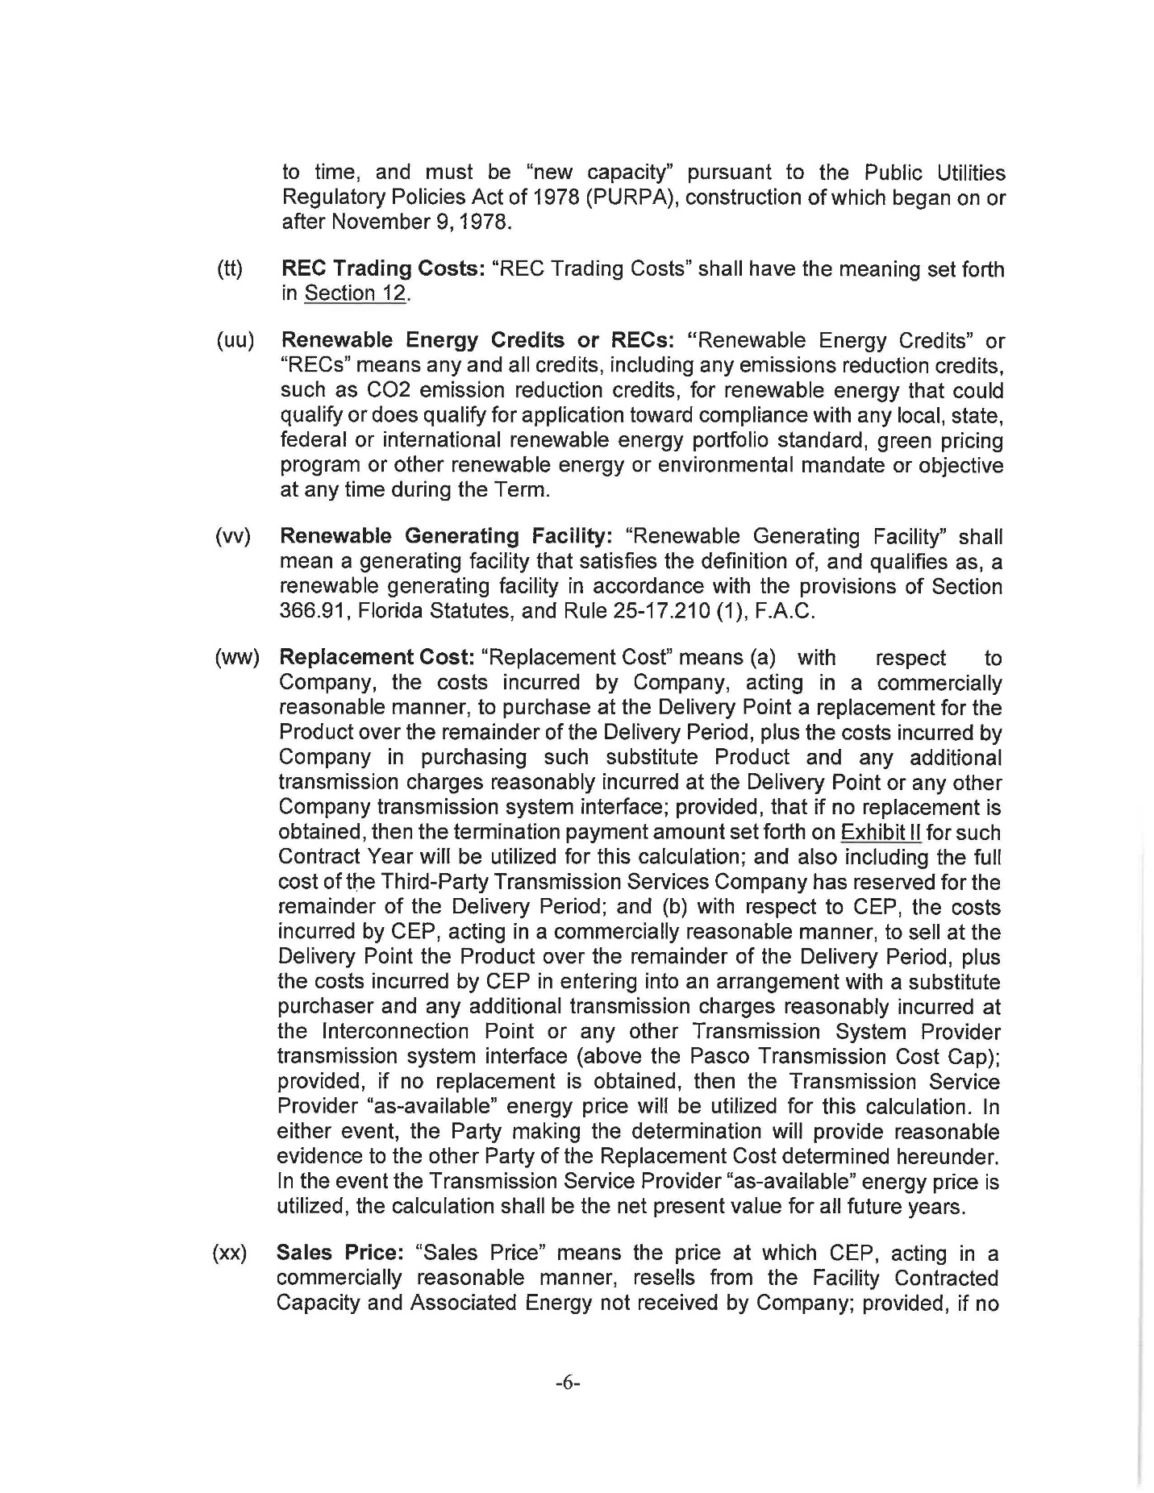

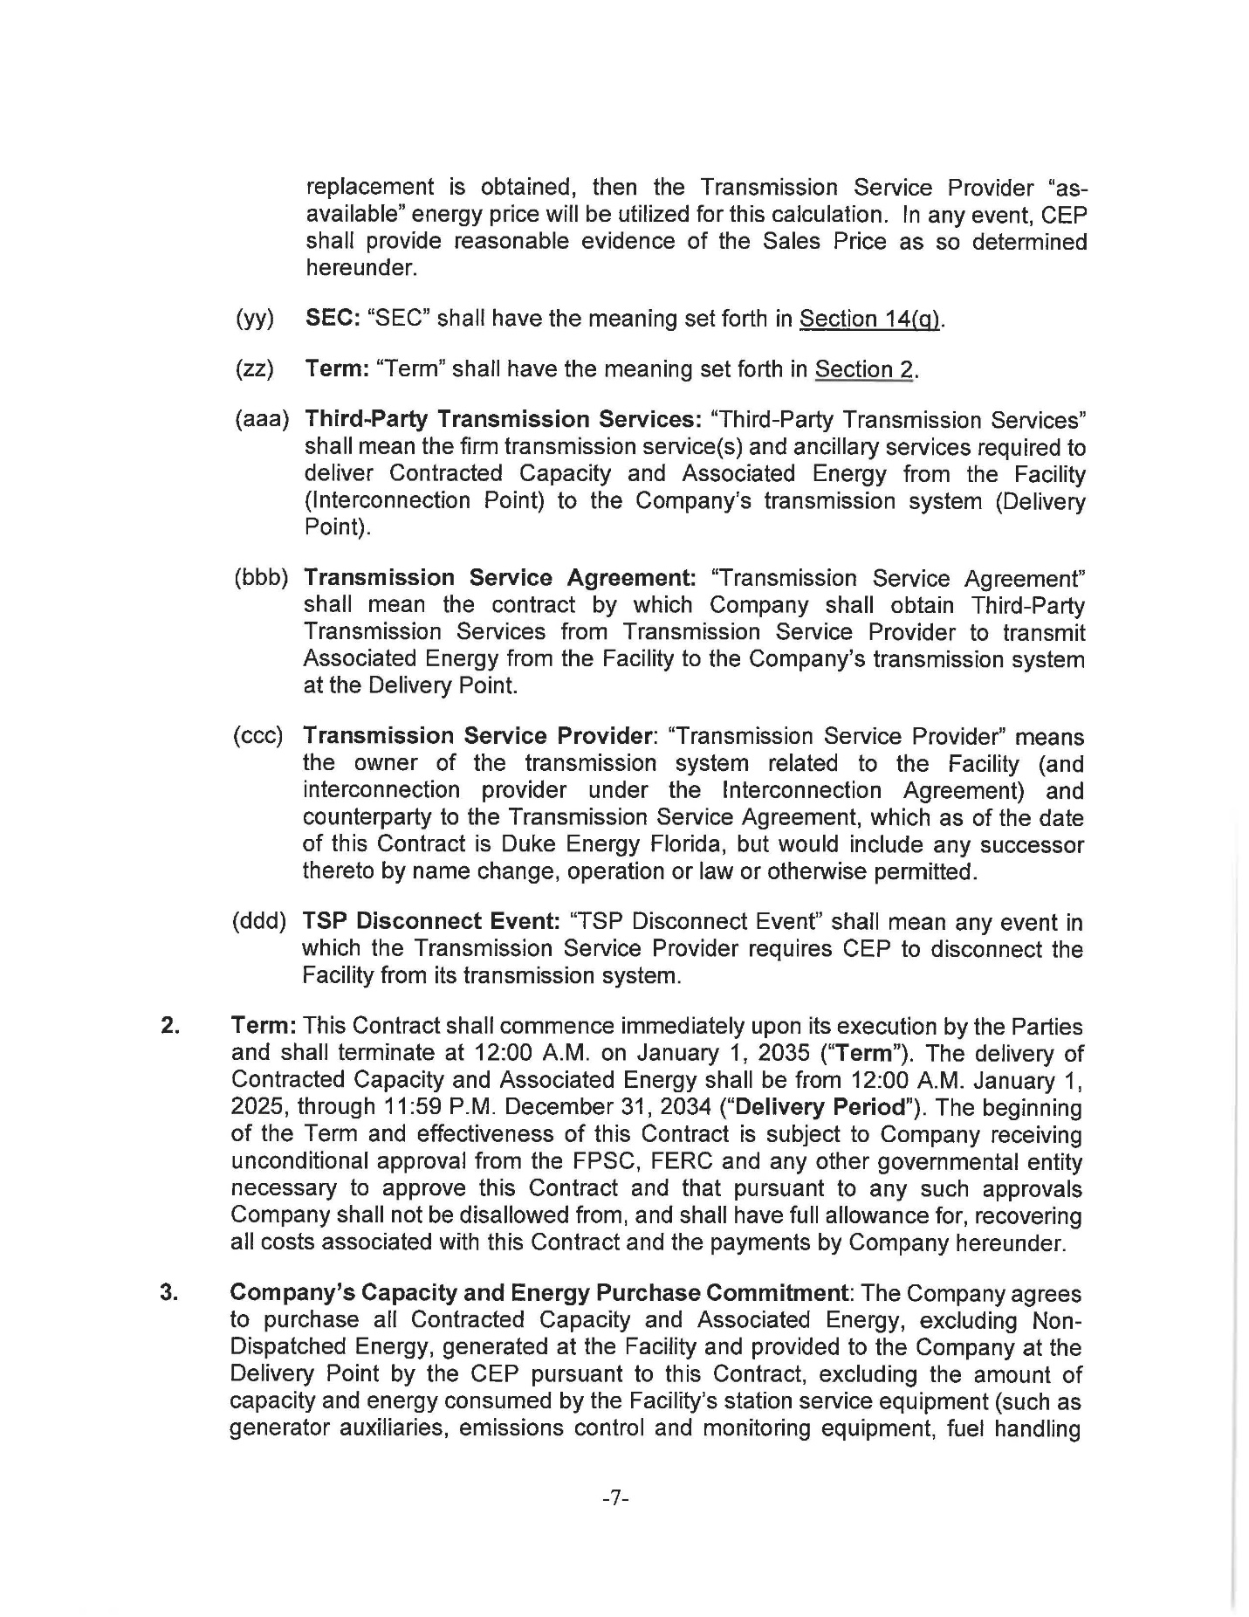

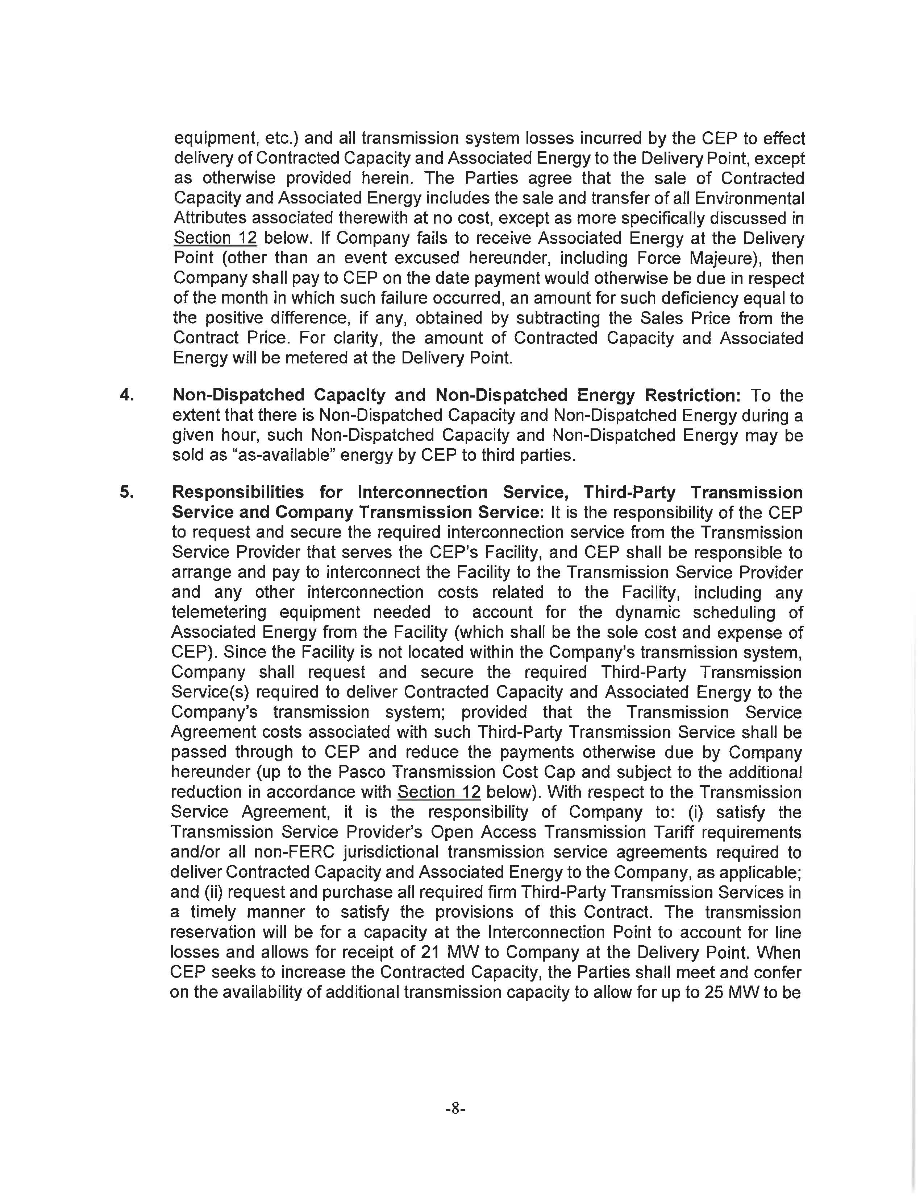

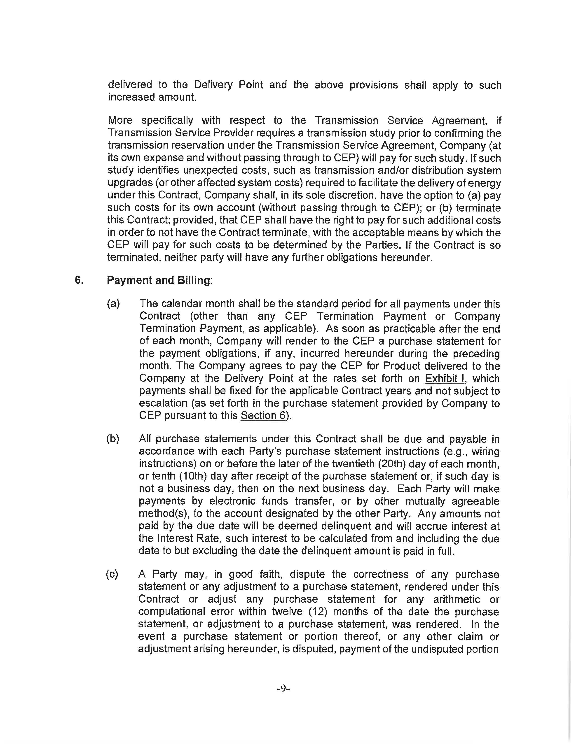

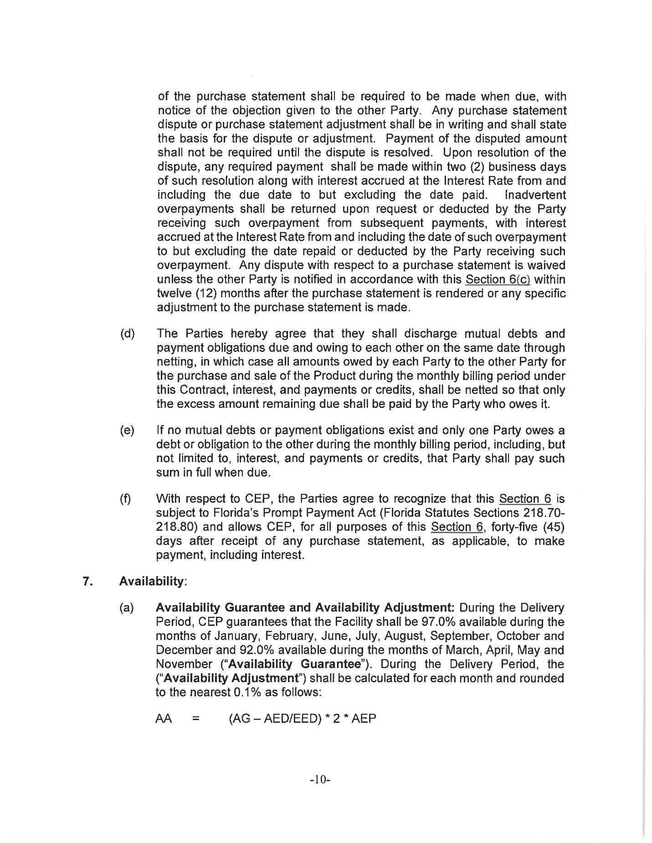

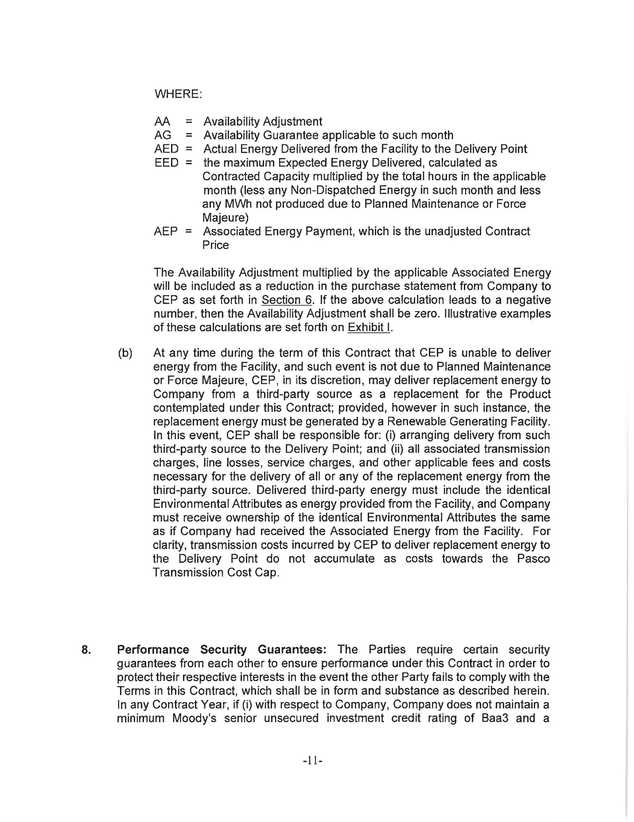

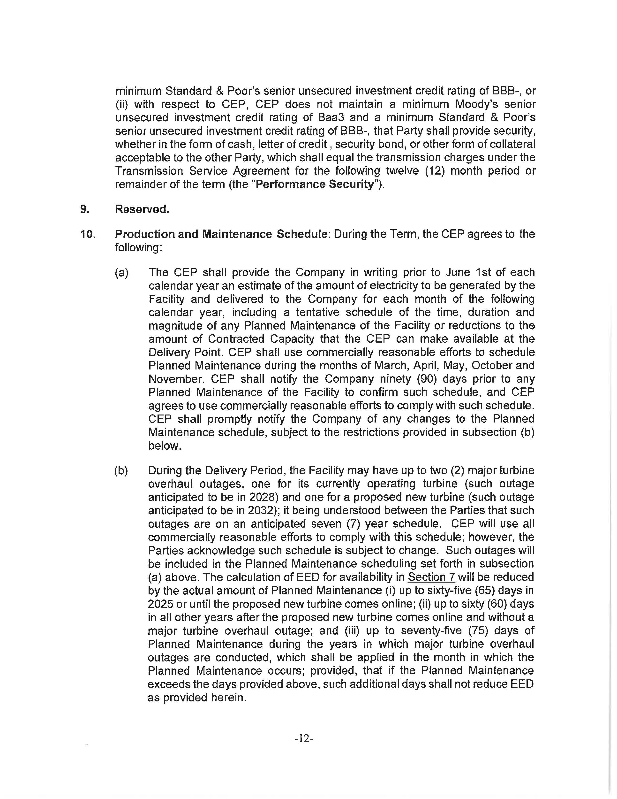

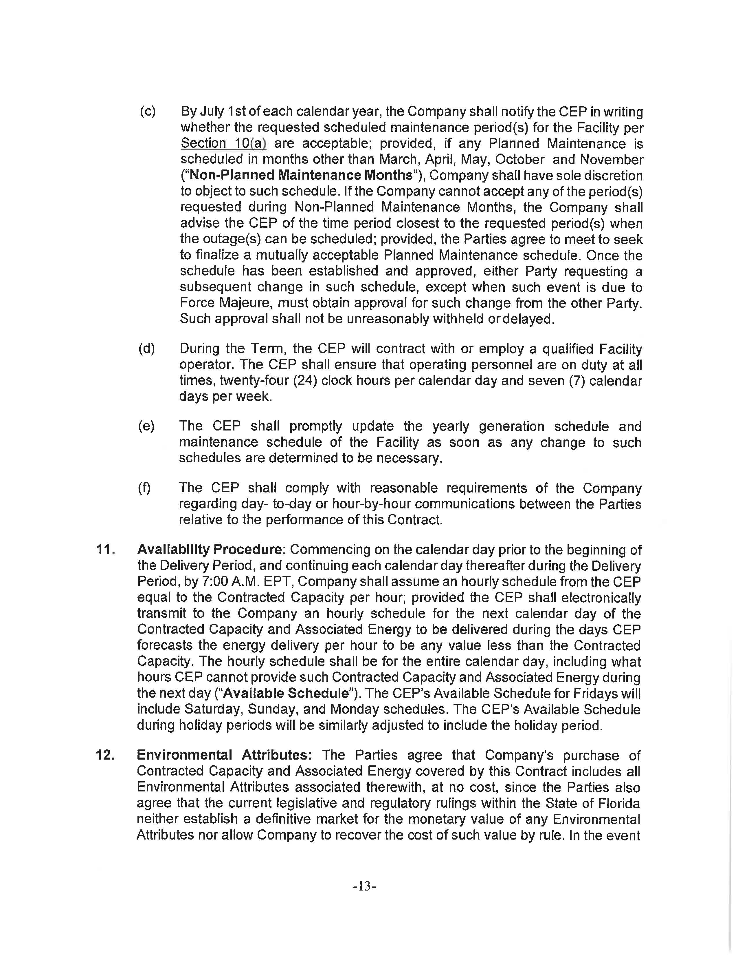

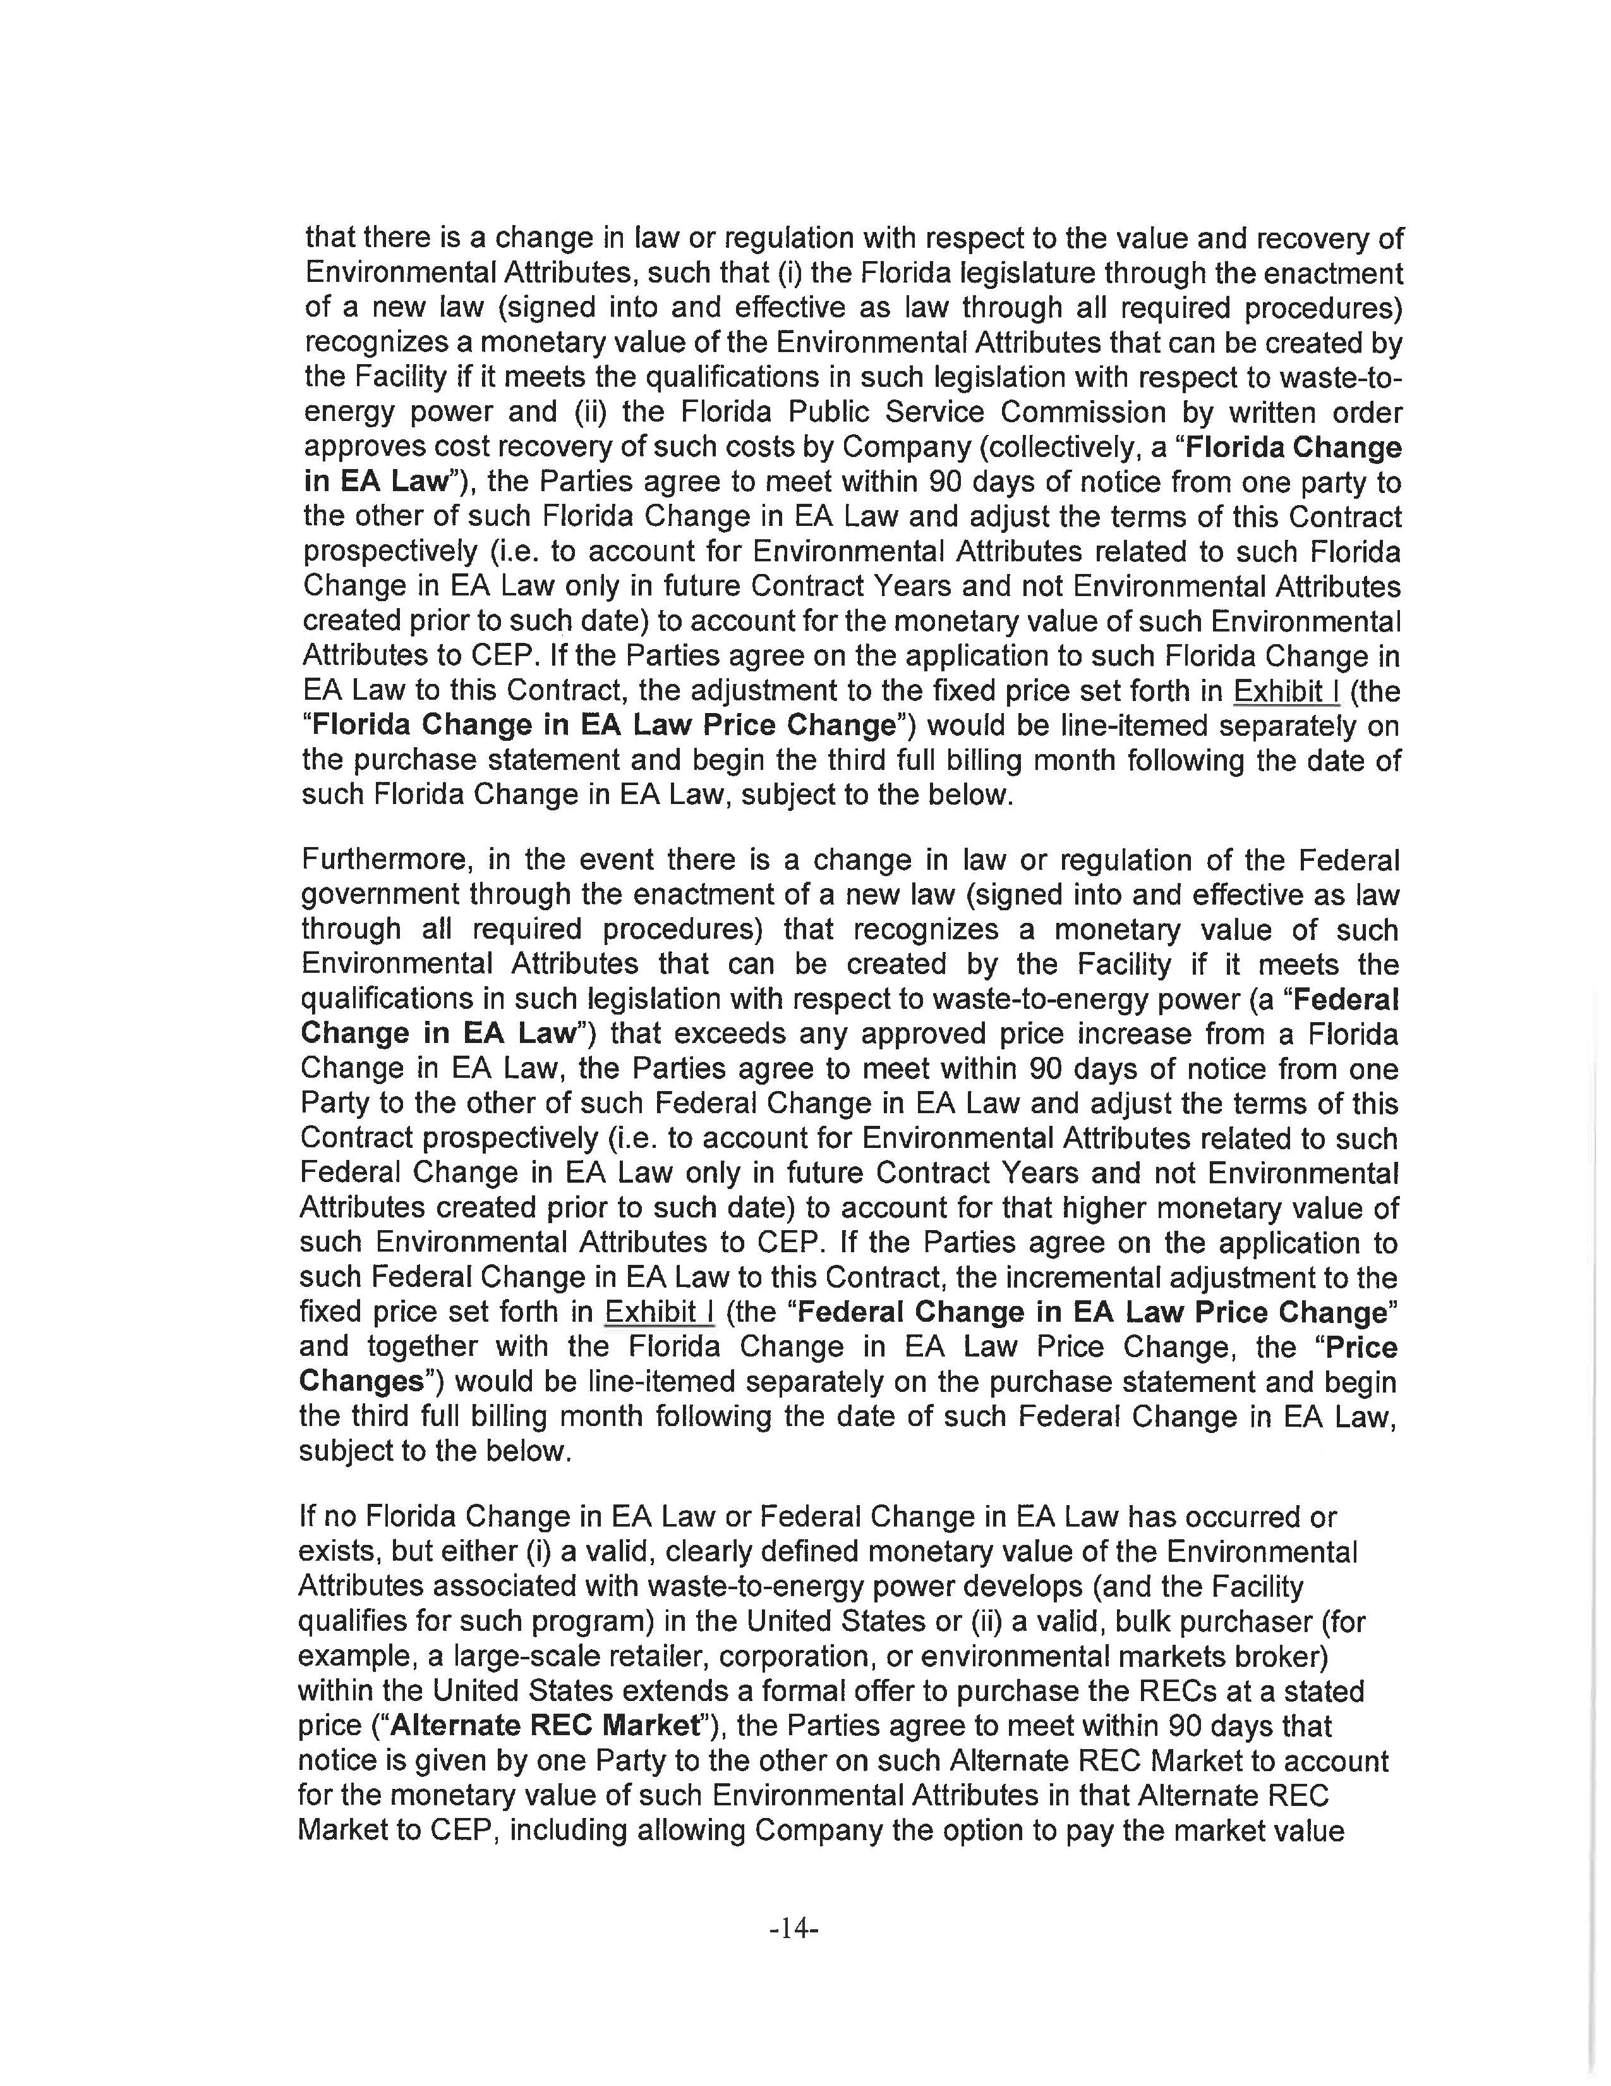

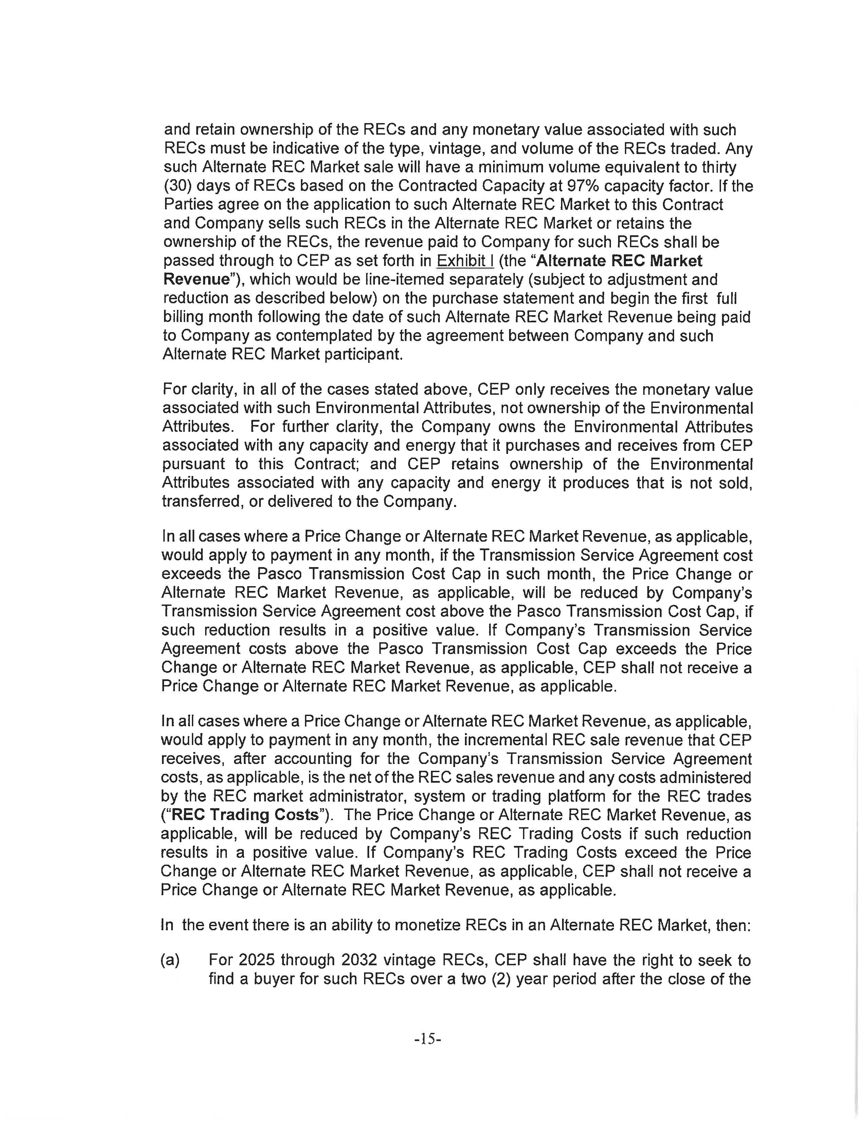

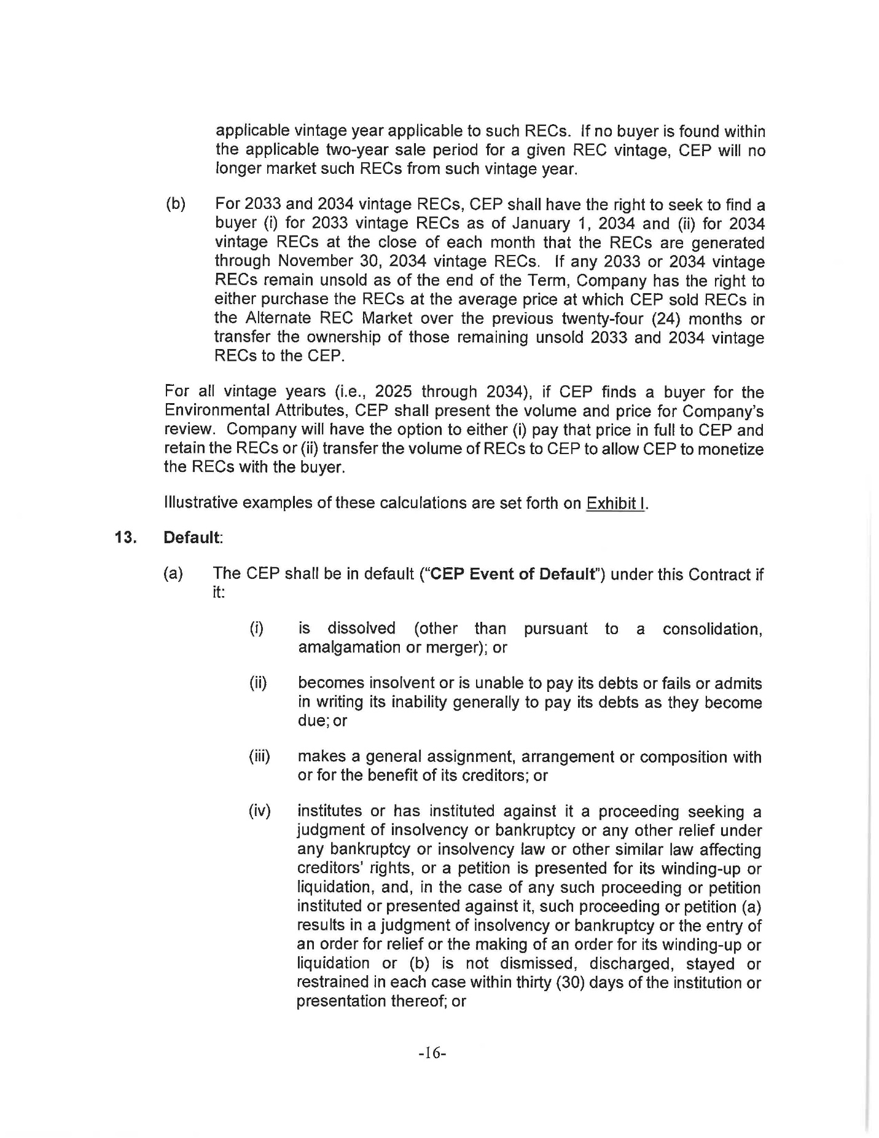

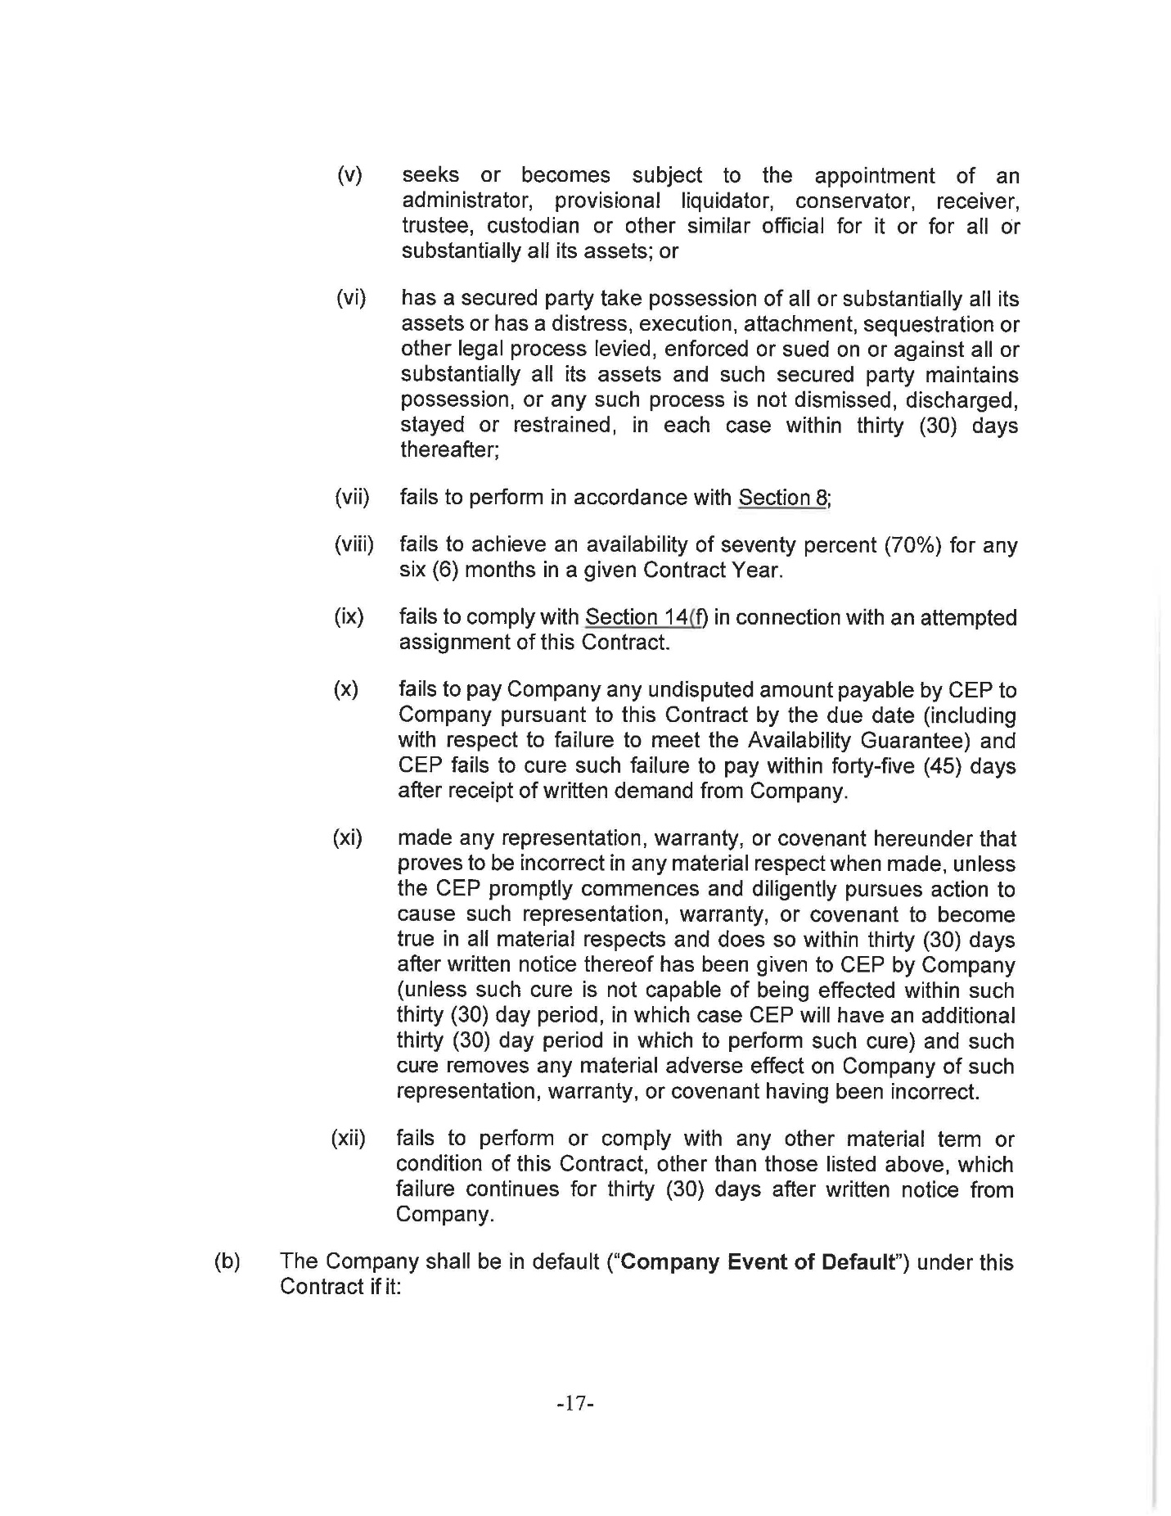

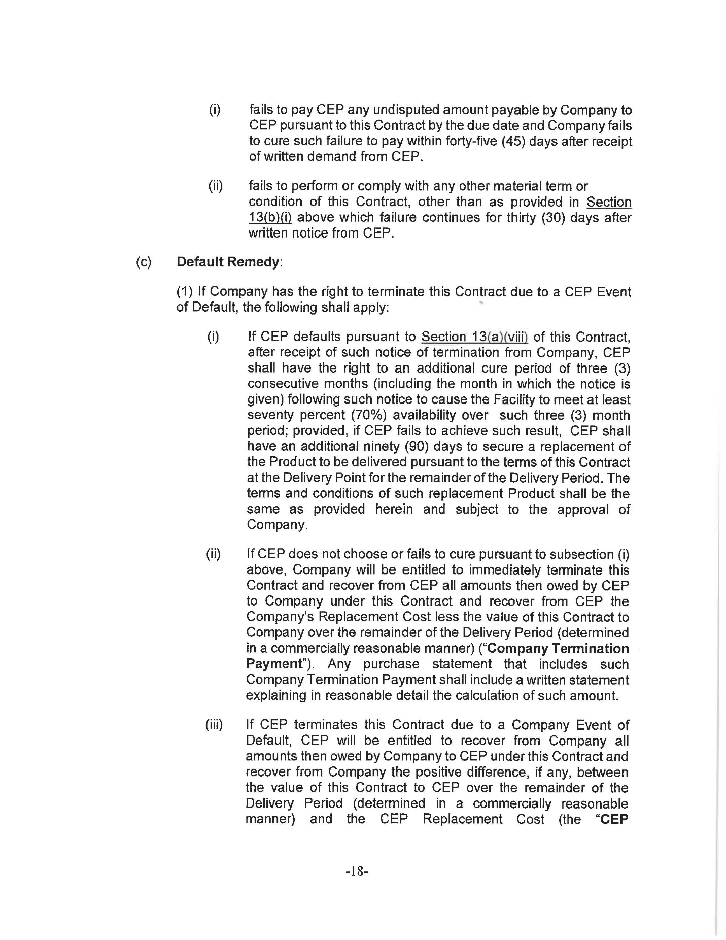

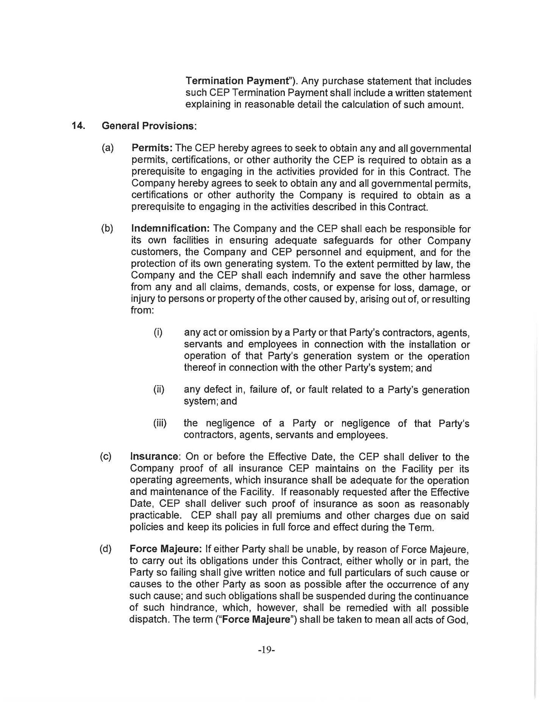

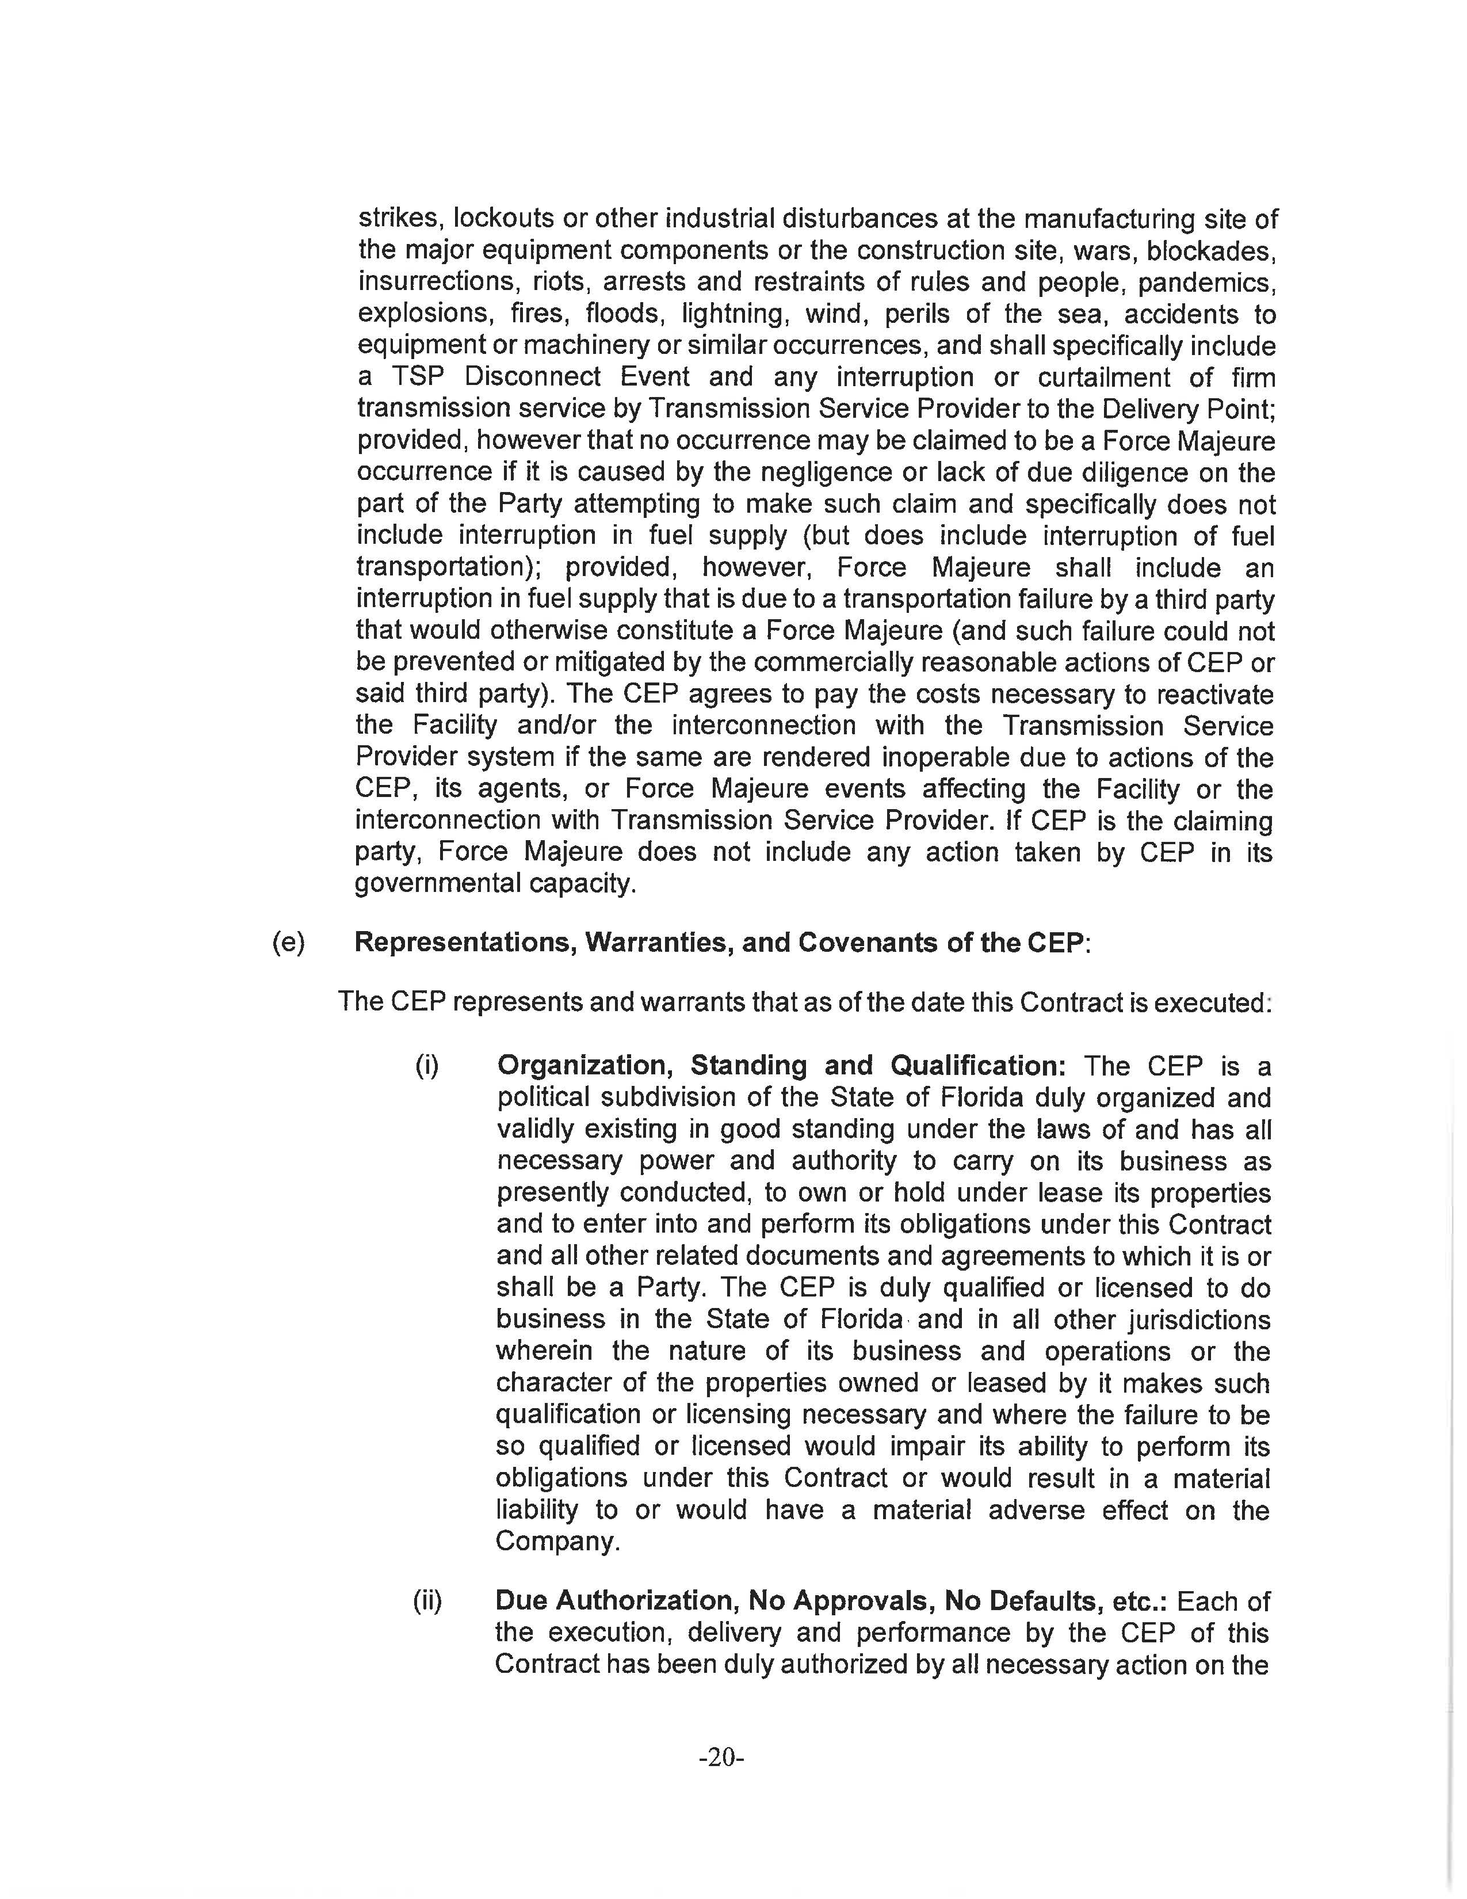

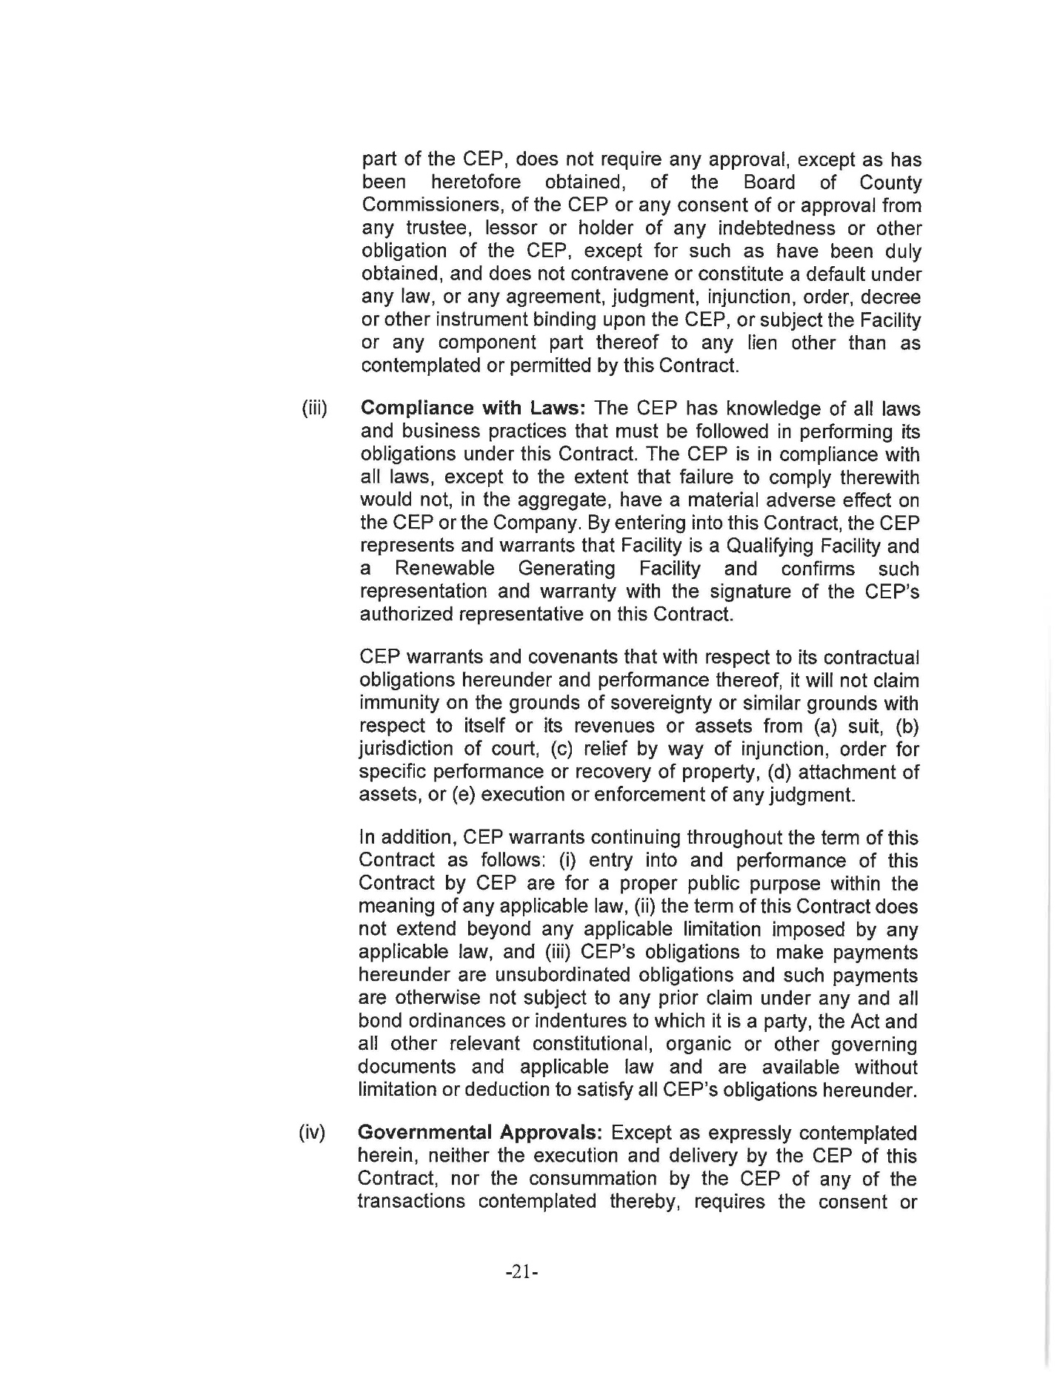

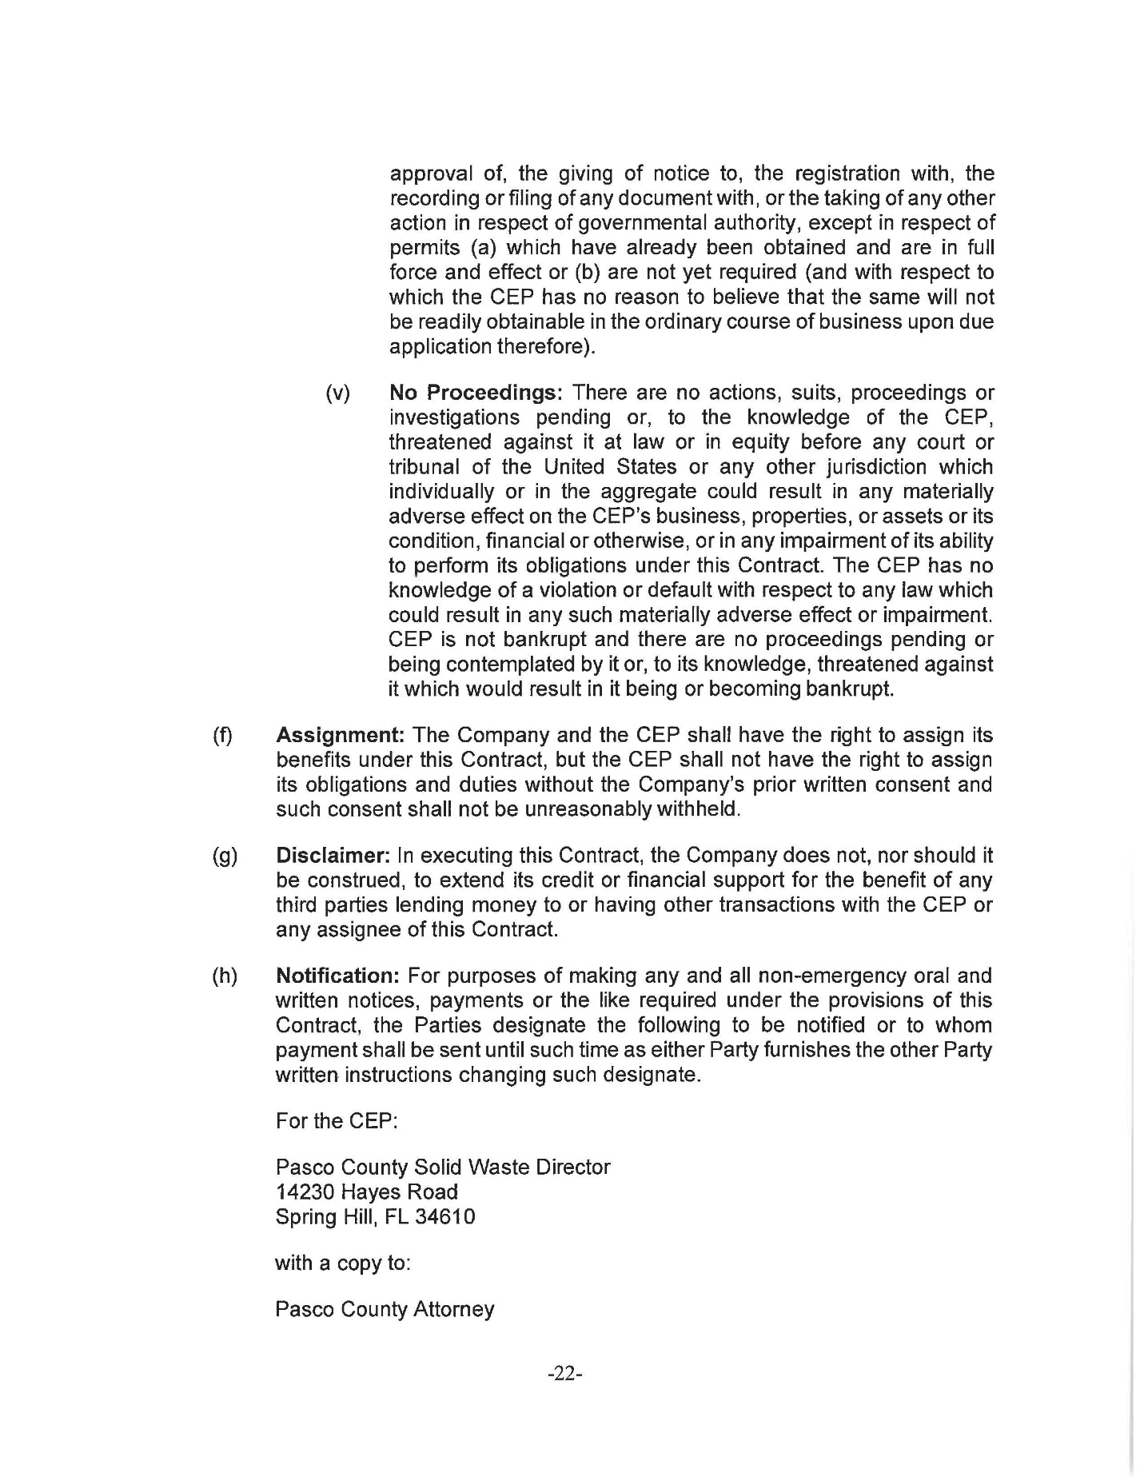

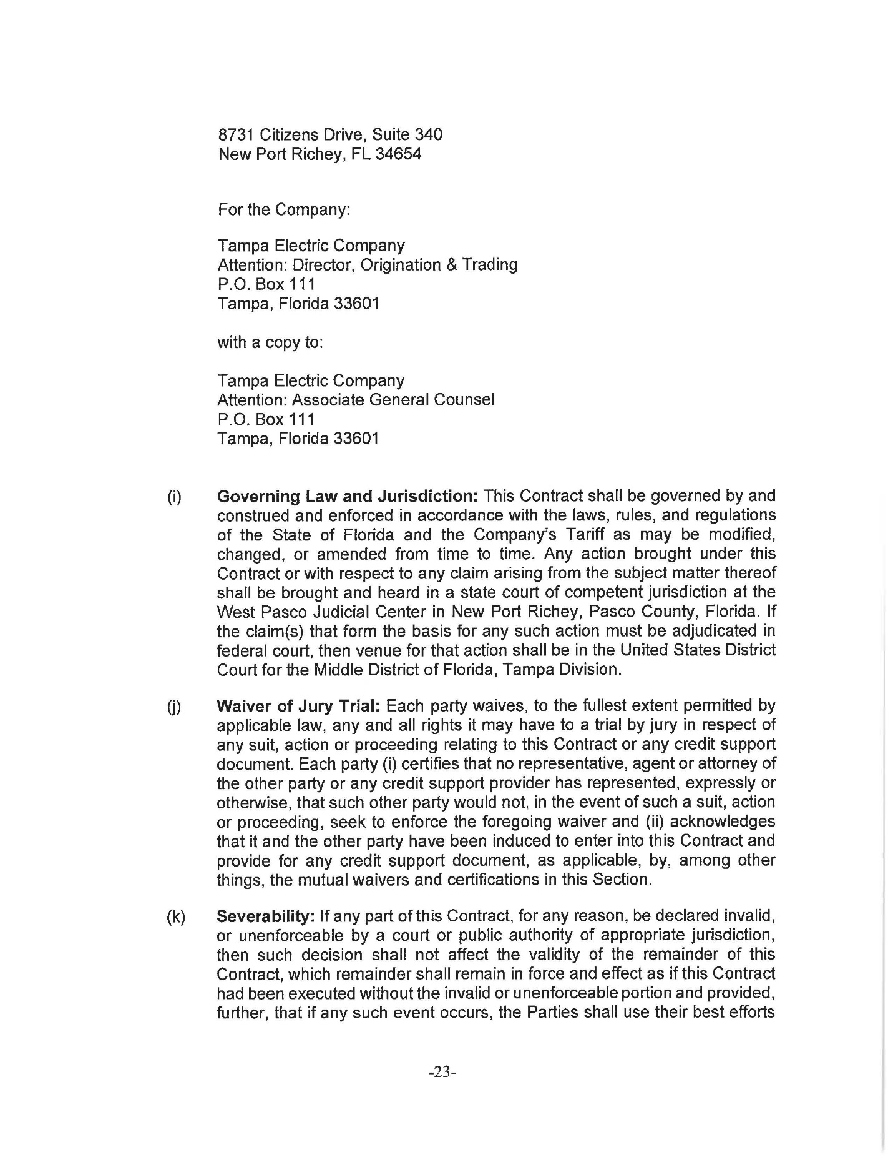

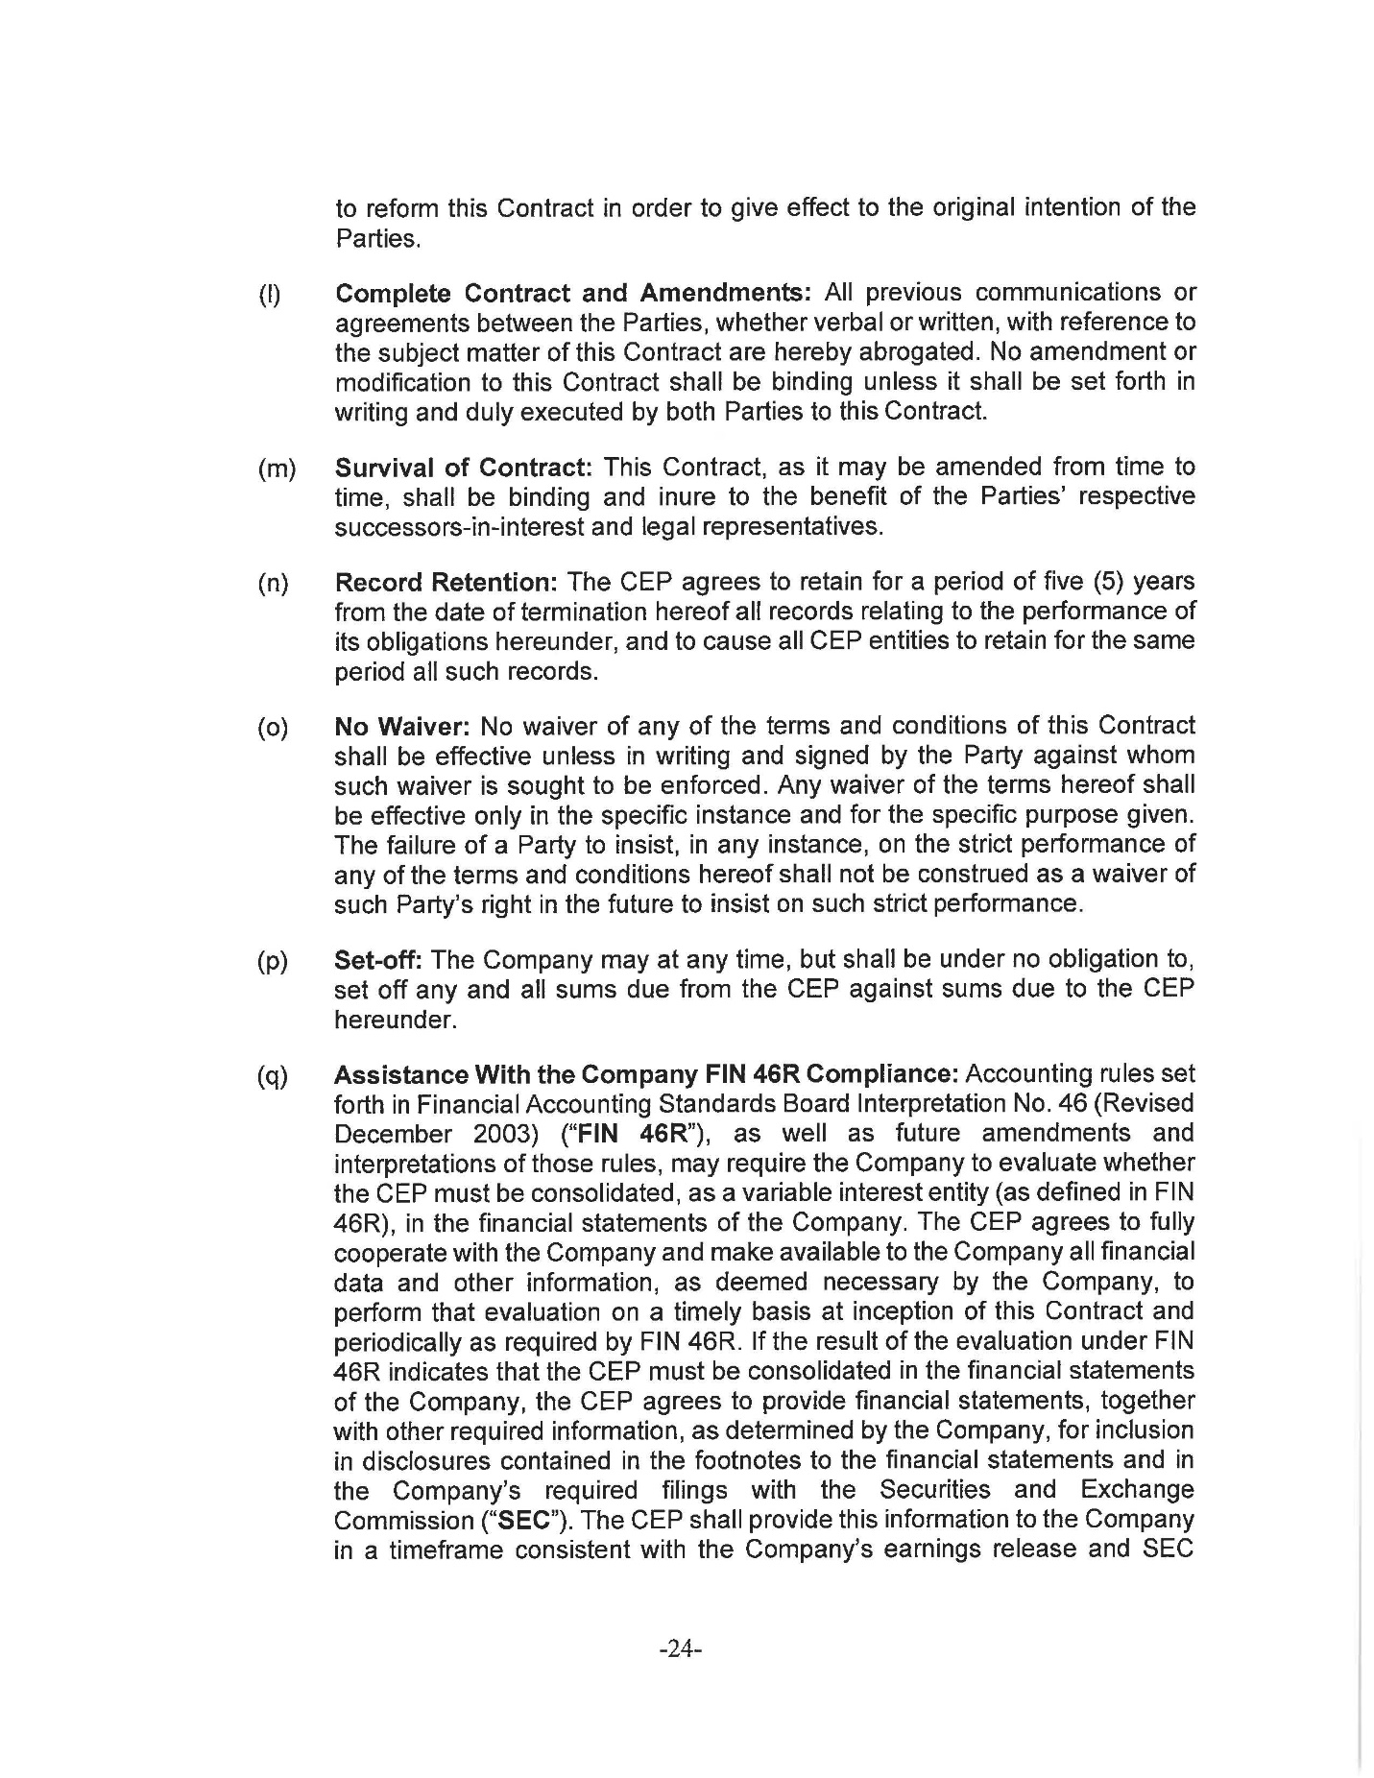

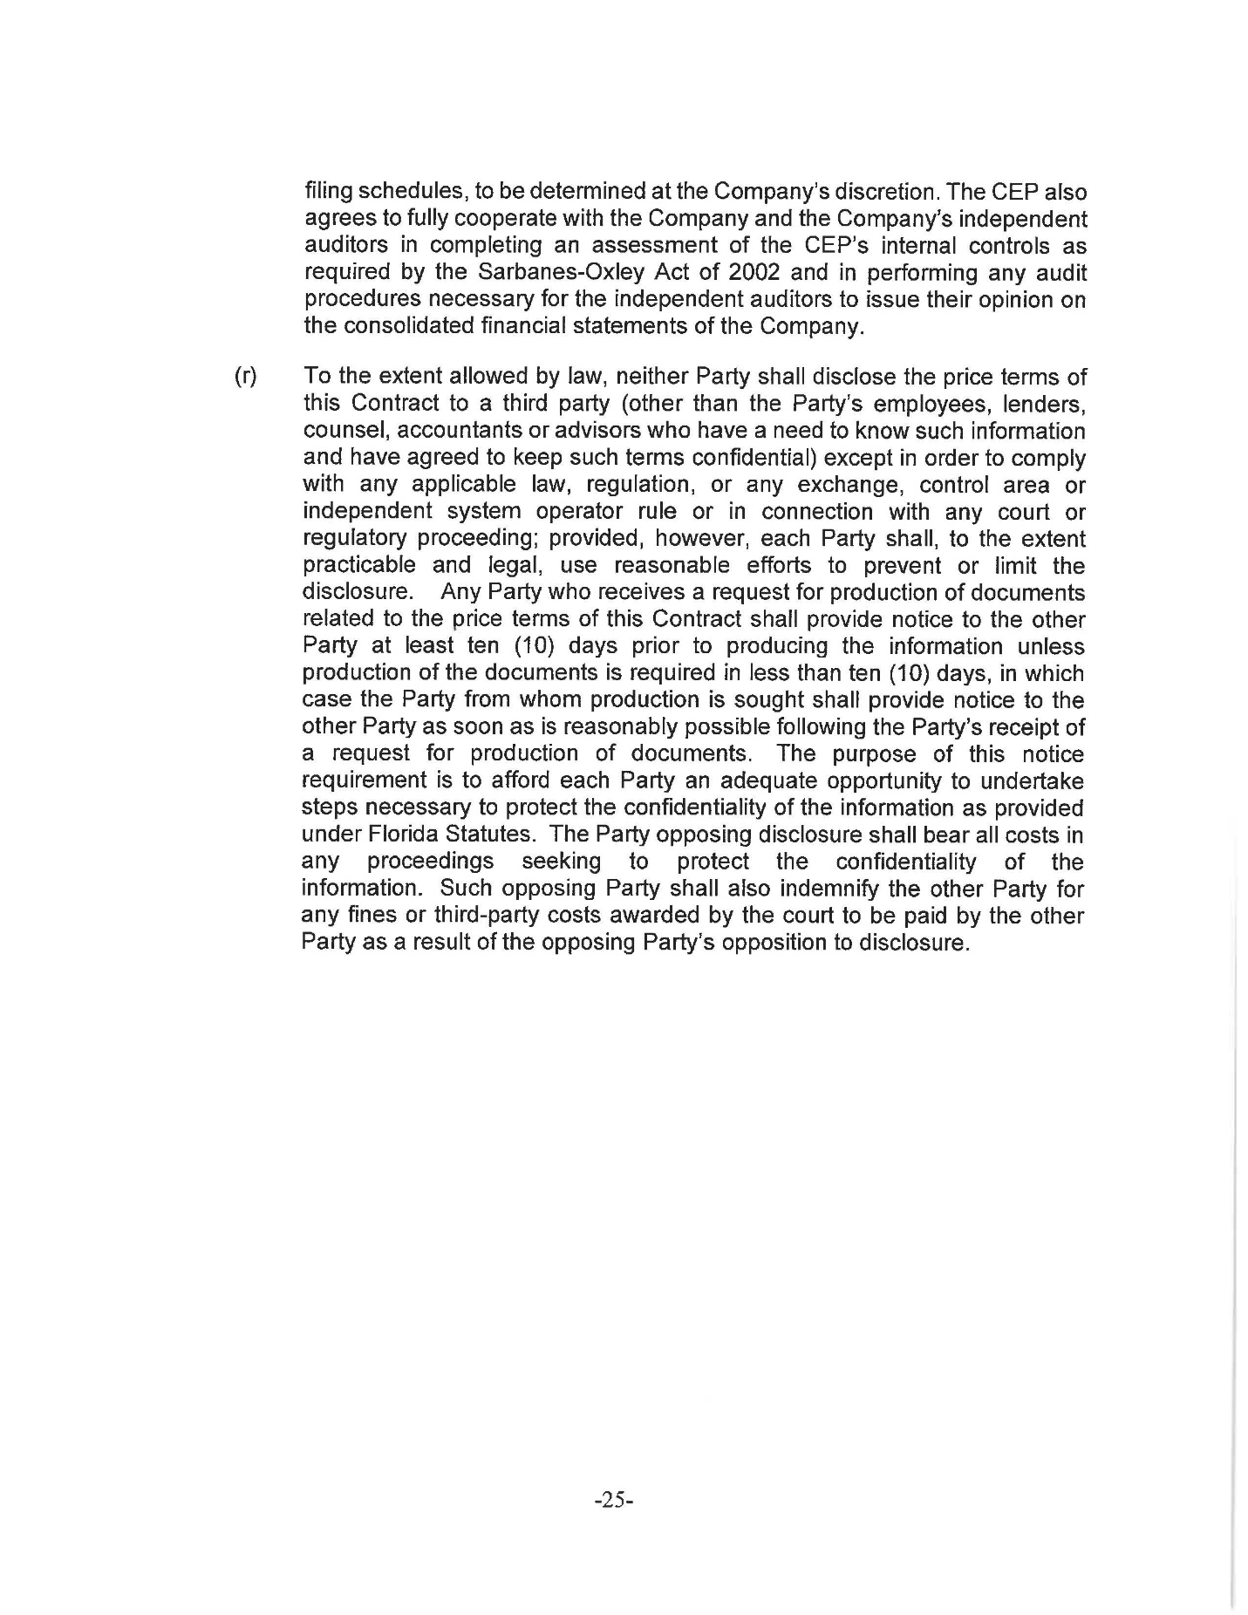

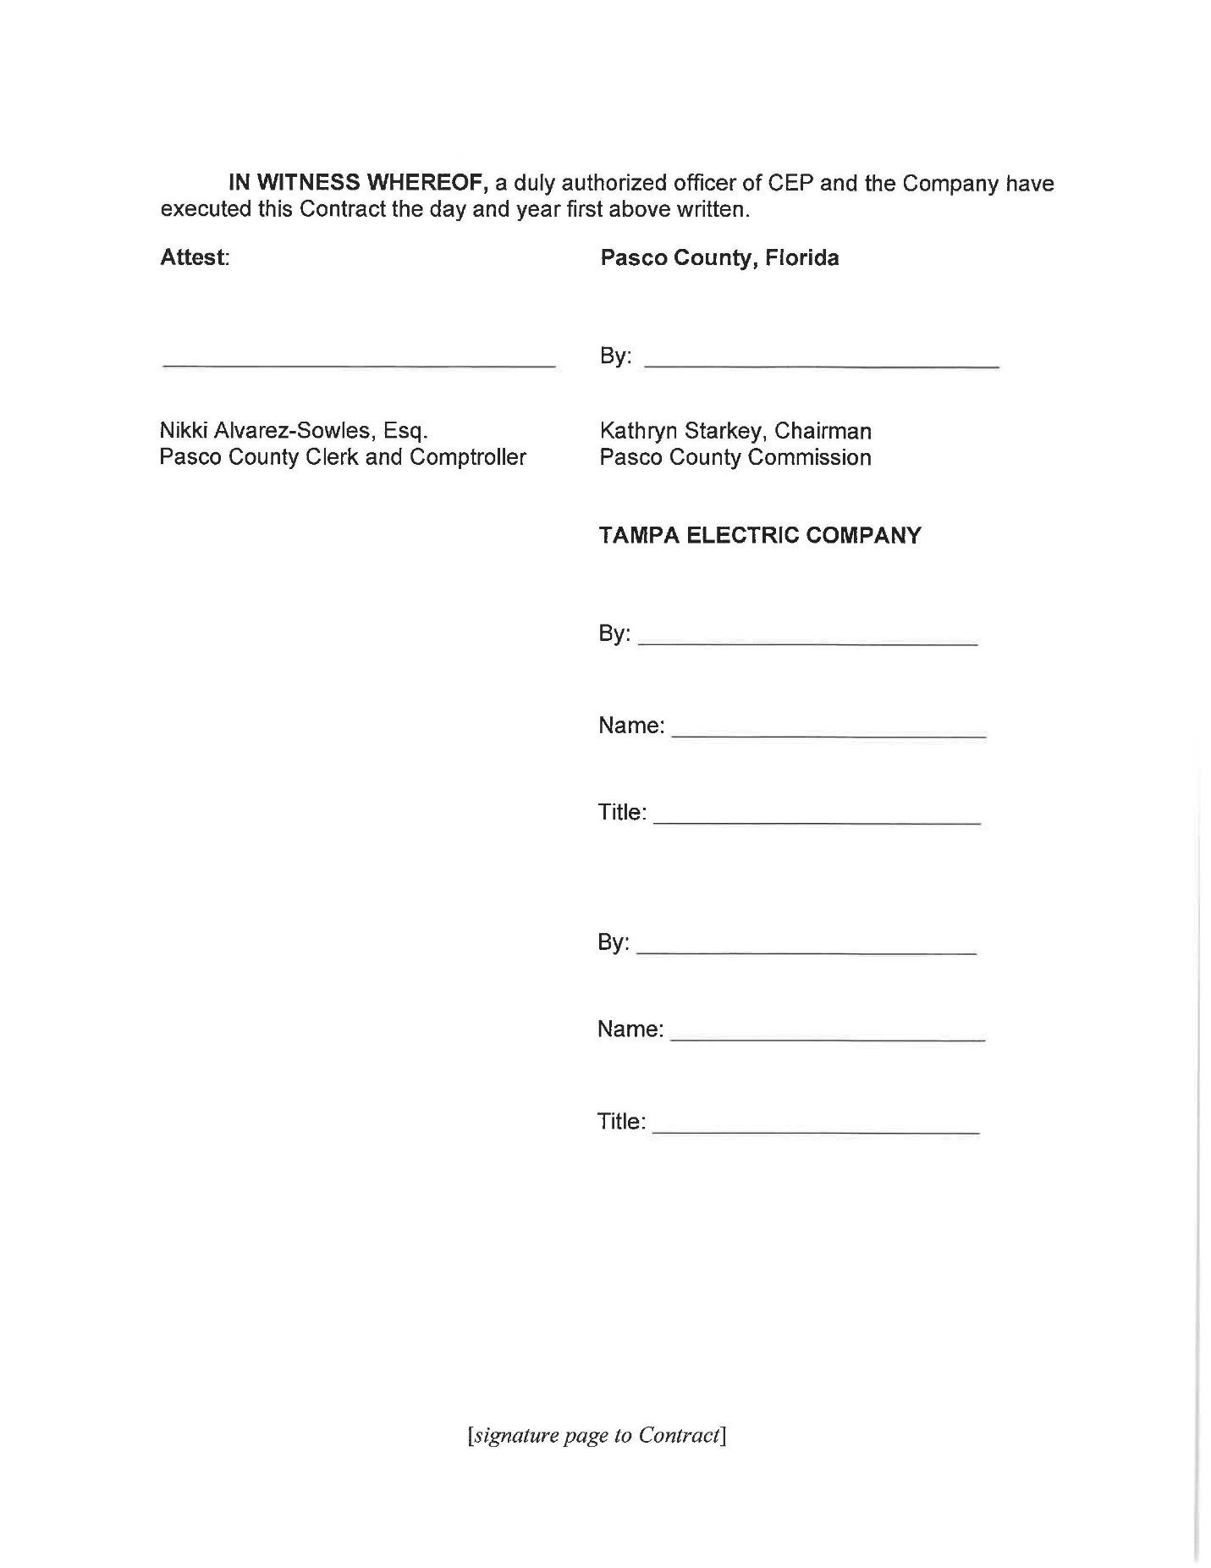

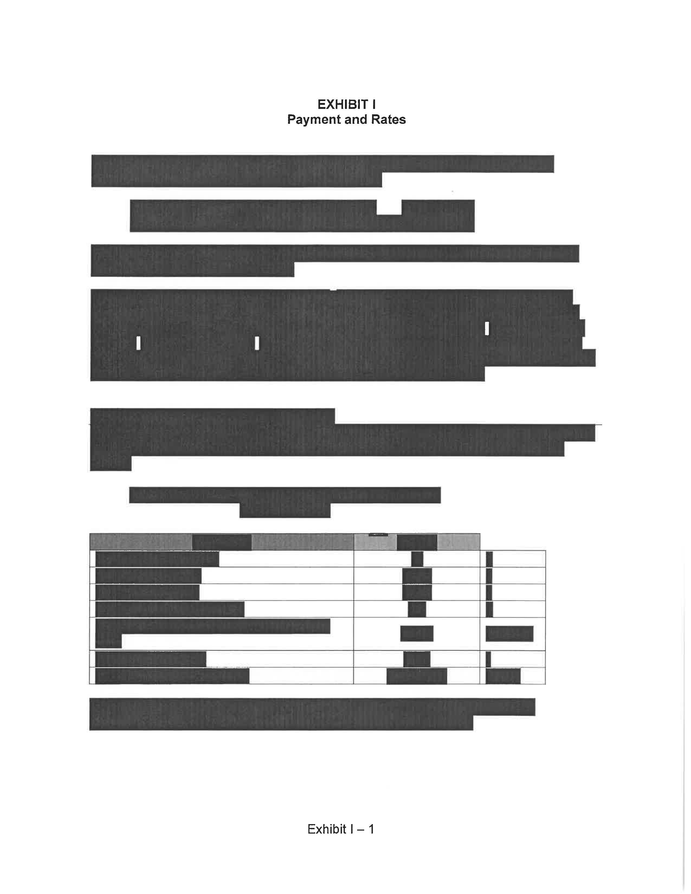

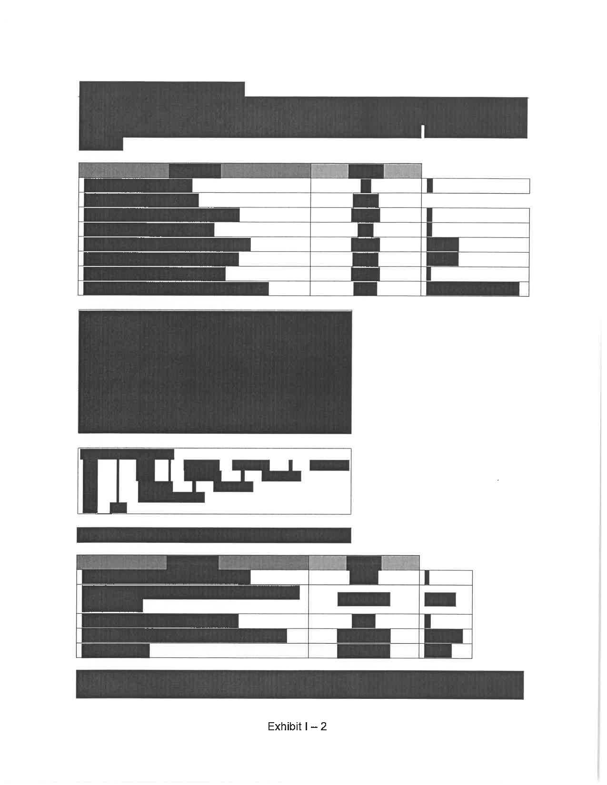

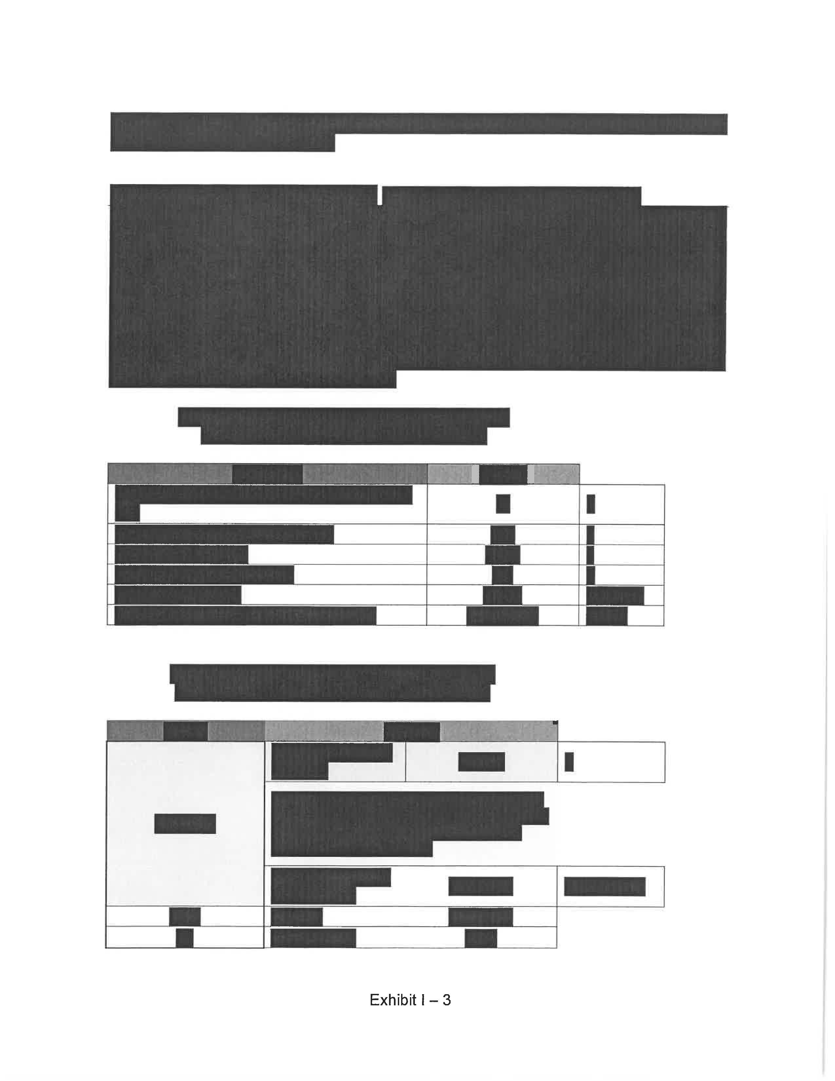

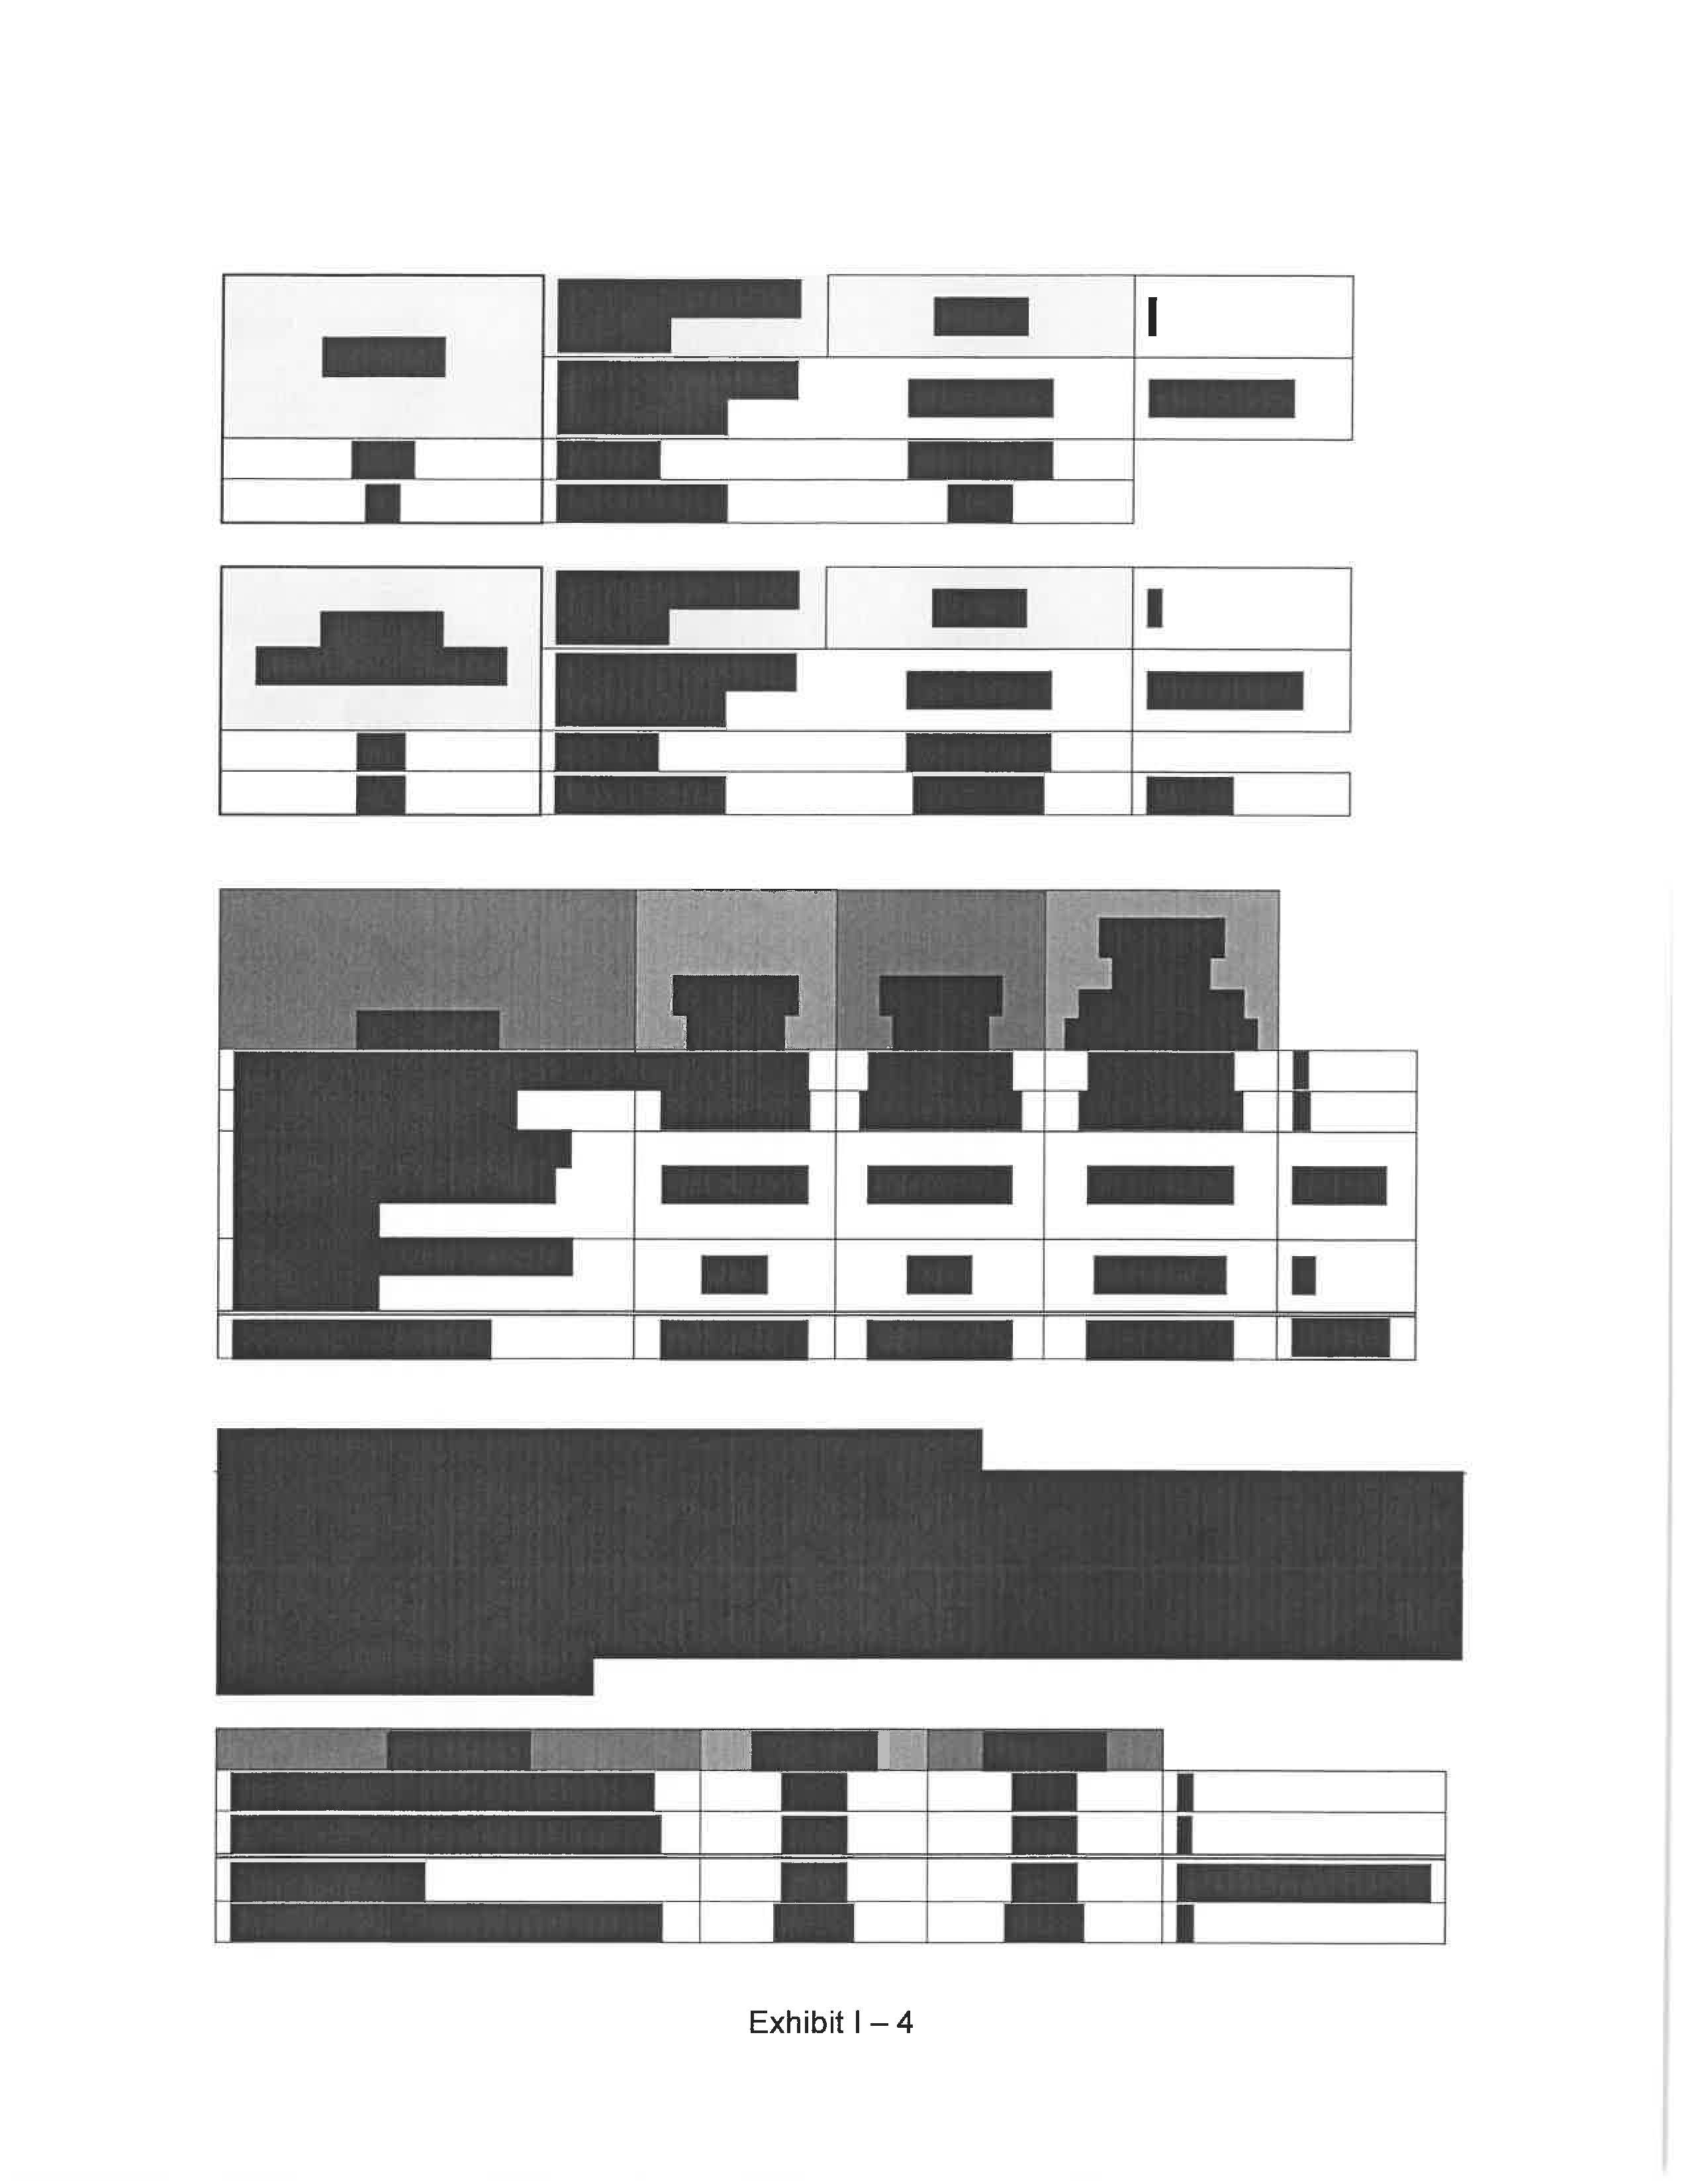

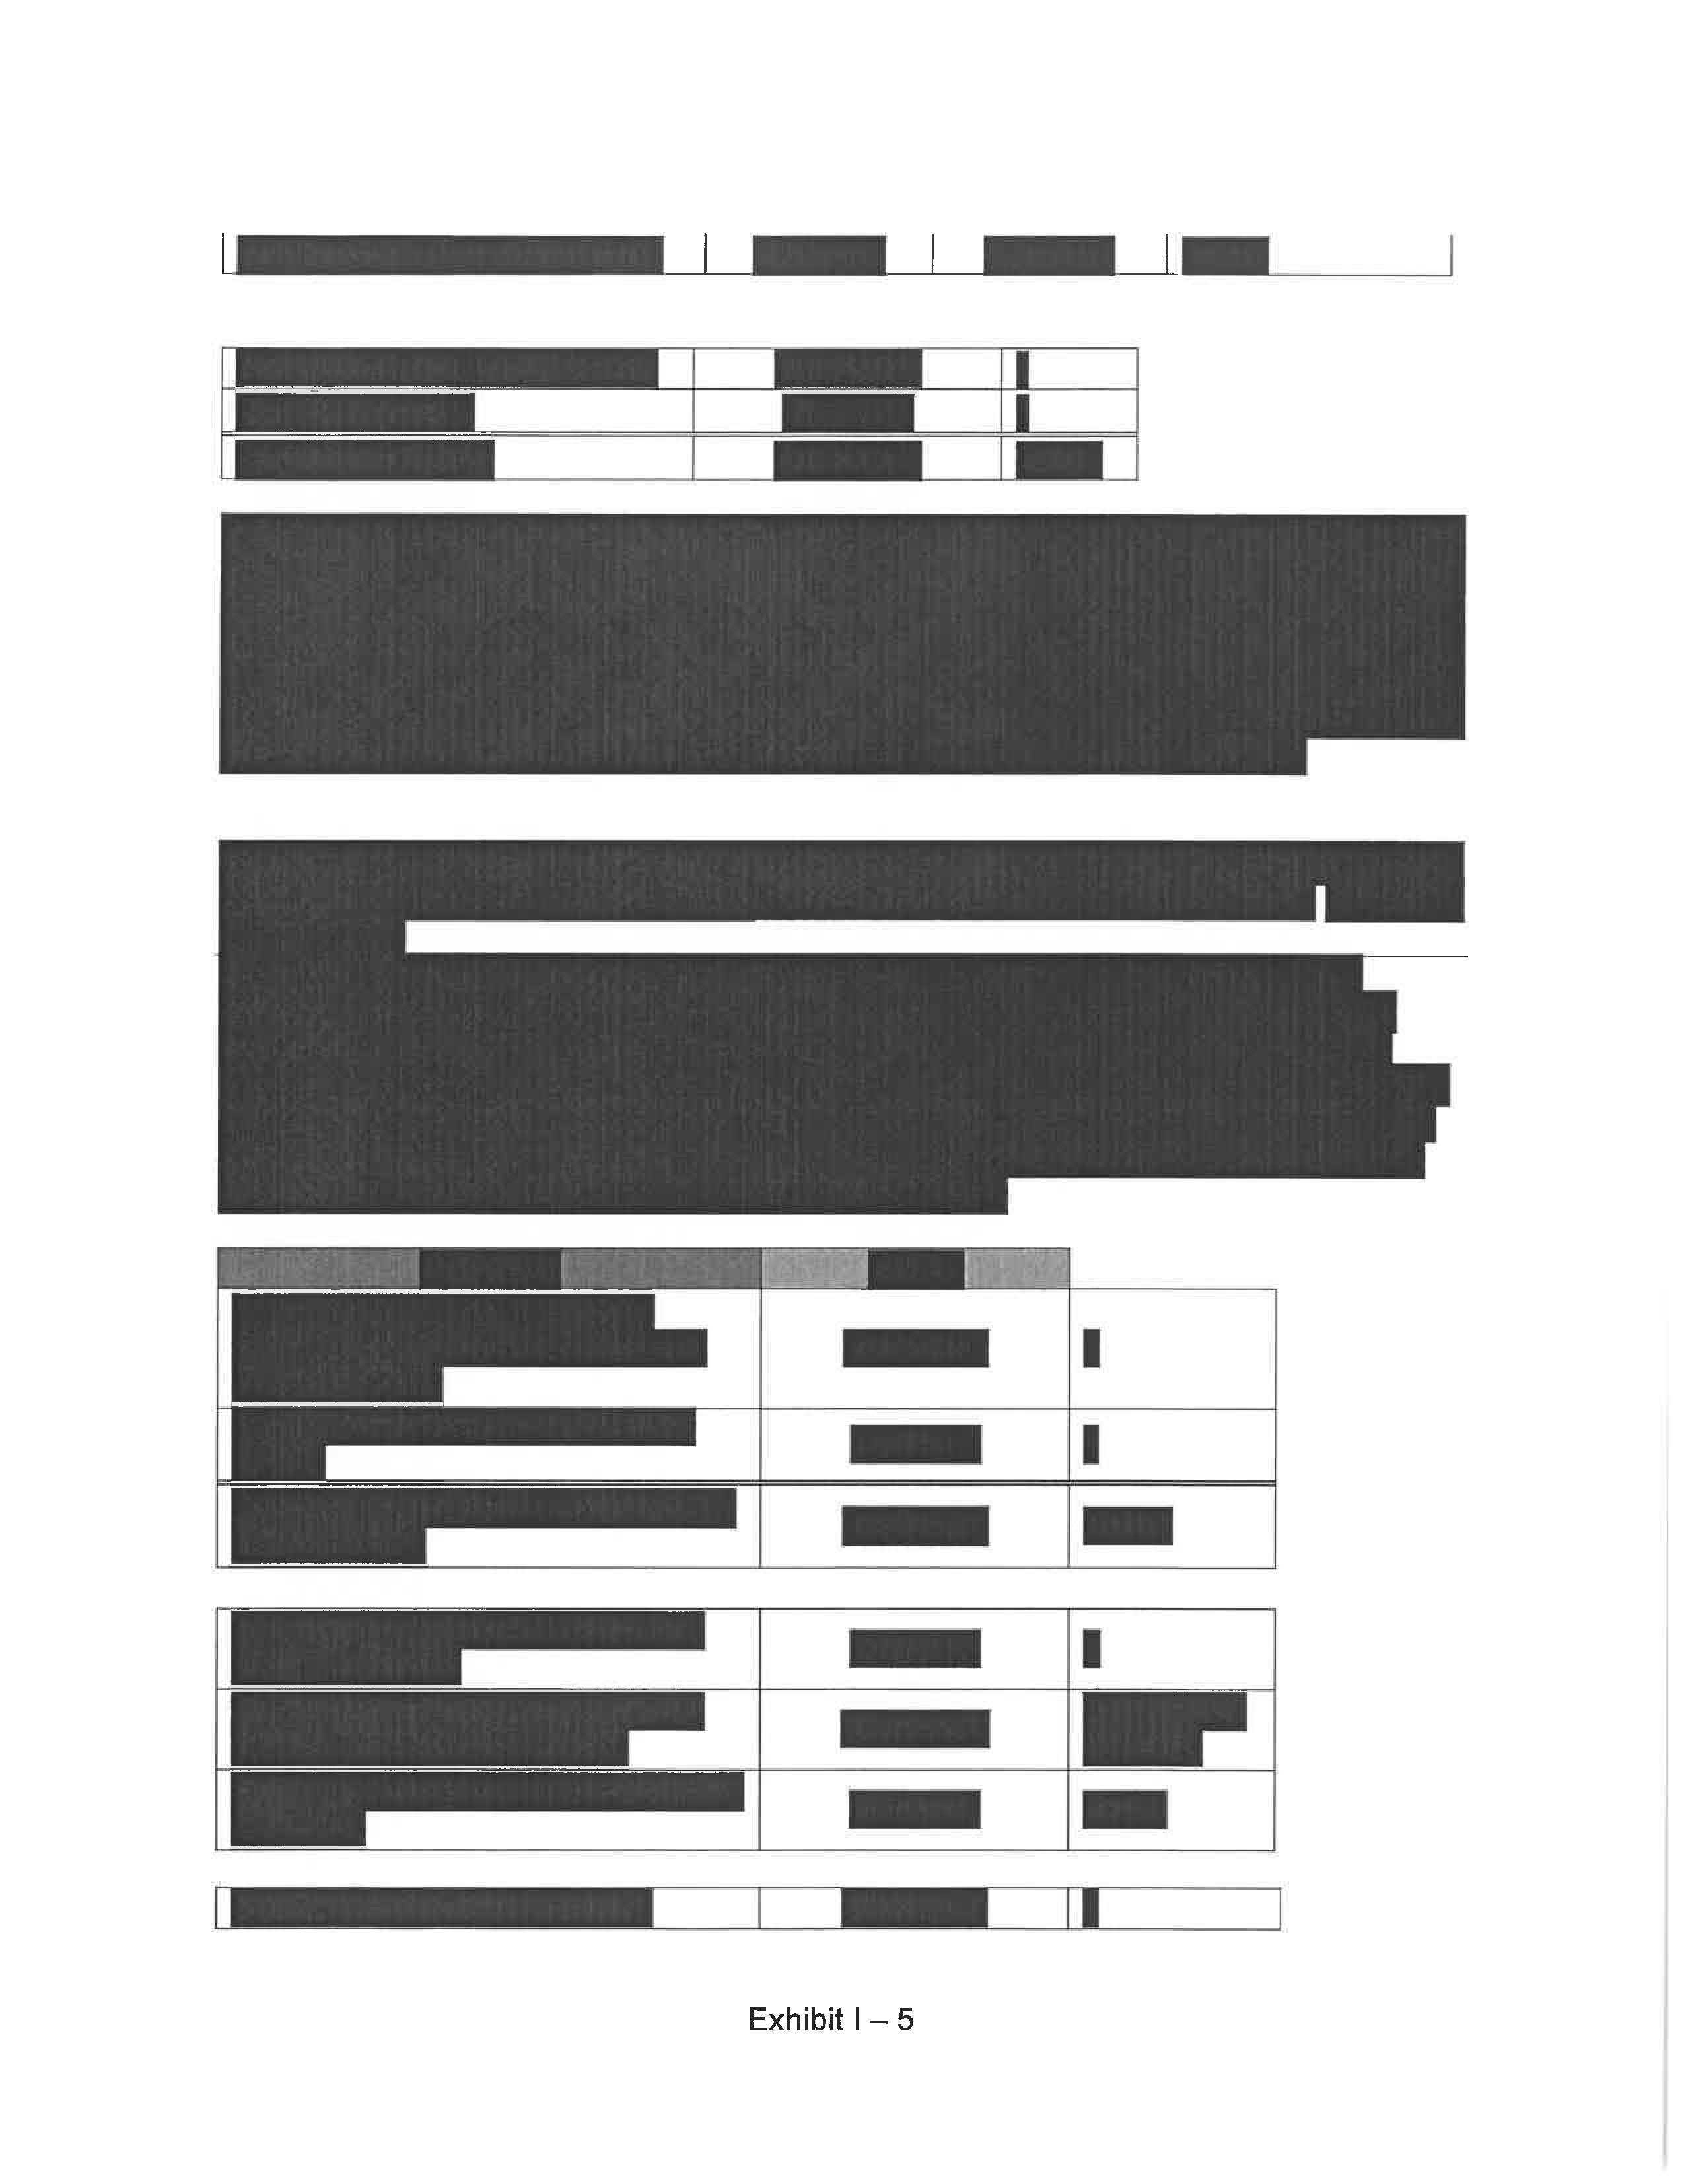

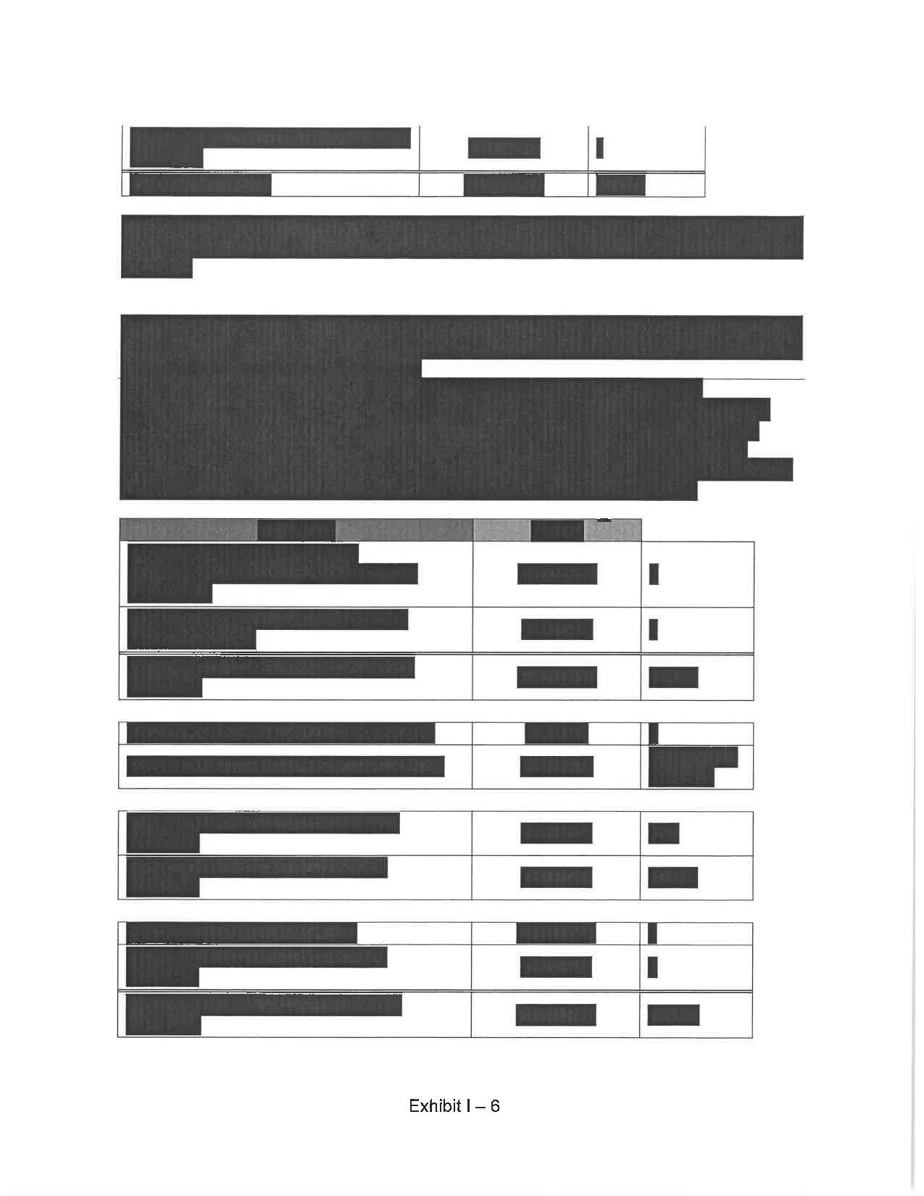

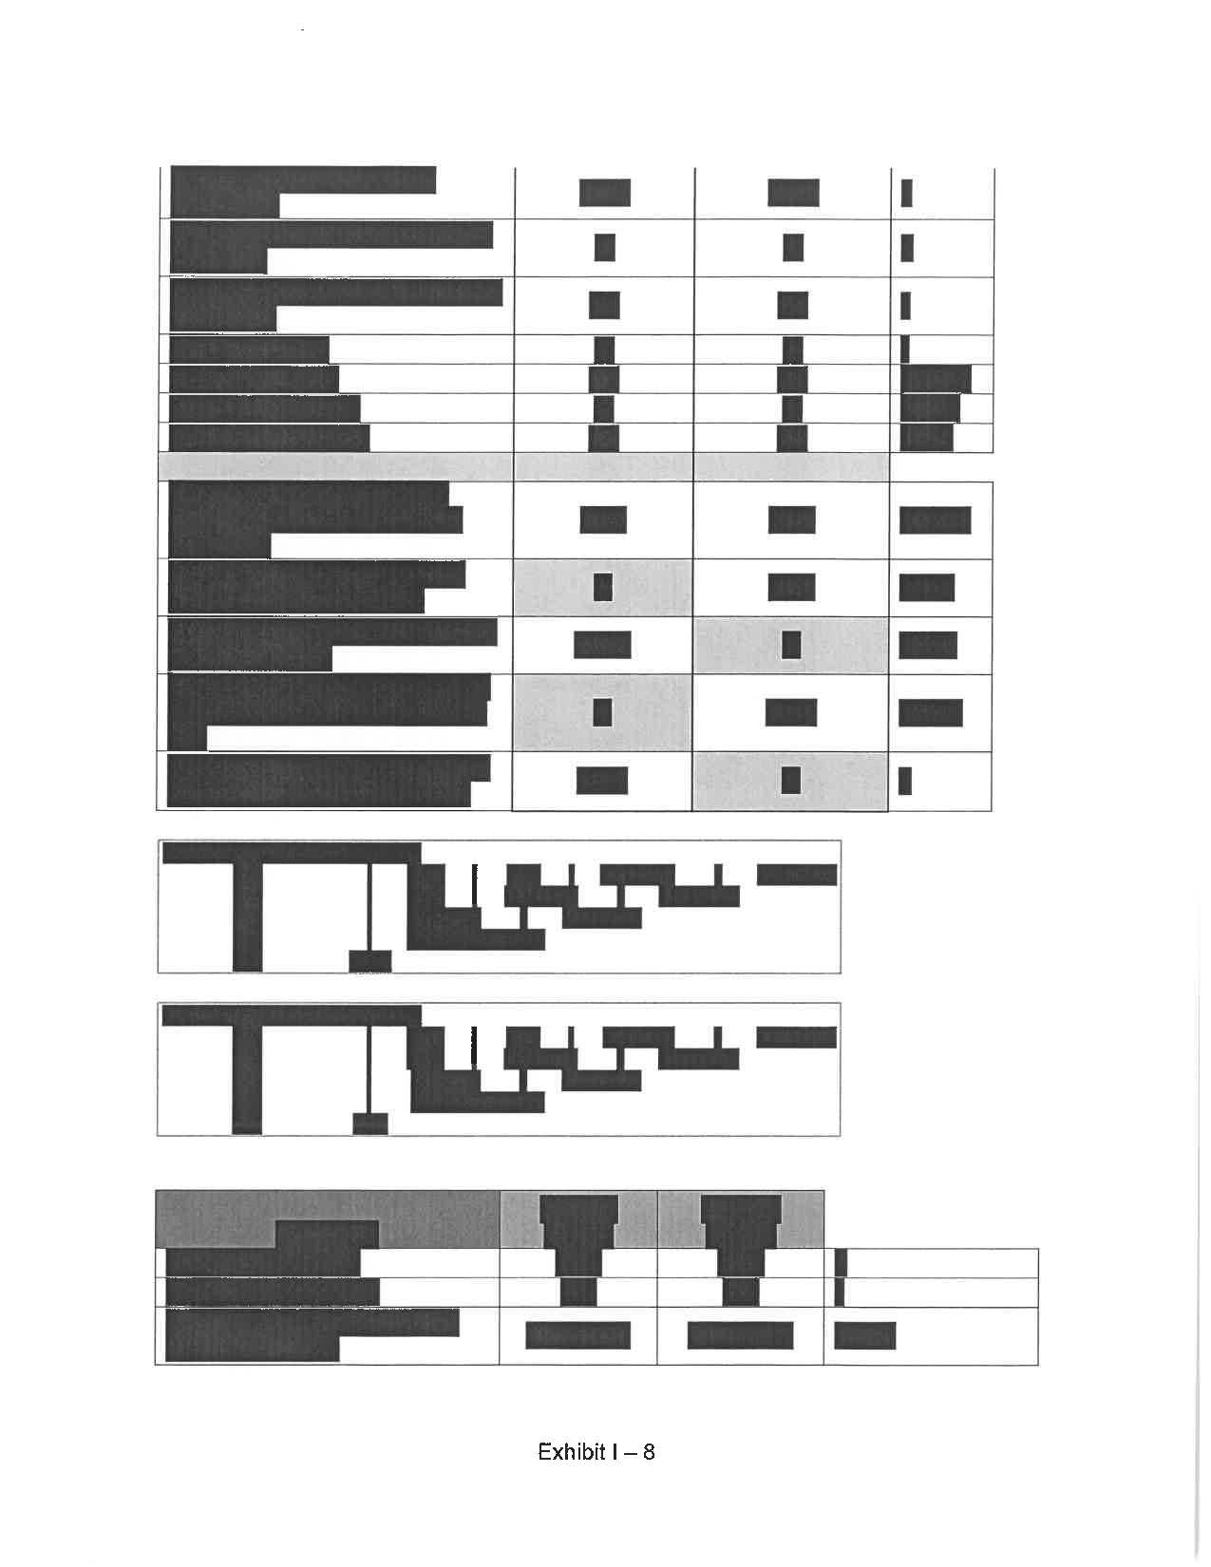

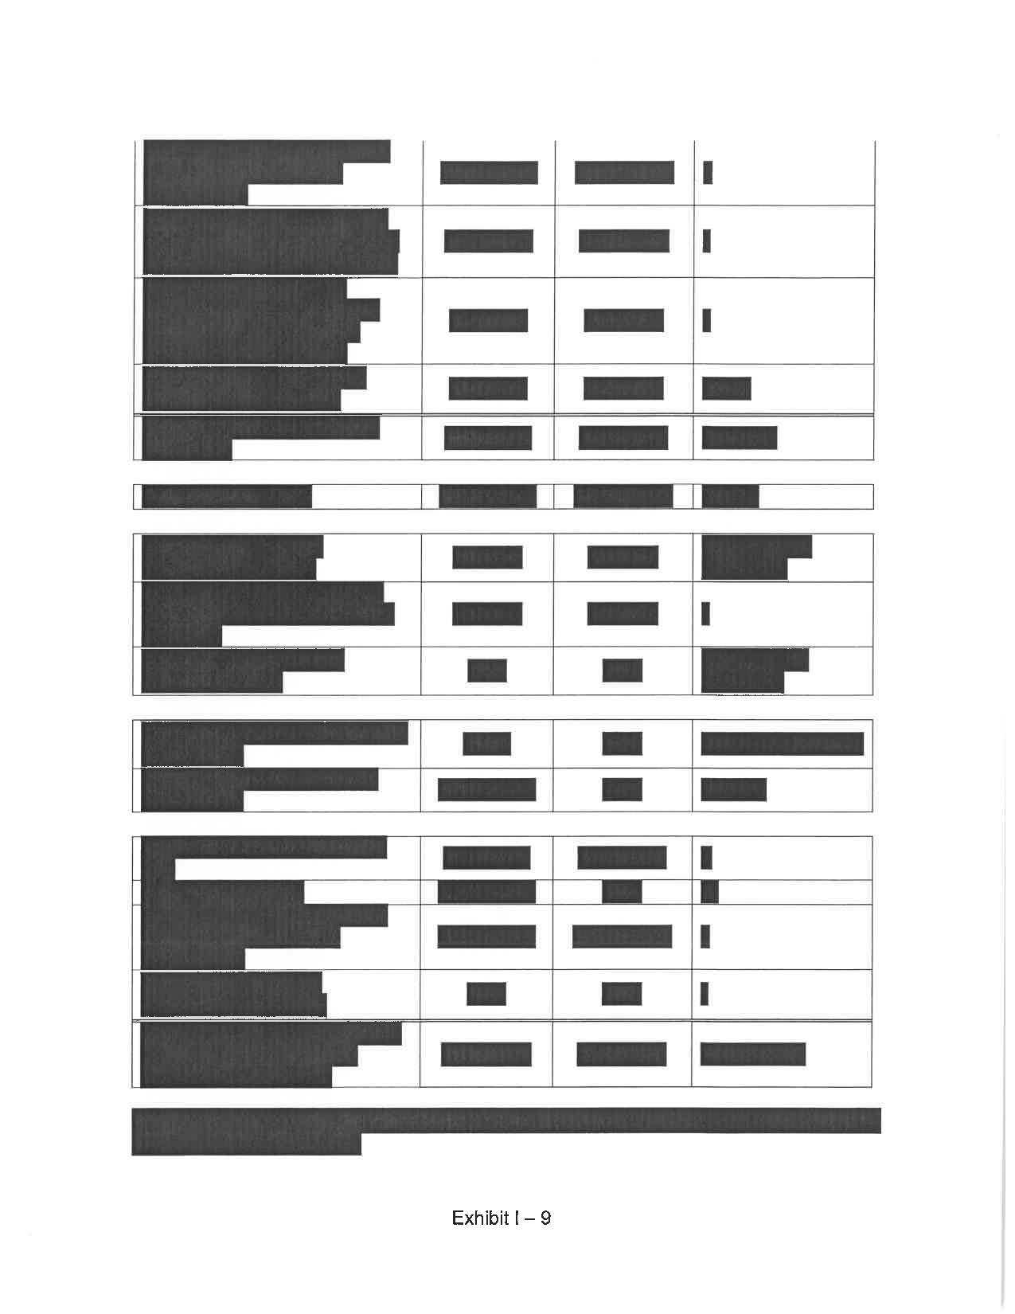

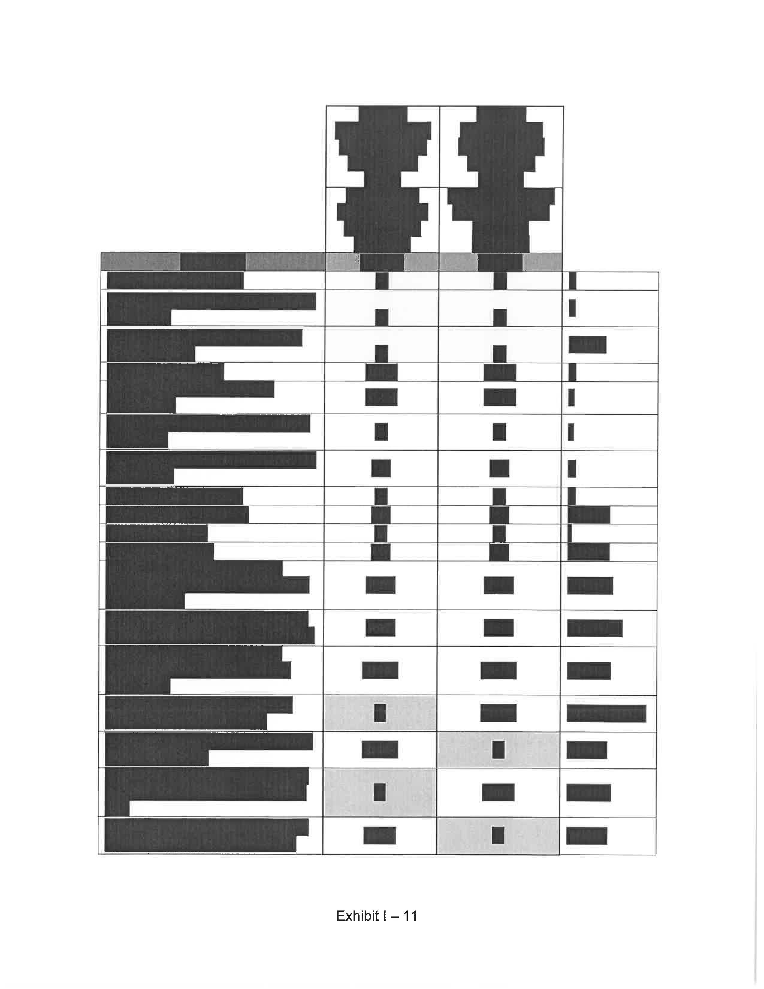

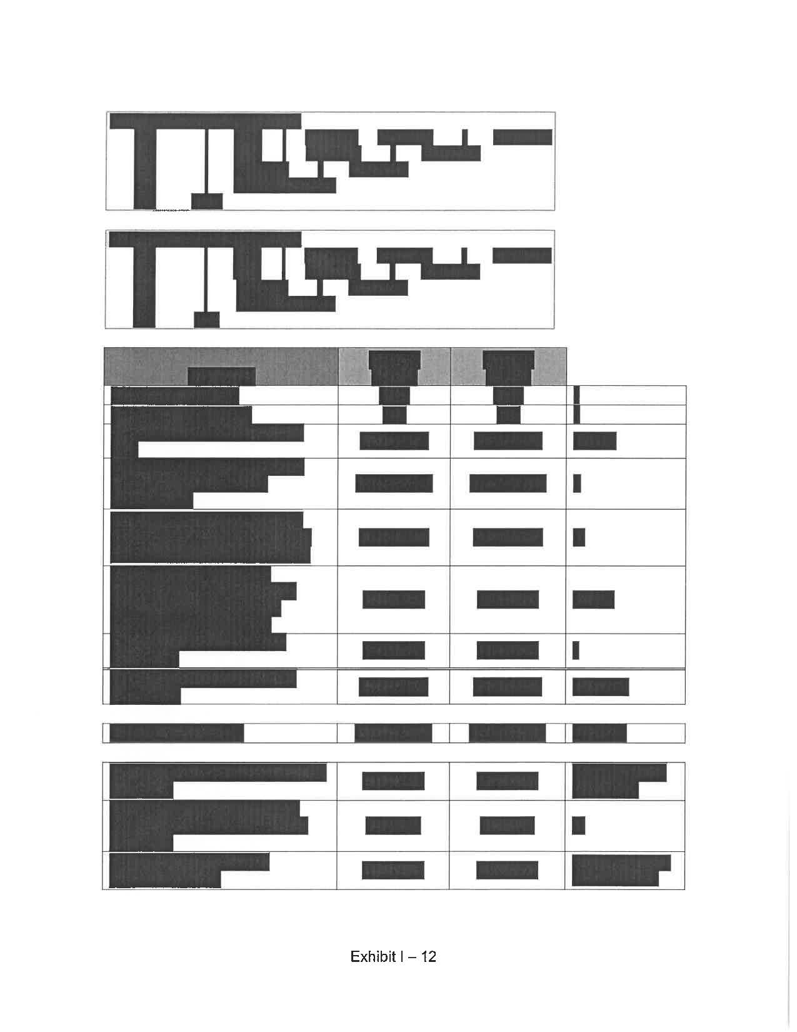

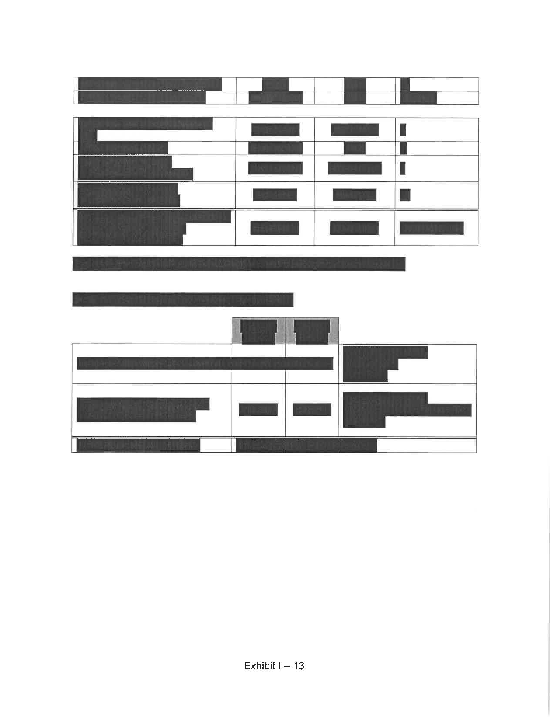

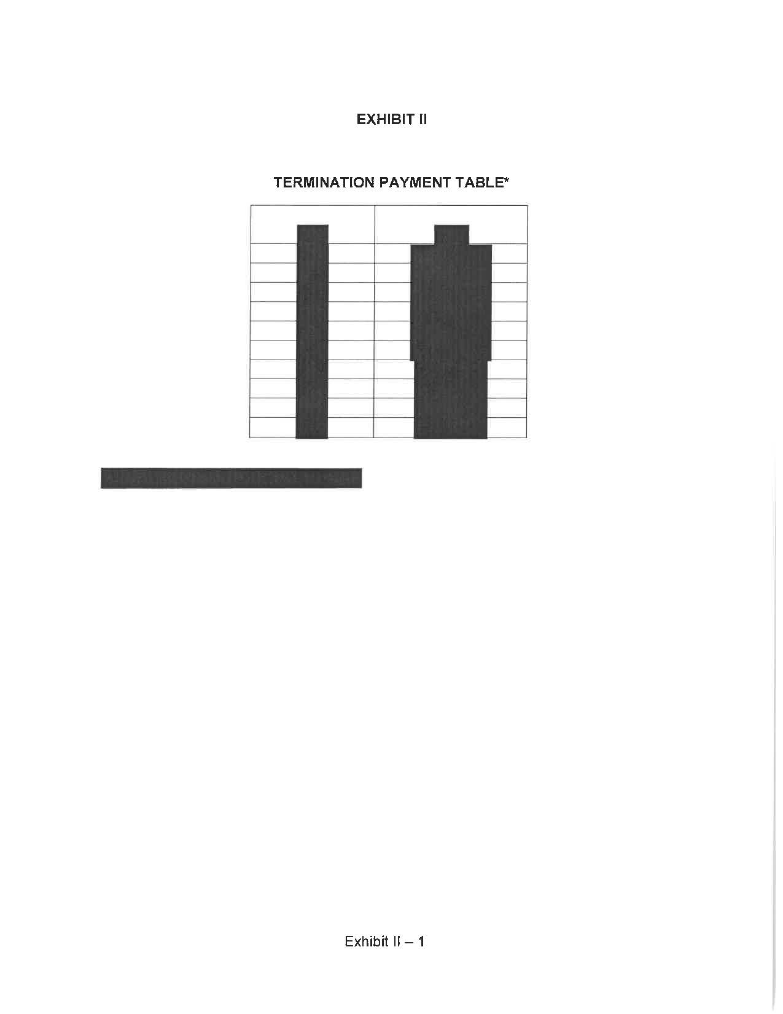

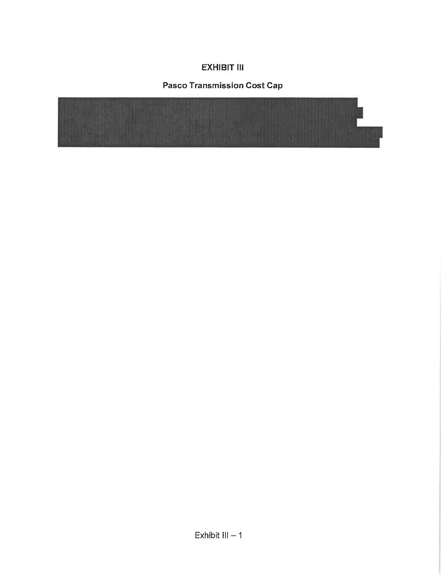

TECO’s revised analysis uses the same fuel forecast from the Company’s midcourse correction filed on January 23, 2023.
Document No. 00828-2023, filed on February 2, 2023 in Docket No. 20220186-EI.
See Order No. PSC-11-0439-PAA-EQ, issued October 11, 2011, in Docket No. 20110090-EQ, In re: Petition for Approving Negotiated Power Purchase Agreement between Progress Energy Florida, Inc. and U.S. Ecogen Polk, LLC.
See Order No. PSC-2022-0247-PAA-EQ, issued June 9, 2022, in Docket No. 20220070-EQ, In re: Petition for Approval of revisions to standard offer contract and rate schedule COG-2, by Tampa Electric Company.
Document No. 01713-2023, filed on March 2, 2023 in Docket No. 20220186-EI.

