BEFORE THE FLORIDA PUBLIC SERVICE COMMISSION

In re: Petition for limited proceeding for recovery of incremental storm restoration costs related to Hurricanes Ian and Nicole, by Florida Power & Light Company. | DOCKET NO. 20230017-EI  ORDER NO. PSC-2023-0110-PCO-EI  ISSUED: March 23, 2023

The following Commissioners participated in the disposition of this matter:

ANDREW GILES FAY, Chairman
ART GRAHAM
GARY F. CLARK
MIKE LA ROSA
GABRIELLA PASSIDOMO

ORDER APPROVING FLORIDA POWER & LIGHT COMPANY’S PETITION FOR RECOVERY OF INCREMENTAL STORM RESTORATION COSTS FOR HURRICANES IAN AND NICOLE AND APPROVING CONSOLIDATED INTERIM STORM RESTORATION RECOVERY SURCHARGE

BY THE COMMISSION:

Background
On January 23, 2023, Florida Power & Light Company (FPL or Company) filed a petition for a limited proceeding seeking authority to implement an interim storm restoration recovery charge to recover $1.3 billion for the incremental restoration costs related to Hurricanes Ian and Nicole and to replenish the storm reserve. This amount includes $18.8 million in interest.
FPL has also presented an alternate storm charge calculation in its petition. This alternate calculation combines the recovery of incremental storm costs associated with Hurricanes Ian and Nicole with the remaining amounts to be collected for Hurricanes Michael, Sally, and Zeta, which we previously approved for recovery by Gulf Power Company (GPC or FPL’s Northwest Florida). This alternate calculation estimates a total of $1.5 billion for incremental restoration costs related to Hurricanes Michael, Sally, Zeta, Ian, and Nicole and to replenish the storm reserve. This amount includes $21.6 million in interest.
FPL filed its petition pursuant to the provisions of the 2021 Settlement Agreement (2021 Settlement), which we approved in the Company’s most recent rate case. Pursuant to the 2021 Settlement, the Company can recover storm costs on an interim basis beginning 60 days following the filing of a petition for recovery. FPL has proposed interim storm restoration charges applicable to all rate classes over a 12-month recovery period, effective with the first billing cycle of April 2023, subject to a final true-up.
We have jurisdiction over this matter pursuant to Sections 366.04, 366.05, 366.06, and 366.076, Florida Statutes.

Decision

FPL filed a petition for a limited proceeding seeking authority to implement an interim storm restoration recovery charge to recover an estimated total of $1.3 billion for incremental restoration costs related to Hurricanes Ian and Nicole and to replenish the storm reserve. In its petition, FPL requested to replenish the storm reserve to the pre-storm level of $219.9 million.
The petition was filed pursuant to the provisions of the 2021 Settlement we approved in Order No. PSC-2021-0446-S-EI. Storm restoration costs for Ian and Nicole were incurred during the term of the 2021 Settlement. Pursuant to Paragraph 10 of the 2021 Settlement, FPL can begin recovery of storm costs 60 days following the filing of a petition for recovery.

FPL is seeking approval of interim storm cost recovery surcharges associated with Hurricanes Ian and Nicole as shown in proposed tariff sheet No. 8.030.7 (Appendix F to the petition). The surcharges would be applicable to all rate classes and customers served by FPL, including customers previously served by GPC.
FPL also prepared an alternate storm charge calculation seeking authority to implement an interim storm restoration recovery charge to recover an estimated total of $1.5 billion. This alternate calculation combines the incremental restoration costs related to Hurricanes Ian and Nicole with the remaining amounts to be collected for Hurricanes Michael, Sally, and Zeta, which we previously approved for recovery by GPC, and to replenish the storm reserve.
Current bills for FPL’s Northwest Florida customers include surcharges for Hurricanes Michael and Sally, which equate to $8 and $3 on the residential 1,000 kilowatt-hour (kWh) bill, respectively. The Hurricane Michael surcharge went into effect in July 2019 and was approved to terminate in October 2023. Once the Hurricane Michael surcharge terminates, the $3/1,000 kWh residential Hurricane Sally surcharge will increase to $10/1,000 kWh. Once recovery of Hurricane Sally is complete in October 2024, the recovery of Hurricane Zeta ($9.34/1,000 kWh) will occur in the months of November and December 2024. These hurricanes impacted GPC’s service territory prior to the merger of FPL and GPC. Tariff sheet Nos. 8.030.4, 8.030.5, and 8.030.6 show the currently approved surcharges for Michael, Sally, and Zeta, applicable to FPL’s Northwest Florida customers. FPL indicated in its calculations in Appendix A of the petition that the storm costs associated with the Hurricane Michael surcharge are expected to be fully recovered by March 31, 2023.
In its petition, FPL asserted that it incurred total retail recoverable costs of approximately $1.5 billion as a result of Hurricanes Michael, Sally, Zeta, Ian, and Nicole. The Company further asserted that this amount was calculated in accordance with the Incremental Cost and Capitalization Approach methodology prescribed in Rule 25-6.0143, Florida Administrative Code.
The current storm surcharges for Sally and Zeta applicable to FPL’s Northwest Florida customers were established in 2022 by Final Order following a disputed fact hearing. Testimony filed by FPL in 2021 in its rate case indicated that FPL’s Northwest Florida legacy storm restoration costs and surcharges associated with Hurricanes Michael and Sally were to remain applicable to only those customers. Our final orders are generally afforded administrative finality and are not subject to subsequent modification. The issue of maintaining the current surcharge in place for FPL’s Northwest Florida customers only until full recovery was not specifically litigated or a material issue in either the prior storm recovery or FPL rate case docket. We are not persuaded that finality is attached to this issue. Moreover, administrative finality does not apply where there has been a substantial change in circumstances or a demonstrated public interest. Both are present in this docket and, accordingly, we have the legal authority to unify the charges.
Hurricanes Ian and Nicole affected only FPL Peninsular customers, i.e., customers served by FPL prior to the merger with GPC. The proposal to apply the surcharge for this storm recovery to all current FPL customers, including FPL’s Northwest Florida customers who were not impacted, is a substantial change in circumstances from the prior approach of segregating costs based on impacts. Spreading costs evenly across customers for all storms no matter the location of impacts is the appropriate reaction to these changed circumstances.
The alternate storm charge calculations project a 12-month recovery period (April 2023 through March 2024), subject to a final true-up. Under the currently-approved recovery schedule, recovery of Hurricanes Sally and Zeta costs are projected to be complete in December 2024. In response to staff’s data request, FPL stated that this accelerated recovery of storm costs would “benefit FPL and its general body of customers by reducing the amount of interest recovered from customers and regulatory lag, while also mitigating the potential for overlapping storm recovery charges in the future.” As to whether the alternative is preferable, FPL stated in its response that it “views both as being potentially appropriate options for storm cost recovery.”
FPL explained that it has allocated the storm cost recovery amount to the rate classes consistent with the rate design approved in the 2021 Settlement. We have reviewed the storm cost recovery allocation and calculation of rates, for FPL’s proposal and the alternate calculations, and find that FPL has calculated rates in accordance with the 2021 Settlement, using the most recent load research study and projected billing determinants for the recovery period. The storm cost recovery surcharge shall be included in the non-fuel energy charge on customer bills, which FPL states is consistent with its standard practice.
For residential customers, the alternate surcharge will be 1.530 cents per kWh, which would equate to $15.30 on a 1,000 kWh residential bill. Under FPL’s proposed tariff, for residential customers, the surcharge would be 1.384 cents per kWh, which would equate to $13.84 on a 1,000 kWh residential bill. Under FPL’s proposal, FPL’s Northwest Florida customers would pay the proposed $13.84/1,000 kWh while continuing to pay the approved Hurricanes Sally and Zeta surcharges. FPL’s Northwest Florida customers will have paid for all the Hurricane Michael costs by March 31, 2023.
Under the alternate tariff, the FPL Peninsular customers would pay a storm recovery surcharge that is $1.46 ($15.30-$13.84) higher than FPL’s proposal on the 1,000 kWh bill for a 12-month period. However, FPL’s Northwest Florida customers would save monthly between $11 (Hurricanes Michael and Sally surcharges) to $9.34 (Hurricane Zeta surcharge) on the 1,000 kWh bill for a 21-month period. The savings to FPL Northwest Florida customers, in addition to the reasons discussed above, outweigh the incremental $1.46/1,000 kWh for the FPL Peninsular customers, when comparing the two storm recovery options.
For these reasons, we deny FPL’s proposed interim storm restoration recovery charge. We approve FPL’s alternate storm charge calculation and associated tariff sheet No. 8.030.7 as shown in Attachment A to this Order, effective with the first billing cycle of April 2023. Furthermore, effective with the first billing cycle of April 2023, tariff sheet Nos. 8.030.4, 8.030.5, and 8.030.6 shall be cancelled, as shown in Attachment A hereto. The alternate storm charge calculation avoids significant disparities in surcharges among customers of one, consolidated utility, reduces regulatory lag and interest payments, and mitigates the potential for overlapping storm recovery charges in the future.

The approval of an interim storm restoration recovery charge is preliminary in nature and is subject to refund pending further review once the total actual storm restoration costs are known. After the actual costs are reviewed for prudence and reasonableness, and are compared to the actual amount recovered through the interim storm restoration recovery charge, a determination will be made whether any over/under recovery has occurred. The disposition of any over/under recovery, and associated interest, will be considered by us at a later date.

Based on a review of the information provided by FPL in its petition, we authorize the Company to implement an interim storm restoration recovery charge subject to refund. Once the total actual storm costs are known, FPL shall file documentation of the storm costs for our review and true-up of any excess or shortfall.

FPL has requested that all funds collected subject to refund be secured by a corporate undertaking. The criteria for a corporate undertaking include sufficient liquidity, ownership equity, profitability, and interest coverage to guarantee any potential refund. FPL requested a 12-month collection period from April 2023 through March 2024 for Interim Storm Cost Recovery Charges of $1.5 billion related to Hurricanes Michael, Sally, Zeta, Ian and Nicole. We reviewed FPL’s three most recent annual reports filed with us (2021, 2020, and 2019) to determine if the Company can support a corporate undertaking to guarantee the funds collected for recovery of incremental storm restoration costs related to the weather events. FPL’s financial information demonstrates the Company has acceptable levels of liquidity, ownership equity, profitability, and interest coverage to support a potential refund of $1.5 billion. Moreover, it is improbable FPL will be required to refund the entire requested amount.
We find that FPL has adequate resources to support a corporate undertaking in the amount requested. Based on our analysis, a corporate undertaking of $1.5 billion is acceptable. This brief financial analysis is only appropriate for deciding if the Company can support a corporate undertaking in the amount proposed and was not considered in our evaluation of other issues in this proceeding.

Based on the foregoing, it is

ORDERED by the Florida Public Service Commission that Florida Power & Light Company’s petition for recovery of incremental storm restoration costs related to Hurricanes Ian and Nicole is approved. It is further

ORDERED that FPL’s proposed interim storm restoration recovery charge for Hurricanes Ian and Nicole is denied. It is further

ORDERED that FPL’s proposed consolidated interim storm restoration charge for Hurricanes Ian, Nicole, Michael, Sally, and Zeta as shown on tariff sheet no. 8.030.7, appended to this Order as Attachment A, is approved, subject to refund, effective with the first billing cycle of April 2023. It is further

ORDERED that FPL’s tariff sheet Nos. 8.030.4, 8.030.5, and 8.030.6 shall be cancelled effective with the first billing cycle of April 2023. It is further

ORDERED that once the total actual consolidated storm costs are known, the Company shall file documentation of the storm costs for our review and true up of any excess or shortfall. It is further

ORDERED that the appropriate security to guarantee the funds collected subject to refund is a corporate undertaking. It is further

ORDERED that this docket shall remain open pending final reconciliation of actual recoverable storm costs with the amount collected pursuant to the consolidated interim storm restoration recovery charge, and the calculation of a refund or additional charge if warranted.

By ORDER of the Florida Public Service Commission this 23rd day of March, 2023.

/s/ Adam J. Teitzman
ADAM J. TEITZMAN
Commission Clerk
Florida Public Service Commission
2540 Shumard Oak Boulevard
Tallahassee, Florida 32399
(850) 413-6770
www.floridapsc.com

Copies furnished: A copy of this document is provided to the parties of record at the time of issuance and, if applicable, interested persons.

SPS

NOTICE OF FURTHER PROCEEDINGS OR JUDICIAL REVIEW

The Florida Public Service Commission is required by Section 120.569(1), Florida Statutes, to notify parties of any administrative hearing or judicial review of Commission orders that is available under Sections 120.57 or 120.68, Florida Statutes, as well as the procedures and time limits that apply. This notice should not be construed to mean all requests for an administrative hearing or judicial review will be granted or result in the relief sought.

Mediation may be available on a case-by-case basis. If mediation is conducted, it does not affect a substantially interested person's right to a hearing.

Any party adversely affected by this order, which is preliminary, procedural or intermediate in nature, may request: (1) reconsideration within 10 days pursuant to Rule 25-22.0376, Florida Administrative Code; or (2) judicial review by the Florida Supreme Court, in the case of an electric, gas or telephone utility, or the First District Court of Appeal, in the case of a water or wastewater utility. A motion for reconsideration shall be filed with the Office of Commission Clerk, in the form prescribed by Rule 25-22.0376, Florida Administrative Code. Judicial review of a preliminary, procedural or intermediate ruling or order is available if review of the final action will not provide an adequate remedy. Such review may be requested from the appropriate court, as described above, pursuant to Rule 9.100, Florida Rules of Appellate Procedure.

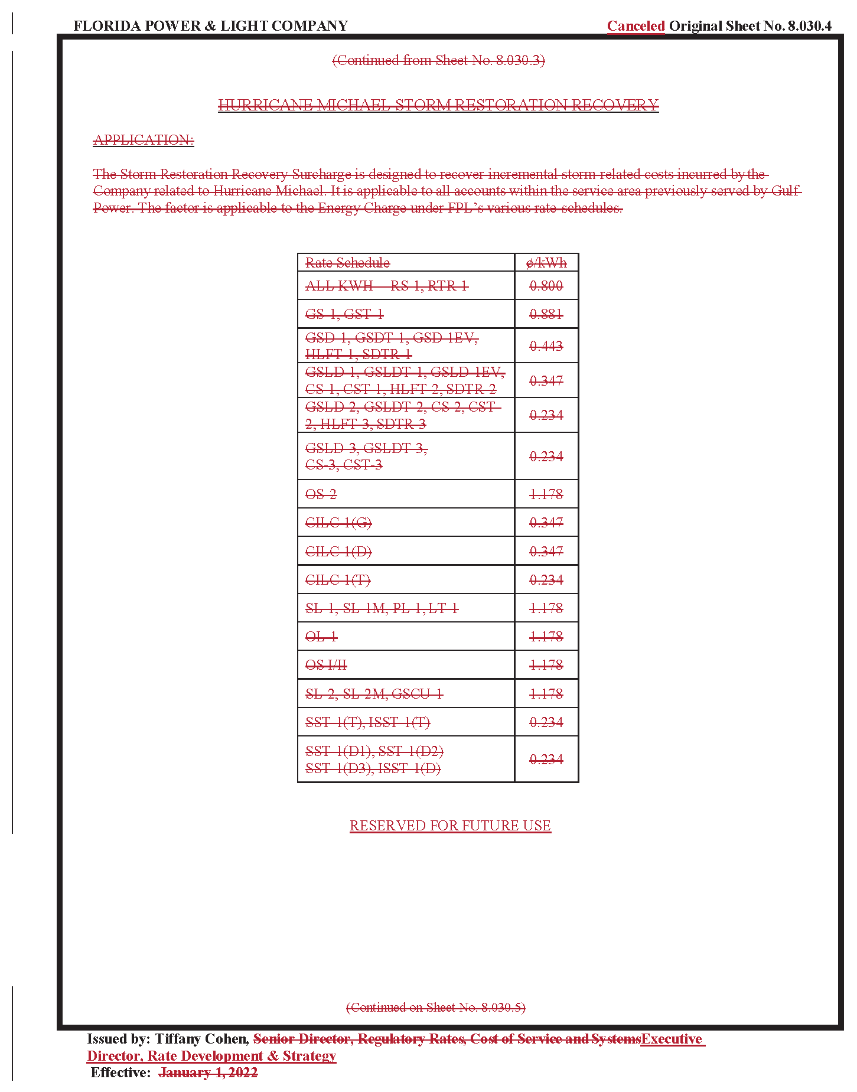

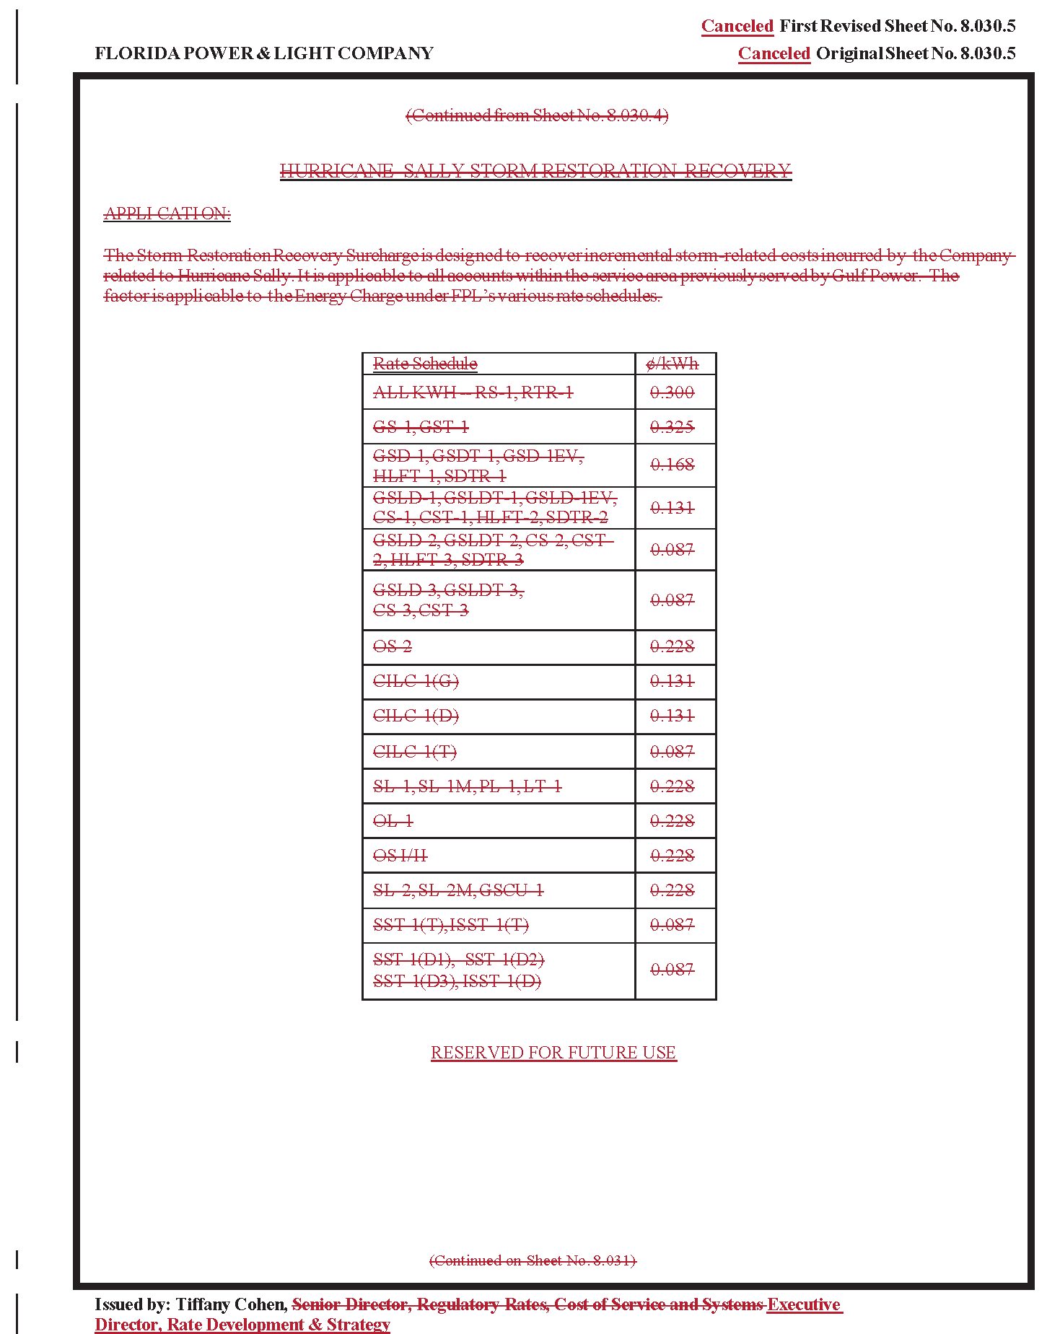

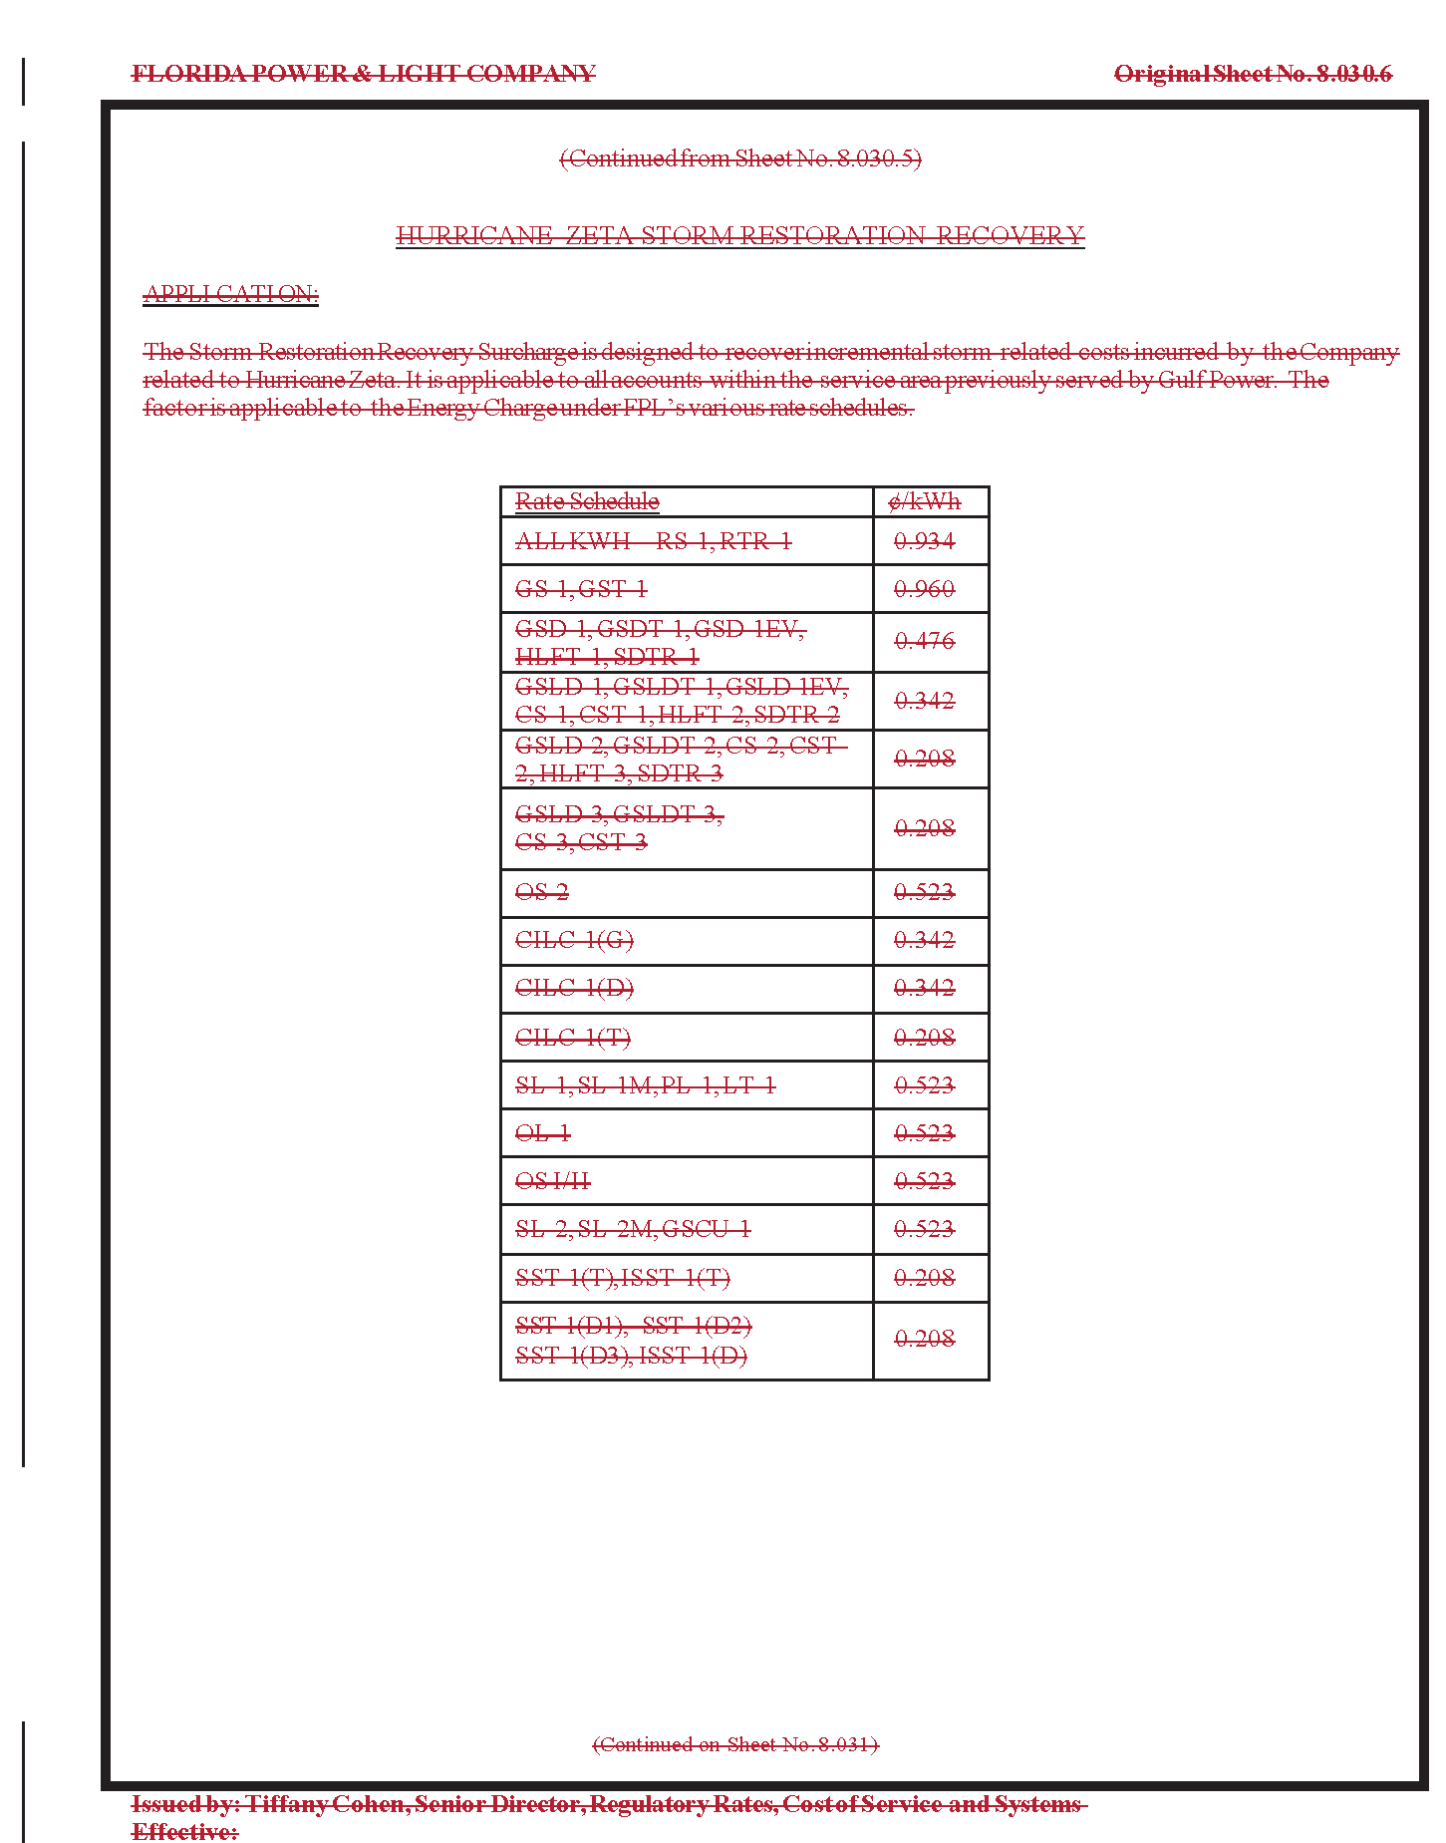

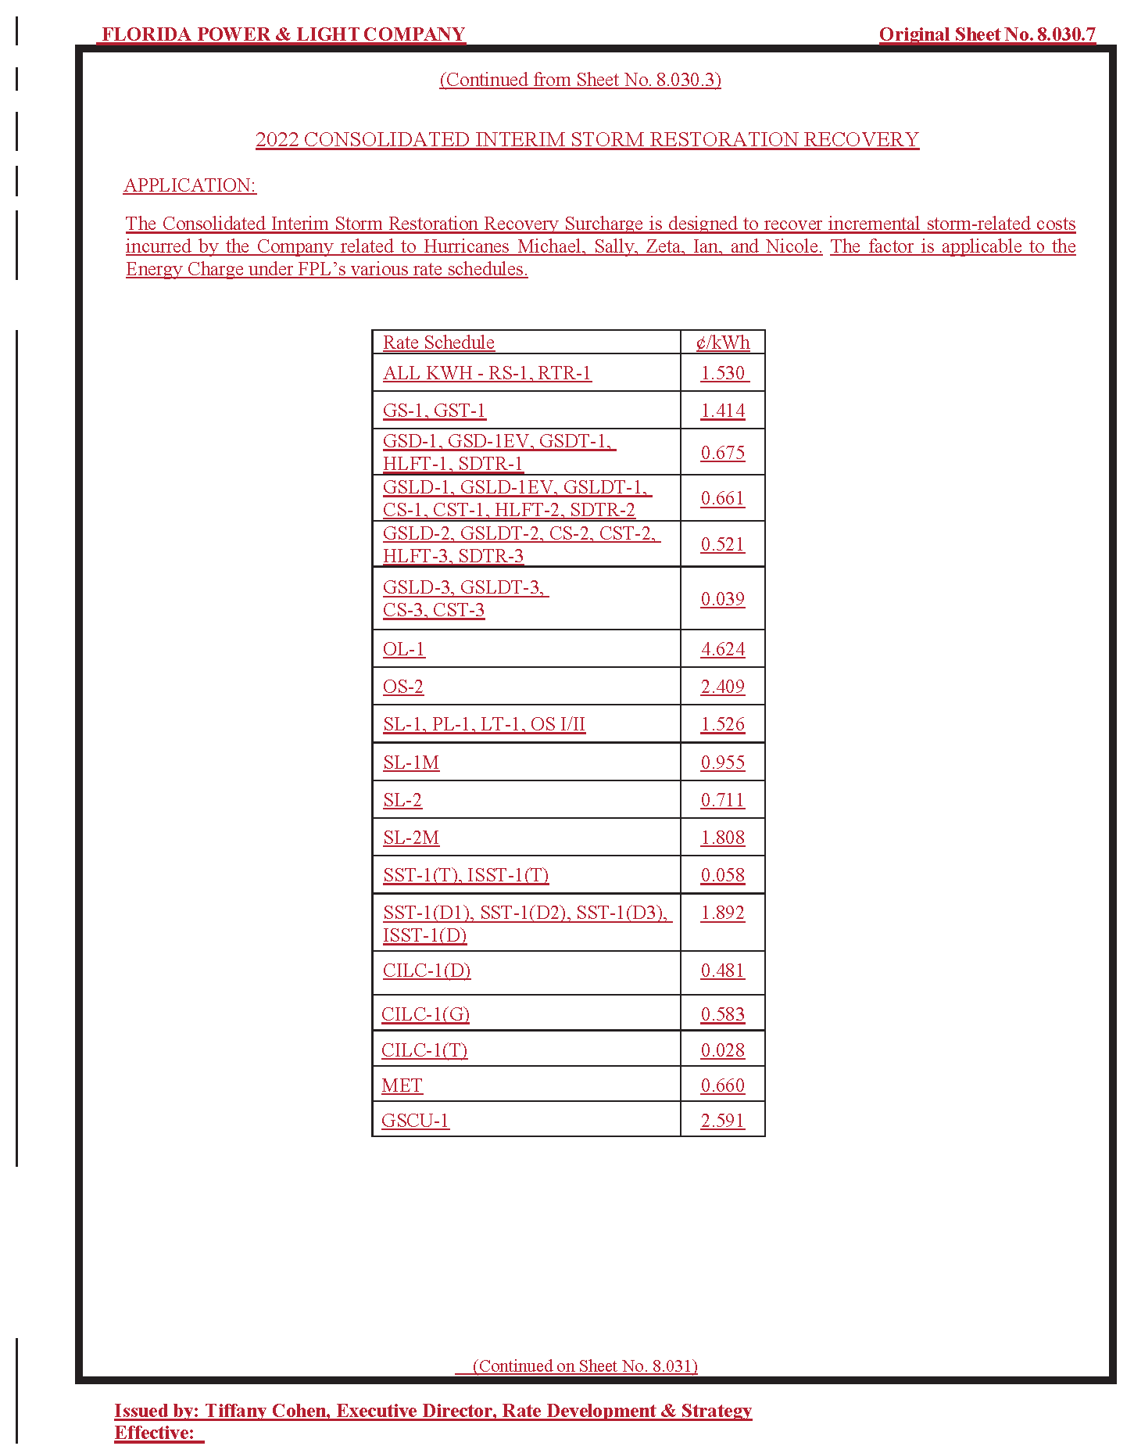

Order No. PSC-2019-0221-PCO-EI, issued June 3, 2019, in Docket No. 20190038-EI, In re: Petition for limited proceeding for recovery of incremental storm restoration costs related to Hurricane Michael, by Gulf Power Company; and Order No. PSC-2022-0406-FOF-EI, issued November 21, 2022, in Docket No. 20200041-EI, In re: Petition for limited proceeding for recovery of incremental storm restoration costs related to Hurricane Sally, by Gulf Power Company.
Order No. PSC-2021-0446-S-EI, issued December 2, 2021, in Docket No. 20210015-EI, In re: Petition for rate increase by Florida Power & Light Company.
Order Nos. PSC-2019-0221-PCO-EI; and PSC-2022-0406-FOF-EI.
Order No. PSC-2022-0406-FOF-EI, issued on November 21, 2022, in Docket Nos. 20200241-EI, 20210178-EI, and 20210179-EI, in In re: Petition for limited proceeding for recovery of incremental storm restoration costs related to Hurricane Sally, In re: Petition for evaluation of Hurricane Isaias and Tropical Storm Eta storm costs, by Florida Power & Light Company, and In re: Petition for limited proceeding for recovery of incremental storm restoration costs and associated true-up process related to Hurricane Zeta, by Gulf Power Company.
FPL and GPC were separate ratemaking entities until the end of 2021.
Document No. 02776-2021 in Docket No. 20210015-EI, Direct Testimony of Tiffany Cohen, p. 30 lns. 9-15.
Peoples Gas System, Inc. v. Mason, 187 So. 2d 335, 339 (Fla. 1966) (“orders of administrative agencies must eventually pass out of the agency’s control and become final and no longer subject to modification”).
Delray Medical Center, Inc. v Agency for Health Care Admin., 5 So. 3d 26, 29 (Fla. 4th DCA 2009).
In response to a data request from staff, FPL concurred that there is no legal prohibition on our imposing a uniform storm surcharge on all current FPL customers. Document No. 01037-2023.
See Mason, 187 So. 2d at 339 (“actions of administrative agencies are usually concerned with deciding issues according to a public interest that often changes with shifting circumstances and passage of time”).
Id.
Id.
Order No. PSC-2021-0446-S-EI, issued December 2, 2021, in Docket No. 20210015-EI, In re: Petition for rate increase by Florida Power & Light Company.

