BEFORE THE FLORIDA PUBLIC SERVICE COMMISSION

In re: Joint petition for approval of temporary territorial variance, by Duke Energy Florida, LLC and Peace River Electric Cooperative, Inc. | DOCKET NO. 20230035-EU  ORDER NO. PSC-2023-0186-PAA-EU  ISSUED: June 27, 2023

The following Commissioners participated in the disposition of this matter:

ANDREW GILES FAY, Chairman
ART GRAHAM
GARY F. CLARK
MIKE LA ROSA
GABRIELLA PASSIDOMO

NOTICE OF PROPOSED AGENCY ACTION
ORDER APPROVING TEMPORARY TERRITORIAL VARIANCE

BY THE COMMISSION:

NOTICE is hereby given by the Florida Public Service Commission that the action discussed herein is preliminary in nature and will become final unless a person whose interests are substantially affected files a petition for a formal proceeding, pursuant to Rule 25-22.029, Florida Administrative Code (F.A.C.).

BACKGROUND

On March 15, 2023, Duke Energy Florida, LLC (Duke) and Peace River Electric Cooperative, Inc. (PRECO) (jointly, the Parties) filed a joint petition for approval of a temporary territorial agreement variance (2023 Agreement). The 2023 Agreement would enable Duke to provide temporary electric service to an industrial customer’s planned eastern phosphate mining expansion project (project) south of State Road 64 (SR 64). The area south of SR 64 is located in PRECO’s service territory; however, PRECO does not have the transmission facilities necessary to serve the planned mining load. The 2023 Agreement also includes a provision to transfer Duke’s Lake Branch substation and 1.84 acres of land on which the substation resides to PRECO.

In 1994, we approved a territorial agreement that established service territory boundaries for the Parties in Hardee, Highlands, Polk, and Osceola counties (1994 Agreement). The 1994 Agreement contained a provision permitting Duke (formerly Florida Power Corporation) to provide transmission level electric service to certain phosphate mining companies in PRECO’s service territory, because PRECO did not have the appropriate facilities to meet the industrial customers’ service needs. In 2006, the Commission approved an amendment to certain sections of the 1994 Agreement to clarify the Parties’ obligations with respect to the existing phosphate mining customers in PRECO’s service territory.
In 2019, we approved a territorial agreement between the Parties which replaced the prior territorial agreement in its entirety (2019 Agreement). The 2019 Agreement modified the territorial boundaries, transferring customers to better eliminate duplication of service and creating operational efficiencies for both utilities. Furthermore, the 2019 Agreement incorporated many provisions from the previous agreements, including Section 2.5, which allows Duke to provide electric service to a phosphate mining industrial customer in PRECO’s service territory north of SR 64. The 2019 Agreement was negotiated for an initial term of 30 years, which would expire in 2049 and would remain in effect for succeeding periods of five years.
Order No. PSC-2023-0127-PCO-EU acknowledges the Office of Public Counsel’s (OPC) intervention in this docket. Duke and PRECO responded to Staff’s First Data Request on April 21, 2023 and to Staff’s Second Data Request on May 18, 2023. On May 17, 2023, the Parties responded to OPC’s First Set of Interrogatories and First Request for Production of Documents.
This order addresses the joint petition for a temporary territorial variance agreement. The 2023 Agreement and a map providing the proposed territorial boundaries are found in Attachments A and B to this order. We have jurisdiction over this matter pursuant to Section 366.04, Florida Statutes (F.S.).
DECISION
Pursuant to Section 2.5 of the 2019 Agreement, Duke provides service to the industrial customer in PRECO’s service territory north of SR 64. The eastern expansion project’s site includes areas located both north and south of SR 64. The part of the project located south of SR 64 is currently within PRECO’s service territory. The project is an industrial phosphate mining operation and associated pump operation. Phosphate mining companies operate draglines that excavate phosphate used to produce fertilizer and other commercial products. Once a specific mining area has been depleted, the companies move to another location.
The Parties request that Duke, instead of PRECO, temporarily serve the industrial customer’s entire project area including the area south of SR 64. The Parties estimate the customer will conclude its mining operations in the project south of SR 64 by December 31, 2028. The Parties stated in response to Staff’s Second Data Request that they will notify us once the mining operations are concluded.

Duke states that it has sufficient capacity to serve the industrial customer’s load south of SR 64 and can provide immediate electric service to the project from an existing substation located within Duke’s electric service territory located in Hardee County. PRECO states that it does not currently have sufficient capacity to serve the load and will need Duke’s assistance to provide immediate electric service to the project. To serve the new load south of SR 64, PRECO would need to construct a new substation, estimated to cost approximately $4 million. Due to these circumstances, the Parties agree Duke should serve the load as the industrial customer estimates that the project would add approximately 20 megawatts (MW) of load south of SR 64.
No customers are being transferred as a result of the proposed variance. Therefore, Rule 25-6.0440(1)(d), F.A.C., regarding customer notification of transferred customers, does not apply.

Lake Branch Substation Transfer
The proposed variance includes a provision that PRECO will acquire Duke’s Lake Branch substation (substation) by December 31, 2025. The substation is located in PRECO’s service territory north of SR 64 by the intersection of Lake Branch Road and Platt Road (County Road 664A) in Hardee County. Pursuant to Section 2.5 of the 2019 Agreement, Duke serves the phosphate mining load in certain areas north of SR 64. Specifically, the industrial customer receives electric service for its South Meade mining operations from Duke at multiple delivery points, including Duke’s Lake Branch substation. Pursuant to the 2019 Agreement, Duke only has the right to serve the industrial customer’s load in the particular area served by the Lake Branch substation; PRECO has the right to serve any other load.
Section 4 of the 2023 Agreement includes a provision that the Lake Branch substation would be transferred to PRECO on or before December 31, 2025, dependent on if the substation’s pumping load ceases before the stated date. The Parties have agreed upon a transfer of the Lake Branch substation and the 1.84 acres of land on which the substation resides for the nominal consideration of $10. The Parties explained that nominal consideration is a legal formality commonly employed to ensure that a contract is enforceable. The details of the substation transfer are contained in the Asset Purchase Agreement that was included with the petition. The Parties are not seeking our approval of the Asset Purchase Agreement.
The Parties assert that the nominal consideration was determined by considering the exchange of benefits between the Parties. Duke would have the benefit of serving the industrial customer and associated additional 20 MW of load, south of SR 64, for approximately five years (2024-2028) in PRECO’s territory. In exchange, PRECO would acquire the substation to serve its customers. Duke stated that the substation only serves the industrial customer and will have no other benefit to Duke once the mining operations served by the substation cease. PRECO stated that it would be able to tie the substation into its distribution system with minimal additional construction, because the utility has feeder lines adjacent to the Lake Branch substation.
To support the transfer of the Lake Branch substation, the Parties state that by agreeing to convey the substation to PRECO, Duke’s customers would no longer have the obligation for the cost of removal of the substation. Further, the revenues Duke is projected to receive from the additional 20 MW of load will more than offset the estimated $1.9 million net book value of the substation as of December 31, 2025. Duke has provided an analysis showing that the future expected non-fuel revenues from the additional 20 MW of load total $6.4 million on a nominal basis, or $4.3 million on a net present value basis. Based on Duke’s analysis, the expected revenues offset the net book value of the substation. Therefore, Duke’s general body of ratepayers is not being harmed by the transfer of the substation to PRECO for nominal consideration.
Based on the representations of the Parties stated above, we find that the proposed variance in the 2019 Agreement will avoid uneconomic duplication of facilities and is in the public interest. We further find that for the term of the 2023 Agreement, Duke will temporarily serve the mining load south of SR 64 in the eastern expansion project area until the mining project is completed. The mining project south of SR 64 is estimated to begin in 2024 and continue until 2028. The Parties shall notify us once the mining operations subject to the 2023 Agreement are concluded.

Based on the foregoing, it is

ORDERED by the Florida Public Service Commission that the Joint petition for approval of temporary territorial variance filed by Duke Energy Florida, LLC and Peace River Electric Cooperative, Inc. is hereby granted. It is further

ORDERED that the 2023 Agreement, contained in Attachment A to this order, is hereby approved and that the Parties shall notify this Commission when the mining operations subject to the 2023 Agreeement are concluded. It is further

ORDERED that the provisions of this order issued as proposed agency action shall become final and effective upon the issuance of a Consummating Order if no protest to the proposed agency action is filed by a substantially affected person with the Commission Clerk, 2540 Shumard Oak Boulevard, Tallahassee, Florida 32399-0850, within 21 days of the date of the order in the form provided by Rule 28-106.201, F.A.C. It is further

ORDERED that if no protest is filed by a person whose substantial interests are affected within 21 days of the issuance of this order, this docket shall be closed upon the issuance of a Consummating Order.
By ORDER of the Florida Public Service Commission this 27th day of June, 2023.

/s/ Adam J. Teitzman

ADAM J. TEITZMAN
Commission Clerk
Florida Public Service Commission
2540 Shumard Oak Boulevard
Tallahassee, Florida 32399
(850) 413-6770
www.floridapsc.com

Copies furnished: A copy of this document is provided to the parties of record at the time of issuance and, if applicable, interested persons.

SBr

NOTICE OF FURTHER PROCEEDINGS OR JUDICIAL REVIEW

The Florida Public Service Commission is required by Section 120.569(1), Florida Statutes, to notify parties of any administrative hearing that is available under Section 120.57, Florida Statutes, as well as the procedures and time limits that apply. This notice should not be construed to mean all requests for an administrative hearing will be granted or result in the relief sought.

Mediation may be available on a case-by-case basis. If mediation is conducted, it does not affect a substantially interested person's right to a hearing.

The action proposed herein is preliminary in nature. Any person whose substantial interests are affected by the action proposed by this order may file a petition for a formal proceeding, in the form provided by Rule 28-106.201, Florida Administrative Code. This petition must be received by the Office of Commission Clerk, 2540 Shumard Oak Boulevard, Tallahassee, Florida 32399-0850, by the close of business on July 18, 2023.

In the absence of such a petition, this order shall become final and effective upon the issuance of a Consummating Order.

Any objection or protest filed in this/these docket(s) before the issuance date of this order is considered abandoned unless it satisfies the foregoing conditions and is renewed within the specified protest period.

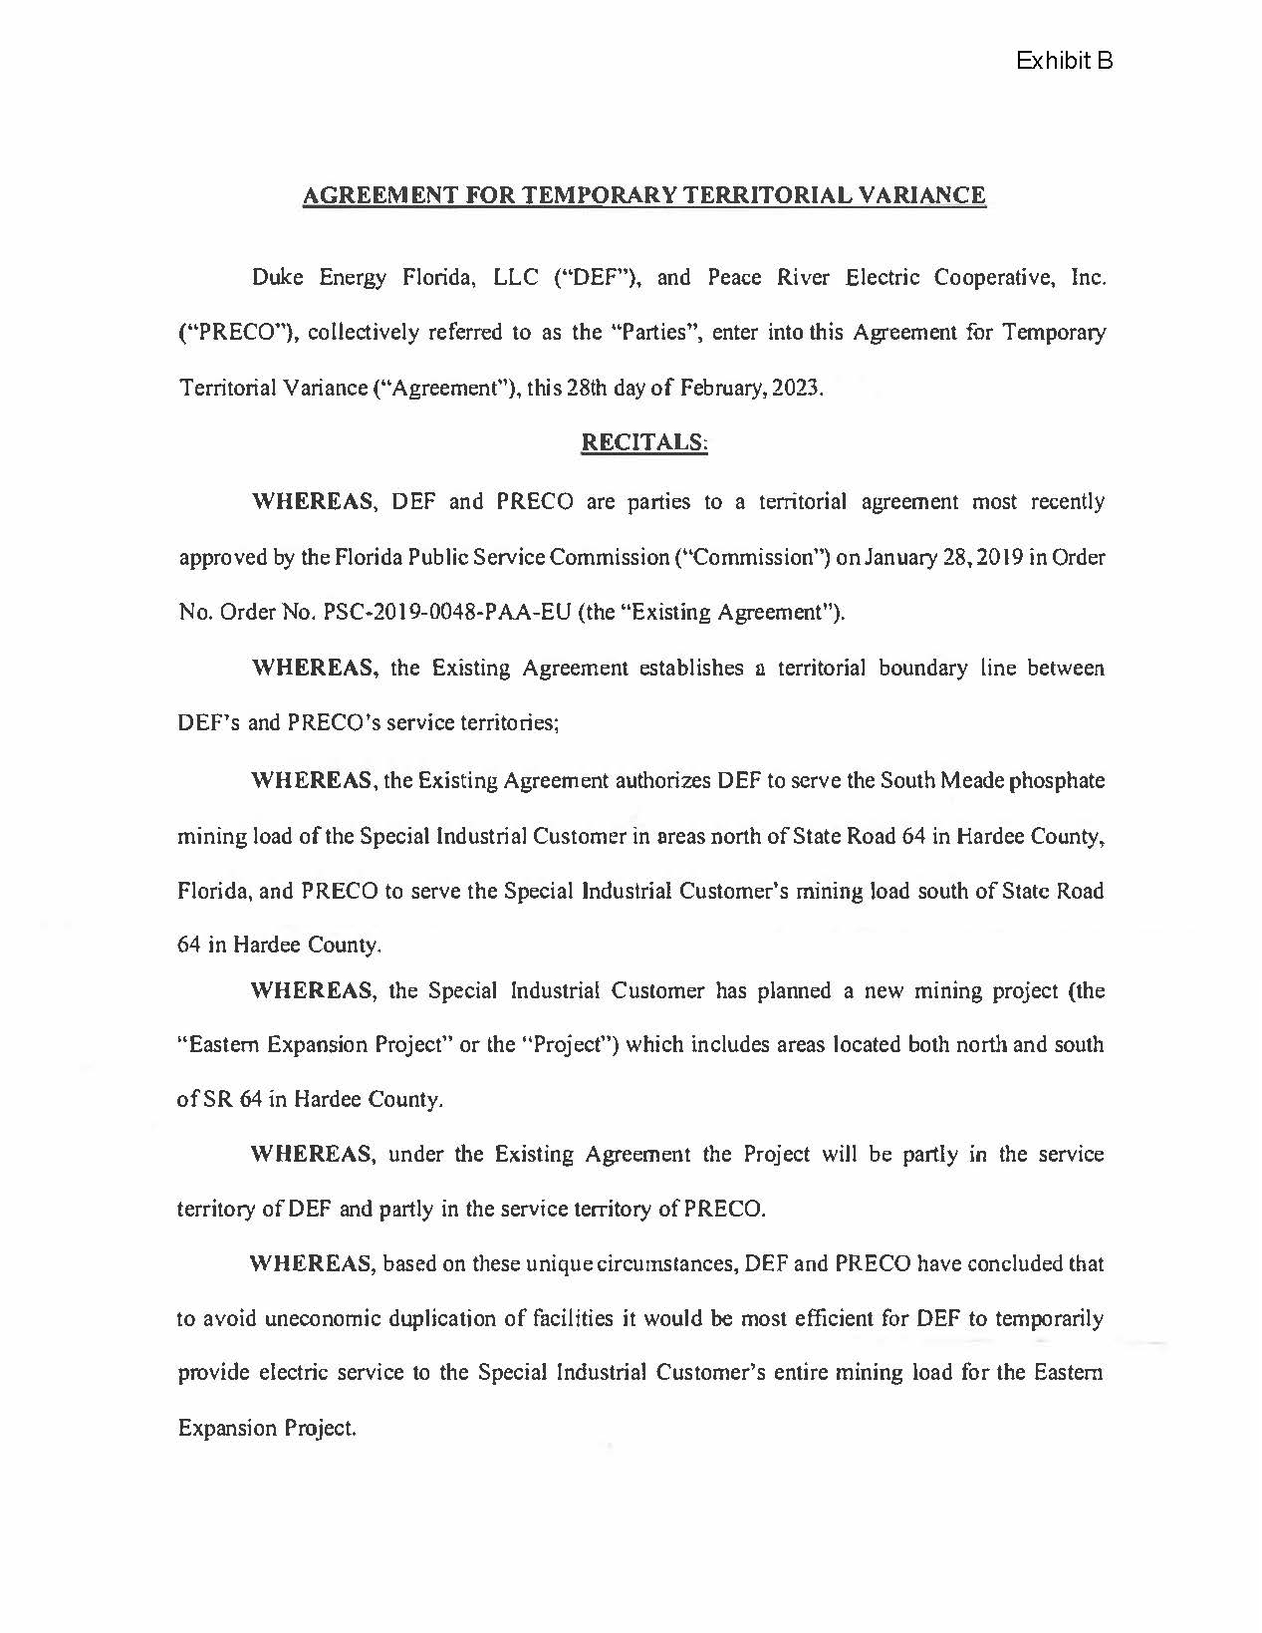
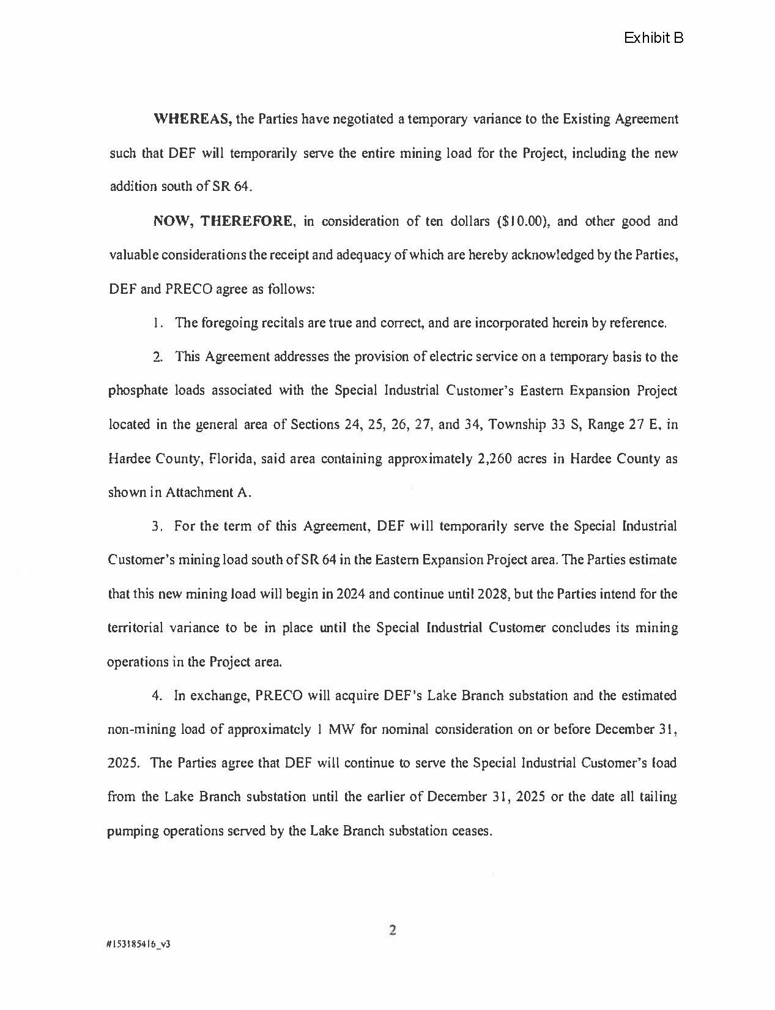
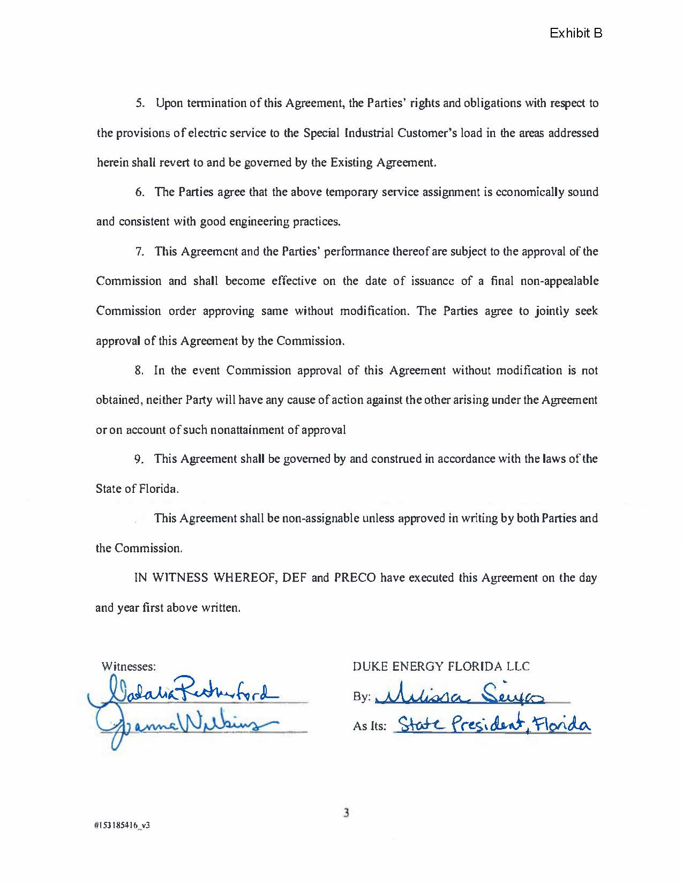
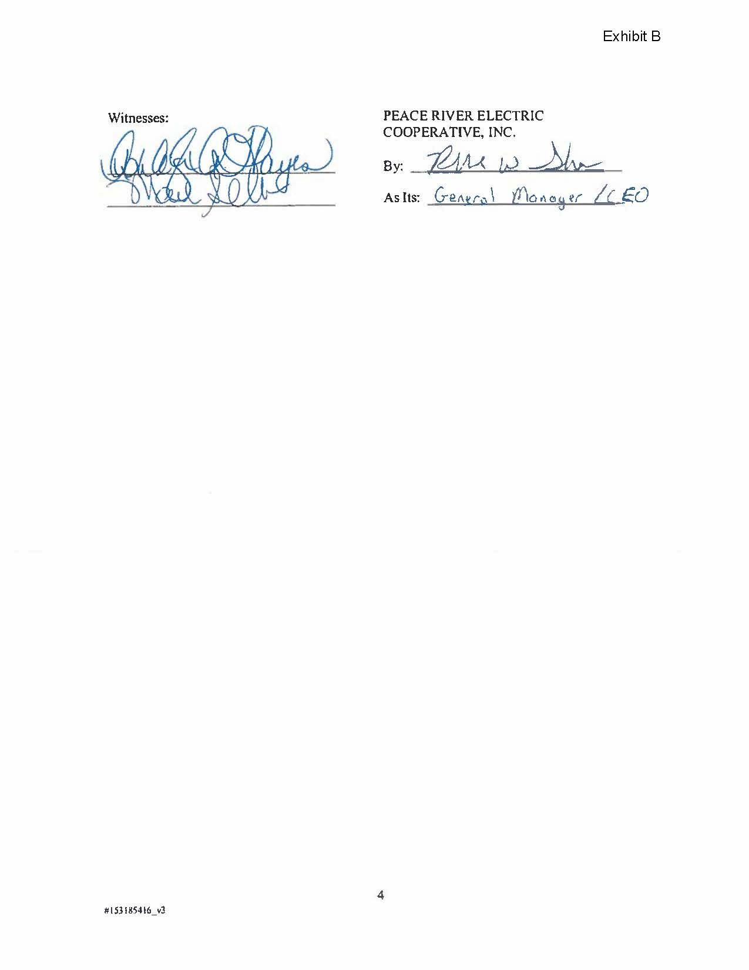
ATTACHMENT B
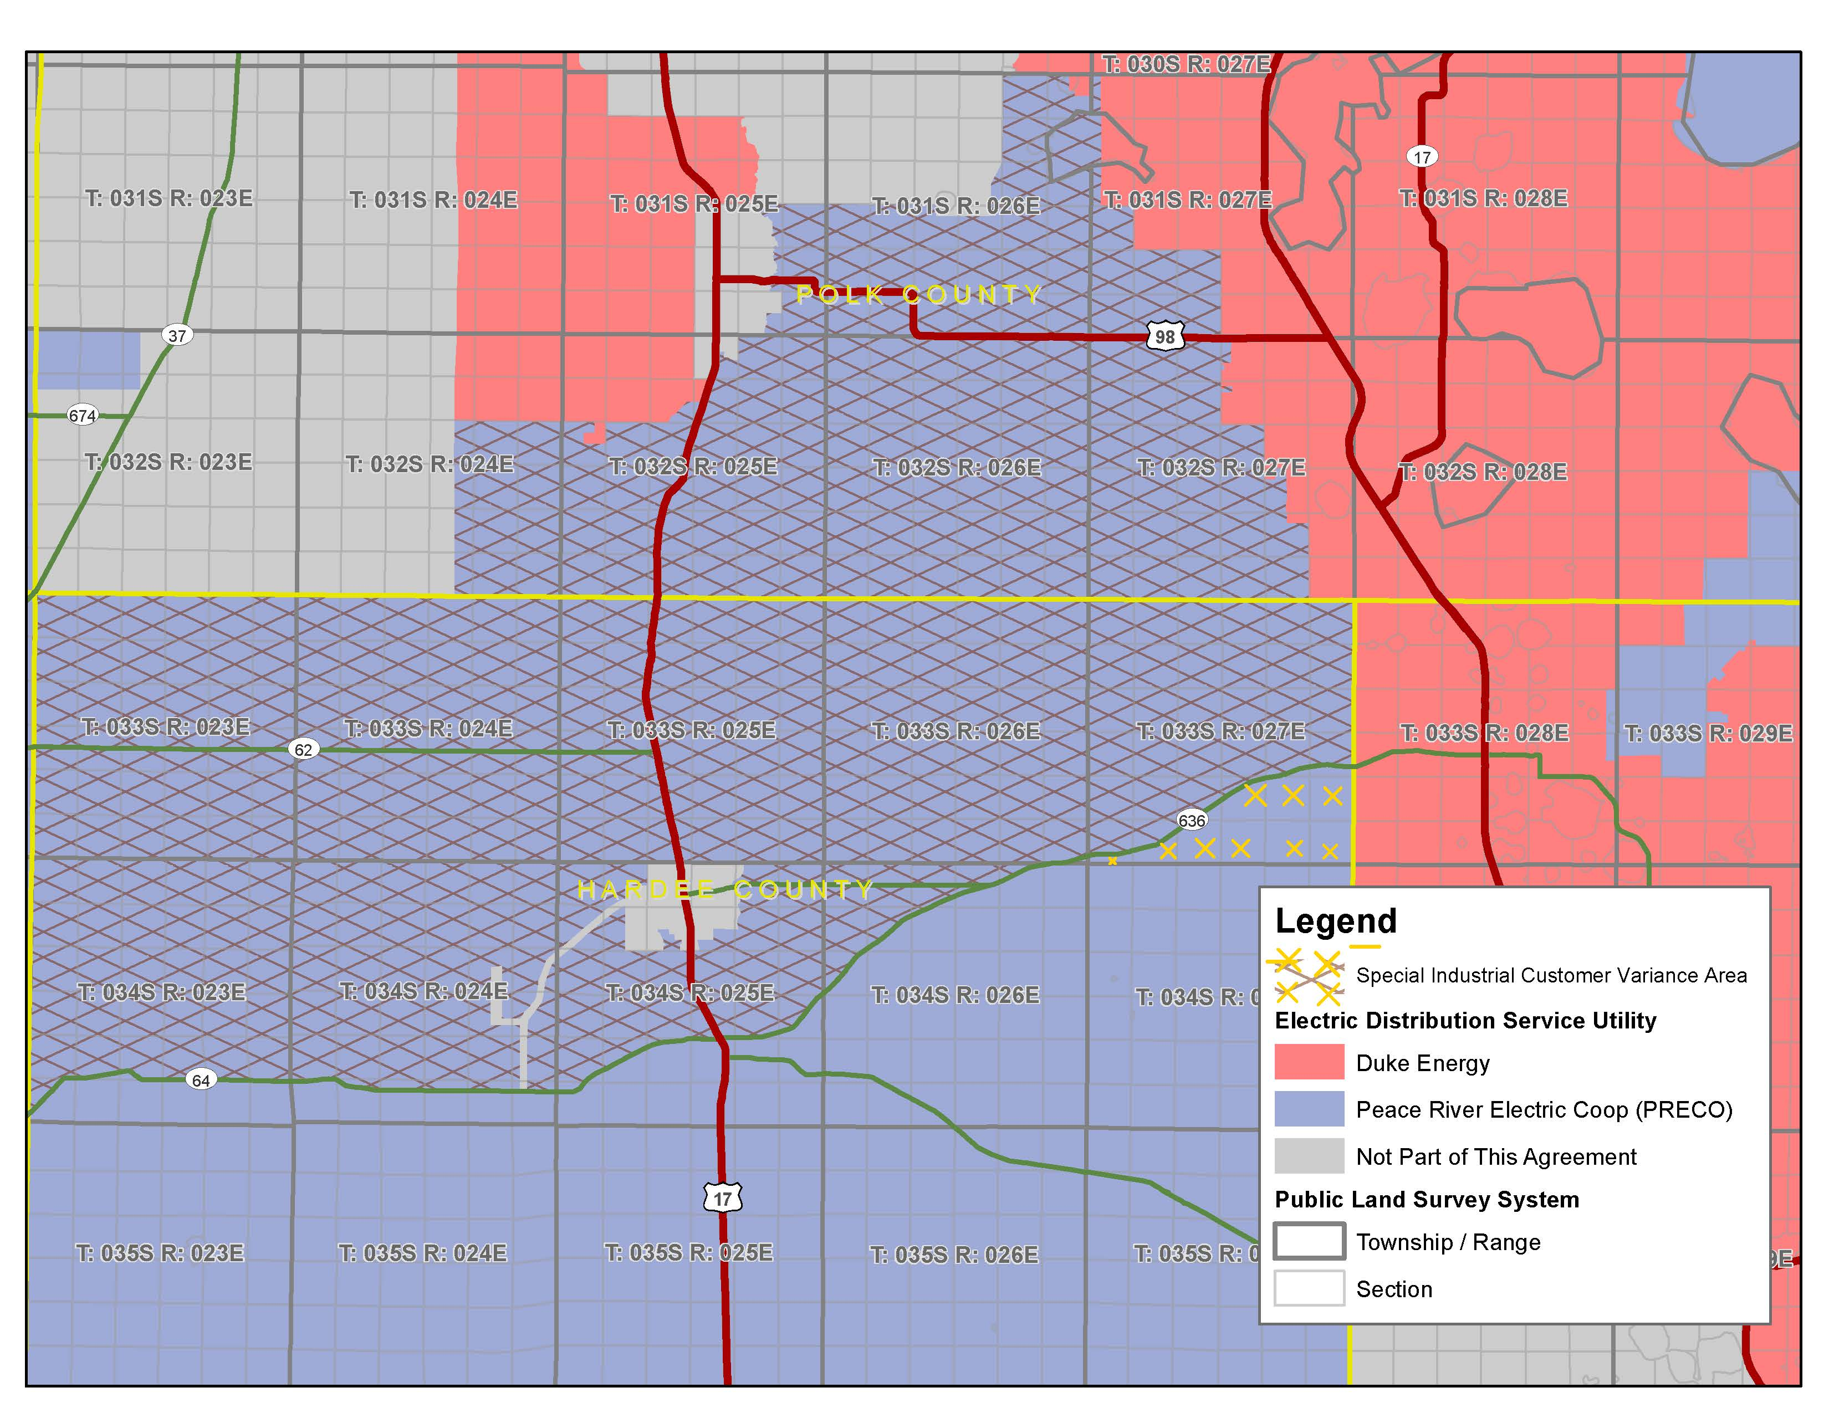

Order No. PSC-94-1522-FOF-EU, issued December 12, 1994, in Docket No. 940376-EU, In re: Joint petition for approval of territorial agreement between Florida Power Corporation and Peace River Electric Cooperative, Inc.
Order No. PSC-06-0673-PAA-EU, issued August 7, 2006, in Docket No. 060277-EU, In re: Joint petition for approval of territorial amendment in Polk, Hardee, Highlands, Manatee, and Osceola Counties by Progress Energy Florida, Inc. and Peace River Electric Cooperative, Inc.
Order No. PSC-2019-0048-PAA-EU, issued January 28, 2019, in Docket No. 20180159-EU, In re: Joint petition for approval of amendment to territorial agreement in Hardee, Highlands, Polk, and Osceola Counties, by Peace River Electric Cooperative and Duke Energy Florida, LLC.
Order No. PSC-2023-0127-PCO-EU, issued April 12, 2023, in Docket No. 20230035-EU, In re: Joint petition for approval of temporary territorial variance, by Duke Energy Florida, LLC and Peace River Electric Cooperative, Inc.

