BEFORE THE FLORIDA PUBLIC SERVICE COMMISSION

In re: Petition for approval of Amendment No. 1 to Escambia County firm gas transportation service agreement with Florida Public Utilities Company to reflect construction of additional delivery point, by Peninsula Pipeline Company, Inc. | DOCKET NO. 20230050-GU  ORDER NO. PSC-2023-0256-PAA-GU  ISSUED: August 21, 2023

The following Commissioners participated in the disposition of this matter:

ANDREW GILES FAY, Chairman
ART GRAHAM
GARY F. CLARK
MIKE LA ROSA
GABRIELLA PASSIDOMO

NOTICE OF PROPOSED AGENCY ACTION
ORDER APPROVING AN AMENDMENT TO A FIRM TRANSPORTATION AGREEMENT BETWEEN FLORIDA PUBLIC UTILITIES COMPANY AND PENINSULA PIPELINE COMPANY, INC.

BY THE COMMISSION:

NOTICE is hereby given by the Florida Public Service Commission that the action discussed herein is preliminary in nature and will become final unless a person whose interests are substantially affected files a petition for a formal proceeding, pursuant to Rule 25-22.029, Florida Administrative Code (F.A.C.).

Background
On April 12, 2023, Peninsula Pipeline Company, Inc. (Peninsula) filed a petition seeking approval of amendment No. 1 to Escambia County firm transportation service agreement (amendment) between Peninsula and Florida Public Utilities Company (FPUC) (collectively, the parties).
The purpose of the amendment is to revise certain provisions of the firm transportation service agreement, dated January 1, 2018, to reflect the construction of an additional point of delivery on the original project and to revise the monthly reservation charge to include the new point of delivery. Peninsula operates as an intrastate natural gas transmission company as defined by Section 368.103(4), Florida Statutes (F.S). FPUC is a local distribution company (LDC) subject to our regulatory jurisdiction pursuant to Chapter 366, F.S.
The firm transportation agreement was approved by us in 2018 and provided for Peninsula to construct an interconnection between Peninsula and Florida Gas Transmission’s (FGT) interstate pipeline at the northernmost edge of Escambia County. From the interconnection with FGT, the pipeline constructed by Peninsula extends approximately 33 miles south and delivers natural gas to FPUC’s distribution system. The pipeline was constructed to provide transportation service to an industrial customer, Pensacola Energy, and provide FPUC opportunities to serve additional customers. Pensacola Energy is a municipal natural gas utility and provides natural gas service to the City of Pensacola and certain other areas in Escambia County.
The 2018 firm transportation service agreement was executed between Peninsula and the Florida Division of Chesapeake Utilities Corporation. In the recent rate case Docket No. 20220067-GU, we approved the consolidation of four natural gas utilities, including the Florida Division of Chesapeake Utilities Corporation, into one utility operating under the name FPUC. As a result of the consolidation, FPUC assumed the 2018 firm transportation service agreement. Due to the timing of the consolidation approved in the rate case, the proposed amendment included in the petition was not dated and signed. On July 17, 2023, the parties filed a fully executed amendment that was dated and signed.
The proposed amendment, as filed on July 17, 2023, and the project map are shown as Attachments A and B to this order. During the evaluation of the petition, our staff issued a data request to the parties for which responses were received on May 11, 2023. We have jurisdiction over this matter pursuant to Sections 366.05(1), 366.06, and 368.105, F.S.

Decision
The parties explained that Pensacola Energy has requested an additional point of delivery to enhance their gas service in the area. Specifically, the proposed project will begin by installing a tap to the existing Peninsula pipeline near the intersection of US 29 and Champion Drive. From this tap, Peninsula will install 510 feet of two-inch pipeline to the new point of delivery. Peninsula states that construction will commence in July 2023 and be completed by September 2023.
The 2018 transportation agreement contains a negotiated monthly reservation charge that reflects Peninsula’s cost to construct and maintain the pipeline constructed in 2018 in Escambia county. The proposed amendment includes the reservation charge approved in the 2018 transportation agreement and an additional amount related to Peninsula’s costs to construct the facilities necessary in response to Pensacola Energy’s request for the additional point of delivery.
The parties stated that the amount associated with the increase in the reservation charge will be solely paid by Pensacola Energy and will not impact FPUC’s general body of ratepayers. We find that is appropriate as Pensacola Energy requested the additional point of delivery. The parties confirmed that Pensacola Energy has been informed of the construction costs and its responsibility to pay FPUC for the additional point of delivery. Finally, the parties assert that the negotiated rates in the amendment meet the requirements of Section 368.105(3), F.S., and are consistent with a market rate in that they are within the range of the rates set forth in similar agreements.
Therefore, we approve the proposed amendment No. 1 to firm transportation agreement dated January 8, 2018, between FPUC and Peninsula. The proposed amendment is reasonable and meets the requirements of Section 368.105, F.S.

Based on the foregoing, it is

ORDERED by the Florida Public Service Commission that the proposed amendment to firm transportation agreement dated January 8, 2018, between Florida Public Utilities Company and Peninsula Pipeline Company, Inc. is hereby approved. It is further

ORDERED that the provisions of this Order, issued as proposed agency action, shall become final and effective upon the issuance of a Consummating Order unless an appropriate petition, in the form provided by Rule 28-106.201, Florida Administrative Code, is received by the Commission Clerk, 2540 Shumard Oak Boulevard, Tallahassee, Florida 32399-0850, by the close of business on the date set forth in the “Notice of Further Proceedings” attached hereto. It is further

ORDERED that in the event this Order becomes final, this docket shall be closed.
By ORDER of the Florida Public Service Commission this 21st day of August, 2023.

ADAM J. TEITZMAN
Commission Clerk
Florida Public Service Commission
2540 Shumard Oak Boulevard
Tallahassee, Florida 32399
(850) 413-6770
www.floridapsc.com

Copies furnished: A copy of this document is provided to the parties of record at the time of issuance and, if applicable, interested persons.

RPS

NOTICE OF FURTHER PROCEEDINGS OR JUDICIAL REVIEW

The Florida Public Service Commission is required by Section 120.569(1), Florida Statutes, to notify parties of any administrative hearing that is available under Section 120.57, Florida Statutes, as well as the procedures and time limits that apply. This notice should not be construed to mean all requests for an administrative hearing will be granted or result in the relief sought.

Mediation may be available on a case-by-case basis. If mediation is conducted, it does not affect a substantially interested person's right to a hearing.

The action proposed herein is preliminary in nature. Any person whose substantial interests are affected by the action proposed by this order may file a petition for a formal proceeding, in the form provided by Rule 28-106.201, Florida Administrative Code. This petition must be received by the Office of Commission Clerk, 2540 Shumard Oak Boulevard, Tallahassee, Florida 32399-0850, by the close of business on September 11, 2023.

In the absence of such a petition, this order shall become final and effective upon the issuance of a Consummating Order.

Any objection or protest filed in this/these docket(s) before the issuance date of this order is considered abandoned unless it satisfies the foregoing conditions and is renewed within the specified protest period.

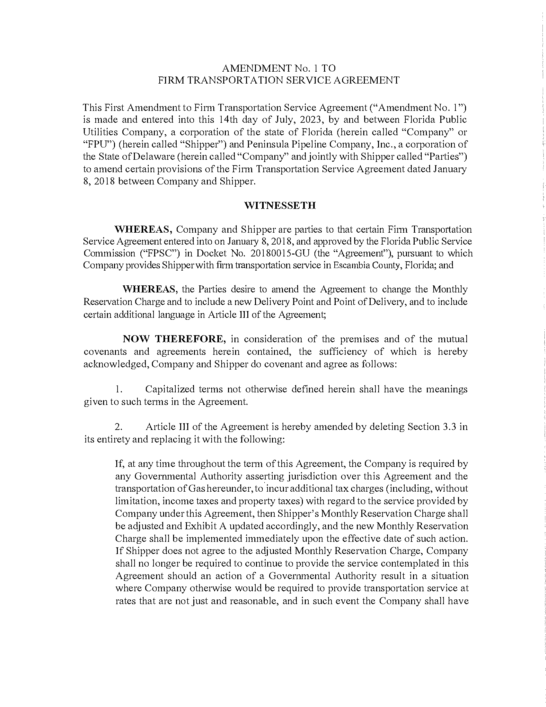

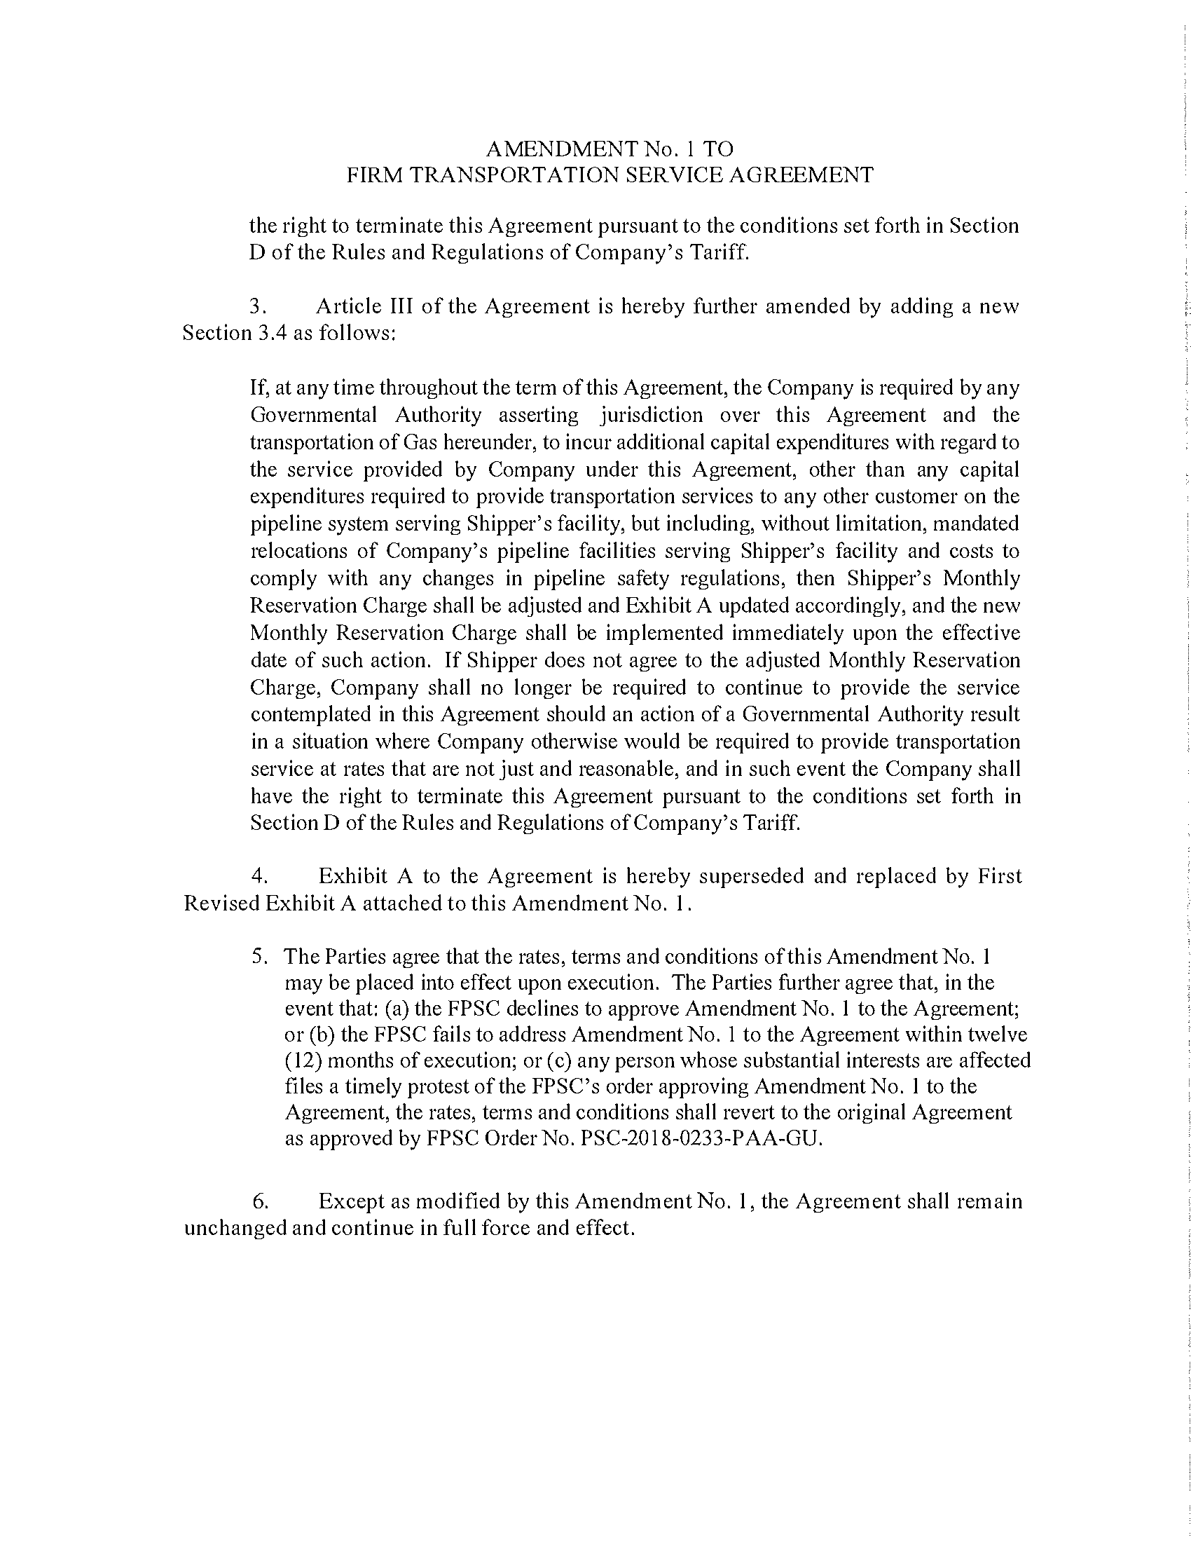

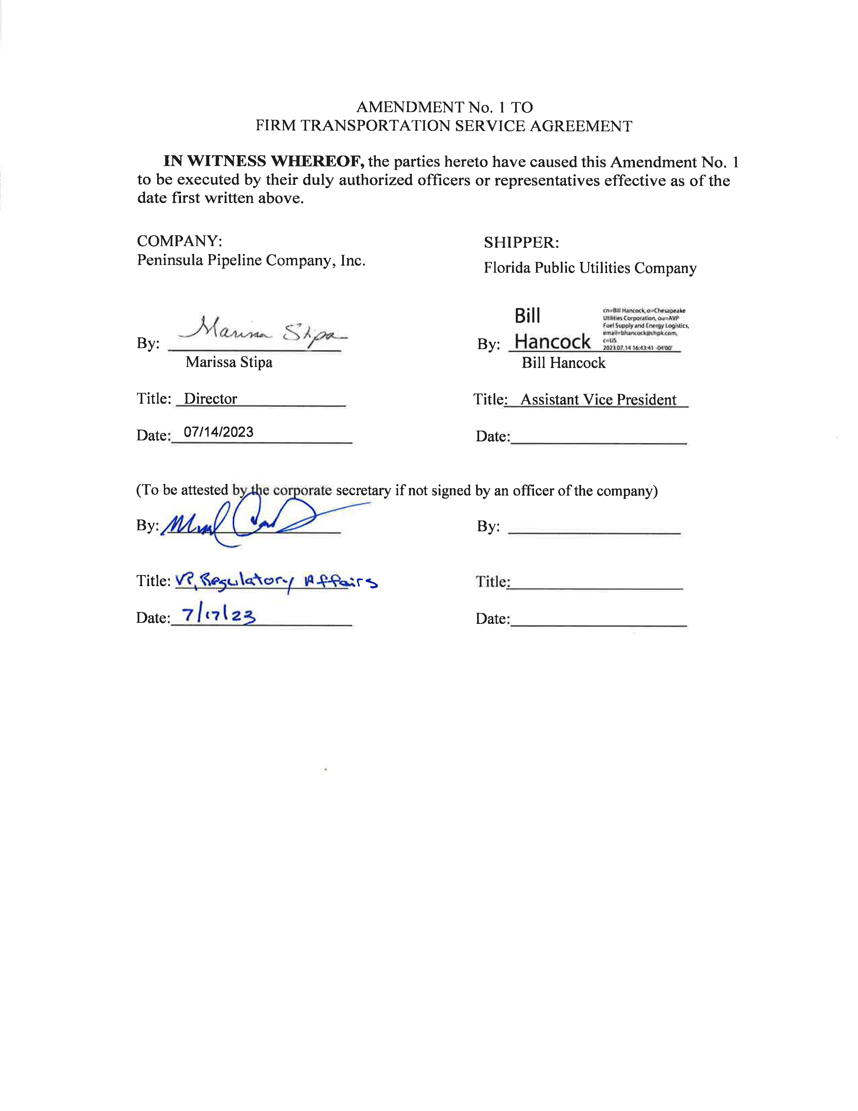

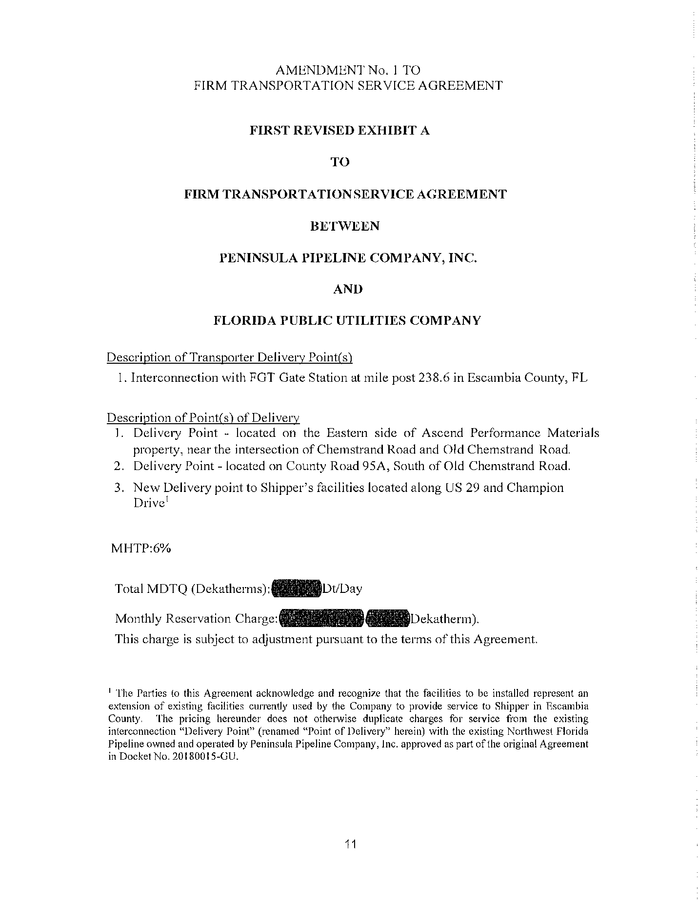

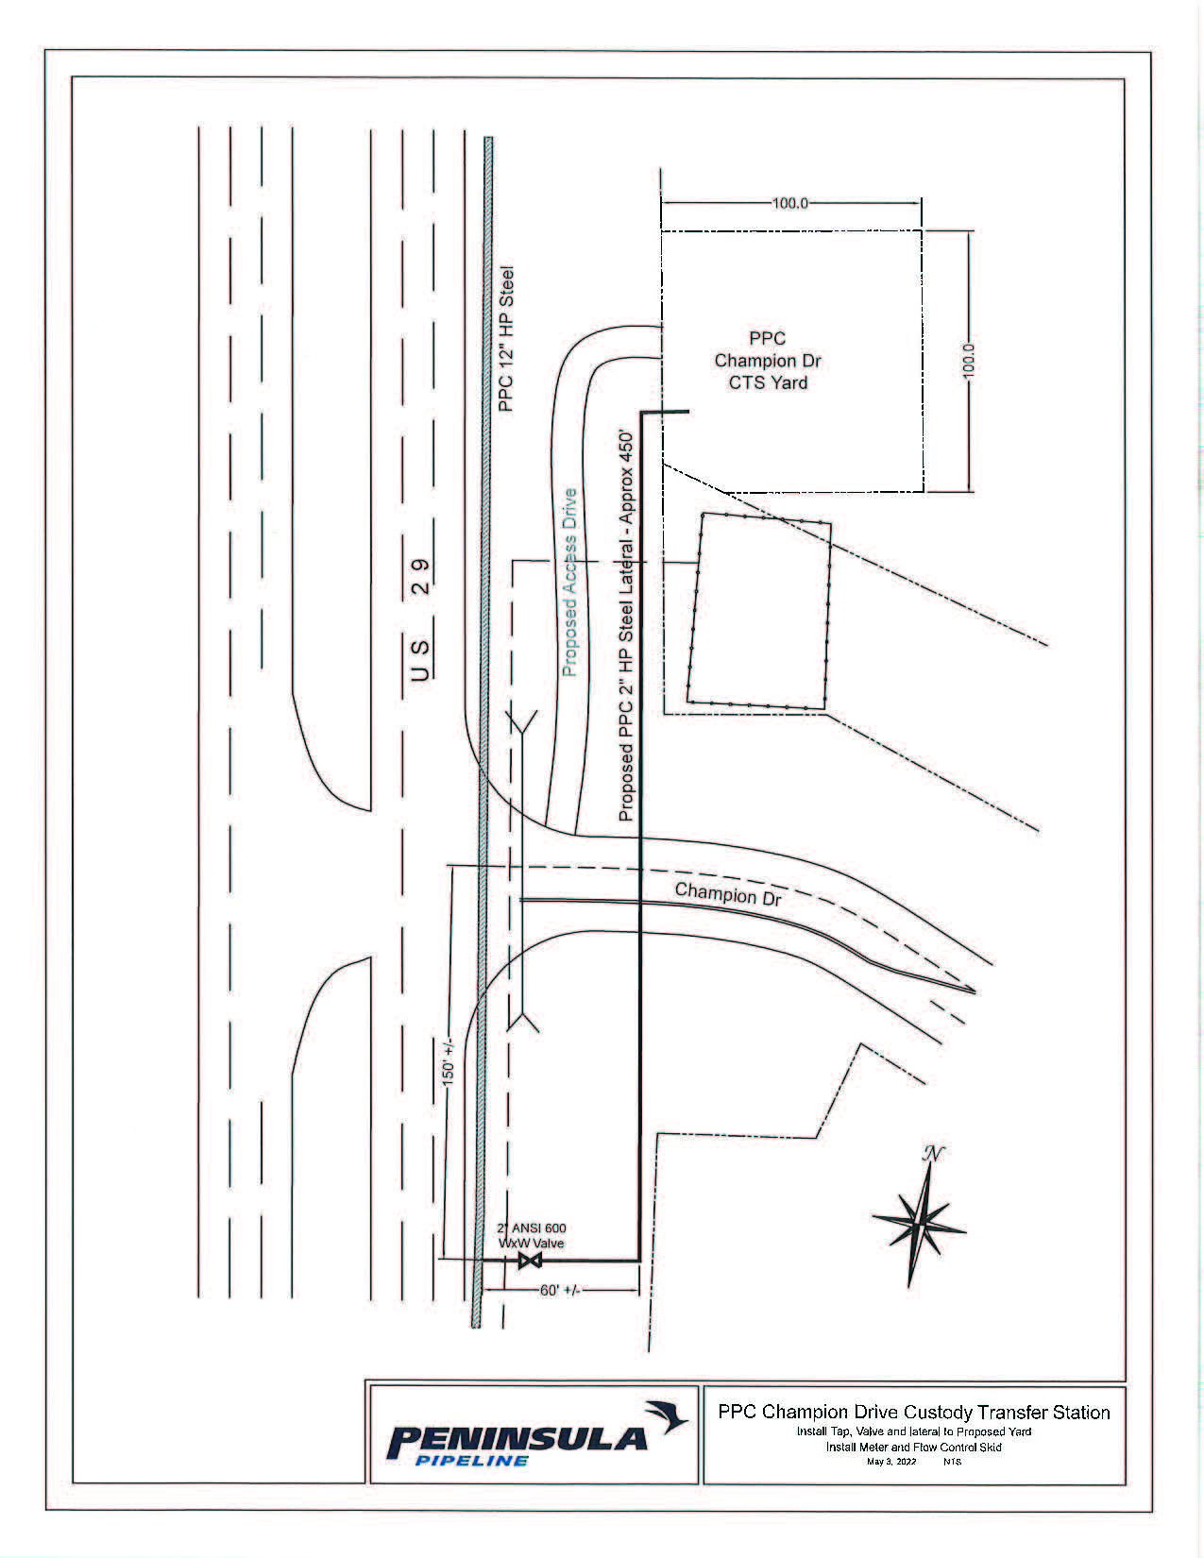

Order No. PSC-06-0023-DS-GP, issued January 9, 2006, in Docket No. 050584-GP, In re: Petition for declaratory statement by Peninsula Pipeline Company, Inc. concerning recognition as a natural gas transmission company under Section 368.101, F.S., et seq.
Order No. PSC-2018-0233-PAA-GU, issued May 8, 2018, in Docket No. 20180015-GU, In re: Petition for approval of transportation service agreement with Florida Division of Chesapeake Utilities Corporation, by Peninsula Pipeline Company, Inc.
Order No. PSC-2023-0103-FOF-GU, issued March 15, 2023, in Docket No. 20220067-GU, In re: Petition for rate increase by Florida Public Utilities Company, Florida Division of Chesapeake Utilities Corporation, Florida Public Utilities Company - Fort Meade, and Florida Public Utilities Company - Indiantown Division.
Document No. 04101-2023.

