BEFORE THE FLORIDA PUBLIC SERVICE COMMISSION

In re: Bankruptcy cancellation of CLEC Certificate No. 8867 issued to Discount CLEC Services Corporation. | DOCKET NO. 20230093-TX  ORDER NO. PSC-2023-0317-PAA-TX  ISSUED: October 20, 2023

The following Commissioners participated in the disposition of this matter:

ANDREW GILES FAY, Chairman
ART GRAHAM
GARY F. CLARK
MIKE LA ROSA
GABRIELLA PASSIDOMO

NOTICE OF PROPOSED AGENCY ACTION
ORDER CANCELLING COMPETITIVE LOCAL EXCHANGE
TELECOMMUNICATIONS COMPANY CERTIFICATE
AND SERVICE SCHEDULE DUE TO BANKRUPTCY
ON THE COMMISSION’S OWN MOTION

BY THE COMMISSION:

NOTICE is hereby given by the Florida Public Service Commission that the action discussed herein is preliminary in nature and will become final unless a person whose interests are substantially affected files a petition for a formal proceeding, pursuant to Rule 25-22.029, Florida Administrative Code (F.A.C.).

Case Background
This order addresses a telecommunications company with an active certificate of authority that has completed Chapter 7 bankruptcy proceedings. In a Chapter 7 bankruptcy proceeding, the company stops all operations and goes completely out of business.
Pursuant to Section 364.335(2), Florida Statutes (F.S.), applicants for certificates of authority must “. . . ensure continued compliance with applicable business formation, registration, and taxation provisions of law.” A liquidated company would be unable to comply with these requirements.
Discount CLEC Services Corporation currently holds CLEC Certificate No. 8867, issued by the Commission on July 24, 2015. The company filed for Chapter 11 bankruptcy on September 14, 2016. On March 21, 2017, the bankruptcy type was converted to Chapter 7 bankruptcy, and on July 27, 2018, the case was decreed to have been fully administered.
The Commission has jurisdiction over this matter pursuant to Chapter 364, including Sections 364.01 and 364.335, F.S.

Analysis and Decision

The Public Access to Court Electronic Records system shows that Discount CLEC Services Corporation completed a Chapter 7 bankruptcy liquidation on July 27, 2018. According to the U.S. Securities and Exchange Commission, “(U)nder Chapter 7, the company stops all operations and goes completely out of business. A trustee is appointed to "liquidate" (sell) the company's assets and the money is used to pay off the debt, which may include debts to creditors and investors.”, A company that has undergone Chapter 7 bankruptcy proceedings will no longer be able to serve its customers or meet its obligation to maintain continued compliance with applicable business formation, registration, and taxation provisions of law.
The Florida Department of State, Division of Corporations website shows that the company filed its last annual report on October 30, 2018, and the company’s status is listed as “inactive” as of September 27, 2019. The Federal Communications Commission Form 499 Filer Database lists the company as no longer active as of March 31, 2018.,
Discount CLEC Services Corporation did not have any outstanding Regulatory Assessment Fees (RAFs) when its bankruptcy was converted to a Chapter 7 proceeding. Upon notification that a company has entered into a Chapter 7 bankruptcy case, the Commission ceases to bill for RAFs, because RAFs owed are not secured debts and, as a practical matter, are uncollectible.
We hereby cancel Discount CLEC Services Corporation’s CLEC certificate and service schedules (if any) due to the company’s Chapter 7 bankruptcy liquidation effective upon the issuance of a final order in this docket.

Based on the foregoing, it is

ORDERED by the Florida Public Service Commission that Discount CLEC Services Corporation’s CLEC Certificate No. 8867 and service schedules (if any) are hereby cancelled and its status changed to “cancelled” in the Master Commission Directory, and that Discount CLEC Services Corporation shall immediately cease and desist providing telecommunications services in Florida. It is further

ORDERED that the provisions of this Order, issued as proposed agency action, shall become final and effective upon the issuance of a Consummating Order unless an appropriate petition, in the form provided by Rule 28-106.201, Florida Administrative Code, is received by the Commission Clerk, 2540 Shumard Oak Boulevard, Tallahassee, Florida 32399-0850, by the close of business on the date set forth in the “Notice of Further Proceedings” attached hereto. It is further

ORDERED that that if no person whose substantial interests are affected by this Proposed Agency Action files a protest within 21 days of the issuance of this Order, this docket should be closed upon the issuance of a Consummating Order.

By ORDER of the Florida Public Service Commission this 20th day of October, 2023.

/s/ Adam J. Teitzman
ADAM J. TEITZMAN
Commission Clerk
Florida Public Service Commission
2540 Shumard Oak Boulevard
Tallahassee, Florida 32399
(850) 413-6770
www.floridapsc.com

Copies furnished: A copy of this document is provided to the parties of record at the time of issuance and, if applicable, interested persons.

TPS

NOTICE OF FURTHER PROCEEDINGS OR JUDICIAL REVIEW

The Florida Public Service Commission is required by Section 120.569(1), Florida Statutes, to notify parties of any administrative hearing that is available under Section 120.57, Florida Statutes, as well as the procedures and time limits that apply. This notice should not be construed to mean all requests for an administrative hearing will be granted or result in the relief sought.

Mediation may be available on a case-by-case basis. If mediation is conducted, it does not affect a substantially interested person's right to a hearing.

The action proposed herein is preliminary in nature. Any person whose substantial interests are affected by the action proposed by this order may file a petition for a formal proceeding, in the form provided by Rule 28-106.201, Florida Administrative Code. This petition must be received by the Office of Commission Clerk, 2540 Shumard Oak Boulevard, Tallahassee, Florida 32399-0850, by the close of business on November 13, 2023.

In the absence of such a petition, this order shall become final and effective upon the issuance of a Consummating Order.

Any objection or protest filed in this/these docket(s) before the issuance date of this order is considered abandoned unless it satisfies the foregoing conditions and is renewed within the specified protest period.

Discount CLEC Services Corporation
United States Bankruptcy Court
Final Decree

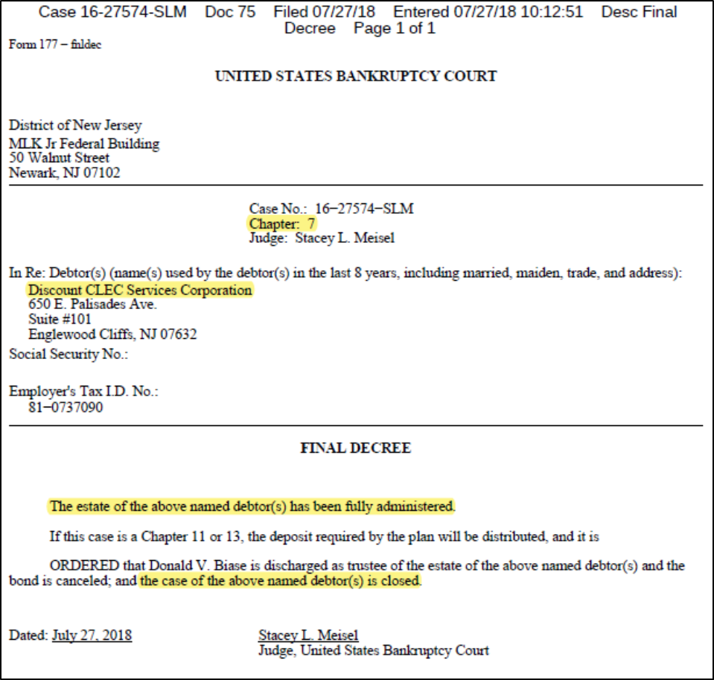

U.S. Securities and Exchange Commission, “Bankruptcy: What Happens When Public Companies Go Bankrupt,” modified January 19, 2016, https://www.sec.gov/reportspubs/investor-publications/investorpubsbankrupthtm.html, accessed August 11, 2023.
See Attachment A.
U.S. Securities and Exchange Commission, “Bankruptcy: What Happens When Public Companies Go Bankrupt,” modified January 19, 2016, https://www.sec.gov/reportspubs/investor-publications/investorpubsbankrupthtm.html, accessed August 11, 2023.
See 11 U.S.C. §721.
Florida Department of State Division of Corporations, Sunbiz Corporate Records Search, https://dos.myflorida.com/sunbiz/, accessed August 25, 2023.
FCC Form 499 is used to facilitate the quarterly and annual revenue reporting requirements for telecommunications companies. The FCC Form 499 Filer Database is a compilation of all telecommunications companies that are required to file either Form 499-Q or Form 499-A. It contains company information such as the company’s name, address, designated agent, and jurisdictions in which it provides service.
FCC, “FCC Form 499 Filer Database Detailed Information,” updated August 18, 2023, https://apps.fcc.gov/cgb/form499/499detail.cfm?FilerNum=832119, accessed August 25, 2023.

