State of Florida |  | Public Service Commission  Capital Circle Office Center ● 2540 Shumard Oak Boulevard  Tallahassee, Florida 32399-0850  -M-E-M-O-R-A-N-D-U-M-
DATE: | October 27, 2023
TO: | Office of Commission Clerk (Teitzman)
FROM: | Division of Accounting and Finance (Norris)  Division of Economics (Hampson)  Office of the General Counsel (Stiller, Dose)
RE: | Docket No. 20230017-EI – Petition for limited proceeding for recovery of incremental storm restoration costs related to Hurricanes Ian and Nicole, by Florida Power & Light Company.
AGENDA: | 11/09/23 – Regular Agenda – Interested Persons May Participate
COMMISSIONERS ASSIGNED: |  |  | All Commissioners
PREHEARING OFFICER: |  |  | Graham
CRITICAL DATES: |  |  | None
SPECIAL INSTRUCTIONS: |  |  | None

Case Background
By Order issued March 23, 2023, the Commission approved Florida Power & Light Company’s (FPL or Company) petition for a limited proceeding seeking authority to implement an interim storm restoration recovery charge to recover $1.3 billion for the incremental restoration costs related to Hurricanes Ian and Nicole and to replenish the storm reserve. This amount included $18.8 million in interest.
The Commission also approved the alternate storm charge calculation FPL proposed in its petition, which combined the recovery of incremental storm costs associated with Hurricanes Ian and Nicole with the remaining amounts to be collected for Hurricanes Michael, Sally, and Zeta, which have been previously approved by the Commission for Gulf Power Company (GPC). This alternate calculation estimated a total of $1.5 billion for incremental restoration costs related to Hurricanes Michael, Sally, Zeta, Ian, and Nicole, to replenish the storm reserve, and included $21.6 million in interest. FPL filed its petition pursuant to the provisions of the 2021 Settlement Agreement (2021 Settlement) approved by the Commission in Order No. PSC-2021-0446-S-EI.
On September 5, 2023, FPL filed a supplemental petition to reduce the interim storm surcharge based on its internal review and finalization of the invoices and storm costs associated with Hurricanes Ian and Nicole. As a result of this internal process, the estimated incremental storm restoration cost related to the two storms decreased from the original estimate of $1.3 billion to $1.1 billion. Thus, the total estimate reflected in the alternative storm charge calculation decreased from $1.5 billion to $1.3 billion. FPL has proposed amended reduced interim storm restoration charges applicable to all rate classes, effective with the first billing cycle of January 2024 and continuing through March 2024, subject to a final true-up.
The Commission has jurisdiction over this matter pursuant to Sections 366.04, 366.05, 366.06, and 366.076, Florida Statutes.

Discussion of Issues

Issue 1:
Should the Commission authorize FPL to implement an amended interim storm restoration recovery charge?

Recommendation:
Yes. The Commission should authorize FPL to implement an amended interim storm restoration recovery charge, subject to refund. Once the total actual storm costs are known, FPL should be required to file documentation of the storm costs for Commission review and true up of any excess or shortfall. (Norris)

Staff Analysis:
As stated in the Case Background, FPL filed a supplemental petition to reduce the interim storm surcharge based on its internal review and finalization of the invoices and storm costs associated with Hurricanes Ian and Nicole. As a result of this internal process, the estimated incremental storm restoration cost related to the two storms decreased from the original estimate of $1.3 billion to $1.1 billion. Thus, the estimate of total costs reflected in the alternative storm charge calculation decreased from $1.5 billion to $1.3 billion. Included in that total is FPL’s request to replenish the storm reserve to the pre-storm level of $219.9 million.
The initial interim petition was filed pursuant to the provisions of the 2021 Settlement approved by the Commission in Order No. PSC-2021-0446-S-EI. Storm restoration costs for Ian and Nicole were incurred during the term of the 2021 Settlement. Based on the updated estimates for the two storms, the current interim storm surcharge would result in an over-recovery of approximately $200 million if allowed to remain effective through March 2024.
The approval of an interim storm restoration recovery charge is preliminary in nature and is subject to refund pending further review once the total actual storm restoration costs are known. After the actual costs are reviewed for prudence and reasonableness, and are compared to the actual amount recovered through the interim storm restoration recovery charge, a determination will be made whether any over/under recovery has occurred. The disposition of any over/under recovery, and associated interest, will be considered by the Commission at a later date. However, staff recommends amending the interim storm surcharge to reflect the known and measurable changes identified by the Company in advance of the final disposition.
Based on a review of the information provided by FPL in its supplemental petition, staff recommends that the Commission authorize the Company to implement an amended interim storm restoration recovery charge subject to refund. Once the total actual storm costs are known, FPL should be required to file documentation of the storm costs for Commission review and true-up of any excess or shortfall.

Issue 2:
Should the Commission approve FPL’s proposed amended interim storm restoration recovery charge tariff as shown in Attachment A to the recommendation?

Recommendation:
Yes. The Commission should approve FPL’s proposal to revise the interim storm restoration recovery surcharges and associated tariff, as shown in Attachment A to this recommendation. The tariff should become effective the first billing cycle of January 2024. The interim storm restoration surcharges should be subject to final true-up once the final total actual storm-related costs are known and filed. (Hampson)

Staff Analysis:
FPL has proposed to decrease the currently effective interim storm restoration recovery surcharges based on the Company’s internal review of storm costs, as discussed in Issue 1. In paragraph 10 of the petition, FPL states that the updated surcharges are allocated to the rate classes consistent with the rate design approved in FPL’s most recent rate case. Staff has reviewed the allocation to rate classes and believes that the allocations provided in Appendix D to the petition are consistent with those approved in FPL’s most recent rate case. Furthermore, staff has reviewed the derivation of the surcharges provided in Appendix D to the petition. Staff agrees that the surcharges have been calculated correctly, using projected kilowatt hour (kWh) sales for January through March 2024. The proposed interim storm restoration recovery factors should remain in effect until a final true-up is approved by the Commission.
The proposed interim storm restoration surcharges are shown on First Revised Tariff Sheet No. 8.030.7, provided in Appendix F to the petition. For residential customers the proposed surcharge would be 0.665 cents per kWh, which equates to a total surcharge of $6.65 for a 1,000 kWh monthly bill. The current surcharge is 1.53 cents per kWh, which equates to a total surcharge of $15.30 for a 1,000 kWh monthly bill. The storm cost recovery surcharge would be included in the non-fuel energy charge on customer bills.
Staff recommends that the Commission approve FPL’s proposal to revise the interim storm restoration recovery surcharges and associated tariff, as shown in Attachment A to this recommendation. The tariff should become effective the first billing cycle of January 2024. The proposed interim storm restoration recovery factors should remain in effect until a final true-up is approved by the Commission. The interim storm restoration surcharges should be subject to final true-up once the final total actual storm-related costs are known and filed.

Issue 3:
Should this docket be closed?

Recommendation:
No. This docket should remain open pending final reconciliation of actual recoverable storm costs with the amount collected pursuant to the interim storm restoration recovery charge and the calculation of a refund or additional charge if warranted. (Stiller)

Staff Analysis:
No, this docket should remain open pending final reconciliation of actual recoverable storm costs with the amount collected pursuant to the interim storm restoration recovery charge and the calculation of a refund or additional charge if warranted.

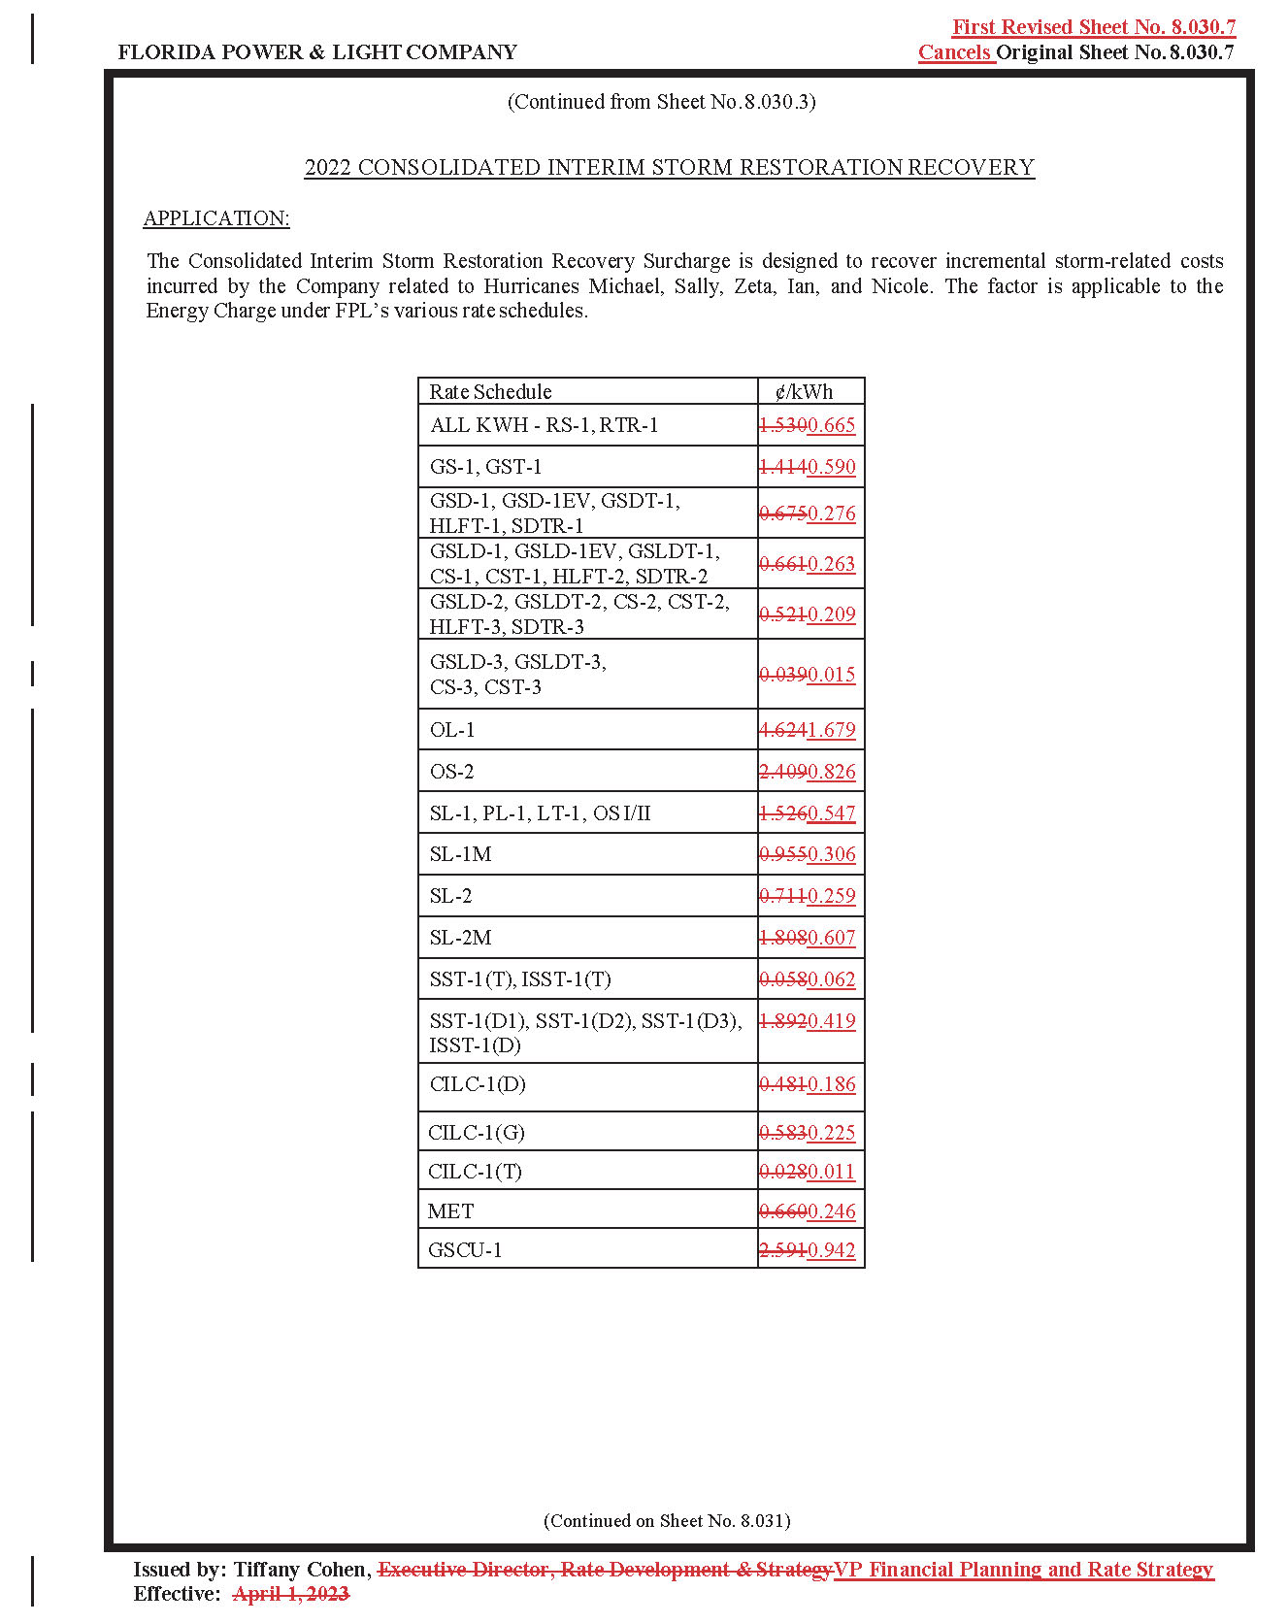

Order No. PSC-2023-0110-PCO-EI, issued March 23, 2023, in Docket No. 20230017-EI, In re: Petition for limited proceeding for recovery of incremental storm restoration costs related to Hurricanes Ian and Nicole, by Florida Power & Light Company.
Order No. PSC-2019-0221-PCO-EI, issued June 3, 2019, in Docket No. 20190038-EI, In re: Petition for limited proceeding for recovery of incremental storm restoration costs related to Hurricane Michael, by Gulf Power Company; and Order No. PSC-2022-0406-FOF-EI, issued November 21, 2022, in Docket No. 20200041-EI, In re: Petition for limited proceeding for recovery of incremental storm restoration costs related to Hurricane Sally, by Gulf Power Company.
Order No. PSC-2021-0446-S-EI, issued December 2, 2021, in Docket No. 20210015-EI, In re: Petition for rate increase by Florida Power & Light Company.
Order No. PSC-2021-0446-S-EI.

