State of Florida |  | Public Service Commission  Capital Circle Office Center ● 2540 Shumard Oak Boulevard  Tallahassee, Florida 32399-0850  -M-E-M-O-R-A-N-D-U-M-
DATE: | October 27, 2023
TO: | Office of Commission Clerk (Teitzman)
FROM: | Division of Economics (McClelland, Hampson)  Office of the General Counsel (Watrous)
RE: | Docket No. 20230096-GU – Petition for approval of swing service rider rates for January through December 2024, by Florida Public Utilities Company.
AGENDA: | 11/09/23 – Regular Agenda – Tariff Filing – Interested Persons May Participate
COMMISSIONERS ASSIGNED: |  |  | All Commissioners
PREHEARING OFFICER: |  |  | Administrative
CRITICAL DATES: |  |  | 04/29/24 (8-Month Effective Date)
SPECIAL INSTRUCTIONS: |  |  | None

Case Background
On August 29, 2023, Florida Public Utilities Company (FPUC or utility) filed a petition for approval of revised swing service rider rates and associated tariffs for the period January through December 2024. The swing service rider is a cents per therm charge that is included in the monthly gas bill of transportation customers, who purchase gas from third party marketers, and therefore do not pay the Purchased Gas Adjustment (PGA) charge. FPUC is a local natural gas distribution company (LDC) subject to the regulatory jurisdiction of the Commission pursuant to Chapter 366, Florida Statutes (F.S.).
The Commission first approved FPUC’s swing service rider tariff in Order No. PSC-16-0422-TRF-GU (swing service order) and the initial swing service rider rates were in effect for the period March through December 2017. As required in the swing service order, FPUC submitted the instant petition with revised 2024 swing service rider rates for Commission approval by September 1, 2023. The January through December 2023 swing service rider rates were approved in Order No. PSC-2022-0378-TRF-GU, conditional on Commission approval of FPUC’s pending rate increase. Following the rate increase, which was approved in Order No. PSC-2023-0103-FOF-GU, the swing service rider tariffs were updated to reflect a change in the rate classes approved in the rate case.
At the October 3, 2023 Agenda, the Commission suspended the proposed swing service rider tariffs for further review by staff. During its evaluation of the petition, staff issued a data request to the utility for which responses were received on September 21, 2023. Staff met with the utility via telephone on October 23, 2023, after which the utility filed a revised response to staff’s first data request. The proposed swing service rider rates and associated tariff revisions are provided in Attachment A to the recommendation. The Commission has jurisdiction over this matter pursuant to Sections 366.03, 366.04, 366.05, and 366.06, Florida Statutes (F.S.).

Discussion of Issues

Issue 1:
Should the Commission approve the utility's proposed swing service rider rates and tariffs for the period January through December 2024?

Recommendation:
Yes. The Commission should approve the utility’s proposed swing service rider rates for the period January through December 2024. The costs included are appropriate and the methodology for calculating the swing service rider rates is consistent with the initial Order approving the tariff. (McClelland, Hampson)

Staff Analysis:
The utility incurs intrastate capacity costs when they transport natural gas on intrastate pipelines (i.e., pipelines operating within Florida only). The utility has two types of natural gas customers: sales and transportation. Sales customers are primarily residential and small commercial customers that purchase natural gas from an LDC and receive allocations of intrastate capacity costs through the Purchased Gas Adjustment (PGA) charge. Transportation customers receive natural gas from third party marketers, known as shippers and, therefore, do not pay the PGA charge to the LDC. The swing service rider allows FPUC to recover allocations of intrastate capacity costs from transportation customers.

Updated 2024 Swing Service Rider Rates
The updated 2024 swing service rider rates were calculated based on the same methodology approved in the 2016 swing service order. As stated in paragraph 7 of the FPUC’s instant petition, the total intrastate capacity costs for the period July 2022 through June 2023 are $31,941,095. The total intrastate capacity costs reflect payments by FPUC to intrastate pipelines for the transportation of natural gas, pursuant to Commission-approved transportation agreements.
The proposed intrastate capacity costs include the purchase of renewable natural gas (RNG) at market price, generated by the New River Solid Waste Association (New River or landfill). New River is a waste management company that owns a landfill that produces methane near Starke, Florida. FPUC purchased the RNG during the period April 2022 through February 2023. New River contracted for the construction of a direct connection pipeline with Florida Gas Transmission facilities; however, the RNG production facilities were completed before the pipeline could deliver RNG to market. Therefore, the landfill’s RNG was undeliverable to market and would have resulted in loss of revenue and Renewable Energy Credits for the landfill. FPUC offered to purchase the gas without the Renewable Energy Credits, and in exchange, the landfill arranged to cover the cost of delivery of the gas via truck to FPUC’s distribution system. New River mitigated potential losses and, as the landfill assumed the costs of delivery, FPUC received a savings of $149,538 on 365,159 dekatherms of gas, which is equivalent to a savings of about $0.05 per dekatherm compared to gas traditionally acquired at market.
In addition, the intrastate capacity costs include payments associated with a software tool to manage customer usage and assist in determining the gas supply and capacity needs for FPUC, legal and consulting fees, and subscription fees to obtain market data and gas daily pricing.
Of these costs, $7,367,169 will be billed directly to certain large special contract customers. The remaining costs of $24,573,927 will be recovered during the period January 1, 2024 through December 31, 2024.
The utility used actual therm usage data for the period July 2022 through June 2023 to allocate the intrastate capacity costs. Based on the usage data, staff agrees that the appropriate split for allocating the cost is 73.49 percent or $18,060,416 to transportation customers and 26.51 percent or $6,513,511 to sales customers. The transportation customers’ share of $18,060,416 is further allocated to the various transportation rate schedules in proportion with each rate schedule’s share of the utility’s total throughput. The sales customers’ share of the cost of $6,513,511 is embedded in the PGA.
To calculate the swing service rider rates, the transportation customers’ share of the cost is allocated to each transportation customer class and then divided by the customer class’ number of therms. The swing service revenues the utility is projected to receive in 2024 totals to $18,060,416.

Credit to the PGA
The total intrastate capacity costs are embedded in the PGA with the projected 2024 swing service rider revenues incorporated as a credit in the calculation of the 2024 PGA. The amount credited to the 2024 PGA is $18,060,416 plus $7,367,169 received from special contract customers, for a total of $25,427,585.

Conclusion
After reviewing the information provided in the petition and in response to staff’s data request, staff recommends that FPUC’s proposed swing service rider reflects the updated cost of swing service for transportation customers. Staff reviewed the total projected intrastate capacity costs and verified that the costs included are appropriate. The Commission should approve the proposed swing service rider rates for the period January through December 2024. The costs included are appropriate and the methodology for calculating the swing service rider rates is consistent with the swing service order.

Issue 2:
Should this docket be closed?

Recommendation:
Yes. If Issue 1 is approved and a protest is filed within 21 days of the issuance of the order, the tariff should remain in effect, with any revenues held subject to refund, pending resolution of the protest. If no timely protest is filed, this docket should be closed upon the issuance of a consummating order. (Watrous)

Staff Analysis:
If Issue 1 is approved and a protest is filed within 21 days of the issuance of the order, the tariff should remain in effect, with any revenues held subject to refund, pending resolution of the protest. If no timely protest is filed, this docket should be closed upon the issuance of a consummating order.

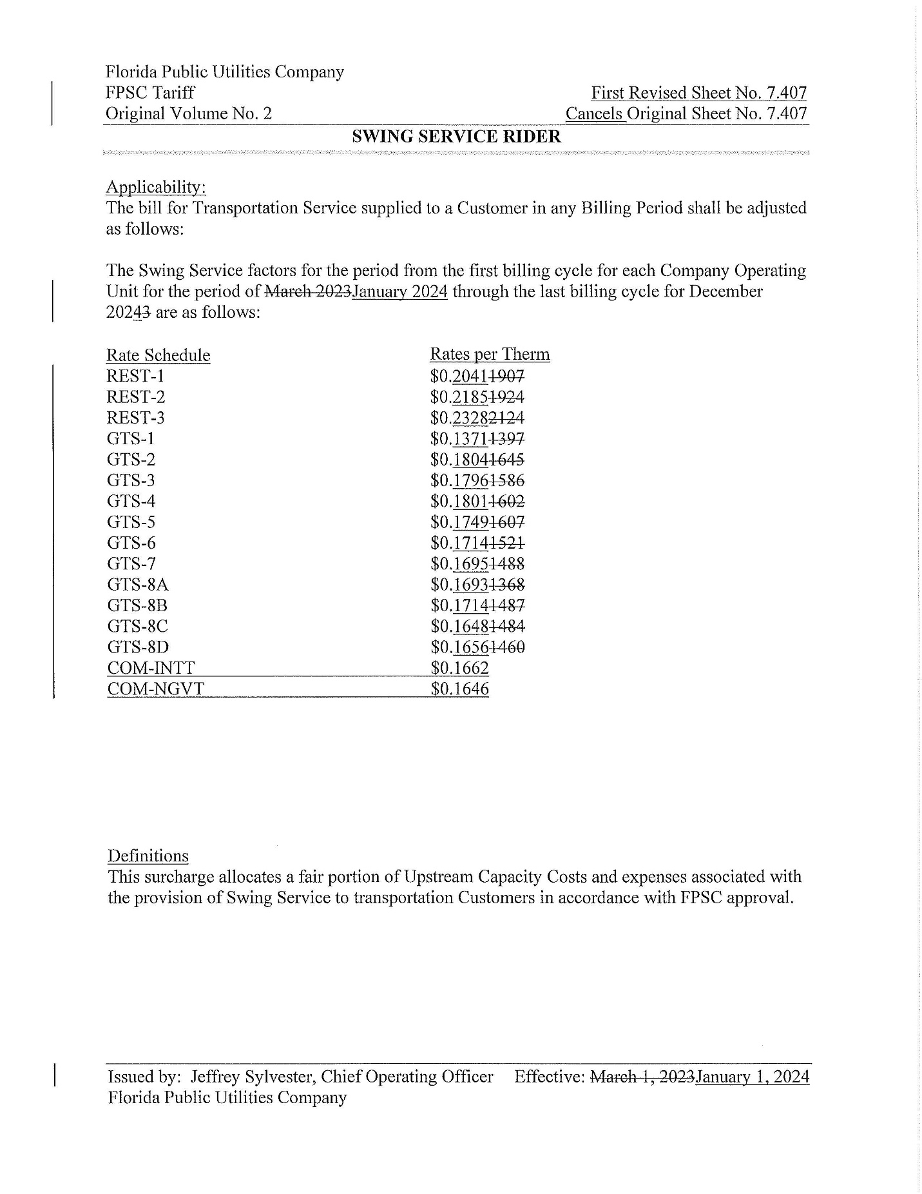

The PGA charge is set by the Commission in the annual PGA cost recovery clause proceeding.
Order No. PSC-16-0422-TRF-GU, issued October 3, 2016, in Docket No. 160085-GU, In re: Joint petition for approval of swing service rider, by Florida Public Utilities Company, Florida Public Utilities Company-Indiantown Division, Florida Public Utilities Company-Fort Meade, and Florida Division of Chesapeake Utilities Corporation.
Order No. PSC-2022-0378-TRF-GU, issued November 7, 2022, Docket No. 20220154-GU, In re: Joint petition for approval of swing service rider rates for January through December 2023, by Florida Public Utilities Company, Florida Public Utilities Company-Indiantown Division, Florida Public Utilities Company-Fort Meade, and Florida Division of Chesapeake Utilities Corporation.
Order No. PSC-2023-0103-FOF-GU, issued March 15, 2023, Docket No. 20220067-GU, In re: Petition for rate increase by Florida Public Utilities Company, Florida Division of Chesapeake Utilities Corporation, Florida Public Utilities Company - Fort Meade, and Florida Public Utilities Company - Indiantown Division.
The Commission does not regulate the shippers or their charges for the gas commodity.
See direct testimony of witness Robert Waruszewski on behalf of FPUC, filed on August 4, 2023, Document No. 04540-2023, in Docket No. 20230003-GU, Exhibit RCW-2, Schedule E-1, line 8 on page 1, and the direct testimony of Robert Waruszewski, page 4, lines 8-9, included in the instant petition.

