|  |  |  |  |
| --- | --- | --- | --- |
| State of Florida  pscSEAL | | Public Service Commission  Capital Circle Office Center ● 2540 Shumard Oak Boulevard Tallahassee, Florida 32399-0850  -M-E-M-O-R-A-N-D-U-M- | |
| DATE: | October 27, 2023 | | |
| TO: | Office of Commission Clerk (Teitzman) | | |
| FROM: | Division of Economics (Guffey)  Division of Accounting and Finance (Mason)  Office of the General Counsel (Dose) | | |
| RE: | Docket No. 20230101-GU – Petition for approval of gas utility access and replacement directive cost recovery factors for January 2024 through December 2024, by Florida Public Utilities Company. | | |
| AGENDA: | 11/09/23 – Regular Agenda – Tariff Filing – Interested Persons May Participate | | |
| COMMISSIONERS ASSIGNED: | | | All Commissioners |
| PREHEARING OFFICER: | | | Administrative |
| CRITICAL DATES: | | | 05/01/24 (8-Month Effective Date) |
| SPECIAL INSTRUCTIONS: | | | None |

Case Background

On September 1, 2023, Florida Public Utilities Company (FPUC or Company) filed a petition for approval of its Gas Utility Access and Replacement Directive (GUARD program) cost recovery factors for January through December 2024. The petition includes the direct testimony and Exhibits RCW-1 and RCW-2 of Robert Waruszewski providing the calculations of the proposed factors.

In Order No. PSC-2023-0235-PAA-GU (GUARD Order), the Commission approved FPUC’s 10-year GUARD program consisting of two components: (1) replacement of problematic pipes and facilities and (2) relocation of mains and service lines located in rear easement and other difficult to access areas to the front lot easements.[1] As established in the GUARD Order, FPUC would be able to recover the revenue requirements of expedited programs to replace problematic pipes and facilities and to relocate certain facilities in rear easements and other difficult to access areas in order to enhance the safety of portions of FPUC’s natural gas distribution system through a monthly surcharge on customers’ bills. The GUARD Order further established the methodology for annually setting the GUARD surcharge to recover the costs of the program.

In 2012, the Commission approved FPUC’s 10-year Gas Reliability and Infrastructure Program (GRIP).[2] The purpose of GRIP was to recover the cost of accelerated replacement of cast iron and bare steel distribution mains and services that are subject to corrosion through a separate surcharge on customers’ bills. In the recently concluded FPUC rate case in Docket No. 20220067-GU, the Company moved $19.8 million of GRIP revenue requirement to rate base.[3] Any remaining GRIP amounts that were not moved into base rates are included in the instant petition in the beginning balance for the GUARD program. The GRIP program was completed in July 2023. The GRIP program was originally scheduled to conclude at the end of December 2022; however, due to some permit delays, approximately 0.5 miles of pipeline were replaced in 2023.

The methodology to calculate the GUARD program surcharges is the same that was approved for the GRIP. The GUARD cost recovery procedure requires an annual filing with three components, similar as those approved in the 2012 GRIP Order:

1. A final true-up showing the actual replacement costs, actual surcharge revenues, and over- or under-recovery amount for the 12-month historical period from January 1 through December 31 of the year prior to FPUC’s annual GUARD petition.

2. An actual/estimated true-up showing seven months of actual and five months of projected replacement costs, surcharge revenues, and over- or under-recovery amount.

3. A revenue requirement projection showing 12 months of projected GUARD revenue requirement for the period beginning January 1 following FPUC’s annual GUARD petition filing.

In the GUARD Order, the Commission directed FPUC to file its annual GUARD program petition to revise the surcharge on or before September 1 of each year, to implement the revised surcharge effective January 1 through December 31 of the following year, and to file its first GUARD cost recovery petition on September 1, 2023. FPUC, in its petition, included revised tariff sheets 7.000 through 7.002 (Index), 7.403, 7.404, and 7.405.

The Commission further ordered FPUC to (1) include all calculations to show a final true-up, actual-estimated true-up, projected year investments and associated revenue requirements, and the calculations of the GUARD factors by rate class, (2) provide a report including the location, date, description, and associated costs of all replacement projects completed and all projects scheduled for the following year, and (3) include any remaining GRIP over- or under-recovery in the 2024 GUARD cost recovery.

FPUC has complied with the GUARD Order directives stated above. Since the GUARD Order established that any remaining GRIP investments that were not included for recovery in base rates in the rate case Docket No. 20220067-GU shall be rolled into the GUARD program for cost recovery, there will be no GRIP surcharge on customers’ bills starting January 1, 2024. Accordingly, the proposed GUARD surcharge would replace the GRIP surcharge. The current 2023 GRIP factors have been approved in Order No. PSC-2022-0401-TRF-GU.[4] Finally, the GUARD Order provided for FPUC to start GUARD program expenditures in April 2023 and request recovery of any 2023 expenditures starting on January 1, 2024.

During the review process, staff issued a data request to FPUC on September 11, 2023, for which the responses were received on September 18, 2023. In Order No. PSC-2023-0304-PCO-GU, the Commission suspended the proposed tariffs. The Commission has jurisdiction over this matter pursuant to Sections 366.04, 366.05, and 366.06, Florida Statutes (F.S.).

Discussion of Issues

Issue :

 Should the Commission approve FPUC's 2024 Gas Utility Access and Replacement Directive (GUARD) cost recovery factors and associated revised tariff sheets (Nos. 7.000 through 7.002, 7.403, 7.404, and 7.405) for the period January to December 2024?

Recommendation:

 Yes. The Commission should approve FPUC's 2024 GUARD cost recovery factors and associated revised tariff sheets (Nos. 7.000 through 7.002, 7.403, 7.404, and 7.405), included in Attachment B, to be effective for the first billing cycle of January through the last billing cycle of December 2024. The GUARD surcharge would allow FPUC to replace problematic pipes and facilities and relocate certain facilities located in rear easements, and recover the project costs on an expedited basis. (Guffey)

Staff Analysis:

 The GRIP surcharges have been in place since 2013 and the GRIP program is complete. As discussed in the GUARD Order, the Company identified additional safety risks and reliability concerns. Specifically, the GUARD program is driven by risks identified under FPUC’s Distribution Integrity Management Program (DIMP)[5] and risk assessments performed by an independent contractor. The prioritized projects for 2023 and 2024 are included in Attachment A to this recommendation. Attachment A indicates that FPUC will replace obsolete/Aldyl-A and certain span pipes, and relocate pipes from rear lot to the street front in Martin, Palm Beach and Seminole counties in 15 projects for an estimated investment of $33 million during 2023 and 2024. As indicated in FPUC’s response to staff’s data request, the selected project areas include existing distribution mains and services that are considered high risk due to, but not limited to, Aldyl-A and vintage plastic pipes, damage due to excavation in rear lots, corrosion, leaks, and inaccessible rear lot facilities.[6]

Remaining GRIP Revenue Requirement

As authorized by the GUARD Order, FPUC included the remaining GRIP investment and the remaining GRIP over- or under-recoveries in the 2024 GUARD cost recovery. Exhibit RCW-1, page 5 of 9, of the petition reflects the GRIP investments from the rate case being removed from the calculations at the end of February 2023 and only reflect the GRIP investments above the amount approved in the rate case ($4,197,096). The GRIP investment approved to be moved into rate base represents the total investment projected at the time of the rate case filing in May 2022. FPUC explained that the actual final GRIP investment was higher than projected, resulting in a remaining GRIP investment of $4,197,096.

The Company has been collecting Commission-approved GRIP factors from its customers in 2022 and 2023. FPUC’s calculations for the 2022 and January – July 2023 GRIP revenue requirement and surcharges include a final GRIP true-up amount for the period ending July 31, 2023 of $332,795 (over-recovery). That over-recovery amount is being applied to the GUARD program in July 2023 (termination date for the GRIP program).

2023 GUARD Revenue Requirement

The Company initiated work on the GUARD program in April 2023. Specifically, the Company explained that in April and May of 2023 activities were related to project material procurement, engineering design, and permitting necessary to start construction activities in June of 2023.

The April through December 2023 GUARD investment and associated revenue requirement amounts are shown on Exhibit RCW-1, page 6 of 9. The forecasted GRIP revenues for the remainder of 2023 exceed the GUARD 2023 revenue requirement, resulting in an over-recovery of $227,566, inclusive of interest of $9,613, for the period April through December 2023. Therefore, the total GUARD true-up, which includes the final over-recovery for GRIP, is $560,361 ($332,795+$227,566), inclusive of interest. As shown in Table 1-1 below, that amount is being applied to the 2024 GUARD revenue requirement, resulting in a lower revenue requirement to be recovered from customers in 2024.

Exhibit RCW-1, page 6 of 9, shows the 2023 year end net book value investment of $16,965,008. This amount represents the final GRIP investment moved into the GUARD program as of July 2023 ($4,347,919) and the 2023 GUARD investment ($12,617,089). That amount is reflected as the beginning balance for the 2024 GUARD calculations discussed below.

Projected 2024 GUARD Revenue Requirement

For 2024, FPUC projects to invest $20,371,485 ($12,415,872 for mains and $7,955,613 for services), resulting in a total projected 2024 investment of $36,783,862 (including the year-end 2023 investment). Similar to the GRIP, the GUARD program revenue requirement includes a return on investment, depreciation expense, customer notification expense, and property taxes; all expenses are dependent upon the level of investment costs. Pursuant to witness Waruszewski’s testimony, the Company also included $49,416 for the 2024 projection period as operating and maintenance costs which are for extending customer-owned downstream fuel lines to connect to meters that are required to be relocated due to safety concerns.[7] After subtracting the $560,361 over-recovery true-up amount, the 2024 GUARD revenue requirement to be recovered through the proposed surcharges is $2,296,223.

Table 1-1

2024 GUARD Revenue Requirement Calculation

|  |  |
| --- | --- |
| **2024 Projected Investment $36,783,862** | |
| Return on Investment | $1,903,237 |
| Depreciation Expense | $552,631 |
| Operations & Maintenance Expense | $49,416 |
| Property Tax Expense | $339,300 |
| Customer Notification Expense | $12,000 |
| 2024 GUARD Revenue Requirement | $2,856,584 |
| Less 2023 Over-Recovery | -$560,361 |
| 2024 Total Revenue Requirement | $2,296,223 |

Source: Witness Waruszewski Testimony Exhibit RCW-1

Proposed GUARD Surcharges

As approved in the GUARD Order, the total 2024 revenue requirement is allocated to the rate classes using the same methodology used for the allocation of mains and services in the cost of service study used in the Company’s most recent rate case. The respective percentages were multiplied by the 2024 revenue requirements and divided by each rate class’s projected therm sales to provide the GUARD surcharge for each rate class. This methodology was originally established by the 2012 Order approving the GRIP program.

The proposed 2024 GUARD surcharge for FPUC’s residential customers who use 20 therms a month (240 therms annually) on the Residential Service tariff (RES-2) would pay $0.03263 per therm compared to the 2023 GRIP surcharge of $0.02166 per therm. The monthly bill impact is $0.65 for a residential customer using 20 therms per month or $7.83 per year. The proposed GUARD surcharges are shown in Attachment B, in Tariff Sheet No. 7.403.

Conclusion

Staff believes the calculation of FPUC’s GUARD revenue requirement and surcharges for each rate class are reasonable and accurate. Staff therefore recommends approval of FPUC’s proposed GUARD surcharges, effective for January 1, 2024. The proposed GUARD surcharge factors should be applied to each rate class during the billing period January 1 through December 31, 2024. Issue 2:

 Should this docket be closed?

Recommendation:

 Yes. If a protest is filed within 21 days of the issuance of the order, the tariffs should remain in effect, with any revenues held subject to refund, pending resolution of the protest. If no timely protest is filed, this docket should be closed upon the issuance of a consummating order. (Dose)

Staff Analysis:

 If a protest is filed within 21 days of the issuance of the order, the tariffs should remain in effect, with any revenues held subject to refund, pending resolution of the protest. If no timely protest is filed, this docket should be closed upon the issuance of a consummating order.



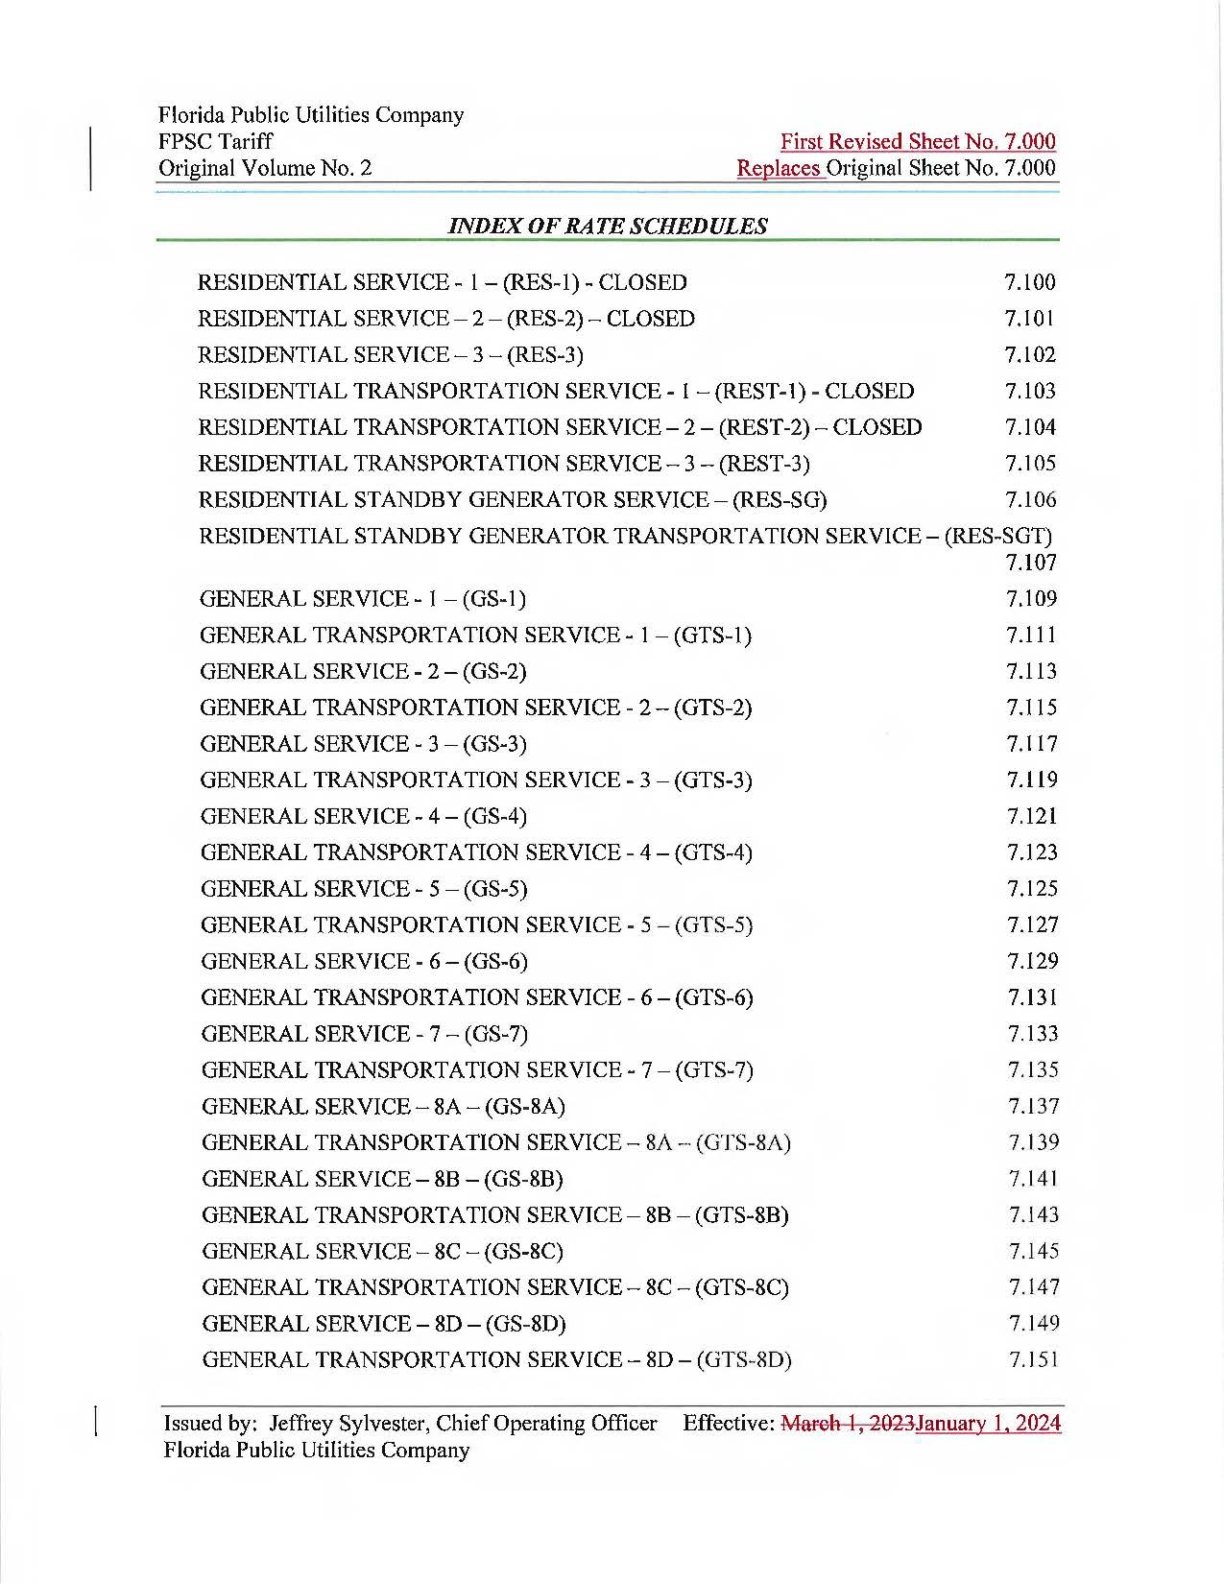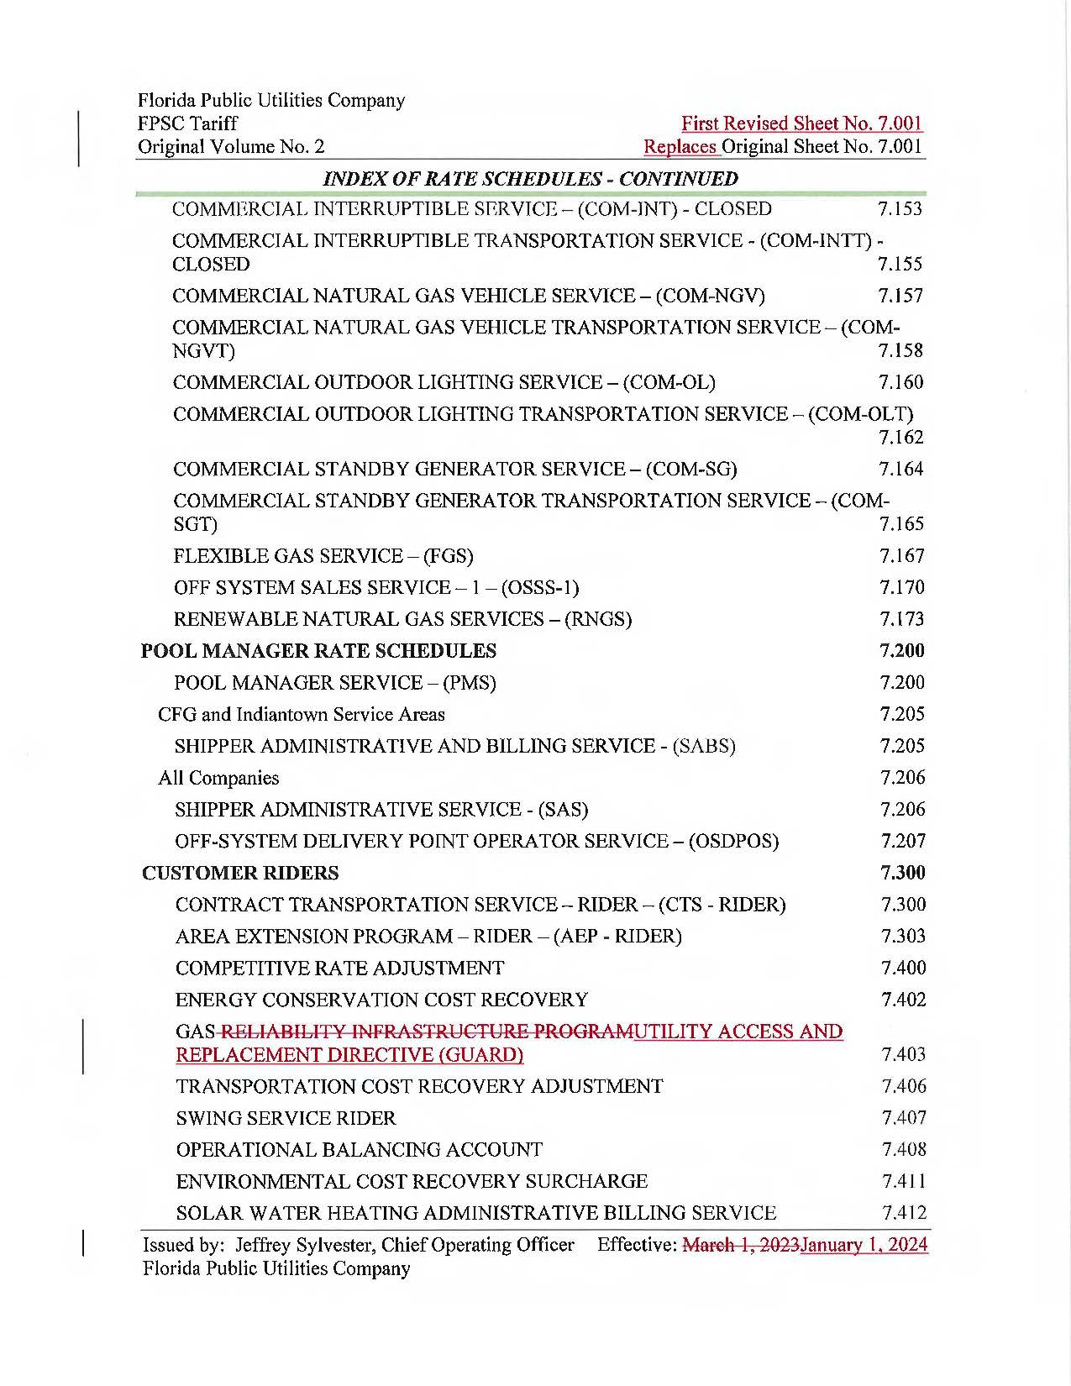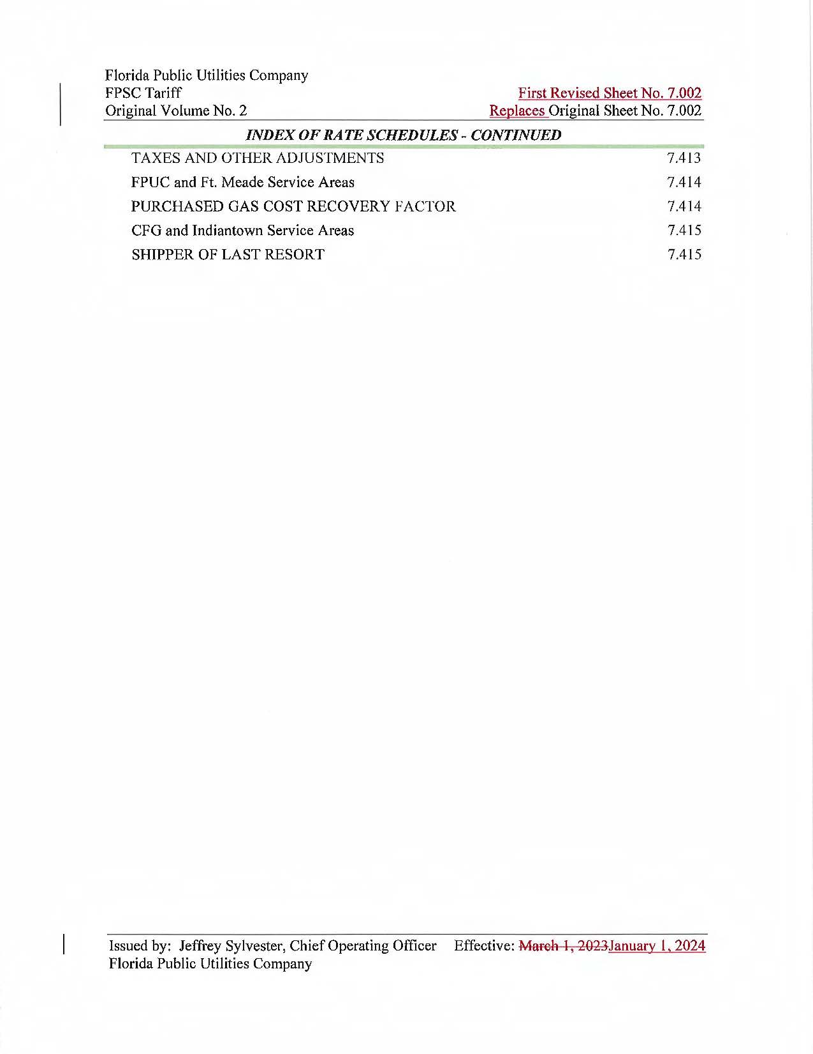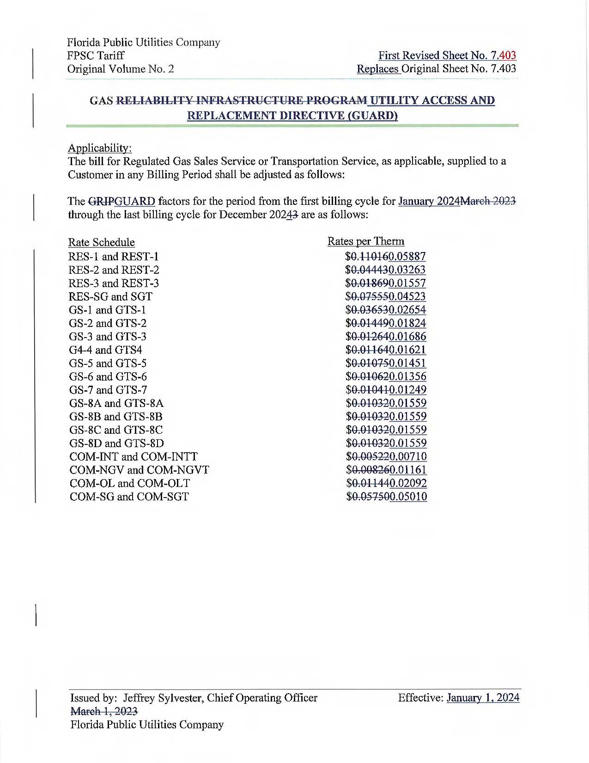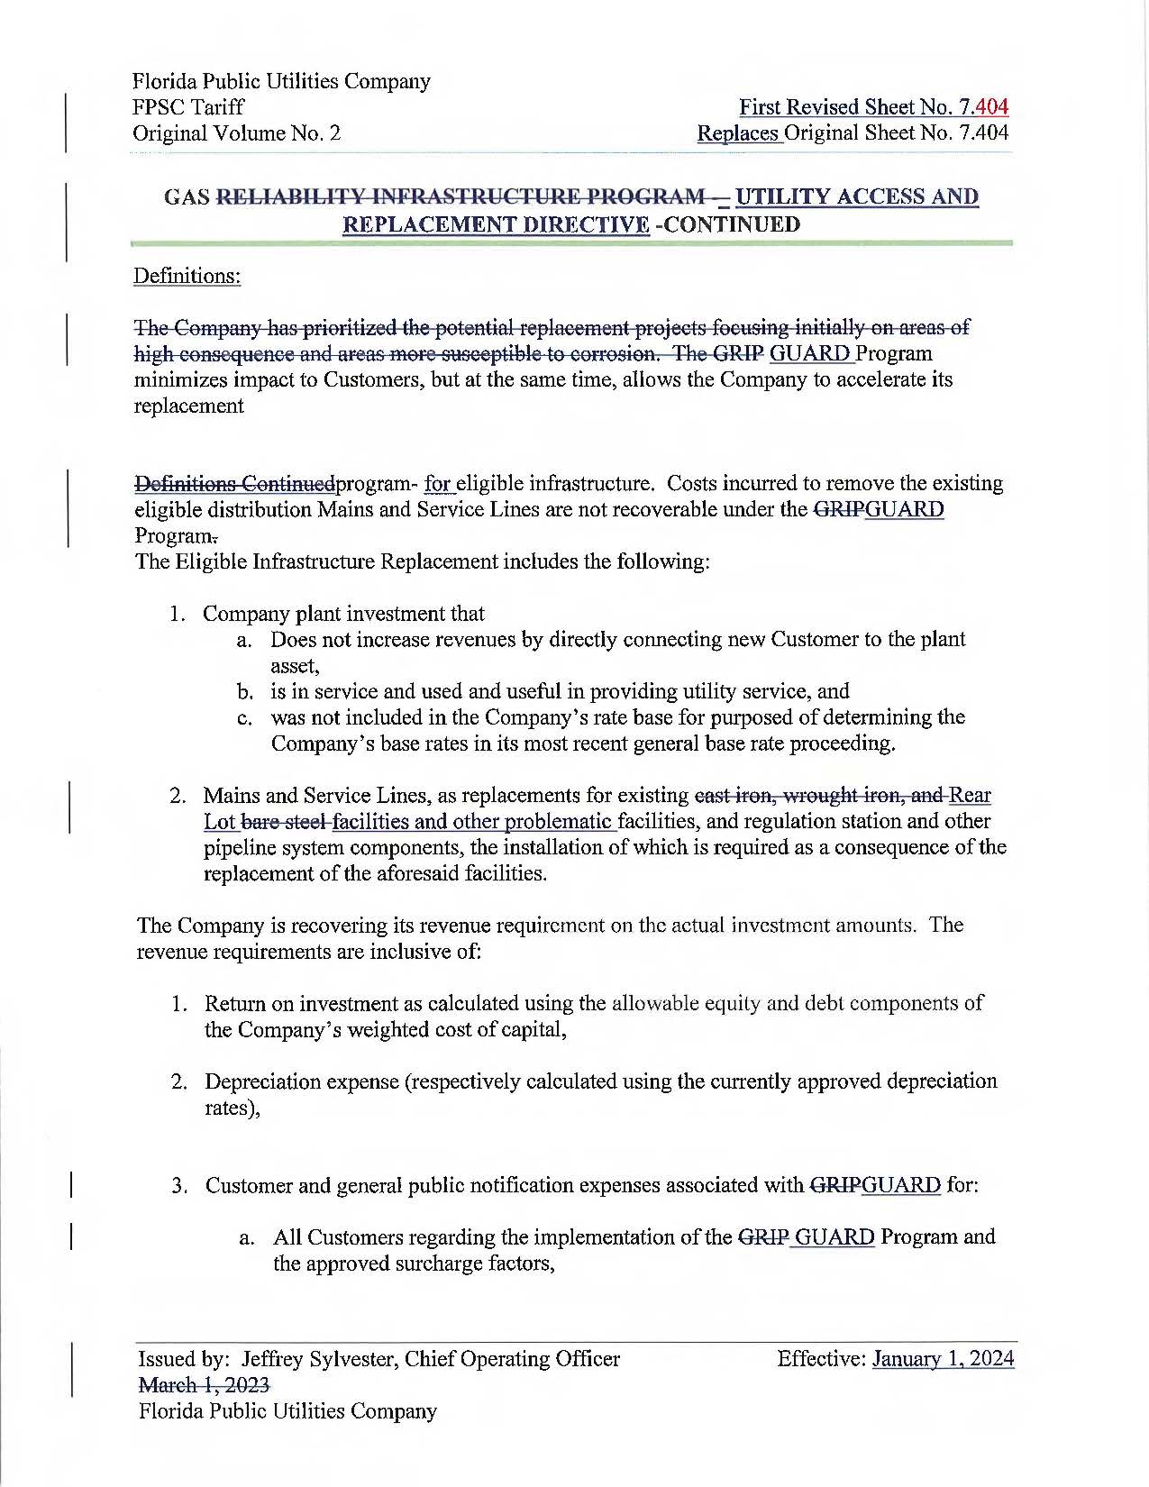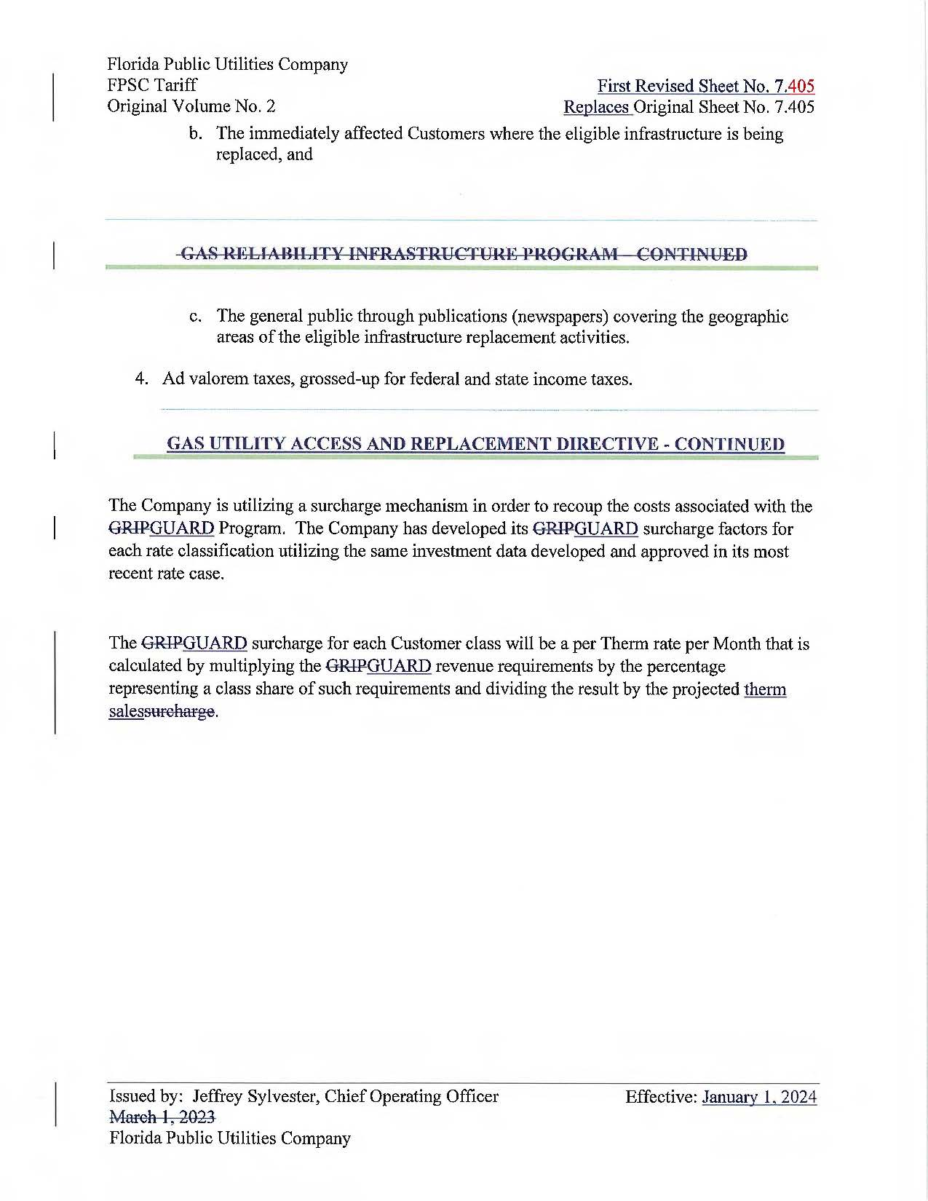

1. Order No. PSC-2023-0235-PAA-GU, issued August 15, 2023, amended by Order No. PSC-2023-0235A-PAA-GU, issued August 18, 2023, in Docket No. 20230029-GU, *In re: Petition for approval of gas utility access and replacement directive, by Florida Public Utilities Company.*
2. Order No. PSC-2012-0490-TRF-GU, issued September 24, 2012, in Docket No. 20120036-GU, *In re: Joint petition for approval of Gas Reliability Infrastructure Program (GRIP) by Florida Public Utilities Company and the Florida Division of Chesapeake Utilities Corporation*.
3. Order No. PSC-2023-0103-FOF-GU, issued March 15, 2023, in Docket No. 20220067-GU, *In re: Petition for rate increase by Florida Public Utilities Company, Florida Division of Chesapeake Utilities Corporation, Florida Public Utilities Company - Fort Meade, and Florida Public Utilities Company - Indiantown Division.*
4. Order No. PSC-2023-0304-PCO-GU, issued November 17, 2022 in Docket No. 20220155-GU, *In re:* *Joint petition for approval of GRIP cost recovery factors, by Florida Public Utilities Company, Florida Public Utilities Company-Fort Meade, and Florida Division of Chesapeake Utilities Corporation.*
5. Pursuant to Chapter 49, Section 192.1005 Code of Federal Regulations (2023), a gas distribution operator must develop and implement an integrity management program that includes a written integrity management plan.
6. Response No. 6 in Staff’s First Data Request, Document No. 05239-2023.
7. Exhibit RCW-1, Schedule C-1, page 6 of 9 and Schedule C-2, page 7 of 9.