|  |  |  |  |
| --- | --- | --- | --- |
| State of Florida  pscSEAL | | Public Service Commission  Capital Circle Office Center ● 2540 Shumard Oak Boulevard Tallahassee, Florida 32399-0850  -M-E-M-O-R-A-N-D-U-M- | |
| DATE: | December 28, 2023 | | |
| TO: | Office of Commission Clerk (Teitzman) | | |
| FROM: | Office of the General Counsel (Rubottom, Dike) SMC  Deputy Executive Director, Administrative (Lynn) ACL  Division of Economics (McNulty, Hampson, Kunkler) EJD | | |
| RE: | Docket No. 20230115-EU – Proposed amendment of Rule 25-6.0131, F.A.C., Regulatory Assessment Fees; Investor-owned Electric Companies, Municipal Electric Utilities, Rural Electric Cooperatives. | | |
| AGENDA: | 01/10/24 – Regular Agenda – Rule Proposal – Interested Persons May Participate | | |
| COMMISSIONERS ASSIGNED: | | | All Commissioners |
| PREHEARING OFFICER: | | | Administrative |
| CRITICAL DATES: | | | None |
| SPECIAL INSTRUCTIONS: | | | None |

Case Background

Rule 25-6.0131, Florida Administrative Code (F.A.C.), Regulatory Assessment Fees; Investor-owned Electric Companies, Municipal Electric Utilities, Rural Electric Cooperatives, implements the Commission’s statutory mandate to collect a fee, known as a regulatory assessment fee (RAF), from each regulated electric company under the jurisdiction of the Commission as provided in Sections 350.113 and 366.14, Florida Statutes (F.S.). Specifically, the rule establishes filing requirements and a rate at which the RAF should be calculated for investor-owned electric utility companies (IOUs), municipal electric utilities, and rural electric cooperatives.

Statutory History

In Section 350.113, F.S., the Legislature established RAFs as the exclusive funding mechanism for the Commission. Each utility or company regulated by the Commission is required to pay a RAF, and collected RAFs are credited to the Florida Public Service Regulatory Trust Fund (PSC Trust Fund).[1] Monies from the PSC Trust Fund are to be used in the operation of the Commission and are withdrawn according to the Commission’s budget that is set annually by the Legislature.[2]

Each utility or company under the Commission’s jurisdiction is required to pay a RAF every six months, and the RAF must be based upon the company’s gross operating revenues for the preceding six-month period.[3] The Legislature did not prescribe the rate at which the RAF must be calculated from a company’s revenues, but it did provide statutory guidance the Commission must follow in establishing and managing RAF rates through rulemaking:

1. The RAF for each industry must, to the extent practicable, be related to the cost of regulating that industry; the Commission must therefore endeavor to establish a RAF rate for each regulated industry that is sufficient to cover the cost of regulating the utilities or companies in that industry.[4]
2. The RAF rate may not exceed a maximum rate established by the Legislature for each industry.[5]
3. RAFs collected from one industry may not be used to subsidize the regulatory costs of another industry.[6]

History of Commission RAFs for Electric Utilities

Prior to 1980, the Legislature controlled RAFs directly by statute and set a separate RAF rate for each industry regulated by the Commission.[7] However, in 1980 the Legislature enacted a statute that provided a maximum RAF rate for each industry and left it to the Commission to establish specific RAF rates through agency rulemaking.[8] To implement this change enacted by the Legislature in the statutory scheme related to RAFs, the Commission adopted its original RAF rules, including for electric utilities, in 1980 through emergency rulemaking[9] and adopted them as permanent rules later that year.[10]

Rule 25-6.0131, F.A.C., was adopted by the Commission in 1983 to replace the original RAF rules for electric utilities.[11] The RAF rate for municipal electric utilities and rural electric cooperatives has not been updated since it was originally established by the Commission in 1980.[12] The RAF rate for IOUs has been amended five times since it was adopted in 1980, but has not been updated since 1999.[13]

Temporary Exemption from SERC and Legislative Ratification Requirements

In 2010, the Legislature amended Section 120.541, F.S., to require agencies to prepare a statement of estimated regulatory costs (SERC) for any rule that will have an adverse impact on small business or that is likely to directly or indirectly increase regulatory costs in excess of $200,000 in the aggregate within one year after implementation. Since the statute was amended in 2010, Section 120.541, F.S., has also required legislative ratification of all proposed agency rules that exceed $1 million in regulatory cost impact within a 5-year period after implementation.[14] During the 2023 legislative session, however, the Legislature granted the Commission a one-year exemption from the SERC and ratification requirements for rules amended to increase RAF rates.[15]

Because of the size of the industries regulated by the Commission, any meaningful increase in RAFs will trigger ratification. The lengthy time and uncertainty introduced by the legislative ratification requirement, coupled with the time required for rulemaking and the additional time required to realize the collection of RAFs, have prevented the Commission from managing RAF revenues through rulemaking in any industry since 2010.

Other Procedural Issues

A Notice of Rule Development for Rule 25-6.0131, F.A.C., appeared in the September 12, 2023, edition of the Florida Administrative Register, Vol. 49, No. 177. Staff held a rule development workshop on September 27, 2023. Participating in the workshop were the Office of Public Counsel and Tampa Electric Company. No post-workshop comments were filed.

This recommendation addresses whether the Commission should propose the amendment of Rule 25-6.0131, F.A.C., Regulatory Assessment Fees; Investor-owned Electric Companies, Municipal Electric Utilities, Rural Electric Cooperatives. The Commission has jurisdiction pursuant to Sections 120.54, 350.113, 366.05, and 366.14, F.S.

Discussion of Issues

Issue 1:

 Should the Commission propose the amendment of Rule 25-6.0131, F.A.C., Regulatory Assessment Fees; Investor-owned Electric Companies, Municipal Electric Utilities, Rural Electric Cooperatives?

Recommendation:

 Yes, the Commission should propose the amendment of Rule 25-6.0131, F.A.C., as set forth in Attachment A. The Commission should also certify that Rule 25-6.0131, F.A.C., is a rule the violation of which would be a minor rule violation pursuant to Section 120.695, F.S. (Rubottom, Lynn, McNulty).

Staff Analysis:

 Rule 25-6.0131, F.A.C., implements the Commission’s statutory mandate to establish and collect RAFs from electric utilities. The purpose of this rulemaking is to update the rate at which RAFs are calculated for electric utilities to accurately reflect the cost of regulation.

Current Situation and Future Projections

The Commission’s overall cost of regulation has exceeded its collected RAF revenues in seven of the last eleven years. In recent years, Commission management has used internal cost controls to mitigate the difference in revenues and expenditures. Internal cost controls have involved holding positions vacant, limiting travel to only mission-critical functions, reducing/deferring professional development and training, postponing IT equipment purchases, reducing leased space, closing field offices and eliminating positions. As an example, and to quantify some of these actions, since 2010 the staffing footprint has been reduced by 15%, lease costs have been reduced $80,000, and vehicle fleet has been reduced by 23%. All internal management of the Commission’s budget has allowed total expenditures to stay relatively flat, despite recent legislative mandates (Table 1-1) that may have otherwise increased expenditures and adversely influenced the trust fund.

**Table 1-1 - Recent Legislative Mandates**

|  |  |
| --- | --- |
| Florida Retirement System Modifications | $182,000 |
| Health Insurance Adjustment | $420,000 |
| Salary Increases | $2,155,000 |
| SB 1944 (Utility Pole Bill) | $926,000 |
| Storm Hardening | $276,000 |
|  | $3,959,000 |

Commission expenditures include both operating and non-operating costs. (Table 1-2). Non-operating cost are roughly $2 million per year and are determined as a percentage of revenues collected. The Commission would consider the non-operating cost and roughly 96% of operating cost as non-discretionary. In other words, only 3% - 4% of operating cost, or approximately $1 million (using FY 2020 – FY 2023 as an example) of Commission expenditures are subject to internal controls. Therefore, the internal measures described above have only a temporary and limited impact on the cost of regulation.

**Table 1-2**

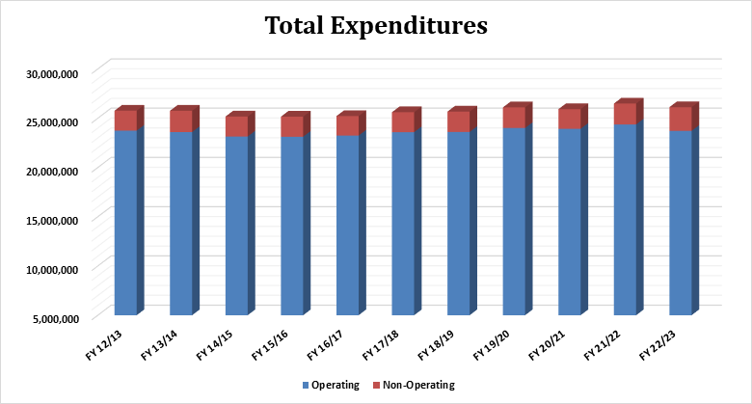

The recent legislative changes and mandates have increased the Commission’s costs, and staff projects that without any offsetting increase in revenues, the annual deficit will increase significantly over the next three to five years. (Table 1-3).

Table 1-3

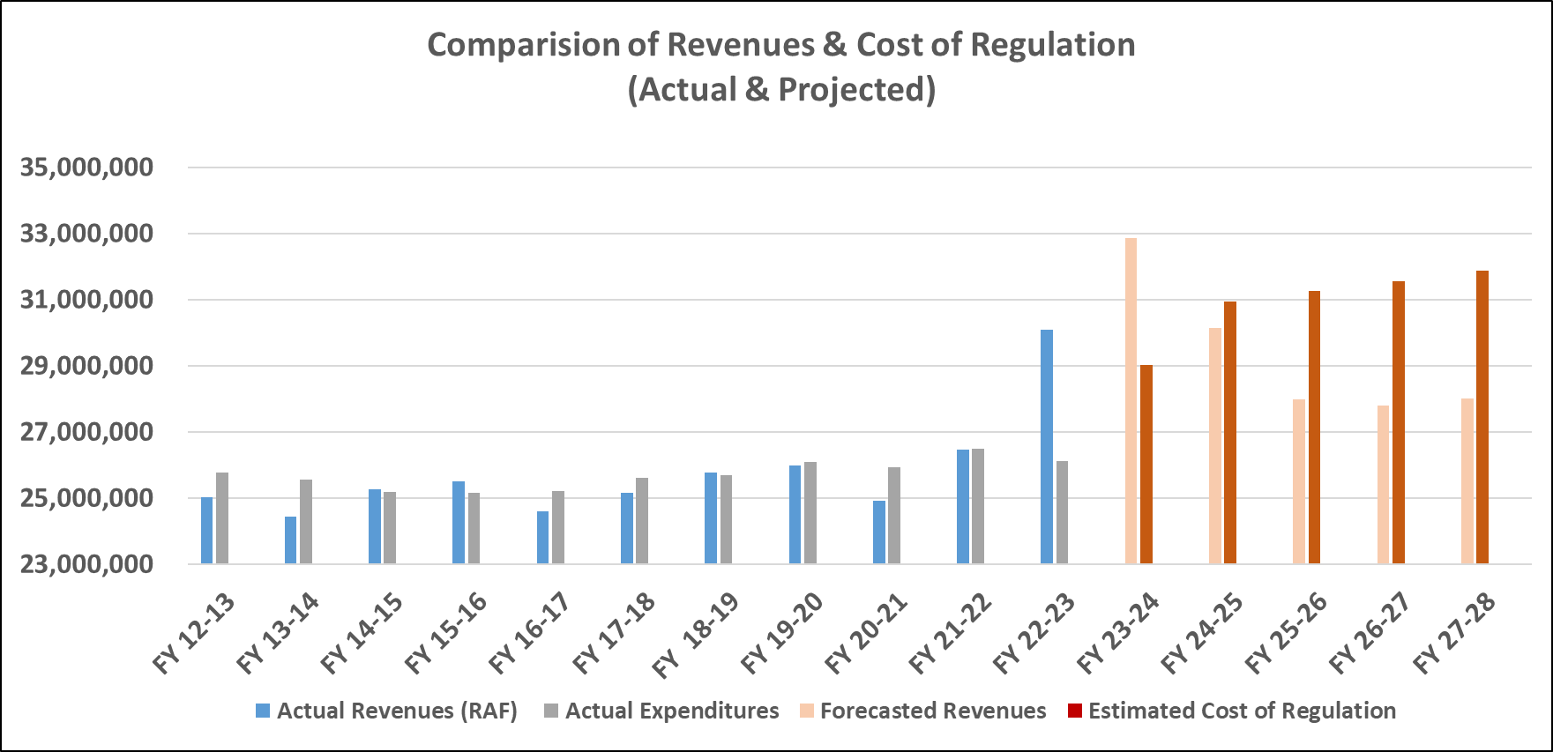

Source: Commission Staff[16]

Projected deficits in the electric industry are particularly concerning. Regulation of electric IOUs accounts for the largest share of the Commission’s total regulatory workload and therefore of the Commission’s total expenditures. Looking at FY 26/27, staff calculates that the projected cost of regulating IOUs will be $18,233,324 and that the projected RAF revenues from IOUs, based on the current RAF rate of 0.00072, will be $15,473,309, resulting in a projected shortfall of $2,760,015.

When the Commission’s revenues consistently do not match expenditures, the PSC Trust Fund is depleted over time as deposits fail to replace the agency’s annual operating budget appropriated by the Legislature. Under current RAF rates and the projected annual budget deficit described above, staff projects that the PSC Trust Fund balance will decline substantially over the next few years. (Table 1-4).

Table 1-4

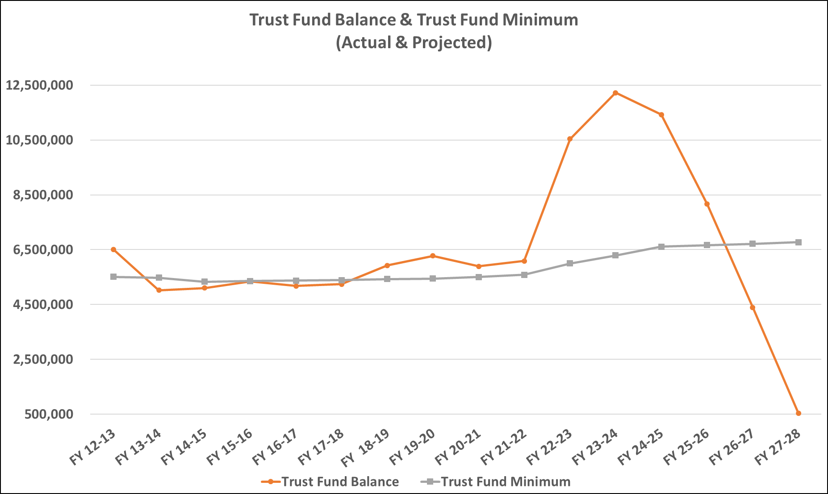

Source: Commission Staff

The current status and near-term projections of the PSC Trust Fund balance and of the Commission’s annual revenues and expenditures in the electric industry demonstrate a need to raise agency revenues by increasing RAF rates for IOUs.

Calculation of Recommended RAF Rates for Electric Companies

In order to calculate a new RAF rate that would address the projected shortfall in the Commission’s budget for the electric industry, staff first determined how much additional revenue is needed to cover the cost of regulation. For IOUs, and separately for municipal and cooperative utilities, staff looked at projections for FY 26/27 and performed the following calculation to determine the projected revenue deficit:

Cost of Regulation – (Utility Gross Revenues x Current RAF Rate) = Revenue Deficit

For electric IOUs in FY 26/27, staff projected a cost of regulation of $18,233,324 and utilities’ aggregate gross revenues of $21,490,706,756. Applying the current RAF rate of 0.00072, staff projected a deficit of $2,760,015.[17] Staff calculated that increasing the RAF rate for electric IOUs from 0.00072 to 0.000848 would result in an increase of nearly $2.8 million in Commission revenues for FY 26/27, covering the projected shortfall.[18]

For municipal and cooperative electric utilities in FY 26/27, staff projected a cost of regulation of $849,208 and utilities’ aggregate gross revenues of $8,573,862,477. Applying the current RAF rate of 0.00015625, staff projected a surplus of $490,458.[19] Staff calculated that decreasing the RAF rate for municipal electric utilities and rural electric cooperatives from 0.00015625 to 0.00009905 would result in a decrease of nearly $500,000 in Commission revenues for FY 26/27, avoiding the projected surplus.[20]

Therefore, staff recommends that the RAF rate for electric IOUs be increased from 0.00072 to 0.000848. The new rate would be well below the statutory RAF cap of 0.00125,[21] and the impact of the new RAF rate on individual IOU customers, based on a residential monthly bill for 1,000 kilowatt-hours (kWh), would come to an increase of approximately $0.02. (Table 1-5 below).

Staff also recommends that the RAF rate for municipal electric utilities and rural electric cooperatives be decreased from 0.00015625 to 0.00009905. The new rate will be below the statutory RAF cap of 0.00015625,[22] and the impact of the new RAF rate on individual municipal and cooperative customers, based on a residential monthly bill for 1,000 kWh, would come to a decrease of approximately $0.01. (Table 1-5 below).

Table 1-5

|  |  |  |
| --- | --- | --- |
|  | **IOUs** | **Munis/Coops** |
| **Statutory RAF Cap** | 0.00125 | 0.00015625 |
| **Current RAF Rate** | 0.00072 | 0.00015625 |
| **Recommended RAF Rate** | 0.000848 | 0.00009905 |
| **Impact on Customers**  (Based on Residential Bill at 1,000 kWh) | $0.02 | -$0.01 |

Source: Commission Staff

Recommended Amendments to Rule 25-6.0131, F.A.C.

Staff recommends that the Commission amend Rule 25-6.0131, F.A.C., including the forms incorporated by reference, as set forth in Attachment A. Updated RAF rates, as detailed above, are the only substantive amendments staff is recommending to Rule 25-6.0131, F.A.C. Other recommended amendments to the rule are non-substantive, designed to provide consistency and clarity to the rule language.

Minor Violation Rules Certification

Pursuant to Section 120.695, F.S., for each rule filed for adoption, the agency head shall certify whether any part of the rule is designated as a rule the violation of which would be a minor violation. Rule 25-6.0131, F.A.C., is on the Commission’s minor violation rule list because violation of the rule would not result in economic or physical harm to a person or adverse effects on the public health, safety, or welfare and would not create a significant threat of such harm. The proposed amendments to the rule would not alter the likelihood or risk of such harms in the event of a violation. Thus, if the Commission proposes the amendment, staff recommends that the Commission certify that Rule 25-6.0131, F.A.C., is a rule the violation of which would be a minor violation pursuant to Section 120.695, F.S.

Statement of Estimated Regulatory Costs

As discussed above, rules adopted by the Commission during the 2023-2024 fiscal year to implement Sections 350.113 and 366.14, F.S., are not subject to the SERC requirement of Section 120.541, F.S.[23] Therefore, no SERC has been prepared.

Conclusion

Based on the foregoing, staff recommends that the Commission propose the amendment of Rule 25-6.0131, F.A.C., as set forth in Attachment A. In addition, staff recommends that the Commission certify that Rule 25-6.0131, F.A.C., is a rule the violation of which would be a minor rule violation pursuant to Section 120.695, F.S.

If the Commission proposes the amendment, staff notes that the new RAF rate will be applied to the company’s gross operating revenues based on the date the amended rule becomes effective. For example, if the new rule becomes effective on April 1, 2024, the current RAF rate will be applied to the company’s gross operating revenues for the period of January 1, 2024, through March 31, 2024, and the new RAF rate will be applied to the company’s gross operating revenues for the period of April 1, 2024, through June 30, 2024.

Issue :

### Should this docket be closed?

Recommendation:

 Yes, if no requests for hearing or JAPC comments are filed, the rule should be filed for adoption with the Department of State, and the docket should be closed. (Rubottom).

Staff Analysis:

 If no requests for hearing or JAPC comments are filed, the rule should be filed with the Department of State for adoption, and the docket should be closed. Staff notes that if there are no requests for hearing or JAPC comments filed, the rule will be filed for adoption on approximately March 12, 2024, and will become effective on approximately April 1, 2024.

**25-6.0131 Regulatory Assessment Fees; Investor-owned Electric Companies, Municipal Electric Utilities, Rural Electric Cooperatives.**

(1) As applicable and as provided in Section 350.113, F.S., and Section 366.14, F.S., each company, utility, or cooperative shall remit to the Commission a fee based upon its gross operating revenue. This fee shall be referred to as a regulatory assessment fee. Regardless of the gross operating revenue of a company, utility, or cooperative, a minimum annual regulatory assessment fee of $25 shall be imposed.

(a) Each investor-owned electric company shall pay a regulatory assessment fee in the amount of 0.000848 ~~.00072~~ of its gross operating revenues derived from intrastate business, excluding sales for resale between investor-owned electric companies ~~public utilities~~, municipal electric utilities, and rural electric cooperatives or any combination thereof.

(b) Each municipal electric utility and rural electric cooperative shall pay a regulatory assessment fee in the amount of 0.00009905 ~~0.00015625~~ of its gross operating revenues derived from intrastate business, excluding sales for resale between investor-owned electric companies ~~public utilities~~, municipal electric utilities, and rural electric cooperatives or any combination thereof.

(2) Regulatory assessment fees are due each January 30 for the preceding period or any part of the period from July 1 until December 31, and on July 30 for the preceding period or any part of the period from January 1 until June 30.

(3) If the due date falls on a Saturday, Sunday, or a holiday, the due date is extended to the next business day. If the fees are sent by registered mail, the date of the registration is the United States Postal Service’s postmark date. If the fees are sent by certified mail and the receipt is postmarked by a postal employee, the date on the receipt is the United States Postal Service’s postmark date. The postmarked certified mail receipt is evidence that the fees were delivered. Regulatory assessment fees are considered paid on the date they are postmarked by the United States Postal Service or received and logged in by the Commission’s Division of Administrative and Information Technology Services in Tallahassee. Fees are considered timely paid if properly addressed, with sufficient postage and postmarked no later than the due date.

(4) Commission Form PSC/ECO ~~PSC/AFD~~ 68 (12/23) ~~(01/99)~~, entitled “Investor-Owned Electric Utility Regulatory Assessment Fee Return,”~~;~~ is available at [new hyperlink] ~~http://www.flrules.org/Gateway/reference.asp?No=Ref-02610~~; Commission Form PSC/ECO ~~PSC/AFD~~ 69 (12/23) ~~(07/96)~~, entitled “Municipal Electric Utility Regulatory Assessment Fee Return,” is available at [new hyperlink] ~~http://www.flrules.org/Gateway/reference.asp?No=Ref-02611~~; and Commission Form PSC/ECO ~~PSC/AFD~~ 70 (12/23) ~~(07/96)~~, entitled “Rural Electric Cooperative Regulatory Assessment Fee Return,” is available at [new hyperlink] ~~http://www.flrules.org/Gateway/reference.asp?No=Ref-02612~~. These forms are incorporated into this rule by reference and may be also be obtained from the Commission’s Division of Administrative and Information Technology Services. The failure of a company, utility, or cooperative to receive a return form shall not excuse the company, utility, or cooperative from its obligation to timely remit the regulatory assessment fees.

(5) Each company, utility, or cooperative shall have up to and including the due date in which to:

(a) Remit the total amount of its fee; or

(b) Remit an amount which the company, utility, or cooperative estimates is its full fee.

(6) Where the company, utility, or cooperative remits less than its full fee, the remainder of the full fee shall be due on or before the 30th day from the due date and shall, where the amount remitted was less than 90 percent of the total regulatory assessment fee, include interest as provided by paragraph (8)(b) of this rule.

(7) A company, utility, or cooperative may request either a 15-day or a 30-day extension of its due date for payment of regulatory assessment fees or for filing its return form by submitting to the Division of Administrative and Information Technology Services Commission Form PSC/AIT 124 (12/11), entitled “Regulatory Assessment Fee Extension Request,” which is incorporated into this rule by reference and is available at: http://www.flrules.org/Gateway/reference.asp?No=Ref-02620. This form may also be obtained from the Commission’s Division of Administrative and Information Technology Services.

(a) The request for extension must be received by the Division of Administrative and Information Technology Services at least two weeks before the due date.

(b) The request for extension will not be granted if the company, utility, or cooperative has any unpaid regulatory assessment fees, penalties, or interest due from a prior period.

(c) Where a company, utility, or cooperative receives an extension of its due date pursuant to this rule, the entity shall remit a charge as set out in Section 350.113(5), F.S., in addition to the regulatory assessment fee.

(8) The delinquency of any amount due to the Commission from the company, utility, or cooperative pursuant to the provisions of Section 350.113, F.S., and this rule, begins with the first calendar day after any date established as the due date either by operation of this rule or by an extension pursuant to this rule.

(a) A penalty, as set out in Section 350.113(4), F.S., shall apply to any such delinquent amounts.

(b) Interest at the rate of 12 percent per annum shall apply to any such delinquent amounts.

*Rulemaking Authority 350.127(2), 366.05 FS. Law Implemented 350.113, 366.14 FS. History–New 5-18-83, Amended 2-9-84, Formerly 25-6.131, Amended 6-18-86, 10-16-86, 3-7-89, 2-19-92, 7-7-96, 1-1-99, 5-7-13, .*

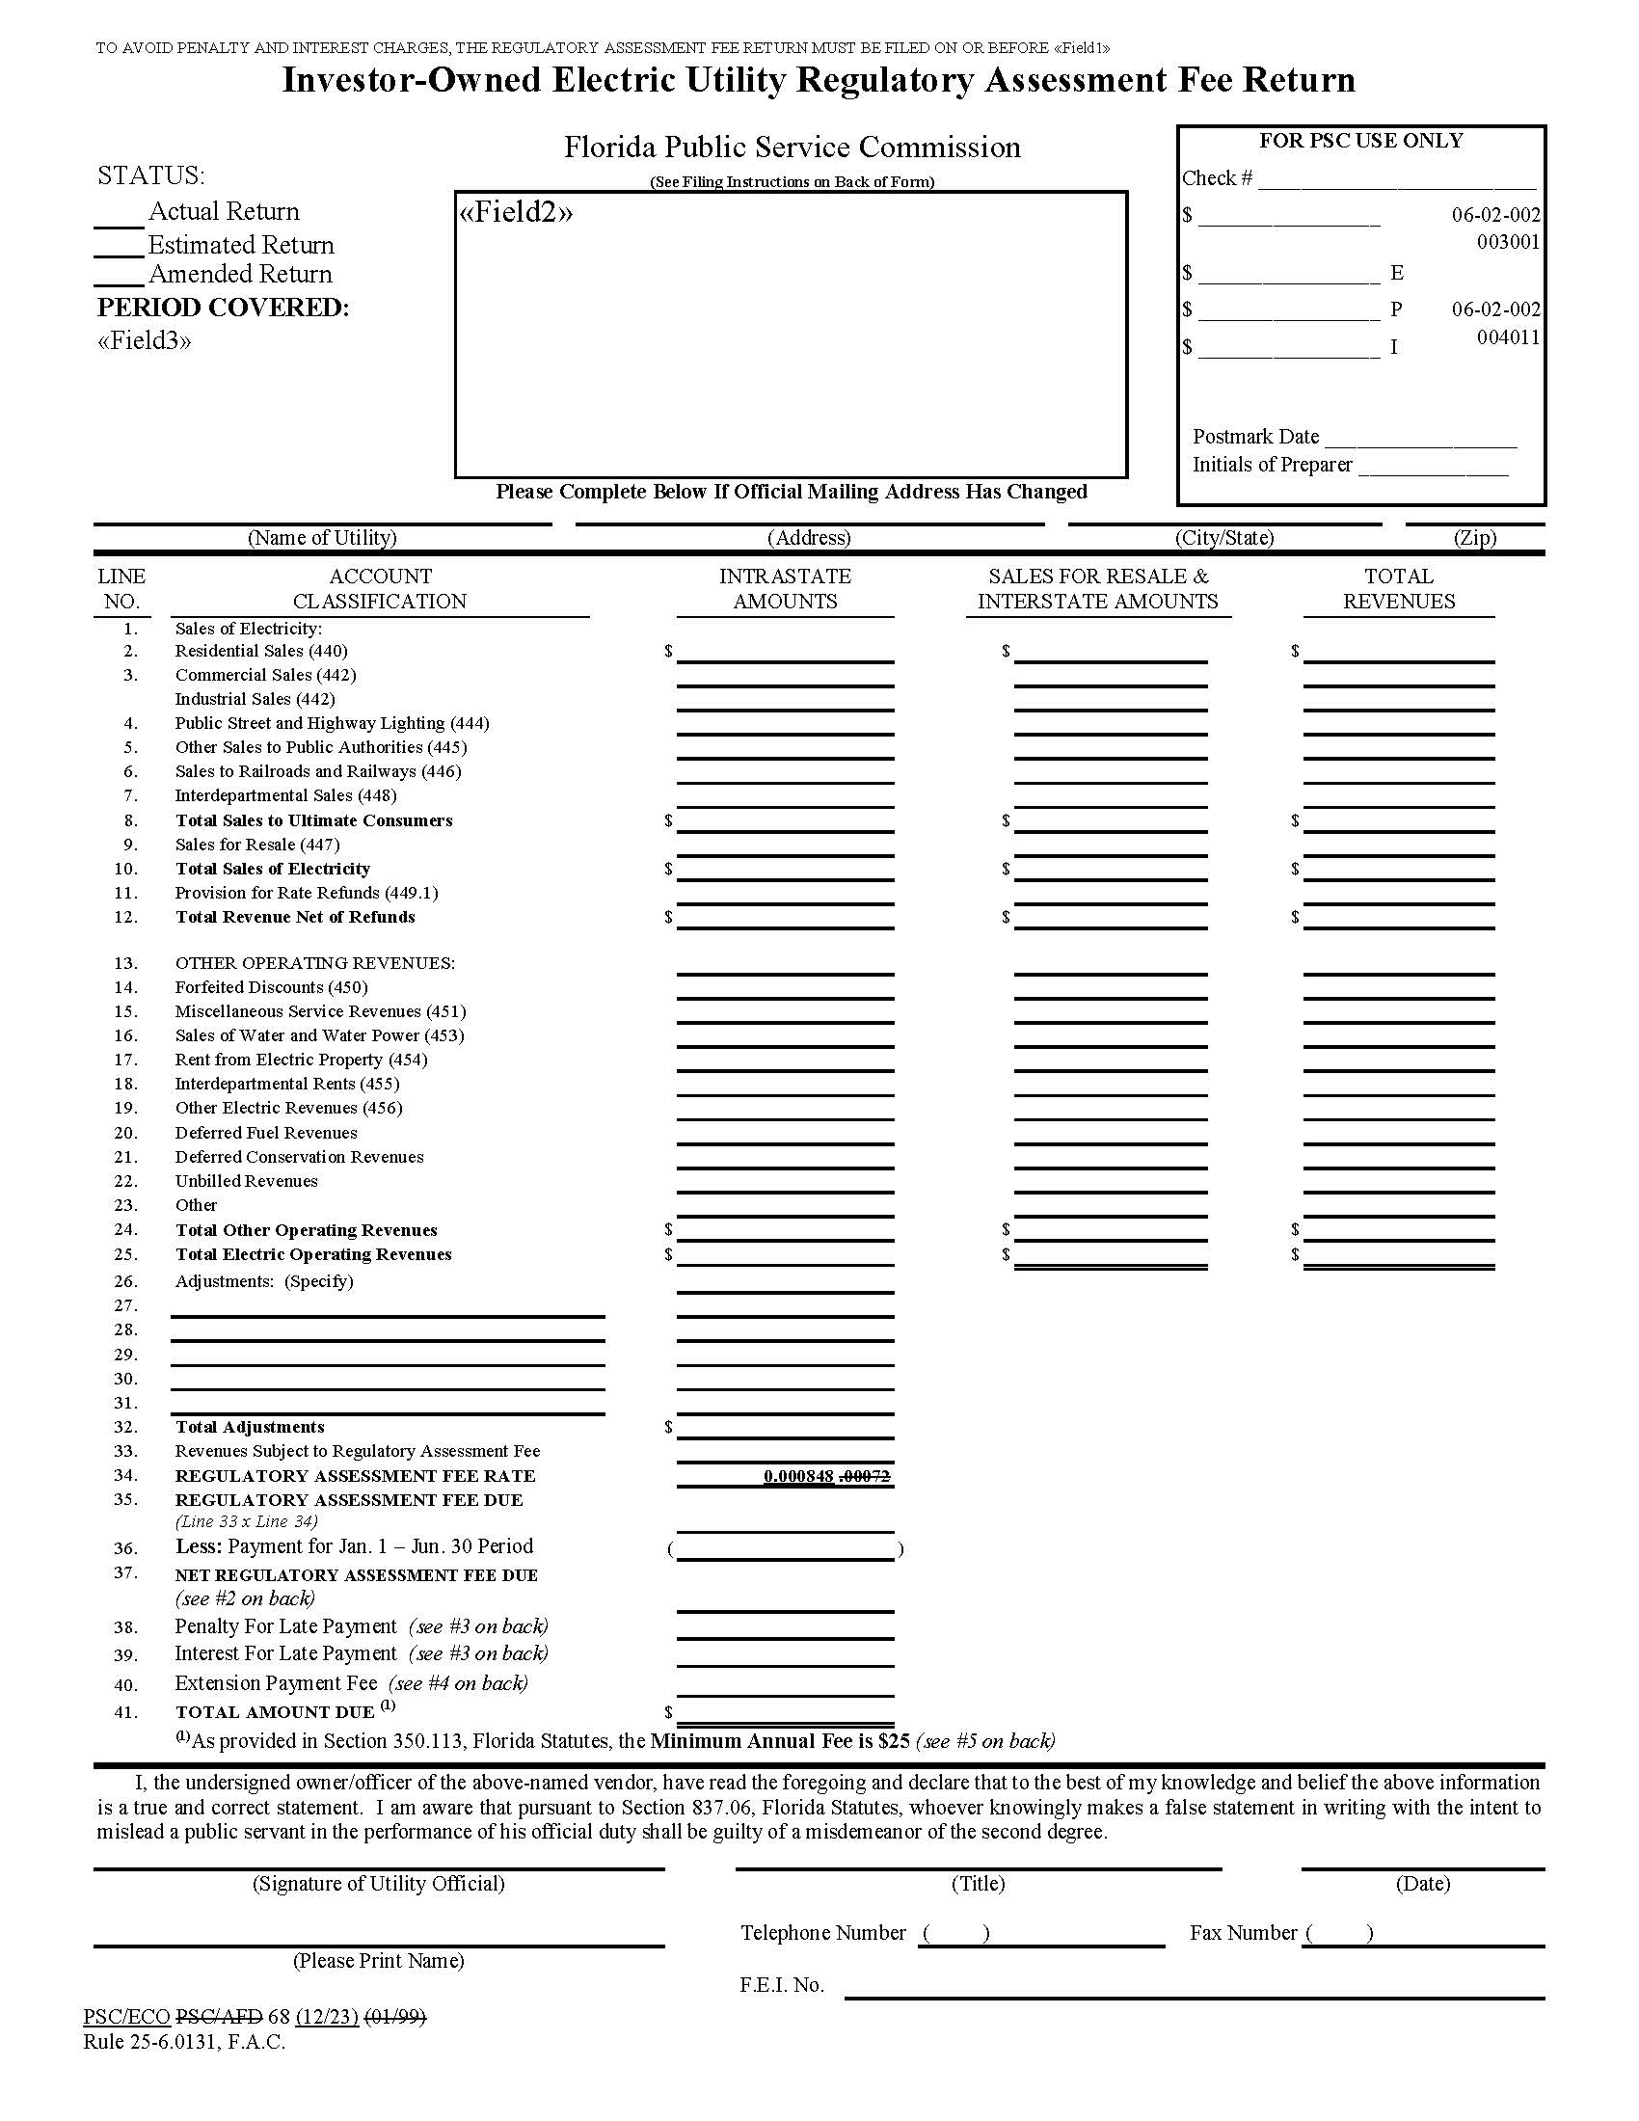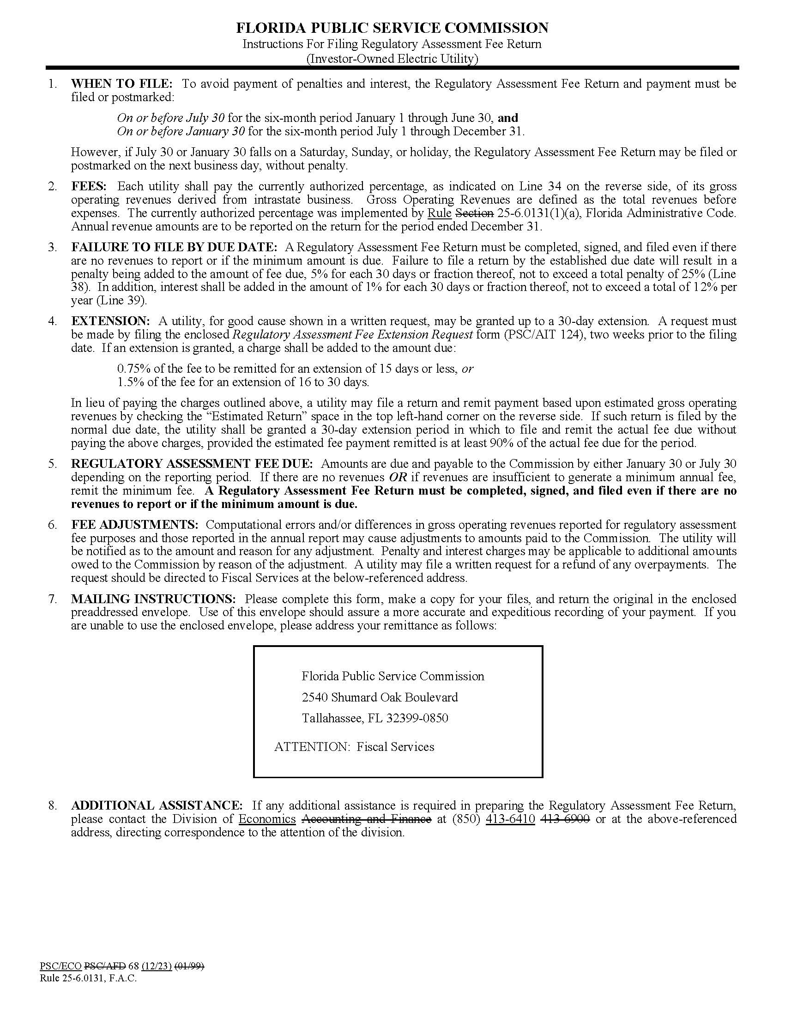

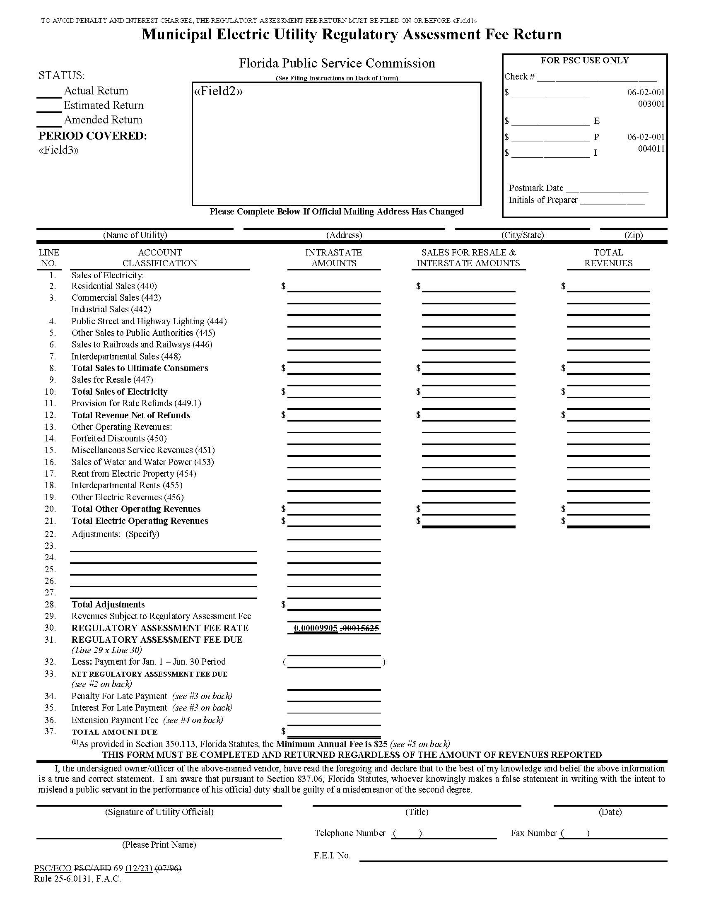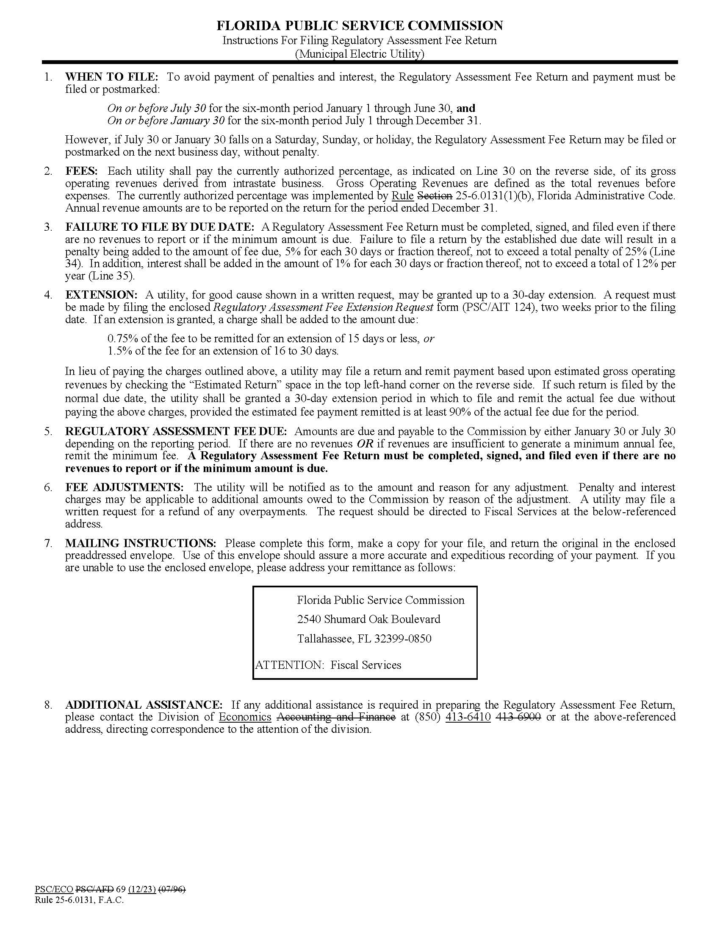

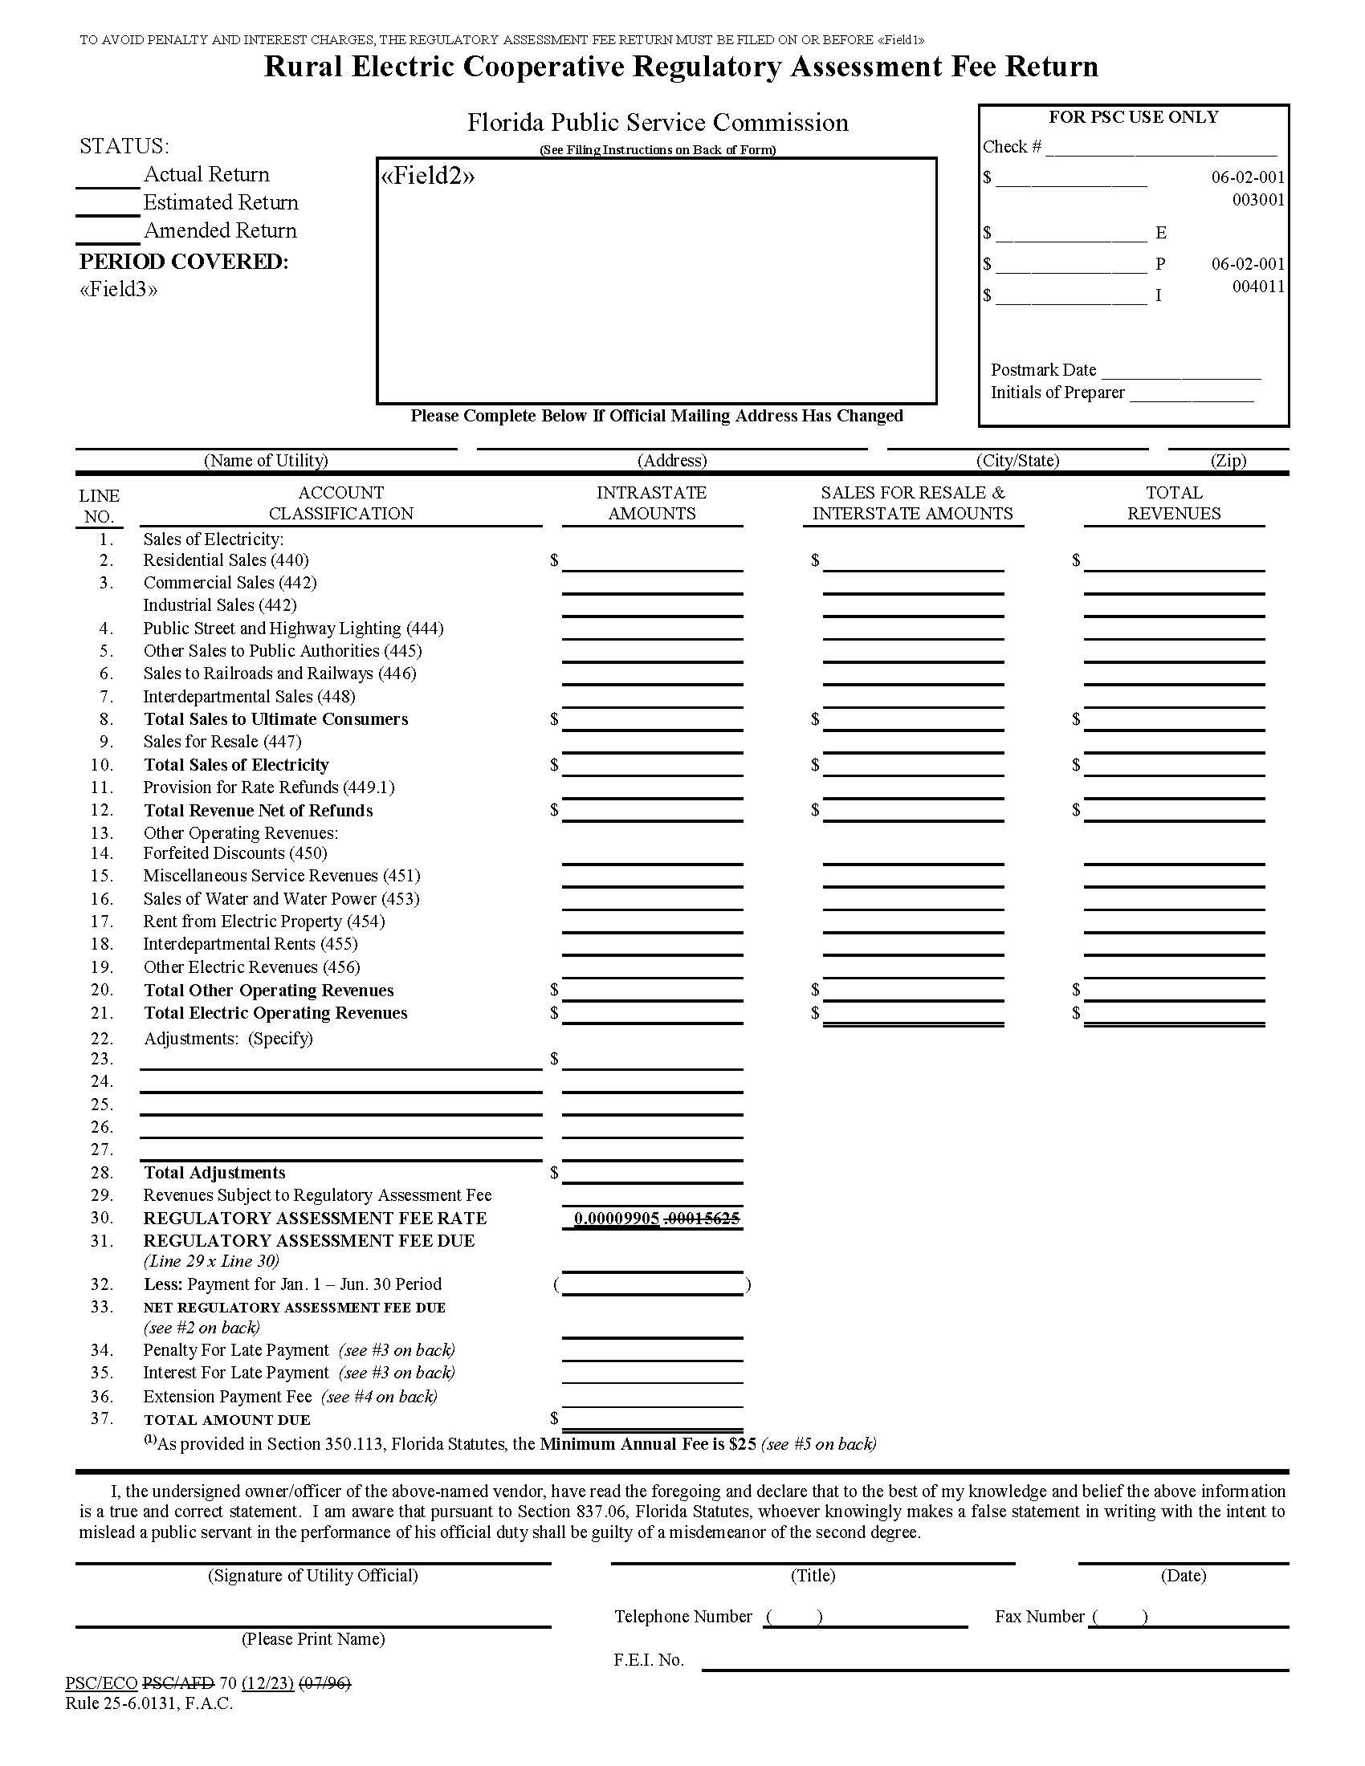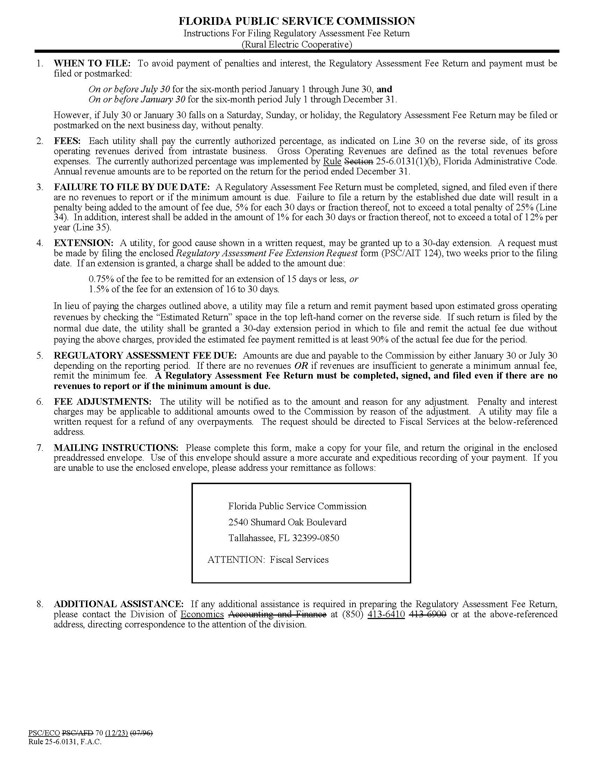

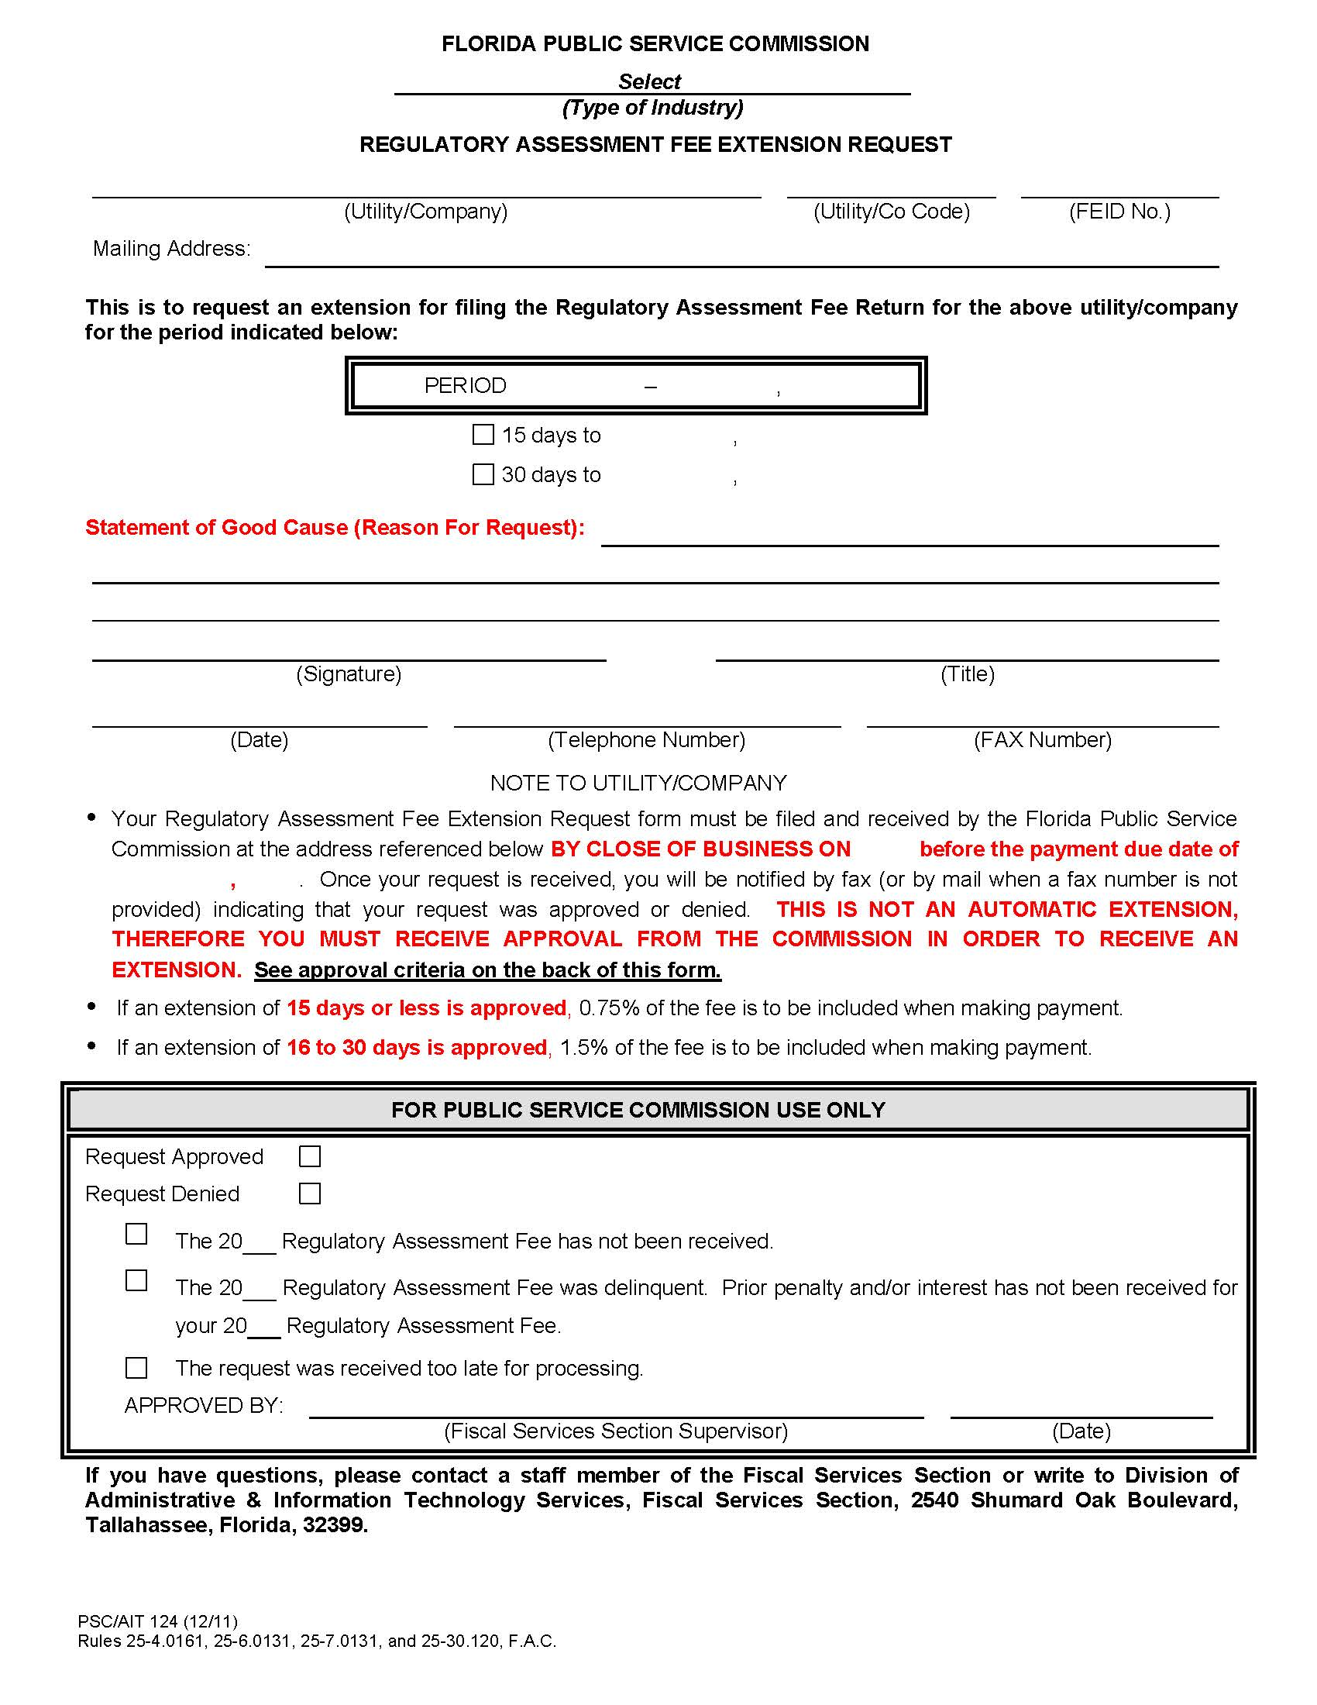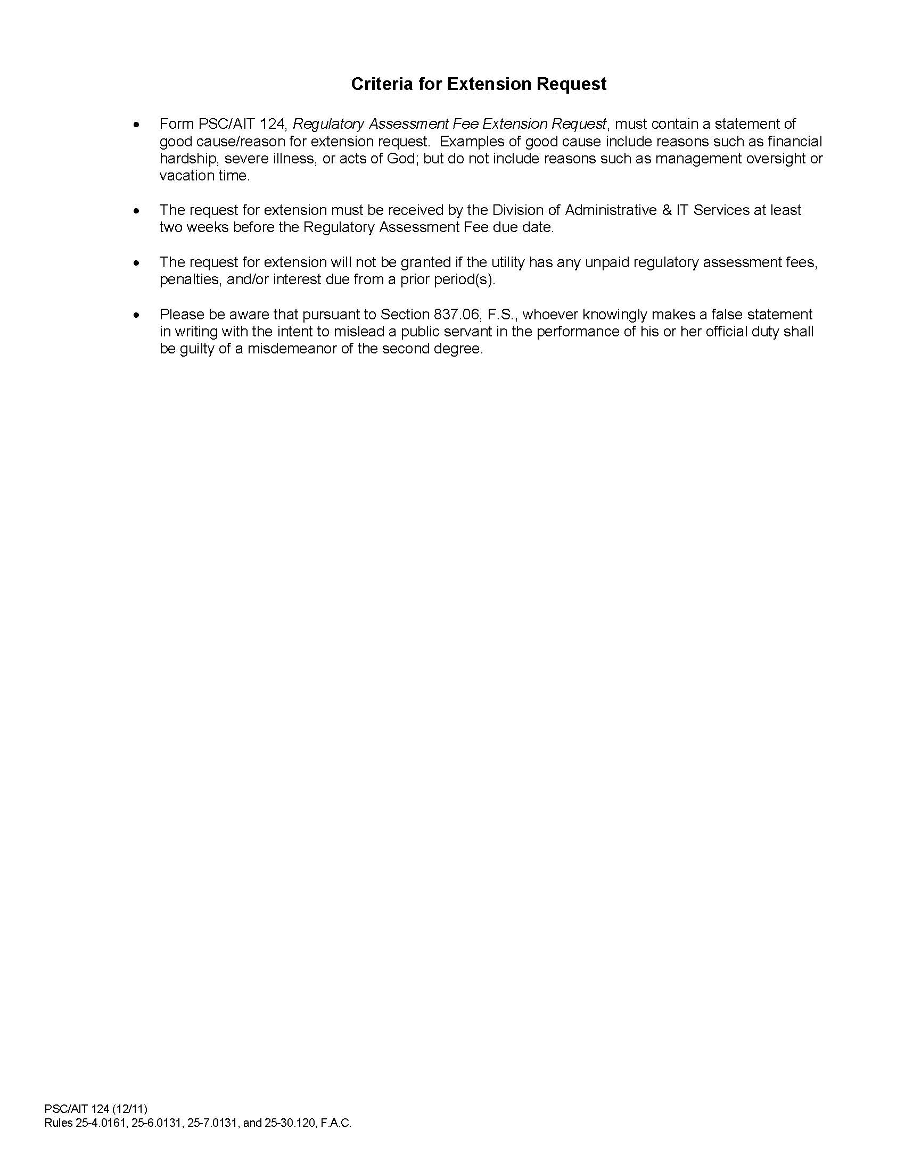

1. *See* Sections 350.113, 364.336, 366.14, 367.145, 368.109, F.S.
2. Section 350.113, F.S.
3. *Id.*
4. Section 350.113(3), F.S.
5. *See* Sections 364.336, 366.14, 367.145, 368.109, F.S.
6. *See* Section 367.145(3), F.S.
7. *See* Order No. 9438, issued on July 3, 1980, in Docket No. 800521-PU, *In Re: Proposed Rulemaking to Impose Upon Utilities and Railroads Regulatory Fees Based Upon Gross Operating Revenues for: Telephone Companies, Electric IOUs, Municipal and Rural Electric Cooperatives, Gas Companies, Water and Sewer Companies, Radio Common Carriers, Railroads.*
8. *Id.*; *see also* Ch. 80-289, 1980 Fla. Laws 1249 (creating Section 351.51, F.S., which was later renumbered as Section 350.113, F.S., and was amended when separate RAF statutes were adopted for each industry).
9. *See* Order No. 9438, *supra* note 7.
10. *See* Order No. 9491, issued on August 13, 1980, in Docket No. 800521-PU, *In Re: Proposed Rulemaking to Impose Upon Utilities and Railroads Regulatory Fees Based Upon Gross Operating Revenues for: Telephone Companies, Electric IOU's, Municipal and Rural Electric Cooperatives, Gas Companies, Water and Sewer Companies, Radio Common Carriers, Railroads.* (adopting Rules 25-1.45 – 25.1.49, F.A.C., Regulatory Assessment Fees).
11. *See* Order No. 11887, issued on April 27, 1983, in Docket No. 810160-ADM(RA), *In Re: Adoption of Rules 25-4.161, 25-6.131, 25-7.131, 25-10.24, and 25-23.12, Regulatory Assessment Fees; Repeal of Rules 25-1.45 through 25-1.49, Pertaining to Regulatory Assessment Fees; and Repeal of Rules 25-6.13 and 25-7.13, Gross Intrastate Operating Revenue Report.* Rule 25-6.131, F.A.C., was later renumbered as Rule 25-6.0131, F.A.C.
12. *See* Order No. 9438, *supra* note 7 (establishing a RAF rate of “1/64 of one percent,” or 0.00015625, for municipal electrics and rural electric cooperatives).
13. *See* Order No. PSC-98-1660-FOF-EI, issued on December 9, 1998, in Docket No. 980276-EI, *In re: Proposed Amendment of Rule 25-6.0131, F.A.C., Investor-Owned Electric Company Regulatory Assessment Fees.* (decreasing the RAF rate for investor-owned utilities from 0.000833 to 0.00072).
14. *See* Section 120.541(3), F.S.
15. *See* Section 120.80(13)(g)2., F.S. (“For the 2023-2024 fiscal year, rules adopted by the Florida Public Service Commission to implement ss. 350.113, 364.336, 366.14, 367.145, and 368.109 are not subject to s. 120.541. This subparagraph expires July 1, 2024.”). *See also* Ch. 2023-240, § 51.
16. Staff’s projection of the Commission’s future cost of regulation in Table 1-3 includes, for more immediate years, the known operational costs and legislative mandates and, for the out years, assumes a growth rate of 2.6%.
17. $18,233,324 – ($21,490,706,756 x 0.00072) = $2,760,015.
18. $18,233,324 – ($21,490,706,756 x 0.000848) = $0.
19. $849,208 – ($8,573,862,477 x 0.00015625) = ($490,458).
20. $849,208 – ($8,573,862,477 x 0.00009905) = $0.
21. *See* Section 366.14(1), F.S.
22. *See* Section 366.14(4), F.S.
23. *See* *supra* p. 3 and note 15.