State of Florida |  | Public Service Commission  Capital Circle Office Center ● 2540 Shumard Oak Boulevard  Tallahassee, Florida 32399-0850  -M-E-M-O-R-A-N-D-U-M-
DATE: | February 22, 2024
TO: | Office of Commission Clerk (Teitzman)
FROM: | Office of the General Counsel (Sapoznikoff, Dike) SMC  Division of Accounting and Finance (Cicchetti, Higgins, Mouring) ALM  Division of Economics (Guffey, Hudson) EJD  Division of Engineering (Ballinger, King, Ramos, Watts) TB
RE: | Docket No. 20230123-WS – Proposed Rule 25-30.0372, Alternative Procedure for Establishing Rate Base Value of Acquired Utility System.
AGENDA: | 03/05/24 – Regular Agenda – Rule Proposal – Interested Persons May Participate
COMMISSIONERS ASSIGNED: |  |  | All Commissioners
PREHEARING OFFICER: |  |  | Passidomo
RULE STATUS: |  |  | May Not Be Deferred. Rule must be proposed by April 1, 2024, pursuant to Section 120.74(5), F.S.
SPECIAL INSTRUCTIONS: |  |  | None

Case Background
In 2023, the Florida Legislature passed SB 194 to enact Section 367.0811, Florida Statutes (F.S.), entitled “Rates; alternative procedure for establishing rate base value of acquired utility system.” Section 367.0811, F.S., creates an alternative process to the cost method contained in Section 367.081, F.S., for certain, qualifying water and/or wastewater utilities to establish a rate base value when acquiring a water and/or wastewater utility system.

The Statute Being Implemented: Section 367.0811, F.S.
For ease of reference, a copy of Section 367.0811, F.S., is appended to this recommendation as Attachment C.
Section 367.0811(1), F.S., states:
It is in the public interest to promote consolidation efforts with water and wastewater utility systems in order to encourage economies of scale, better access to lower material and supply costs, better access to capital, improvement in utility infrastructure, and improvement in the quality of service overall.
Section 367.0811(3)(b), F.S., allows certain water and/or wastewater utilities to establish a rate base value using the lesser of the purchase price negotiated between the parties to the acquisition transaction or the average of the three appraisals conducted by “licensed appraisers.” To qualify for this new procedure, the transaction must be at arm’s length and the acquiring utility must either provide water or wastewater service, or both, to more than 10,000 customers or be permitted to produce at least 3 million gallons per day of drinking water. Section 367.0811(8), F.S.
The rate base value established under this new process will be used for ratemaking purposes in the acquiring utility’s next general rate case. Section 367.0811(3)(b), F.S. However, Section 367.0811(7), F.S., allows the Commission “to classify the acquired utility system as a separate entity for ratemaking purposes if it is deemed to be in the public interest.”
Section 367.0811(4)(a), F.S., requires the utility system being acquired to be appraised in conformance with the Uniform Standards of Professional Appraisal Practice by “three licensed appraisers chosen from a list established by the commission.” It further requires the acquiring utility pay for the three appraisals. The statute is silent as to how the “licensed appraisers” are to be chosen from the Commission’s list. Section 367.0811(3)(b), F.S., allows reasonable transaction and closing costs incurred by the acquiring utility and reasonable fees paid to the “licensed appraisers” to be included in the rate base value.
Section 367.0811(4)(b), F.S., requires the acquiring utility and the utility system being acquired to jointly retain a licensed engineer to assess “the tangible assets of the utility system being acquired.” The engineering assessment must be used by the three “licensed appraisers” in determining the value of the utility system being acquired.
Section 367.0811(5), F.S., specifies what information must be contained in the petition. Section 367.0811(5)(d), F.S., requires the petition to include a 3-year plan to address each deficiency identified in the engineering assessment, but does not state what must be included in the 3-year plan. Section 367.0811(5)(e), F.S., requires the petition to contain “the 5-year projected rate impact on the customers of the utility system being acquired” and specifies some, but not all, of what the 5-year projected rate impact should include. Section 367.0811(5)(h), F.S., requires the petition to contain a rate stabilization plan if the acquisition would result in a “significant individual increase in rates during the first five years.” However, the statute does not set forth what would constitute “a significant individual increase in rates” or what must be contained in the rate stabilization plan.
Section 367.0811(6), F.S., requires that no later than eight months after receiving a complete petition the Commission must “grant the petition, in whole or in part, or with modifications, or may deny the petition.” Sections 367.0811(6)(a)-(b), F.S. However, the statute is silent as to how to determine whether a petition is complete or when the petition must be filed.
Section 367.0811(9), F.S., indicates what, at a minimum, the Commission must consider in determining whether a rate base value petition serves the public interest and pursues the statutory goals. Part of the consideration must include improvements to the quality of service and compliance with regulatory requirements.
Section 367.0811(11), F.S., requires the Commission to adopt rules to implement the statute.

Procedural Matters
In furtherance of the Legislature’s directive, staff initiated rulemaking to adopt a new rule to implement Section 367.0811, F.S. The Commission’s Notice of Development of Rulemaking was published in Volume 49, Number 211, of the Florida Administrative Register on October 30, 2023. That notice included one rule: Rule 25-30.0372, Florida Administrative Code (F.A.C.), titled “Alternative Procedure for Establishing Rate Base Value of Acquired Utility System.”
Staff held a rule development workshop on November 14, 2023, to obtain stakeholder comments on the draft rule. Prior to the workshop, Sunshine Water Services (Sunshine) submitted pre-workshop comments. Representatives of the Office of Public Counsel (OPC), Sunshine, American Water, U.S. Water Services Corporation (U.S. Water), Southwest Florida Company and Florida Utilities (SWFCFU), Central States Water Systems (Central), and CSWR-Florida (CSWR) attended the workshop. U.S. Water, OPC, CSWR, and Sunshine submitted post-workshop comments.
This recommendation addresses whether the Commission should propose new Rule 25-30.0372, F.A.C. The Commission has jurisdiction pursuant to Sections 120.54, 350.127(2), and 367.121(1), F.S.

Discussion of Issues

Issue 1:
Should the Commission propose the adoption of Rule 25-30.0372, F.A.C., Alternative Procedure for Establishing Rate Base Value of Acquired Utility System?

Recommendation:
Yes. The Commission should propose the adoption of Rule 25-30.0372, F.A.C., as set forth in Attachment A. The Commission should also certify the rule as a minor violation rule. (Sapoznikoff, Cicchetti, Watts, Guffey)

Staff Analysis:
The purpose of this rulemaking is to adopt Rule 25-30-0372, F.A.C., to implement the requirements of Section 367.0811, F.S. Staff recommends that the Commission propose adoption of Rule 25-30.0372, F.A.C., as set forth in Attachment A. Below is a detailed explanation of each section of the rule that staff recommends and stakeholder comments on the rule provisions.

Subsection (1) - Definitions
Staff drafted this section to define certain terms used in the rule, either because the term had no clear meaning or to simplify and streamline discussion of other components of the rule by using a specific definition.

Paragraph (1)(a) - Definition of “Licensed Appraiser”
Section 367.0811(4)(a), F.S., requires three appraisals to be performed by “licensed appraisers chosen from a list established by the [C]ommission.” However, it does not define “licensed appraiser.” Florida’s Department of Business and Professional Regulation has not issued a license for the category of “licensed appraiser” since July 1, 2003. See Section 475.611(1)(t), F.S. Accordingly, staff believes that the rule needs to define that term.
The definition of “licensed appraiser” that staff is recommending includes individuals who hold the following certifications or designations: Accredited Senior Appraiser by the American Society of Appraisers (ASA), designation as a Certified Valuation Analyst by the National Association of Certified Valuators and Analysts (NACVA), designation as a Certified Business Appraiser by the Institute of Business Appraisers (IBA), or designation as Accredited in Business Valuation by the American Institute of Certified Public Accountants (AICPA). Staff’s recommended definition is designed to identify those individuals who would have the skills necessary to perform the valuation of the utility being acquired. Staff reviewed the standards adopted in other jurisdictions that allow for a similar valuation of acquired water and wastewater utilities. Staff also looked at the credentials held by valuation experts who have testified before the Commission in other matters and the credentials required to be on the Approved Appraiser List of Florida’s Department of Environmental Protection, Division of State Lands, Bureau of Appraisal. In doing so it was discovered that most of these valuation experts are not necessarily appraisers, but are also engineers and certified public accountants.
Sunshine’s pre-workshop comments express that the criteria to be on the Commission’s list of “licensed appraisers” are too narrow; however, its post-workshop comments are silent in that regard. OPC suggests that the rule be revised to add additional membership designations as qualifications to be on the approved list of “licensed appraisers.” The rule reflects the expanded membership designations. All of the organizations have stringent educational and continuing education requirements, ethical standards, and qualification criteria related to the valuation of utility systems.

Paragraph (1)(b) - Definition of “Price Index”
Paragraph (1)(b) defines “price index.” This term is used in paragraph (3)(f) of the draft rule in discussing when a rate stabilization plan is required. Section 367.0811(5)(h), F.S., requires the petition include a rate stabilization plan when the alternative rate base value results in a “significant individual increase in rates.” Staff included this definition as an expedient way to refer to the most recent annual order entered pursuant to Section 367.081(4)(a), F.S., titled “In re: Annual reestablishment of price increase or decrease index of major categories of operating costs incurred by water and wastewater utilities established by the Commission by order entered pursuant to Section 367.081(4)(a), F.S.” The term “price index” is used in paragraph (3)(f) of the draft rule in addressing whether there is a “significant individual increase in rates” that requires the petition to include a rate stabilization plan.
While use of the price index in the draft rule to measure whether there is a “significant individual increase in rates” is disputed, no stakeholder provided comment on the definition of “price index.”

Subsection (2) - Appraisals
As previously mentioned, Section 367.0811(4)(a), F.S., requires the utility system being acquired to be appraised by “three licensed appraisers chosen from a list established by the [C]ommission,” However, the statute is silent as to how the utility being acquired is to be appraised, how the “licensed appraisers” are to be chosen from the Commission’s list, how “licensed appraisers” can be added to or removed from the list, and how the list can be accessed.

Paragraph (2)(a) - Type of Appraisal
Paragraph (2)(a) requires that each appraisal value the utility system being acquired according to its intended use. This provision ensures that appraisals are not based on valuation of the land for non-utility purposes. No stakeholder provided comment on this provision of the draft rule.

Paragraph (2)(b) - How “Licensed Appraisers” Are Chosen
Just as Section 367.0811(4)(a), F.S., does not define “licensed appraiser,” it also does not state how the “licensed appraisers” should be chosen. Paragraph (2)(b) of the draft rule states that the acquiring utility and the utility being acquired will each select a “licensed appraiser,” and the third “licensed appraiser” will be chosen at random by the Commission. This provision resolves concerns raised at the workshop by CSWR and OPC.
CSWR’s post-workshop comments express concern with what would happen if the two utilities each chose a “licensed appraiser,” but could not agree on the third. OPC’s comments suggest that the Commission choose the third “licensed appraiser.” Accordingly, by having the Commission randomly select the third appraiser, the rule incorporates OPC’s comment and eliminates the basis for CSWR’s concern that there might be an impasse on selecting the third “licensed appraiser.”

Paragraph (2)(c) - The “Licensed Engineer” May Not Also Be a “Licensed Appraiser”
Because the definition of “licensed appraiser” includes engineers, paragraph (2)(c) of the draft rule indicates that the licensed engineer who performs the statutorily required engineering assessment may not also serve as a “licensed appraiser” on the same acquisition transaction. Staff believes it is important to keep these roles independent. Staff is concerned that an appraisal performed by the engineer who also conducts the engineering assessment may have the appearance of being biased against the other appraisals.
CSWR objects to this limitation asserting there is no conflict of interest between the two roles and the engineer would be in the best position to appraise the system. While there may not be a conflict of interest, staff believes each role has distinct duties. Moreover, the fact that CSWR suggests that the engineer would be in the best position to appraise the system supports staff’s concern that the appraisal performed by the engineer who also conducts the engineering assessment may have the appearance of being biased against the other appraisals. The engineering report will be made available to all three licensed appraisers and incorporated in each appraisal, so all the appraisals can rely on the same information.

Paragraph (2)(d) - How the Appraiser List May Be Accessed
Section 367.0811(4)(a), F.S., requires the Commission to establish a list of “licensed appraisers” from which the three “licensed appraisers” will be chosen to perform the appraisals. Paragraph (2)(d) of the draft rule facilitates this requirement by describing how the list the Commission establishes may be accessed – either on the Commission’s website or from the Office of the Commission Clerk. No stakeholder provided comment regarding this provision of the draft rule.

Paragraph (2)(e) - How a “Licensed Appraiser” May Be Added to the List
Paragraph (2)(e) of the draft rule indicates how a “licensed appraiser” may be added to the list the Commission is statutorily required to maintain, and what information must be provided. The information required contains not only the name and contact information for the “licensed appraiser,” but also that the “licensed appraiser” satisfies the requirements of paragraph (1)(a) of the draft rule and is qualified to be on the list of “licensed appraisers.” This information is necessary to maintain the statutorily-required list. No stakeholder provided comment regarding this provision of the draft rule.

Paragraph (2)(f) - “Licensed Appraiser” is Responsible for the Accuracy of information
Paragraph (2)(f) of the draft rule places the burden on the “licensed appraiser” to ensure their information remains updated and correct. The list needs to be up-to-date and correct to ensure that only qualified individuals are performing the appraisals. In addition, the list needs to be up-to-date and correct to ensure that all individuals may be readily contacted in the selection process or if any question or concern arises. The “licensed appraiser” is in the best position to know when information changes. No stakeholder provided comment regarding this provision of the draft rule.

Paragraph (2)(g) - Removing a “Licensed Appraiser” from the list
Paragraph (2)(g) of the draft rule indicates how and why a licensed appraiser may be removed from the list. A “licensed appraiser” may request to be removed from the list simply by requesting such in writing via the email provided. Inclusion on the list is voluntary, so this paragraph provides the means by which a “licensed appraiser” may opt out of participation. No stakeholder provided comment regarding this provision of the draft rule.

Subsection (3) - Petition
The statute contains a prescriptive list of what the petition may contain. However, staff is recommending provisions in the draft rule to clarify ambiguous terms in the statute and the procedures for handling the petition before the Commission.

Paragraph (3)(a) - Petition Filing Date and Determination of Completeness
Section 367.0811, F.S., is silent as to when the petition must be filed. Paragraph (3)(a) of the draft rule allows that the petition “may be filed concurrent with the application to transfer the certificate(s) of authorization, but must be filed no later than 6 months after the issuance of the final order approving the transfer of the certificate(s) of authorization or the closing date of the sale.” Staff believes simultaneous filing allows for regulatory efficiency and comprehensive resolution of issues related to the transfer. This timing requirement incorporates comments from Sunshine and CSWR.
OPC alleges that customers may be harmed if a higher rate base is established without sufficient justification and before all factors are known. Staff believes that the notice requirement of subsection (5) of the draft rule addresses OPC’s concern because notice will be provided to customers allowing them to intervene in the alternative rate base proceeding.
CSWR’s comments also suggest that the petition filing deadline should be able to be extended upon good cause shown by the acquiring utility. CSWR alleges there could be circumstances outside the acquiring utility’s control that cause a delay, such as in obtaining the required engineering assessment and appraisals.
The draft rule does not allow for extensions of time to file the petition as requested by CSWR. Most of the information necessary for the petition will be known well in advance of the petition. In requesting that the rule allow the petition to be filed at the time of the transfer application CSWR even admits, “there are many instances where the materials required to be filed with the petition are available at the time of the transfer application.”

Paragraph (3)(b) - 3-year Plan Data required if Deficiencies Noted in the Engineering Assessment
If the engineering assessment required by Section 367.0811(4)(b), F.S., identifies any deficiencies, paragraph (3)(b) of the draft rule requires certain information to be contained in the 3-year plan required by Section 367.0811(5)(d), F.S. The 3-year plan “must address impact on quality of service and any planned improvement to water quality.” Moreover, in considering the rate base value petition, one thing the Commission must consider, at a minimum, is improvements to quality of service. Section 367.0811(9)(a), F.S. The information required by the draft rule provides the Commission the data necessary to evaluate water quality and improvements to quality of service.
This language is supported by comments from OPC and U.S. Water. However, U.S. Water opines that improvements in both quality of service and compliance with regulatory requirements should have been included in the filing requirements for petition. However, the statute is prescriptive about what the petition may contain, so water quality information could not be added as an extra requirement. Because the statute requires the Commission to consider water quality, requiring this information to be provided if there is a deficiency is appropriate because it allows the Commission to assess whether the 3-year plan is sufficient.

Paragraph (3)(c) - CPVRR Required
Under paragraph (3)(c) of the draft rule, staff is recommending a new Cumulative Present Value of the Revenue Requirement (CPVRR) form that must be filed as part of the 5-year projected rate impact required under Section 367.0811(5)(e), F.S. Paragraph (3)(d) of the draft rule specifies what information the projected 5-year rate impact must include. The form and the required data will provide the Commission the information necessary to evaluate the stated rate impact.
None of the stakeholders object to the concept of a CPVRR being required to substantiate the projected 5-year rate impact or dispute the Commission’s need to obtain the information the CPVRR provides. OPC supports the draft rule’s required use of a standardized worksheet. CSWR and Sunshine want use of the CPVRR worksheet to be optional. CSWR indicates that in providing its own analysis of the 5-year projected rate impact, the utilities would provide “all data and assumptions used in the analysis, including the spreadsheet with formulas intact.”
Staff agrees with OPC that use of the CPVRR form provides consistency in evaluating these types of petitions. Having a consistent spreadsheet will facilitate staff being able to determine if all the filing requirements have been met. Because the utilities suggest that the same information would be provided under their individualized worksheets, use of the CPVRR form places no additional requirements on the utilities.

Paragraph (3)(d) - CPVRR Data
As discussed regarding the CPVRR, the Commission needs certain data (base facility charge, gallonage charge, and billing determinants) to assess the 5-year projected rate impact. This information includes the items set forth in paragraph (3)(d) of the draft rule. U.S. Water indicates that billing determinants may be too difficult to determine. CSWR asserts that obtaining this data may not be feasible in all cases and should only be required if those matters can be reasonably calculated.
Staff points out that the current residential and general service base facility charges and gallonage charges are available in a utility’s tariff. In addition, billing determinants data reflects the number of customers. The draft rule allows utilities to present standard components of rates (base facility charges, gallonage charges, and billing determinants) in support of its 5-year projected rate impact, which information provides the Commission the data necessary to fulfill its statutory duty to consider whether there are rate reductions or rate stability over a long term.

Paragraph (3)(e) - NARUC Uniform System of Accounts Journal Entries
Because of the uniqueness of this rate base determination process, paragraph (3)(e) of the draft rule requires the acquiring utility to set forth the journal entries under the 1996 National Association of Regulatory Utility Commissioners (NARUC) Uniform System of Accounts associated with the information provided as part of the 5-year projected rate impact. This information is necessary for the Commission to fully analyze how an increase in a utility’s rate base value will affect its customers. The Commission needs to know how the utility plans to account for an increase in the revenue requirement and if that increase will be amortized over a certain period of time. No stakeholders provided comment regarding this provision of the draft rule.

Paragraph (3)(f) - “Significant Individual Increase in Rates”
Under Section 367.0811(5)(h), F.S., the petition must include a rate stabilization plan if the acquisition would result in a “significant individual increase in rates.” Staff recommends that the draft rule define “significant individual increase in rates” as a rate increase during any twelve consecutive months of the 5-year projected rate impact period in excess of the price index over the current rates of the utility system being acquired. “Price index” is defined in paragraph (1)(b) of the draft rule as “the most recent annual price increase or decrease index of major categories of operating costs incurred by water and wastewater utilities established by the Commission by order entered pursuant to Section 367.081(4)(a), F.S.”
CSWR asserts the Commission should instead use an inflation factor or an affordability index, but staff believes the rule language adequately encompasses those considerations. While Sunshine suggests a significant increase occurs when the rate increase over the projected rate impact exceeds 1.5 times a seller’s current rates, staff believes a threshold increase of 50 percent will not encapsulate all significant increases.
Staff believes, and OPC agrees, that the annual price index provides a reliable metric by which to define a substantial increase in rates. Under Rule 25-30.420, F.A.C., water and wastewater utilities may seek a change in rates based on application of the price index without a hearing. Accordingly, an increase greater than the price index is certainly substantial and a rate stabilization plan should be required. Staff recommends that the Commission include this requirement in the draft rule because it is necessary information.

Subsection (4) - General Filing Instruction
Given the eight month deadline imposed by Section 367.0811(6), F.S., for the Commission to enter a final order following the filing of a complete petition, subsection (4) of the draft rule requires, as a general filing requirement, that the acquiring utility file prepared direct testimony and exhibits for each of its witnesses at the time the petition is filed.
This requirement is consistent with Commission practice in other industries in which there are statutory deadlines for the Commission to issue a final order in a case.

Subsection (5) - Notice
Section 367.0811, F.S., provides a new process to establish the rate base value of the utility system being acquired. Before the acquiring utility files its petition under Section 367.0811, F.S., it will know the projected rate impact over the next five years. Given the due process concerns raised by OPC in its comments that a rate impact has, staff recommends that the draft rule require direct notice to customers of the acquiring utility’s use of this new process, the projected rate impact for customers of both the acquiring system and the system being acquired, and the rights of substantially affected customers to intervene. In the event the petition for alternative procedure for establishing an alternative rate base and the application for transfer are filed concurrently, utilities would be allowed to combine the notice required by this draft rule with the notice regarding the application to transfer, thus allowing them to avoid duplication of efforts in a short time frame.

Minor Violation Rule Certification
Pursuant to Section 120.695, F.S., for each rule filed for adoption, the agency head shall certify whether any part of the rule is designated as a rule the violation of which would be a minor violation. Under Section 120.695(2)(b), F.S., a violation of a rule is minor if it does not result in economic or physical harm to a person or adversely affect the public health, safety, or welfare or create a significant threat of such harm. Rule 25-30.0372, F.A.C., should be listed as a minor violation rule by the Commission. This rule is a minor violation rule because the violation of this rule would not result in economic or physical harm to a person, cause an adverse effect on the public health, safety, or welfare, or create a significant threat of such harm. Violations of Rule 25-30.0372, F.A.C., would be minor violations. Therefore, for the purposes of filing the rule for adoption with the Department of State, staff recommends that the Commission certify Rule 25-30.0372, F.A.C., as a minor violation rule.

Statement of Estimated Regulatory Costs
Section 120.54(3)(b)1., F.S. encourages agencies to prepare a Statement of Estimated Regulatory Costs (SERC) before the adoption, amendment, or repeal of any rule. A SERC was prepared for this rulemaking and is appended as Attachment B. As required by Section 120.541(2)(a)1., F.S., the SERC analysis includes whether the rule is likely to have an adverse impact on economic growth, private sector job creation or employment, or private sector investment in excess of $1 million in the aggregate within five years after implementation.
The SERC concludes that the rule will likely not directly or indirectly increase regulatory costs in excess of $200,000 in the aggregate in Florida within one year after implementation. Further, the SERC concludes that the rule will not likely increase regulatory costs, including any transactional costs, or have an adverse impact on business competitiveness, productivity, or innovation, in excess of $1 million in the aggregate within five years of implementation. Thus, pursuant to Section 120.541(3), F.S., the rule do not require legislative ratification.
In addition, the SERC states that the rule would have no adverse impact on small businesses, would have no implementation or enforcement costs on the Commission or any other state or local government entity, and would have no impact on small cities or small counties. The SERC states that there will be no transactional costs likely to be incurred by individuals and entities required to comply with the requirements. None of the impact/cost criteria established in Section 120.541(2)(a), F.S., will be exceeded as a result of the rule.

Conclusion
Based on the foregoing, staff recommends the Commission should propose the adoption of Rule 25-30.0372, F.A.C., as set forth in Attachment A. Staff also recommends the Commission certify the rule as a minor violation rule.

Issue 2:
Should this docket be closed?

Recommendation:
Yes. If no requests for hearing or comments are filed, the rule should be filed for adoption with the Department of State, and the docket should be closed. (Sapoznikoff)

Staff Analysis:
If no requests for hearing or comments are filed, the rule should be filed for adoption with the Department of State, and the docket should be closed.

25-30.0372 Alternative Procedure for Establishing Rate Base Value of Acquired Utility System.
(1) Definitions. For the purposes of this rule, the following definitions apply:
(a) “Licensed Appraiser,” as referenced in Section 367.0811(4)(a), F.S., means a person who meets all the following criteria:
1. Has certification as an Accredited Senior Appraiser by the American Society of Appraisers (ASA), designation as a Certified Valuation Analyst by the National Association of Certified Valuators and Analysts (NACVA), designation as a Certified Business Appraiser by the Institute of Business Appraisers (IBA), or designation as Accredited in Business Valuation by the American Institute of Certified Public Accountants (AICPA), and
2. Is in good standing with the ASA, NACVA, IBA, or AICPA.
(b) “Price Index” means the most recent annual price increase or decrease index of major categories of operating costs incurred by water and wastewater utilities established by the Commission by order entered pursuant to Section 367.081(4)(a), F.S.
(2) Appraisals.
(a) Each appraisal must assess the value of the utility system being acquired according to its intended use.
(b) The acquiring utility will choose one licensed appraiser, the utility being acquired will choose one licensed appraiser, and the Executive Director of the Florida Public Service Commission or their designee will randomly choose the third licensed appraiser. The process the Commission will use to randomly select the third licensed appraiser is as follows:
1. The licensed appraiser will be selected from the list of licensed appraisers referenced in paragraph (1)(d) of this rule by the Executive Director or their designee using a computationally-generated random number.
2. If the licensed appraiser randomly selected has already been selected by the acquiring utility or the utility being acquired, the process will be repeated until a third licensed appraiser is selected.
(c) The licensed engineer who performs the engineering assessment required by Section 367.0811(4)(b), F.S., may not also serve as a licensed appraiser on the same acquisition transaction.
(d) The list of licensed appraisers required by Section 367.0811(4)(a), F.S., can be found at www.floridapsc.com/appraiserlist or obtained from the Office of the Commission Clerk, Florida Public Service Commission, 2540 Shumard Oak Boulevard, Tallahassee, Florida 32399-0850.
(e) A licensed appraiser will be included on the Commission’s list of approved licensed appraisers by submitting all of the following to appraiserlist@psc.state.fl.us or the Office of the Commission Clerk, Florida Public Service Commission, 2540 Shumard Oak Boulevard, Tallahassee, FL 32399-0850:
1. The licensed appraiser’s name, mailing address, telephone number, and email address;
2. The name of any company with which the licensed appraiser is employed or associated; and
3. Proof of the information required by paragraph (1)(a) above.
(f) It is the responsibility of the licensed appraiser to ensure that correct and updated information remains on file with the Commission. The licensed appraiser must submit updated information to appraiserlist@psc.state.fl.us within 30 days of any change of information. If the Commission determines that a person no longer meets the requirements to be a licensed appraiser on the Commission’s list, that person will be removed from the list. Upon request and upon providing proof that the requirements listed in paragraph (1)(a) above are met, a person will be added back to the list.
(g) The licensed appraiser can be removed from the list by submitting a request for removal in writing to appraiserlist@psc.state.fl.us.
(3) Petition. Section 367.0811(5), F.S., sets forth the filing requirements a petition to establish the rate base value must contain.
(a) The petition may be filed concurrent with the application to transfer the certificate(s) of authorization, but must be filed no later than 6 months after the issuance of the final order approving the transfer of the certificate(s) of authorization or the closing date of the sale. Commission staff will review the petition and within 30 days of receipt of the petition will notify the acquiring utility whether the petition is complete or identify the information required by Section 367.0811(5), F.S., which is missing from the petition. If an amended petition is filed, Commission staff will review the amended petition and within 30 days of receipt of the amended petition will notify the acquiring utility whether the amended petition is complete or identify the information required by Section 367.0811(5), F.S., which is missing from the amended petition. This process will continue until Commission staff determines the petition satisfies the requirements of Section 367.0811(5), F.S. The date a petition is complete under Section 367.0811(6), F.S., is the date that all documents required by Section 367.0811(6), F.S. have been filed.
(b) If the assessment of tangible assets required by Section 367.0811(4)(b), F.S., identifies deficiencies, the 3-year plan required by Section 367.0811(5)(d), F.S., must include the following regarding the system being acquired:
1. A copy of the most recent DEP and/or county health department sanitary survey, compliance inspection report, primary and secondary standards drinking water report; and
2. A copy of all correspondence with the DEP, county health department, and water management district, including consent orders and warning letters, and the utility’s responses to the same, for the past five years.
(c) Form PSC 1035 (03/24), entitled “Water and/or Wastewater Cumulative Present Value of the Revenue Requirement for Alternate Rate Base Worksheet” (CPVRR), which is incorporated by reference in this rule and may be obtained from [hyperlink], must be included in the petition to show the 5-year projected rate impact required by Section 367.0811(5)(e), F.S. The form can also be found at www.floridapsc.com, or obtained from the Office of the Commission Clerk, Florida Public Service Commission, 2540 Shumard Oak Boulevard, Tallahassee, Florida 32399-0850.
(d) The 5-year rate impact required by Section 367.0811(5)(e), F.S., must also include the following for each year for residential and general service customers, and the CPVRR must support the projections for the following:
1. Base facility charge,
2. Gallonage charge, and
3. Billing determinants.
(e) The information filed under Section 367.0811(5)(e), F.S., must include the acquiring utility’s proposed journal entries anticipated to result from the acquisition, including tax entries and account numbers in conformance with the 1996 NARUC Uniform System of Accounts, which is incorporated by reference in Rule 25-30.115, F.A.C.
(f) For purposes of determining whether the petition must include a rate stabilization plan under Section 367.0811(5)(h), F.S., “significant individual increase in rates” means a rate increase during any twelve consecutive months of the 5-year projected rate impact period in excess of price index over the current rates of the utility system being acquired. A copy of the most recent Commission order establishing the price index can be obtained from the Public Service Commission, Division of Accounting & Finance, 2540 Shumard Oak Boulevard, Tallahassee, Florida 32399-0850.
(4) General filing instruction. Prepared direct testimony and exhibits for each witness testifying on behalf of the acquiring utility must be filed at the time the petition is filed.
(5) Notice. At the time the petition is filed with the Commission, the acquiring utility must provide a draft notice for review by Commission staff. Commission staff will review the draft notice within 7 days. Once staff has approved the notice, the acquiring utility must provide notice by regular mail to the Office of Public Counsel and by regular mail or personal service to each customer and owner of property located within the service area for both the acquiring utility and the utility being acquired, to the extent the utilities’ customers are within the Commission’s jurisdiction. The notice required by this rule may be combined with the notice of Application for Authority to Transfer issued pursuant to Rule 25-30.030, F.A.C. The notice must contain:
(a) Title: Notice of Utility’s Petition to Establish Rate Base Value Using Alternative Procedure;
(b) A statement that the utility has filed a petition with the Commission to establish rate base value of acquired utility system using the alternative procedure set forth in Section 367.0811, F.S.;
(c) The date the petition was filed with the Commission;
(d) The docket number associated with the petition;
(e) A statement of the 5-year projected rate impact or the anticipated effect of the requested rate base on rates for the next five years;
(f) A statement that the utility’s petition is available on the Commission’s website;
(g) The acquiring utility’s address, telephone number, and business hours; and
(h) A statement that any customer substantially affected by the petition may file a motion to intervene in accordance with Rule 28-106.205, F.A.C.
Rulemaking Authority 367.0811(11), FS. Law Implemented 367.0811, FS., History–New___
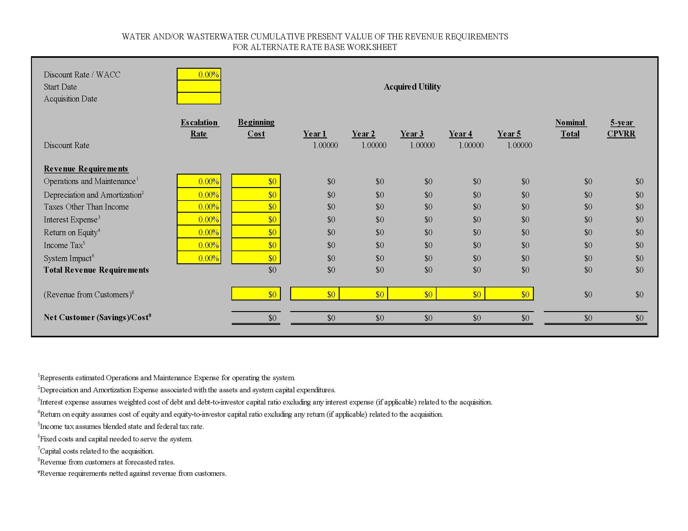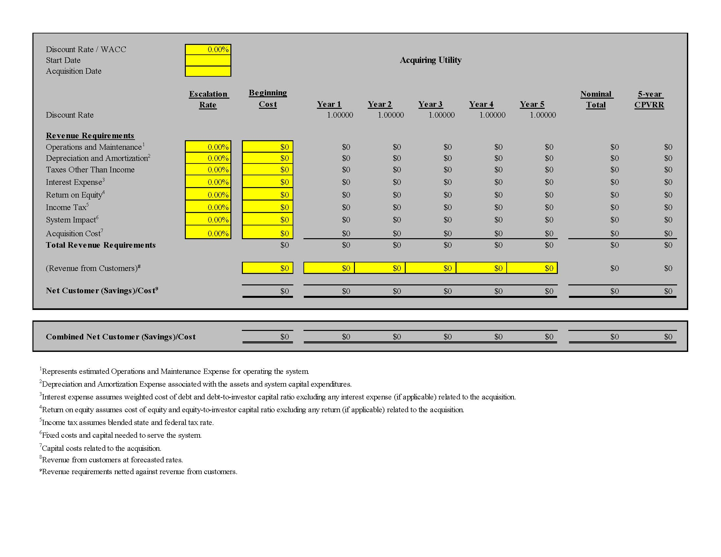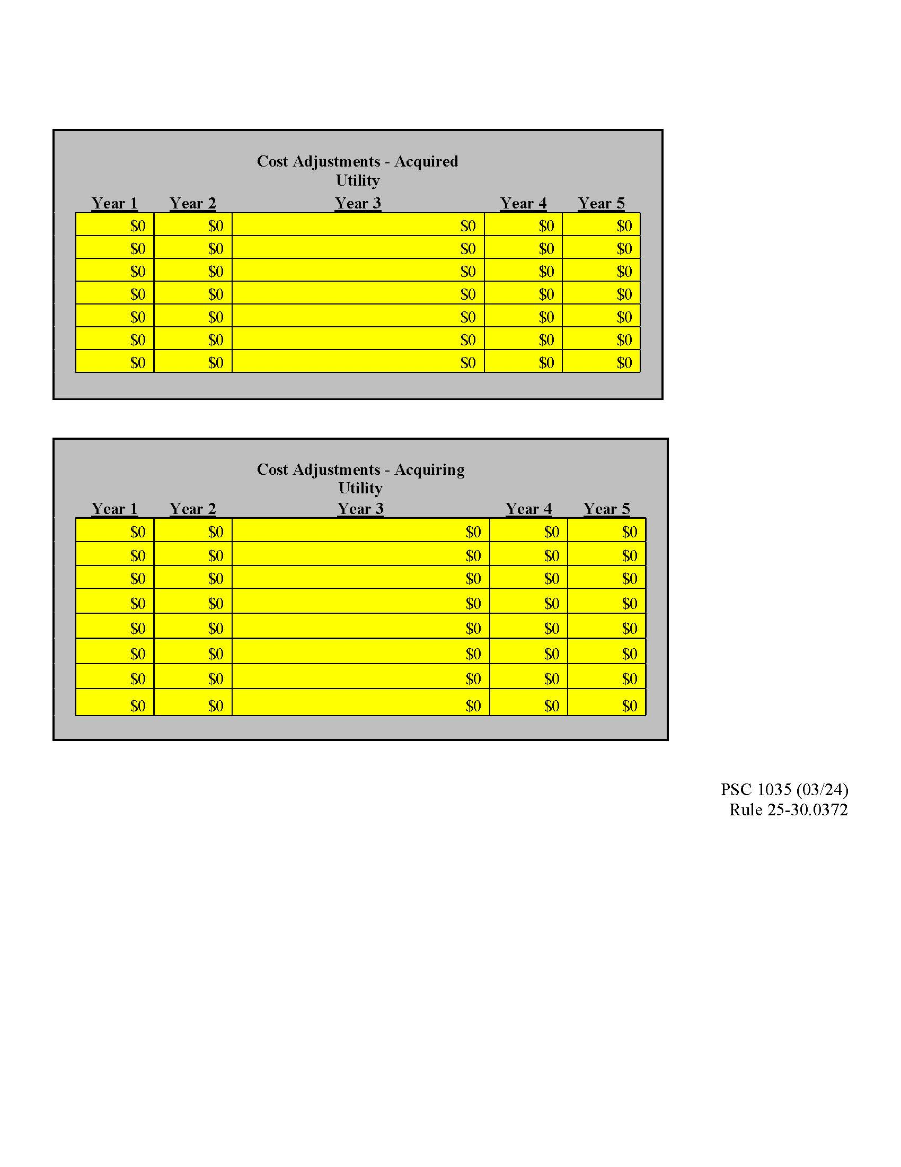
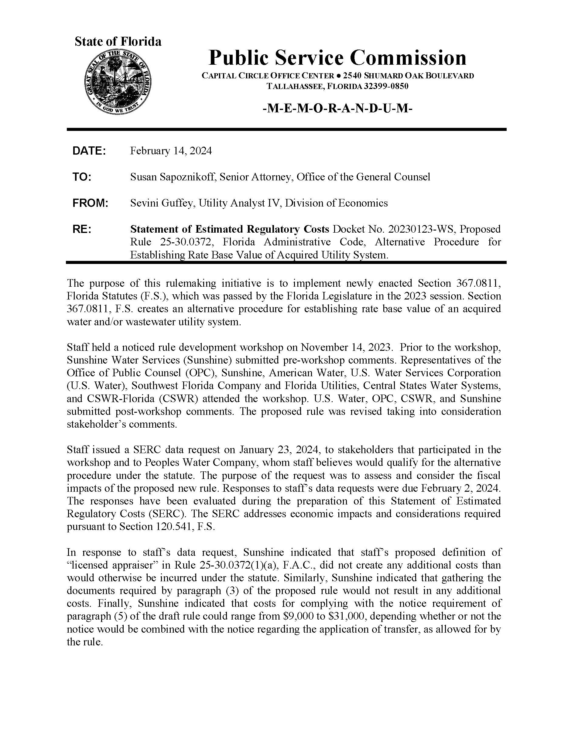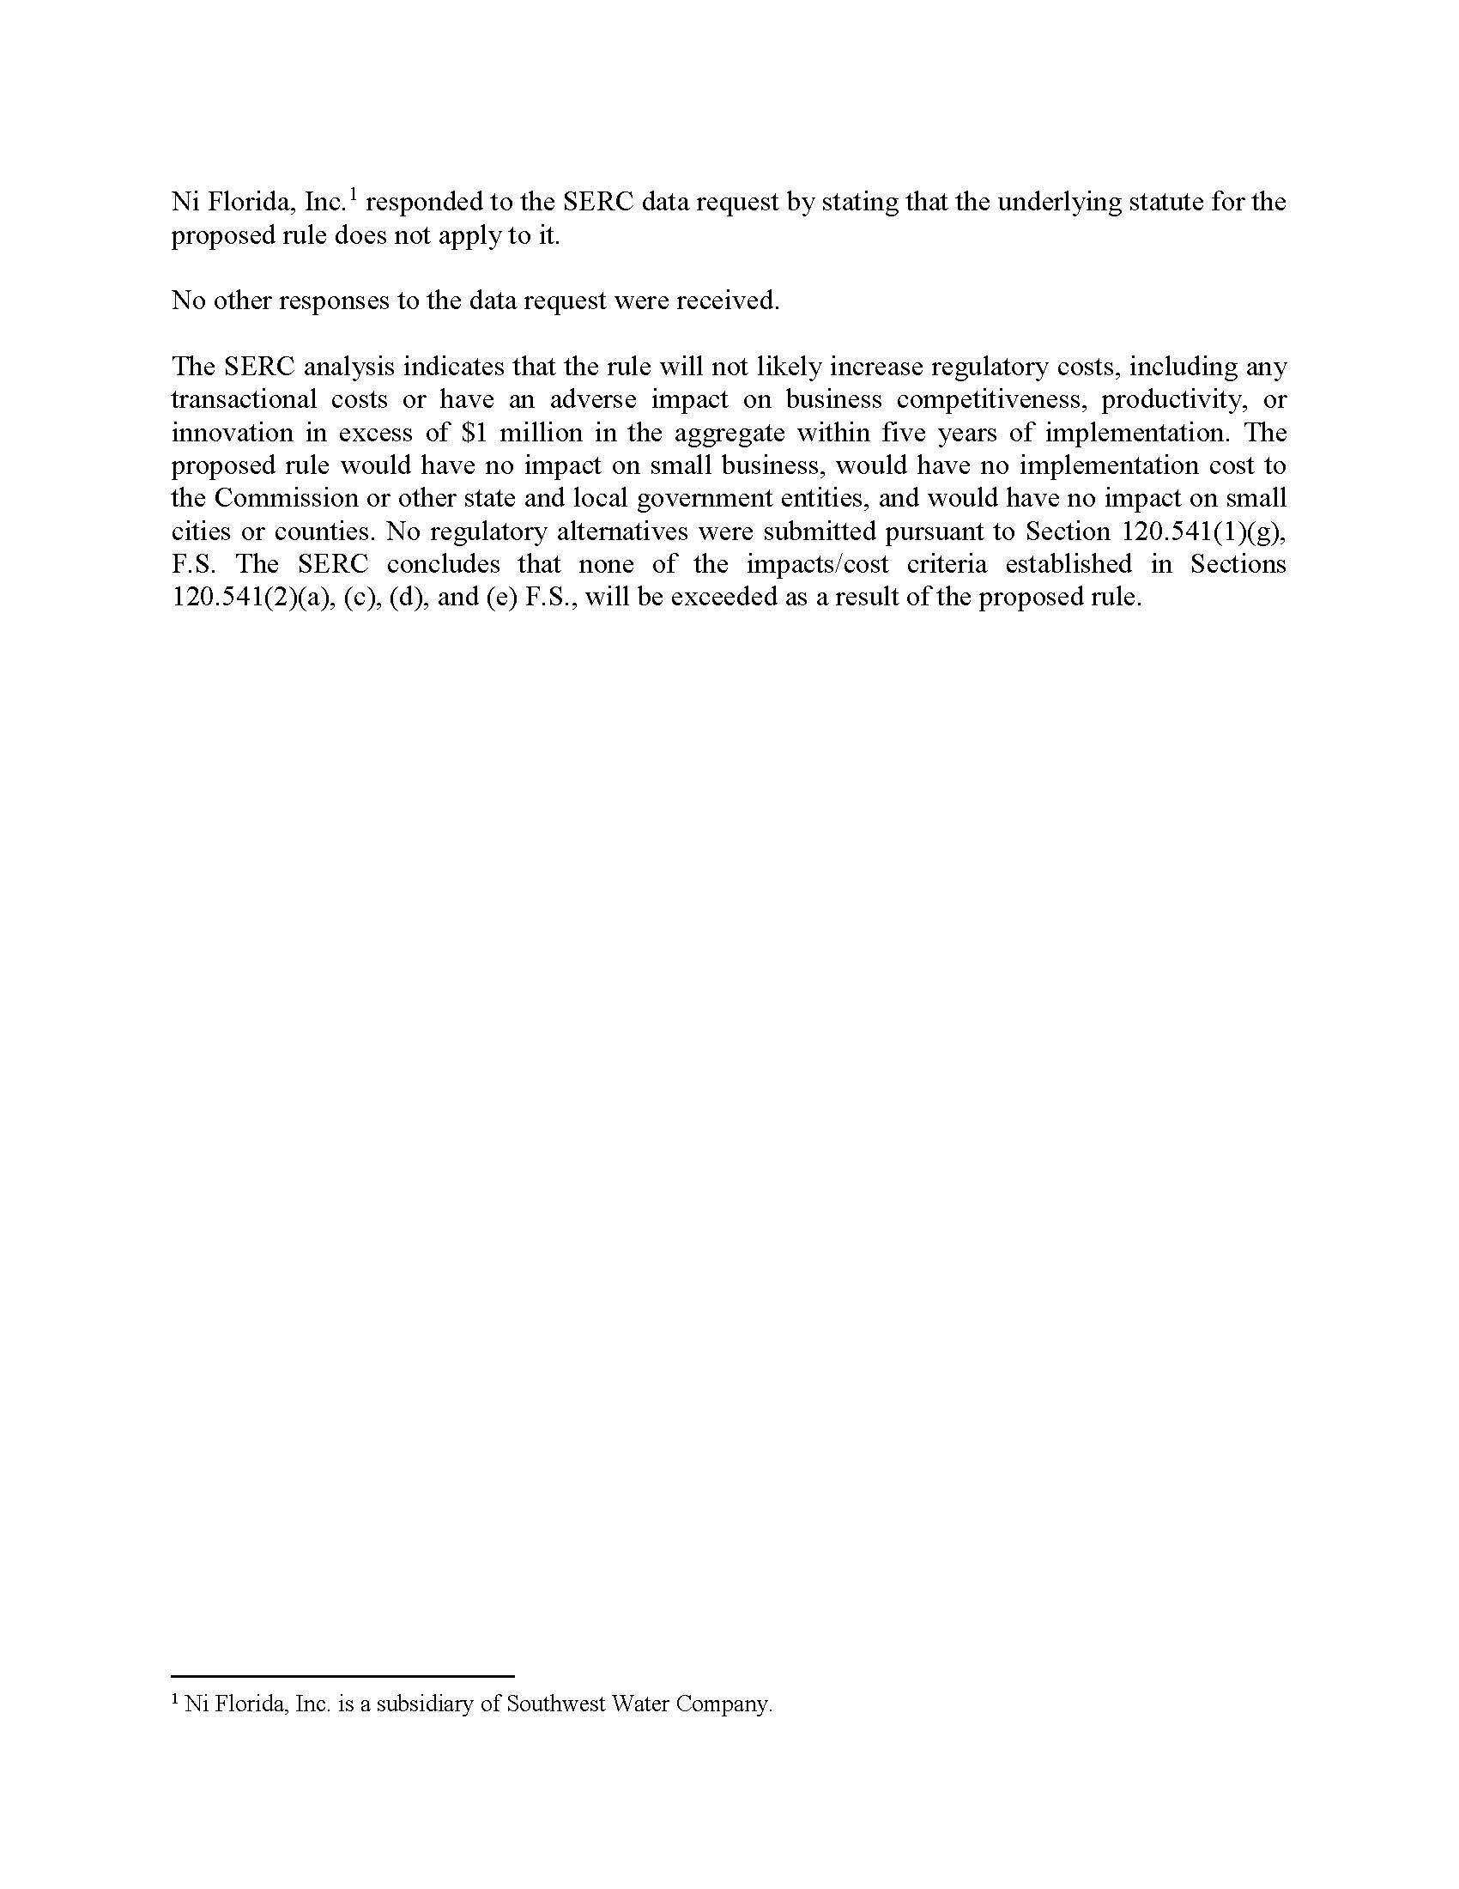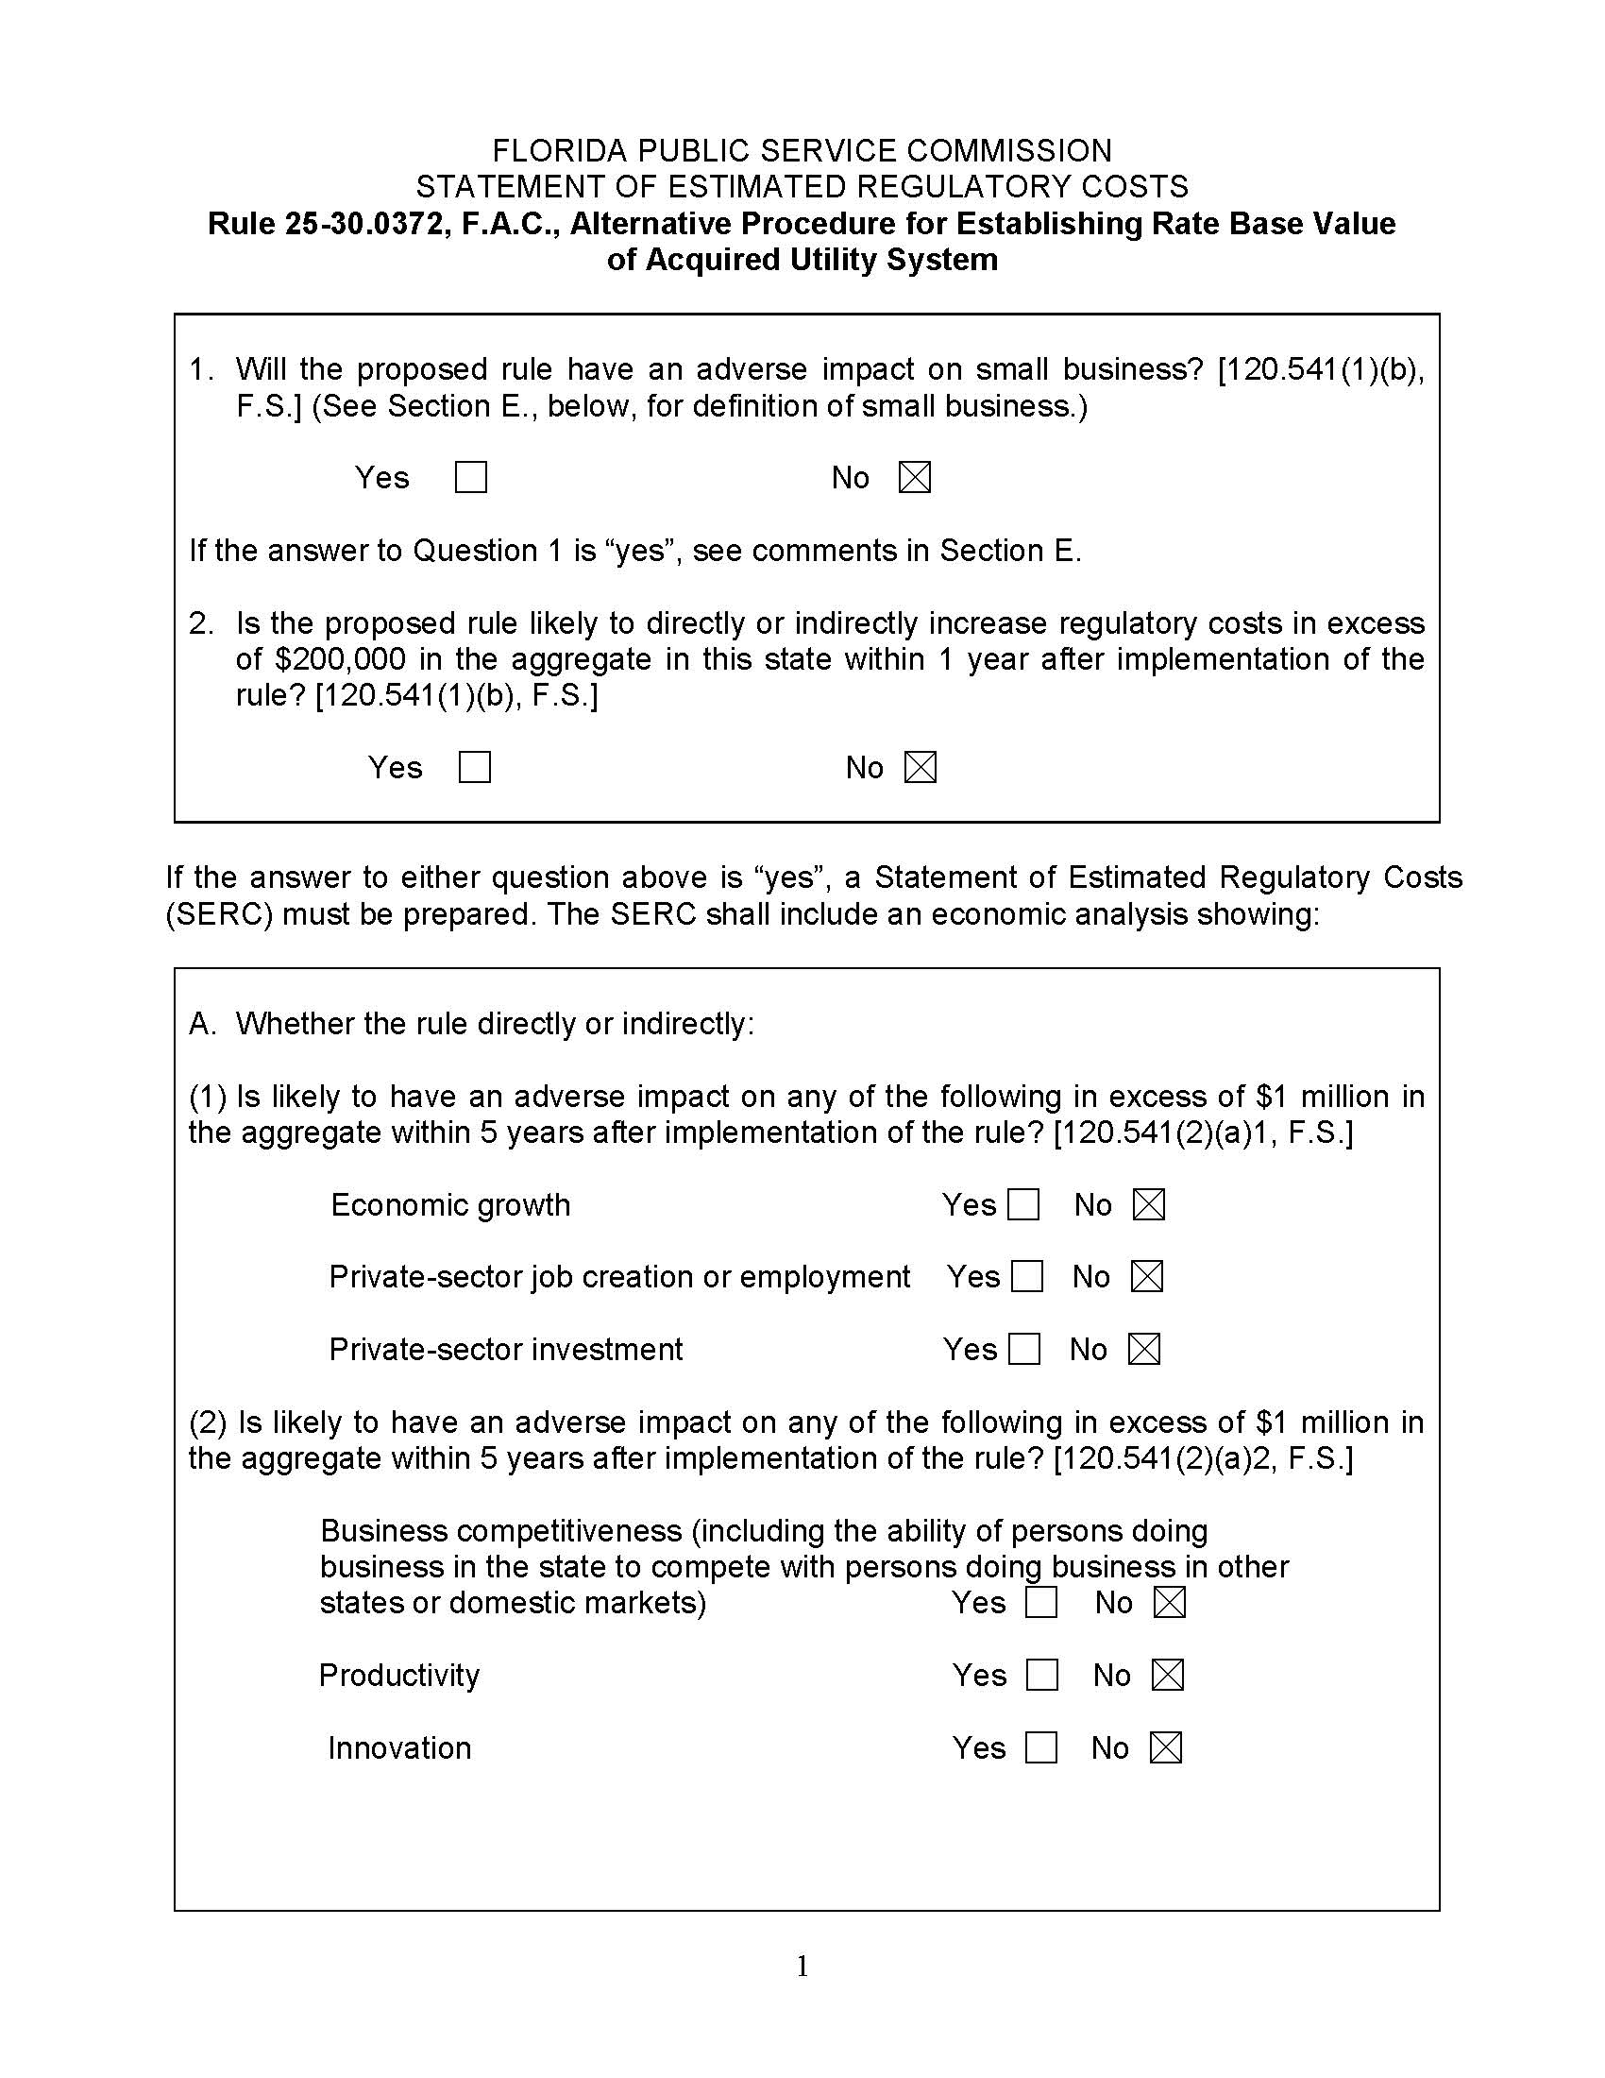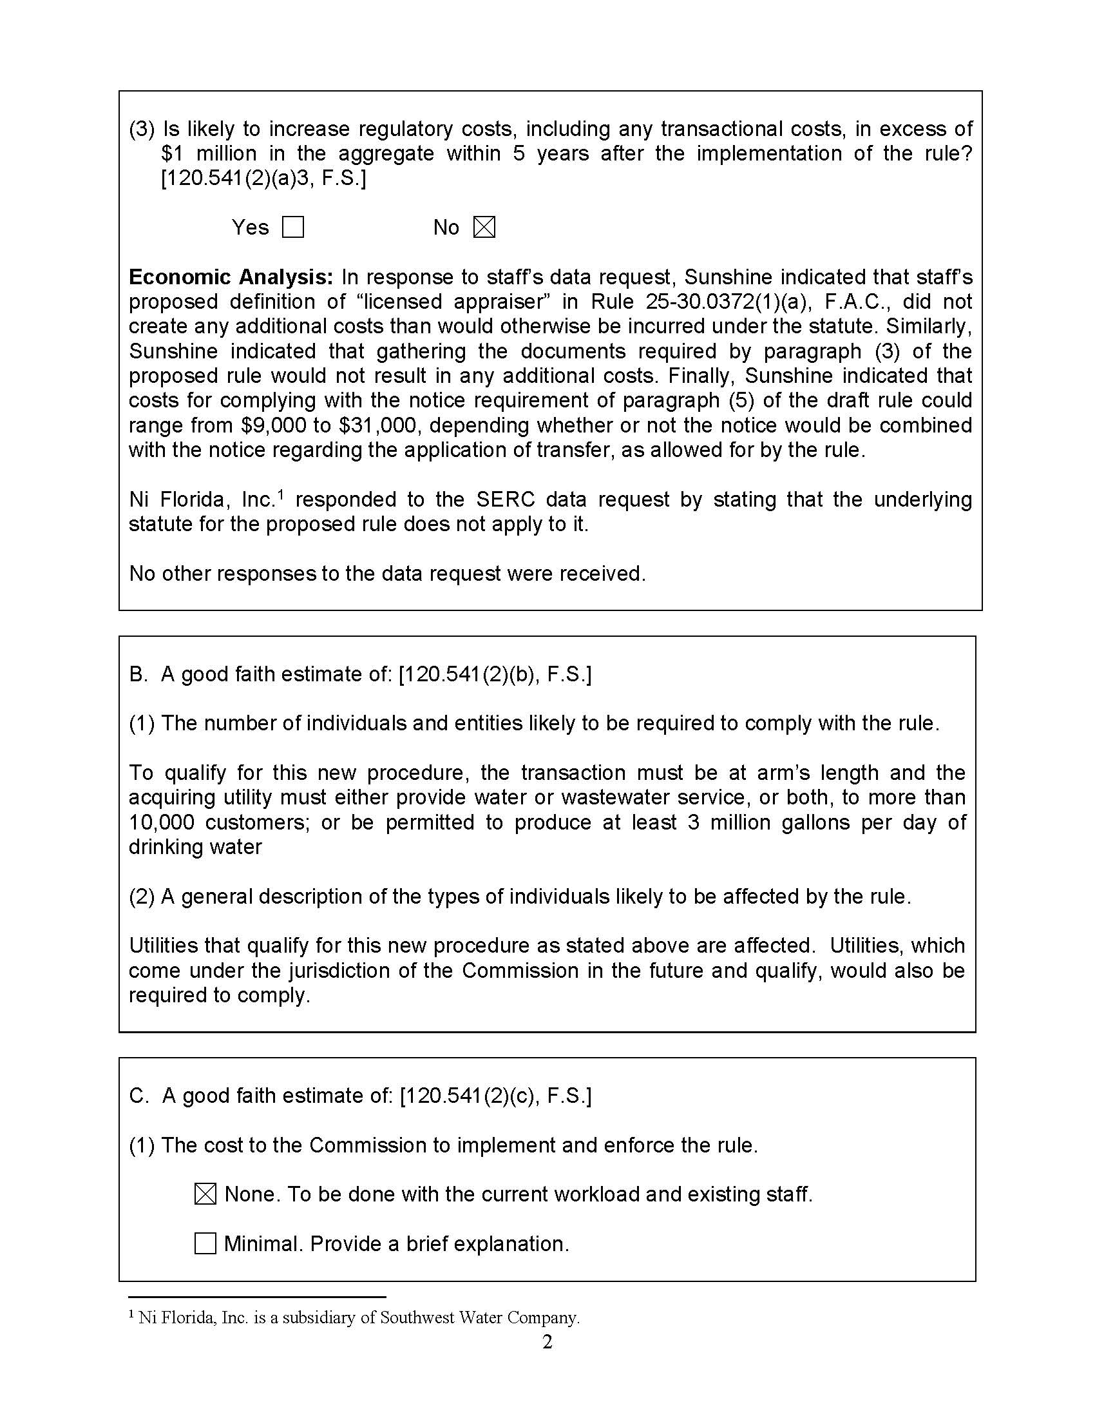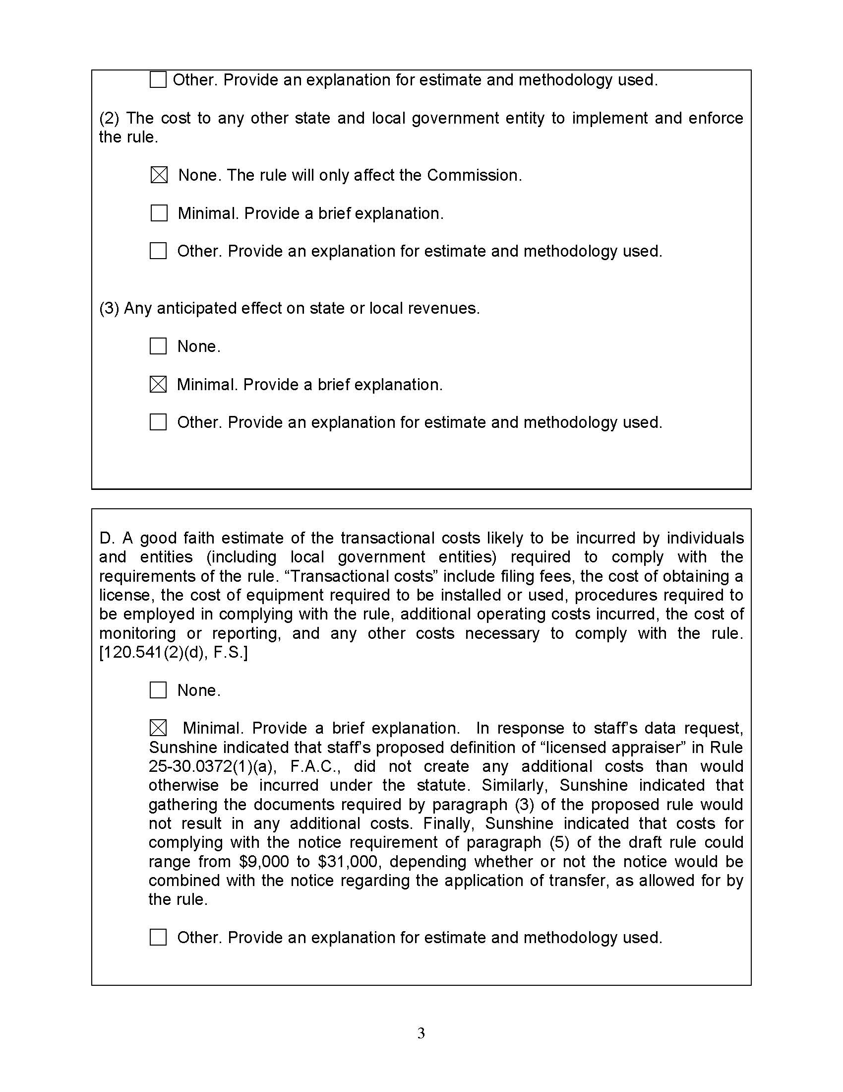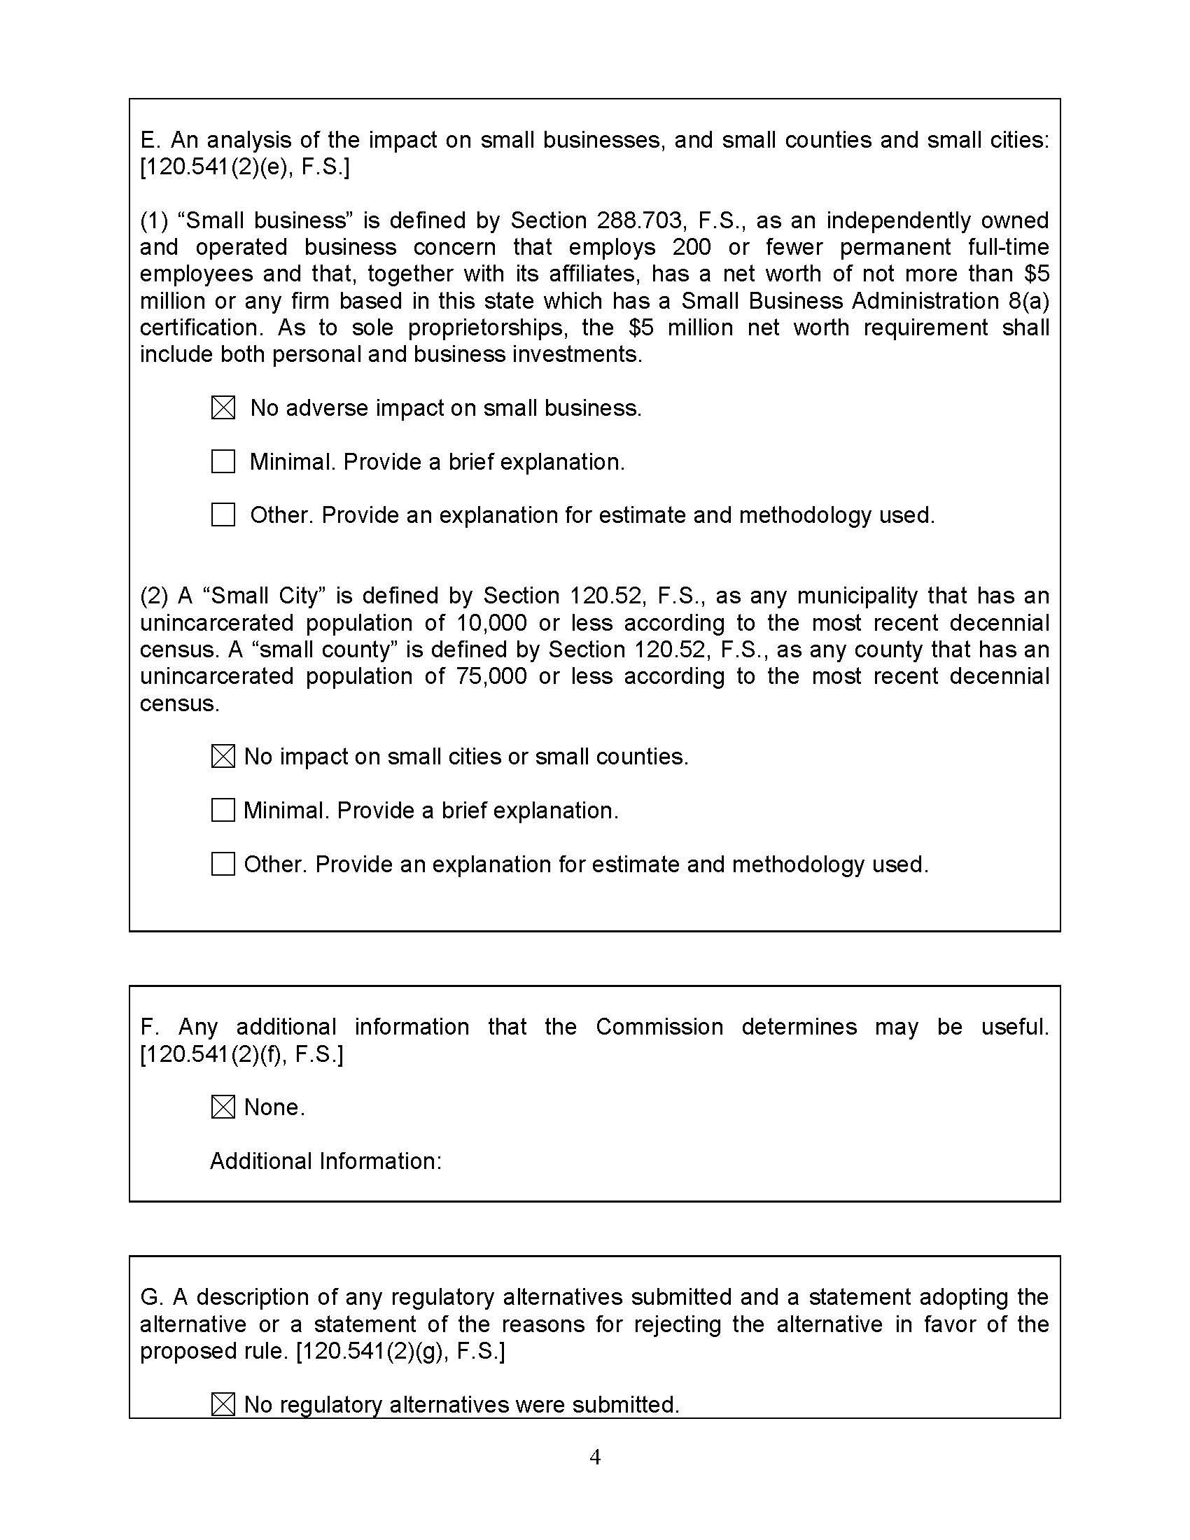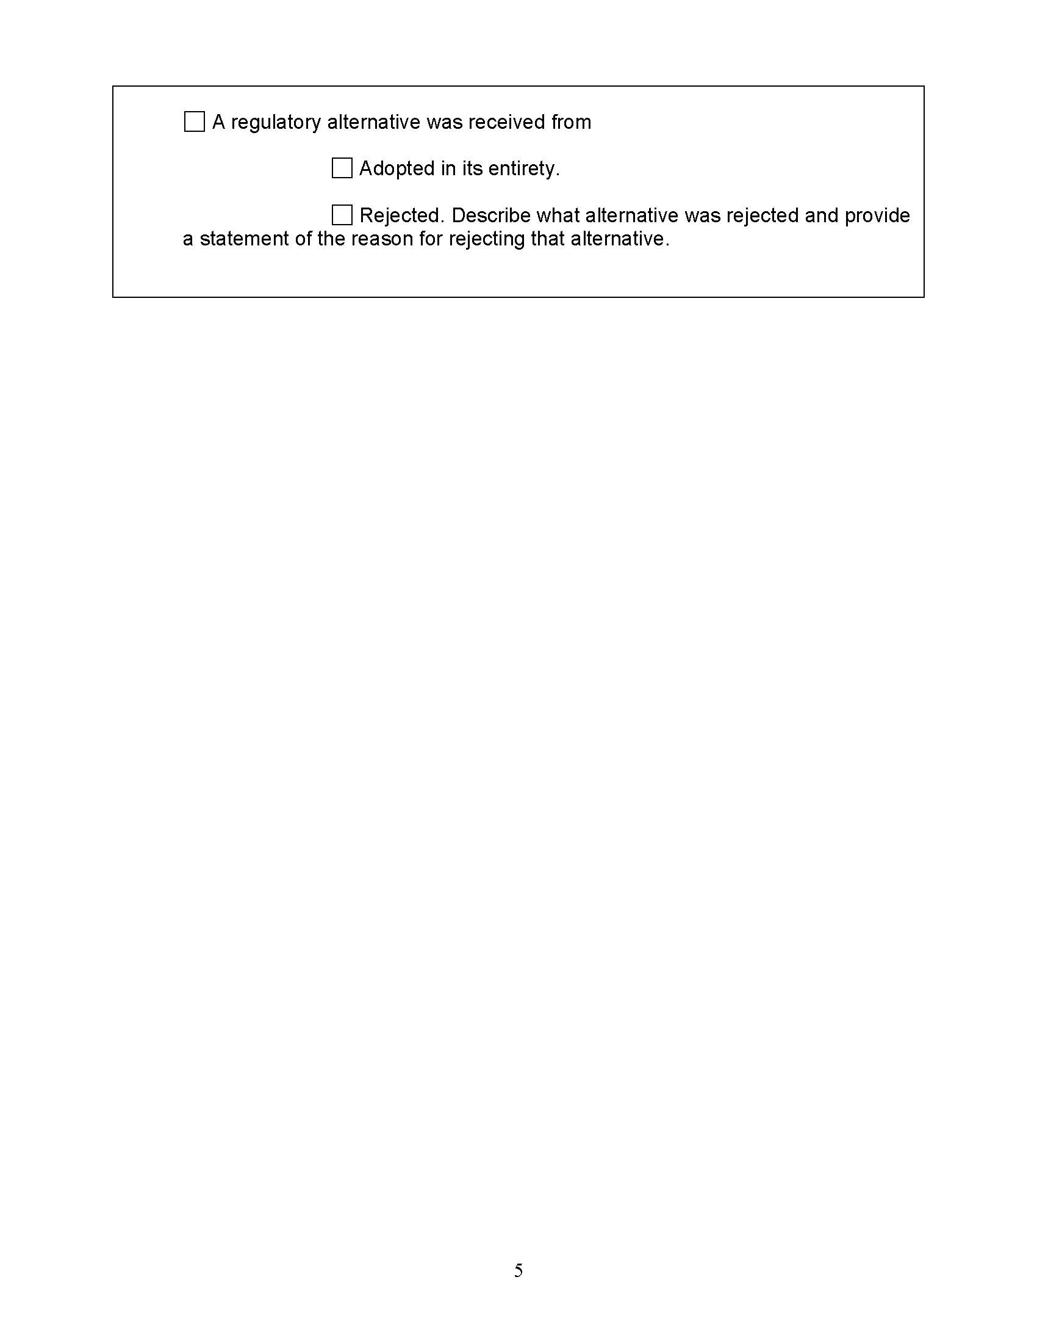

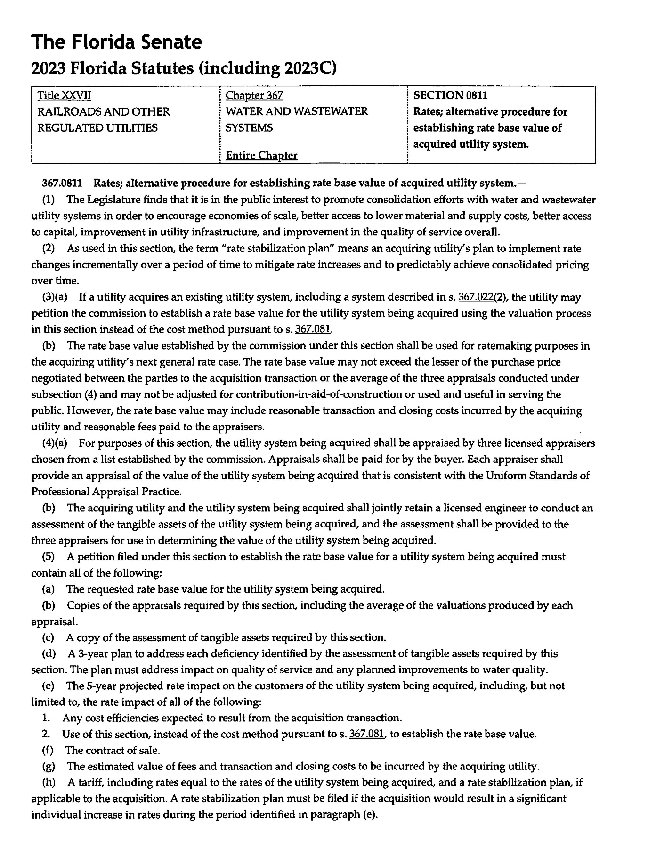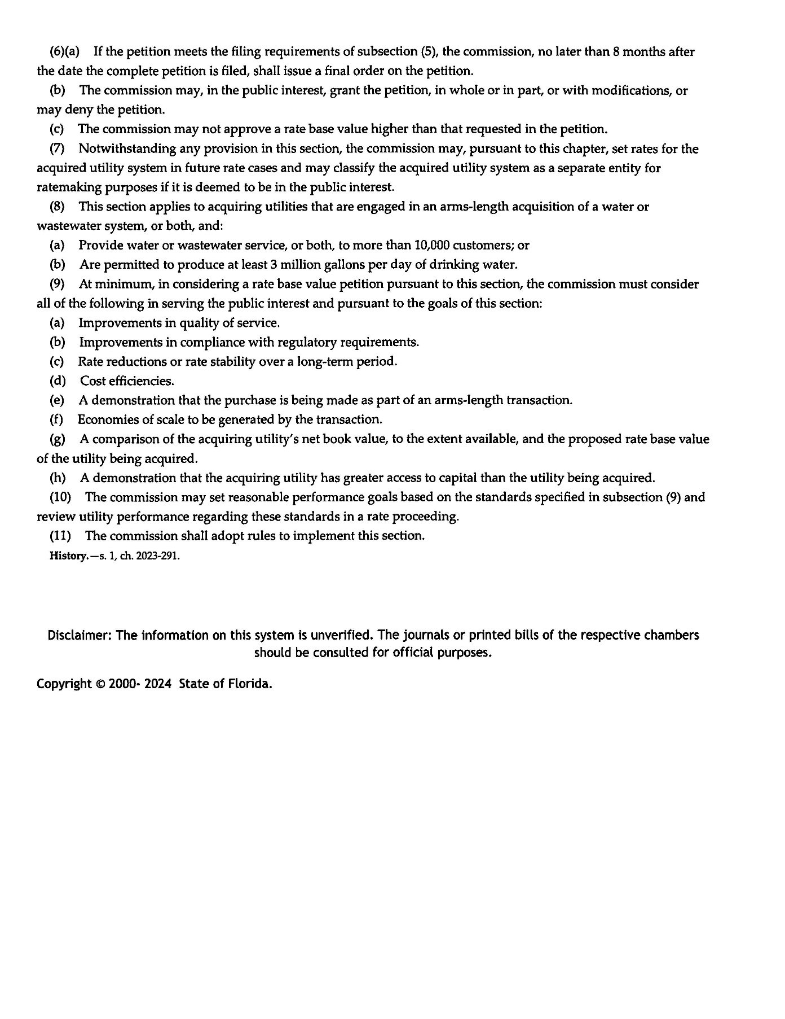

Moreover, when such category of license was issued, it pertained to appraisal of residential real property, which would not be appropriate for appraisal of a water and/or wastewater system.
Provided certain customer notice and filing requirements are met.

