

James A. McGee
ASSOCIATE GENERAL COUNSEL
PROGRESS ENERGY SERVICE COMPANY, LLC

July 31, 2026

Ms. Blanca S. Bayó, Director
Division of the Commission Clerk
and Administrative Services
Florida Public Service Commission
2540 Shumard Oak Boulevard
Tallahassee, Florida 32399-0850

Re: Commercial/Industrial Service Rider Quarterly Report;
October through December, 2003.

Dear Ms. Bayó:
Pursuant to Order No. PSC-01-1789-TRF-EI, issued in Docket No. 010876-EI, enclosed for filing on behalf of Progress Energy Florida, Inc., are an original and fifteen copies of the subject Quarterly Report for the period October through December, 2003.
Please acknowledge your receipt of the above filing on the enclosed copy of this letter and return to the undersigned. A 3 inch diskette containing the above-referenced document in Excel format is also enclosed. Thank you for your assistance in this matter.
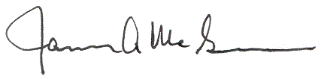
Very truly yours,

James A. McGee
JAM/scc
Enclosures

