|  |  |  |  |
| --- | --- | --- | --- |
| State of Florida  pscSEAL | | Public Service Commission  Capital Circle Office Center ● 2540 Shumard Oak Boulevard Tallahassee, Florida 32399-0850  -M-E-M-O-R-A-N-D-U-M- | |
| DATE: | May 21, 2025 | | |
| TO: | Office of Commission Clerk (Teitzman) | | |
| FROM: | Division of Economics (Bethea, Bruce, Hudson)  Division of Engineering (Watts)  Office of the General Counsel (Dose, Crawford) | | |
| RE: | Docket No. 20240106-WU – Application for a revenue-neutral uniform water rate restructuring limited proceeding in Alachua, Duval, Leon, Okaloosa, and Washington Counties, by North Florida Community Water Systems, Inc. | | |
| AGENDA: | 06/03/25 – Regular Agenda – Proposed Agency Action – Interested Persons May Participate | | |
| COMMISSIONERS ASSIGNED: | | | All Commissioners |
| PREHEARING OFFICER: | | | Fay |
| CRITICAL DATES: | | | None |
| SPECIAL INSTRUCTIONS: | | | None |

Case Background

North Florida Community Water System, Inc. (NFCWS or utility) owns six water and three wastewater systems in Alachua, Duval, Franklin, Leon, Okaloosa, and Washington counties. Service is provided to approximately 2,213 water and 243 wastewater customers. According to NFCWS’s 2024 Annual Report, the combined operating revenues were $1,468,386 for water and $449,525 for wastewater. NFCWS also recorded combined net operating expenses of $1,271,683 for water and $384,890 for wastewater. This proceeding is for the water systems, which are in all counties except for Franklin.

The six water systems are Gator Waterworks, Inc. (Gator); Duval Waterworks, Inc. (Duval), Lake Talquin Waterworks, Inc. (Lake Talquin), Seminole Waterworks, Inc. (Seminole), Okaloosa Waterworks, Inc. (Okaloosa), and Sunny Hills Utility Company, Inc. (Sunny Hills). In February of 2023, the Commission acknowledged the corporate reorganization and name change of these systems to NFCWS.[1] The corporate reorganization resulted in no change in ownership or control of the utilities and each NFCWS system continued to charge its own Commission-approved rates and charges.

On July 25, 2024, NFCWS filed an application for a revenue-neutral rate restructuring limited proceeding for the purpose of consolidating the rates of the six water systems into uniform rates. In its application, NFCWS states that there is a wide disparity in rates among the systems. The utility believes that implementing uniform rates will result in a more equitable disbursement of operating costs among the customer group. Three of NFCWS systems have had rate cases before the Commission, which established rate base, operating income, rate of return on equity, and rates. The following table reflects the rate proceedings in which rates were last established for NFCWS’s respective systems in this proceeding.

**Last Proceedings Establishing Rates for NFCWS Water Systems**

|  |  |  |  |
| --- | --- | --- | --- |
| **County** | **Former Utility Name** | **Order** | **Issuance Date** |
| Alachua | Gator Waterworks, Inc. | PSC-2020-0086-PAA-WU | March 24, 2020 |
| Duval | Duval Waterworks, Inc. | PSC-2012-0436-PAA-WS | August 24, 2012 |
| Leon | Lake Talquin Waterworks, Inc. | N/A | N/A |
| Leon | Seminole Waterworks, Inc. | N/A | N/A |
| Okaloosa | Okaloosa Waterworks, Inc. | N/A | N/A |
| Washington | Sunny Hills Utility Company | PSC-2022-0335-PAA-WS | September 28, 2022 |

Source: NFCWS’s petition

Rule 25-30.445(6), Florida Administrative Code (F.A.C.), provides that a limited proceeding will not be allowed if the utility has not had a rate case within seven years of the date of the petition for limited proceeding is filed with the Commission. Lake Talquin, Seminole, and Okaloosa have never had a rate case before the Commission and it has been more than seven years since Duval’s last rate proceeding. Therefore, on August 2, 2024, NFCWS sought a partial variance or waiver of a requirement of Rule 25-30.445, F.A.C. On November 25, 2024, the Commission approved NFCWS’s petition to waive Rule 25-30.455(6) for the limited purpose requested.[2]

In each of the system’s last rate cases, before the consolidation into NFCWS, the Commission found the overall quality of service to be satisfactory except for Sunny Hills. In its 2022 rate case, the Commission found Sunny Hills’ overall quality of service to be marginal due to noncompliance with the Department of Environmental Protection’s (DEP) iron limits in its 2021 secondary water quality tests for Well No. 1.[3] Sunny Hills was ordered to submit a report to Commission staff six months from the date of the order on the status of the improvements to Well No. 1. Sunny Hills provided the required status report, and followed up with a second report as it was not able to complete the work within the six months due to supply chain issues. The issue was resolved, and the docket closed. As stated above, Lake Talquin, Okaloosa, and Seminole have not had a rate case before the Commission and therefore have not previously had a quality of service determination.

Staff reviewed each system’s customer complaint record from July 2019 through August 2024. There were four complaints filed with the Commission regarding secondary water quality standards. Two complaints were for low water pressure, one for Sunny Hills and one for Seminole. When Sunny Hills investigated the low pressure complaint, it found that the water pressure tested within the DEP’s approved limits. The low pressure issue for Seminole was determined to be caused by the freezing temperatures in Tallahassee, and that no line breaks occurred. The third complaint was for dirty water for Okaloosa, and the fourth complaint was for excessive chlorine in Sunny Hills. Each of these complaints was resolved through flushing.

The DEP also received two secondary water complaints for Sunny Hills after its last rate case was processed. Both DEP complaints involved odor and color problems that were due to low chlorine. One was due to a line break that was fixed. The other was due to problems at one of the two water treatment plants (WTP). The first WTP was shut down and the second WTP serviced the area until repairs were made to the first plant. All of the other systems that make up the NFCWS system are passing DEP’s secondary water standards.[4]

A customer meeting was held virtually on March 26, 2024. One customer participated and voiced concerns regarding water pressure issues. Two comments were filed in the docket file pertaining to water quality. One identified the water as being brown in color, and the customer also reported low water pressure regarding Sunny Hills. The other stated that the water from Gator smelled strongly of chlorine.

This recommendation addresses the request for a revenue-neutral uniform rate restructuring limited proceeding. The Commission has jurisdiction to consider this matter pursuant to Sections 367.0822 and 367.0816, Florida Statutes (F.S.).

Discussion of Issues

Issue :

 Should North Florida Community Water System’s request for a revenue-neutral restructuring limited proceeding for uniform rates be approved?

Recommendation:

 Yes. The Commission should approve NFCWS’s request for a revenue-neutral rate restructuring limited proceeding for uniform rate. (Hudson, Bethea)

Staff Analysis:

 NFCWS indicated that the implementation of uniform rates would result in a more equitable disbursement of operating costs among the customers. NFCWS believes it would be more efficient to have a uniform rate structure that would allow it to consolidate the accounting records and financial information into one set of books. It would allow a less stringent and more meaningful, understandable rate structure for the Okaloosa water system.

In prior dockets, the Commission has approved rate consolidation because it encourages large utilities to acquire small utilities; recognizes economies of scale attributable to large utilities with respect to combined operations; results in cost savings associated with regulatory filings; and produces rate stability across all systems.[5] In evaluating consolidated rates in prior decisions, the Commission has set a subsidy limit and evaluated the consolidated rates at the average consolidated residential demand for the individual systems.

The last subsidy limit was set by the Commission in 2023 at $17.27 for water and wastewater.[6] To put the $17.27 subsidy limit in perspective, if the limit is indexed from 2024 and 2025, using the Commission-approved indexes, it results in a subsidy limit of $18.23 for the instant docket. The indexed subsidy limit for water is based on 7,000 gallons. The average consolidated water residential demand is approximately 4,000 gallons and should be used to evaluate subsidies for water. Since the subsidy limit is based on 7,000 gallons, for 4,000, the subsidy limit is $10.42. As reflected in Table 1-1, the Gator, Okaloosa, and Seminole systems are paying a subsidy for water using staff’s recommended rates. However, the subsidies are below the subsidy limit of $10.42.

**Table 1-1**

**Residential Water Bill Comparison**

**Based on 4,000 Gallons a Month**

|  |  |  |  |
| --- | --- | --- | --- |
| **System** | **Bill at Stand Alone Rates** | **Bill at Consolidated Rates** | **Subsidy Paid (Received)** |
| Gator | $41.73 | $46.91 | $5.18 |
| Lake Talquin | $52.77 | $46.91 | ($5.86) |
| Okaloosa | $45.64 | $46.91 | $1.27 |
| Seminole | $39.98 | $46.91 | $6.93 |
| Sunny Hills | $58.31 | $46.91 | ($11.40) |

Based on the above, the proposed consolidation of rates results in rates that are below the subsidy limit of $10.42 for those systems paying a subsidy based on average usage. This is consistent with the Commission’s previous analysis methodology for similar dockets. As discussed previously, there are many benefits of rate consolidation. As a result, the Commission should approve NFCWS’s request for a revenue-neutral rate restructuring limited proceeding for uniform rates.

Issue :

 What is the appropriate revenue requirement for restructuring the rates?

Recommendation:

 The appropriate revenue requirement for restructuring the water rates is $1,537,556. (Hudson)

Staff Analysis:

 In its application, NFCWS requests the rate restructuring for uniform rates be revenue neutral. In its revised filing, the utility proposed to use the operating revenues that were generated by billing determinants and rates for 2023, increased by the 2024 price index and reduced by the 2023 operating revenues associated with overearnings by the Duval water system. In addition, NFCWS requested rate case expense to cover the cost incurred in this proceeding.

Subsequent to its 2023 test year, the utility was approved for price index rate adjustments for all water systems, except Duval, effective September 1, 2024. NFCWS’s billing analyses are generated based on base facility charges. Therefore, when there is a rate change in a month, the prorated base facility charge shows up as two bills with a proration of usage for each customer in the billing analysis. The additional bills will overstate the operating revenues. The prorated usage will understate the operating revenues for the systems with tiered rate structures because the total usage would not be reflected in the appropriate tier. Staff adjusted the billing analyses to correct the issues that take place when there is a rate change during the month. Annualizing the operating revenues using the current rates, and the revised billing analysis resulted in water operating revenues of $1,548,370.

The utility requested rate case expense to cover the filing fee, customer noticing, newspaper noticing, final notice, and travel expense to attend the Commission Conference.[7] NFCWS paid a filing fee of $2,250, newspaper noticing costs of $407, and $3,485 for mailing customer meeting notice. The utility estimated cost of $3,485 for the final notice, $350 for mileage, and $145 for lodging. NFCWS is required by Rule 25-22.0407, F.A.C., to mail notices for the customer meeting, final rates, and four-year rate reduction. The utility’s final notice cost was based on the cost incurred to mail notices for the customer meeting. However, the customer meeting notice was five pages while the final notice would only be two pages. The average cost per page for noticing the customer meeting was $697 ($3,485/5). For the two page final notice, the cost for noticing would be approximately $1,394. In addition, the utility did not include any cost for mailing the notices for the pending rate reduction, which would also be a two page notice resulting in a cost of $1,394. Staff has examined the requested expenses and supporting documentation and recommends total rate case expense of $9,425 ($2,250 + $407 + $3,485 + $1,394 + $350 + $145 + $1,394). The recommended total rate case expense should be amortized over four years, which represents an annual expense of $2,356 ($9,425/4 Years). The annual expense grossed-up for regulatory assessments fees (RAFs) results in $2,467 that should be recovered in rates.

The annualized 2023 water operating revenues of $1,548,370 should be increased by $2,467 for the rate case expense. In addition, as mentioned above, the total 2023 overearnings of $13,281 for water should be removed.[8] Based on the above, the appropriate revenue requirement for restructuring the water rates is $1,537,556 ($1,548,370 + $2,467 - $13,281).

Issue :

 What are the appropriate rate structures and rates for the water systems?

Recommendation:

 The staff recommended rate structure and rates for the water systems are shown on Schedule No. 1. The utility should file revised tariff sheets and a proposed customer notice to reflect the Commission-approved rates. The approved rates should be effective for service rendered on or after the stamped approval date on the tariff sheets pursuant to Rule 25-30.475(1), F.A.C. In addition, the approved rates should not be implemented until staff has approved the proposed customer notices and the notices have been received by the customers. The utility should provide proof of the date notices were given within 10 days of the date of the notice. (Hudson)

Staff Analysis:

 For its consolidated water rates, NFCWS proposed a rate structure which consists of recovering 40 percent of the operating revenues from the base facility charge (BFC) and a three-tier inclining block rate structure. The proposed rate blocks are: (1) 0-6,000 gallons, (2) 6,001-12,000 gallons, and (3) all usage in excess of 12,000 gallons per month. The general service rate structure consists of a BFC and uniform gallonage charge.

NFCWS provides water service to approximately 2,121 residential customers and 92 general service customers. A review of the consolidated billing data indicates that approximately 15 percent of the residential bills had zero gallons, which signifies a slightly seasonal consolidated customer base. The average consolidated water demand is approximately 4,000 gallons per month. Staff performed an analysis of the utility’s consolidated billing data in order to evaluate the appropriate rate structure for the residential water customers. The goal of the evaluation was to select the rate design parameters that: (1) produce the recommended revenue requirement; (2) equitably distribute cost recovery among the utility’s customers; (3) establish the appropriate non-discretionary usage threshold for restricting repression; and (4) implement, where appropriate, water conserving rate structures consistent with Commission practice.

Due to approximately 30 percent of the bills being 1,000 gallons or less, staff recommends that the utility’s proposal that 40 percent of the water revenue be generated from the BFC is appropriate. The 40 percent BFC allocation provides revenue stability. The average people per household served by the systems on a consolidated basis is approximately 2.5; therefore, based on the number of people per household, 50 gallons per day per person, and the number of days per month, the non-discretionary usage threshold should be 4,000 gallons per month.

Based on the consolidated billing analysis, the utility’s three-tier inclining blocks rate structure was too aggressive for the usage distribution and the revenues. Staff recommends a BFC and a two-tier inclining block rate structure, which includes separate gallonage charges for non-discretionary and discretionary usage for residential water customers. The rate blocks are: (1) 0-4,000 gallons and (2) all usage in excess of 4,000 gallons per month. General service customers should be billed a BFC and a gallonage charge. Private fire protection customers should be billed one-twelfth of the BFC for the respective meter size pursuant to Rule 25-30.465, F.A.C.

On a consolidated basis, approximately 36 percent of the total residential consumption is discretionary. However, based on the moderate increase in bills for the customers in the Gator, Okaloosa, and Seminole systems, the number of gallons reduced is de minimis. Therefore, staff recommends no repression adjustment.

The staff recommended rate structure and rates for water are shown on Schedule No. 1. The utility should file revised tariff sheets and a proposed customer notice to reflect the Commission-approved rates. The approved rates should be effective for service rendered on or after the stamped approval date on the tariff sheets pursuant to Rule 25-30.475(1), F.A.C. In addition, the approved rates should not be implemented until staff has approved the proposed customer notices and the notices have been received by the customers. The utility should provide proof of the date notices were given within 10 days of the date of the notice.

Issue :

 What is the appropriate amount of rate case expense and what is the appropriate amount by which rates should be reduced four years after the published effective date to reflect the removal of the amortized rate case expense?

Recommendation:

 The appropriate amount of rate case expense is $9,425. The total rate case expense should be amortized over four years, resulting in an annual expense of $2,467, when grossed-up for RAFs. The rates should be reduced as shown on Schedule Nos. 1-A and 1-B, to remove rate case expense grossed-up for RAFs and amortized over a four-year period. In addition, for prior unamortized rate case expense, the rates should be reduced as shown on Schedule No. 2. Pursuant to Section 367.081(8), F.S., the decrease in rates should become effective immediately following the expiration of the rate case expense recovery period. NFCWS should be required to file revised tariffs and a proposed customer notice setting forth the lower rates and the reason for the reduction no later than one month prior to the actual date of the required rate reduction. If the utility files this reduction in conjunction with a price index or pass-through rate adjustment, the utility should file separate data for the price index and/or pass-through increase or decrease and the reduction in the rates due to the amortized rate case expense. (Hudson)

Staff Analysis:

 Section 367.081(8), F.S., requires that the rates be reduced immediately following the expiration of the recovery period by the amount of the rate case expense previously included in rates. The appropriate amount of rate case expense is $9,425. The total rate case expense should be amortized over four years, resulting in an annual expense of $2,467, when grossed-up for RAFs. The reduction will reflect the removal of revenue associated with the amortization of rate case expense and the gross-up for RAFs, as shown on Schedule No. 1.

In addition, in a prior docket, Sunny Hills was allowed a four-year amortization period for rate case expense of $1,627. The amortization period has not expired. The amortization of prior rate case expense is set to expire on December 1, 2026. The dollar amount of the rate reductions at the end of the amortization period were defined in the order.[9] The rate reductions were calculated based on the percentage of rate case expense to the revenue requirement and was applied to the Commission-approved rates. With the recommendation of consolidation, the prior amortization rate case expense is embedded in the consolidated rates. The amount of rate case expense for Sunny Hills relative to the consolidated revenue requirement results in a lesser amount of rate reduction compared to the amount on a stand-alone basis. Using the rate reductions defined in the prior order for Sunny Hills would result in more rate case expense being removed than appropriate. Therefore, staff has recalculated the amount of the reductions based on the recommended consolidation. The amount of the rate reductions that should be applied to the consolidated rates, which will be applicable to all systems, at the end of the amortization period for the Sunny Hills water system is shown on Schedule No. 2.

Staff recommends that the rates be reduced as shown on Schedule No. 1, to remove rate case expense grossed-up for RAFs and amortized over a four-year period. In addition, for prior unamortized rate case expense, the rates should be reduced as shown on Schedule No. 2. The decrease in rates should become effective immediately following the expiration of the rate case expense recovery period, pursuant to Section 367.081(8), F.S. NFCWS should be required to file revised tariffs and a proposed customer notice setting forth the lower rates and the reason for the reduction no later than one month prior to the actual date of the required rate reduction. If the utility files this reduction in conjunction with a price index or pass-through rate adjustment, the utility should file separate data for the price index and/or pass-through increase or decrease and the reduction in the rates due to the amortized rate case expense.

Issue :

 Should this docket be closed?

Recommendation:

 No. If no person whose substantial interests are affected by the proposed agency action files a protest within 21 days of the issuance of the Proposed Agency Action Order, a consummating order should be issued. The docket should remain open for staff’s verification that the revised tariff sheets and customer notices have been filed by the utility and approved by staff. Upon staff’s approval of the tariff sheets and customer notices, this docket should be closed administratively. (Dose)

Staff Analysis:

 If no person whose substantial interests are affected by the proposed agency action files a protest within 21 days of the issuance of the Proposed Agency Action Order, a consummating order should be issued. The docket should remain open for staff’s verification that the revised tariff sheets and customer notices have been filed by the utility and approved by staff. Upon staff’s approval of the tariff sheets and customer notices, this docket should be closed administratively.













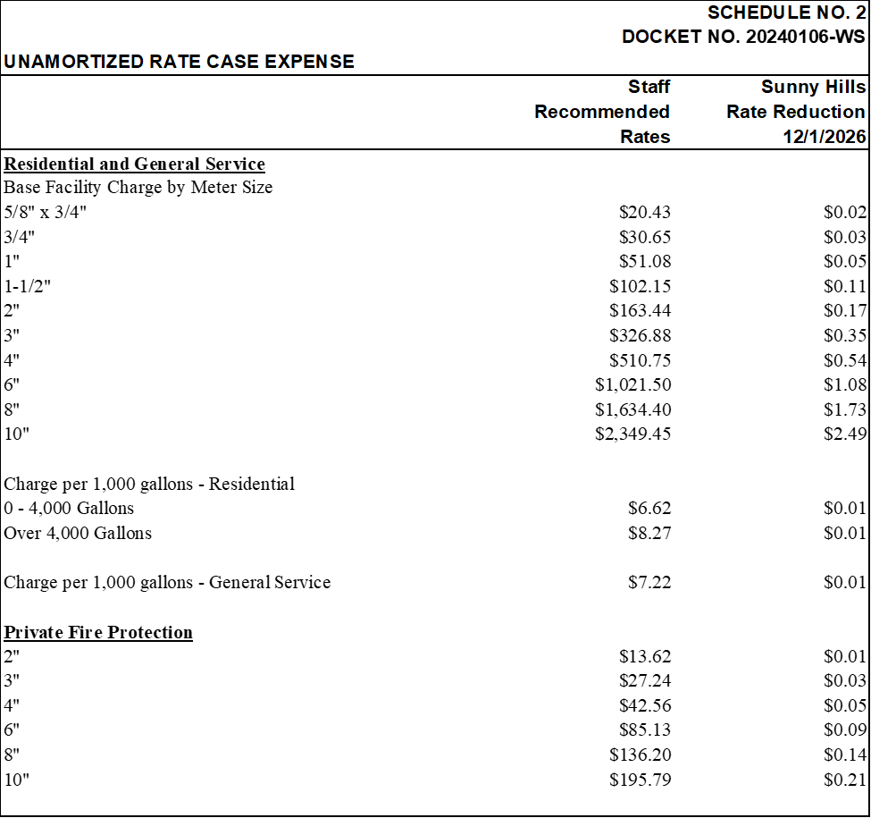

1. Order No. PSC-2023-0097-FOF-WS, issued February 22, 2023, in Docket No. 20220199-WS, *In re: Joint application for acknowledgement of corporate reorganization and approval of name changes on Certificate Nos. 641-W and 551-S in Duval County, Certificate No. 555-W in Alachua County, Certificate Nos. 678-W and 672-W in Leon County, Certificate No. 676-W in Okaloosa County, and Certificate Nos. 501-W and 435-S in Washington County from Duval Waterworks, Inc., Gator Waterworks, Inc., Lake Talquin Waterworks, Inc., Seminole Waterworks, Inc., Okaloosa Waterworks, Inc., and Sunny Hills Utility Company to North Florida Community Water Services, Inc.*
2. Order No PSC-2024-0485-PAA-WU, issued November 25, 2024, in the instant docket.
3. Order No. PSC-2022-0436-PAA-WS, issued September 28, 2022, in Docket No. 20220066-WS, *In re: Application for increase in water rates in Washington County, by Sunny Hills Utility Company*.
4. While staff requested complaint data for all water and wastewater systems of NFCWS from the DEP, the DEP only reported the complaint data for the wastewater systems.
5. Order Nos. PSC-2023-0300-PAA-WS, issued October 2, 2023, in Docket No. 20220201-WS, *In re: Request by Florida Community Water Systems, Inc. for a revenue-neutral rate restructuring in Brevard, Lake, and Sumter Counties* and PSC-2017-0361-FOF-WS, issued September 25, 2017, in Docket No. 20160101-WS, *In re: Application for increase in water and wastewater in Charlotte, Highlands, Lake, Lee, Marion, Orange, Pasco, Pinellas, Polk, and Seminole Counties by Utilities, Inc. of Florida.*
6. Order No. PSC-2023-0300-PAA-WS, issued October 2, 2023, in Docket No. 20220201-WS, page 6.
7. Document No. 03300-2025 filed May 1, 2025.
8. Document No. 08157-2024 filed August 1, 2024.
9. Order No. PSC-2022-0436-PAA-WS, issued September 28, 2022, in Docket No. 20220066-WS, *In re: Application for increase in water rates in Washington County, by Sunny Hills Utility Company*.