State of Florida   |  | Public Service Commission  Capital Circle Office Center ● 2540 Shumard Oak Boulevard  Tallahassee, Florida 32399-0850  -M-E-M-O-R-A-N-D-U-M-
DATE: | December 19, 2025
TO: | Office of Commission Clerk (Teitzman)
FROM: | Division of Economics (Nguyen, Hampson)  Office of the General Counsel (Dose)
RE: | Docket No. 20250132-GU – Petition for approval of second amendment to transportation service agreement between Peninsula Pipeline Company, Inc. and Florida Public Utilities Company, for the New Smyrna Beach project.
AGENDA: | 01/06/26 – Regular Agenda – Proposed Agency Action – Interested Persons May Participate
COMMISSIONERS ASSIGNED: |  |  | All Commissioners
PREHEARING OFFICER: |  |  | Passidomo Smith
CRITICAL DATES: |  |  | None
SPECIAL INSTRUCTIONS: |  |  | None

Case Background
On October 29, 2025, Peninsula Pipeline Company, Inc. (Peninsula), filed a petition seeking approval of a second amendment to firm transportation service agreement between Peninsula and Florida Public Utilities Company (FPUC), collectively the Parties. The proposed second amendment to the agreement is included as Attachment A to this recommendation.
Peninsula and FPUC are both wholly owned subsidiaries of Chesapeake Utilities Corporation (Chesapeake). Peninsula operates as an intrastate natural gas transmission company as defined by Section 368.103(4), Florida Statutes (F.S.). FPUC operates as a local distribution company subject to the regulatory jurisdiction of the Commission pursuant to Chapter 366, F.S.
By Order No. PSC-07-1012-TRF-GP, Peninsula received approval of an intrastate gas pipeline tariff that allows it to construct and operate intrastate pipeline facilities and to actively pursue agreements with natural gas customers. The Parties are subsidiaries of Chesapeake, and agreements between affiliated companies must be approved by the Commission pursuant to Section 368.105, F.S.
By Order No. PSC-2017-0498-PAA-GU, the Commission approved the initial transportation service agreement between Peninsula and FPUC (2017 Order). Pursuant to the 2017 Order, Peninsula would construct and own a new pipeline in New Smyrna Beach and relocate an existing gate station. The purpose of this construction project was to eliminate pressure issues FPUC was facing at the time as well as to provide the opportunity for growth in the New Smyrna Beach area.
By Order No. PSC-2024-0072-PAA-GU, the Commission approved Peninsula’s amended agreement to include an additional source of gas, an additional interconnect, and four new delivery points. Peninsula stated the addition to the project was needed to ensure sufficient additional gas supply and provide operational support to FPUC’s system. In response to staff’s data request, Peninsula states the construction of this project is anticipated to be complete in 2026. This petition for a second amendment arises out of the need for an additional delivery point.
During the evaluation of the petition, staff issued one data request to the Parties for which responses were received on December 2, 2025. The Commission has jurisdiction over this matter pursuant to Sections 368.104, and 368.105, F.S.

Discussion of Issues

Issue 1:
Should the Commission approve the proposed second amendment to the firm transportation service agreement dated October 27, 2025, between Peninsula and FPUC?

Recommendation:
Yes, the Commission should approve the proposed second amendment to the firm transportation service agreement dated October 27, 2025, between Peninsula and FPUC. The proposed second amendment to the firm transportation service agreement is reasonable and meets the requirements of Section 368.105, F.S. (Nguyen)

Staff Analysis:
The purpose of this amendment is to revise certain provisions of the currently approved firm transportation service agreement to reflect the construction of an additional point of delivery. In response to staff’s data request, Peninsula stated that the additional delivery point is necessary to enhance reliability and to meet FPUC’s supply capacity design-day demand due to additional growth in the New Smyrna Beach area. Currently, FPUC is using compressed natural gas to supplement supply in the area during high demand months to ensure adequate supply. The additional delivery point would be located at or near the intersection of Pioneer Trail and Junonia Boulevard in Volusia County. In response to staff’s data request, Peninsula stated that the expected completion date of the new delivery point would be March 31, 2026.
Peninsula stated that there would be no change in the monthly reservation charge in response to staff’s data request. The monthly reservation charge has been previously approved in Order No. PSC-2024-0072-PAA-GU. The reservation charge to FPUC allows Peninsula to recover the pipeline construction costs. Furthermore, Peninsula explained that it would be able to construct the additional delivery point within the existing anticipated capital cost for the original project.

Conclusion
Based on the petition and the Parties’ responses to staff’s data request, staff recommends that the Commission should approve the proposed second amendment to the firm transportation service agreement dated October 27, 2025, between Peninsula and FPUC. The proposed second amendment to the firm transportation service agreement is reasonable and meets the requirements of Section 368.105, F.S.

Issue 2:
Should this docket be closed?

Recommendation:
If no person whose substantial interests are affected by the proposed agency action files a protest within 21 days of the issuance of the order, this docket should be closed upon the issuance of a consummating order. (Dose)

Staff Analysis:
If no person whose substantial interests are affected by the proposed agency action files a protest within 21 days of the issuance of the order, this docket should be closed upon the issuance of a consummating order.

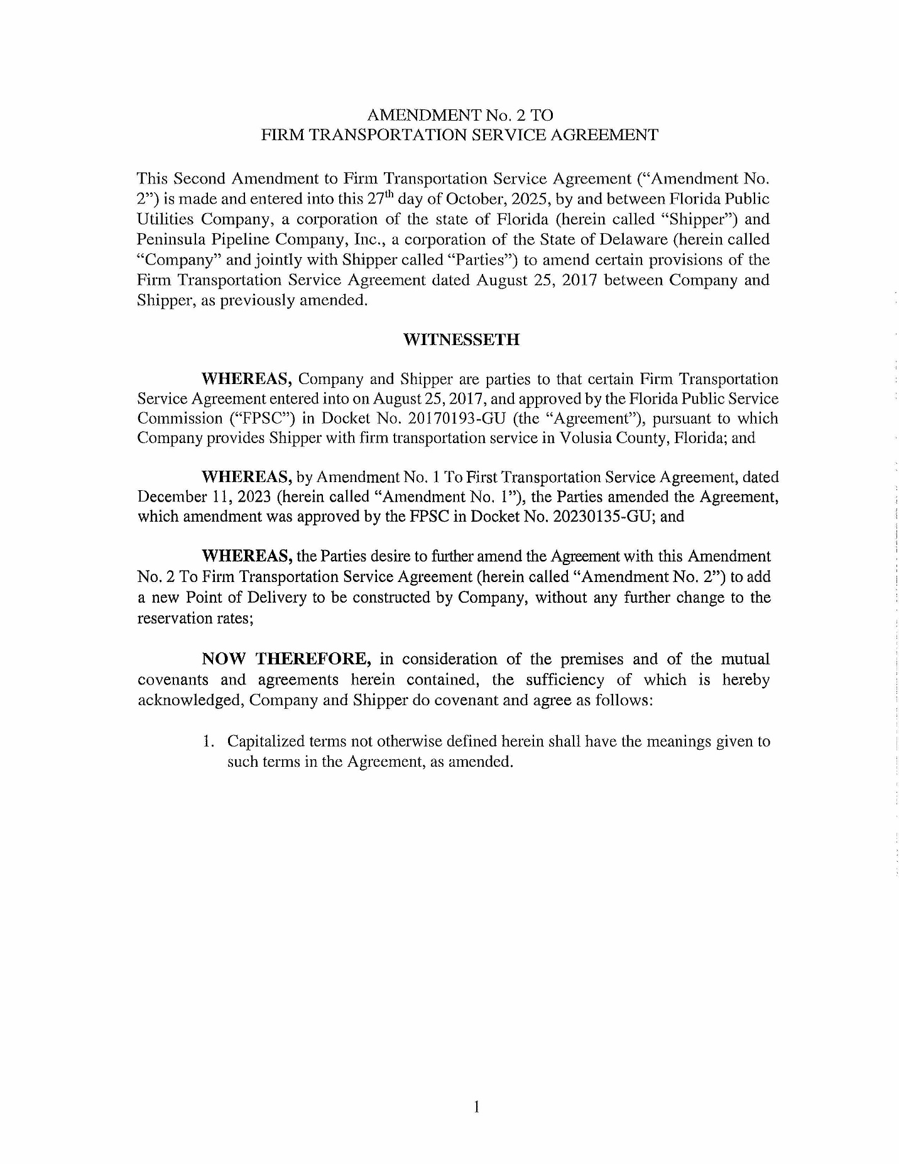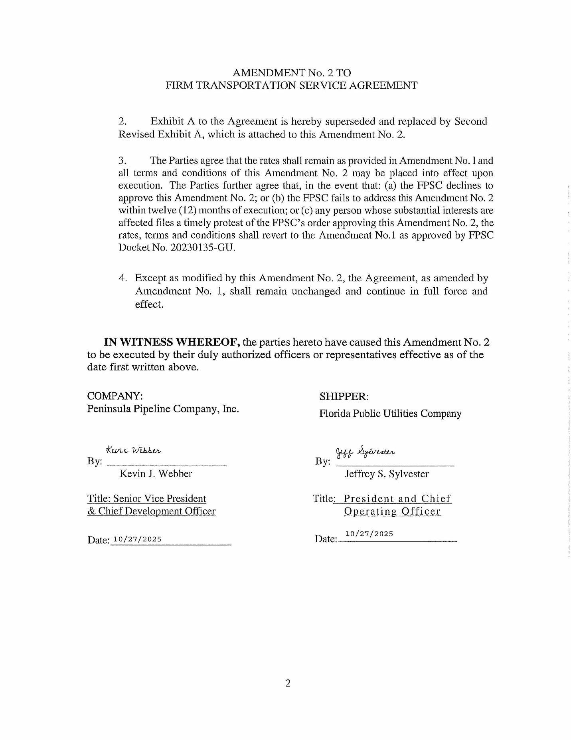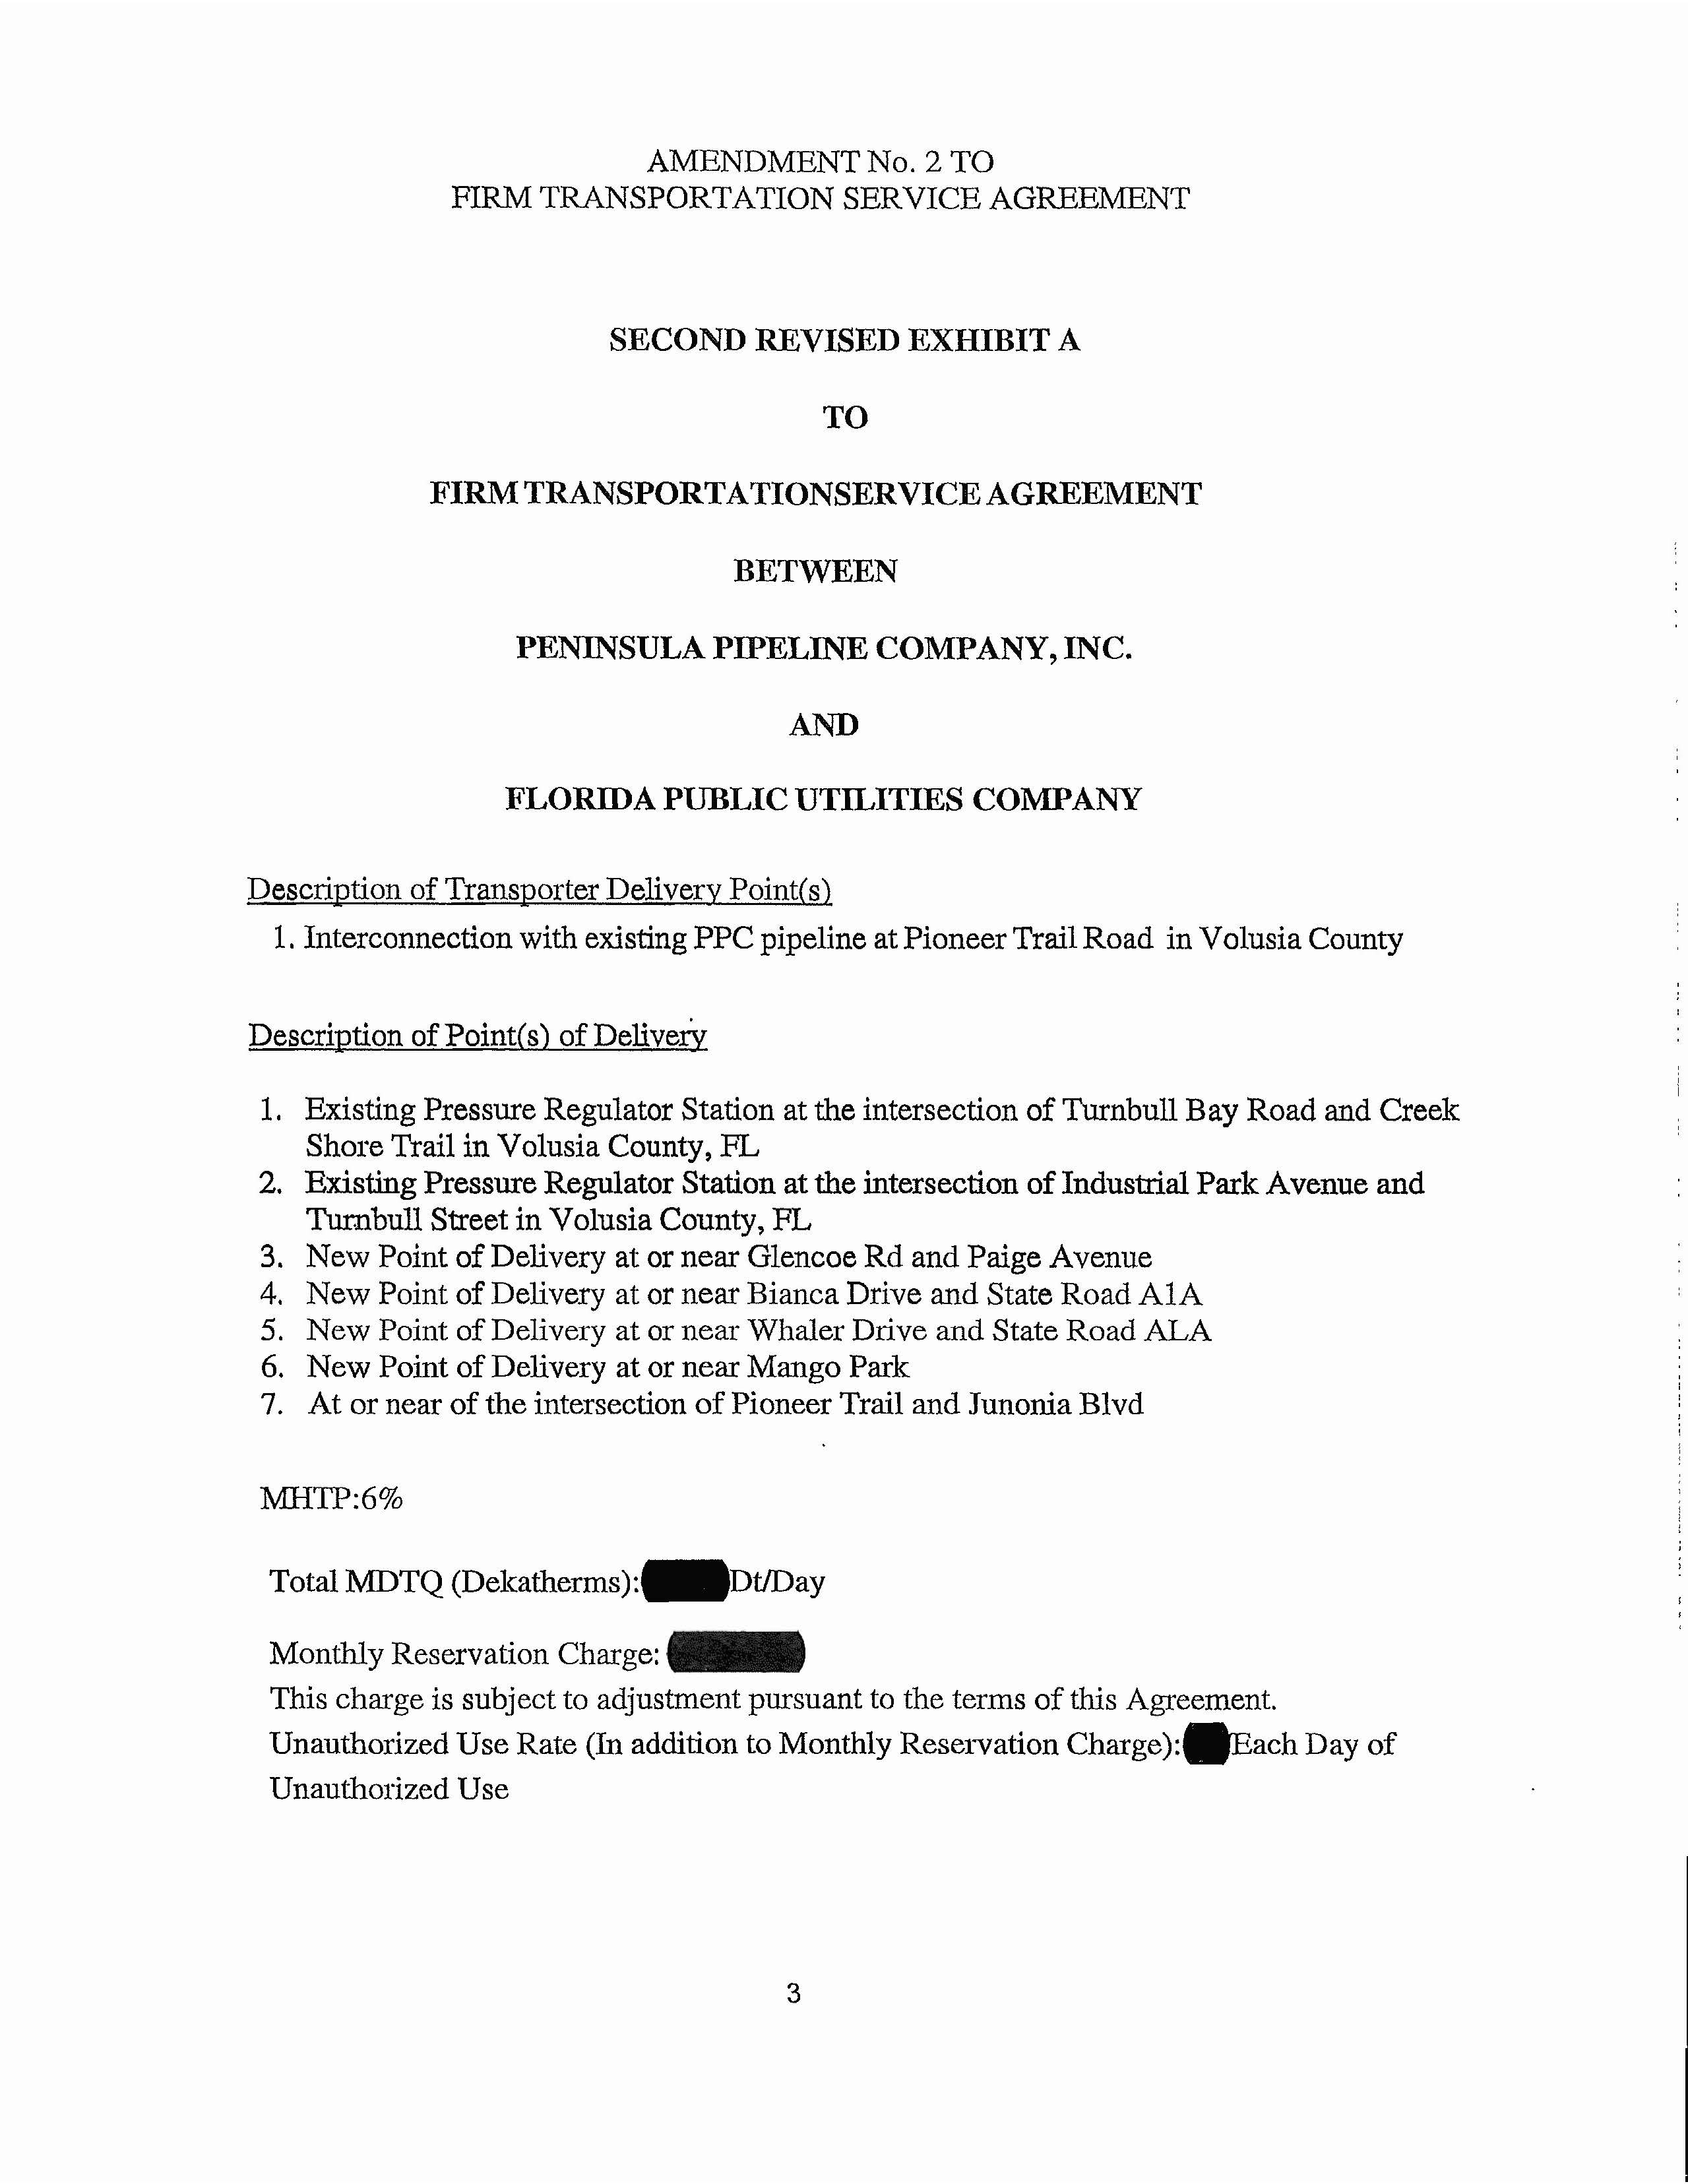

Order No. PSC-06-0023-DS-GP, issued January 9, 2006, in Docket No. 050584-GP, In re: Petition for declaratory statement by Peninsula Pipeline Company, Inc. concerning recognition as a natural gas transmission company under Section 368.101, F.S., et seq.
Order No. PSC-07-1012-TRF-GP, issued December 21, 2007, in Docket No. 20070570-GP, In re: Petition for approval of natural gas transmission pipeline tariff by Peninsula Pipeline Company, Inc.
Order No. PSC-2017-0498-PAA-GU, issued December 29, 2017, in Docket No. 20170193-GU, In re: Petition for approval of transportation service agreement with Florida Public Utilities Company, by Peninsula Pipeline Company, Inc.
Document No. 07483-2017, filed September 1, 2017.
Order No. PSC-2024-0072-PAA-GU, issued March 20, 2024, in Docket No. 20230135-GU, In re: Petition for approval of transportation service agreement with Florida Public Utilities Company by Peninsula Pipeline Company, Inc.
Document No. 06598-2023, filed December 14, 2023.
Document No. 15299-2025, filed December 2, 2025.
Id.
Document No. 15299-2025, filed December 2, 2025.
Document No. 15299-2025, filed December 2, 2025.

