State of Florida   |  | Public Service Commission  Capital Circle Office Center ● 2540 Shumard Oak Boulevard  Tallahassee, Florida 32399-0850  -M-E-M-O-R-A-N-D-U-M-
DATE: | February 19, 2026
TO: | Office of Commission Clerk (Teitzman)
FROM: | Division of Accounting and Finance (Gatlin, Vogel)  Division of Economics (Sibley)  Office of the General Counsel (M. Thompson)
RE: | Docket No. 20260015-WU – Joint motion requesting Commission approval of settlement agreement by the Office of Public Counsel and Leighton Estates Utilities, LLC.
AGENDA: | 03/03/26 – Regular Agenda – Proposed Agency Action – Interested Persons May Participate
COMMISSIONERS ASSIGNED: |  |  | All Commissioners
PREHEARING OFFICER: |  |  | La Rosa
CRITICAL DATES: |  |  | None
SPECIAL INSTRUCTIONS: |  |  | None

Case Background
Leighton Estates Utilities, LLC (Leighton Estates or Utility) is a Class C water utility serving approximately 86 customers in Marion County, Florida. On December 22, 2022, the Florida Public Service Commission (Commission) authorized a 10.45 percent return on equity (ROE) with an authorized range of 9.45 percent to 11.45 percent and a rate of return of 6.83 percent, as codified by Order No. PSC-2022-0435-PAA-WU. Based on the review of Leighton Estates’ 2024 Annual Report, Commission staff identified potential overearnings with a reported rate of return of 7.82 percent and an achieved ROE of 20.03 percent.
On November 21, 2025, the Office of Public Counsel (OPC) filed a letter with the Commission outlining concerns of potential water and wastewater utilities overearning, with Leighton Estates being the only utility requiring a reduction. On December 12, 2025, OPC and Commission staff held a conference call to discuss the possible overearnings of Leighton Estates and other utilities. On December 22, 2025, the owner of Leighton Estates, Mike Smallridge, reached out to staff and inquired about a voluntary rate reduction and a refund to customers. Leighton Estates and OPC (collectively known as the Parties) conducted informal meetings to analyze the financial data provided by Leighton Estates and to determine the appropriate disposition of the potential overearnings. On January 29, 2026, the Parties filed a joint motion requesting Commission approval of a Settlement Agreement to resolve the potential overearnings and to avert future overearnings.
The purpose of this recommendation is to present the Parties’ Settlement Agreement to the Commission for approval. The Joint Motion and Settlement Agreement are attached as Attachment A. The Commission has jurisdiction pursuant to Sections 367.081, 367.082, and 367.121, Florida Statutes.

Discussion of Issues

Issue 1:
Should the Commission grant the Joint Motion and approve the Settlement Agreement by the Parties?

Recommendation:
Yes. The proposed Settlement Agreement adequately addresses the potential overearnings staff identified during its ongoing earnings surveillance activities. As outlined in the proposed Settlement Agreement, Leighton Estates should reduce its rates by 11.60 percent. Additionally, Leighton Estates should refund customers 11.60 percent of water revenues billed from January 1, 2026, until the effective date of the rate reduction. The refund should be made pursuant to Rule 25-30.360, Florida Administrative Code (F.A.C). The Utility should file a proposed customer notice reflecting the Commission’s decision within 15 days of the Commission vote. The approved rates should be effective for service rendered on or after the stamped approval date of the tariff sheets pursuant to Rule 25-30.475(1), F.A.C. In addition, the approved rates should not be implemented until staff has approved the proposed customer notice and the notice has been received by the customers. The Utility should provide proof of the date notice was given within 10 days of the date of the notice. (Gatlin, Sibley)

Staff Analysis:
As stated in the case background, staff identified possible overearnings based upon a review of Leighton Estates’ 2024 Annual Report. On January 29, 2026, the Parties filed a Joint Motion to request Commission approval of a Settlement Agreement to resolve the disposition of ongoing overearnings. Leighton Estates agreed to reduce its rates by 11.60 percent to ensure it will remain within range of its ROE. Furthermore, Leighton Estates agreed to refund customers 11.60 percent of water revenues billed from January 1, 2026, until the effective date of the rate reduction. The refund credit will be based upon each individual customer’s billed amounts from January 1, 2026, until the effective date of the rate reduction, and will be made pursuant to Rule 25-30.360, F.A.C.
In keeping with the Commission’s long-standing policy and practice of encouraging parties to settle issues whenever possible, staff recommends that the Commission grant the Joint Motion and approve the Settlement Agreement by the Parties. The settlement provides protections for Leighton Estates’ customers for possible overearnings in subsequent years. Staff notes that this recommendation is consistent with other Commission decisions regarding possible overearnings. Schedule No. 1 reflects the Utility’s existing rates and staff’s recommended rates per the Utility’s settlement proposal. Staff will continue to monitor the earnings of the Utility, and if any subsequent overearnings are identified, staff may open a formal earnings investigation.
Conclusion
The proposed Settlement Agreement adequately addresses the potential overearnings staff identified during its ongoing earnings surveillance activities. As outlined in the proposed Settlement Agreement, Leighton Estates should reduce its rates by 11.60 percent. Additionally, Leighton Estates should refund customers 11.60 percent of water revenues billed from January 1, 2026, until the effective date of the rate reduction. The refund should be made pursuant to Rule 25-30.360, F.A.C. The Utility should file a proposed customer notice reflecting the Commission’s decision within 15 days of the Commission vote. The approved rates should be effective for service rendered on or after the stamped approval date of the tariff sheets pursuant to Rule 25-30.475(1), F.A.C. In addition, the approved rates should not be implemented until staff has approved the proposed customer notice and the notice has been received by the customers. The Utility should provide proof of the date notice was given within 10 days of the date of the notice.

Issue 2:
Should this docket be closed?

Recommendation:
No. If no timely protest is received from a substantially affected person upon expiration of the protest period, the PAA Order will become final upon the issuance of a Consummating Order. However, this docket should remain open to allow staff to verify completion of the refunds discussed in Issue 1. Once staff has verified that the refunds have been made in accordance with Rule 25-30.360, F.A.C., the docket should be closed administratively. (M. Thompson)

Staff Analysis:
If no timely protest is received from a substantially affected person upon expiration of the protest period, the PAA Order will become final upon the issuance of a Consummating Order. However, this docket should remain open to allow staff to verify completion of the refunds discussed in Issue 1. Once staff has verified that the refunds have been made in accordance with Rule 25-30.360, F.A.C., the docket should be closed administratively.

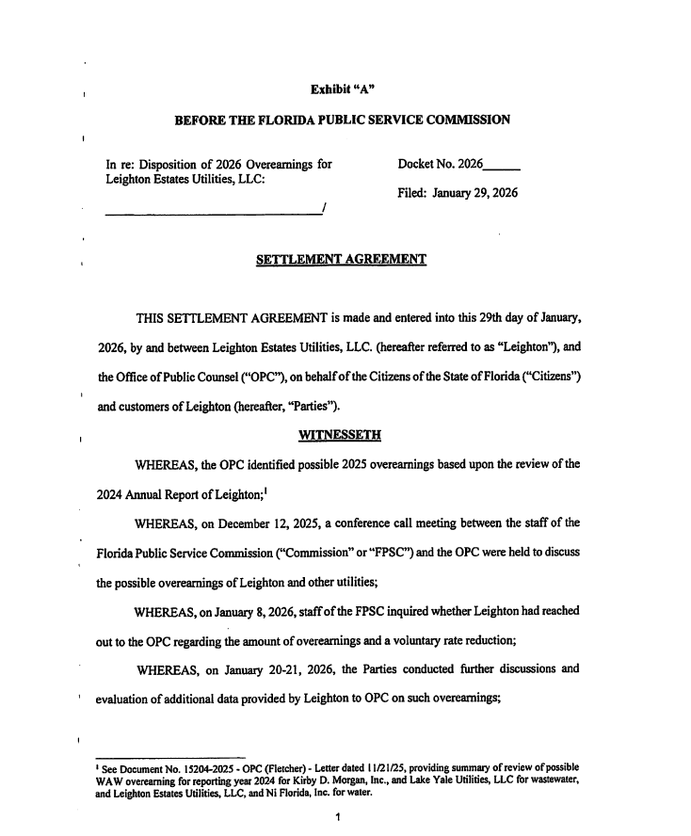
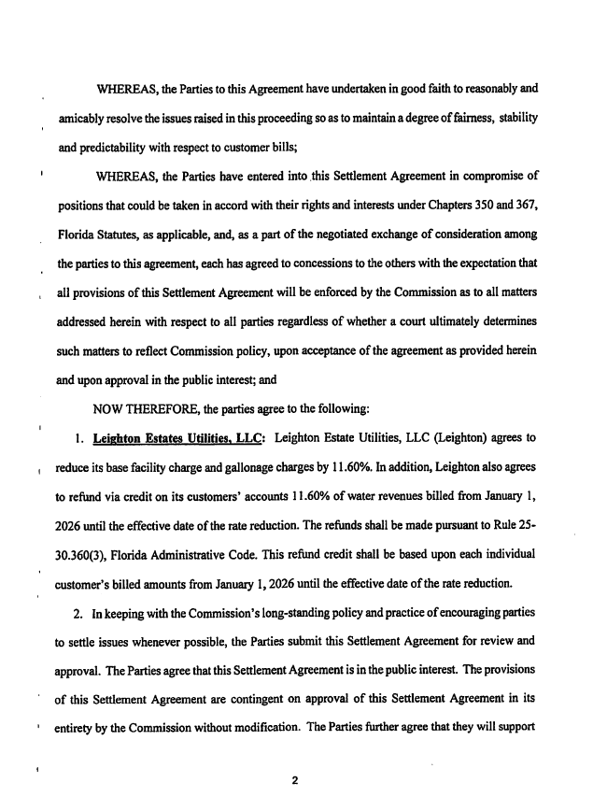

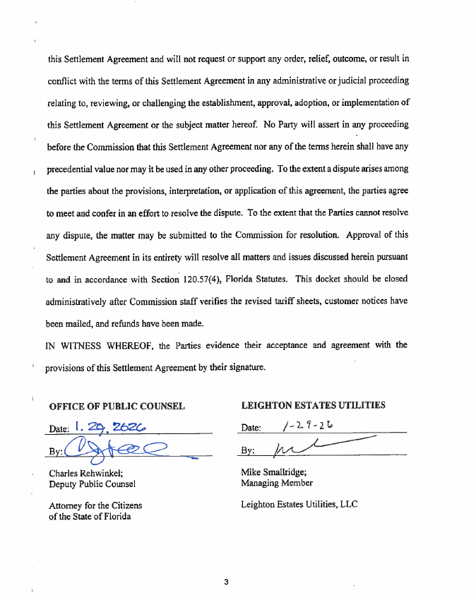

Order No. PSC-15-0173-PAA-WS, issued May 5, 2015, in Docket No. 20150069-WS, In re: Settlement proposal for possible overearnings by Southlake Utilities, Inc. in Lake County.

