State of Florida  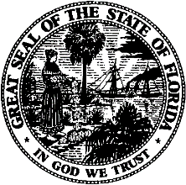 |  | Public Service Commission  Capital Circle Office Center ● 2540 Shumard Oak Boulevard  Tallahassee, Florida 32399-0850  -M-E-M-O-R-A-N-D-U-M-
DATE: | March 3, 2026
TO: | Adam J. Teitzman, Commission Clerk, Office of Commission Clerk
FROM: | Penny Mallow, Public Utility Analyst III, Office of Industry Development  and Market Analysis GF  Jacob Imig, Senior Attorney, Office of the General Counsel SPS
RE: | Docket No. 20260028-TC-Request for cancellation of PATS Certificate No. 1835 by Douglas B. Ferrell, effective February 19, 2026.

Douglas B. Ferrell has requested cancellation of Certificate No. 1835, effective February 19, 2026. The certificate holder has complied with Section 364.335(3), Florida Statutes, by providing the Florida Public Service Commission notice in writing of its request for voluntary cancellation of its certificate.

Neither the cancellation of the certificate nor the failure to receive a RAF return notice shall relieve Douglas B. Ferrell from its obligation to pay RAFs. This includes the obligation to pay any penalty and interest that may be due for the current year. Failure to pay the amounts owed to the Florida Public Service Commission will result in the Company's fees, penalties and interest being sent to a collection agency.

Pursuant to Section 2.07.C.5 .f., Administrative Procedures Manual, the voluntary cancellation is acknowledged and the docket should be closed.

