BEFORE THE FLORIDA PUBLIC SERVICE COMMISSION

In re: Petition for approval of tariff modification to reflect TTS pool manager, by Florida Public Utilities Company. | DOCKET NO. 20250102-GU  ORDER NO. PSC-2025-0399-TRF-GU  ISSUED: October 23, 2025

The following Commissioners participated in the disposition of this matter:

MIKE LA ROSA, Chairman
GARY F. CLARK
ANDREW GILES FAY
GABRIELLA PASSIDOMO SMITH

ORDER APPROVING TARIFF MODIFICATION

BY THE COMMISSION:

Background
On August 14, 2025, Florida Public Utilities Company (FPUC or utility) filed a petition for approval of a tariff modification reflecting the automation of FPUC’s Transitional Transportation Service (TTS) pool manager assignment process. The TTS program is designed to allow Indiantown and Central Florida Gas (CFG) Division customers to purchase natural gas from one of two TTS shippers and select from certain gas pricing options offered by the TTS shippers. The TTS tariff was originally established in 2002 to facilitate the conversion of remaining sales customers to aggregated customer pools. These customer pools are administered by qualified gas marketers (also known as pool managers) who have the capability of combining the gas supply requirements of customers in the TTS pools with other customers served by the pool managers, both on and off the utility’s distribution system. FPUC’s Indiantown and CFG Division provides transportation service only. Under the proposed tariff, FPUC will utilize its new billing system to automate the assignment of TTS pool managers. In response to our staff’s data request, the utility stated that TTS pool manager A will be assigned to customers moving in on even numbered calendar days, while TTS pool manager B will be assigned to customers moving in on odd numbered calendar days. Currently, this assignment is done manually.

During the evaluation of the petition, our staff issued a data request for which responses were received on September 5, 2025. Proposed tariff sheet No. 6.526 is included to the order as Attachment A. We have jurisdiction over this matter pursuant to Sections 366.03, 366.04, 366.05, and 366.06, Florida Statutes (F.S.).

Decision
Historically, if a premises had previously been assigned a particular pool manager, then any customer that subsequently moved into that premises would automatically be assigned to that same pool manager. If no pool manager had been assigned to the premises in the past, then a pool manager would be manually assigned to either TTS pool manager A or B. In response to our staff’s data request, the utility stated that pool manager A is assigned to customers signing up for service on even numbered calendar days and pool manager B is assigned to customers signing up for service on odd numbered calendar days.

In its petition, FPUC states that with the utility’s new billing system, pool manager assignments can be done automatically without manual intervention, regardless of any prior history. In response to our staff’s data request, the utility stated that it will utilize the new customer move-in workflow in System Analysis Program Development (SAP), its new billing system, to automate the assignment of TTS pool managers. The new automated process will automatically assign new customers to TTS pool managers based upon whether the customer at that location signs up for service on an odd or even day of the week. Under the proposed tariff, this will take place regardless of any prior pool manager history at the location. In response to our staff’s data request, the utility asserted that if in the future a third TTS pool manager was added, the utility will adjust the automation to assign TTS pool managers every third day, ensuring that each pool manager is provided an equal opportunity to be assigned during the move-in workflow.

Additionally, in response to our staff’s data request, the utility stated that a periodic review will be performed to confirm TTS pool manager assignments are distributed as expected based on move-in dates. The utility asserts that the new automated process will improve the utility’s ability to bill customers efficiently and accurately, as well as further ensure that initial pool manager assignments are made on a fair and unbiased basis.

We hereby approve FPUC’s request to automatically assign TTS pool managers and the associated tariff. The new automated process will allow the utility to bill customers efficiently, while ensuring the initial pool manager assignments are made on a fair and unbiased basis. Proposed tariff sheet No. 6.526, attached hereto, will become effective upon the issuance of a Consummating Order.

Based on the foregoing, it is

ORDERED by the Florida Public Service Commission that Florida Public Utilities Company’s proposed tariff modification to reflect Transitional Transportation Service pool managers is approved. It is further

ORDERED that if a timely protest is filed, the tariff should not be implemented while the protest is pending. It is further

ORDERED that if no protest is filed by a person whose substantial interests are affected within 21 days of the issuance of the Order, this docket should be closed upon the issuance of a Consummating Order. It is further

By ORDER of the Florida Public Service Commission this 23rd day of October, 2025.

/s/ Adam J. Teitzman
ADAM J. TEITZMAN
Commission Clerk
Florida Public Service Commission
2540 Shumard Oak Boulevard
Tallahassee, Florida 32399
(850) 413-6770
www.floridapsc.com

Copies furnished: A copy of this document is provided to the parties of record at the time of issuance and, if applicable, interested persons.

ZB

NOTICE OF FURTHER PROCEEDINGS

The Florida Public Service Commission is required by Section 120.569(1), Florida Statutes, to notify parties of any administrative hearing or judicial review of Commission orders that is available under Sections 120.57 or 120.68, Florida Statutes, as well as the procedures and time limits that apply. This notice should not be construed to mean all requests for an administrative hearing or judicial review will be granted or result in the relief sought.

Mediation may be available on a case-by-case basis. If mediation is conducted, it does not affect a substantially interested person's right to a hearing.

The Commission's decision on this tariff is interim in nature and will become final, unless a person whose substantial interests are affected by the proposed action files a petition for a formal proceeding, in the form provided by Rule 28-106.201, Florida Administrative Code. This petition must be received by the Office of Commission Clerk, 2540 Shumard Oak Boulevard, Tallahassee, Florida 32399-0850, by the close of business on November 13, 2025.

In the absence of such a petition, this Order shall become final and effective upon the issuance of a Consummating Order.

Any objection or protest filed in this docket before the issuance date of this order is considered abandoned unless it satisfies the foregoing conditions and is renewed within the specified protest period.

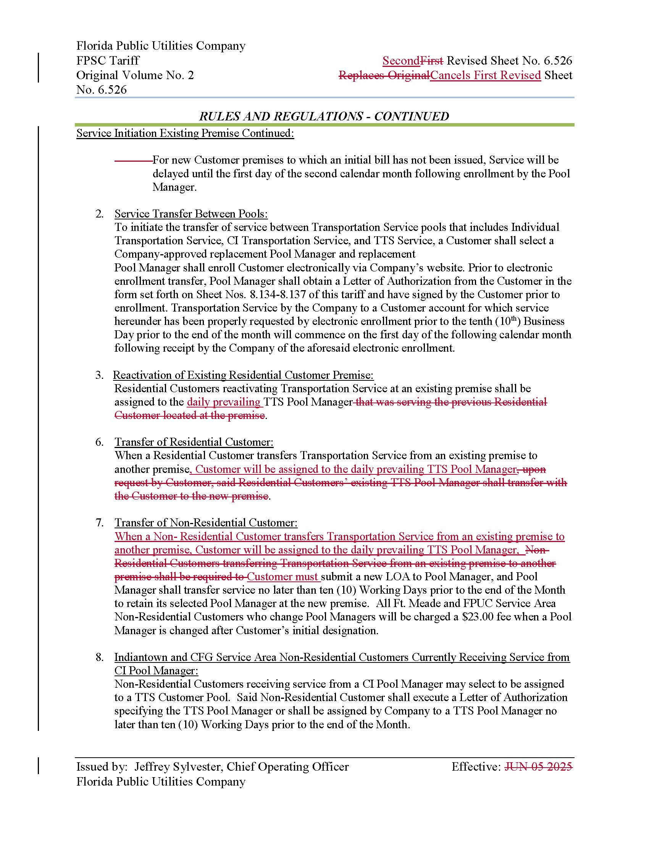

Document No. 09211-2025, filed September 5, 2025.
Id.
Id.
Id.

