BEFORE THE FLORIDA PUBLIC SERVICE COMMISSION

In re: Application for increase in water and wastewater rates in Brevard, Citrus, Duval, Highlands, Marion, and Volusia Counties by CSWR-Florida Utility Operating Company. | DOCKET NO. 20250052-WS  ORDER NO. PSC-2025-0404-PCO-WS  ISSUED: October 27, 2025

The following Commissioners participated in the disposition of this matter:

MIKE LA ROSA, Chairman
GARY F. CLARK
ANDREW GILES FAY
GABRIELLA PASSIDOMO SMITH

ORDER GRANTING INTERIM RATES

BY THE COMMISSION:

Background
CSWR-Florida Utility Operating Company, LLC (CSWR or utility) is a Class A utility providing water and wastewater service to 11 systems in the following counties: Brevard, Citrus, Duval, Highlands, Marion, and Volusia. CSWR is a Florida domestic limited liability company that, as a result of recent acquisitions and a grandfather certificate, owns and operates the water and wastewater systems that are the subject of this rate case application. CSWR is a wholly-owned subsidiary of CSWR-Florida Utility Holding Company, LLC (CSWR, LLC).

In 2024, the utility recorded consolidated company operating revenues of $3,853,102 for water and $3,332,319 for wastewater. CSWR reported a net operating loss of $1,436,909 for water and $136,494 for wastewater. The utility has approximately 144,303 water customers and 87,571 wastewater customers for its combined systems. The following table reflects the rate proceeding in which rates were last established for each of CSWR’s systems.

Last Rate Proceedings Establishing Rates for CSWR Systems
Former Utility Name | Order | Issuance Date
Aquarina Utilities, Inc. | PSC-2020-0158-PAA-WS | May 15, 2020
BFF Corp. | PSC-2002-0487-PAA-SU | April 8, 2002
C.F.A.T. H2O, Inc. | PSC-2011-0366-PAA-WS | August 31, 2011
Neighborhood Utilities, Inc. | PSC-2016-0537-PAA-WU | November 23, 2016
North Peninsula Utilities, Corp. | PSC-2019-0461-PAA-SU | October 25, 2019
Rolling Oaks Utilities, Inc. | Citrus County Approved | February 1, 2022
Sebring Ridge Utilities, Inc. | PSC-1996-0869-FOF-WS | July 2, 1996
Sunshine Utilities, Inc. | PSC-2012-0357-PAA-WU | July 10, 2012
TKCB, Inc. | PSC-2021-0435-PAA-SU | November 22, 2021
Tradewinds Utilities, Inc. | PSC-2011-0385-PAA-WS | September 13, 2011
Tymber Creek Utilities, Inc. | PSC-2011-0345-PAA-WS;  Amendatory Order PSC-2011-0345A-PAA-WS | August 16, 2011

During the years of 2021-2024, CSWR applied to acquire ten of the systems in this rate proceeding, and all ten transfer dockets were approved by us. On July 21, 2025, we approved a grandfather certificate for Rolling Oaks Utilities, Inc., as the eleventh CSWR system.

On May 30, 2025, CSWR filed an application for approval of interim and final water and wastewater rate increases. By letter dated June 27, 2025, our staff advised the utility that its Minimum Filing Requirements (MFRs) had several deficiencies. Having reviewed the utility’s deficiency response, our staff sent a second letter to CSWR on August 15, 2025, advising that the utility’s rate application remains deficient. To date, the official date of filing has not been established for noticing purposes.

The utility's application for increased final water and wastewater rates is based on the historical 12-month period ended January 31, 2025, with requested capital recovery for facility improvements since the time of acquisitions. Additionally, the utility requested a single, consolidated rate structure. In approving interim rates pursuant to Section 367.082, Florida Statutes (F.S.), it has been our practice to use the utility’s current rate structure at the time of the interim rate request. For purposes of this order, the analysis for each rate structure will be referred to by the former utility name prior to the acquisitions.

CSWR requested interim rates for all of its systems, designed to generate additional revenues of $2,279,365 for water operations and $225,973 for wastewater operations.

In setting final rates, the current rate structure of each system is also used for the collection of the final revenues. CSWR requested final rates designed to generate additional revenues of $3,223,769 for water operations and $954,881 for wastewater operations. By Order No. PSC-2025-0318-PCO-WS, issued August 21, 2025, we suspended CSWR’s final rates request.

The intervention of the Office of Public Counsel (OPC) was acknowledged by Order No. PSC-2025-0113-PCO-WS, issued April 7, 2025, in this docket.

On September 4, 2025, we approved CSWR’s interim rates request for nine systems and denied the request for one system.
CSWR has one remaining system, Aquarina, for which the request for interim rates has not yet been addressed. The utility agreed to extend the statutory time frame to address its interim rates request for Aquarina through the October 7, 2025 Commission Conference, as the utility has multiple services for water, and potable and non-potable water requires separate revenue requirements.

This order addresses the utility’s interim rate request for Aquarina. We have jurisdiction pursuant to Sections 367.081 and 367.082, F.S.

Decision
- Interim Revenue Increase

Pursuant to Section 367.082(1), F.S., we may authorize the collection of interim rates during any proceeding for a change of rates upon petition from any party or its own motion, and in order to establish a prima facie entitlement for interim relief, the utility shall demonstrate that it is earning outside the range of reasonableness on its rate of return. Pursuant to Section 367.082(2)(a), F.S., in a proceeding for an interim increase in rates, we shall authorize, within 60 days of the filing for such relief, the collection of rates sufficient to earn the minimum of the range of rate of return. CSWR filed rate base, cost of capital and net operating statements to support its requested interim water and wastewater increases. However, it had to re-file its request for Aquarina, as the water revenue requirement required a break out of the potable and non-potable rates.

Pursuant to Section 367.082(5)(b)1., F.S., the achieved rate of return for interim purposes must be calculated by applying adjustments consistent with those used in the utility’s most recent rate proceeding and annualizing any rate changes. We reviewed CSWR’s interim request, as well as all orders that addressed the utility’s most recent rate proceedings. We have attached accounting schedules for Aquarina’s Potable water, Non-Potable water, and Wastewater systems to illustrate rate base, capital structure, and test year operating income amounts. The rate base schedules are labeled as Schedule Nos. 1-A, 1-B, and 1-C. The capital structure schedule is labeled Schedule No. 2. The operating income schedules are labeled as Schedule Nos. 3-A, 3-B, and 3-C. Our adjustments are discussed below.

Interim Rate Base

Simple Average Adjustment
Consistent with Rule 25-30.433(5), Florida Administrative Code (F.A.C.), and Aquarina’s previous rate case, the utility’s interim test year shall reflect rate base calculated using the simple beginning and end-of-year average (simple average) method. CSWR’s interim filing for Aquarina reflects a rate base calculated using a 13-month average. We adjusted the balances to reflect the simple average method, as shown on Schedule No. 1 for each system. Our adjustments are reflected in the table below.

Table 1
Interim Adjustments to Reflect Simple Average
System | Plant | Accumulated Depreciation | Accumulated Amortization of CIAC
Aquarina – Potable | $588,548 | ($468,392) | $588
Aquarina – Non-Potable | $397,787 | ($334,905) | $0
Aquarina – Wastewater | $448,523 | ($629,006) | $847

Used & Useful
We reviewed the utility’s interim used and useful (U&U) calculations, our previous decisions, and available usage and capacity data contained in CSWR’s MFR schedules. We find the adjustments, as identified in Table 2 for Aquarina, are appropriate based on current system conditions and using the methodology approved in the system’s prior rate case order.
Table 2
Interim U&U Adjustments
Aquarina | Last Rate Case U&U | CSWR Requested U&U | Comm. Approved  U&U
Potable WTP | 81% | 81% | 100%
Non-Potable Water Plant | 100% | 81% | 100%
Potable Water Storage | 47% | 47% | 61%
Non-Potable Water Storage | 61% | 47% | 61%
WWTP | 56% | 56% | 56%
Potable Water Distribution System | 63% | 63% | 63%
Non-Potable Water Distribution System | 100% | 63% | 100%
Collection System | 65% | 65% | 65%
Sources: Order No. PSC-2016-0583-PAA-WS, issued December 29, 2016, in Docket No. 20150010-WS, In re: Application for staff-assisted rate case in Brevard County by Aquarina Utilities, Inc., Document Nos. 04080-2025, 04993-2025, and 07961-2025, in Docket No. 20250052-WS, In re: Application for increase in water and wastewater rates in Brevard, Citrus, Duval, Highlands, Marion, and Volusia Counties by CSWR-Florida Utility Operating Company.

In its interim MFR B-3 schedules, the utility indicated non-used and useful adjustments to depreciation expense for all three systems. However, for two systems, Aquarina – Potable and Aquarina – Non-Potable, the adjustment was not reflected on the MFR B-1 schedules and therefore, not included in the revenue requirement for either system. As such, we made corresponding adjustments to reflect these adjustments.

Based on the above calculations and our corrections to CSWR’s used and useful percentages, we find the adjustments indicated on the table below.

Table 3
Interim – Used & Useful Adjustments
System | Rate Base | Depreciation Expense | Property Tax
Aquarina – Potable | $43,454 | ($3,032) | $457
Aquarina – Non-Potable | $61,163 | ($90) | $510
Aquarina – Wastewater | $54,220 | $1,250 | $391

Contributions-In-Aid-of-Construction
In its initial and revised MFRs, CSWR listed balances of $421,159 in Contributions-In-Aid-of-Construction (CIAC) and $280,629 in Accumulated Amortization of CIAC for Aquarina – Potable, with no balance allotted to either account for Aquarina – Non-Potable. In our staff’s correspondence with CSWR, the utility acknowledged that the amount should have been allocated between the two systems, and provided the correct allocation. For Aquarina – Potable, the CIAC balance shall be decreased by $47,636 for a total of $373,523, and the accumulated amortization of CIAC shall be reduced by $34,963 to a total of $245,666. For Aquarina – Non-Potable, the CIAC balance shall be $47,636, and the accumulated amortization of CIAC balance shall be $34,963. Based on the corrections to CSWR’s CIAC balances for both systems, we find that net depreciation expense shall be increased by $1,584 for Aquarina – Potable, and decreased by $1,584 for Aquarina – Non-Potable to reflect the corresponding CIAC amortization expense.

Acquisition Adjustment
In its filing, the utility requested an acquisition adjustment for all Aquarina systems. The utility reflected an acquisition adjustment of $1,145,736 for Aquarina – Potable, $863,567 for Aquarina – Non-Potable, and $306,986 for Aquarina - Wastewater in its interim request. The acquisition adjustments have been removed from rate base for the purpose of calculating interim rates, as they have not been approved by us. It is expected that CSWR’s acquisition adjustment petitions will be consolidated with the instant rate proceeding, and that the acquisition adjustment requests will be addressed together with CSWR’s rate request in a future administrative hearing.

Working Capital Allowance
Although CSWR, post-consolidation, would be classified as a Class A utility, working capital shall be calculated for each system using the same basis from its respective prior rate case. Pursuant to Rule 25-30.433(3), F.A.C., working capital allowance for Class B and C utilities are calculated using the formula method, which is one-eighth of operation and maintenance (O&M) expenses. CSWR did not calculate working capital allowance in accordance with the rule in its MFRs, and instead calculated a working capital allowance of approximately one-eight hundredth of O&M expenses for each system. We adjusted the working capital allowance for each system pursuant to Rule 25-30.433(3), F.A.C., using the formula method and the O&M we found for each system. Table 4, below, shows all working capital adjustments made by us.

Table 4
Interim Working Capital Adjustments
System | Adjustment
Aquarina – Potable | $11,882
Aquarina – Non-Potable | $24,091
Aquarina – Wastewater | $26,145

Interim Cost of Capital

Capital Structure
In its initial filing, Aquarina’s capital structure included only common equity and short term debt. Our staff asked the utility for clarification on how capital structure was calculated. The utility confirmed that the cost of capital is imputed from CSWR - LLC., the parent company of CSWR. The capital structure is calculated based on Aquarina’s actual financial data. The debt portion consists of notes payable to the parent, which are available as the result of a debt facility sourced by the parent in 2024 and transferred in response to the capital needs of the system. The equity consists of paid-in capital contributed primarily for the acquisition and improvement of the system and the accumulated retained earnings or deficit.

Return on Equity
Pursuant to the provisions of the interim statute, an interim decrease shall be calculated using the maximum return on equity (ROE) limit, and an interim increase shall be calculated using the minimum ROE limit. CSWR’s deficient initial interim filing, dated May 30, 2025, included schedules labeled “Interim Rate – Revenue Deficiency” which indicated the use of the ROEs from Aquarina’s previous rate case. In its updated interim filing, dated June 27, 2025, the MFR Schedule D-1 reflected a ROE of 8.77 percent. The Excel workpapers did not provide support calculations for the ROE. The updated filing also included the “Interim Rate – Revenue Deficiency” schedules with ROEs from each previous rate case, but the actual calculation of revenue requirement reflected 8.77 percent. The updated interim Aquarina filing, dated August 5, 2025, maintained the previously indicated 8.77 percent ROE.

Section 367.082(5)(b), F.S., states the required rate of return shall be calculated using the last authorized rate of return on equity of the utility or regulated company, which also includes using the leverage formula as appropriate. However, consistent with our practice, the existing ROE does not transfer when a system assumes a new owner, so it is permissible to use the leverage formula as the last authorized rate of return. We find that the interim cost of capital shall be calculated using the 2025 leverage formula, which results in a ROE of 8.55 percent, as shown on Schedule No. 2.

Simple Average Adjustment
Consistent with Rule 25-30.433(5), F.A.C., and Aquarina’s previous rate case, the utility’s interim test year for Class B utilities shall reflect a cost of capital calculated using the simple average method. CSWR’s interim filing reflects a cost of capital calculated using a 13-month average. We adjusted the balance to reflect the simple average method, as shown on Schedule No. 2.

Pro Rata Adjustment
In its MFRs, the utility only made an adjustment to common equity. Aquarina’s capital structure consists of common equity and short term debt. Consistent with Aquarina’s most recent rate case, we find that the capital structure shall be prorated across both sources of capital, as shown on Schedule No. 2.

Interim Net Operating Income
Pursuant to Section 367.082(5)(b)1., F.S., the achieved rate of return for interim purposes must be calculated by applying adjustments consistent with those made in the utility’s most recent rate proceeding and annualized for any rate changes. Based on our review, several adjustments are necessary for interim purposes as reflected on the respective adjustments to operating income schedules.

Test Year O&M Adjustments – Annualization
CSWR made several adjustments to O&M expenses for Aquarina related to new third party contracts that began during the test year. However, we find this set of adjustments is improper for interim purposes. Rule 25-30.437(2)(d), F.A.C., states that for the utility to “demonstrate that it is earning outside the range of reasonableness” on its rate of return, “the utility must submit schedules of rate base, cost of capital, and net operating income on an historical basis.” The adjustments provided in its interim filings were made to annualize a change in O&M expenses that occurred during the test year. These adjustments would shift O&M expenses in their entirety from a historical basis to a pro forma basis. We find these adjustments are appropriate for consideration in the final rate increase, but violate the nature of the interim process. As such, we have removed the annualization adjustments in amounts of $1,790 for Aquarina – Potable, $7,375 for Aquarina – Non-Potable, and $6,596 for Aquarina – Wastewater.

O&M Adjustments Consistent with the Last Rate Case
Adjustments to bad debt expense are necessary for interim purposes in order to be consistent with the treatment in Aquarina’s last rate case. CSWR applied a 3-year averaging adjustment to bad debt expense for Aquarina. Upon review, we determined that, consistent with its prior rate case, Aquarina did not require a bad debt adjustment and so we have removed the requested adjustments. CSWR’s and our adjustments are detailed in the table below.

Table 5
3-Year Averaging Adjustment to Bad Debt – Water Systems
Utility | Utility Adjustment | Comm. Adjustment
Aquarina – Potable | $299 | ($299)
Aquarina – Non-Potable | $299 | ($299)
Aquarina – Wastewater | $432 | ($432)

Excessive Unaccounted Water
We reviewed the utility’s interim excessive unaccounted water (EUW) calculations, our previous decisions, and available usage data contained in CSWR’s MFR schedules. We determined that Aquarina did not have any EUW for the potable water system in its prior rate case. However, based on the utility’s interim data, we determined the Aquarina system to have an EUW of 29 percent. The non-potable well did not have a flow meter during the test year, so EUW could not be determined. We will continue to investigate this matter during the course of the rate case. Following the same methodology used in the last rate case, we have applied the updated EUW percentages to the actual purchased power and chemicals expenses for Aquarina – Potable, resulting in a total reduction of $1,481.

Infiltration & Inflow
We reviewed the utility’s interim excessive infiltration and inflow (I&I) calculations, our previous decisions, and available usage data contained in CSWR’s MFR schedules. Using the methodology approved in the prior rate case and current conditions, we do not find that any I&I adjustments for interim purposes are required. While we find no adjustment is necessary for interim purposes, the I&I for the Aquarina system will be further reviewed during the course of this rate case.

Earnings Analysis

Aquarina - Wastewater
Based on the adjustments outlined above, Aquarina – Wastewater reflected overearnings in the interim test year. Pursuant to Section 367.082(2)(b), F.S., in a proceeding for an interim decrease in rates, we shall authorize the continued collection of the previously authorized rates; however, revenues collected under those rates that are sufficient to reduce the achieved rate of return to the maximum of the rate of return shall be held subject to refund with interest. Although Aquarina – Wastewater’s rates indicate overearning, we find that the utility shall continue to collect its current rates, and hold subject to refund revenues collected under those rates that are sufficient to reduce the achieved rate of return to the maximum of the current rate of return, with interest. Over the full course of the rate case and potential rate consolidation, we will evaluate the potential refund. As such, we find that $42,253 shall be held subject to refund for Aquarina – Wastewater.

Revenue Requirement
Revenue requirements shall be consistent with the calculations required by Section 367.082, F.S. For those systems that appear to be underearning, the revenue requirements were determined using the minimum ROE limit. Consistent with the interim statute, we used the maximum ROE limit for Aquarina – Wastewater, which appears to be overearning.

Based upon recovery of actual operating expenses for the year ended January 31, 2025, we find that the utility is authorized to collect annual water revenues for Aquarina – Non-Potable in the amount of $274,095, which is an increase of $62,050, or 29.26 percent, over our adjusted test year revenues of $212,044. The utility shall also be authorized to collect annual water revenues for Aquarina – Potable in the amount of $194,053, which is an increase of $9,820, or 5.33 percent, over our adjusted test year revenues of $184,233. We find no change to rates for Aquarina – Wastewater, with a total of $42,253 held subject to refund.

According to Section 367.082, F.S., any refund shall be calculated to reduce the rate of return of the utility during the pendency of the proceeding to the same level within the range of the newly authorized rate of return. We will evaluate each system’s post-consolidation revenue requirement to determine if any refunds should be made.

- Interim Water and Wastewater Rates

We find that interim service rates for CSWR are designed to allow the utility the opportunity to generate additional annual operating revenues as shown below for potable and non-potable water. The test year revenues were adjusted to annualize the rates in effect at the end of the test year. To determine the appropriate increase to apply to the service rates, miscellaneous revenues shall be removed from the adjusted test year revenues for potable. The utility recorded miscellaneous services revenues of $1,588 for its potable system. There were no miscellaneous revenues recorded for the non-potable system. The calculations are as follows:

Table 6
Potable Percentage Service Rate Increase
1 | Total Test Year Revenues | $184,233
2 | Less: Miscellaneous Revenues | $1,588
3 | Test Year Revenues from Service Rates | $182,645
4 | Revenue Increase | $9,820
5 | Percentage Service Rate Increase (Line 4/Line 3) | 5.38%
Source: Staff’s Interim Recommended Revenue Requirement

Table 7
Non-Potable Percentage Service Rate Increase
1 | Total Test Year Revenues | $212,044
2 | Less: Miscellaneous Revenues | $0
3 | Test Year Revenues from Service Rates | $212,044
4 | Revenue Increase | $62,050
5 | Percentage Service Rate Increase (Line 4/Line 3) | 29.26%
Source: Staff’s Interim Recommended Revenue Requirement

Consistent with our practice for interim rates, the above percentage increases shall be applied as an across-the-board increase to the service rates in effect as of January 31, 2025. Due to a decrease in percentage, we find that CSWR’s Aquarina wastewater rates shall remain the same for interim purposes. However, as discussed in Section 1, above, we have established amounts to be held subject to refund for that system. Table 8 reflects the typical residential bill at the 5,000 gallon consumption level for the utility’s current rates, proposed interim rates, and interim rates.

Table 8
Typical Residential 5/8" x 3/4" Meter Bill Comparison
At 5,000 Gallons
System | Utility  Current  Rates | Utility  Proposed  Interim Rates | Comm.  Approved  Interim Rates
Aquarina – Potable | $66.79 | $99.68 | $70.37
Aquarina – Non-Potable | $19.97 | $29.82 | $25.81

The rates shown on Schedule No. 4 shall be effective for service rendered on or after the stamped approval date on the tariff sheets pursuant to Rule 25-30.475(1), F.A.C. The utility shall file revised tariff sheets and a proposed customer notice to reflect the approved rates. In addition, the approved rates shall not be implemented until the required security has been filed, our staff has approved the proposed customer notice, and the notice has been received by the customers. The utility shall provide proof of the date notice was given within 10 days of the date of the notice.

- Security to Guarantee the Interim Increase

Pursuant to Section 367.082, F.S., revenues collected under interim rates shall be placed under bond, escrow, letter of credit, or corporate undertaking and be subject to refund with interest at a rate as may be ordered by us. As set forth in Section I, the total interim increase for Aquarina is $71,871, with an additional $42,253 being held subject to refund due to potential overearnings. In accordance with Rule 25-30.360, F.A.C., we calculated the potential refund of revenues and interest collected under interim conditions to be $96,830. This amount is based on an estimated 10-month collection period of interim rates. A corporate undertaking request for the interim request associated with CSWR’s other systems, as approved by us at our September Commission Conference in the amount of $2,333,036, is still pending. Including this amount and the current corporate undertaking request of $96,830, the total cumulative outstanding guarantee is $2,429,866, subject to refund.

The criteria for a corporate undertaking includes sufficient liquidity, equity ownership, and profitability to guarantee any potential refund. We reviewed CSWR, LLC’s 2022, 2023, and 2024 confidential financial statements filed with us to determine if CSWR can support a corporate undertaking for the requested amount. Our analysis indicated that over the three-year period ending December 31, 2024, the utility’s parent, CSWR, LLC, has insufficient profitability over the period, but did have sufficient liquidity and equity ownership. The parent company has a substantial amount of cash available which is sufficient to support a cumulative corporate undertaking in the amount of $2,429,866. Additionally, CSWR, LLC has positive working capital and its equity capital significantly exceeds the requested amount and is supported by an equity ratio that is greater than 50 percent.

Based on the analysis of CSWR, LLC’s financial position, we find that CSWR is financially able to support a cumulative corporate undertaking in the amount of $2,429,866. Our finding is contingent upon CSWR, LLC providing a signed letter by a corporate officer that it will support CSWR in its corporate undertaking endeavor. We also received confirmation from the utility that it had no other outstanding guarantees on behalf of CSWR-owned utilities in other jurisdictions.

This brief financial analysis is only appropriate for determining if CSWR, through its parent, can support a corporate undertaking in the amount proposed and shall not be considered a finding regarding our position on other issues in this proceeding. In no instance shall maintenance and administrative costs associated with any refund be borne by the customers. Such costs are the responsibility of, and shall be borne by CSWR.

Pursuant to Rule 25-30.360(6), F.A.C., the utility shall provide a report by the 20th day of each month indicating the monthly and total revenue collected subject to refund. Should a refund be required, the refund shall be with interest and undertaken in accordance with Rule 25-30.360, F.A.C.

Based on the foregoing, it is

ORDERED by the Florida Public Service Commission that CSWR-Florida Utility Operating Company, LLC shall be authorized to collect annual water revenues for Aquarina – Non-Potable in the amount of $274,095, which is an increase of $62,050, or 29.26 percent, over our adjusted test year revenues of $212,044. The utility shall also be authorized to collect annual water revenues for Aquarina – Potable in the amount of $194,053, which is an increase of $9,820, or 5.33 percent, over our adjusted test year revenues of $184,233. Aquarina – Wastewater appears to be earning above its maximum return on equity. As such, revenues in the amount of $42,253 shall be collected subject to refund, instead of decreasing rates at this time. It is further

ORDERED that the service rates for CSWR-Florida Utility Operating Company, LLC in effect as of January 31, 2025, shall be increased as shown below to generate the ordered revenue increase for the interim period.
System | % Rate Increase
Aquarina – Potable | 5.38%
Aquarina – Non-Potable | 29.26%

The rates, as shown on Schedule No. 4, shall be effective for service rendered on or after the stamped approval date on the tariff sheets pursuant to Rule 25-30.475(1), F.A.C. The utility shall file revised tariff sheets and a proposed customer notice to reflect the approved rates. In addition, the approved rates shall not be implemented until the required security has been filed, our staff has approved the proposed customer notice, and the notice has been received by the customers. The utility shall provide proof of the date the notice was given within 10 days of the date of the notice. It is further

ORDERED that the appropriate security to guarantee the funds collected subject to refund is a corporate undertaking by CSWR, LLC, on behalf of its subsidiary, CSWR-Florida Utility Operating Company, LLC. CSWR, LLC shall be required to provide a written guarantee that it will support a cumulative corporate undertaking on behalf of CSWR-Florida Utility Operating Company, LLC in the amount of $2,429,866. It is further

ORDERED that this docket shall remain open pending our final action on the utility’s requested rate increase.

By ORDER of the Florida Public Service Commission this 27th day of October, 2025.

/s/ Adam J. Teitzman
ADAM J. TEITZMAN
Commission Clerk
Florida Public Service Commission
2540 Shumard Oak Boulevard
Tallahassee, Florida 32399
(850) 413-6770
www.floridapsc.com

Copies furnished: A copy of this document is provided to the parties of record at the time of issuance and, if applicable, interested persons.

DD

NOTICE OF FURTHER PROCEEDINGS OR JUDICIAL REVIEW

The Florida Public Service Commission is required by Section 120.569(1), Florida Statutes, to notify parties of any administrative hearing or judicial review of Commission orders that is available under Sections 120.57 or 120.68, Florida Statutes, as well as the procedures and time limits that apply. This notice should not be construed to mean all requests for an administrative hearing or judicial review will be granted or result in the relief sought.

Any party adversely affected by this order, which is non-final in nature, may request (1) reconsideration within 10 days pursuant to Rule 25-22.0376, Florida Administrative Code, or (2) judicial review by the Florida Supreme Court, in the case of an electric, gas or telephone utility, or the First District Court of Appeal, in the case of a water or wastewater utility. A motion for reconsideration shall be filed with the Office of Commission Clerk, in the form prescribed by Rule 25-22.0376, Florida Administrative Code. Citizens of the State of Florida v. Mayo, 316 So.2d 262 (Fla. 1975), states that an order on interim rates is not final or reviewable until a final order is issued. Such review may be requested from the appropriate court, as described above, pursuant to Rule 9.100, Florida Rules of Appellate Procedure.

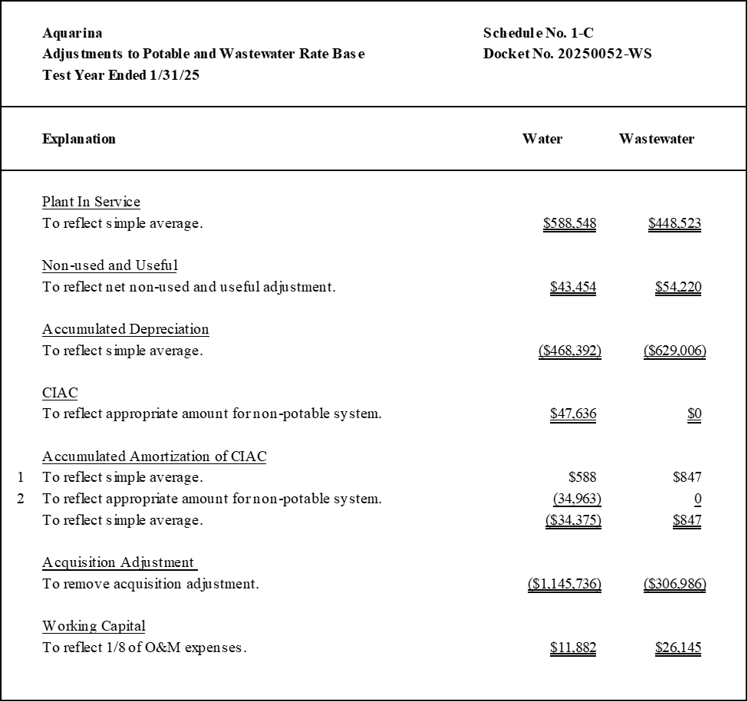
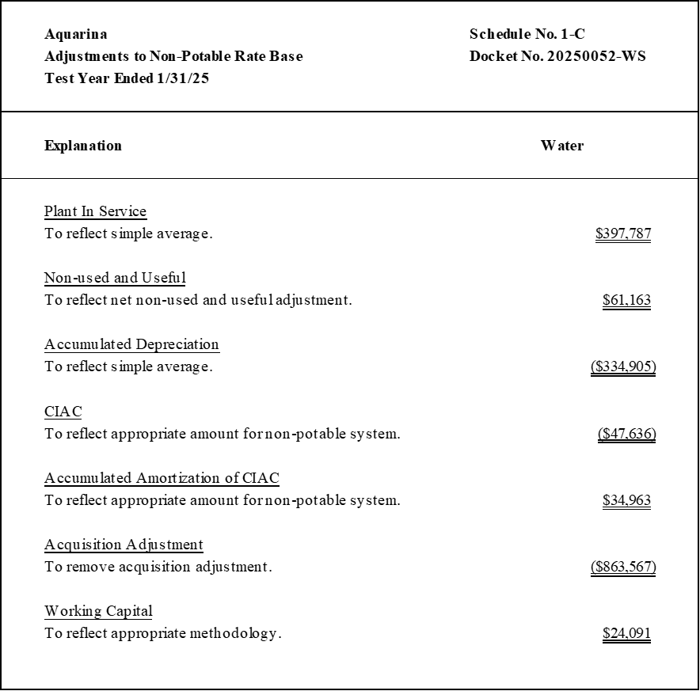
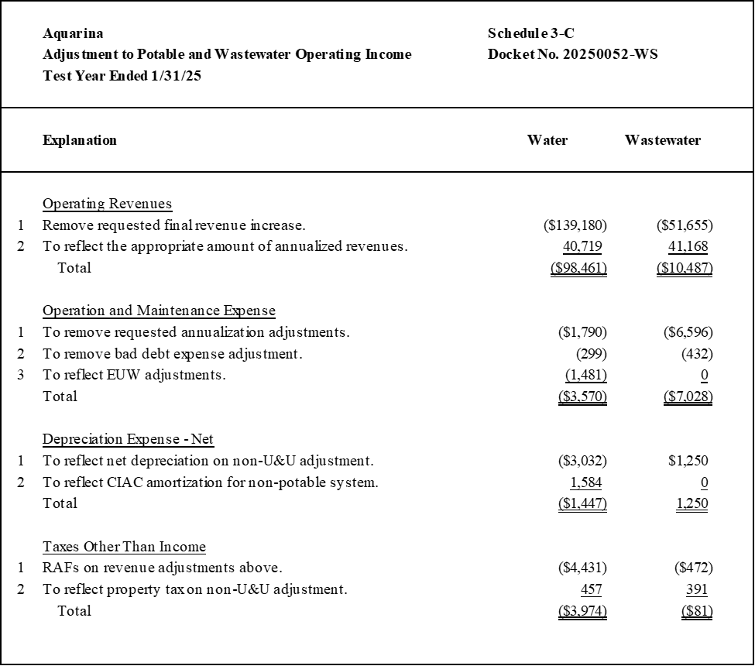
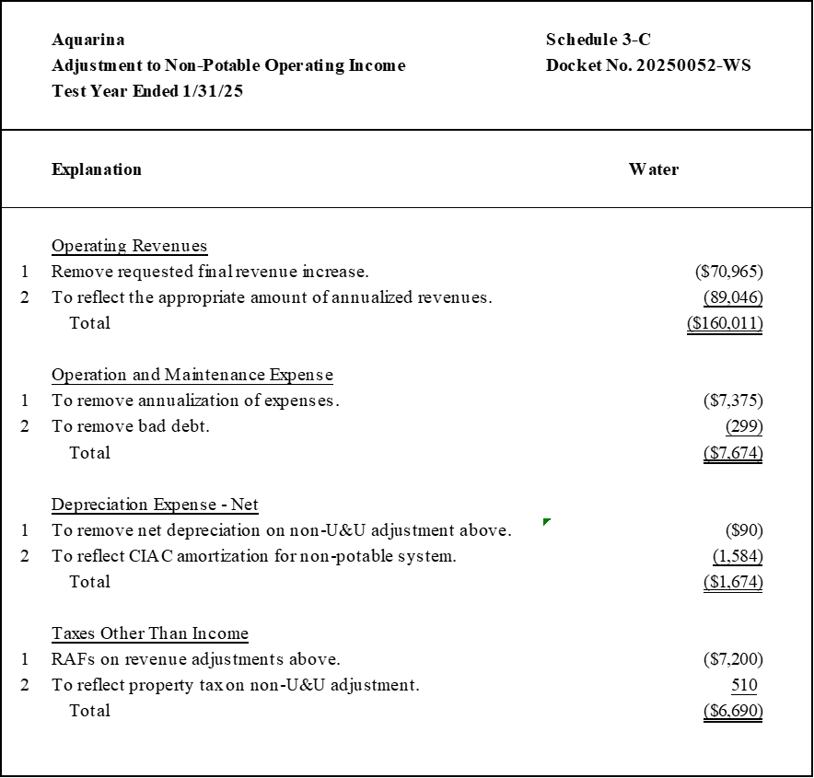

Order No. PSC-2025-0361-PCO-WS, issued September 24, 2025, in Docket No. 20250052-WS, In re: Application for increase in water and wastewater rates in Brevard, Citrus, Duval, Highlands, Marion, and Volusia Counties by CSWR-Florida Utility Operating Company.
Document No. 06826-2025, filed on July 25, 2025.
Document 13587-2025 filed on September 19, 2025.
Docket Nos. 20250038-WS, 20250043-WS, and 20250047-WS, in which CSWR requested an acquisition adjustment for Aquarina and two other CSWR systems. By Order No. PSC-2025-0250-PCO-WS, issued June 25, 2025, we denied a motion to dismiss the petitions, allowing the three acquisition adjustment applications to proceed; however, no acquisition adjustments have been ordered for these systems at this time.
Document No. 07685-2025, filed on August 8, 2025.
See Order Nos. PSC-2022-0227-PCO-WS, issued June 27, 2022, in Docket No. 20220066-WS, In re: Application for increase in water rates in Washington County, by Sunny Hills Utility.; PSC-2006-0670-FOF-WS, issued August 7, 2006, in Docket No. 20060261-WS, In re: Application for increase in water and wastewater rates in Lake County by Utilities, Inc. of Pennbrooke; and PSC-2012-0554-PCO-WS, issued October 17, 2012, in Docket No. 20120152-WS, In re: Application for increase in water and wastewater rates in Orange County by Pluris Wedgefield, Inc.
Order No. PSC-2025-0269-PCO-WS, issued July 25, 2025, in Docket No. 20240108-SU, In re: Water and wastewater industry annual reestablishment of authorized range of return on common equity for water and wastewater utilities pursuant to Section 367.081(4)(f), F.S.
Order Nos. PSC-2025-0289-PAA-SU, issued July 28, 2025, and Amendatory Order PSC-2025-0289A-PAA-SU, issued August 1, 2025, in Docket No. 20240108-SU, In re: Application for increase in wastewater rates in Monroe County by K W Resorts Utilities Corp.; and PSC-2024-0046-PAA-WS, issued February 22, 2024, and Amendatory Order PSC-2024-0046A-PAA-WS, issued March 12, 2024, in Docket No. 20230081-WS, In re: Application for increase in water and wastewater rates in Broward County by Royal Waterworks, Inc.
Order No. PSC-2016-0583-PAA-WS, issued December 29, 2016, in Docket No. 20150010-WS, In re: Application for staff-assisted rate case in Brevard County by Aquarina Utilities, Inc.; Document Nos. 04080-2025, 04993-2025, and 07961-2025, in Docket No. 20250052-WS, In re: Application for increase in water and wastewater rates in Brevard, Citrus, Duval, Highlands, Marion, and Volusia Counties by CSWR-Florida Utility Operating Company.
Document No. 07961-2025, in Docket No. 20250052-WS, In re: Application for increase in water and wastewater rates in Brevard, Citrus, Duval, Highlands, Marion, and Volusia Counties by CSWR-Florida Utility Operating Company.
Order No. PSC-2016-0583-PAA-WS, issued December 29, 2016, in Docket No. 20150010-WS, In re: Application for staff-assisted rate case in Brevard County by Aquarina Utilities, Inc.
Document No. 05250-2025, filed on June 26, 2025.
Document No. 07685-2025, filed on August 8, 2025.

