BEFORE THE FLORIDA PUBLIC SERVICE COMMISSION

In re: Petition for approval of 2026 subsequent year adjustment, by Tampa Electric Company. | DOCKET NO. 20250112-EI  ORDER NO. PSC-2025-0438-TRF-EI  ISSUED: November 24, 2025

The following Commissioners participated in the disposition of this matter:

MIKE LA ROSA, Chairman
ART GRAHAM
GARY F. CLARK
ANDREW GILES FAY
GABRIELLA PASSIDOMO SMITH

ORDER AUTHORIZING IMPLEMENTATION
OF SUBSEQUENT YEAR ADJUSTMENT

BY THE COMMISSION:

Background

On September 4, 2025, Tampa Electric Company (TECO) filed a petition seeking approval to implement its 2026 Subsequent Year Adjustment (SYA). This Florida Public Service Commission (Commission) approved the 2026 SYA in our final order addressing TECO’s request for base rate increase, Order No. PSC-2025-0038-FOF-EI (Rate Case Order). Pages 151–169 of the Rate Case Order discuss the 2026 SYA, including the specific projects and their associated incremental operating and maintenance expense, depreciation expense, and investment tax credit amortization. Based on our approved adjustments to each of those projects, the total approved 2026 SYA revenue requirement was $86,627,795.

The Rate Case Order further required TECO to file its proposed 2026 SYA rates for approval in September 2025, with rates effective the first billing cycle of January 2026. In addition, the Rate Case Order required TECO to verify the in-service dates of all projects and use the then-current billing determinates.

On June 11, 2025, this Commission granted in part and denied in part the Office of Public Counsel’s Motions for Reconsideration and Clarification of the Rate Case Order by Order No. PSC-2025-0203-FOF-EI (Reconsideration Order). There we agreed that inadvertent errors in the underlying calculations of the revenue requirement should be corrected, resulting in a revenue requirement increase of $1.1 million. After accounting for the original balance from the Rate Case Order, this meant that the total 2026 SYA revenue requirement was now $87,727,795.

Pursuant to Section 366.06(3), Florida Statutes (F.S.), this Commission may withhold consent to any portion of new rate schedules for good cause shown provided such notice is given within 60 days. On September 15, 2025, TECO waived the 60-day suspension deadline until the November 4, 2025 Agenda Conference. Our staff issued one data request during the evaluation of the petition, with responses filed by TECO on October 3, 2025. We have jurisdiction over this matter pursuant to Sections 366.05(1)(e), 366.06 and 366.076, F.S.

Decision

The Polk 1 Flexibility, Energy Storage, Corporate Headquarters, Bearss Operations Center, South Tampa Resilience, Grid Reliability and Resilience (PLTE Spectrum), and Cottonmouth and Long Branch Solar Projects went into service in 2025 or are expected to be in-service by the end of 2025. Two Polk Fuel Diversity Project unit upgrades are expected to be in-service in 2026. TECO submitted sworn affidavits in support thereof. Additionally, our staff conducted discovery on the in-service dates estimated for the projects. TECO provided additional detail regarding the original in-service dates, our ordered in-service dates, most recent anticipated in-service dates, clarification, and explanations for any adjustments to the projects. All relevant projects appear on track to meet the time periods contemplated in the Rate Case Order.

TECO’s petition included the proposed tariff sheets, the allocation of the revenue increase to the various rate classes, and calculations showing the revenue from the sale of electricity by rate schedule under current and proposed rates. Our staff conducted discovery on the underlying rate calculations. Consistent with the Rate Case Order and the Reconsideration Order, the total amount to be collected through the 2026 SYA is $87,727,795, as reflected in Table 1 below. Also, consistent with the Rate Case Order, TECO used the most recent billing determinants, which were also used for TECO’s cost recovery clause projection filings, to calculate the 2026 SYA base rates.

Table 1
2026 Subsequent Year Adjustment
Project Name Commission-Approved Amount
Polk 1 Flexibility | $4,702,513
Energy Storage | $5,669,748
Corporate Headquarters | $10,073,129
Bearss Operation Center | $25,295,086
South Tampa Resilience | $9,308,157
Polk Fuel Diversity | $1,986,496
Grid Reliability and Resilience | $2,530,333
Solar | $27,062,333
Subtotal | $86,627,795
Reconsideration Order Adjustment | $1,100,000
Total | $87,727,795

The base rate portion of a monthly residential electric bill for 1,000 kilowatt-hours would increase from the current $97.47 to $102.98, which is an increase of $5.51. TECO will provide notice of the proposed rate increase with its December bills.

Conclusion

We hereby approve TECO’s proposed rates and associated tariffs to implement the 2026 SYA because the project timelines, rates, and associated tariffs are consistent with our prior decision in the Rate Case Order. The rates have been calculated to recover a total 2026 SYA revenue requirement of $87,727,795 as previously approved by us and as reflected in Table 1 above. Therefore the associated tariffs, included as Attachment A to this Order, shall become effective with the first billing cycle of January 2026.

Based on the foregoing, it is

ORDERED by the Florida Public Service Commission that Tampa Electric Company’s Petition for Approval of 2026 Subsequent Year Adjustment is GRANTED. The total amount to be collected through the 2026 Subsequent Year Adjustment shall be $87,727,795. It is further

ORDERED that the tariffs shown on Attachment A to this Order are hereby approved and shall be effective for the first billing cycle of January 2026. It is further

ORDERED that if a protest is filed within 21 days of issuance of this Order by a person whose substantial interests are affected, the tariff shall remain in effect with any incremental revenues held subject to refund pending resolution of the protest. It is further

ORDERED that if no timely protest is filed, this docket shall be closed upon the issuance of a Consummating Order.
By ORDER of the Florida Public Service Commission this 24th day of November, 2025.

/s/ Adam J. Teitzman
ADAM J. TEITZMAN
Commission Clerk
Florida Public Service Commission
2540 Shumard Oak Boulevard
Tallahassee, Florida 32399
(850) 413-6770
www.floridapsc.com

Copies furnished: A copy of this document is provided to the parties of record at the time of issuance and, if applicable, interested persons.

CMM

NOTICE OF FURTHER PROCEEDINGS

The Florida Public Service Commission (Commission) is required by Section 120.569(1), Florida Statutes, to notify parties of any administrative hearing or judicial review of Commission orders that is available under Sections 120.57 or 120.68, Florida Statutes, as well as the procedures and time limits that apply. This notice should not be construed to mean all requests for an administrative hearing or judicial review will be granted or result in the relief sought.

Mediation may be available on a case-by-case basis. If mediation is conducted, it does not affect a substantially interested person’s right to a hearing.

The Commission’s decision on this tariff is interim in nature and will become final, unless a person whose substantial interests are affected by the proposed action files a petition for a formal proceeding, in the form provided by Rule 28-106.201, Florida Administrative Code. This petition must be received by the Office of Commission Clerk, 2540 Shumard Oak Boulevard, Tallahassee, Florida 32399-0850, by the close of business on December 15, 2025.

In the absence of such a petition, this Order shall become final and effective upon the issuance of a Consummating Order.

Any objection or protest filed in this docket before the issuance date of this Order is considered abandoned unless it satisfies the foregoing conditions and is renewed within the specified protest period.

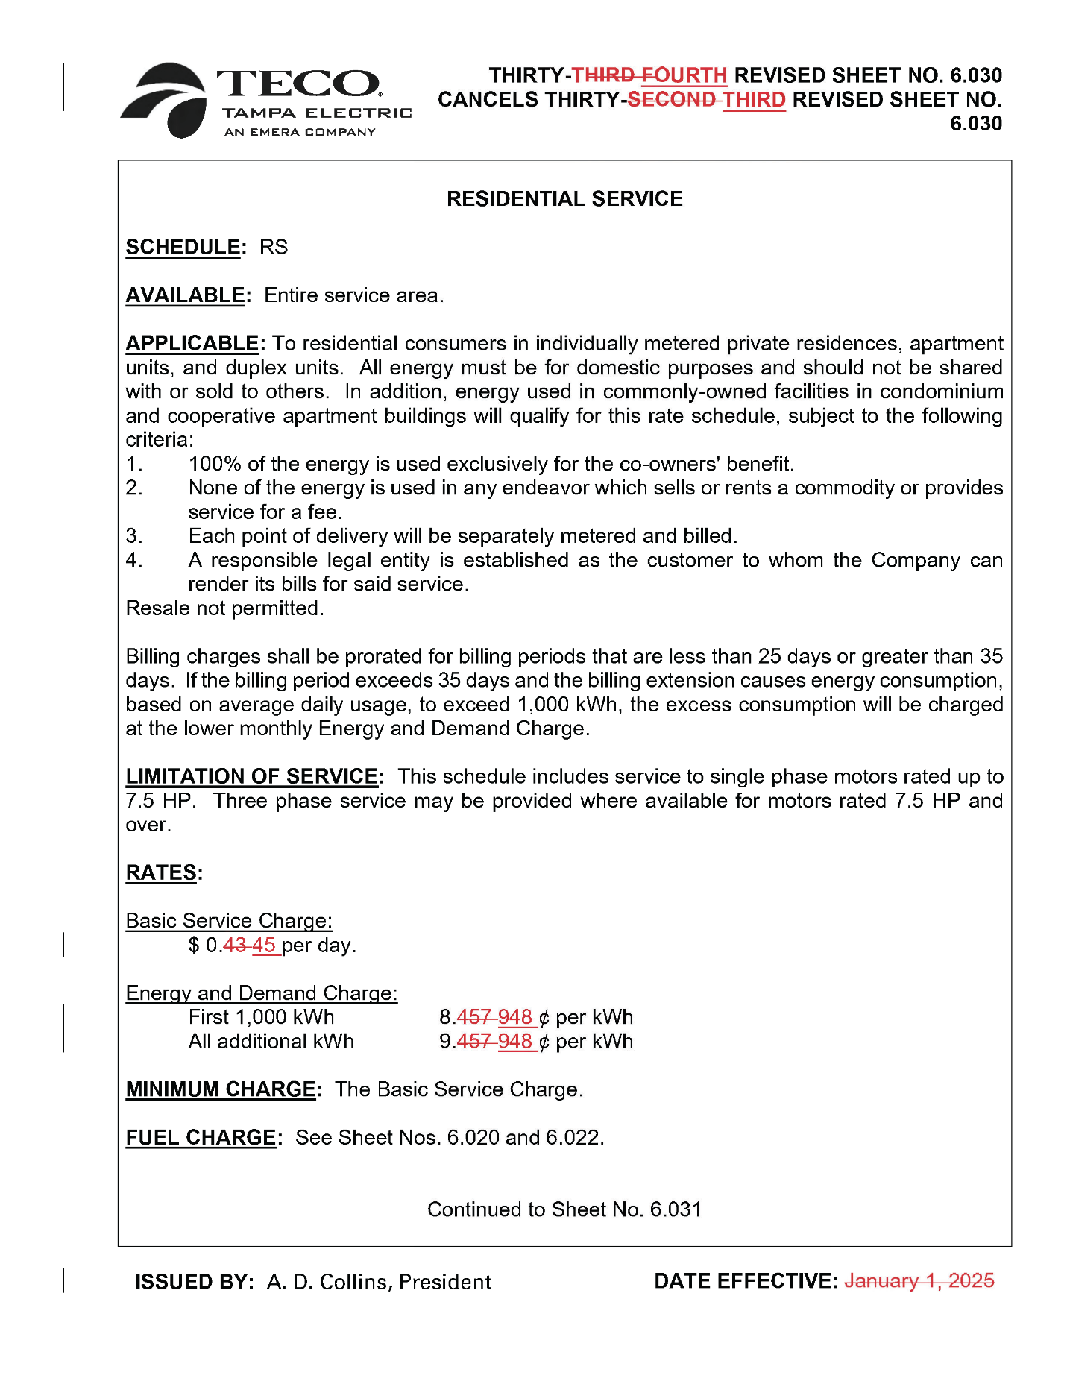

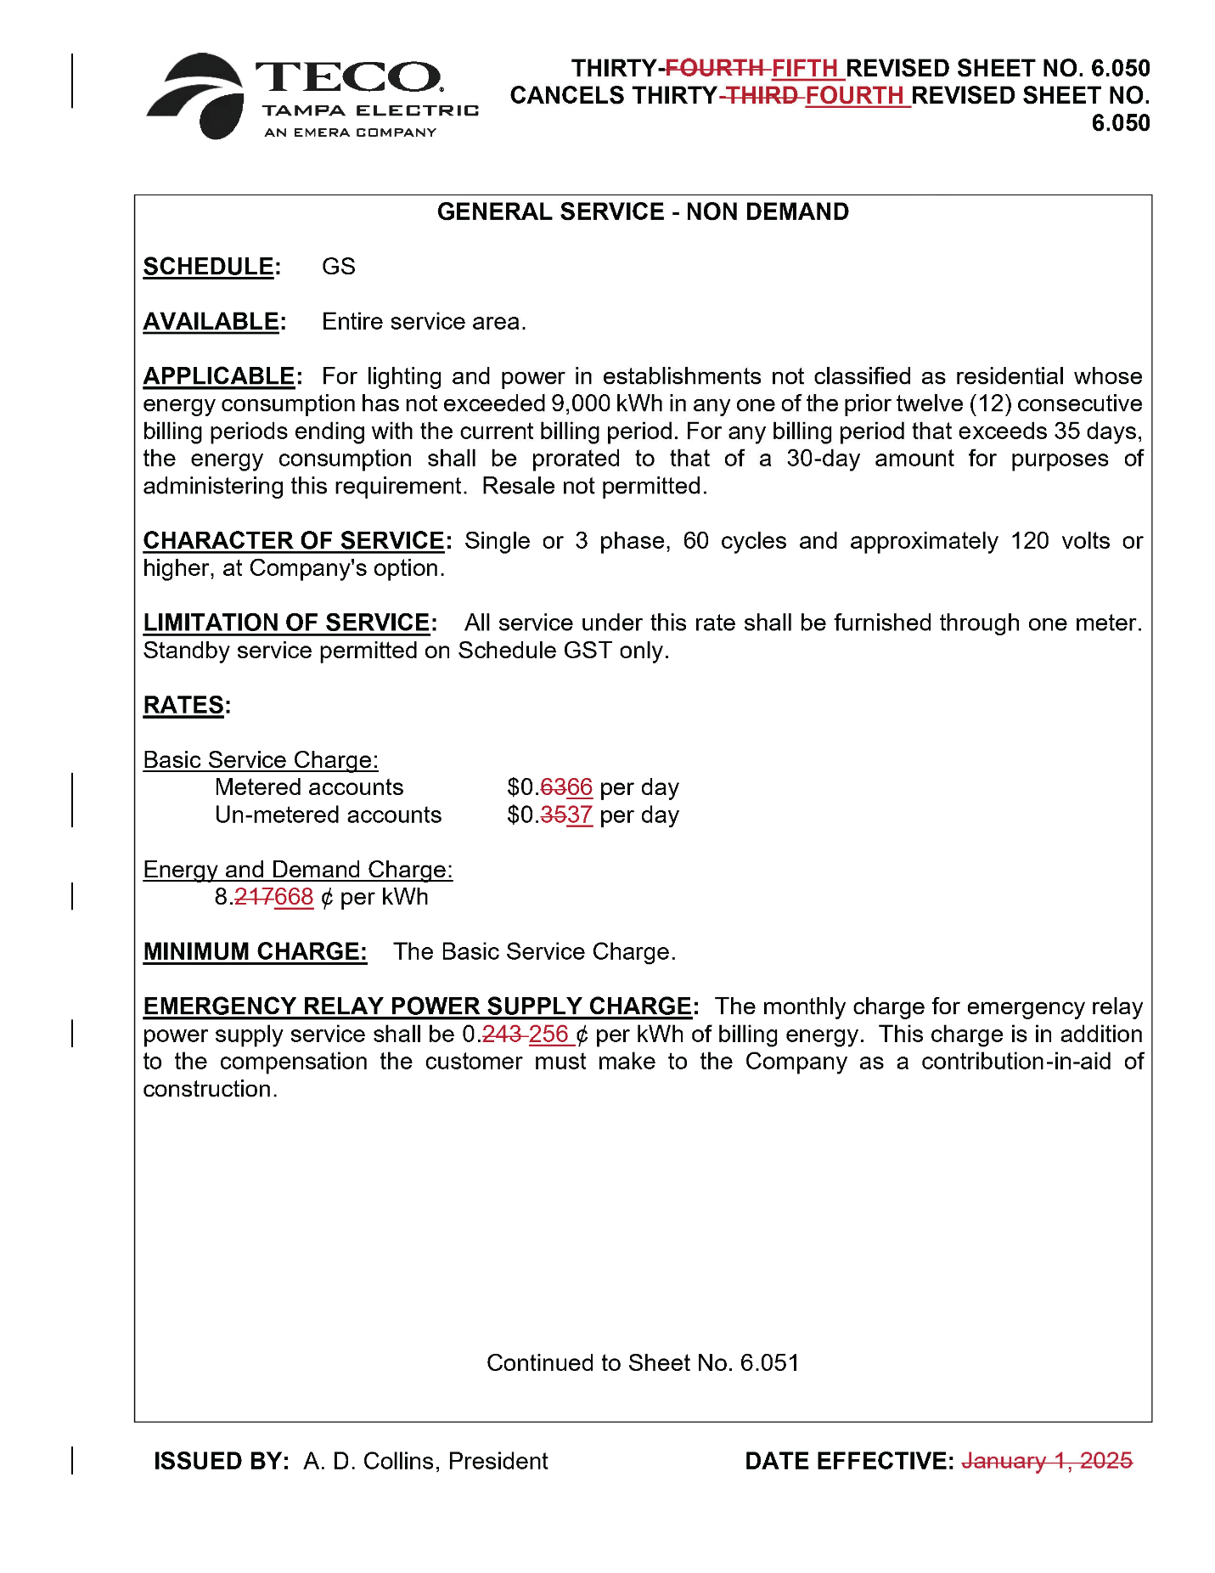

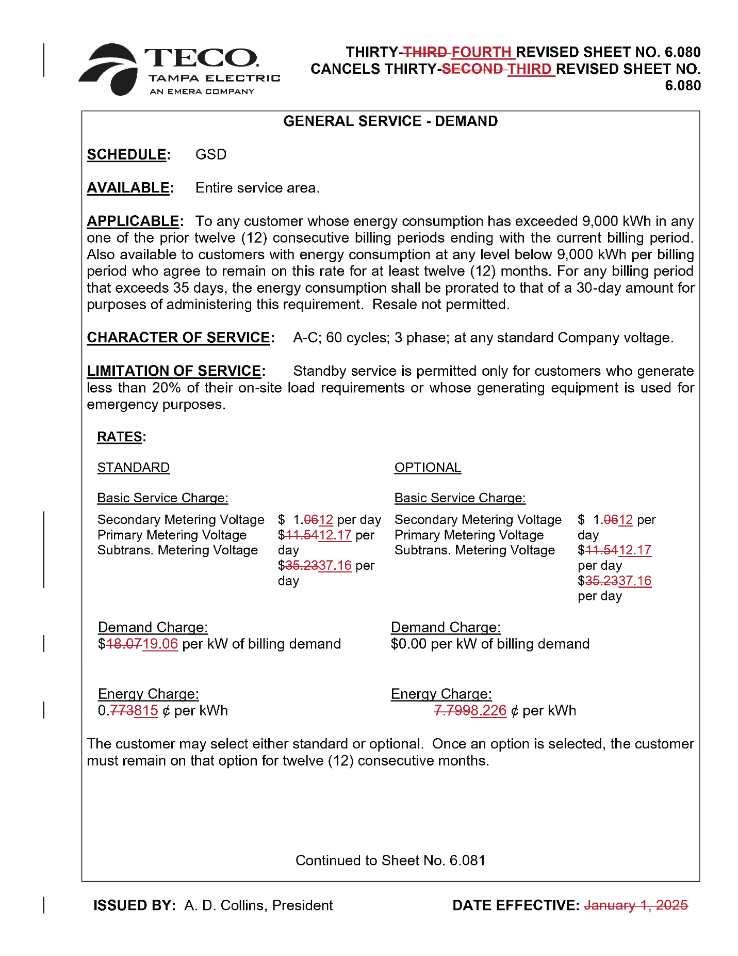

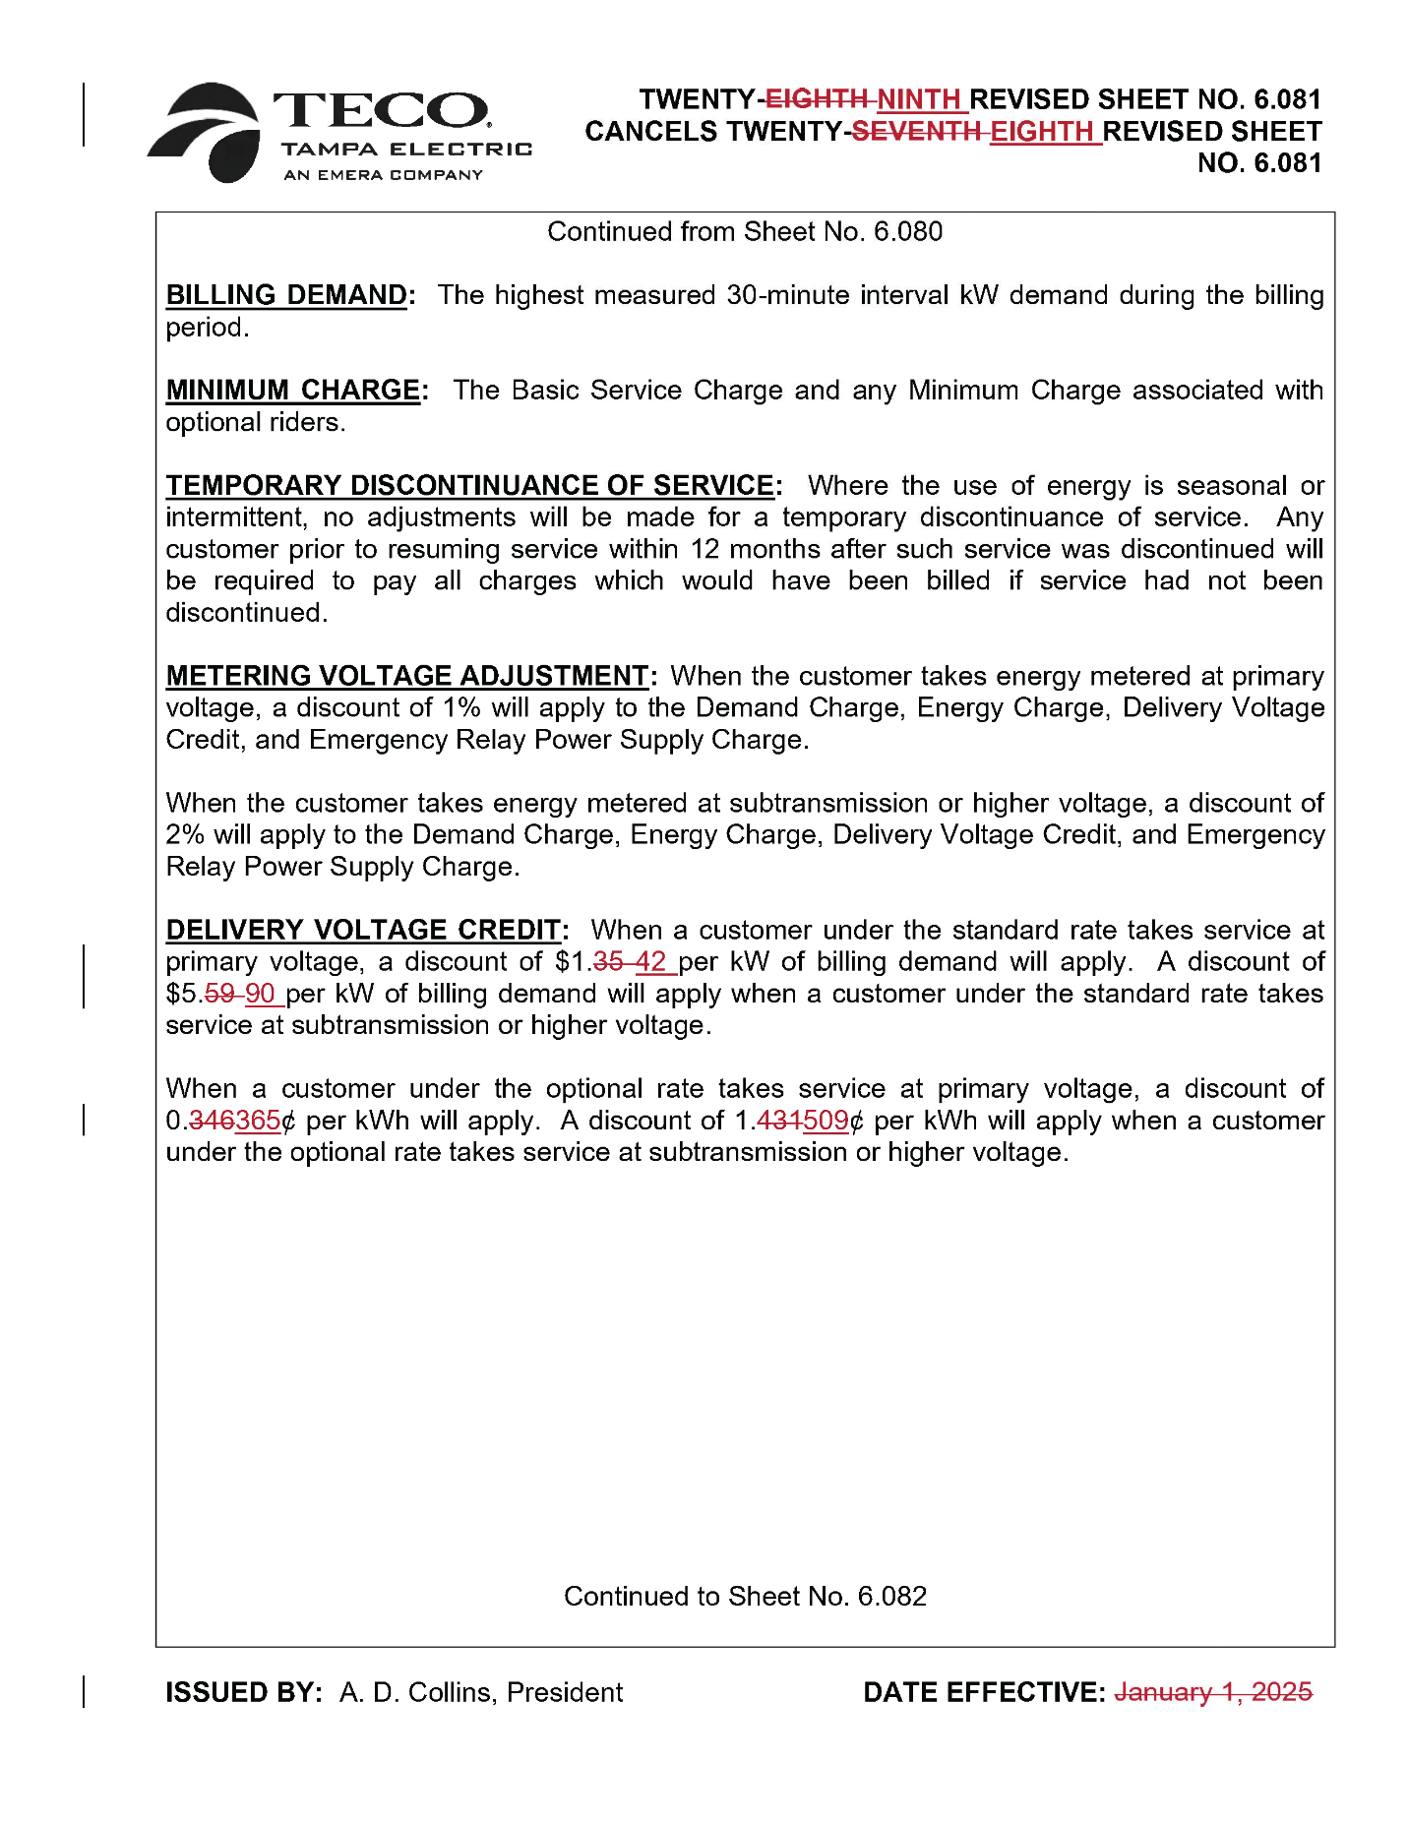

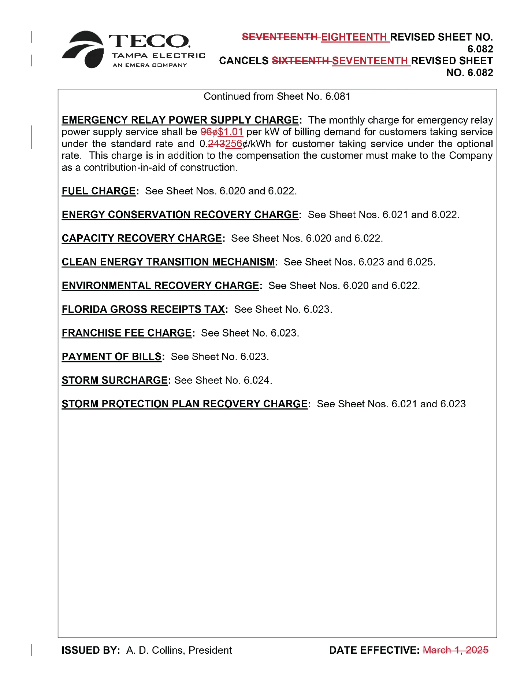

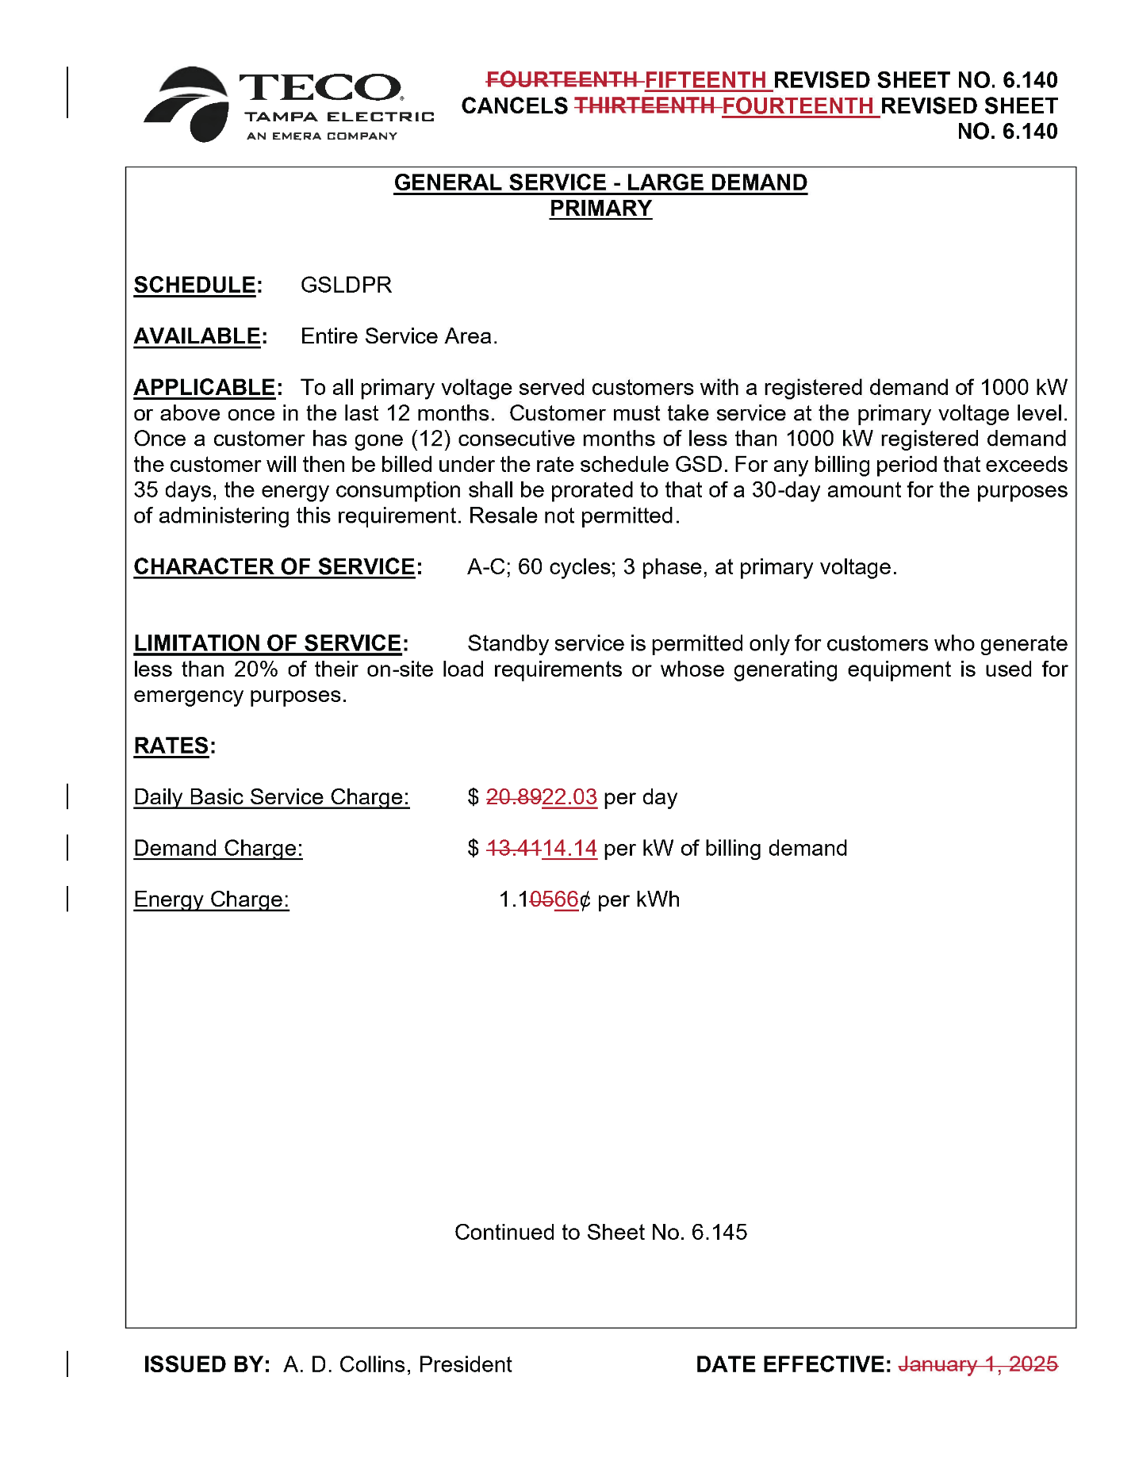

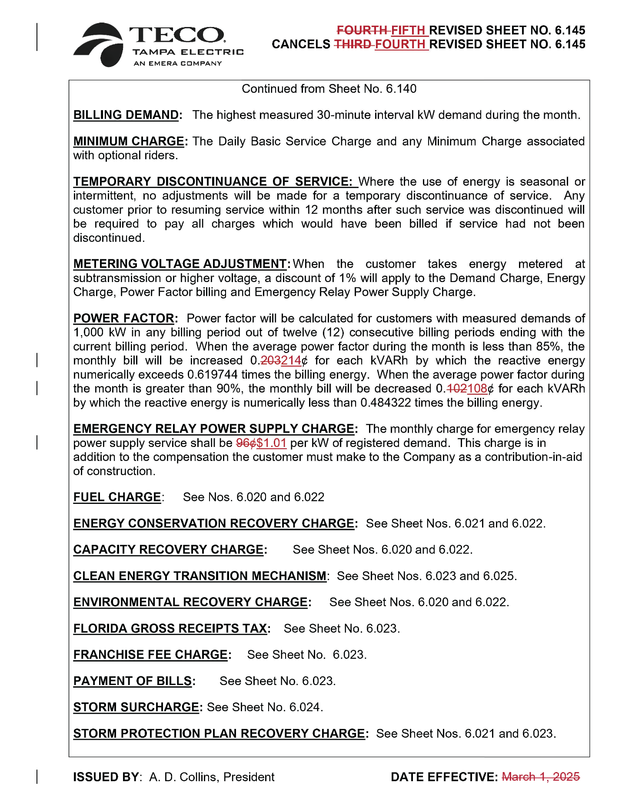

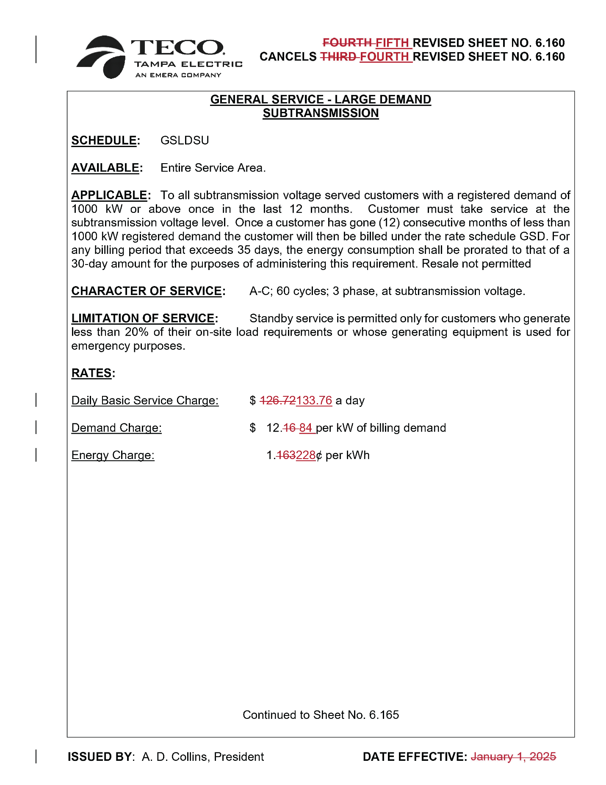

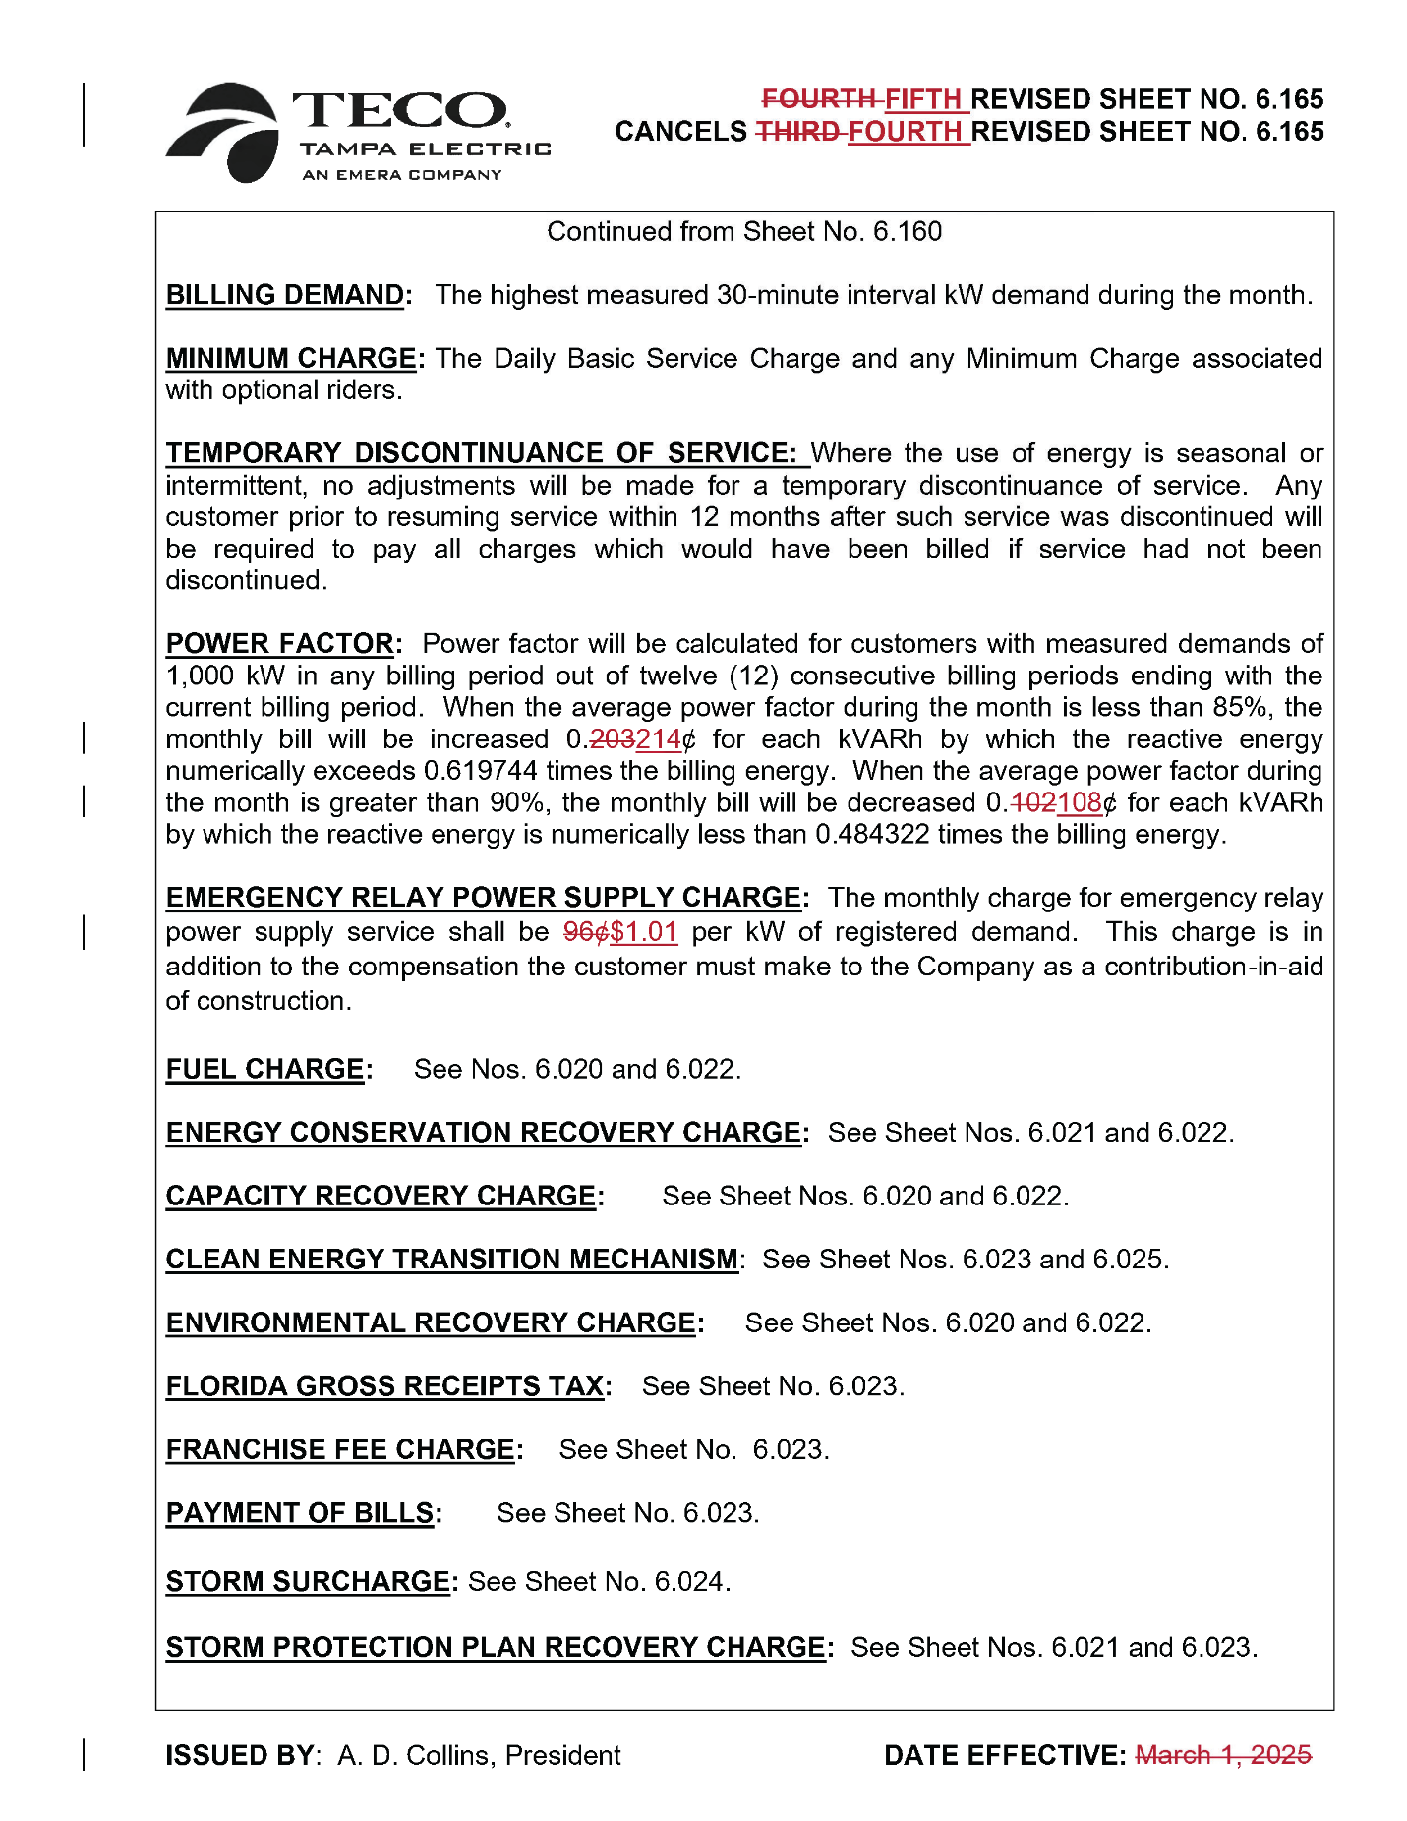

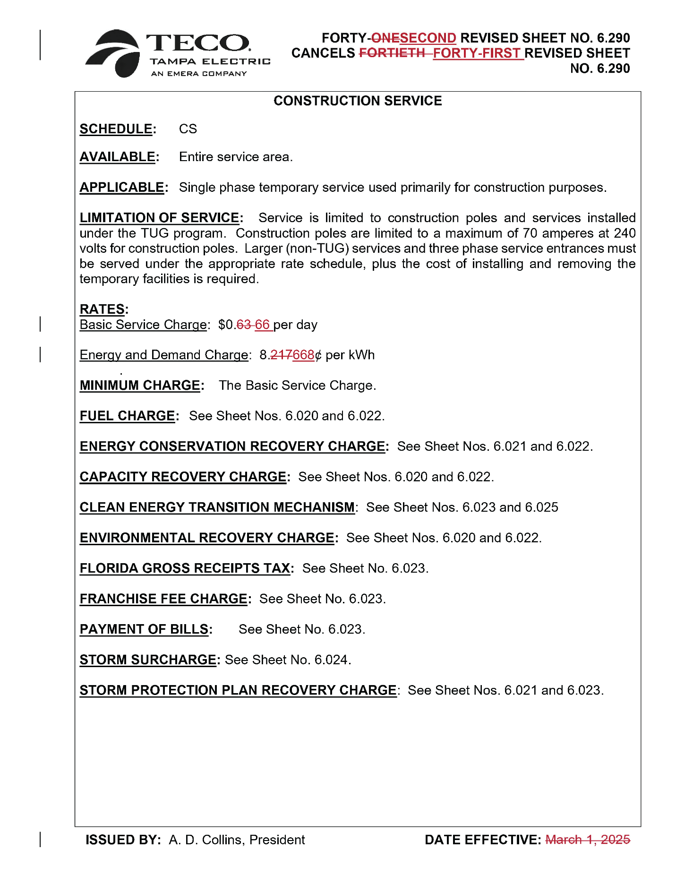

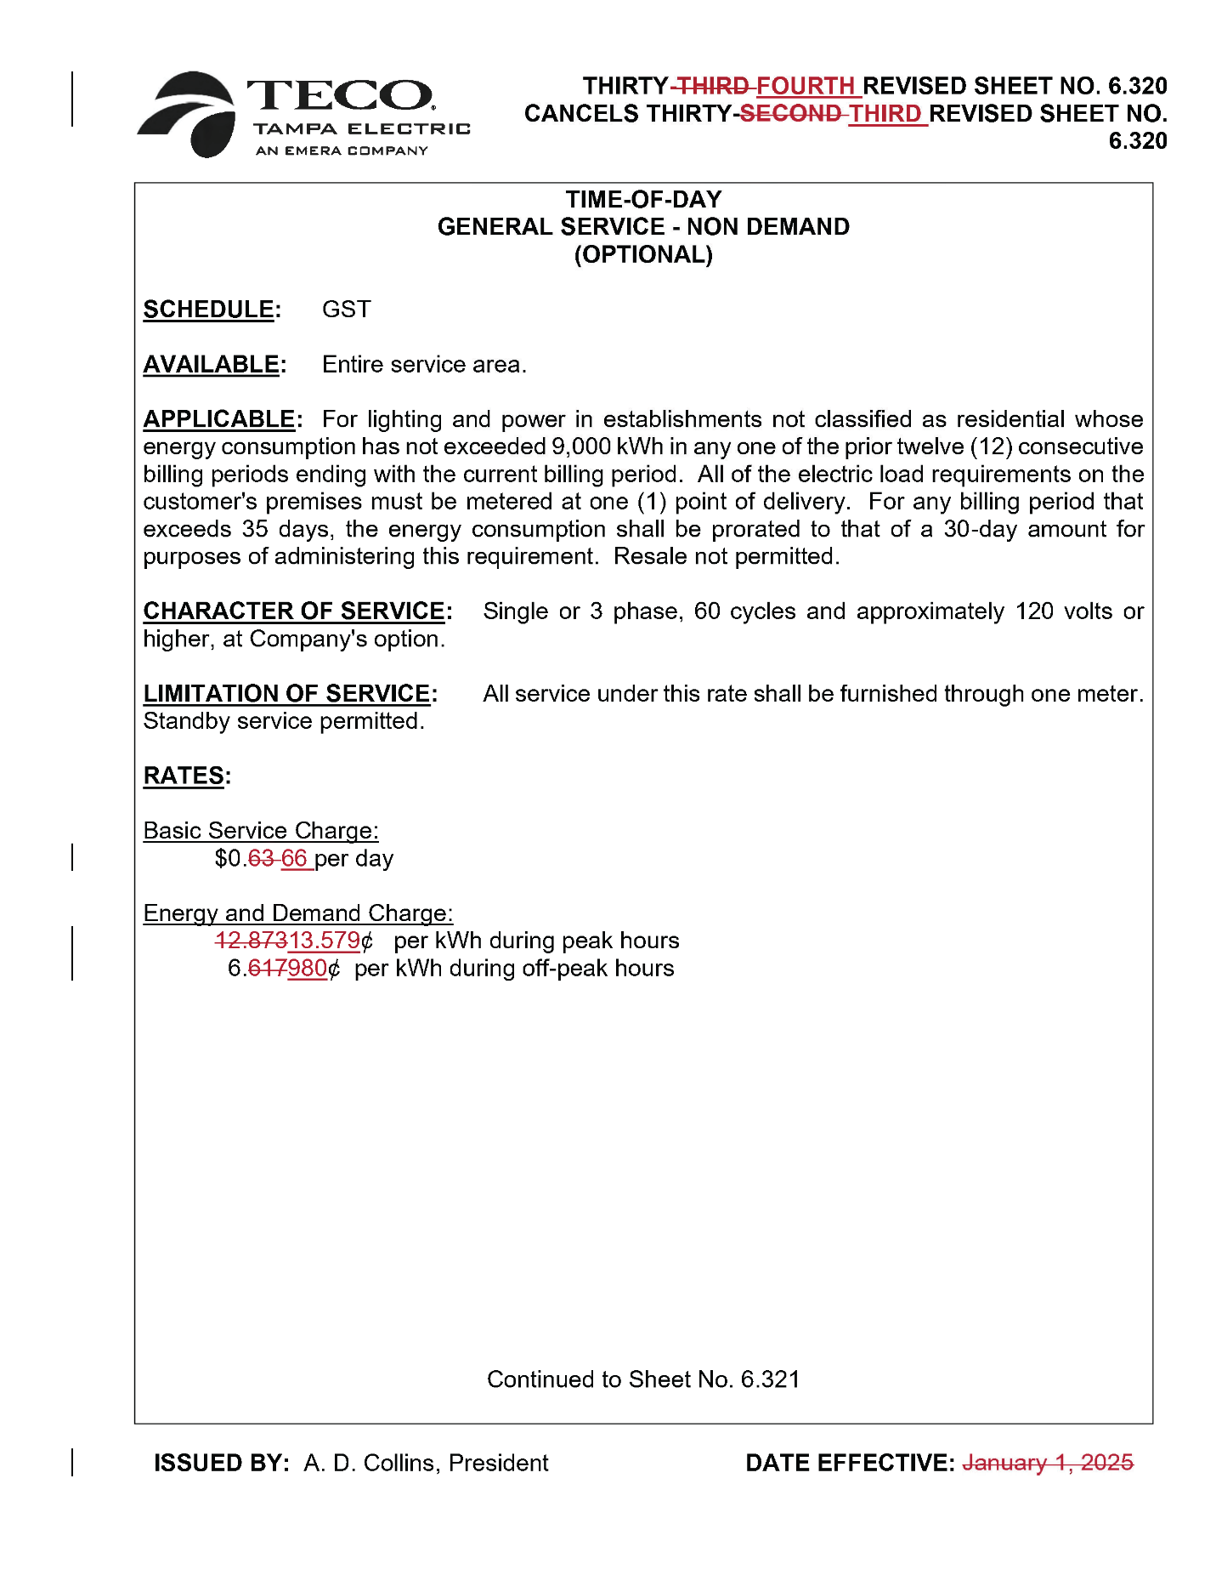

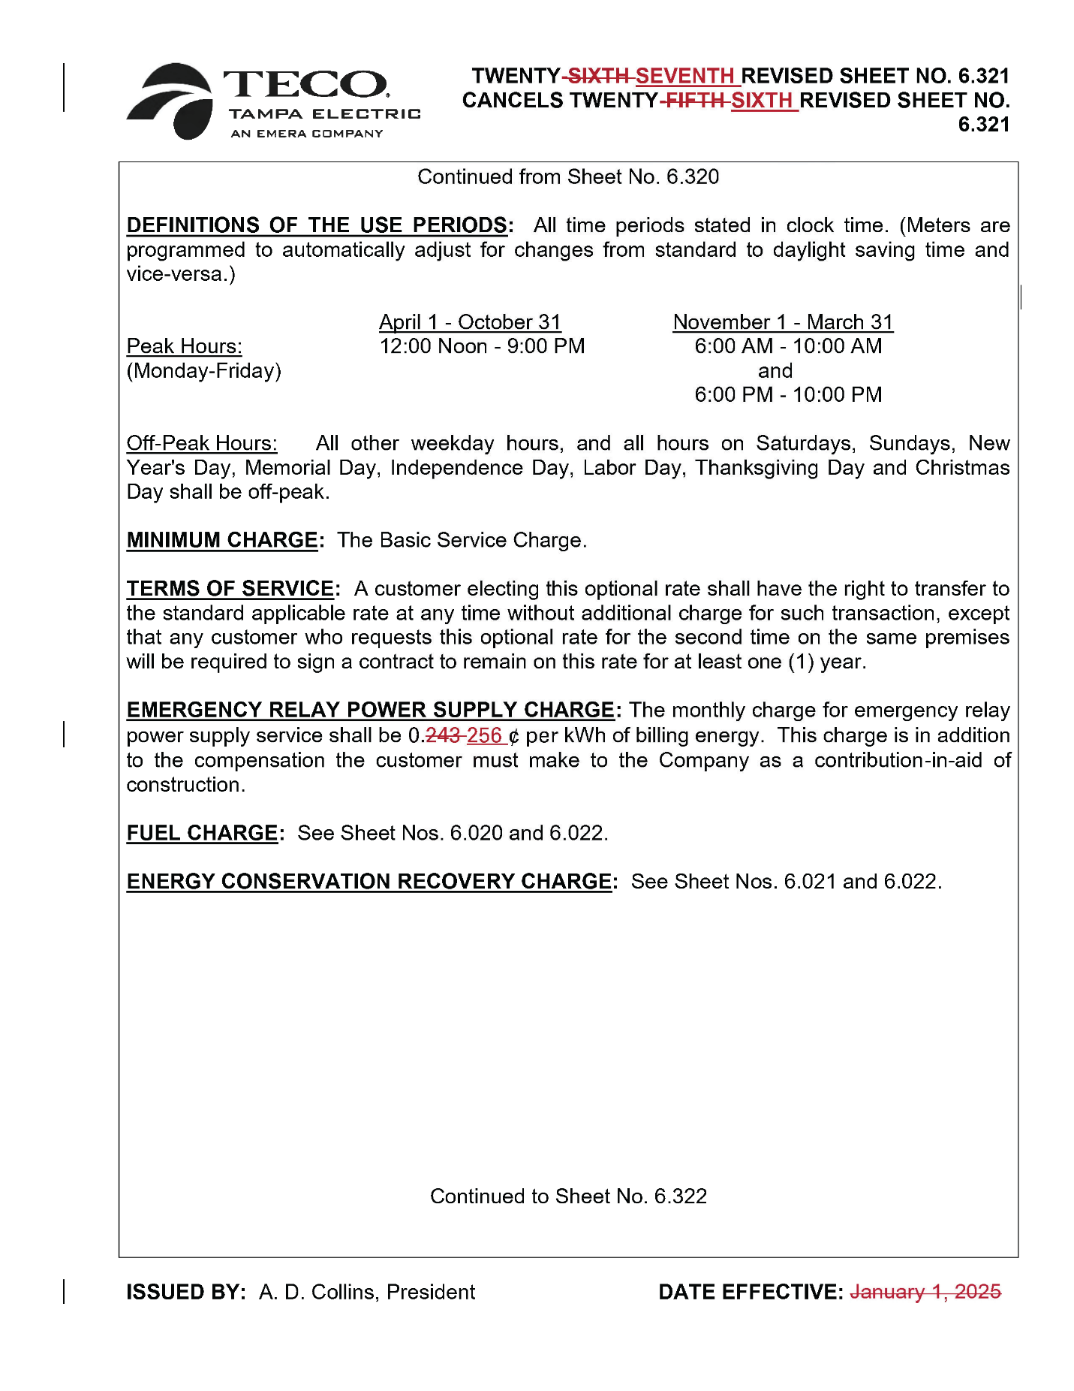

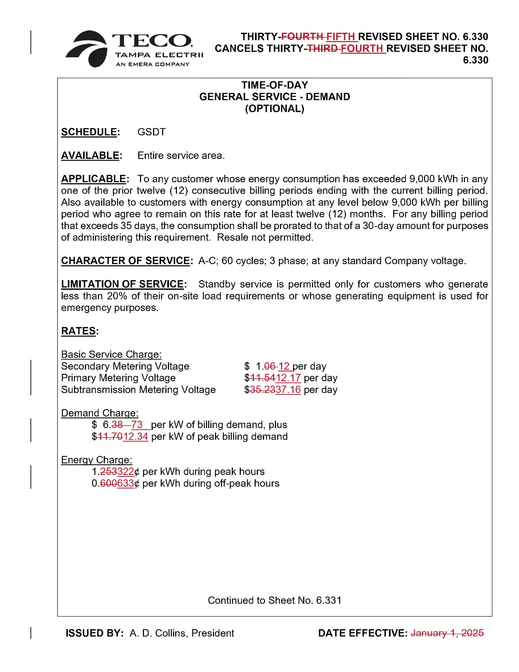

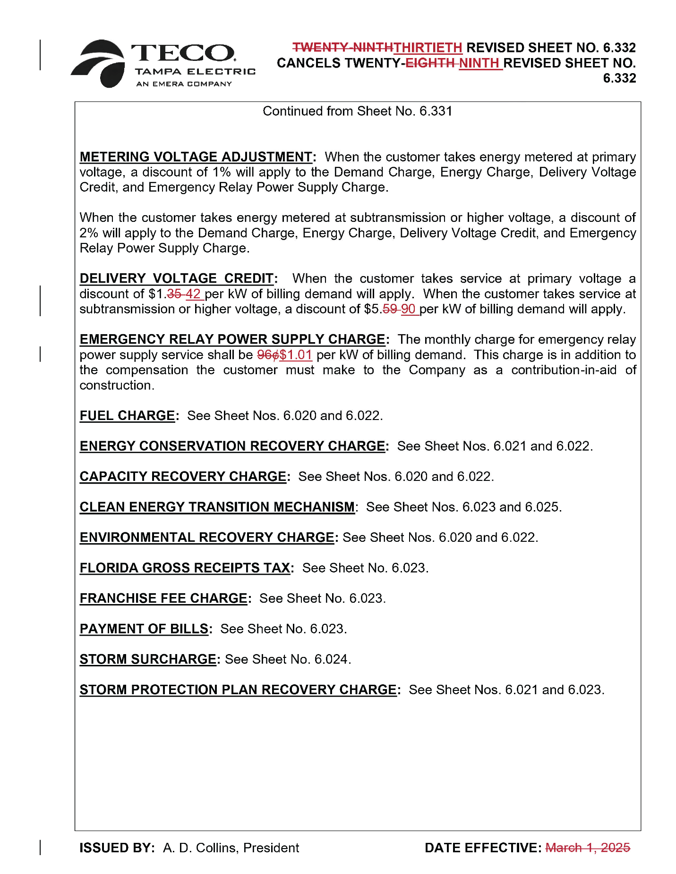

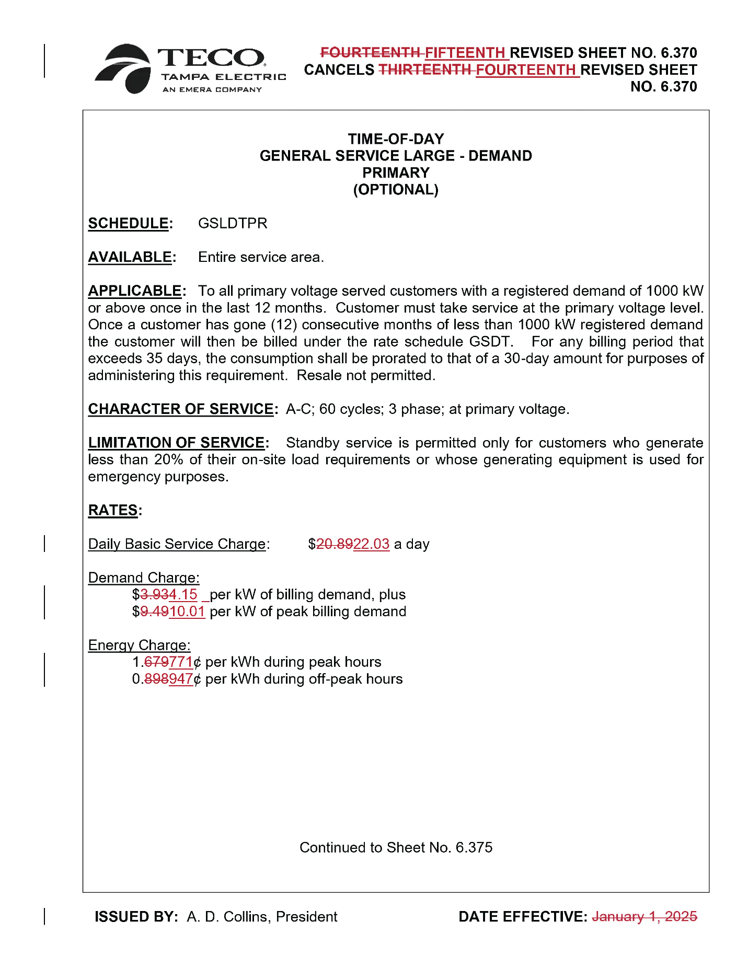

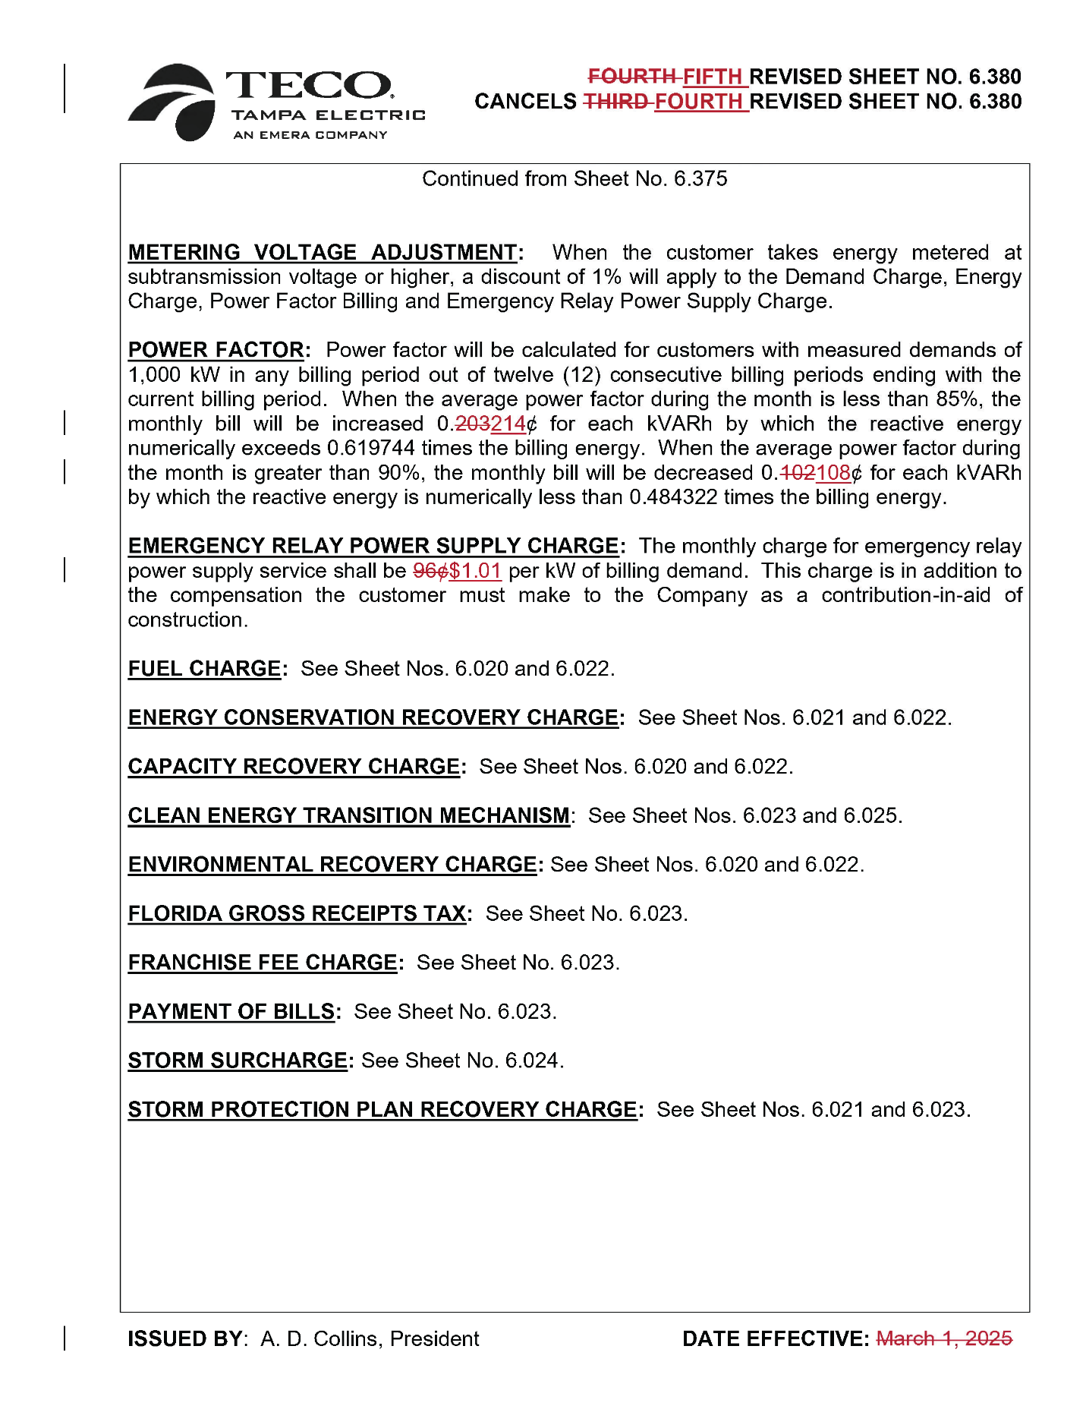

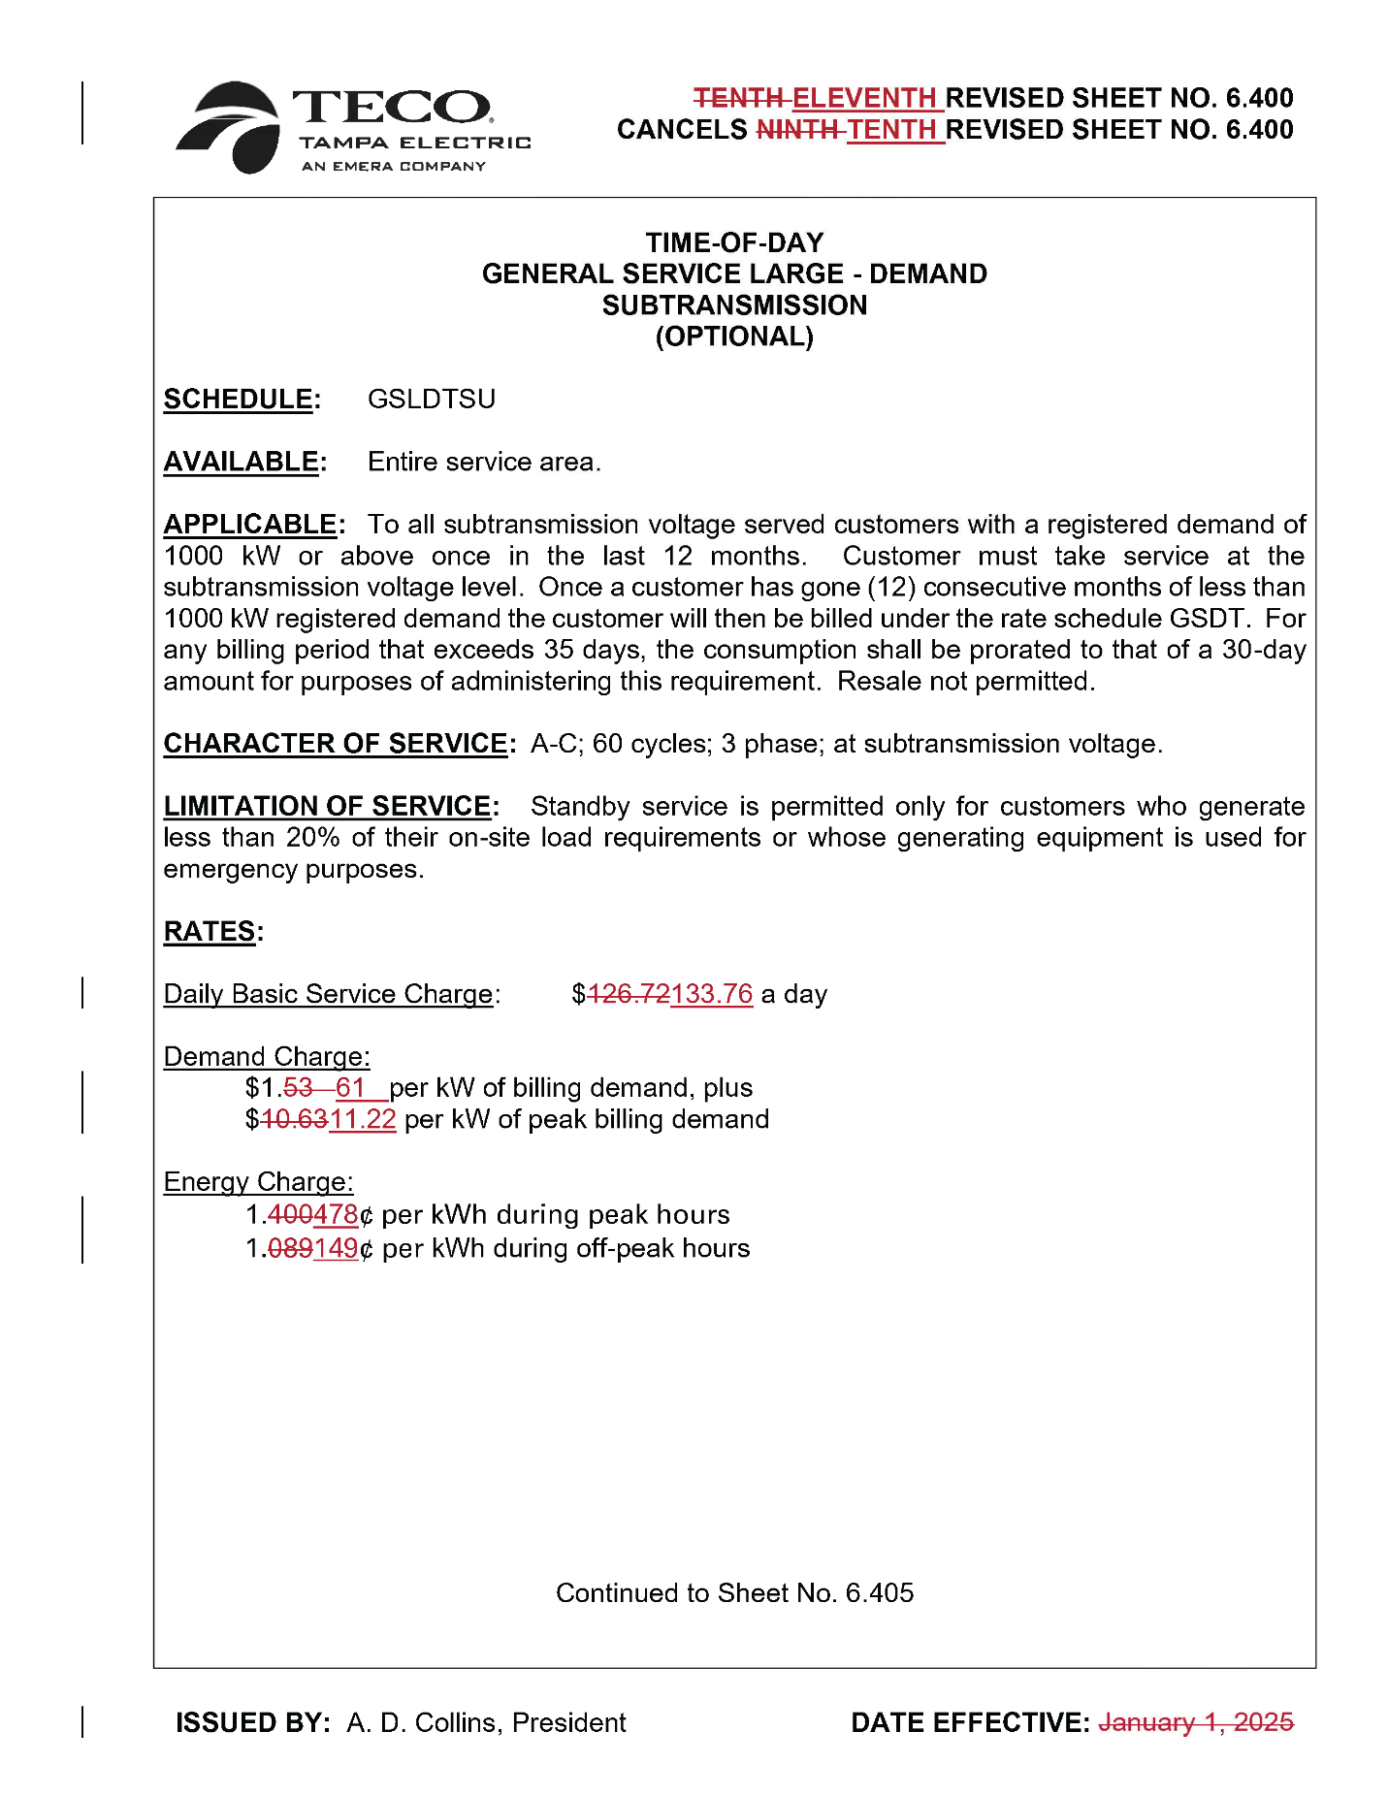

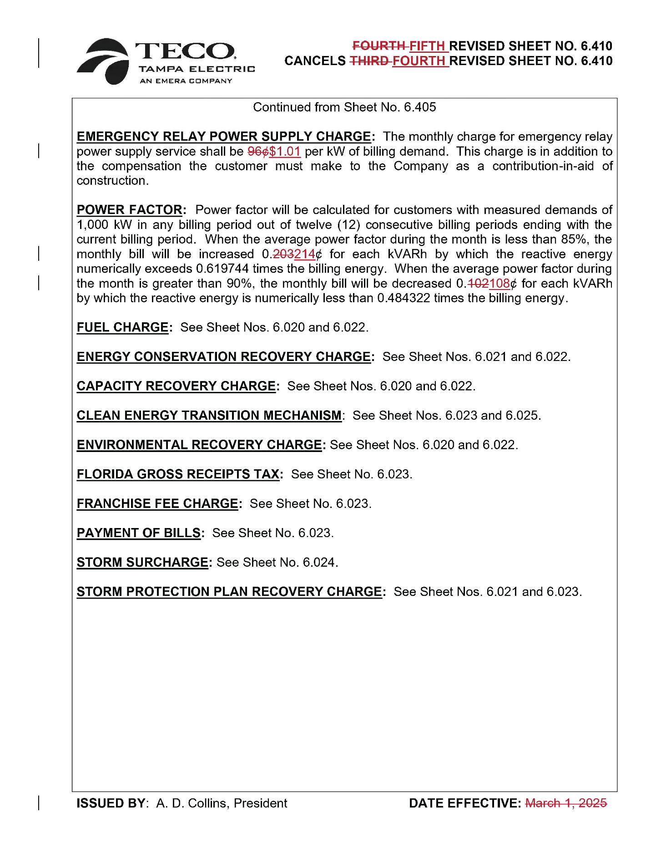

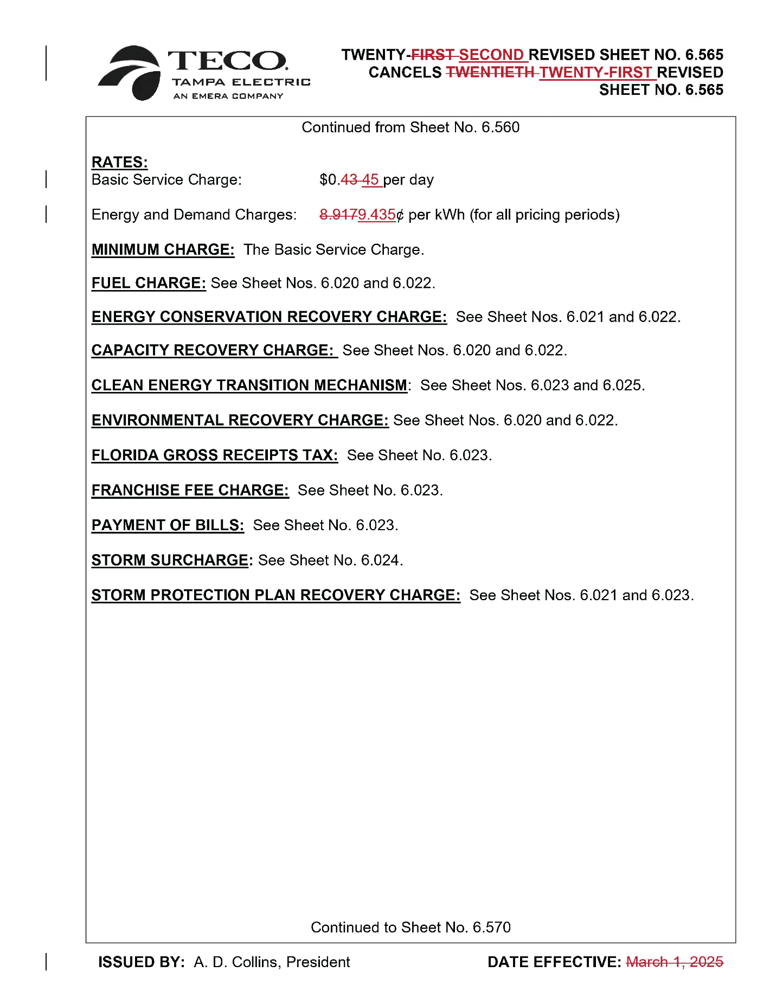

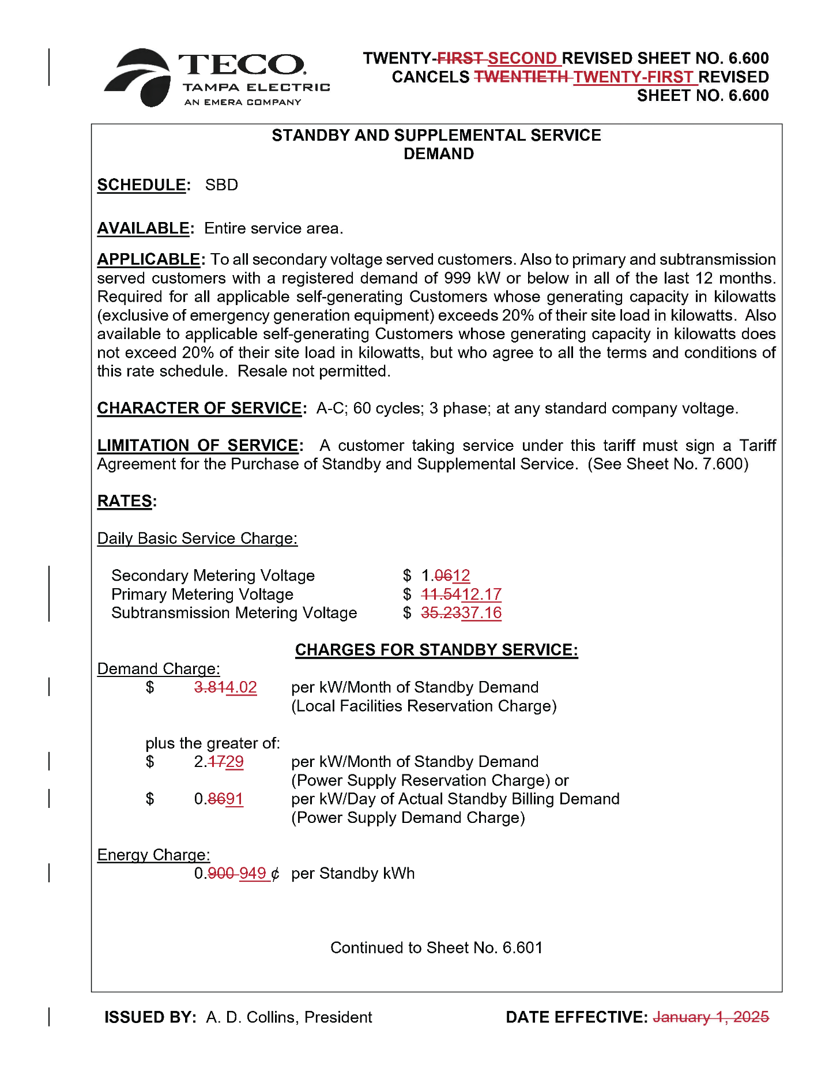

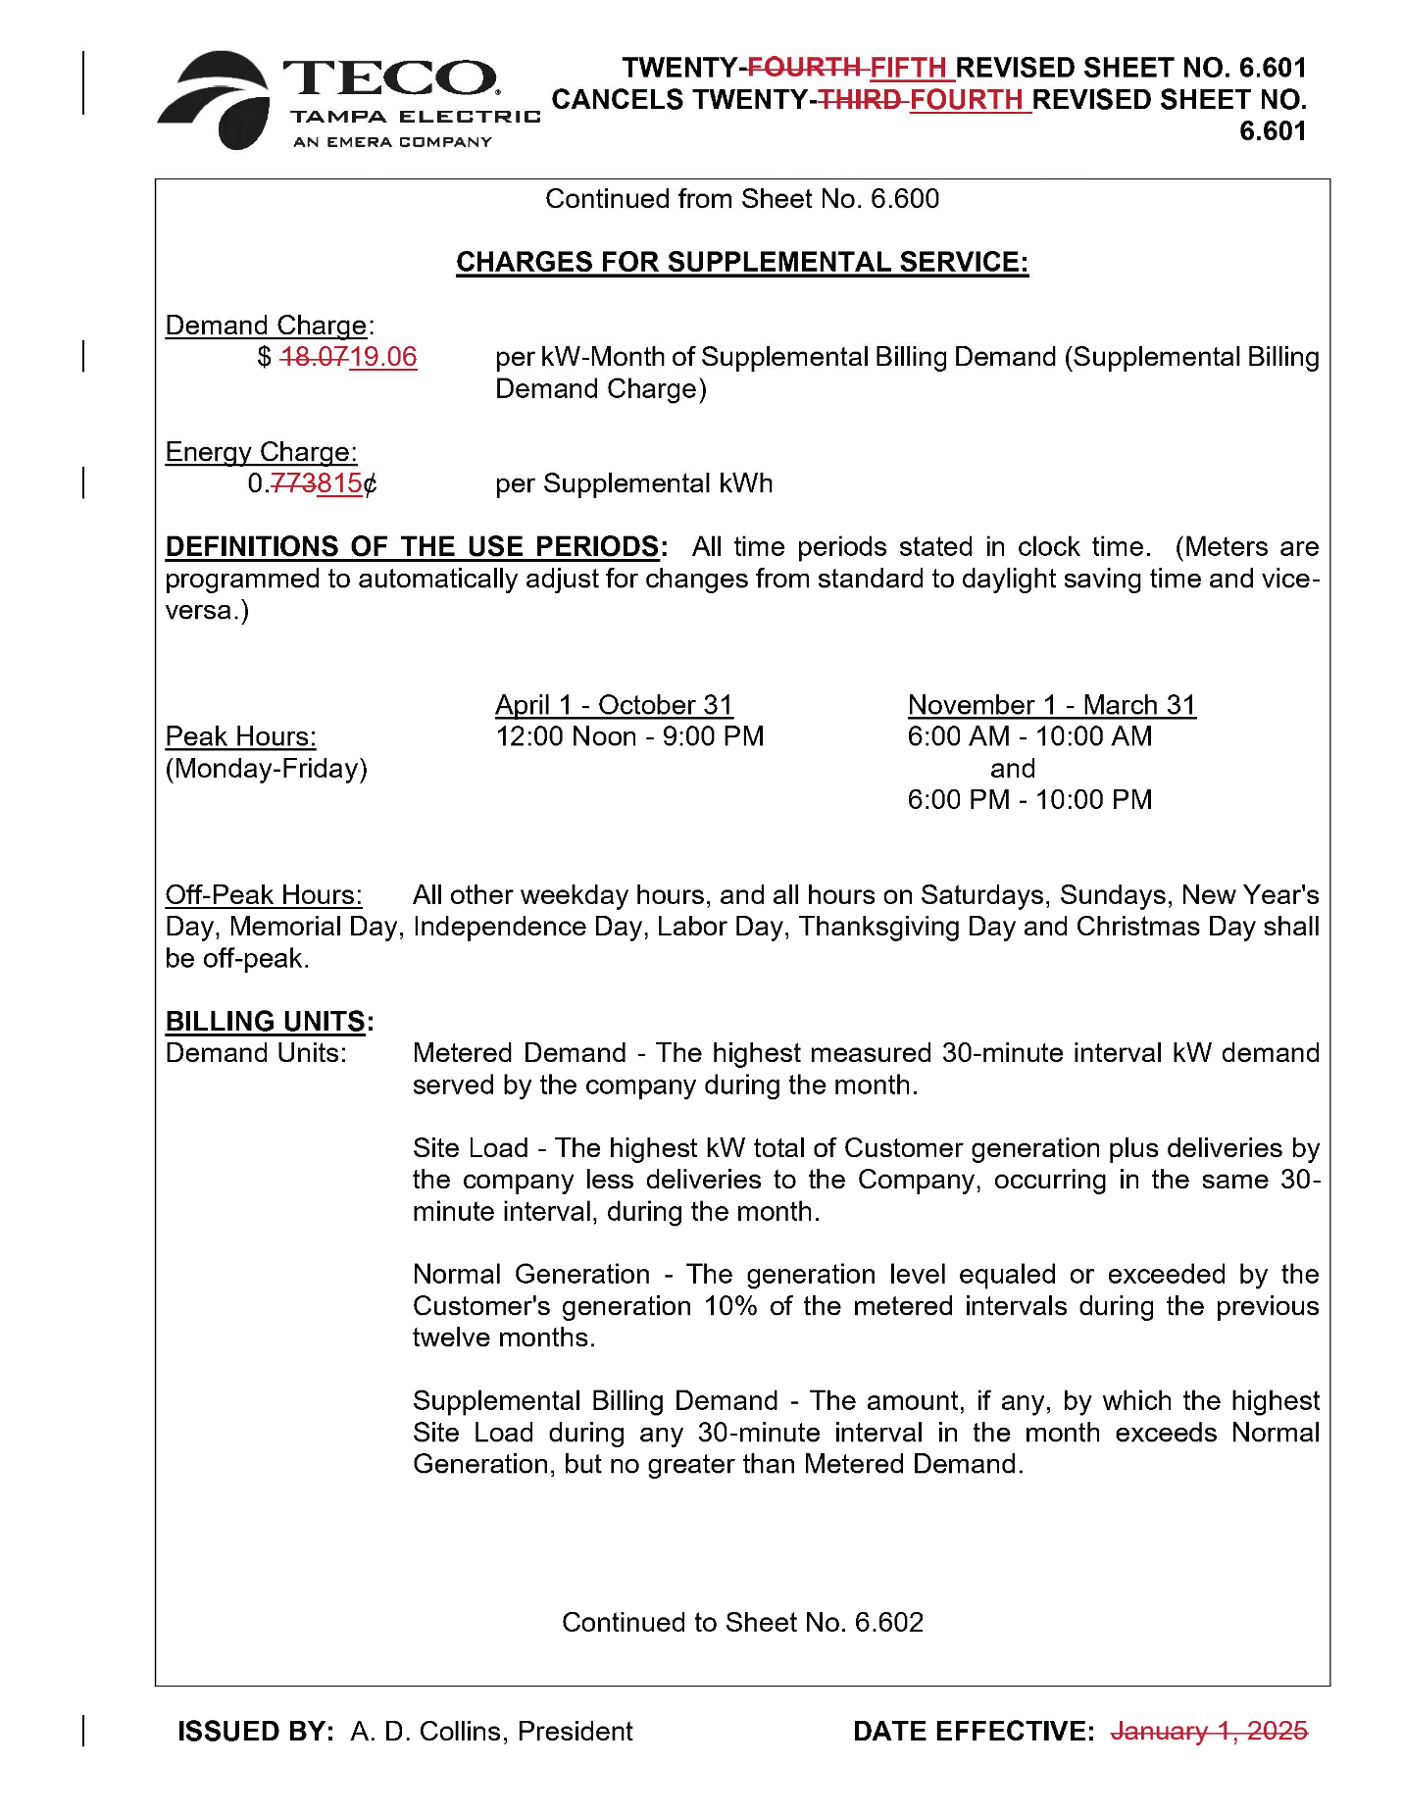

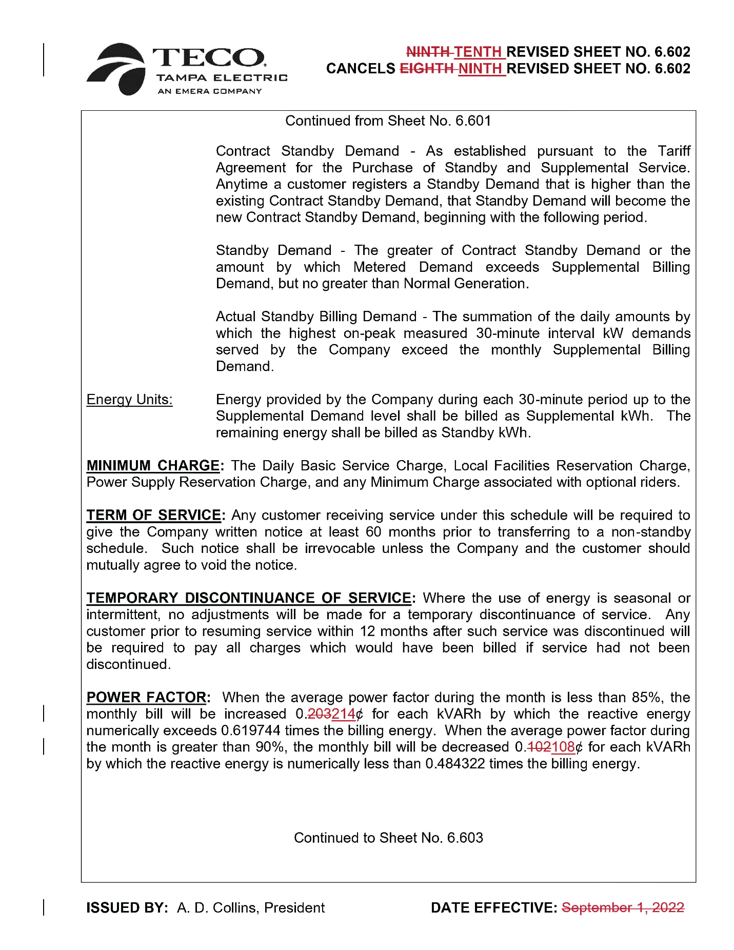

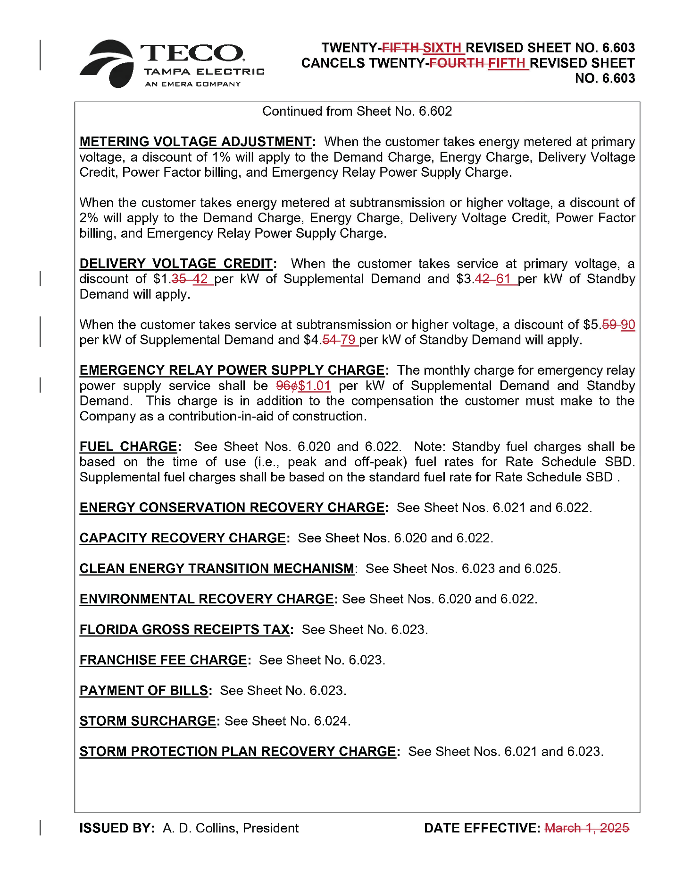

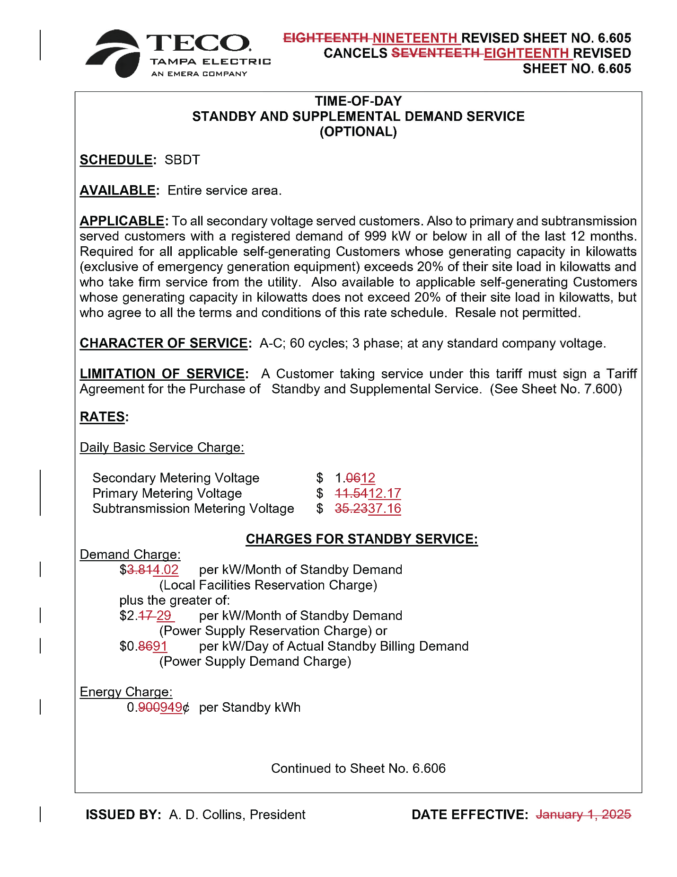

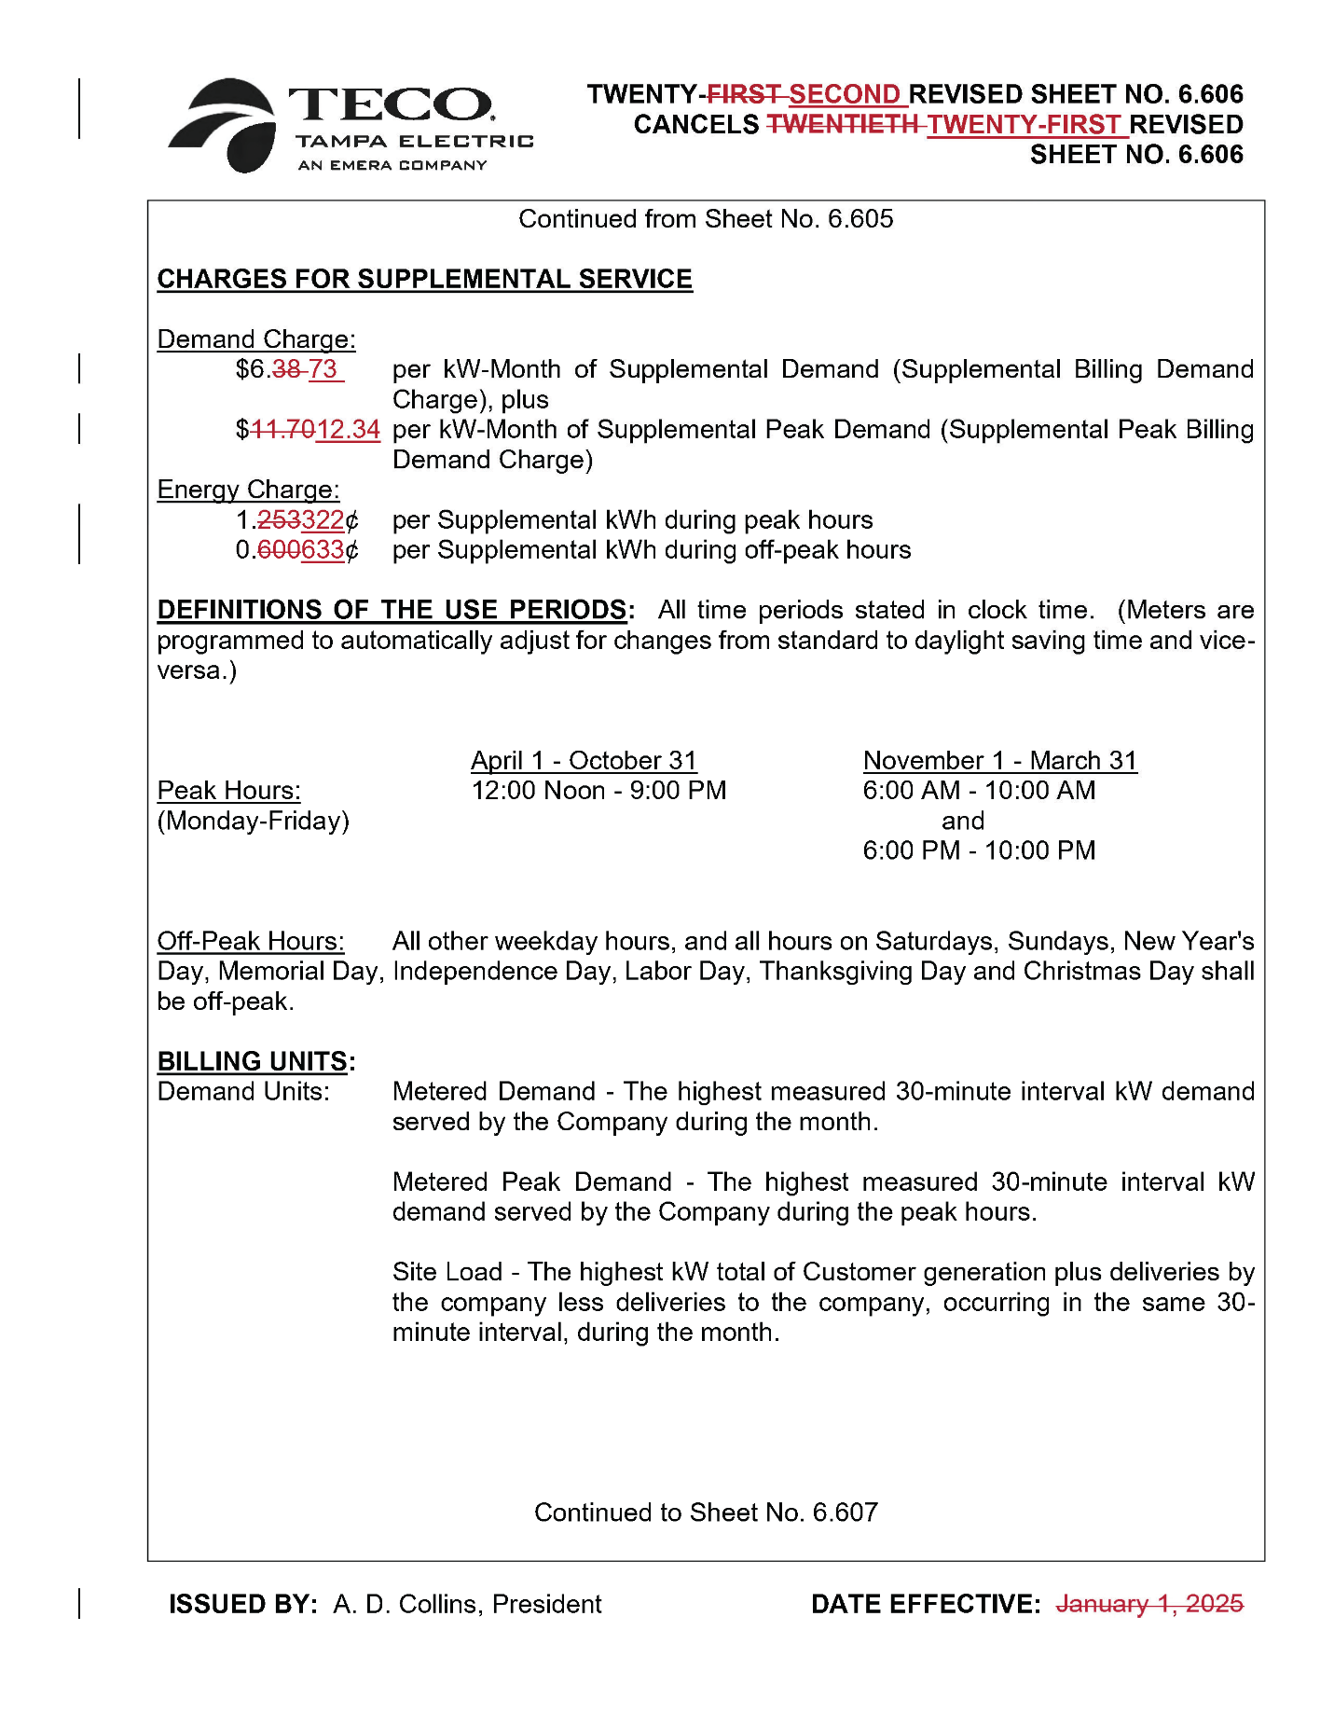

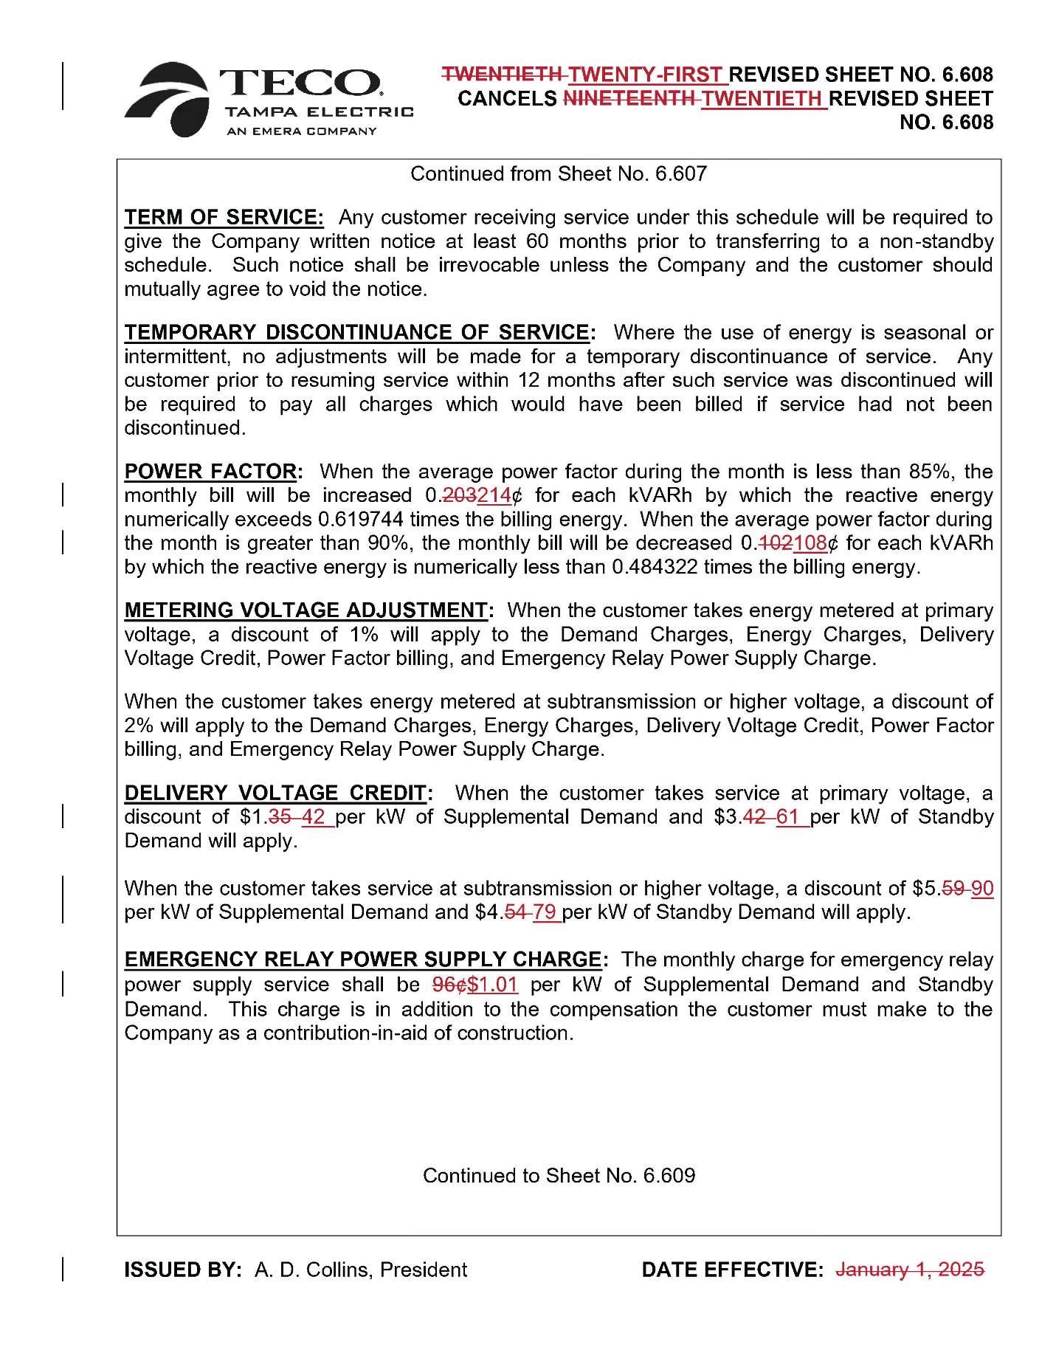

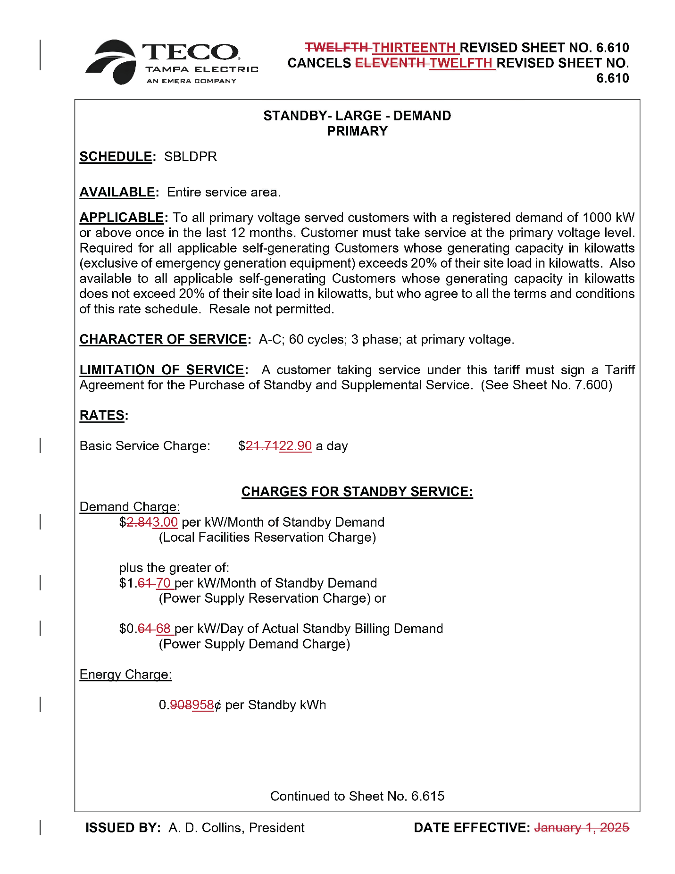

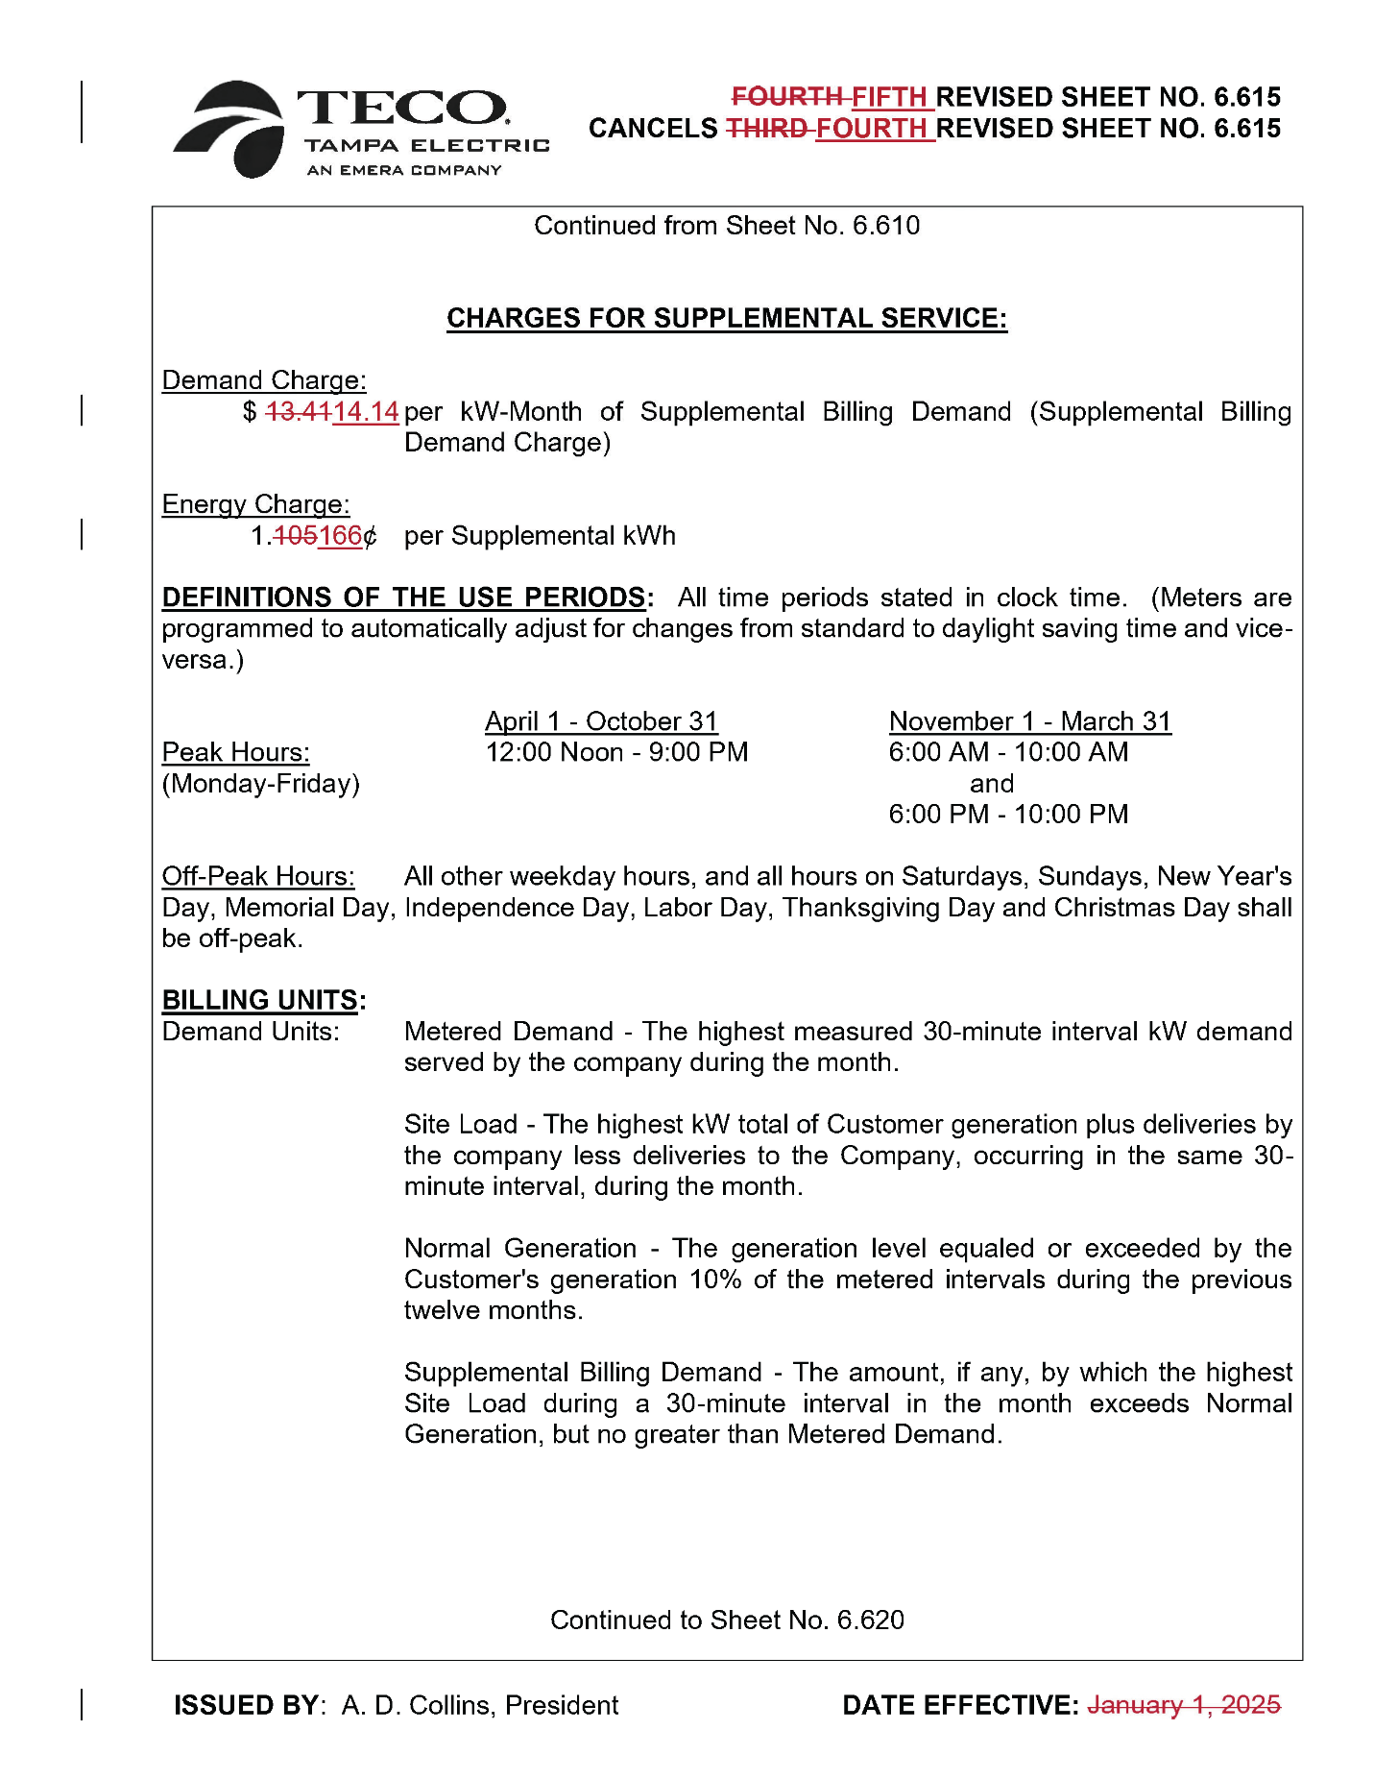

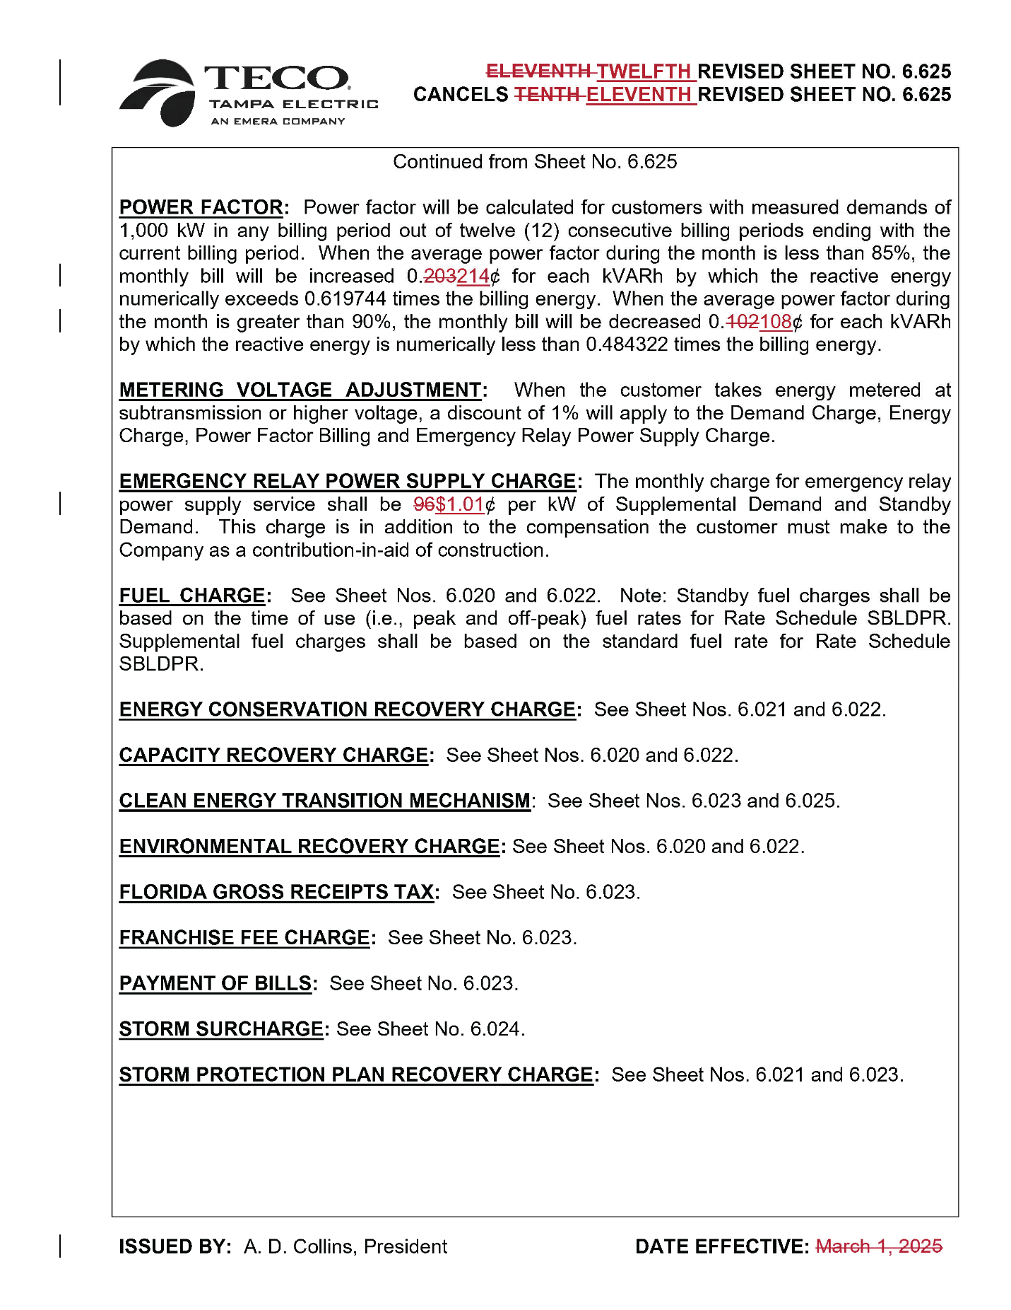

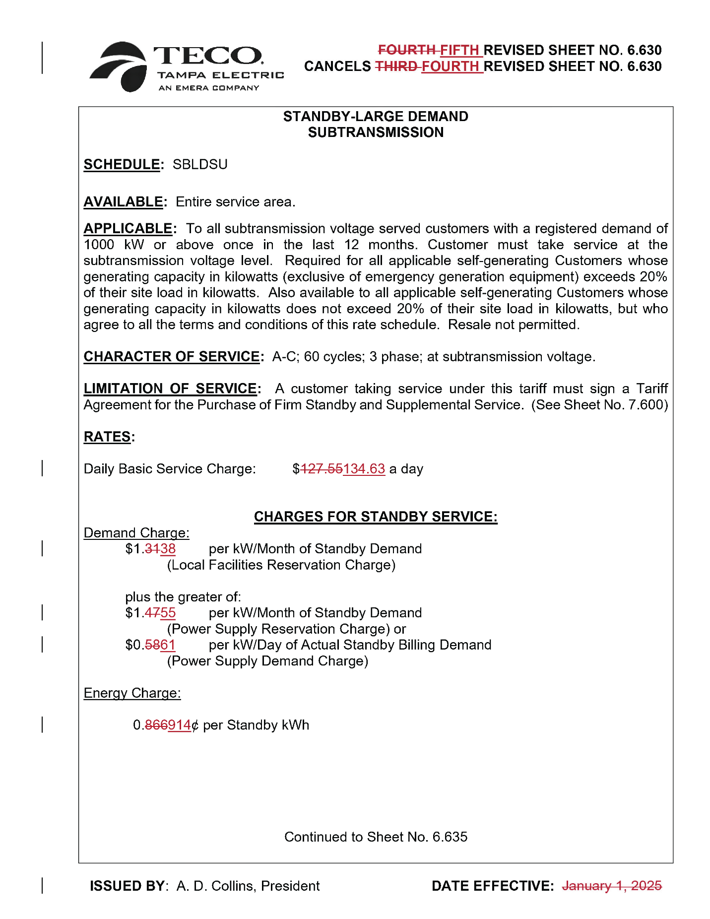

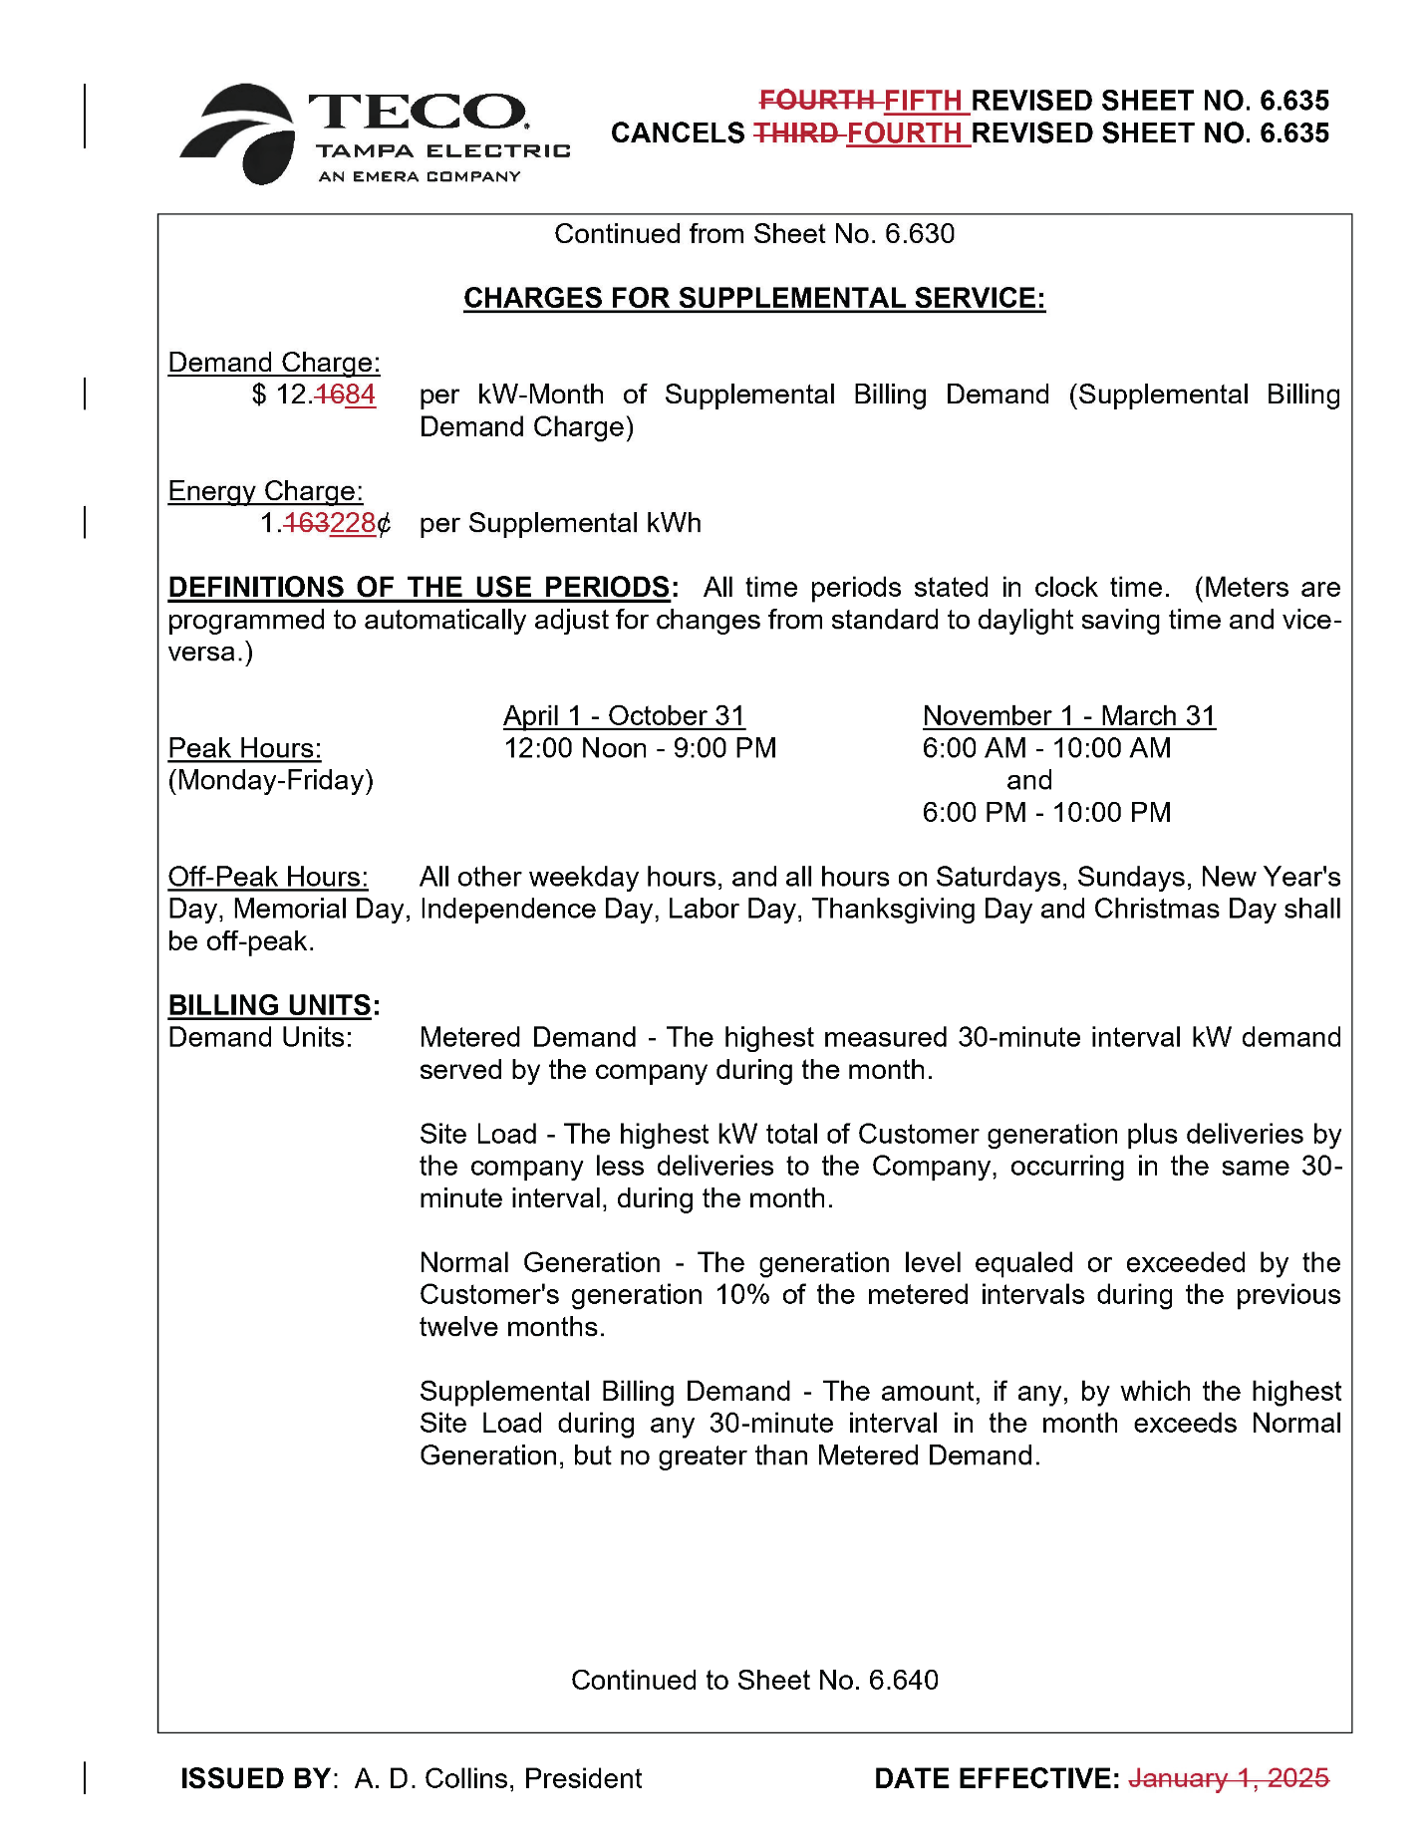

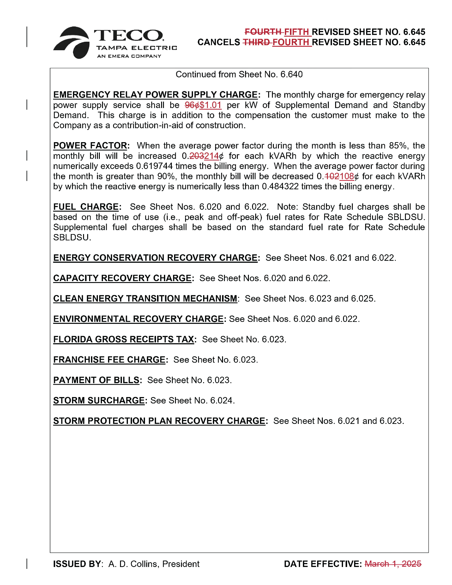

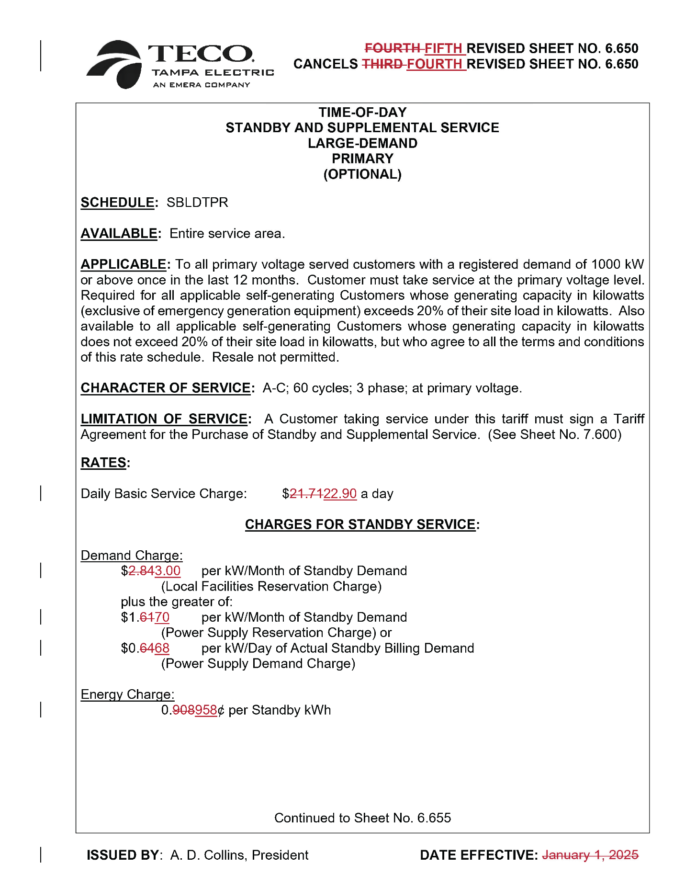

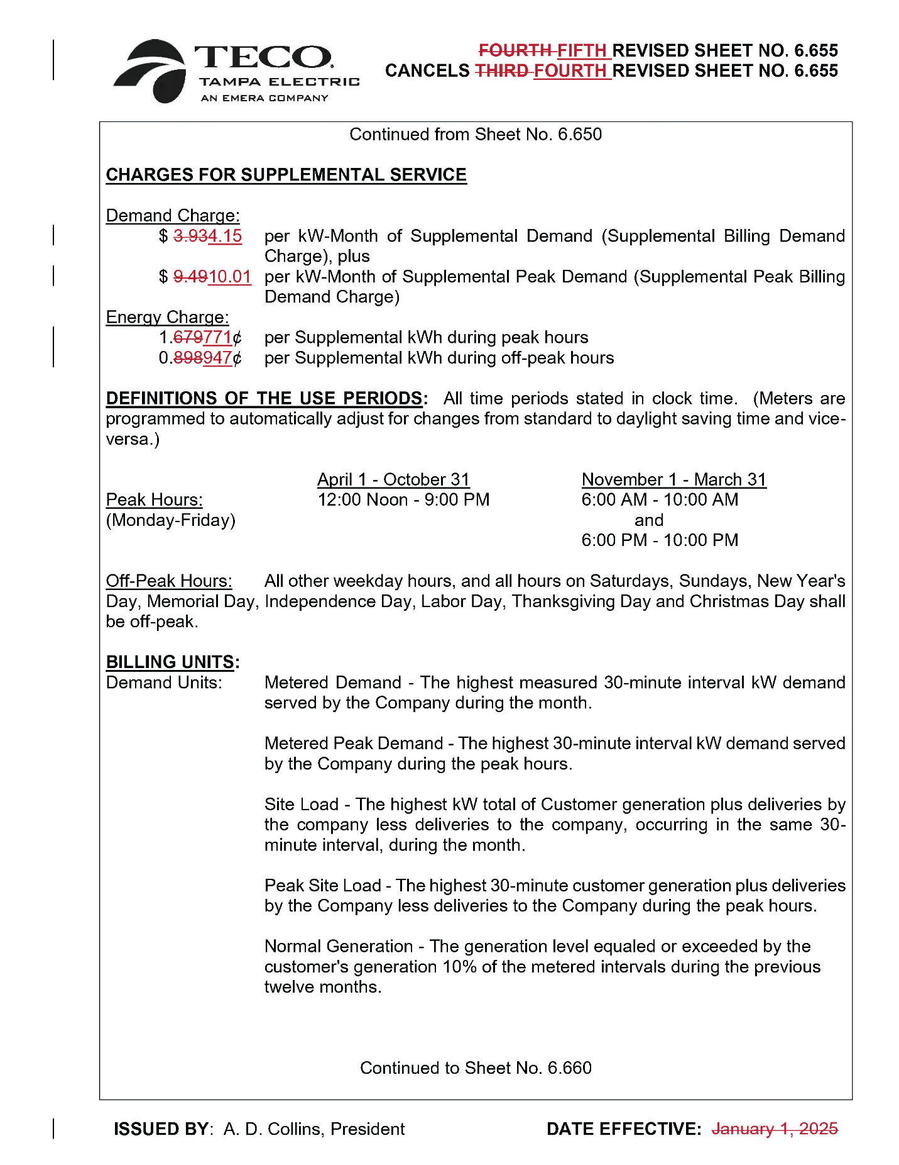

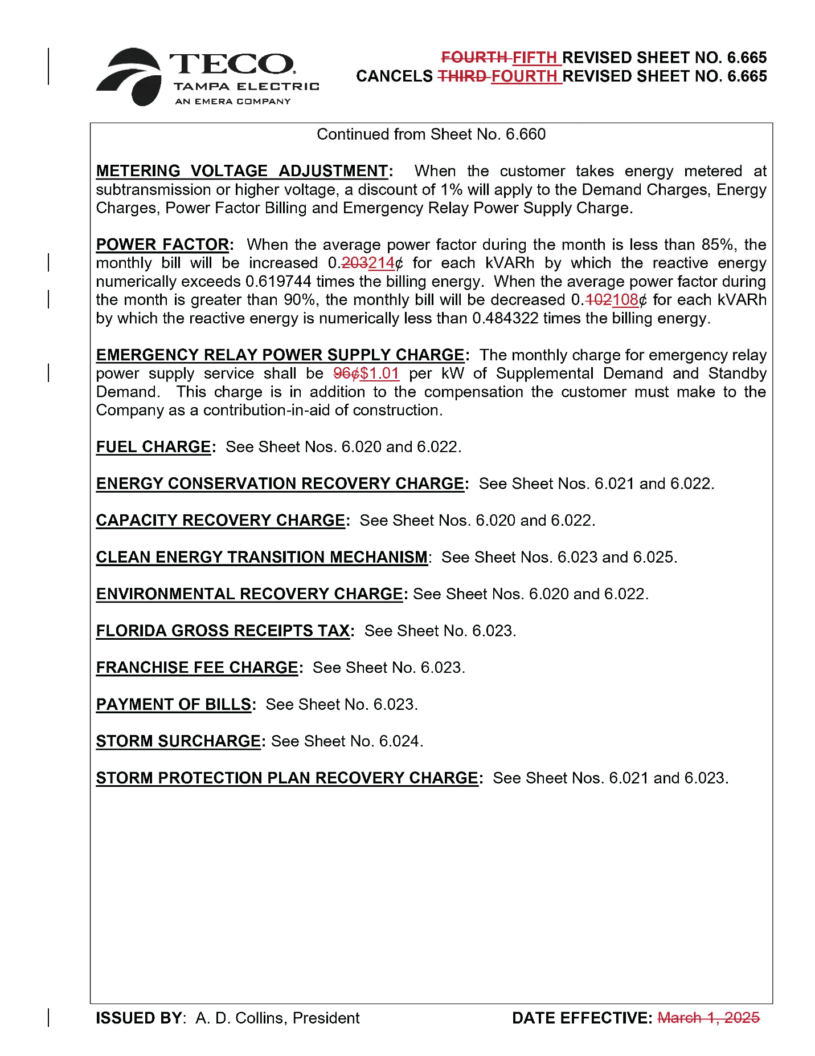

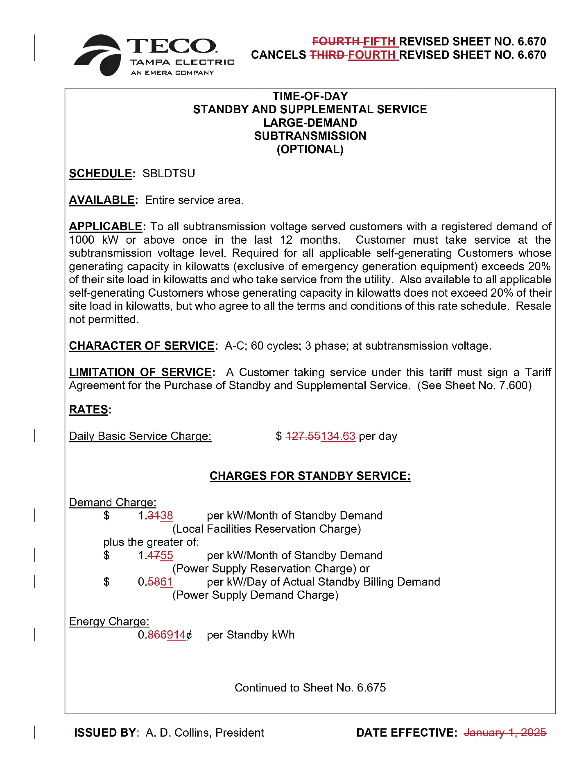

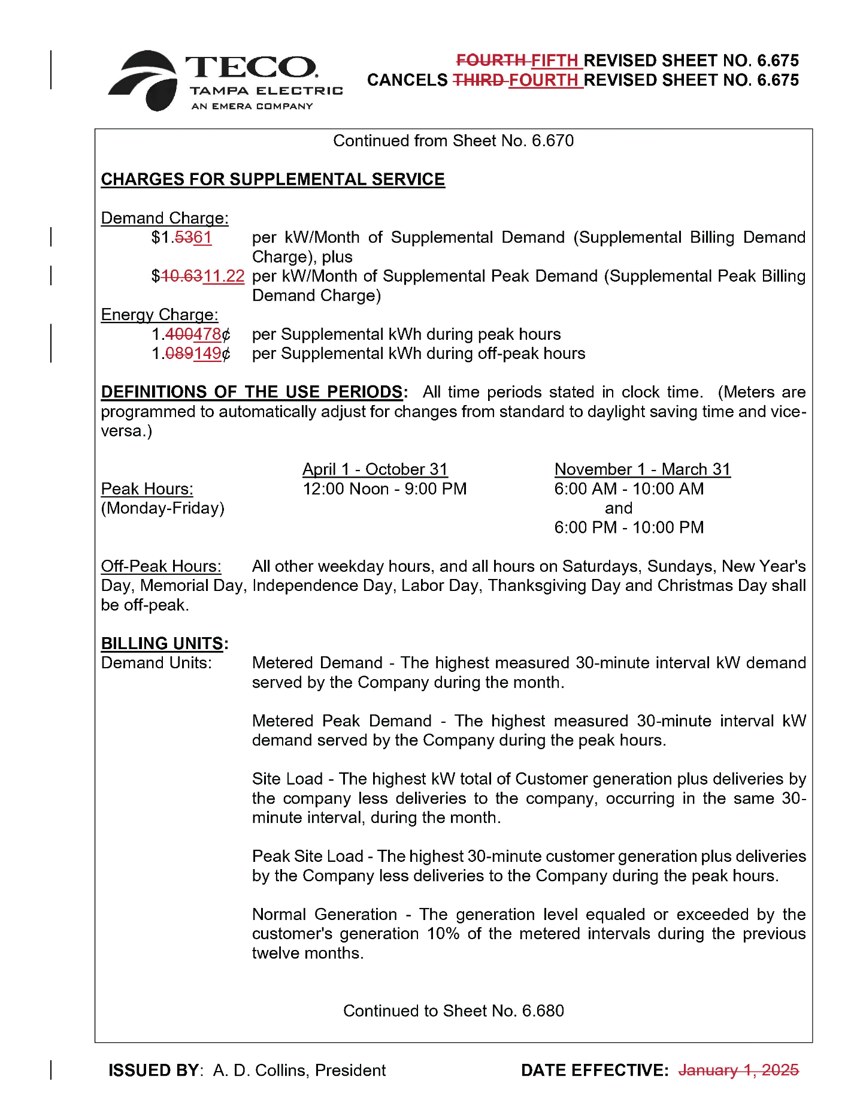

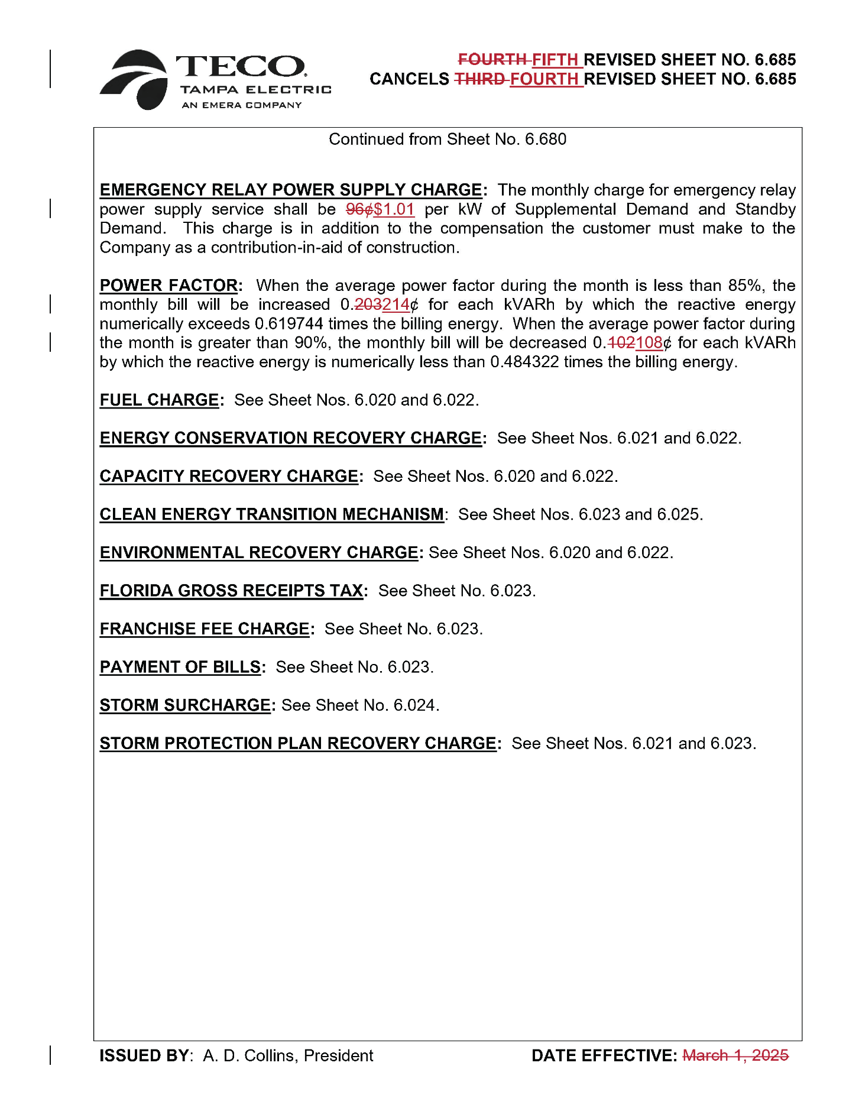

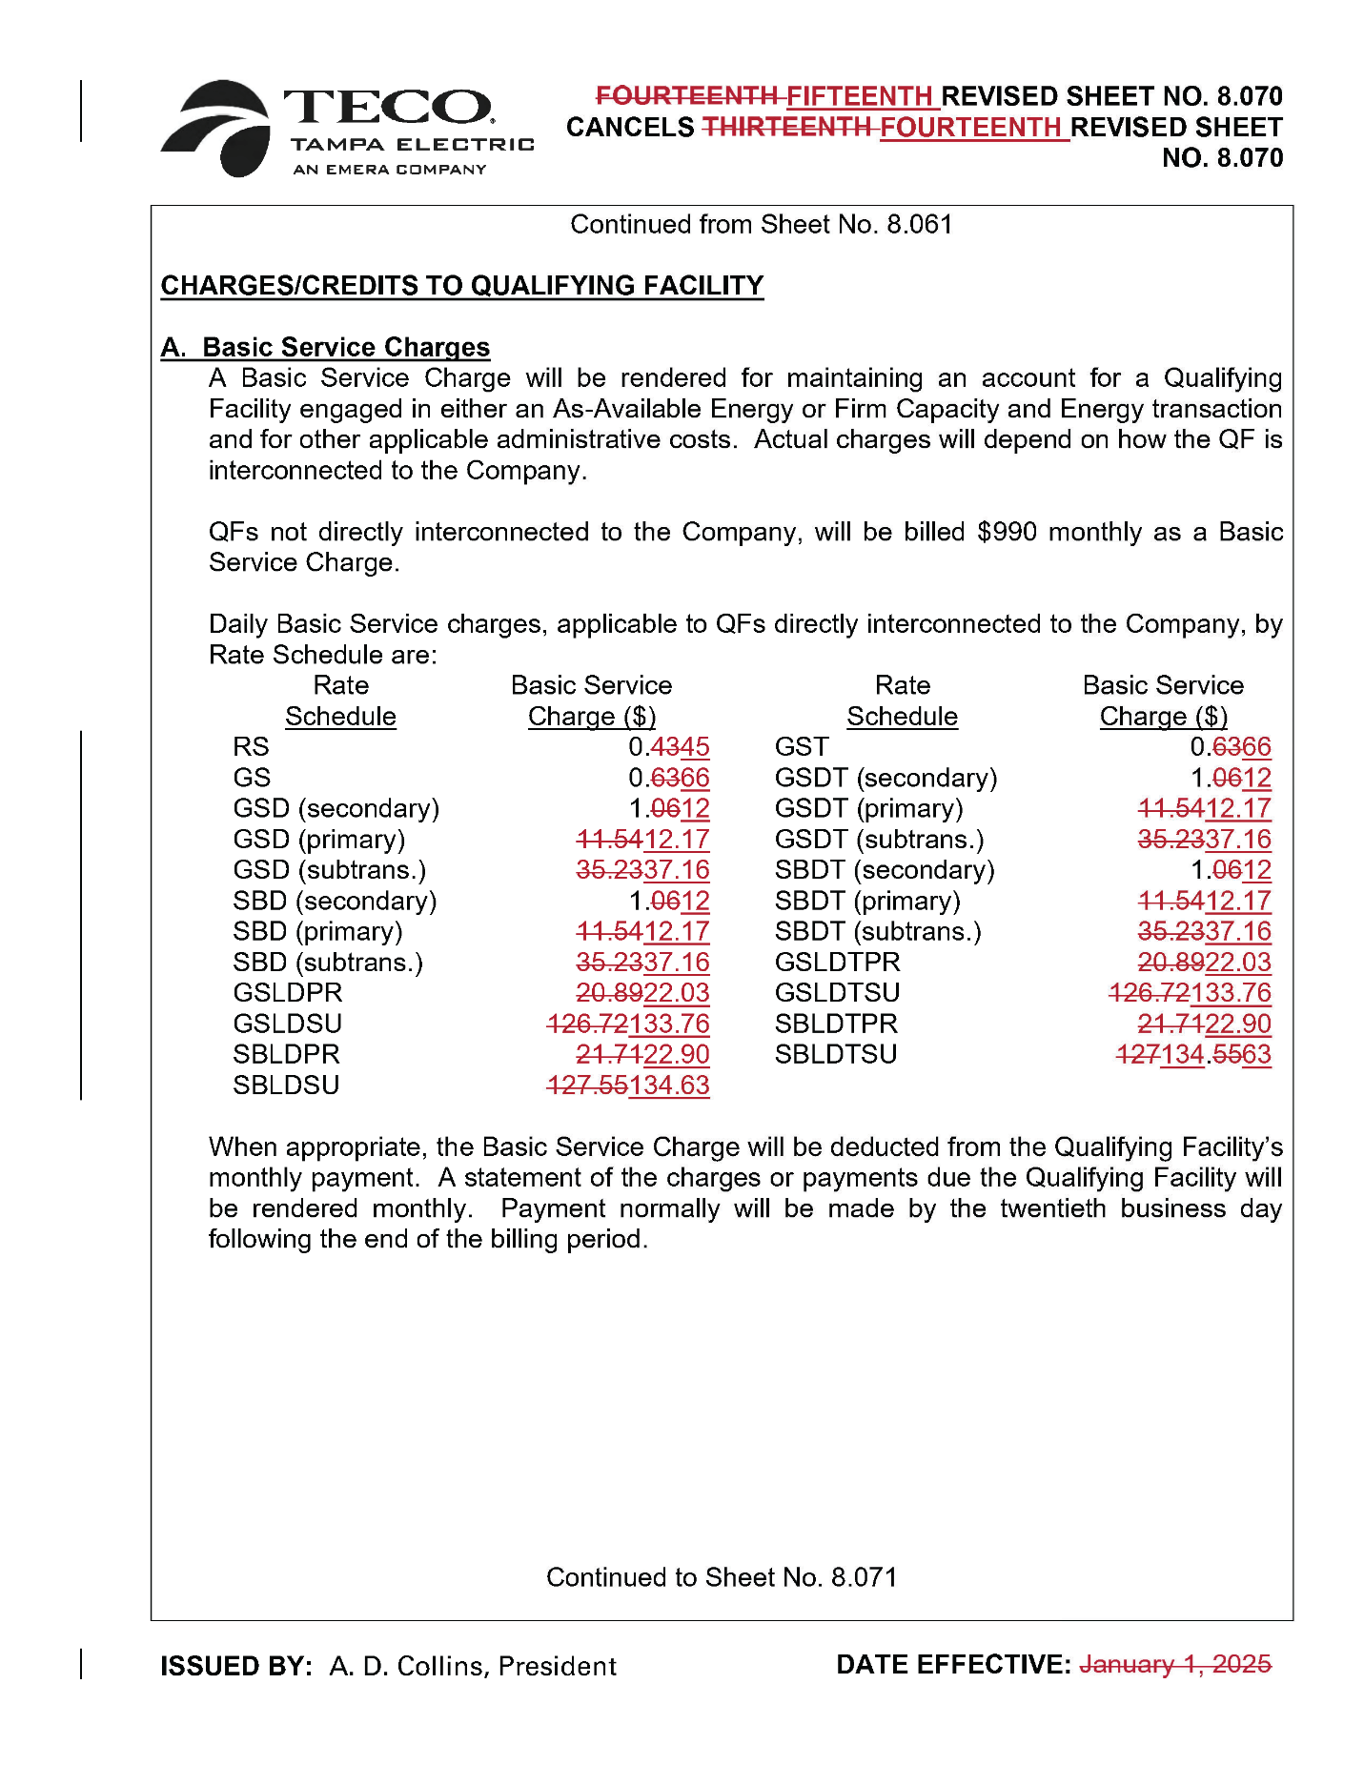

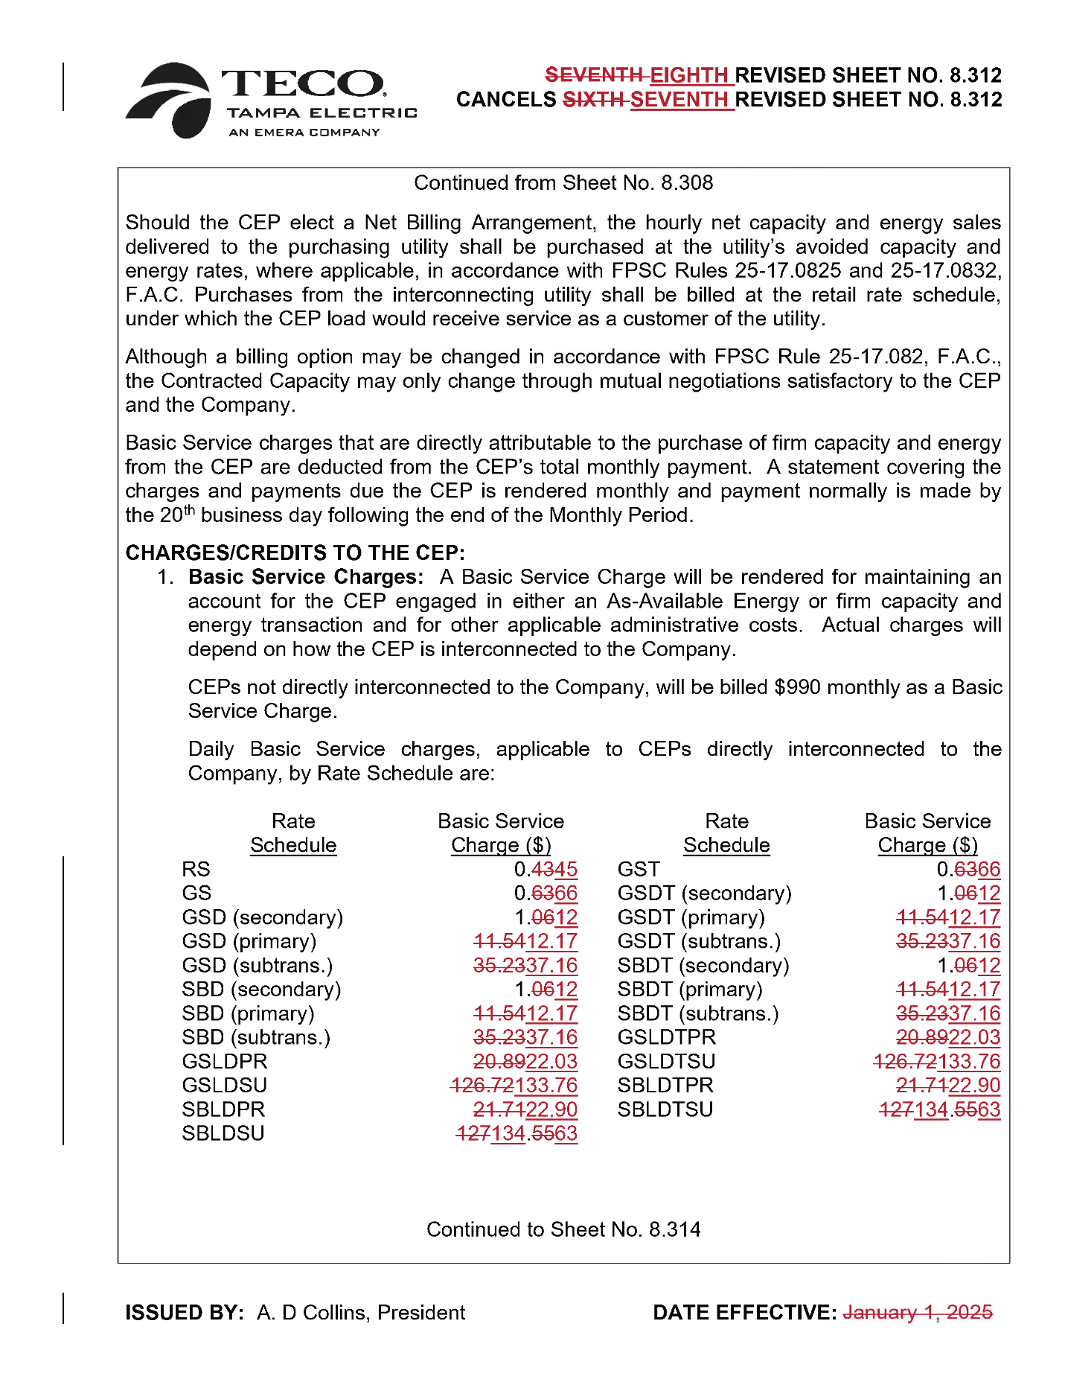

Order No. PSC-2025-0038-FOF-EI, issued February 3, 2025, in Docket No. 20240026-EI, In re: Petition for rate increase by Tampa Electric Company.
Id. at 167.
Order No. PSC-2025-0203-FOF-EI, issued June 11, 2025, in Docket No. 20240026-EI, In re: Petition for rate increase by Tampa Electric Company.
Id. at 15–17.

