BEFORE THE FLORIDA PUBLIC SERVICE COMMISSION

In re: Joint petition to modify tariffs to accommodate receipt and transport of renewable natural gas, by Florida Public Utilities Company, Florida Public Utilities - Indiantown Division, Florida Public Utilities - Fort Meade, and Florida Division of Chesapeake Utilities Corporation. | DOCKET NO. 20210088-GU  ORDER NO. PSC-2021-0374-TRF-GU  ISSUED: September 28, 2021

The following Commissioners participated in the disposition of this matter:

GARY F. CLARK, Chairman
ART GRAHAM
ANDREW GILES FAY
MIKE LA ROSA
GABRIELLA PASSIDOMO

ORDER APPROVING RENEWABLE NATURAL GAS SERVICE TARIFF

BY THE COMMISSION:

Background
Florida Public Utilities Company, Florida Public Utilities-Indiantown Division, Florida Public Utilities-Fort Meade, and Florida Division of Chesapeake Utilities Corporation (jointly, Companies) are local distribution companies subject to our jurisdiction pursuant to Chapter 366, Florida Statutes (F.S.). The Companies serve customers in 26 counties within Florida. On April 21, 2021, the Companies submitted a joint petition for a new Renewable Natural Gas Service (RNGS) tariff for biogas producers to allow the Companies to provide services for the purposes of converting biogas into usable Renewable Natural Gas (RNG) that meets pipeline quality gas standards. RNG is produced by cleaning and conditioning biogas in order to meet pipeline quality gas and heat standards, which can then be used interchangeably with natural gas within a gas distribution system.
We have approved similar RNG rate schedules for Peoples Gas System in Order No. PSC-2017-0497-TRF-GU and for Florida City Gas in Order No. PSC-2021-0040-TRF-GU. In 2020, the Companies received our approval to modify the quality of gas provisions in their tariff to allow for the receipt and transportation of RNG.
The proposed tariff modifications include the new RNGS tariff (tariff sheet Nos. 7.506-7.507) and certain other tariff revisions to include definitions of RNG. During the review of this petition, Commission staff issued two data requests for which responses were received on June 22, 2021 and July 23, 2021. On August 24, 2021, the Companies filed an amended tariff to include additional language concerning ratepayer protections and to correct a scriveners error in the availability provision. The proposed RNGS tariffs are included as Attachment A to the order.
By Order No. PSC-2021-0239-PCO-GU, issued on July 1, 2021, we suspended the proposed tariffs pursuant to the 60-day file and suspend provision in Section 366.06(3), F.S. We have jurisdiction over this matter pursuant to Sections 366.03, 366.04, 366.05, and 366.06, F.S.
Decision
The Companies stated in the petition that RNG captures methane from animal waste and other biomass sources that otherwise would have directly entered the atmosphere. When it is eventually combusted, the RNG releases significantly fewer greenhouse gas emissions. Without the collection of the biogas to be conditioned into RNG, the biogas produced would escape into the atmosphere or be burned off at the source with emissions from the burning process released into the atmosphere. Once conditioned, RNG can be interchangeable with conventional natural gas from other sources and can be used as a carbon neutral fuel source for a variety of applications by different types of customers. The Companies explained that not only can RNG be used for fuel and generation purposes, but also has the opportunity to encourage growth in the agriculture industry by providing a solution to waste management.

Proposed New RNGS Tariff
Under the proposal, a biogas-producing customer would enter into a mutually satisfactory RNG Service Agreement (agreement) with one of the Companies to construct and operate the RNG facilities on behalf of the customer. In the response to Commission staff’s first data request, the Companies stated that the estimated cost for biogas conditioning equipment and facility could range from $2 to $40 million for a single facility based on size and scope of the project. The tariff requires that all RNG be conditioned to meet the Companies’ pipeline quality gas and heat standards. This requirement would ensure that all RNG produced under the proposed tariff can be safely used without any adverse impact to the integrity of the customers’ and the Companies’ natural gas equipment.

The proposed RNGS tariff provides the terms and conditions under which the Companies may provide service to biogas producers who wish to convert their biogas into RNG. These services include upgrading and conditioning biogas to pipeline quality gas standards that can then be interconnected and injected for delivery onto the Companies’ distribution system. The terms of this agreement would include the design, location, quality specifications, operational requirements, and the required monthly service charge.
The monthly service charge would be designed to cover the costs of construction, operational costs, and carrying costs of the facilities that would allow the respective Company to collect a rate of return on the RNG facility investment. Under the tariff, ownership and title of the RNG remains with the customer and the customer is solely responsible for determining the end-user of the RNG. Should the Companies elect to purchase RNG from a biogas producer, the Companies and the customer would enter into an RNG commodity purchase agreement.

Impact on the General Body of Ratepayers
The Companies state that the RNGS tariff has essential safeguards that ensure that the contracting company’s general body of ratepayers would not subsidize the biogas customers taking service under the RNGS tariff. Specifically, the Companies stated that they would ensure that service taken under the proposed RNGS tariff would not affect any ratepayers by confirming the credit worthiness of the customers taking service under the tariff. In response to Commission staff’s second data request, the Companies stated that they would do sufficient due diligence to ensure that the non-participants are not at risk by requiring RNGS customers to provide one of the following options: (a) a guarantor to secure payment of bills, (b) an irrevocable letter of credit from a bank equal to two months average bills, (c) a surety bond equal to two months average bills, or (d) pay a cash deposit.
In the event of default, the Companies stated that they would discontinue service, terminate the contract, and start all remedies that are provided in the service agreement. This may include applying any deposit paid to the customer’s account, seeking payment from a guarantor to cover the outstanding balance, and pursuing legal or equitable claims against the defaulting customer. In response to staff’s second data request, the Companies modified the proposed tariff on August 24, 2021, to incorporate language on tariff sheet No. 7.507 (last paragraph) emphasizing that the tariff would not cause any additional costs to non-participants.
We hereby approve of this petition based, in part, on the Companies’ assertion that they would implement a thorough and reasonable process to evaluate the credit worthiness of a potential customer to be served under the RNGS tariff. Based on this process, the Companies do not anticipate any cost impact to the general body of ratepayers.

Conclusion
We hereby approve the Companies’ proposed new RNGS rate schedule and associated tariff modifications effective September 8, 2021. The RNGS rate schedule would furnish the Companies with an opportunity to provide biogas cleaning and conditioning services to interested customers. The Companies demonstrated a reasonable approach to implementing the proposed tariff. A participating customer would enter into an agreement with the respective Company and all capital and operating costs associated with the biogas upgrading and conditioning service would be borne by the customer over the life of the contract.

Based on the foregoing, it is

ORDERED by the Florida Public Service Commission that the new Renewable Natural Gas Service rate schedule and associated tariff modifications proposed by Florida Public Utilities Company, Florida Public Utilities Company-Indiantown Division, Florida Public Utilities Company-Fort Meade, and the Florida Division of Chesapeake Utilities Corporation are hereby approved, effective September 8, 2021. It is further

ORDERED that if a protest is filed within 21 days of issuance of the Order, the tariff shall remain in effect with any charges held subject to refund pending resolution of the protest. It is further

ORDERED that if no timely protest is filed, this docket shall be closed upon the issuance of a Consummating Order.

By ORDER of the Florida Public Service Commission this 28th day of September, 2021.

/s/ Adam J. Teitzman
ADAM J. TEITZMAN
Commission Clerk
Florida Public Service Commission
2540 Shumard Oak Boulevard
Tallahassee, Florida 32399
(850) 413-6770
www.floridapsc.com

Copies furnished: A copy of this document is provided to the parties of record at the time of issuance and, if applicable, interested persons.

SFO

NOTICE OF FURTHER PROCEEDINGS

The Florida Public Service Commission is required by Section 120.569(1), Florida Statutes, to notify parties of any administrative hearing or judicial review of Commission orders that is available under Sections 120.57 or 120.68, Florida Statutes, as well as the procedures and time limits that apply. This notice should not be construed to mean all requests for an administrative hearing or judicial review will be granted or result in the relief sought.

Mediation may be available on a case-by-case basis. If mediation is conducted, it does not affect a substantially interested person's right to a hearing.

The Commission's decision on this tariff is interim in nature and will become final, unless a person whose substantial interests are affected by the proposed action files a petition for a formal proceeding, in the form provided by Rule 28-106.201, Florida Administrative Code. This petition must be received by the Office of Commission Clerk, 2540 Shumard Oak Boulevard, Tallahassee, Florida 32399-0850, by the close of business on October 19, 2021.

In the absence of such a petition, this Order shall become final and effective upon the issuance of a Consummating Order.

Any objection or protest filed in this docket before the issuance date of this order is considered abandoned unless it satisfies the foregoing conditions and is renewed within the specified protest period.

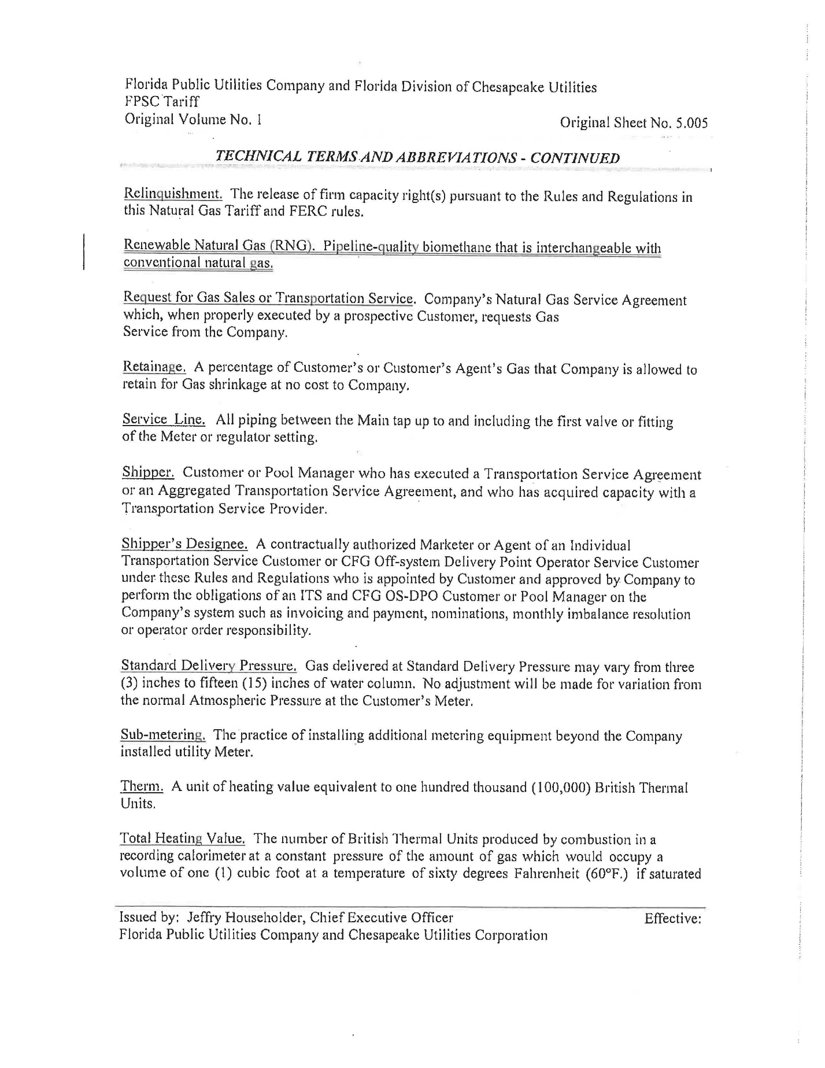

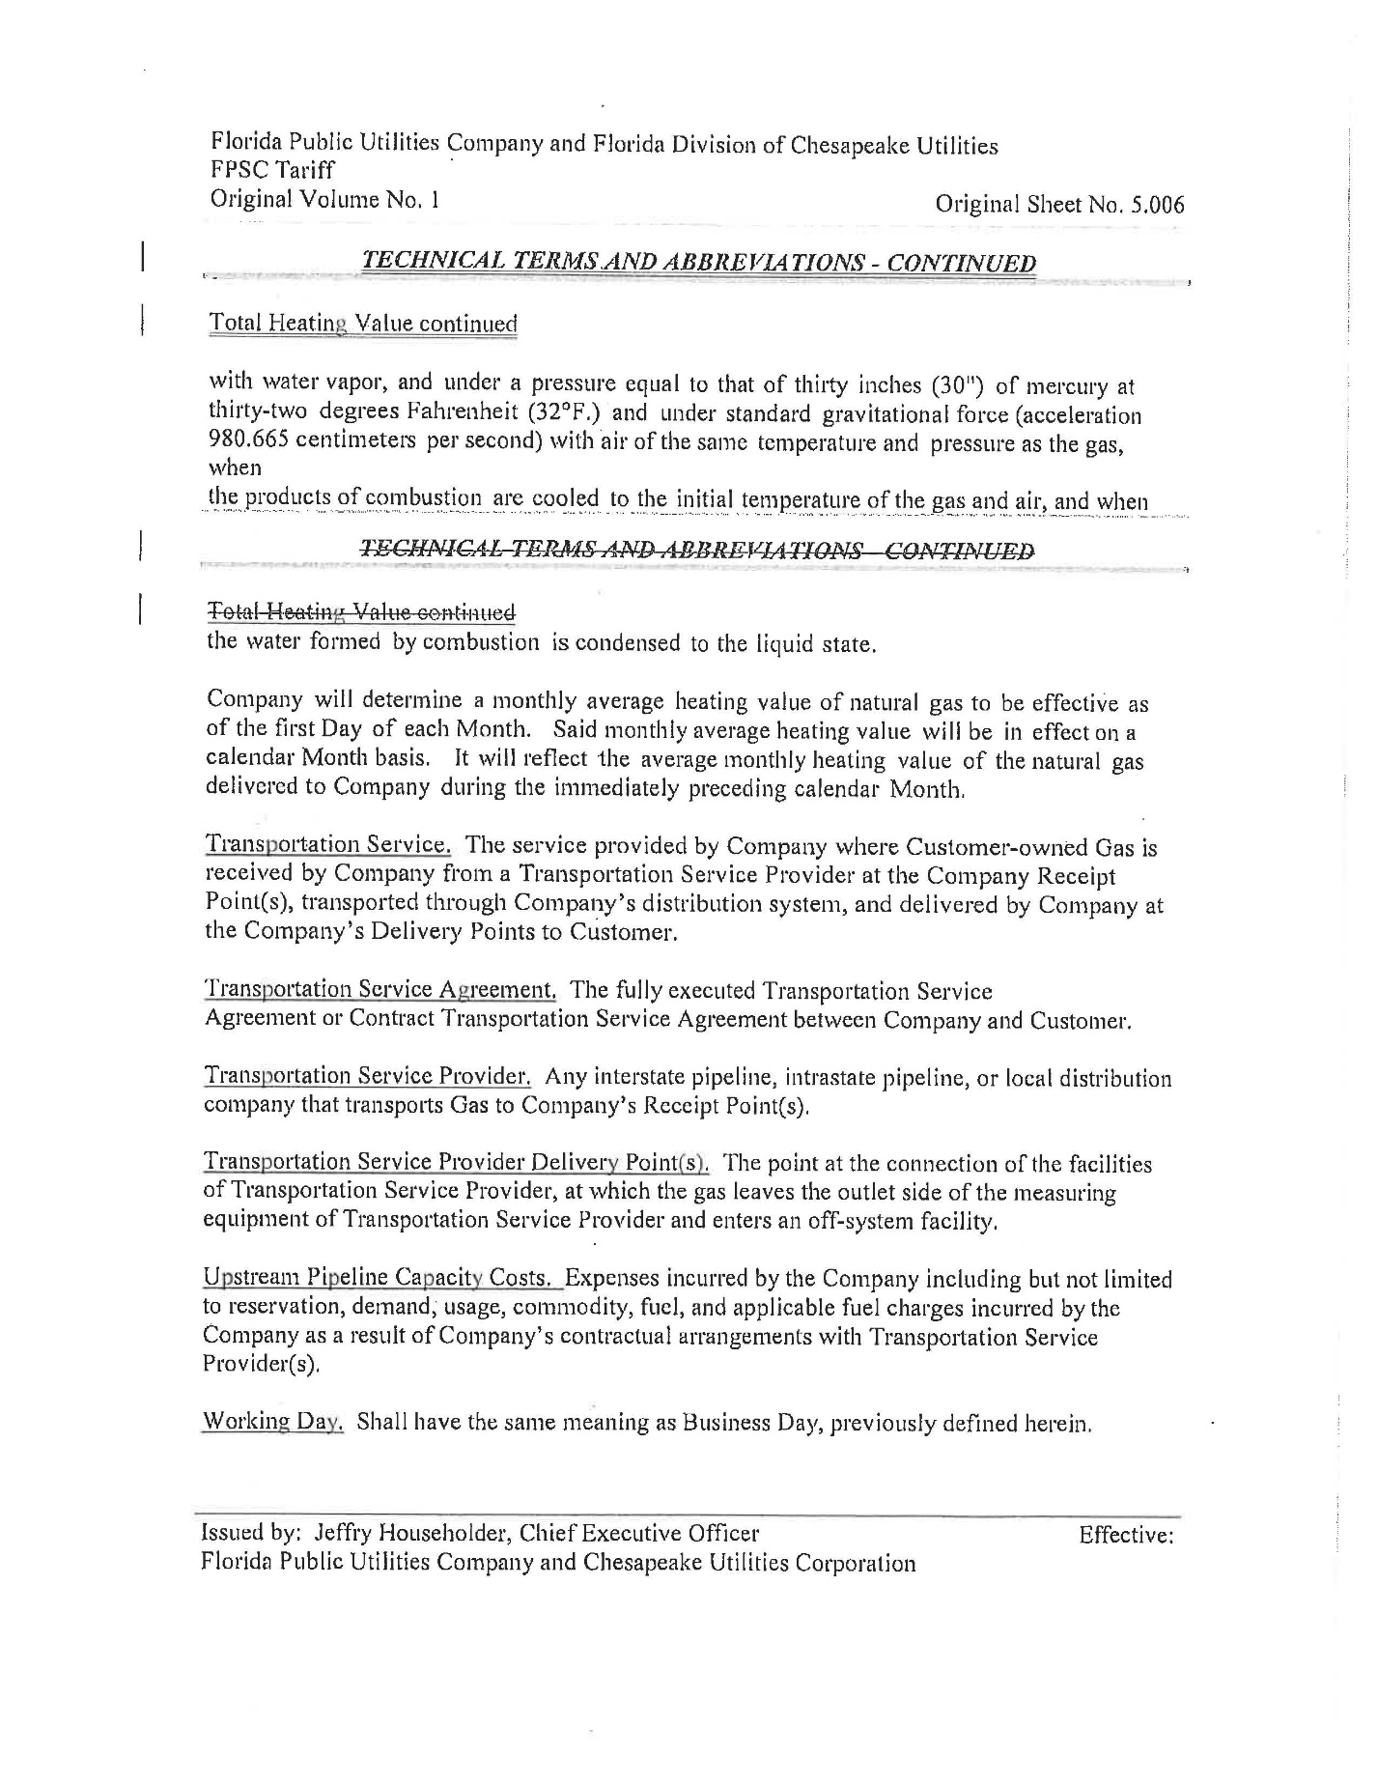

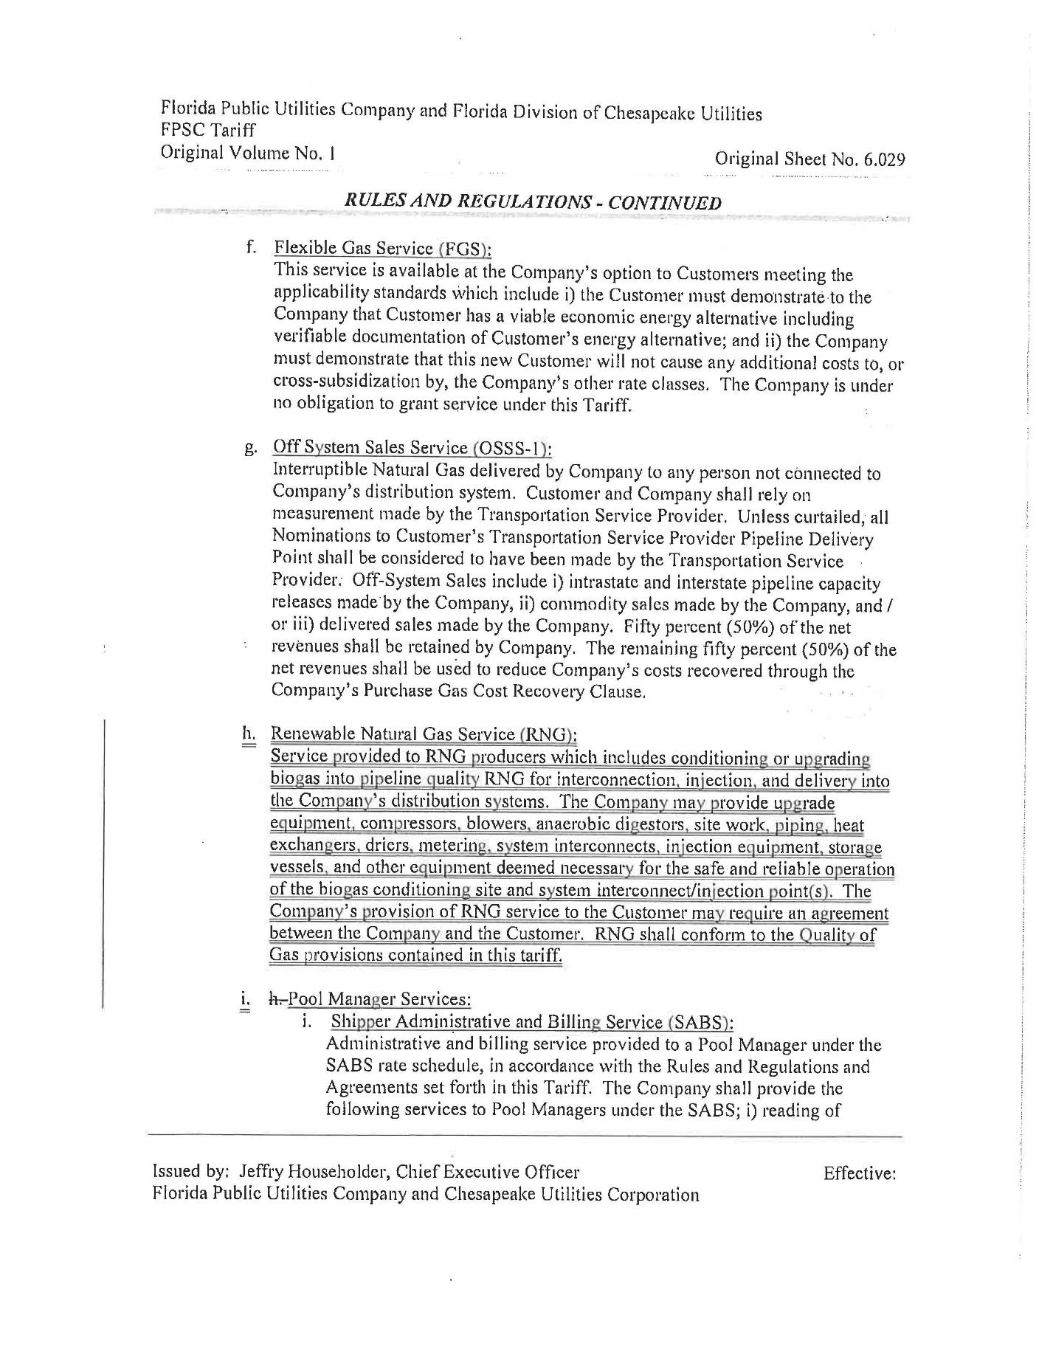

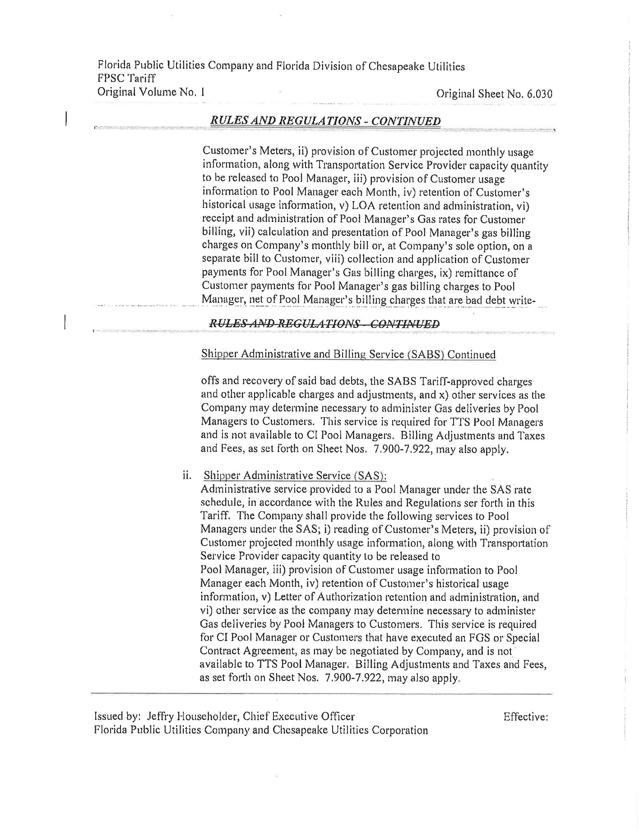

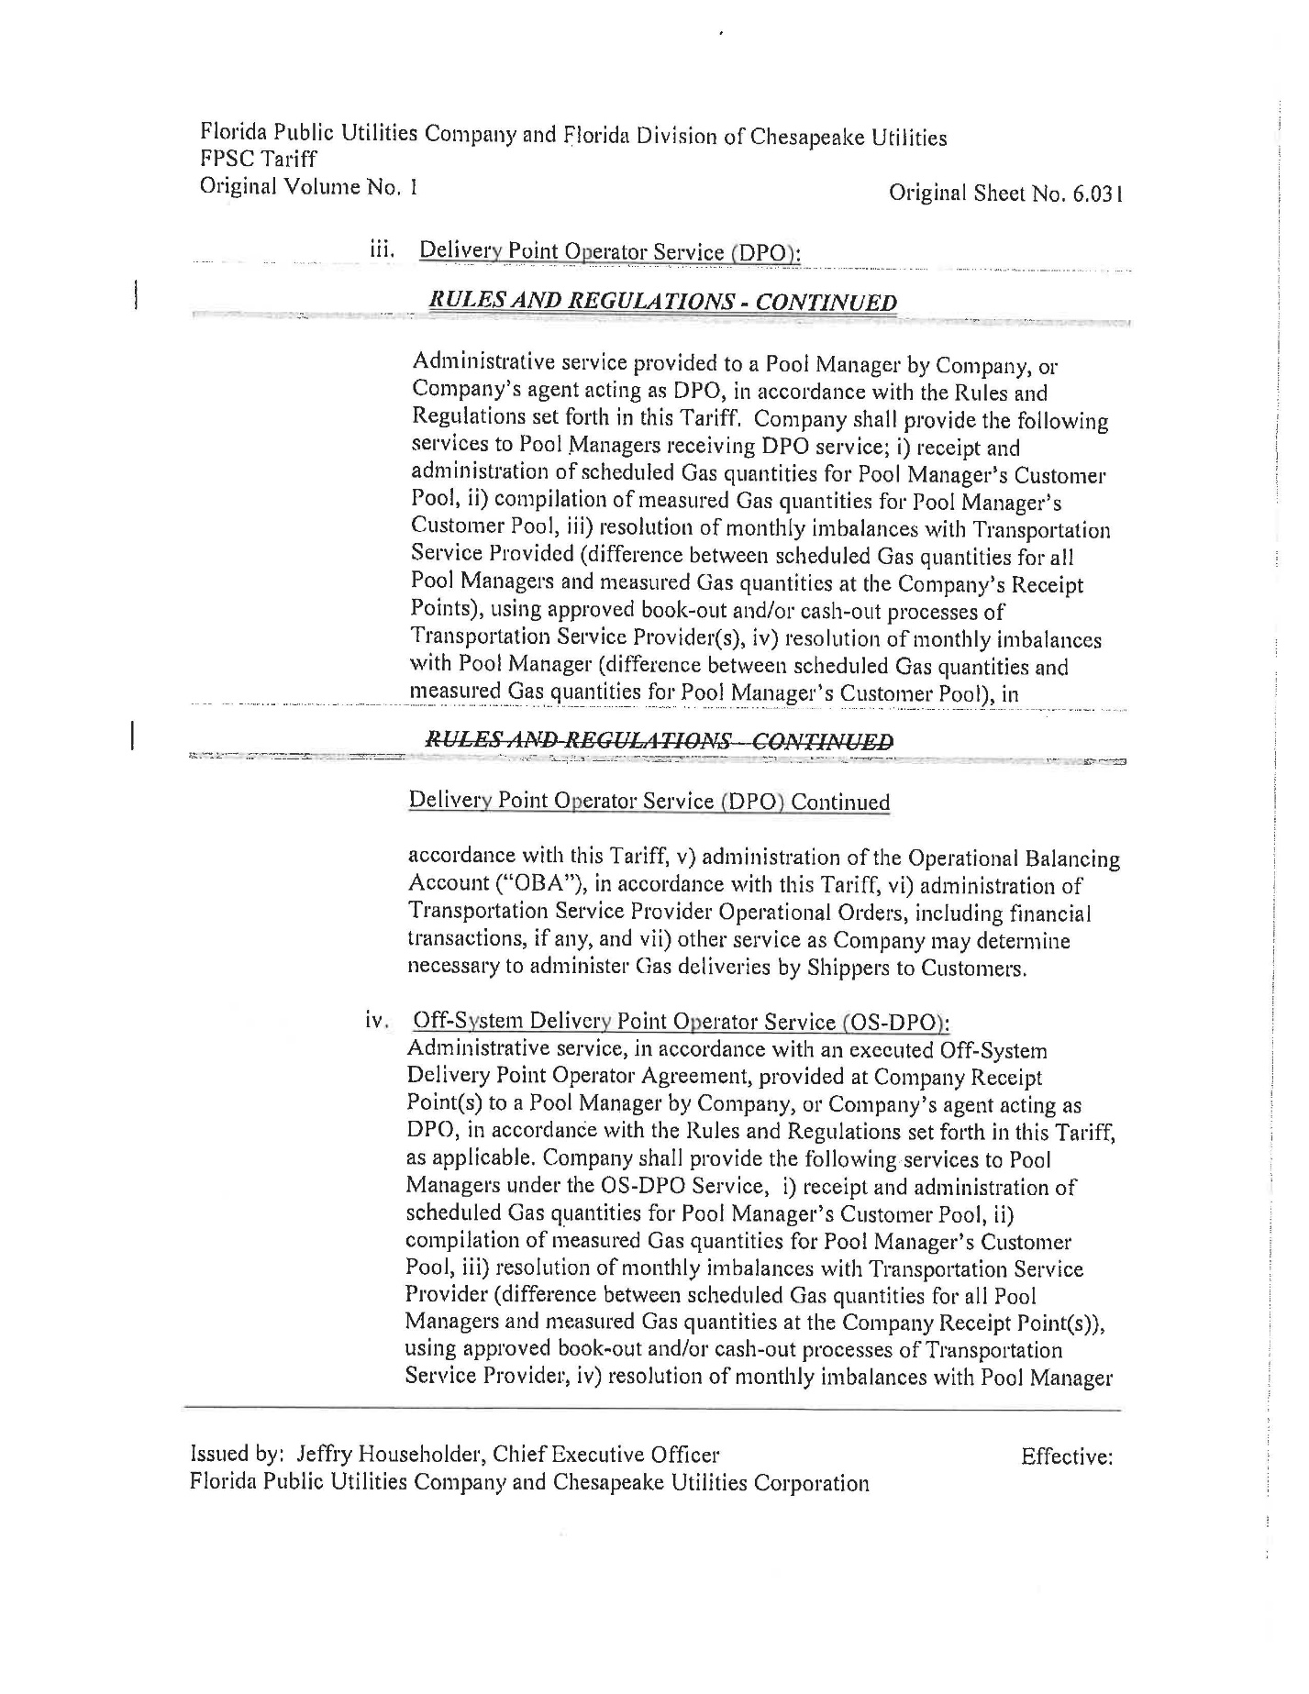

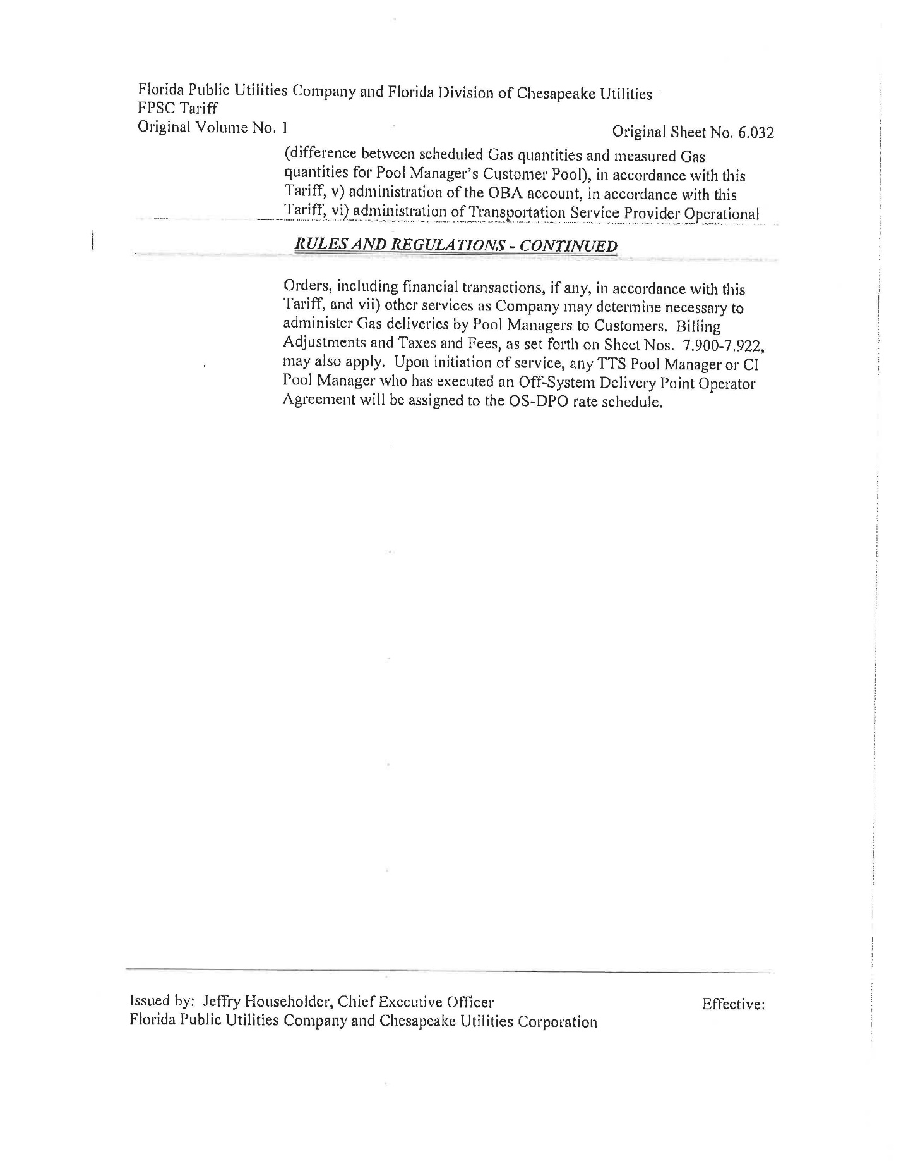

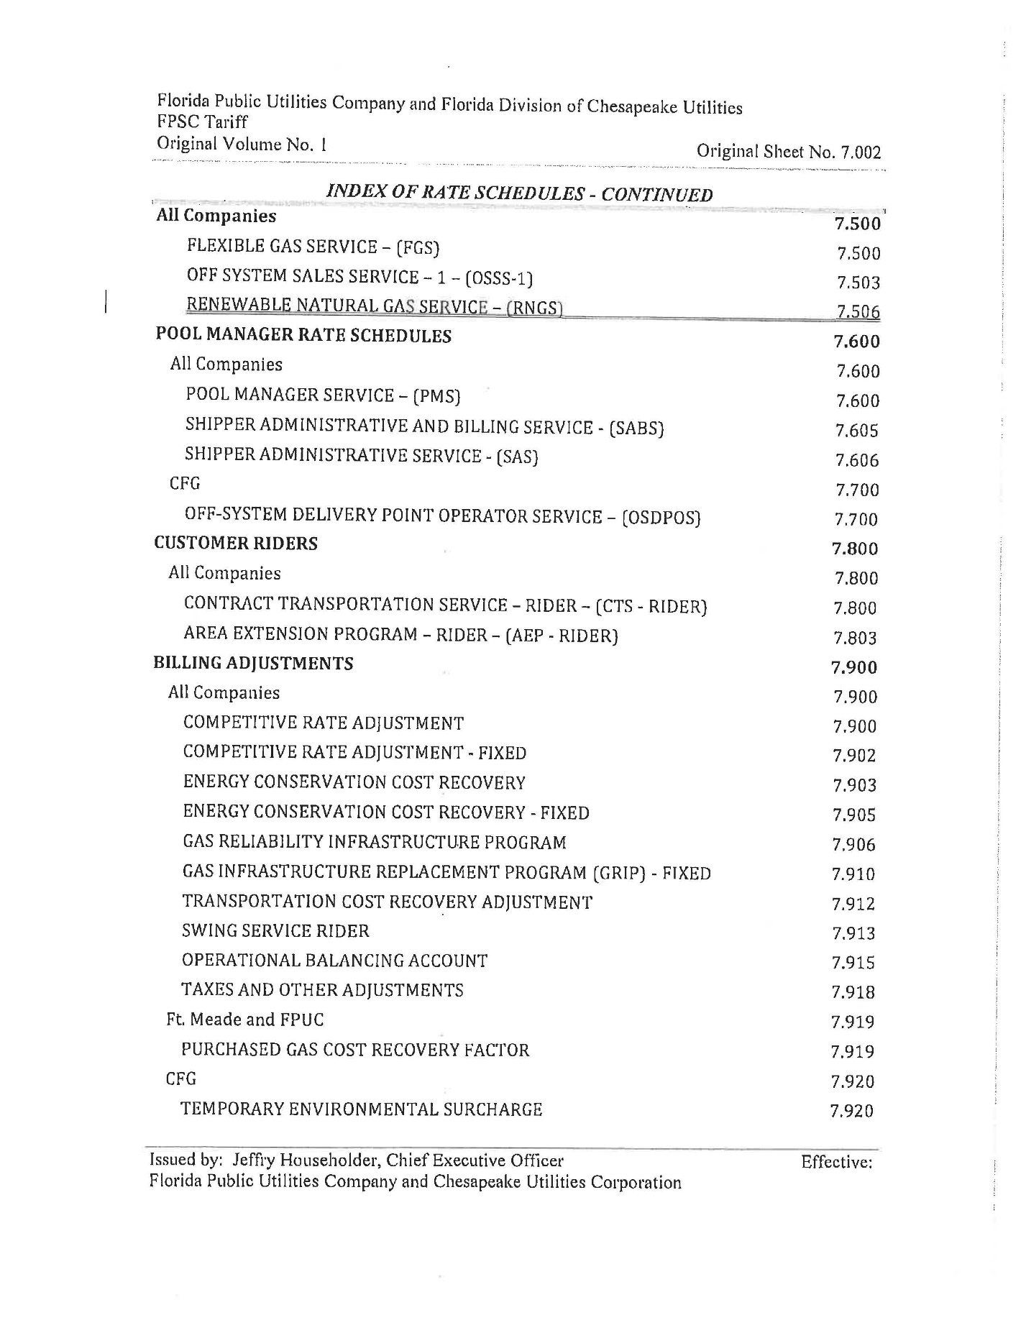

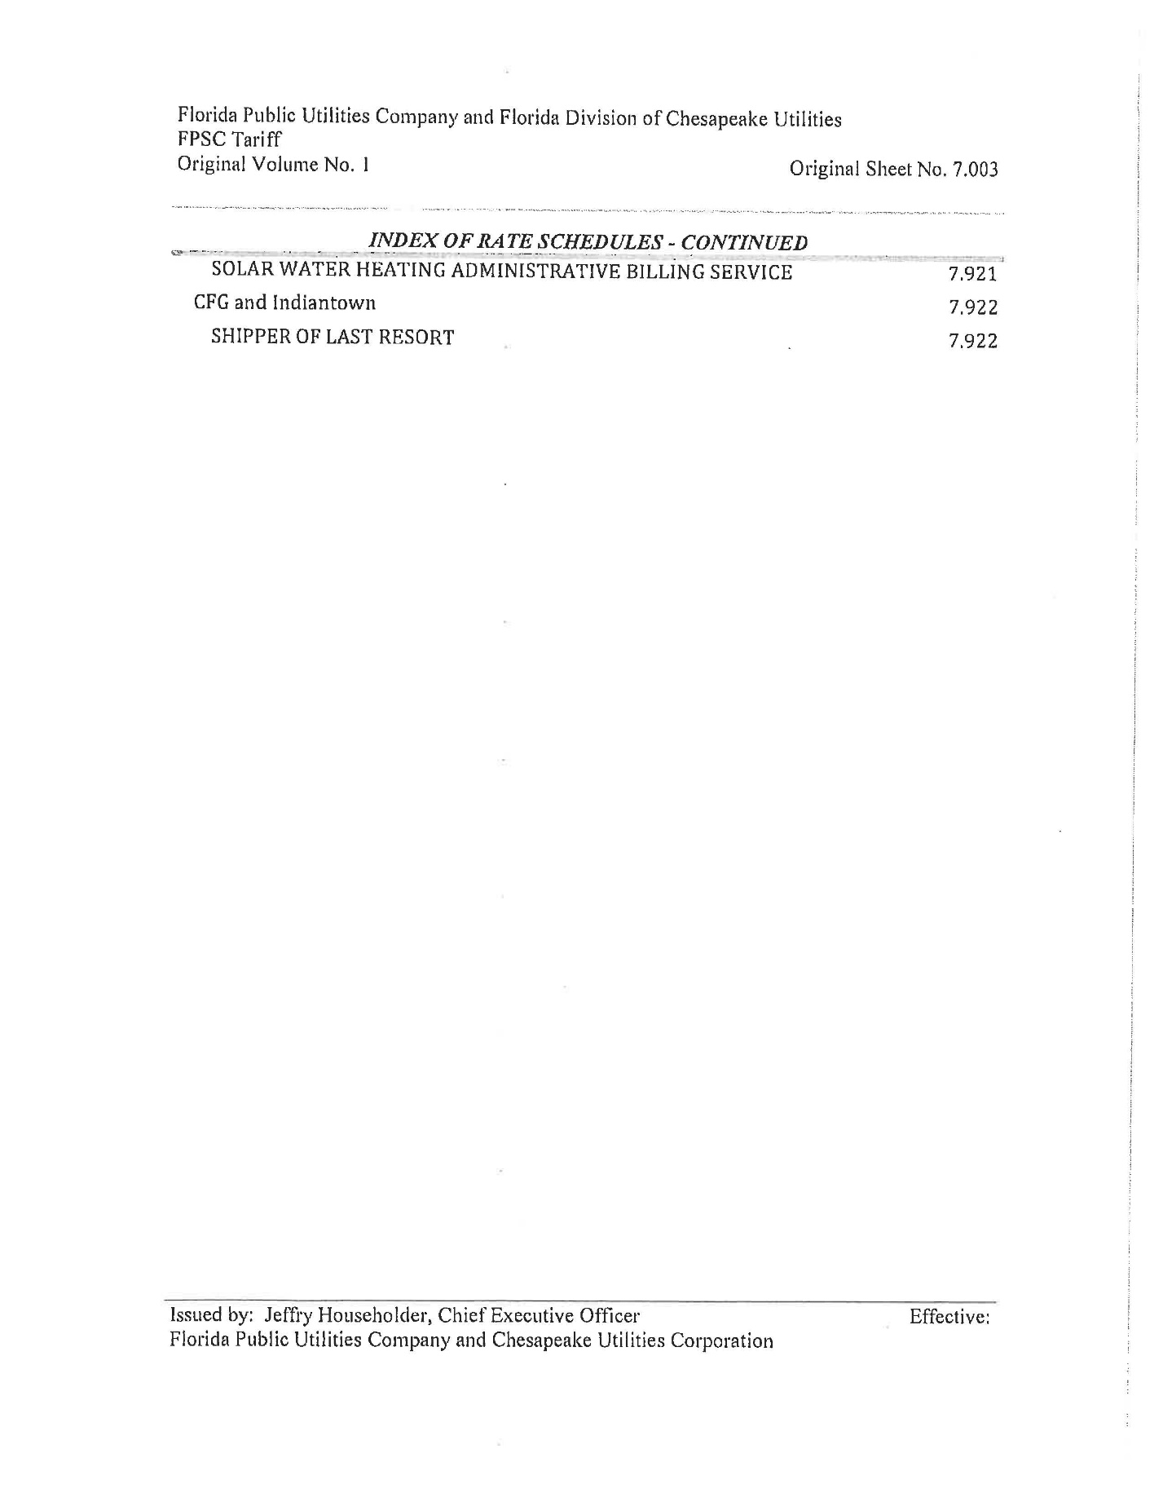

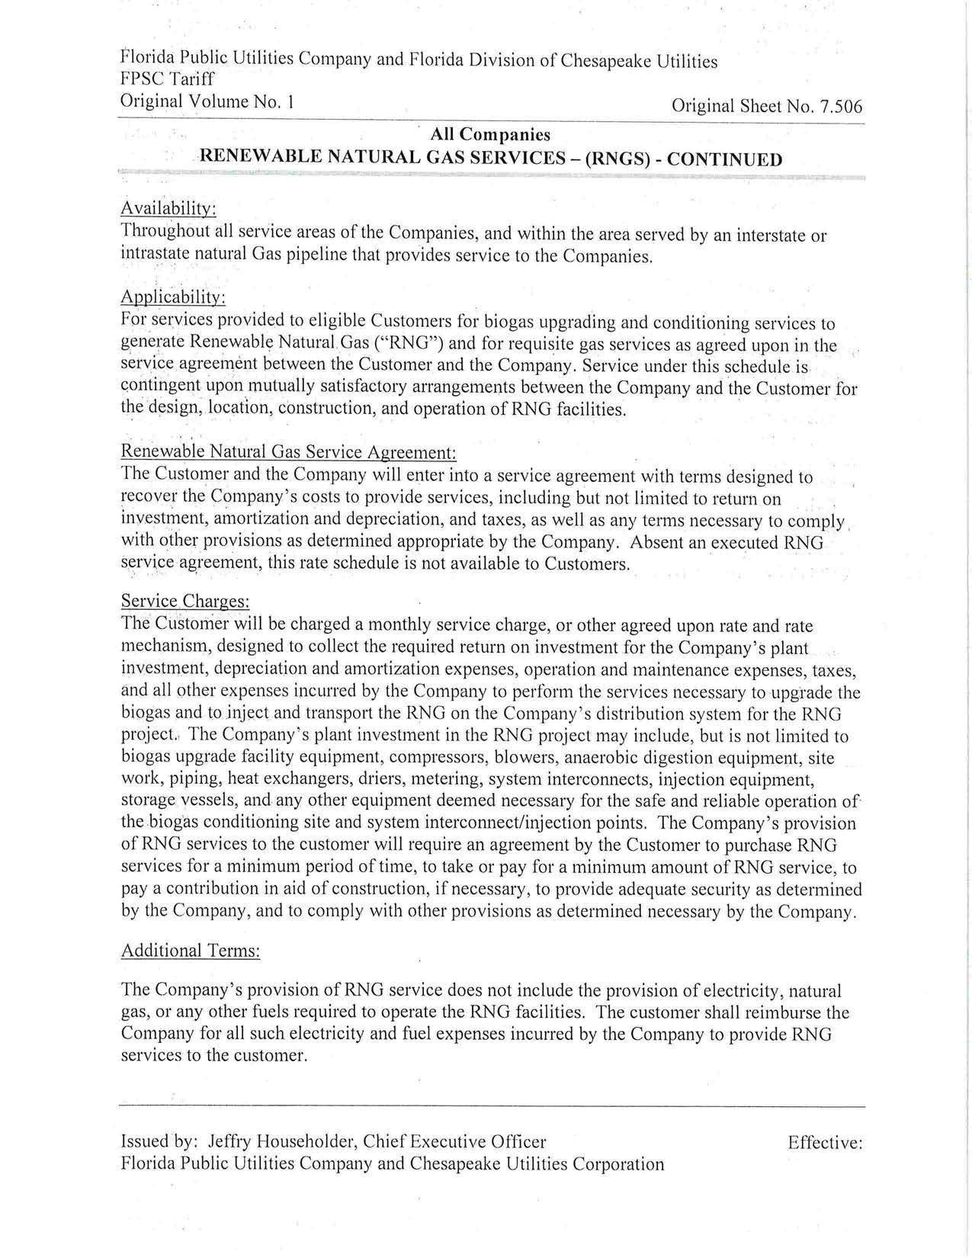

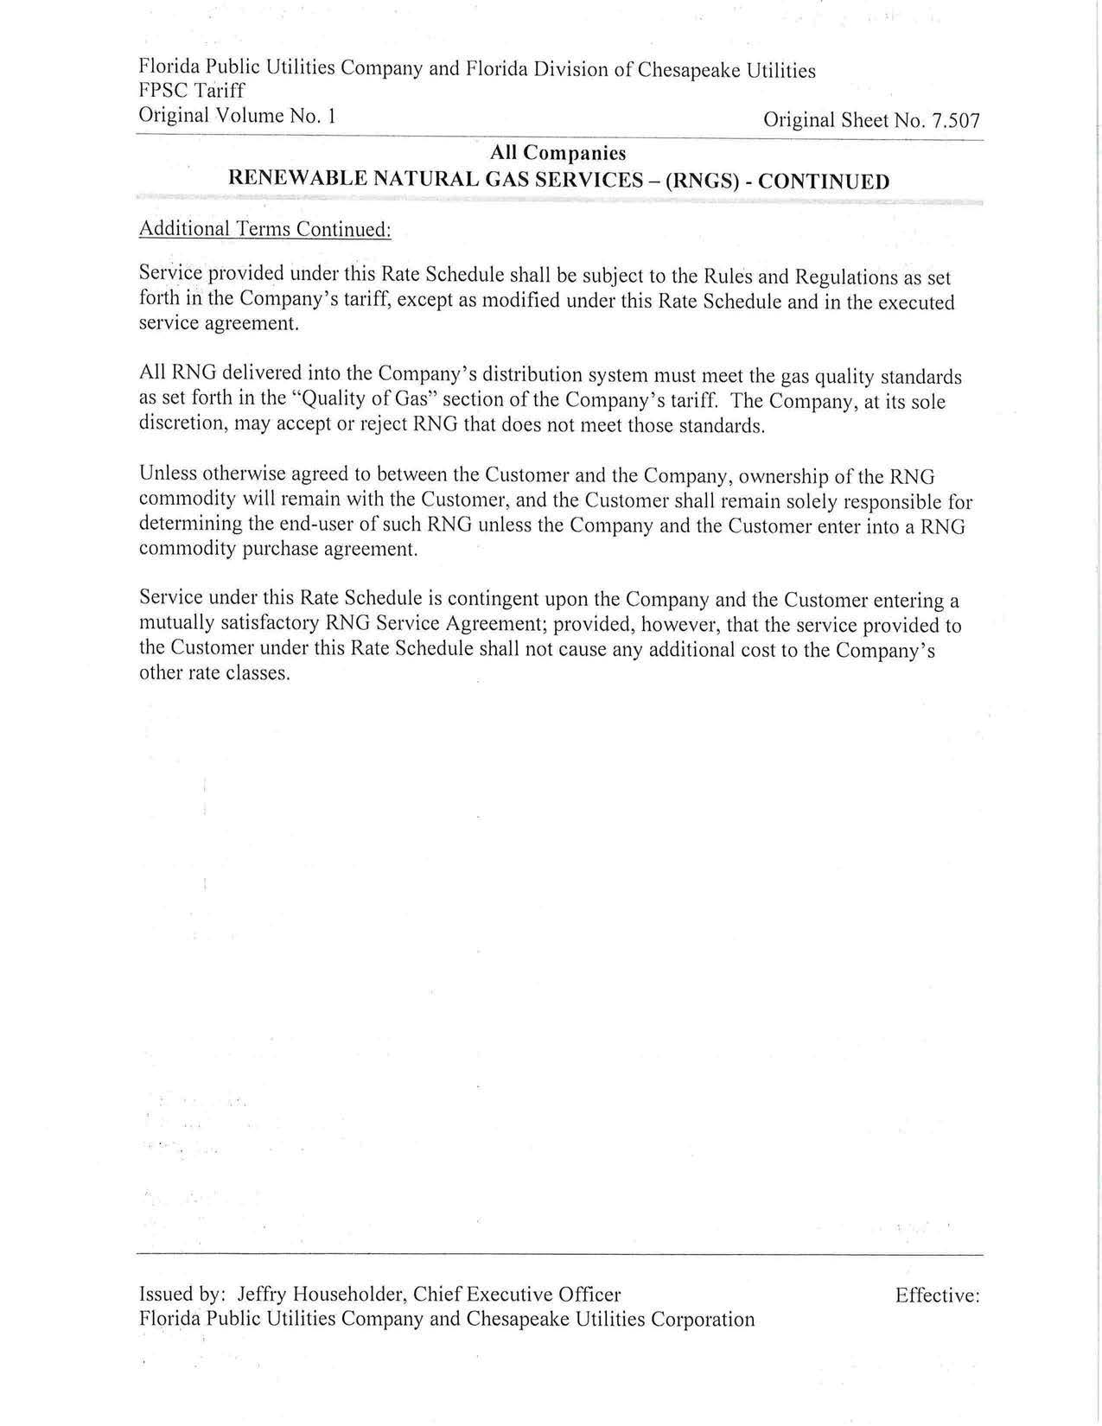

Biogas is described as raw, freshly emitted, and untreated gas, especially methane, produced by the breakdown of organic matter.
Order No. PSC-2017-0497-TRF-GU, issued December 29, 2017, in Docket No. 20170206-GU, In re: Petition for approval of tariff modifications to accommodate receipt and transportation of renewable natural gas from customers, by Peoples Gas System.
Order No. PSC-2021-0040-TRF-GU, issued January 25, 2021, in Docket No. 20200216-GU, In re: Request for approval of tariff modifications to accommodate receipt and transportation of renewable natural gas from customers, by Florida City Gas.
Order No. PSC-2020-0113-TRF-GU, issued April 20, 2020, in Docket No. 20200046-GU, In re: Petition to revise tariffs for Florida Public Utilities Company, Florida Public Utilities Company-Indiantown Division, Florida Public Utilities Company-Fort Meade, Florida Division of Chesapeake Utilities Corporation, and Peninsula Pipeline Company to update the description of gas quality and character of service.
Florida Public Utilities Company, Florida Public Utilities Company- Indiantown Division, Florida Public Utilities Company- Fort Meade, and the Florida Division of Chesapeake Utilities Corporation petition, Document No. 03632-2021.
Response to staff’s first data request No. 3, (Document No. 06659-2021).
Response to our second data request No. 1 (Document No. 08261-2021).

