|  |  |  |  |
| --- | --- | --- | --- |
| State of Florida  pscSEAL | | Public Service Commission  Capital Circle Office Center ● 2540 Shumard Oak Boulevard Tallahassee, Florida 32399-0850  -M-E-M-O-R-A-N-D-U-M- | |
| DATE: | May 21, 2025 | | |
| TO: | Office of Commission Clerk (Teitzman) | | |
| FROM: | Division of Economics (Hampson)  Office of the General Counsel (Dose) | | |
| RE: | Docket No. 20250042-GU – Petition for approval of amendment to transportation service agreement between Peninsula Pipeline Company, Inc. and Florida City Gas. | | |
| AGENDA: | 06/03/25 – Regular Agenda – Proposed Agency Action – Interested Persons May Participate | | |
| COMMISSIONERS ASSIGNED: | | | All Commissioners |
| PREHEARING OFFICER: | | | Clark |
| CRITICAL DATES: | | | None |
| SPECIAL INSTRUCTIONS: | | | None |

Case Background

On March 14, 2025, Peninsula Pipeline Company, Inc. (Peninsula) filed its petition for approval of an amendment to a transportation service agreement between Peninsula and Florida City Gas (FCG). Peninsula states that it has received notice of a mandatory relocation by the Florida Department of Transportation (FDOT) for a road enhancement project. Peninsula has been mandated to relocate approximately 6,000 feet of 6-inch steel gas pipeline from the public right of way in Indian River County. The proposed amendment to the transportation service agreement is a result of the mandatory relocation by FDOT.

Peninsula, a wholly owned subsidiary of Chesapeake Utilities Corporation (Chesapeake), operates as an intrastate natural gas transmission company as defined by Section 368.103(4), Florida Statutes (F.S.).[1] FCG is a local distribution company, and is also a wholly owned subsidiary of Chesapeake, subject to the regulatory jurisdiction of the Commission pursuant to Chapter 366, F.S. FCG provides natural gas service to residential, commercial, and industrial customers in Brevard, Indian River, and Miami-Dade Counties, and receives deliveries of natural gas to serve these customers over the interstate transmission pipelines owned by Florida Gas Transmission Company, LLC. The Parties are subsidiaries of Chesapeake, and agreements between affiliated companies must be approved by the Commission pursuant to Section 368.105, F.S.

In July 2024, the Commission approved Peninsula’s petition for approval of transportation service agreements between Peninsula and FCG.[2] As described on page 5 of the 2024 Order, the Indian River agreement also consolidated certain pre-existing agreements, which had been entered into before FCG was acquired by Chesapeake and therefore were not subject to the approval of the Commission. The pipeline segment FDOT has now required Peninsula to relocate was initially constructed pursuant to a 2012 agreement and was consolidated in the 2024 agreement, as discussed on page 5 of the 2024 Order.

During the evaluation of the petition, staff issued one data request to Peninsula, for which responses were received on April 28, 2025.[3] The proposed amendment to the transportation service agreement is included in the recommendation as Attachment A. This proposed amendment also includes Exhibits A, B, and C to the transportation service agreement. The Commission has jurisdiction over this matter pursuant to Sections 366.05(1), 366.06, and 368.105, F.S.

Discussion of Issues

Issue 1:

 Should the Commission approve the proposed amendment to the transportation service agreement between Peninsula and FCG, dated February 14, 2025?

Recommendation:

 Yes, the Commission should approve the proposed amendment to the transportation service agreement between Peninsula and FCG, dated February 14, 2025. The proposed Total Monthly Reservation Charge for Segment I, as shown on Exhibits A and C to the transportation service agreement, is reasonable and meets the requirements of Section 368.105, F.S. (Hampson)

Staff Analysis:

 Peninsula initially received notice from FDOT of the road enhancement project in Indian River County on May 24, 2024.[4] As described in Peninsula’s notice to FCG, this road enhancement project requires Peninsula to relocate approximately 6,000 feet of 6-inch steel gas pipeline from the public right of way. Peninsula stated that the relocation of the pipeline segment is expected to be completed by November 2025.[5] Section 4.3 of the 2024 transportation service agreement allows Peninsula to adjust the Monthly Reservation Charge to recover the cost of mandatory relocations of pipeline facilities.[6] Section 4.3 of the 2024 agreement states:

“If, at any time after the Execution Date and throughout the term of this Agreement, [Peninsula] is required by any Governmental Authority… asserting jurisdiction over this Agreement and the transportation of Gas hereunder, to incur additional capital expenditures with regard to the service provided by [Peninsula] under this Agreement… including, without limitation, mandated relocations of [Peninsula’s] pipeline facilities serving [FCG’s] facility…, then [FCG’s] Monthly Reservation Charge shall be adjusted and Exhibit A updated accordingly, and the new Monthly Reservation Charge shall be implemented immediately upon the effective date of such action, subject to Commission approval of the amendment.”

Peninsula states the revised monthly reservation charge in the proposed amendment is appropriately modified to include the incremental costs required to relocate the pipeline segment. Peninsula provided a breakdown of the incremental capital costs to be incurred in response to staff’s first data request.[7] In its response, Peninsula stated that the pipeline relocation would total approximately $3.1 million in capital costs, which includes $1.3 million in materials, supplies, and contingency, $940,000 in contractor labor, and $366,000 in inspections. Peninsula also provided in its responses the inputs used to calculate the incremental monthly reservation charge, which includes interest expense and return on equity, book depreciation, incremental operations and maintenance, and tax expense associated with the capital costs.

In addition to the revised Monthly Reservation Charge on Exhibits A and C to the agreement, Peninsula has also updated Exhibit B to include Pivotal Utility Holding, Inc. to Florida City Gas’s name in the title. No other modifications to Exhibit B have been proposed.

Conclusion

Based on the information provided in the petition and Peninsula’s responses to data requests, staff recommends the Commission should approve the proposed amendment to the transportation service agreement between Peninsula and FCG, dated February 14, 2025. The proposed Total Monthly Reservation Charge for Segment I, as shown on Exhibits A and C to the transportation service agreement, is reasonable and meets the requirements of Section 368.105, F.S.

Issue 2:

 Should this docket be closed?

Recommendation:

 Yes. If no protest is filled by a person whose substantial interest are affected within 21 days of the issuance of the Order, this docket should be closed upon the issuance of a Consummating Order. (Dose)

Staff Analysis:

 If no protest is filled by a person whose substantial interest are affected within 21 days of the issuance of the Order, this docket should be closed upon the issuance of a Consummating Order.

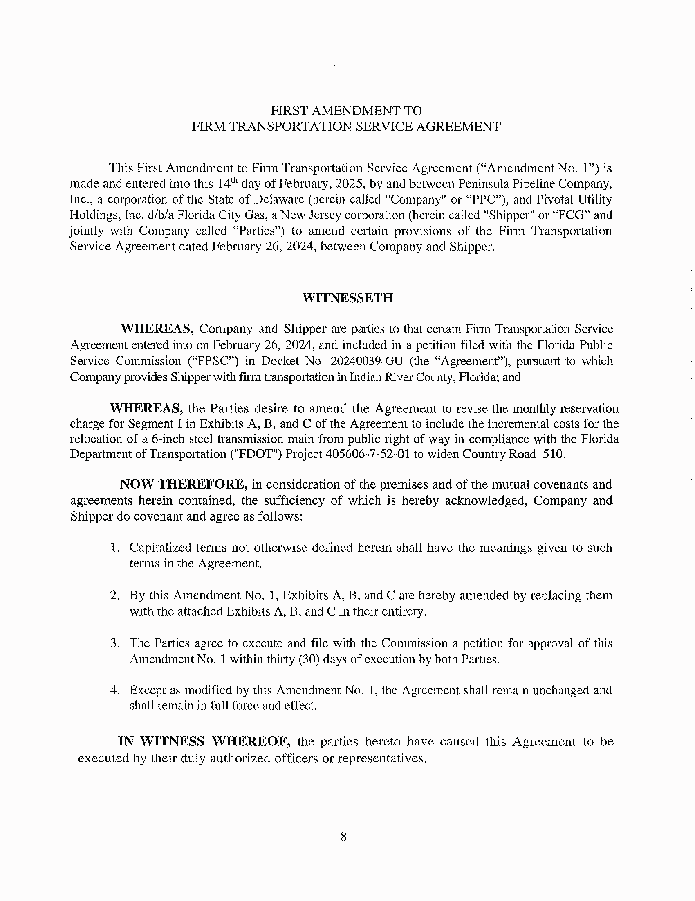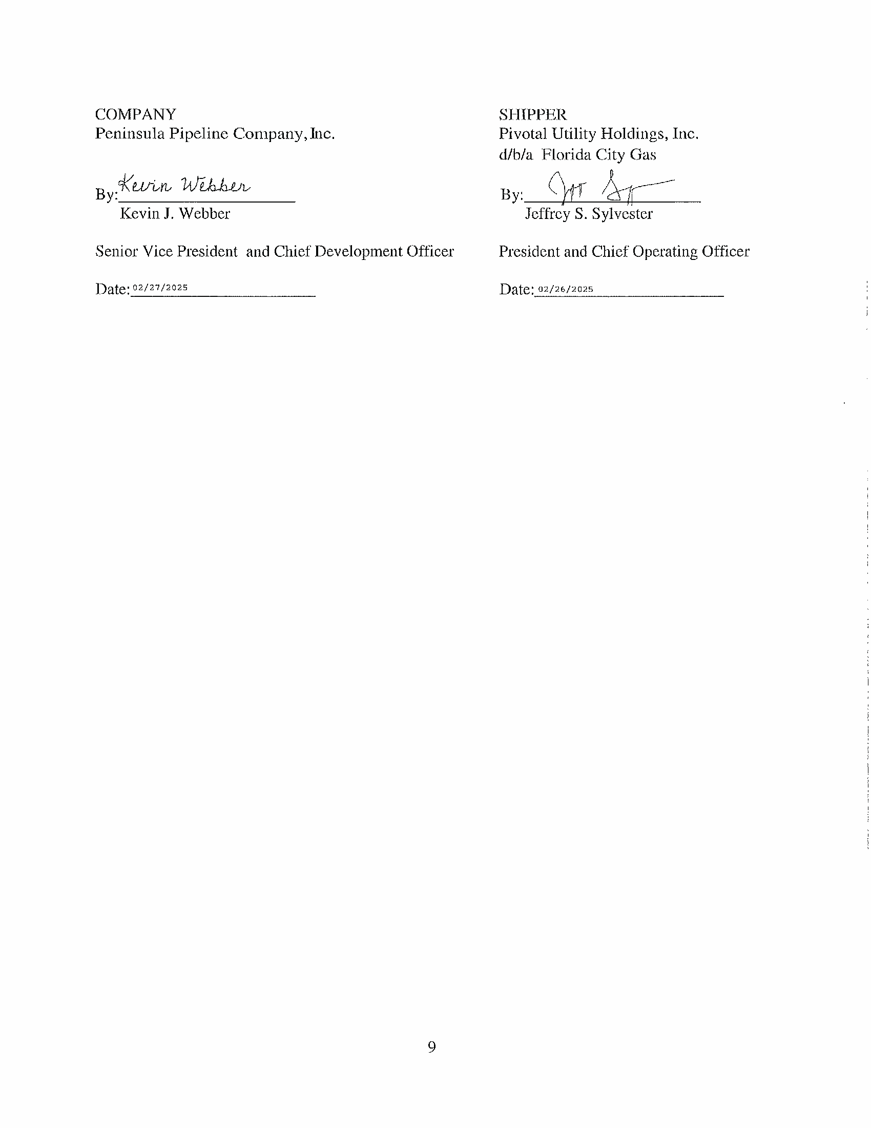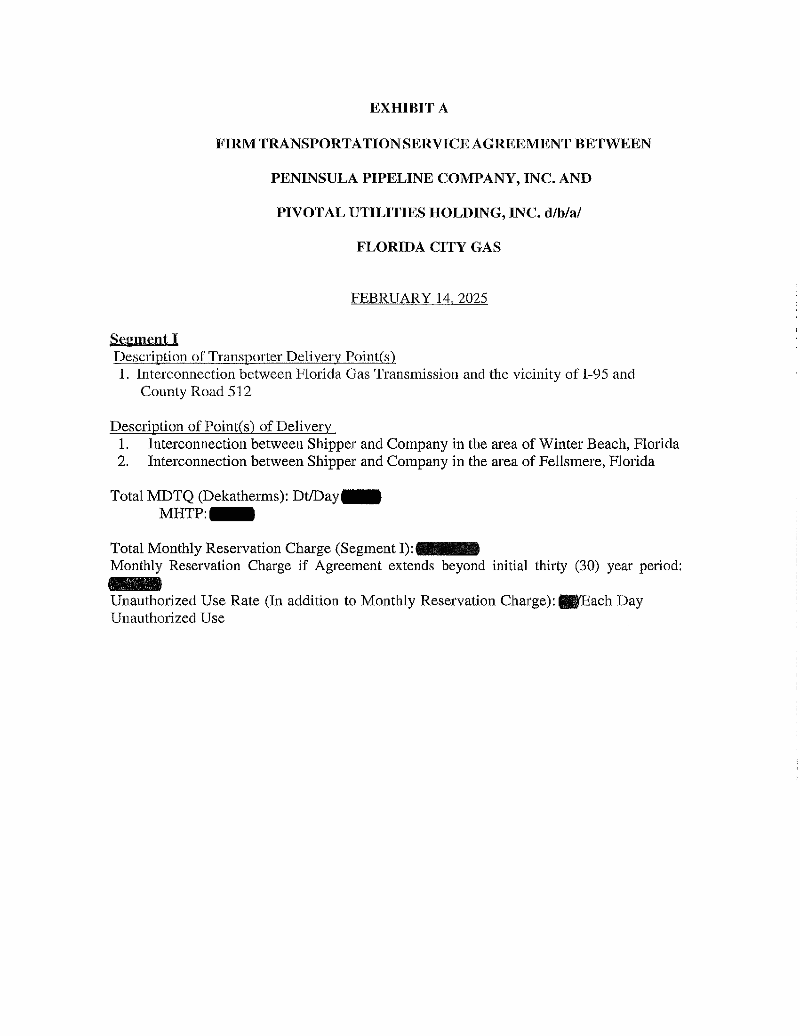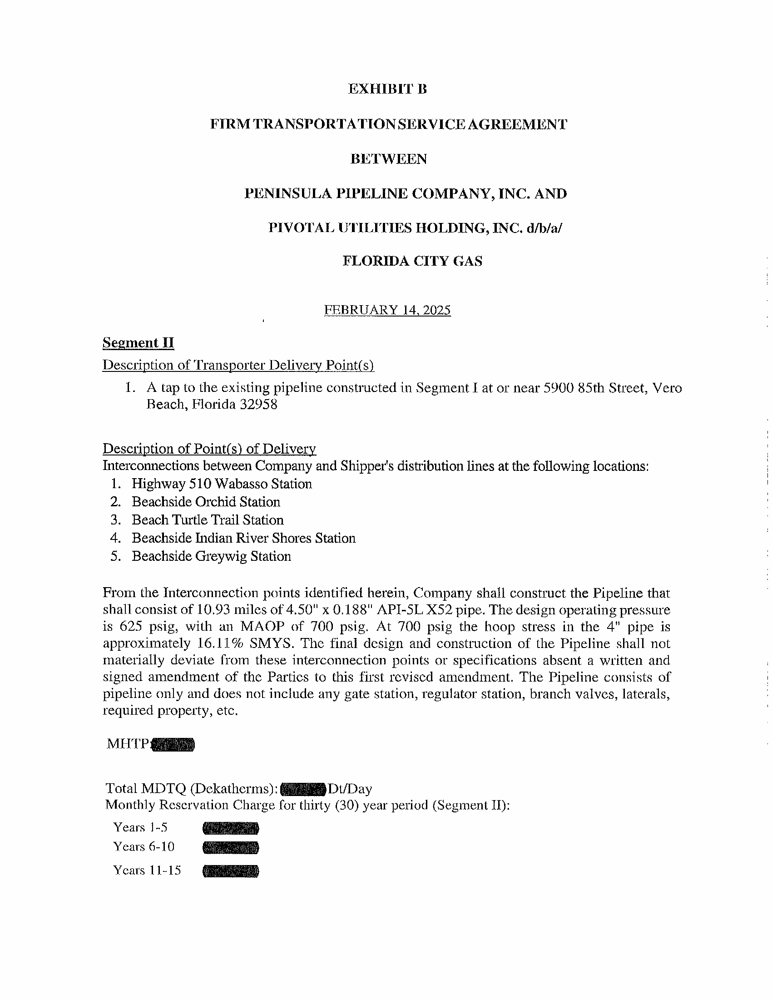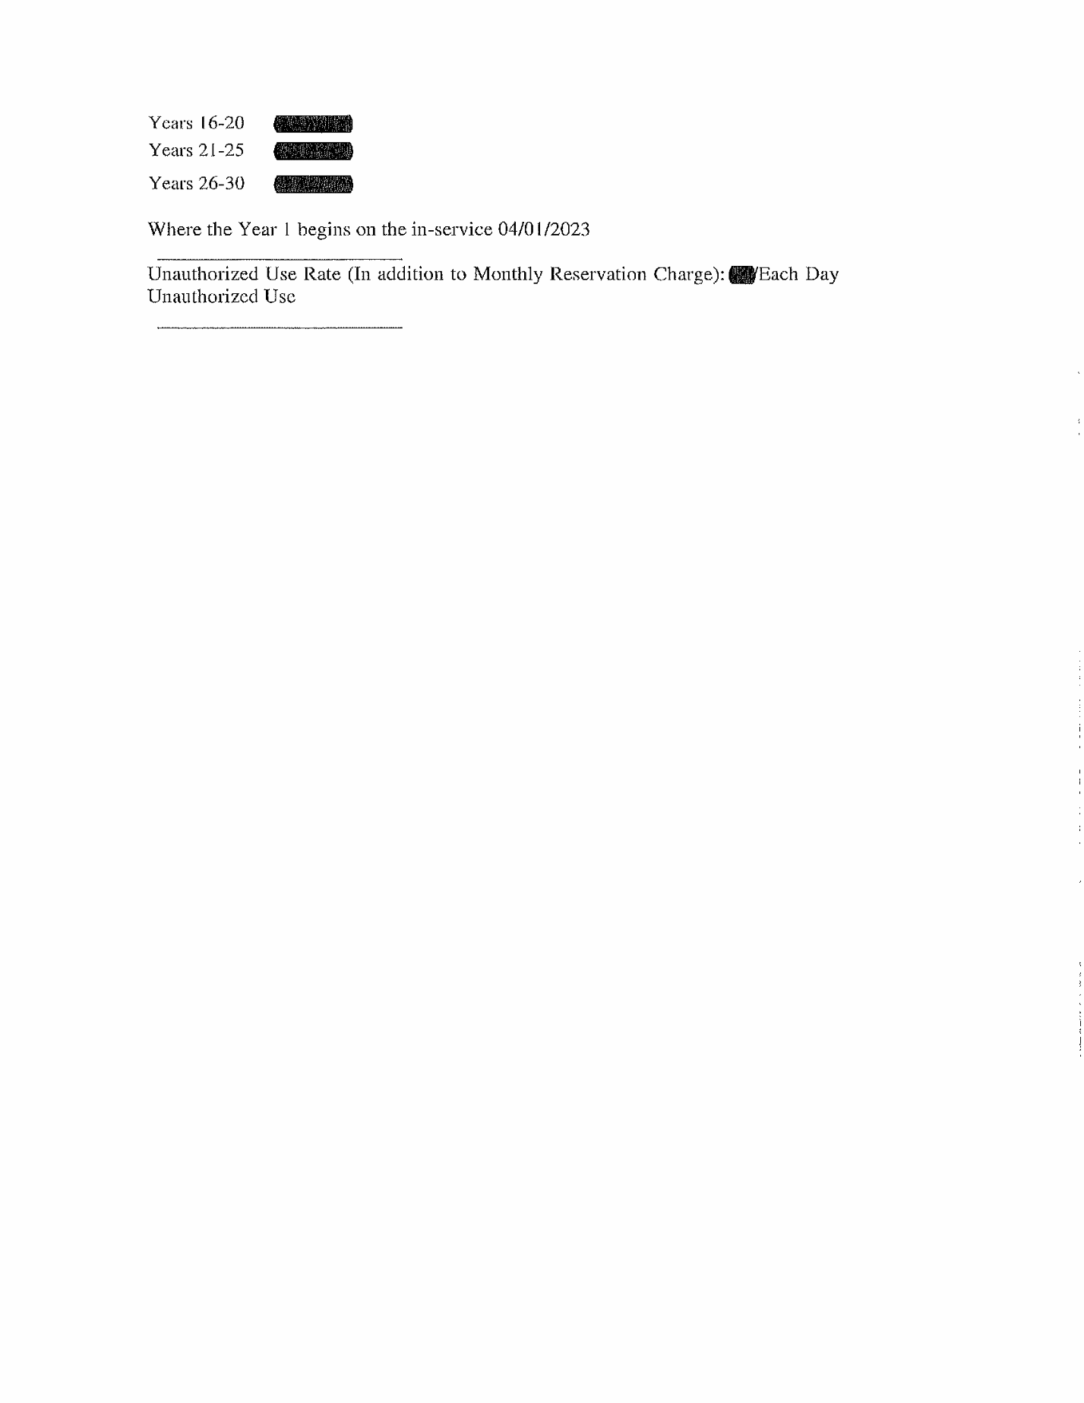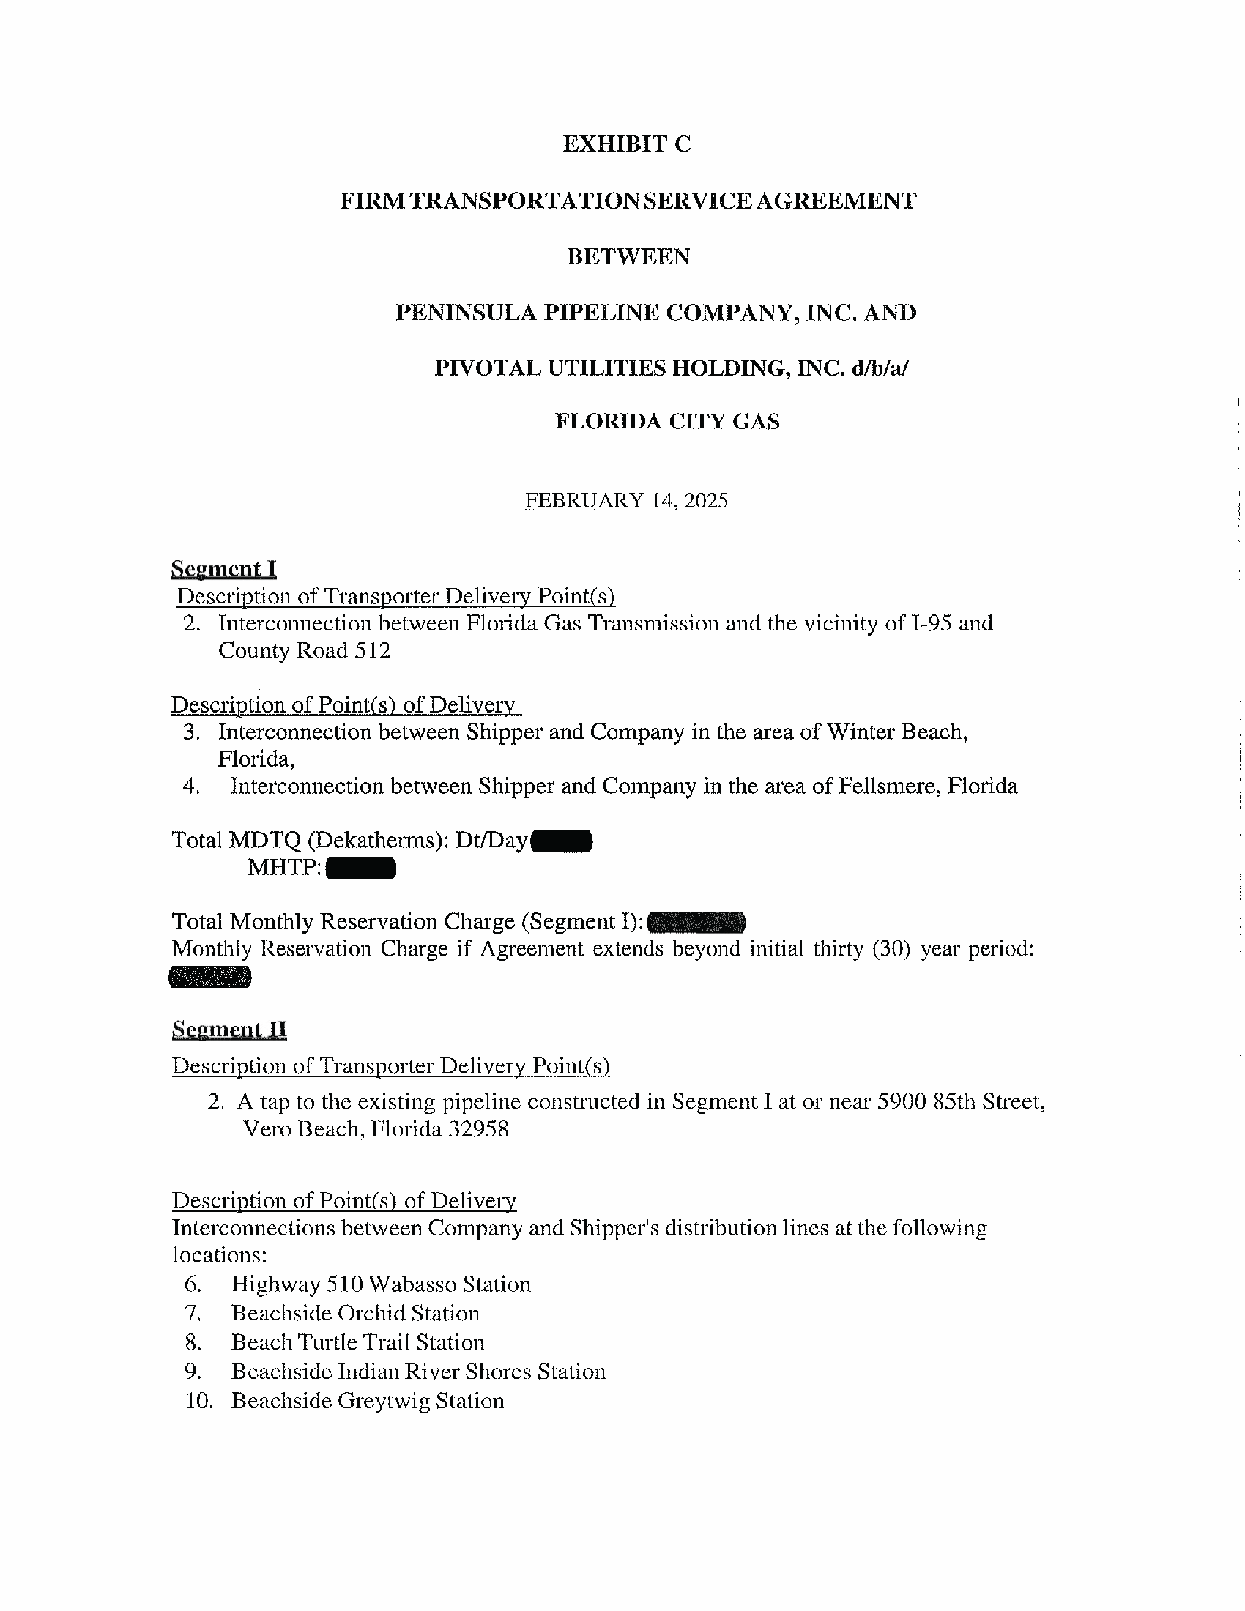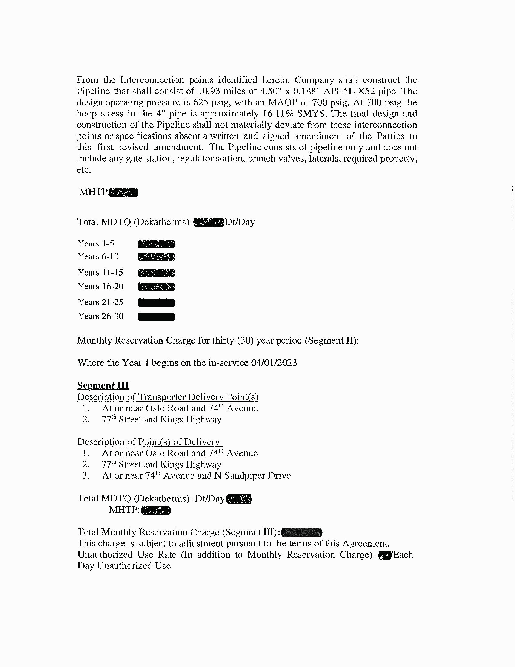

1. Order No. PSC-06-0023-DS-GP, issued January 9, 2006, in Docket No. 050584-GP, *In re: Petition for declaratory statement by Peninsula Pipeline Company, Inc. concerning recognition as a natural gas transmission company under Section 368.101, F.S., et seq.*
2. Order No. PSC-2024-0271-PAA-GU, issued July 26, 2024, in Docket No. 20240039-GU, *In re: Petition for approval of transportation service agreements between Peninsula Pipeline Company, Inc. and Pivotal Utility Holdings, Inc. d/b/a Florida City Gas.*
3. Document No. 03191-2025.
4. Responses to Staff’s First Data Request, No. 7.
5. Responses to Staff’s First Data Request, No. 8.
6. See Order No. PSC-2024-0271-PAA-GU, page 27.
7. Responses to Staff’s First Data Request, No. 1.