BEFORE THE FLORIDA PUBLIC SERVICE COMMISSION

In re: Petition for approval of swing service rider rates for January through December 2026, by Florida Public Utilities Company. | DOCKET NO. 20250107-GU  ORDER NO. PSC-2025-0421-TRF-GU  ISSUED: November 17, 2025

The following Commissioners participated in the disposition of this matter:

MIKE LA ROSA, Chairman
ART GRAHAM
GARY F. CLARK
ANDREW GILES FAY
GABRIELLA PASSIDOMO SMITH

ORDER APPROVING SWING SERVICE RIDER RATES

BY THE COMMISSION:

Background
On September 2, 2025, Florida Public Utilities Company (FPUC or utility) filed a petition for approval of revised swing service rider rates and associated tariffs for the period January through December 2026. The swing service rider is a cents per therm charge that is included in the monthly gas bill of transportation customers, who purchase gas from third party marketers, and therefore do not pay the Purchased Gas Adjustment (PGA) charge. FPUC is a local natural gas distribution company (LDC) subject to our jurisdiction pursuant to Chapter 366, Florida Statutes (F.S.).

We first approved FPUC’s swing service rider tariff by Order No. PSC-16-0422-TRF-GU (2016 Order). The swing service rider requires FPUC to file an annual petition to recalculate the swing service rider rates based on the utility’s actual interstate capacity costs and the most recent 12 months of usage data. Furthermore, the swing service order requires FPUC to incorporate the calculated revenues from the swing service rider as a credit to the PGA proceeding for the concurrent year. The January through December 2025 swing service rider rates were approved in Order No. PSC-2024-0487-TRF-GU.

By Order No. PSC-2025-0394-PCO-GU, issued October 22, 2025, we suspended the proposed swing service rider tariffs pending further review by our staff. During evaluation of the petition, our staff issued one data request to the utility, for which responses were received October 1, 2025. Our staff also sent an email to ask follow up questions about the marginal increase from 2024 to 2025 for the Peninsula Pipeline contracts on October 14, 2025, after which the company sent a response on October 15, 2025. The proposed swing service rider rates and associated tariff revisions are provided in Attachment A of this order. We have jurisdiction over this matter pursuant to Sections 366.04, 366.041, 366.05, and 366.06, F.S.

Decision

The utility incurs intrastate capacity costs when it transports natural gas on intrastate pipelines (i.e., pipelines operating within Florida only). The utility has two types of natural gas customers: sales and transportation. Sales customers are primarily residential and small commercial customers that purchase natural gas from an LDC and receive allocations of intrastate capacity costs through the PGA charge. Transportation customers receive natural gas from third party marketers, known as shippers and, therefore, do not pay the PGA charge to the LDC. The swing service rider allows FPUC to recover allocations of intrastate capacity costs from transportation customers.

Updated 2026 Swing Service Rider Rates

The updated 2026 swing service rider rates were calculated based on the same methodology approved in the 2016 Order. As stated in paragraph 7 of FPUC’s petition, the intrastate capacity costs, other related costs, and LDC-LDC interconnects for the period July 2024 through June 2025 are $37,509,443, compared to $30,003,382, for the period July 2023 through June 2024.

The total intrastate capacity costs reflect payments by FPUC to intrastate pipelines for the transportation of natural gas, pursuant to our approved transportation agreements. In addition, FPUC’s other intrastate capacity cost changes include payments associated with legal and consulting fees, software to manage forecasting, usage tracking, and market tracking. Of the intrastate pipeline costs, $7,367,169 will be recovered through special contracts. The remaining costs of $30,142,275 will be recovered during the period January 1, 2026 through December 31, 2026.

Updated Swing Service Costs

The increase in cost recovered for the swing service rider can be mainly attributed to the addition of an increase in operational projects undertaken by Peninsula and two new contracts. In the response to our staff’s first data request, FPUC stated Peninsula pipeline provides gas transportation services to FPUC. FPUC then explained in the response received on October 15, 2025, that five pipeline expansion projects we approved became operational in the current year, causing a $5.2 million increase. Another $1.2 million increase is due to three other Peninsula projects being in-service for a full year, rather than the partial year in-service from July 2023 to June 2024.

One of the new contracts was to Nassau County Tampa Electric Company, which FPUC clarified is for Peoples Gas to provide firm transportation capacity service for a limited duration. This allows FPUC to access potentially cheaper, less volatile and more liquid gas supply at an alternate receipt location. The second new contract reflects renewable natural gas (RNG) purchases from BP RNG. FPUC entered into an agreement with BP to buy RNG that has been stripped of its environmental attributes. The gas supply is purchased at prevailing commodity market index pricing.

Calculation of Swing Service Charges

The utility used actual therm usage data for the period July 2024 through June 2025 to allocate the intrastate capacity costs. Based on the usage data, we find that the appropriate split for allocating the cost is 68.14 percent, or $20,538,170, to transportation customers and 31.86 percent, or $9,604,104, to PGA customers, as demonstrated on page 3 of the instant petition. The sales customers’ share of the cost of $9,604,104 is embedded in the PGA.

The transportation customers’ share of $20,538,170 is allocated to the various transportation rate schedules based on the percent of peak and average usage. These costs were then divided by the rate schedule’s actual billed volumes to calculate the cost recovery factor to be billed directly to the transportation customers as the swing service rider rates.

Credit to the PGA

The total intrastate capacity costs are embedded in the PGA with the projected 2026 swing service rider revenues incorporated as a credit in the calculation of the 2026 PGA. On page 3 of the instant petition, FPUC states, the amount credited to the 2026 PGA is $20,538,170 plus $7,367,169 received from special contract customers, for a total of $27,905,339.

Conclusion

After reviewing the information provided in the petition and in response to our staff’s data request, we find that FPUC’s proposed swing service rider reflects the updated cost of swing service for transportation customers. We reviewed the total projected intrastate capacity costs and verified that the costs included are appropriate. We approve the proposed swing service rider rates for the period January through December 2026. The cost included are appropriate and the methodology for calculating the swing service rider rates is consistent with the 2016 Order.

Based on the foregoing, it is

ORDERED by the Florida Public Service Commission that Florida Public Utilities Company's proposed swing service rider rates and tariffs for the period January through December 2026 are approved. The costs included are appropriate and the methodology for calculating the swing service rider rates is consistent with the initial order approving the tariff. It is further

ORDERED that if a protest is filed within 21 days of issuance of the Order, the tariff shall remain in effect with any revenues held subject to refund pending resolution of the protest. It is further

ORDERED that if no timely protest is filed, this docket shall be closed upon the issuance of a Consummating Order.

By ORDER of the Florida Public Service Commission this 17th day of November, 2025.

/s/ Adam J. Teitzman
ADAM J. TEITZMAN
Commission Clerk
Florida Public Service Commission
2540 Shumard Oak Boulevard
Tallahassee, Florida 32399
(850) 413-6770
www.floridapsc.com

Copies furnished: A copy of this document is provided to the parties of record at the time of issuance and, if applicable, interested persons.

ZB

NOTICE OF FURTHER PROCEEDINGS

The Florida Public Service Commission is required by Section 120.569(1), Florida Statutes, to notify parties of any administrative hearing or judicial review of Commission orders that is available under Sections 120.57 or 120.68, Florida Statutes, as well as the procedures and time limits that apply. This notice should not be construed to mean all requests for an administrative hearing or judicial review will be granted or result in the relief sought.

Mediation may be available on a case-by-case basis. If mediation is conducted, it does not affect a substantially interested person's right to a hearing.

The Commission's decision on this tariff is interim in nature and will become final, unless a person whose substantial interests are affected by the proposed action files a petition for a formal proceeding, in the form provided by Rule 28-106.201, Florida Administrative Code. This petition must be received by the Office of Commission Clerk, 2540 Shumard Oak Boulevard, Tallahassee, Florida 32399-0850, by the close of business on December 8, 2025.

In the absence of such a petition, this Order shall become final and effective upon the issuance of a Consummating Order.

Any objection or protest filed in this docket before the issuance date of this order is considered abandoned unless it satisfies the foregoing conditions and is renewed within the specified protest period.

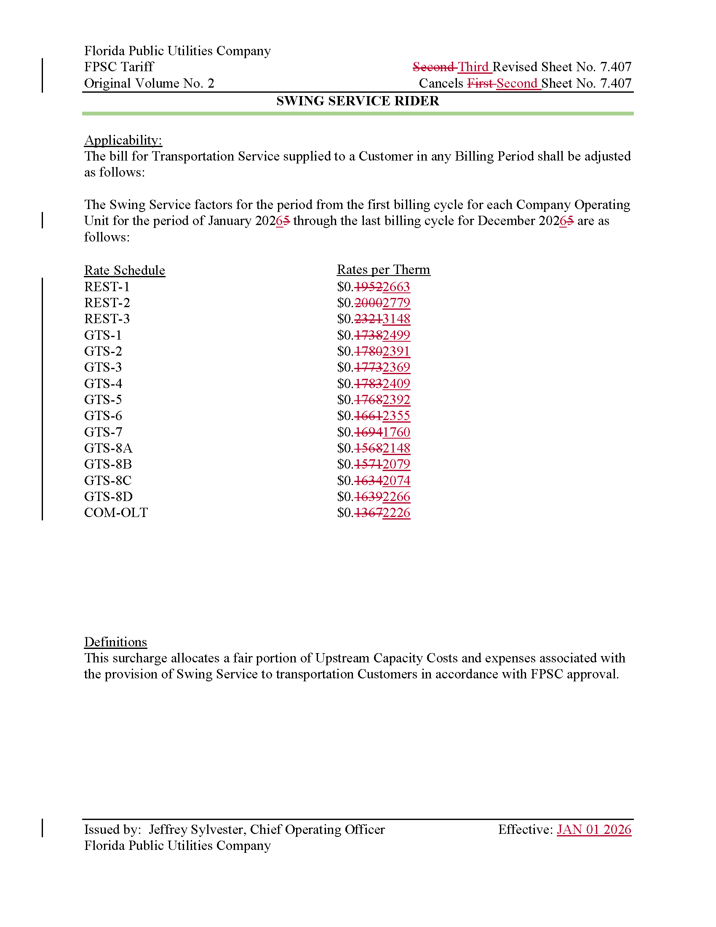

The PGA charge is set by us in the annual PGA cost recovery clause proceeding.
Order No. PSC-16-0422-TRF-GU, issued October 3, 2016, in Docket No. 160085-GU, In re: Joint petition for approval of swing service rider, by Florida Public Utilities Company, Florida Public Utilities Company-Indiantown Division, Florida Public Utilities Company-Fort Meade, and Florida Division of Chesapeake Utilities Corporation.
Order No. PSC-2024-0487-TRF-GU, issued November 25, 2024, in Docket No. 20240135-GU, In re: Petition for approval of swing service rider, by Florida Public Utilities Company, Florida Public Utilities Company-Indiantown Division, Florida Public Utilities Company-Fort Meade, and Florida Division of Chesapeake Utilities Corporation.
Document No. 14140-2025, filed October 1, 2025.
Document No. 14637-2025, filed October 17, 2025.
We do not regulate the shippers or their charges for the gas commodity.
See direct testimony of witness Diana Williams on behalf of FPUC, filed on September 2, 2025, Document No. 08618-2025, in Docket No. 20250107-GU, Page 4.
Document No. 14140-2025, filed October 1, 2025.
See direct testimony of witness Diana Williams on behalf of FPUC, filed on September 2, 2025, Document No. 08618-2025, in Docket No. 20250107-GU, Page 3, line 13 through 18.

