2022 – 2031 Storm Protection Plan Resilience Benefits Report



Tampa Electric Company

TEC SPP Resilience Benefits Report

Project No. 132540

Revision 0

2/16/2022

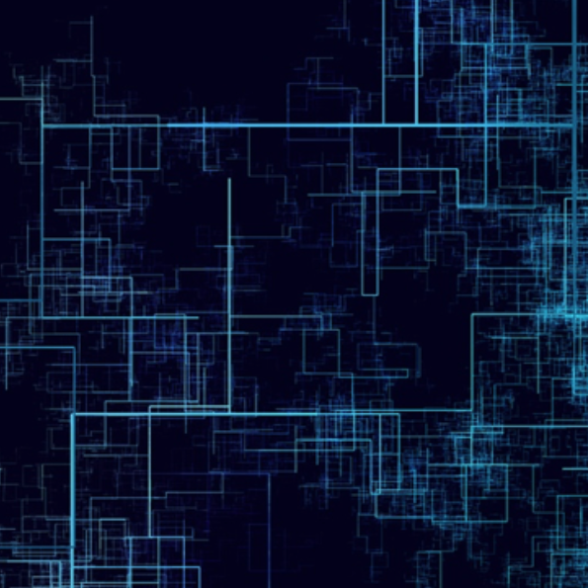

TABLE OF CONTENTS

**Page No.**

1.0 Executive Summary 1

**1.1** Resilience Based Planning Approach 2

**1.2** Key Updates to Storm Resilience Model from 2020 to 2029 SPP to 2022 to 2031 SPP 4

**1.3** Results & Conclusions 6

2.0 Introduction 11

**2.1** Resilience as the Benefits Assessment 12

**2.2** Evaluated System for Resilience Investment 16

**2.3** Resilience Planning Approach Overview 18

**2.3.1** Major Storms Event Database 19

**2.3.2** Storm Impact Model 21

**2.3.3** Resilience Benefit Calculation 23

**2.3.4** Project Scheduling and Budget Optimization 23

**2.4** S-Curves and Resilience Benefit 24

3.0 Major Storms Event Database 28

**3.1** Analysis of NOAA Major Storm Events 29

**3.1.2** Direct Hits (50 Miles) 31

**3.1.3** Partial Hits (51 to 100 Miles) 34

**3.1.4** Peripheral Hits (101 to 150 Miles) 37

**3.2** Major Storms in the Future 40

**3.3** Major Storms Impact 40

**3.4** Major Storms Database 41

4.0 Storm Impact Model 43

**4.1** Core Data Sets and Algorithms 44

**4.1.1** Geographical Information System 44

**4.1.2** Outage Management System 45

**4.1.3** Customer Type Data 46

**4.1.4** Vegetation Density Algorithm 46

**4.1.5** Wood Pole Inspection Data 48

**4.1.6** Wind Zone 48

**4.1.7** Accessibility 49

**4.1.8** ICE Calculator 50

**4.1.9** Substation Flood Modeling 50

**4.2** Weighted Storm Likelihood of Failure Module 51

**4.2.1** Substation Storm Likelihood of Failure 51

**4.2.2** Circuits Storm Likelihood of Failure 51

**4.2.3** Site Access Storm Likelihood of Failure 54

**4.3** Project & Asset Reactive Storm Restoration 54

**4.4** Duration and Customer Impact 55

**4.5** ‘Status Quo’ and Hardening Scenarios 56

5.0 Resilience Net Benefit Calculation Module 58

**5.1** Economic Assumptions 58

**5.2** Project Cost 58

**5.2.1** Distribution Lateral Undergrounding Project Costs 59

**5.2.2** Transmission Asset Upgrades Project Costs 59

**5.2.3** Substation Extreme Weather Hardening Project Costs 59

**5.2.4** Distribution Overhead Feeder Hardening Project Costs 59

**5.2.5** Transmission Access Enhancements 60

**5.3** Resilience-weighted Life-Cycle Benefit 60

**5.4** Feeder Automation Benefits Calculation 63

6.0 Budget Optimization and Project Selection 67

**6.1** Prioritization Metric - Benefit Cost Ratio 67

**6.2** Budget Optimization 68

**6.3** Storm Protection Plan Project Prioritization 69

7.0 Results & Conclusions 70

**7.1** Storm Protection Plan 70

**7.1.1** Investment Profile 70

**7.1.2** Restoration Cost Reduction 71

**7.1.3** Customer Benefit 72

**7.2** Program Investment Profile Details 73

**7.3** Program Benefits 75

**7.4** Conclusions 77

LIST OF TABLES

**Page No.**

Table 1‑1: Potential Projects Considered 3

Table 2‑1: TEC Asset Base Modeled 16

Table 2‑2: Potential Hardening Projects Considered 18

Table 3‑1: Historical Storm Summary 30

Table 3‑2: Recent Major Event Damages Cost 40

Table 3‑3: Storm Report Summary 41

Table 3‑4: Storm Event Database 42

Table 4‑1: TEC Asset Base 45

Table 4‑2: Projects Created from TEC Data Systems 45

Table 4‑3: Customer Counts by Type 46

Table 5‑1: Monte Carlo Simulation Storm Event Selection 61

Table 5‑2: Project CMI and Restoration Cost Example – Iteration 1 62

Table 7‑1: Storm Protection Plan Investment Profile by Program (Nominal $000) 71

Table 7‑2: Distribution Lateral Undergrounding Investment Profile 74

Table 7‑3: Transmission Asset Upgrades Investment Profile 74

Table 7‑4: Substation Extreme Weather Hardening Investment Profile 74

Table 7‑5: Distribution Overhead Feeder Hardening Investment Profile 75

Table 7‑6: Transmission Access Enhancements Investment Profile 75

Table 7‑7: Program Benefit Levels 76

LIST OF FIGURES

**Page No.**

Figure 1‑1: Storm Resilience Model Overview 3

Figure 1‑2: Budget Optimization Results 6

Figure 1‑3: Storm Protection Plan Investment Profile 7

Figure 1‑4: Storm Protection Plan Restoration Cost Benefit 8

Figure 1‑5: Storm Protection Plan Customer Benefit 9

Figure 2‑1: Phases of Resilience 15

Figure 2‑2: Resilience Planning Approach Overview 20

Figure 2‑3: Status Quo and Hardened Results Distribution Example 24

Figure 2‑4: S-Curves and Future Storms 25

Figure 2‑5: S-Curves and Resilience Focus 27

Figure 3‑1: NOAA Example Output – 50 Mile Radius 29

Figure 3‑2: “Direct Hits” (50 Miles) Over Time 32

Figure 3‑3: “Direct Hits” (50 Miles) 100 Year Rolling Average 33

Figure 3‑4: “Direct Hits” (50 Miles) 100 Year Rolling Probability3 33

Figure 3‑5: “Partial Hits” (51 to 100 Miles) 35

Figure 3‑6: “Partial Hits” (51 to 100 Miles) 100 Year Rolling Average 36

Figure 3‑7: “Partial Hits” (51 to 100 Miles) 100 Yr. Rolling Probability5 37

Figure 3‑8: “Peripheral Hits” (101 to 150 Miles) 38

Figure 3‑9: “Peripheral Hits” (51 to 100 Miles) 100 Yr. Rolling Avg. 39

Figure 3‑10: “Peripheral Hits” (51 to 100 Miles) 100 Yr. Rolling Probability7 39

Figure 3‑11: Hurricane Irma Impact to TEC Service Territory 41

Figure 4‑1: Storm Impact Model Overview 44

Figure 4‑2: Vegetation Density on TEC Primary Conductor 47

Figure 4‑3: Vegetation Density on TEC Transmission Conductor 48

Figure 4‑4: Pole Wind Zone Distribution 49

Figure 4‑5: Storm LOF Framework for Circuit Assets 53

Figure 4‑6: Age & Condition LOF Distribution 54

Figure 4‑7: Example Storm Duration Profile 55

Figure 5‑1: Status Quo and Hardened Results Distribution Example 63

Figure 5‑2: Automation Hardening Percent CMI Decrease 65

Figure 5‑3: Automation Hardening Monetization of CMI Decrease 66

Figure 6‑1: Budget Optimization Results 68

Figure 7‑1: Storm Protection Plan Restoration Cost Benefit 72

Figure 7‑2: Storm Protection Plan Customer Benefit 73

Figure 7‑3: Program Benefits vs. Capital Investment 76

list of abbreviations

| **Abbreviation** | **Term/Phrase/Name** |
| --- | --- |
| AHI | Asset Health Index |
| ANL | Argonne National Laboratory |
| Burns & McDonnell | Burns & McDonnell Engineering Company, Inc. |
| C&I | Commercial & Industrial |
| CMI | Customer Minutes Interrupted |
| DOE | Department of Energy |
| FLISR | Fault Location, Isolation, Service Restoration |
| GIS | Geographic Information System |
| ICE | Interruption Cost Estimator |
| IEEE | Institute of Electrical and Electronics Engineers |
| LOF | Likelihood of Failure |
| MED | Major Event Day |
| NARCU | National Association of Regulatory Utility Commissioners |
| NASC | National Electric Safety Code |
| NIAC | National Infrastructure Advisory Council |
| NOAA | National Oceanic and Atmospheric Administration |
| NPV | Net Present Value |
| OMS | Outage Management System |
| PNNL | Pacific Northwest National Laboratory’s |
| POF | Probability of Failure |
| ROW | Right-of-Way |
| SIM | Storm Impact Model |
| SLOSH | Sea, Land, and Overland Surges from Hurricanes |
| SPP | Storm Protection Plan |
| T&D | Transmission and Distribution |
| TEC | Tampa Electric Company |
|  |  |

# Executive Summary

Tampa Electric Company (TEC) engaged the services of 1898 & Co, the advisory and technology consulting arm of Burns & McDonnell, to assist with the development of the 2022 to 2031 10-year Storm Protection Plan required by Florida Statute 366.96, also known as Senate Bill 796. In collaboration, TEC and 1898 & Co. utilized a resilience-based planning approach to identify hardening projects and prioritize investment in the Transmission and Distribution (T&D) system utilizing a Storm Resilience Model. The Storm Resilience Model evaluates each hardening project’s ability to reduce the magnitude and/or duration of disruptive storm events. Key objectives for the Storm Resilience Model are:

1. Calculate the customer benefit of hardening projects through reduced utility restoration costs and impacts to customers
2. Prioritize hardening projects with the highest resilience benefit per dollar invested into the system
3. Establish an overall investment level that maximizes customers benefit while not exceeding TEC technical execution constraints

While the resilience benefit is significant and is the focus of this report, it is not the only benefit of TEC’s Storm Protection Plan. Additional benefits are described and quantified elsewhere in TEC’s Plan. The Resilience Model employs a data-driven decision-making methodology utilizing robust and sophisticated algorithms to calculate the resilience benefit of hardening projects in terms of the range of reduced restoration costs and Customer Minutes Interrupted (CMI). The hardening projects provide resilience benefit from several perspectives. Some of the hardening projects eliminate storm-based outages all together, some reduce the number of customers impacted (CI), and others decrease the duration of storm-related outages. This report shows only the reduction in CMI, which accounts for both types of benefits. However, there is a strong relationship between reduction in CMI and reduction in CI.

Resilience-based prioritization facilitates the identification of the hardening projects that provide the most benefit. Prioritizing and optimizing investments in the system helps provide confidence that the overall investment level is appropriate and that customers will get the most value for the level of investment.

This report outlines project prioritization and benefits calculations for the following TEC storm hardening programs:

* Distribution Lateral Undergrounding
* Transmission Asset Upgrades
* Substation Extreme Weather Hardening
* Distribution Overhead Feeder Hardening
* Transmission Access Enhancements

The other programs within TEC’s Storm Protection Plan, Vegetation Management, Infrastructure Inspections, and Distribution Pole Replacements, are not evaluated or included in this report. Their benefits and prioritization are described in other parts of TEC’s Storm Protection Plan. Similarly, their benefits are described in other portions of TEC’s Storm Protection Plan.

## Resilience Based Planning Approach

Figure 1‑1 provides an overview of the Storm Resilience Model. The model employs a resilience-based planning approach to calculate the benefits of reducing storm restoration costs, CI, and CMI. Each of the different components are reviewed in further detail in Sections 3.0, 4.0, 5.0, and 6.0.

The Major Storm Events Database contains 13 unique storm types with a range of probabilities and impacts to create a total database of 99 different unique storm scenarios. The storm scenarios range from a Category 3 or greater direct hit from the Gulf of Mexico to a Category 1 or 2 partial hit over Florida, to a tropical storm. Section 3.0 provides additional details on the 99 different storm scenarios.

Figure 1‑1: Storm Resilience Model Overview

Each storm scenario is then modeled within the Storm Impact Model to identify which parts of the system are most likely to fail given each type of storm. The Likelihood of Failure (LOF) is based on the vegetation density around each conductor asset, the age and condition of the asset base, and the applicable wind zone for the asset’s location. The Resilience Model is comprehensive in that it evaluates nearly all TEC’s T&D system. Table 1‑1 provides an overview of the potential project count for each of the programs.

Table 1‑1: Potential Projects Considered

|  |  |
| --- | --- |
| Program | Project Count |
| Distribution Lateral Undergrounding | 12,310 |
| Transmission Asset Upgrades | 107 |
| Substation Extreme Weather Hardening | 9 |
| Distribution Overhead Feeder Hardening | 1,385 |
| Transmission Access Enhancements | 44 |
| Total | 13,855 |

The Storm Impact Model also estimates the restoration costs and CMI for each of the projects in Table 1‑1 above for each storm scenario. For purposes of this report, the term “project” refers to a collection of assets. Assets are typically organized from a customer impact perspective, see Section 2.2. Finally, the Storm Impact Model calculates the benefit in decreased restoration costs and CMI if that project is hardened per TEC’s hardening standards. The CMI benefit is monetized using the DOE’s Interruption Cost Estimator (ICE) for project prioritization purposes.

The Resilience Benefit Calculation utilizes stochastic modeling, or Monte Carlo simulation, to select a storm scenario for each of the 13 storm types for 1,000 iterations. This produces 1,000 different future storm worlds and the expected range of benefit values depending on the different probabilities and impact ranges to the TEC system. The probability of each storm scenario is multiplied by the benefits calculated for each project from the Storm Impact Model to provide a resilience-weighted benefit for each project in dollars. Feeder Automation Hardening projects are evaluated based on historical outages and the expected decrease in historical outages if automation had been in place.

The Project Scheduling and Budget Optimization model prioritizes the projects based on the highest resilience benefit cost ratio. It also performs a budget optimization over a range of budget levels to identify the point of diminishing returns.

The model prioritizes each project based on the sum of the restoration cost benefit and monetized CMI benefit divided by the project cost. This is done for the range of potential benefit values to create the resilience benefit cost ratio. The model also incorporates TEC’s technical and operational constraints in scheduling the projects such as contractor capacity and scheduling planned transmission outages. Using the Resilience Benefit Calculation and Project Scheduling and Budget Optimization model, the Storm Resilience Model calculates the net benefit in terms of reduced restoration costs and CMI for the 10-year investment profile.

## Key Updates to Storm Resilience Model from 2020 to 2029 SPP to 2022 to 2031 SPP

The following are the key updates from the 2020-2029 to the 2022-2031 Storm Resilience Model:

1. General – these updates include shifting of the time horizon, adding another year of storms to the historical analysis, and accounting for completed projects.
2. Capital Cost Assumptions – based on actual completed projects and communicated increases in commodity prices the cost assumptions for all project types were adjusted.
3. Substation Projects Development – TEC completed a technical evaluation of substation hardening alternatives since the 2020-2029 Storm Protection Plan filing. The results of that evaluation, including specific substation hardening activities and their cost were included in the model.
4. Site Access Project Development – TEC performed additional evaluation of transmission site access and updated the projects and associated costs.
5. Automation Hardening Capital Costs – 1898 & Co. performed detailed analysis on 300 circuits to identify more specific scope and cost. Based on lessons learned from the 2020 projects, the cost to deploy automation had a wide range given the uncertainty in circuit reconductoring and substation upgrades needed to not overload and burn down circuits. With improved cost estimates for the 300 circuits the prioritization of projects in the Storm Resilience Model is improved. This increasing the overall benefit in decreasing major outage events for customers.
6. Lateral Undergrounding Branching’ Approach – Based on a lessons learned evaluation, the project definition for lateral projects was adjusted to include a collection of electrically connected protection zones, or ‘branches’. TEC’s undergrounding design standard includes looping for added resilience. Based on the 2020 project execution it was identified that some of the projects included higher costs to achieve the full loop. By undergrounding all the electrically connected protection zones off a circuit feeder / mainline the higher costs will be mitigated since it can be designed to minimize the number of new underground miles.

## Results & Conclusions

TEC and 1898 & Co. utilized a resilience-based planning approach to establish an overall budget level and identify and prioritize resilience investment in the T&D system. Figure 1‑2 shows the results of the budget optimization analysis. Given the total level of potential investment, the budget optimization analysis was performed in $250 million increments up to $2.5 billion. The figure shows the total life-cycle gross NPV benefit for each budget scenario for P50, P75, and P95. P50 to P65 levels represent a future world in which storm frequency and impact are close to average, P70 to P85 level represent a future world where storms are more frequent and intense, and P90 and P95 levels represent a future world where storm frequency and impacts are all high.

Figure 1‑2: Budget Optimization Results

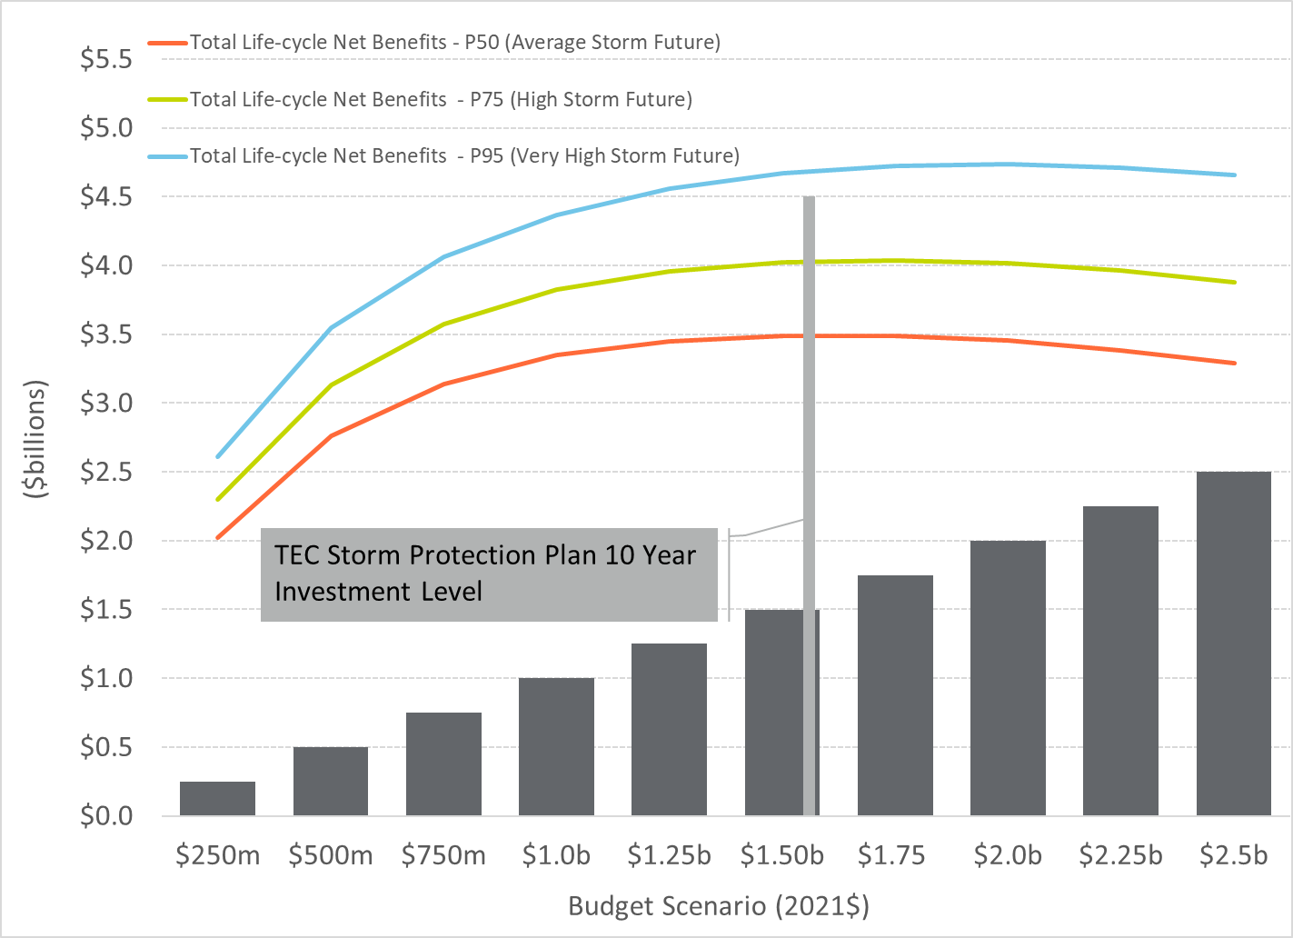

The figure shows significantly increasing levels of net benefit from the $250 million to $1.25 billion budget scenarios with the benefit level flattening from $1.25 billion to $1.75 billion and decreasing from $1.75 billion to $2.5 billion. The figure also shows the total investment level in 2021 dollars for the TEC Storm Protection Plan. The TEC overall investment level is right before the point of diminishing returns, which demonstrates that TEC’s plan has an appropriate level of investment over the next 10 years capturing the hardening projects that provide the most value to customers.

Figure 1‑3 shows the Storm Protection Plan investment profile. The table includes the buildup by program to the total. The investment capital costs are in nominal dollars, the dollars of that day. The overall plan investment level is approximately $1.59 billion. Lateral undergrounding makes up most of the total, accounting for 67.6 percent of the total investment. Feeder Hardening is second accounting for 20.0 percent. Transmission upgrades make up approximately 8.8 percent of the total with substations and transmission site access making up 1.7 percent and 2.0 percent, respectively.

Figure 1‑3: Storm Protection Plan Investment Profile

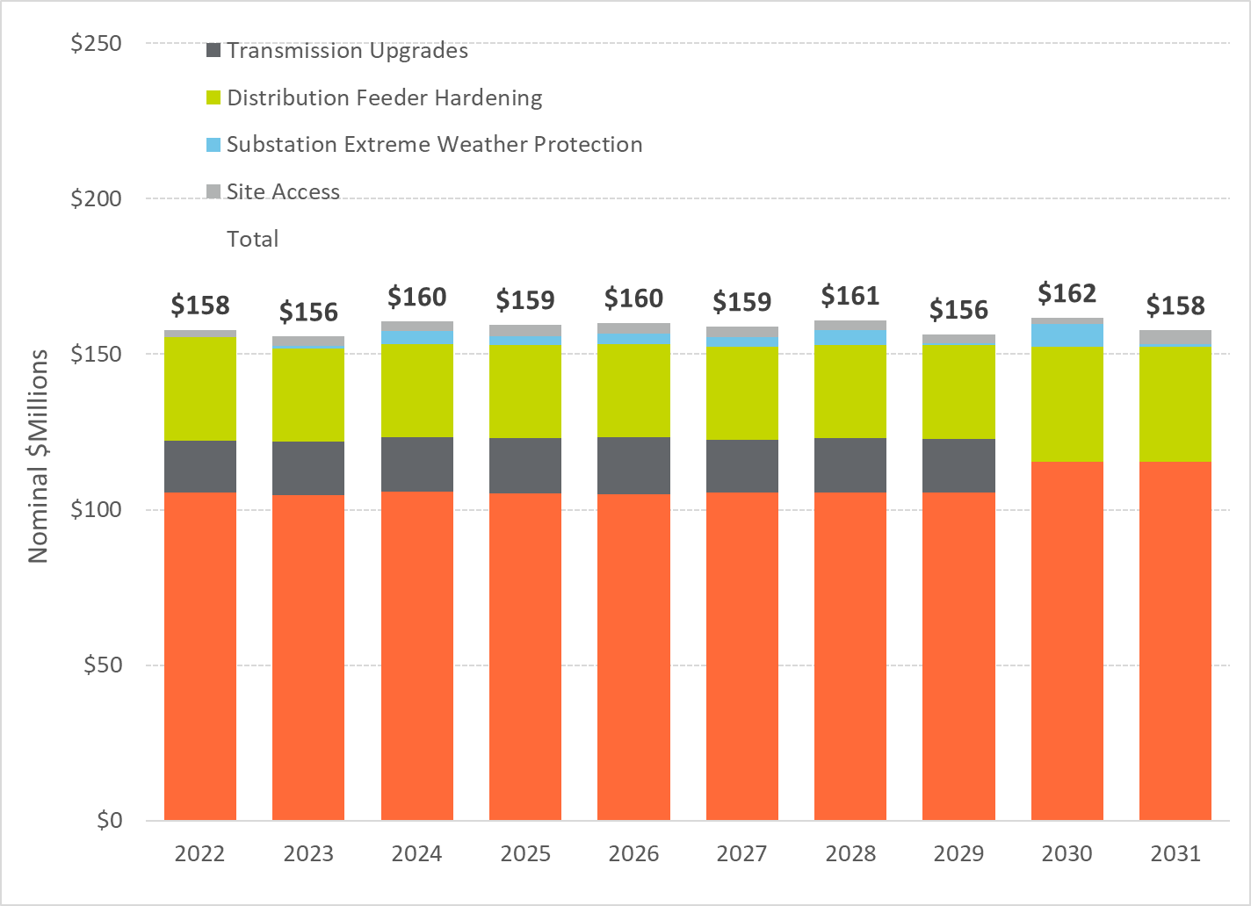

Customer benefits are calculated in terms of the:

1. Reduction in the Storm Restoration Costs
2. Reduction in the number of customers impacted and the duration of the overall outage, calculated as CMI

Figure 1‑4 shows the range in restoration cost reduction at various probability of exceedance levels. To reiterate, the P50 to P65 level represents a future world in which storm frequency and impact are close to average, the P70 to P85 levels represent a future world where storms are more frequent and intense, and the P90 and P95 levels represent a future world where storm frequency and impacts are all high.

Figure 1‑4: Storm Protection Plan Restoration Cost Benefit

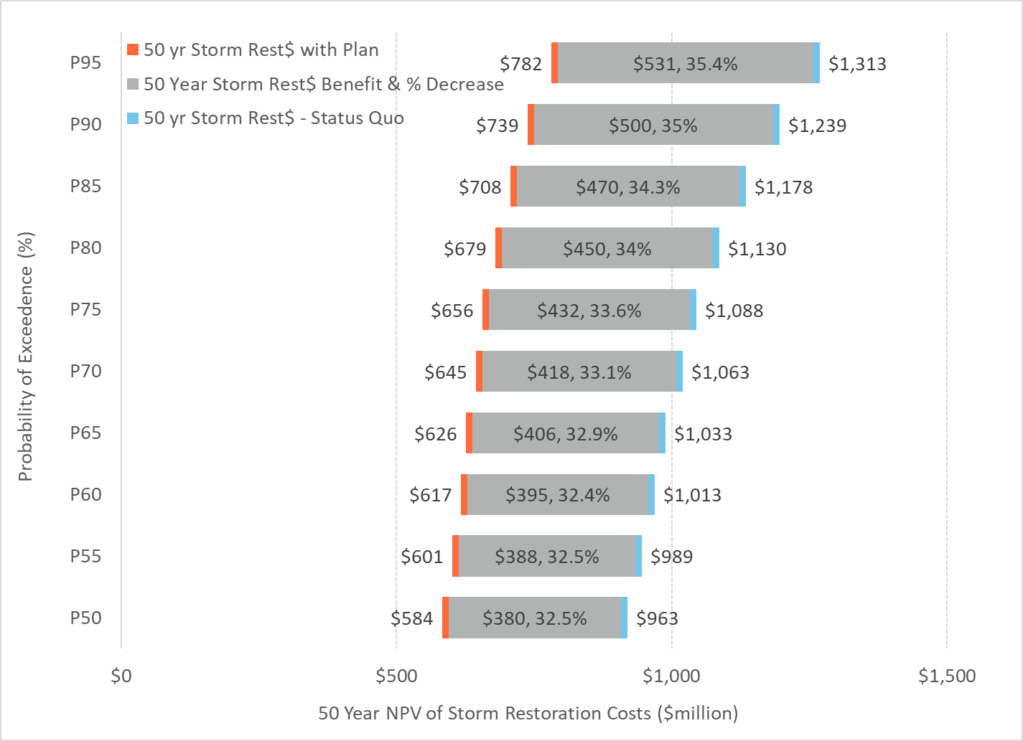

The figure shows that the 50-year NPV of future storm restoration costs in a Status Quo scenario from a resilience perspective is $960 million to $1,310 million. With the Storm Protection Plan, the restoration costs decrease by approximately 33 to 35 percent. The decrease in restoration costs is approximately $380 to $530 million. From an NPV perspective, the restoration cost benefit is approximately 24 to 33 percent of the Storm Protection Plan Investment Level. In other words, the reduction in restoration costs pay for 24 to 33 percent of the total invested capital costs.

Figure 1‑5 shows the range in CMI reduction at various probability of exceedance levels. The figure shows relative consistency in benefit level across the P-values with approximately 46 percent decrease in the storm CMI over the next 50 years.

Figure 1‑5: Storm Protection Plan Customer Benefit

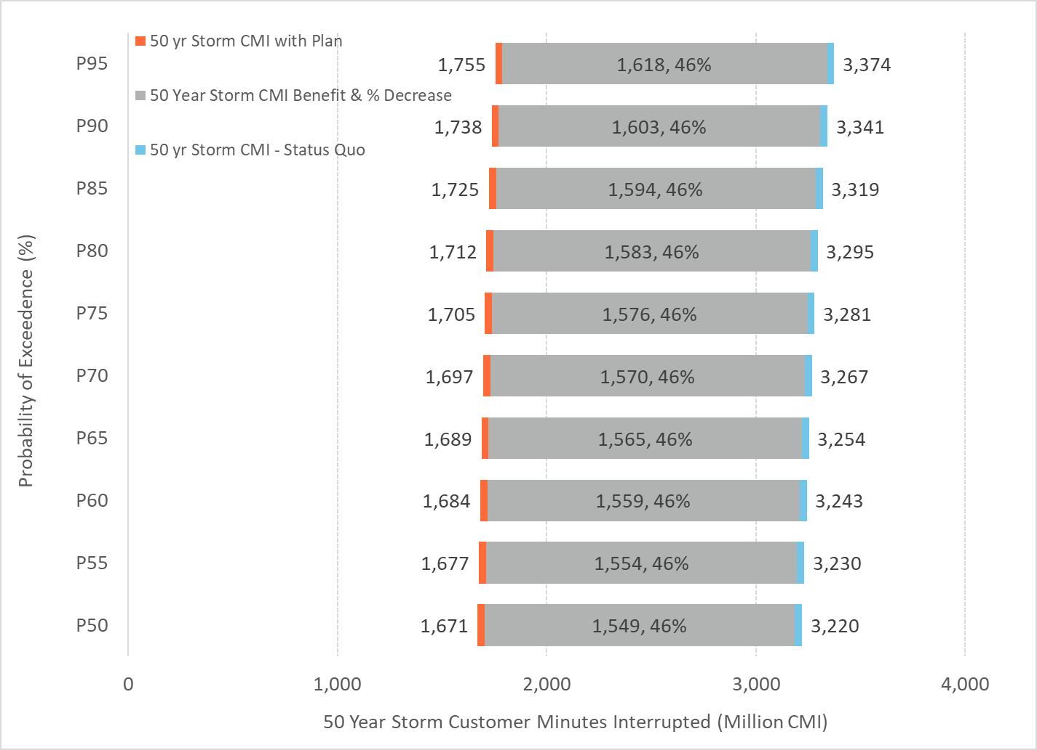

The following include the conclusions of TEC’s Storm Protection plan evaluated within the Storm Resilience Model:

* The overall investment level of $1.59 billion for TEC’s Storm Protection Plan is reasonable and provides customers with maximum benefits. The budget optimization analysis (see Figure 1‑2) shows the investment level is right before the point of diminishing returns.
* TEC’s Storm Protection Plan results in a reduction in storm restoration costs of approximately 33 to 35 percent. In relation to the plan’s capital investment, the restoration costs savings range from 24 to 33 percent depending on future storm frequency and impacts.
* The customer minutes interrupted decrease by approximately 46 percent over the next 50 years. This decrease includes eliminating outages all together, reducing the number of customers interrupted, and decreasing the length of the outage time.
* The cost (Investment – Restoration Cost Benefit) to purchase the reduction in storm customer minutes interrupted is in the range of $0.65 to $0.78 per minute. This is below outage costs from the DOE ICE Calculator and lower than typical ‘willingness to pay’ customer surveys.
* TEC’s mix of hardening investment strikes a balance between investment in the substations and transmission system targeted mainly at increasing resilience for the high impact / low probability events and investment in the distribution system, which is impacted by all ranges of event types.
* The hardening investment will provide additional ‘blue sky’ benefits to customers not factored into this report.

# Introduction

Hurricanes have inflicted significant damage to Florida in recent years and parts of the state face years of recovery. One of the most important things Florida can do to prepare for the next major storm is to make the electric grid more resilient. When the grid can better withstand the impacts of storms, everyone benefits. Florida businesses and families save money because they can get back on their feet more quickly[1]. Florida Statute 366.96 allows for the comprehensive planning and front-end investment necessary to protect Florida’s power supply. It also allows utilities to design integrated programs to address all phases of resilience which, in turn, will reduce storm-related restoration costs and outage times.

This document outlines the approach to

1. Calculate the benefit of hardening projects through reduced utility restoration costs and impacts to customers
2. Prioritize hardening projects with the highest resilience benefit per dollar invested into the system
3. Establish an overall investment level that maximizes customers’ benefit while not exceeding TEC technical execution constraints

The resilience-based approach is an integrated data driven decision-making strategy comparing various storm hardening projects on a normalized and consistent basis. This approach takes an integrated asset management perspective, a bottom-up approach starting at the asset level. Each asset is evaluated for its likelihood of failure in a storm event. Additionally, the consequence of failure is also evaluated at the asset level in terms of the restoration costs and CMI. Assets are rolled up to hardening projects and hardening projects are then rolled up to programs. Each project only hardens the assets that provide the most benefit to customers and that align with TEC’s design standards.

This report outlines project prioritization and benefits calculations for the following TEC storm hardening programs:

* Distribution Lateral Undergrounding
* Transmission Asset Upgrades
* Substation Extreme Weather Hardening
* Distribution Overhead Feeder Hardening
* Transmission Access Enhancements

The other programs within TEC’s Storm Protection Plan, Vegetation Management, Infrastructure Inspections, and Distribution Pole Upgrades, are not evaluated or included in this report. Their benefits and prioritization are described in other parts of TEC’s Storm Protection Plan. Similarly, their benefits are described in other portions of TEC’s Storm Protection Plan.

The following sections outline the foundation and background necessary to understand the rest of this report. These sections include a review of:

* Topic of resilience
* Resilience as the project assessment approach
* TEC asset base evaluated for resilience measures
* Resilience-based planning approach
* Resilience Investment Business Case Results

## Resilience as the Benefits Assessment

Resilience has many faces. It looks different to different people and organizations depending on their challenges and focus. Is it more important to avoid an event from disrupting your business or is it more important to recover quickly? Both are important and TEC’s approach considers both of these questions and more.

Resilience has been defined differently by many organizations. In a 2013 paper, the National Association of Regulatory Utility Commissioners (NARUC) paraphrased its own definition of resilience in a manner that is simple and easy to understand.

*“it’s the gear, the people and the way the people operate the gear immediately before, during and after a bad day that keeps everything going and minimizes the scale and duration of any interruptions.”*

Before that, the National Infrastructure Advisory Council (NIAC) provided a definition that is often quoted, and which includes elements used in many other definitions. It states that resilience is

*“The ability to reduce the magnitude and/or duration of disruptive events. The effectiveness of a resilient infrastructure or enterprise depends upon its ability to anticipate, absorb, adapt to, and/or rapidly recover from a potentially disruptive event.”*

The NIAC definition includes a system’s ability to absorb and adapt. These important characteristics were also used by Argonne National Laboratory (ANL) in its work on state and social resilience and were incorporated into Pacific Northwest National Laboratory’s (PNNL) work on the resilience impacts of transactive energy systems. The ANL approach can be used to break resilience into four phases that also align with NARUC’s elegantly simple description. The difference is that ANL explicitly includes the ability of the system to recognize and mitigate potential failures before they happen. These four phases are described below.

* Prepare (Before)  
  The grid is running normally but the system is preparing for potential disruptions.
* Mitigate (Before)  
  The grid resists and absorbs the event until, if unsuccessful, the event causes a disruption. During this time the precursors are normally detectable.
* Respond (During)  
  The grid responds to the immediate and cascading impacts of the event. The system is in a state of flux and fixes are being made while new impacts are felt. This stage is largely reactionary (even if using prepared actions).
* Recover (After)  
  The state of flux is over, and the grid is stabilized at low functionality. Enough is known about the current and desired (normal) states to create and initiate a plan to restore normal operations.

This is depicted graphically in Figure 2‑1. The green line represents an underlying issue that is stressing the grid, and which increases in magnitude until it reaches a point where it impacts the operation of the grid and causes an outage. The origin of the stress may be electrical due to a failing component, or external due to storms or other events. The black line shows the status of the entire system or parts of the system (e.g. transmission circuits). The “pit” depicted after the event occurs represents the impact on a system in terms of the magnitude of impact (vertical) and the duration (horizontal). For utilities this can be measured after the event and is used by the Institute of Electrical and Electronics Engineers (IEEE) 1366 to calculate reliability metrics. If TEC is able to detect the strain on the grid caused by these stresses then it increases the opportunity to act before a failure occurs, thus reducing or avoiding the impact of the subsequent event.

Figure 2‑1 represents a conceptual view of resilience. It can be used to depict a specific transmission line or the whole transmission system. If the figure is used to represent a specific line, it represents the impact of the event on that line. If the figure is used to represent the impact on the whole TEC system, it represents the aggregated impacts of the event (storm) and the multiple outages that may result from it. Note that whether this is a specific or overall depiction of resilience there is no quantification of time. Time increases from left to right but due to the nature of events that may occur there are no timescales used.

Figure 2‑1: Phases of Resilience

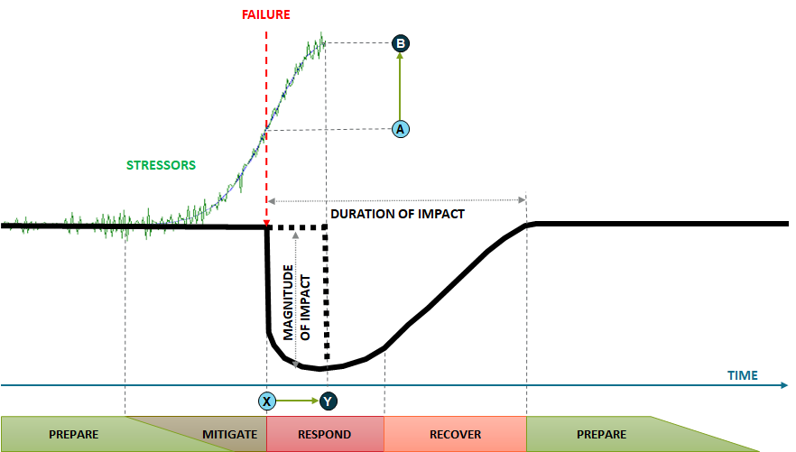

For example, hardening of the overhead transmission system is targeted at the “prepare” phase. Mitigation depends on the ability to detect developing issues and includes the capability to detect stresses on the grid by monitoring it. Responding to an event as it is impacting the grid depends on the ability to make informed decisions, to deploy crews rapidly to the right place at the right time, and for the grid to adapt to the stresses through reconfiguration. Recovery depends on coordinated activity and good planning.

In Figure 2‑1, the level of strain on the grid caused by the early effects of an event that could cause asset failure is represented by ‘A’. As an example, this might be a wooden transmission pole, with failure occurring at time ‘X’. In this example suppose a steel monopole was used to replace the wood pole transmission structure. The monopole might succumb to failure at higher strain levels depicted by ‘B’ and would result in later failure at time ‘Y’.

For the line where this occurred, this illustrates how hardening did not prevent failure but delayed it and shortened the outage duration. If it takes more work to erect a new monopole it might increase recovery time for a specific line, yet if less steel monopoles failed relative to the number of wood poles that would have failed, there would be less to replace and the overall system outage time and recovery time would be reduced. Fewer asset failures means that more crews will be able to work on the assets that do fail, which can have a multiplying effect on outage reduction time.

The Storm Resilience Model evaluates the phases of resilience for storms on both the entire system and at the sub-system level (substations, transmission circuit, site access, feeder, and lateral). Section 2.3 provides additional detail on this evaluation approach.

## Evaluated System for Resilience Investment

The Storm Resilience Model (described in more detail in Section 2.3) is comprehensive in that it evaluates nearly all of TEC’s T&D system. Table 2‑1 shows the asset types and counts included in the Storm Resilience Model.

Table 2‑1: TEC Asset Base Modeled

|  |  |  |
| --- | --- | --- |
| Asset Type | Units | Value |
| Distribution Circuits | **[count]** | **710** |
| Feeder Poles | [count] | 58,700 |
| Lateral Poles | [count] | 122,500 |
| Feeder OH Primary | [miles] | 2,300 |
| Lateral OH Primary | [miles] | 3,900 |
| Transmission Circuits | **[count]** | **215** |
| Wood Poles | [count] | 5,000 |
| Steel / Concrete / Lattice Structures | [count] | 20,400 |
| Conductor | [miles] | 1,300 |
| Substations | **[count]** | **9** |
| Site Access | **[count]** | **44** |
| Roads | [count] | 25 |
| Bridges | [count] | 19 |

1. All of the assets are strategically grouped into potential hardening projects, and only the assets that require hardening are included in the projects. For distribution projects, assets were grouped by their most upstream protection device, which was either a breaker, a recloser, trip savers, or a fuse. For lateral projects, where applicable, several protection zones were combined that were electrically connected right off the circuit feeder. This approach focuses on reducing customer outages. The objective is to harden each asset that could fail and result in a customer outage. Since only one asset needs to fail downstream of a protection device to cause a customer outage, failure to harden all the necessary assets still leaves weak links that could potentially fail in a storm. Rolling assets into projects at the protection device level allows for hardening of all weak links in the circuit and for capturing the full benefit for customers.

For lateral projects, those with a fuse or trip saver protection device, the preferred hardening approach is to underground the overhead circuits. Since the main cause of storm related outages, especially for weakened structures, is the wind blowing vegetation into conductor, causing structure failures, undergrounding lateral lines provides full storm hardening benefits. While rebuilding overhead laterals to a stronger design standard (i.e. bigger and stronger poles and wires) would provide some resilience benefit, it would not solve the vegetation issues, since the high wind speeds can blow tree limbs from outside the trim zone into the conductor.

For distribution feeder projects, those with a recloser or breaker protection device, the preferred hardening approach is to rebuild to a storm resilient overhead design standard and add automation hardening. Assets in these projects include older wood poles and those with a ‘poor’ condition rating. Additionally, poles with a class that is not better than ‘1’ were also included in these projects. The combination of the physical hardening and automation hardening provides significant resilience benefit for feeders. The physical hardening addresses the weakened infrastructure storm failure component. While the vegetation outside the trim zone as still a concern, most distribution feeders are built along main streets where vegetation densities outside the trim zone are typically less than compared to laterals. Further, the feeder automation hardening allows for automated switching to perform ‘self-healing’ functions to mitigate vegetation outside trim zone and other types of outages. The combination of the physical and automation hardening provide a balanced resilience strategy for feeders. It should be noted that this balanced strategy with automation hardening is not available for laterals. As such, undergrounding is preferred approach for lateral hardening and overhead physical hardening combined with automation hardening is the preferred approach for feeders.

At the transmission circuit level, wood poles were identified for hardening by replacing with non-wood materials like steel, spun concrete, and composites. These materials have consistent external shell strength while wood poles can vary widely and are more likely to fail. Transmission wood poles were grouped at the circuit level into projects.

TEC identified 44 separate transmission access, road, and bridge projects based on field inspection of the system.

TEC performed detailed storm surge modeling using the Sea, Land, and Overland Surges from Hurricanes (SLOSH) model. The SLOSH model identified 59 substations with a flood risk, depending on the hurricane category. Based on TEC’s more detailed assessment, 9 substations were identified that included flooding risk to the level that could justify investment.

Table 2‑2 contains a list of potential hardening projects based on the methodology outlined above. As seen below, there are a significant number of potential hardening projects, over 13,800. The following sections outline the approach to selecting the hardening projects that provide the most value to customers from a restoration cost and CMI decrease perspective.

Table 2‑2: Potential Hardening Projects Considered

|  |  |
| --- | --- |
| Program | Project Count |
| Distribution Lateral Undergrounding | 12,310 |
| Transmission Asset Upgrades | 107 |
| Substation Extreme Weather Hardening | 9 |
| Distribution Overhead Feeder Hardening | 1,385 |
| Transmission Access Enhancements | 44 |
| Total | 13,855 |

## Resilience Planning Approach Overview

The resilience-based planning approach calculates the benefit of storm hardening projects from a customer perspective. This approach calculates the resilience benefit at the asset, project, and program level within the Storm Resilience Model. The results of the Storm Resilience Model are a:

1. Reduction in the Storm Restoration Costs
2. Reduction in the number of customers impacted and the duration of the overall outage, calculated as CMI

Figure 2‑2 provides an overview of the resilience planning approach to calculate the customer benefit, restoration cost reduction and CMI reduction of hardening projects and prioritization of the projects.

### Major Storms Event Database

Since the magnitude of the restoration cost decrease and CMI decrease is dependent on the frequency and magnitude of future major storm events, the Storm Resilience Model starts with the ‘universe’ of major storm events that could impact TEC’s service territory, the Major Events Storms Database.

Figure 2‑2: Resilience Planning Approach Overview

The Major Storms Event Database describes the stressor that causes system failure. The database also provides the high-level impact to the system of the storm stressor. The major events database includes the following:

* Storm Type
* Probability of a storm occurring
* Restoration Costs
* Percentage of the system impacted
* Duration of the storm

The major storm events database includes 13 unique storm types. The storm types include the various hurricane categories and direction they come from (hurricane impacts from the Gulf side are much different than from the Florida side). Each storm type has a range of probabilities and impacts. With the various combinations (high probability with lower consequence and low probability with high consequence, etc.) the Major Storms Event Database includes 99 different storm scenarios. Section 3.0 provides additional detail on the Major Storms Event Database.

### Storm Impact Model

Each storm scenario is then modeled within the Storm Impact Model to identify which parts of the system are most likely to fail given each type of storm. The Storm Impact Model calculates the restoration costs and customers impacted by system failures for both the Status Quo and Hardened Scenarios. The Storm Impact Model identifies the damaged portions of the system by modeling the elements that cause failures in the TEC asset base.

For circuits, the main cause of failure is wind blowing vegetation onto conductor causing conductor or structures to fail. If structures (i.e. wood poles) have any deterioration, for example rot, they are more susceptible to failure. The Storm Impact Model calculates a storm LOF score for each asset based on a combination of the vegetation rating, age and condition rating, and wind zone rating. The vegetation rating factor is based on the vegetation density around the conductor. The age and condition rating utilize expected remaining life curves with the asset’s ‘effective’ age, determined using condition data. The wind zone rating is based on the wind zone that the asset is located within. The Storm Impact Model includes a framework that normalizes the three ratings with each other to develop one overall storm LOF score for all circuit assets. The project level scores are equal to the sum of the asset scores normalized for length. The project level scores are then used to rank each project against each other to identify the likely lateral, backbone, or transmission circuit to fail for each storm type. The model estimates the weighted storm LOF based on the asset level scoring.

The model determines which substations are likely to flood during various storm types based on the flood modeling analysis. That analysis provides the flood level, meaning feet of water above the site elevation, for various storm types.

Each transmission site access project provides access to one or more transmission circuits. If a major storm event causes a transmission outage and the access location is also impacted, it can take longer to restore the system. The Storm Impact Model uses each transmission circuit’s storm LOF to estimate the LOF of each site access during a storm. For instance, if site access ‘A’ is needed to gain access to Circuit ‘1’ and ‘4’, the storm likelihood for site access ‘A’ equals the storm likelihood of failure for Circuit ‘1’ and ‘4’ combined.

Once the Storm Impact model identifies the portions of the system that are damaged and caused an outage for a specific storm, it then calculates the restoration costs to rebuild the system to provide service. The restoration costs are based on the multipliers for storm replacement over the planned replacement costs using TEC labor and procured materials only. The restoration cost multipliers are based on historical storm events and the expected outside labor and expedited material cost needed to restore the system.

Similarly, the Storm Impact Model calculates the CMI for each project. Since circuit projects are organized by protection device, the customer counts and customer types are known for each asset in the Storm Impact Model. The time it will take to restore each protection device, or project, is calculated based on the expected storm duration and the hierarchy of restoration activities. This restoration time is then multiplied by the known customer count to calculate the CMI. The CMI benefit is monetized using DOE’s ICE Calculator for project prioritization purposes.

Finally, the Storm Impact Model then calculates the reductions in project storm LOF, restoration costs, and CMI for each hardening project. The output of the Storm Impact Model is the project LOF, CMI, monetized CMI, and restoration costs for each of the 99 storms for both the Status Quo and Hardened scenarios.

### Resilience Benefit Calculation

The Resilience Benefit Calculation utilizes stochastic modeling, or Monte Carlo simulation, to select a storm scenario for each of the 13 storm types for 1,000 iterations. This produces 1,000 different future “storm worlds” and the expected range of benefit values depending on the different probabilities and impact ranges to the TEC system. The probability of each storm scenario is multiplied by the benefits calculated for each project from the Storm Impact Model to provide a resilience-weighted benefit for each project in dollars. Feeder Automation Hardening projects are evaluated based on historical outages and the expected decrease in historical outages if automation had been in place.

### Project Scheduling and Budget Optimization

The Project Scheduling and Budget Optimization model prioritizes the projects based on the highest ratio of resilience benefit to cost. It also performs a budget optimization simulation to identify the point of diminishing returns for hardening investments for the 10-year period and portions of the system evaluated.

The model prioritizes each project based on the sum of the restoration cost benefit and monetized CMI benefit divided by the project cost. This calculation is performed for the range of potential benefit values to create the resilience benefit cost ratio. The model also incorporates TEC’s technical and operational constraints in scheduling the projects such as contractor capacity and scheduling transmission planned outages. Using the Resilience Benefit Calculation and project scheduling model, the Storm Resilience Model calculates the net benefit in terms of reduced restoration costs and CMI for the 10-year investment profile.

Budget optimization is performed by running the model over a wide range of budget scenarios. Each budget scenario calculates the range in reduction of restoration costs and CMI. The budget optimization calculates the point where incremental hardening investments result in diminishing returns in customer benefit.

## S-Curves and Resilience Benefit

The results of the 1,000 iterations are graphed in a cumulative density function, also known as an ‘S-Curve’. In layman’s terms, the thousand results are sorted from lowest to highest (cumulative ascending) and then charted. Figure 2‑3 shows an illustrative example of the 1,000 iteration simulation results for the ‘Status Quo’ and Hardened Scenarios.

Figure 2‑3: Status Quo and Hardened Results Distribution Example

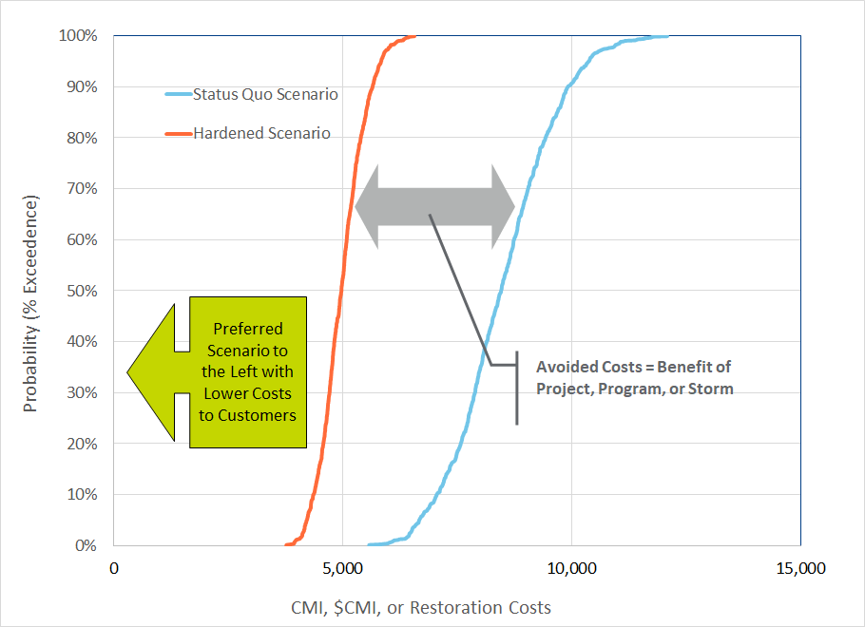

The horizontal axis shows the storm cost in terms of CMI, monetized CMI, or restoration costs. The values in the figure are illustrative. The vertical axis shows the percent exceedance values. For the Hardened Scenario, the chart shows a value of 5,000 at the 40-percentile level. This means there is a 40 percent confidence that the Hardened Scenario will have a value of 5,000 or less. Each of the probability levels is often referred to as the P-value. In this case the P40 (40 percentile) has a value of 5,000 for the Hardened Scenario.

Since the figure shows the overall cost (in minutes or dollars) to customers, the preferred scenario is the S-Curve further to the left. The gap or delta between the two curves is the overall benefit.

The S-Curves typically have a linear slope between the P10 and P90 values with ‘tails’ on either side. The tails show the extremes of the scenarios. The slope of the line shows the variability in results. The steeper the slope (i.e. vertical) the less range in the result. The more horizontal the slope the wider the range and variability in the results. Figure 2‑4 provides additional guidance on understanding the S-Curves and the kind of future storm worlds they represent.

Figure 2‑4: S-Curves and Future Storms

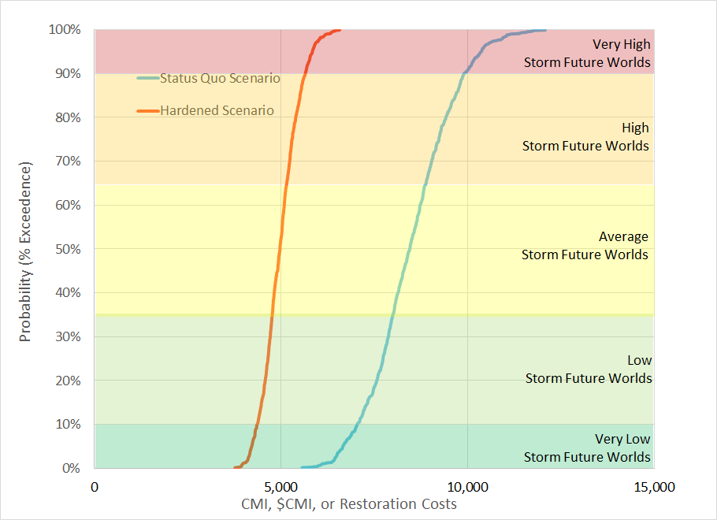

For the storm resilience evaluation, the top portion of the S-curves is the focus as it includes the average to very high storm futures, this is referred to as the resilience portion of the curve. Rather than show the entire S-curve, the results in the report will show specific P-values to highlight the gap between the ‘Status Quo’ and Hardened Scenarios. Additionally, highlighting the specific P-values can be more intuitive. Figure 2‑5 illustrates this concept of looking at the top part of the S-curves and showing the P-values. Section 7.0 includes results figures similar to the second figure in Figure 2‑5 below.

Figure 2‑5: S-Curves and Resilience Focus

9



# Major Storms Event Database

The first main component of the Storm Resilience Model is the Major Storms Event Database. The database describes the phases of resilience, Figure 2‑1, for the TEC high-level system perspective for a range of storm stressors. This section describes the data sources and approach used to develop the database. Since the benefits of hardening projects are directly related to the frequency and impact of major storm events, the resilience-based planning approach starts with developing the range of storm types that could impact TEC’s service territory. The impact of major storm events to the TEC system is dependent on following:

* Wind speeds of the storm (i.e. category of storm). Higher wind speeds means more trees and tree limbs from inside and outside of the tree trim zone on the conductor. The additional weight and forces on the conductor cause pole or tower failures. At high enough wind speeds, the wind speed alone can cause a structure failure.
* Direction that it comes from (Gulf or Florida). Storms from the Gulf could bring storm surge and associated flooding. Additionally, the counter-clockwise storm band rotation include different level of energy (i.e. wind speed) if they have been over land for a period of time.
* Eye Distance from TEC’s territory. Storms that directly hit Tampa are impactful since the entire service territory effectively gets hit twice by the storm bands. Additionally, the total duration of the event is longer. For more distant storms, only a few storm bands may hit the TEC service territory.

The major storms event database includes the range of storm stressors that would cause an outage(s) to the TEC system based on the three main contributing factors above. The database includes both the probability of the storm stressor, impact in terms of restoration costs and duration, and impact with respect to which parts of the TEC system fail. The following sections provide additional analysis and commentary on how these assumptions were developed for the storms event database.

## Analysis of NOAA Major Storm Events

The National Oceanic and Atmospheric Administration (NOAA) includes a database of major storm events over 169years, beginning in 1852. This database was mined to evaluate the different types and frequency of major storms to impact the TEC service territory. Figure 3‑1 provides an example screen shot from NOAA’s storms database. It shows all the events, including path and category, to come within 50 miles of TEC’s service territory center.

Figure 3‑1: NOAA Example Output – 50 Mile Radius

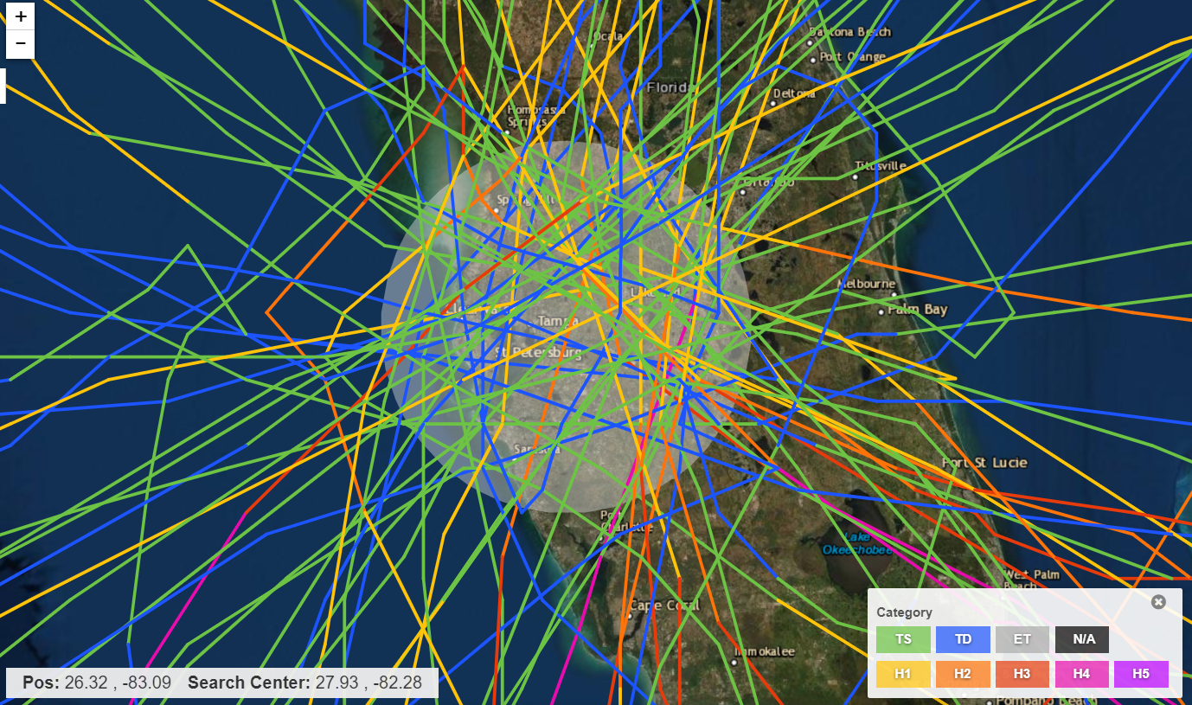

Source: <https://coast.noaa.gov/hurricanes/>

This database was mined for all major event types up to 150 miles from TEC service territory center. The 150-mile radius was selected since many hurricanes can have diameters of 300 miles where some of the hurricane storm bands impact a significant portion of the TEC service territory. Additionally, the database was mined for the category of the storm as it hit the TEC service territory. The analysis of NOAA’s database was done for the following types of storm categories:

* ‘Direct Hits’ – 50 Mile Radius from the Gulf and Florida directions. The max wind speeds hit all or significant portions of TEC service territory twice, once from the front end and again on the back end of the storm. Additionally, the wind speeds cause all the assets and vegetation to move in one direction as the storm comes in and in the opposite direction as it moves out. This double exposure to the system causes significant system failures.
* ‘Partial Hits’ – 51 to 100 Mile Radius. At this radius, the storm bands hit a significant portion of the TEC service territory. Wind speeds are typically at their highest at the outer edge of the storm bands. The storm passes through the territory once, so to speak, minimizing damage relative to a ‘direct hit’. For large category storms, the ‘Partial Hit’ could still cause more damage than a ‘Direct Hit’ small storm.
* ‘Peripheral Hits’ – 101 to 150 Mile Radius. Since hurricanes can be 300 miles wide in diameter, some of the storm bands can hit a fairly large portion of the system even if the main body of the storm misses the service area.

Table 3‑1 includes the summary results from the NOAA database of storms to hit or nearly hit the TEC service territory since 1852.

Table 3‑1: Historical Storm Summary

|  |  |  |  |  |  |  |
| --- | --- | --- | --- | --- | --- | --- |
| **Event Type** | **Direct Hits Gulf** | **Direct Hits Florida** | **Direct Hits Total** | **Partial Hits** | **Peripheral Hits** | **Total** |
| Cat 5 | 0 | 0 | 0 | 0 | 0 | 0 |
| Cat 4 | 0 | 1 | 1 | 0 | 1 | 2 |
| Cat 3 | 0 | 1 | 1 | 5 | 4 | 10 |
| Cat 2 | 4 | 1 | 5 | 2 | 8 | 15 |
| Cat 1 | 6 | 6 | 12 | 14 | 8 | 34 |
| Tropical Storm | 12 | 20 | 32 | 30 | 29 | 91 |
| Tropical Depression | 10 | 8 | 18 | 17 | NA | 35 |
| Total | 32 | 37 | 69 | 68 | 50 | 187 |

Table 3‑1 shows a total of 187 storms to hit the Tampa area since 1852. A total of 69 were direct hits within 50 miles, 68 were partial hits in the 51 to 100-mile radius, and 50 were peripheral hits in the 101 to 150 mile radius. The table also shows very few category 4 and above events, 2 out of 187, with one ‘Direct Hit’. While there are 10 Category 3 types storms, only 1 is a ‘Direct Hit’. Nearly 20 percent of the events are Category 1 Hurricanes. Almost two thirds of the events are Tropical Storms or Tropical Depressions. For direct hits, the results show approximately 46 percent of the events come from the Gulf of Mexico while the other 54 percent come over Florida. The direction the storm comes from has significant impact on the overall damage to TEC’s system. Based on these results and the various quantities by event type, the following 13 unique storm types serves as the foundation for the Major Storms Event Database:

Category 3 and Above ‘Direct Hit’ from the Gulf

Category 1 & 2 ‘Direct Hit’ over Florida

Category 1 & 2 ‘Direct Hit’ from the Gulf

Tropical Storm ‘Direct Hit’

Tropical Depression ‘Direct Hit’

Localized Event ‘Direct Hit’

Category 3 and Above ‘Partial Hit’

Category 1 & 2 ‘Partial Hit’

Tropical Storm ‘Partial Hit’

Tropical Depression ‘Partial Hit’

Category 3 and Above ‘Peripheral Hit’

Category 1 & 2 ‘Peripheral Hit’

Tropical Storm ‘Peripheral Hit’

Each of these storm types serve as a stressor on the system that causes an outage and damage. The next three subsections provide a historical analysis of storm events that impacted TEC’s Service Territory to provide information on the probability of each of the 13 storm types.

### Direct Hits (50 Miles)

Figure 3‑2 provides a historical view of the number of major storm events to hit the TEC service territory over the last 169 years. The figure shows 6 different storm types. Figure 3‑3 converts the storm data in Figure 3‑2 to show the total storm count for a 100-year rolling average starting with the period 1852 to 1951. Review of the two figures shows there have been no Category 3 or above hurricanes to hit the TEC service territory from the Florida side.

Figure 3‑2: “Direct Hits” (50 Miles) Over Time[2]

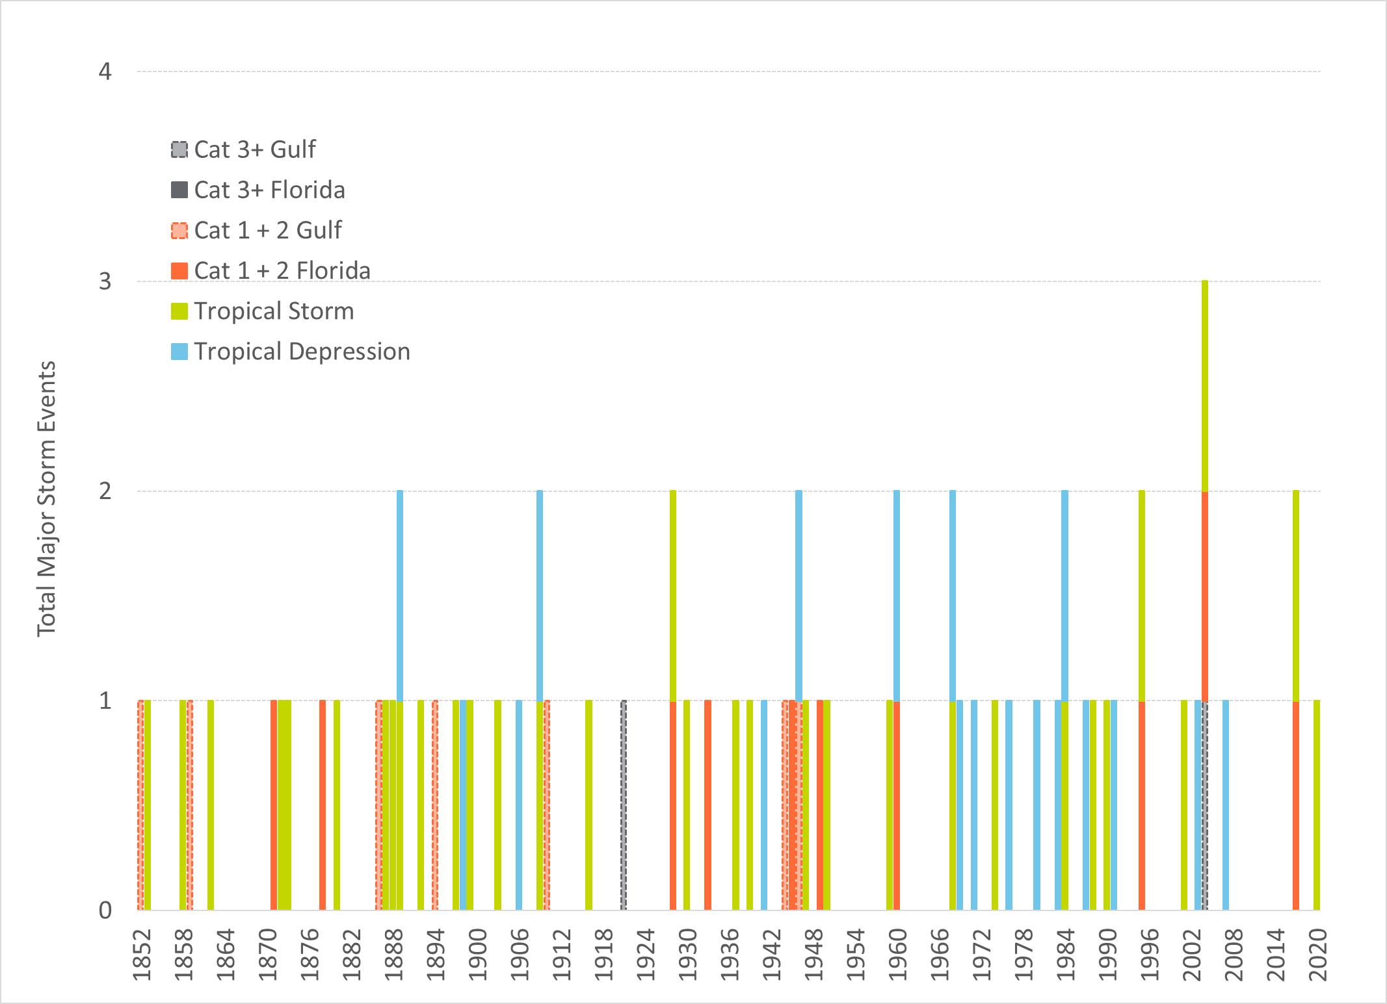

Figure 3‑3 shows an average of approximately 40 storms for each rolling 100-year period from 1951 to 2020. The rolling 100-year average results show a stability to the number of ‘Direct Hits’ over the time horizon. The figure shows a relative stability in the number of Category 1 and above storms over the period. Even though there is relative stability in the 40-storm average for the 100-year rolling average time horizon, the figure shows a decrease in the number of tropical storms with a corresponding increase in the number of tropical depressions. Figure 3‑4 converts the totals for each 100-year period in Figure 3‑3 to probabilities by dividing by 100.

Figure 3‑3: “Direct Hits” (50 Miles) 100 Year Rolling Average[3]

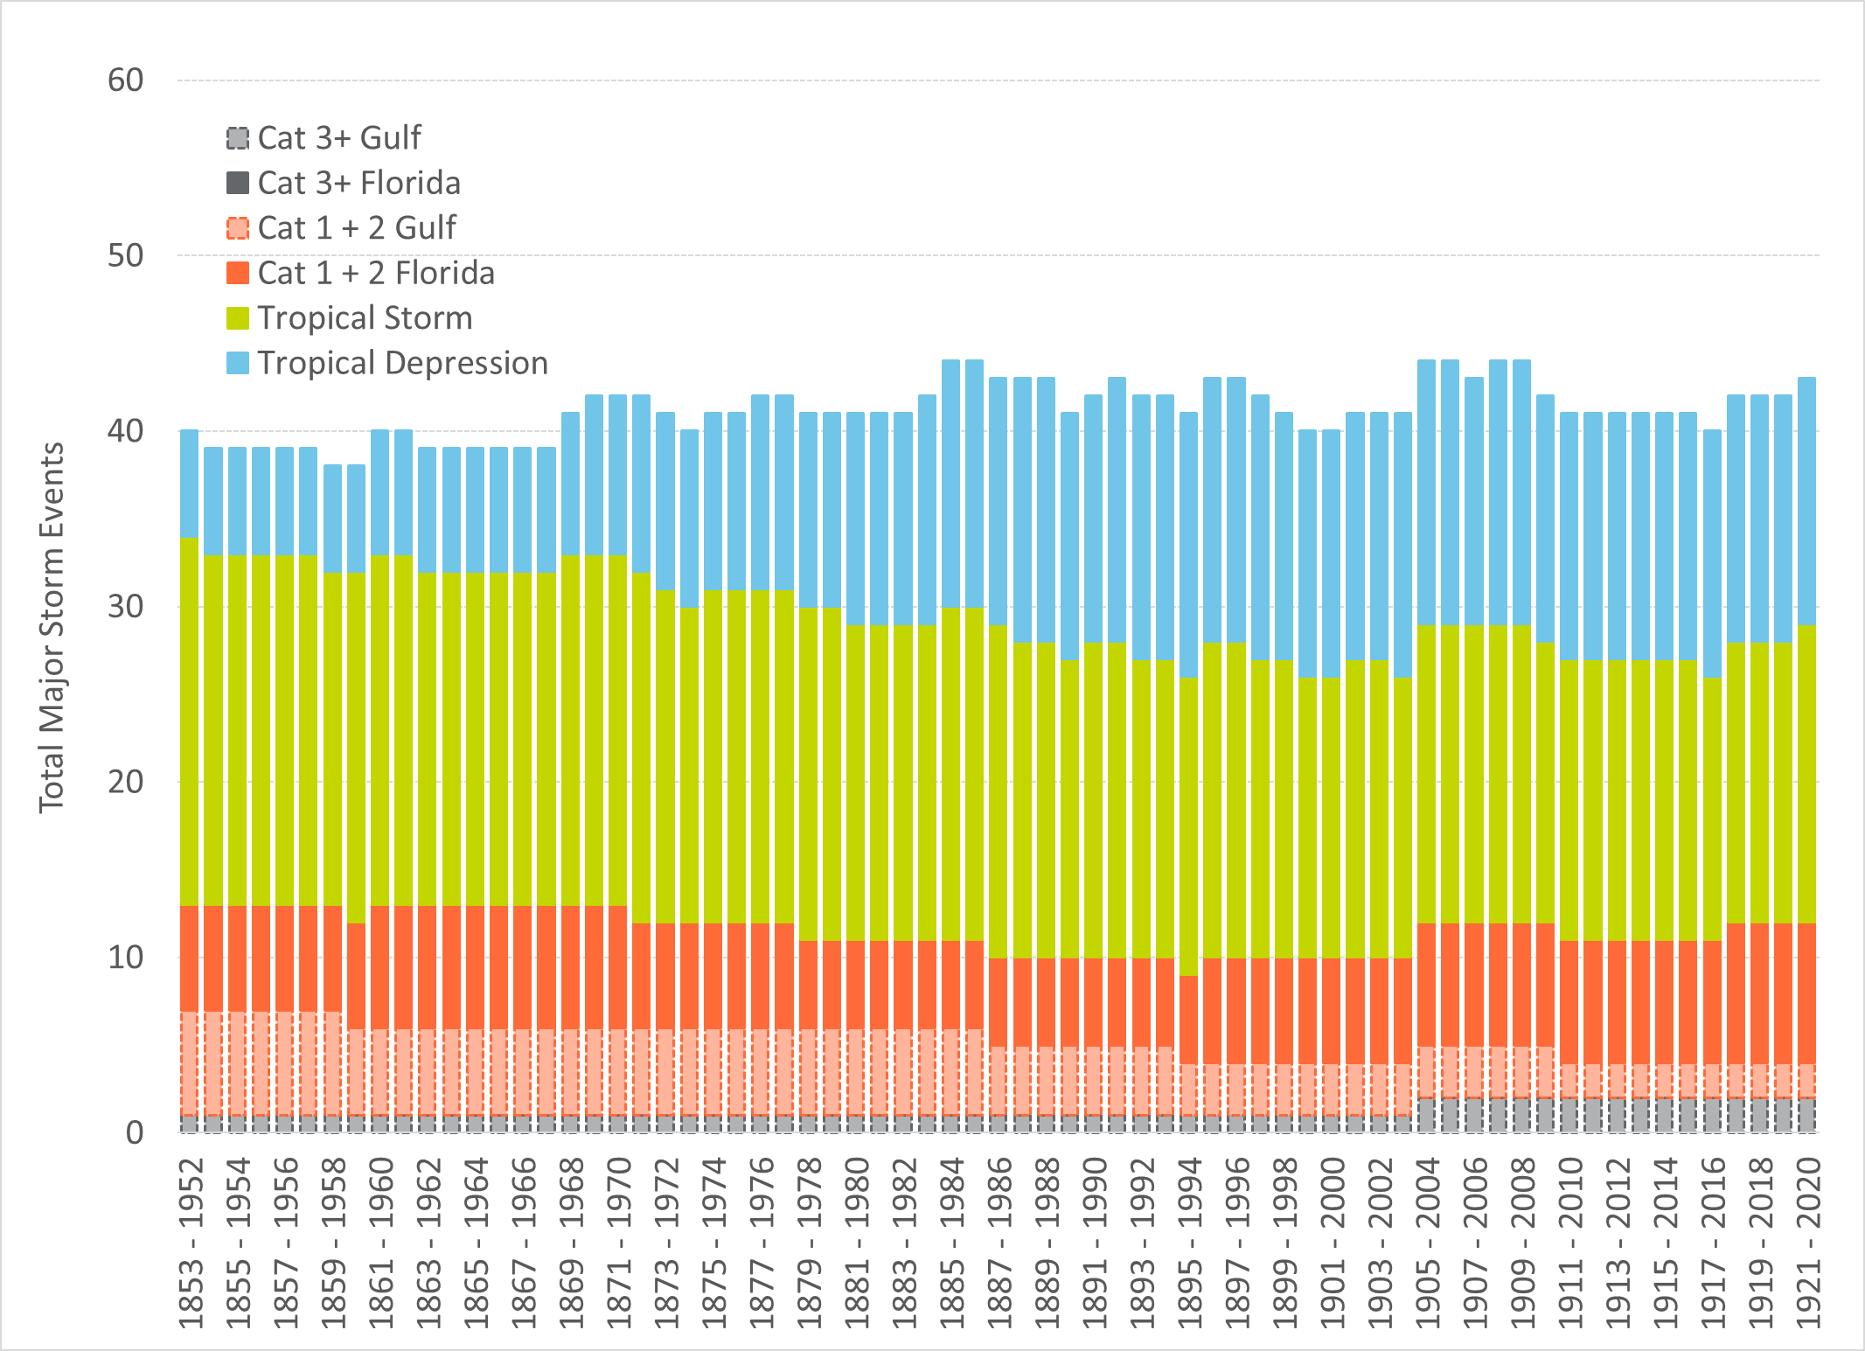

Figure 3‑4: “Direct Hits” (50 Miles) 100 Year Rolling Probability3

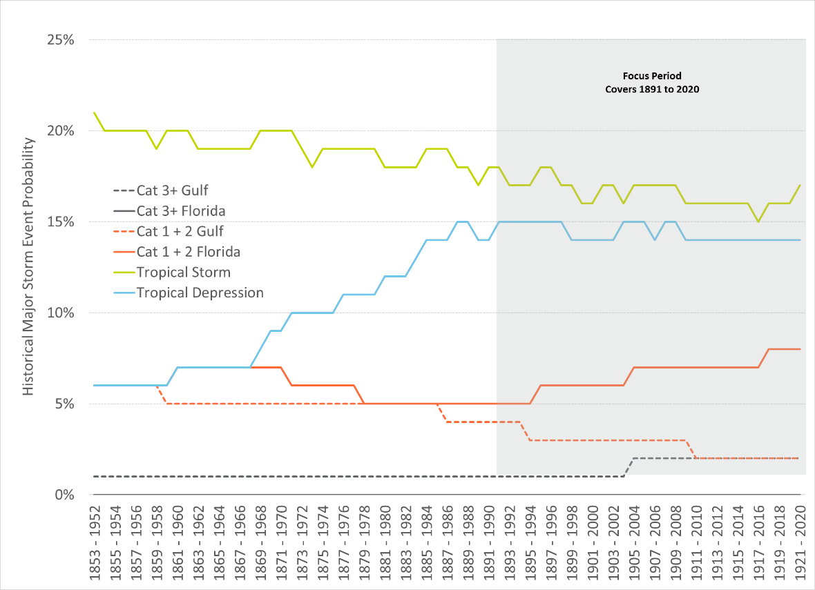

The figure shows a low historical probability for Category 3 and above events from the Gulf of 1 to 2 percent. Additionally, there has been a decrease in the probability of Category 1 and 2 storms from the Gulf with a corresponding increase in the number coming from the Florida side. The story is similar for Tropical Storms and Tropical Depressions. The number of Tropical Storms shows a steady relative decline with a significant increase in probability of Tropical Depression until 1990 and stabilizes thereafter. As the figure shows, the probabilities of failure show a relative stability for the 100-year rolling average probabilities from 1990 to 2020, which encompasses thirty 100-year periods. Given the recent stability over this period these probability ranges were utilized in the Major Storms Event Database.

### Partial Hits (51 to 100 Miles)

Figure 3‑5 provides a historical view of the number of major storm events that have partially hit the TEC service territory over the last 169 years. A storm is classified as a partial hit if the eye passes between 51 and 100 miles from TEC’s service territory. The figure shows 4 different storm types. Figure 3‑6 converts the storm data in Figure 3‑5 to show the total storm count for a 100-year rolling average starting with the period 1852 to 1951. The 100-year rolling average of storm events for partial hits follows a similar profile to that of direct hits, but it does show that Category 3 storms have hit TEC’s service territory within a 51 to 100-mile radius throughout the rolling average windows in the analysis. This illustrates that there is a real possibility that TEC’s service territory will be impacted by a Category 3 or higher hurricane each year.

Figure 3‑5: “Partial Hits” (51 to 100 Miles)[4]

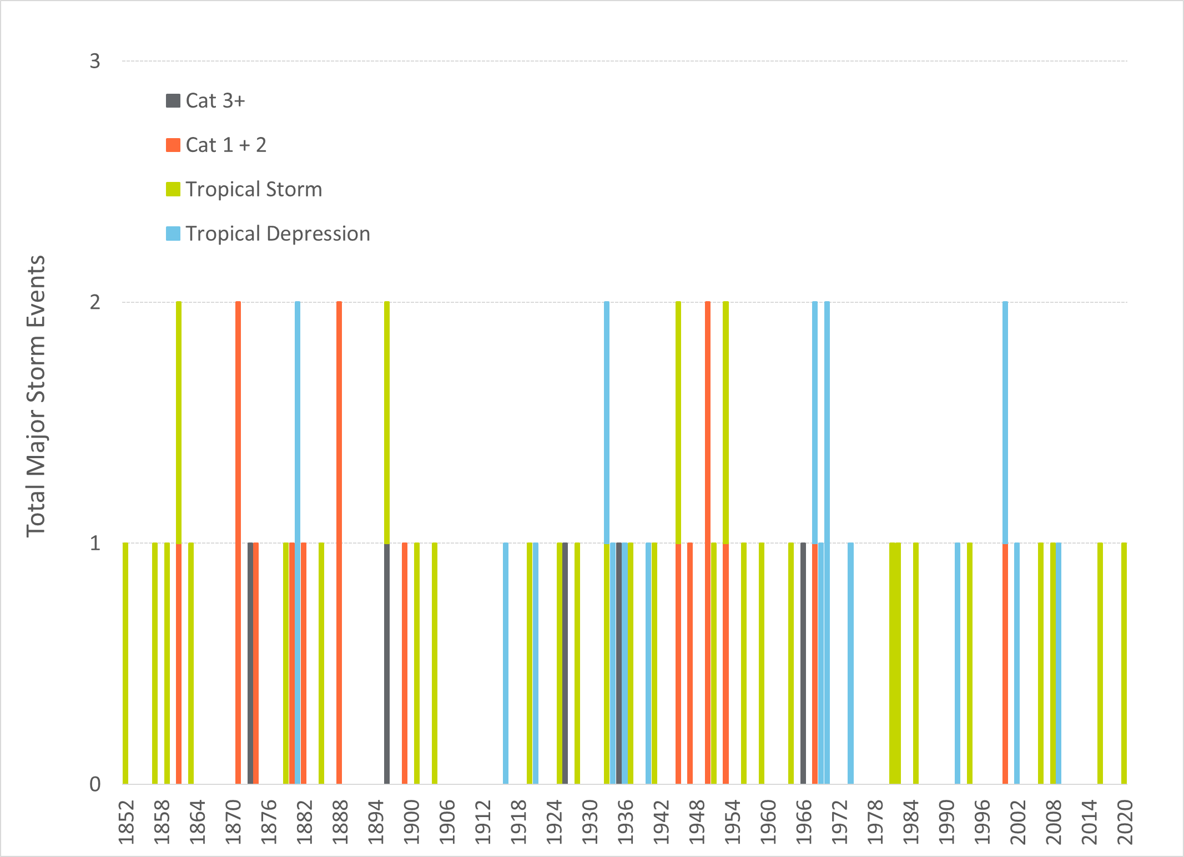

Figure 3‑5 shows an average storm count of approximately 42 for each rolling 100-year period from 1951 to 2020. The rolling 100-year average results show a stability to the number of ‘Partial Hits’ over the time horizon. The figure shows a slight decline in the number of Category 1 and 2 storms over the period. As the overall storm count has remained stable, the slight decline in Category 1 and 2 storms was inversely mirrored by an increase in tropical depression counts.

Figure 3‑7 converts the totals for each 100-year period in Figure 3‑6 to probabilities by dividing by 100. This figure further illustrates the change in storm type distributions as Category 1 and 2 storms gave way to tropical depressions. The reason for the shift is unknown, but it is possible that this change is due to increases in data accuracy or recording procedures over time.

Figure 3‑6: “Partial Hits” (51 to 100 Miles) 100 Year Rolling Average[5]

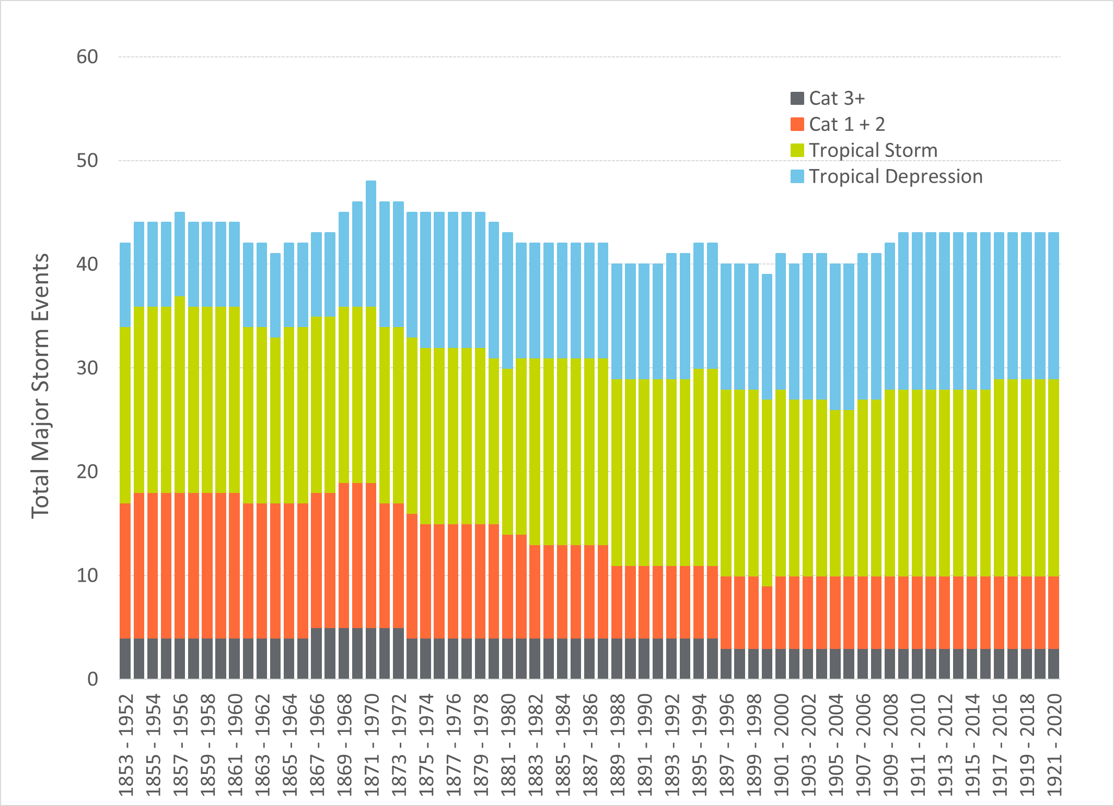

Figure 3‑7: “Partial Hits” (51 to 100 Miles) 100 Yr. Rolling Probability5

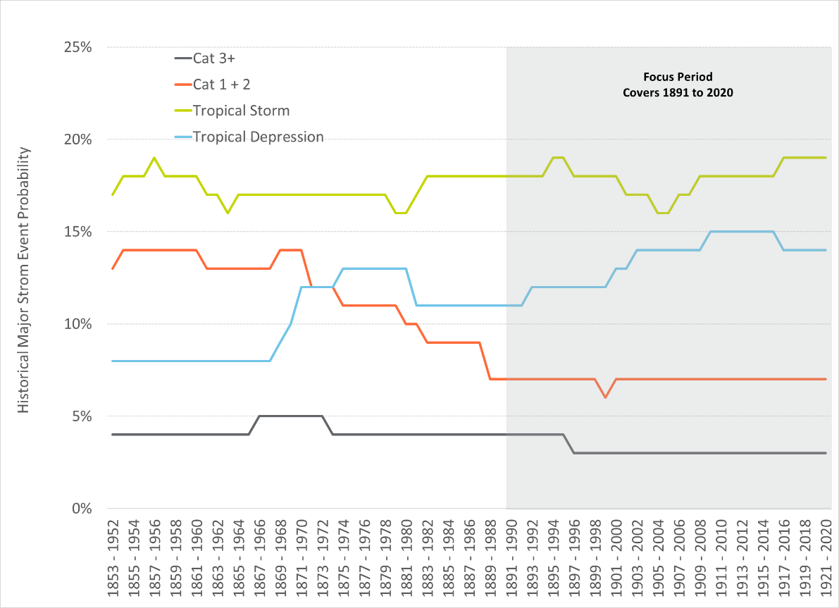

### Peripheral Hits (101 to 150 Miles)

Figure 3‑8 provides a historical view of the number of major storm events that have hit TEC’s service territory in the periphery over the last 169 years. A storm is classified as a partial hit if the eye passes between 101 and 150 miles from TEC’s service territory. Since tropical depressions within this range may not be large enough to impact TEC’s service territory, the figure only includes Tropical Storms, Category 1 and 2 storms, and Category 3 and higher storms. Figure 3‑9 converts the storm data in Figure 3‑8 to show the total storm count for a 100-year rolling average starting with the period 1853 to 1952.

Figure 3‑8: “Peripheral Hits” (101 to 150 Miles)[6]

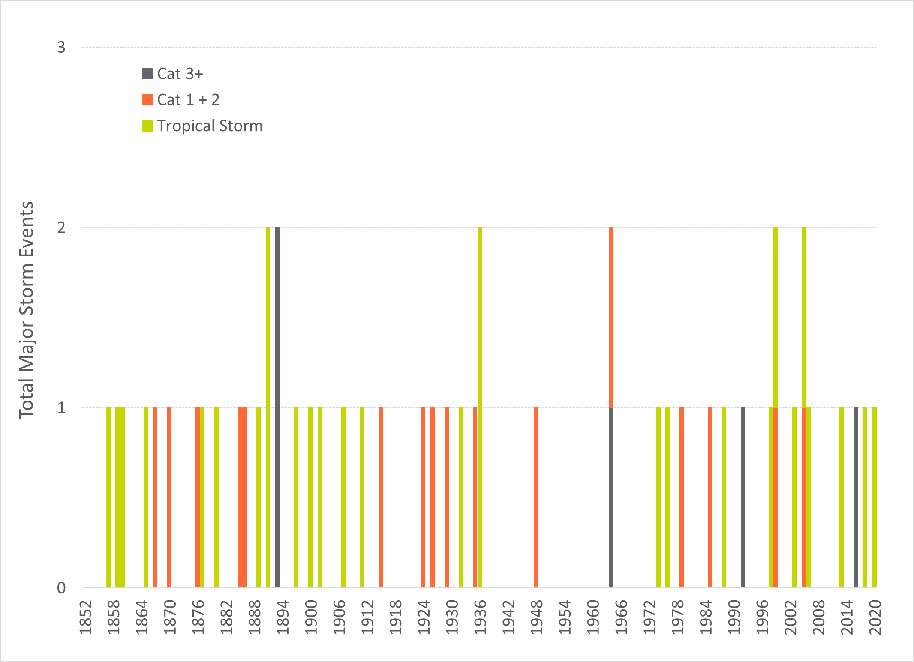

The 100-year rolling average of storm events for peripheral hits shows a slight decline from 30 to 25 storms, mostly driven by a decline in Tropical Storms.

Figure 3‑10 converts the totals for each 100-year period in Figure 3‑9 by dividing by 100. This figure further illustrates the decline in probability of Tropical Storms over the analysis period.

Figure 3‑9: “Peripheral Hits” (51 to 100 Miles) 100 Yr. Rolling Avg.[7]

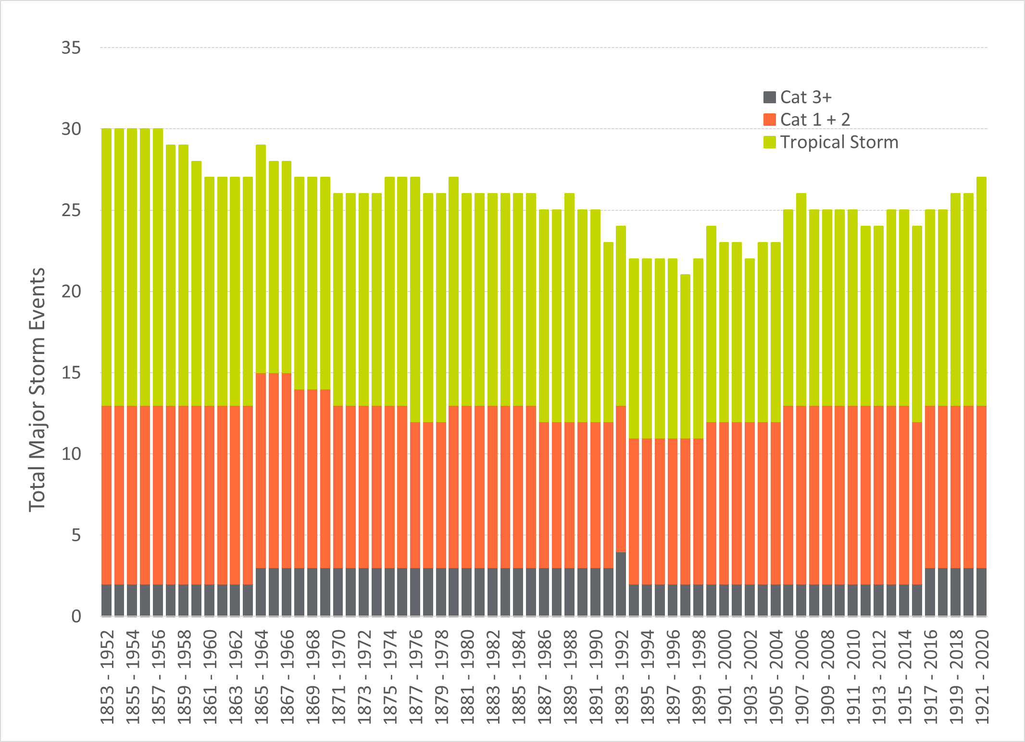

Figure 3‑10: “Peripheral Hits” (51 to 100 Miles) 100 Yr. Rolling Probability7

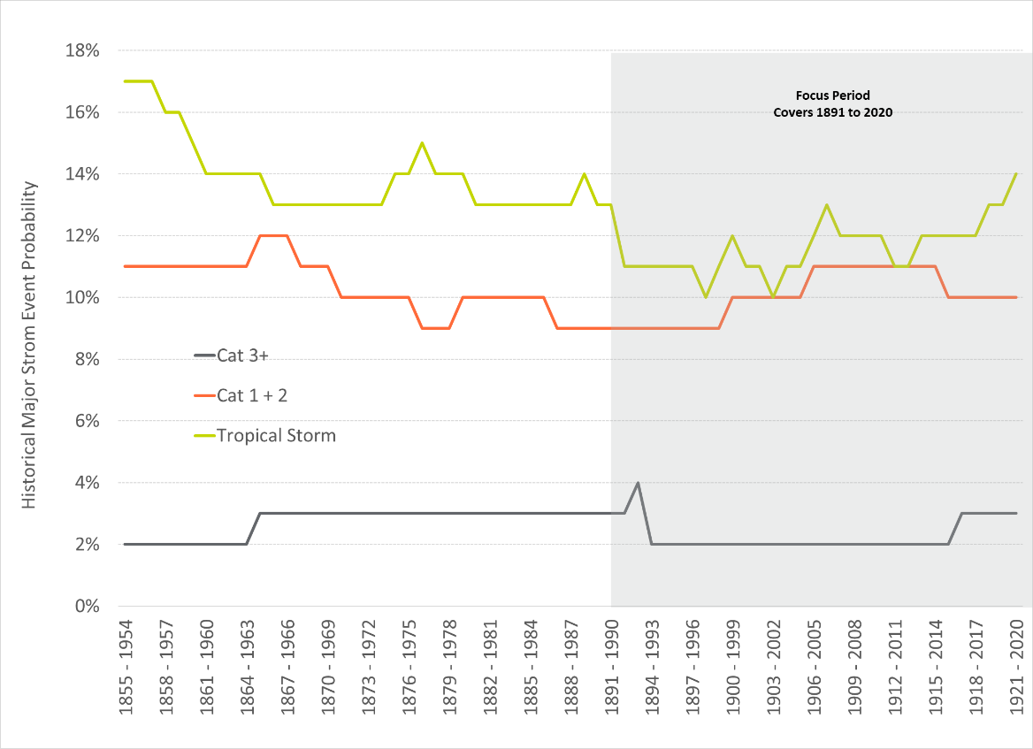

## Major Storms in the Future

Section 3.1 reviewed the historical major events to hit the TEC service territory over the last 169 years. It is unclear whether climate change is affecting or will affect the frequency or severity of major storm events in the future. Research into this question reveals that there is no statistical evidence to support a higher frequency of major storm activity. The World Meteorological Organization provided the following comment:

“Though there is evidence both for and against the existence of a detectable anthropogenic signal in the tropical cyclone climate record to date, no firm conclusion can be made on this point. However, research shows that there is evidence that the magnitude of the events are and will continue to increase.”

Given this research, the Major Storm Event Database utilizes the historical probabilities for future storm probability. The impact of the events is discussed in the next section.

## Major Storms Impact

Table 3‑2 shows the damages cost of recent major storms to hit the Southeast United States. The table shows that the costs of these major events is significant.

Table 3‑2: Recent Major Event Damages Cost

|  |  |  |  |
| --- | --- | --- | --- |
| Storm Name | Category | Year | Damages  (2018 $Billions) |
| Michael | 5 | 2018 | $25 |
| Irma | 4 | 2017 | $51 |
| Matthew | 5 | 2016 | $10 |
| Wilma | 3 | 2005 | $10 |
| Dennis | 3 | 2005 | $3 |
| Jeanne | 3 | 2004 | $9 |
| Ivan | 3 | 2004 | $19 |
| Frances | 2 | 2004 | $12 |
| Charley | 4 | 2004 | $19 |

The costs shown in the table are all damage costs to society and are based on insurance claims. The utility restoration costs are one element of this total. The TEC storm reports provide information on the restoration costs of historical events to hit the TEC service territory. Figure 3‑11 provides a summary of the storm report for Hurricane Irma in 2017. It cost TEC approximately $100 million and restoration took slightly more than 7 days. Table 3‑3 provides a summary of other recent TEC storm reports.

Figure 3‑11: Hurricane Irma Impact to TEC Service Territory[8]

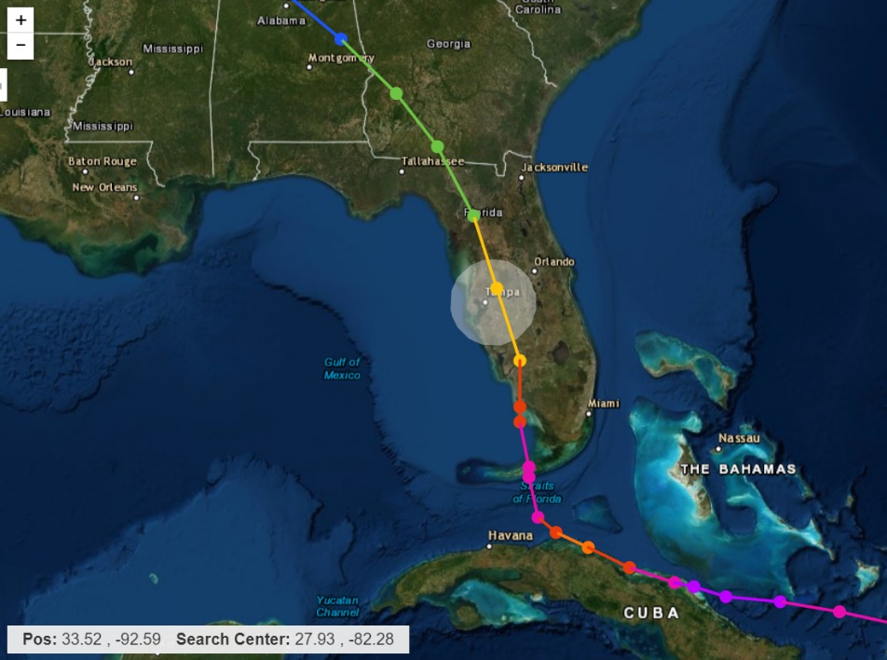

**Storm Name: Irma**

**Year: 2017**

**TEC Cost: ~$100 million**

**Category: 1 over Florida**

**Radius: 50 Miles**

**Outage Duration: 7 Days**

**System Impact:**

**15 T-Lines**

**200 Circuits**

**55% of Customers**

Table 3‑3: Storm Report Summary

|  |  |  |  |
| --- | --- | --- | --- |
| Storm Name | Category | Year | Damages  (2018 $Millions) |
| Irma | 1 | 2017 | $102 |
| Matthew | 3 | 2016 | $1 |
| Hermine | 1 | 2016 | $6 |
| Colin | TS | 2016 | $3 |

## Major Storms Database

TEC and 1898 & Co collaborated in developing the Major Storm Events Database. The database utilizes the results of the NOAA analysis to identify 13 unique storm types. With the range of storm probabilities, the range in cost for each unique storm type, and the range in system impact, the 13 unique storm types are represented by 99 different storm events. Table 3‑4 provides a summary of the Major Storms Event Database. The table includes the ranges of probabilities, restoration costs, impact to the system, and duration. Each of the 99 storm events are then modeled within the Storm Impact Model described more in the next section.

Table 3‑4: Storm Event Database

|  |  |  |  |  |  |
| --- | --- | --- | --- | --- | --- |
| **Storm Type No** | **Scenario Name** | **Annual Probability** | **Restoration Costs (Millions)** | **System Impact (Laterals)** | **Total Duration (Days)** |
| 1 | Cat 3+ Direct Hit - Gulf | 1.0% - 2.0% | $306 - $1,224 | 60% - 70% | 17.4 - 34.5 |
| 2 | Cat 1 & 2 Direct Hit – Florida | 5% - 8% | $76.5 - $153 | 35% - 55% | 6.0 - 8.8 |
| 3 | Cat 1 & 2 Direct Hit – Gulf | 2% - 4% | $153 - $306 | 45% - 60% | 8.7 - 12.9 |
| 4 | TS Direct Hit | 16.5% | $25.5 - $76.5 | 12.5% - 31.3% | 2.6 - 5.3 |
| 5 | TD Direct Hit | 14.5% | $5.1 - $15.3 | 6.3% - 15.6% | 2.0 - 3.6 |
| 6 | Localized Event Direct Hit | 50.0% | $0.5 - $1.5 | 1.3% - 3.1% | 0.3 - 0.6 |
| 7 | Cat 3+ Partial Hit | 3% - 4% | $91.8 - $184 | 36% - 48% | 6.4 - 9.2 |
| 8 | Cat 1 & 2 Partial Hit | 7.0% | $15.3 - $91.8 | 8.5% - 28% | 2.3 - 6.9 |
| 9 | TS Partial Hit | 17% - 18% | $11.5 - $30.6 | 8% - 15% | 2.0 - 3.6 |
| 10 | TD Partial Hit | 12% - 15% | $0.4 - $3.1 | 2% - 3.8% | 1.5 - 2.7 |
| 11 | Cat 3+ Peripheral Hit | 2% - 3% | $0.8 - $ 22.2 | 1.2% - 14.1% | 1.0 - 3.0 |
| 12 | Cat 1 & 2 Peripheral Hit | 10% - 11% | $0.6 - $8.9 | 0.9% - 6.5% | 0.9 - 2.3 |
| 13 | TS Peripheral Hit | 11% - 12% | $0.5 - $3.8 | 0.7% - 3.4% | 0.9 - 1.3 |

# Storm Impact Model

The second major component of the Storm Resilience Model is the Storm Impact Model. Whereas the Major Storms Event Database describes the phases of resilience, Figure 2‑1, for the TEC high-level system perspective for each storm stressor, the Storm Impact Model goes a layer deeper and develops the phases of resilience for each potential hardening project on the TEC T&D system for each storm stressor scenario.

The Storm Impact Model models the impact to the system of any type of major storm event. Specifically, it identifies, from a weighted perspective, the particular laterals, feeders, transmission lines, access sites, and substations that fail for each type of storm in the Major Storms Event Database. The model also estimates the restoration costs associated with the specific sub-system failures and calculates the impact to customers in terms of CMI. Finally, the Storm Impact Model models each storm event for both a Status Quo and Hardened scenario. The Hardened scenario assumes the assets that make up each project have been hardened. The Storm Impact Model then calculates the benefit of each hardening project from a reduced restoration cost and CMI perspective.

The Storm Impact Model utilizes a robust and sophisticated set of data and algorithms to model the benefits of each hardening project for each storm scenario. This section of the report outlines the core data, algorithms, and frameworks that are part of the Storm Impact Model. It outlines a very granular level of analysis of the TEC System. This granular level of data and analysis allows for the Storm Resilience Model to accurately calculate the ratio of resilience benefit to cost resulting in more efficient hardening investment. This also provides confidence that investments are targeted to the portions of the system that provide the most value for customers.

Figure 4‑1 provides an overview of the Storm Impact Model architecture. The following sections describe in more detail each of the core modules in more detail.

Figure 4‑1: Storm Impact Model Overview

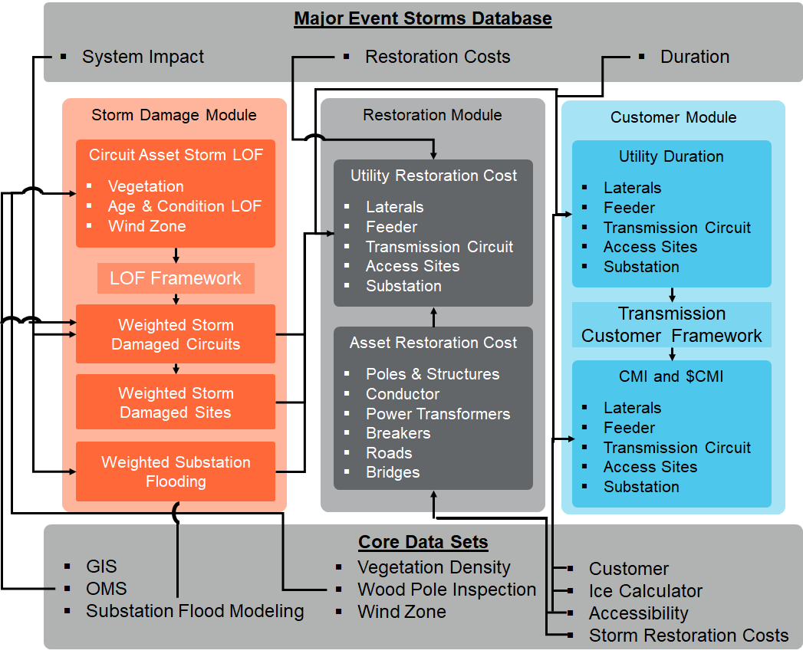

## Core Data Sets and Algorithms

As discussed above, the resilience-based approach and methodology is data driven. This section outlines the core data sets and base algorithms employed within the Storm Impact Model. TEC’s data systems include a connectivity model that allows for the linkage of the three foundational data sets used in the Storm Impact Model – the Geographical Information System (GIS), the Outage Management System (OMS), and Customer Information.

### Geographical Information System

The Geographic Information System (GIS) serves as the first of three foundational data sets for the Storm Impact Model. The GIS provides the list of assets in TEC’s system and how they are connected to each other. Since the resilience-based approach is fundamentally an asset management bottom-up based methodology, it starts with the asset data, then rolls all the assets up to projects, and all projects up to programs, and finally the programs up to the Storm Protection Plan.

In alignment with this methodology, TEC utilized the connectivity in their GIS model to link each distribution voltage asset up to a lateral (fuse protection device) or feeder (breaker or recloser protection device). This provides a granular evaluation of the distribution system that allows projects to be created to target only portions of a circuit for resilience investment. Through this approach, TEC and 1898 & Co. were able to use the asset level information from Table 4‑1 and convert it to the project level summaries in Table 4‑2. It is important to note that each asset in Table 4‑1 is tied to one of the projects listed in Table 4‑2, which provides a bottom-up analysis.

Table 4‑1: TEC Asset Base

|  |  |  |
| --- | --- | --- |
| Asset Type | Units | Value |
| Distribution Circuits | **[count]** | **710** |
| Feeder Poles | [count] | 58,700 |
| Lateral Poles | [count] | 122,500 |
| Feeder OH Primary | [miles] | 2,300 |
| Lateral OH Primary | [miles] | 3,900 |
| Transmission Circuits | **[count]** | **215** |
| Wood Poles | [count] | 5,000 |
| Steel / Concrete / Lattice Structures | [count] | 20,400 |
| Conductor | [miles] | 1,300 |
| Substations | [count] | **9** |

Table 4‑2: Projects Created from TEC Data Systems

|  |  |
| --- | --- |
| Program | Project Count |
| Distribution Lateral Undergrounding | 12,310 |
| Transmission Asset Upgrades | 107 |
| Substation Extreme Weather Hardening | 9 |
| Distribution Overhead Feeder Hardening | 930 |
| Total | 13,356 |

### Outage Management System

The second foundational data set is the OMS. The OMS includes detailed outage information by cause code for each protection device over the last 20 years. The Storm Impact Model utilized this information to understand the historical storm related outages for the various distribution laterals and feeders on the system to include Major Event Days (MED), vegetation, lightening, and storm-based outages. The OMS served as the link between customer class information and the GIS to provide the Storm Impact Model with the information necessary to understand how many customers and what type of customers would be without service for each project. The OMS data also served as the foundation for calculating benefits for feeder automation projects. This is discussed in more detail in Section 5.4.

### Customer Type Data

TEC provided customer count and type information that featured connectivity to the GIS and OMS. This allowed the Storm Impact Model to directly link the number and type of customers impacted to each project and the project’s assets. For example, the Storm Impact Model ‘knows’ that if pole ‘Y’ fails, fuse ‘1’ will operate causing XX customers to be without service. The model also knows what type of customers are served by each asset; residential, small or large commercial, small or large industrial, and priority customers. This customer information is included for every distribution asset in TEC system. The customer information is used within the Storm Impact Model to calculate the CMI (customers affected * outage duration) for each storm for each lateral or feeder project. Table 4‑3 below shows the count of customers by class from TEC’s service territory that have been linked to assets in the Storm Impact Model.

Table 4‑3: Customer Counts by Type

|  |  |
| --- | --- |
| Customer Type | Customer Count |
| Residential | 695,000 |
| Small Commercial and Industrial | 71,200 |
| Large Commercial and Industrial | 16,300 |
| Total | 782,500 |

### Vegetation Density Algorithm

The vegetation density for each overhead conductor is a core data set for identifying and prioritizing resilience investment for the circuit assets since vegetation blowing into conductor is the primary failure mode for major storm event for TEC. The Storm Impact Model calculates the vegetation density around each transmission and distribution overhead conductor. The Storm Impact Model utilizes tree canopy data to calculate the percentage of vegetation for 100 feet by 100 feet grids across the entire TEC system. The 100 square foot grid size is indicative of the vegetation density on the system from a major storm perspective. For each span of conductor (approximately 240,000) a vegetation density is assigned based on the grid the conductor goes through. This information is used within the LOF framework to identify the portions of the system mostly likely to have an outage for each type of storm.

Figure 4‑2 and Figure 4‑3 show the range of vegetation density for OH Primary and Transmission Conductor, respectively. The figures rank the conductors from highest to lowest level of vegetation density. As shown in the figures, approximately 30 to 35 percent of the conductor spans (not weighted by length) for OH Primary and Transmission Conductor have near zero tree canopy coverage, while approximately 65 to 70 percent have some level of coverage all the way up to 100 percent coverage.

Figure 4‑2: Vegetation Density on TEC Primary Conductor

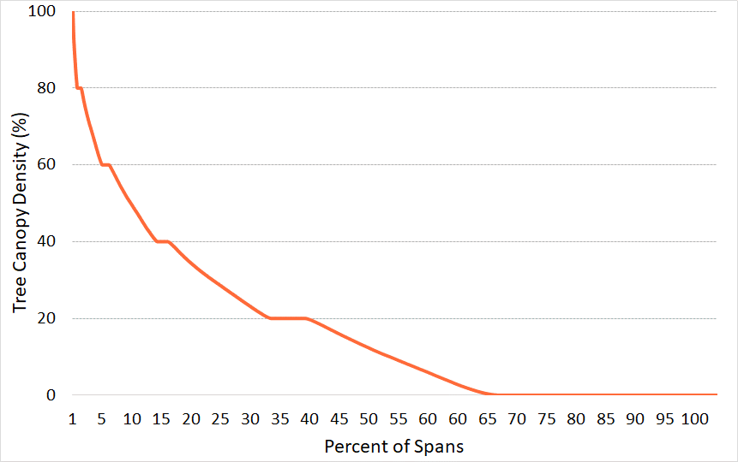

Figure 4‑3: Vegetation Density on TEC Transmission Conductor



### Wood Pole Inspection Data

A compromised, or semi-compromised, pole will fail at lower dynamic load levels then poles with their original design strength. The Storm Impact Model utilizes wood pole inspection data within 1898 & Co.’s asset health algorithm to calculate an Asset Health Index (AHI) and ‘effective’ age for each pole. Section 4.2.2 outlines the approach for using the ‘effective’ age for assets to calculate the age and condition based LOF.

### Wind Zone

A third driver of storm-based failure is the asset’s location with respect to wind speeds. Wind zones have been created across the United States for infrastructure design purposes. The National Electric Safety Code (NESC) provides wind and ice loading zones. The zones show that wind speeds are typically are higher closer to the coast and lower the further inland as shown in the adjacent figure. The Storm Impact Model utilizes the provided wind zone data from the public records and the asset geospatial location from GIS to designate the appropriate wind zone. Figure 4‑4 shows distribution of assets within each wind zone. As shown in the figure, most of the poles are in the 120 mph and 110 mph zones, while a smaller percentage are in the 130 mph zone near the coast.

Figure 4‑4: Pole Wind Zone Distribution

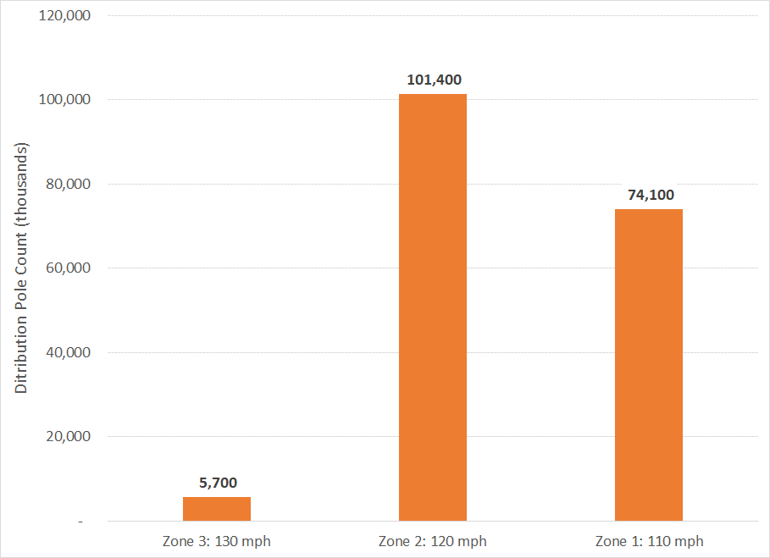

### Accessibility

The accessibility of an asset has a tremendous impact on the duration of the outage and the cost to restore that part of the system. Rear lot poles take much longer to restore and cost more to restore than front lot poles. To take differences in accessibility into account, the Storm Impact Model performs a geospatial analysis of each structure against a data set of roads. Structures within a certain distance of the road were designated as having roadside access, others were designated as in the deep right-of-way (ROW). This designation was used to calculate restoration and hardening project costs in the Storm Impact Model. Approximately 60 percent of the T&D system has some kind of road access while the remainder, approximately 40 percent, is in the deep right-of-way.

### ICE Calculator

To monetize the cost of a storm outage, the Storm Impact Model and Resilience Benefit Calculation utilize the ICE Calculator. The ICE Calculator is an electric reliability planning tool developed by Freeman, Sullivan & Co. and [Lawrence Berkeley National Laboratory](https://openei.org/wiki/Lawrence_Berkeley_National_Laboratory_Berkeley_Lab). This tool is designed for electric reliability planners at utilities, government organizations or other entities that are interested in estimating interruption costs and/or the benefits associated with reliability improvements in the United States. The ICE Calculator was funded by the Office of Electricity Delivery and Energy Reliability at the [U.S. Department of Energy](https://openei.org/wiki/United_States_Department_of_Energy) (DOE).

The Storm Impact Model includes the estimated storm interruption costs for residential, small commercial and industrial (C&I), and large C&I customers. The calculator was extrapolated for the longer outage durations from storm outages. The extrapolation includes diminishing costs as the storm duration extends. These estimates for outage cost for each customer are multiplied by the specific customer count and expected duration for each storm for each project to calculate the monetized CMI at the project level. The avoided monetized CMI and restoration cost benefit are used for prioritization of projects.

### Substation Flood Modeling

TEC performed detailed storm surge modeling using the Sea, Land, and Overland Surges from Hurricanes (SLOSH) model. The SLOSH models perform simulations to estimate surge heights above ground elevation for various storm types. The simulations are based on historical, hypothetical, and predicted hurricanes. The model uses a set of physics equations applied to the specific location shoreline, Tampa in this case, incorporating the unique bay and river configurations, water depths, bridges, roads, levees, and other physical features to establish surge height. These results are simulated several thousand times to develop the Maximum of the Maximum Envelope of Water, the worst-case scenario for each storm category. The SLOSH model results were overlaid with the location of TEC’s 216 substations to estimate the height of above the ground elevation for storm surge. The SLOSH model identified 59 substations with flooding risk depending on the hurricane category Based on TEC’s more detailed assessment 9 substations were identified that included flooding risk to the level that could justify investment.

## Weighted Storm Likelihood of Failure Module

The Weighted Storm LOF Module of the Storm Impact Model identifies the parts of the system that are likely to fail given the specific storm loaded from the Major Storms Event Database. The module is grounded in the primary failure mode of the asset base; storm surge and associated flooding for substations and wind, asset condition, and vegetation for circuit assets.

### Substation Storm Likelihood of Failure

The main driver of substation failures during major storm events is flooding. The Major Storms Event Database designates the number of substations expected to have minor and major flooding for each of the 99 storm scenarios. Only the storm scenarios with hurricanes coming from the Gulf of Mexico provide the necessary condition for storm surge that would cause substation flooding.

To identify which substations would be the likely to experience flooding, the Storm Impact Model uses the substation flood modeling described in Section 4.1.9. This model provides the estimated feet of flooding above site elevation assuming the maximum of maximum approach, a worst of the worst-case scenario. Because of this extreme worst-case scenario, the results could not be used for a typical hurricane category to hit the TEC service territory. The flood modeling has flood height data for all 5 hurricane category types. The Storm Impact Model uses the flooding height values as likelihood scores to identify the substation Probability of Failure (POF) for each storm event in the Major Storms Event Database.

### Circuits Storm Likelihood of Failure

The main driver of circuit failures during storms is wind blowing vegetation (and other debris) into conductor. The conductor is weighted down. The additional weight, when combined with the wind loading, causes the structures holding up the conductor to fail. Typically, the vegetation touching the conductor triggers the protection device to operate, however, the enhanced loading on the poles causes asset failures that are costly to repair both in terms of restoration costs and in CMI. The storm LOF of an overhead distribution asset is a function of the vegetation around it, the age and condition of the asset, and the applicable wind zone (coastal zones see higher wind speeds).

Figure 4‑5 depicts the framework used to calculate the storm LOF score for each circuit asset on TEC’s T&D system. Assets included within the framework are: wood poles, steel poles, concrete poles, lattice towers, overhead primary, and overhead transmission conductor. The framework does not use weightings, rather it is normalized across each of the scoring criteria.

For the vegetation LOF scores, the Storm Impact Model uses the vegetation density of each overhead primary and transmission conductor normalized for length. Section 4.1.4 outlines the approach to estimate the vegetation density for approximately 240,000 primary and transmission conductors. Each primary and transmission conductor is one span from structure to structure. The vegetation density, normalized for length, is used in the LOF framework to calculate an LOF score for vegetation. Overall, the vegetation score contributes on average 60 to 80 percent of system LOF depending on the storm scenario.

Figure 4‑5: Storm LOF Framework for Circuit Assets

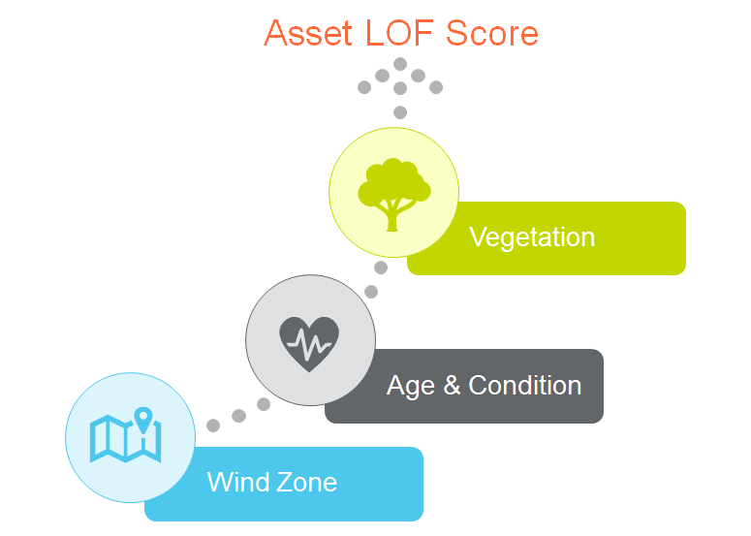

The Storm Impact Model utilizes 1898 & Co.’s asset management solution, Capital Asset Planning Solution (CAPS), to estimate the age and condition based LOF for each wood pole, metal structure, overhead primary, and transmission conductor. 1898 & Co.’s CAPS utilizes industry standard survivor curves with an asset class expected average service life and the asset’s ‘effective’ age (or calendar age if condition data is not available) to estimate the age and condition based LOF over the next 10 years. Condition data for wood poles was used to factor in any rot or impacts to the pole’s ground-line circumference. Section 4.1.5 outlines the wood pole inspection data used in the ‘effective’ age calculations.

Figure 4‑6 shows the age and condition LOF distribution of the T&D infrastructure asset base. The age and condition based LOF scores were used in the storm LOF framework to calculate storm LOF scores for each asset. Overall, the age and condition score contribute on average 20 to 30 percent of system LOF depending on the storm scenario.

Figure 4‑6: Age & Condition LOF Distribution

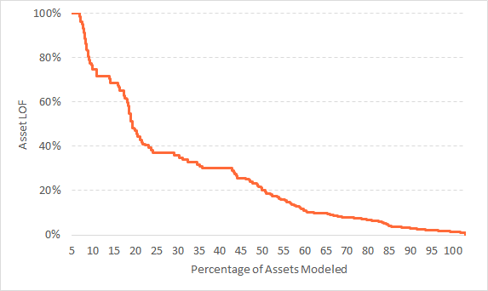

The wind zone criteria use the wind zone designation data from Section 4.1.6 inside the asset LOF framework to develop the LOF scores. Overall, the wind zone contributes on average 5 to 10 percent of system LOF depending on the storm scenario.

The Storm Impact Model uses the sum of the three criteria (vegetation, age & condition, and wind zone) to calculate the total storm LOF for each asset. The assets are then totaled up to the project level, providing a granular understanding of the LOF for each project. The Storm Impact Model uses the storm LOF scores to identify the circuit project POF for each storm event in the Major Storms Event Database.

### Site Access Storm Likelihood of Failure

The site access dataset includes a hierarchy of the impacted circuits. Using this hierarchy, each site access LOF equals the total of the circuits it provides access to. Section 4.2.2, above, provides the details on how the circuit LOF is calculated.

## Project & Asset Reactive Storm Restoration

The Storm Impact Model estimates the cost to repair assets from a storm-based failure. Storm restoration costs were calculated for every asset in the Storm Protection Model including wood poles, overhead primary, transmission structures (steel, concrete, and lattice), transmission conductors, power transformers, and breakers. The costs were based on storm restoration costs multipliers above planned replacement costs. The multipliers were in the 1.4 to 4.0 range. These multipliers were developed by TEC and 1898 & Co. collaboratively. They are based on the expected inventory constraints and foreign labor resources needed for the various asset types and storms. Substation restoration costs include storm costs for minor and major flooding events. For minor flooding events, the substation equipment can be used in the short term to restore power flow after cleaning, but the equipment needs to be replaced within 1 year. For major flooding, the substation equipment cannot be restored and must all be replaced. Restoration costs for site access projects were developed by TEC and provided to 1898 & Co.

For each storm event, the restoration costs at the asset level are aggregated up the project level and then weighted based on the project LOF (Section 4.2) and the overall restoration costs for the storm event outlined in the Major Event Storms Database.

## Duration and Customer Impact

The Storm Impact Model calculates the duration to restore each project in the Status Quo Scenario. The assumptions for major asset class outage duration are outlined in the Major Event Storms Database. Figure 4‑7 provides an example duration profile for the Category 3 and above storm event.

Figure 4‑7: Example Storm Duration Profile



The project specific duration is based on percent complete vs percent time curves for each major asset class. The projects are ranked by metrics that are similar to those TEC uses to prioritize storm restoration activity, such as priority customers. Specific project durations are calculated based on completion vs time curves. For example, using the example from the figure above, a lateral project may have a relatively high priority (i.e. customer count is high with more critical customers). That lateral would be restored by day 7 of the profile above. However, the lowest ranked laterals will have project durations in the 16 to 17-day range.

The project duration is then multiplied by the number of affected customers for each project (see Section 4.1.3) to calculate the CMI for each project. It should be noted that the Storm Impact Model assumes feeder automation has been installed on each circuit so that the affected number of customers is 350, the target for each hardening protection zone. This is a conservative assumption so that no double counting of benefits occurs.

Some of the storm scenarios include significant outages to the transmission system. The percentage of the system impacted is so high that the designed resilience (looping) of the system is lost for a short period of time, which in turn causes mass customer outages across the system from the transmission system. The Storm Impact Model allocates customer outages from these events to the various parts of the TEC transmission system based on transmission system operating capacity and overall importance to the Bulk Electric System (BES).

Finally, the CMI for each project for each storm event is monetized using the ICE Calculator. Section 4.1.8 provides additional detail on the ICE Calculator. The monetization is performed for each type of customer; residential, small C&I, large C&I, and the various priority customers. The monetization of CMI is calculated for project prioritization purposes as discussed below in Section 5.0.

## ‘Status Quo’ and Hardening Scenarios

The Storm Impact Model calculates the storm restoration costs and CMI for the ‘Status Quo’ and Hardening Scenarios for each project by each of the 99 storm events. The delta between the two scenarios is the benefit for each project. This is calculated for each storm event based on the change to the core assumptions (vegetation density, age & condition, wind zone, flood level, restoration costs, duration, and customers impacted) for each project.

The output from the Storm Impact Model is a project by project probability-weighted estimate of annual storm restoration costs, annual CMI, and annual monetized CMI for both the ‘Status Quo’ and Hardened Scenarios for all 99 major storm scenarios. The following section describes the methodology utilized to model all 99 major storms and calculate the resilience benefit of each project.

# Resilience Net Benefit Calculation Module

The Resilience Benefit Calculation Module of the Storm Resilience Model uses the annual benefit results of the Storm Impact Model and the estimated project costs to calculate the net benefits for each project. Since the benefits for each project are dependent on the type and frequency of major storm activity, the Resilience Benefit Module utilizes stochastic modeling, or Monte Carlo Simulation, to randomly select a thousand future worlds of major storm events to calculate the range of both ‘Status Quo’ and Hardened restoration costs and CMI. The benefit calculation is performed over a 50-year time horizon, matching the expected life of hardening projects.

The feeder automation hardening project resilience benefit calculation employs a different methodology given the nature of the project and the data available to calculate benefits. The Outage Management System (OMS) includes 20 years of historical data. The resilience benefit is based on the expected decrease in impacted customers if the automation had been in place.

The following sections provide additional detail on the project costs, Monte Carlo Simulation, and feeder automation.

## Economic Assumptions

The resilience net benefit calculation includes the following economic assumptions:

* Period: 50 years – most of the hardening infrastructure will have an average service life of 50 or more years
* Escalation Rate: 2 percent
* Discount Rate: 6 percent

## Project Cost

Project costs were estimated for the over 20,000 projects in the Storm Resilience Model. Some of the project costs were provided by TEC while others were estimated using the data within the Storm Resilience Model to estimate scope (asset counts and lengths) that was then multiplied by unit cost estimates to calculate the project costs. The following sub-sections outline the approach to calculate project costs for each of the programs.

### Distribution Lateral Undergrounding Project Costs

For each project, the GIS (see Section 4.1.1) and Accessibility algorithm (see Section 4.1.7) were leveraged to estimate:

* Miles of overhead conductor for 1, 2, and 3 phase laterals
* Number of overhead line transformers, including number of phases, that need to be converted to pad mounted transformers
* Number of meters connected through the secondary via overhead line.

Each of these values creates the scope for each of the projects. TEC provided unit costs estimates, which are multiplied by the scope activity (asset counts and lengths) to calculate the project cost. The unit cost estimates are based on supplier information and previous undergrounding projects.

### Transmission Asset Upgrades Project Costs

The Transmission Asset Upgrades program project costs are based on the number of wood poles by class, type (H-Frame vs monopole), and circuit voltage. TEC provided unit cost estimates for each type of pole to be replaced. The project costs equal the number wood poles on the circuit multiplied by the unit replacement costs.

### Substation Extreme Weather Hardening Project Costs

The project costs for the Substation Extreme Weather Hardening program are based on the perimeter of each substation multiplied by the unit cost per foot to install storm surge walls. The costs per foot vary by the required height of the wall. The substation wall height is based off the needed height to mitigate the flooding from the SLOSH model results.

### Distribution Overhead Feeder Hardening Project Costs

The distribution overhead feeder hardening project costs are based on the number of wood poles that don’t meet current design standards for storm hardening and the cost to include automation. TEC provided unit replacement costs based on the accessibility of the pole as well as the average cost to add automation to each circuit.

### Transmission Access Enhancements

TEC provided all the project costs for the Transmission Access Enhancements. The cost estimates were based on the length of the bridge or road. Those lengths were developed using geospatial solutions using TEC’s GIS for each problem area.

## Resilience-weighted Life-Cycle Benefit

The benefits of storm hardening projects are highly dependent on the frequency, intensity, and location of future major storm events over the next 50 years. Each storm type (e.g. Category 1 from the Gulf) has a range of potential probabilities and consequences. For this reason, the Storm Resilience Model employs stochastic modeling, or Monte Carlo Simulation. Monte Carlo Simulation is a random sampling methodology.

In the context of the Storm Resilience Model, the Monte Carlo simulator selects the major storm events to impact the TEC service territory over the next 50 years from the Major Storms Event Database (Section 3.0). That database outlines the ‘universe’ of storm event types that could impact the TEC service territory. The database includes 13 unique storm types with 99 different storm events when factoring in the range of probabilities and impacts. The database is based on a historical analysis of major storms to come within 150 miles of the TEC service territory over the last 169 years.

Table 5‑1 shows the selection of storm events for each storm type for the first 7 iterations and iteration 1,000. The selected 13 storm events for each iteration represent the future world of storms to impact the TEC service territory over the next 50 years. Each storm has a different frequency and impact to the TEC system. The Monte Carlo Simulation is performed over 1,000 iterations creating a 1,000 of these future storm ‘worlds’.

Each project’s CMI, monetized CMI, and restoration costs are calculated for the 13 storm events for each iteration for both the ‘Status Quo’ and Hardened Scenarios over a 50-year time horizon. The difference between the ‘Status Quo’ and Hardened Scenarios is the benefit of the project for that storm event. The sum of the benefits for all 13 storm events for each iteration equals the total benefits for the project. The CMI, monetized CMI, and restoration costs are then weighted by the probability of the storm event to calculate the storm resilience-weighted life-cycle benefit.

Table 5‑1: Monte Carlo Simulation Storm Event Selection

|  |  |  |  |  |  |  |  |  |  |  |
| --- | --- | --- | --- | --- | --- | --- | --- | --- | --- | --- |
| **Storm Type No** | **Scenario Name** | **Storm Event - Iteration** | | | | | | | | |
| **1** | **2** | **3** | **4** | **5** | **6** | **7** | **…** | **1000** |
| 1 | Cat 3+ Direct Hit - Gulf | 5 | 6 | 5 | 2 | 3 | 6 | 1 | … | 3 |
| 2 | Cat 1 & 2 Direct Hit – Florida | 13 | 16 | 11 | 11 | 8 | 17 | 12 | … | 17 |
| 3 | Cat 1 & 2 Direct Hit – Gulf | 20 | 24 | 20 | 19 | 19 | 20 | 23 | … | 20 |
| 4 | TS Direct Hit | 28 | 29 | 29 | 30 | 29 | 29 | 30 | … | 29 |
| 5 | TD Direct Hit | 31 | 32 | 31 | 32 | 33 | 31 | 33 | … | 31 |
| 6 | Localized Event Direct Hit | 36 | 35 | 34 | 35 | 36 | 34 | 35 | … | 34 |
| 7 | Cat 3+ Partial Hit | 39 | 39 | 39 | 39 | 40 | 37 | 37 | … | 41 |
| 8 | Cat 1 & 2 Partial Hit | 43 | 45 | 46 | 43 | 43 | 48 | 45 | … | 43 |
| 9 | TS Partial Hit | 50 | 52 | 52 | 52 | 50 | 54 | 52 | … | 50 |
| 10 | TD Partial Hit | 62 | 61 | 56 | 58 | 61 | 59 | 59 | … | 62 |
| 11 | Cat 3+ Peripheral Hit | 74 | 72 | 72 | 72 | 71 | 70 | 72 | … | 70 |
| 12 | Cat 1 & 2 Peripheral Hit | 82 | 87 | 87 | 76 | 79 | 84 | 81 | … | 82 |
| 13 | TS Peripheral Hit | 99 | 92 | 98 | 90 | 92 | 93 | 95 | … | 88 |

Table 5‑2 provides an example calculation of storm resilience weighted CMI, monetized CMI, and restoration costs for both the ‘Status Quo’ and Hardened Scenarios. Each of the values is weighted by the probability of the event from the storms database over the 50-year time horizon. The monetized CMI and restoration cost show the NPV of the 50-year storm probability adjusted cash flows. The delta between the ‘Status Quo’ and Hardened scenarios is the benefits of the project for the first iteration. The example shows that the project is not impacted by small or peripheral storms. This calculation is repeated for all 1,000 iterations for the over 20,000 projects in the Storm Resilience Model.

Table 5‑2: Project CMI and Restoration Cost Example – Iteration 1

|  |  |  |  |  |  |  |  |
| --- | --- | --- | --- | --- | --- | --- | --- |
| **Storm Type No** | **Scenario Name** | **Status Quo** | | | **Hardened** | | |
| **CMI** | **$CMI** | **Rest$** | **CMI** | **$CMI** | **Rest$** |
| 1 | Cat 3+ Direct Hit – Gulf | 64,910 | $606,664 | $132,303 | 41,947 | $392,045 | $0 |
| 2 | Cat 1 & 2 Direct Hit – Florida | 26,001 | $377,198 | $38,694 | 16,803 | $243,757 | $0 |
| 3 | Cat 1 & 2 Direct Hit – Gulf | 22,228 | $305,395 | $38,078 | 14,364 | $197,356 | $0 |
| 4 | TS Direct Hit | 26,587 | $471,815 | $53,821 | 17,072 | $302,952 | $43,127 |
| 5 | TD Direct Hit | 9,612 | $150,651 | $9,619 | 6,172 | $96,733 | $7,708 |
| 6 | Localized Event Direct Hit | 1,282 | $27,601 | $4,858 | 823 | $17,723 | $3,893 |
| 7 | Cat 3+ Partial Hit | 5,975 | $86,440 | $12,779 | 3,862 | $55,860 | $0 |
| 8 | Cat 1 & 2 Partial Hit | 3,575 | $58,056 | $14,771 | 2,310 | $37,517 | $0 |
| 9 | TS Partial Hit | 1,077 | $27,788 | $6,303 | 691 | $17,843 | $5,051 |
| 10 | TD Partial Hit | $0 | $0 | $0 | $0 | $0 | $0 |
| 11 | Cat 3+ Peripheral Hit | $0 | $0 | $0 | $0 | $0 | $0 |
| 12 | Cat 1 & 2 Peripheral Hit | $0 | $0 | $0 | $0 | $0 | $0 |
| 13 | TS Peripheral Hit | $0 | $0 | $0 | $0 | $0 | $0 |
|  | Total | 161,246 | $2,111,610 | $311,225 | 104,043 | $1,361,786 | $59,779 |

The results of the 1,000 iterations are graphed in a cumulative density function, also known as an ‘S-Curve’. Figure 5‑1 shows an illustrative example of the 1,000 iteration simulation results for the ‘Status Quo’ and Hardened Scenarios. The resilience benefit of the project, program, or plan is the gap between the S-curves for the top part of the curve. Section 2.4 describes this in further detail.

Figure 5‑1: Status Quo and Hardened Results Distribution Example



## Feeder Automation Benefits Calculation

As part of the Storm Protection Plan, TEC intends to include feeder automation to allow for automatic switching during storm events. The design standard is to limit outages to impact a maximum of 350 customers. While many of the other Storm Protection Programs provide resilience benefit by mitigating outages from the beginning, feeder automation projects provide resilience benefit by decreasing the impact of a storm event, the ‘pit’ of the resilience conceptual model described in Figure 2‑2 above.

The resilience benefit for feeder automation was estimated using historical Major Event Day (MED) outage data from the OMS (see Section 4.1.2). TEC has outage records going back 20 years. The analysis assumes that future MED outages for the next 50 years will be similar to the last 20 years.

The outage records document all outages by protection device. The system includes customer relationship information for each protection device to calculate the number of customers impacted if a device operates. The OMS records the start and end times for each outage. The information from the OMS is used to calculate reliability metrics for reporting purposes. The OMS also includes designations for MED, which are days during which a significant part of the system is impacted by a major event. These are typically major storms. MED is often referred to as ‘grey-sky’ days as opposed to non-MED which is referenced as ‘blue-sky’ days.

For the resilience benefit calculation, the Storm Resilience Model re-calculates the number of customers impacted by an outage, assuming that feeder automation had been in place. For example, a historical outage may have included a down pole from a storm event, causing the substation breaker to lock out and resulting in a four-hour outage for 1,500 customers, or 360,000 CMI. The Storm Resilience Model re-calculates the outages as 350 customers without power for four hours, or 96,000 CMI. That example provides a reduction in CMI of over 70 percent. The Storm Resilience Model extrapolates the 19 years of benefit calculation to 50 years to match the time horizon of the other projects.

The feeder automation projects include a range of investment types including reclosers, poles, re-conductoring, adding tie lines, and substation upgrades to handle the load transfer. TEC provided the itemized costs for feeder automation for projects installed in years 2020 and 2021, and expected average feeder costs for years 2022 through 2029.

Figure 5‑2 shows the percent decrease in CMI using this approach for all circuits. The figure is ranked from highest to lowest from left to right. The figure also includes the benefits to all outages. The figure shows a wide range of decreased CMI percentages with nearly 40 percent of circuits resulting in a 40 percent or more decrease in MED CMI. Additionally, the figure shows that approximately two thirds of the circuits would decrease MED CMI.

Figure 5‑2: Automation Hardening Percent CMI Decrease

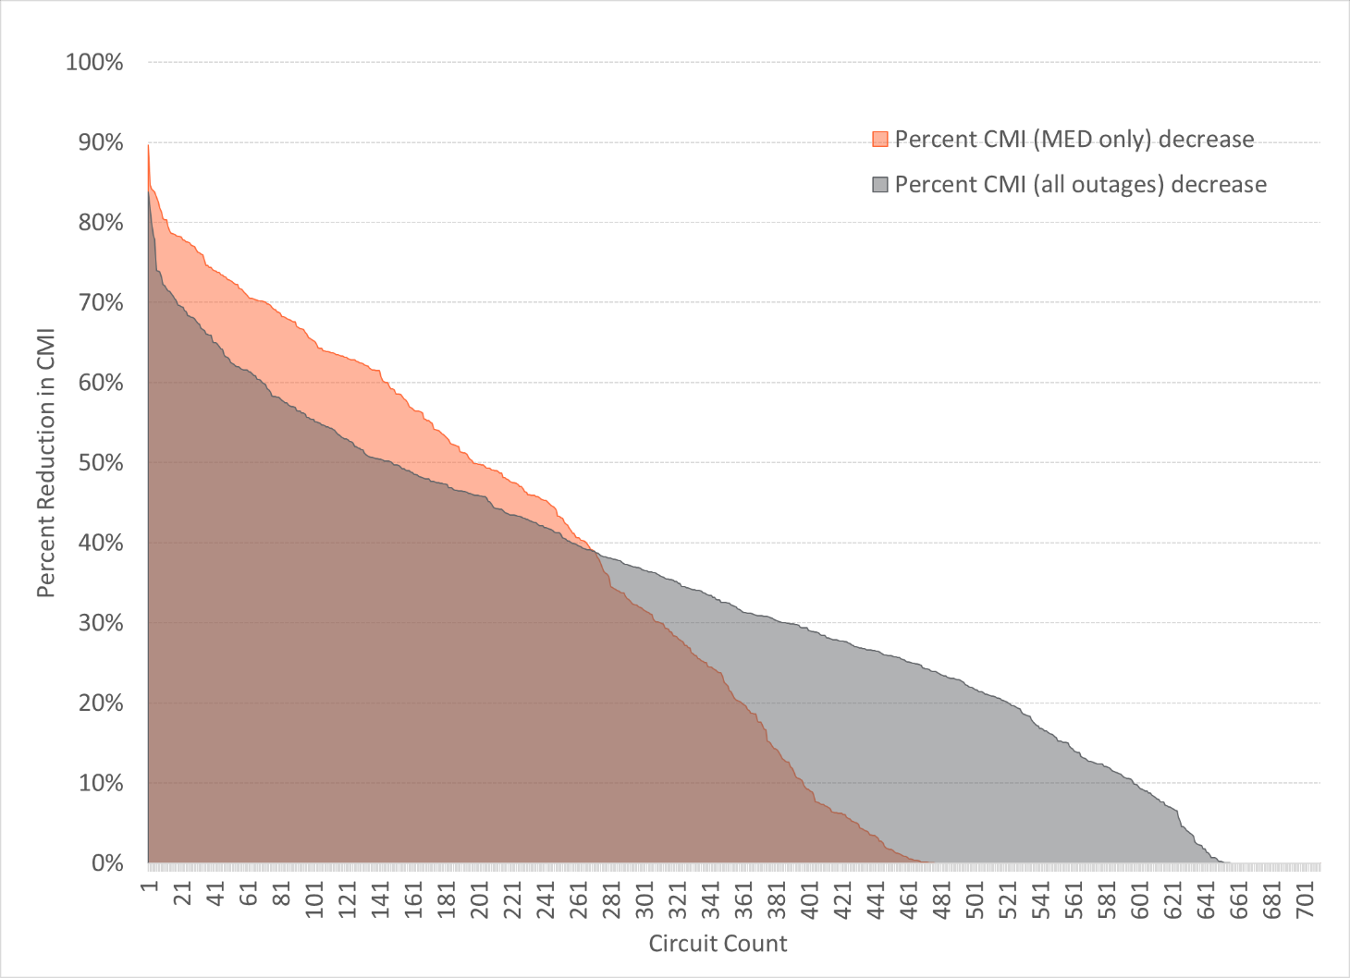

The resilience benefit calculation also monetized the CMI decrease using the ICE Calculator (Section 4.1.8). Figure 5‑3 shows the percent decrease in monetized CMI for each circuit. The CMI was monetized and discounted over the 50-year time horizon to calculate the NPV. The NPV calculation assumed a replacement of the reclosers in year 25; the rest of the feeder automation investment has an expected life of 50 years or more. The monetization and discounted cash flow methodology was performed for project prioritization purposes.

Figure 5‑3: Automation Hardening Monetization of CMI Decrease

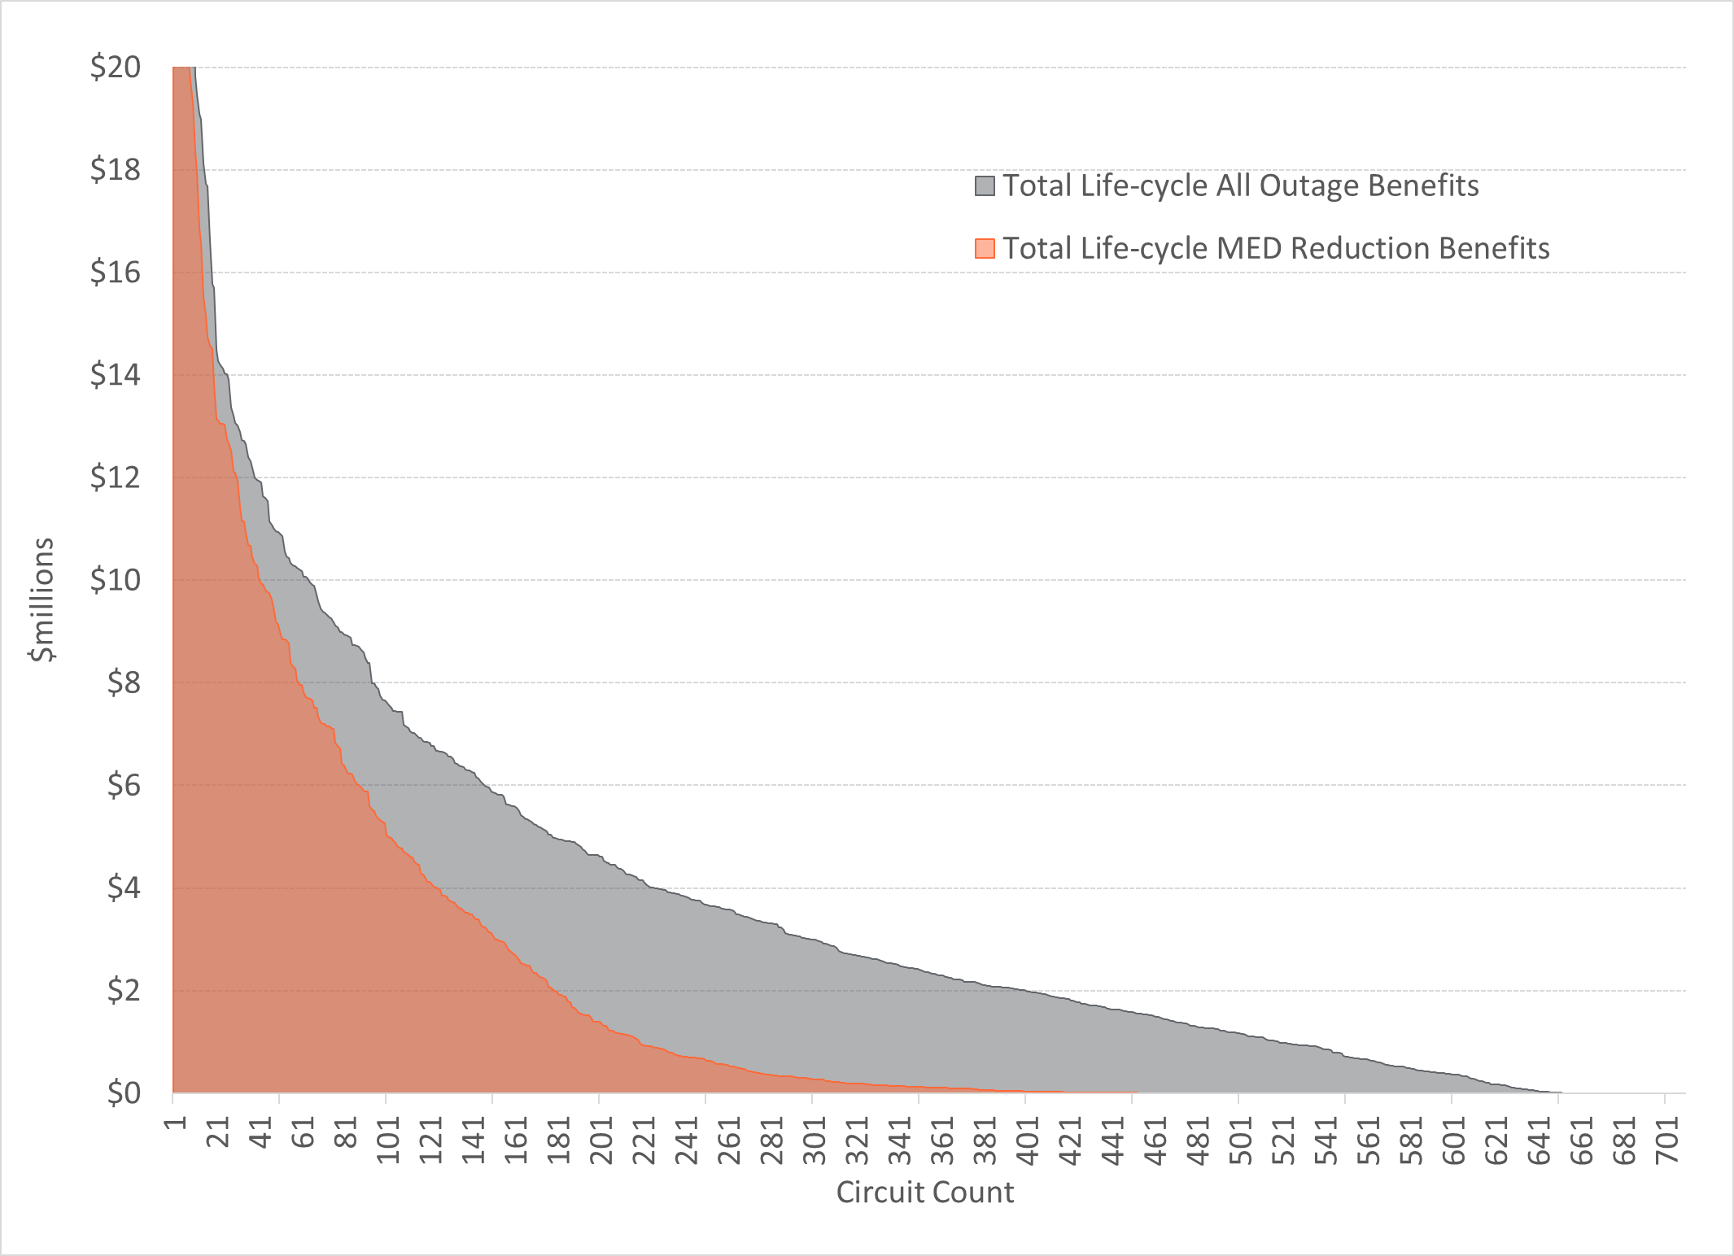

# Budget Optimization and Project Selection

The Storm Resilience Model models consistently models the benefits of all potential hardening projects for an ‘apples to apples’ comparison. Sections 3.0, 4.0, and 5.0 described the approach and methodology to calculate the resilience benefit for the over 13,500 projects. Resilience benefit values include:

* CMI 50-year Benefit
* Restoration Cost 50-year NPV Benefit
* Life-cycle 50 year NPV gross Benefit (monetized CMI benefit + restoration cost benefit)
* Life-cycle 50 year NPV net Benefit (monetized CMI benefit + restoration cost benefit – project costs)

Each of these values includes a distribution of results from the 1,000 iterations. For ease of understanding and in alignment with the resilience base strategy, the approach focuses on the P50 and above values, specifically considering:

* P50 – Average Storm Future
* P75 – High Storm Future
* P95 – Extreme Storm Future

The following sections discuss the prioritization metric, budget optimization, and approach to developing the Storm Protection Plan.

## Prioritization Metric - Benefit Cost Ratio

With all the projects being evaluated on a consistent basis, they can all be ranked against each other and compared. The Storm Resilience Model ranks all the projects based on their benefit cost ratio using the life-cycle 50 year NPV gross benefit value listed above. The ranking is performed for each of the P-values listed above (P50, P75, and P95) as well as a weighted value.

Performing prioritization for the four benefit cost ratios is important since each project has a different slope in their benefits from P50 to P95. For instance, many of the lateral undergrounding projects have the same benefit at P50 as they do at P95. Alternatively, many of the transmission asset hardening projects are minorly beneficial at P50 but have significant benefits at P75 and even more at P95. TEC and 1898 & Co. settled on a weighting on the three values for the base prioritization metric, however, investment allocations are adjusted for some of the programs where benefits are small at P50 but significant at P75 and P95.

## Budget Optimization

The Storm Resilience Model performs project prioritization across a range of budget levels to identify the appropriate level of resilience investment. The goal is to identify where ‘low hanging’ resilience investment exists and where the point of diminishing returns occurs. Given the total level of potential investment the budget optimization analysis was performed in $250 million increments up to $2.5 billion. Figure 6‑1 shows the results of the budget optimization analysis. The figure shows the total life-cycle gross NPV benefit for each budget scenario for P50, P75, and P95.

Figure 6‑1: Budget Optimization Results

The figure shows significantly increasing levels of net benefit from the $250 million to $1.5 billion with the benefit level flattening from $1.5 billion to $2.0 billion and decreasing from $2.0 billion to $2.5 billion. The figure also shows the total investment level in 2021 dollars for the TEC Storm Protection Plan. The TEC overall investment level is right before the point of diminishing returns showing that TEC’s plan has an appropriate level of investment capturing the hardening projects that provide the most value to customers.

## Storm Protection Plan Project Prioritization

In developing TEC’s Storm Protection Plan, TEC and 1898 & Co. used the Storm Resilience Model as a tool for developing the overall budget level and the budget levels for each category. It is important to note that the Storm Resilience Model is only a tool to enable more informed decision making. While the Storm Resilience Model employs a data-driven decision-making approach with robust set of algorithms at a granular asset and project level, it is limited by the availability and quality of assumptions. In developing the TEC Storm Protection plan project identification and schedule, the TEC and 1898 & Co team factored in the following:

* Resilience benefit cost ratio including the weighted, P50, P75, and P95 values.
* Internal and external resources available to execute investment by program and by year.
* Lead time for engineering, procurement, and construction
* Transmission outage and other agency coordination.
* Asset bundling into projects for work efficiencies.
* Project coordination (i.e. project A before project B, project Y and project Z at the same time).

# Results & Conclusions

TEC and 1898 & Co. utilized a resilience-based planning approach to identify and prioritize resilience investment in the T&D system. This section presents the costs and benefits of TEC’s Storm Protection Plan. Customer benefits are shown in terms of the:

1. Decrease in the Storm Restoration Costs
2. Decrease in the customers impacted and the duration of the overall outage, calculated as CMI

## Storm Protection Plan

This section includes the program capital investment and resilience benefit results for TEC’s Storm Protection Plan.

### Investment Profile

Table 7‑1 shows the Storm Protection Plan investment profile. The table includes the buildup by program to the total. The investment capital costs are in nominal dollars, the dollars of that day. The overall plan is approximately $1.59 billion. Lateral undergrounding makes up most of the total, accounting for 67.6 percent of the total investment. Feeder Hardening is second, accounting for 20.0 percent. Transmission upgrades make up 8.8 percent of the total, with substations and site access making up 1.7 percent and 2.0 percent, respectively.

Table 7‑1: Storm Protection Plan Investment Profile by Program (Nominal $000)

| **Year** | **Lateral Undergrounding** | **Transmission Asset Upgrades** | **Substation Hardening** | **Feeder Hardening** | **Transmission Site Access** | **Total** |
| --- | --- | --- | --- | --- | --- | --- |
| 2022 | $105,600 | $16,500 | $- | $33,300 | $2,400 | $157,800 |
| 2023 | $104,500 | $17,500 | $700 | $29,900 | $3,000 | $155,600 |
| 2024 | $105,700 | $17,500 | $4,300 | $30,000 | $3,000 | $160,500 |
| 2025 | $105,100 | $17,900 | $2,700 | $30,000 | $3,700 | $159,400 |
| 2026 | $105,000 | $18,200 | $3,300 | $30,000 | $3,400 | $159,900 |
| 2027 | $105,600 | $16,900 | $2,900 | $30,000 | $3,400 | $158,800 |
| 2028 | $105,600 | $17,300 | $4,800 | $30,000 | $3,100 | $160,800 |
| 2029 | $105,600 | $17,200 | $700 | $30,000 | $2,800 | $156,300 |
| 2030 | $115,400 | $- | $7,200 | $37,000 | $2,000 | $161,600 |
| 2031 | $115,400 | $- | $900 | $37,000 | $4,400 | $157,700 |
| Total | $1,073,500 | $139,000 | $27,500 | $317,200 | $31,200 | $1,594,700 |

### Restoration Cost Reduction

Figure 7‑1 shows the range in restoration cost reduction at various probability of exceedance levels. As a refresher, the P50 to P65 level represents a future world in which storm frequency and impact are close to average, the P70 to P85 level represents a future world where storms are more frequent and intense, and the P90 and P95 levels represent a future world where storm frequency and impact are all high.

Figure 7‑1: Storm Protection Plan Restoration Cost Benefit



The figure shows that the 50 NPV of future storm restoration costs in a Status Quo scenario from a resilience perspective is $960 million to $1,310 million. With the Storm Protection Plan, the costs decrease by approximately 33 to 35 percent. The decrease in restoration costs is approximately $380 to $530 million. From an NPV perspective, the restoration costs decrease benefit is approximately 24 to 33 percent of the project costs.

### Customer Benefit

Figure 7‑2 shows the range in CMI reduction at various probability of exceedance levels. The figure shows relative consistency in benefit level across the P-values with approximately 46 percent decrease in the storm CMI over the next 50 years.

Figure 7‑2: Storm Protection Plan Customer Benefit

## Program Investment Profile Details

Table 7‑3, Table 7‑4, Table 7‑5, and Table 7‑6 show annual investment for the five programs evaluated in the Storm Resilience Model. The tables also show the counts associated with the investment level. For Table 7‑3 the total count of circuits being worked on each year is shown. Several circuits are worked on over multiple years. The plan includes upgrading assets on 97 different circuits.

Table 7‑2: Distribution Lateral Undergrounding Investment Profile

|  |  |  |  |
| --- | --- | --- | --- |
| Year | Lateral Count | Miles | Nominal Cost ($000) |
| 2022 | 225 | 76 | $105,600 |
| 2023 | 268 | 83 | $104,500 |
| 2024 | 436 | 108 | $105,700 |
| 2025 | 538 | 111 | $105,100 |
| 2026 | 471 | 110 | $105,000 |
| 2027 | 426 | 107 | $105,600 |
| 2028 | 443 | 112 | $105,600 |
| 2029 | 389 | 106 | $105,600 |
| 2030 | 436 | 123 | $115,400 |
| 2031 | 502 | 143 | $115,400 |
| Total | 4,134 | 1,079 | $1,073,500 |

Table 7‑3: Transmission Asset Upgrades Investment Profile

|  |  |  |
| --- | --- | --- |
| Year | Circuits Worked On | Nominal Cost ($000) |
| 2022 | 37 | $16,500 |
| 2023 | 26 | $17,500 |
| 2024 | 10 | $17,500 |
| 2025 | 10 | $17,900 |
| 2026 | 5 | $18,200 |
| 2027 | 11 | $16,900 |
| 2028 | 14 | $17,300 |
| 2029 | 24 | $17,200 |
| 2030 | 0 | $- |
| 2031 | 0 | $- |
| Total | 137 | $139,000 |

Table 7‑4: Substation Extreme Weather Hardening Investment Profile

|  |  |  |
| --- | --- | --- |
| Year | Count | Nominal Cost  ($000) |
| 2022 | 0 | $- |
| 2023 | 1 | $700 |
| 2024 | 1 | $4,300 |
| 2025 | 1 | $2,700 |
| 2026 | 1 | $3,300 |
| 2027 | 1 | $2,900 |
| 2028 | 1 | $4,800 |
| 2029 | 1 | $700 |
| 2030 | 1 | $7,200 |
| 2031 | 1 | $900 |
| Total | 9 | $33,800 |

Table 7‑5: Distribution Overhead Feeder Hardening Investment Profile

|  |  |  |
| --- | --- | --- |
| Year | Feeder Count | Nominal Cost ($000) |
| 2022 | 37 | $33,300 |
| 2023 | 31 | $29,900 |
| 2024 | 23 | $30,000 |
| 2025 | 28 | $30,000 |
| 2026 | 28 | $30,000 |
| 2027 | 32 | $30,000 |
| 2028 | 25 | $30,000 |
| 2029 | 29 | $30,000 |
| 2030 | 57 | $37,000 |
| 2031 | 51 | $37,000 |
| Total | 341 | $317,200 |

Table 7‑6: Transmission Access Enhancements Investment Profile

|  |  |  |
| --- | --- | --- |
| Year | Count | Nominal Cost  ($000) |
| 2022 | 25 | $2,400 |
| 2023 | 25 | $3,000 |
| 2024 | 4 | $3,000 |
| 2025 | 7 | $3,700 |
| 2026 | 4 | $3,400 |
| 2027 | 3 | $3,400 |
| 2028 | 3 | $3,100 |
| 2029 | 5 | $2,800 |
| 2030 | 5 | $2,000 |
| 2031 | 1 | $4,400 |
| Total | 82 | $31,200 |

## Program Benefits

Table 7‑7 shows the restoration cost and CMI benefit for each of the programs. The ranges include the P50 to P95 values. Figure 7‑3 shows each program’s percentage of the total benefits compared to the program’s percentage of the total capital investment. The figure shows the benefit values for both restoration cost and CMI.

Table 7‑7: Program Benefit Levels

|  |  |  |
| --- | --- | --- |
| Program | Restoration Cost Percent Decrease | Storm CMI Percent Decrease |
| Distribution Lateral Undergrounding | ~32% | ~45% |
| Transmission Asset Upgrades | ~85% | ~14% |
| Substation Extreme Weather Hardening | 20%-25% | 12%-45% |
| Distribution Feeder Hardening | ~54% | ~46% |
| Transmission Access Enhancements | ~28% | ~55% |

Figure 7‑3: Program Benefits vs. Capital Investment

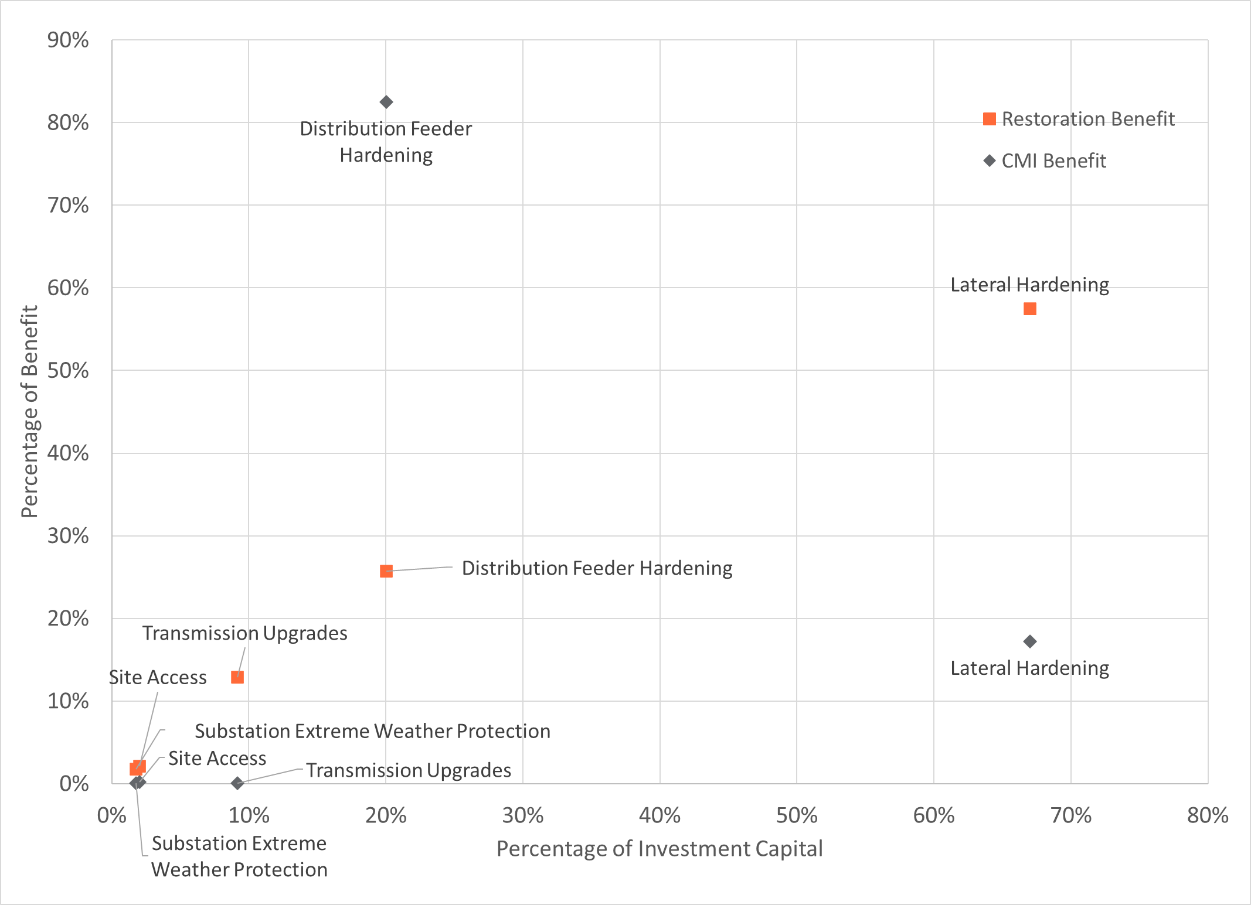

Table 7‑7 and Figure 7‑3 shows

* Distribution Feeder Hardening and Lateral Undergrounding account for 88 percent of the total capital investment, nearly all the CMI benefit, and approximately 81 percent of the restoration benefit.
* The Distribution Lateral Undergrounding program decreases the storm related CMI and restoration costs for the asset base by approximately 45 and 32 percent, respectively. Additionally, the program accounts for approximately 68 percent of the total plan’s invested capital, approximately 57 percent of the plan’s restoration benefit, and approximately 17 percent of the plan’s CMI benefit. The low overall CMI reduction relative to the total reduction is because of the high decrease from the Feeder Hardening program, specifically feeder automation.
* The Distribution Feeder Hardening program contributes approximately 82 percent of the CMI benefit of the plan, mainly from feeder automation based on the historical ‘grey sky’ days.
* While Transmission Assets, Substation, and Access programs achieve fairly high percentages in decreasing CMI, their total contribution to CMI reduction for the plan is low (less than 1 percent).
* Substation Hardening accounts for over 3.4 percent of the restoration benefit of the plan while only accounting for approximately 1.7 percent of the capital investment. The cost to restore flooded substations is extremely high.

## Conclusions

The following include the conclusions of TEC’s Storm Protection plan evaluated within the Storm Resilience Model:

* The overall investment level of $1.59 billion for TEC’s Storm Protection Plan is reasonable and provides customers with maximum benefits. The budget optimization analysis (see Figure 6‑1) shows the investment level is right before the point of diminishing returns.
* TEC’s Storm Protection Plan results in a reduction in storm restoration costs of approximately 33 to 35 percent. In relation to the plan’s capital investment, the restoration costs savings range from 24 to 33 percent depending on future storm frequency and impacts.
* The customer minutes interrupted decrease by approximately 46 percent over the next 50 years. This decrease includes eliminating outages all together, reducing the number of customers interrupted, and decreasing the length of the outage time.
* The cost (Investment – Restoration Cost Benefit) to purchase the reduction in storm customer minutes interrupted is in the range of $0.65 to $0.78 per minute. This is below outage costs from the DOE ICE Calculator and lower than typical ‘willingness to pay’ customer surveys.
* TEC’s mix of hardening investment strikes a balance between investment in the substations and transmission system targeted mainly at increasing resilience for the high impact / low probability events and investment in the distribution system, which is impacted by all ranges of event types.
* The hardening investment will provide additional ‘blue sky’ benefits to customers not factored into this report.

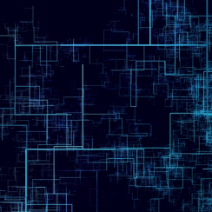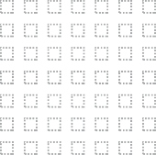

9400 Ward Parkway

Kansas City, MO

816-605-7800

1898andCo.com

1. State Rep. Randy Fine and State Sen. Joe Gruters, Sun Sentinel, May 2019
2. Source: <https://coast.noaa.gov/hurricanes/> with analysis by 1898 & Co.
3. See Footnote 2
4. See Footnote 2
5. See Footnote 2
6. See Footnote 2
7. See Footnote 2
8. See Footnote 2