BEFORE THE FLORIDA PUBLIC SERVICE COMMISSION

|  |  |
| --- | --- |
| In re: Review of 2026-2035 Storm Protection Plan, pursuant to Rule 25-6.030, F.A.C., Florida Power & Light Company. | DOCKET NO. 20250014-EI |
| In re: Review of 2026-2035 Storm Protection Plan, pursuant to Rule 25-6.030, F.A.C., Duke Energy Florida, LLC. | DOCKET NO. 20250015-EI |
| In re: Review of 2026-2035 Storm Protection Plan, pursuant to Rule 25-6.030, F.A.C., Tampa Electric Company. | DOCKET NO. 20250016-EI |
| In re: Review of 2026-2035 Storm Protection Plan, pursuant to Rule 25-6.030, F.A.C., Florida Public Utilities Company. | DOCKET NO. 20250017-EI  ORDER NO. PSC-2025-0158-PHO-EI  ISSUED: May 12, 2025 |

**PREHEARING ORDER**

Pursuant to Notice and in accordance with Rule 28-106.209, Florida Administrative Code (F.A.C.), a Prehearing Conference was held on May 5, 2025, in Tallahassee, Florida, before Commissioner Gabriella Passidomo Smith, as Prehearing Officer.

APPEARANCES:

CHRISTOPHER T. WRIGHT, ESQUIRE, 700 Universe Boulevard, Juno Beach, Florida 33408-0420

On behalf of Florida Power & Light Company (FPL).

DIANNE M. TRIPLETT, MATTHEW R. BERNIER and STEPHANIE A. CUELLO, ESQUIRES, 299 First Avenue North, St. Petersburg, Florida 33701

On behalf of Duke Energy Florida, LLC (DEF).

BETH KEATING, ESQUIRE, Gunster, Yoakley & Stewart, P.A., 215 South Monroe Street, Suite 601, Tallahassee, Florida 32301

On behalf of Florida Public Utilities Company (FPUC).

J. JEFFREY WAHLEN, MALCOLM N. MEANS, and VIRGINIA PONDER, ESQUIRES, Post Office Box 391, Tallahassee, Florida 32302

On behalf of Tampa Electric Company (TECO).

WALT TRIERWEILER, PATRICIA A. CHRISTENSEN, OCTAVIO SIMOES-PONCE, CHARLES REHWINKEL, MARY A. WESSLING, and AUSTIN A. WATROUS, ESQUIRES, 111 West Madison Street, Room 812, Tallahassee, Florida 32399-1400

On behalf of Office of Public Counsel (OPC).

JAMES W. BREW, LAURA WYNN BAKER and SARAH B. NEWMAN, ESQUIRES, Stone, Mattheis, Xenopoulos & Brew, PC, 1025 Thomas Jefferson Street, NW, Eighth Floor, West Tower, Washington, DC 20007

On behalf of White Springs Agricultural Chemicals, Inc. d/b/a PCS Phosphate – White Springs (PCS Phosphate).

JACOB IMIG, TIMOTHY SPARKS, JENNIFER AUGSPURGER, CARLOS MARQUEZ, SAAD FAROOQI, and ADRIA HARPER, ESQUIRES, Florida Public Service Commission, 2540 Shumard Oak Boulevard, Tallahassee, Florida 32399-0850

On behalf of the Florida Public Service Commission (Staff).

MARY ANNE HELTON, ESQUIRE, Interim General Counsel, Florida Public Service Commission, 2540 Shumard Oak Boulevard, Tallahassee, Florida 32399-0850

Advisor to the Florida Public Service Commission.

**I. CASE BACKGROUND**

Section 366.96(3), Florida Statutes (F.S.), requires each public utility to file a transmission and distribution storm protection plan (SPP) that covers the immediate 10-year planning period, and explains the systematic approach the utility will follow to achieve the objectives of reducing restoration costs and outage times associated with extreme weather events and enhancing reliability. Pursuant to Section 366.96(4)-(6), F.S., at least every three years the Florida Public Service Commission (Commission) is required to determine whether it is in the public interest to approve, approve with modification, or deny each utility’s transmission and distribution storm protection plan filed in accordance with Commission Rule 25-6.030, F.A.C.

Docket Nos. 20250014-EI, 20250015-EI, 20250016-EI, and 20250017-EI were opened to address the storm protection plans for Florida Power & Light Company (FPL), Duke Energy Florida, LLC (DEF), Tampa Electric Company (TECO), and Florida Public Utilities Company (FPUC), respectively. These utilities are subject to the requirements of Section 366.96, F.S., and the dockets have been consolidated for the purpose of the hearing. The dockets will be governed by the procedures set forth in Order No. PSC-2025-0029-PCO-EI, issued January 24, 2025.

Intervention by the Office of Public Counsel (OPC) was acknowledged in all four dockets. White Springs Agricultural Chemicals, d/b/a PCS Phosphate (PCS), was granted intervention in the DEF docket. The consolidated dockets are scheduled for an administrative hearing from May 20, 2025 through May 22, 2025.

**II. CONDUCT OF PROCEEDINGS**

Pursuant to Rule 28-106.211, F.A.C., this Prehearing Order is issued to prevent delay and to promote the just, speedy, and inexpensive determination of all aspects of this case.

**III. JURISDICTION**

This Commission is vested with jurisdiction over the subject matter of this proceeding by the provisions of Section 366.96, F.S. This hearing will be governed by Chapters 120 and 366, F.S., and Chapters 25-6, 25-22, and 28-106, F.A.C., as well as any other applicable provisions of law.

**IV. PROCEDURE FOR HANDLING CONFIDENTIAL INFORMATION**

Information for which proprietary confidential business information status is requested pursuant to Section 366.093, F.S., and Rule 25-22.006, F.A.C., shall be treated by the Commission as confidential. The information shall be exempt from Section 119.07(1), F.S., pending a formal ruling on such request by the Commission or pending return of the information to the person providing the information. If no determination of confidentiality has been made and the information has not been made a part of the evidentiary record in this proceeding, it shall be returned to the person providing the information. If a determination of confidentiality has been made and the information was not entered into the record of this proceeding, it shall be returned to the person providing the information within the time period set forth in Section 366.093, F.S. The Commission may determine that continued possession of the information is necessary for the Commission to conduct its business.

It is the policy of this Commission that all Commission hearings be open to the public at all times. The Commission also recognizes its obligation pursuant to Section 366.093, F.S., to protect proprietary confidential business information from disclosure outside the proceeding. Therefore, any party wishing to use any proprietary confidential business information, as that term is defined in Section 366.093, F.S., at the hearing shall adhere to the following:

* 1. When confidential information is used in the hearing that has not been filed as prefiled testimony or prefiled exhibits, parties must have copies for the Commissioners, necessary staff, and the court reporter, in red envelopes clearly marked with the nature of the contents and with the confidential information highlighted. Any party wishing to examine the confidential material that is not subject to an order granting confidentiality shall be provided a copy in the same fashion as provided to the Commissioners, subject to execution of any appropriate protective agreement with the owner of the material.
  2. Counsel and witnesses are cautioned to avoid verbalizing confidential information in such a way that would compromise confidentiality. Therefore, confidential information should be presented by written exhibit when reasonably possible.

At the conclusion of that portion of the hearing that involves confidential information, all copies of confidential exhibits shall be returned to the proffering party. If a confidential exhibit has been admitted into evidence, the copy provided to the court reporter shall be retained in the Office of Commission Clerk’s confidential files. If such material is admitted into the evidentiary record at hearing and is not otherwise subject to a request for confidential classification filed with the Commission, the source of the information must file a request for confidential classification of the information within 21 days of the conclusion of the hearing, as set forth in Rule 25-22.006(8)(b), F.A.C., if continued confidentiality of the information is to be maintained.

**V. PREFILED TESTIMONY AND EXHIBITS; WITNESSES**

Testimony of all witnesses to be sponsored by the parties (and Staff) has been prefiled and will be inserted into the record as though read after the witness has taken the stand and affirmed the correctness of the testimony and associated exhibits. All testimony remains subject to timely and appropriate objections. Upon insertion of a witness’ testimony, exhibits appended thereto may be marked for identification. Each witness will have the opportunity to orally summarize his or her testimony at the time he or she takes the stand. Summaries of testimony shall be limited to three minutes. OPC shall have eight minutes for their witness summary.

Witnesses are reminded that, on cross-examination, responses to questions calling for a simple yes or no answer shall be so answered first, after which the witness may explain his or her answer. After all parties and Staff have had the opportunity to cross-examine the witness, the exhibit may be moved into the record. All other exhibits may be similarly identified and entered into the record at the appropriate time during the hearing.

The Commission frequently administers the testimonial oath to more than one witness at a time. Therefore, when a witness takes the stand to testify, the attorney calling the witness is directed to ask the witness to affirm whether he or she has been sworn.

The parties shall avoid duplicative or repetitious cross-examination. Further, friendly cross-examination will not be allowed. Cross-examination shall be limited to witnesses whose testimony is adverse to the party desiring to cross-examine. Any party conducting what appears to be a friendly cross-examination of a witness should be prepared to indicate why that witness’ direct testimony is adverse to its interests.

**VI. ORDER OF WITNESSES**

| Witness | Proffered By | Issues # |
| --- | --- | --- |
| Direct |  |  |
| Name | Utility/Staff |  |
| Michael Jarro | FPL | FPL 1 |
| Brian Lloyd | DEF | DEF 2 |
| Alexandra M. Vazquez | DEF | DEF 1, 2 |
| Christopher Menendez | DEF | DEF 2, 3 |
| Kevin Palladino | TECO | TECO 1-3 |
| A. Sloan Lewis | TECO | TECO 1-3 |
| Jason D. DeStigter (1898 & Co) | TECO | TECO 3 |
| P. Mark Cutshaw | FPUC | FPUC 1, 2 |
| Kevin J. Mara | OPC | FPL 1; DEF 1, 2;  TECO 1-3; FPUC 1, 2 |
| Rebuttal |  |  |
| Name | Utility/Staff |  |
| Michael Jarro | FPL | FPL 1 |
| Brian Lloyd | DEF | DEF 2 |
| Alexandra M. Vazquez | DEF | DEF 1, 2 |
| Kevin Palladino | TECO | TECO 1-3 |
| A.Sloan Lewis | TECO | TECO 3 |
| P. Mark Cutshaw | FPUC | FPUC 1, 2 |

**VII. BASIC POSITIONS**

**FPL:** Pursuant to Section 366.96, Florida Statutes, and Rule 25-6.030, Florida Administrative Code, FPL has proposed its 2026 SPP to reasonably achieve the legislative objectives of promoting the overhead hardening of electrical distribution and transmission facilities, the undergrounding of certain electrical distribution lines, and vegetation management to reduce restoration costs and outage times associated with extreme weather events. FPL’s 2026 SPP is a continuation of the following eight programs included in FPL’s 2020-2029[1] and 2023-2032[2] SPPs previously approved by the Commission:

* Distribution Inspection Program
* Transmission Inspection Program
* Distribution Feeder Hardening Program
* Distribution Lateral Hardening Program
* Transmission Hardening Program
* Distribution Vegetation Management Program
* Transmission Vegetation Management Program
* Substation Storm Surge/Flood Mitigation Program

For purposes of the 2026 SPP, FPL is not proposing any material modifications to any of these existing programs previously approved in the 2023 SPP. Rather, FPL has (i) updated the projected costs for certain limited programs to better reflect current data and pricing, (ii) reduced the estimated average cost per project under the Distribution Lateral Hardening Program, and (iii) identified additional substations that require storm surge and flood mitigation through the Substation Storm Surge/Flood Mitigation Program. Each of these updates are described in detail in the Direct Testimony of FPL witness Michael Jarro and in Section IV of Exhibit MJ-1.

The majority of these eight storm hardening programs have been in place since 2007 and have already demonstrated that they have and will continue to increase T&D infrastructure resiliency, reduce restoration times, and reduce restoration costs when FPL’s system is impacted by extreme weather events. A description of the benefits of continuing the existing SPP programs as part of the 2026 SPP is provided in Sections II and IV of Exhibit MJ-1.

FPL’s 2026 SPP includes estimated costs and a description of the benefits of the SPP programs and criteria to select and prioritize the SPP projects, as well as additional details for the first three years of the SPP. FPL’s 2026 SPP also provides the estimated revenue requirements for each SPP program, and the estimated rate impact for the first three years of the SPP. FPL’s 2026 SPP provides the information required by and is fully consistent with Rule 25-6.030, Florida Administrative Code.

No party submitted testimony opposing the continuation of the eight programs included in FPL’s 2026 SPP, nor has any party contested or challenged the benefits associated with these existing storm hardening programs. Rather, OPC, the only other party to submit testimony in this docket, recommended a decrease and cap on the number of annual projects to be completed under FPL’s Distribution Lateral Hardening Program, Distribution Feeder Hardening Program, and Transmission Hardening Program, claiming that the proposed reductions will make electric service more affordable for FPL’s customers.

As explained in the rebuttal testimony of FPL witness Jarro, OPC’s proposed adjustments to the Distribution Lateral Hardening Program, Distribution Feeder Hardening Program, and Transmission Hardening Program are generally in line and consistent with the estimated annual range of projects proposed in FPL’s 2026 SPP. However, as explained by FPL witness Jarro, OPC’s proposed adjustments to these SPP programs would delay when customers receive the important storm hardening benefits from these programs and result in additional costs to stop and restart projects after OPC’s proposed annual cap has been reached. Additionally, as shown in Exhibit MJ-9, OPC’s proposed adjustments would have little impact on customer rates. For these reasons, as more fully explained in the rebuttal testimony of FPL witness Jarro, FPL submits that it is appropriate to continue to use an estimated range of projects for each SPP program, which is consistent with the approach approved in both FPL’s 2020 SPP and 2023 SPP.

On April 25, 2025, FPL and OPC filed Joint Stipulations and Proposed Resolutions (“Stipulations”) that, if approved, would fully resolve their respective issues in this proceeding. The Stipulations provide, among other things, that the Distribution Inspection Program, Transmission Inspection Program, Distribution Vegetation Management Program, Transmission Vegetation Management Program, and Substation Storm Surge/Flood Mitigation Program included in FPL’s proposed 2026 SPP should be approved as filed. The Stipulations also provide that the targeted number of annual projects for the Distribution Feeder Hardening Program, Distribution Lateral Hardening Program, and the Transmission Hardening Program included in FPL’s proposed 2026 SPP should be modified as set forth in Attachment 1 to the Stipulations. FPL and OPC agree that FPL’s proposed 2026 SPP, as modified by the Stipulations, is in the public interest and should be approved.

For all the reasons discussed above, and as explained in the Stipulations jointly filed by FPL and OPC, FPL’s proposed 2026 SPP is in the public interest and should be approved. FPL’s proposed 2026 SPP complies with the requirements and objectives of Section 366.96, Florida Statutes, complies with Rule 25-6.030, Florida Administrative Code, and provides a systematic approach to achieve the legislative objectives of reducing restoration costs and outage times associated with extreme weather events.

**DEF:** As required by Section 366.96, Florida Statutes (the "SPP Statute"), Rule 25-6.030, F.A.C. (the "SPP Rule"), and the OEP, on January 15, 2025, DEF filed its proposed Storm Protection Plan ("SPP" or the "Plan"). DEF's transmission and distribution SPP covers the immediate 10 year planning period (2026-2035) and explains the systematic approach DEF will follow to protect and strengthen its transmission and distribution infrastructure to achieve the objectives of reducing restoration costs and outage times associated with extreme weather events and enhancing overall reliability, as demonstrated by the pre-filed testimonies and exhibits of DEF's witnesses Mr. Brian Lloyd and Mrs. Alexandra Vazquez, and converted into the 3-year projected rates and revenue requirements as required by the SPP Rule and included in the testimony and exhibit of Mr. Christopher Menendez. DEF's SPP continues the same suite of Distribution and Transmission Programs approved by the Commission in Order No. 2022-0388-FOF-EI, *affirmed by Citizens of the State of Fla. v. Fay,* 396 So. 3d 549 (Fla 2024), with the addition of one subprogram, the Insulator Upgrade subprogram, within the Transmission Structure Hardening Program.

DEF's SPP includes all elements required by the SPP Rule, is in the public interest as defined in the SPP Statute and should be approved by this Commission.

**TECO:** It is in the public interest to approve Tampa Electric Company’s 2026-2035 Storm Protection Plan (“2026-2035 SPP” or “Plan”) without modification. Consideration of the four factors set out in Section 366.96(4)(a)-(d) of the Florida Statutes weighs in favor of such a finding. The 2026-2035 SPP will “reduce restoration costs and outage times associated with extreme weather events and enhance reliability” by systematically hardening components of the company’s transmission and distribution system. The implementation of Tampa Electric’s proposed SPP programs will provide additional value to customers, and the costs and rate impacts of the 2026-2035 SPP are reasonable considering the significant customer benefits of the Plan.

**FPUC:** Pursuant to Section 366.96, Florida Statutes and Rule 25-6.030, Florida Administrative Code, FPUC submitted its Storm Protection Plan (“SPP”) for 2026 through 2035 for approval on January 15, 2025. In accordance with Section 366.96(3), Florida Statutes, the programs and projects contemplated therein meet the statutory objectives of reducing restoration costs and outage times associated with extreme weather events and enhancing reliability. Overall, the SPP combines the beneficial legacy Storm Hardening programs with new programs developed based upon resiliency risk scores from across FPUC’s electric system to provide an organized, highly navigable “roadmap” for the investments necessary to fully implement the SPP statutory objectives. The SPP put forth by FPUC is consistent with the Legislative directive of Section 366.96, Florida Statutes, and it includes the details and information required by Rule 25-6.030, Florida Administrative. To a large extent, FPUC’s 2026-2035 SPP reflects the programs and projects reflected in the final, approved version of the Company’s 2022-2031 SPP.

The Company has included one new program, the Distribution Connectivity and Automation Program, which, when fully implemented, will enable the Company to: 1) balance loads more effectively; 2) allow power to flow from an alternative path minimizing downtime and improving overall system resilience; and 3) provide automated communication and restoration capabilities, which will reduce both the duration of outages and the costs associated with restoration.

In developing its SPP, FPUC appropriately considered the costs, benefits, historic service reliability performance, and appropriate prioritization of the various programs and projects, including an analysis of the costs of its various programs and projects balanced with the benefits of reduced outage times for its customers, including critical load customers. Also, in its initial 2022-2031 SPP, FPUC incorporated a methodical “ramp-up” approach in the first three years in order to mitigate the rate impact in those years. The Company’s 2026-2035 SPP reflects the continuation of that “ramp up” approach, which also recognized that the Hurricane Michael Storm Surcharge will terminate in January 2026.

The criteria applied by FPUC to select the programs and projects for inclusion in its SPP are consistent with the statute and in the public interest. Implementation of FPUC’s plan, as filed, would be in the public interest; therefore, FPUC asks that it be approved.

**OPC:** The 2025 SPP process has been an unusual one. The OPC was surprised by an unannounced move of the beginning of the filing process from the second week of April to the second week of January. The Companies were told about this obviously because they had to prepare their plans and testimony for filing by the January filing date. The OPC was notified of this move on or about January 8, 2025. These circumstances required the OPC to literally scramble to engage an expert witness and put him under contract. The Commission did make some accommodation to move the hearing times and testimony deadlines out by two weeks. This was appreciated but the advantage was largely lost due to our expert’s – totally unaware of the significant move in the schedule – being out of pocket on other business matters, resulting in his unavailability to complete the contracting process. The OPC also has appreciated the fact that the companies have all cooperated in facilitating discovery and deposition availability.

This background is provided not as a complaint about water-over-the-dam, but as a predicate to the nature of the OPC’s inquiry and positions taken here and in testimony. The Legislature has directed that the Commission make its decision on each Company’s filing within 180 days. In this case it means a decision is required by July 14, 2025. In order to provide the Public Counsel and other intervenors an opportunity for hearing, the Commission has a very difficult scheduling task that allows limited discovery – two written rounds and a brief deposition window on company direct and a single round with a deposition window on rebuttal. Each company has to manage its own filing and case; the OPC has to manage four cases simultaneously. This is not a complaint. The Legislature has directed the timeline and the Commission, companies and intervenors have cooperatively managed this process successfully.

One point to be made in this predicate is that there are specific criteria that the Legislature has entrusted and empowered the Commission with determining by rule. Among these is the establishment of information it needs to make the findings and determinations mandated by law. The Commission has accordingly required that information to be filed ***on day one*** of the 180-day statutory clock-driven process. The rule does not contemplate or allow the mandatory supporting information to be submitted through discovery responses, supplemental filings or rebuttal testimony. Late-filed, information filings that should have been made on the mandatory “day one” in this docket have nevertheless occurred.

In the company-specific sections, the OPC will address the instances where information was not provided and the recommended impact on the proposed SPP. While not attempting to elevate form over substance, the Public Counsel is concerned that if the agency does not nip this practice in the bud and send a strong signal that, because of the required very tight schedule for four simultaneously considered plans, the filing requirements should be and will be strictly enforced and the pre-approved spending proposed in the SPP will be denied where the required information is not filed on day one. Otherwise, it may create the impression that what the Legislature envisioned to be an intense, yet robust, triennial review of billions of dollars of spending, is only a rote and superficial one.

The OPC has made some specific recommendations for disallowances for proposed aspects of the company SPPs. The OPC’s basic positions by specific company are as follows:

## Florida Power & Light (“FPL”)

The OPC and FPL have stipulated to modify FPL’s 2026-2035 SPP as set out in the Stipulation filed in this docket on April 25, 2025 and incorporated herein as Attachment 1.

## Duke Energy Florida (“DEF”)

The OPC recommends that the proposed new Insulator Upgrade program be excluded from the proposed SPP for non-compliance with the filing requirements and that Tower Upgrade program be excluded from the proposed SPP because this program is a like-for-like replacement. DEF is alone in including the cost of lattice tower replacement in their respective SPP. The OPC recommends that the Overhead Ground Wire Upgrade program be excluded from the SPP because this program is simply replacing old overhead ground wire with another conductor that serves the same purpose without any increase in performance of the transmission line during extreme weather events. It is a base rate program. In addition to making the modification to exclude the proposed new sub-program and new elements of the existing sub-programs, the Commission should consider whether to slow down the pace of the deployment of the SPP under the authority granted to them to modify the proposed plan under Section 366.96(5), Florida Statutes, and the decision in *Citizens of the State of Fla. v. Fay.* Specifically, the OPC recommends a reduction in the pace of the proposed SPP which results in a reduction of 3.9% in the jurisdictional revenue requirements and therefore provides some level of rate relief for customers. (Mara).

## Tampa Electric Company (“TECO”)

The OPC recommends that the Distribution Storm Surge Hardening program be excluded from the SPP for non-compliance with the filing requirements and that the Transmission Switch Hardening program be excluded from the SPP for non-compliance with the filing requirements. In addition to making these program-specific modifications, the Commission should consider whether to slow down the pace of the deployment of the proposed TEC SPP under the authority granted to them to modify the proposed plan under Section 366.96(5), Florida Statutes, and the decision in *Citizens of the State of Fla. v. Fay.*

## Florida Public Utilities (“FPUC”)

The OPC recommends that the Distribution Connectivity and Automation Program should be excluded from the SPP due to redundancy and for non-compliance with the filing requirements. In addition to making the recommended program-specific modification, the Commission should consider whether to slow down the pace of the deployment of the proposed FPUC SPP under the authority granted to them to modify the proposed plan under Section 366.96(5), Florida Statutes, and the decision in *Citizens of the State of Fla. v. Fay.*

## Contested Issues

The OPC has raised issues with whether the Tower Upgrade Sub-Program and Overhead Wire Upgrade (OHGW) Sub-Program activities proposed by DEF for SPP approval and future SPPCRC cost recovery that do not comply with the statute or Commission rule. The Commission should consider the discrete testimony by the OPC and the company on these issues and decide them separately based on an individual analysis by its professional staff. The OPC further supports the legal issue C, raised by DEF the inclusion of which is essential to its position that it does not oppose inclusion of the OPC Contested Issues A & B.

Terminology:As used herein, Section 366.96, Florida Statutes shall be referred to as the “SPP Statute” and Rule 25-6.030, Florida Administrative Code shall be referred to as the “SPP Rule.”

**PCS**

**Phosphate:** Section 366.96, Florida Statutes, provides for a Transmission and Distribution Storm Protection Plan (“SPP” or “Plan”) “for the overhead hardening and increased resilience of electric transmission and distribution facilities, undergrounding of electric distribution facilities, and vegetation management.” The public utility must demonstrate that the investments proposed under the Plan will “achieve the objectives of reducing restoration costs and outage times associated with extreme weather events and enhancing reliability.”[3] The statute restricts Plan costs to those actions related to storm *hardening*, and does not serve as an alternative rate recovery vehicle for replacement of aging infrastructure.[4] With respect to the instant Plan proposed by Duke Energy Florida, LLC (“Duke” or “DEF”), the Office of the Public Counsel (“OPC”) correctly points out that DEF seeks to recover replacement costs for aging infrastructure that belong in base rates, not in the Plan. OPC witness Kevin J. Mara raises legitimate concerns in this proceeding that DEF has proposed several programs that target routine replacement of degrading infrastructure, and that DEF should recover such investments through base rates.[5] Specifically, DEF’s new proposed Line Insulator Upgrades program, the Tower Upgrade subprogram, and the Overhead Ground Wire subprogram target replacement of deteriorated and/or aging infrastructure. DEF should recover the costs of such routine replacements through base rates rather than through the SPP. The Commission should therefore require DEF to modify its Plan to remove the above-noted programs.

Finally, in discovery, the Commission Staff inquired whether DEF should reduce the pace of deployment of certain SPP subprograms, and OPC witness Mara subsequently recommended such a reduction in his testimony.[6] PCS Phosphate supports the OPC’s recommendation. DEF’s SPP as filed produces an estimated annual revenue requirement of approximately $519 million by 2028 and will impose close to $1 billion per year on DEF customers by the end of the Plan period of 2035.[7] DEF’s SPP lacks focus and restraint required to produce affordable rates. The Commission should either reject DEF’s proposed Plan or modify it as recommended by the OPC to include only those hardening programs that DEF has precisely targeted to reduce restoration costs and outage times.

**STAFF:** Staff’s positions are preliminary and based on materials filed by the parties and on discovery. The preliminary positions are offered to assist the parties in preparing for the hearing. Staff’s final positions will be based upon all the evidence in the record and may differ from the preliminary positions stated herein.

**VIII. ISSUES AND POSITIONS**

**20250014-EI (FPL)**

**ISSUE 1:** **Should the Commission approve, approve with modification, or deny FPL’s Storm Protection Plan?**

**FPL:** The Commission should approve FPL’s 2026 SPP as modified by Attachment 1 to the Stipulations jointly filed by FPL and OPC on April 25, 2025. (*Stipulations filed April 25, 2025*)

**OPC:** Pursuant to the stipulation entered into by FPL and the OPC on April 24, 2025 the OPC supports approval of the FPL SPP, as modified by the stipulation.

**STAFF:** No position at this time.

**ISSUE 2:** **Should this docket be closed?**

FPL:

Yes. This docket should be closed upon the issuance of an appropriate order approving FPL’s 2026 SPP as modified by the Stipulations jointly filed by FPL and OPC on April 25, 2025. (*Stipulations filed April 25, 2025*)

**OPC:** Pursuant to the stipulation entered into by FPL and the OPC on April 24, 2025 the OPC supports approval of the FPL SPP, as modified by the stipulation, and accordingly the closure of this docket.

**STAFF:** No position at this time.

**20250015-EI (DEF)**

**ISSUE 1:** **Should the proposed Insulator Upgrade Sub-Program be included in DEF’s proposed 2026-2035 SPP?**

DEF:

Yes, the Insulator Upgrade subprogram is intended to upgrade targeted equipment

that is more vulnerable during extreme weather events to protect the integrity of the grid. This subprogram of Structure Hardening will mitigate outages during extreme weather events. (Vazquez)

**OPC:** No. The proposed Insulator Sub-Program does not qualify for recovery under the SPP Statute or SPP Rule. The OPC recommends that the new Insulator Upgrade program be excluded from the SPP for non-compliance with the filing requirements. (Mara)

**PCS   
Phosphate:** Agree with OPC.

**STAFF:** No position at this time.

**ISSUE 2:** **Should the Commission approve, approve with modification, or deny DEF’s Storm Protection Plan?**

DEF:

The Commission should approve, without modification, DEF's 2026-2035 Storm Protection Plan. DEF's proposed SPP is in the public interest as defined by, and using the factors outlined in, the SPP Statute.

DEF's SPP, with the exception of the Insulator Upgrade subprogram discussed in Issue 1, continues without material modification the Distribution and Transmission Programs approved by the Commission in Order No. PSC-2022-388-FOF-EI. As depicted in Exhibit No. BML-1 and further explained in the testimonies of Witnesses Lloyd and Vazquez, the estimated benefits customers will receive from the deployment of DEF's SPP continue to outweigh the projected costs of the Plan. The estimated Annual Rate Impact is provided in Exhibit No. BML-3. (Vazquez, Lloyd, Menendez)

**OPC:** The OPC recommends that the proposed new Insulator Upgrade program be excluded from the proposed SPP for non-compliance with the filing requirements and that Tower Upgrade program be excluded from the proposed SPP because this program is a like-for-like replacement. DEF is alone in including the cost of lattice tower replacement in their respective SPP. The OPC recommends that the Overhead Ground Wire Upgrade program be excluded from the SPP because this program is simply replacing old overhead ground wire with another conductor that serves the same purpose without any increase in performance of the transmission line during extreme weather events. It is a base rate program. In addition to making the modification to exclude the proposed new sub-program and new elements of the existing sub-programs, the Commission should consider whether to slow down the pace of the deployment of the SPP under the authority granted to them to modify the proposed plan under Section 366.96(5), Florida Statutes, and the decision in *Citizens of the State of Fla. v. Fay.* Specifically, the OPC recommends a reduction in the pace of the proposed SPP which results in a reduction of 3.9% in the jurisdictional revenue requirements and therefore provides some level of rate relief for customers. (Mara).

**PCS   
Phosphate:** Agree with OPC.

**STAFF:** No position at this time.

**ISSUE 3:** **Should this docket be closed?**

DEF:

Upon issuance of the Commission's decision, this docket should be closed.

**OPC:** No position.

**PCS   
Phosphate:** No position.

**STAFF:** No position at this time.

**20250016-EI (TECO)**

**ISSUE 1:** **Should the proposed Distribution Storm Surge Hardening Program be included in TECO’s proposed 2026-2035 SPP?**

TECO:

Yes. The Distribution Storm Surge Hardening Program will achieve the goals of Section 366.96 of the Florida Statutes and meets the requirements of Rule 25-6.030 of the Florida Administrative Code. This Program will reduce restoration costs and outage times associated with extreme weather and enhance reliability by hardening distribution switchgear and transformers in critical flood zones, making them resistant to storm surge and freshwater flooding.

**OPC:** No. The Distribution Storm Surge Hardening Program should be excluded from the SPP for non-compliance with the filing requirements and that the Transmission Switch Hardening program be excluded from the SPP for non-compliance with the filing requirements. (Mara)

**STAFF:** No position at this time.

**ISSUE 2: Should the proposed Transmission Switch Hardening Program be included in TECO’s proposed 2026-2035 SPP?**

TECO:

Yes. The Transmission Switch Hardening Program will achieve the goals of Section 366.96 of the Florida Statutes and meets the requirements of Rule 25-6.030 of the Florida Administrative Code. This Program will reduce restoration costs and outage times associated with extreme weather and enhance reliability by adding remotely operable switches to the company’s transmission system. This will allow the company to restore power to customers more efficiently by remotely re-energizing portions of the company’s transmission system during extreme weather. It will also reduce the expense associated with dispatching team members to manually operate these switches in the field.

**OPC:** The Transmission Switch Hardening Program should be excluded from the SPP for non-compliance with the filing requirements. (Mara)

**STAFF:** No position at this time.

**ISSUE 3:** **Should the Commission approve, approve with modification, or deny TECO’s Storm Protection Plan?**

TECO:

It is in the public interest to approve Tampa Electric Company’s 2026-2035 Storm Protection Plan (“2026-2035 SPP” or “Plan”) without modification. Consideration of the four factors set out in Section 366.96(4)(a)-(d) of the Florida Statutes weighs in favor of such a finding.

The 2026-2035 SPP will “reduce restoration costs and outage times associated with extreme weather events and enhance reliability.” S. 366.96(4)(a), Fla. Stat. Tampa Electric’s Distribution Lateral Undergrounding, Overhead Feeder Hardening, Transmission Asset Upgrades, and Substation Extreme Weather Hardening Programs are each expected to generate net benefits for customers. Collectively, these programs are expected to reduce restoration costs by $130 million to $450 million over the next 50 years, depending on the frequency and severity of future storms, and reduce customer minutes of interruption by 10 percent over the same time span. Tampa Electric estimates that the Distribution Storm Surge Hardening Program will result in a 48 percent reduction in restoration costs and a 38 percent reduction in outage times. The company also expects that the Transmission Switch Hardening Program will result in faster isolation of trouble spots, fewer truck rolls, less technician time in the field, and more rapid restoration of service. Finally, the company’s proposed Vegetation Management Program will result in an 8 percent improvement in day-to-day restoration costs and a 19 percent reduction in major storm event restoration costs.

Tampa Electric evaluated the feasibility, reasonableness, and practicality of hardening all parts of the company’s transmission and distribution system in developing the proposed Plan. S. 366.96(4)(b), Fla. Stat. Tampa Electric determined that all components of the company’s transmission and distribution system can be hardened and concluded that all customers would benefit from its proposed storm protection investments.

Tampa Electric’s 2026-2035 SPP presents a comparison of the estimated costs and benefits of the Plan, as well as the estimated annual rate impacts of the plan over the first three years of the Plan as required by S. 366.96(4)(c)-(d), Fla. Stat. These costs and rate impacts are reasonable considering the significant customer benefits of the Plan, which are described above.

Finally, Tampa Electric’s Plan also includes all elements required by Rule 25-6.030 of the Florida Administrative Code.

**OPC:** In addition to making the modification to exclude the Distribution Storm Surge Hardening Program Transmission Switch Program, the Commission should consider whether to slow down the pace of the deployment of the SPP under the authority granted to them to modify the proposed plan under Section 366.96(5), Florida Statutes, and the decision in *Citizens of the State of Fla. v. Fay.*

**STAFF:** No position at this time.

**ISSUE 4: Should this docket be closed?**

TECO:

Yes, this docket should be closed upon issuance of an appropriate order approving Tampa Electric’s 2026-2035 SPP without modification.

**OPC:** No position.

STAFF:

No position at this time.

**20250017-EI (FPUC)**

**ISSUE 1:** **Should the proposed Distribution Connectivity and Automation Program be included in FPUC’s proposed 2026-2035 SPP?**

FPUC:

Yes. The Distribution Connectivity and Automation Program (“DCA”) will enable the Company to: 1) balance loads more effectively; 2) allow power to flow from an alternative path, which will minimize downtime and improve overall system resilience; and 3) provide automated communication and restoration capabilities, which will reduce both the duration of outages and the costs associated with restoration. Deployment of feeder protective interrupting devices with automation capabilities have proven reliability benefits in Florida Grids. The automation features, including fault detection and restoration, reduce truck rolls, enhance crew productivity, and strengthen the system's ability to react to disruptions in real-time. The DCA will give FPUC advanced capabilities to detect faults and either restore or isolate the impacted section(s) of the grid based on analyzed fault information. As such, implementation of the DCA is expected to reduce storm restoration costs and increase service reliability during both extreme and non-extreme weather conditions. The DCA program, therefore, meets the purposes of Section 366.96, F.S., and its inclusion in FPUC’s SPP is consistent with the public interest.

**OPC:** The OPC recommends that the Distribution Connectivity and Automation Program should be excluded from the SPP due to redundancy and for non-compliance with the filing requirements. (Mara)

**STAFF:** No position at this time.

**ISSUE 2:** **Should the Commission approve, approve with modification, or deny FPUC’s Storm Protection Plan?**

FPUC:

The Commission should approve FPUC’s 2026-2025 SPP as filed. Implementation of FPUC’s SPP will result in a reduction to future restoration costs from severe storms because the projects and programs in the SPP will enhance system reliability and ultimately result in less damage in a storm event. The Risk Resiliency Model used to develop the SPP considered, among other things, geographic location and population; thus, flood zones and rural areas have been considered. The proposed 2026-2035 SPP is largely a continuation of the 2022-2031 SPP and enhances those efforts through an additional program that will further enhance the reliability and resiliency of FPUC’s electric system in a cost-effective manner. Using the Risk Resiliency Model, FPUC historical data was analyzed, critical load was categorized, number of customers served by circuits was assessed, and an Interruption Cost Estimate (ICE) calculator was utilized to estimate the cost impact of outages. In addition, location and historical weather patterns were taken into consideration.

The estimated annual rate impact associated with implementation of FPUC’s SPP is set forth in Section 5.0 of Exhibit No. PMC-01, at page 40, which provides the estimated impact in 2026, 2027, and 2028 for residential, commercial, and industrial customers. The Company’s 2026-2035 SPP reflects the continuation of the “ramp up” approach originally contemplated in its 2022-2031 SPP. The “ramp up” in activity also recognized that the Hurricane Michael Storm Surcharge will terminate in January 2026. Any reduction in this “ramp up” approach or other delay in FPUC’s SPP projects will only serve to delay the benefits of the SPP contemplated by Section 366.96, Florida Statutes.

All proposed programs and subsequent projects provide economic benefits, including reduced restoration costs associated with improved resiliency of its facilities and economic benefits to customers whose power delivery will either be uninterrupted or be restored more expeditiously because of these initiatives.

The criteria applied by FPUC to select the programs and projects for inclusion in its SPP are consistent with the statute and in the public interest and continued implementation of FPUC’s plan, as filed, would be in the public interest. FPUC, therefore, asks that it be approved. (*Witness Cutshaw*).

**OPC:** In addition to making the modification to exclude the proposed Distribution Connectivity and Automation Program, the Commission should consider whether to slow down the pace of the deployment of the SPP under the authority granted to them to modify the proposed plan under Section 366.96(5), Florida Statutes, and the decision in *Citizens of the State of Fla. v. Fay.*

**STAFF:** No position at this time.

**ISSUE 3:** **Should this docket be closed?**

FPUC:

Yes

**OPC:** No position.

STAFF: No position at this time.

**IX. EXHIBIT LIST**

| Witness | Proffered By | Exhibit # | Description |
| --- | --- | --- | --- |
| Direct |  |  |  |
| Michael Jarro | FPL | MJ-1 | FPL’s 2026-2035 SPP, including:  Appendix A – FPL’s Third Supplemental Response to Staff’s First Data Request No. 29 in Docket No. 20170215-EU |
| Michael Jarro | FPL | MJ-1 | FPL’s 2026-2035 SPP, including:  Appendix B – FPL Management Areas and Customers Served and Extreme Wind Map |
| Michael Jarro | FPL | MJ-1 | FPL’s 2026-2035 SPP, including:  Appendix C – FPL 2026-2035 SPP Estimated Annual Costs and Number of Projects |
| Michael Jarro | FPL | MJ-1 | FPL’s 2026-2035 SPP, including:  Appendix D – Project Level Detail for First Year of the SPP (2026) |
| Brian Lloyd | DEF | Revised  BML-1  (2nd corrected) | DEF SPP Program Descriptions and Summaries Distribution Portion |
| Brian Lloyd | DEF | BML-2 | DEF SPP Support |
| Brian Lloyd | DEF | BML-3 | DEF Service Area |
| Alexandria Vazquez | DEF | Revised  BML-1  (2nd corrected) | DEF SPP Program Descriptions and Summaries Distribution Portion |
| Alexandria Vazquez | DEF | BML-2 | DEF SPP Support |
| Alexandria Vazquez | DEF | BML-3 | DEF Service Area |
| Christopher Menendez | DEF | Revised  BML-1  (2nd corrected) | DEF SPP Program Descriptions and Summaries -Estimated Revenue Requirements and Estimated Rate Impact |
| Kevin E. Palladino | TECO | KEP-1 | Tampa Electric’s 2026-2035 Storm Protection Plan |
| A.Sloan Lewis | TECO | ASL-1 | Tampa Electric’s 2026-2035 SPP; Total Revenue Requirements by Program |
| Jason D. DeStigter | TECO | JDD-1 | Jason DeStigter Resume |
| P. Mark Cutshaw | FPUC | PMC-01 | FPUC Storm Protection Plan 2026-2035 |
| **OPC EXHIBITS for FPL** |  |  |  |
| Kevin Mara | OPC | KJM-1 | Curriculum Vitae |
| Kevin Mara | OPC | KJM-2 | DEF's Response to Staff's First Set of Interrogatories, No. 7 |
| Kevin Mara | OPC | KJM-3 | Staff’s First Set of Interrogatories, No. 16 |
| Kevin Mara | OPC | KJM-4 | Excerpt from FPL Response to OPC’s First Request for Production of Documents, Nos. 3-4 |
| Kevin Mara | OPC | KJM-1 | Curriculum Vitae |
| **OPC EXHIBITS for DEF** |  |  |  |
| Kevin Mara | OPC | KJM-1 | Curriculum Vitae |
| Kevin Mara | OPC | KJM-2 | FPL’s Response to OPC's First Set of Interrogatories, No. 25 |
| Kevin Mara | OPC | KJM-3 | Excerpt of TECO Exhibit KEP-1, Appendix 2, pages 57-58 |
| Kevin Mara | OPC | KJM-4 | DEF Response to OPC’s First Set of Interrogatories, No. 52 |
| Kevin Mara | OPC | KJM-5 | DEF Response to Staff’s First Set of Interrogatories, No. 7 |  |
| **OPC EXHIBITS for TECO** |  |  |  |  |
| Kevin Mara | OPC | KJM-1 | Curriculum Vitae |
| Kevin Mara | OPC | KJM-2 | TECO's Response to Staff's First Set of Interrogatories, No. 1 |
| Kevin Mara | OPC | KJM-3 | TECO’s Response to Staff’s First Set of Interrogatories, No. 2 |
| **OPC EXHIBITS for FPUC** |  |  |  |
| Kevin Mara | OPC | KJM-1 | Curriculum Vitae |
| Kevin Mara | OPC | KJM-2 | FPUC’s Response to OPCs’ First Set of Interrogatories, No. 10a |
| Kevin Mara | OPC | KJM-3 | FPUC’s Response to OPCs’ First Set of Interrogatories, No. 10b |
| Kevin Mara | OPC | KJM-4 | FPUC’s Response to OPCs’ First Set of Interrogatories, Nos. 10f, g and h |
| Kevin Mara | OPC | KJM-5 | FPUC’s Response to OPCs’ First Set of Interrogatories, No. 11 |
| Rebuttal |  |  |  |
| Michael Jarro | FPL | MJ-2 | Appendices C from FPL’s 2026 SPP and 2023 SPP |
| Michael Jarro | FPL | MJ-3 | FPL’s Response to OPC’s Second Set of Interrogatories No. 33 |
| Michael Jarro | FPL | MJ-4 | FPL’s Response to Staff’s First Set of Interrogatories No. 12 |
| Michael Jarro | FPL | MJ-5 | FPL’s Response to Staff’s First Set of Interrogatories No. 9 |
| Michael Jarro | FPL | MJ-6 | FPL’s Response to Staff’s First Set of Interrogatories No. 7 |
| Michael Jarro | FPL | MJ-7 | FPL’s Response to Staff’s First Set of Interrogatories No. 10 |
| Michael Jarro | FPL | MJ-8 | Annual and Total SPP Costs for OPC Proposed Adjustments |
| Michael Jarro | FPL | MJ-9 | Rate Impacts of OPC’s Proposed Adjustments |
| Michael Jarro | FPL | MJ-10 | FPL’s Response to OPC’s Third Set of Interrogatories No. 42 |
| Alexandra Vazquez | DEF | AV-1 | Excerpt from Howe Testimony, DN 202220050-EI |

**X. PROPOSED STIPULATIONS**

**FPL:** On April 25, 2025, FPL and OPC jointly filed Stipulations that, if approved, would fully resolve their respective issues in this proceeding. As provided therein, FPL and OPC have agreed that FPL’s proposed 2026 SPP, as modified by the Joint Stipulations, is in the public interest and should be approved. Additionally, FPL and OPC have stipulated and agreed to the following:

* To have all pre-filed testimony and exhibits in this docket entered into the record;
* To have all of FPL’s responses to OPC’s and Staff’s written discovery requests entered into the record; and
* To waive cross-examination of all witnesses in Docket No. 20250014-EI and, upon Commission approval, have no objection to witnesses being excused from appearing at the hearing.

A copy of the Stipulations jointly filed by FPL and OPC is provided as Attachment 1 to this Prehearing Order.

**XI. PENDING MOTIONS**

There are no pending motions.

**XII. PENDING CONFIDENTIALITY MATTERS**

There are no pending requests for confidential classification.

**XIII. POST-HEARING PROCEDURES**

If no bench decision is made, each party shall file a post-hearing statement of issues and positions. A summary of each position, set off with asterisks, shall be included in that statement. If a party’s position has not changed since the issuance of this Prehearing Order, the post-hearing statement may simply restate the prehearing position; however, if the prehearing position is longer than 75 words, it must be reduced to no more than 75 words. If a party fails to file a post-hearing statement, that party shall have waived all issues and may be dismissed from the proceeding.

Pursuant to Rule 28-106.215, F.A.C., a party’s proposed findings of fact and conclusions of law, if any, statement of issues and positions, and brief, shall together total no more than 60 pages and shall be filed at the same time, and no later than June 6, 2025.

**XIV. RULINGS**

Opening statements, if any, shall not exceed five minutes per party. OPC shall not exceed eight minutes.

In its Prehearing Statement, OPC raised three issues for inclusion in Docket No. 20250015-EI:

OPC A:          Has the scope of the Tower Upgrade subprogram been modified since it was approved in Docket No. 20220050-EI, and if so, what action, if any, should the Commission take with respect to the scope of the Tower Upgrade subprogram included in DEF’s proposed 2026-2035 SPP?

OPC B:           Has the scope of the Overhead Wire Upgrade (OHGW) subprogram been modified since it was approved in Docket No. 20220050-EI, and if so, what action, if any, should the Commission take with respect to the scope of the OHGW subprogram included in DEF’s proposed 2026-2035 SPP?

OPC C:          What is the preclusive effect, if any, of the prior litigation in Docket No. 20220050-EI and resulting orders, Commission Order No. PSC-2022-0388-EI and Citizens of the State of Fla. v. Fay, 395 So. 3d 549 (Fla. 2024), on the OPC’s right to challenge previously approved subprograms in this docket?

OPC’s proposed Issues A and B address subprograms that were included and approved in DEF’s prior SPP. OPC’s proposed Issue C is a legal issue that addresses the ability to challenge SPP programs that were approved in a prior SPP and are being proposed in an updated plan. DEF represented it would not oppose Issues A and B, so long as proposed Issue C was also included.

OPC asserts Issues A and B are necessary to highlight DEF programs that were approved in a prior SPP, which OPC is contesting in this updated plan. Section 366.96, F.S., requires the Commission to evaluate the updated SPP, which typically consists of programs, pursuant to the criteria used to review the initial plan. After considering the arguments presented by the parties, separate issues are unnecessary as any arguments related to Issues A and B can properly be addressed under Issue 2. Therefore, subpart Issues A and B shall be excluded. Moreover, this ruling does not preclude OPC from presenting testimony and argument on these programs.

Similar to proposed Issues A and B, OPC asserts proposed Issue C is necessary to highlight whether the Commission must evaluate all programs in an updated SPP, including those programs that were approved in prior SPPs. As stated above, the statute requires the Commission to evaluate the updated plan pursuant to the criteria used to evaluate the initial plan. Accordingly, the request to include Issue C shall be excluded as redundant. The application of statute and law to the pending issues need not be set forth as a separate issue as it is implicit in the exercise of this Commission’s authority to either approve, approve with modification, or deny an updated SPP.

It is therefore,

ORDERED by Commissioner Gabriella Passidomo Smith, as Prehearing Officer, that this Prehearing Order shall govern the conduct of these proceedings as set forth above unless modified by the Commission.

By ORDER of Commissioner Gabriella Passidomo Smith, as Prehearing Officer, this 12th day of May, 2025.

|  |  |
| --- | --- |
|  | /s/ Gabriella Passidomo Smith |
|  | Gabriella Passidomo Smith  Commissioner and Prehearing Officer |

Florida Public Service Commission

2540 Shumard Oak Boulevard

Tallahassee, Florida 32399

(850) 413‑6770

www.floridapsc.com

Copies furnished: A copy of this document is provided to the parties of record at the time of issuance and, if applicable, interested persons.

JDI

NOTICE OF FURTHER PROCEEDINGS OR JUDICIAL REVIEW

The Florida Public Service Commission is required by Section 120.569(1), Florida Statutes, to notify parties of any administrative hearing or judicial review of Commission orders that is available under Sections 120.57 or 120.68, Florida Statutes, as well as the procedures and time limits that apply. This notice should not be construed to mean all requests for an administrative hearing or judicial review will be granted or result in the relief sought.

Mediation may be available on a case-by-case basis. If mediation is conducted, it does not affect a substantially interested person's right to a hearing.

Any party adversely affected by this order, which is preliminary, procedural or intermediate in nature, may request: (1) reconsideration within 10 days pursuant to Rule 25-22.0376, Florida Administrative Code; or (2) judicial review by the Florida Supreme Court, in the case of an electric, gas or telephone utility, or the First District Court of Appeal, in the case of a water or wastewater utility. A motion for reconsideration shall be filed with the Office of Commission Clerk, in the form prescribed by Rule 25-22.0376, Florida Administrative Code. Judicial review of a preliminary, procedural or intermediate ruling or order is available if review of the final action will not provide an adequate remedy. Such review may be requested from the appropriate court, as described above, pursuant to Rule 9.100, Florida Rules of Appellate Procedure.

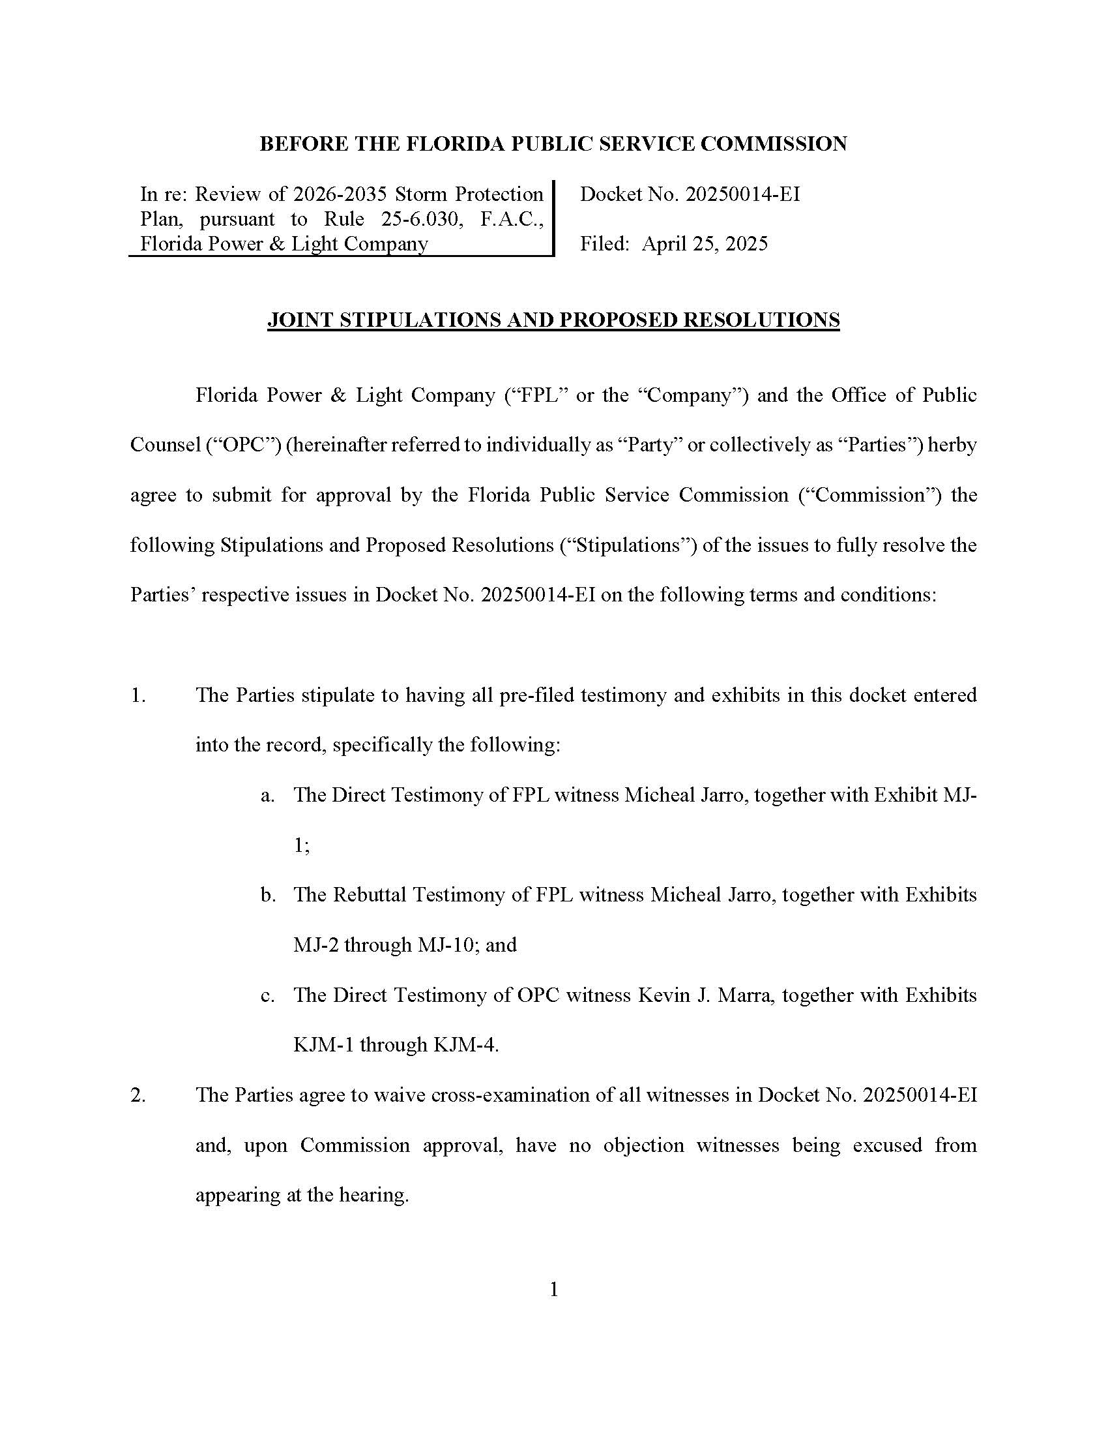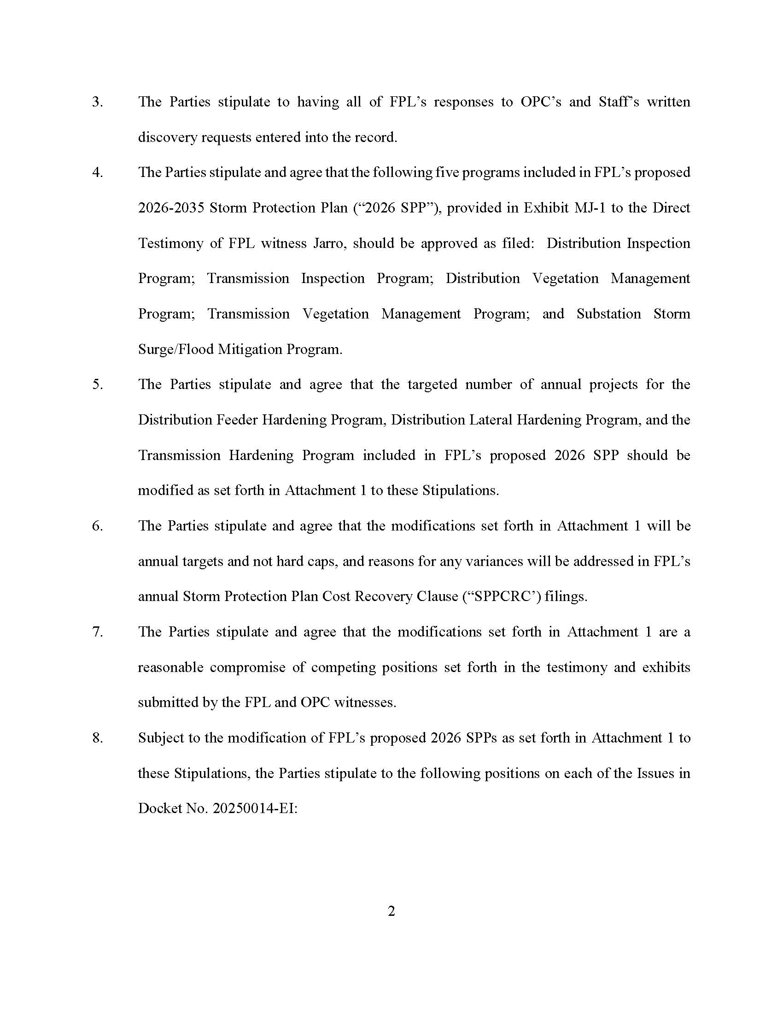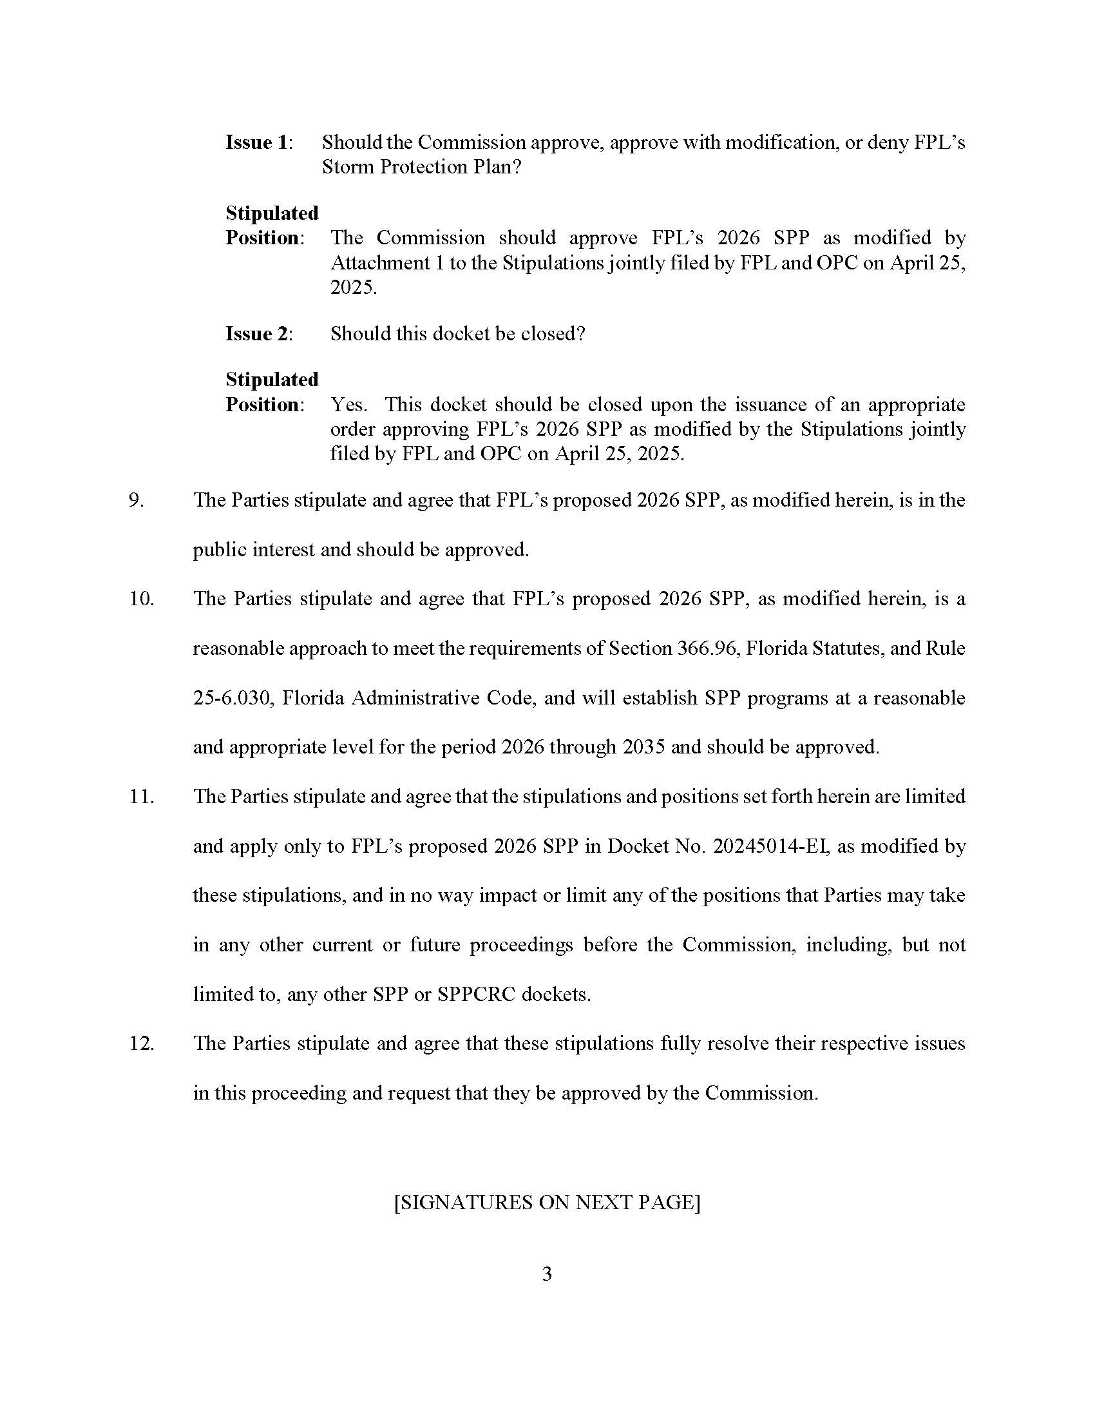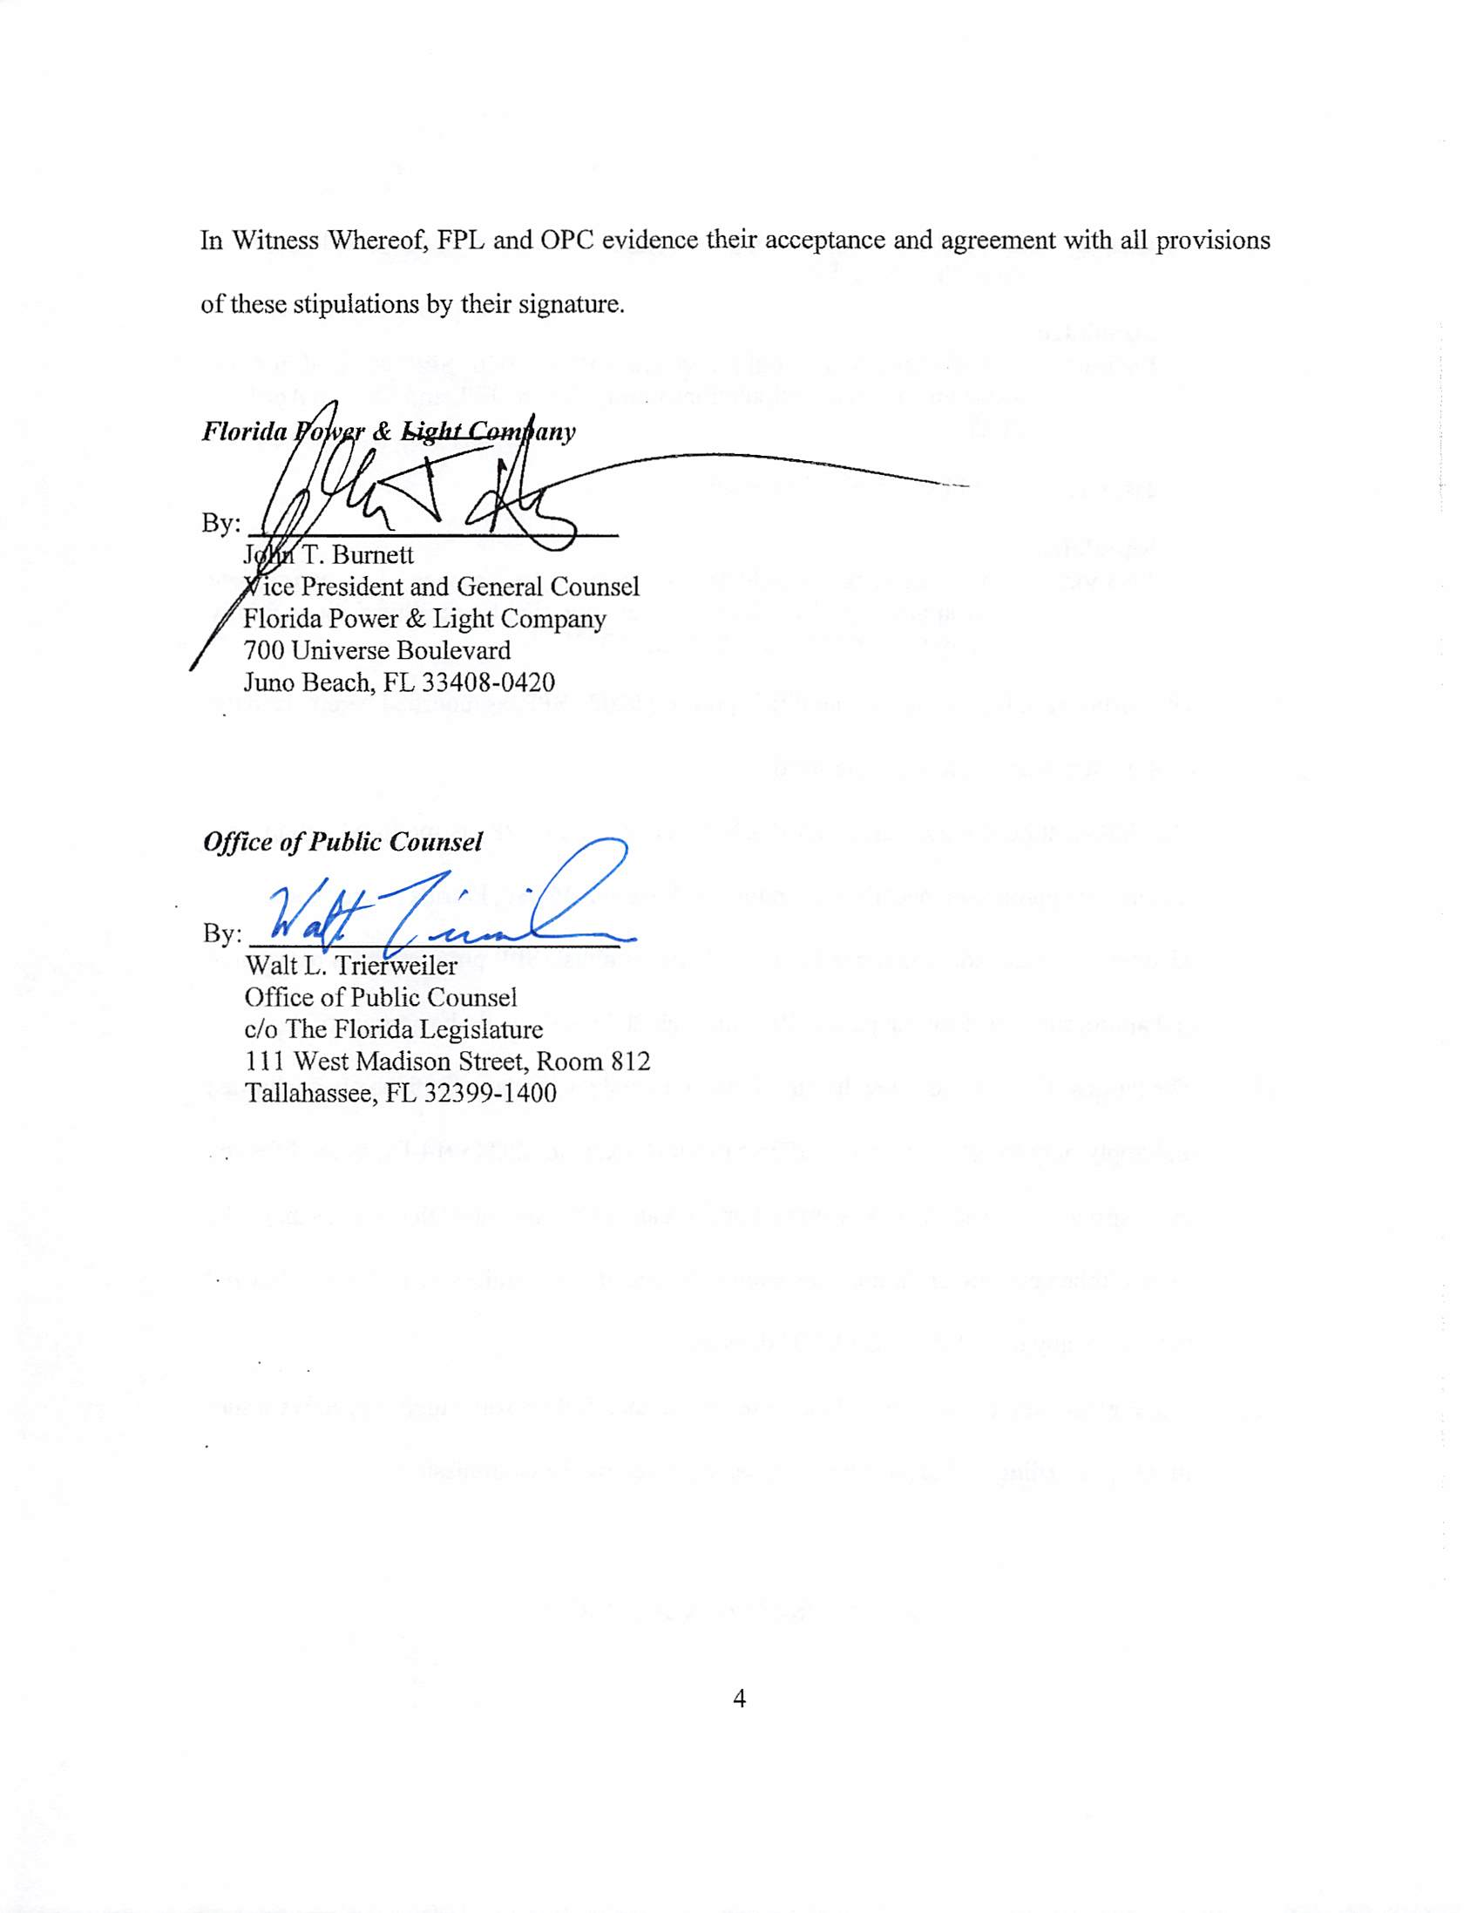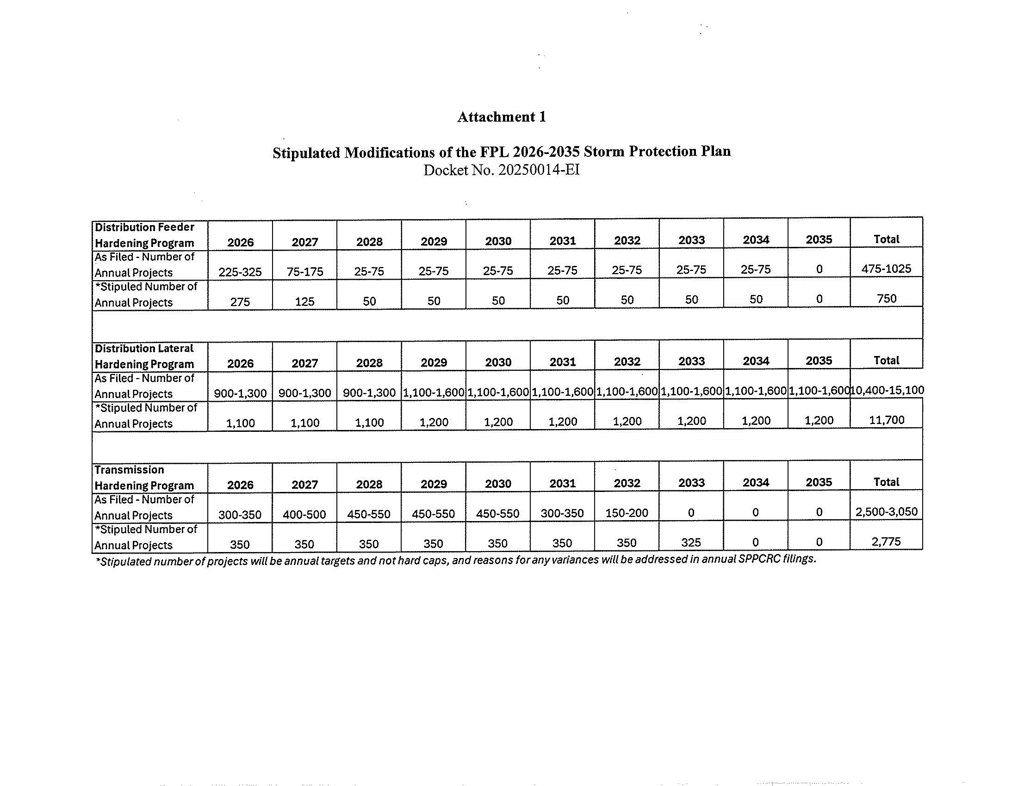

1. Approved by Commission Order No. PSC-2020-0293-AS-EI issued on August 28, 2020.
2. Approved by Commission Order No. PSC-2022-0389-FOF-EI issued on November 10, 2022, and affirmed by *Citizens of the State of Florida, vs. Fay*, 396 So.3d 549 (Fla. Nov. 14, 2024).
3. § 366.96(3), Fla. Stat.
4. *Citizens of the State of Fla. v. Fay*, 396 So. 3d 549, 552 & 555 (2024) (“[T]he SPP Statute stands apart from the rate making process, and in its unique language provides a separate procedure for the Commission's review of storm hardening measures”).
5. *See* Direct Testimony of Kevin J. Mara, P.E. on Behalf of the Citizens of the State of Florida at 9-13.
6. *See* Exh. KJM-5 (DEF Resp. to Staff’s Interrogatory No. 7).
7. *See* Revised Exh. No. BML-1 at 56.