BEFORE THE FLORIDA PUBLIC SERVICE COMMISSION

In re: Petition for approval of gas utility access and replacement directive cost recovery factors for January 2026 through December 2026, by Florida Public Utilities Company. | DOCKET NO. 20250109-GU  ORDER NO. PSC-2025-0450-TRF-GU  ISSUED: December 11, 2025

The following Commissioners participated in the disposition of this matter:

MIKE LA ROSA, Chairman
ART GRAHAM
GARY F. CLARK
ANDREW GILES FAY
GABRIELLA PASSIDOMO SMITH

ORDER APPROVING GUARD COST RECOVERY FACTORS

BY THE COMMISSION:

Background
On September 2, 2025, Florida Public Utilities Company (FPUC or Company) filed a petition for approval of its Gas Utility Access and Replacement Directive (GUARD) cost recovery factors for January through December 2026. The petition includes the direct testimony and Exhibit BD-1 of FPUC witness Bryan Dayton providing the calculations of the proposed factors and Third Revised Sheet No. 7.403.
By Order No. PSC-2023-0235-PAA-GU (GUARD Order), we approved FPUC’s 10-year GUARD program consisting of two components: (1) replacement of problematic pipes and facilities, and (2) relocation of mains and service lines located in rear easement and other difficult to access areas to the front lot easements. As established in the GUARD Order, FPUC is able to recover the revenue requirements of expedited programs to replace problematic pipes and facilities and to relocate certain facilities in rear easements and other difficult to access areas in order to enhance the safety of portions of FPUC’s natural gas distribution system through a monthly surcharge on customers’ bills. The GUARD Order further established the methodology for annually setting the GUARD surcharge to recover the costs of the program.
The methodology to calculate the GUARD program surcharges is the same that was approved for FPUC’s concluded Gas Replacement and Infrastructure Program. In the GUARD Order, we directed FPUC to file its annual GUARD program petition to revise the surcharge on or before September 1 of each year, to implement the revised surcharge effective January 1 through December 31 of the following year.

By Order No. PSC-2024-0504-TRF-GU, we approved FPUC’s 2025 GUARD cost recovery factors and associated Second Revised Sheet No. 7.403, which was effective from the first billing cycle of January through the last billing cycle of December 2025.

Included in this order are Attachment A - list of GUARD projects for 2024-2026 Actual/Forecast, and Attachment B - Third Revised Tariff Sheet No. 7.403 legislative version.

During the review process, our staff issued a data request to FPUC on September 22, 2025, for which responses were received on October 6, 2025. By Order No. PSC-2025-0392-PCO-GU, we suspended the proposed tariffs. We have jurisdiction over this matter pursuant to Sections 366.04, 366.05, and 366.06, Florida Statutes (F.S.).

Decision
The GUARD program is driven by risks identified under FPUC’s Distribution Integrity Management Program and risk assessments performed by an independent contractor. As stated by witness Dayton and in responses to our staff’s data request, the GUARD projects are based upon risk assessment categorized as high, medium, and low risk, by an independent contractor. Projects in high consequence areas and those of high risk continue to be a priority. The prioritized projects for 2025 and 2026 are included in Attachment A to this order. Attachment A indicates that FPUC currently has nine projects in-progress which will relocate 30.21 miles of pipes from rear lots to the street front and install 1,568 service lines in Palm Beach and Seminole counties for an estimated investment cost of $22.6M during 2025. For 2026, 30 projects which include replacing obsolete/Aldyl-A pipes, span pipes, under building, and relocation of pipes from rear lot easements to the front lot easements for 53.13 miles and 2,203 service lines in Palm Beach, Polk, Seminole, and Volusia counties are listed for an estimated investment cost of $25.14M.
The Company requested that the actual/estimated true up amounts be based on six months of actual data and six months of projected data. In the past filings, the Company provided seven months of actual data and five months of projected data. The Company included this revision in this filing and intends to apply it to all future GUARD filings. The Company explained that this change would better align FPUC’s GUARD filing with its sister company, Florida City Gas’ Safety, Access, and Facility Enhancement (SAFE) program filing, because the annual SAFE filing also utilizes six months of actual data and six months of estimated data. Furthermore, any difference between actual and estimated data would be incorporated in the next year’s true up.

FPUC’s True-Ups by Year
FPUC’s calculation for the 2026 GUARD revenue requirement includes a final true-up for 2024, actual/estimated true-up for 2025, and projected costs for 2026.

Final 2024 GUARD True-Up
Company witness Dayton stated that the January through December 2024 true-up resulted in an under-recovery of $701,550, inclusive of interest. As shown in Schedule C-1 of the petition, the 2023 ending balance was an over-recovery of $571,835. Combined with the 2024 under-recovery of $1,283,709, and year-end monthly interest expense of $10,324 associated with any over- and under-recoveries results in a final 2024 under-recovery of $701,550.

Actual/Estimated 2025 GUARD True-Up
The January through December 2024 GUARD investment and associated revenue requirement amounts are shown on Exhibit BD-1, page 2 of 7. In 2024, the actual beginning balance was an under-recovery of $701,550 (inclusive of interest). As shown on Exhibit BD-1, page 3 of 7, the 2025 actual (January through June) and forecasted (July through December) GUARD true-up is an over-recovery of $658,951 (inclusive of interest), resulting in an overall under-recovery of $42,599. As shown in Table 1 below, this under-recovery is being applied to the 2026 GUARD revenue requirement, resulting in a higher revenue requirement to be recovered from customers in 2026.

Projected 2026 GUARD Revenue Requirement
For 2026, FPUC plans to invest $24,902,464 ($18,023,786 for mains, $5,998,678 for service lines, and $880,000 for meters), resulting in a total qualified investment of $110,515,998 (including the year-end 2025 investment) in 2026. The GUARD program revenue requirement includes a return on investment, depreciation expense, extending customer-owned fuel lines (to connect to meters which require to be relocated due to safety issues), customer notification expense, and property taxes. All expenses are dependent upon the level of investment costs. After adding the 2025 under-recovery true-up amount of $42,599, the 2026 GUARD revenue requirement to be recovered through the proposed surcharges is $10,180,614.

Table 1
2026 GUARD Revenue Requirement Calculation
2026 Total Qualified Investment | $110,515,998
2026 Return on Investment | $6,842,806
Depreciation Expenses | $1,615,761
Fuel Line Expenses | $24,000
Property/Ad Valorem Tax Expense | $1,635,408
Customer Notification Expense | $20,040
2026 Net GUARD Revenue Requirement | $10,138,015
Plus 2025 Under-Recovery | $42,599
2026 Total Revenue Requirement | $10,180,614
Source: Witness Dayton’s Testimony Exhibit BD-1, Schedule C-2, Page 4 of 7.

Proposed 2026 GUARD Surcharges
As approved in the 2023 GUARD Order, the total 2026 revenue requirement is allocated to the rate classes using the same methodology used for the allocation of mains and service lines in the cost of service study used in the Company’s most recent rate case. The respective percentages were multiplied by the 2026 revenue requirement and divided by each rate class’s projected therm sales to provide the GUARD surcharge for each rate class. This methodology was originally established by the 2012 Order approving FPUC’s GRIP program.
In 2025, the monthly bill impact was $2.22 for a residential customer using 20 therms per month or $26.64 per year. The proposed 2026 GUARD surcharge for FPUC’s residential customers who use 20 therms a month on the Residential Service tariff (RES-2) would pay $0.26015 per therm compared to the 2025 GUARD surcharge of $0.11116 per therm. The monthly bill impact for 2026 would be $5.20 for a residential customer using 20 therms per month or $62.44 per year. The proposed GUARD surcharges are shown in Attachment B, in Third Revised Sheet No. 7.403.

Conclusion
We approve FPUC's 2026 GUARD cost recovery factors and associated Third Revised Sheet No. 7.403, included in Attachment B to this order, to be effective for the first billing cycle of January 2026 through the last billing cycle of December 2026. We also approve FPUC’s request to provide six months of actual and six months of estimated data in its actual/estimated true-up filings. The GUARD surcharge will allow FPUC to replace problematic pipes and facilities and relocate certain facilities located in rear easements to the front easements, and recover the project costs on an expedited basis.

Based on the foregoing, it is

ORDERED by the Florida Public Service Commission that Florida Public Utilities Company’s 2026 Gas Utility Access and Replacement Directive cost recovery factors and associated Third Revised Sheet No. 7.403, included in Attachment B to this order, to be effective for the last billing cycle of January 2026 through the last billing cycle of December 2026, are approved. It is further
ORDERED that Florida Public Utilities Company’s request to provide six months of actual and six months of estimated data in its actual/estimated true-up filings is approved. The Gas Utility Access and Replacement Directive will allow FPUC to replace problematic pipes and facilities and relocate certain facilities located in rear easements to the front easements, and recover the project costs on an expedited basis. It is further

ORDERED that if a protest is filed within 21 days of issuance of the Order, the tariff shall remain in effect with any revenues held subject to refund pending resolution of the protest. It is further

ORDERED that if no timely protest is filed, this docket shall be closed upon the issuance of a Consummating Order.

By ORDER of the Florida Public Service Commission this 11th day of December, 2025.

/s/ Adam J. Teitzman
ADAM J. TEITZMAN
Commission Clerk
Florida Public Service Commission
2540 Shumard Oak Boulevard
Tallahassee, Florida 32399
(850) 413-6770
www.floridapsc.com

Copies furnished: A copy of this document is provided to the parties of record at the time of issuance and, if applicable, interested persons.

DD

NOTICE OF FURTHER PROCEEDINGS

The Florida Public Service Commission is required by Section 120.569(1), Florida Statutes, to notify parties of any administrative hearing or judicial review of Commission orders that is available under Sections 120.57 or 120.68, Florida Statutes, as well as the procedures and time limits that apply. This notice should not be construed to mean all requests for an administrative hearing or judicial review will be granted or result in the relief sought.

Mediation may be available on a case-by-case basis. If mediation is conducted, it does not affect a substantially interested person's right to a hearing.

The Commission's decision on this tariff is interim in nature and will become final, unless a person whose substantial interests are affected by the proposed action files a petition for a formal proceeding, in the form provided by Rule 28-106.201, Florida Administrative Code. This petition must be received by the Office of Commission Clerk, 2540 Shumard Oak Boulevard, Tallahassee, Florida 32399-0850, by the close of business on January 2, 2026.

In the absence of such a petition, this Order shall become final and effective upon the issuance of a Consummating Order.

Any objection or protest filed in this docket before the issuance date of this order is considered abandoned unless it satisfies the foregoing conditions and is renewed within the specified protest period.

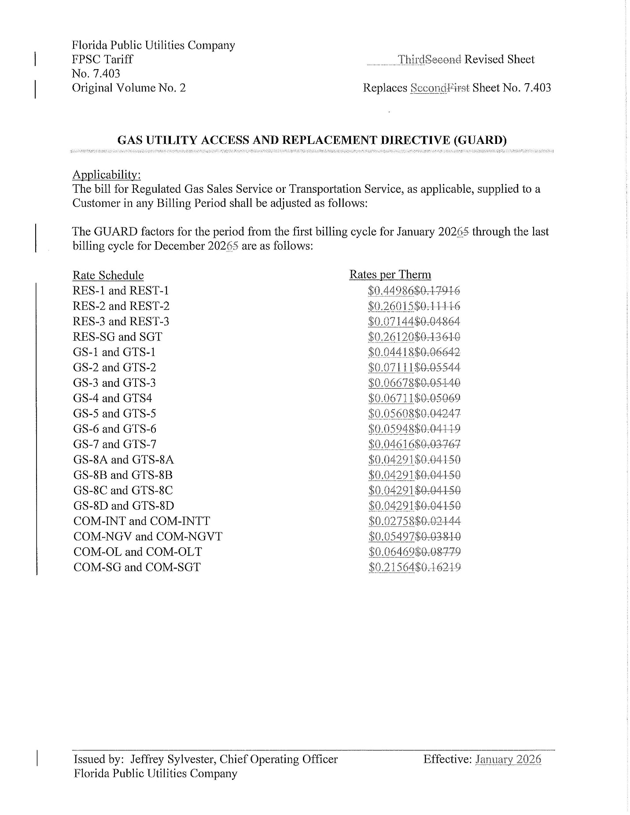

Order No. PSC-2023-0235-PAA-GU, issued August 15, 2023, amended by Order No. PSC-2023-0235A-PAA-GU, issued August 18, 2023, in Docket No. 20230029-GU, In re: Petition for approval of gas utility access and replacement directive, by Florida Public Utilities Company.
Order No. PSC-2012-0490-TRF, issued September 24, 2021, in Docket No. 20120036-GU, In re: Joint petition for approval of Gas Reliability Infrastructure Program (GRIP) by Florida Public Utilities Company and the Florida Division of Chesapeake Utilities Corporation.
Order No. PSC-2024-0504-TRF-GU, issued December 17, 2024, in Docket No. 20240137-GU, In re: Petition for approval of GUARD cost recovery factors, by Florida Public Utilities Company.
Order No. PSC-2025-0392-PCO-GU, issued October 22, 2025, in Docket No. 20250109-GU, In re: Petition for approval of gas utility access and replacement directive cost recovery factors for January 2026 through December 2026, by Florida Public Utilities Company.
Pursuant to Chapter 49, Section 192.1005 Code of Federal Regulations (2023), a gas distribution operator must develop and implement an integrity management program that includes a written integrity management plan.

