BEFORE THE FLORIDA PUBLIC SERVICE COMMISSION

In re: Petition for approval of 2024 true-up, projected 2025 true-up; and 2026 revenue requirements and surcharges associated with cast iron/bare steel pipe replacement rider, by Peoples Gas System. | DOCKET NO. 20250106-GU  ORDER NO. PSC-2025-0451-TRF-GU  ISSUED: December 12, 2025

The following Commissioners participated in the disposition of this matter:

MIKE LA ROSA, Chairman
ART GRAHAM
GARY F. CLARK
ANDREW GILES FAY
GABRIELLA PASSIDOMO SMITH

ORDER APPROVING TARIFF

BY THE COMMISSION:

Background
On August 29, 2025, Peoples Gas System, Inc. (Peoples or utility) filed a petition for approval of its final 2024 true-up, projected 2025 true-up, and 2026 revenue requirement and surcharges associated with the cast iron/bare steel replacement rider (CI/BSR Rider or rider). The rider was originally approved by Order No. PSC-12-0476-TRF-GU (2012 Order) to recover the cost of accelerating the replacement of cast iron and bare steel pipes through a surcharge on customers’ bills. In the 2012 Order, we found that, “replacement of these types of pipelines is in the public interest to improve the safety of Florida’s natural gas infrastructure, and reduce the possibility of loss of life and destruction of property should an incident occur.” Peoples’ current surcharges were approved in Order No. PSC-2024-0511-TRF-GU (2024 Order).

By Order No. PSC-17-0066-AS-GU, we approved a comprehensive settlement agreement between Peoples and the Office of Public Counsel. The settlement agreement, in part, added problematic plastic pipe (PPP) installed in the company's distribution system to eligible replacements under the rider beginning in 2017 and continuing through 2028. PPP was manufactured before 1983 and has significant safety concerns. In certain areas, the PPP is interspersed with, or connected to, the cast iron/bare steel pipe that is being replaced under the rider. As provided for in the settlement agreement, PPP replacements are included in the calculation of the 2025 rider surcharges.

In December 2023, we approved Peoples’ petition for rate increase, which contained two provisions that would impact the CI/BSR Rider. First, Peoples moved its CI/BSR investments as of December 31, 2023, into rate base, as required by the 2012 Order approving the rider. This provision had the effect of resetting the CI/BSR Rider rates to zero.

Second, we approved Peoples’ request for the Long Term Debt Cost Rate (LTDR) true-up mechanism. The LTDR true-up mechanism allowed Peoples to make a one-time adjustment to the estimated cost of long-term debt for the projected test year ending December 31, 2024. The purpose of the LTDR true-up mechanism was to reflect the actual embedded costs of the utility’s inaugural long-term debt issuance in its revenue requirement and rates. This provision was a result of Peoples being spun off from Tampa Electric Company (TECO), because Peoples no longer obtains long-term debt capital from TECO and instead issues its own debt as a separate entity.

We further ordered that if the impact to the incremental revenue requirement was greater than $500,000 for the period between the implementation of the base rate increase and the implementation of the LTDR true-up mechanism, then the incremental revenue requirement would be recovered through the CI/BSR rider for 2025. We approved the incremental revenue requirement of $874,085 associated with the LTDR true-up mechanism in May 2024. The total amount associated with the LTDR true-up mechanism that was recovered through the 2025 CI/BSR rider was $476,034, as shown in Exhibit A to the petition, page 2 of 4, line No. 9a.

On October 7, 2025, we voted to approve Peoples’ 2025 Stipulation and Settlement Agreement (2025 agreement) in settlement of the issues presented in the 2025 rate case petition. The 2025 agreement provides for the transfer of $6.7 million in CI/BSR rider revenues from recovery through the rider to base rates.

Paragraph 4(e) of the 2025 agreement contemplates that for rates that will first go into effect after January 1, 2026, with respect to cost recovery clauses and riders that recover plant investment costs, the utility will use the midpoint return on equity, equity ratio, and weighted average cost of capital specified in Exhibit A of the 2025 agreement. Additionally, the 2025 agreement contemplates that the utility shall allocate among its respective rate schedules the annual cost recovery amounts to be recovered by applying the cost recovery revenue distribution shown in Exhibit B of the 2025 agreement.

On October 9, 2025, Peoples filed an amended petition. The amended petition reflects the updated revenue requirements to be recovered by the utility during the period January through December 2026 and the updated 2026 surcharges. The surcharges were recalculated to reflect the capital structure (effective January 2026) approved in the 2025 agreement.

Attachment A, attached hereto to this Order, contains Table 1, which consolidates actual and projected CI/BSR and PPP miles, replaced investment, and revenue requirements for each year of the replacement program. Additionally, Peoples provided tables that display the replacement progress and forecasts for the CI/BSR Rider (Table 2) and for PPP (Table 3). Attachment B, attached hereto, contains the proposed tariff as filed in the amended petition.

During the review process of the utility’s petition, our staff issued two data requests, for which responses were received on October 6, 2025, and November 10, 2025, respectively. By Order No. PSC-2025-0395-PCO-GU, issued October 22, 2025, the petition was suspended to allow our staff a sufficient opportunity to gather and evaluate all pertinent information related to the tariff proposals in order to present us with an informed recommendation. We have jurisdiction over this matter pursuant to Section 366.03, 366.04, 366.05, and 366.06, Florida Statutes (F.S.).

Decision
The CI/BSR Rider charges have been in effect since January 2013 and were projected to be in effect for 10 years with replacement projects completed by the end of 2022. In response to staff’s first data request in the 2024 docket, Peoples stated that the COVID-19 pandemic environment greatly contributed to replacement efforts going beyond the 10-year period. Contributing factors include construction contractor labor shortages, consulting firm availability, supply chain challenges, and extensive permitting challenges. In response to our staff’s first data request, Peoples stated that it continued to see delays of CI/BSR projects in Dade-Broward due to construction moratoriums, lengthy permitting processes, and denial of easement requests due to the municipality’s plans to redevelop the relevant areas. The utility also stated that St. Petersburg and Orlando each have a project that the utility is in the process of confirming whether the pipe material is bare steel. Additionally, the utility stated that Orlando has two projects in construction and one in redesign. Peoples stated that it expects to have 2.4 miles of CI/BSR replacement remaining entering 2026.

In 2025, Peoples’ cast iron/bare steel and PPP replacement activity focused in the areas of Dade-Broward, Tampa, St. Petersburg, Orlando, Eustis, Jacksonville, Lakeland, Daytona, Jupiter, Panama City, and Ocala. In 2026, for CI/BSR projects, Peoples states it will continue working through permitting challenges and complete any remaining verification necessary to submit projects for design and permitting in Miami and Orlando. Peoples states it will focus on the design and permitting of PPP projects in St. Petersburg, Orlando, Panama City, Eustis, Daytona, Ocala, and Tampa, beginning construction as plans and permits become available. Additionally, the utility will begin design work for replacement of PPP in the downtown Miami area. A detailed description of the projects, including their address, has been provided in response to our staff’s first data request.

True-ups by Year
Peoples’ calculation for the 2026 revenue requirement and surcharges includes a final true-up for 2024, an actual/estimated true-up for 2025, and projected costs for 2026. Pursuant to the 2012 Order, the capital expenditures for 2025 and 2026 exclude the first $1 million of facility replacements each year because that amount is included in rate base. Peoples has included depreciation expense savings as discussed in the 2012 Order; however, the utility has not identified any operations and maintenance savings.

Final True-up for 2024
Exhibit A of the petition shows that the revenues collected for 2024 were $857,610 compared to a revenue requirement of $606,890, resulting in an over-recovery of $250,720. The final 2023 under-recovery of $102,499, 2024 over-recovery of $250,720, 2024 LTDR true-up mechanism adjustment of $476,034, and interest associated with any over- and under-recoveries, results in a total 2024 under-recovery of $331,724.

Actual/Estimated 2025 True-up
In Exhibit B of the petition, Peoples provided actual revenues for January through July and forecast revenues for August through December of 2025, totaling $3,471,552, compared to an actual/estimated revenue requirement of $3,083,205, resulting in an over-recovery of $388,347. The final 2024 under-recovery of $331,724, 2025 over-recovery of $388,347, and interest associated with any over- and under-recoveries, results in a total 2025 over-recovery of $69,991.

Projected 2026 Costs
Exhibit C of the petition shows Peoples’ projects investments or capital expenditures of $62,143,657 for the replacement of cast iron/bare steel infrastructure and PPP in 2026, excluding the $1 million adjustment to rate base. The return on investment, depreciation expense (less savings), and property tax expense associated with that investment are $2,982,438. After adding the total 2025 over-recovery of $69,991, the total 2026 revenue requirement is $2,912,447. Table 1 displays the 2026 revenue requirement calculation. In response to our staff’s first data request, Peoples provided updated investment and revenue requirement projections for CI/BSR and PPP which is contained in Table 1 of Attachment A, attached hereto.

Table 1
2026 CI/BSR Rider Revenue Requirement
2026 Projected Expenditures | $62,143,657
Return on Investment | $2,524,574
Depreciation Expense (less savings) | $457,864
Property Tax Expense | $0
2026 Revenue Requirement | $2,982,438
Less 2025 Over-recovery | $69,991
Total 2026 Revenue Requirement | $2,912,447
Source: Page 1 of 2 in Exhibit C in petition (Docket No. 20250106-GU).

Proposed Surcharges
As established in the 2012 Order, the total 2026 revenue requirement is allocated to rate classes using the same methodology that was used for the allocation of mains and services in the cost of service study used in Peoples’ most recent approved rate case. After calculating the percentage of total plant costs attributed to each rate class, the respective percentages were multiplied by the 2026 revenue requirement resulting in the revenue requirement by rate class. Dividing each rate class’s revenue requirement by projected therm sales provides the rider surcharge for each rate class.

If approved, the proposed 2026 rider surcharge for residential customers would be $0.01593 per therm (compared to the current surcharge of $0.01391). The 2026 monthly bill impact would be $0.32 for a residential customer who uses 20 therms. The proposed tariff sheet, as filed in the amended petition, is attached to this Order as Attachment B.

In response to our staff’s second data request, Peoples identified a formula error reflecting the depreciation savings in the calculation file. The depreciation savings were added to depreciation expense instead of subtracted. Peoples stated that the correction of this error would result in reduction to surcharges filed in the amended petition; however, the reduction is de minimis. For a residential customer, the surcharge would decrease by $0.00001 per therm, or $0.01 per average bill. Peoples proposed to account for the differences in the true-up in next year’s filing. We find it is reasonable, due to the de minimis impact on the surcharges, to reflect the difference in the true-up filing in next year’s filing.

Conclusion
We reviewed Peoples’ filings and supporting documentation and find that the calculations are consistent with the methodology approved in the 2012 Order and are reasonable and accurate. We approve Peoples’ proposed CI/BSR Rider surcharges to be effective for the first billing cycle of January through the last billing cycle of December 2026.

Based on the foregoing, it is

ORDERED by the Florida Public Service Commission that Peoples Gas System's proposed CI/BSR Rider surcharges to be effective for the first billing cycle of January through the last billing cycle of December 2026 are hereby approved. It is further

ORDERED that if a protest is filed within 21 days of issuance of the Order, the tariff shall remain in effect with any revenues held subject to refund pending resolution of the protest. It is further

ORDERED that if no timely protest is filed, this docket shall be closed upon the issuance of a Consummating Order.

By ORDER of the Florida Public Service Commission this 12th day of December, 2025.

/s/ Adam J. Teitzman
ADAM J. TEITZMAN
Commission Clerk
Florida Public Service Commission
2540 Shumard Oak Boulevard
Tallahassee, Florida 32399
(850) 413-6770
www.floridapsc.com

Copies furnished: A copy of this document is provided to the parties of record at the time of issuance and, if applicable, interested persons.

ZB

NOTICE OF FURTHER PROCEEDINGS

The Florida Public Service Commission is required by Section 120.569(1), Florida Statutes, to notify parties of any administrative hearing or judicial review of Commission orders that is available under Sections 120.57 or 120.68, Florida Statutes, as well as the procedures and time limits that apply. This notice should not be construed to mean all requests for an administrative hearing or judicial review will be granted or result in the relief sought.

Mediation may be available on a case-by-case basis. If mediation is conducted, it does not affect a substantially interested person's right to a hearing.

The Commission's decision on this tariff is interim in nature and will become final, unless a person whose substantial interests are affected by the proposed action files a petition for a formal proceeding, in the form provided by Rule 28-106.201, Florida Administrative Code. This petition must be received by the Office of Commission Clerk, 2540 Shumard Oak Boulevard, Tallahassee, Florida 32399-0850, by the close of business on January 2, 2026.

In the absence of such a petition, this Order shall become final and effective upon the issuance of a Consummating Order.

Any objection or protest filed in this docket before the issuance date of this order is considered abandoned unless it satisfies the foregoing conditions and is renewed within the specified protest period.

Table 1
Peoples’ CI/BSR Replacement Program Progress
Year | CI/BS Miles Replaced | PPP Miles Replaced | CI/BS Investmentͣ | PPP Investmentᵇ | CI/BS Revenue Requirement | PPP Revenue Requirement
2017 | 51 | - | $17,588,366 | $2,915,802 | $6,868,302 | $74,021
2018 | 62 | 56 | $27,035,678 | $15,890,424 | $8,510,823 | $848,201
2019 | 52 | 42 | $35,821,371 | $17,425,589 | $11,075,229 | $2,706,161
2020 | 55 | 43 | $32,317,184 | $11,115,571 | $14,817,804 | $4,358,010
2021 | 14 | 38 | $23,726,642 | $19,812,603 | $1,347,321 | $(160,452)
2022 | 10.4 | 29 | $13,079,280 | $15,486,397 | $3,154,597 | $1,921,940
2023 | 2.3 | 44 | $5,815,954 | $18,210,943 | $3,927,032 | $3,604,313
2024 | 2.4 | 10 | $5,798,611 | $15,279,982 | $224,372ͤ | $382,518ͤ
2025* | 4.7 | 51 | $3,001,439 | $28,644,082 | $719,587 | $2,363,618
2026* | 2.4 | 87 | $4,175,820 | $57,967,838 | $194,023ᶠ | $2,751,803ᶠ
2027* | 1.5ͨ | 96 | $2,919,534 | $72,206,101 | $625,475 | $10,269,846
2028* | 1.3 | 54 | $2,868,930ͩ | $43,044,041ͩ | $967,738 | $17,510,136

* Projected
ͣ CI/BS Investment includes removal of initial $1M through 2025.
ᵇ PPP Investment includes removal of initial $1M each year starting in 2026.
ͨ 5-year construction moratoriums in effect in the City of Miami preventing completion before 2027.
ͩ 2028 investment includes rollover costs to occur in 2029.
ͤ Revenue Requirement based on current year investment only as investment for prior years rolled into rate base pursuant to the 2023 Rate Case.
ᶠ Revenue Requirement based on current year investment only as investment for prior years rolled into rate base pursuant to the 2025 Rate Case.

Table 2
Peoples’ CI/BSR Replacement Progress
Year | Main Replacements |  |  |  |  | Service Line Replacements
Year | Replaced Cast Iron (Miles) | Replaced Bare Steel (Miles) | Remaining Cast Iron at Year End (Miles) | Remaining Bare Steel at Year End (Miles) | Total Miles Remaining of CI/BS Mains | Bare Steel Service Lines Replaced | Remaining Bare Steel Service Lines
2012 | - | - | 100 | 354 | 454 | - | 14,978
2013 | 13 | 38 | 87 | 316 | 403 | 907 | 14,071
2014 | 2 | 15 | 85 | 298 | 383 | 7,964 | 6,107
2015 | 26 | 60 | 59 | 238 | 297 | 1,019 | 5,088
2016 | 15 | 35 | 44 | 203 | 247 | 1,050 | 6,963
2017 | 15 | 36 | 29 | 178 | 207 | 1,135 | 4,279
2018 | 10 | 52 | 18 | 126 | 144 | 1,970 | 2,309
2019 | 8 | 44 | 10 | 83ͣ | 93 | 649 | 1,660
2020 | 4 | 51 | 6 | 35ͣ | 41 | 423 | 1,237
2021 | 3.5 | 10.5 | 2 | 24 | 26 | 191 | 998
2022 | 1.3 | 9.1 | 0.9 | 14.6ͣ | 15.5 | 74 | 941
2023 | 0.3 | 2.0 | 0.6 | 12.4ͣ | 12.4 | 40 | 931
2024 | 0.1 | 2.3 | 0.3 | 5.6 | 5.9 | 79 | 686
2025* | < 0 | 4.7 | < 0 | 2.4 | 2.4 | ᵇ | ᵇ

* Projected
ͣ Additional miles of pipe added after reclassification of pipe type.
ᵇ To be determined.

Table 3
Peoples’ PPP Replacement Program Progress
Year | Replaced PPP (Miles) | Total Remaining PPP Mains (Miles) | Replaced PPP Service Lines | Remaining PPP Service Lines
2016 | - | 551 | - | 28,237
2017 | - | 509 | 1,396 | 26,841
2018 | 56 | 461 | 3,941 | 24,741
2019 | 42 | 418 | 2,349 | 20,420
2020 | 43 | 370 | 1,702 | 18,718
2021 | 38 | 337 | 882 | 17,683
2022 | 29 | 306 | 837 | 17,229
2023 | 44 | 281 ͣ | 883 | 16,346 ͣ
2024 | 10 | 296 ͣ | 637 | 15,499ᵇ
2025* | 51 | 236 | ᵇ | ᵇ
2026* | 87 | 150 | ᵇ | ᵇ
2027* | 96 | 54 | ᵇ | ᵇ
2028* | 54 | - | ᵇ | ᵇ

* Projected
ͣ Additional service lines reclassified during the year.
ᵇ This will be determined during the replacement year.

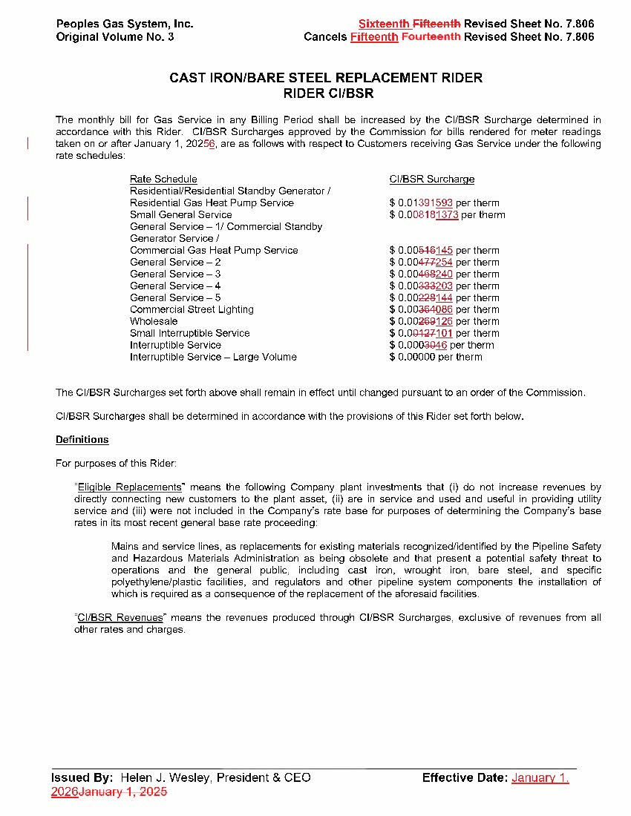

Order No. PSC-12-0476-TRF-GU, issued September 18, 2012, in Docket No. 20110320-GU, In re: Petition for approval of Cast Iron/Bare Steel Pipe Replacement Rider (Rider CI/BSR), by Peoples Gas System.
Order No. PSC-2024-0511-TRF-GU, issued December 20, 2024, in Docket No. 20240133-GU, In re: Petition for approval of 2023 true-up, projected 2024 true-up, and 2025 revenue requirements and surcharges associated with cast iron/bare steel replacement rider, by Peoples Gas System.
Order No. PSC-17-0066-AS-GU, issued February 28, 2017, in Docket No. 20160159-GU, In re: Petition for approval of settlement agreement pertaining to Peoples Gas System’s 2016 depreciation study, environmental reserve account, problematic plastic pipe replacement, and authorized ROE.
Order No. PSC-2023-0388-FOF-GU, issued December 27, 2023, in Docket No. 20230023-GU, In re: Petition for rate increase by Peoples Gas System, Inc.
See page 3 of Order No. PSC-12-0476-TRF-GU.
See pages 107-109 of Order No. PSC-2023-0388-FOF-GU.
Id.
See Id. at 108.
Order No. PSC-2024-0170-TRF-GU, issued May 23, 2024, in Docket No. 20240028-GU, In re: Petition to implement long-term debt cost true-up mechanism, by Peoples Gas System, Inc.
Order No. PSC-2025-0413-S-GU, issued October 31, 2025, in Docket No. 20250029-GU, In re: Petition for rate increase by Peoples Gas System, Inc.
DN 14283-2025, response No. 6.
Id.
DN 09444-2024, response No. 4.
DN 14283-2025, response No. 3.
DN 14283-2025, response Nos. 1 and 3.

