BEFORE THE FLORIDA PUBLIC SERVICE COMMISSION

In re: Petition to resolve territorial dispute in Gadsden County with the City of Quincy, by Talquin Electric Cooperative, Inc. | DOCKET NO. 20250039-EU  ORDER NO. PSC-2025-0455-PAA-EU  ISSUED: December 16, 2025

The following Commissioners participated in the disposition of this matter:

MIKE LA ROSA, Chairman
ART GRAHAM
GARY F. CLARK
ANDREW GILES FAY
GABRIELLA PASSIDOMO SMITH

NOTICE OF PROPOSED AGENCY ACTION
ORDER APPROVING 2025 AMENDED TERRITORIAL AGREEMENT

BY THE COMMISSION:

NOTICE is hereby given by the Florida Public Service Commission that the action discussed herein is preliminary in nature and will become final unless a person whose interests are substantially affected files a petition for a formal proceeding, pursuant to Rule 25-22.029, Florida Administrative Code (F.A.C.).

BACKGROUND

On March 10, 2025, Talquin Electric Cooperative, Inc. (Talquin) filed a petition to resolve a territorial dispute with the City of Quincy (Quincy). The territory in dispute is a proposed development of 65 acres on Bostick Road in Gadsden County, with future plans for up to 155 residential lots with a projected load of approximately 930-1,240 kilowatts (kW). A total of 4 phases are planned for the overall development, with Phases 1-3 being located in the disputed area within the 65 acres (a/k/a the Bostick Road Property). Phase 4, consisting of 75 residential lots, is planned to be constructed on an adjacent property.

The parties executed a territorial agreement in 1995 (1995 Territorial Agreement) which expired in 2010. Since that time the parties have continued to abide by the boundaries of the 1995 Territorial Agreement. The dispute between Talquin and Quincy is which utility would provide electric service to the new development located on the Bostick Road Property. Both parties agreed that Phase 4 lies wholly within Quincy’s territorial area as defined by the 1995 Territorial Agreement., Both Quincy and Talquin requested to provide service to the entire Bostick Road Property as portions of Phases 1-3 are located within each party’s respective service territory according to the 1995 Territorial Agreement. ,

This docket was originally set for an evidentiary hearing on October 28-29, 2025, by Order No. PSC-2025-0262-PCO-EU, issued July 8, 2025. On July 22, 2025, Quincy and Talquin filed a joint motion to extend the time until August 29, 2025, to file their direct testimony which was granted by Order No. PSC-2025-0286-PCO-EU, issued July 23, 2025.

On August 27, 2025, Quincy and Talquin filed a joint motion to suspend the procedural schedule, so that the parties could focus on formalizing the new territorial agreement. This joint motion was granted by Order No. PSC-2025-0326-PCO-EU, issued August 29, 2025.

On September 5, 2025, Quincy and Talquin filed a petition to approve a new territorial agreement (2025 Territorial Agreement) dated August 26, 2025, which resolved all outstanding issues between the parties. The 2025 Territorial Agreement was intended to replace the 1995 Territorial Agreement and also reconcile the dispute over the Bostick Road Property by setting Quincy’s boundary line to include Phase 4 and Talquin’s boundary line to include Phases 1-3.

At the November 4, 2025 Agenda Conference, after hearing argument, this matter was deferred. On November 14, 2025, the parties filed a Joint Motion for Approval of an Amended Territorial Agreement (Amended 2025 Territorial Agreement)(Attachment A).

During the review process of both petitions, Quincy and Talquin responded to four Staff Data Requests. The proposed Amended 2025 Territorial Agreement would establish new territorial boundaries, effect the transfer of extra-territorial customers being served by Talquin to Quincy, and assist the joint petitioners in identifying necessary and appropriate facility transfers. The Amended 2025 Territorial Agreement is the subject of this order. We have jurisdiction over this matter pursuant to Section 366.04, Florida Statutes (F.S.)
DECISION

Pursuant to Section 366.04(2)(d), F.S., and Rule 25-6.0440(2), F.A.C., we have jurisdiction to approve territorial agreements between and among rural electric cooperatives, municipal electric utilities, and other electric utilities. Unless we determine that the Amended 2025 Territorial Agreement will cause a detriment to the public interest, it should be approved.

Rule 25-6.0440(2), F.A.C., addresses the standards we should consider for approving territorial agreements for electric utilities. The rule states:

(2) Standards for Approval. In approving territorial agreements, the Commission may consider:
(a) The reasonableness of the purchase price of any facilities being transferred;
(b) The reasonable likelihood that the agreement, in and of itself, will not cause a decrease in the reliability of electrical service to the existing or future ratepayers of any utility party to the agreement;
(c) The reasonable likelihood that the agreement will eliminate existing or potential uneconomic duplication of facilities; and
(d) Any other factor the Commission finds relevant in reaching a determination that the territorial agreement is in the public interest.

Proposed Amended 2025 Territorial Agreement
Talquin and Quincy executed the proposed Amended 2025 Territorial Agreement addressing common boundaries surrounding the City of Quincy on November 14, 2025, to replace and supersede all prior expired agreements. Through the proposed Amended 2025 Territorial Agreement, the joint petitioners seek to:

- Reallocate service areas to better service accommodations for future loads in a more efficient and cost-effective manner;
- Clarify utility services for future developments in the City of Quincy;
- Transfer facilities and all extra-territorial customers of Talquin to Quincy within six months of the Commission’s approval of the proposed 2025 Territorial Agreement; and
- Revise the 2025 Territorial Agreement previously filed with the Commission so that the Cox properties are located within Talquin’s service territory.

Included in the Amended 2025 Territorial Agreement are maps displaying the territorial boundary lines separating Talquin and Quincy’s service areas along with an exhibit depicting the changes in the territorial boundary lines from the 1995 Territorial Agreement to the Amended 2025 Territorial Agreement. Also included are written descriptions of the territorial areas, terms for temporary service, correction of inadvertent service errors, procedures for the transfer of customers and facilities, the method of compensation for transferred facilities, lists of extra-territorial customers’ addresses being transferred, and a sample copy of the letter provided to customers subject to transfer. With the items previously described, Quincy and Talquin’s Amended 2025 Territorial Agreement completes the items required per Rule 25-6.0440(1), F.A.C.

The Amended 2025 Territorial Agreement would remain in effect for 30 years from date upon which our order approving the Agreement is no longer subject to judicial review. Upon the expiration of the initial 30-year term, the Amended 2025 Territorial Agreement automatically renews for successive one-year renewal terms. Either party may terminate the Amended 2025 Territorial Agreement provided that such termination becomes effective after the initial 30-year term by providing notice of termination to the other party no fewer than 12 months prior to the effective date of the termination in accordance with Section 8.3.

Proposed Boundary Changes

The joint petitioners assert that the proposed boundary line changes would avoid and eliminate the circumstances giving rise to duplication of service facilities and possible hazards. The proposed boundary line changes address the previous 1995 Territorial Agreement’s boundary line going through customers’ properties and splitting land parcels as seen on Exhibit A-3. These changes extend and/or compress the utilities’ service areas by shifting the boundary line to coincide with the boundaries of the land parcels.

The boundary line changes found on Exhibit A-3 Map Page 10 of the proposed Amended 2025 Territorial Agreement delineate the utilities’ service territories and reconciles the main issue concerning the proposed Bostic Road Property housing development found in Talquin’s petition filed on March 10, 2025.¹² Exhibit D of Talquin’s petition provides the Master Plan for the development site. Pursuant to the Amended 2025 Territorial Agreement, Quincy’s service area would consist of Phase 4 while Talquin’s service area would consist of Phases 1 – 3.

Proposed Customer Transfers, Notifications, and Bills
The joint petitioners assert that, upon the effective date, there would be no active temporary service customers as they will have either been converted to permanent customers or will be treated as extra-territorial customers pursuant to Article III. The joint petitioners have identified 35 extra-territorial accounts (8 commercial and 27 residential) that have a point of use located within Quincy’s territorial area but are receiving electric service from Talquin on the effective date of the Amended 2025 Territorial Agreement and are subject to transfer to Quincy. Per the Amended 2025 Territorial Agreement, such accounts would be transferred to Quincy within 6 months, and the parties will notify us if circumstances require additional time.

As required by Rule 25-6.0440(1)(d), F.A.C., the joint petitioners provided notification to the affected customers by letters dated September 2, 2025. Of the 35 extra-territorial accounts, Talquin states the United States Postal Services’ records reflect 32 letters have been delivered, 2 letters were in transit to Washington state, and 1 was an attempted delivery and was returned as undelivered. In its letter to the extra-territorial customers, Talquin asserts that Quincy and Talquin will handle all of the transfer arrangements, and if these customers have a deposit with Talquin, the deposit will be applied to their last bill and any surplus will be refunded directly to the customer. Rule 25-6.0440(1)(d), F.A.C., also requires that affected customers experiencing differences in rates have such rate changes explained. In regards to the customer transfers from Talquin to Quincy noted above, Quincy and Talquin provided a July 2025 sample bill for a residential and commercial class customer using 1,000 kilowatt-hours (kWh) per month. The residential July 2025 sample bill at 1,000 kWh was $159.26 for Talquin and $133.41 for Quincy. Similarly, the sample commercial bill calculations provided show lower July 2025 bills for Quincy compared to Talquin.

Pursuant to Rule 25-6.0440(1)(e), F.A.C., Talquin received communications from three customers by telephone. Of these three, one customer did not appear concerned about the transfer after receiving an explanation. The other two customers expressed discontent over their accounts being transferred to Quincy.

Review

The Amended 2025 Territorial Agreement was analyzed for compliance with each component of Rule 25-6.0440(2), F.A.C. Regarding paragraph (2)(a), while no dollar amounts are given, the joint petitioners have outlined a compensation formula for the transfer of electric distribution facilities used exclusively for providing electric service to transferred customers. The amount of compensation would be based upon the replacement cost (new) at the time of the proposed transfer, less depreciation calculated on a 30-year straight-line basis over the life of the asset (facility) as determined from the transferring party’s books and records and any costs incurred by the transferring party for the reintegration of its remaining system to the extent such reintegration costs are reasonably required by sound utility practices. This compensation would consist of a cash payment made within 60 days of the presentation of an invoice from the transferring party.

Consistent with Rule 25-6.0440(2)(b), F.A.C., the Amended 2025 Territorial Agreement is not expected to result in a decrease in the reliability of electrical service for existing or future customers of either Talquin or Quincy. The joint petitioners state the Amended 2025 Territorial Agreement largely maintains the status quo. Talquin and Quincy argue that they have the capacity for future growth as Talquin has three substations (Gretna, Point Milligan, and Wetumpka) in the surrounding area, which has a combined capacity to serve 112 megavolt-amperes (MVA). Quincy maintains two substations (North and South) that have a combined capacity to serve 81 MVA. Based on these facts, we find that Quincy and Talquin have more than adequate capacity to meet the needs of current load and future growth.

The joint petitioners state that the Amended 2025 Territorial Agreement will eliminate existing and potential uneconomic duplication of facilities as referenced in Rule 25-6.0440(2)(c), F.A.C. In order to eliminate potentially uneconomic duplications of facilities, Talquin will transfer certain facilities related to the extra-territorial customers to Quincy necessary to serve customers within Quincy’s service area. Currently, the parties are only aware of one Talquin Express Distribution Line running north and west along Moore Road within Quincy’s service territory. Talquin suspects that when it was built in 1989, it was to minimize vegetation removal costs, but the parties do not believe it will result in uneconomic duplication of facilities. We agree that both parties have adequately addressed this issue as no Quincy facilities currently exist along Moore Road.

We have broad discretion under Rule 25-6.0440(2)(d), F.A.C, to consider any other factors that we believe are relevant to it in reaching a public interest determination. Our review did not identify any other relevant factors. As it relates to the transfer of extra-territorial customers from Talquin to Quincy noted above, the provided July 2025 sample bills were lower for Quincy when compared to Talquin.

Based on the above analysis, we hereby approve the Amended 2025 Territorial Agreement between Talquin and Quincy, as consistent with the Standards for Approval set forth in Rule 25-6.0440(2), F.A.C. The Amended Territorial Agreement amends the respective boundary lines between these utilities allowing the joint petitioners to further accommodate their service to future loads in a more efficient and cost-effective manner in their respective retail service areas. Also, the terms of the Amended 2025 Territorial Agreement would allow the joint petitioners to avoid unnecessary duplication of transmission and distribution facilities and better serve the future needs of their respective customers.

Based on the foregoing, it is

ORDERED by the Florida Public Service Commission that the Amended 2025 Territorial Agreement between Talquin Electric Cooperative, Inc. and the City of Quincy dated November 14. 2025, complies with Rule 25-6.0440(2), Florida Administrative Code, and adjusts the territorial boundary lines set forth in the utilities’ 1995 Territorial Agreement allowing the parties to accommodate future loads in a more efficient and cost-effective manner. Additionally, the Amended 2025 Territorial Agreement avoids unnecessary duplication of transmission and distribution facilities to better serve the customers of both utilities. For these reasons, the Amended 2025 Territorial Agreement is hereby approved. It is further

ORDERED that the provisions of this Order, issued as proposed agency action, shall become final and effective upon the issuance of a Consummating Order unless an appropriate petition, in the form provided by Rule 28-106.201, F.A.C., is received by the Commission Clerk, 2540 Shumard Oak Boulevard, Tallahassee, Florida 32399-0850, by the close of business on the date set forth in the “Notice of Further Proceedings” attached hereto. It is further

ORDERED that if no protest is filed by a person whose substantial interests are affected within 21 days of the issuance of the Order, this docket shall be closed upon the issuance of a Consummating Order.

By ORDER of the Florida Public Service Commission this 16th day of December, 2025.

/s/ Adam J. Teitzman
ADAM J. TEITZMAN
Commission Clerk
Florida Public Service Commission
2540 Shumard Oak Boulevard
Tallahassee, Florida 32399
(850) 413-6770
www.floridapsc.com

Copies furnished: A copy of this document is provided to the parties of record at the time of issuance and, if applicable, interested persons.

SBr

NOTICE OF FURTHER PROCEEDINGS OR JUDICIAL REVIEW

The Florida Public Service Commission is required by Section 120.569(1), Florida Statutes, to notify parties of any administrative hearing that is available under Section 120.57, Florida Statutes, as well as the procedures and time limits that apply. This notice should not be construed to mean all requests for an administrative hearing will be granted or result in the relief sought.

Mediation may be available on a case-by-case basis. If mediation is conducted, it does not affect a substantially interested person's right to a hearing.

The action proposed herein is preliminary in nature. Any person whose substantial interests are affected by the action proposed by this order may file a petition for a formal proceeding, in the form provided by Rule 28-106.201, Florida Administrative Code. This petition must be received by the Office of Commission Clerk, 2540 Shumard Oak Boulevard, Tallahassee, Florida 32399-0850, by the close of business on January 6, 2026.

In the absence of such a petition, this order shall become final and effective upon the issuance of a Consummating Order.
Any objection or protest filed in this/these docket(s) before the issuance date of this order is considered abandoned unless it satisfies the foregoing conditions and is renewed within the specified protest period.

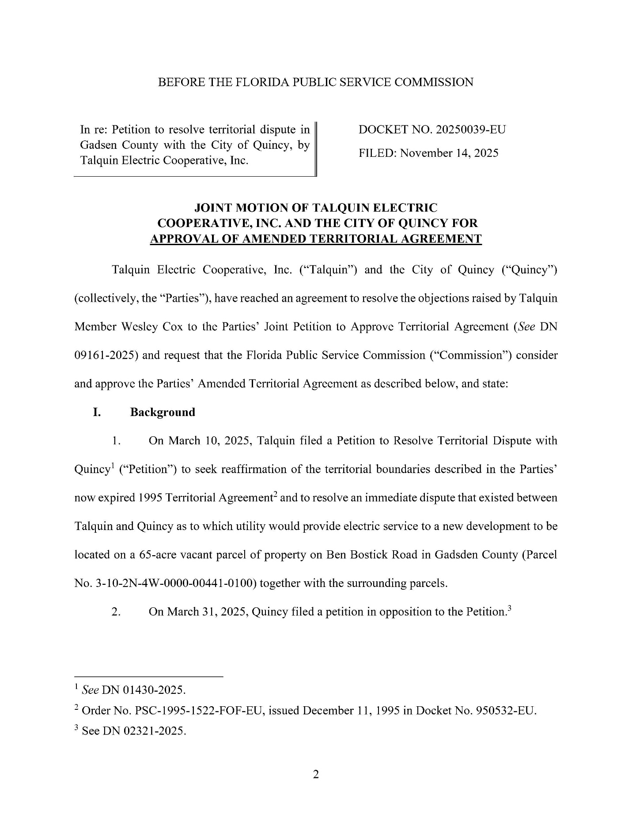
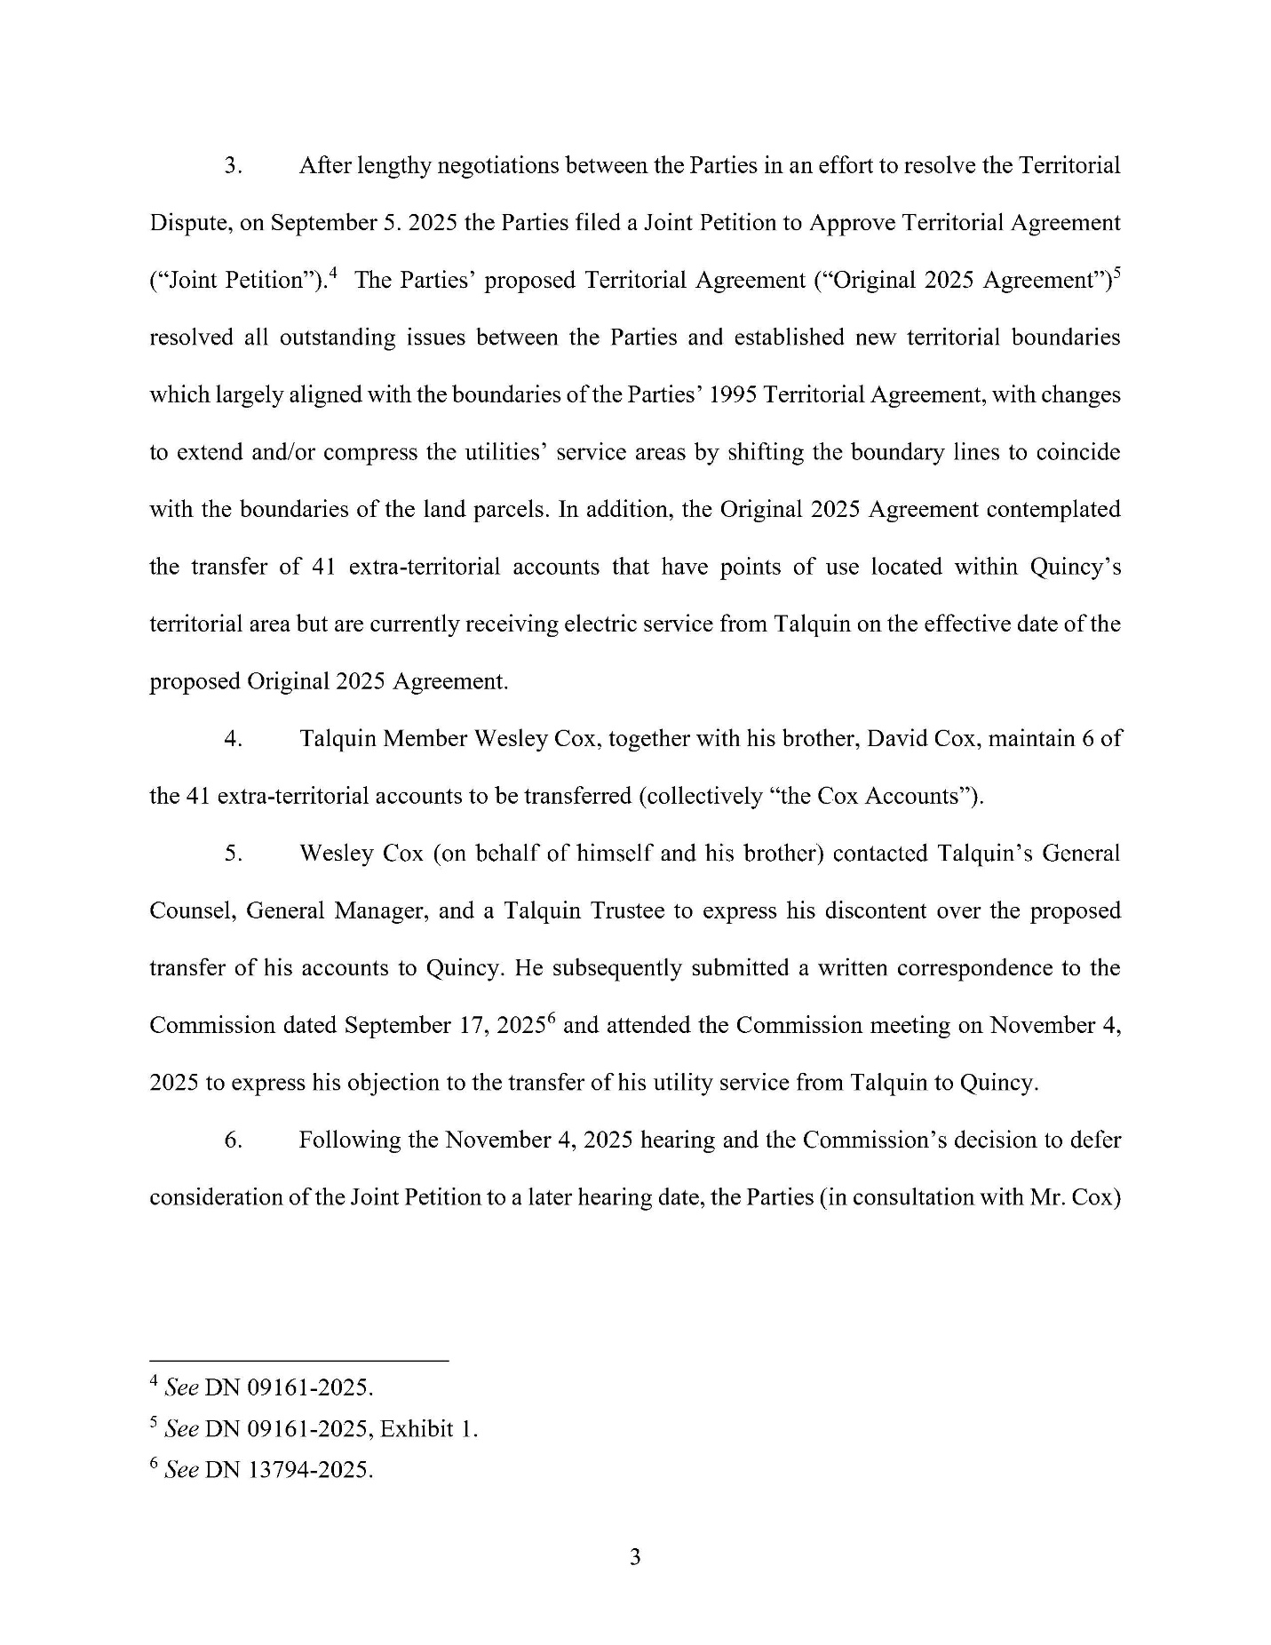
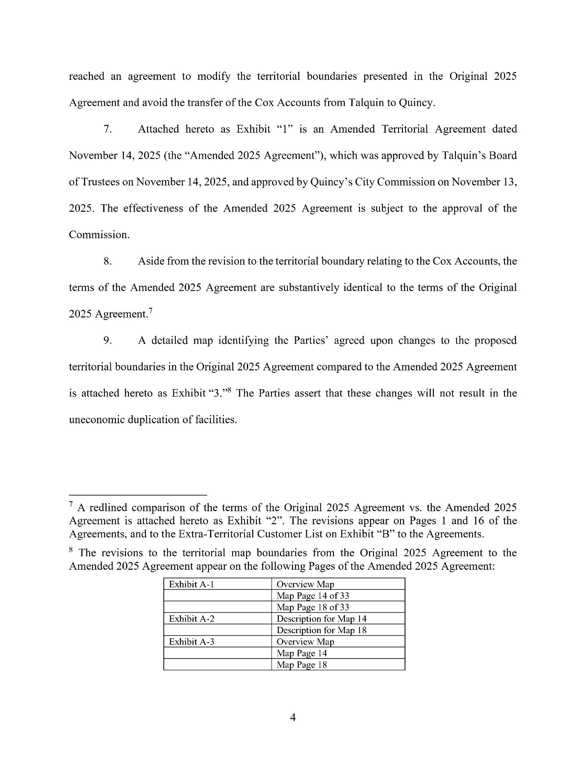
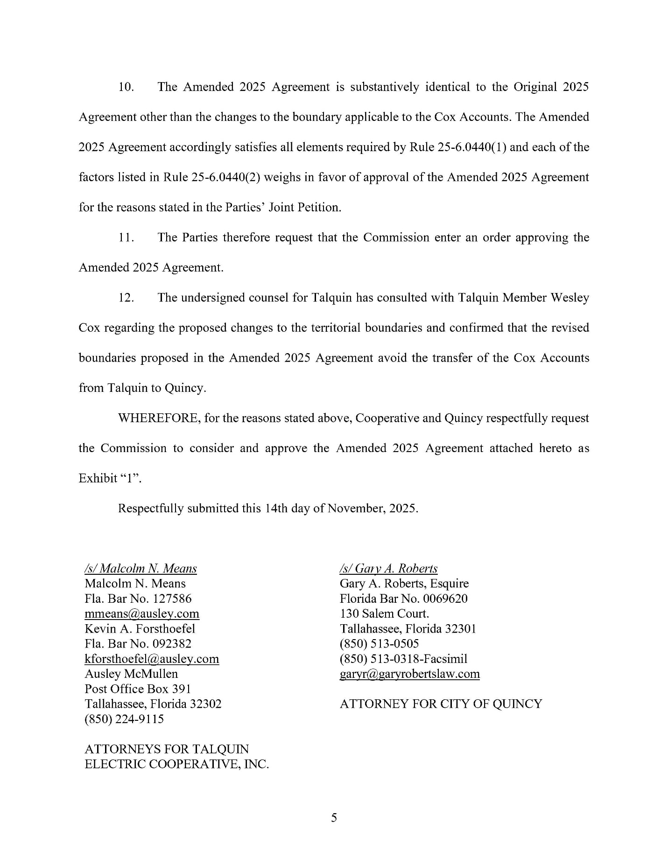
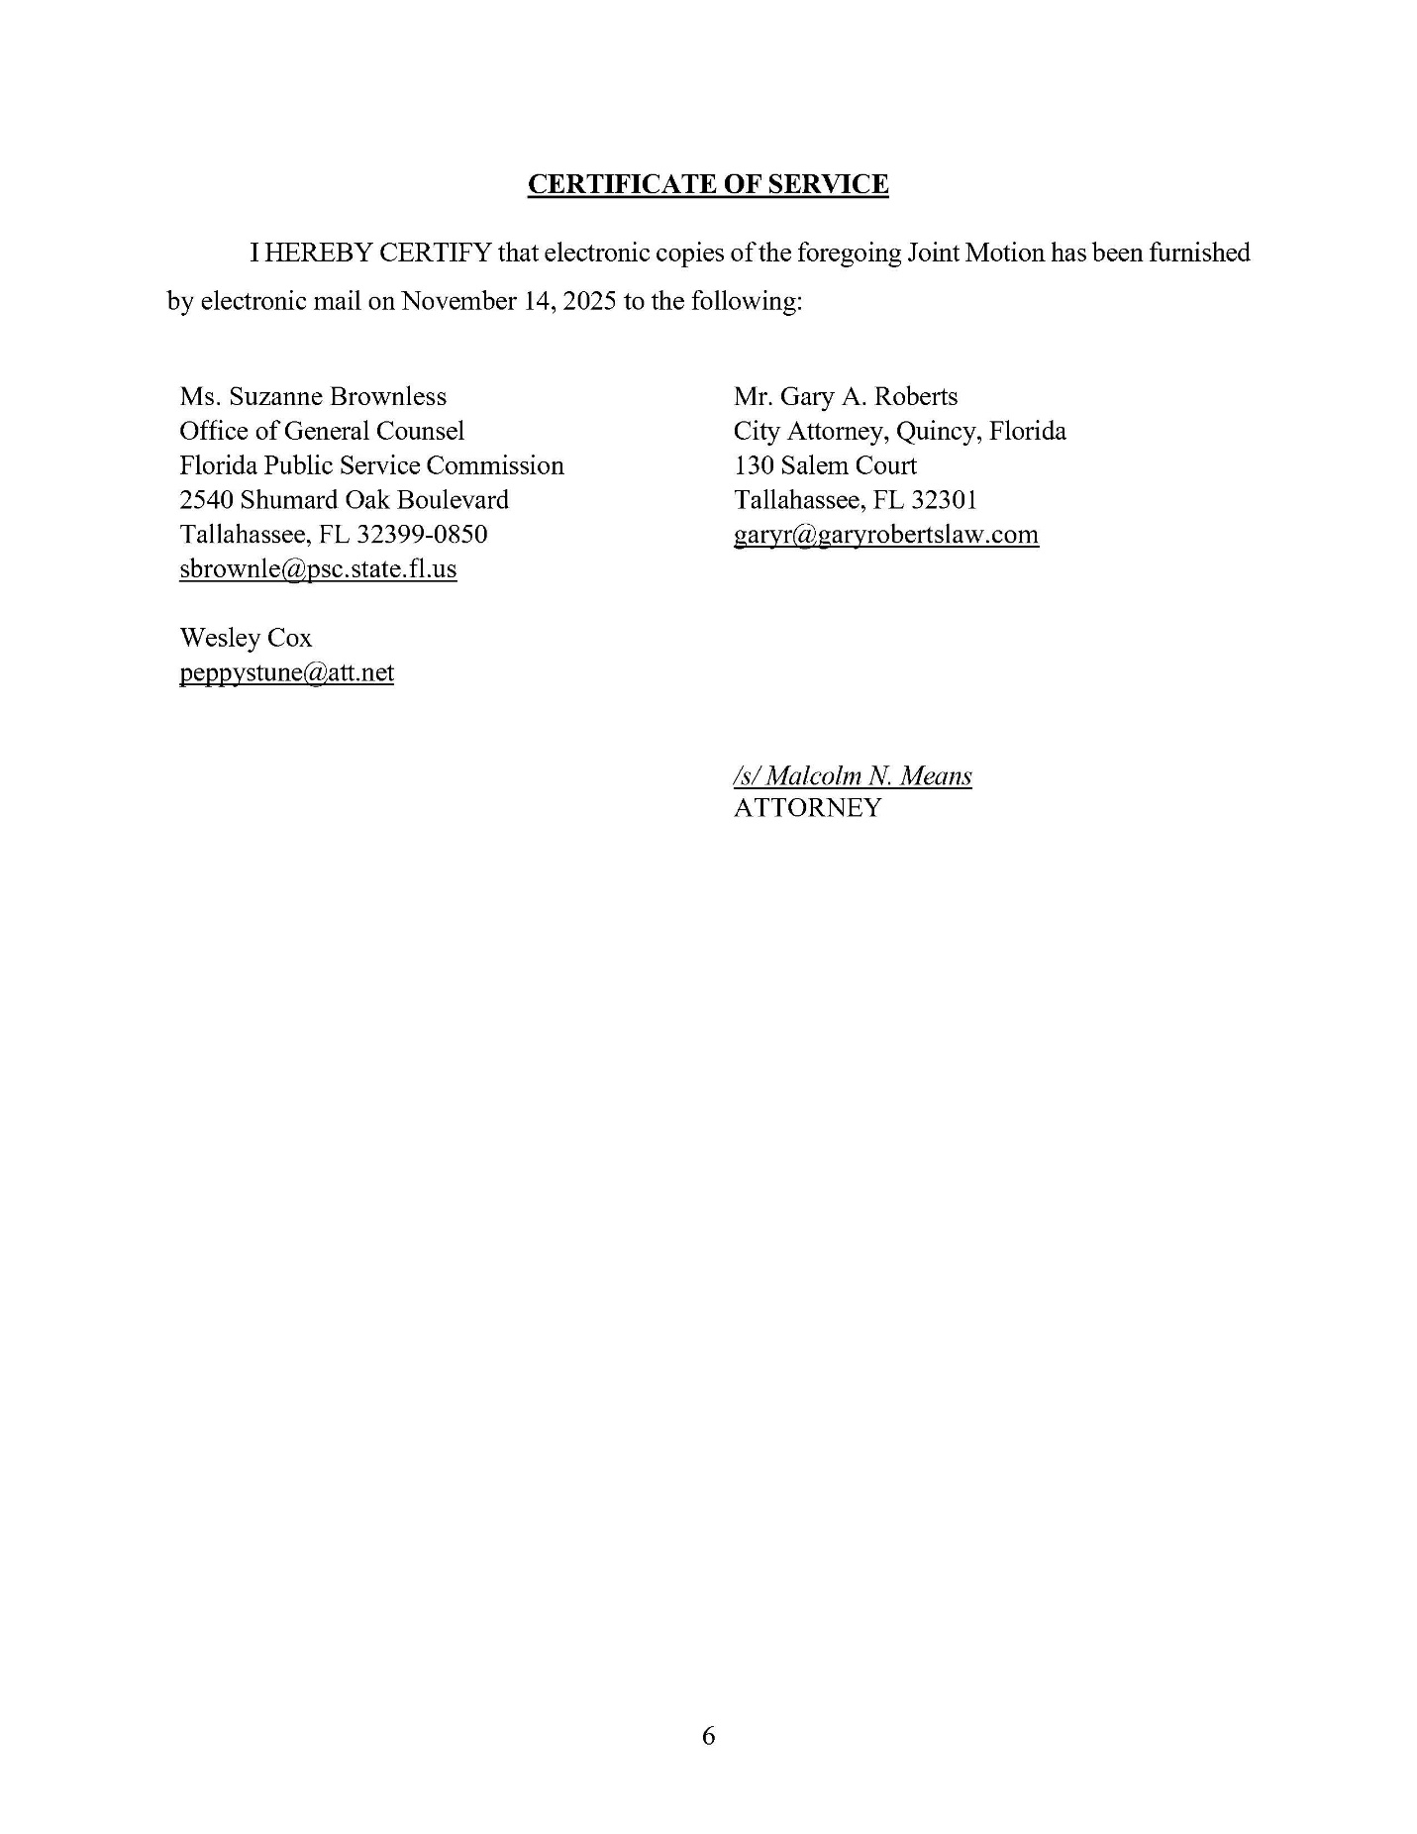
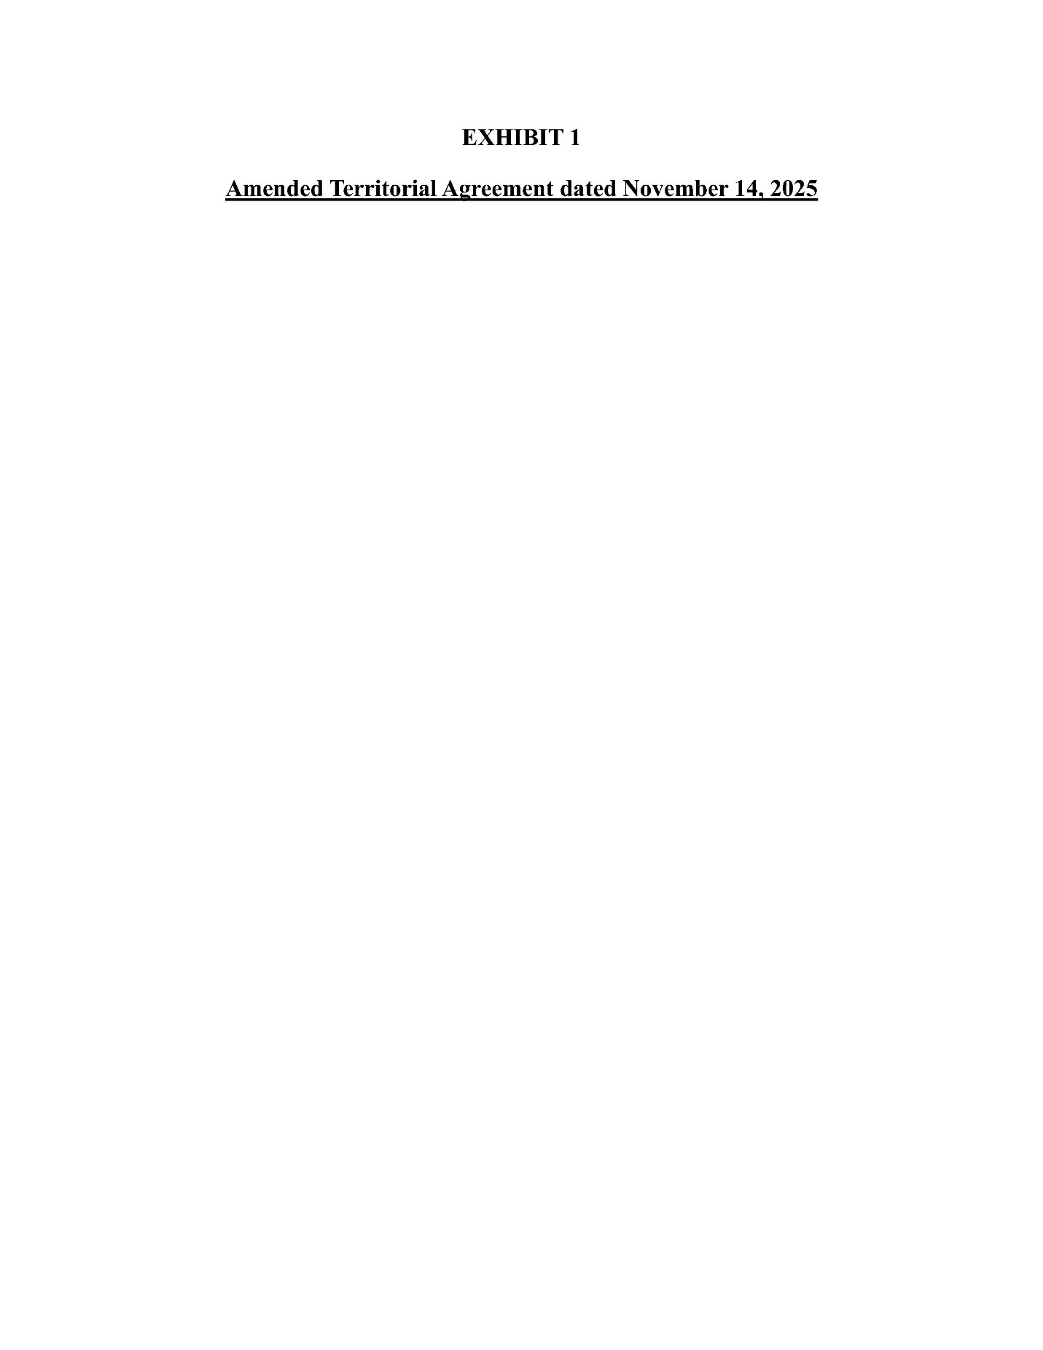
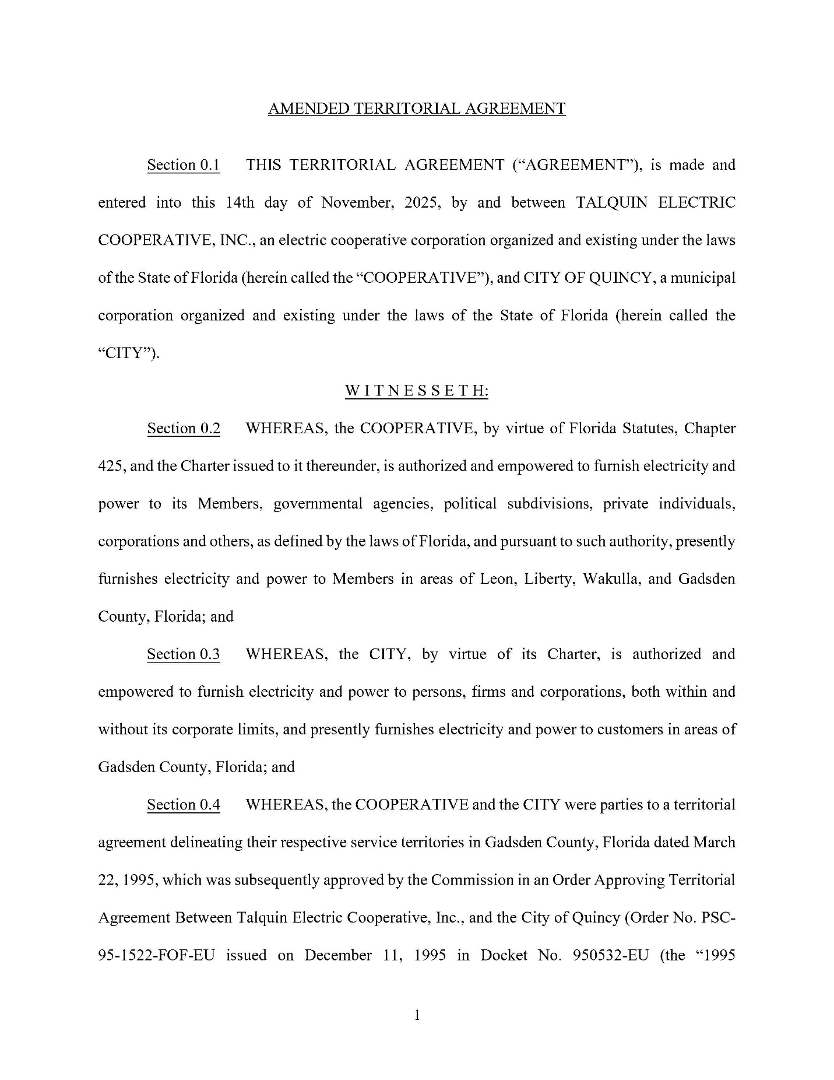
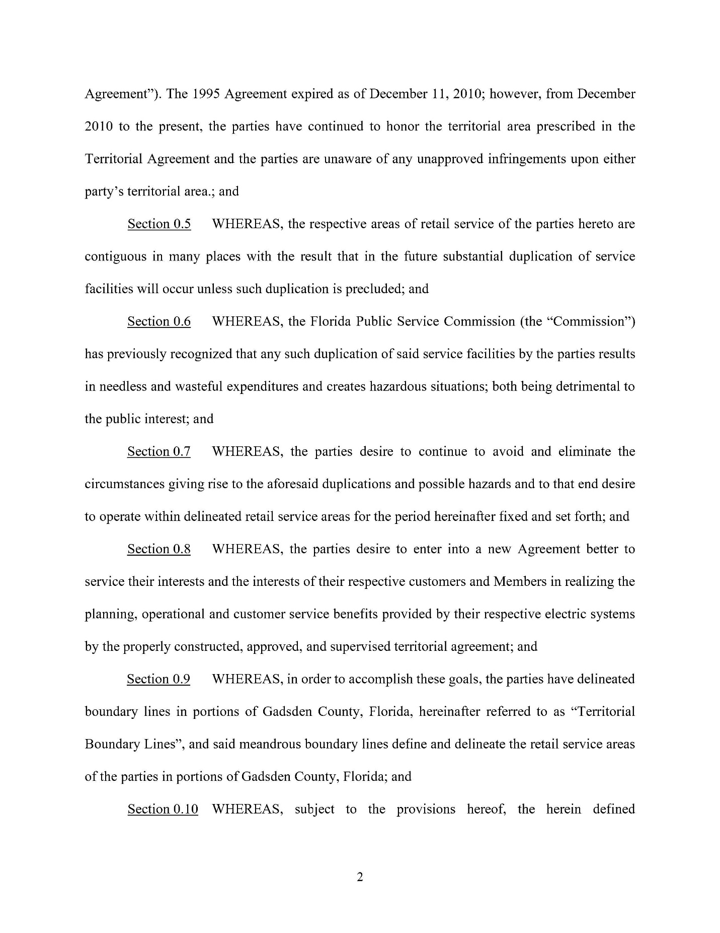
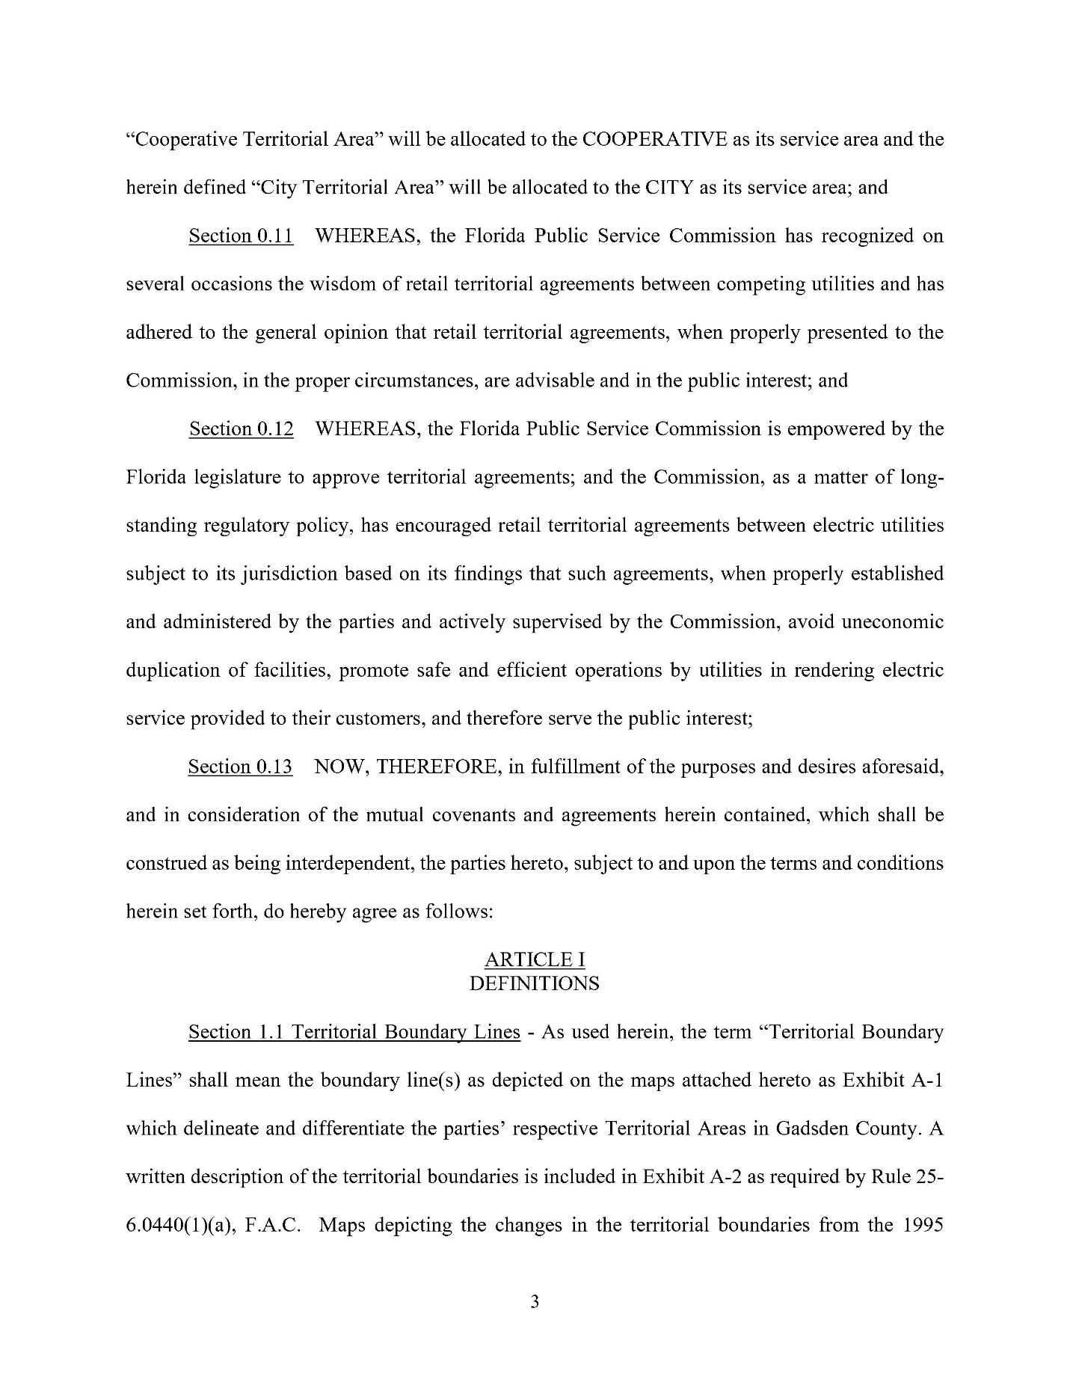
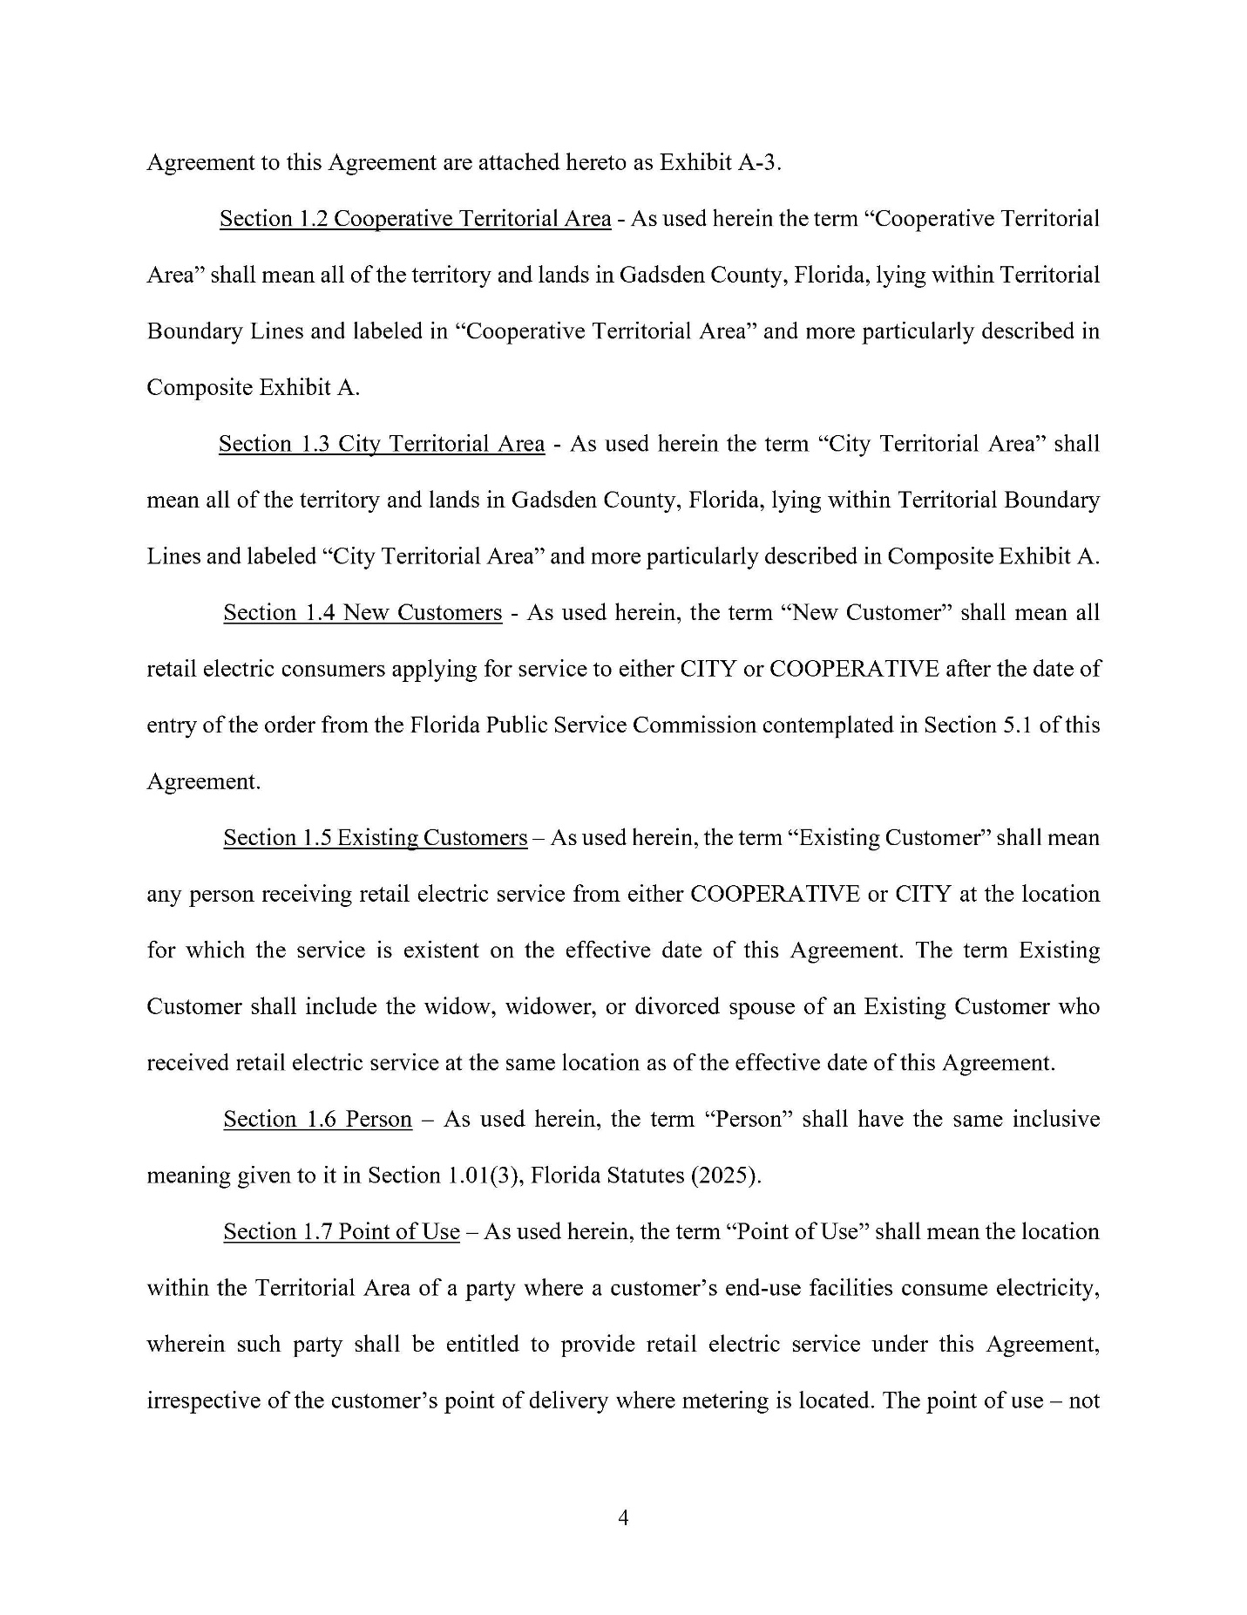
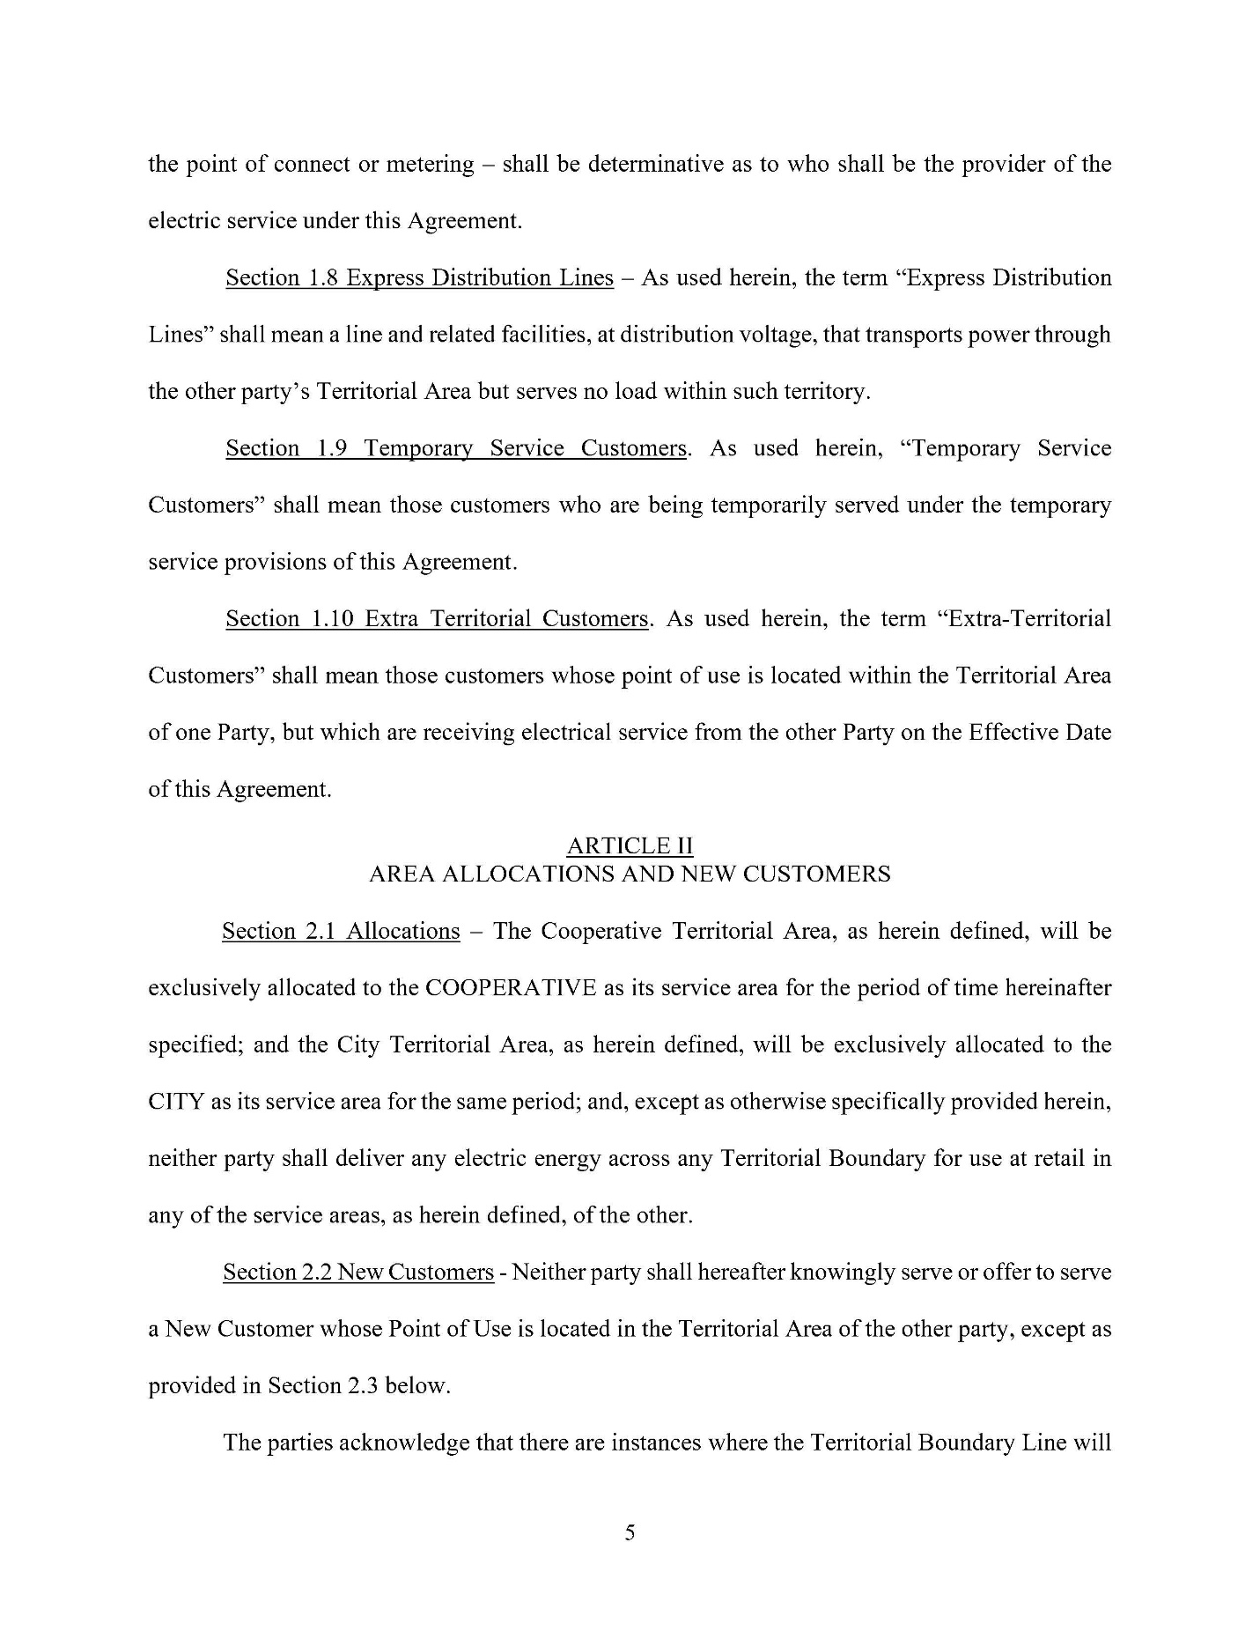
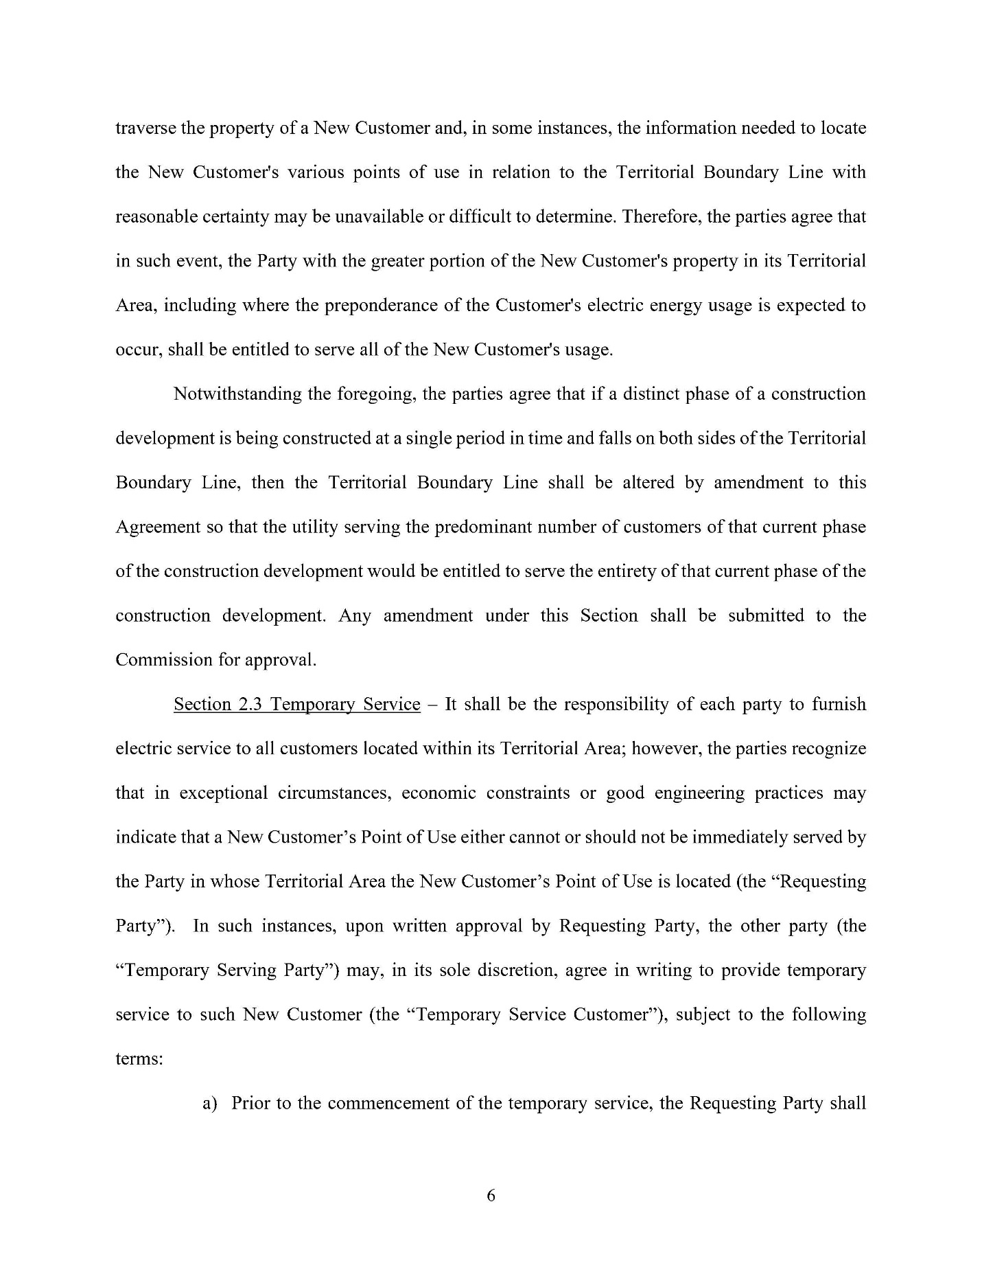
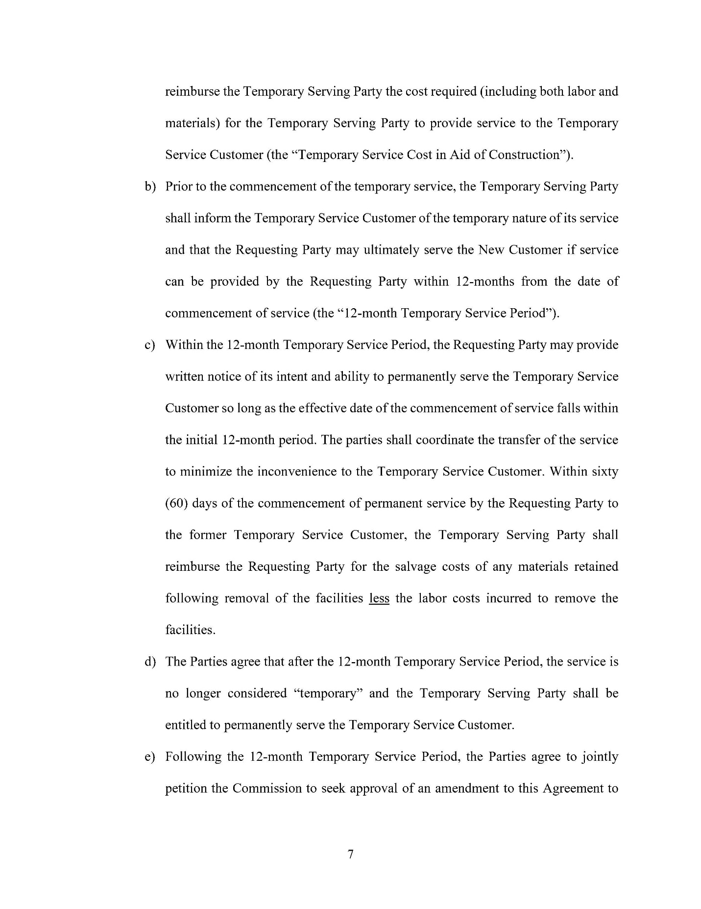
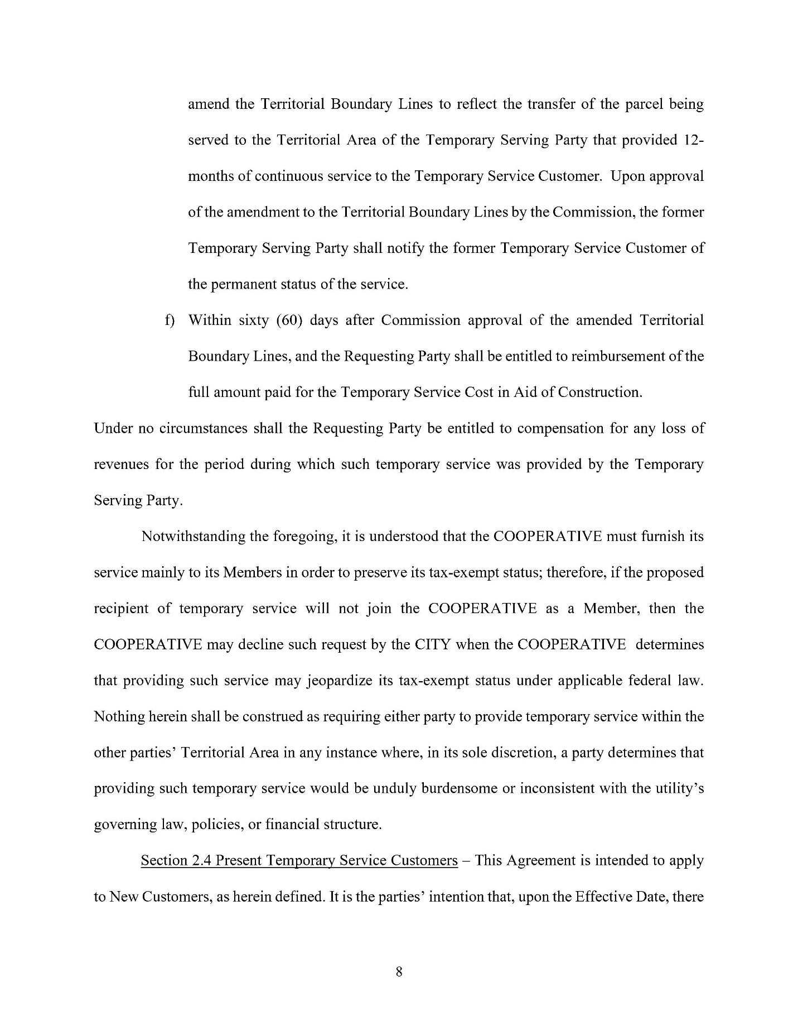
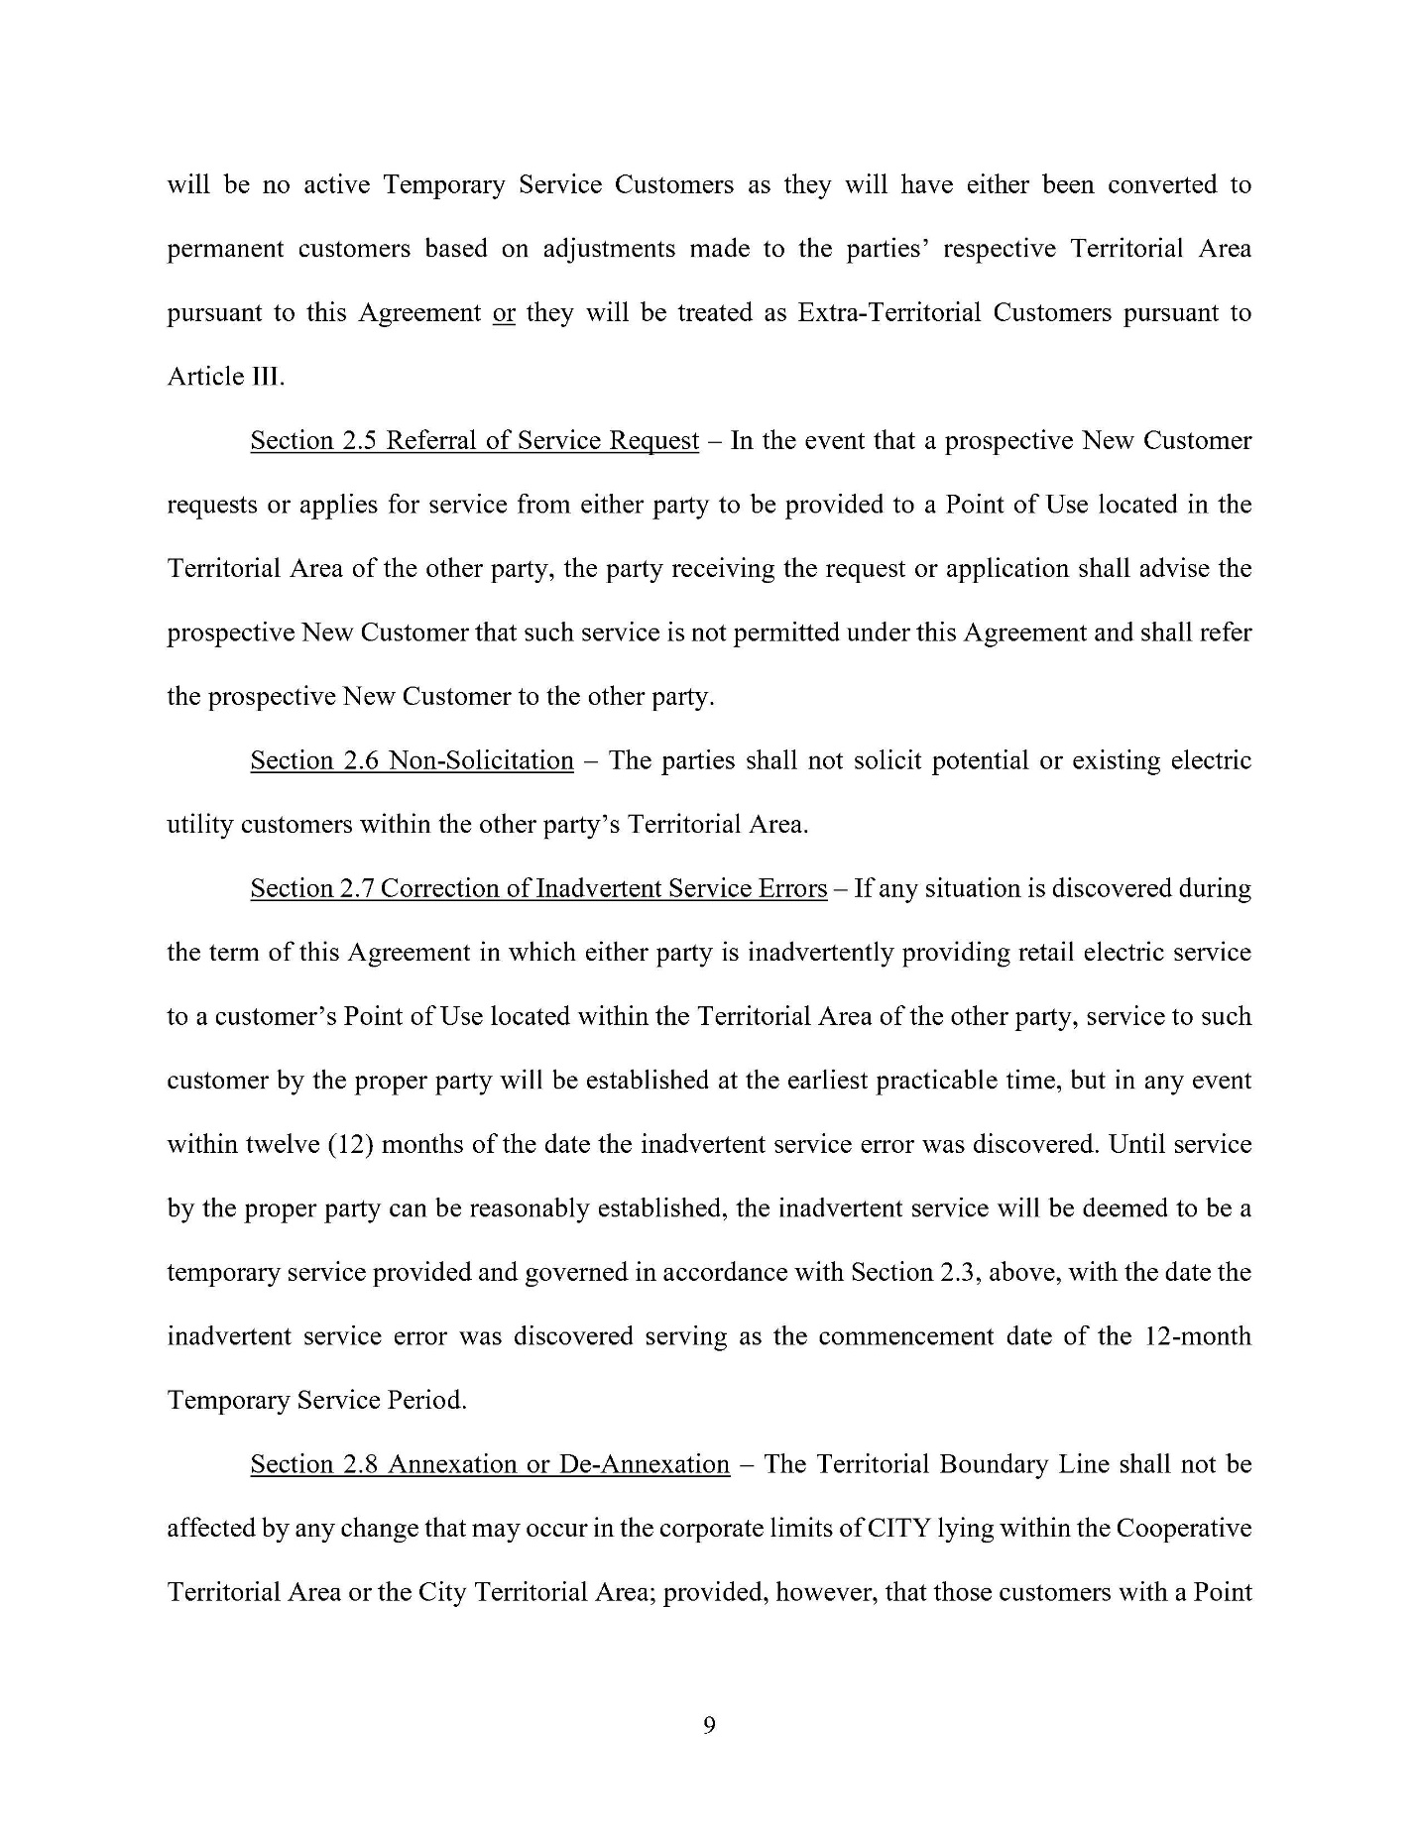
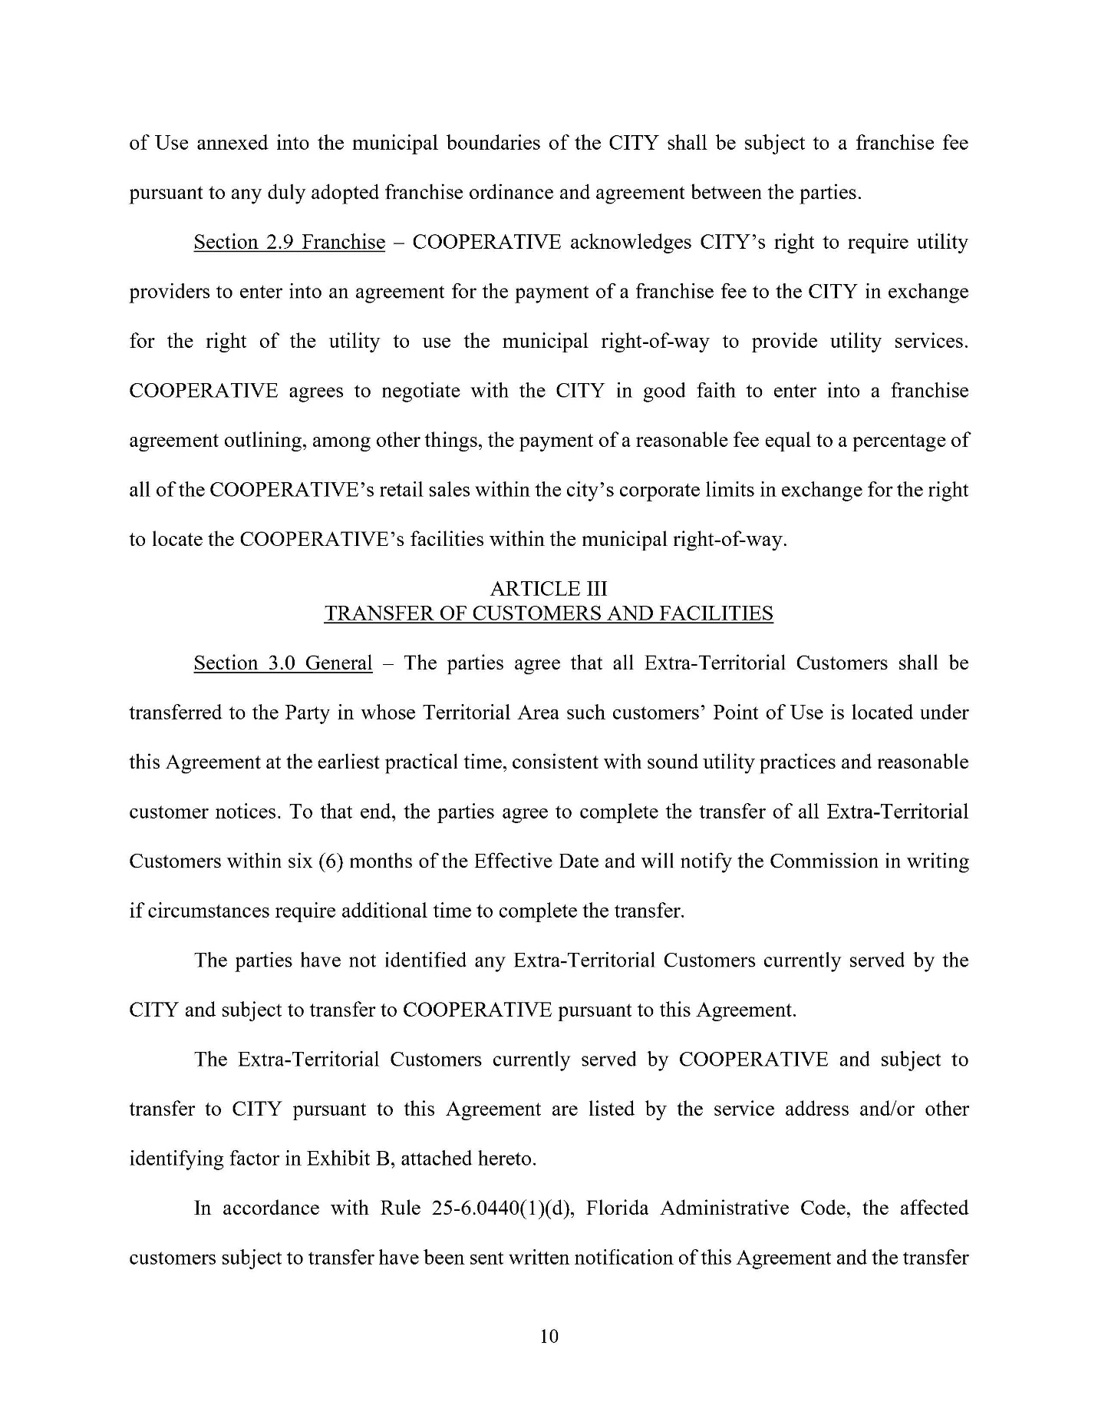
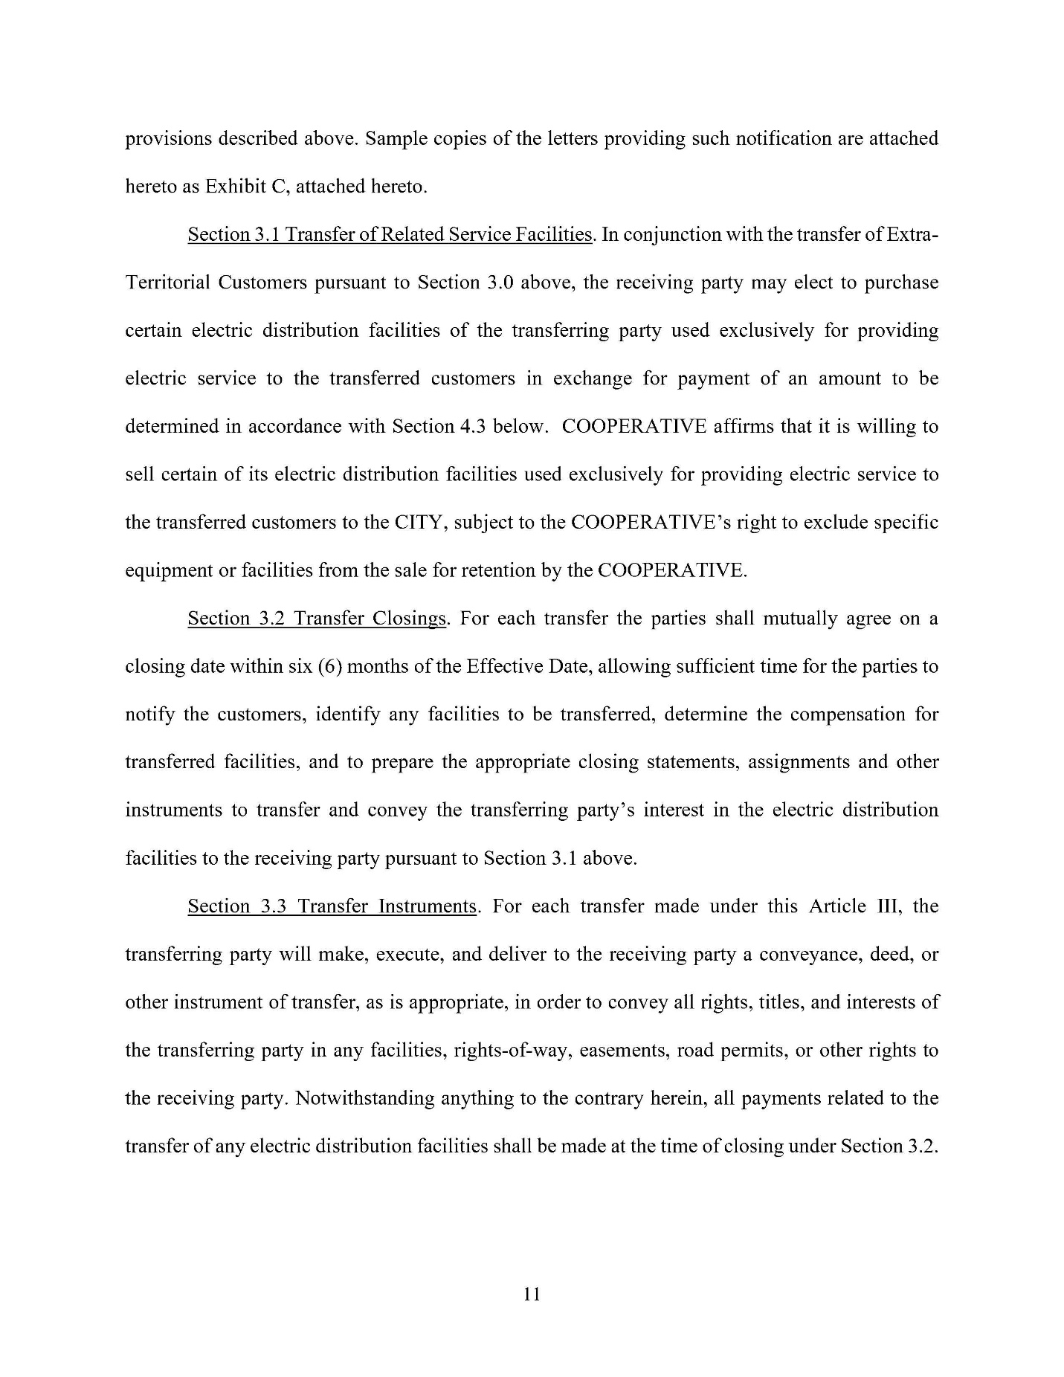
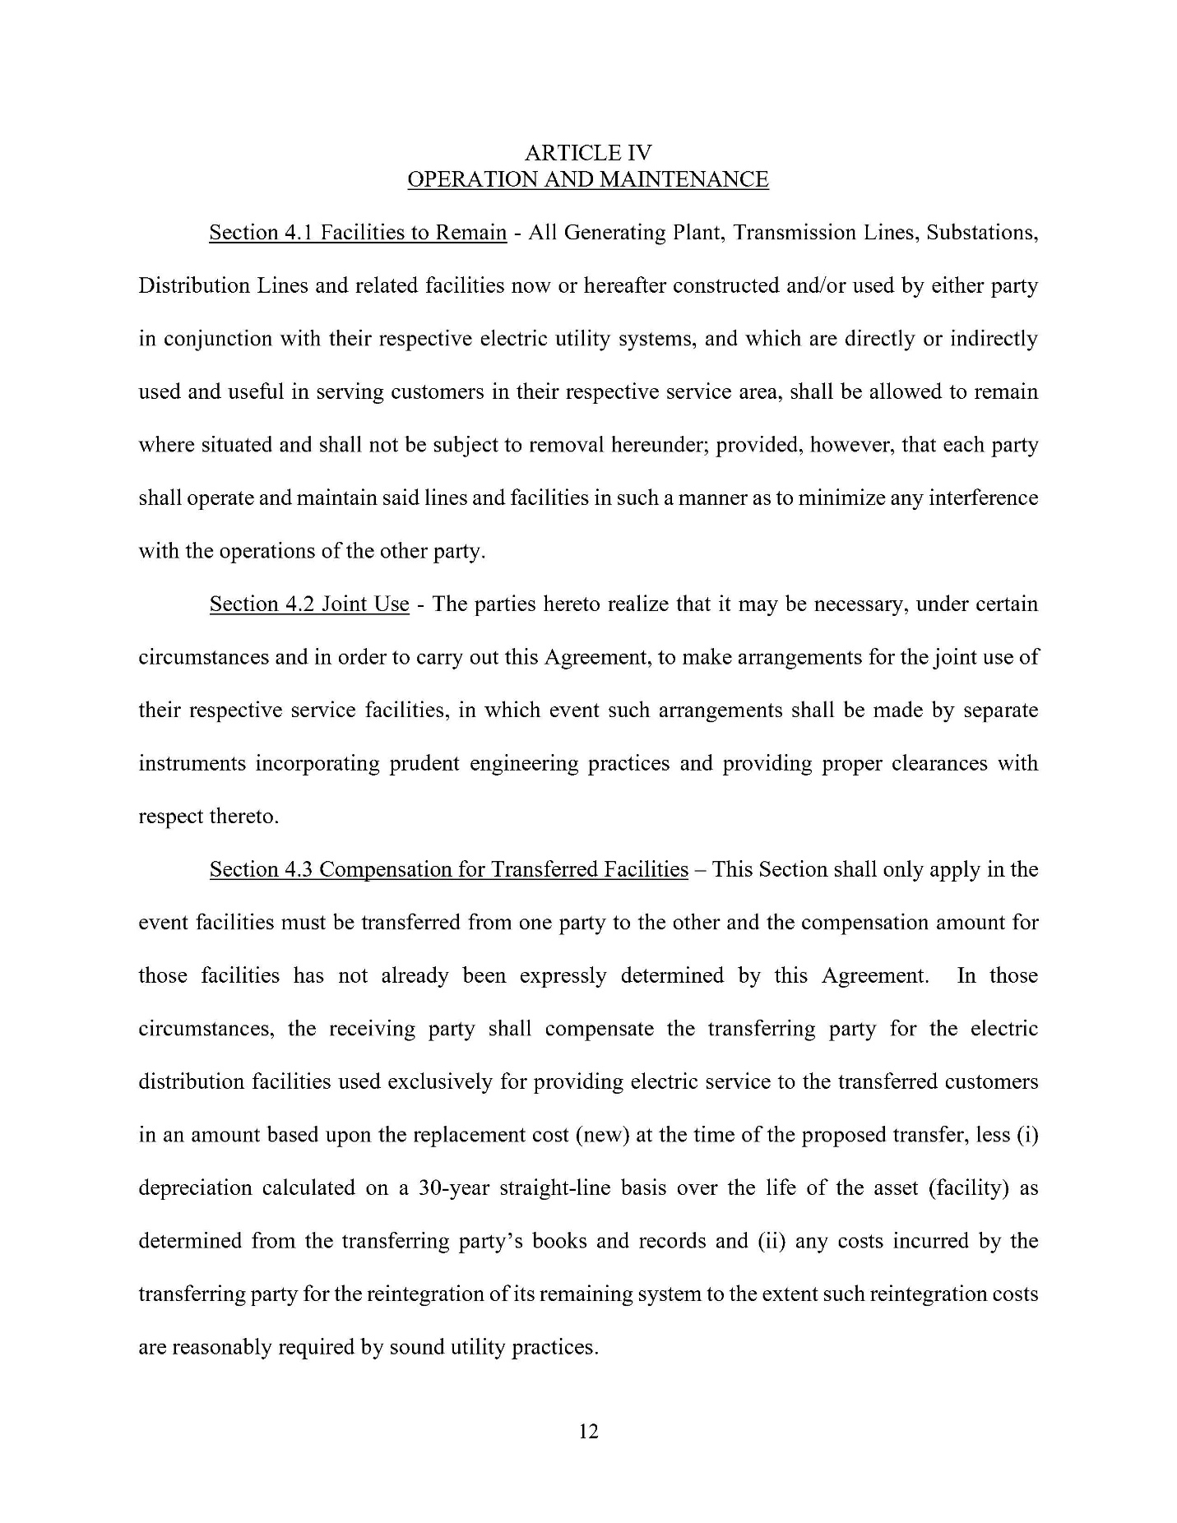
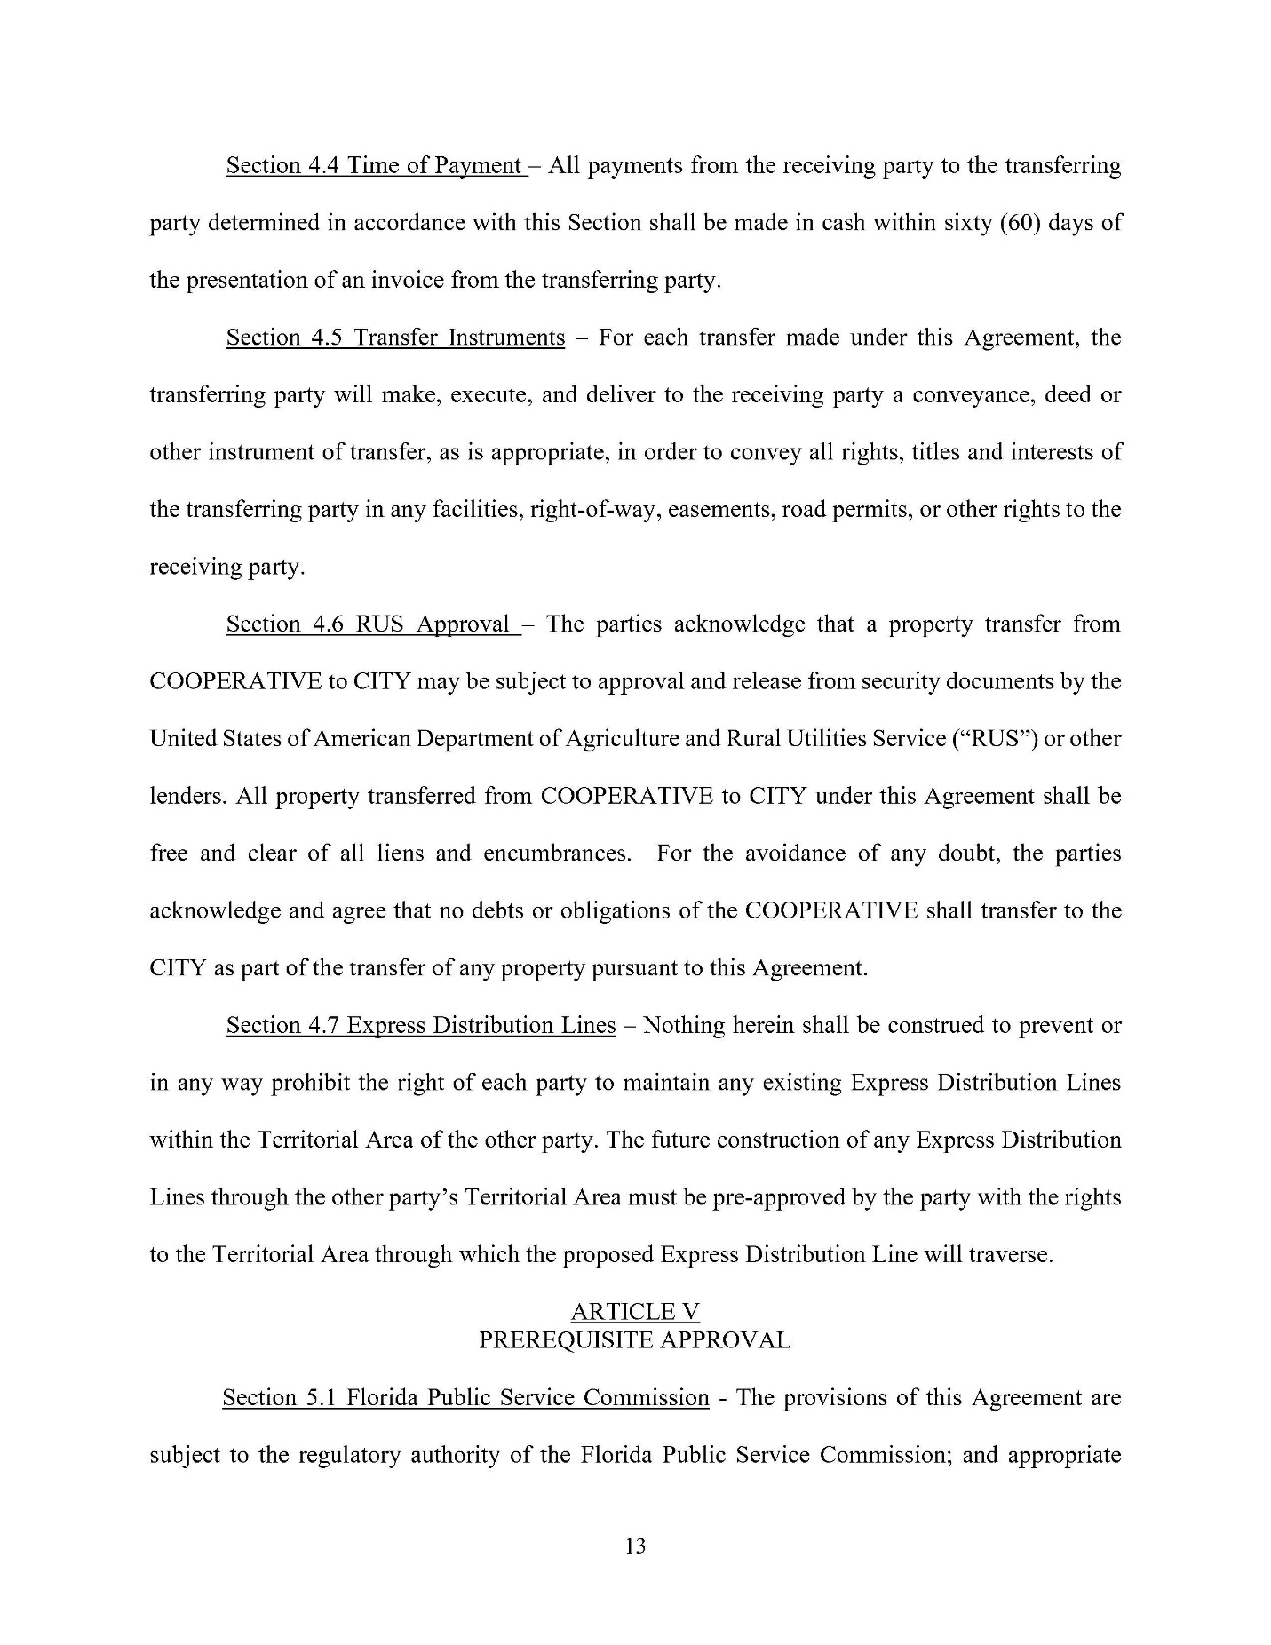
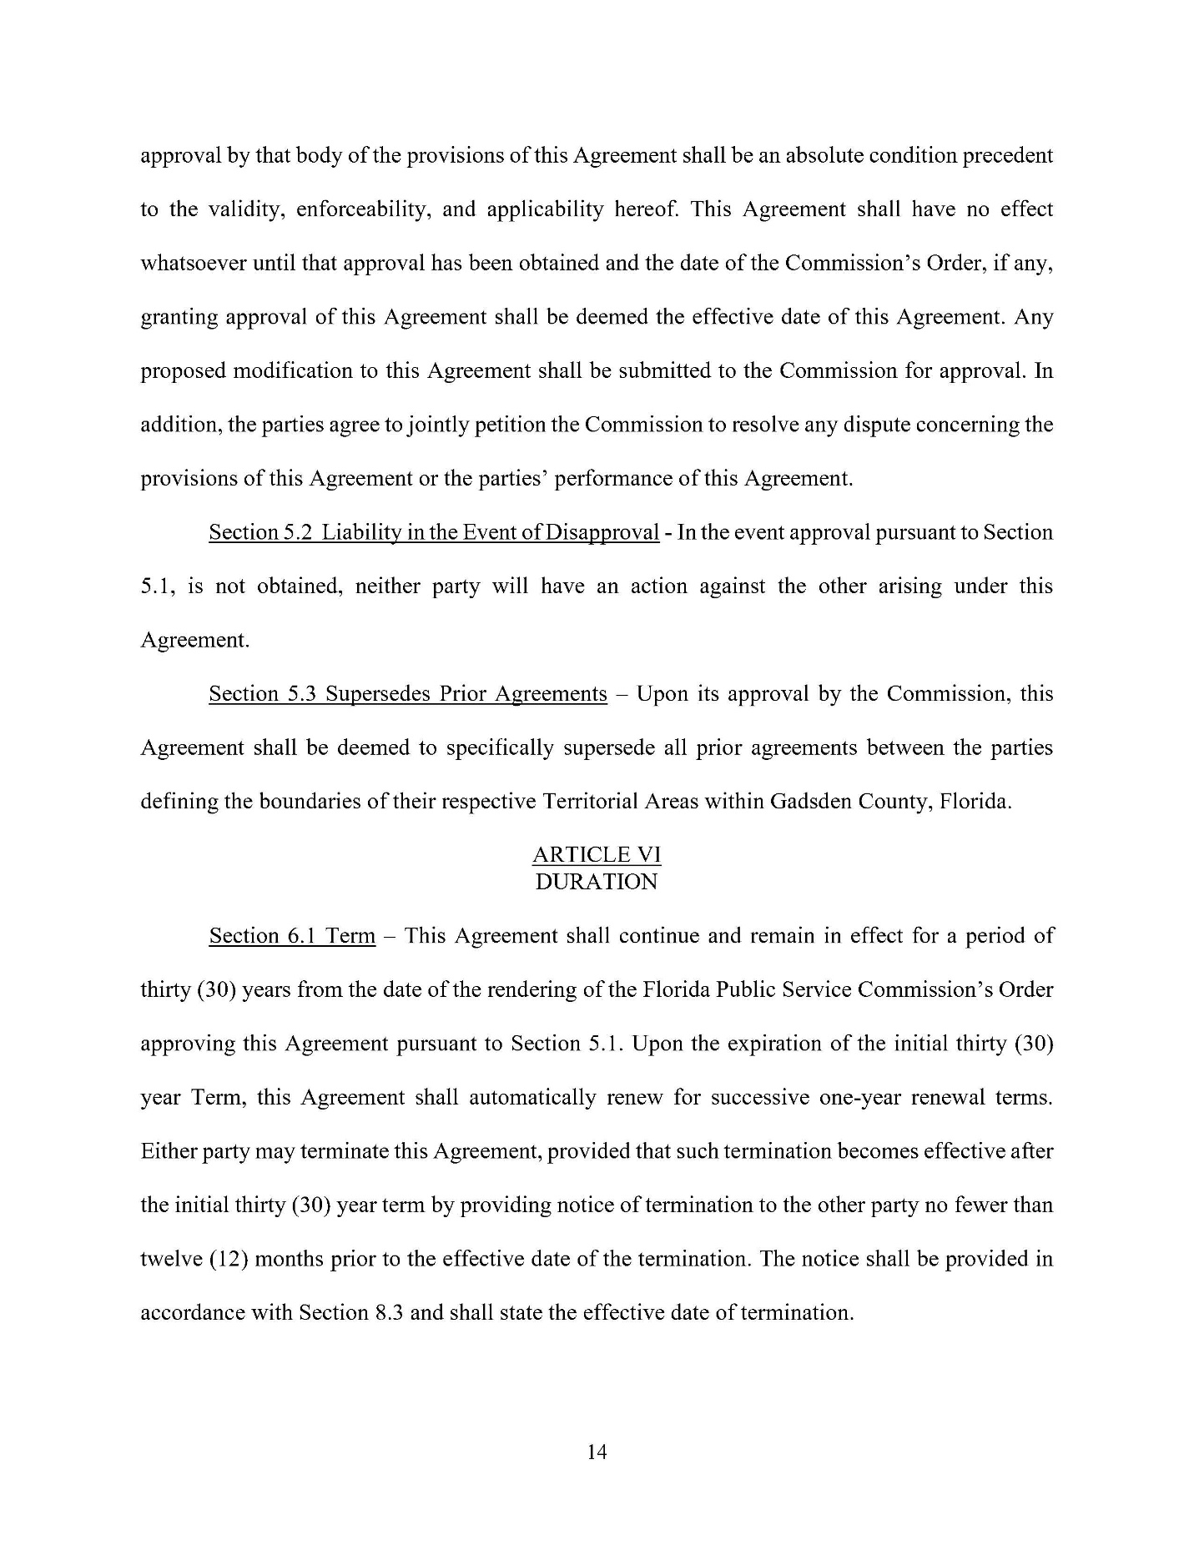
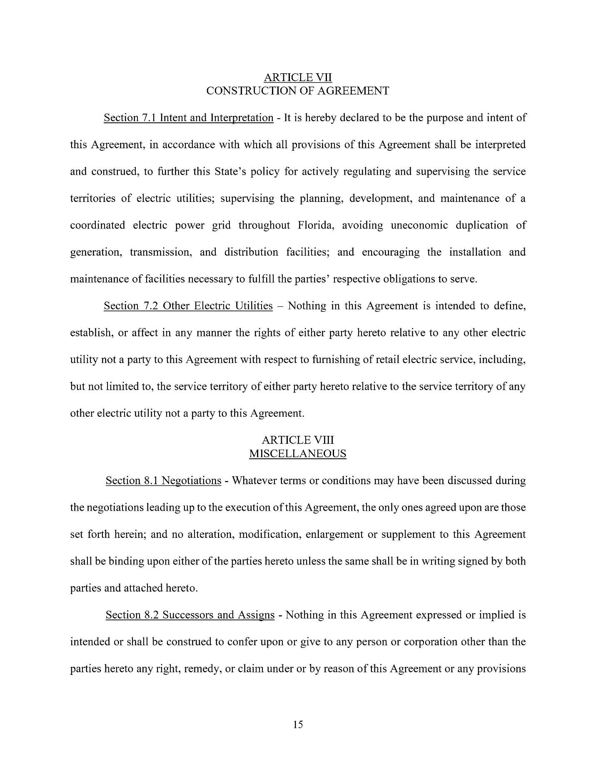
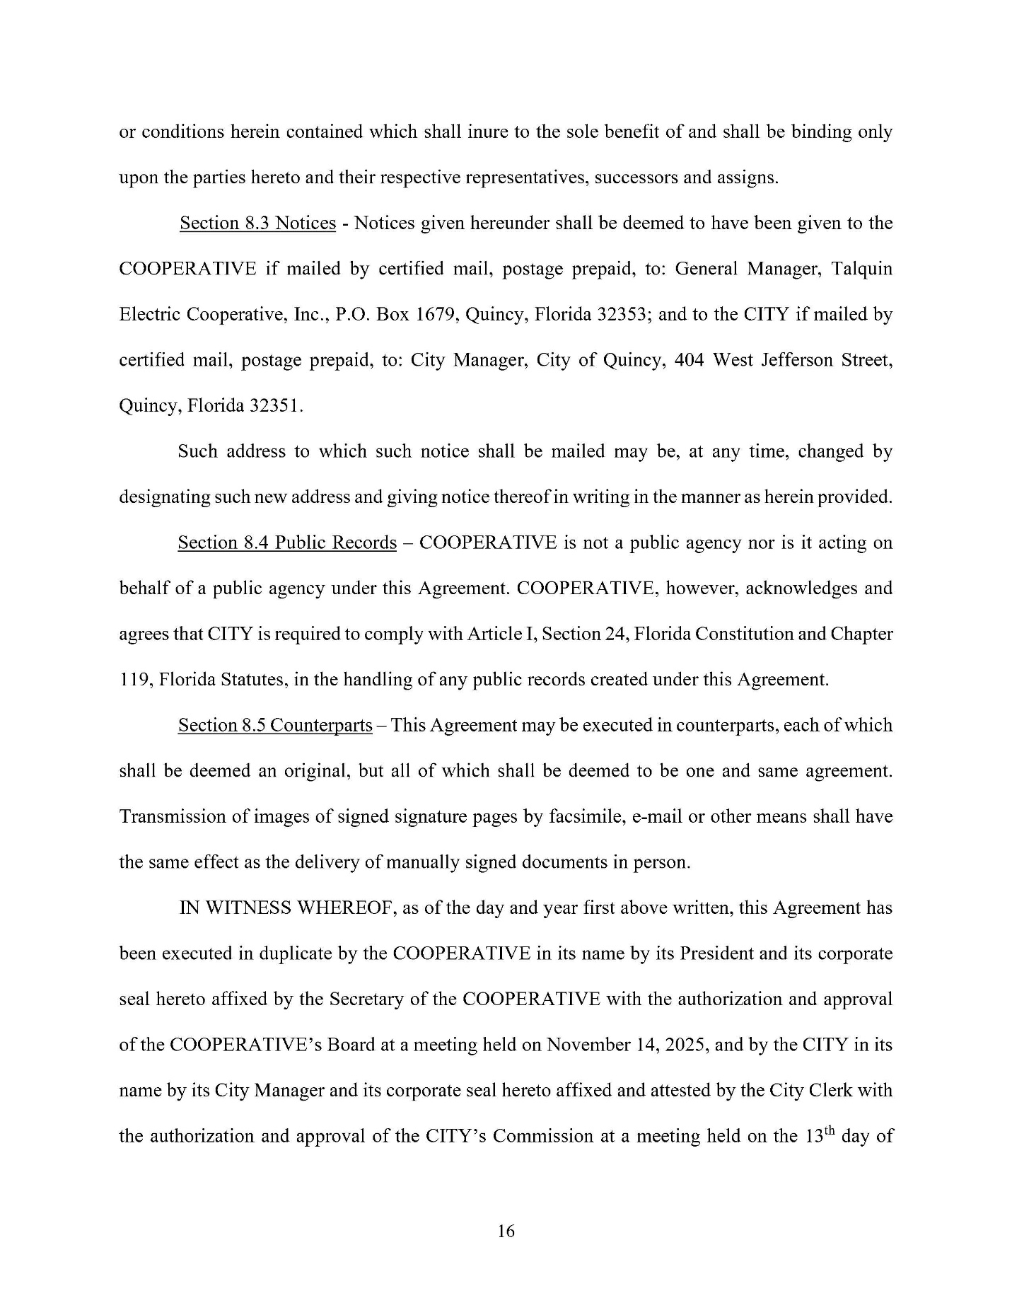
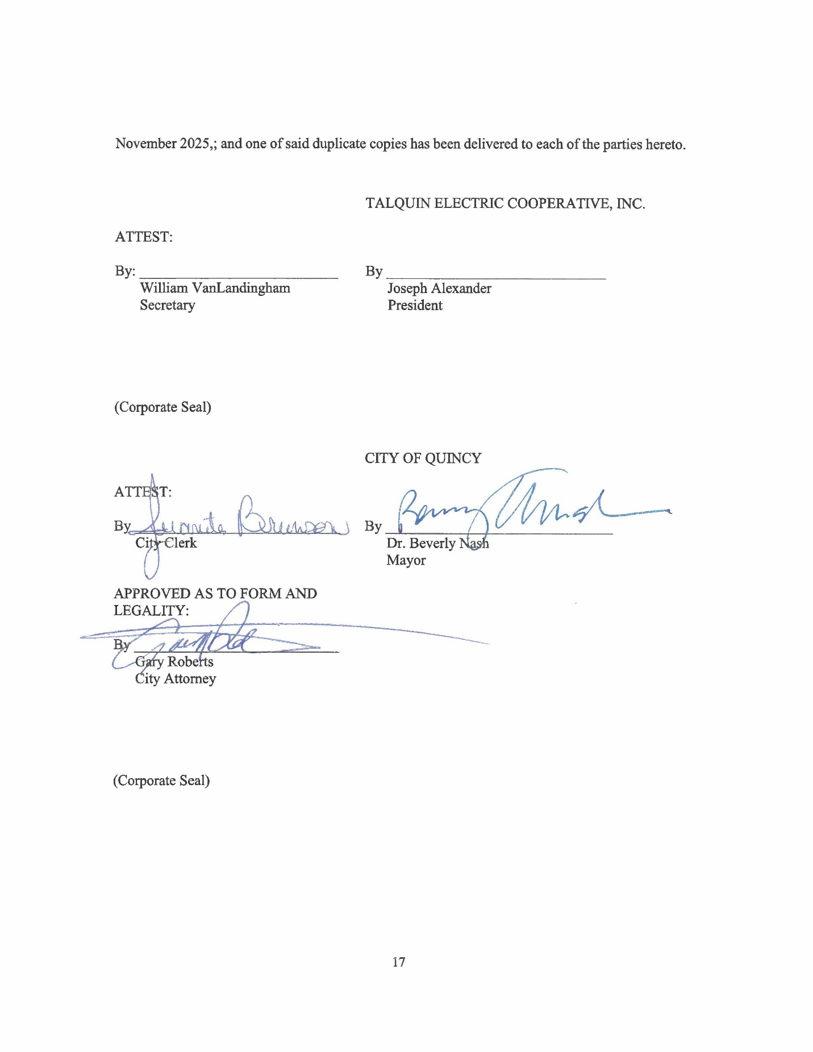
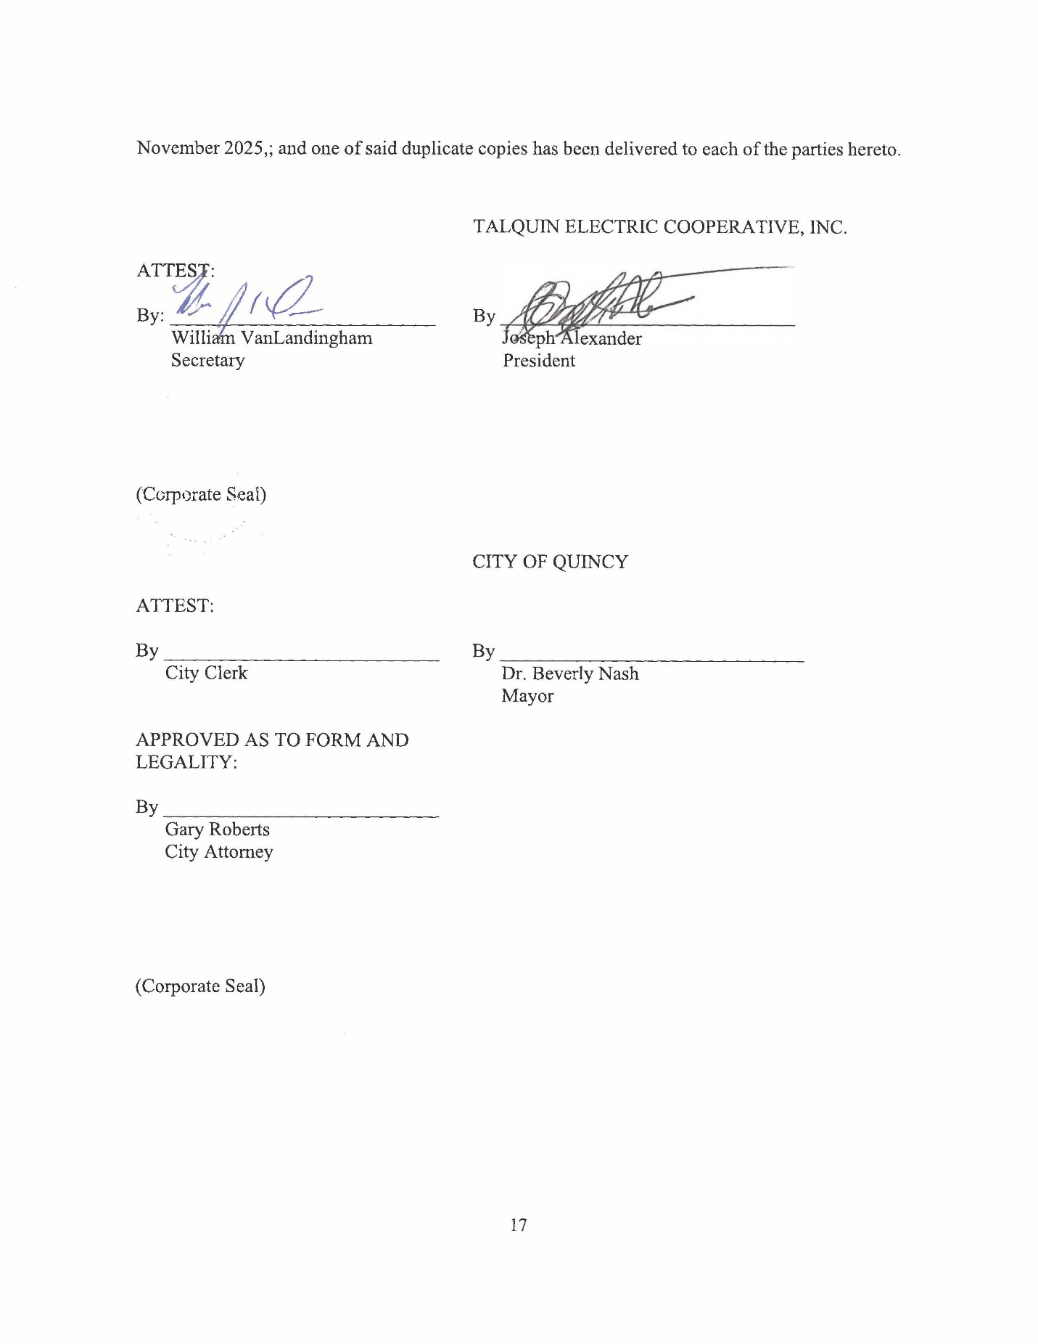
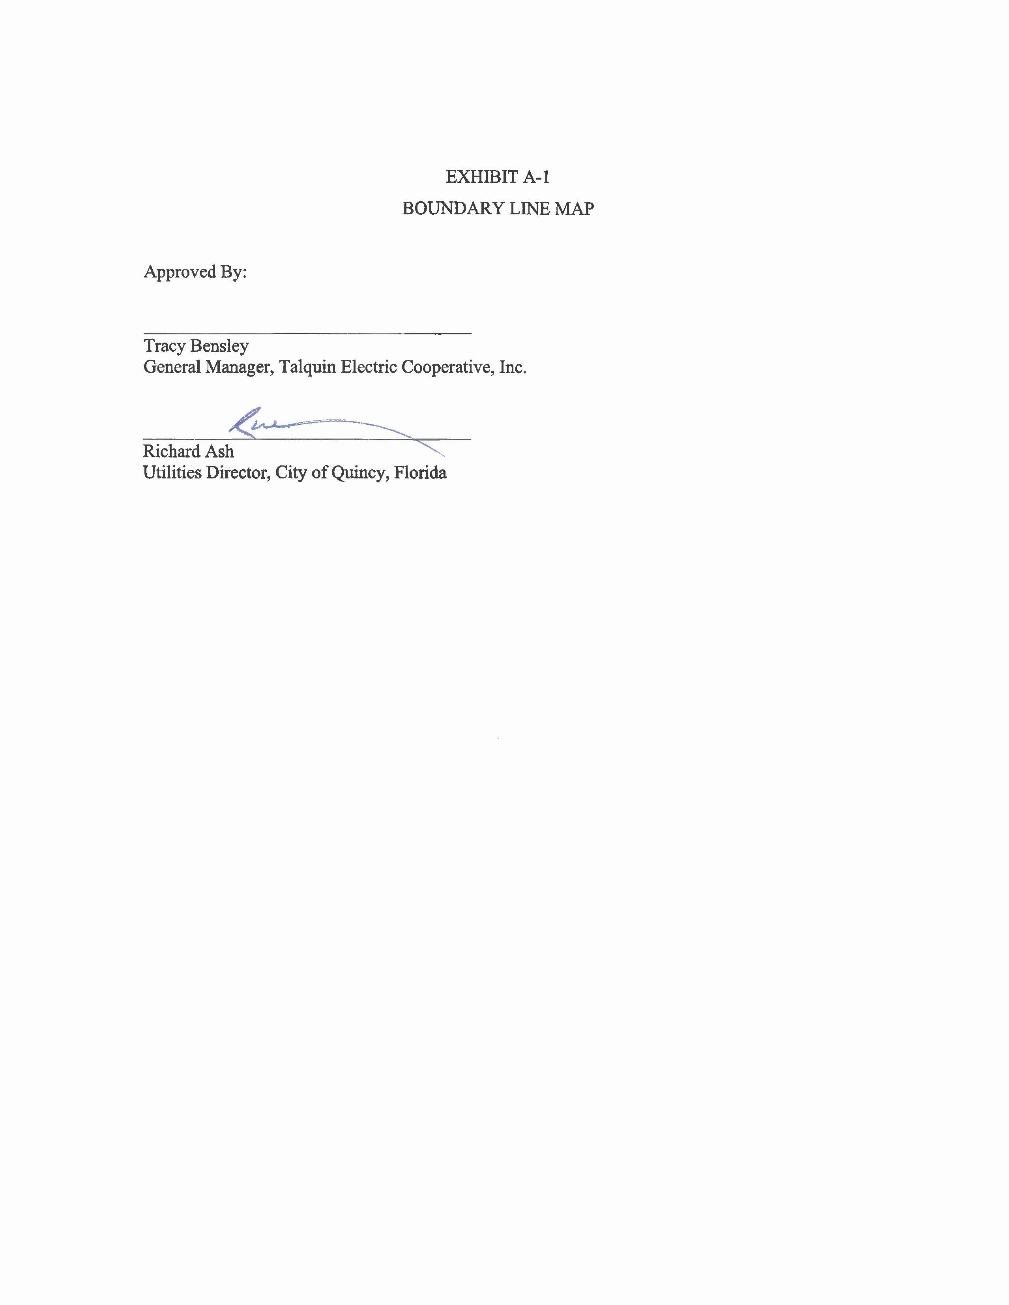
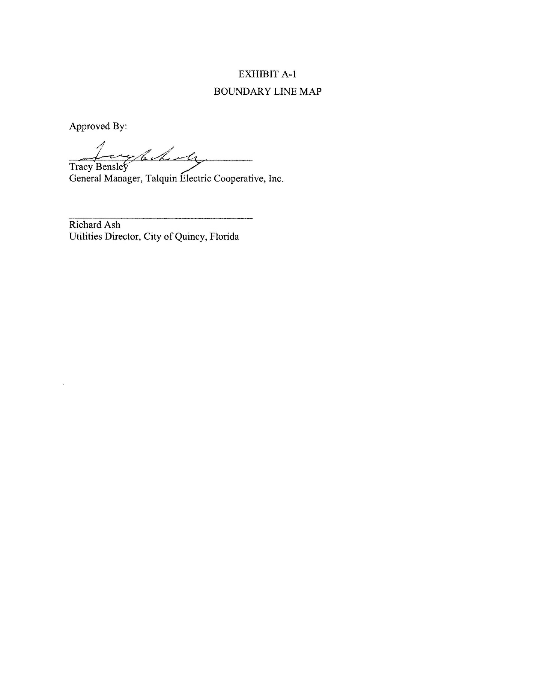
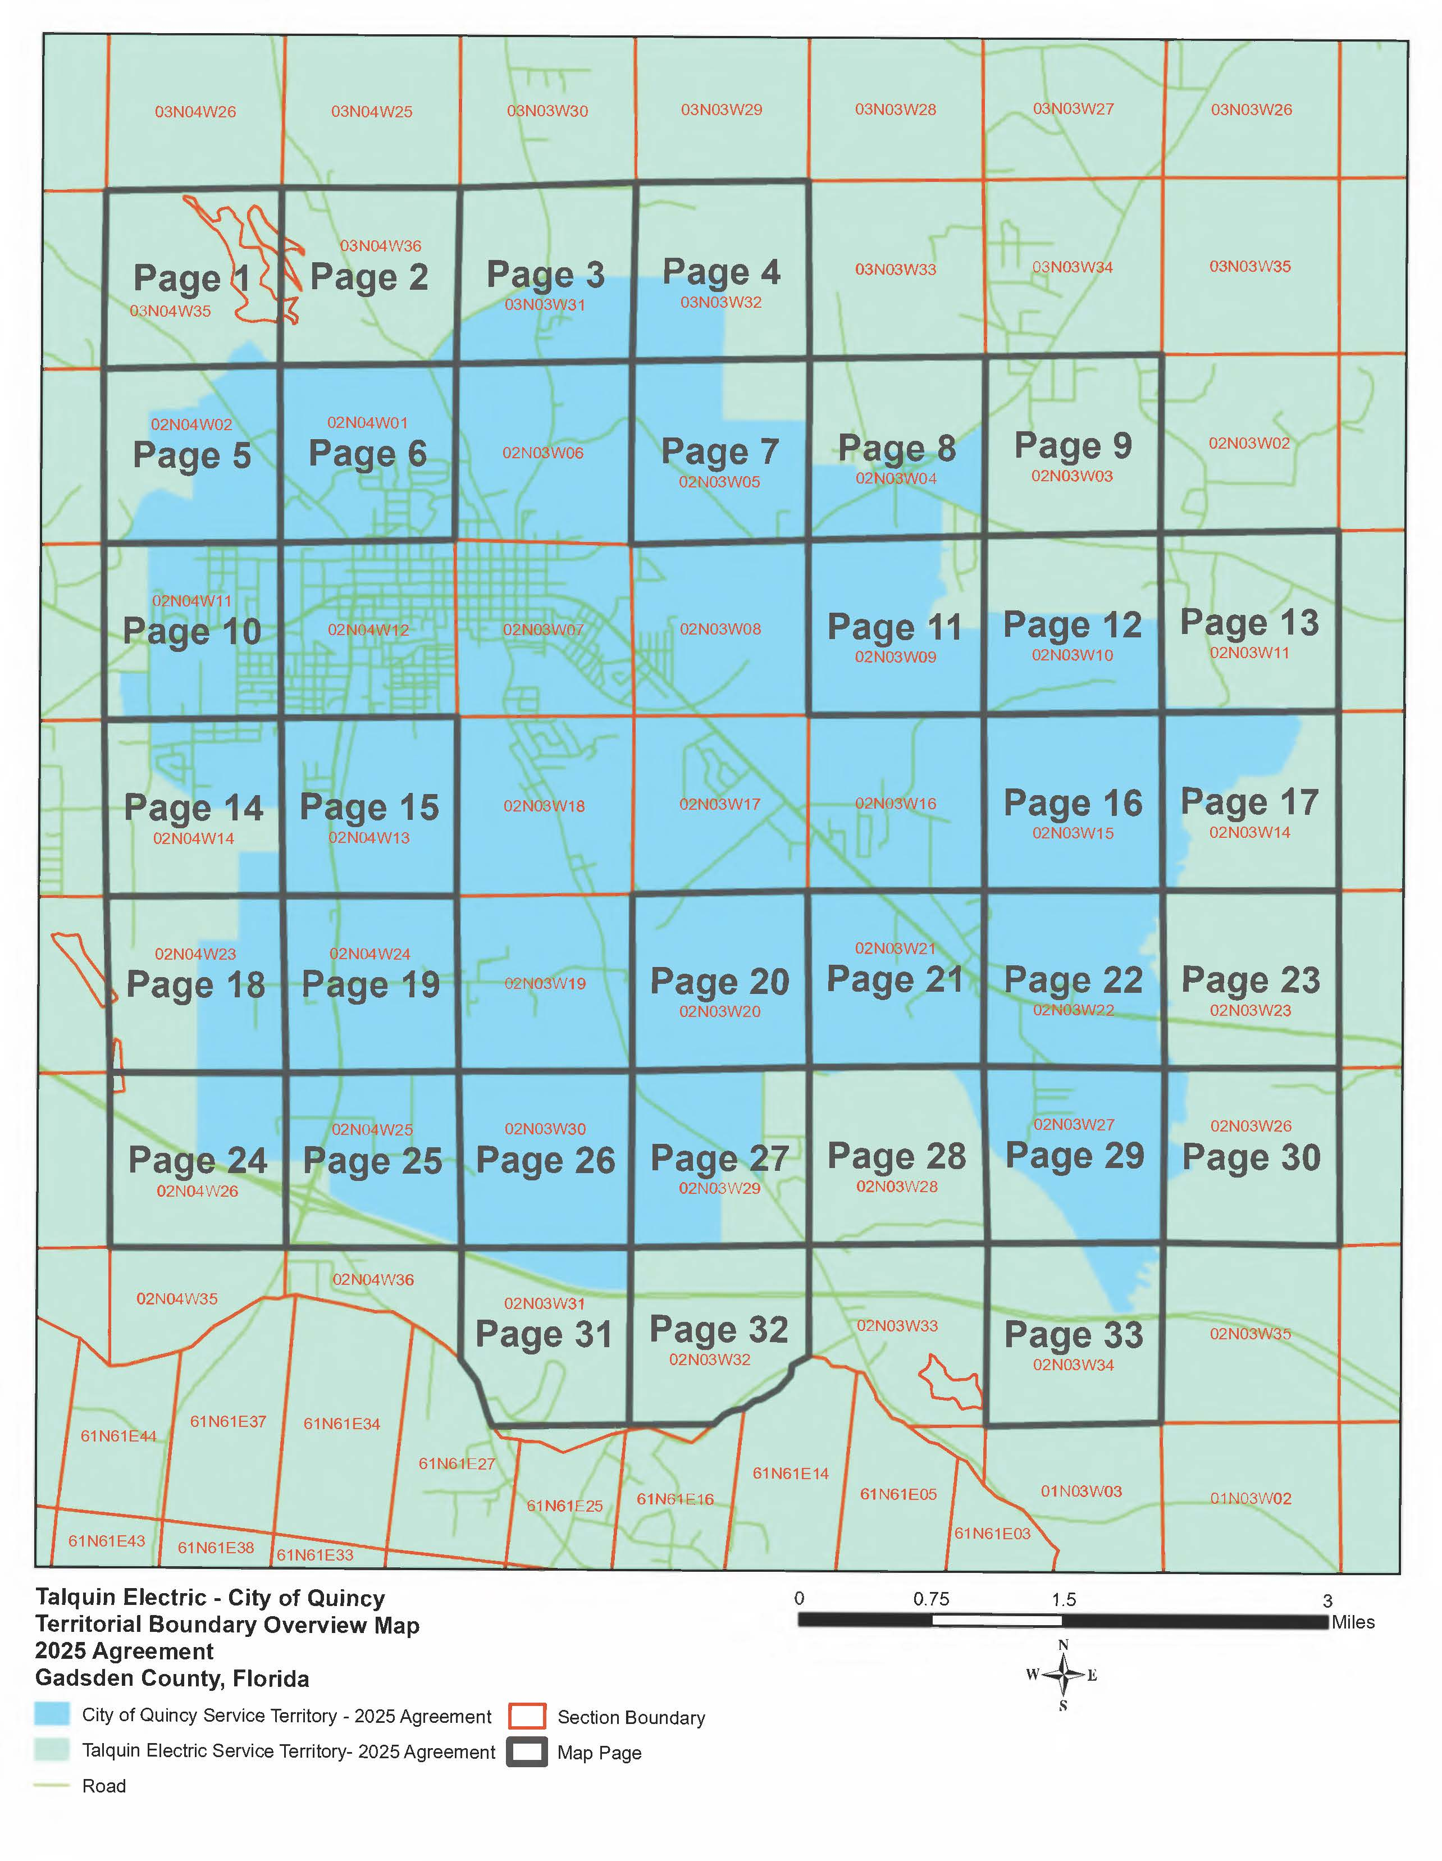
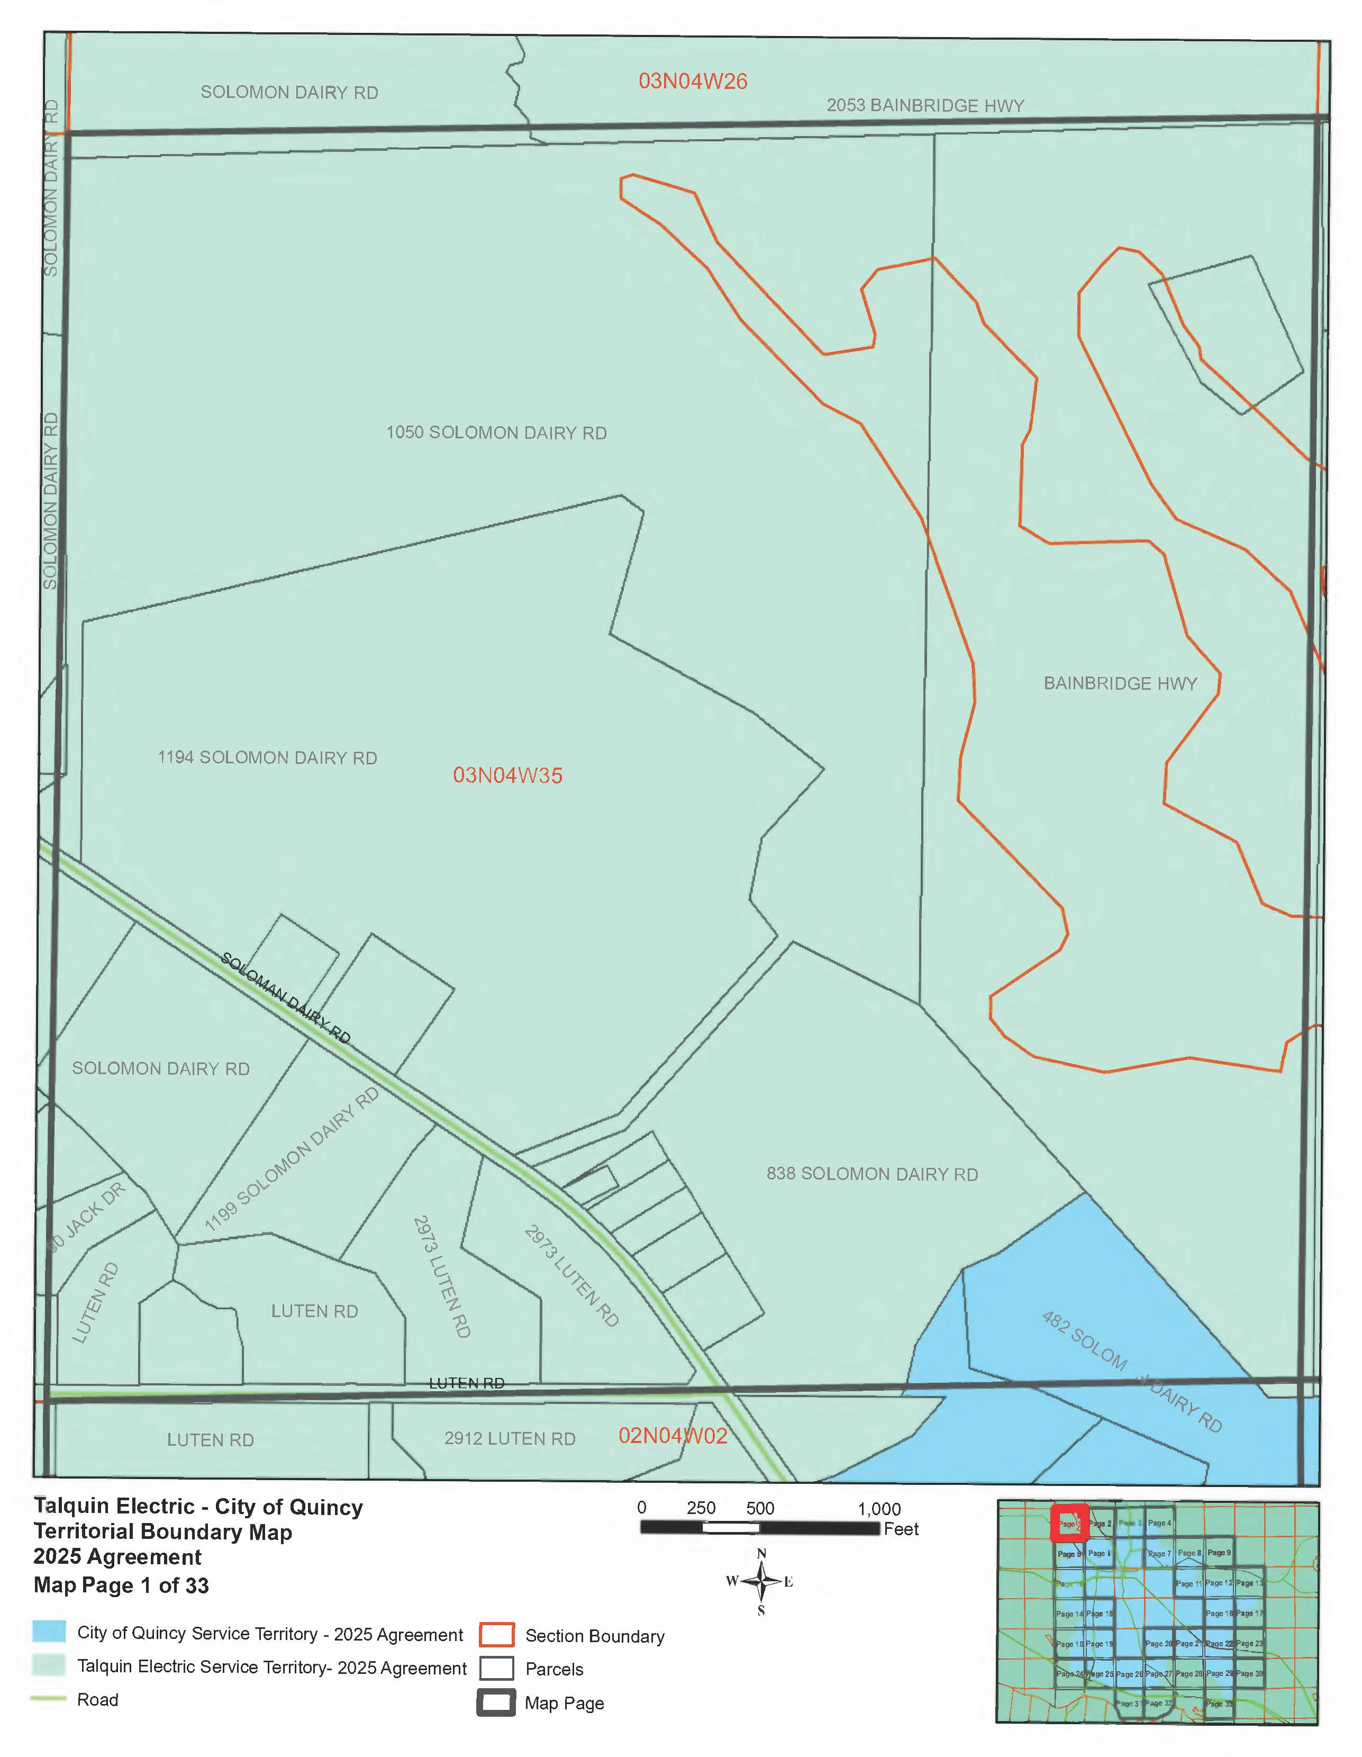
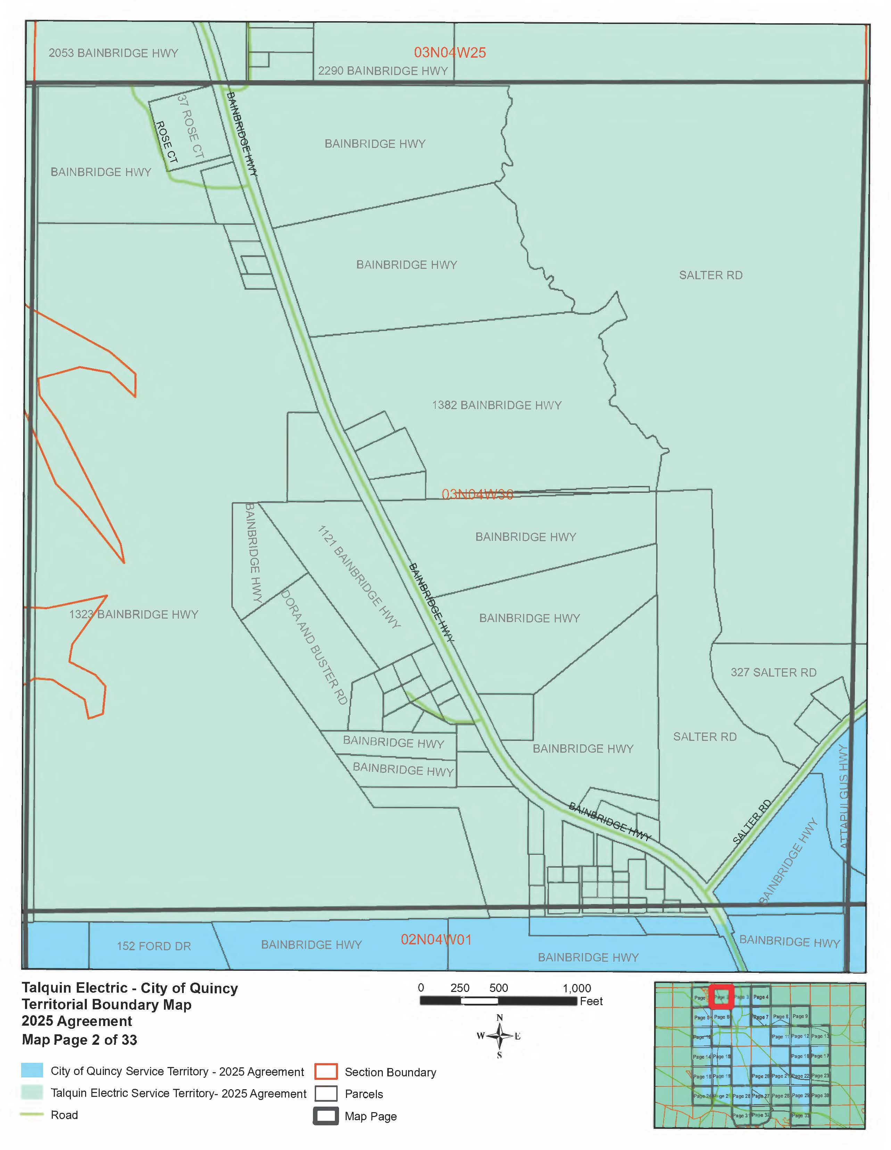
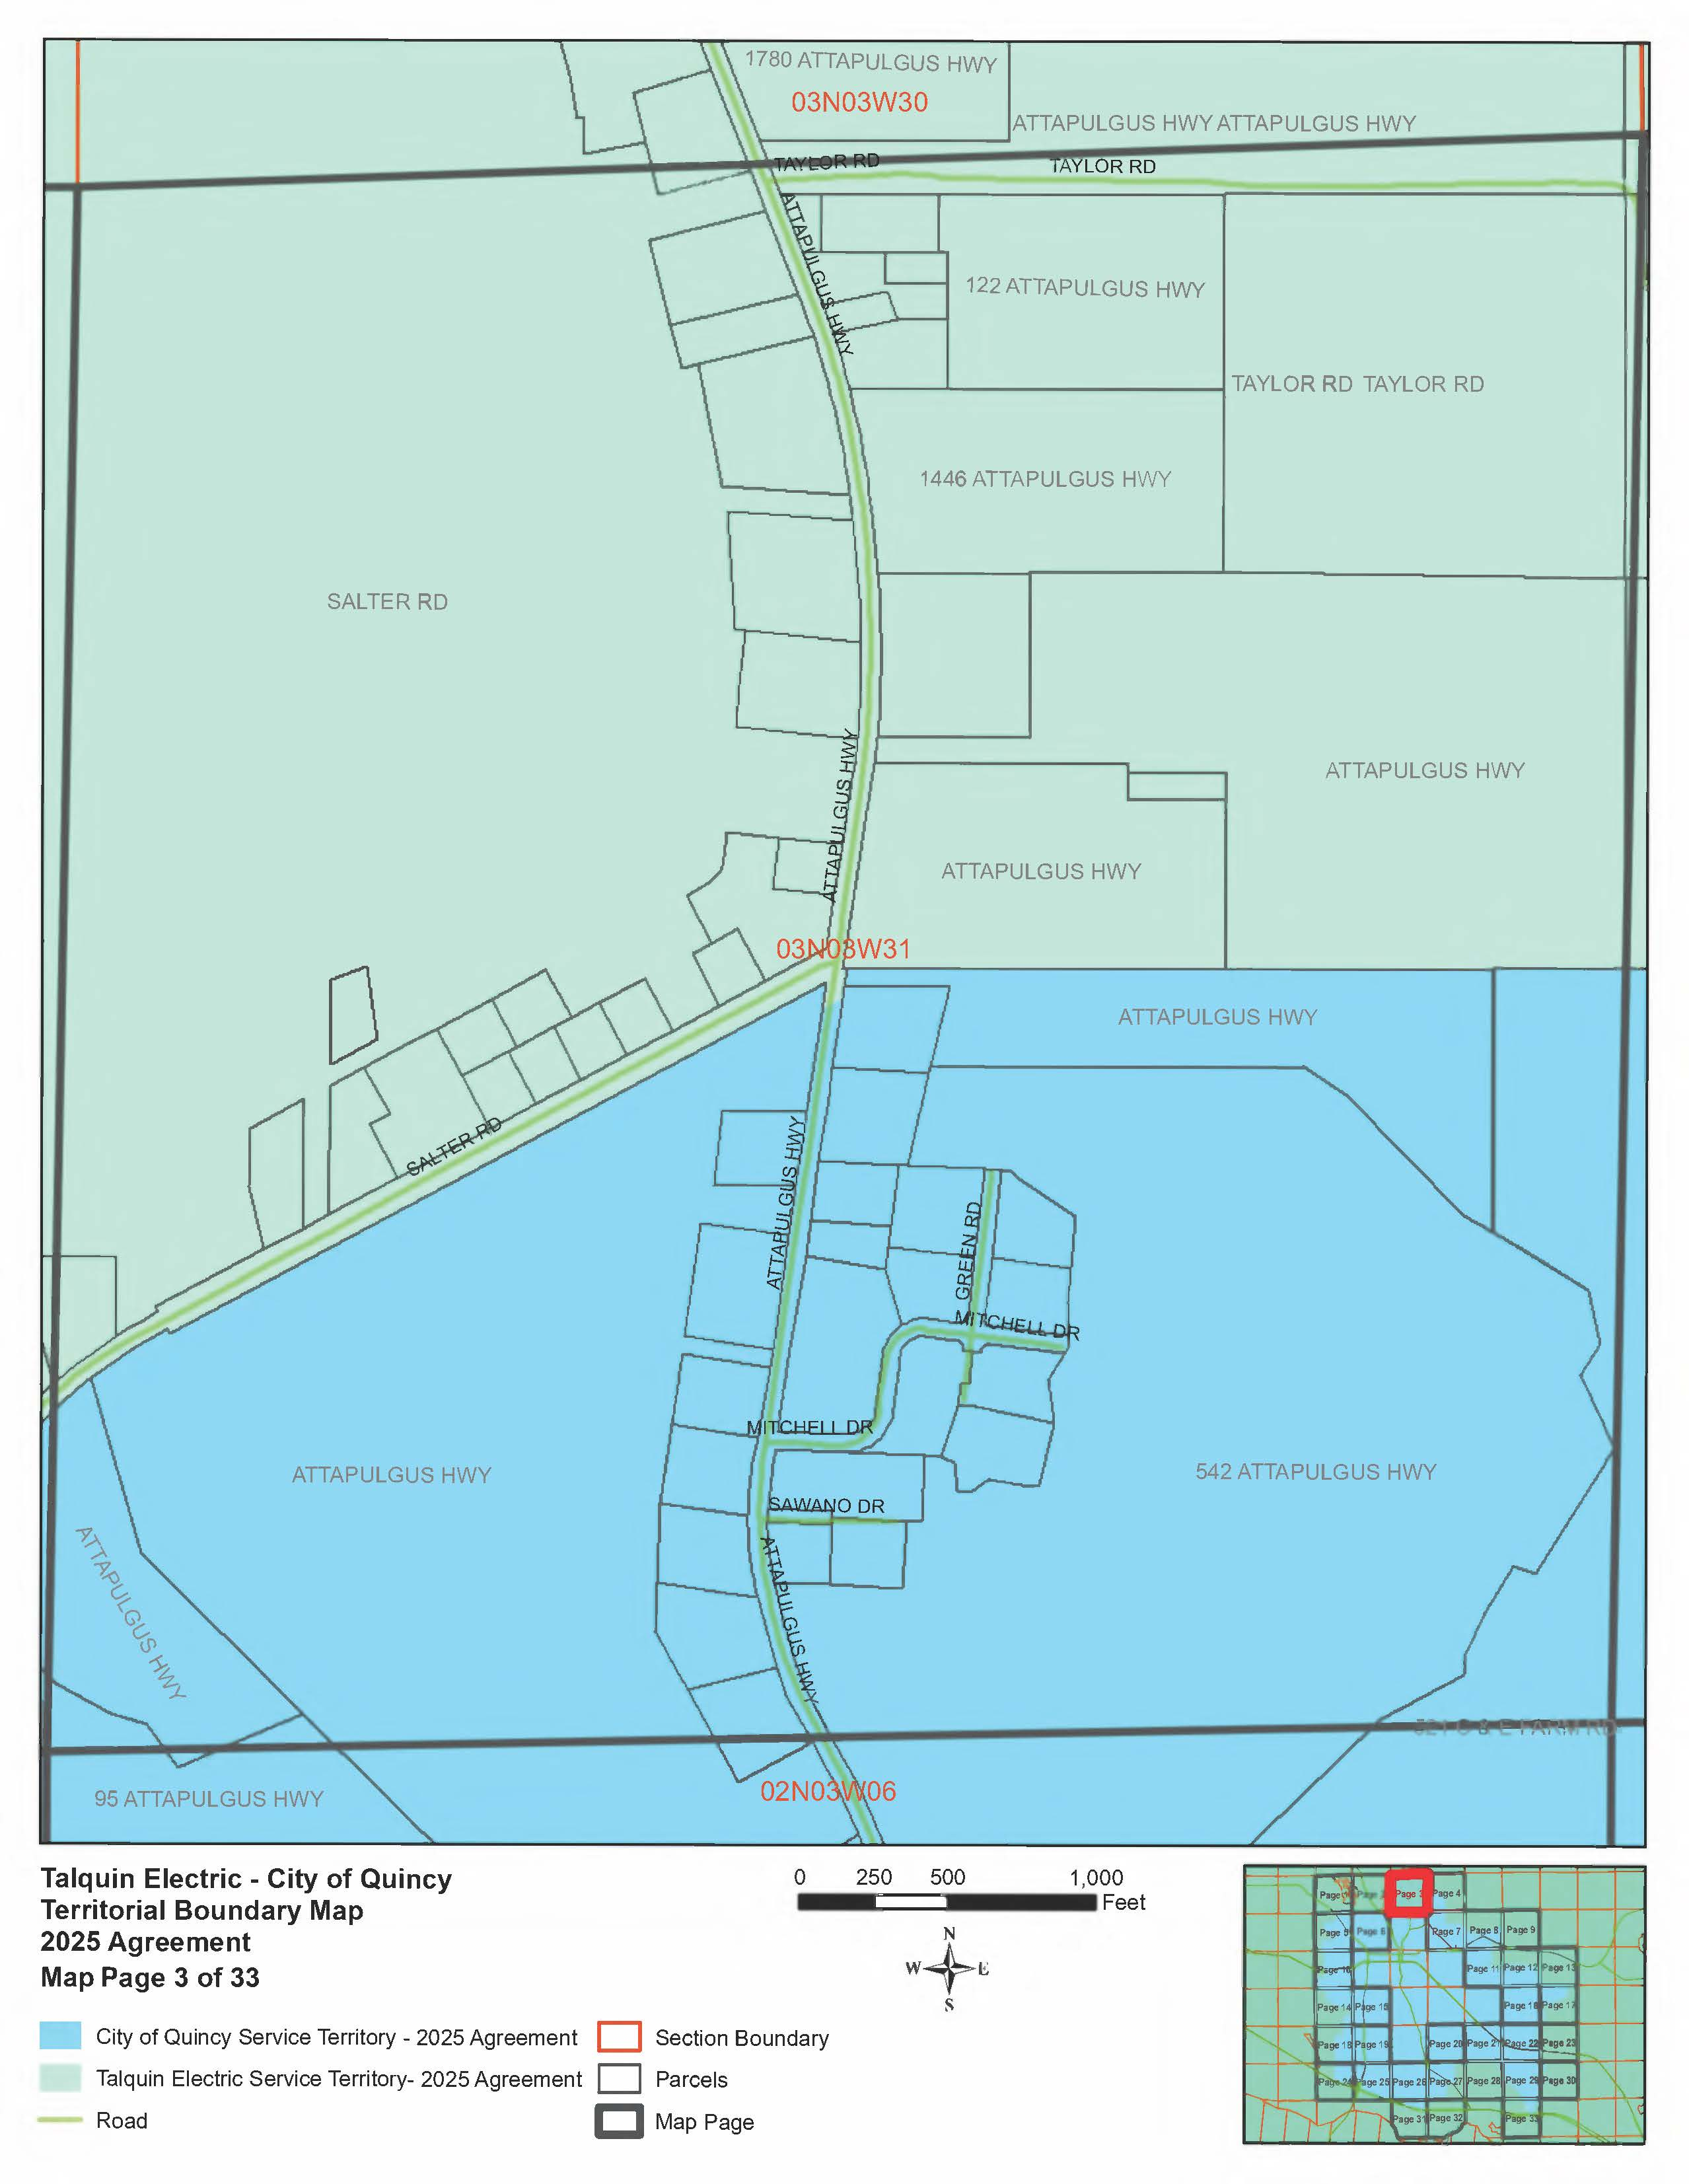
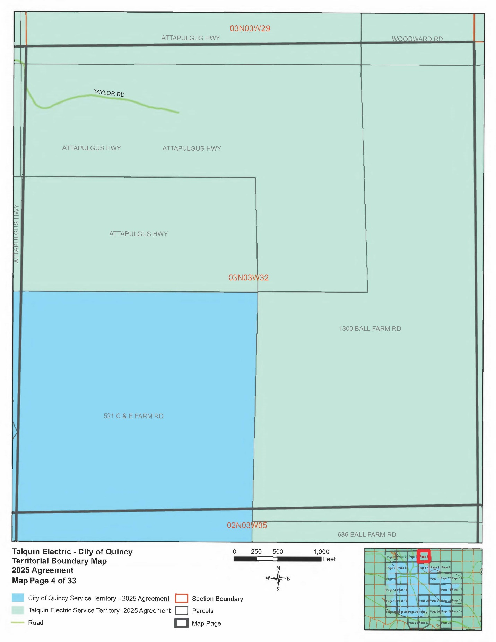
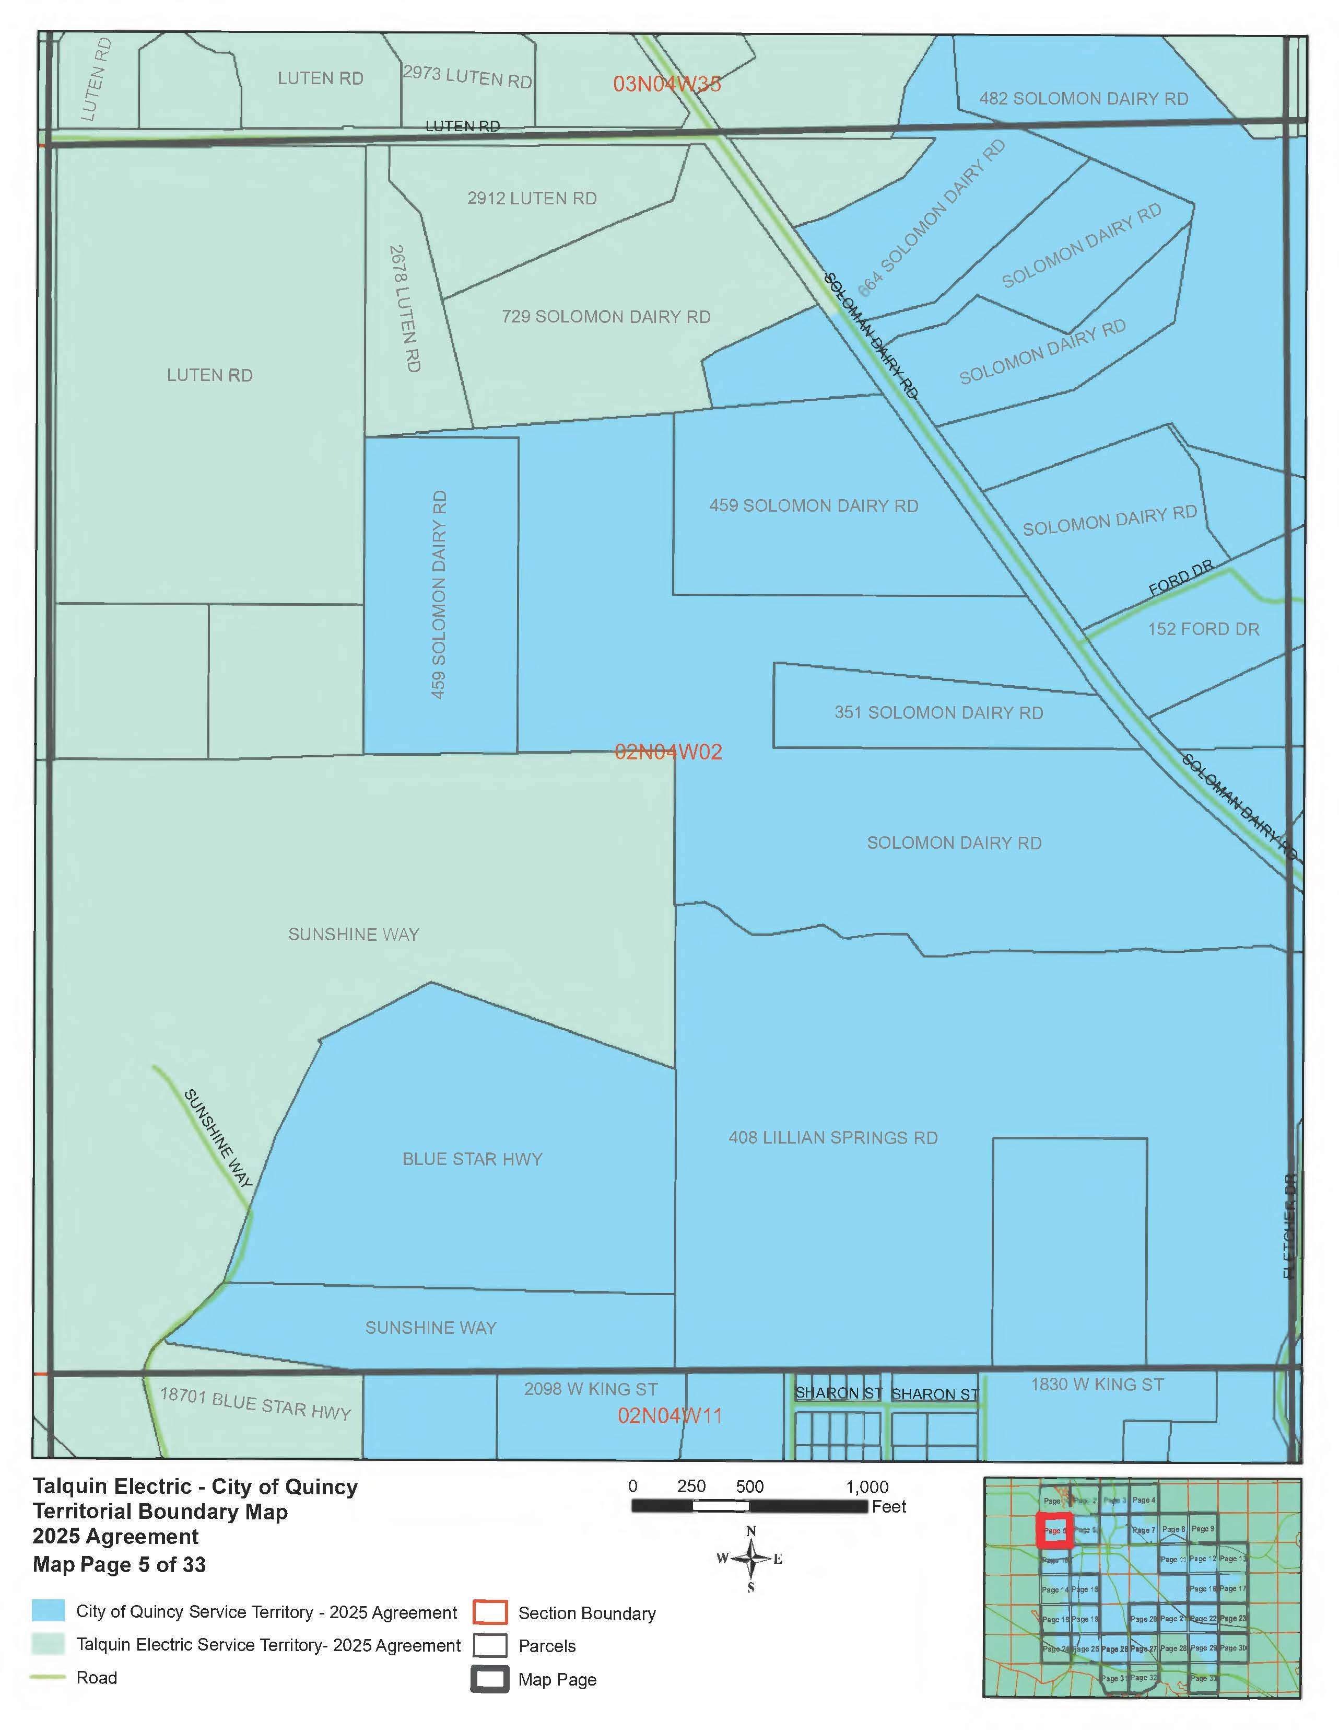
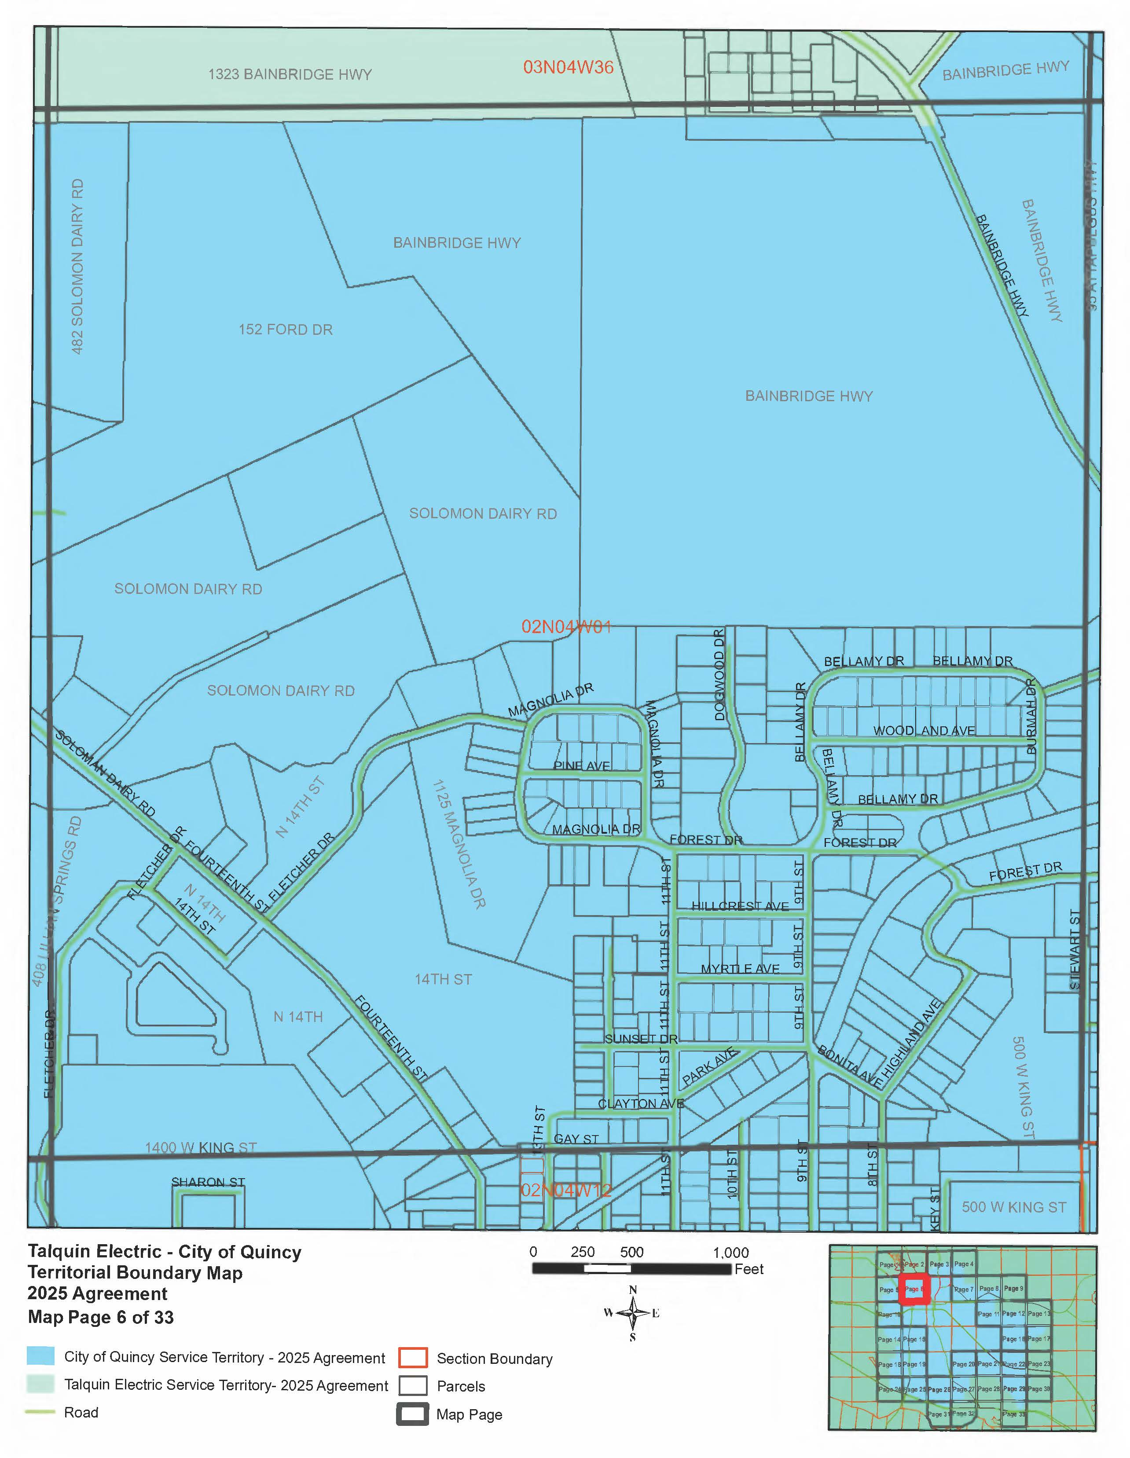
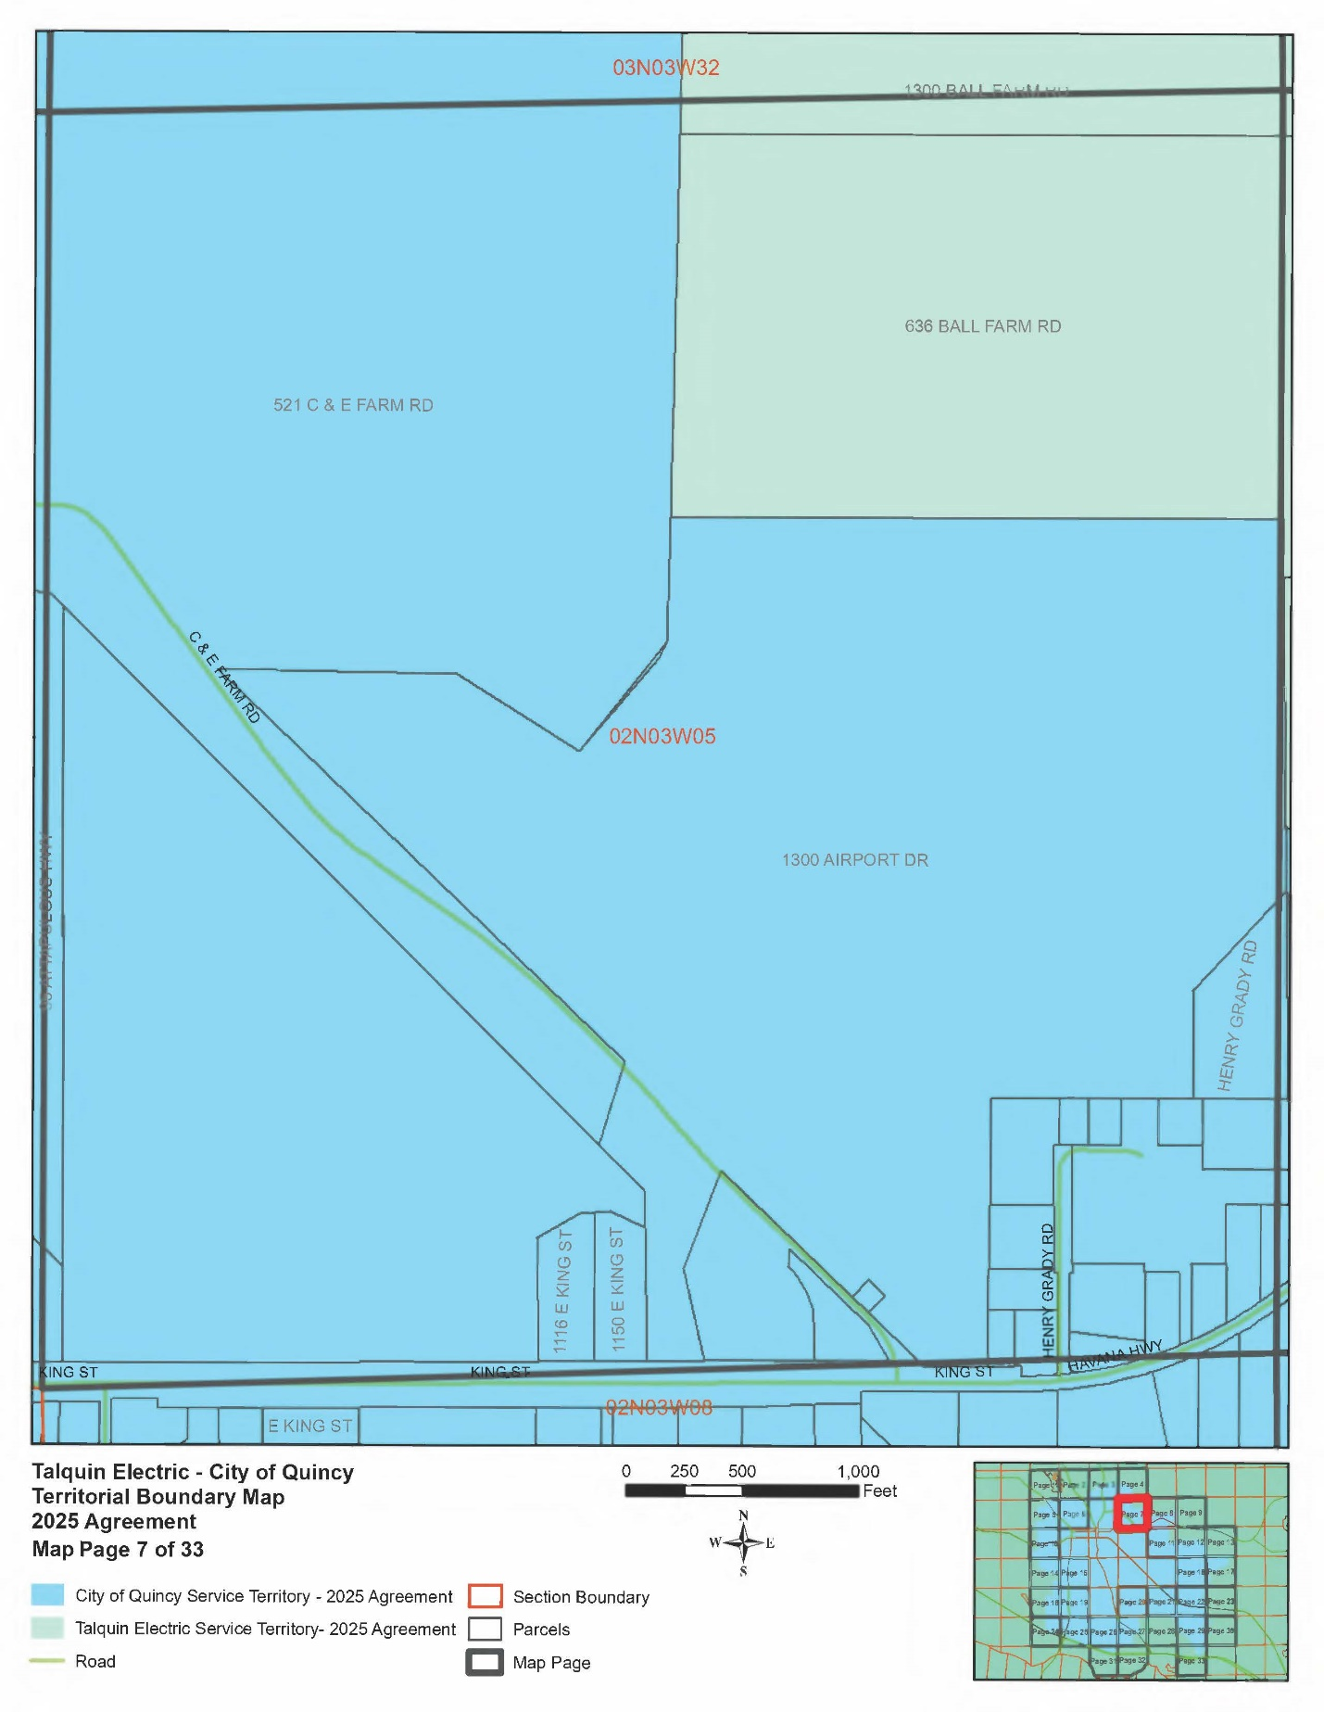
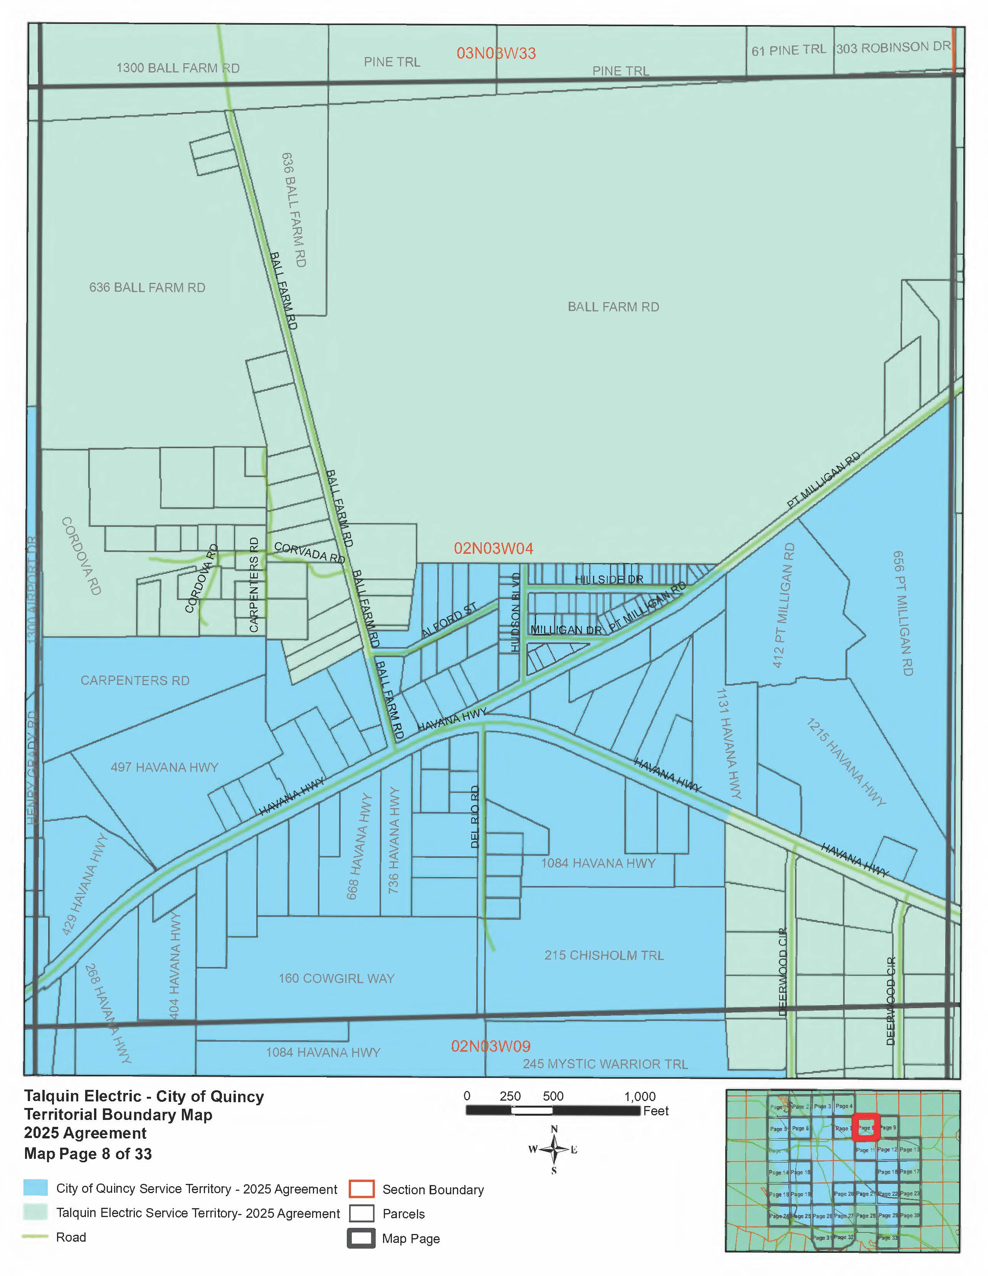
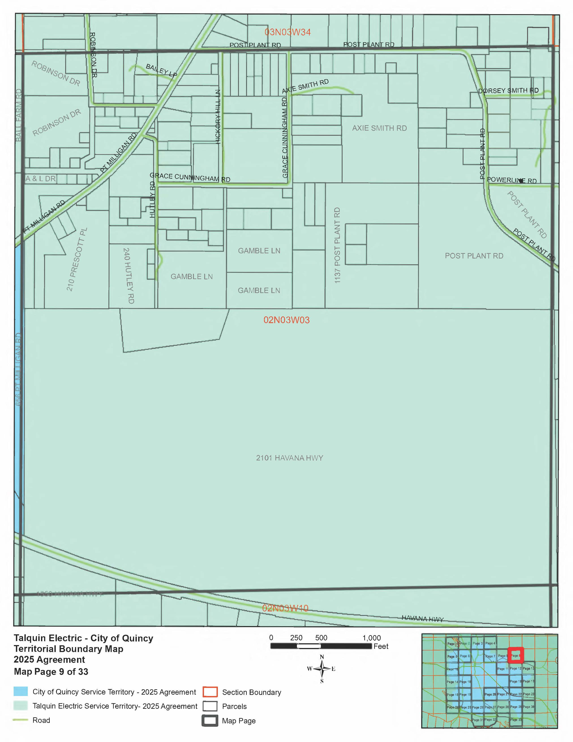
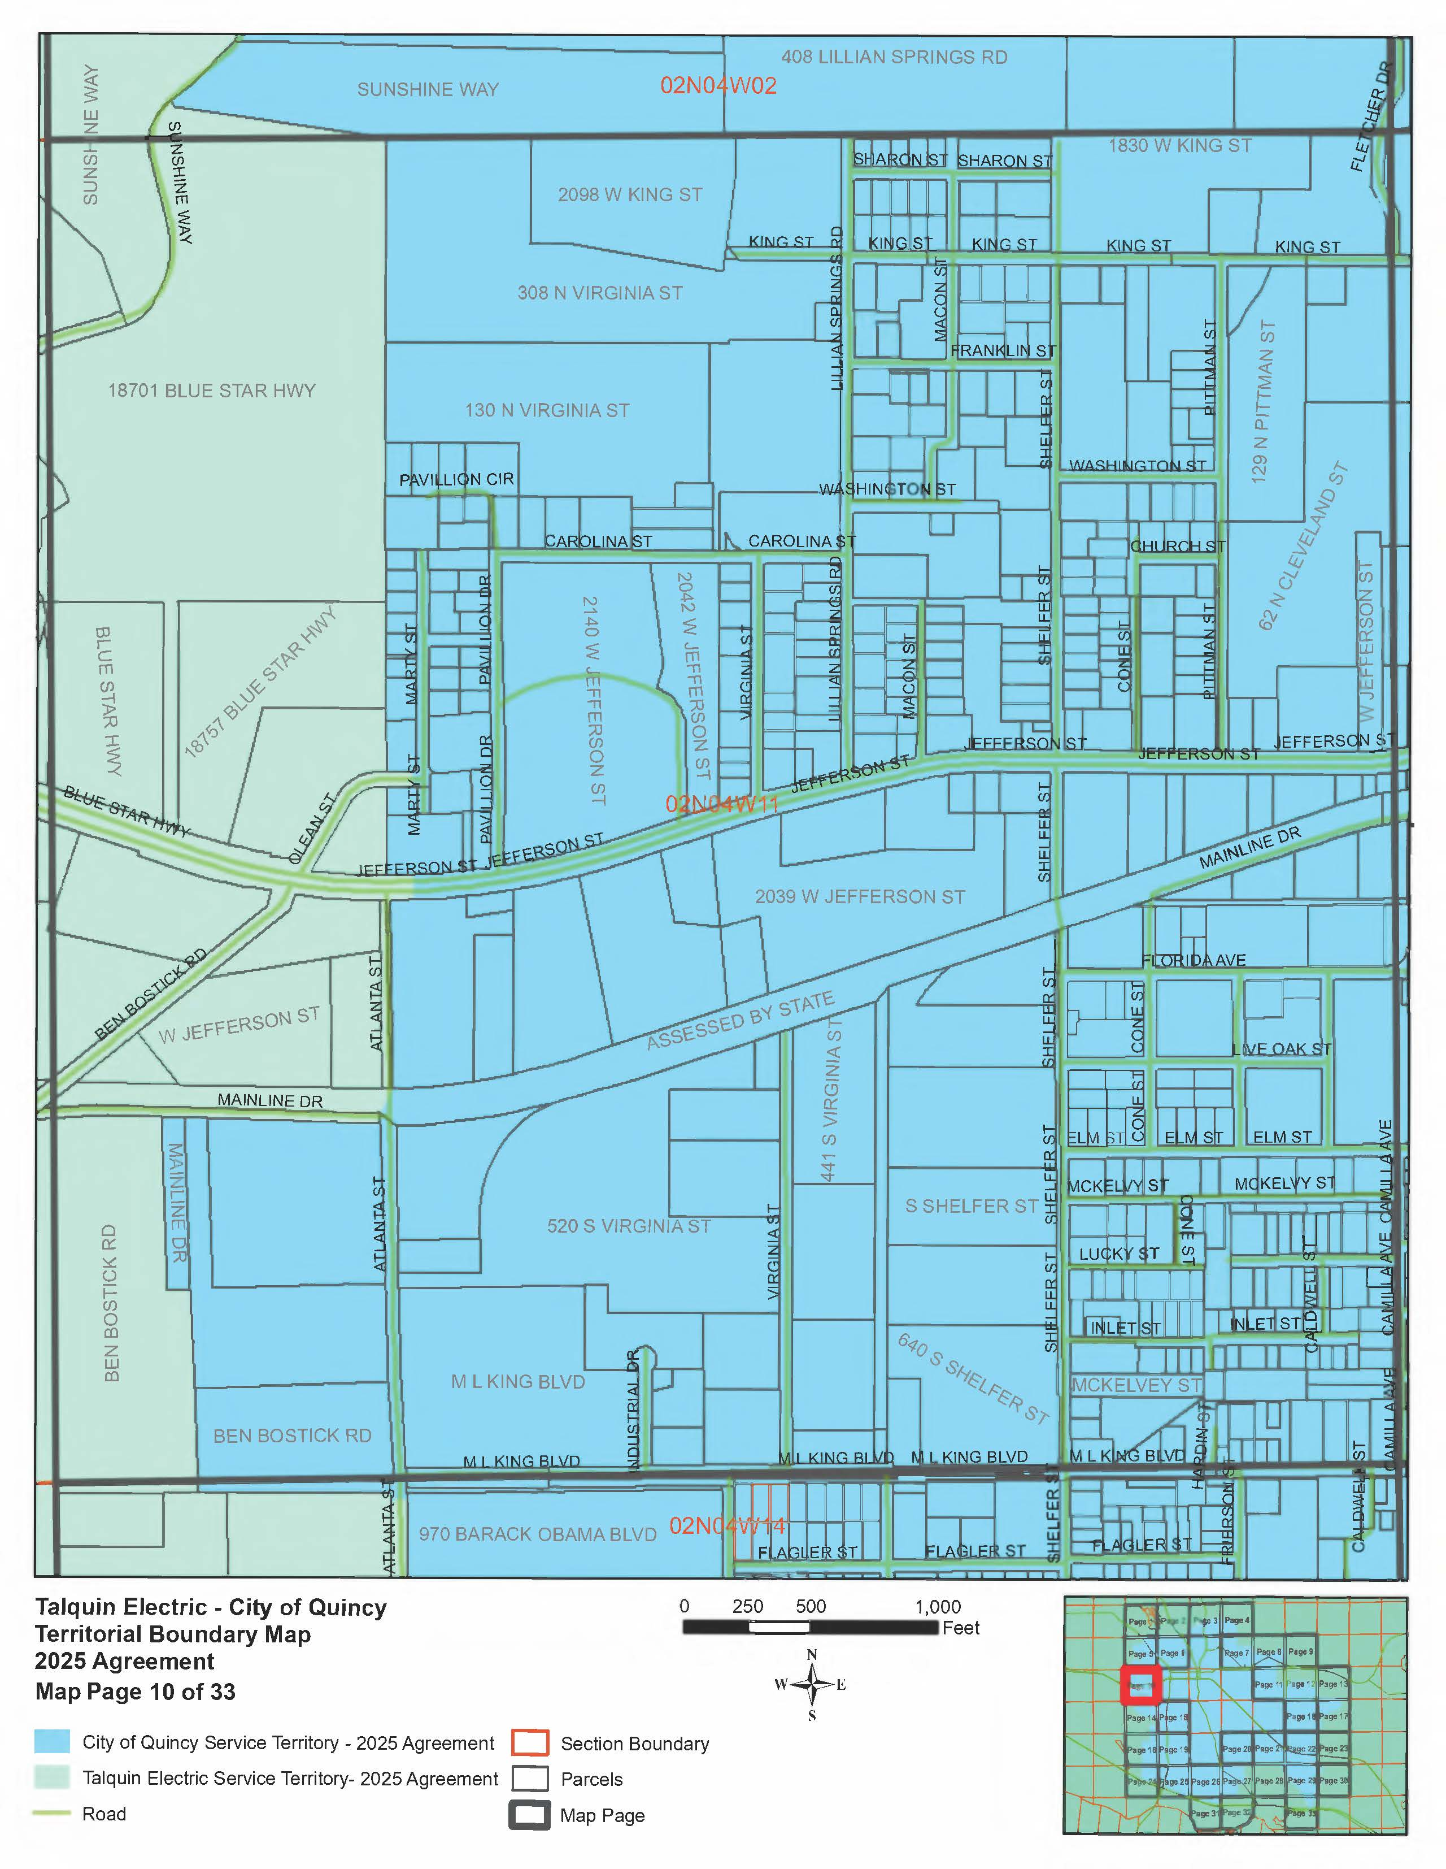
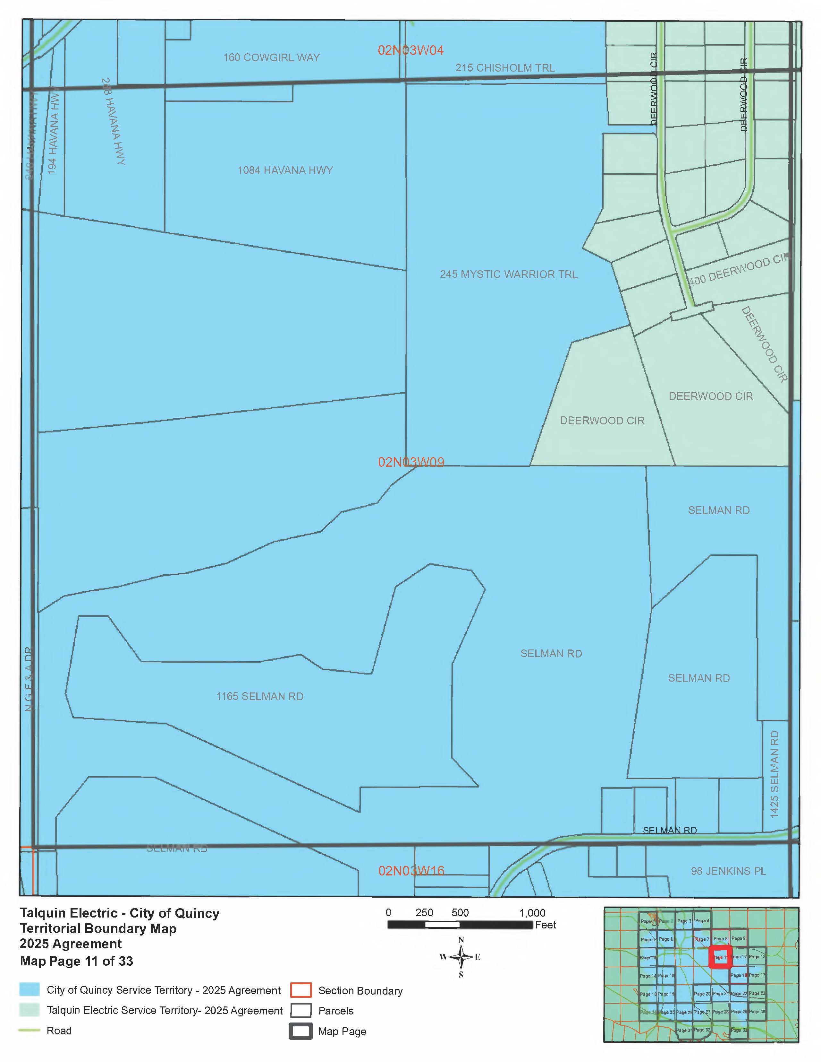
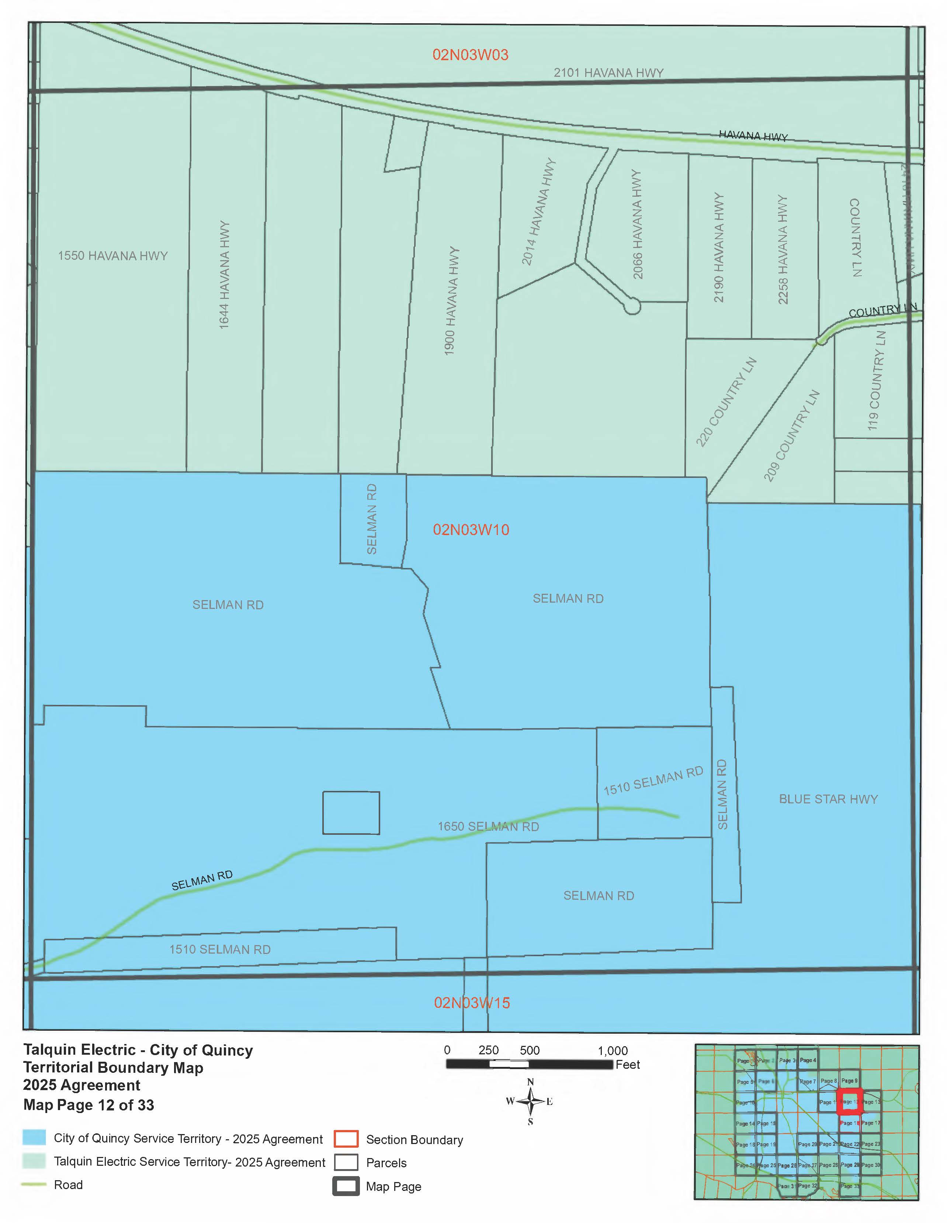
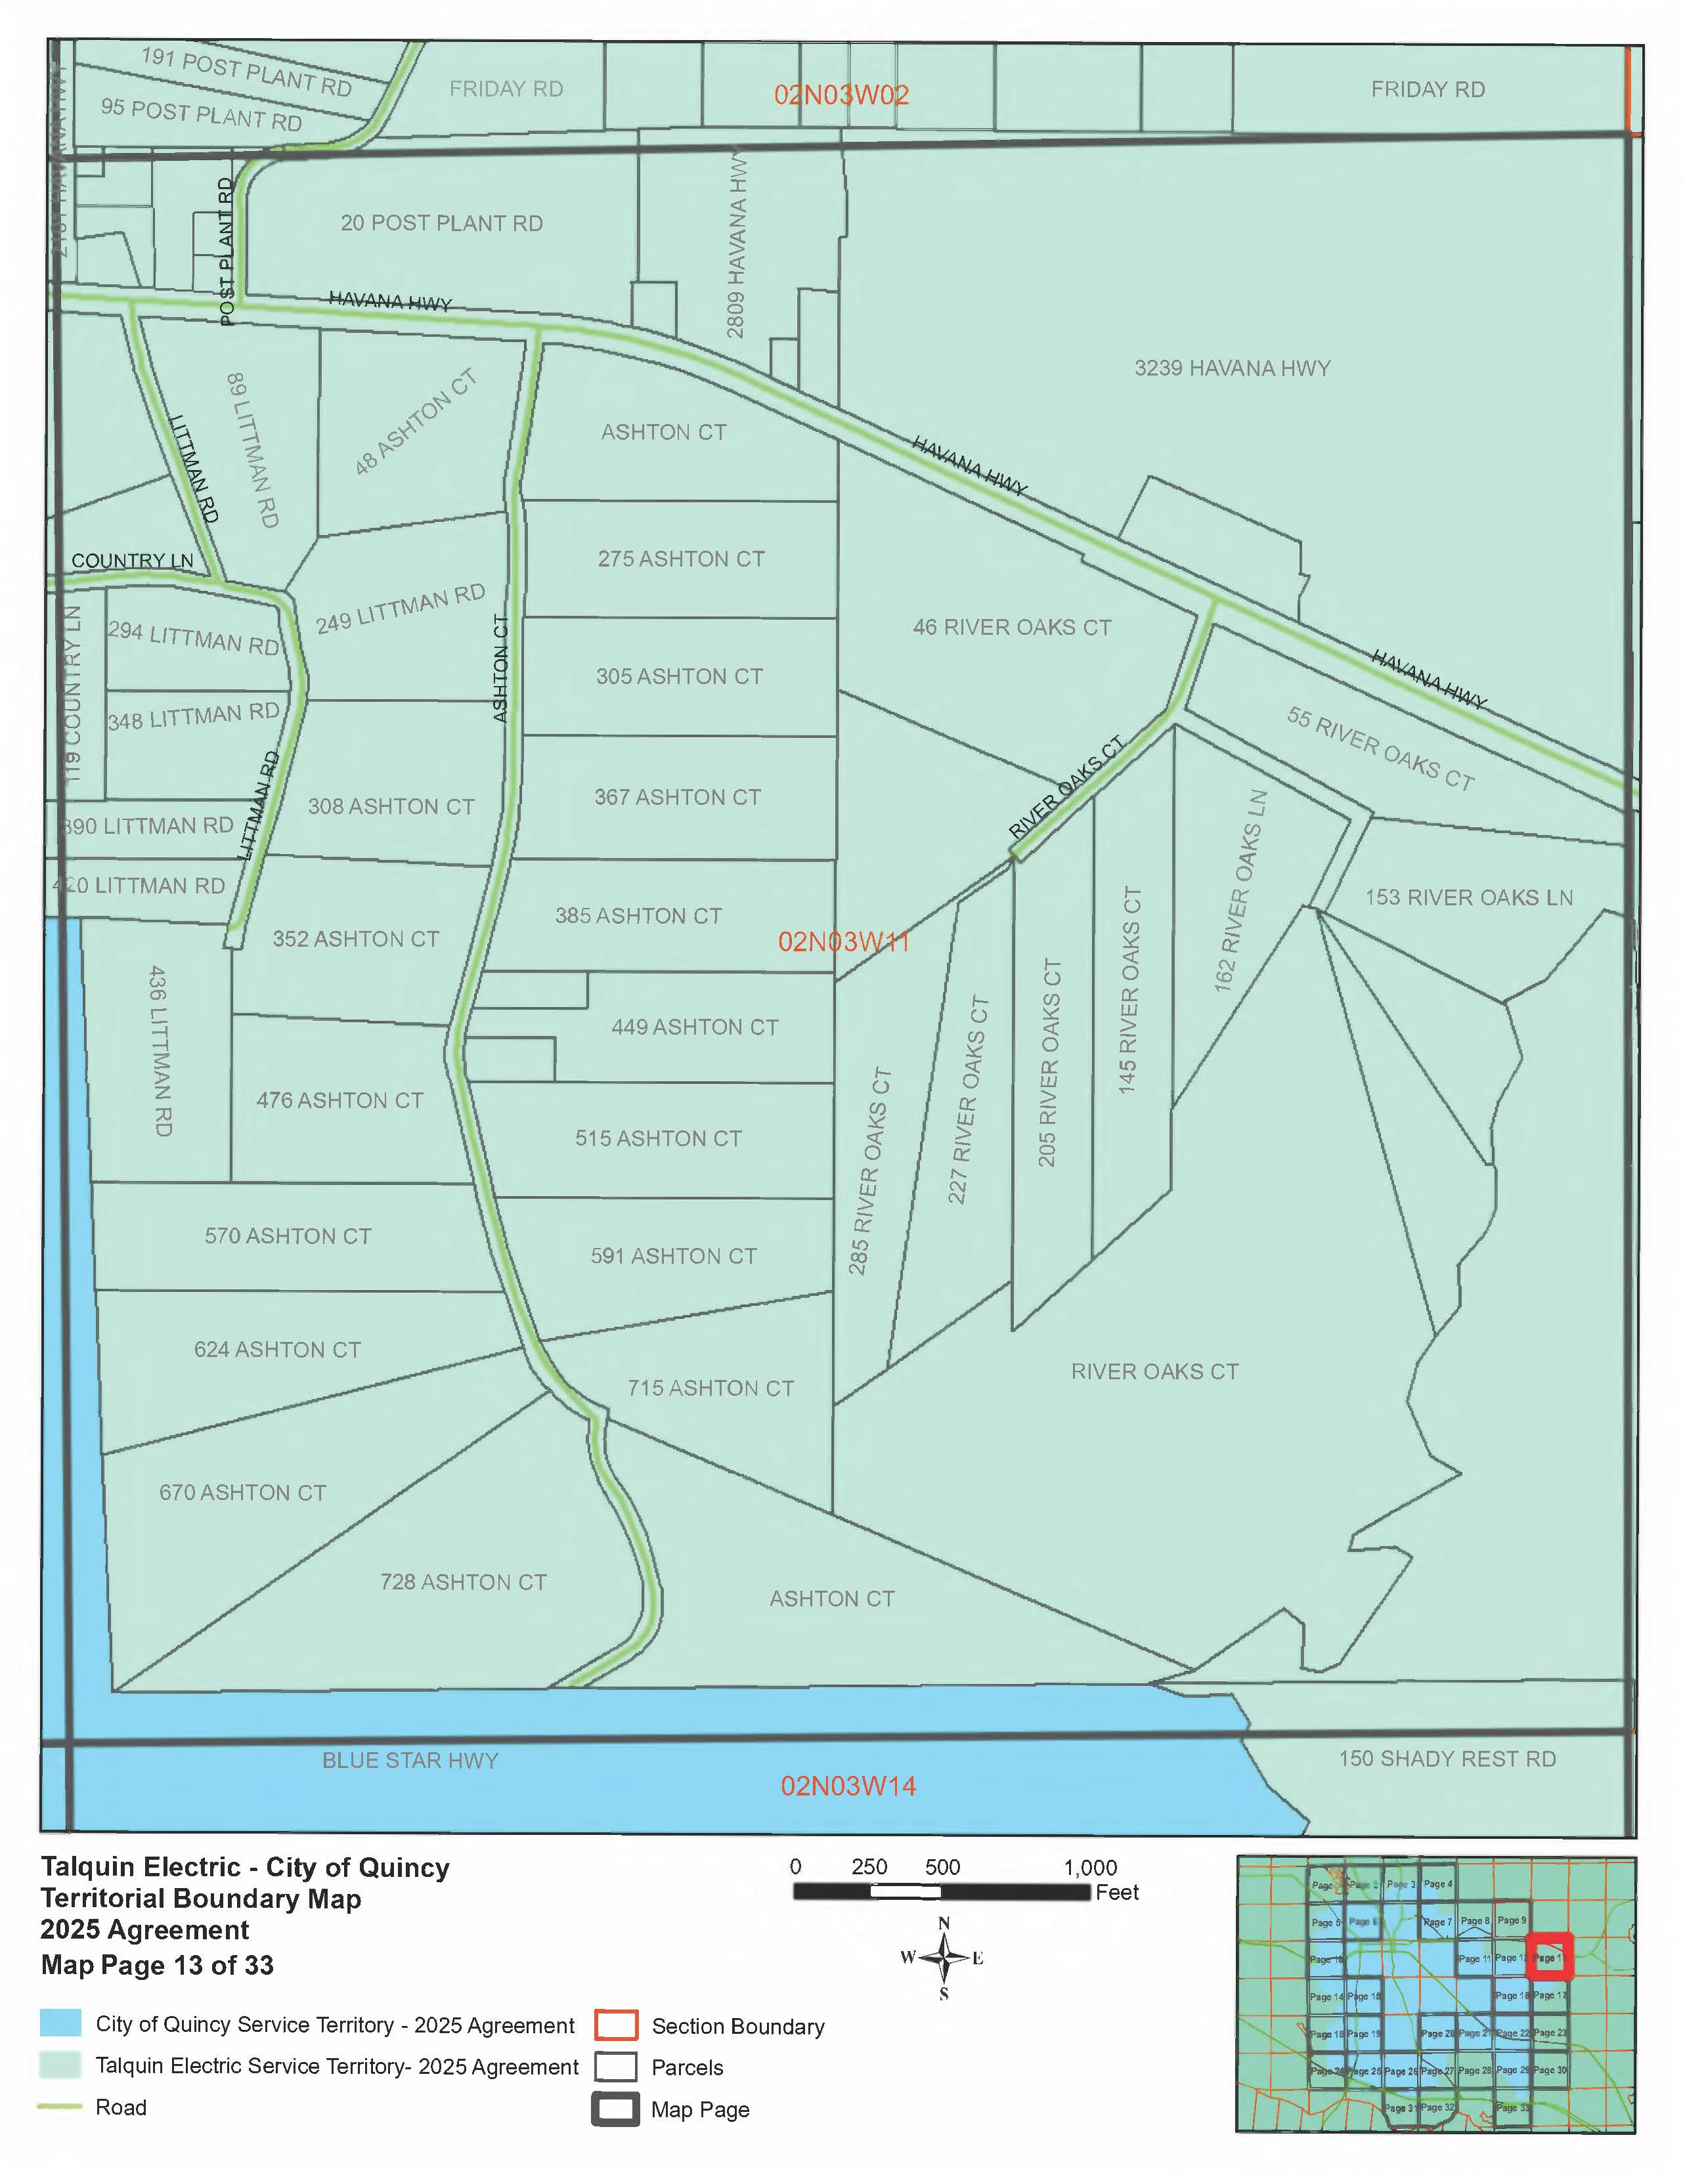
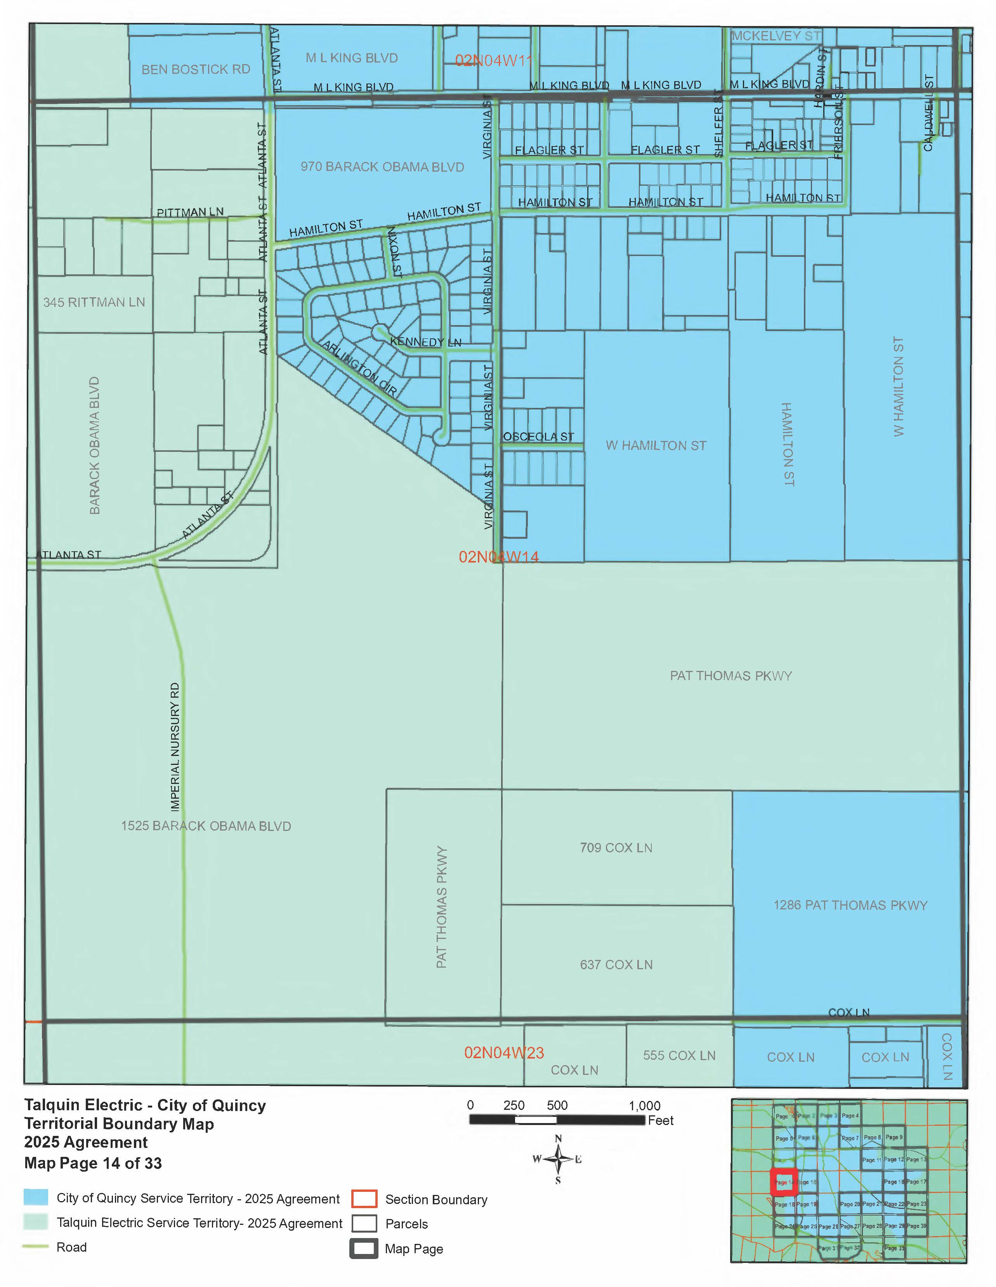
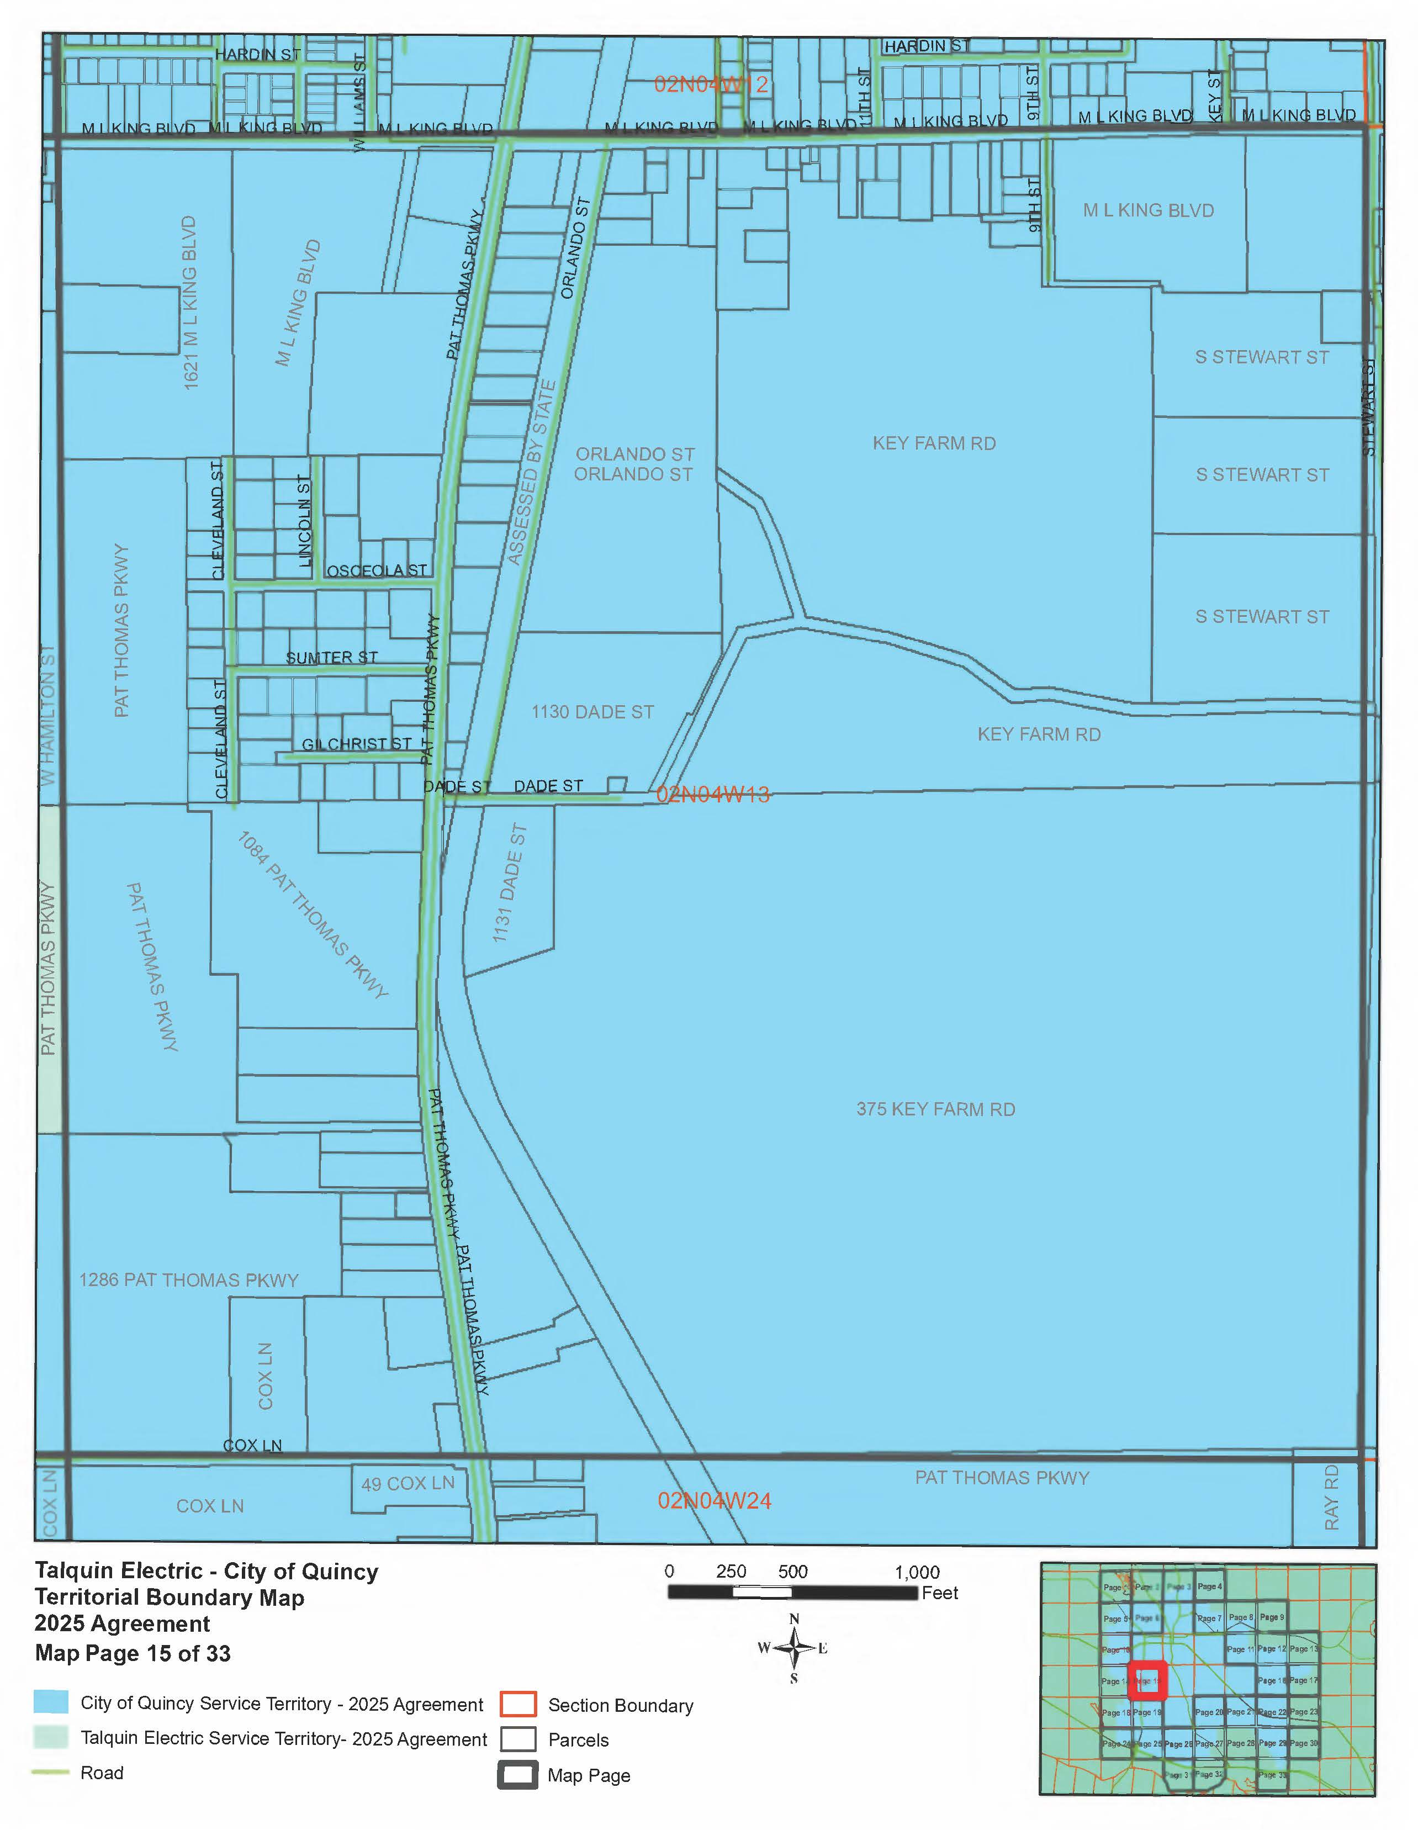
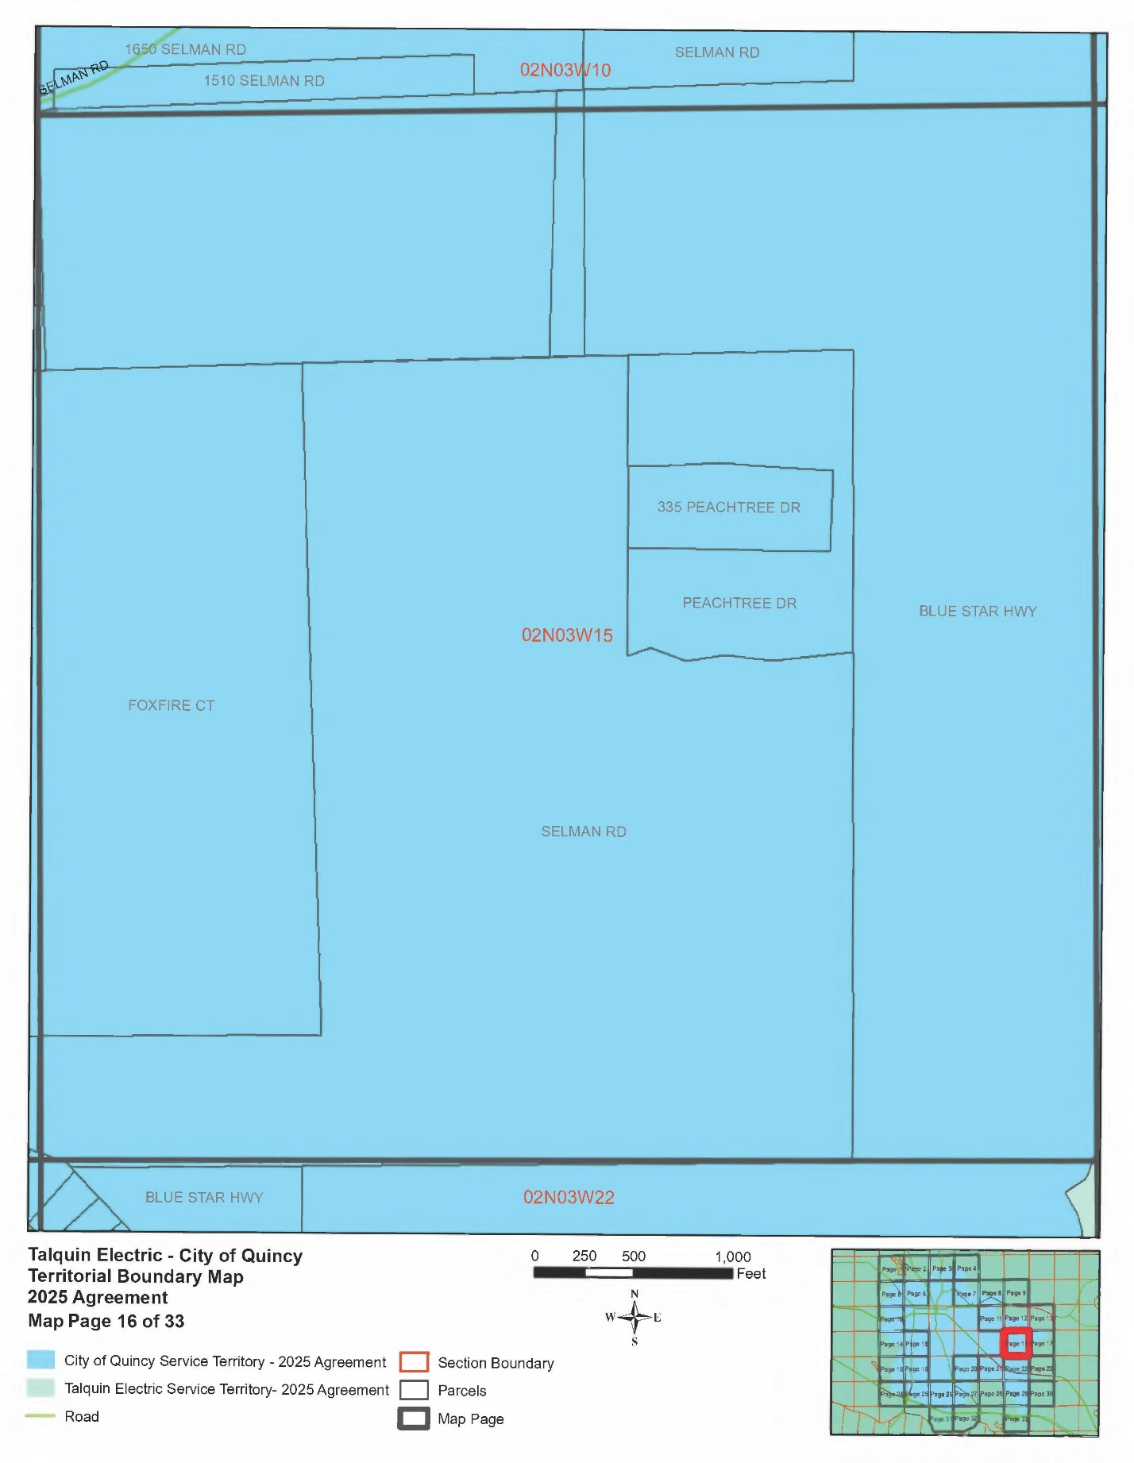
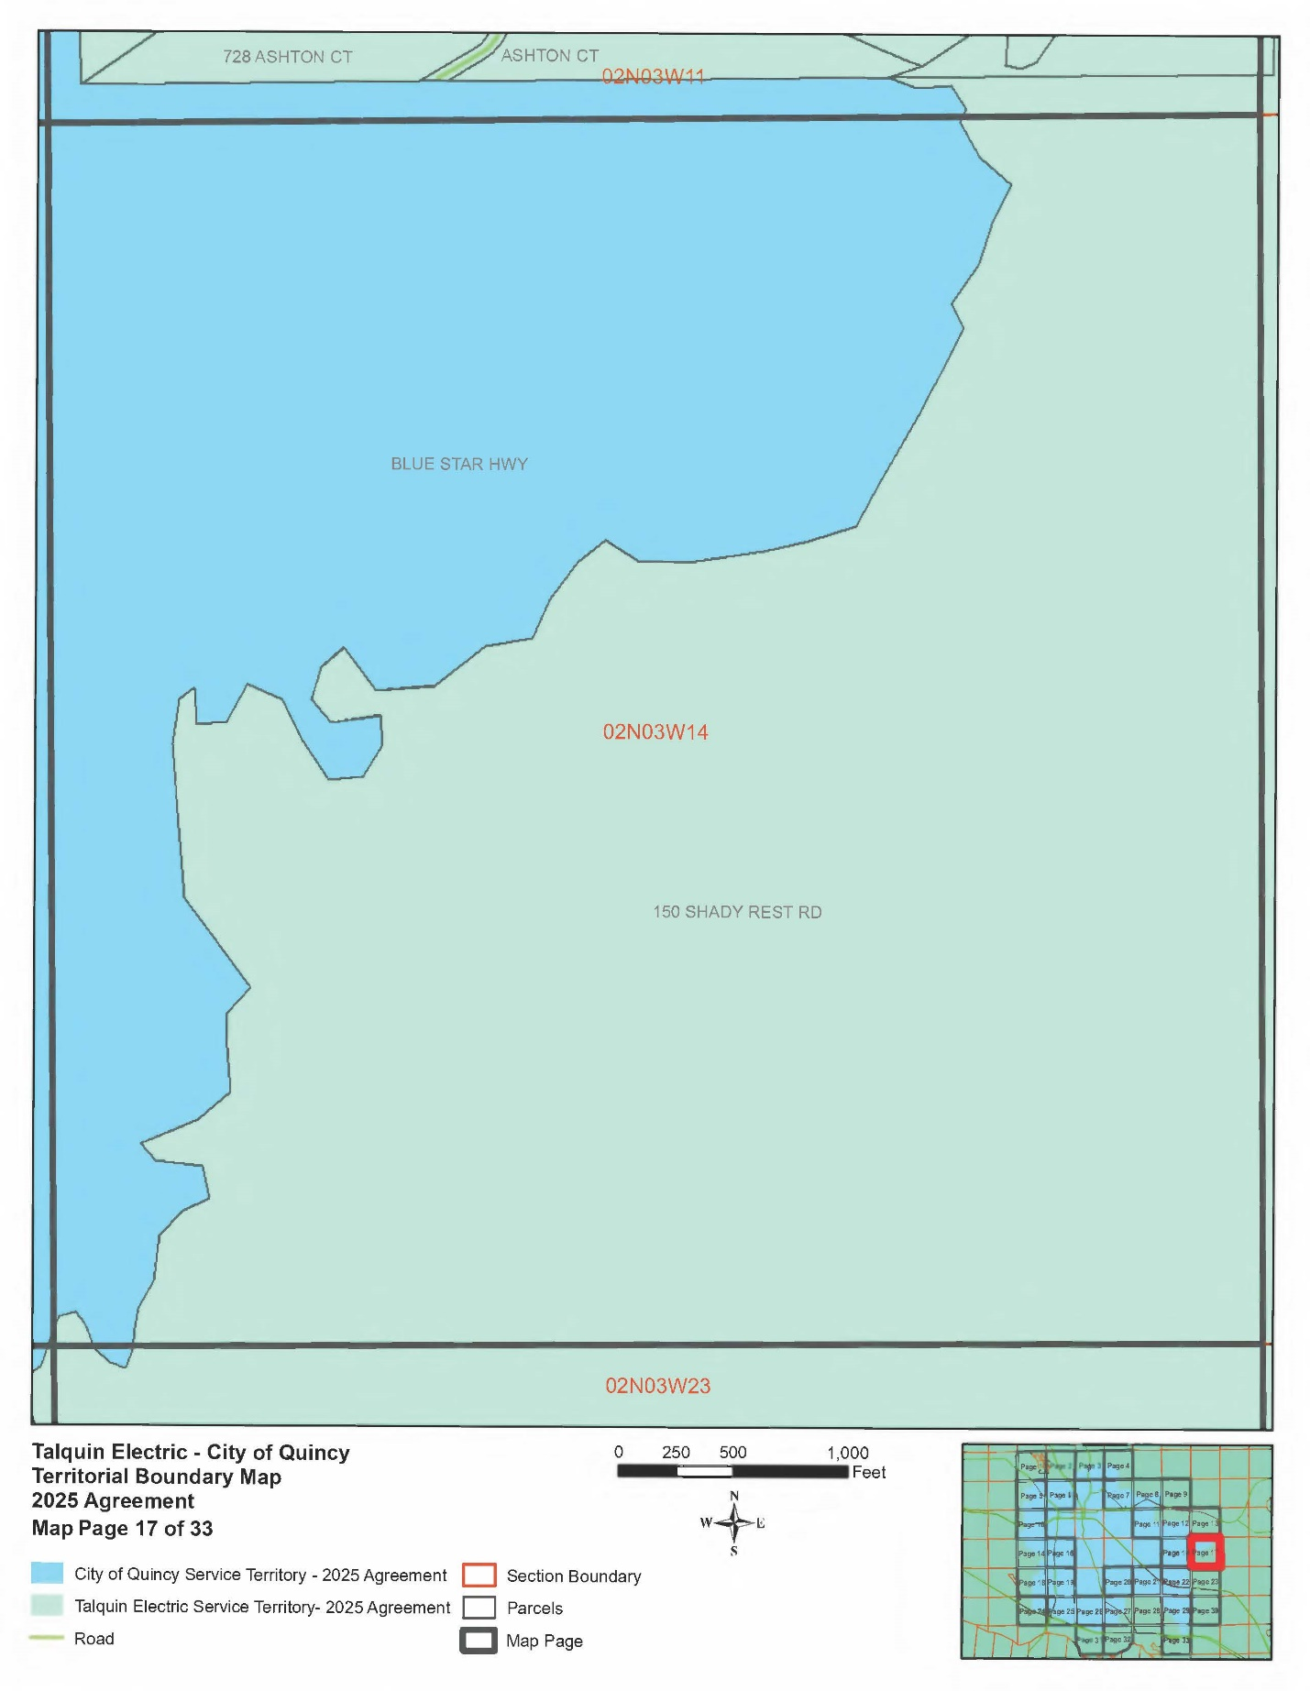
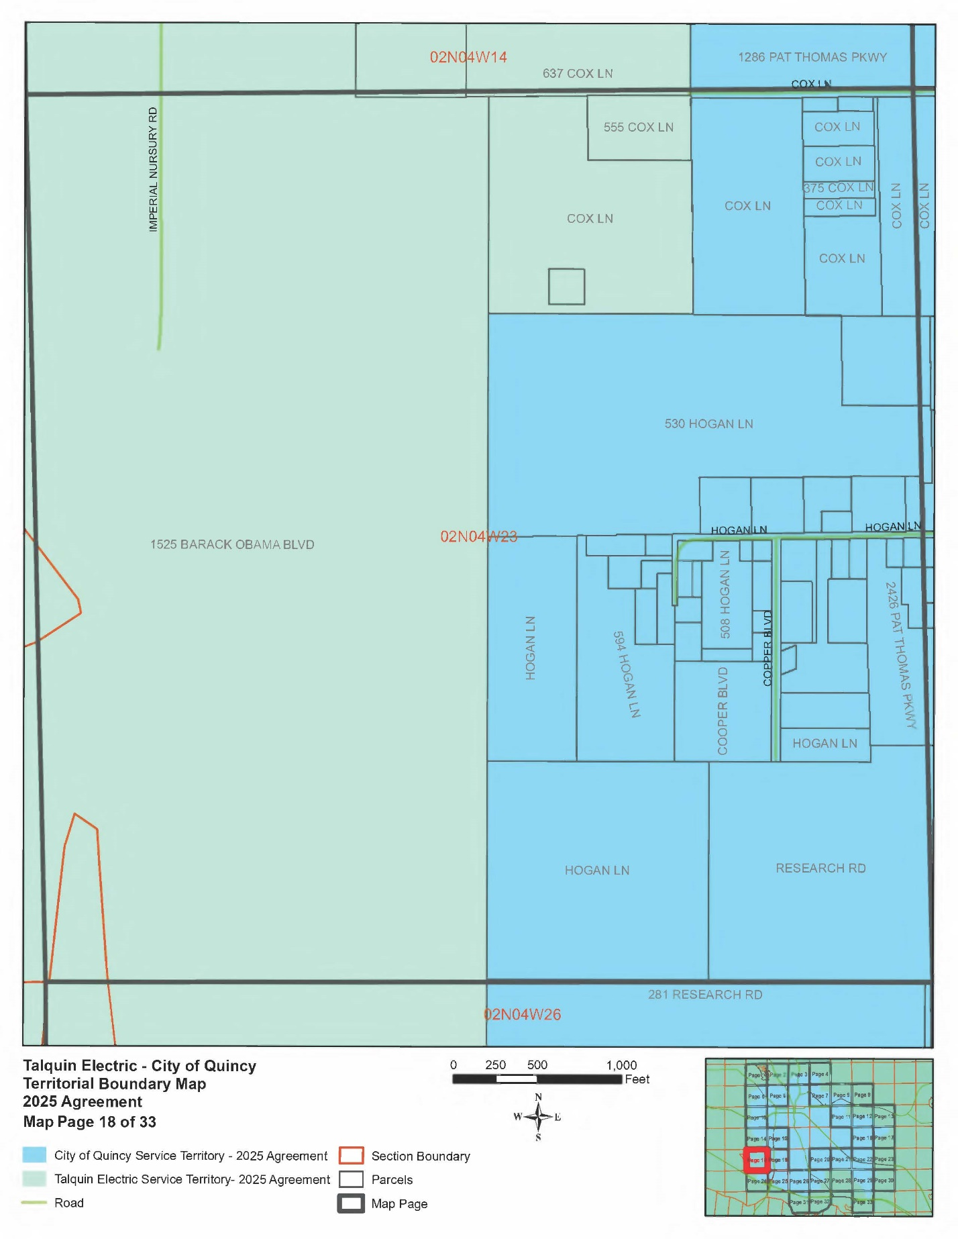
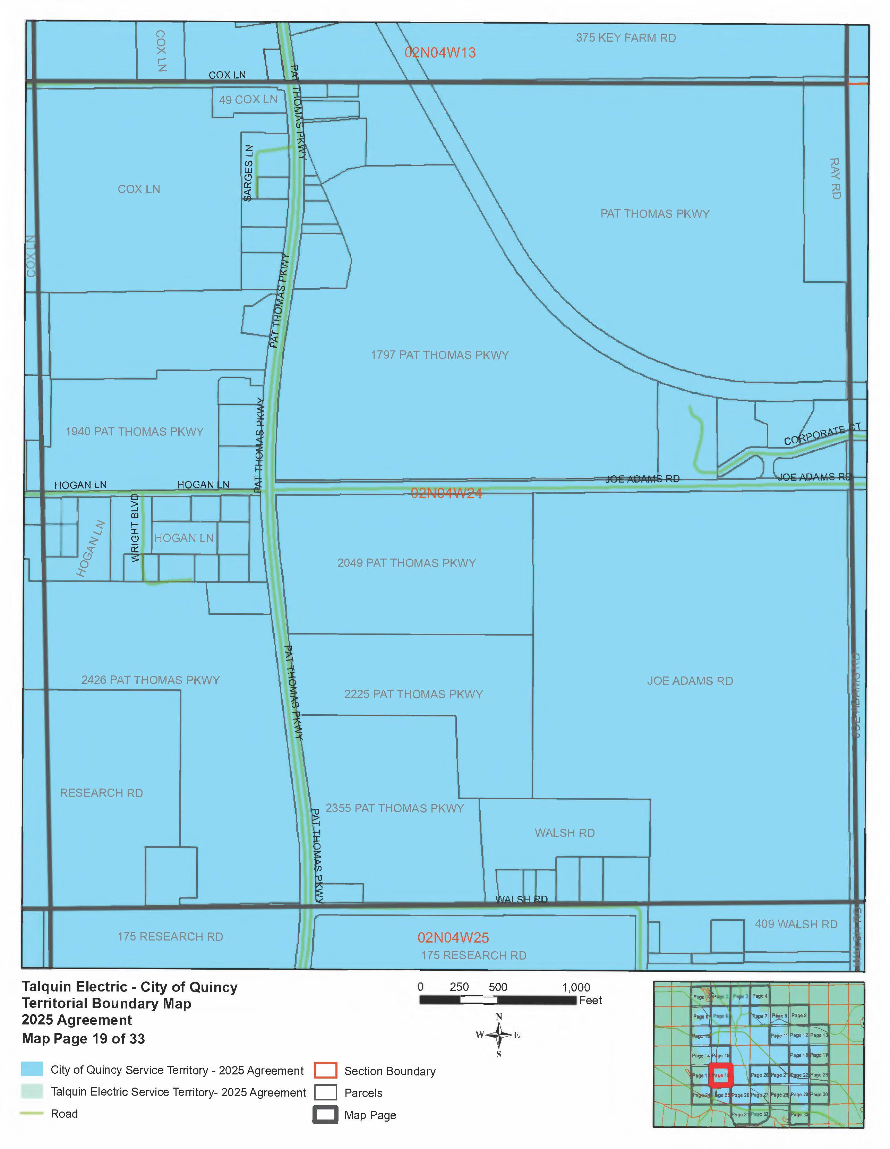
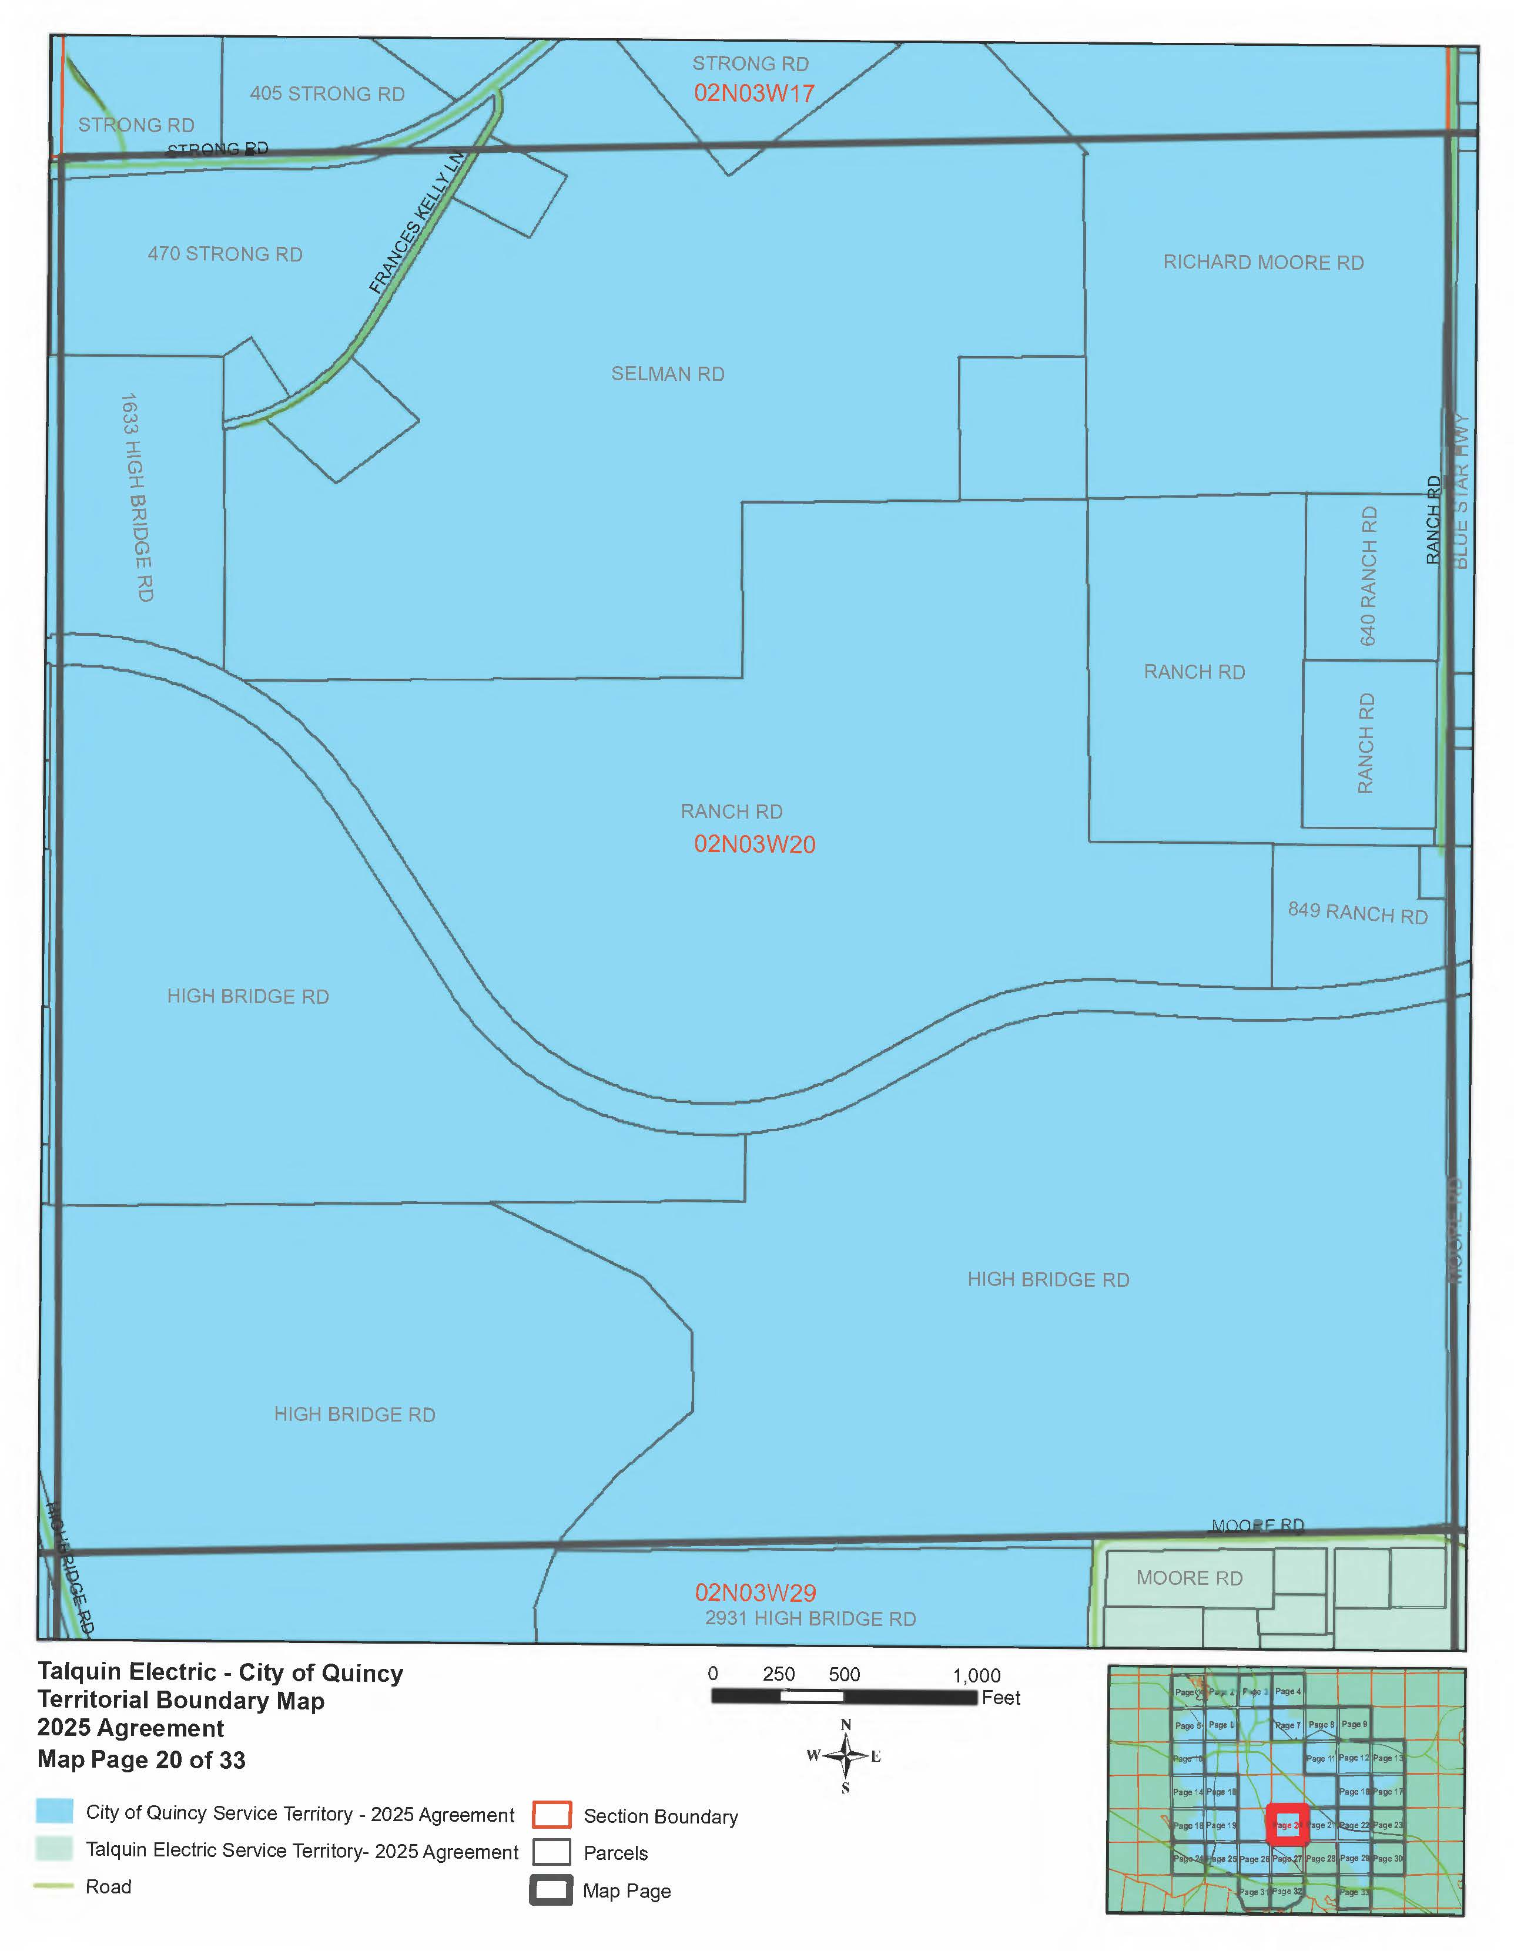
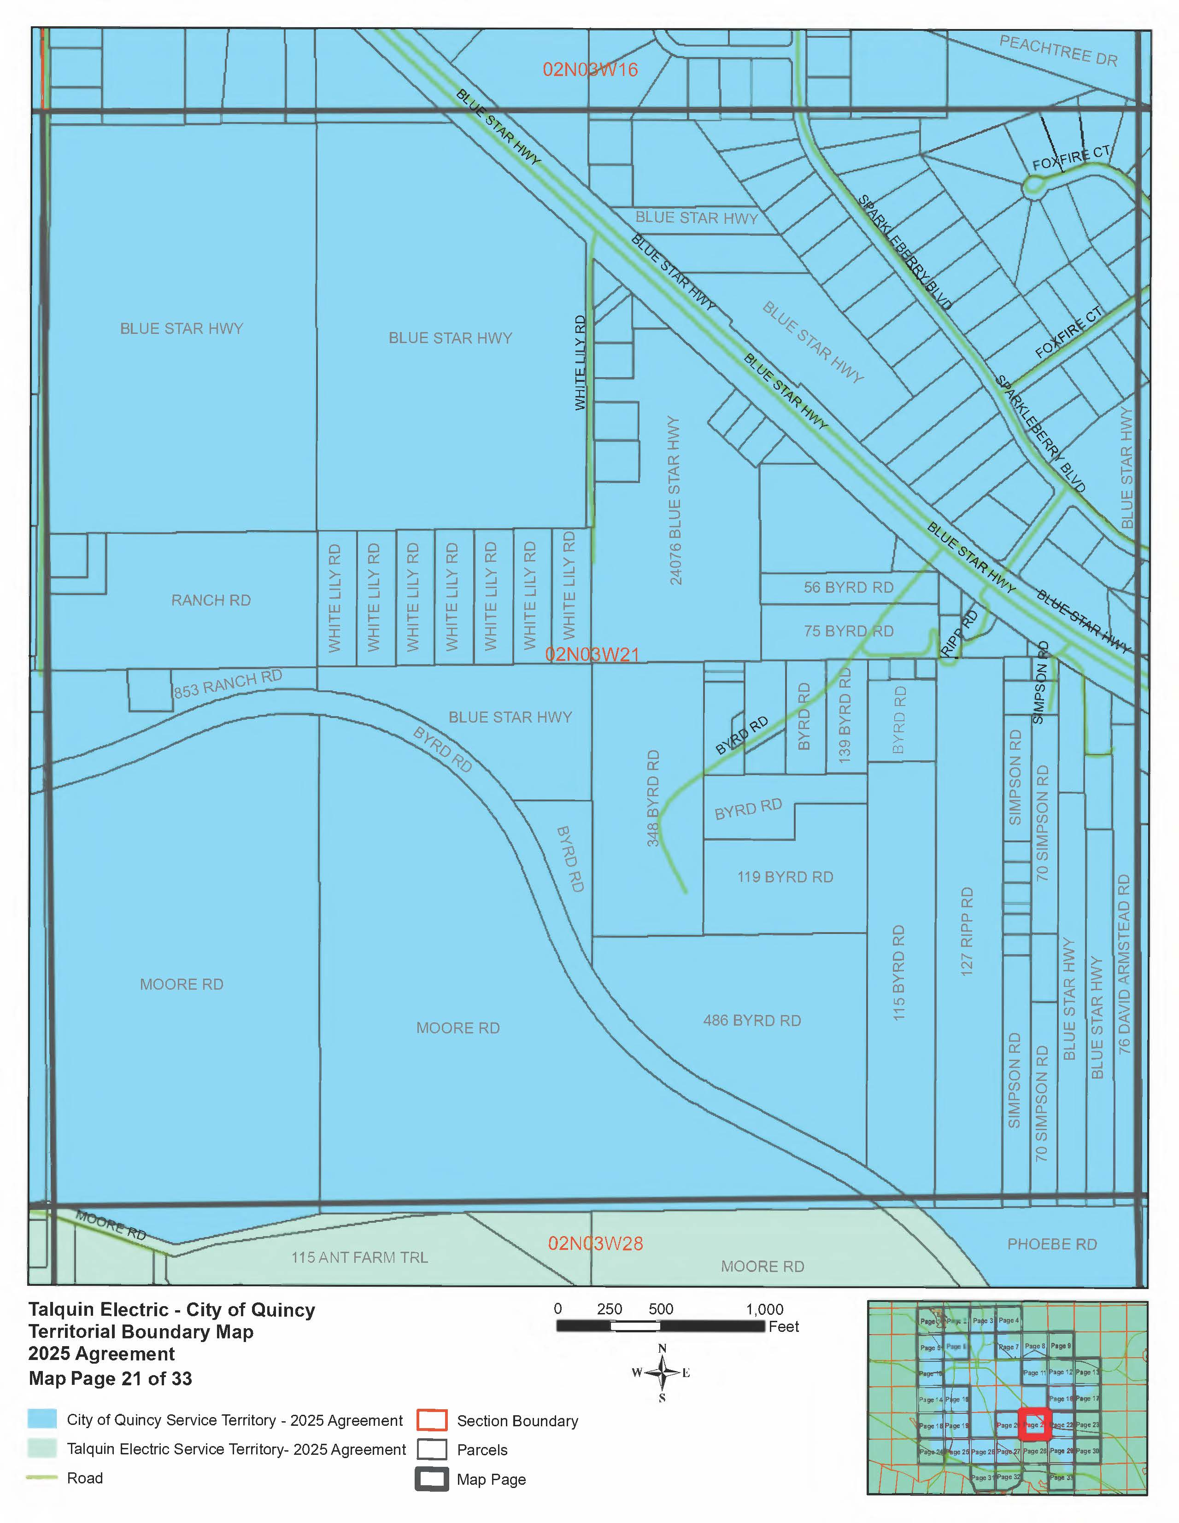
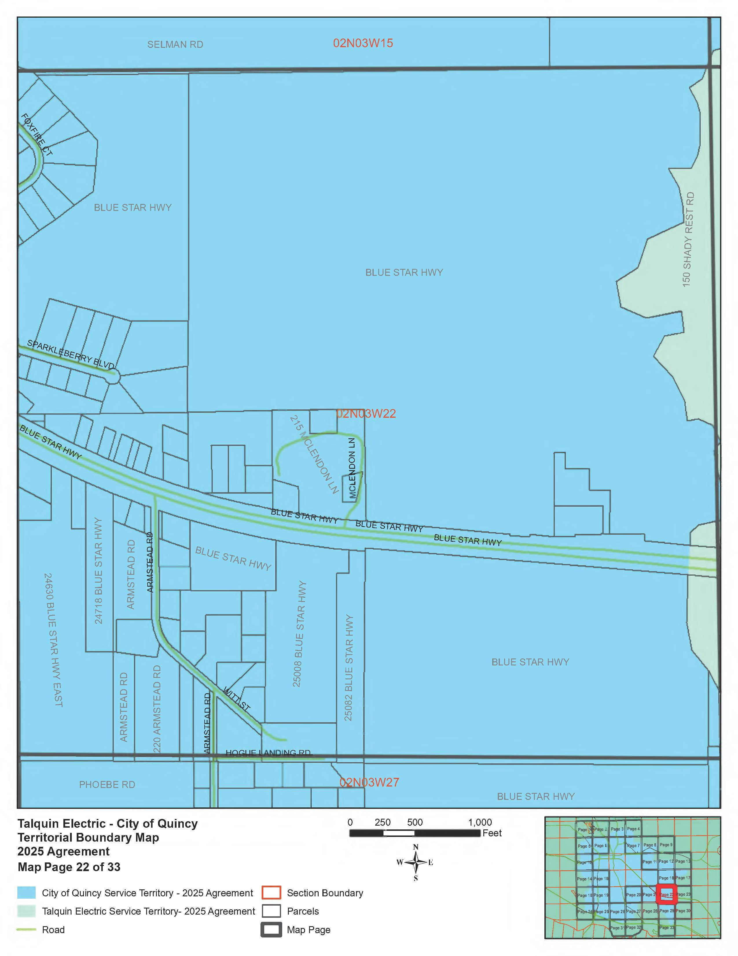
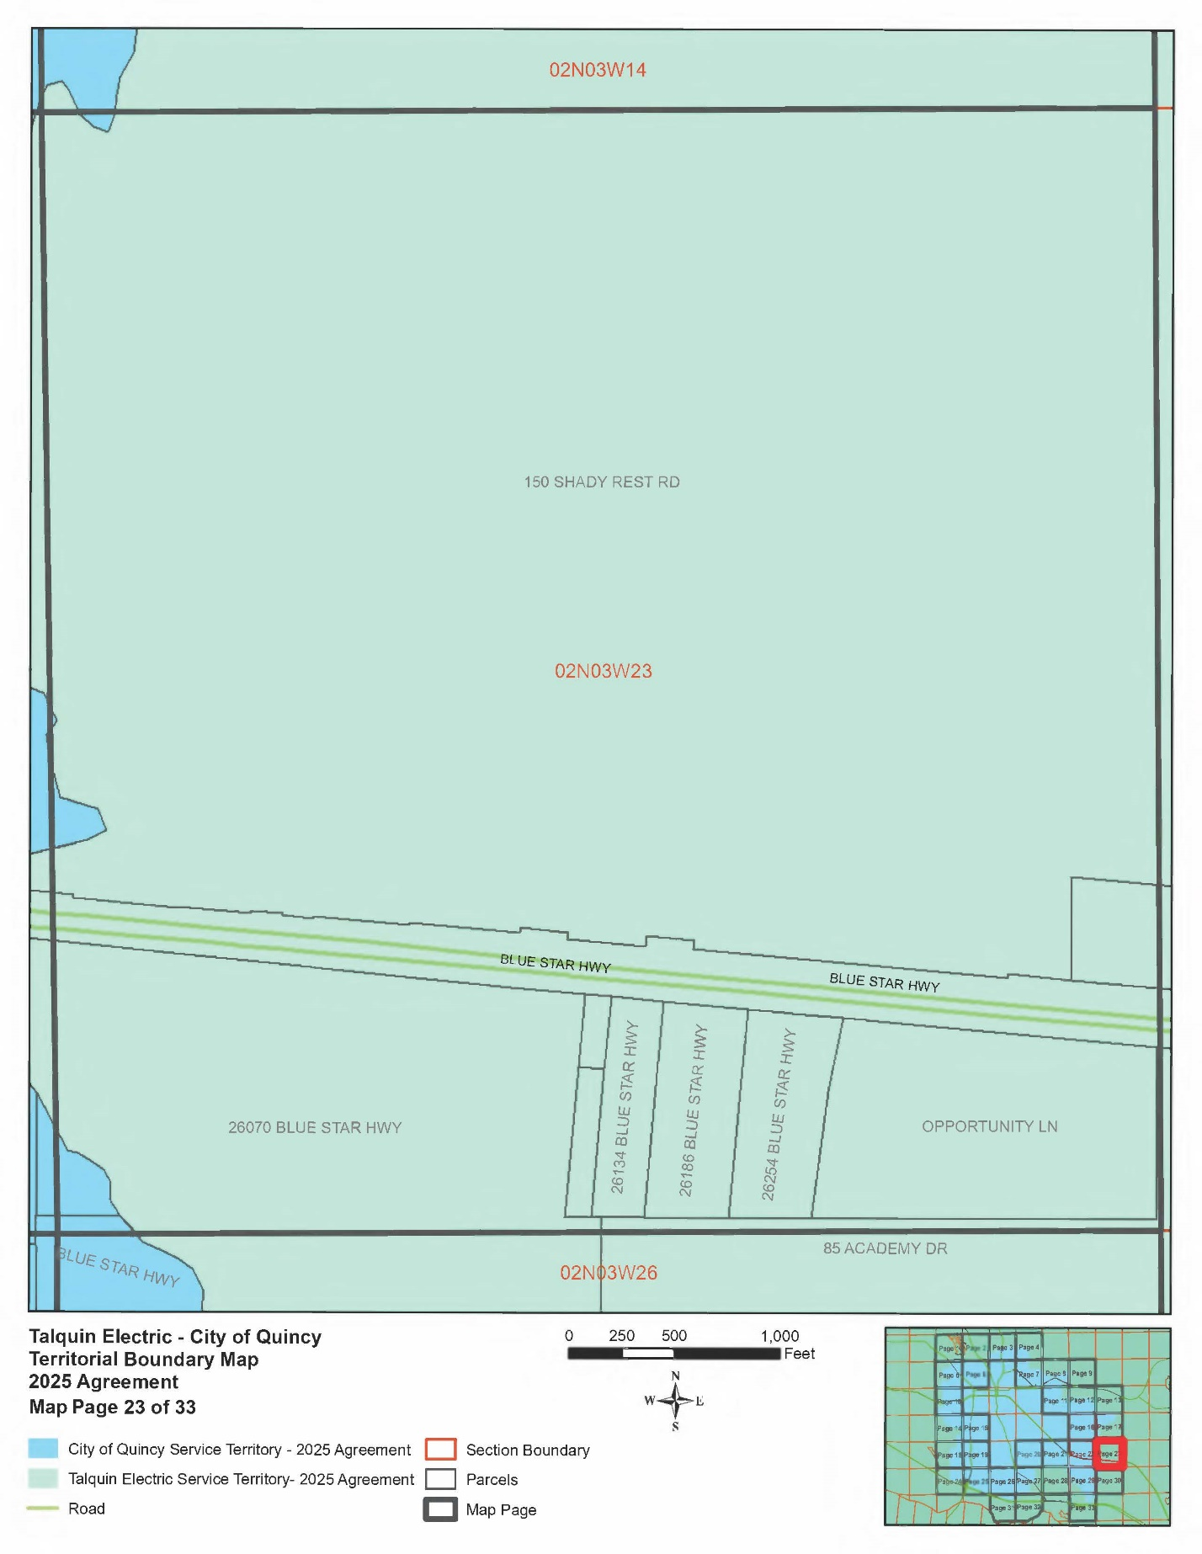
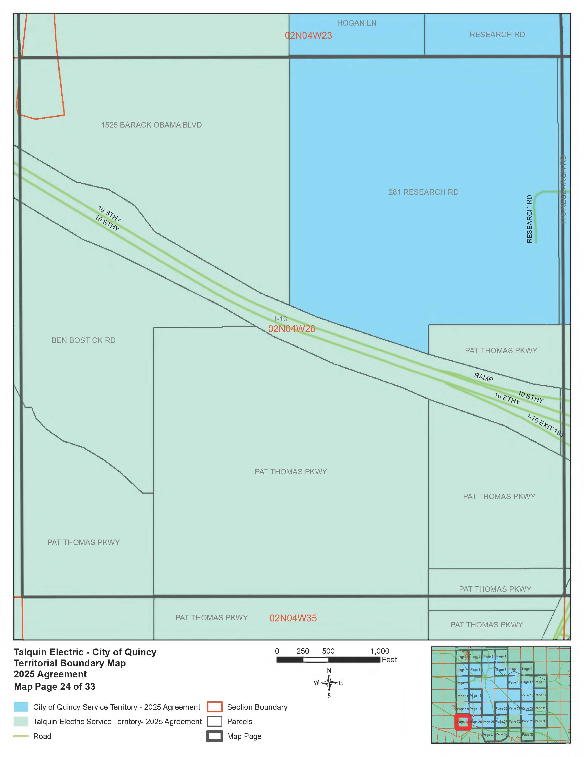
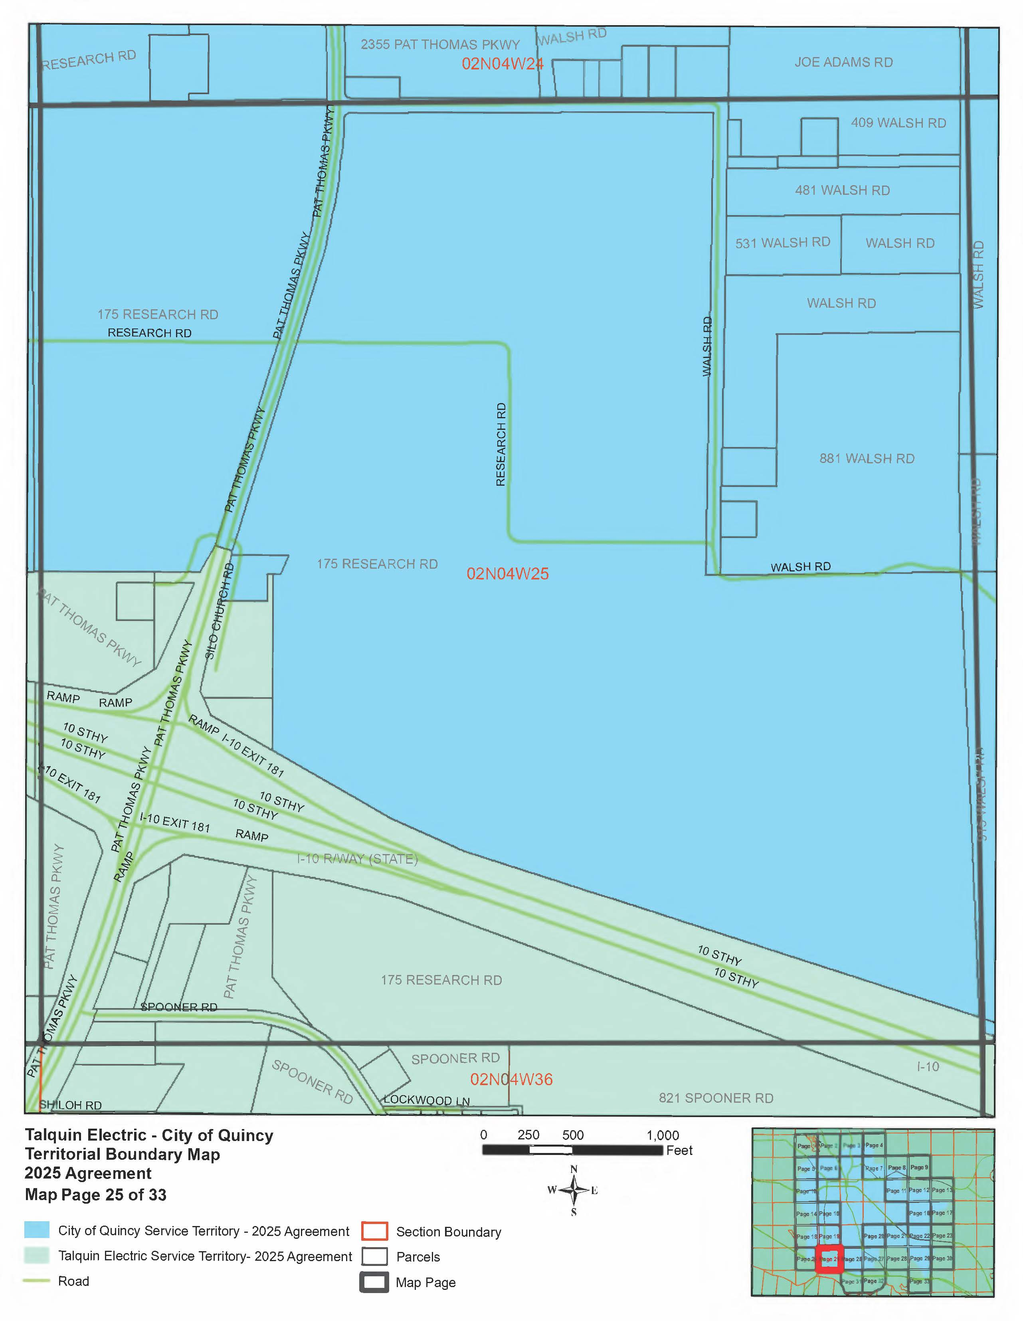
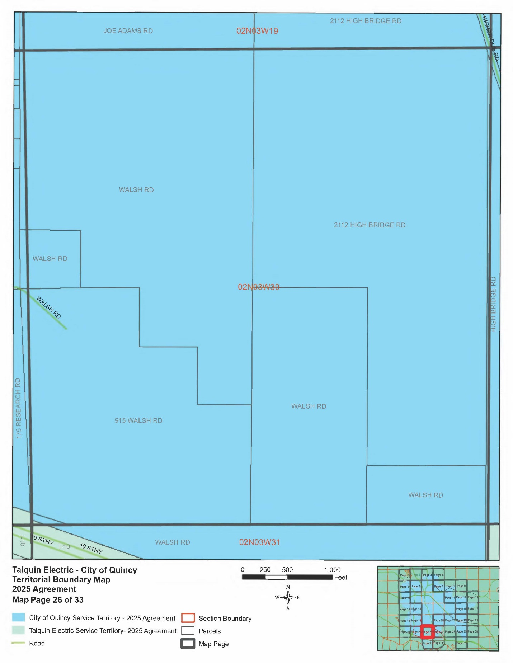
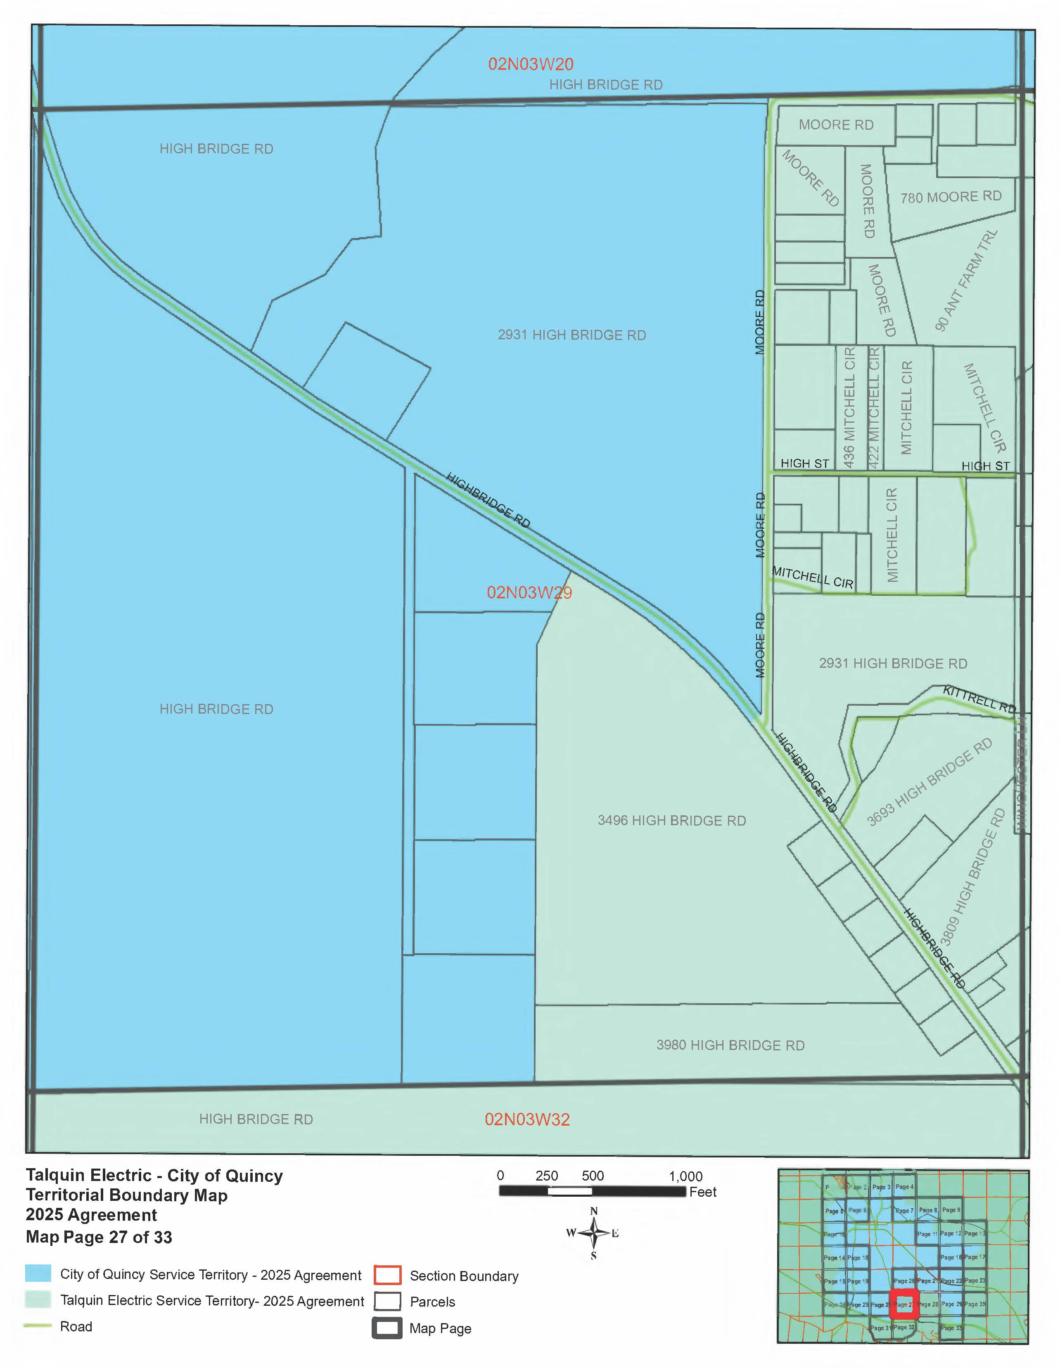
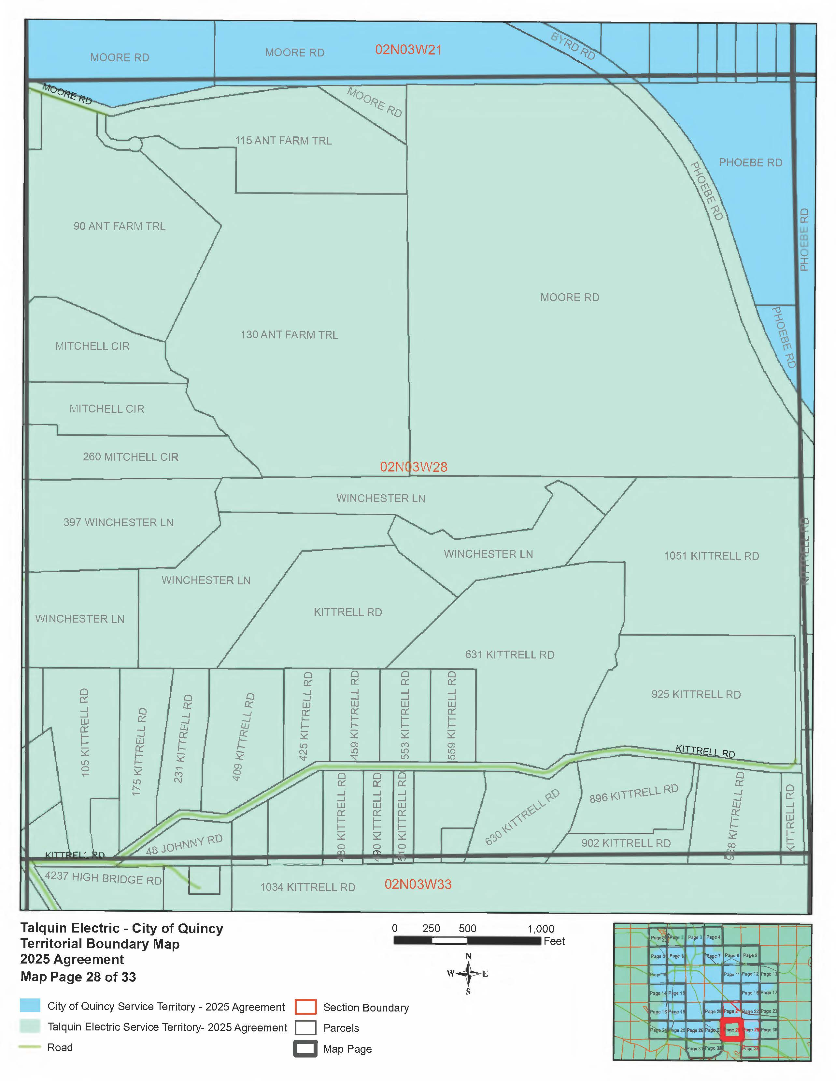
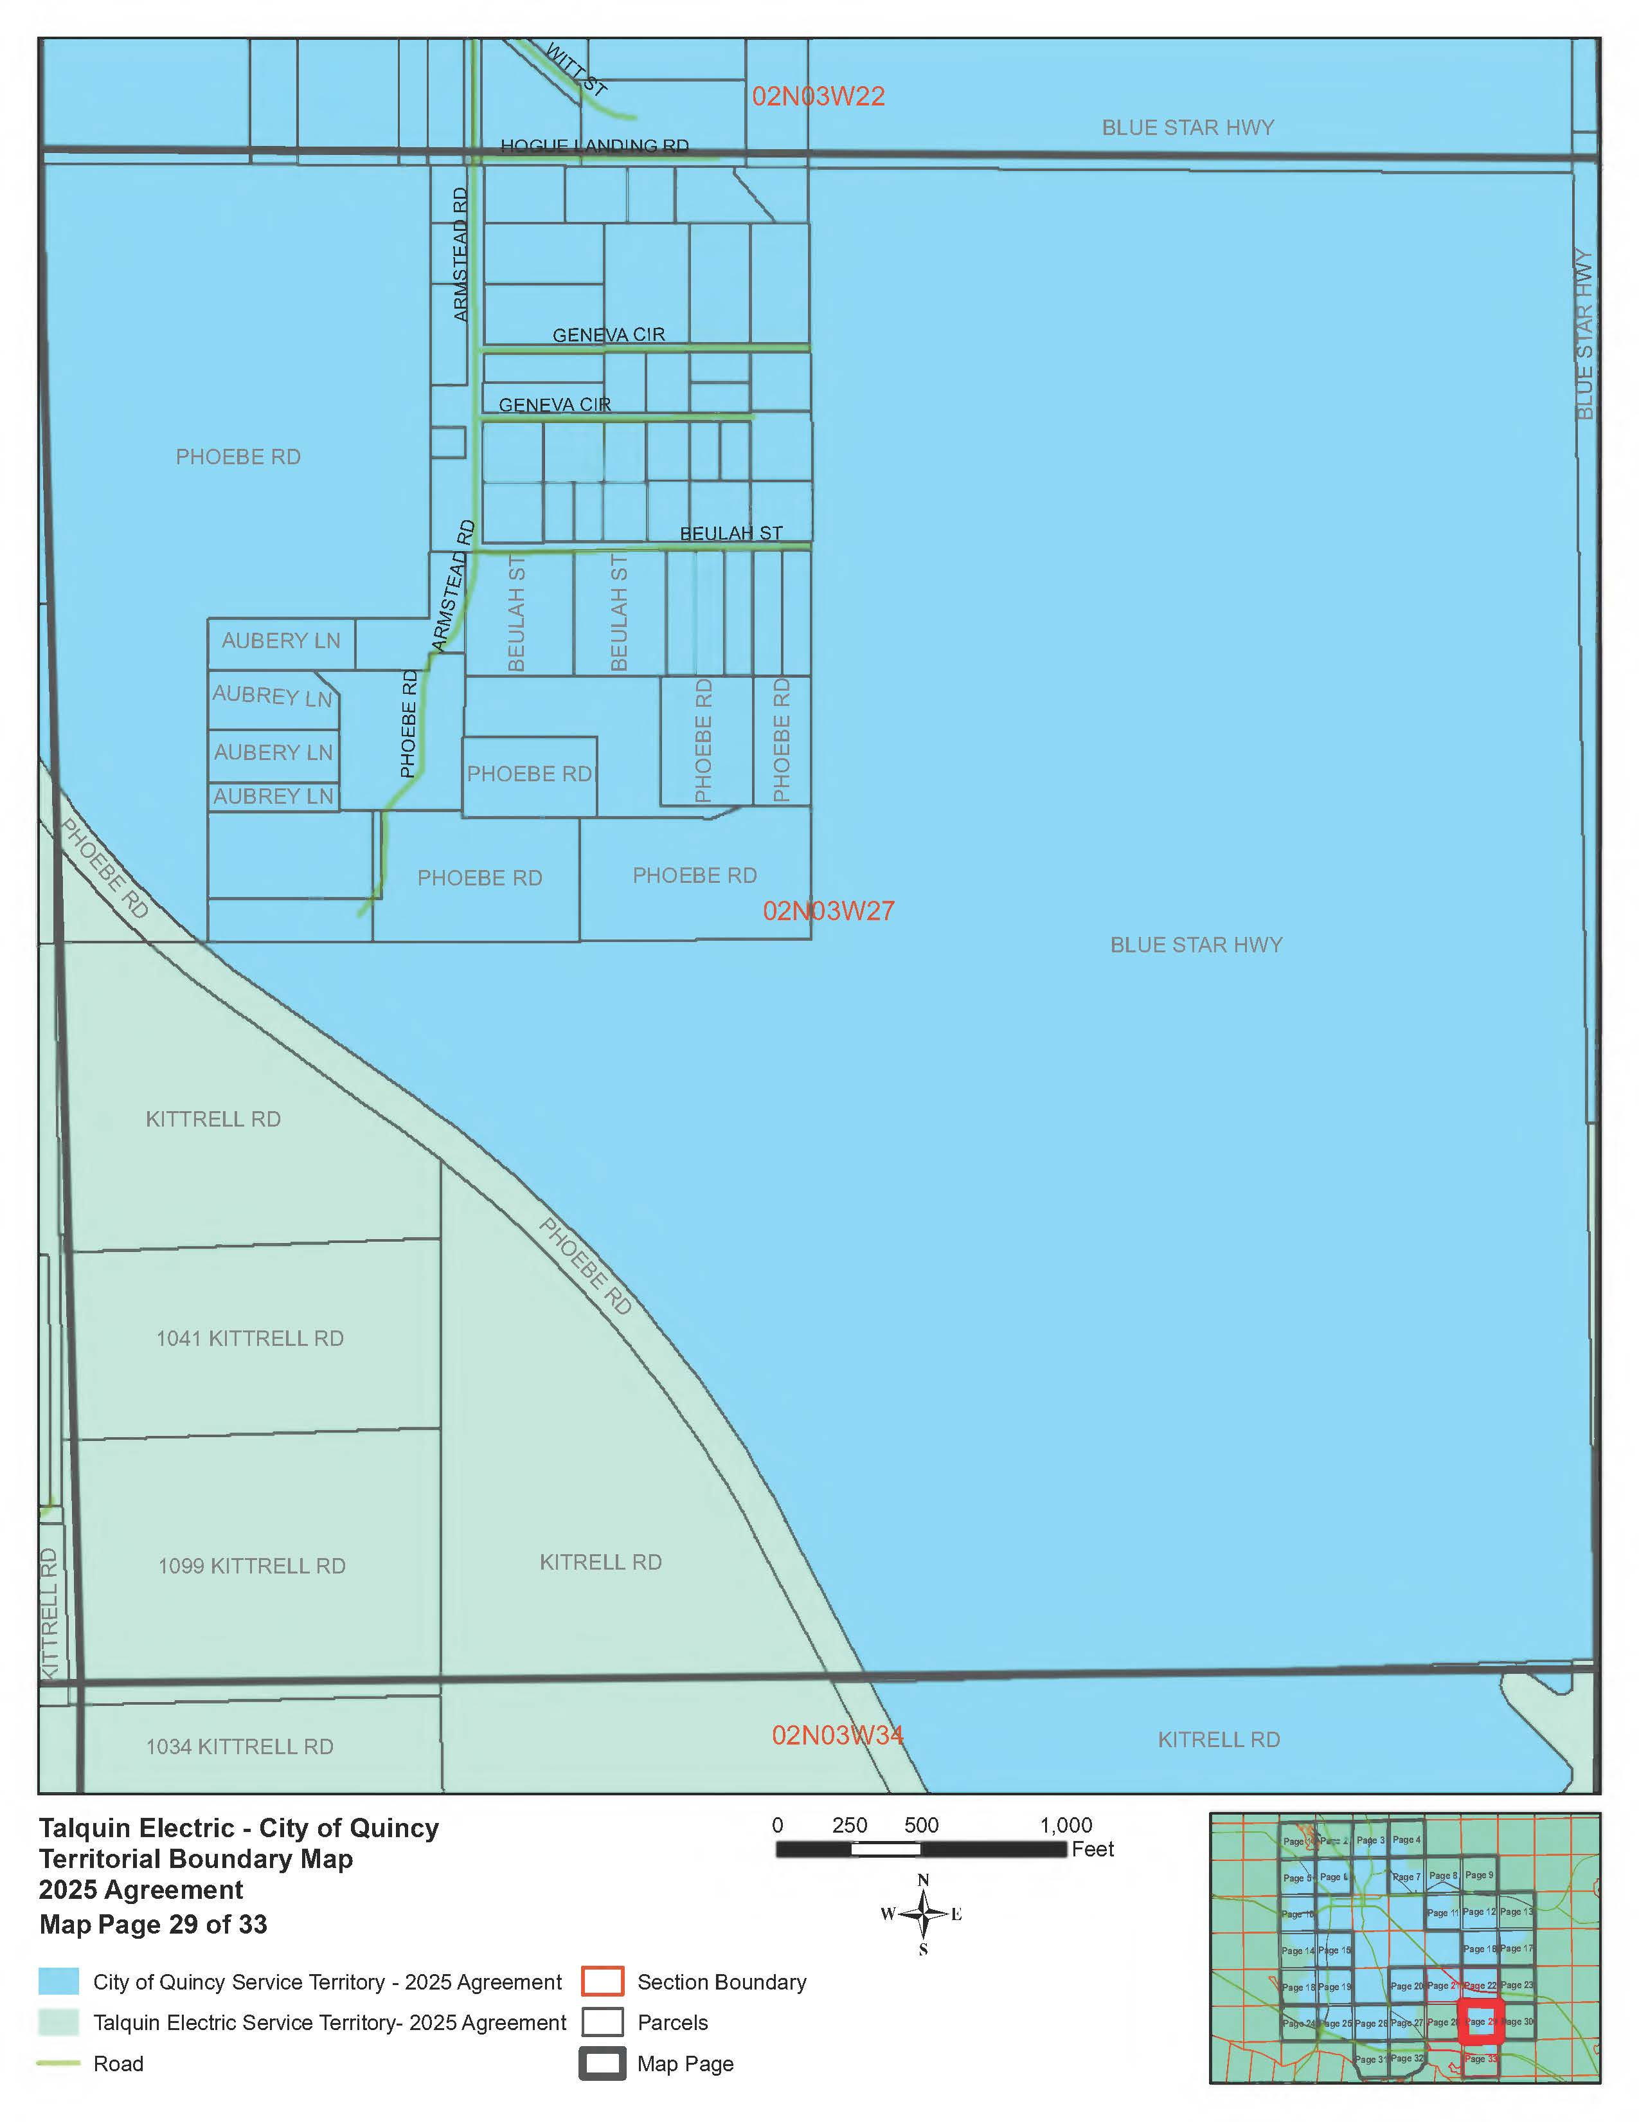
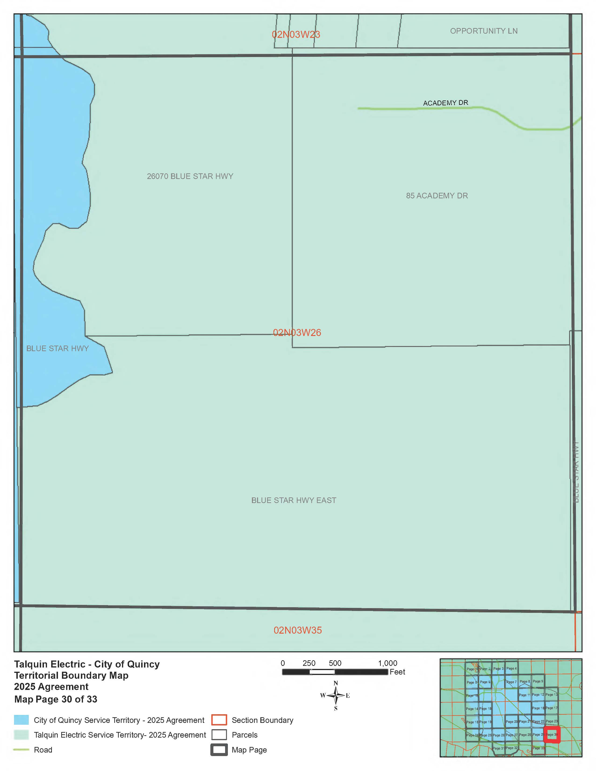
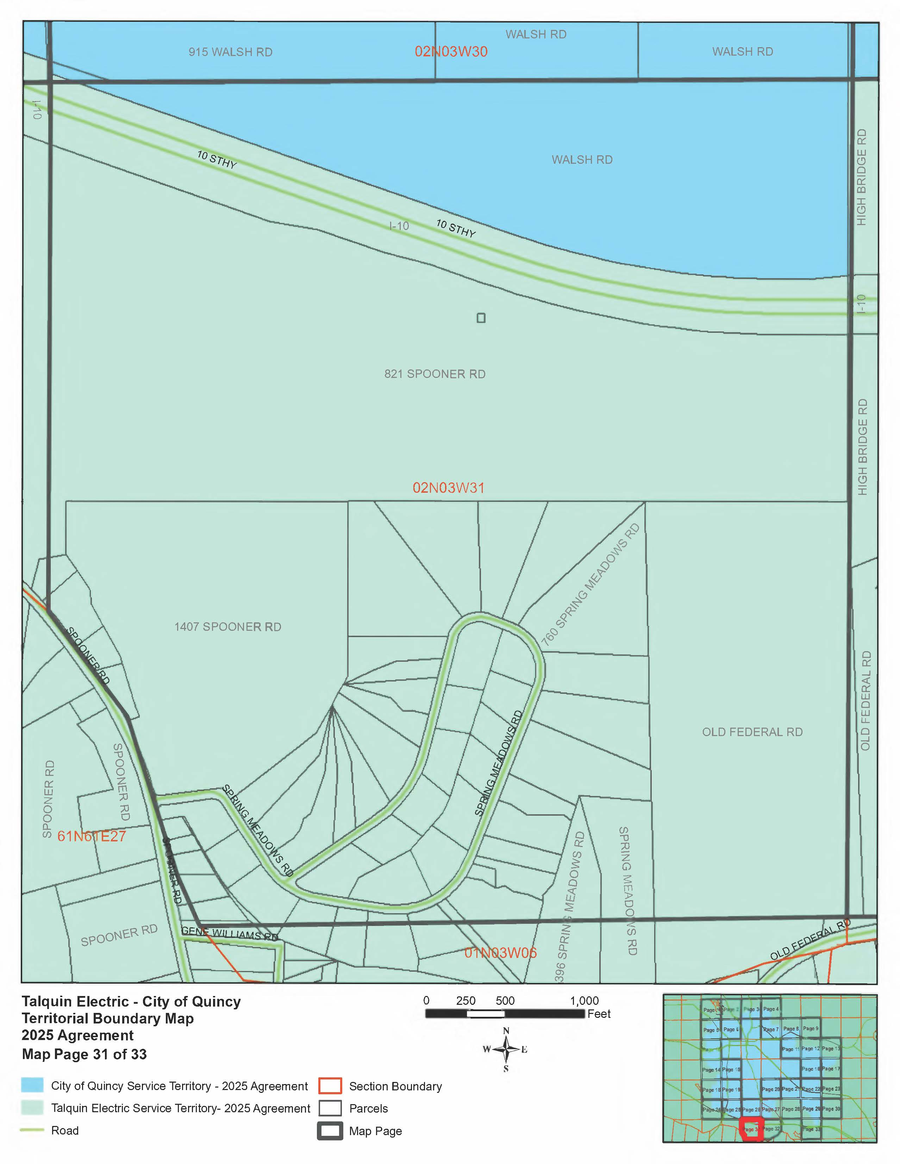
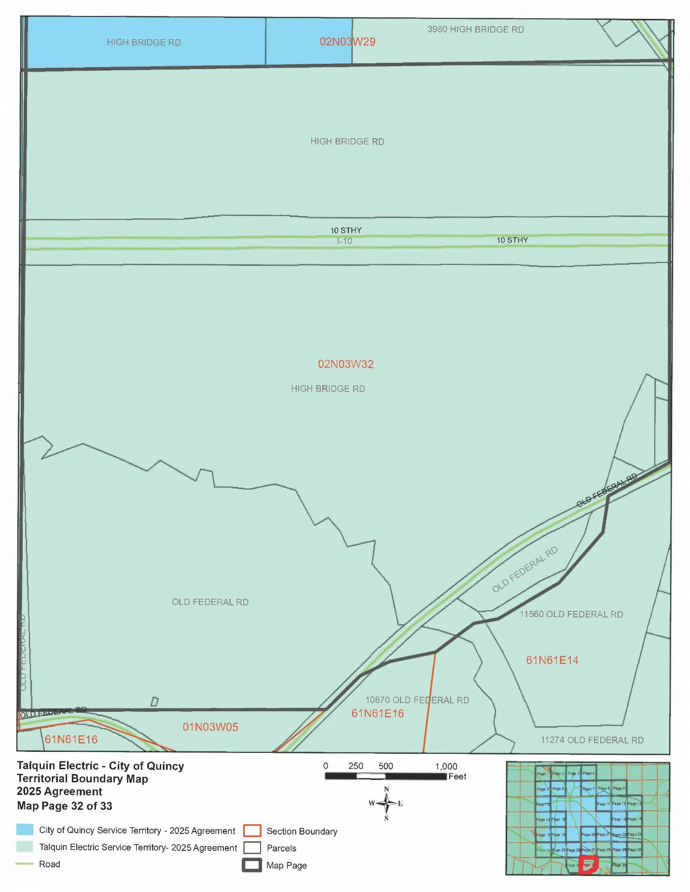
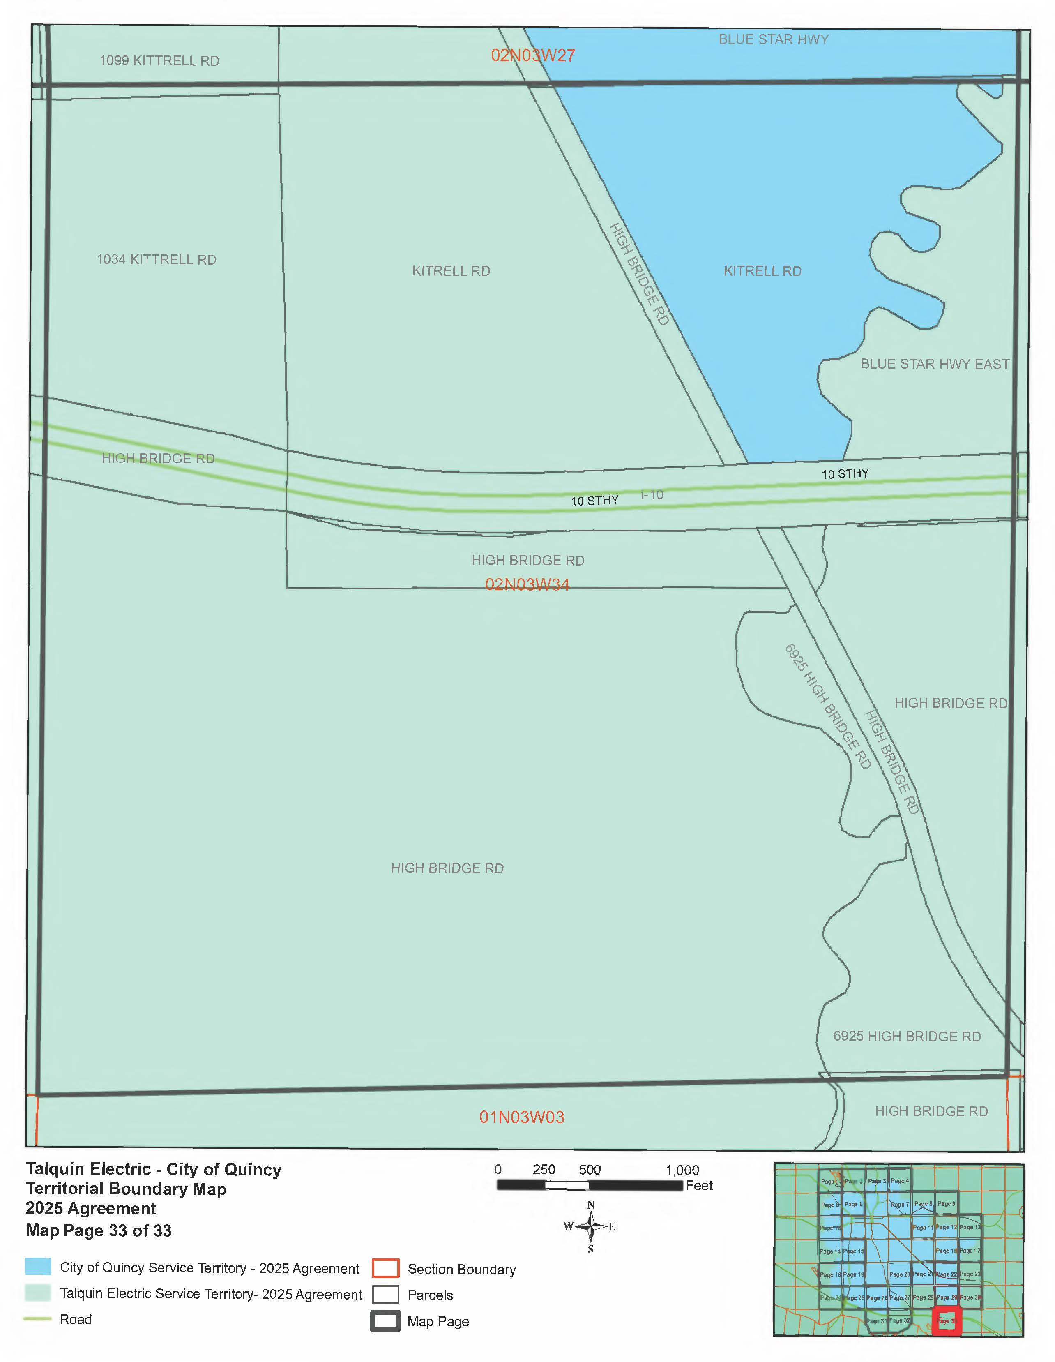
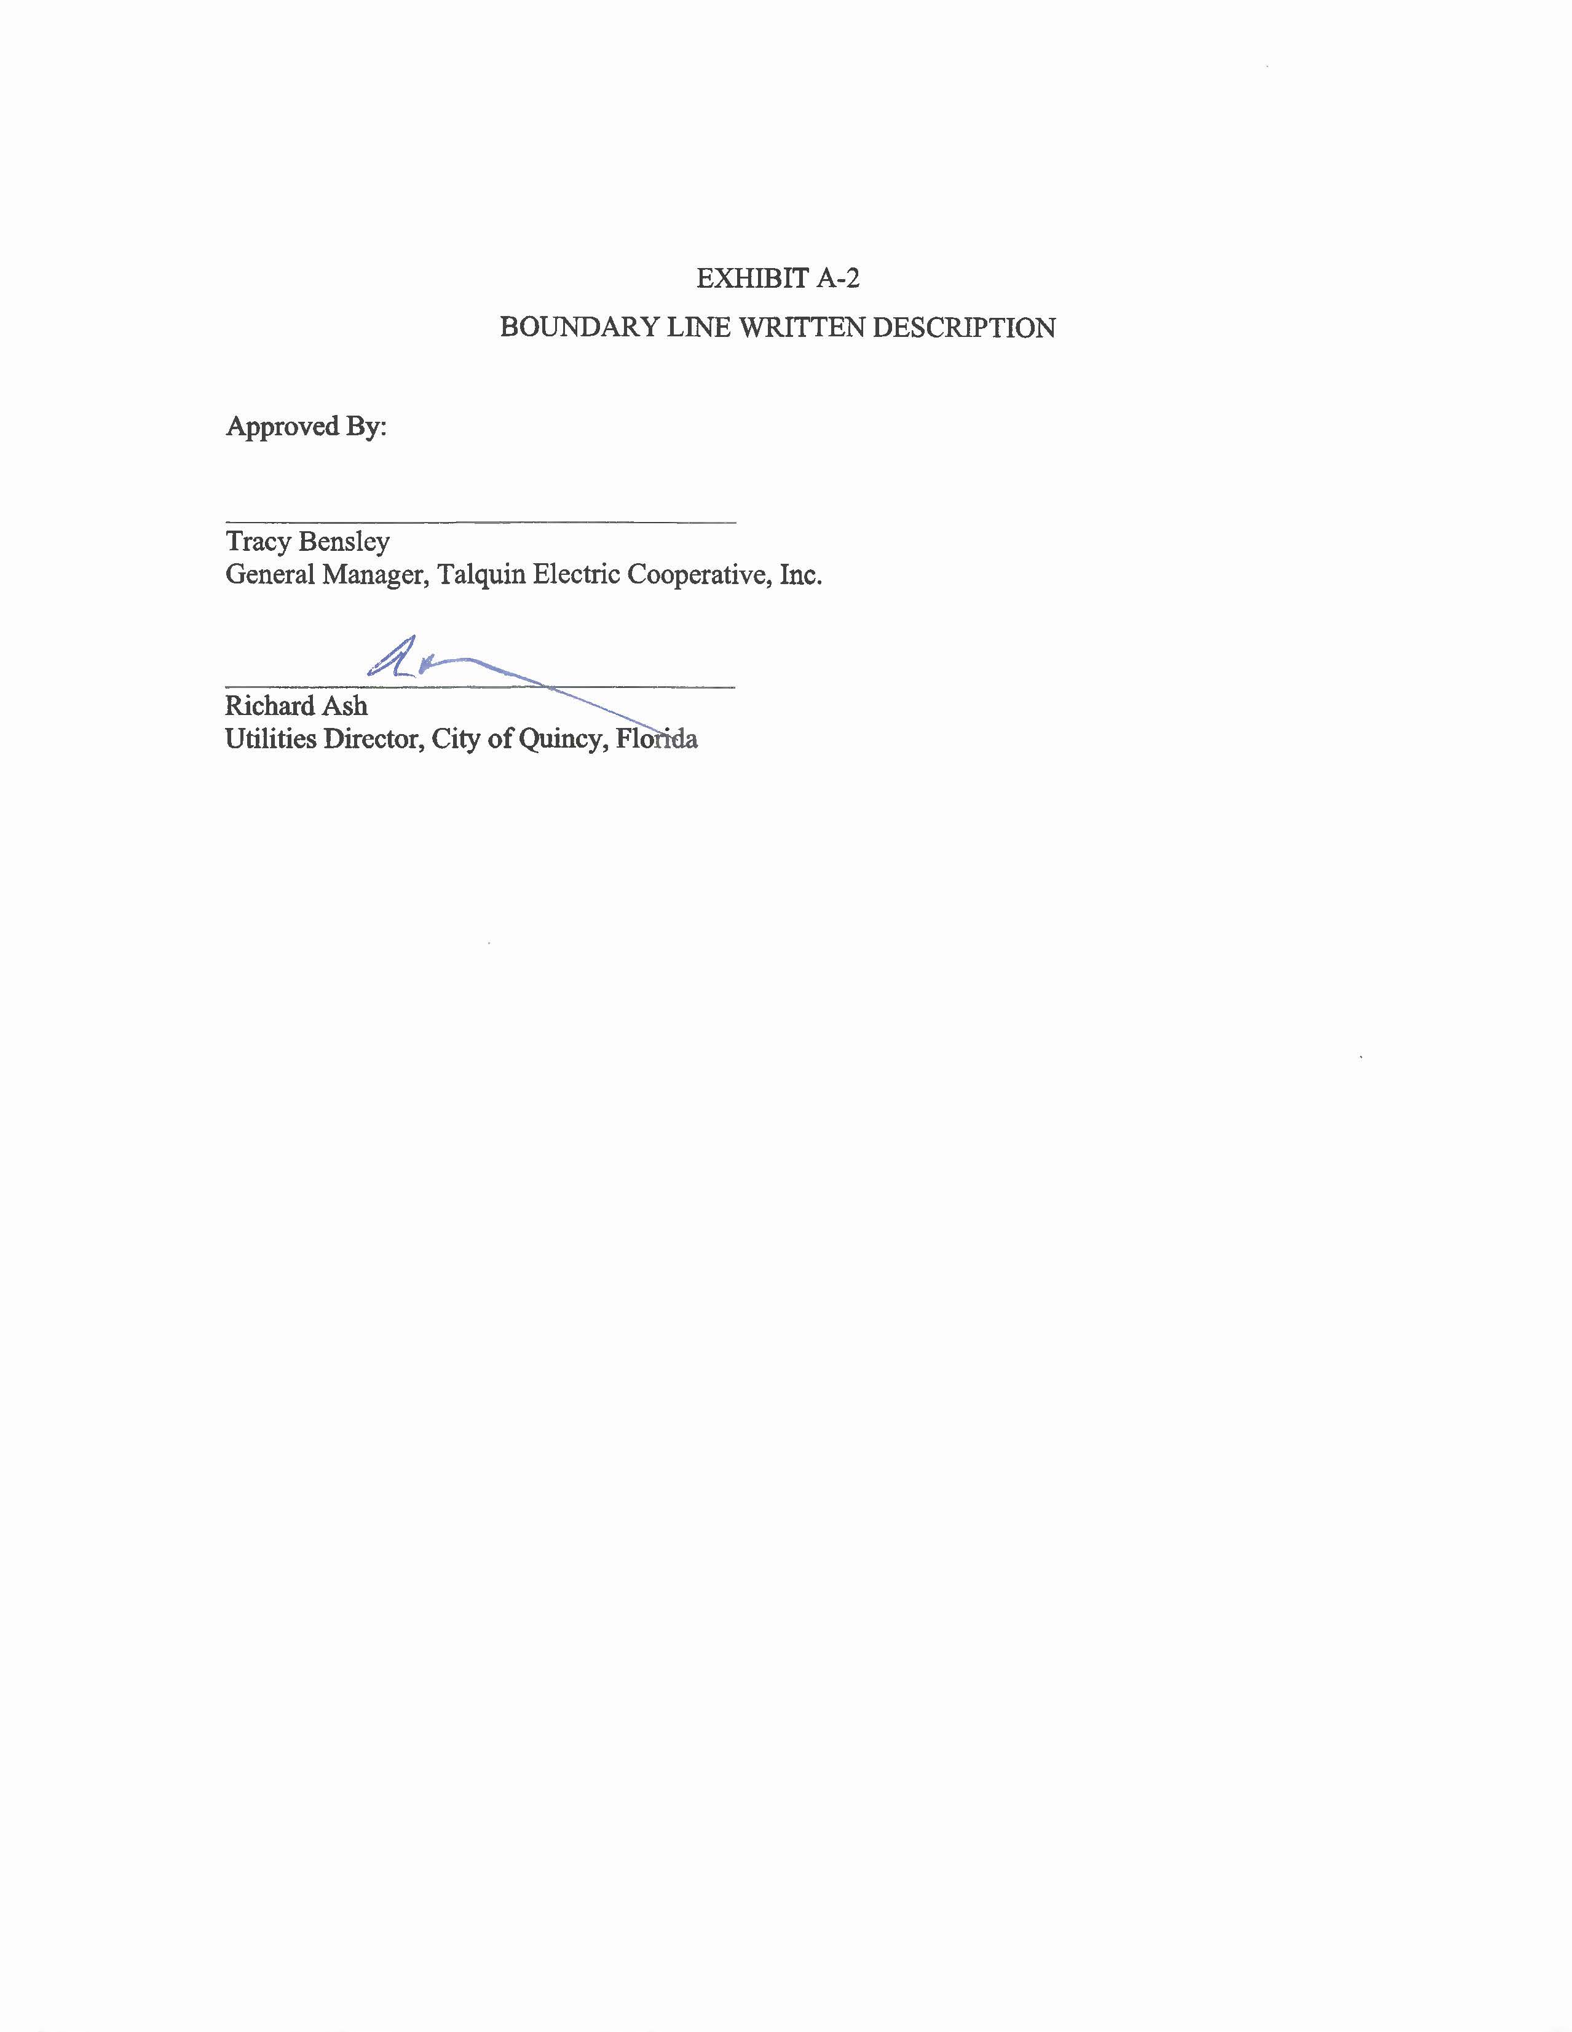
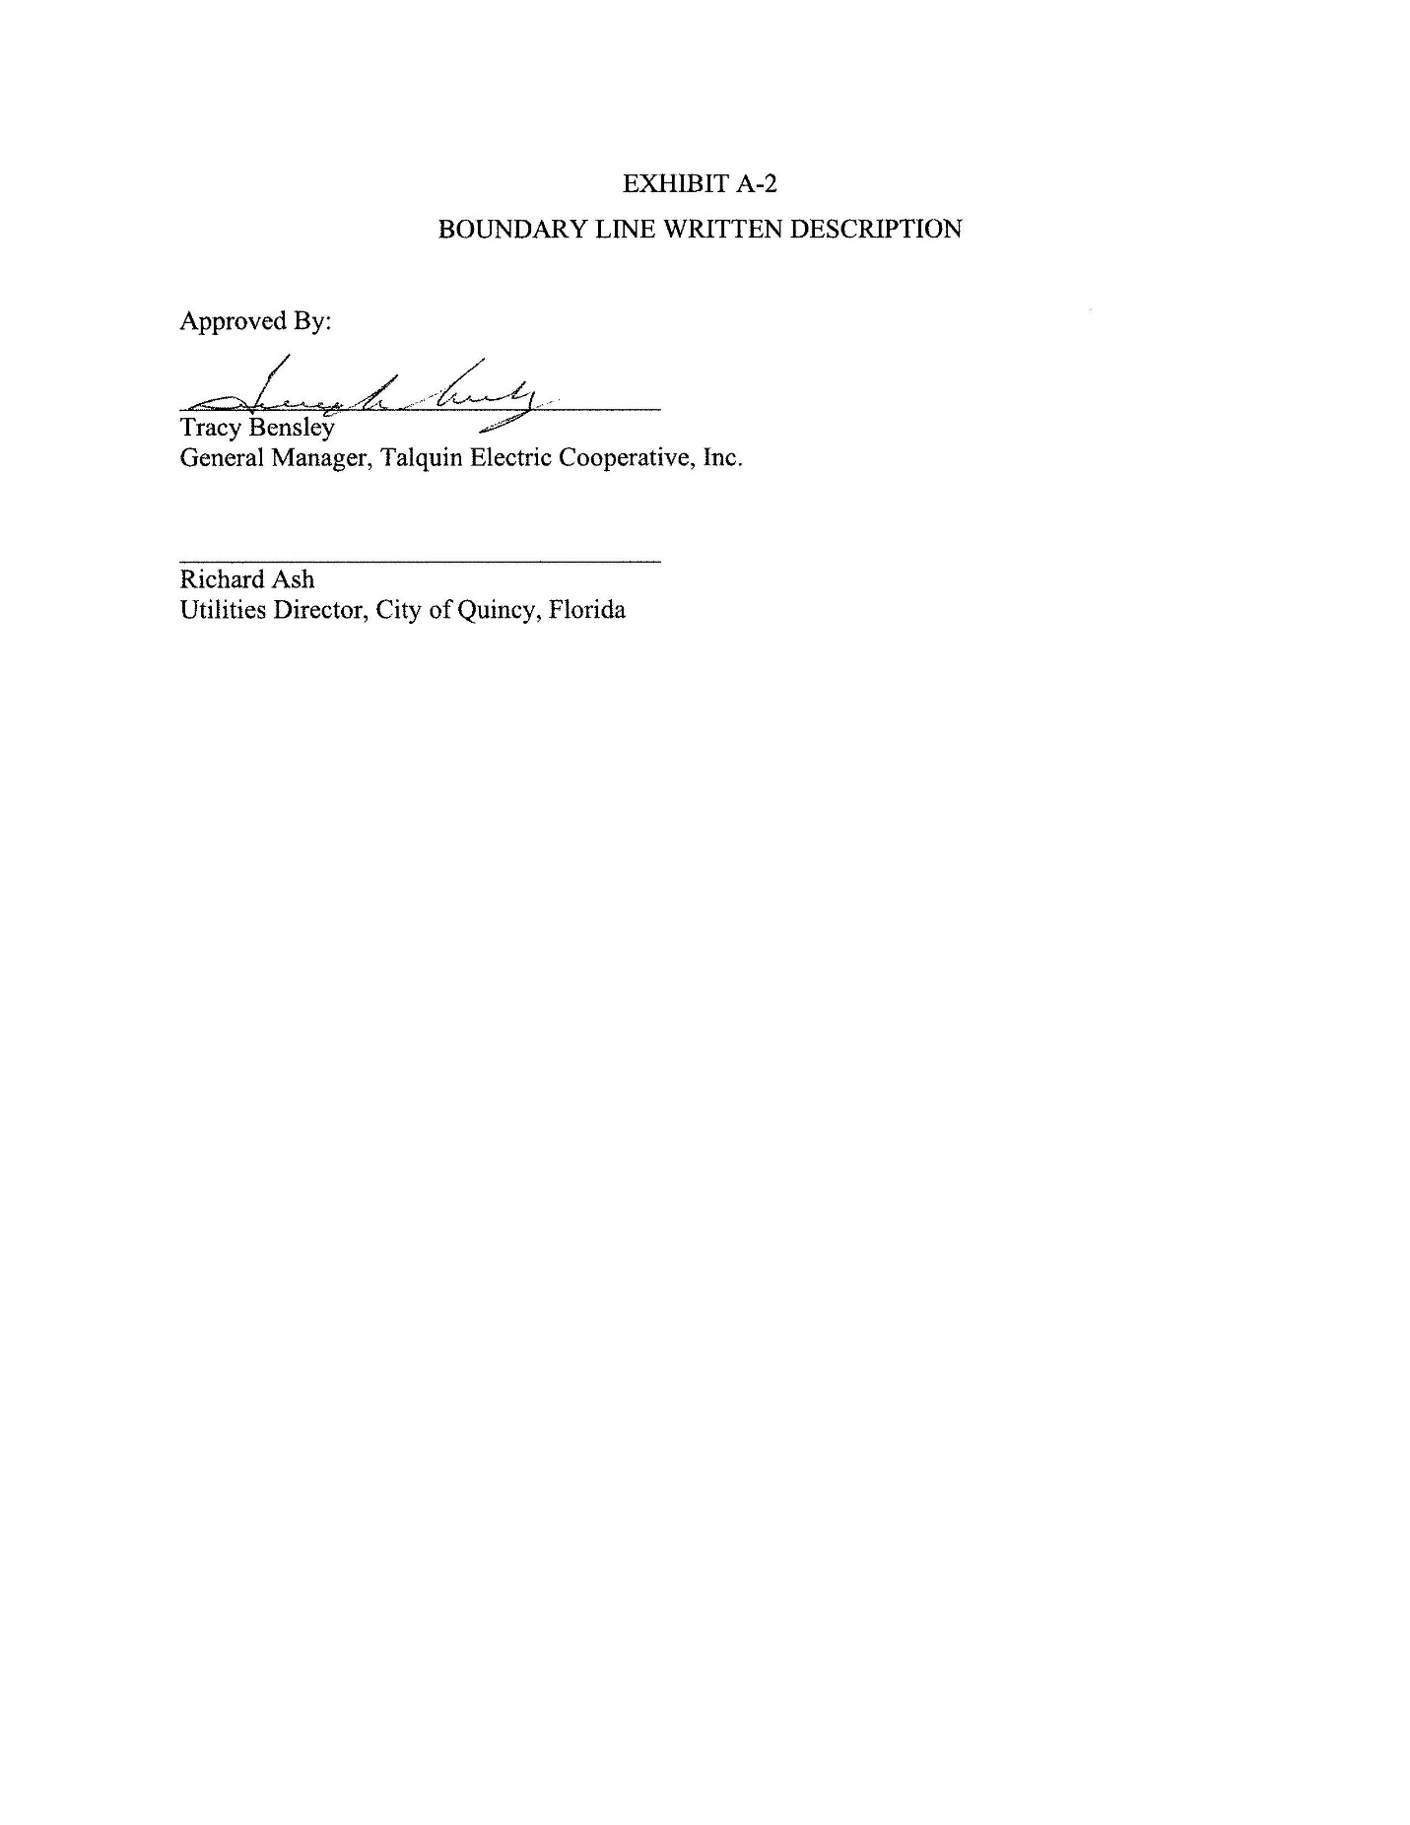
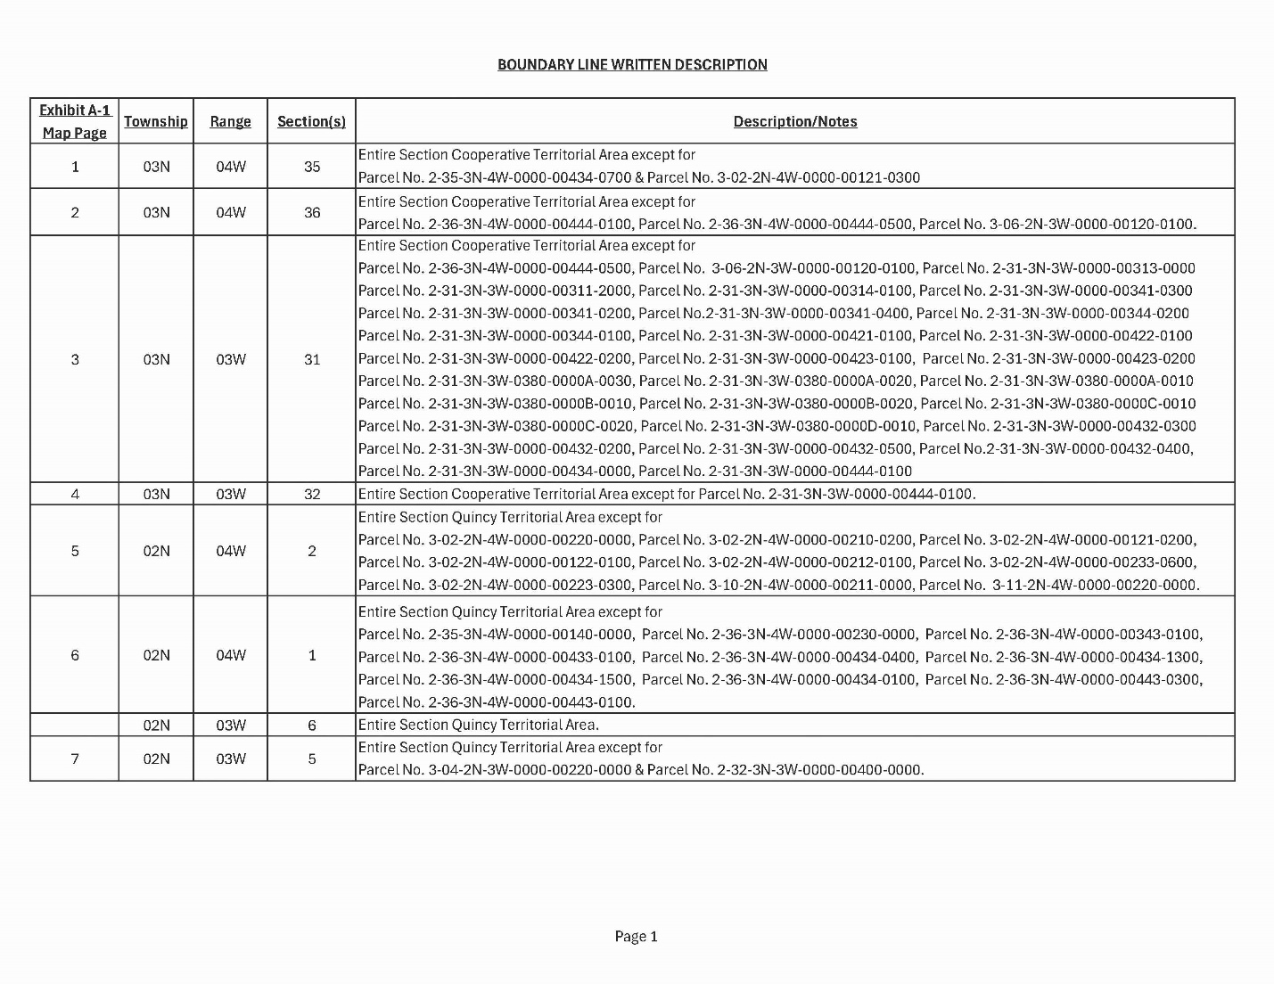
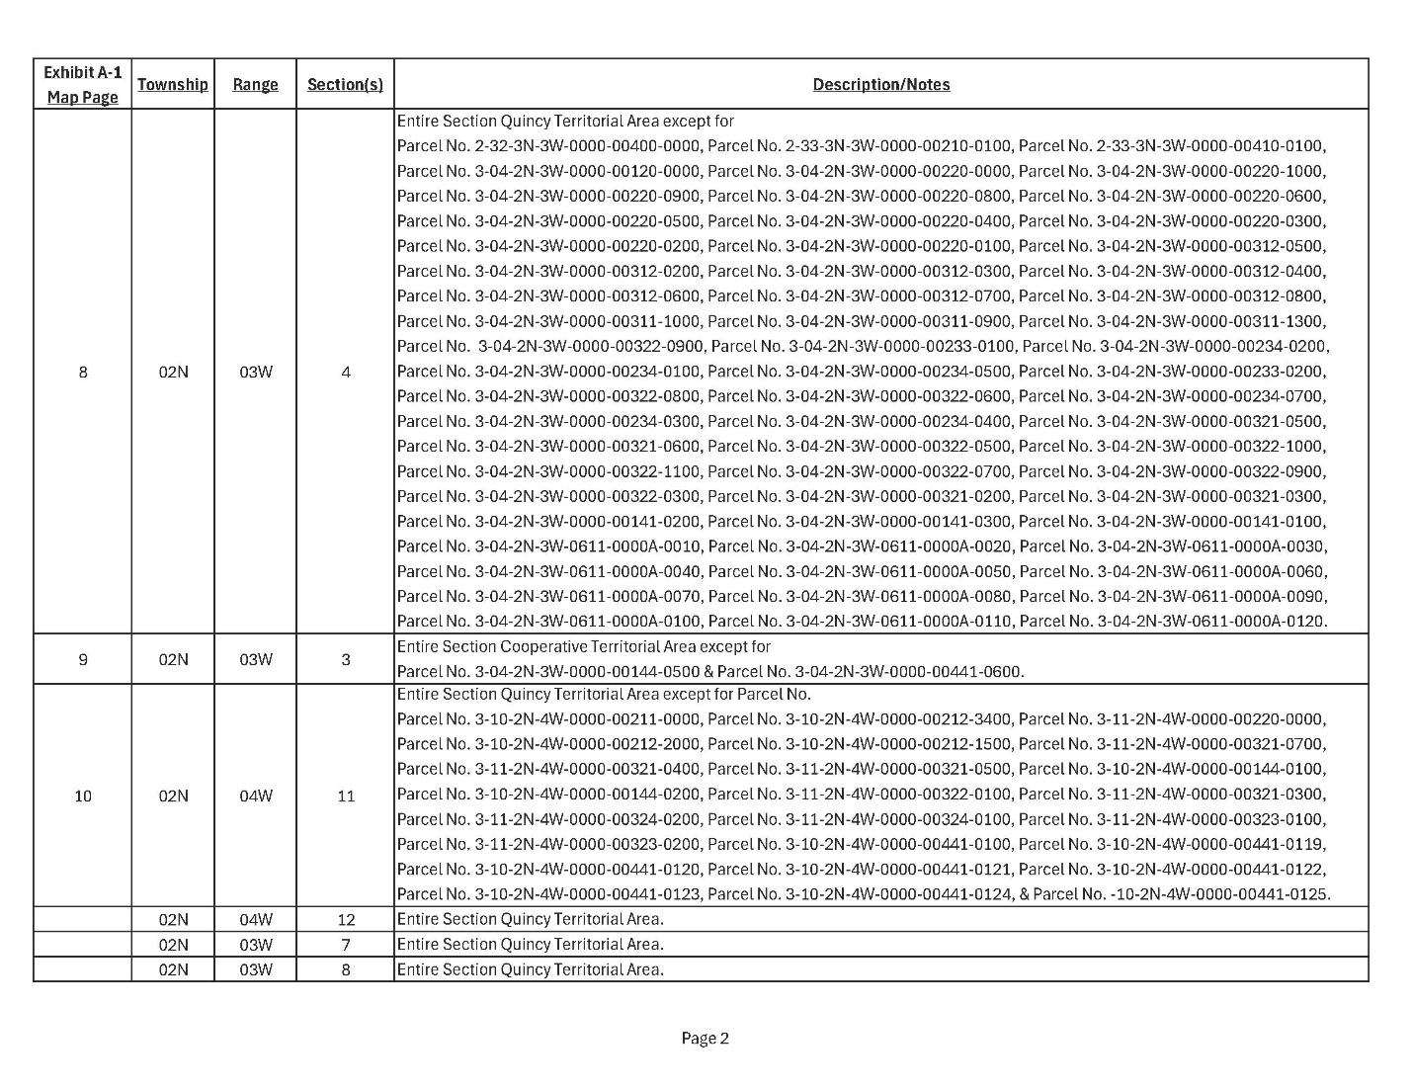
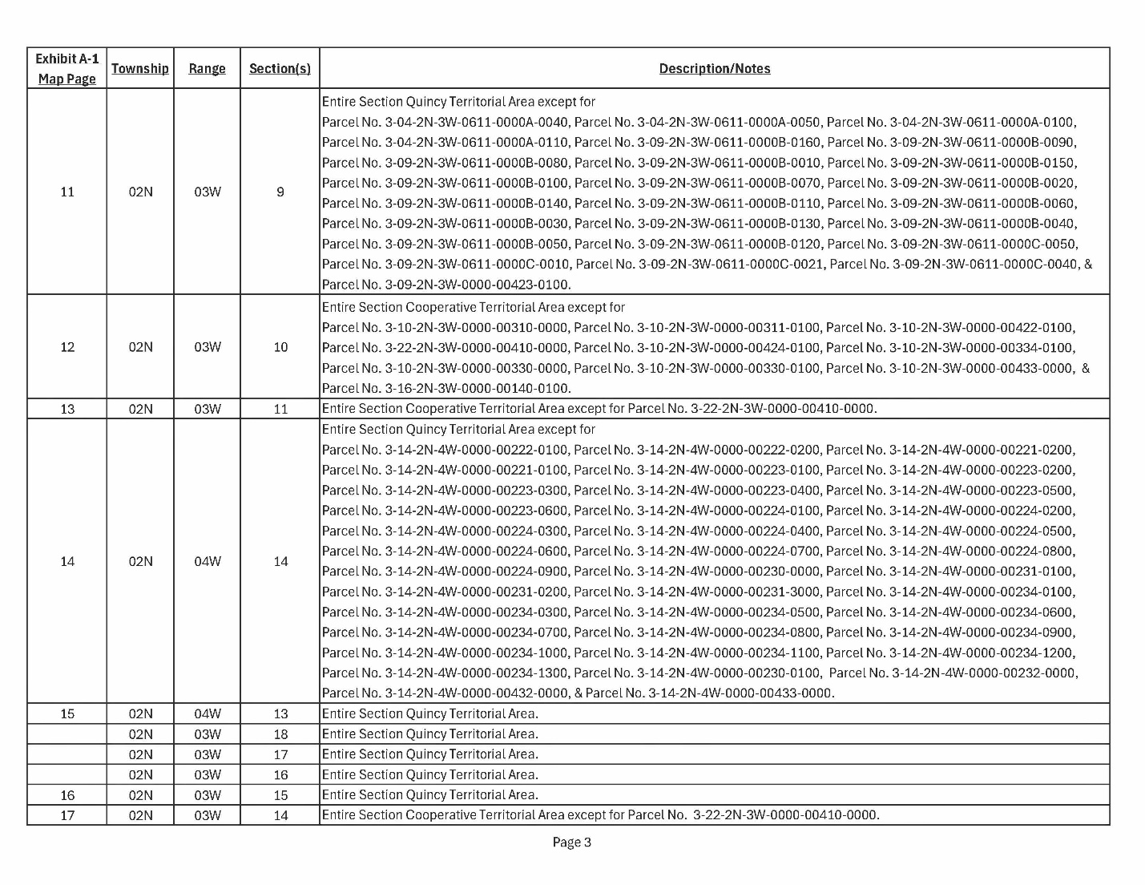
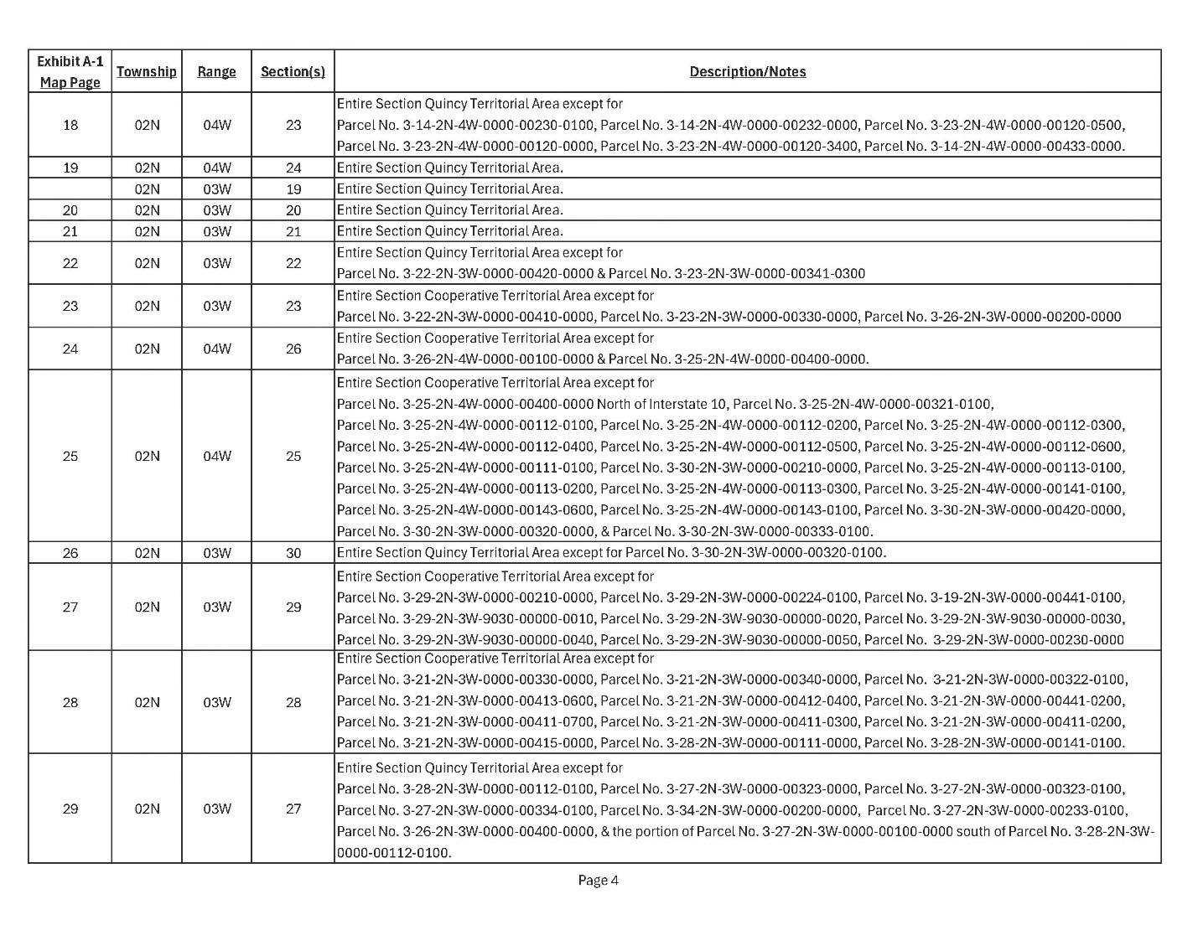
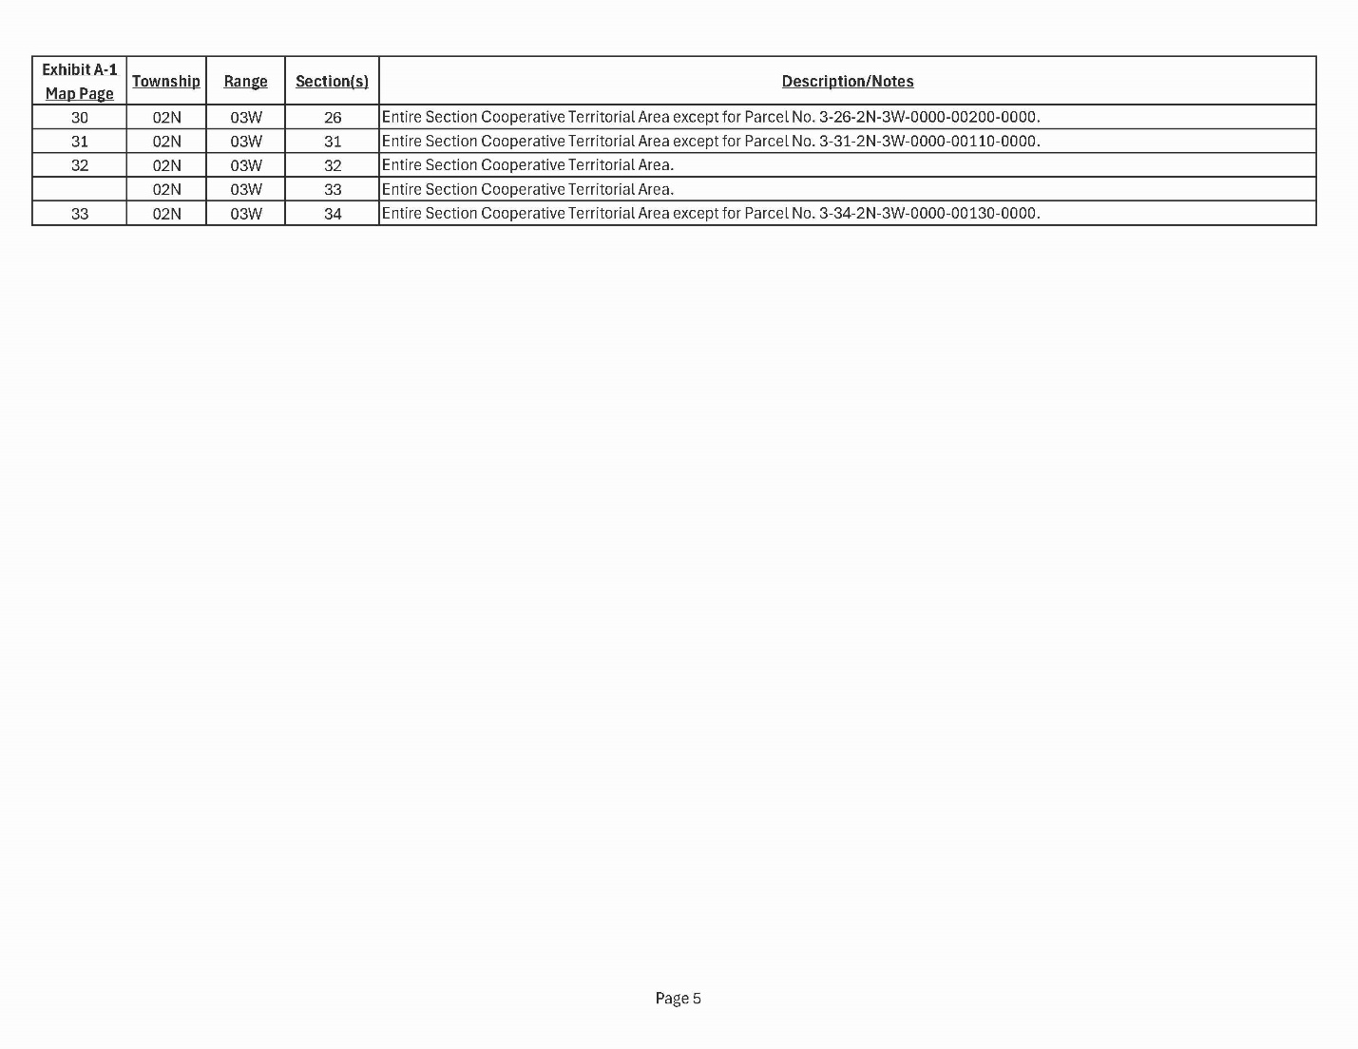
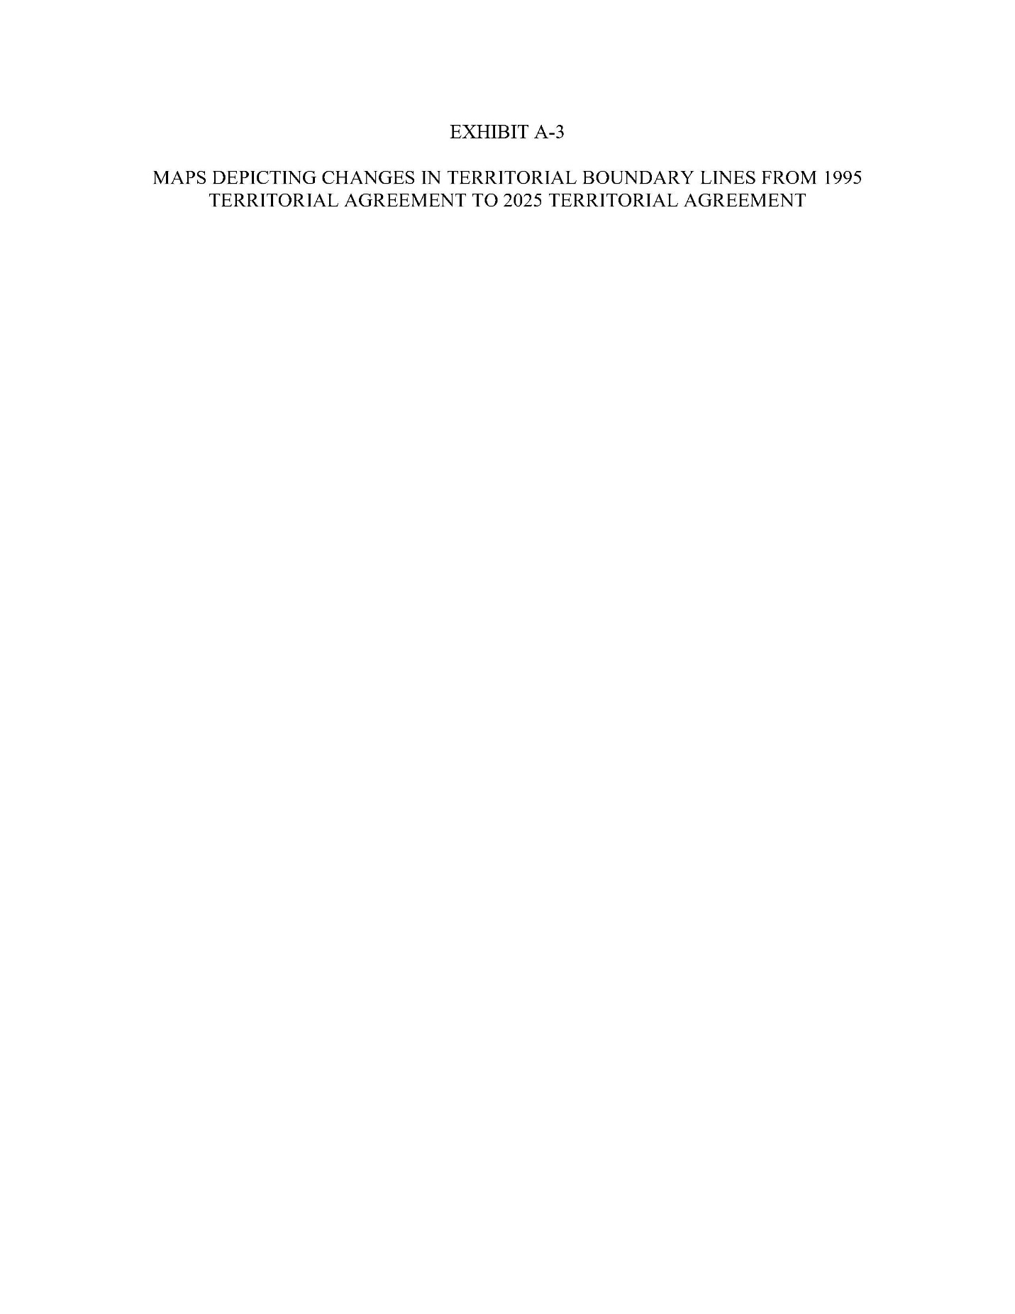
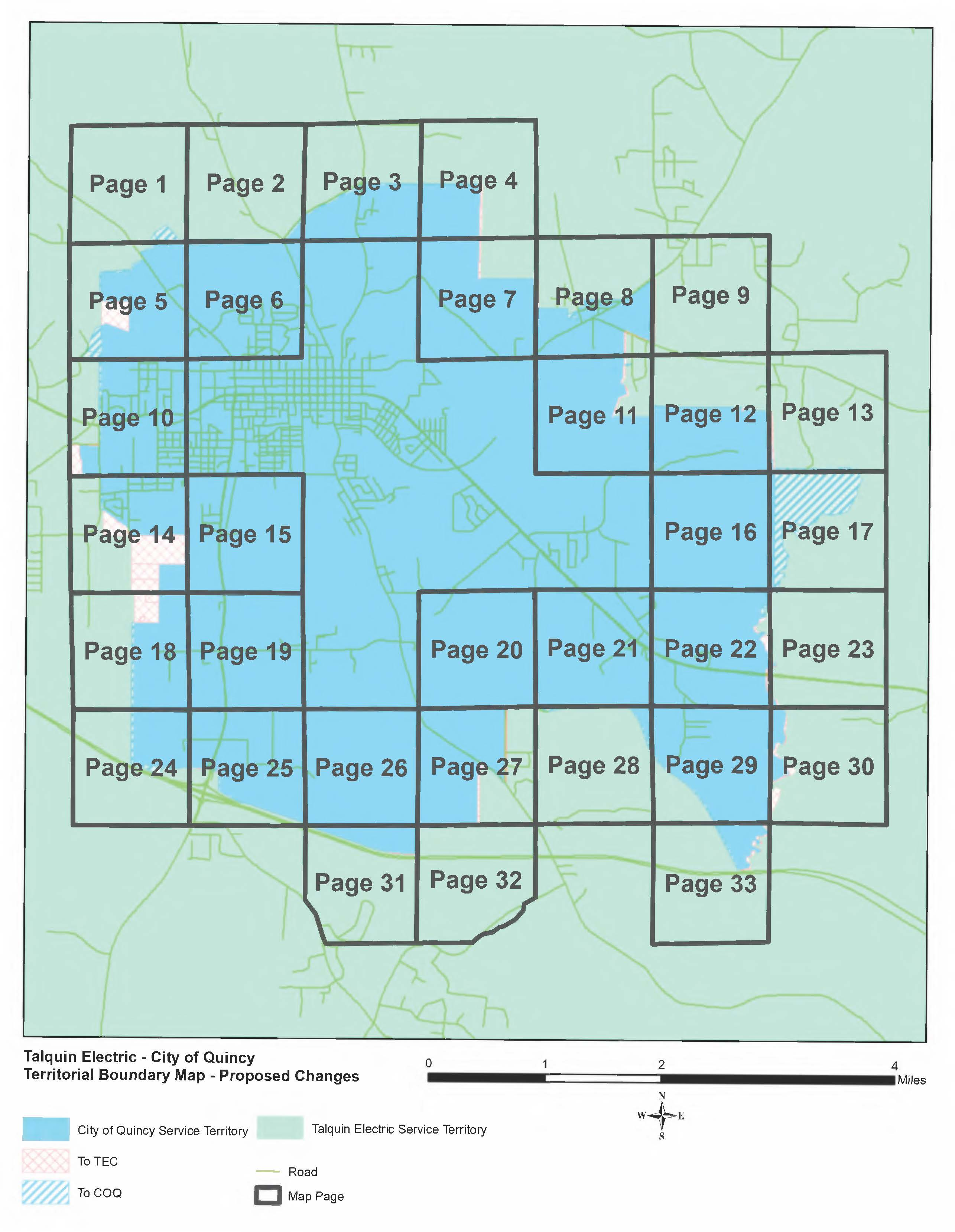
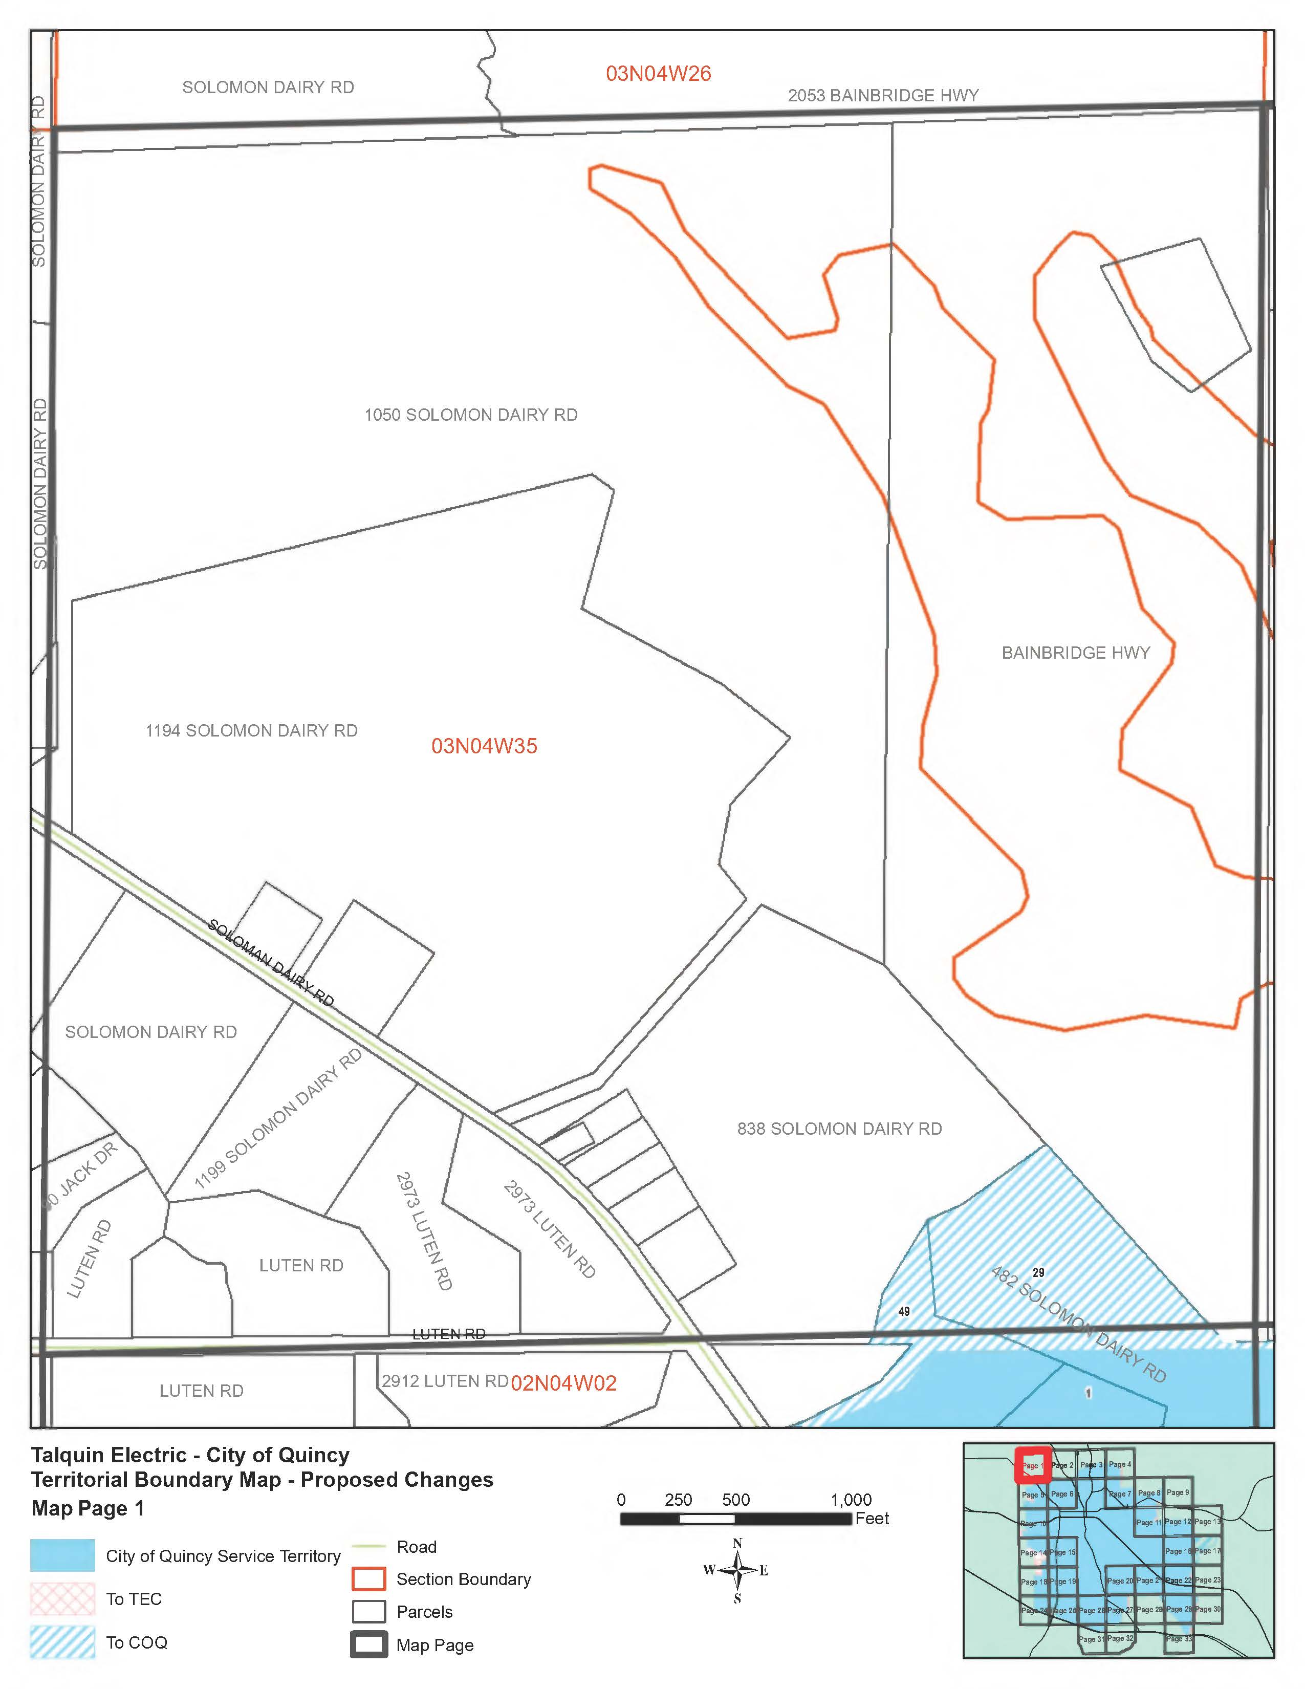
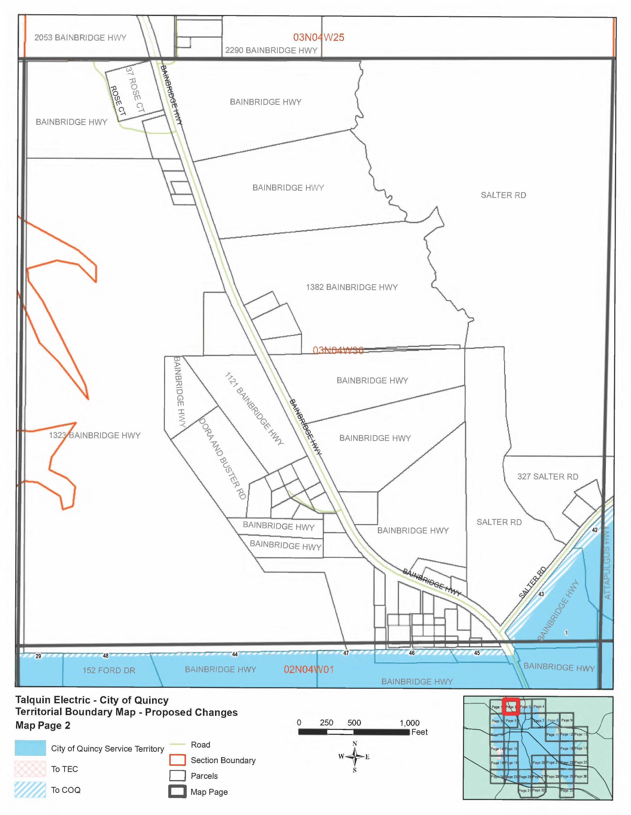
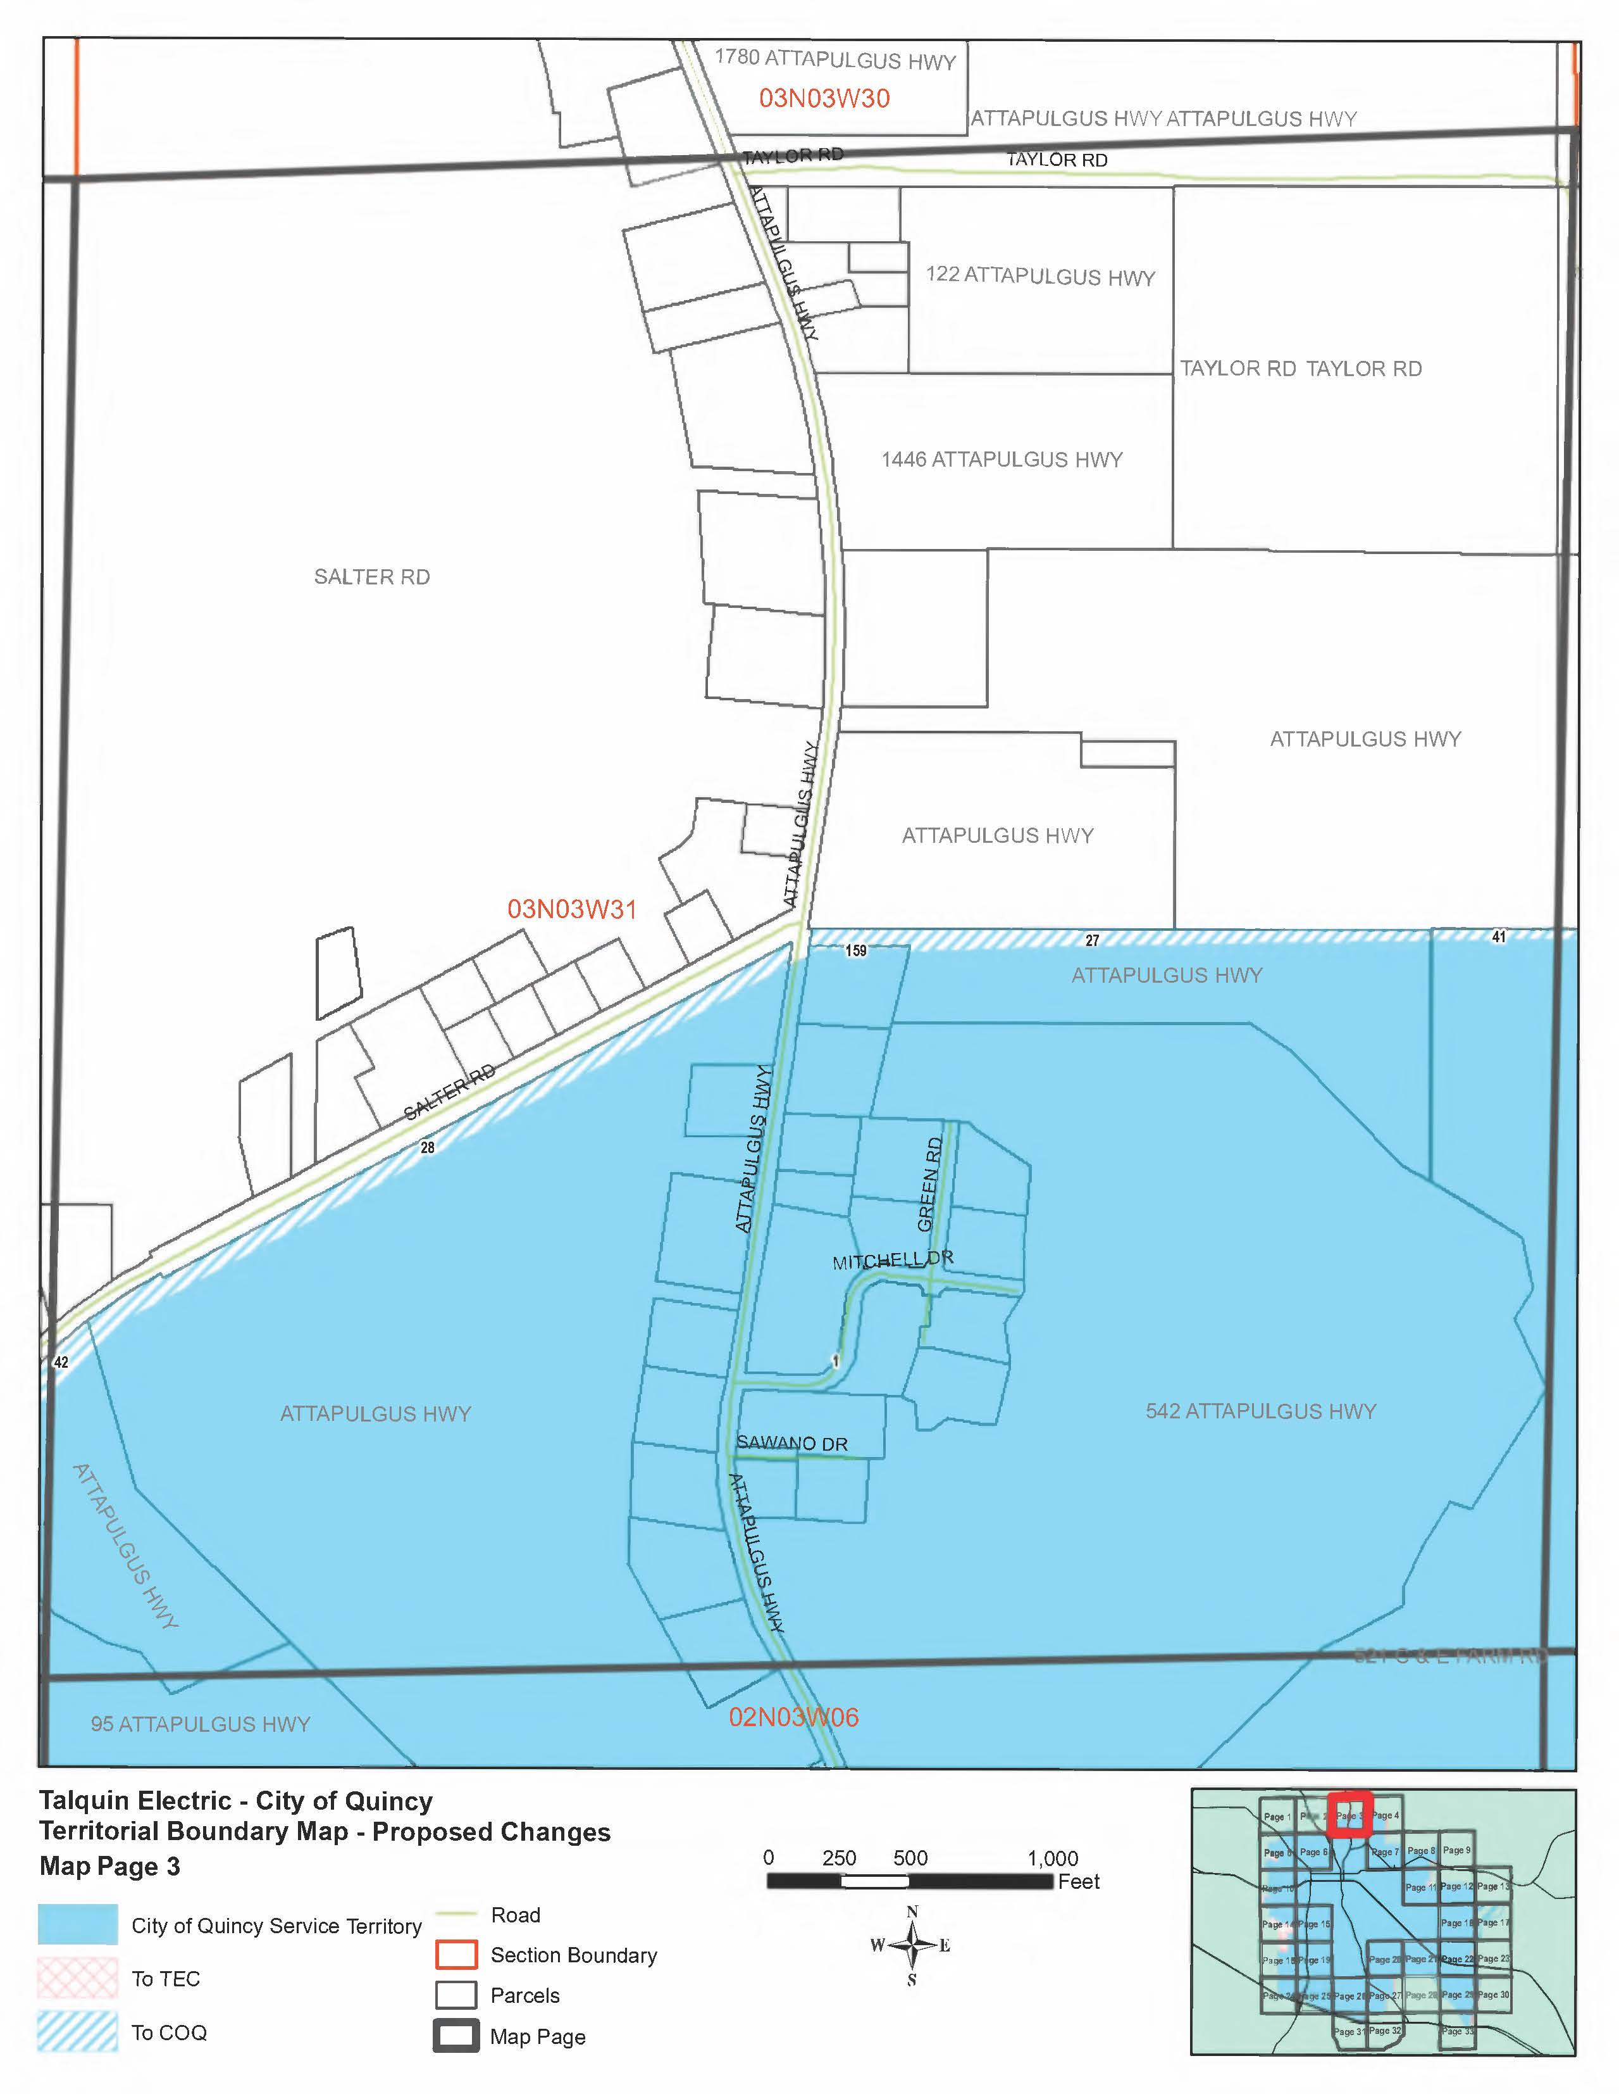
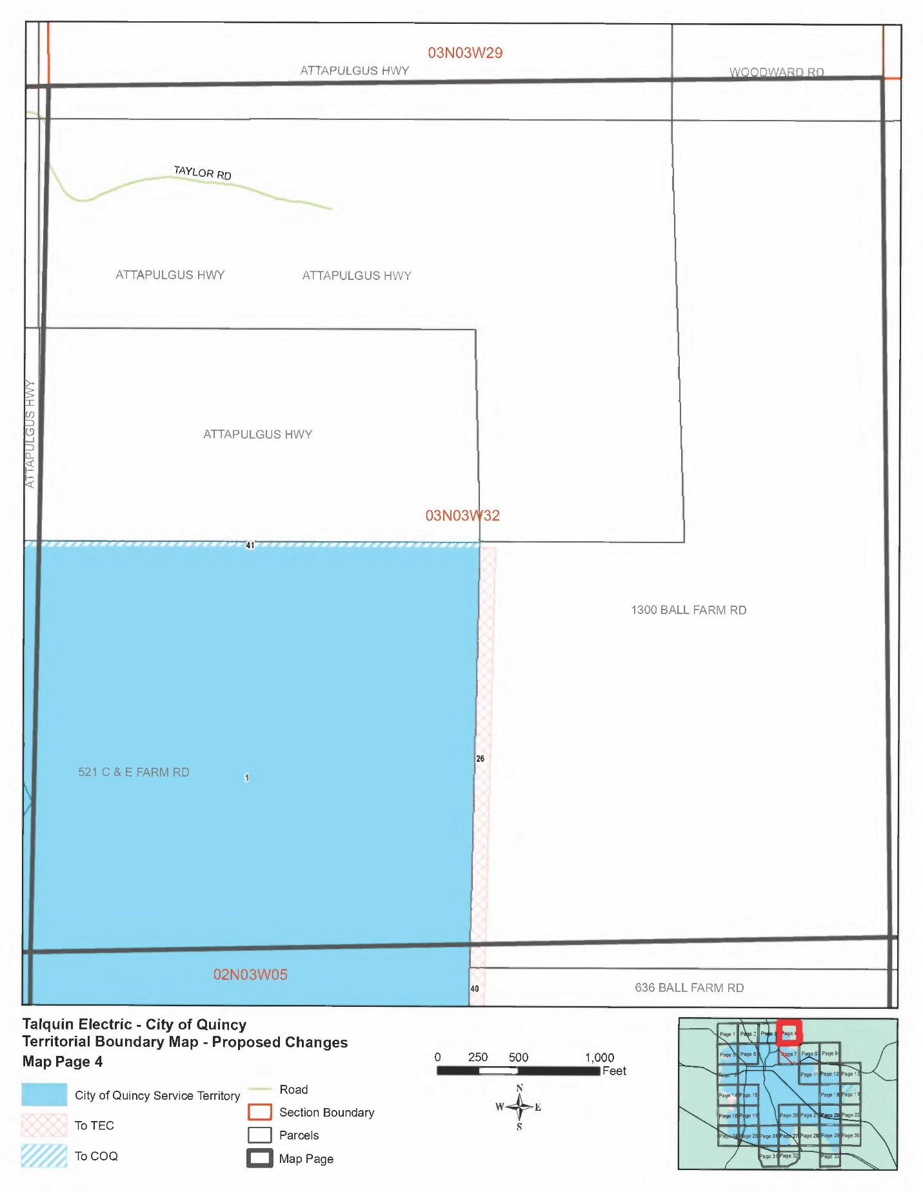
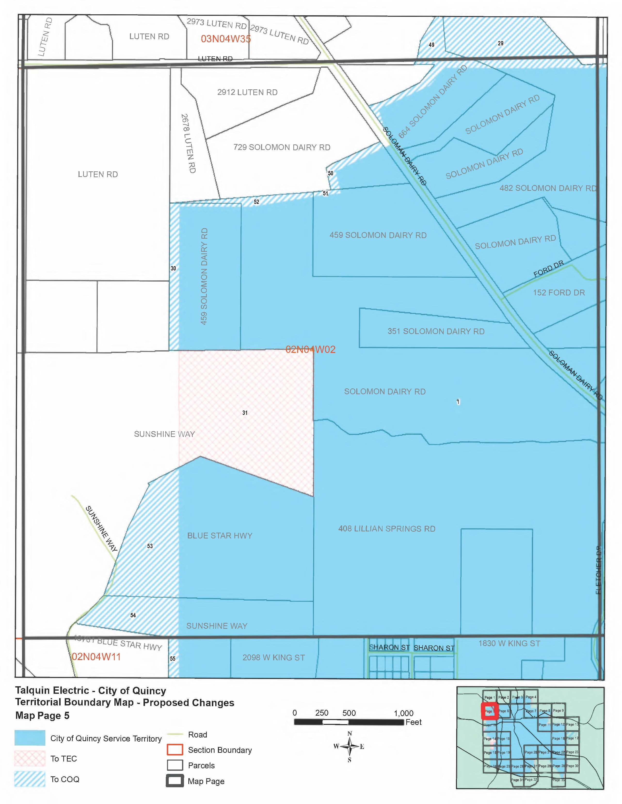
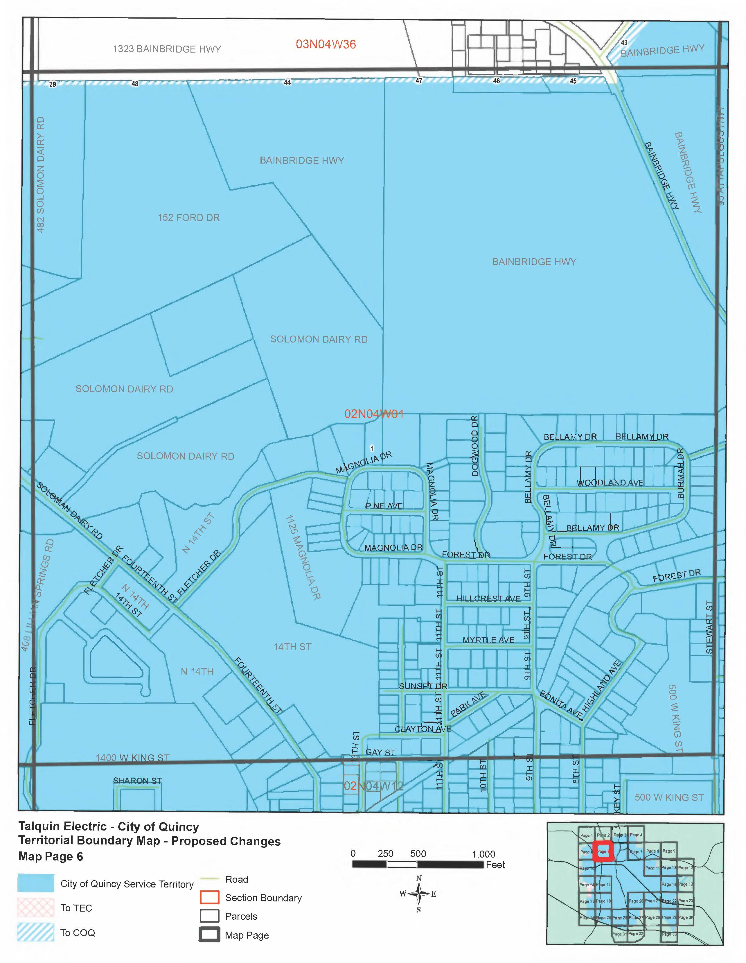
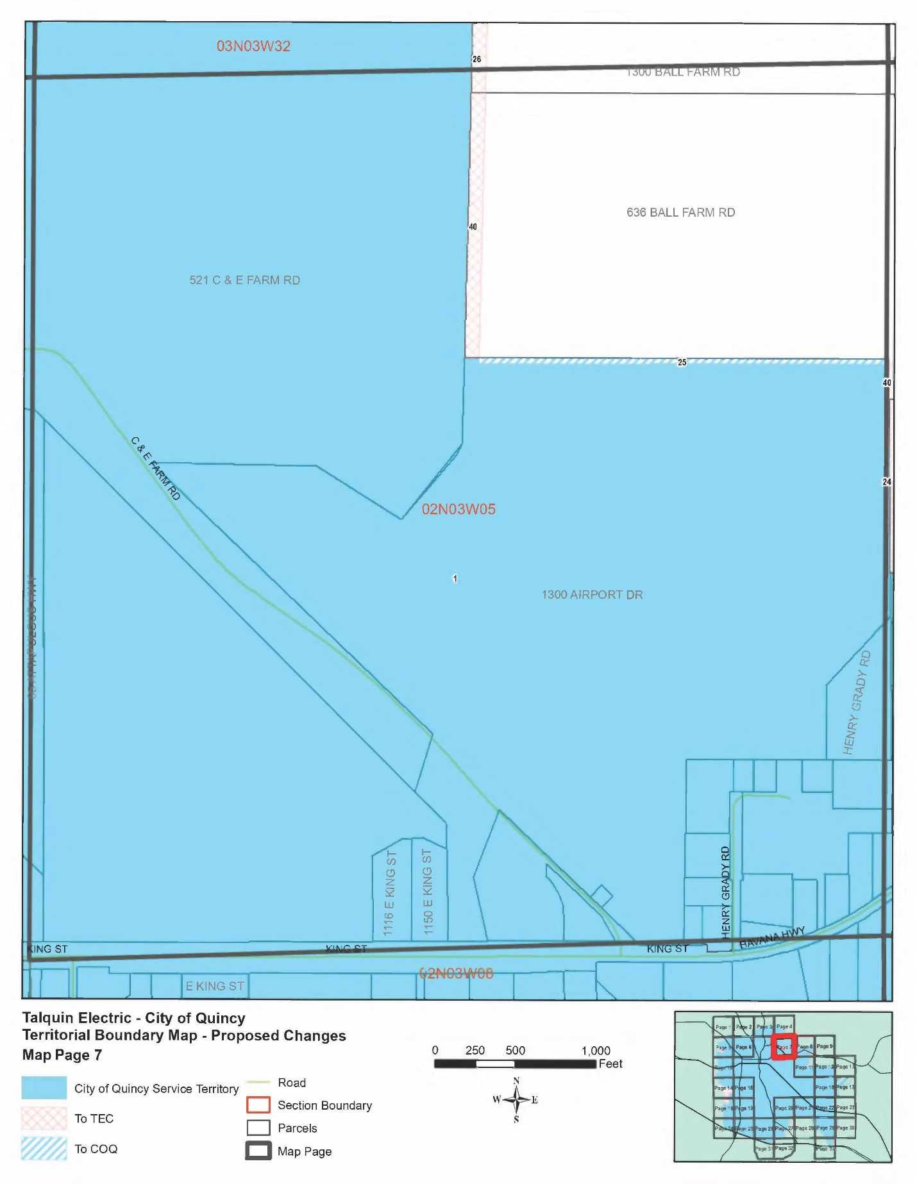
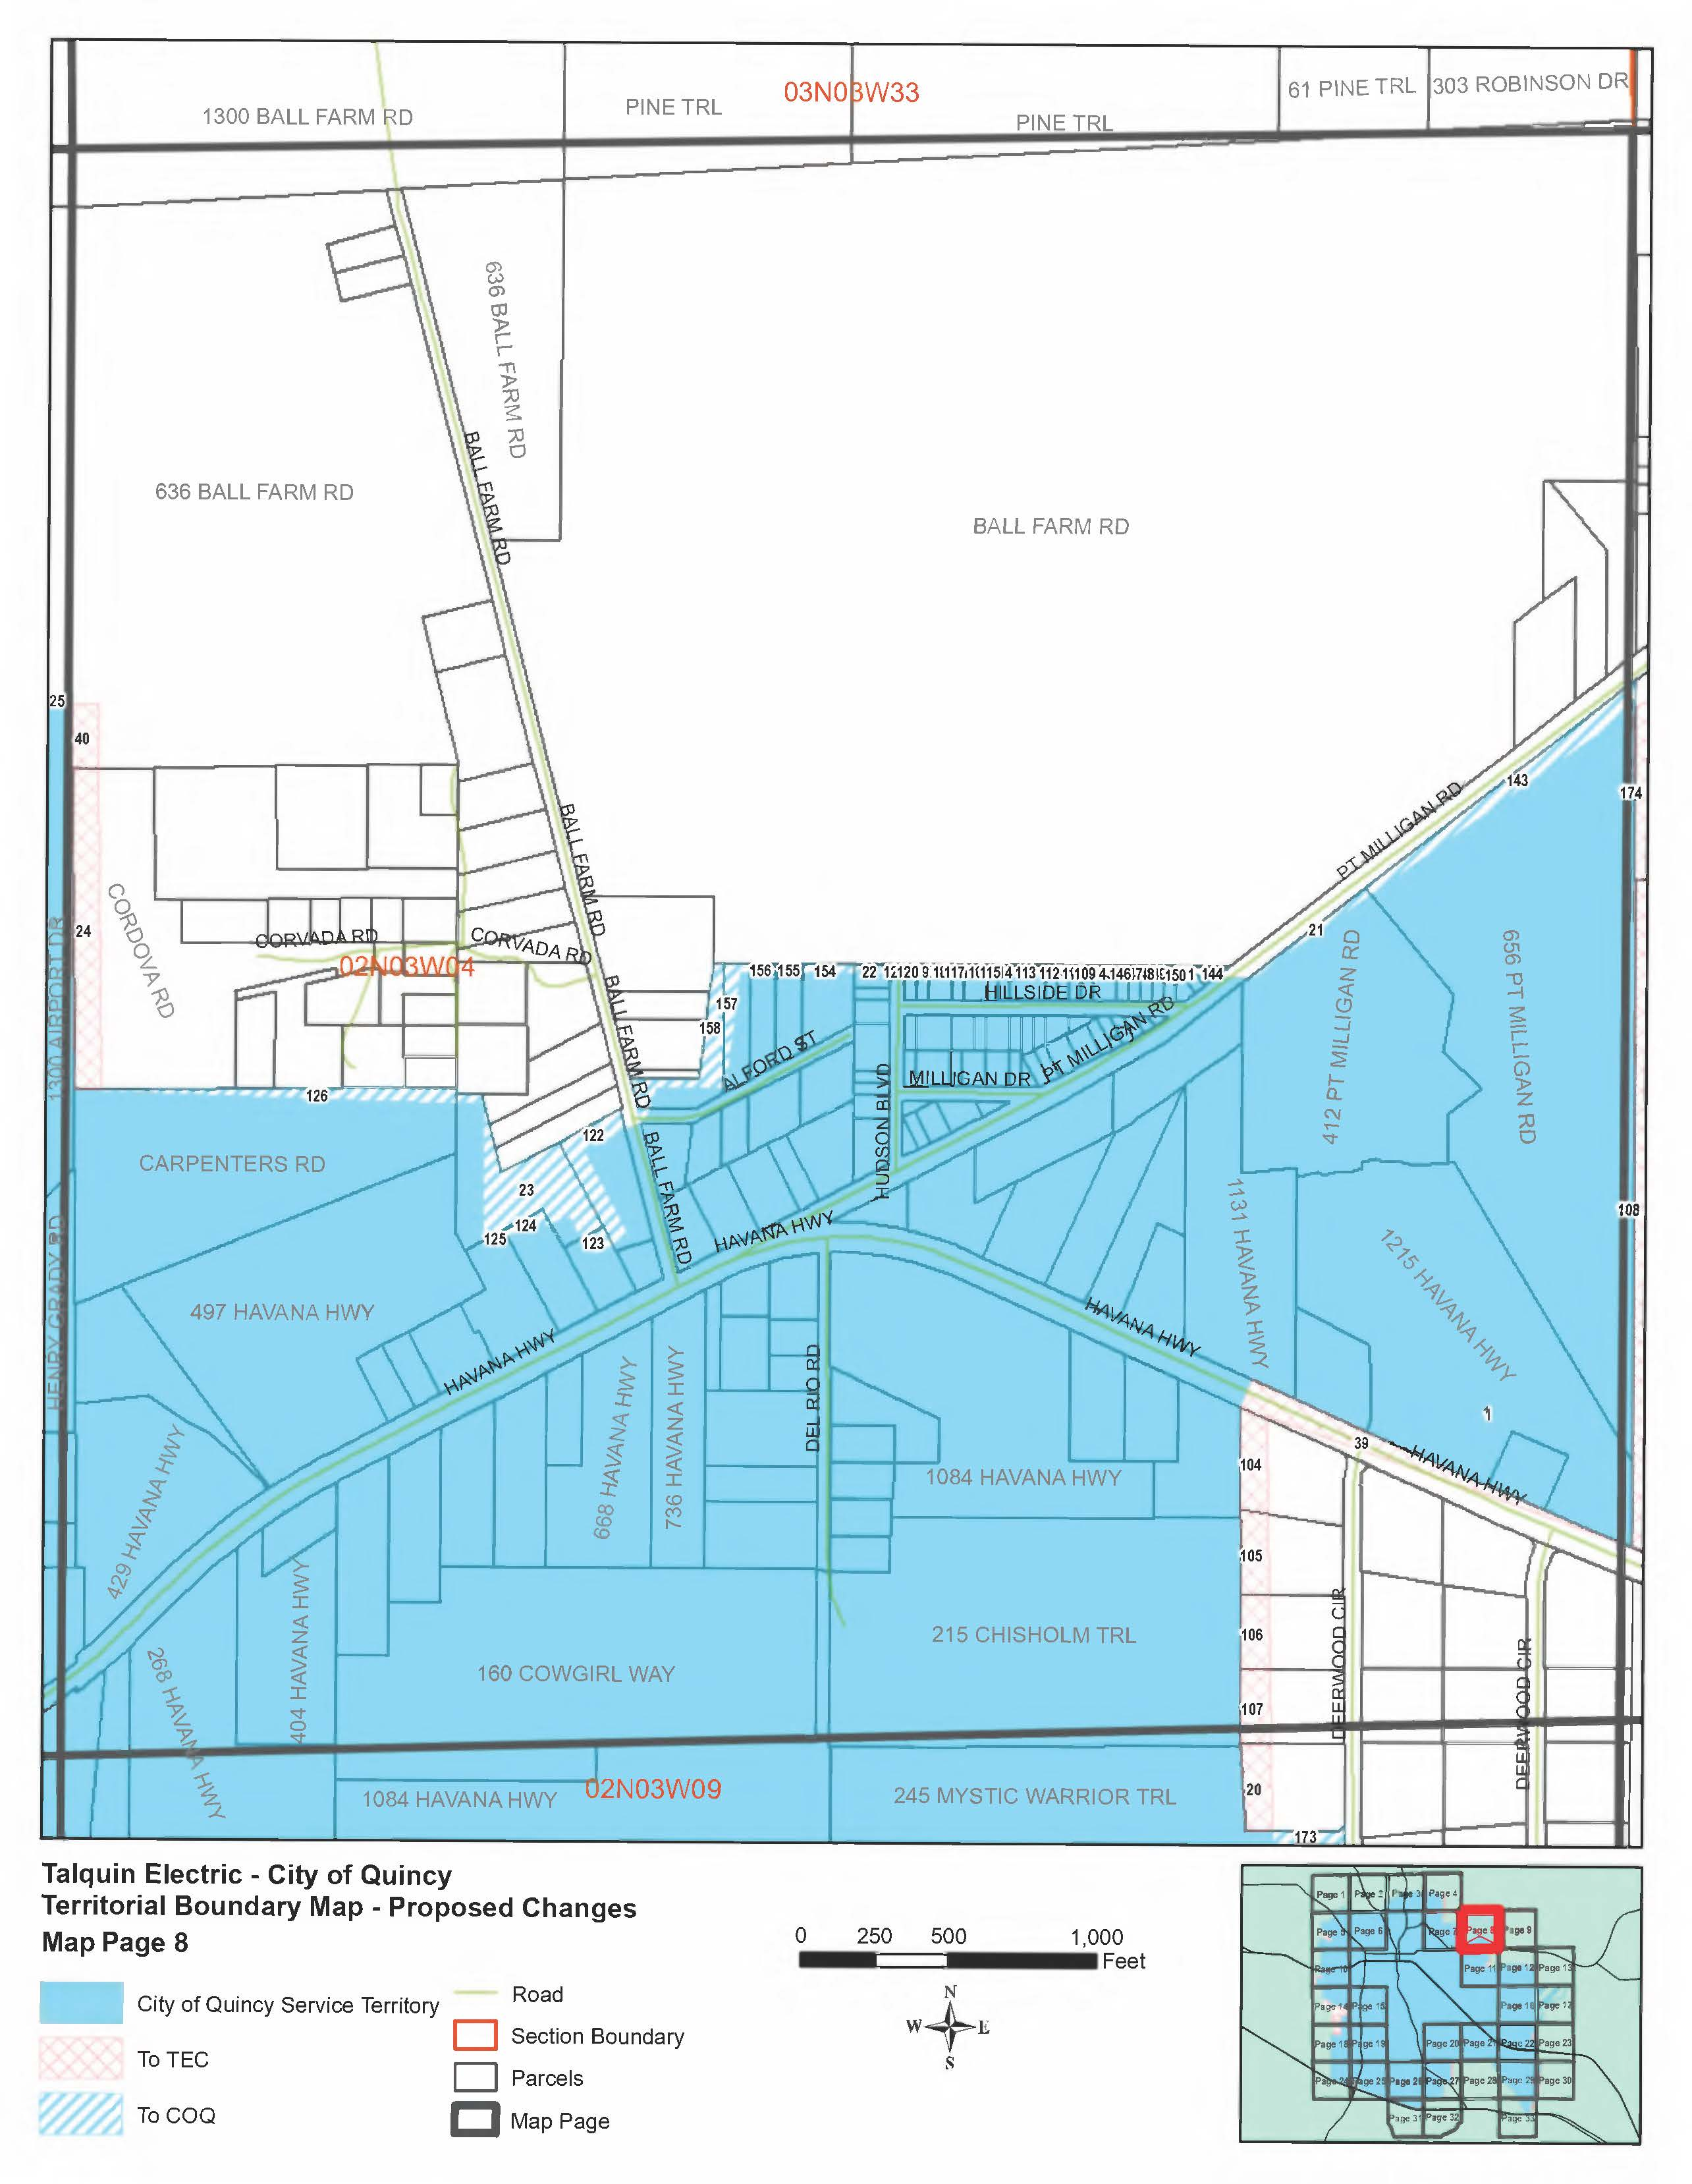
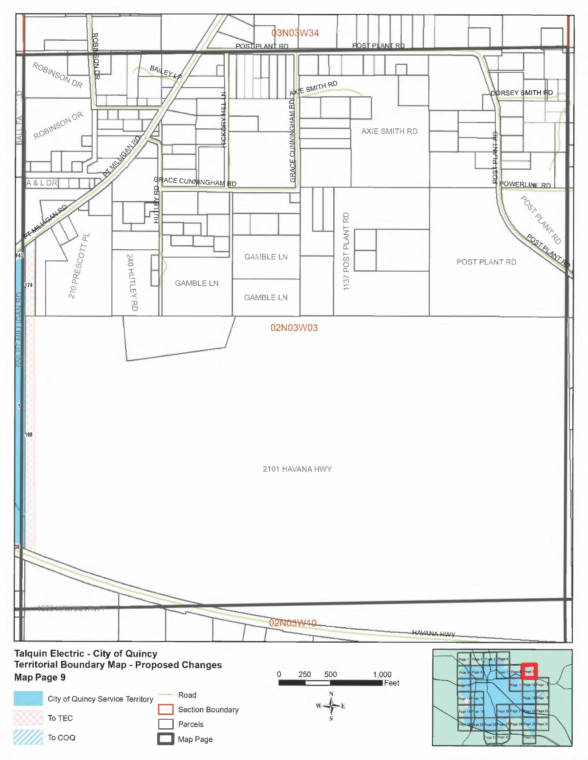
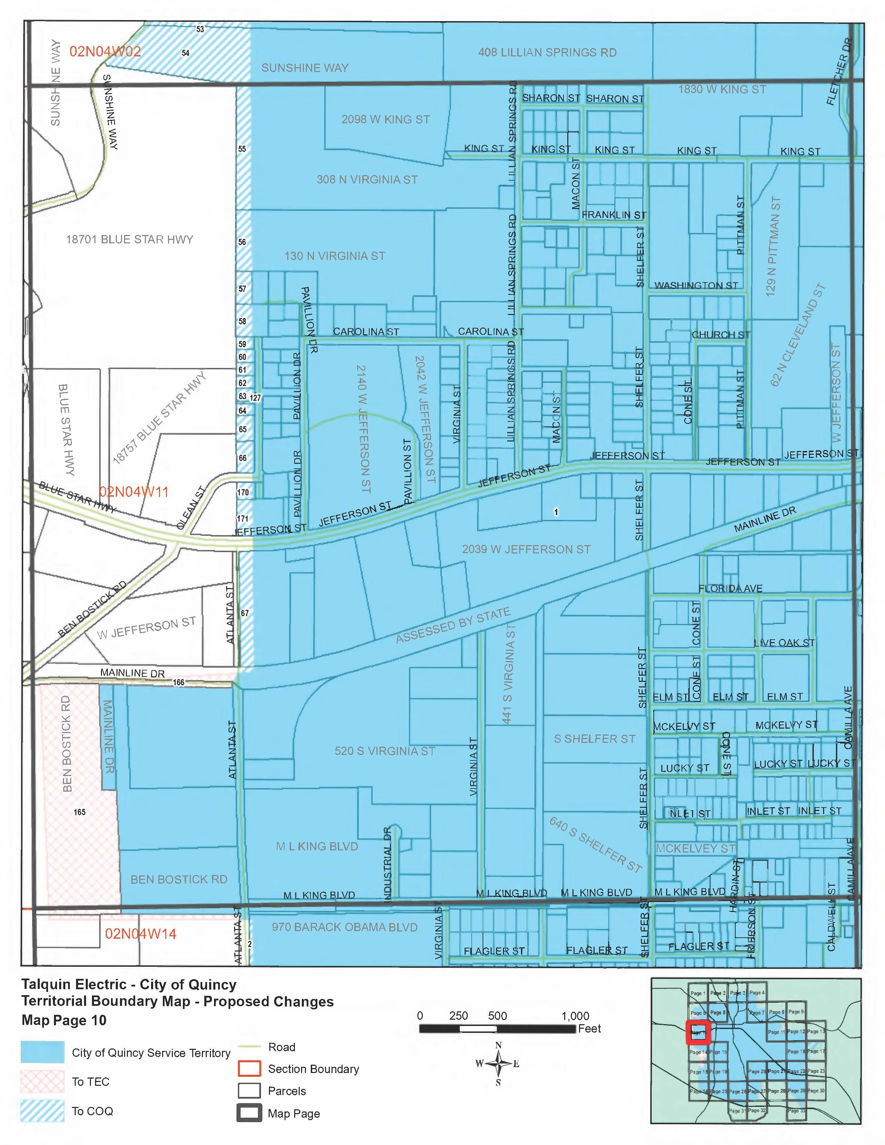
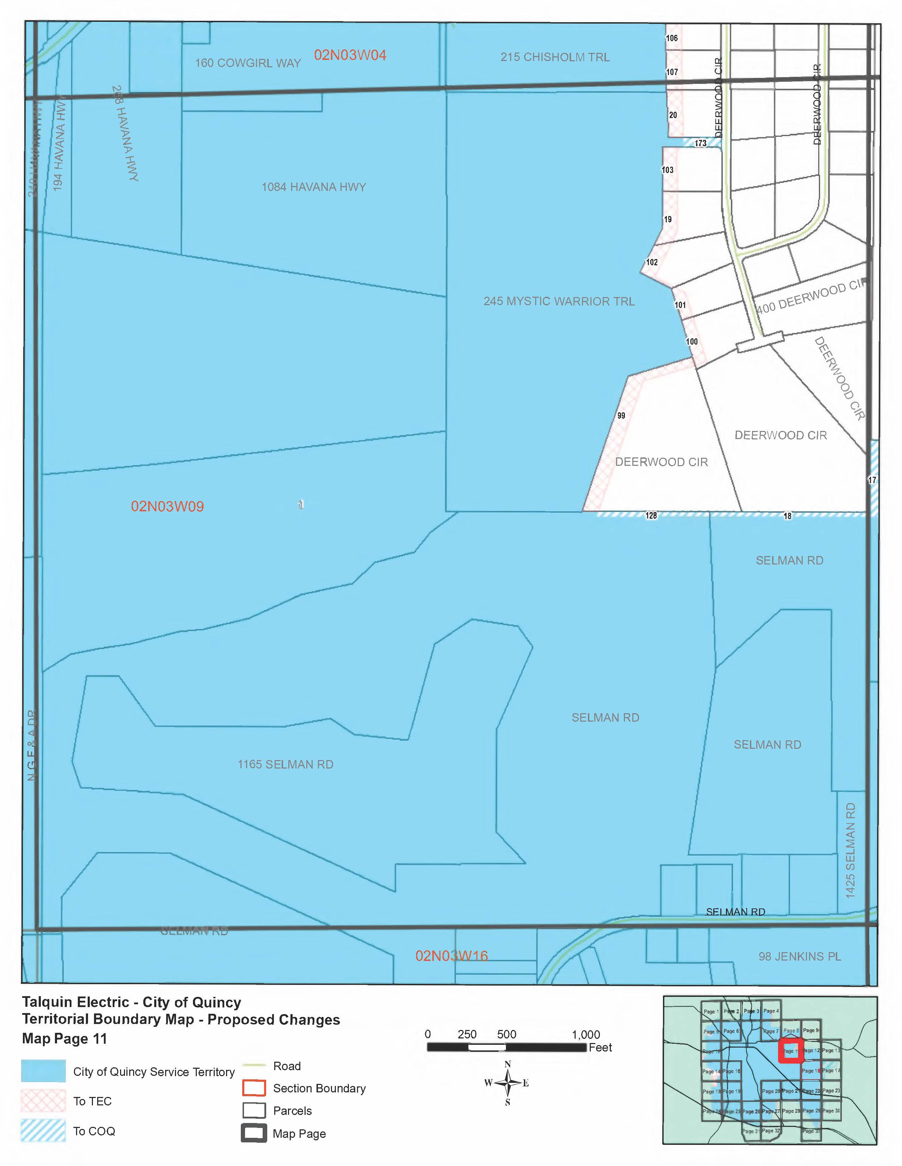
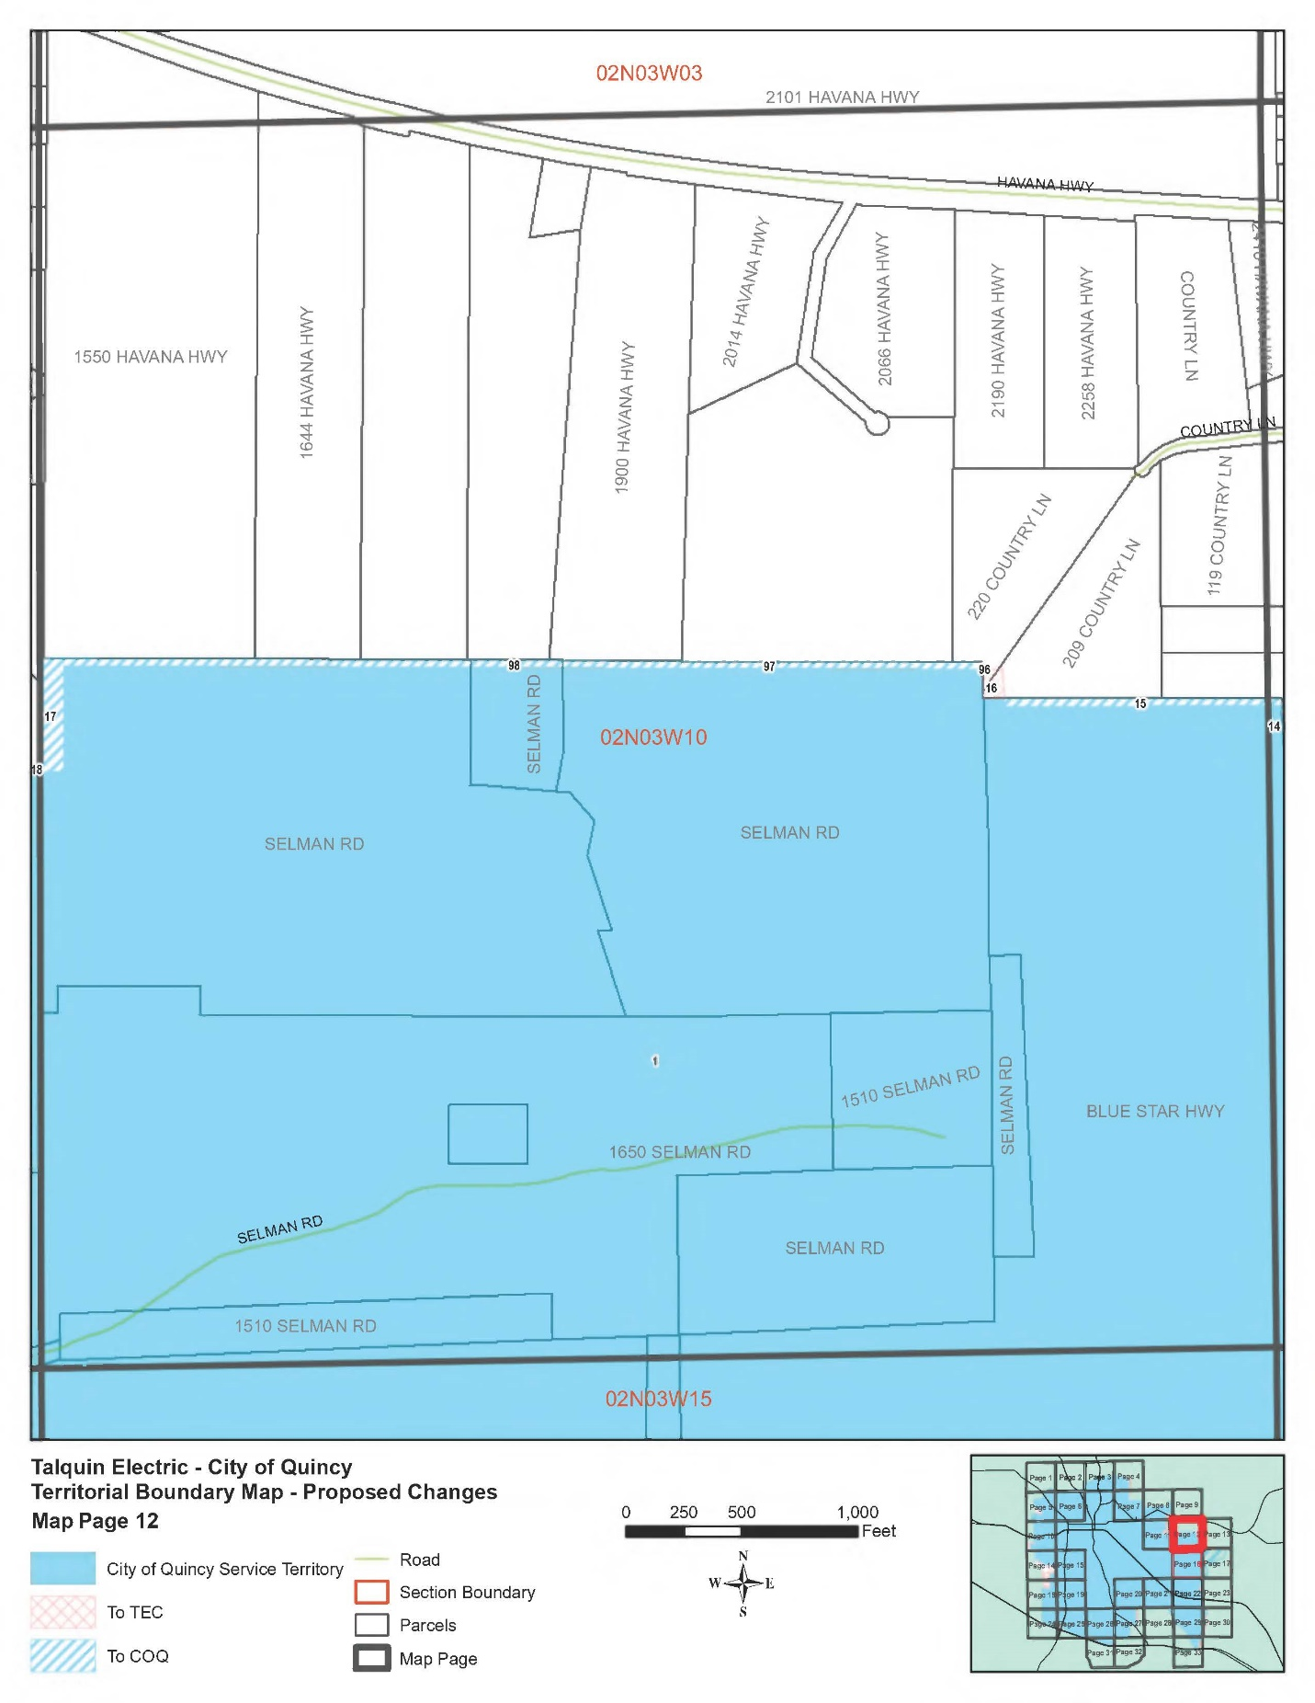
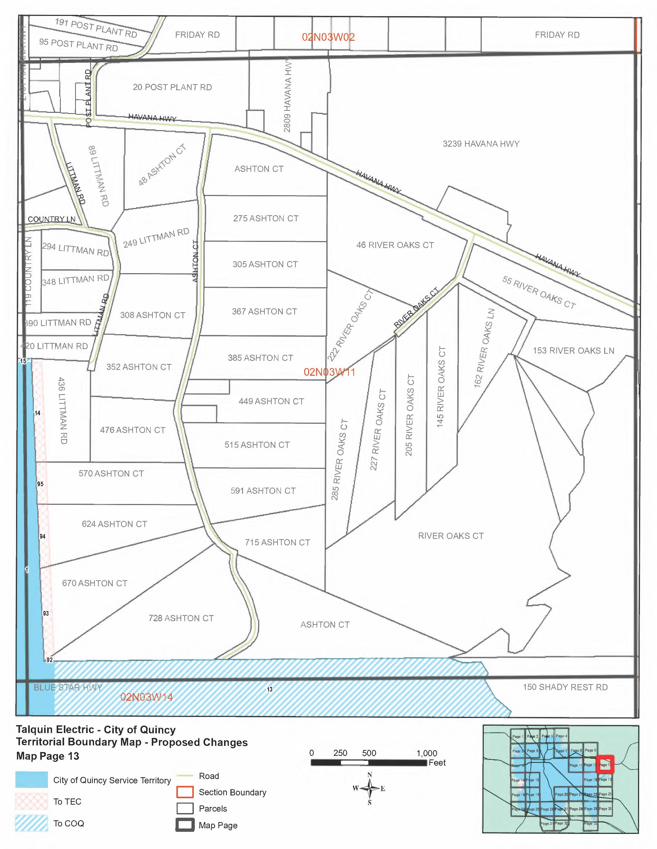
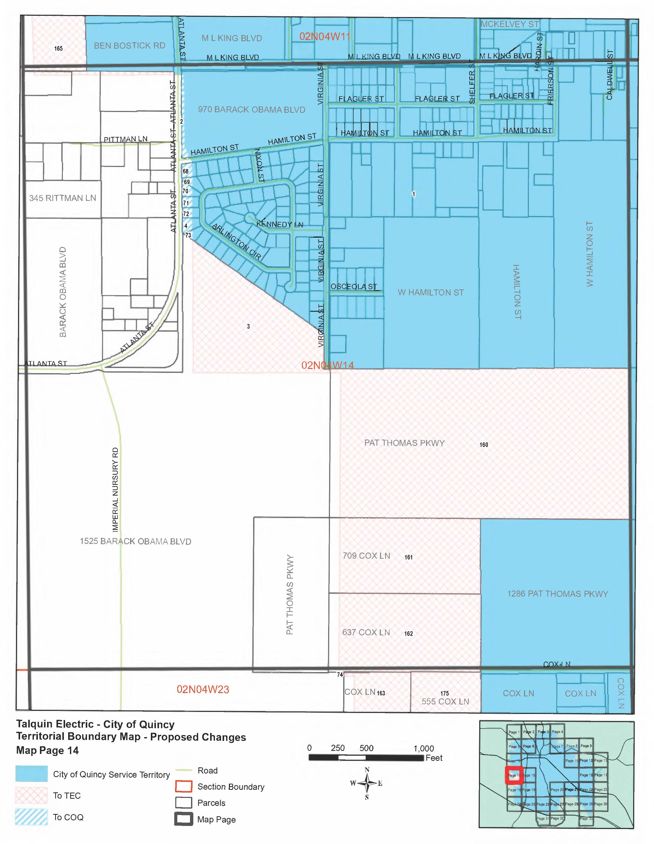
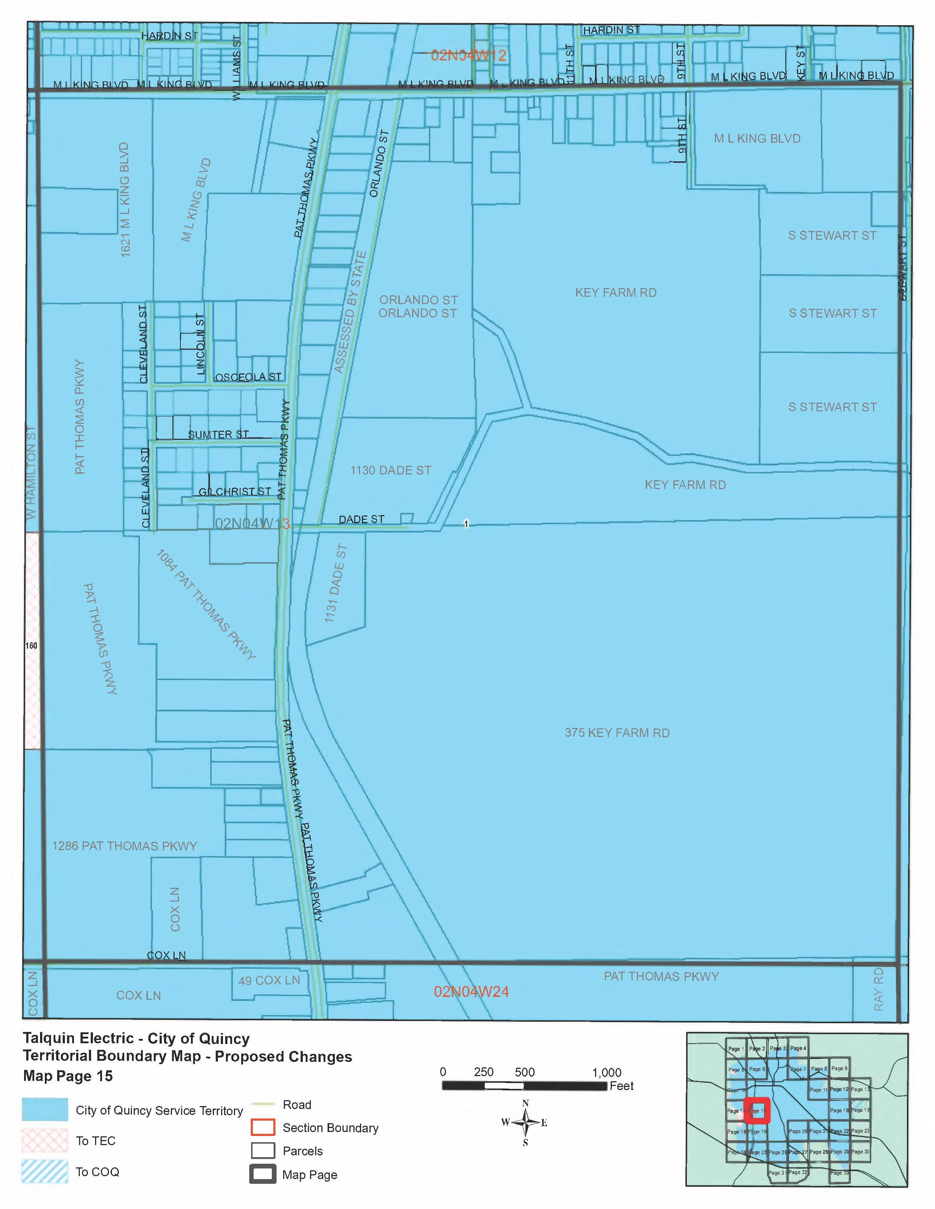
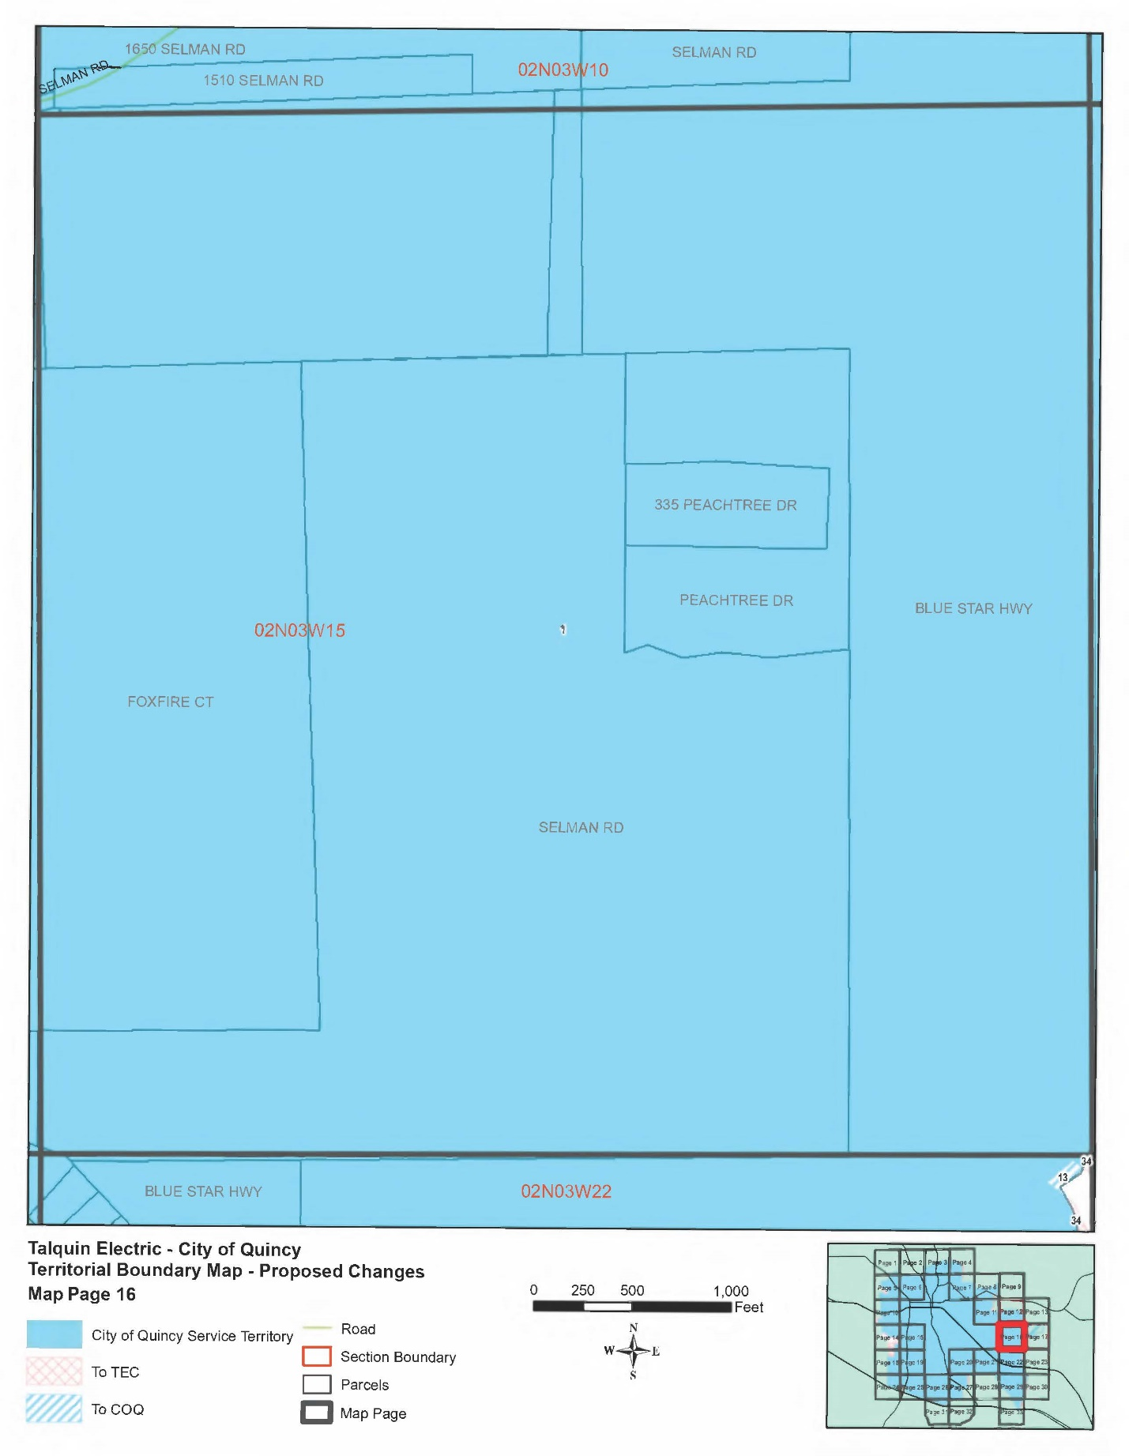
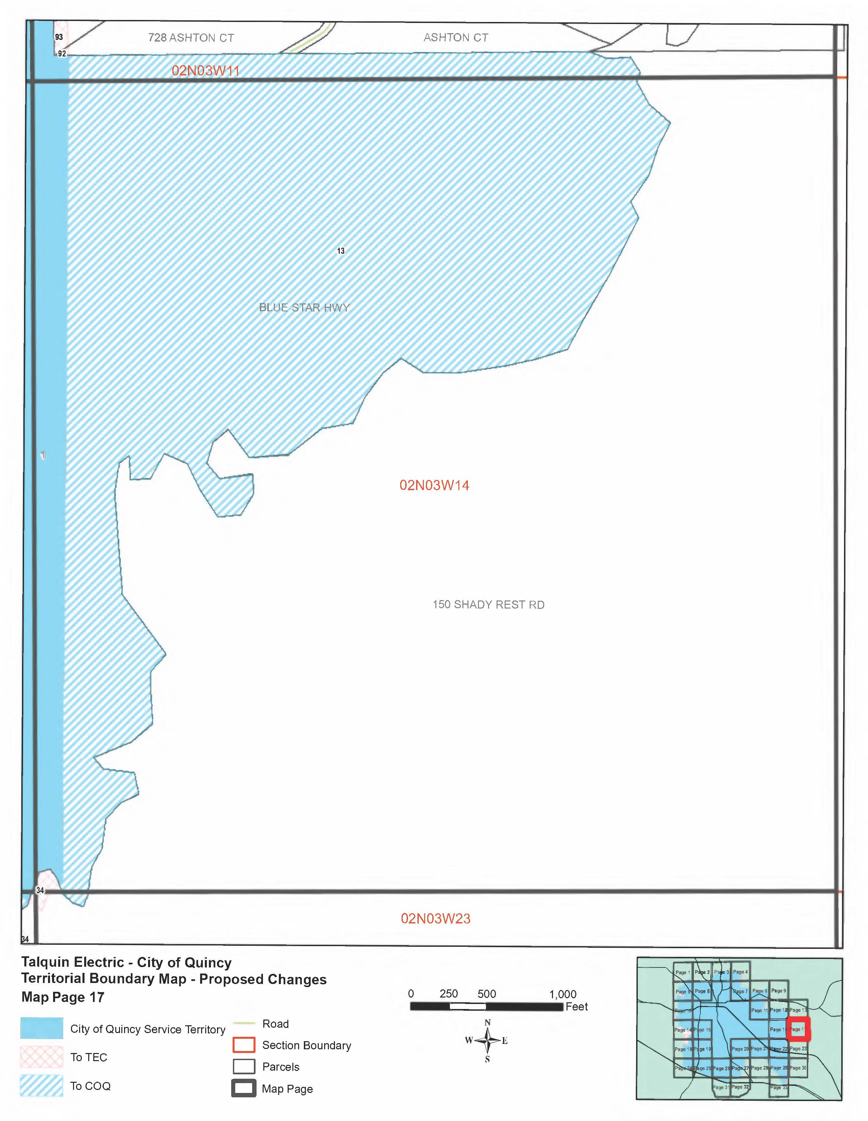
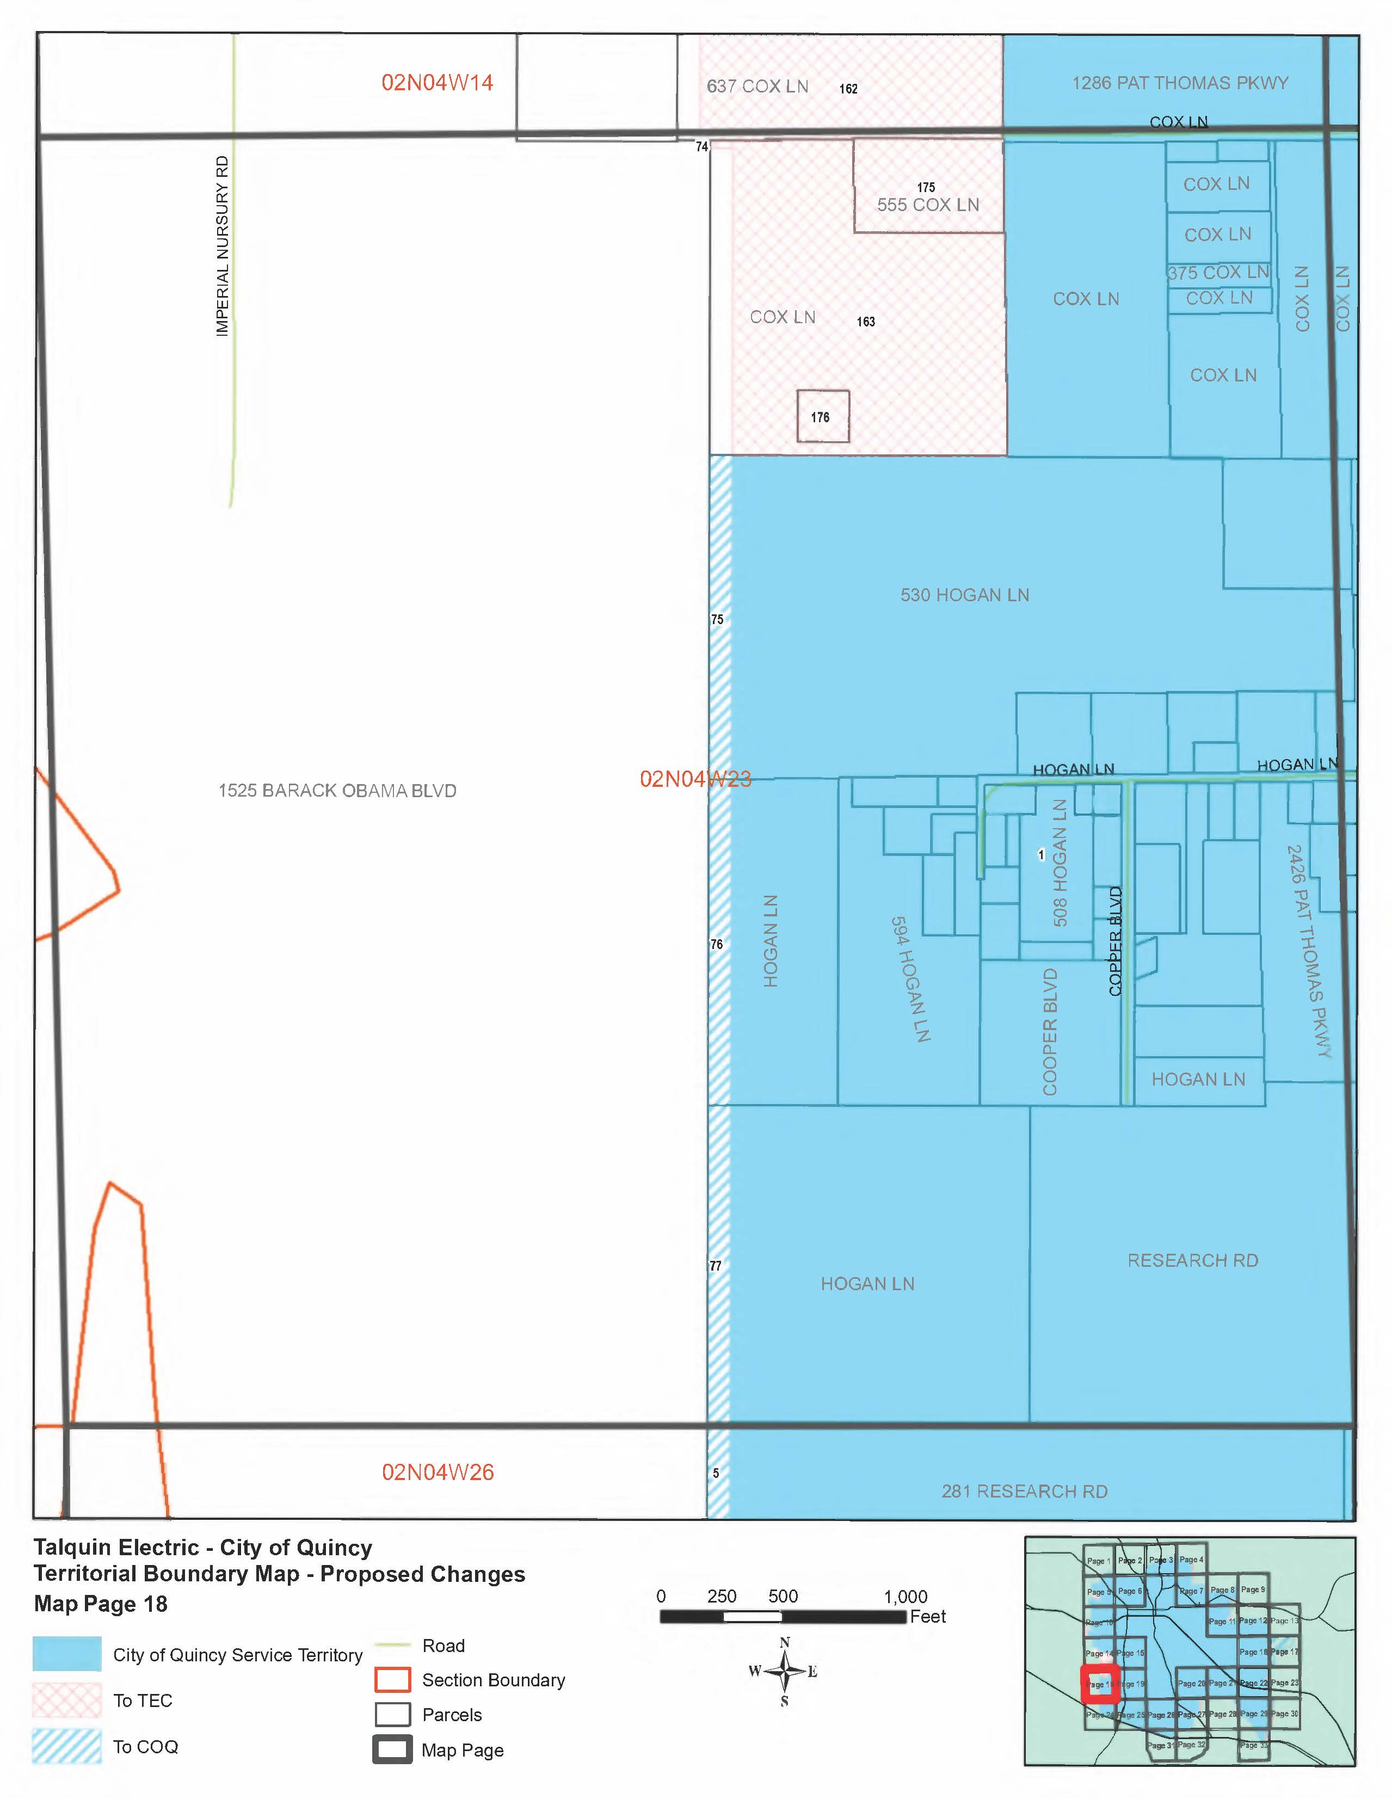
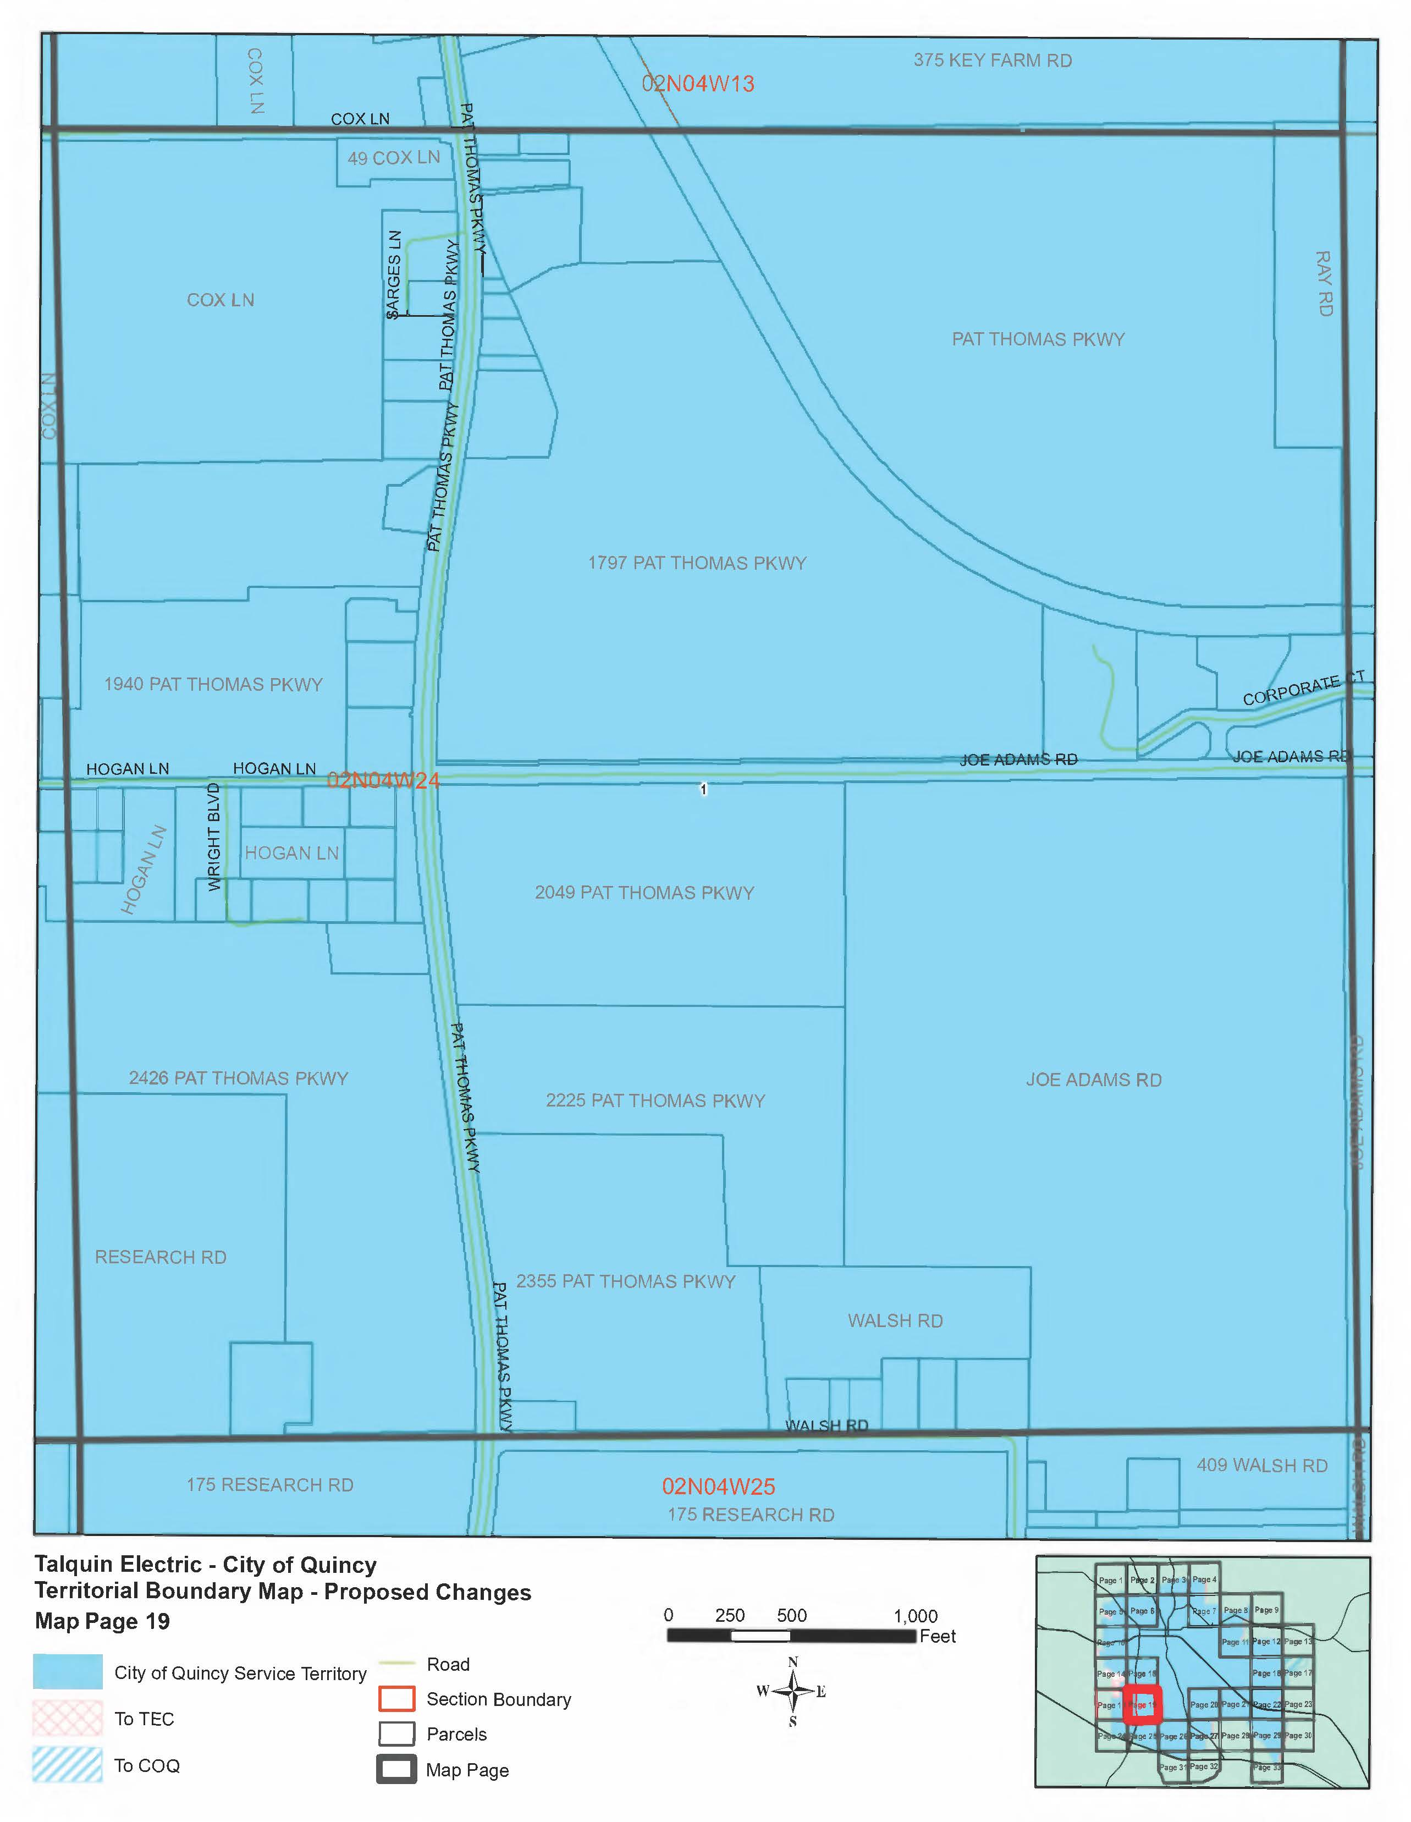
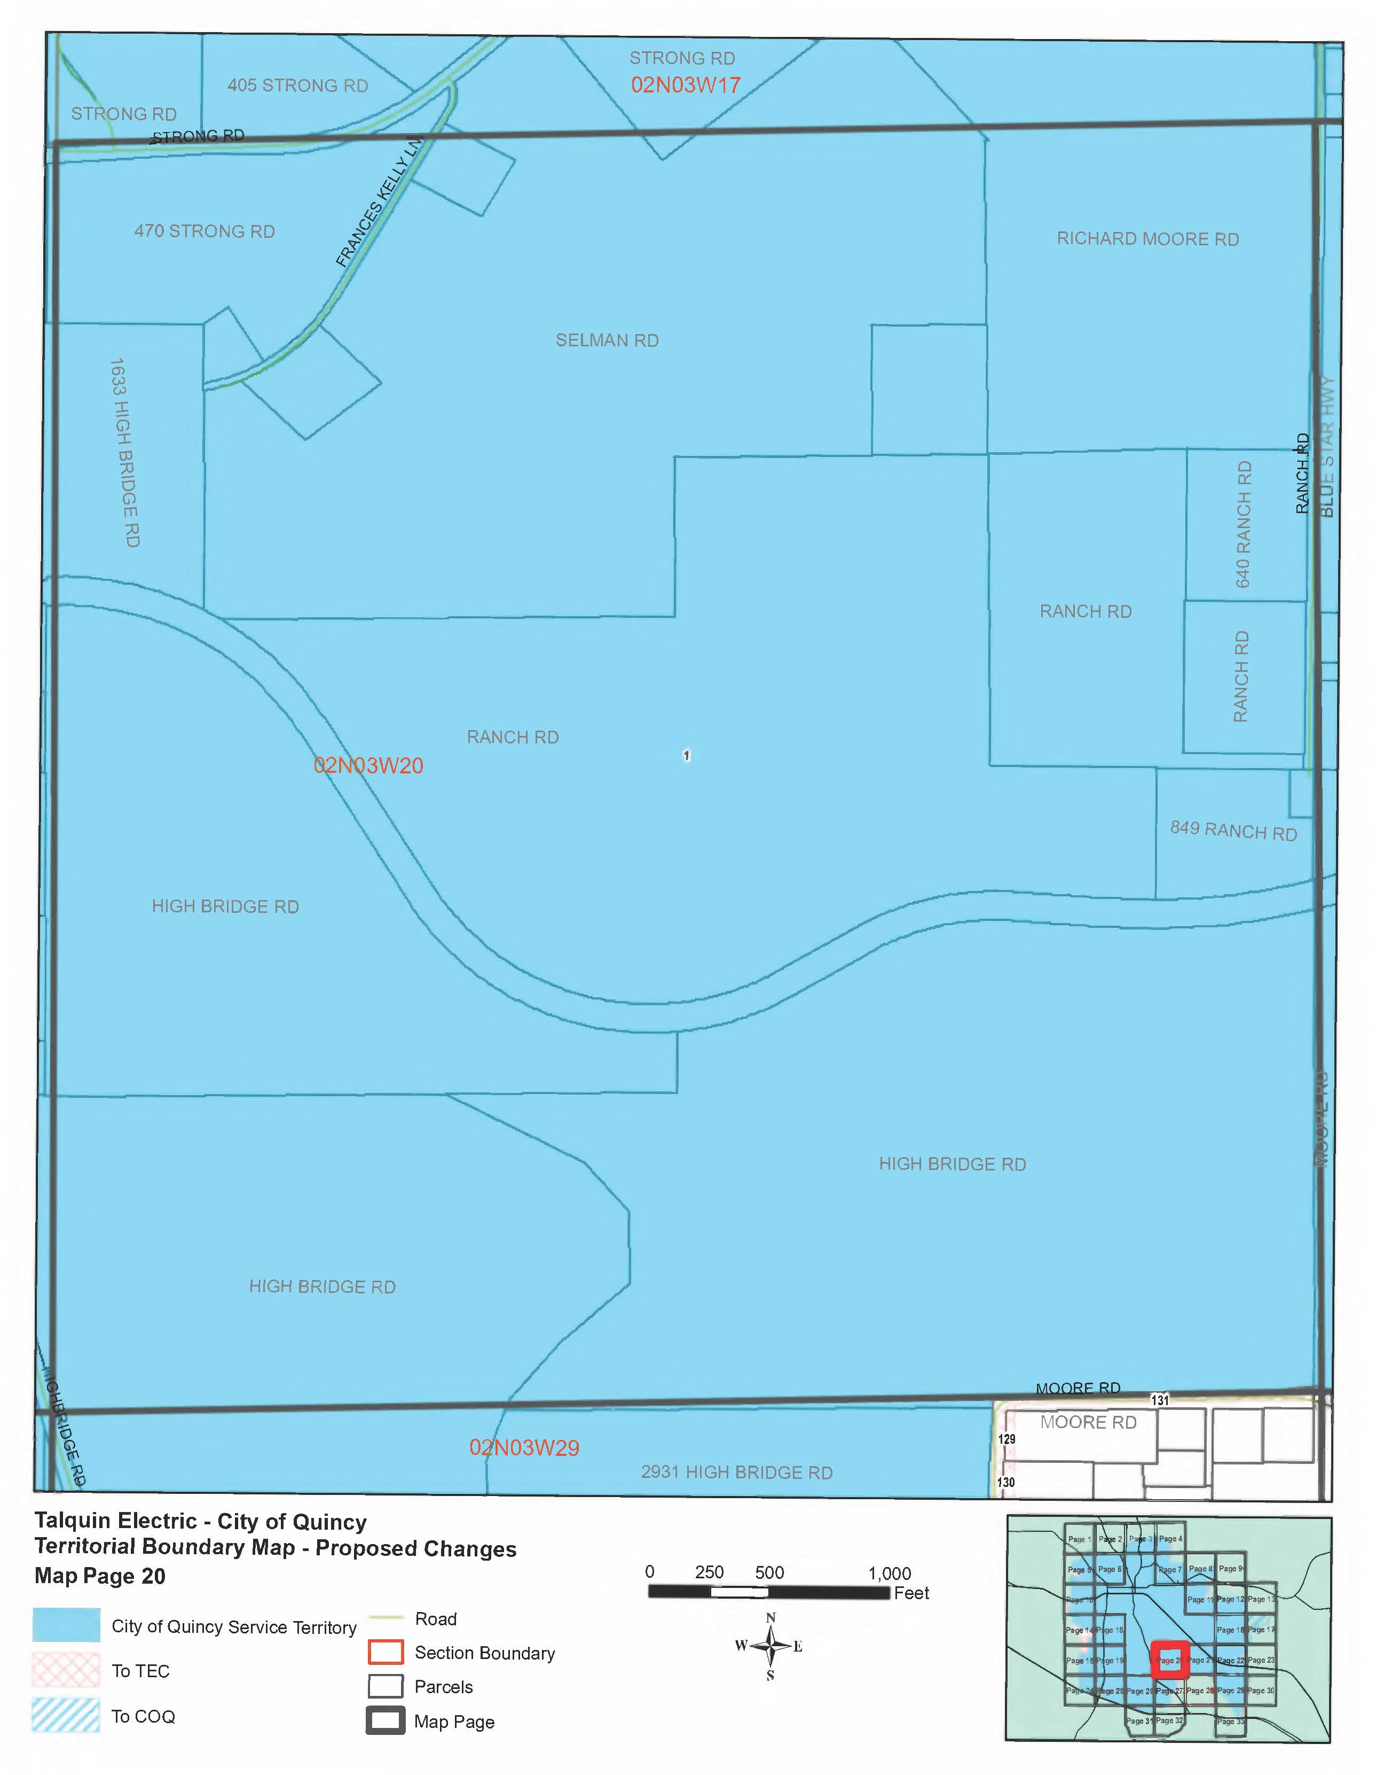
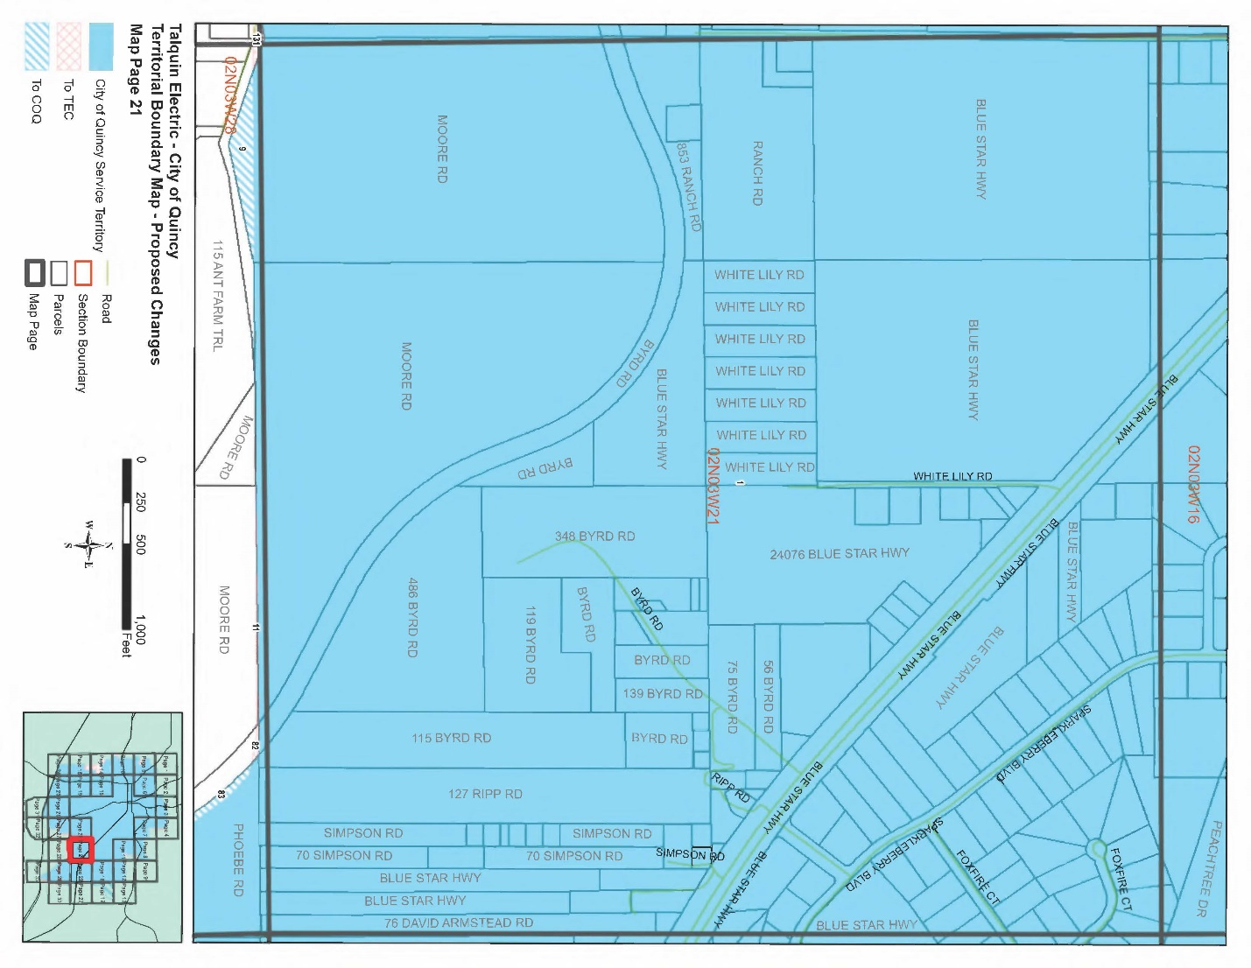
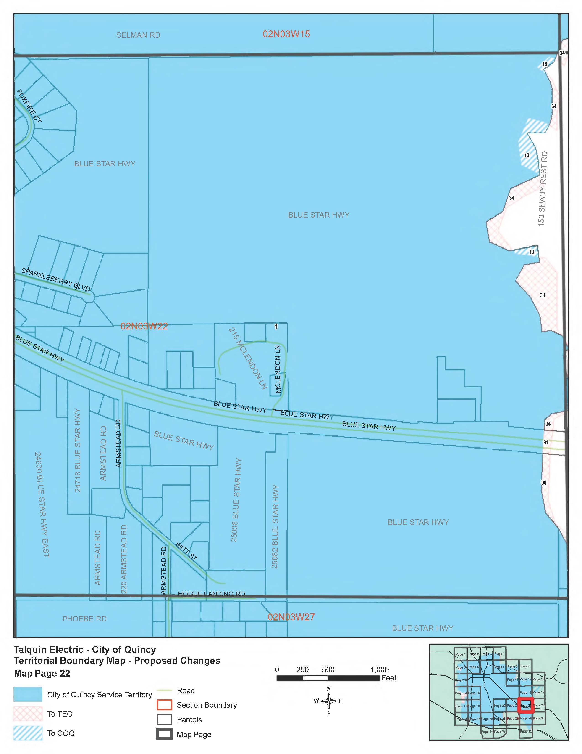
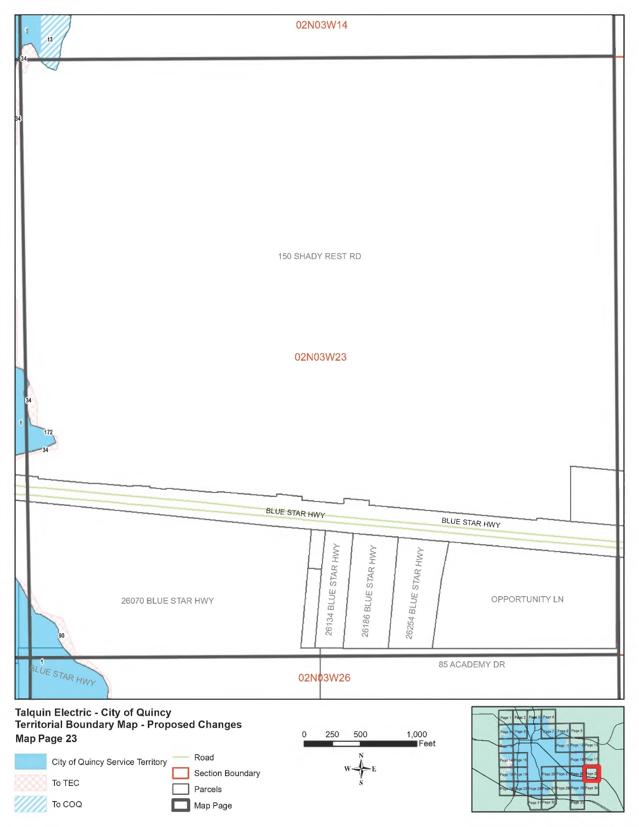
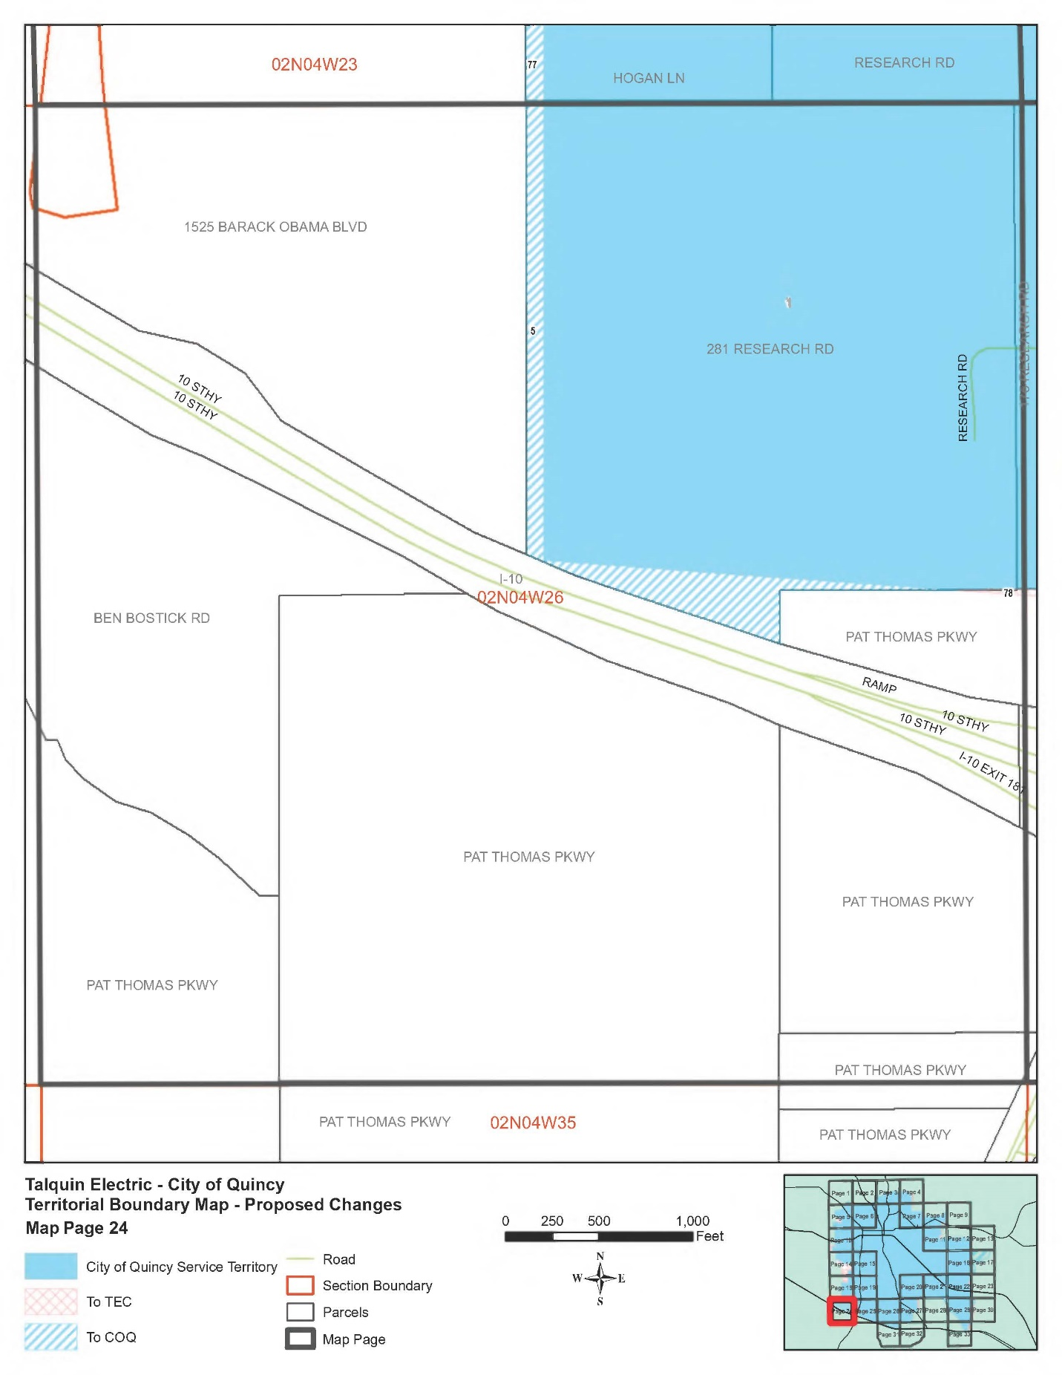
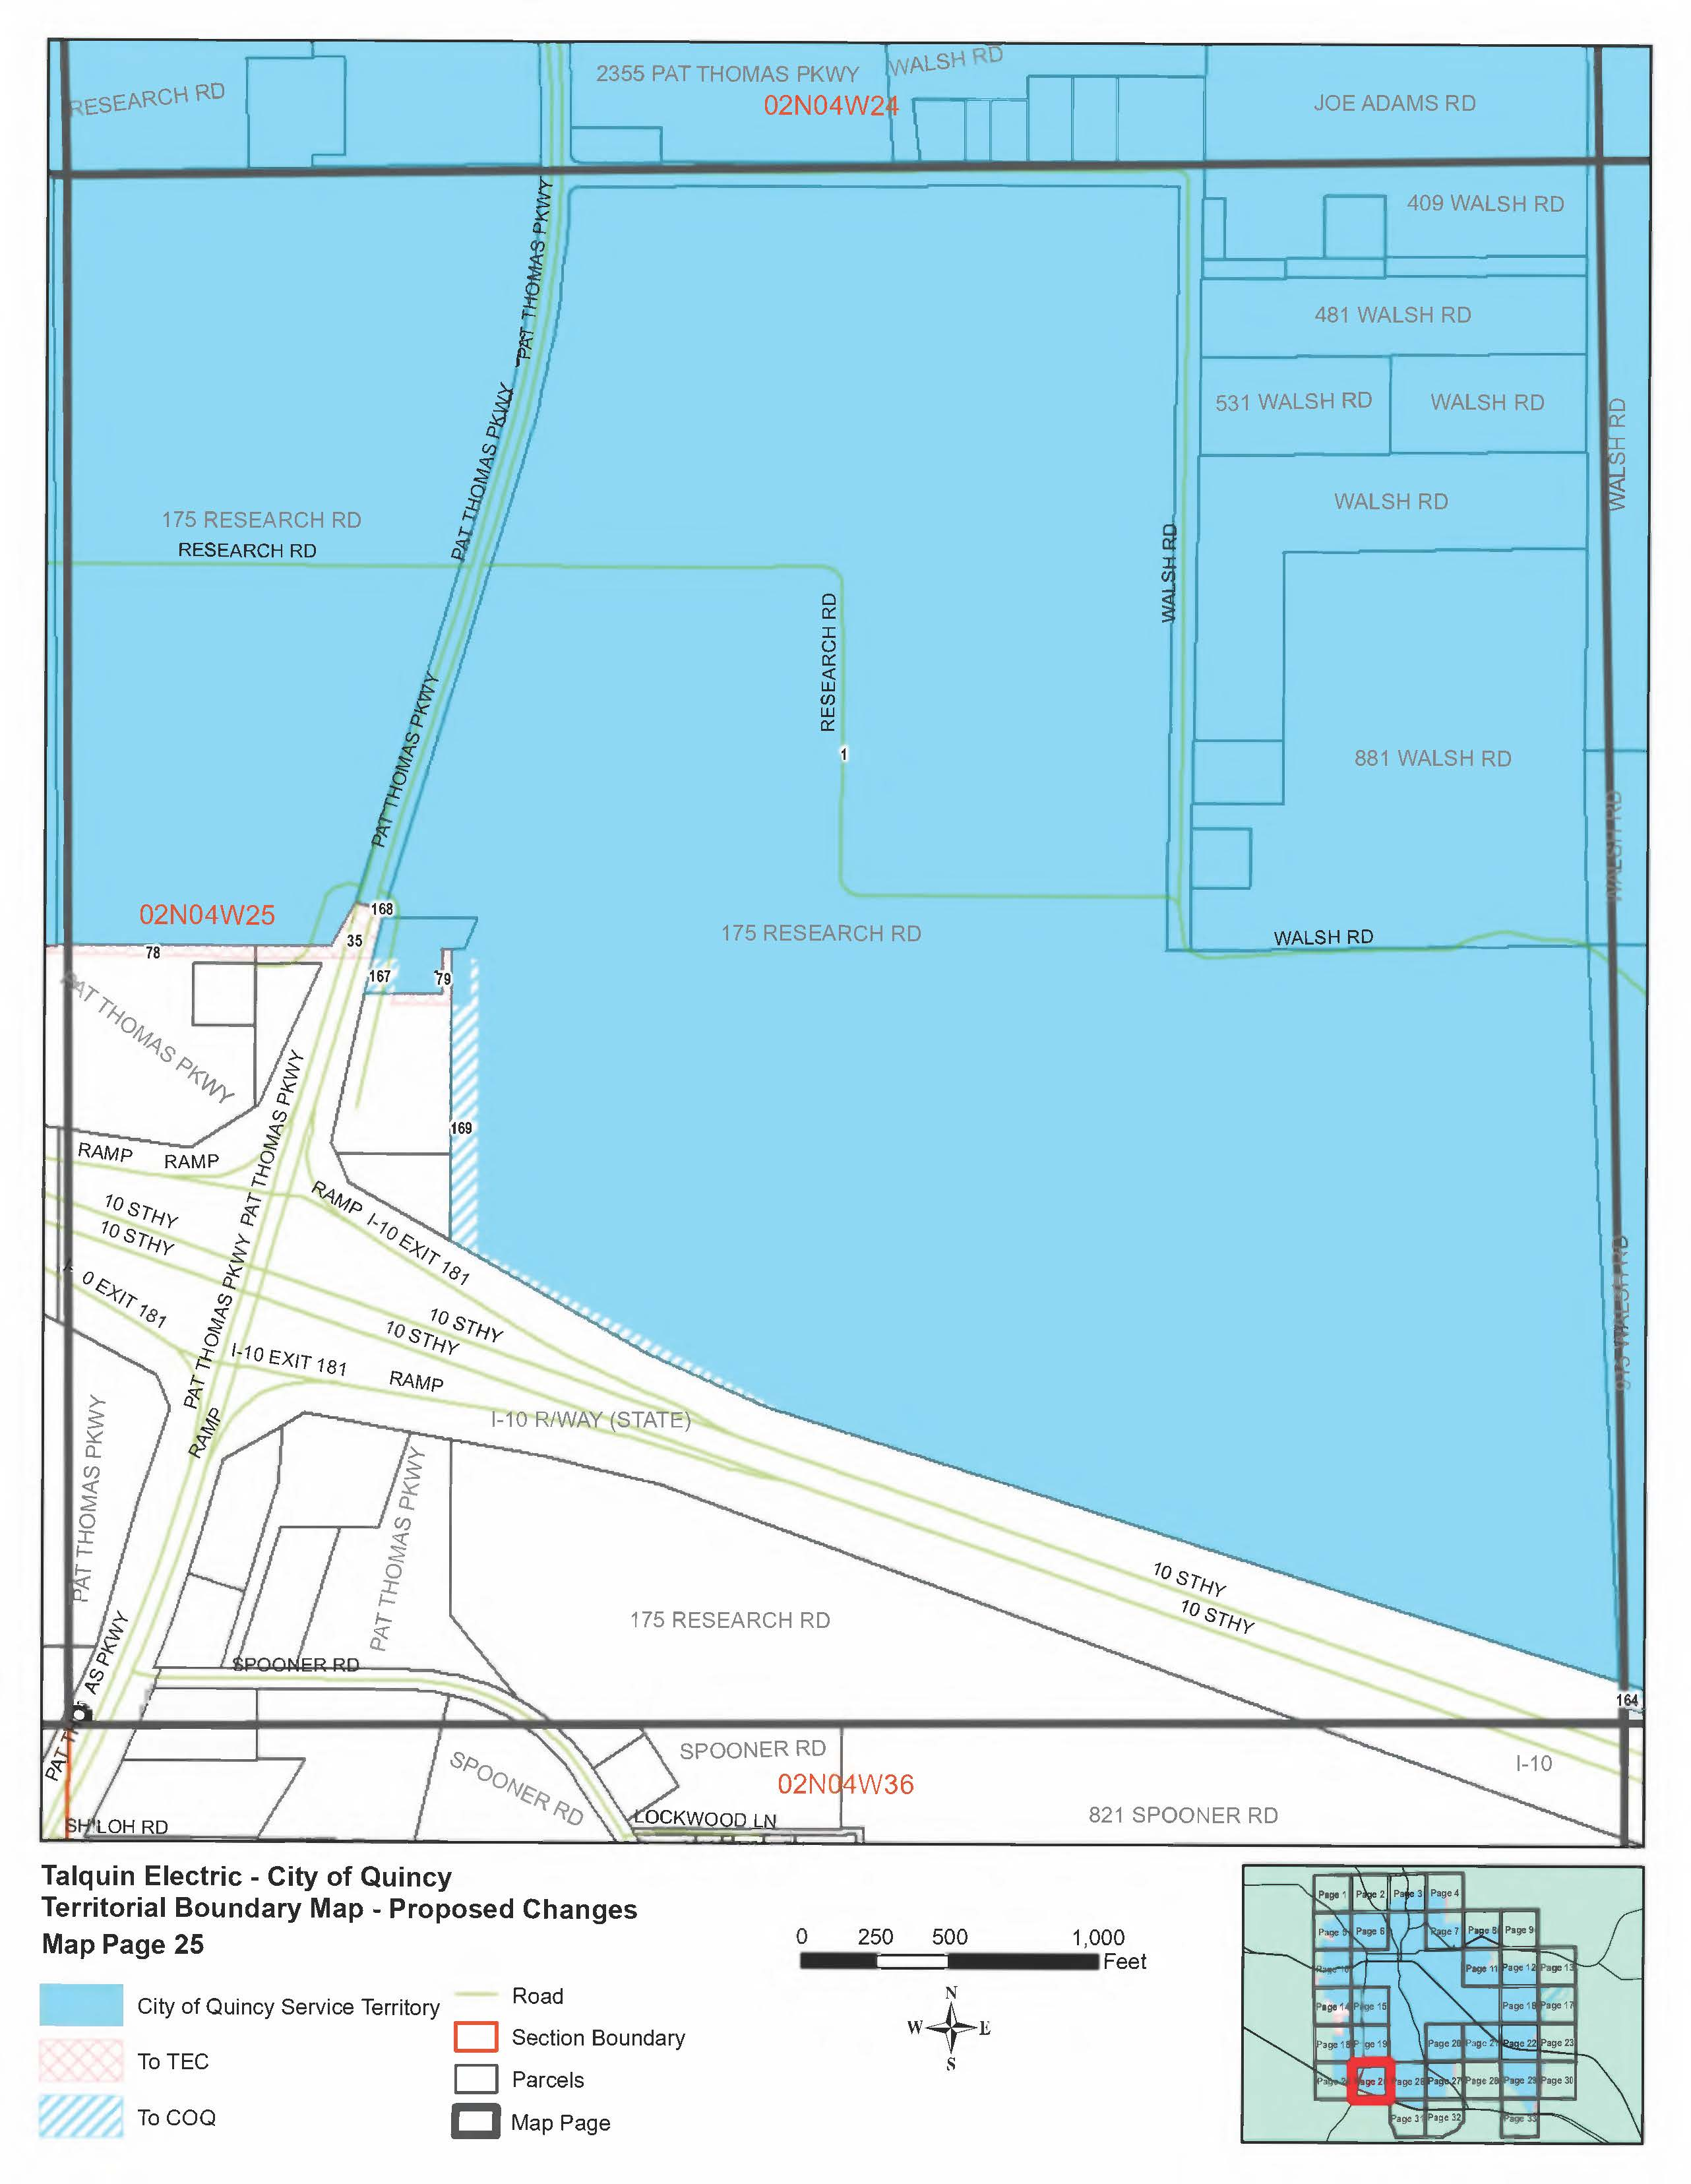
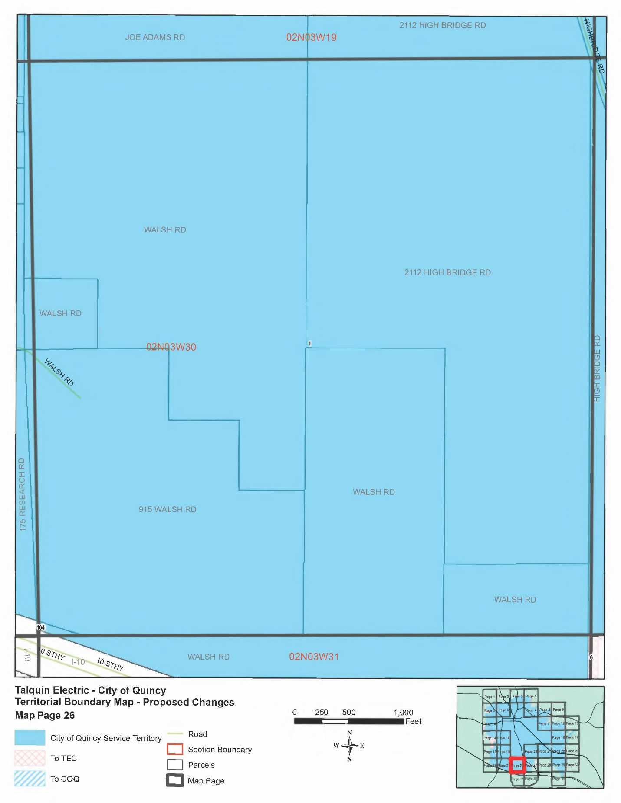
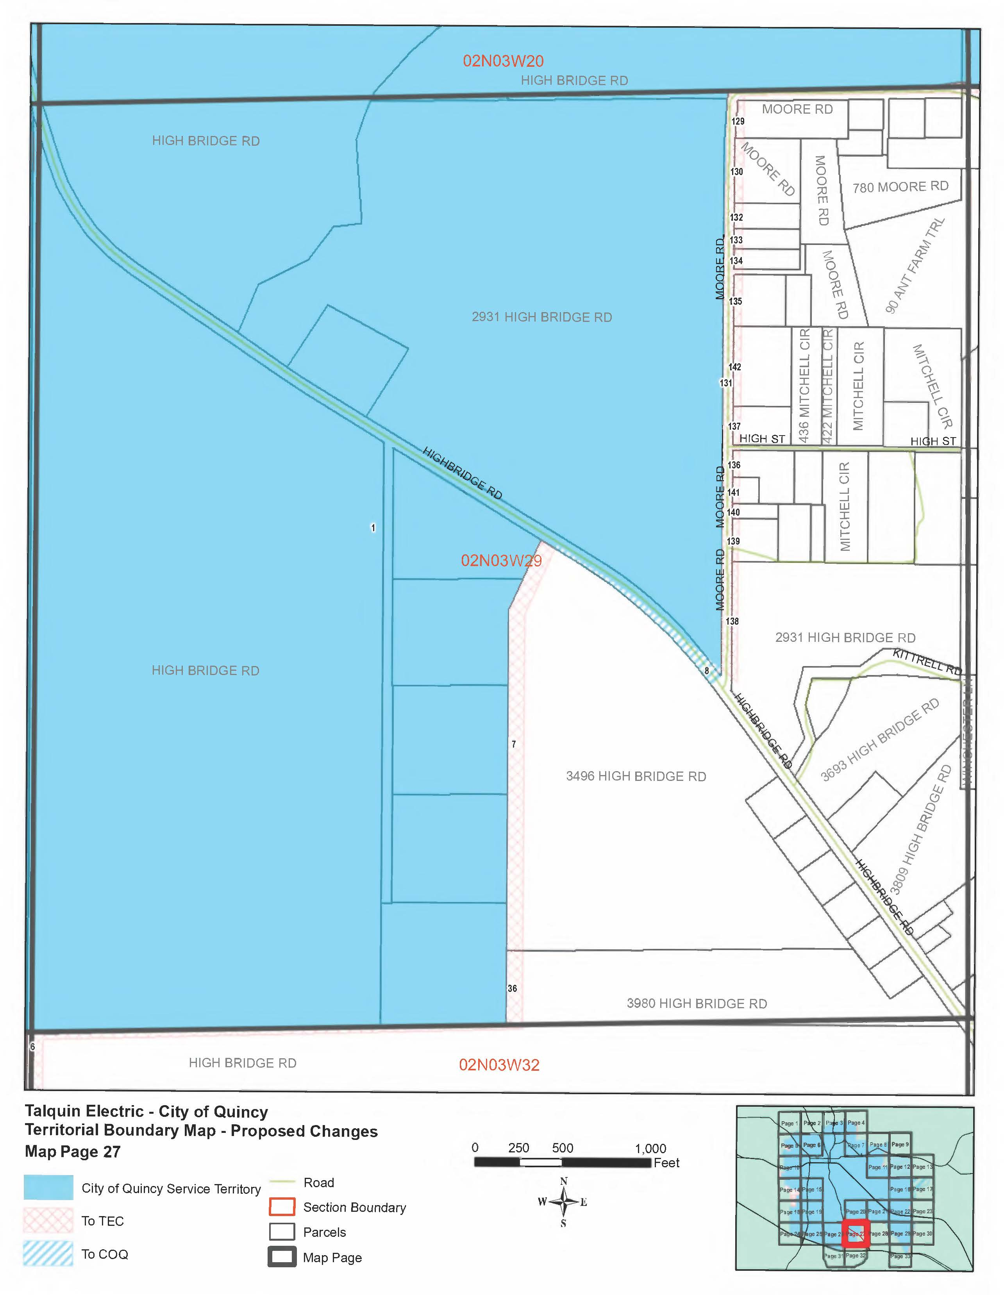
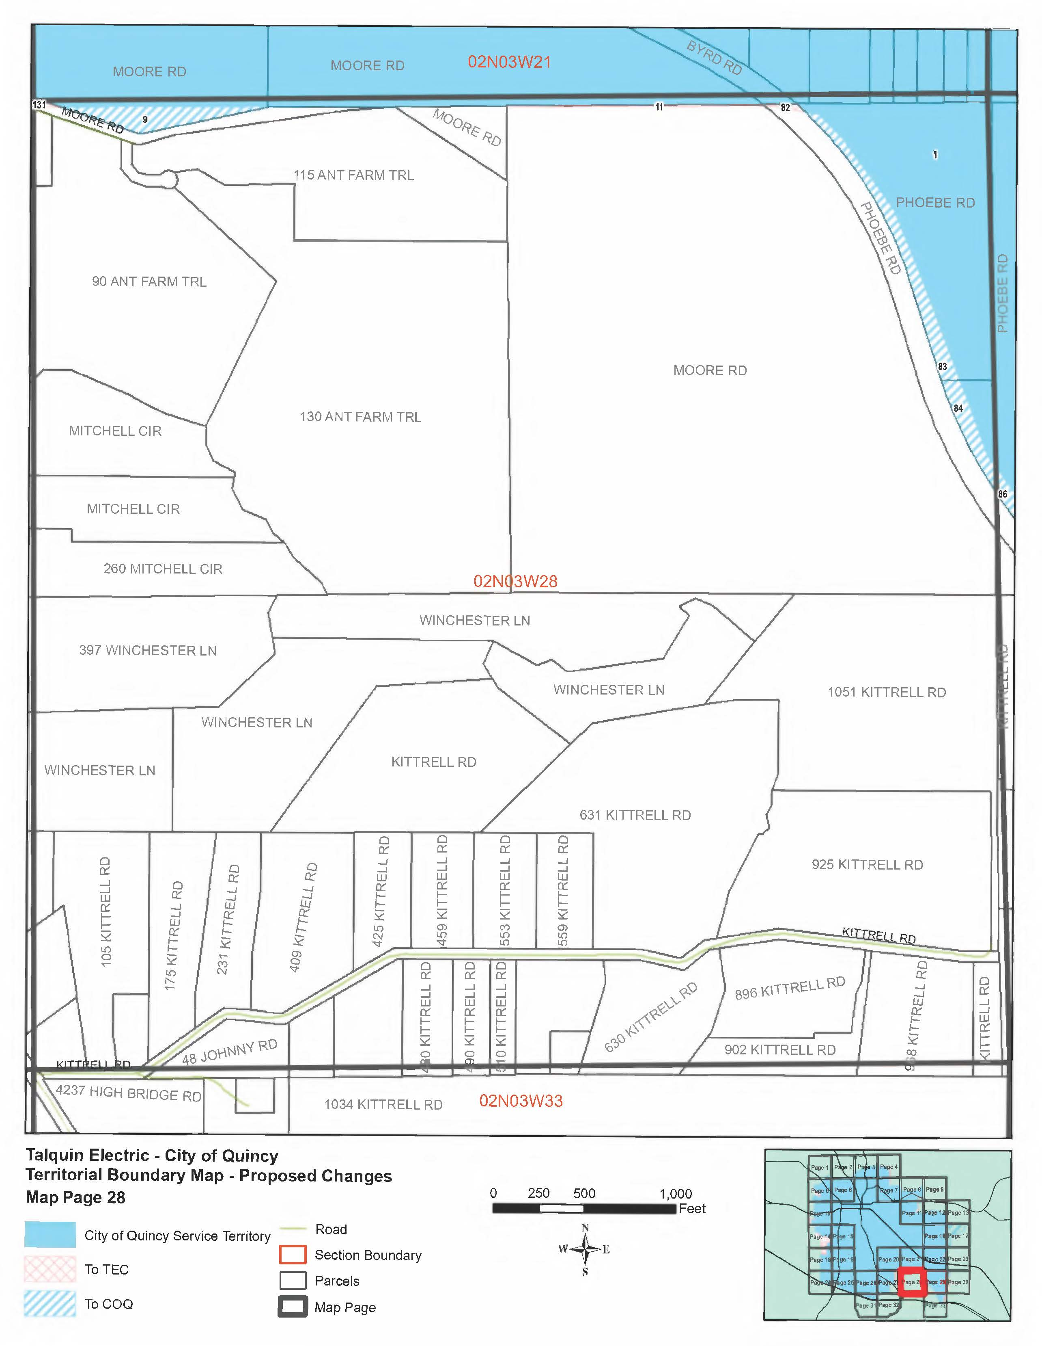
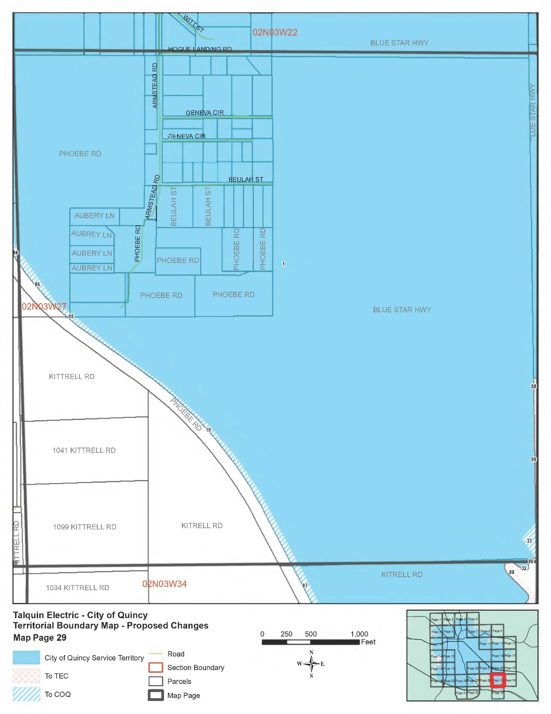
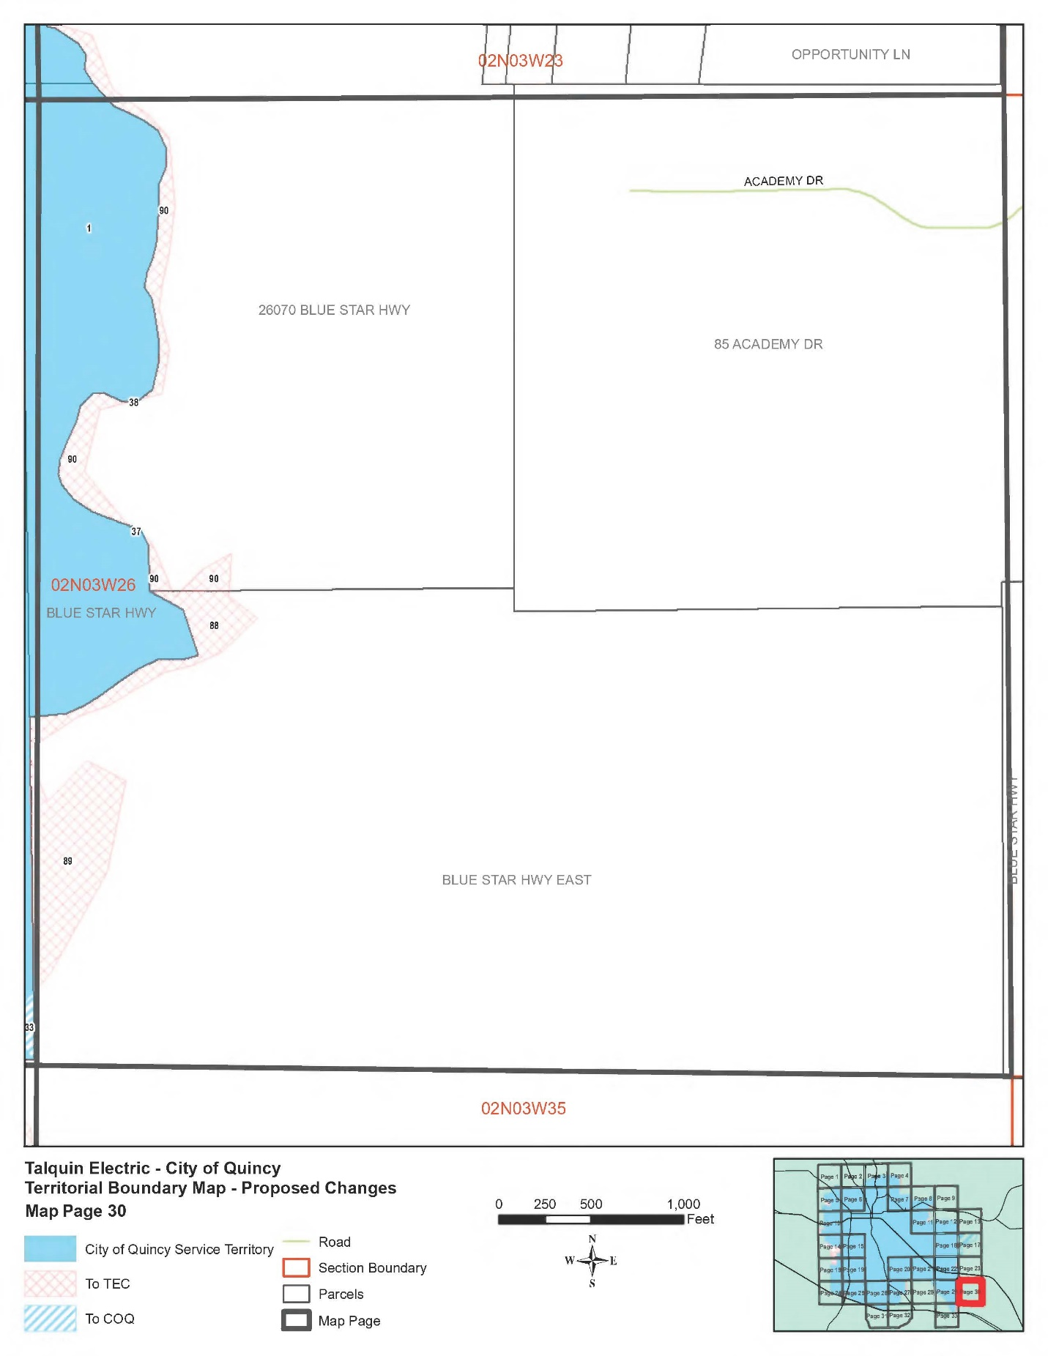
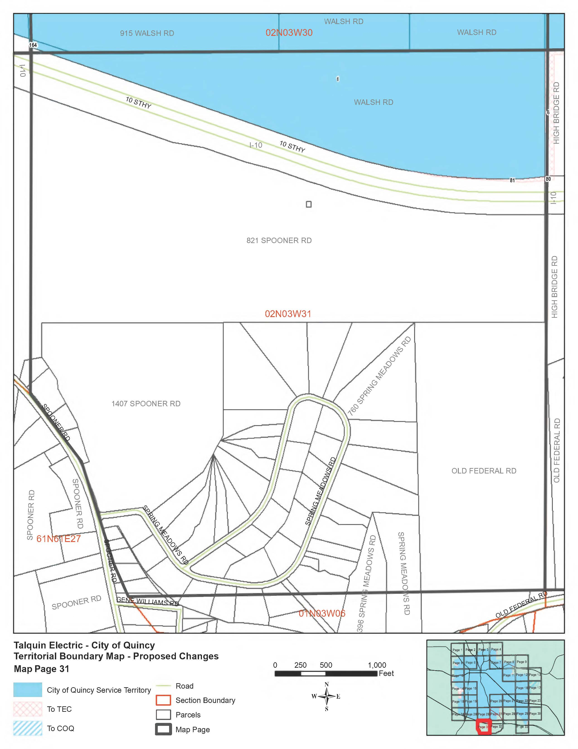
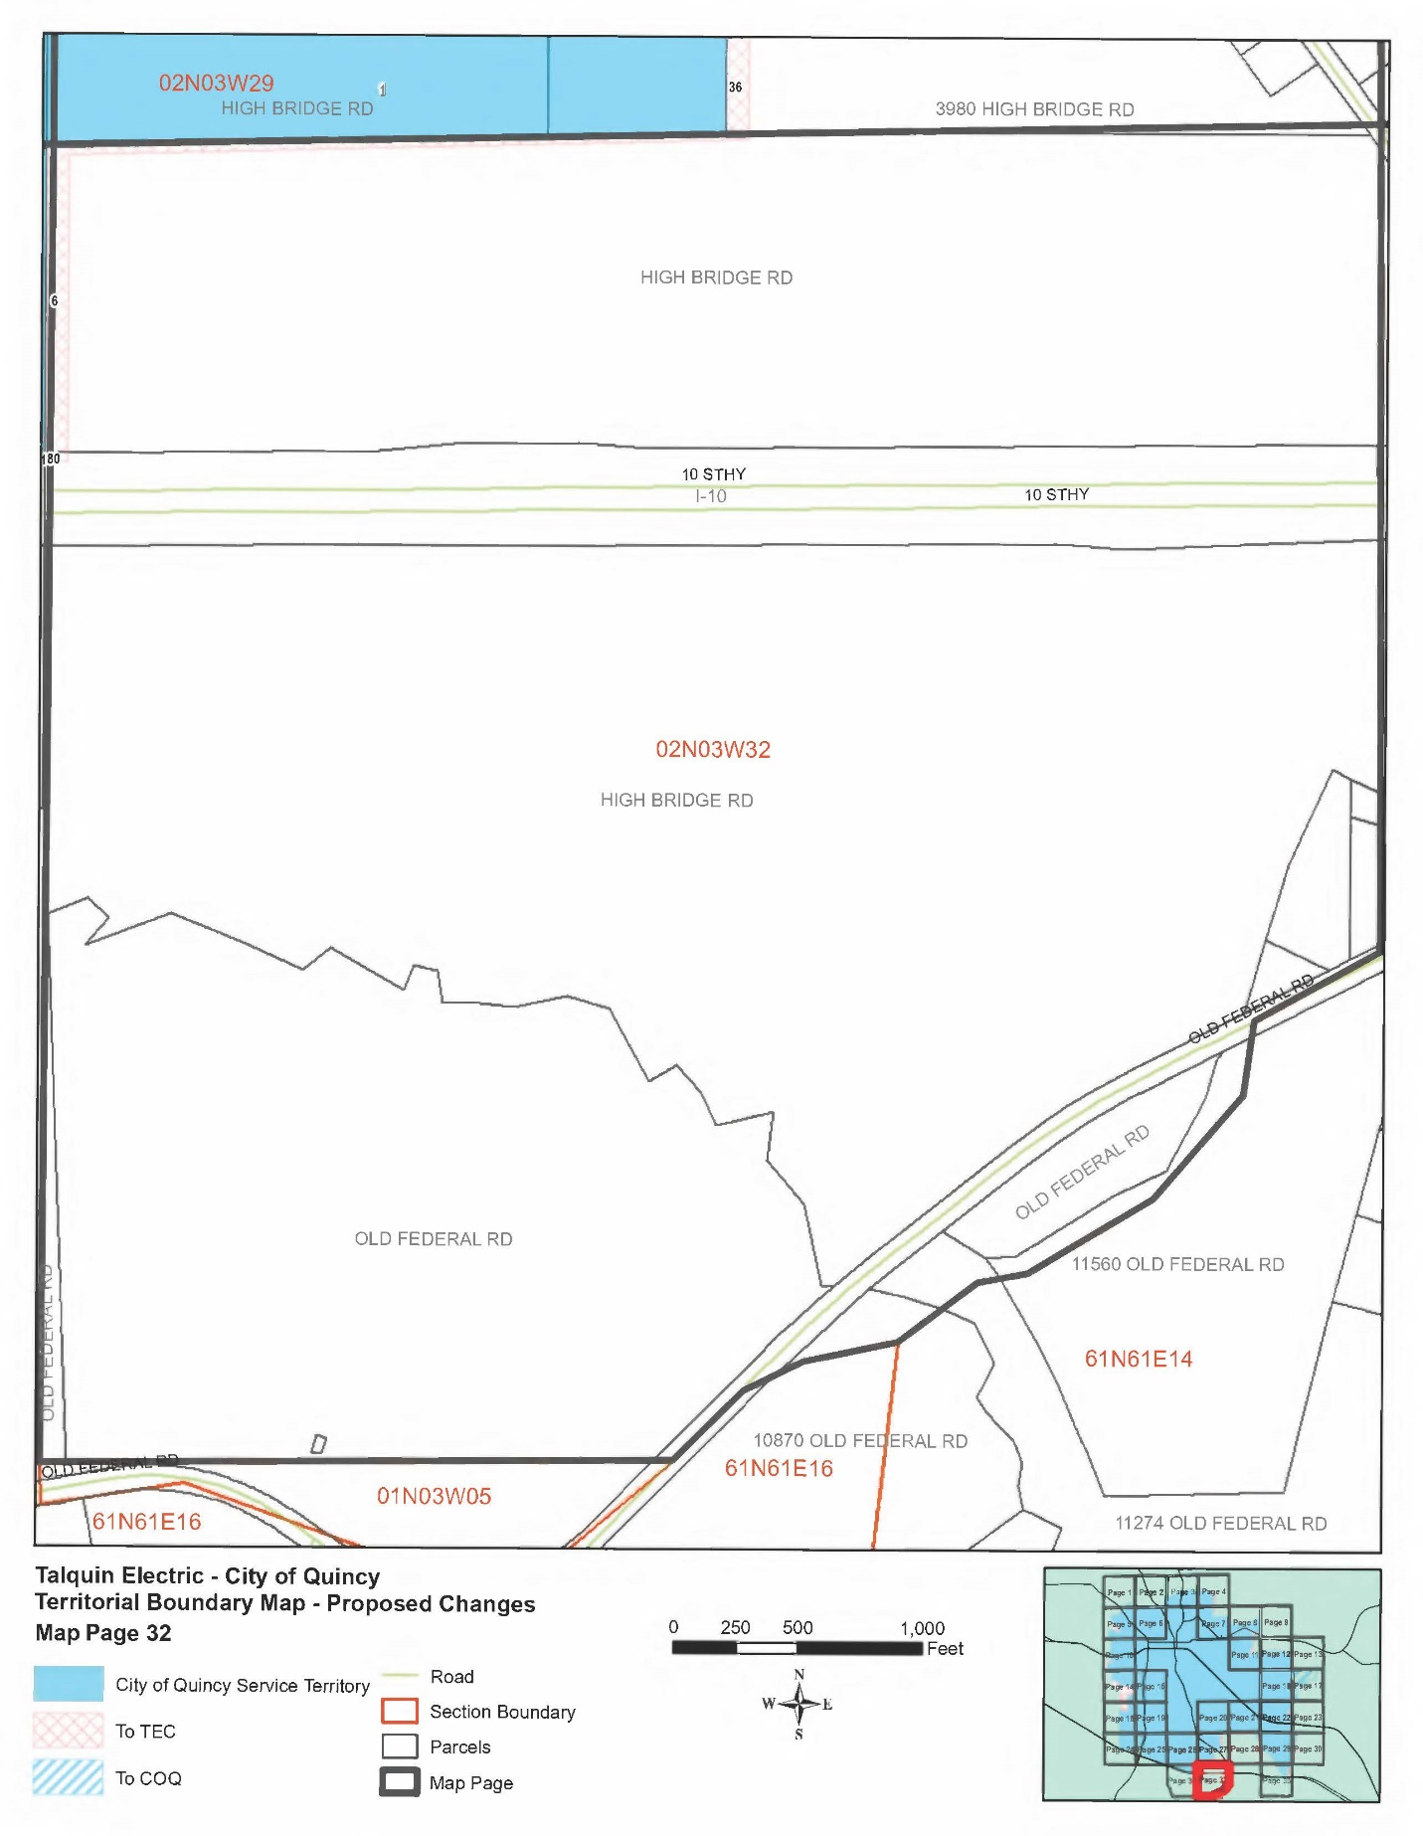
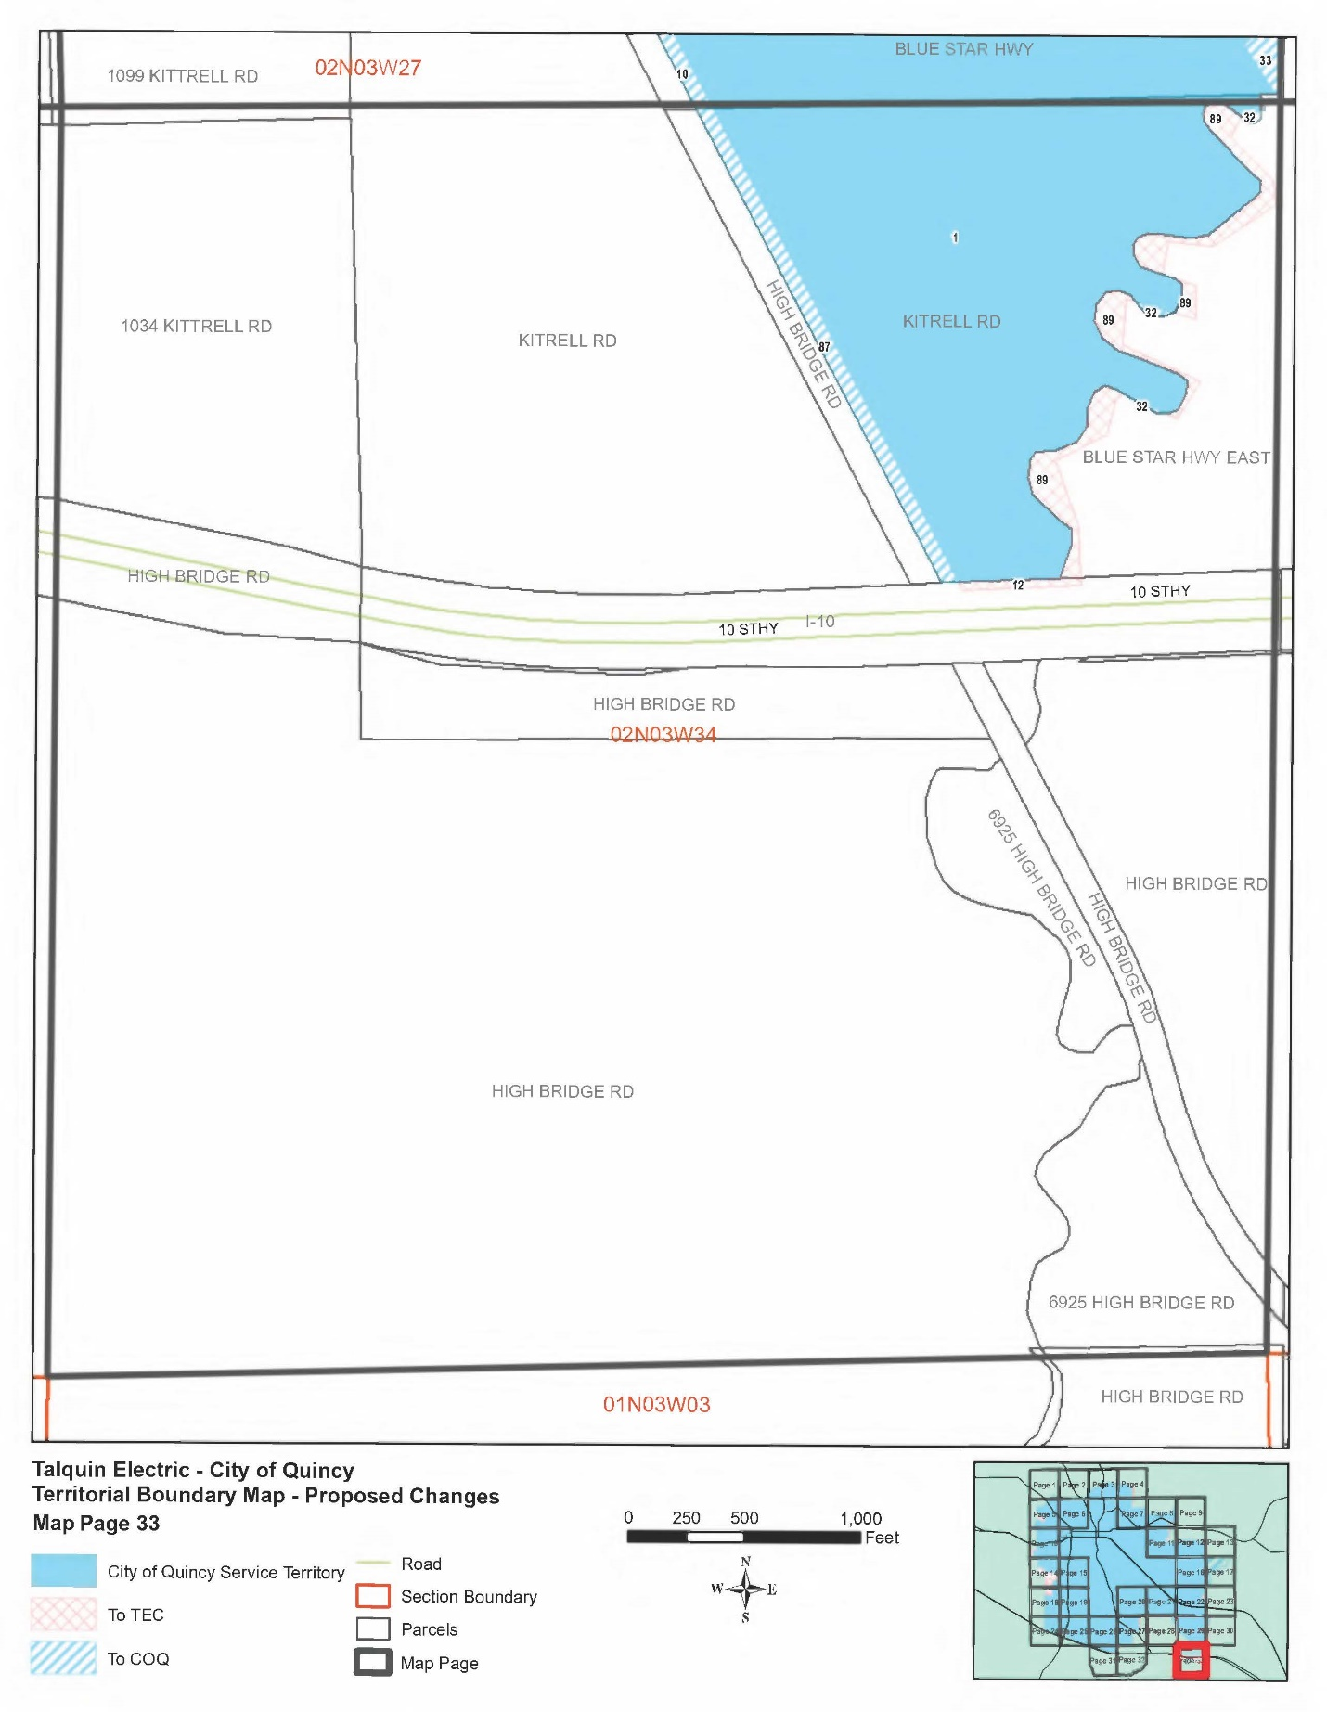
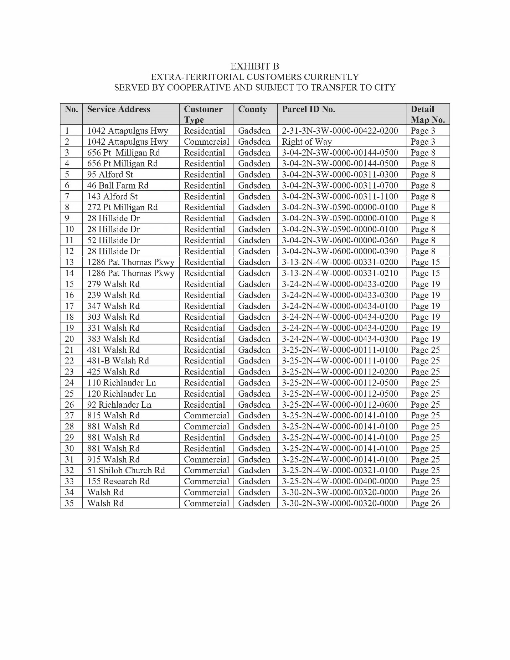
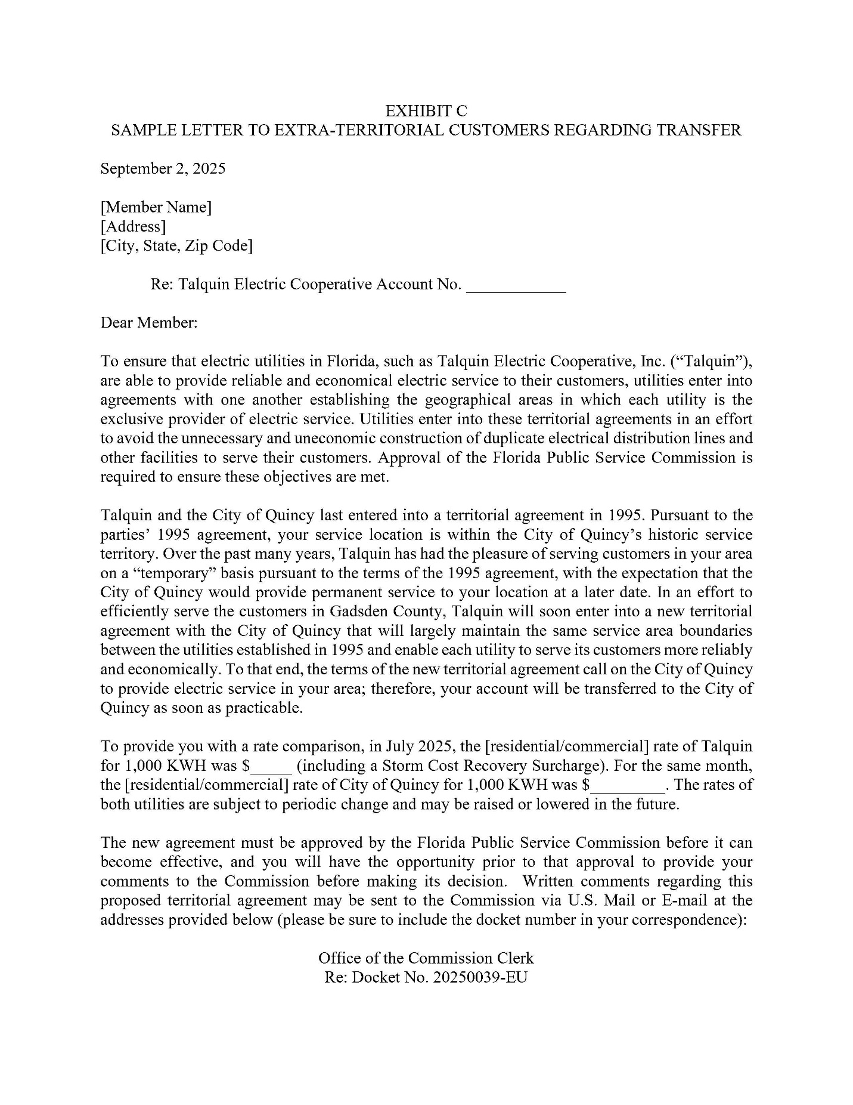
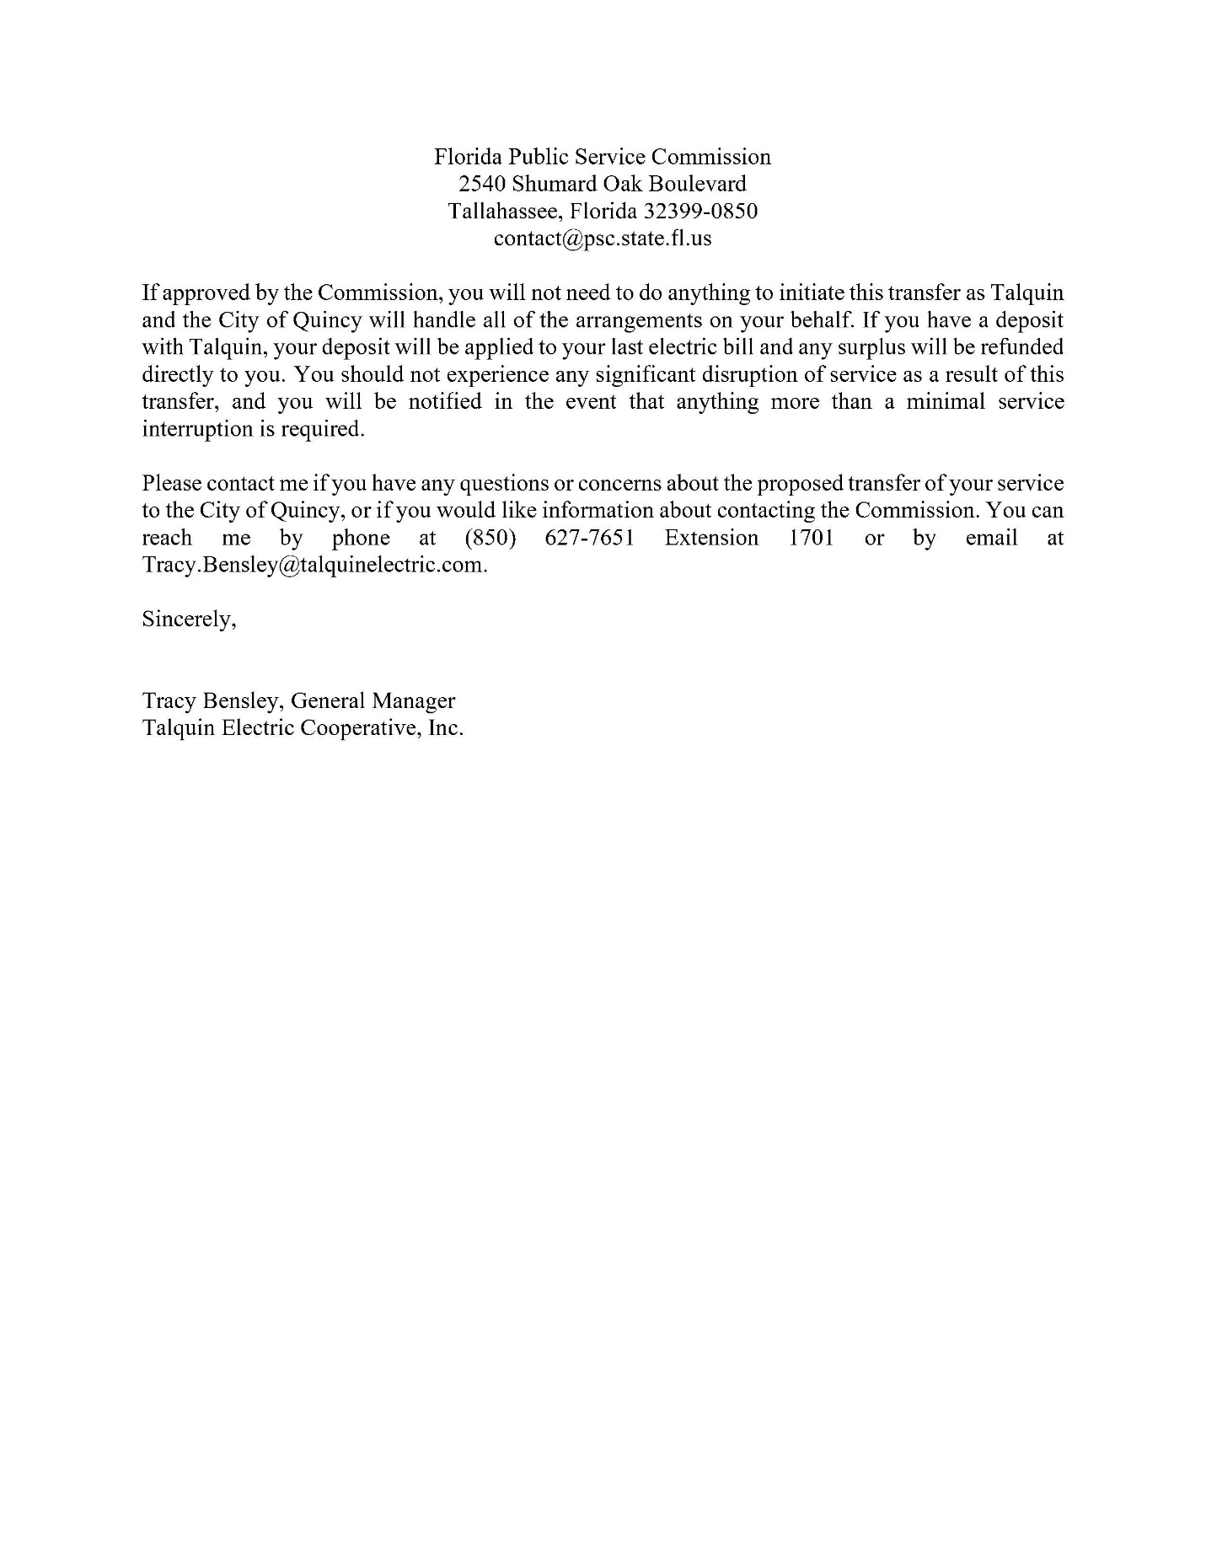
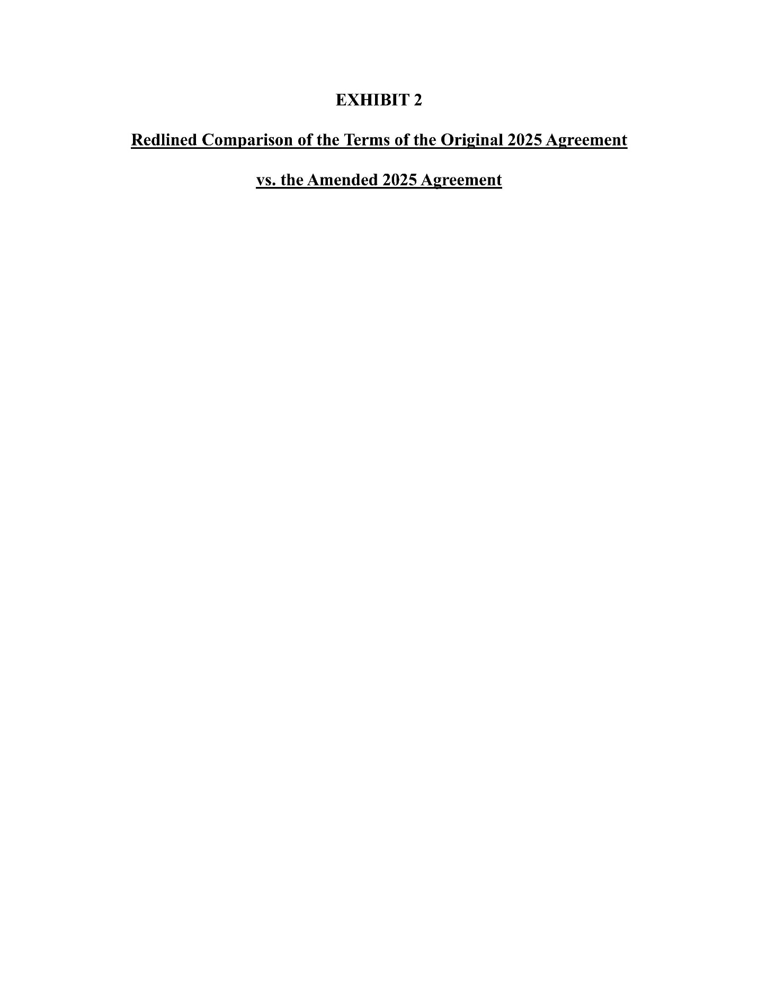
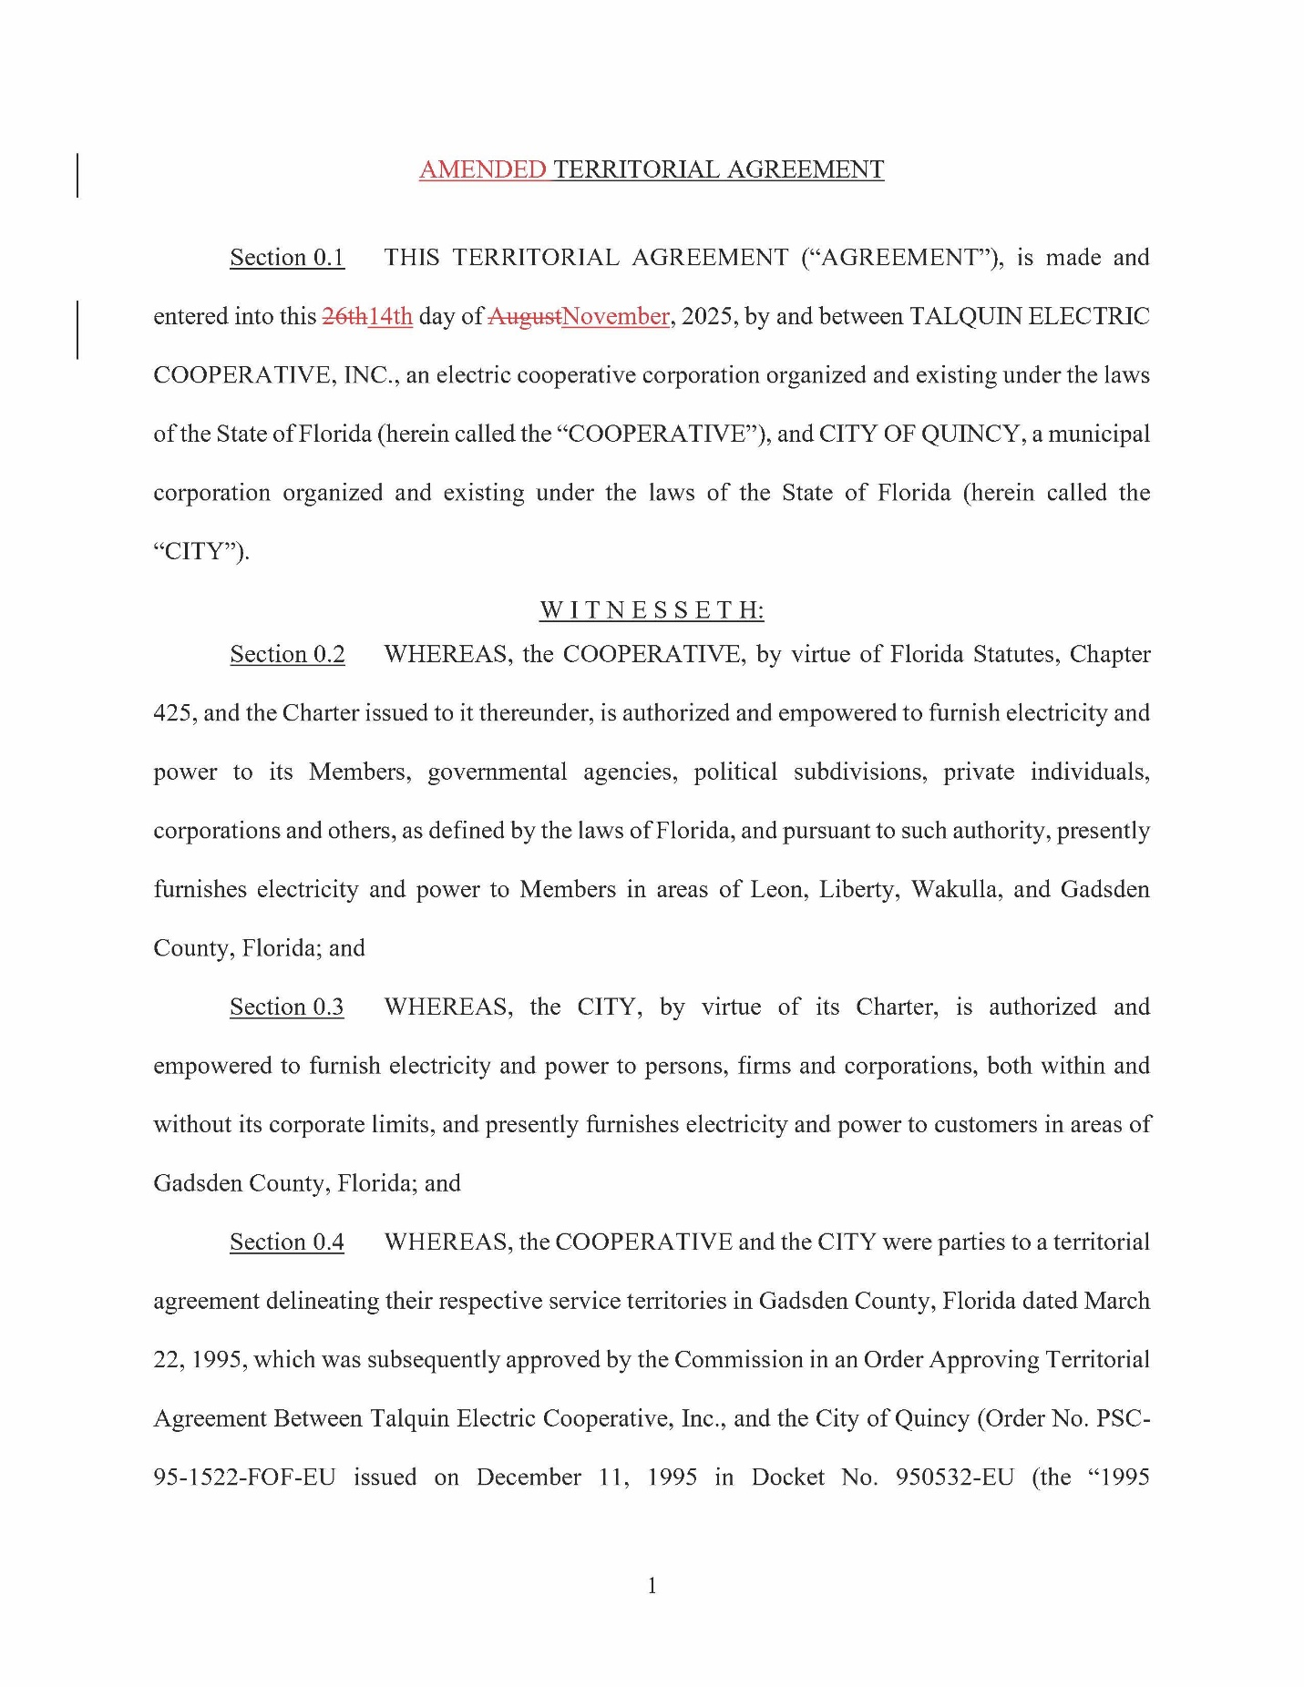
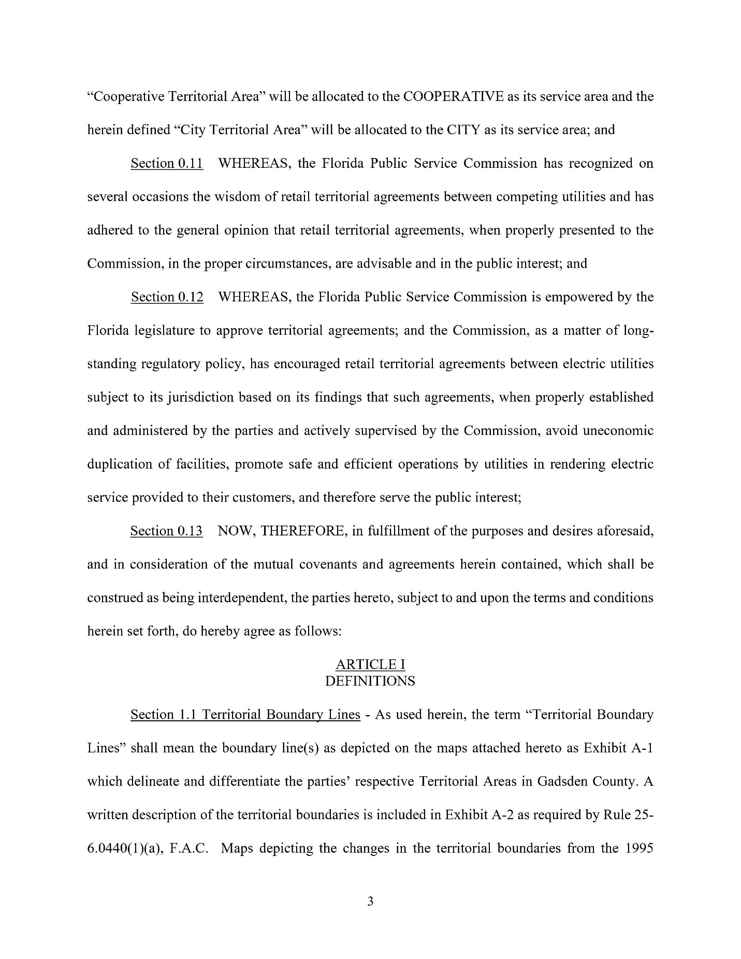
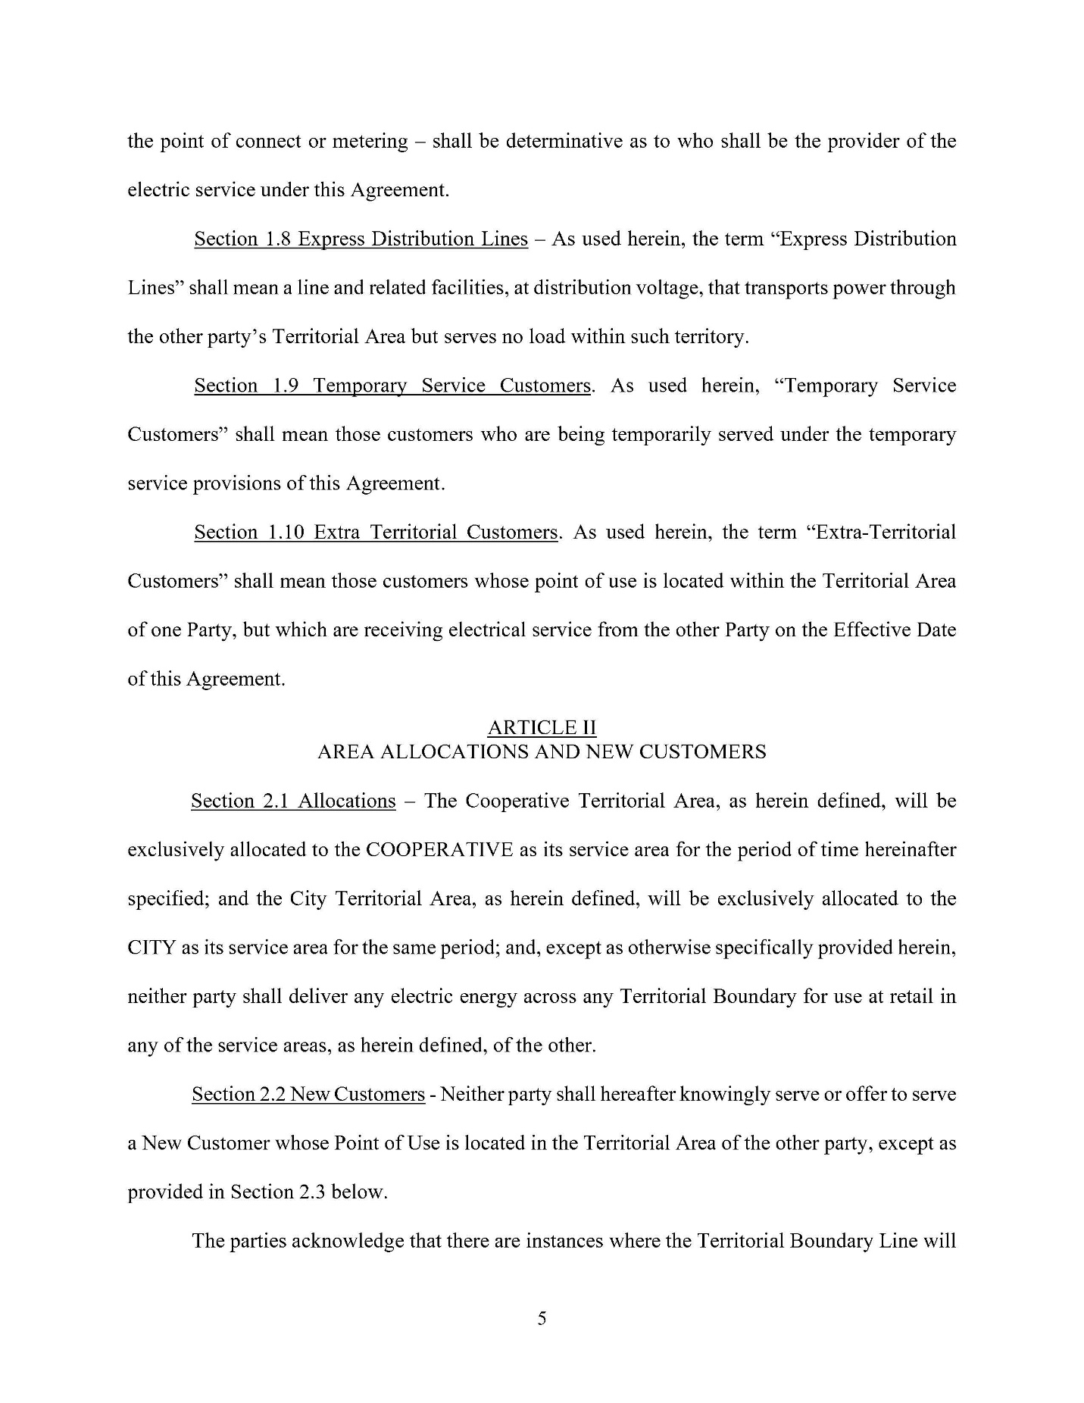
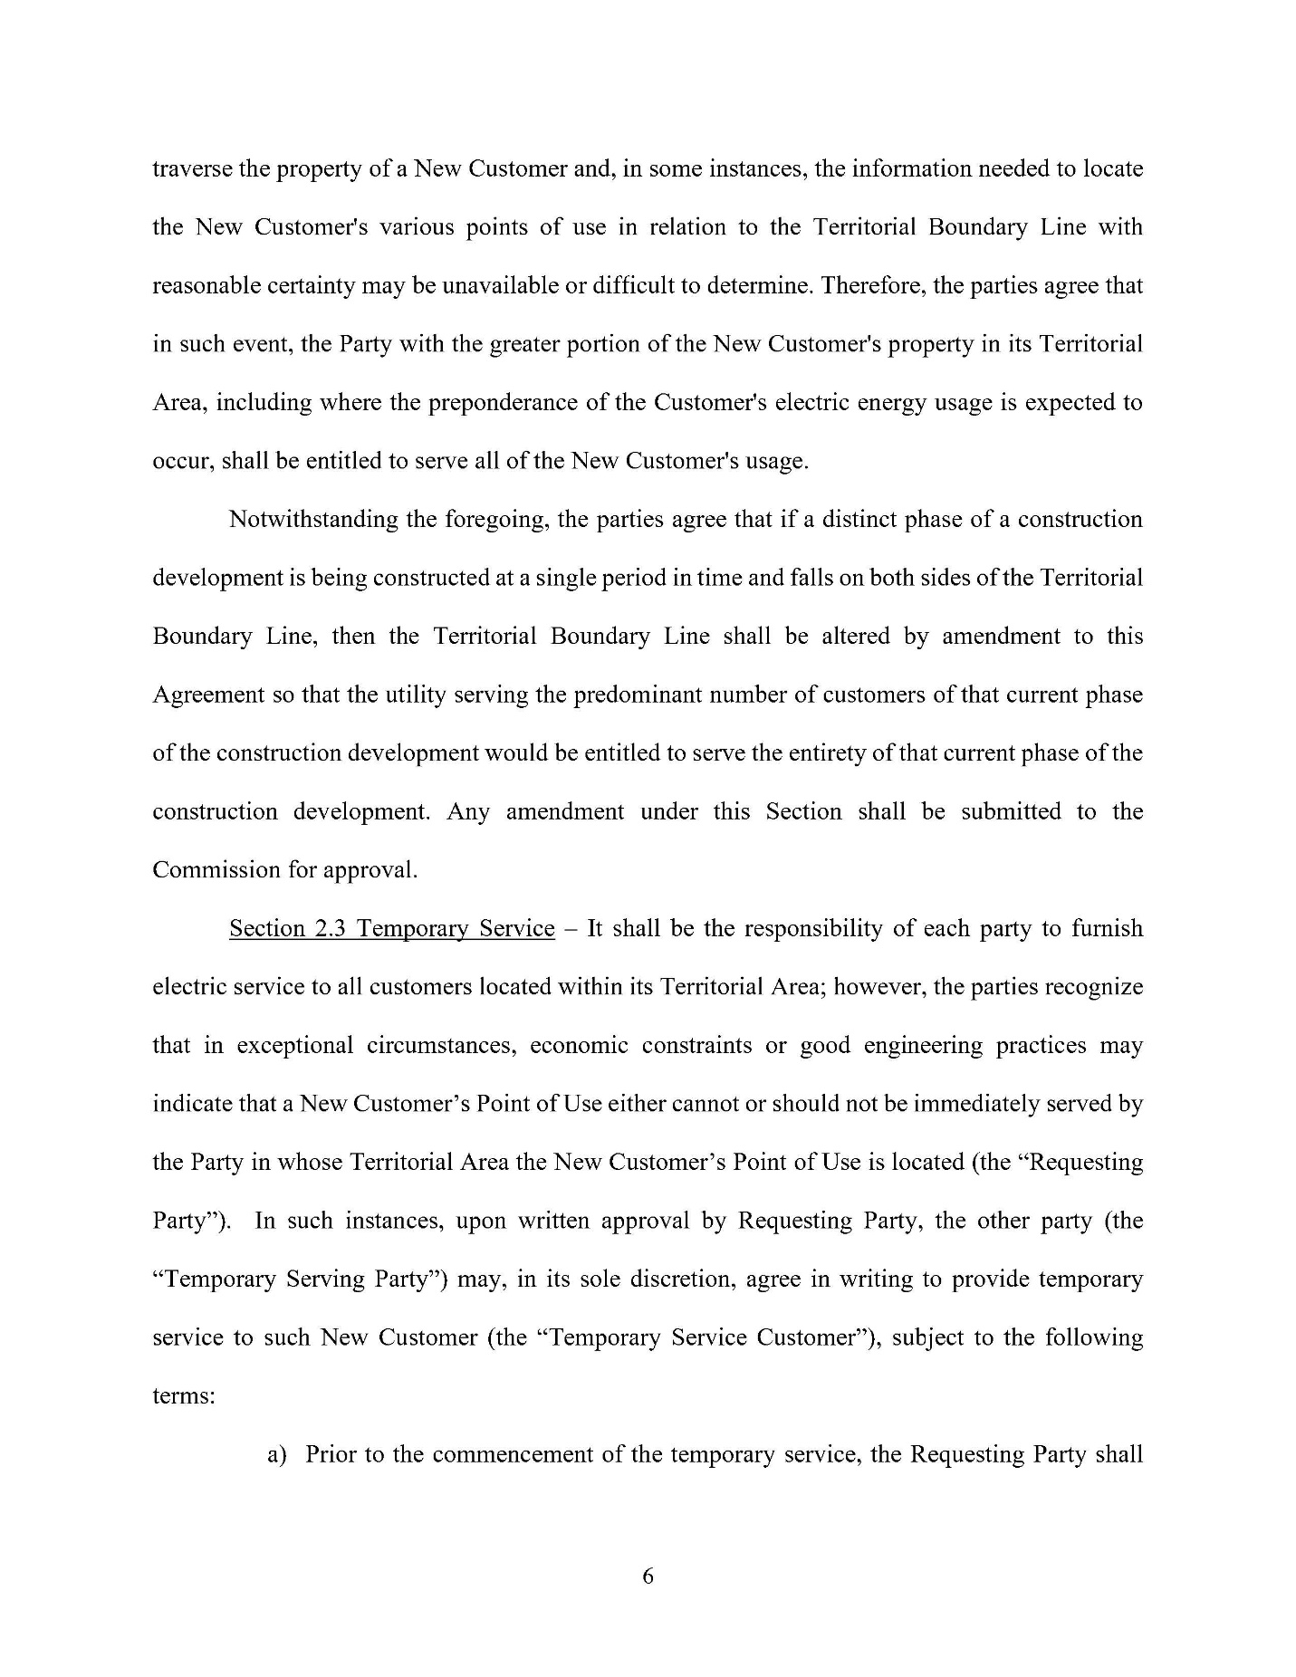
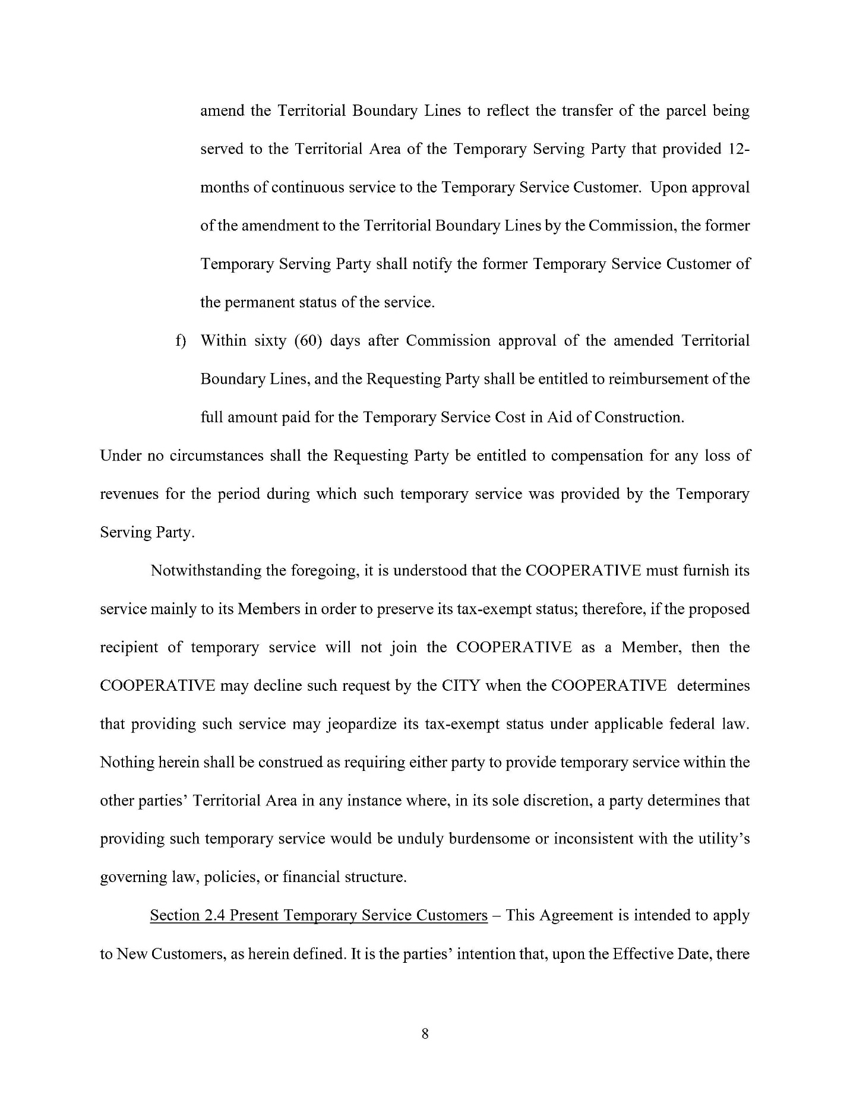
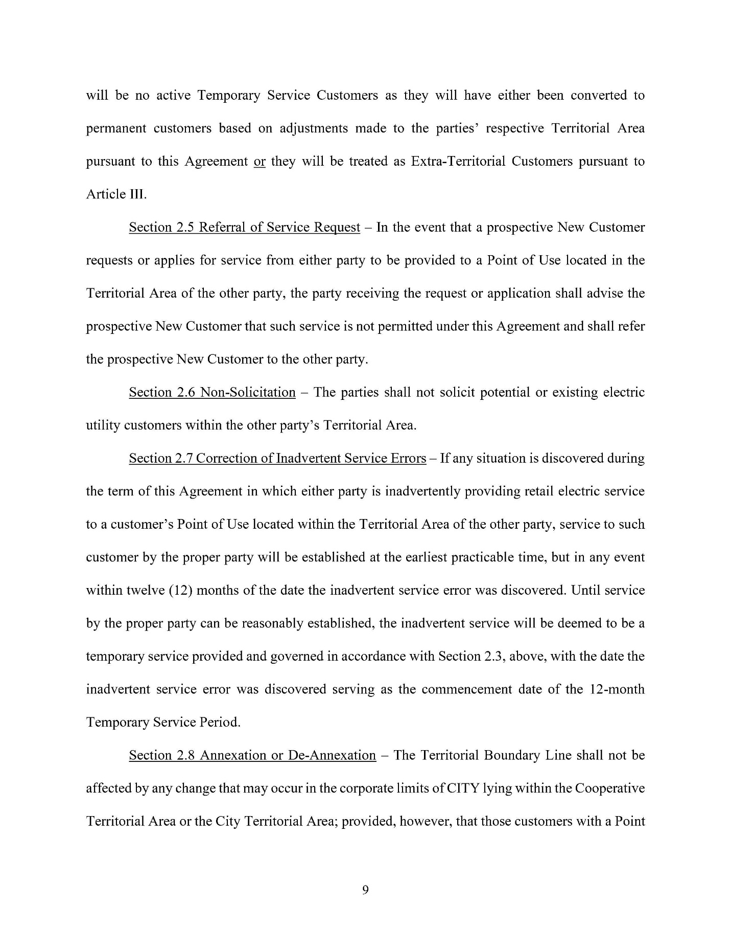
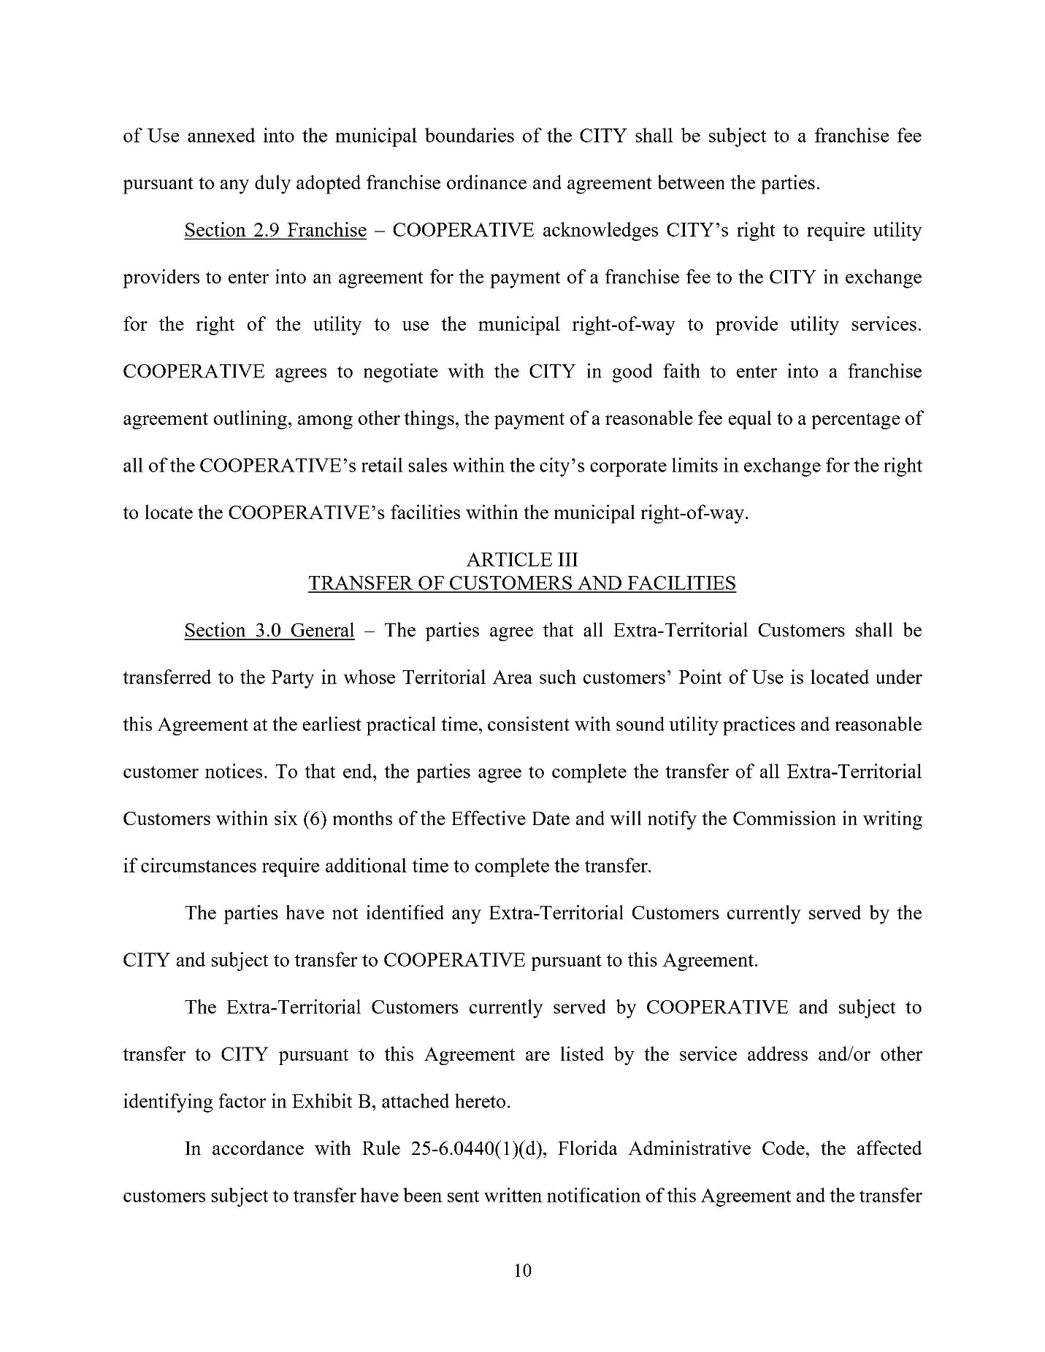
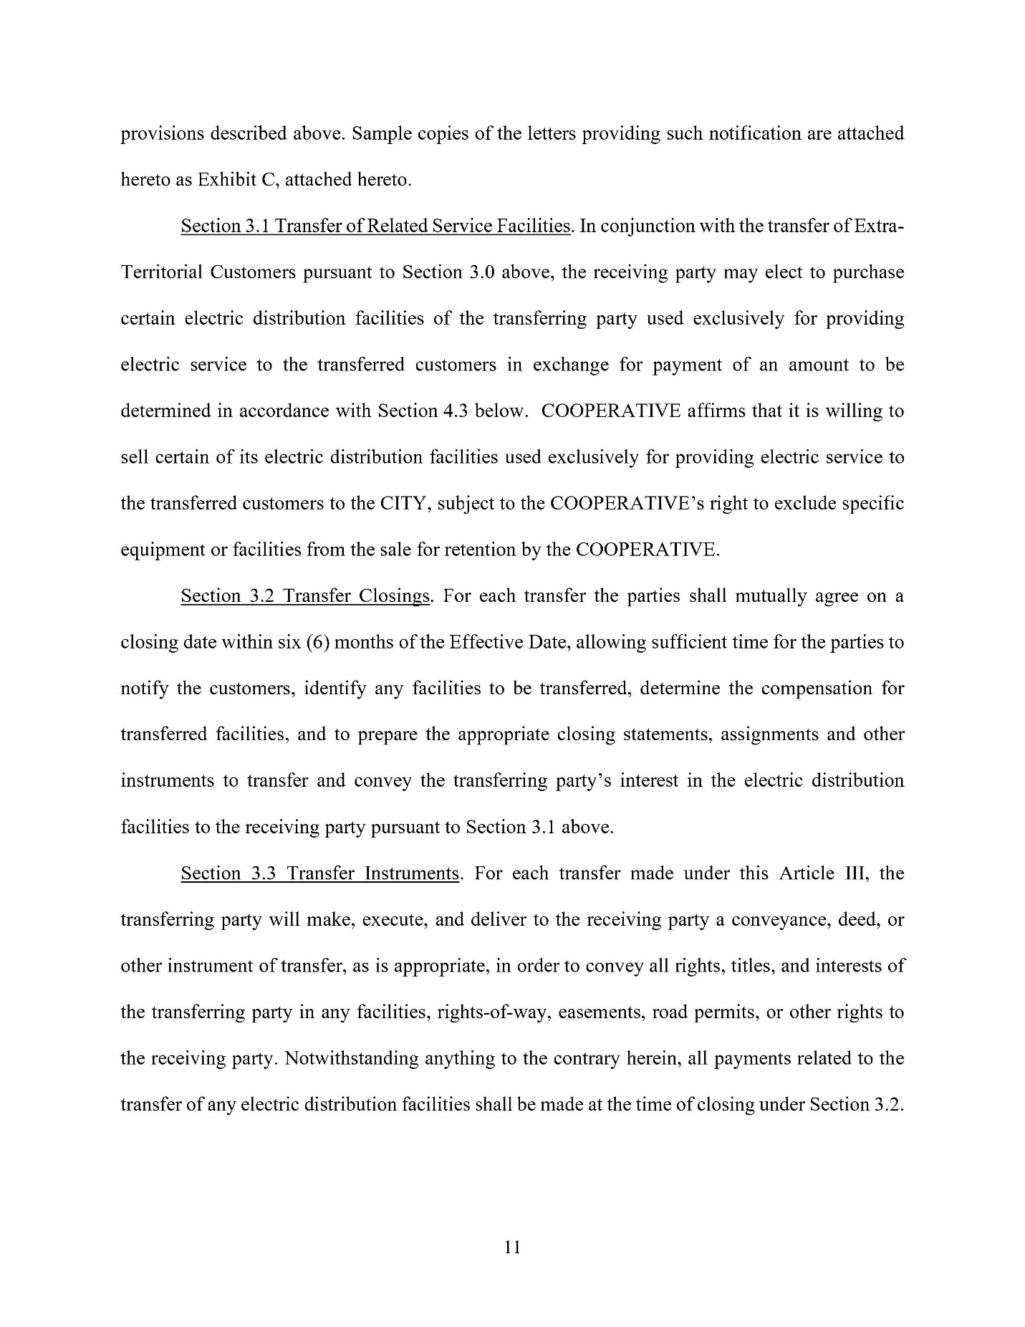
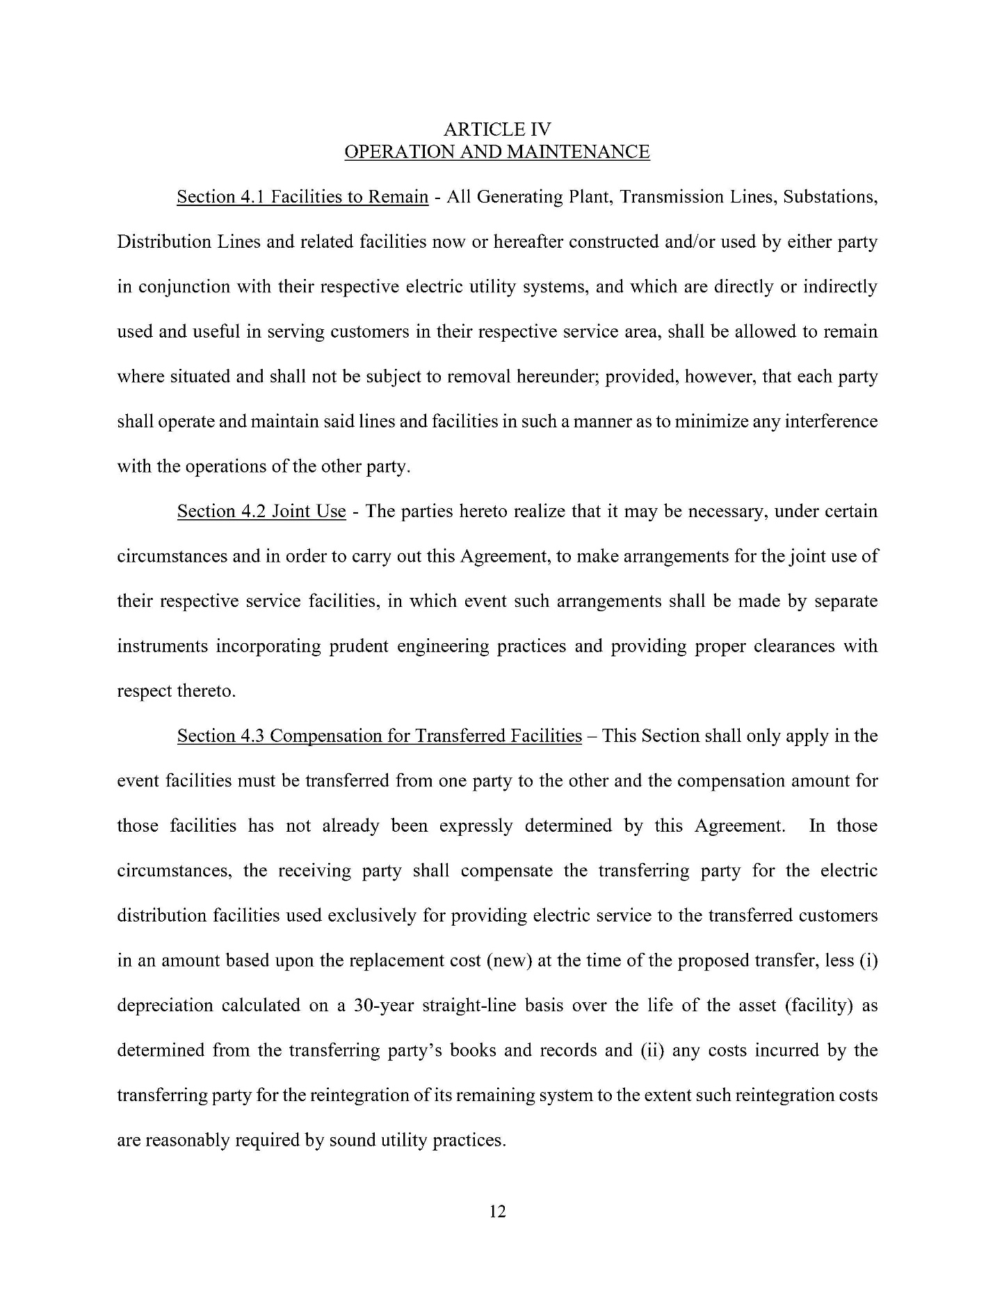
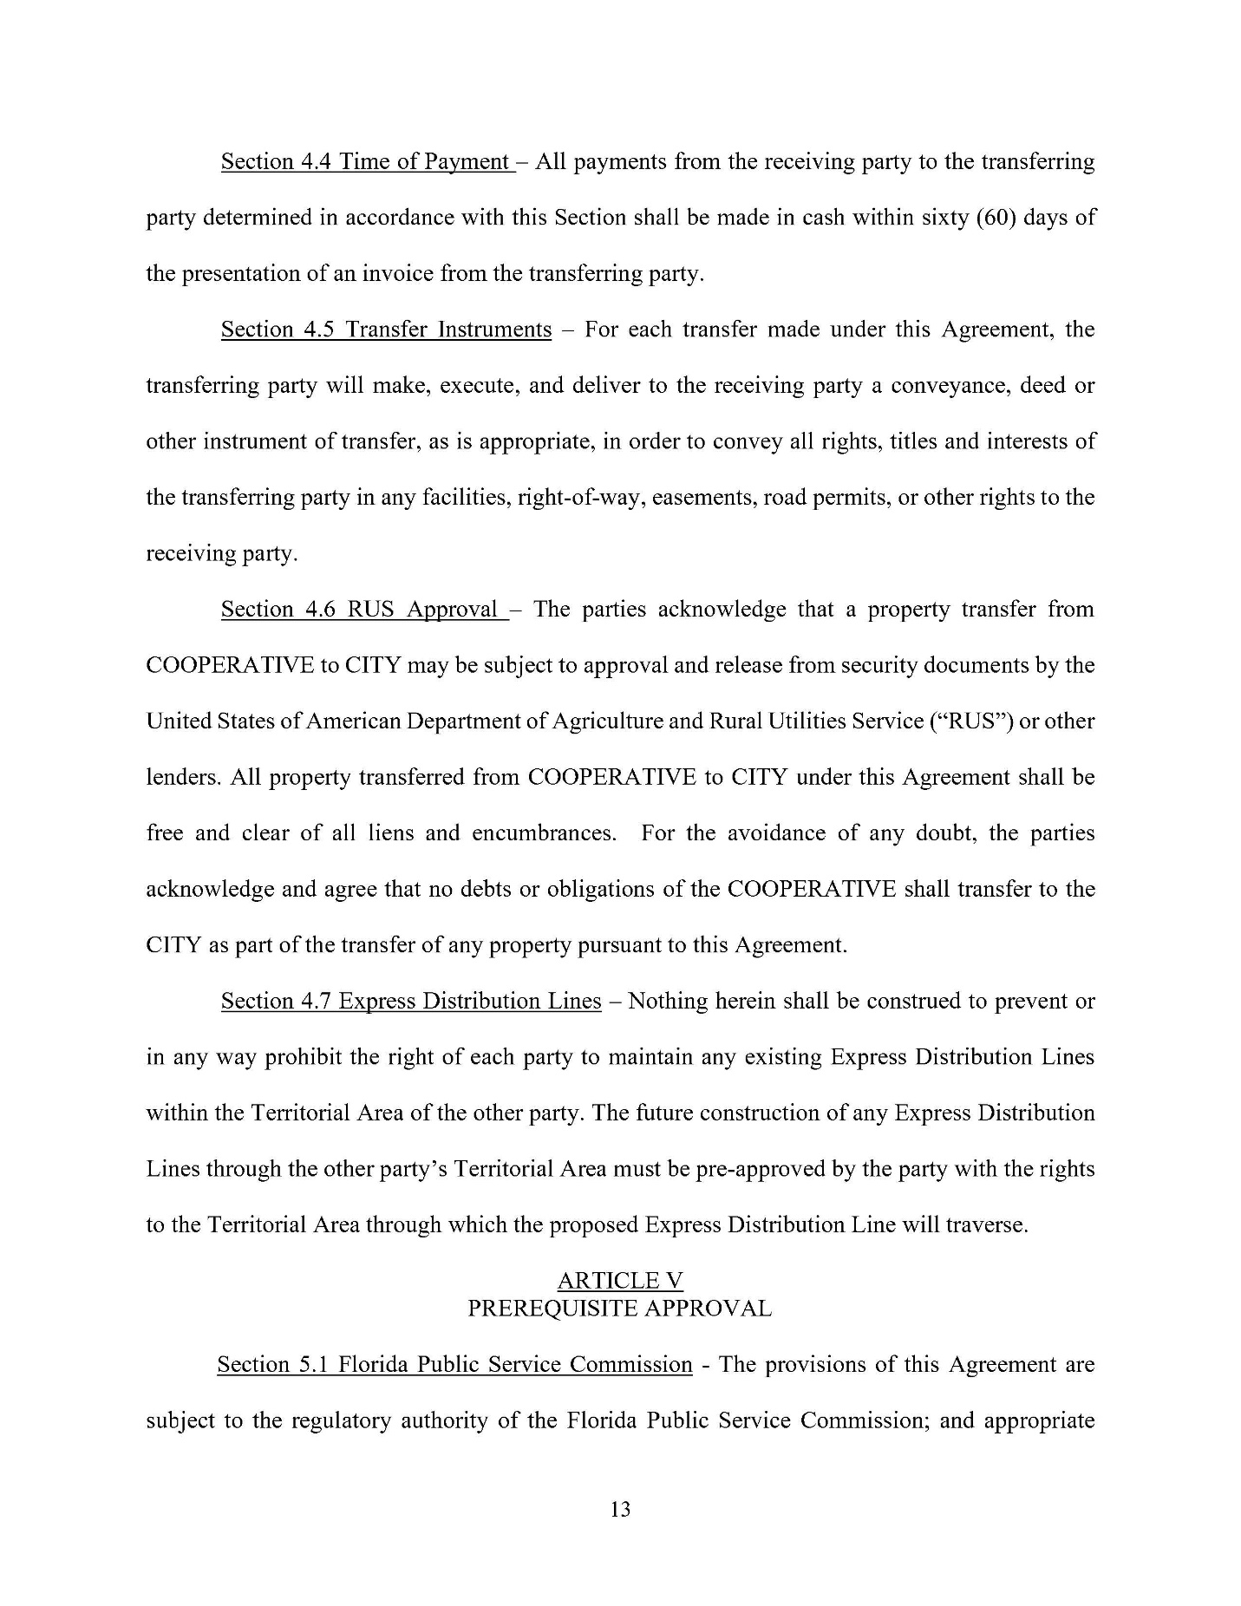
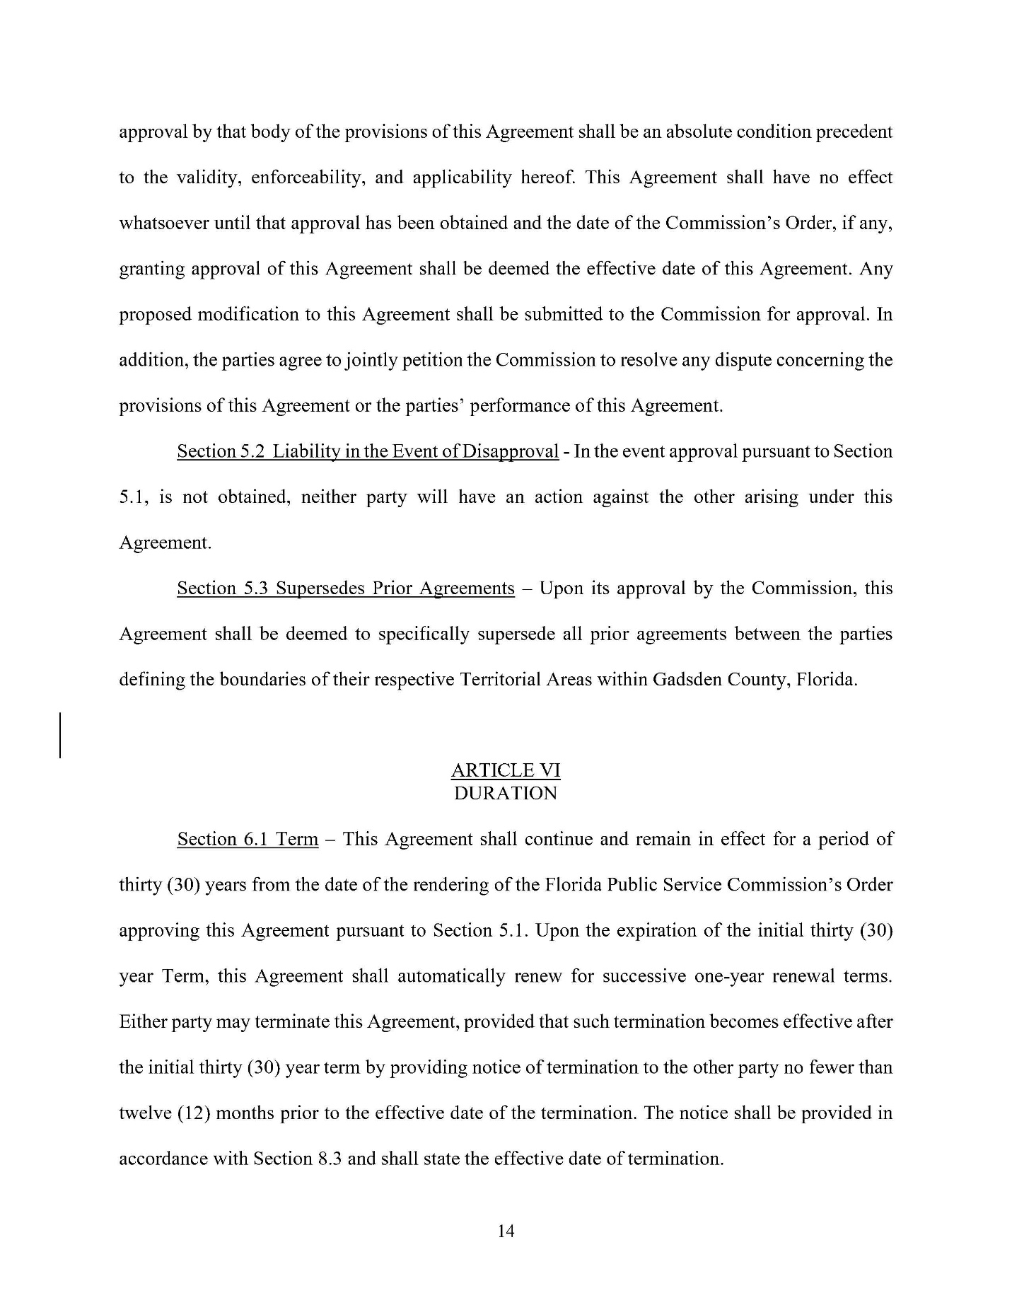
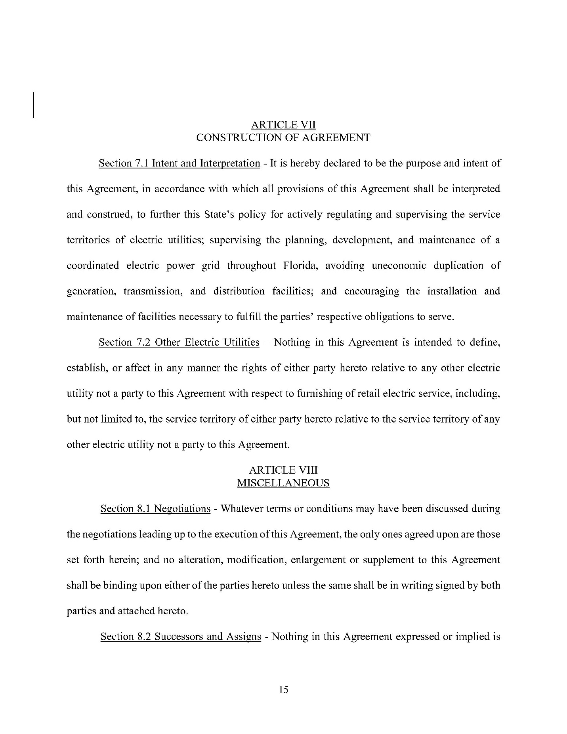
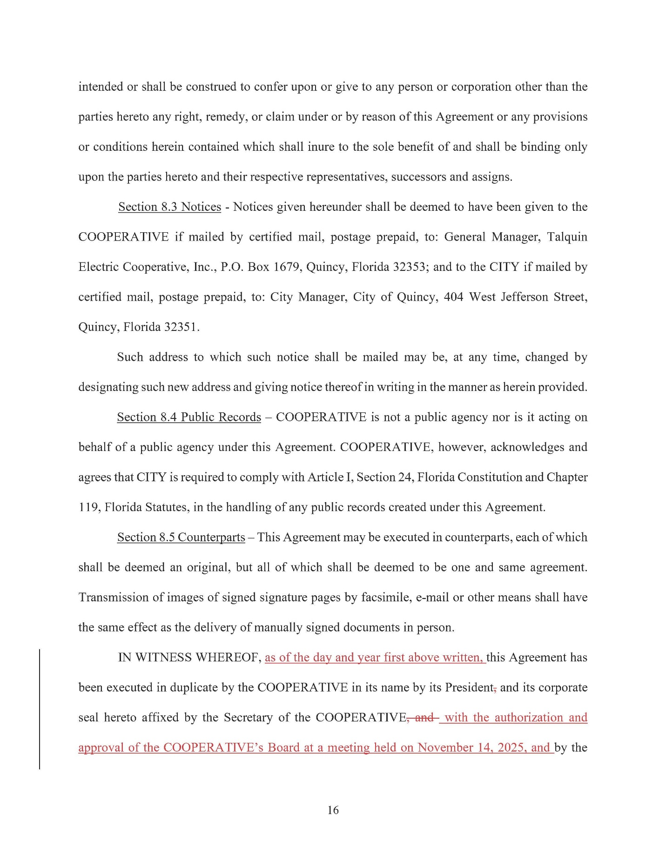
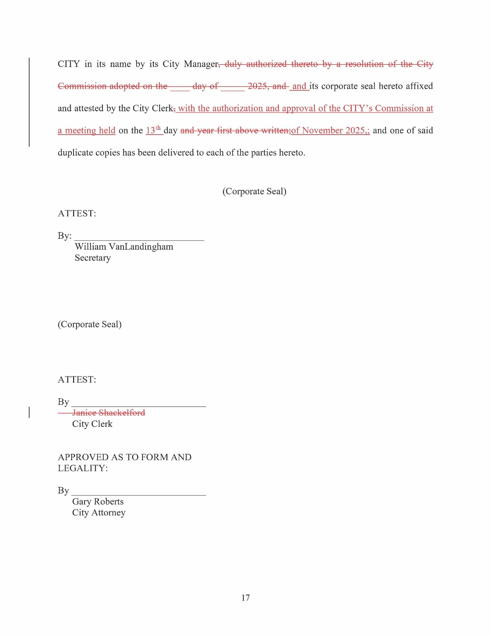
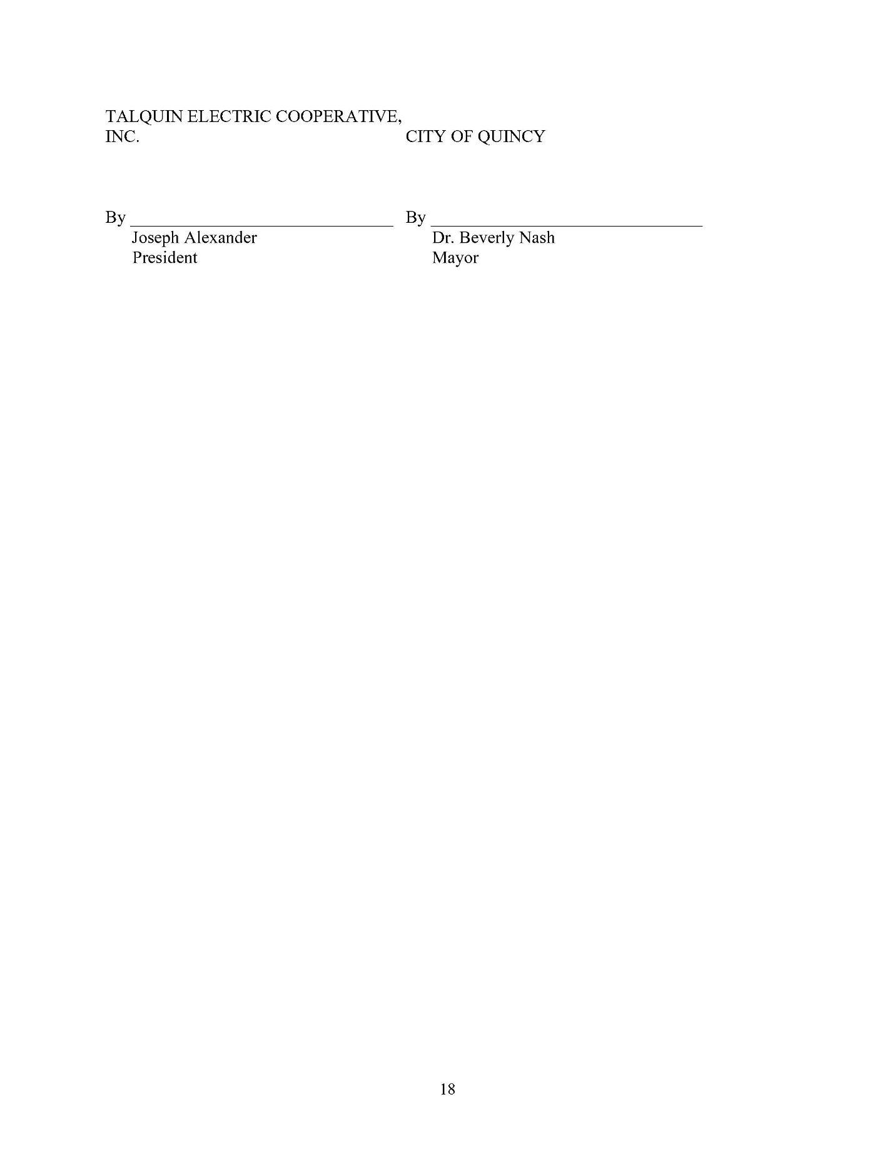
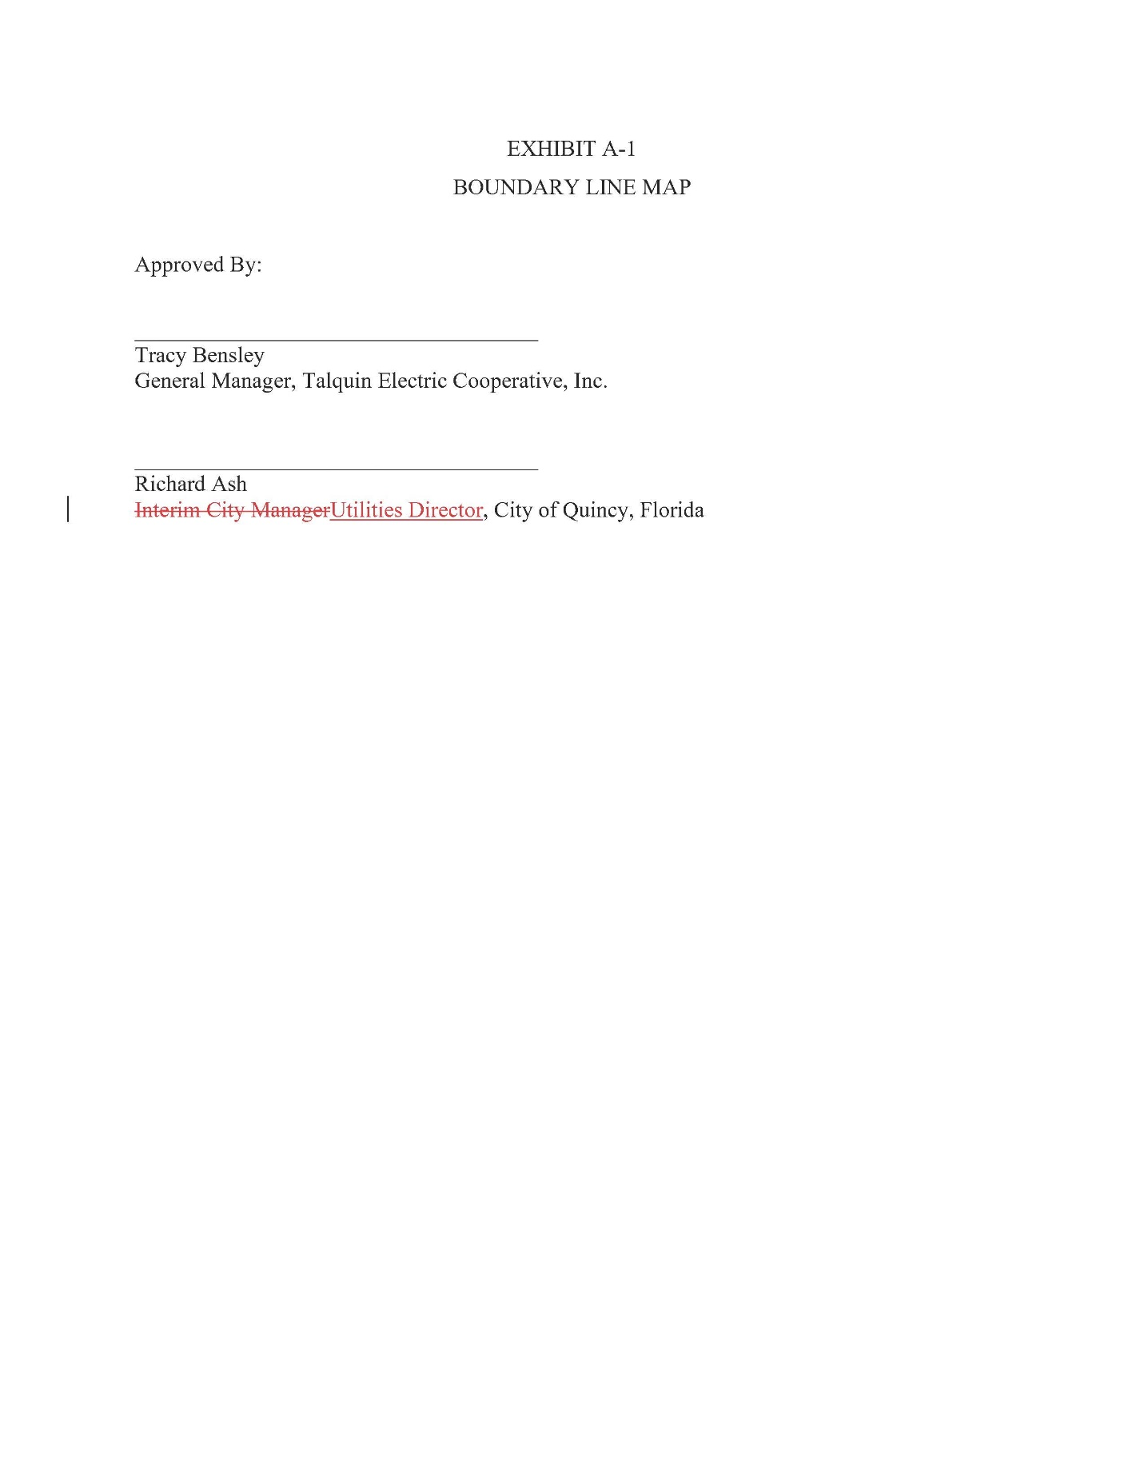
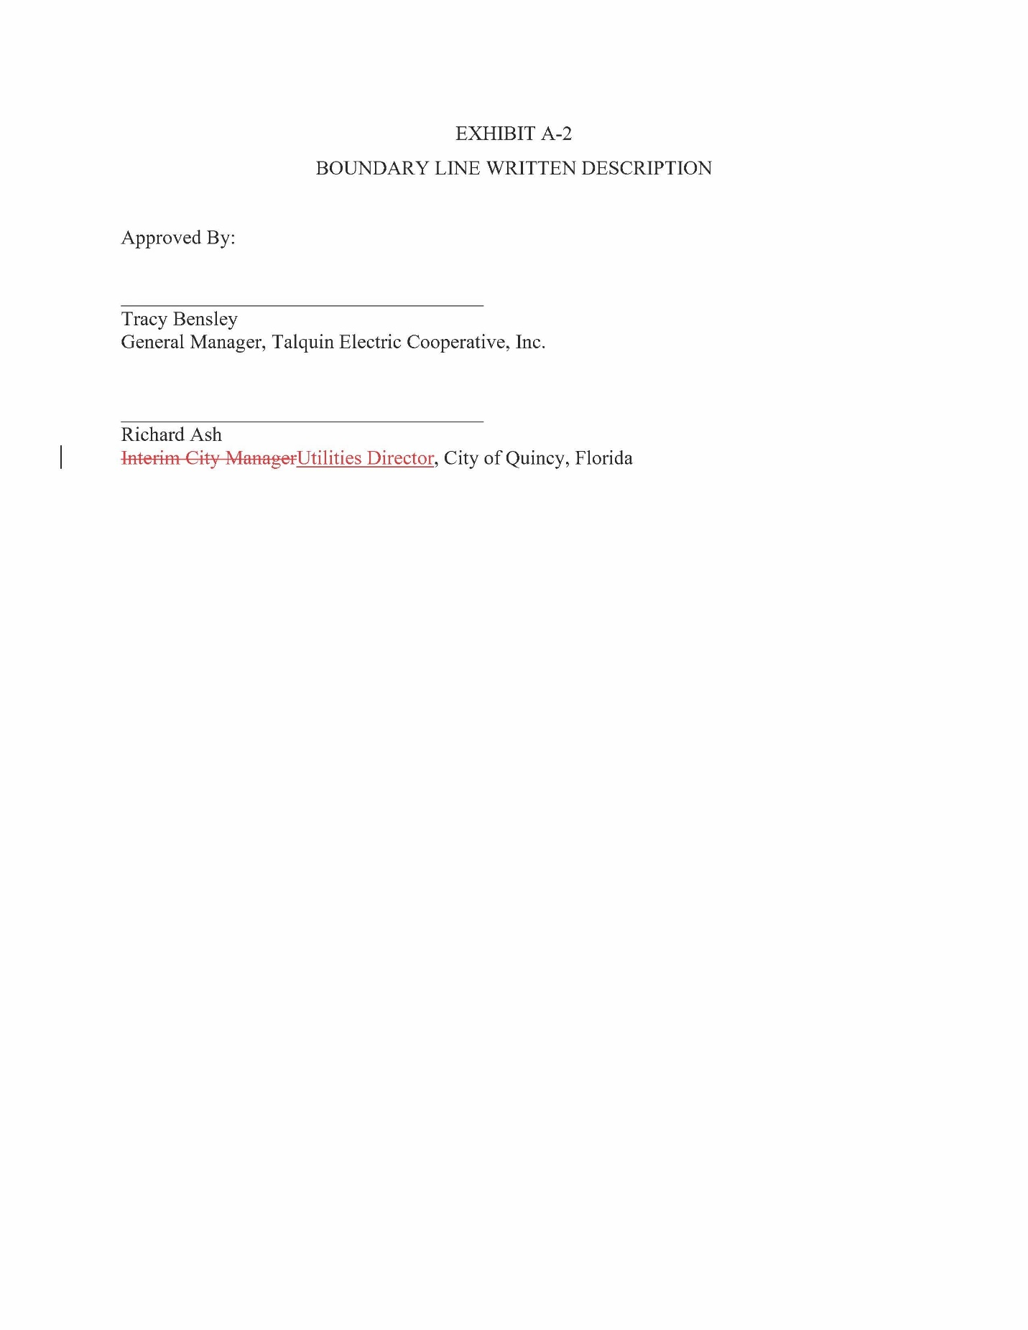
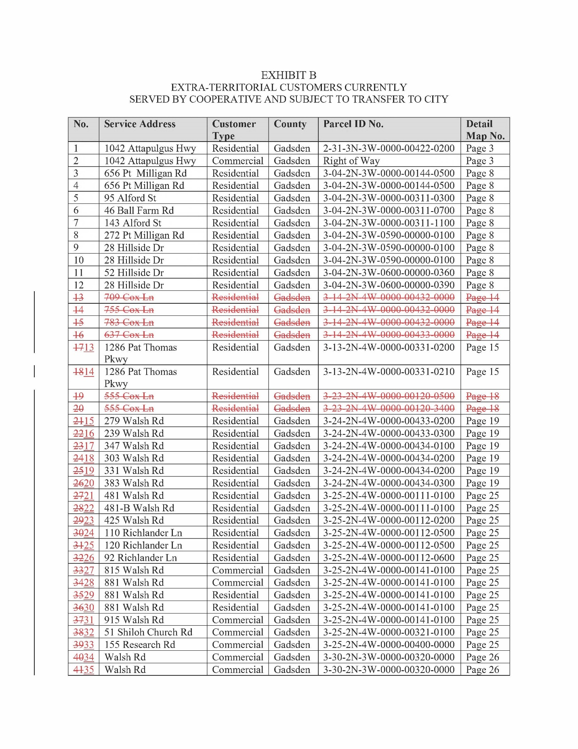
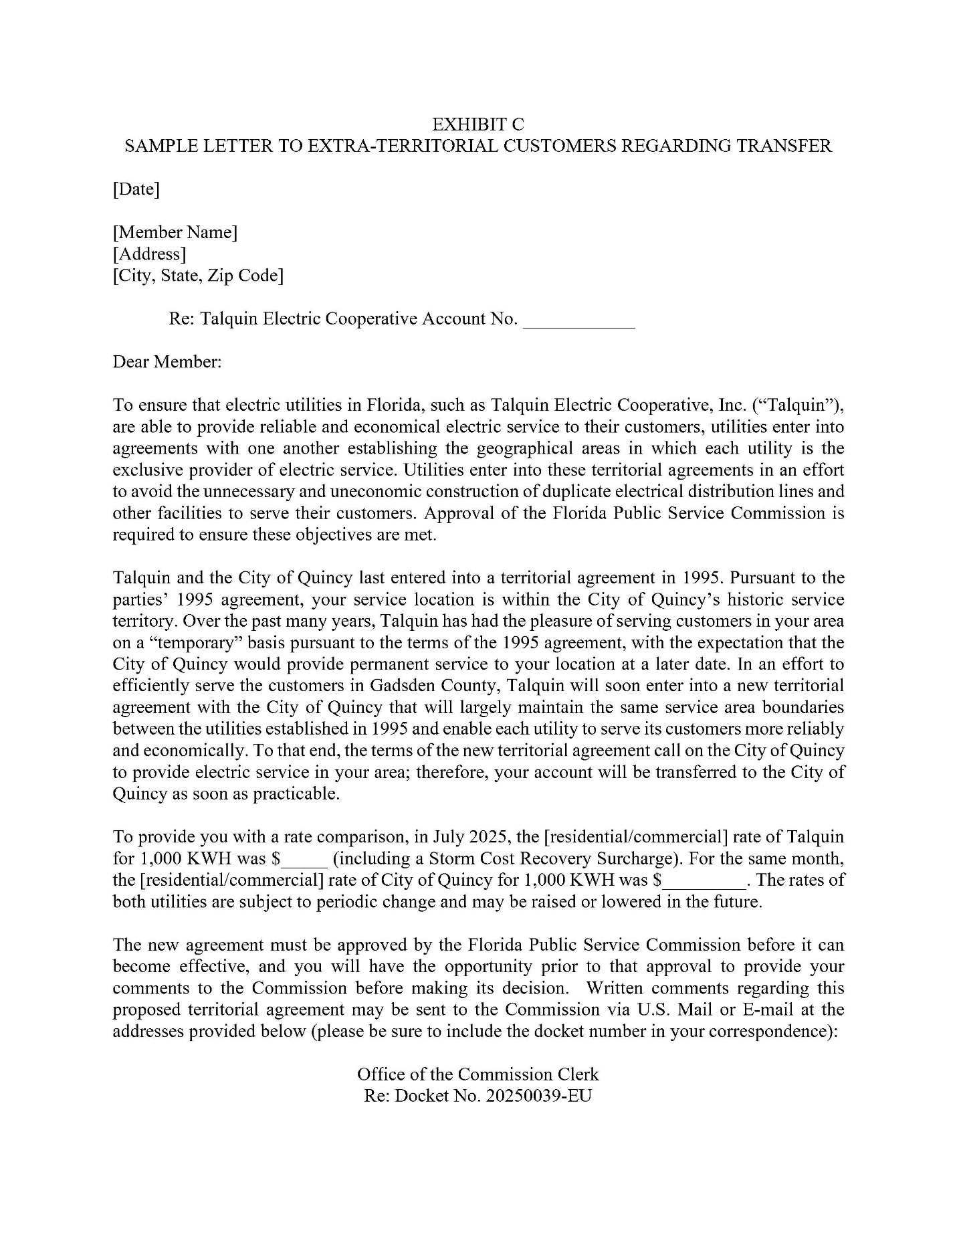
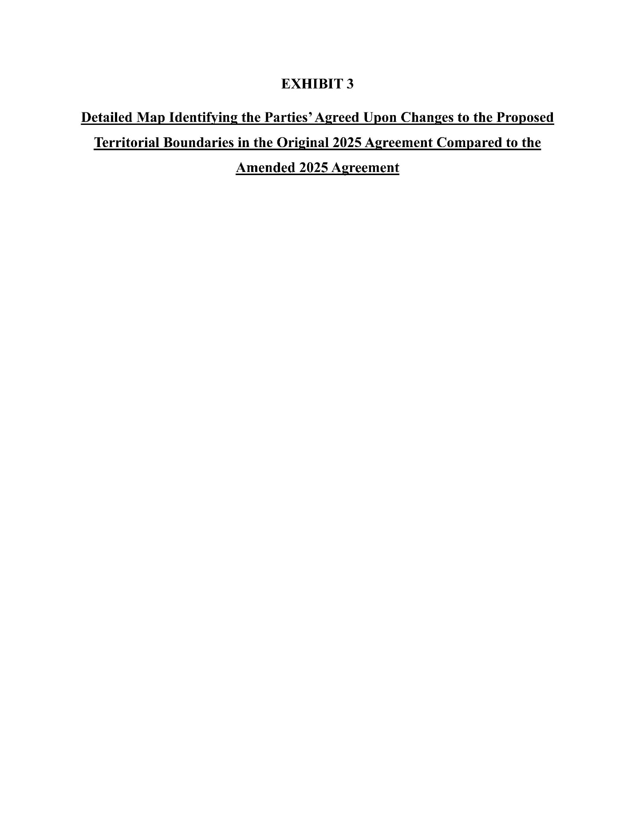
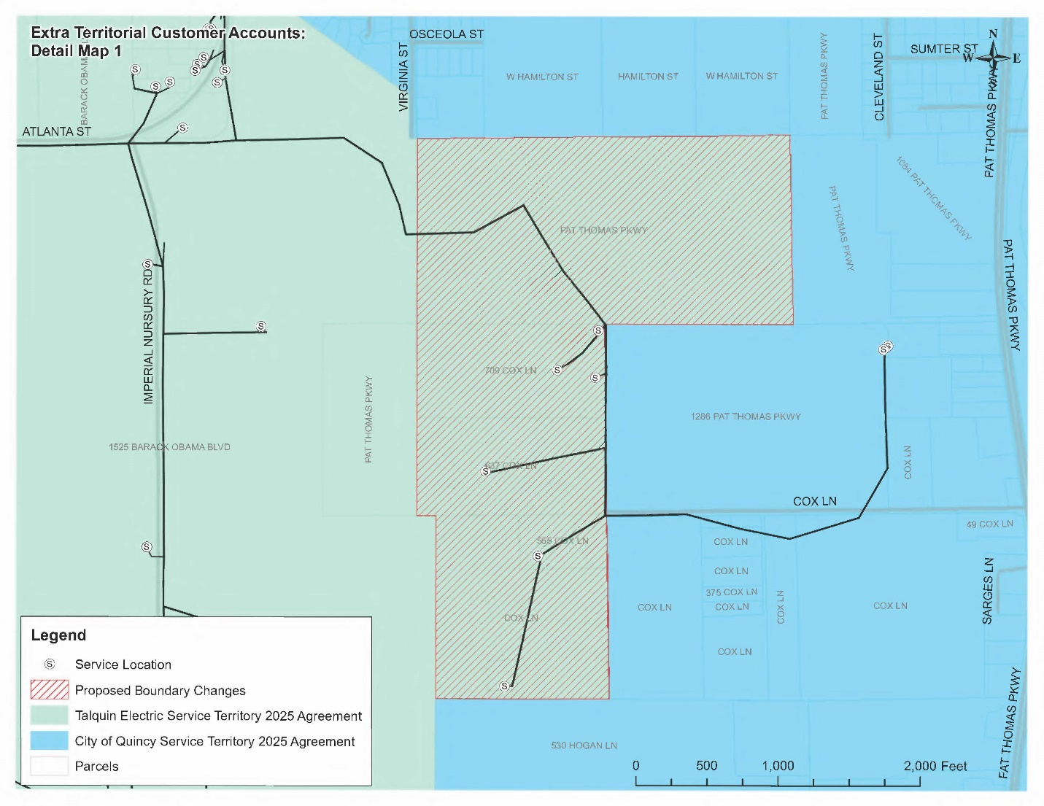

Order No. PSC-95-1522-FOF-EU, issued December 11, 1995, in Docket No. 950532-EU, In re: Joint petition for approval of territorial agreement between Talquin Electric Cooperative, Inc. and City of Quincy.
Document No. 01430-2025, Petition of Talquin Electric Cooperative, Inc. to Resolve Territorial Dispute.
Document No. 02321-2025, City of Quincy’s Opposition to the Petition of Talquin Electric Cooperative, Inc. to Resolve Territorial Dispute.
Document No. 03660-2025, Talquin Electric Cooperative’s Response to Staff’s Third Data Request, No. 5.
Document No. 03668-2025, City of Quincy’s Responses to Staff’s Third Data Request, No. 5.
Order No. PSC-2025-0262-PCO-EU, issued July 8, 2025, in Docket No. 20250039-EU, In re: Petition to resolve territorial dispute in Gadsden County with the City of Quincy, by Talquin Electric Cooperative, Inc.
Order No. PSC-2025-0286-PCO-EU, issued July 23, 2025, in Docket No. 20250039-EU, In re: Petition to resolve territorial dispute in Gadsden County with the City of Quincy, by Talquin Electric Cooperative, Inc.
Order No. PSC-2025-0326-PCO-EU, issued August 29, 2025, in Docket No. 20250039-EU, In re: Petition to resolve territorial dispute in Gadsden County with the City of Quincy, by Talquin Electric Cooperative, Inc.
Utilities Commission of the City of New Smyrna Beach v. Florida Public Service Commission, 469 So. 2d 731 (Fla. 1985).
Document No.15084-2025, Section 6.1 of Amended 2025 Territorial Agreement.
Document No.15084-2025, Background 9 of2025 Amended 2025 Territorial Agreement.
Document No. 15084,-2025, Exhibit A-3 of Amended 2025 Territorial Agreement.
Document No. 01430-2025, Petition of Talquin Electric Cooperative, Inc. to Resolve Territorial Dispute.
Document No. 15084-2025, Section 2.4 of Amended 2025 Territorial Agreement.
Document No.15084-2025, Section 3.2 of 2025 Amended Territorial Agreement.
Document No. 14046-2025, Joint petitioners’ response to Staff’s Fourth Data Request, No. 3.a.
Document No. 15084-2025, Exhibit C of Amended 2025 Territorial Agreement.
Document No. 14046-2025, Joint petitioners’ response to Staff’s Fourth Data Request, No. 1.F
Document No. 14046-2025, Joint petitioners’ response to Staff’s Fourth Data Request, No. 2.
Document No. 15084-2025, Section 4.3 of Amended 2025 Territorial Agreement.
Document No. 15084-2025, Section 4.4 of Amended 2025 Territorial Agreement.
Document No. 14046-2025, Joint petitioners’ response to Staff’s Fourth Data Request, No. 4.
Document No. 14046-2025, Joint petitioners’ response to Staff’s Fourth Data Request, No. 5.a.
Document No. 14046-2025, Joint petitioners’ response to Staff’s Fourth Data Request, No. 5.c.

